+ Fourth Sunday after Epiphany
January 29, 2023

St. Andrew Lutheran Church
304 Morewood Ave.
Pittsburgh, PA 15213
St_andrewELCA@verizon.net
www.standrewpittsburgh.org

+ Fourth Sunday after Epiphany
Order for Worship

Who are the blessed ones of God? For the prophet Micah, they are those who do justice, love kindness, and walk humbly with God. For Paul, they are the ones who find wisdom in the weakness of the cross. For Jesus, they are the poor, the meek, the merciful, the pure in heart, the peacemakers, those who mourn, and those who hunger for righteousness. In Baptism we find our blessed identity and calling in this countercultural way of living and serving.

- Masks are optional at St. Andrew when Covid-19 community level in Allegheny County is in the low and medium categories.
- Worship Services are live streamed to multiple online platforms. By attending worship, you agree that your image and voice may be broadcast.

The festival of Epiphany and the season that follows emphasize God’s ongoing revelation of Jesus Christ to people of all nations. In this spirit, St. Andrew’s worship music throughout the season will feature hymns and songs that reflect the rich variety of contributions that people of various lands, cultures, and languages have made to the hymnody of the global Christian church. “In sharing one another’s music, we share more than music. Music of various cultures brings us a glimpse of one another’s experience of God. As any culture connects its experience of the holy to its music, a unique context for God’s presence is created – we experience together the way God weaves a varied, diverse tapestry of revelation among us. The church’s song is a great place to experience that sharing.”
Evangelical Lutheran Worship: Musician’s Guide, Augsburg Fortress, 2007. p. 63

Welcome to St. Andrew!

- St. Andrew Lutheran Congregation welcomes all who are seeking a place of healing and wholeness, a nurturing, faith-forming spiritual home. Our community embraces people of all ages, ethnicities, cultures, abilities, sexual orientations, gender identities and expressions, and family constellations. Come and See!
- Everyone is invited to make a nametag at the black bookcase in the back of the worship space if they would like.
- Worship “toolkits” to help children engage with the service are available in the black bookcase at the back of the worship space. There are “reader” and “pre-reader” resources available in each kit. Please feel free to use the kits for/with your children during worship.
- St. Andrew has recently returned to serving the sacrament of Holy Communion with both (separate) elements, bread and wine/grape juice. The presiding minister will first distribute the bread (host). Please consume this and then pick up an empty glass from the tray next to the presiding minister. The Communion Assistant will pour wine from the chalice or grape juice from the cruet into your glass. Please step to the side to consume the wine or grape juice. As you return to your pew, glasses may be returned to the empty trays on either side of the center aisle.
- A restroom is available on the main level of the church, through the doors to the Social Hall and to the right in the main office.
Welcome

Prelude

Gathering
The Holy Spirit calls us together as the people of God.

Call to Worship

P: The time is now!
A: The day has come.
C: The kin-dom of God is here!

A: Listen in stillness,
P: Proclaim in song:
C: All are welcome!

P: Reconcile your people.
A: Open our hearts and our doors.
C: Gather us at your table.

A: For the time is now!
P: The day has come.
C: The kin-dom of God is here!

Thanksgiving for Baptism

P: Blessed be the holy Trinity, ☩ one God,
the fountain of living water, the source of breath and nourishment.
C: Amen.

The presiding minister addresses the assembly
P: God calls us through the waters of Baptism to be our authentic selves,
and God has called us holy. Trusting that God leads us to embody divine revolution on earth,
let us give thanks for the gift of Baptism.

Water may be poured into the font as the presiding minister gives thanks.

P: We praise you, O God, for the waters of life:
for streams, rivers, and oceans, lakes and estuaries,
and for the rain and snow that give life to every living being.
From the waters above and the waters below, you made sacred our bond with water.
Through the waters of the flood and the parting of the sea,
you showed your promises to be true.

In the waters of Baptism you claimed us and called each of us by our true name.
Through Baptism you welcomed us into the Body of Christ, transformed our lives,
and made us whole. Send now your Spirit to move in our midst, and immerse us
in your gifts of mercy, love, and grace.

To you be given honor and praise through our Savior Jesus Christ,
in the unity of the Holy Spirit, now and forever.
C: Amen.

Gathering Hymn Light Dawns on a Weary World ELW 726

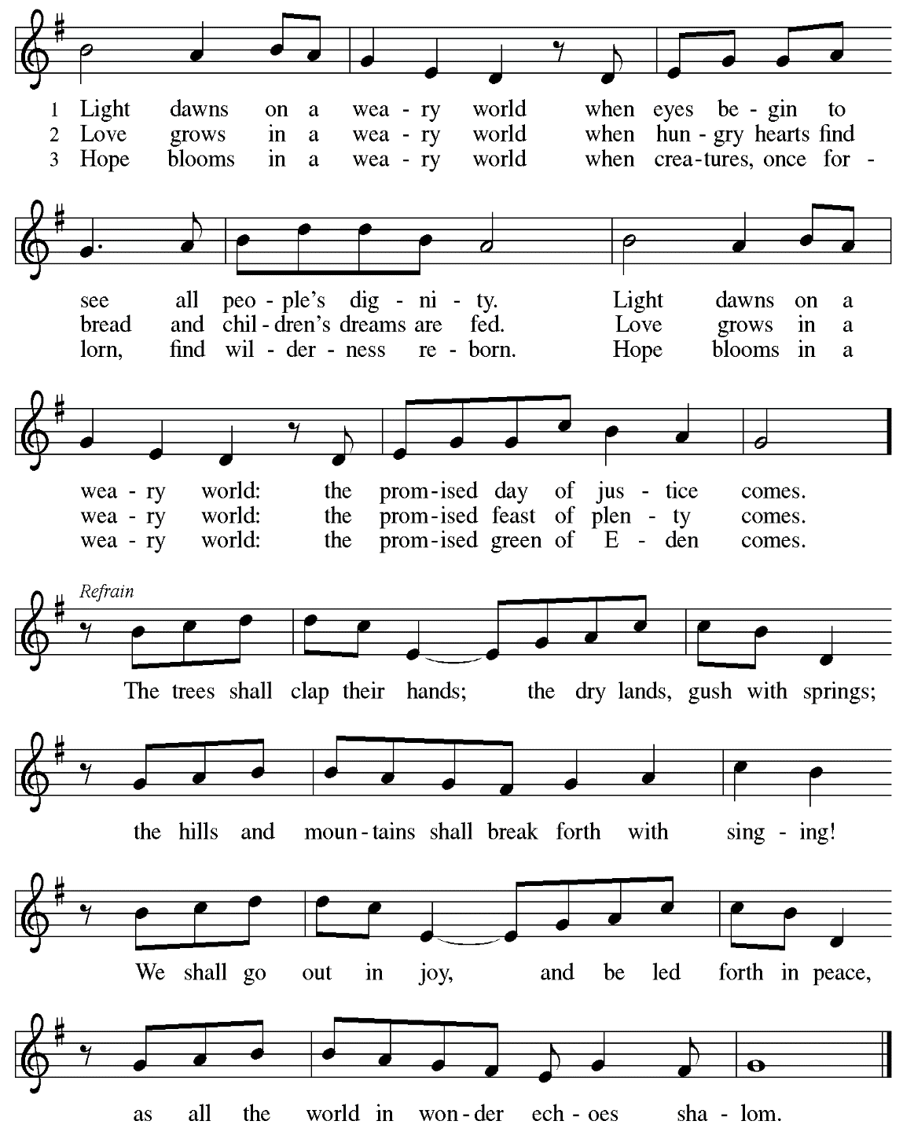

Greeting

P: The grace of our Lord Jesus Christ, the love of God,
and the communion of the Holy Spirit be with you all.
C: And also with you.

Hymn of Praise Glory to God, Glory in the Highest ELW 164

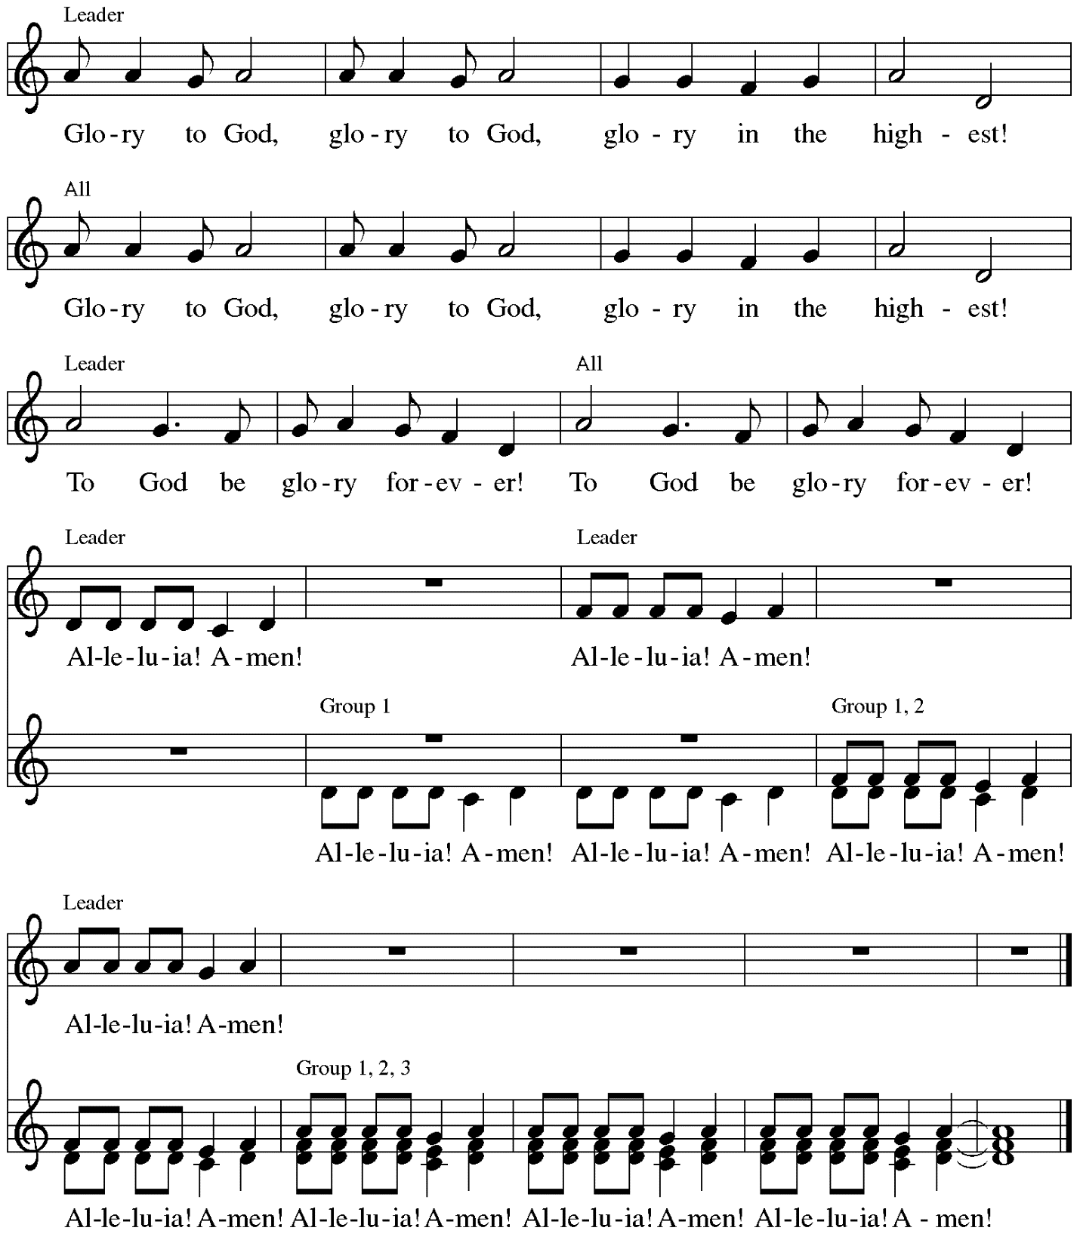

Music: Peruvian traditional

Prayer of the Day

P: The Lord be with you.
C: And also with you.

P: Let us pray.
Holy God, you confound the world’s wisdom in giving your kingdom to the lowly and the pure in heart. Give us such a hunger and thirst for justice, and perseverance in striving for peace, that in our words and deeds the world may see the life of your Son, Jesus Christ, our Savior and Lord.
C: Amen.

Please be seated.
Children are invited to join the adult leaders at the door and move to the office for Little Church; Big Faith. We ask that one additional adult from the congregation attend with the children.

Word
God speaks to us in Scripture reading, preaching, and song

First Reading – Micah 6: 1-8

¹Hear what the Lord says:
Rise, plead your case before the mountains,
and let the hills hear your voice.
²Hear, you mountains, the controversy of the Lord,
and you enduring foundations of the earth;
for the Lord has a controversy with his people,
and the Lord will contend with Israel.
³“O my people, what have I done to you?
In what have I wearied you? Answer me!
⁴For I brought you up from the land of Egypt,
and redeemed you from the house of slavery;
and I sent before you Moses,
Aaron, and Miriam.
⁵O my people, remember now what King Balak of Moab devised,
what Balaam son of Beor answered him,
and what happened from Shittim to Gilgal,
that you may know the saving acts of the Lord.”
⁶“With what shall I come before the Lord,
and bow myself before God on high?
Shall I come before God with burnt offerings,
with calves a year old?
⁷Will the Lord be pleased with thousands of rams,
with ten thousands of rivers of oil?
Shall I give my firstborn for my transgression,
the fruit of my body for the sin of my soul?”
⁸The has told you, O mortal, what is good;
and what does the Lord require of you
but to do justice, and to love kindness,
and to walk humbly with your God?

L: Word of God, word of life.
C: Thanks be to God.

Psalm 15

The cantor will lead the singing of the psalm.
The congregation is invited to respond with the alternate verses in bold print,
and to join in singing the refrain.

Psalm tone

Psalm refrain
¹Lord, who may dwell in your | tabernacle?
Who may abide upon your | holy hill?
²Those who lead a blameless life and do | what is right,
who speak the truth | from their heart; R
³they do not slander with the tongue, they do no evil | to their friends;
they do not cast discredit up- | on a neighbor.
⁴In their sight the wicked are rejected, but they honor those who | fear the Lord.
They have sworn upon their health and do not take | back their word.
⁵They do not give their money in hope of gain, nor do they take bribes a- | gainst the innocent.
Those who do these things shall never be | overthrown. R

Second Reading – 1 Corinthians 1: 18-31

¹⁸The message about the cross is foolishness to those who are perishing, but to us who are being saved it is the power of God. ¹⁹For it is written,
“I will destroy the wisdom of the wise,
and the discernment of the discerning I will thwart.”
²⁰Where is the one who is wise? Where is the scribe? Where is the debater of this age? Has not God made foolish the wisdom of the world? ²¹For since, in the wisdom of God, the world did not know God through wisdom, God decided, through the foolishness of our proclamation, to save those who believe. ²²For Jews demand signs and Greeks desire wisdom, ²³but we proclaim Christ crucified, a stumbling block to Jews and foolishness to Gentiles, ²⁴but to those who are the called, both Jews and Greeks, Christ the power of God and the wisdom of God. ²⁵For God’s foolishness is wiser than human wisdom, and God’s weakness is stronger than human strength.
²⁶Consider your own call, kindred: not many of you were wise by human standards, not many were powerful, not many were of noble birth. ²⁷But God chose what is foolish in the world to shame the wise; God chose what is weak in the world to shame the strong; ²⁸God chose what is low and despised in the world, things that are not, to reduce to nothing things that are, ²⁹so that no one might boast in the presence of God. ³⁰God is the source of your life in Christ Jesus, who became for us wisdom from God, and righteousness and sanctification and redemption, ³¹in order that, as it is written, “Let the one who boasts, boast in the Lord.”

L: Word of God, word of life.
C: Thanks be to God.

Please rise as you are able.

Gospel Acclamation Heleluyan / Hallelujah ELW 171

Heleluyan, heleluyan; hele, heleluyan.
Heleluyan, heleluyan; hele, heleluyan.

Hallelujah, hallelujah; halle, hallelujah.
Hallelujah, hallelujah; halle, hallelujah.

Music: Muscogee (Creek); transc. Charles H. Webb, b. 1933. Transcription © 1989 The United Methodist Publishing House, admin.
The Copyright Company. Reprinted with permission under OneLicense.net # A-722139.

Gospel – Matthew 5: 1-12

P: The holy Gospel according to St. Matthew.
C: Glory to you, O Lord.
¹When Jesus saw the crowds, he went up the mountain; and after he sat down, his disciples came to him. ²Then he began to speak, and taught them, saying:
³“Blessed are the poor in spirit, for theirs is the kingdom of heaven.
⁴“Blessed are those who mourn, for they will be comforted.
⁵“Blessed are the meek, for they will inherit the earth.
⁶“Blessed are those who hunger and thirst for righteousness, for they will be filled.
⁷“Blessed are the merciful, for they will receive mercy.
⁸“Blessed are the pure in heart, for they will see God.
⁹“Blessed are the peacemakers, for they will be called children of God.
¹⁰“Blessed are those who are persecuted for righteousness’ sake, for theirs is the kingdom of heaven.
¹¹“Blessed are you when people revile you and persecute you and utter all kinds of evil against you falsely on my account. ¹²Rejoice and be glad, for your reward is great in heaven, for in the same way they persecuted the prophets who were before you.”

P: The Gospel of the Lord.
C: Praise to you, O Christ.

Please be seated.

Sermon

A time of silence for prayer and reflection follows the sermon.
When the Hymn of the Day begins, please rise as you are able.

Hymn of the Day Look Who Gathers at Christ’s Table ACS 977

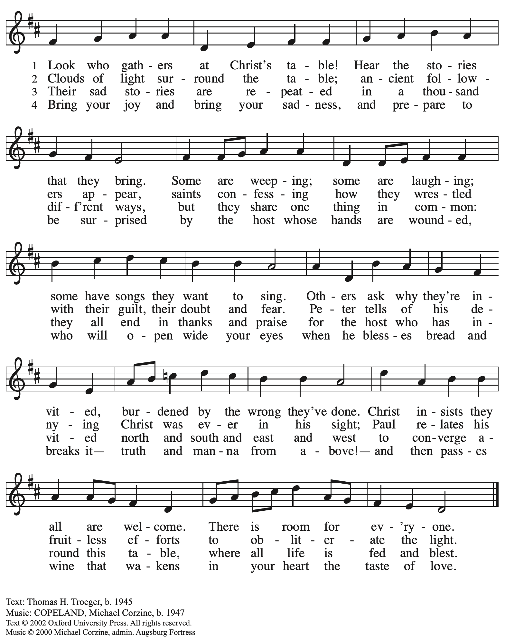
All rights reserved. Reprinted with permission under OneLicense.net # A-722139.

Recommitment to Reconciliation

P: Beloved children of God, we have been gathered together at this time, in this place.
God’s grace surrounds us, cleansing us from our sin and opening to us the words of scripture. God feeds us with God’s very presence and empowers us to proclaim good news:
healing, salvation, and joy! Let us remember our baptismal calling, and the ministry that has been given to us.

Hear these words from 2 Corinthians 5:
So if anyone is in Christ, there is a new creation: everything old has passed away; see, everything has become new! All this is from God, with whom we have been reconciled through Christ, and by whom we have been given the ministry of reconciliation; that is, in Christ God was reconciling the world to Godself, not counting the people’s trespasses against them, and entrusting the message of reconciliation to us.

People of St. Andrew, the powers of this world will attempt to impose old distinctions upon you—male and female, slave and free, Jew and Greek—barriers to keep you separated from one another. Will you remember that in Christ you have been made a new creation?
C: We will, and we ask God to help and guide us.

P: The powers of this world will attempt to restrict your vision, to keep you from seeing the outcast, the poor, and the stranger. Will you remember that God is reconciling the entire world to Godself?
C: We will, and we ask God to help and guide us.

P: The powers of this world will continue to count your trespasses against you, telling you that you are far too flawed, too insignificant, too wounded to make any difference. Will you remember that God has called you to be God’s messenger?
C: We will, and we ask God to help and guide us.

P: The yoke of our burden has been broken!
Let our heads be lifted up; let us be united in purpose; let us follow Christ.

Congregational Refrain HS 808

C: Christ goes before, and we are called to follow,
and all who follow find the Way, the Truth, the Life.

Text: Jarsolav Vajda, b. 1919, © 1987.
Music: RIVERSIDE, Irregular; Carl F. Schalk, b. 1929, © 1987 GIA Publications.
All rights reserved. Reprinted with permission under OneLicense.net # A722139.

Prayers of the People

A: Trusting in God’s extraordinary love, let us come before the Holy One in prayer.

After each petition
A: Merciful God,
C: reconcile your people.

The presiding minister concludes the prayers:
P: Receive the prayers of your children, merciful God,
and hold us forever in your steadfast love,
through Jesus Christ, our holy wisdom.
C: Amen.

Please be seated.

Meal

Offering

We offer ourselves, our gifts, and our faithful service to God.
As the offering is gathered for the mission of the church, including the care of those in need,
the table is set for Holy Communion.

Music during the Offering
What Does the Lord Require of You? ACS 1057

As the gifts are brought forward for presentation, please rise as you are able
and join in singing the Offertory Song.
Offertory Song ELW 523
Vamos todos al banquete / Let Us Go Now to the Banquet
v. 2-3

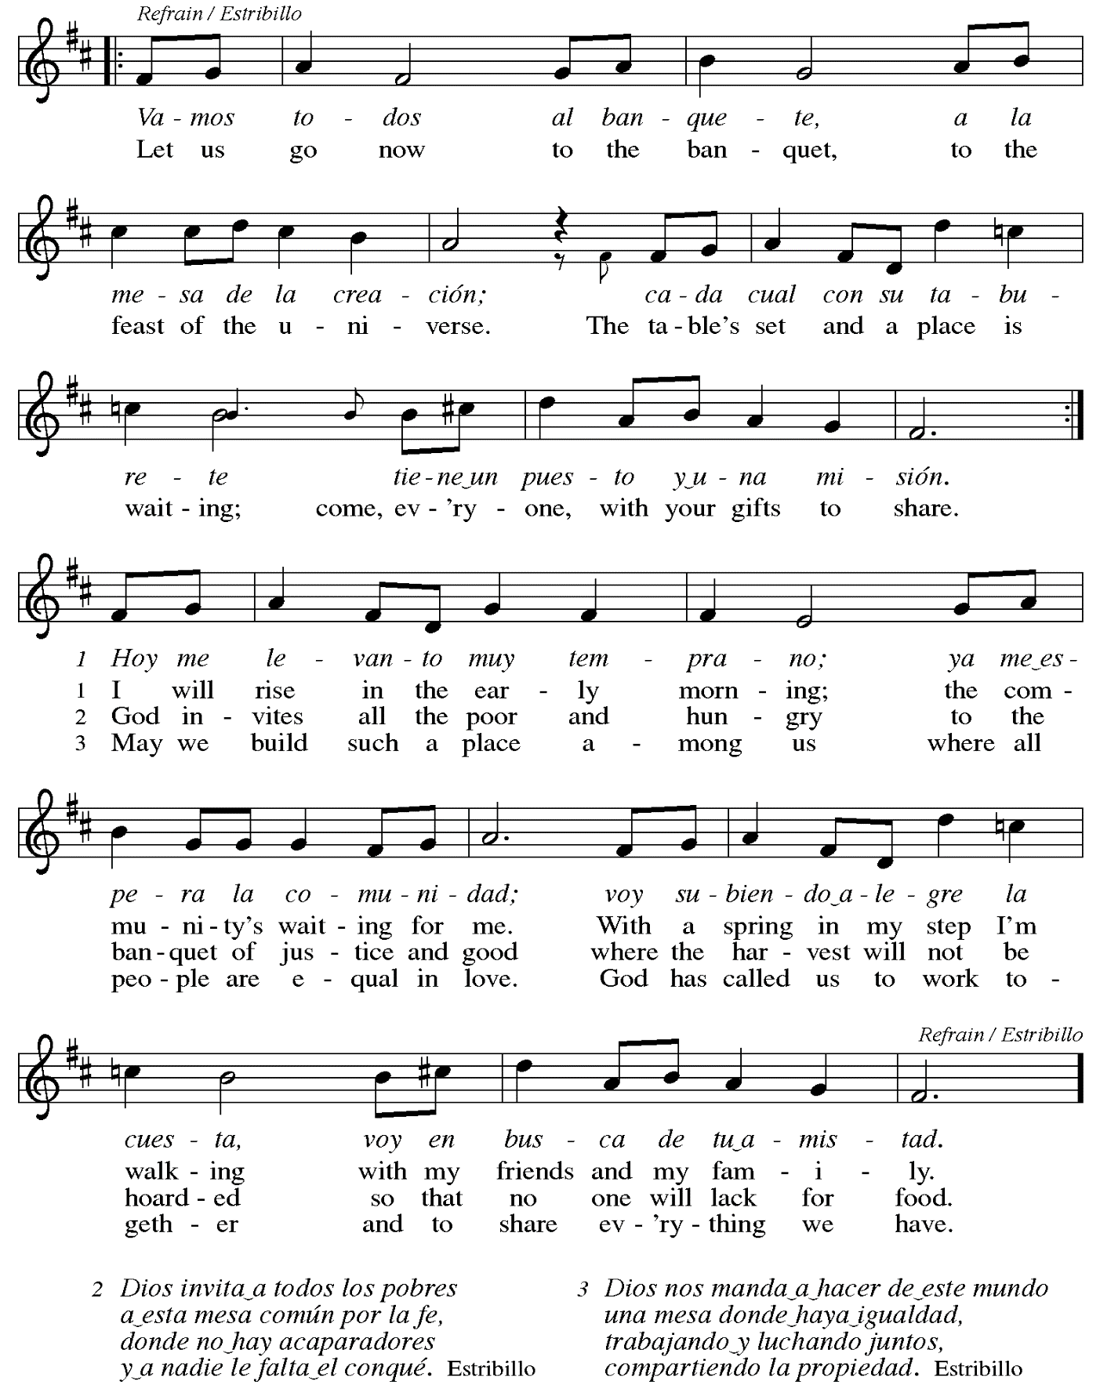

Offertory Prayer

A: Let us pray.
Liberating God,
C: you break the bonds of injustice
and set free those who are oppressed.
Receive these offerings in thanksgiving
for all your deeds of merciful power,
that they may serve in your work of justice and freedom.
You we magnify and adore, through Jesus our Savior.
Amen.

Dialogue

P: The Lord be with you.
C: And also with you.

P: Lift up your hearts.
C: We lift them to the Lord.

P: Let us give thanks to the Lord our God.
C: It is right to give our thanks and praise.

Preface (Spoken by the presiding minister)

P: It is indeed right, our duty and our joy,
that we should at all times and in all places
give thanks and praise to you, almighty and merciful God,
through our Savior Jesus Christ;
who on this day overcame death and the grave,
and by his glorious resurrection opened to us the way of everlasting life.
And so, with all the choirs of angels,
with the church on earth and the hosts of heaven,
we praise your name and join their unending hymn:

Sanctus Santo, Santo, Santo ELW 762
Refrain Only

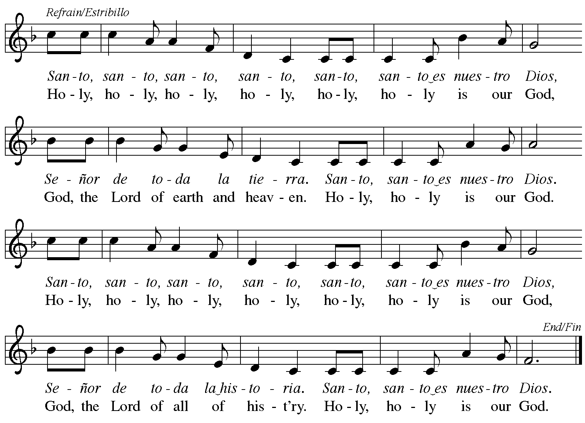
Reprinted with permission under OneLicense.net # A-722139.

Eucharistic Prayer

P: Blessed are you, O God,
creator of heaven and earth.
You rescued your covenant people,
led them on all their journeys,
and taught them by the prophets.
You so loved the world
that you gave your only Son,
so that everyone who believes in him
may not perish but may have eternal life.

In the night in which he was betrayed,
our Lord Jesus took bread,
and gave thanks; broke it,
and gave it to his disciples,
saying: Take and eat;
this is my body, given for you.
Do this for the remembrance of me.

Again, after supper,
he took the cup, gave thanks,
and gave it for all to drink,
saying: This cup
is the new covenant in my blood,
shed for you and for all people
for the forgiveness of sin.
Do this for the remembrance of me.

P: As often as we eat this bread
and drink this cup,
we proclaim the Lord’s death
until he comes.
C: Christ has died.
Christ is risen.
Christ will come again.

P: Pour out your Holy Spirit
in this meal and make us one,
in this community of faith
and with your people throughout the world.

Glory and praise to you, O God,
Author of Life,
Word made flesh,
Power of the Most High,
now and forever.
C: Amen.

Lord’s Prayer

P: Gathered as one by the Holy Spirit, let us pray as Jesus taught us.
C: Our Father in heaven,
hallowed be your name,
your kingdom come,
your will be done,
on earth as in heaven.
Give us today our daily bread.
Forgive us our sins
as we forgive those who sin against us.
Save us from the time of trial
and deliver us from evil.
For the kingdom, the power,
and the glory are yours,
now and forever. Amen.

Fraction and Invitation

P: These are the gifts of God for the people of God.
Come, share the feast.

Agnus Dei Lamb of God TFF 35

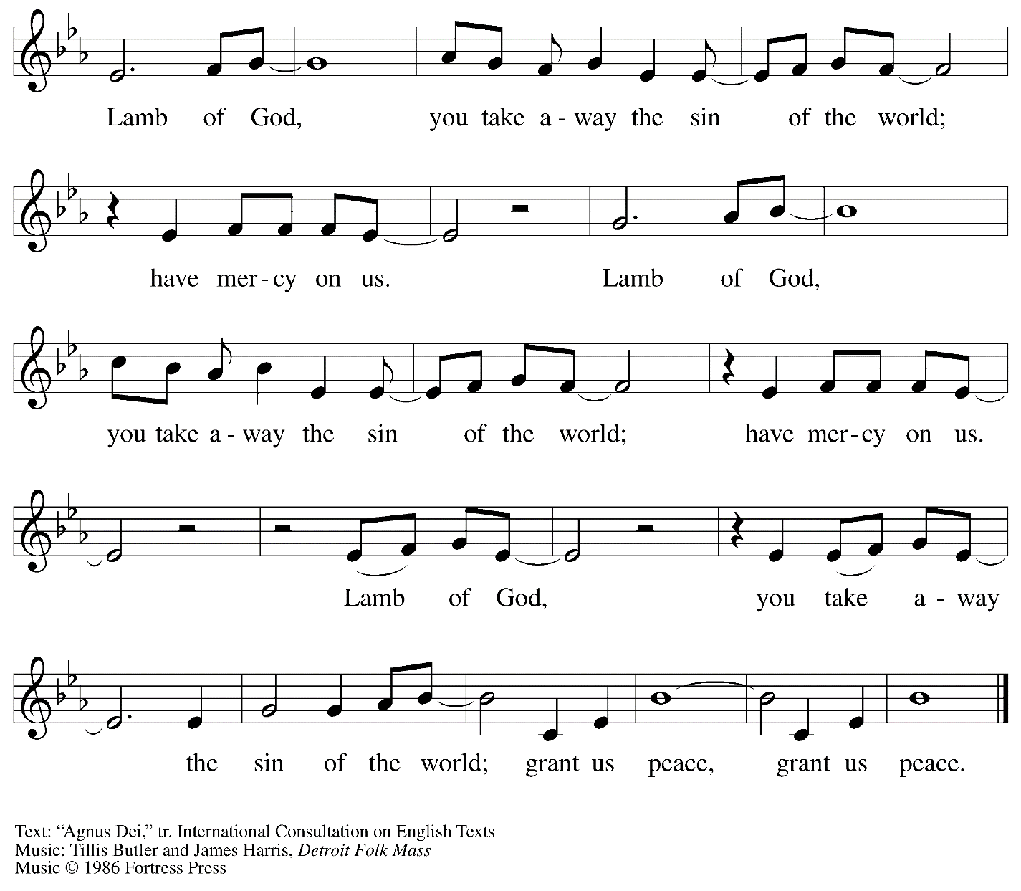
All rights reserved. Reprinted with permission under OneLicense.net # A-722139.

Please be seated.

Holy Communion
- All who seek God and desire a deeper and stronger life in Christ are welcome to receive Holy Communion.
- Worshipers from the pulpit side will proceed forward first, followed by the center section, and then the lectern side.
- Please inform an usher if you would like the ministers to bring Communion to you.
- Holy Communion will be served with bread and wine/grape juice.
- The presiding minister will first distribute the bread (host) to each communicant. Please indicate if you require a gluten-free host.
- Once you have consumed the bread, please pick up an empty glass from the tray next to the presiding minister. The Communion Assistant will pour wine from the chalice or grape juice from the cruet into your glass.
- Please step to the side to consume the wine or grape juice.
- As you return to your pew, glasses may be returned to the empty trays on either side of the center aisle.
- A blessing will be provided for anyone who does not yet receive the sacrament.
- All are invited to join in singing the hymns during Holy Communion.

Hymn during Holy Communion
All Are Welcome ELW 641

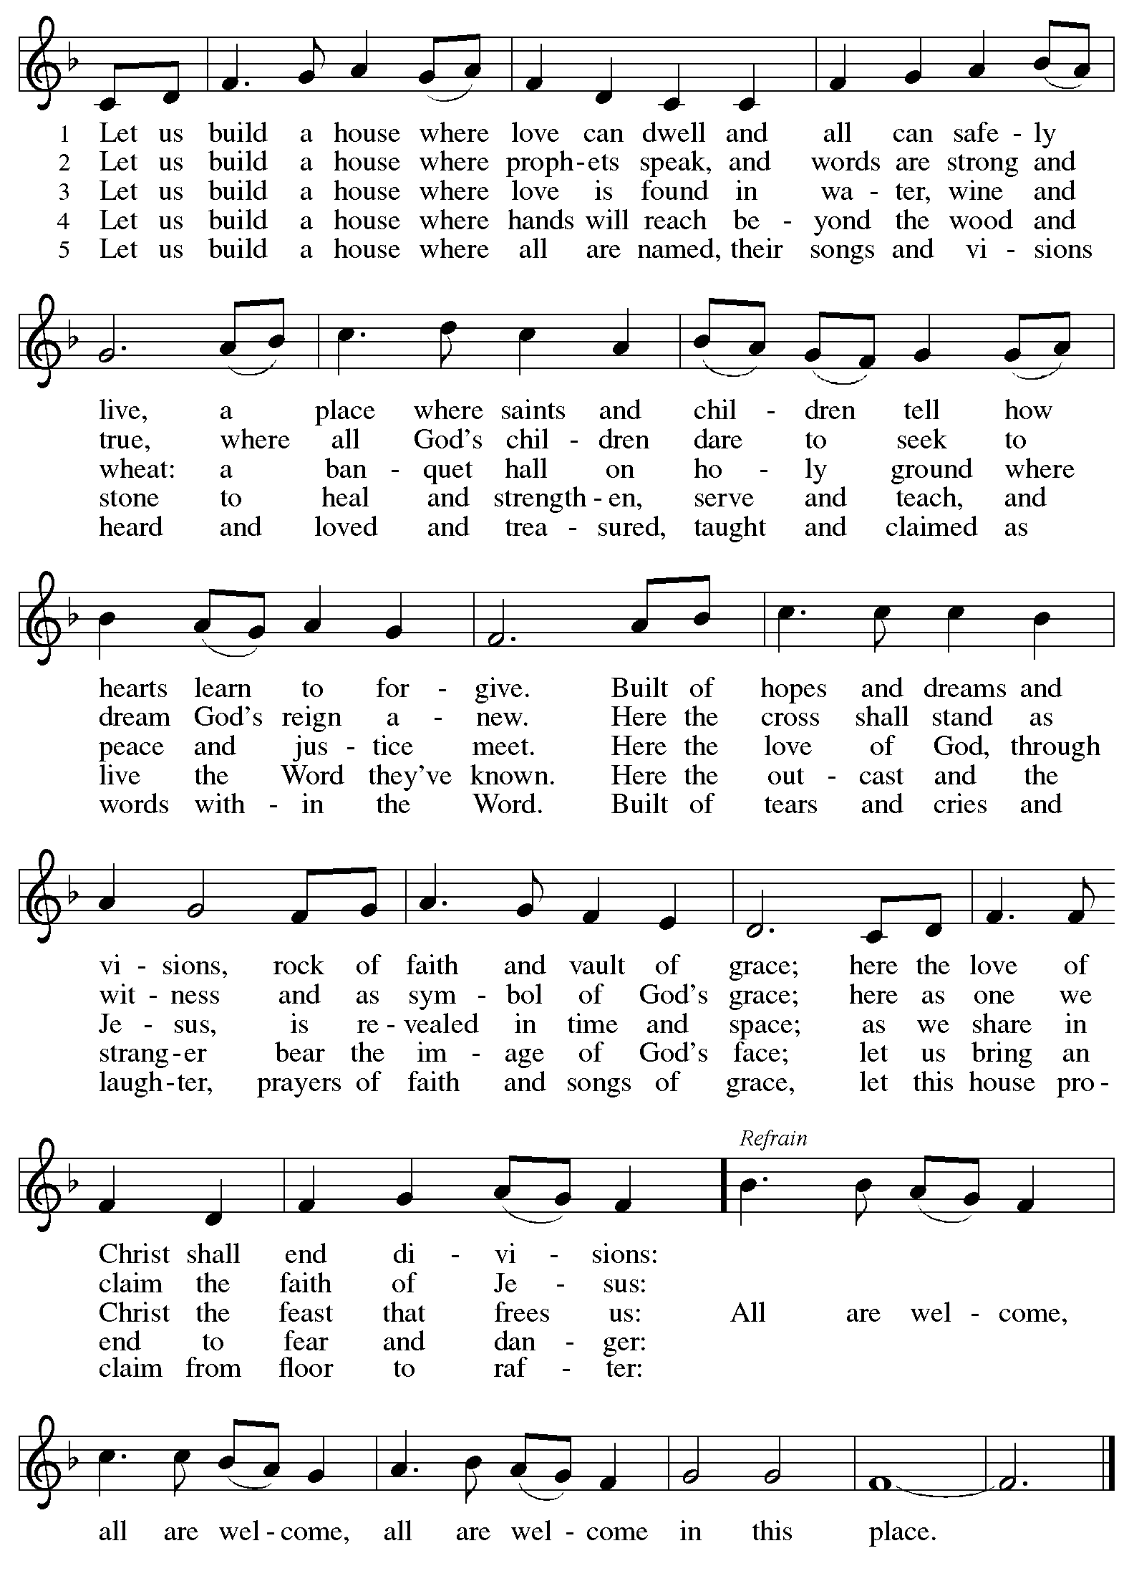
Hymn during Holy Communion
Make Me a Channel of Your Peace W&P 95

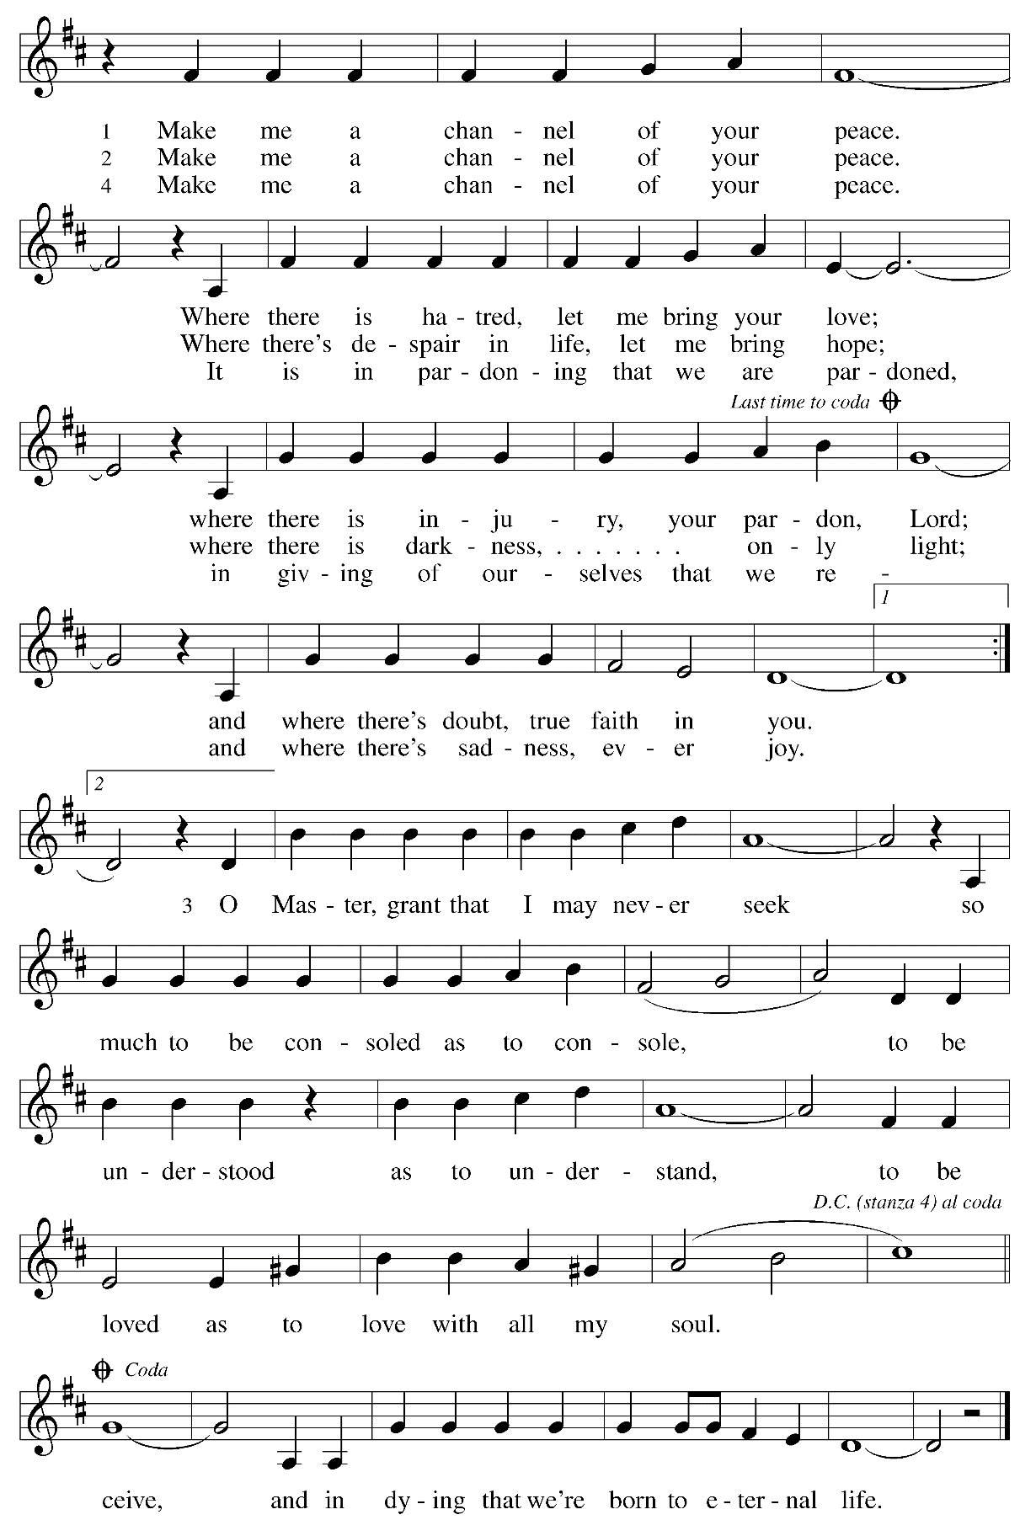

When all have returned to their places, please rise as you are able.

Blessing

P: The body and blood of our Lord Jesus Christ strengthen you and keep you in his grace.
C: Amen.

Prayer

A: Let us pray.
Holy One,
we thank you for the healing
that springs forth abundantly from this table.
Renew our commitment to do justice, love kindness,
and journey humbly with you,
through Jesus Christ, our Savior and Lord.
C: Amen.

Sending

Benediction

P: The Lord bless you and keep you.
The Lord’s face shine on you
with grace and mercy.
The Lord look upon you with favor
and ☩ give you peace.
C: Amen.

Sending Hymn Let Streams of Living Justice Following page

Dismissal

A: Go in peace. Serve
C: Thanks be to God!

Sending Hymn Let Streams of Living Justice ELW 710
With additional verses from the hymn writer

1. Let streams of living justice flow down upon the earth;
give freedom’s light to captives, let all the poor have worth.
The hungry’s hands are pleading, the workers claim their rights,
the mourners long for laughter, the blinded seek for sight.
Make liberty a beacon, strike down the iron power,
abolish ancient vengeance: proclaim your people’s hour.
2. The dreaded disappearance of family and friend;
the torture and the silence—the fear that knows no end;
the mother with her candle, the child who holds a gun,
the old one nursing hatred —all seek release to come.
Each candle burns for freedom; each light a tyrant’s fall
each flower placed for martyrs gives tongue to silenced call.
3. You hallow our vocations, you call us to your way;
you shape us for your service—you the Potter, we the clay.
Share with us Creation’s moulding; form our minds to your delight;
Mighty Crafter of our vessels, fire our visions with your light—
consecrate your priest and people; warm the steps your saints have trod:
bless the bread of our endeavours, bless the wine of our resolve.
4. For healing of the nations, for peace that will not end,
for love that makes us lovers, God grant us grace to mend.
Weave our varied gifts together; knit our lives as they are spun;
on your loom of time enroll us till our thread of life is run.
O great Weaver of our fabric, bind Church and world in one;
dye our texture with your radiance, light our colours with your sun.
5. Your city’s built to music; we are the stones you seek;
your harmony is language: we are the words you speak.
Our faith we find in service, our hope in other’s dreams,
our love in hand of neighbour: our homeland brightly gleams.
Inscribe our hearts with justice; your way—the path untried;
your truth—the heart of stranger; your life—the Crucified.

Text: William Whitla, b. 1934.
Music: THAXTED, Gustav Holst, 1874-1934.
Text © 1989 William Whitla. Used with permission from Rev. Whitla.

Abbreviations

P: Pastor/Presiding Minister
A: Assisting Minister
L: Lector
C: Congregation

ELW: Evangelical Lutheran Worship hymnal
TFF: This Far by Faith hymnal
ACS: All Creation Sings hymnal
W&P: Worship and Praise hymnal
HS: Hymnal Supplement

Those serving in worship today

Assisting Minister Timothy Kocher-Hillmer
Audio-Visual Ministers Kristen Asplin
Joseph Paetz
Cantor Emily Duque
Lector Joyce Compton
Minister of Music Laura Reynolds
Presiding Minister The Rev. Ross I. Carmichael

Liturgy and Hymnody Acknowledgements

From SundaysandSeasons.com. Copyright © 2023 Augsburg Fortress. All rights reserved. Reprinted under OneLicense.net # A-722139.
Used by permission of Augsburg Fortress.

Vamos todos al banquete / Let Us Go Now to the Banquet – Text: Guillermo Cuéllar, b. 1955, Misa popular salvadoreña; tr. Bret Hesla, b. 1957, and William Dexheimer Pharris, b. 1956. Music: VAMOS TODOS AL BANQUETE, Guillermo Cuéllar, b. 1955. Text and music © 1994, 1996 GIA Publications, Inc., 7404 S. Mason Ave., Chicago, IL 60638. www.giamusic.com. 800.442.3358. All rights reserved. Reprinted with permission under OneLicense.net #A-722139.

All Are Welcome – Text: Marty Haugen, b. 1950. Music: TWO OAKS, Marty Haugen. Text and Music © 1994 GIA Publications, Inc., 7404 S. Mason Ave., Chicago, IL 60638. www.giamusic.com. 800.442.3358. All rights reserved. Reprinted with permission under OneLicense.net # A-722139.

Make Me A Channel of Your Peace – Text: Sebastian Temple. Music: PRAYER OF ST. FRANCIS, Sebastian Temple. Text and Music © 1967 OCP Publications. All rights reserved. Reprinted with permission under OneLicense.net # A-722139.

St. Andrew Lutheran Church Announcements
January 29th, 2023

- Welcome to Worship at St. Andrew on January 29th, 2023, the + Fourth Sunday after Epiphany – Today is “Reconciling in Christ” Sunday, when we at St. Andrew renew our commitment to be a Reconciling in Christ congregation, one that seeks the full welcome, inclusion, and participation of people of “all ages, ethnicities, cultures, abilities, sexual orientations, gender identities and expressions, and family constellations.” Masks are optional at St. Andrew when Allegheny County’s Covid-19 community level is in the low and medium categories. Worship attendees are invited to make a name tag at the back of the worship space if you would like. All are welcome to a time of coffee and conversation in the Social Hall after worship.
- Humor and the Bible Discussion Continues Tuesday, January 31st, 7:00 p.m. Online – Is there humor in the Bible? Isn't it a pious look at life that inspires us and places us in awe of God? Doesn't the Bible contain instructions for life's do's and don'ts? Doesn't the Bible give us warnings and signs of hope? Perhaps all these things are true, but if we can suspend our piety, our past notions or suspicions about the Bible, we just might hear and experience a humorous side of the Bible we hadn't appreciated before. We might even laugh! In our last Zoom discussion of the series on Tuesday, January 31st, at 7:00 p.m., Pastor Paul Koch will lead us in looking more closely at various passages in the New Testament. We thank Pastor Koch for leading us throughout this study! Zoom login information can be found in the This Week at St. Andrew email – tune in and enjoy!
- St. Andrew Resumes Special Reparations Collection for Use of African American Spiritual Songs in Worship – First Sunday of Every Month, Beginning February 5th – Jesus' parable of the Good Samaritan from Luke's Gospel provides an example of how God's people are called to work for healing and repair for our neighbors independent of who or what caused them harm. In light of this, the Worship Committee and Congregation Council of St. Andrew have made a commitment to reparations in regard to African American spiritual songs used in our worship. The text and music of most hymns is attributed to specific authors, with copyrights in place, usage reported, and royalties paid to those whose works are featured. With African American spirituals, this is not possible. In response to many years of such uncredited use, St. Andrew will invite people of the congregation to give to a second collection for reparations during the offering. We originally planned to do this each week a spiritual was sung, but after seeing initial logistics we are moving to a First Sunday of every month schedule to allow for consistency and planning in giving. Funds received in our initial collections will be donated to our siblings at Bethel AME Church, whose land and building were taken from them in the 1950s, to support Bethel’s plans for development in the Hill district.
- February Produce Distribution – Tuesday, February 7th, 5:30-7:00 p.m. – St. Andrew’s Monthly produce distribution is scheduled for Tuesday, February 7th. We ask for assistance with unloading and setup (usually sometime between 11:00 a.m. and 1:00 p.m.) and in the evening with the distribution and cleanup from 5:30-7:00 p.m. Please sign up at: https://www.signupgenius.com/go/4090f45afaf2ba75-produce#/.
- Life of Faith Survey – Please Complete by Sunday, February 12th – St. Andrew has been participating in a project that explores the gap between faith (at church) and life (in the world). The foundational Lutheran understanding of vocation serves as the bridge for this consistent gap. (Vocation is often understood as “calling,” and the survey uses the terms interchangeably.) People of St. Andrew are invited to take the following survey, which asks questions about your beliefs about your own vocation or calling, as well as your experiences within your congregation. Some people in the congregation completed this survey last year. We are asking that everyone in the congregation to complete it this time, also, as the project is measuring changes over time. Please be assured that all answers are anonymous and your responses will be kept strictly confidential. Please find the survey here: https://www.surveymonkey.com/r/VB8F3FC. Paper copies can be made available for those who prefer that medium. Thank you for your time and participation!
- Water and Spirit: Devotions for Lent 2023 Available at Church Entrances – The season of Lent begins with Ash Wednesday (February 22nd this year), and in this time the Church invites us into the Lenten disciplines of fasting (giving something up for Lent), almsgiving (generosity and charitable giving), and prayer. A new resource is available to support the St. Andrew congregation in the discipline of prayer this season. Water and the Spirit: Devotions for Lent 2023 offers simple daily readings, reflections, and prayers from Ash Wednesday through Holy Week. These are available at each entrance to the church - please pick one up in the next few weeks to aid in your observation of Lent this year.

