+ Ash Wednesday
February 22, 2023

St. Andrew Lutheran Church
304 Morewood Ave.
Pittsburgh, PA 15213
St_andrewELCA@verizon.net
www.standrewpittsburgh.org

+ Ash Wednesday
Order for Worship

On Ash Wednesday we begin our forty-day journey toward Easter with a day of fasting and repentance. Marking our foreheads with dust, we acknowledge that we die and return to the earth. At the same time, the dust traces the life-giving cross indelibly marked on our foreheads at Baptism. While we journey through Lent to return to God, we have already been reconciled to God through Christ. We humbly pray for God to make our hearts clean while we rejoice that “now is the day of salvation.” Returning to our baptismal call, we seek to more intentionally bear the fruits of mercy and justice in the world.

- Masks are optional at St. Andrew when Covid-19 community level in Allegheny County is in the low and medium categories.
- Worship Services are live streamed to multiple online platforms. By attending worship, you agree that your image and voice may be broadcast.

Welcome to St. Andrew!
- St. Andrew Lutheran Congregation welcomes all who are seeking a place of healing and wholeness, a nurturing, faith-forming spiritual home. Our community embraces people of all ages, ethnicities, cultures, abilities, sexual orientations, gender identities and expressions, and family constellations. Come and See!
- Everyone is invited to make a nametag at the black bookcase in the back of the worship space if they would like.
- Worship “toolkits” to help children engage with the service are available in the black bookcase at the back of the worship space. There are “reader” and “pre-reader” resources available in each kit. Please feel free to use the kits for/with your children during worship.
- St. Andrew has returned to serving Holy Communion with both (separate) elements, bread and wine/grape juice. The presiding minister will distribute the bread (host). Please consume this and then pick up an empty glass from the tray. The Communion Assistant will pour wine or grape juice into your glass. Please step to the side to consume the wine or grape juice. As you return to your pew, glasses may be returned to the empty trays on either side of the center aisle.
- A restroom is available on the main level of the church, through the doors to the Social Hall and to the right in the main office.

On Ash Wednesday, the church gathers in silence.

Gathering
The Holy Spirit calls us together as the people of God.

Please rise as you are able. The cantor leads the congregation in singing Psalm 51,
with the congregation singing the verses in bold.

Psalm 51

Psalm tone

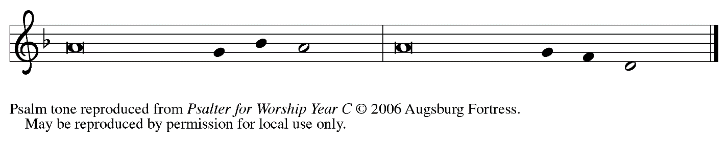

Psalm refrain

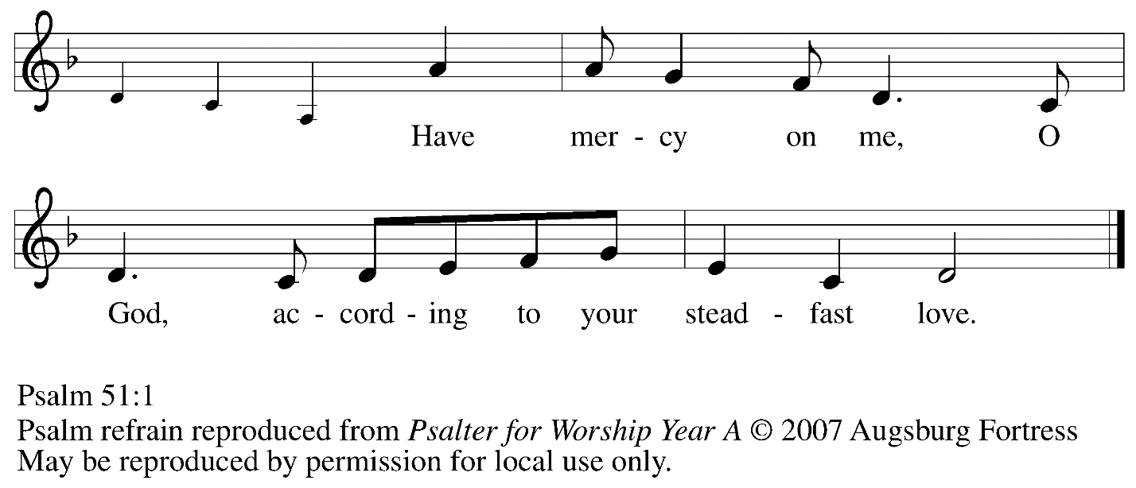

¹Have mercy on me, O God, according to your | steadfast love;
in your great compassion blot out | my offenses.
²Wash me through and through | from my wickedness,
and cleanse me | from my sin.
³For I know | my offenses,
and my sin is ev- | er before me.
⁴Against you only have I sinned and done what is evil | in your sight;
so you are justified when you speak and right | in your judgment. R
⁵Indeed, I was born | steeped in wickedness,
a sinner from my | mother’s womb.
⁶Indeed, you delight in truth | deep within me,
and would have me know wisdom | deep within.
⁷Remove my sins with hyssop, and I | shall be clean;
wash me, and I shall be pur- | er than snow.
⁸Let me hear | joy and gladness;
that the body you have broken | may rejoice. R
⁹Hide your face | from my sins,
and blot out | all my wickedness.
¹⁰Create in me a clean | heart, O God,
and renew a right spir- | it within me.
¹¹Cast me not away | from your presence,
and take not your Holy Spir- | it from me.
¹²Restore to me the joy of | your salvation
and sustain me with your boun- | tiful Spirit. R
¹³Let me teach your ways | to offenders,
and sinners shall be re- | stored to you.
¹⁴Rescue me from bloodshed, O God of | my salvation,
and my tongue shall sing | of your righteousness.
¹⁵O Lord, o- | pen my lips,
and my mouth shall pro- | claim your praise.
¹⁶For you take no delight in sacrifice, or | I would give it.
You are not pleased | with burnt offering.
¹⁷The sacrifice of God is a | troubled spirit;
a troubled and broken heart, O God, you will | not despise. R

Prayer of the Day

P: The Lord be with you.
C: And also with you.

P: Let us pray.
Almighty and ever-living God, you hate nothing you have made,
and you forgive the sins of all who are penitent. Create in us new and honest hearts,
so that, truly repenting of our sins, we may receive from you, the God of all mercy,
full pardon and forgiveness through your Son, Jesus Christ, our Savior and Lord,
who lives and reigns with you and the Holy Spirit, one God, now and forever.
C: Amen.

Please be seated.

Word
God speaks to us in Scripture reading, preaching, and song

First Reading – Joel 2: 1-2, 12-17

¹Blow the trumpet in Zion;
sound the alarm on my holy mountain!
Let all the inhabitants of the land tremble,
for the day of the Lord is coming, it is near—
²a day of darkness and gloom,
a day of clouds and thick darkness!
Like blackness spread upon the mountains
a great and powerful army comes;
their like has never been from of old,
nor will be again after them
in ages to come.
¹²Yet even now, says the Lord,
return to me with all your heart,
with fasting, with weeping, and with mourning;
¹³rend your hearts and not your clothing.
Return to the Lord, your God,
for God is gracious and merciful,
slow to anger, and abounding in steadfast love,
and relents from punishing.
¹⁴Who knows whether God will not turn and relent,
and leave a blessing behind,
a grain offering and a drink offering
for the Lord, your God?
¹⁵Blow the trumpet in Zion;
sanctify a fast;
call a solemn assembly;
¹⁶gather the people.
Sanctify the congregation;
assemble the aged;
gather the children,
even infants at the breast.
Let the bridegroom leave his room,
and the bride her canopy.
¹⁷Between the vestibule and the altar
let the priests, the ministers of the Lord, weep.
Let them say, “Spare your people, O Lord,
and do not make your heritage a mockery,
a byword among the nations.
Why should it be said among the peoples,
‘Where is their God?’ ”
L: Word of God, word of life.
C: Thanks be to God.

Second Reading – 2 Corinthians 5: 20b – 6: 10

^{20b}We entreat you on behalf of Christ, be reconciled to God. ²¹For our sake God made him to be sin who knew no sin, so that in [Christ] we might become the righteousness of God.
^{6:1}As we work together with him, we urge you also not to accept the grace of God in vain. ²For God says,
“At an acceptable time I have listened to you,
and on a day of salvation I have helped you.”
See, now is the acceptable time; see, now is the day of salvation! ³We are putting no obstacle in anyone’s way, so that no fault may be found with our ministry, ⁴but as servants of God we have commended ourselves in every way: through great endurance, in afflictions, hardships, calamities, ⁵beatings, imprisonments, riots, labors, sleepless nights, hunger; ⁶by purity, knowledge, patience, kindness, holiness of spirit, genuine love, ⁷truthful speech, and the power of God; with the weapons of righteousness for the right hand and for the left; ⁸in honor and dishonor, in ill repute and good repute. We are treated as impostors, and yet are true; ⁹as unknown, and yet are well known; as dying, and see—we are alive; as punished, and yet not killed; ¹⁰as sorrowful, yet always rejoicing; as poor, yet making many rich; as having nothing, and yet possessing everything.

L: Word of God, word of life.
C: Thanks be to God.

Please rise as you are able.

Gospel Acclamation

Cantor: Return to the | Lord, your God,
who is gracious and merciful, slow to anger, and abounding in | steadfast love.

Gospel – Matthew 6: 1-6, 16-21

P: The holy Gospel according to St. Matthew.
C: Glory to you, O Lord.
[Jesus said to the disciples:] ¹“Beware of practicing your piety before others in order to be seen by them; for then you have no reward from your Father in heaven.
²“So whenever you give alms, do not sound a trumpet before you, as the hypocrites do in the synagogues and in the streets, so that they may be praised by others. Truly I tell you, they have received their reward. ³But when you give alms, do not let your left hand know what your right hand is doing, ⁴so that your alms may be done in secret; and your Father who sees in secret will reward you.
⁵“And whenever you pray, do not be like the hypocrites; for they love to stand and pray in the synagogues and at the street corners, so that they may be seen by others. Truly I tell you, they have received their reward. ⁶But whenever you pray, go into your room and shut the door and pray to your Father who is in secret; and your Father who sees in secret will reward you.
¹⁶“And whenever you fast, do not look dismal, like the hypocrites, for they disfigure their faces so as to show others that they are fasting. Truly I tell you, they have received their reward.
¹⁷But when you fast, put oil on your head and wash your face, ¹⁸so that your fasting may be seen not by others but by your Father who is in secret; and your Father who sees in secret will reward you.
¹⁹“Do not store up for yourselves treasures on earth, where moth and rust consume and where thieves break in and steal; ²⁰but store up for yourselves treasures in heaven, where neither moth nor rust consumes and where thieves do not break in and steal. ²¹For where your treasure is, there your heart will be also.”

P: The Gospel of the Lord.
C: Praise to you, O Christ.

Please be seated.

Sermon

A time of silence for prayer and reflection follows the sermon.
When the Hymn of the Day begins, please rise as you are able.

Hymn of the Day All Things of Dust to Dust Return ACS 920

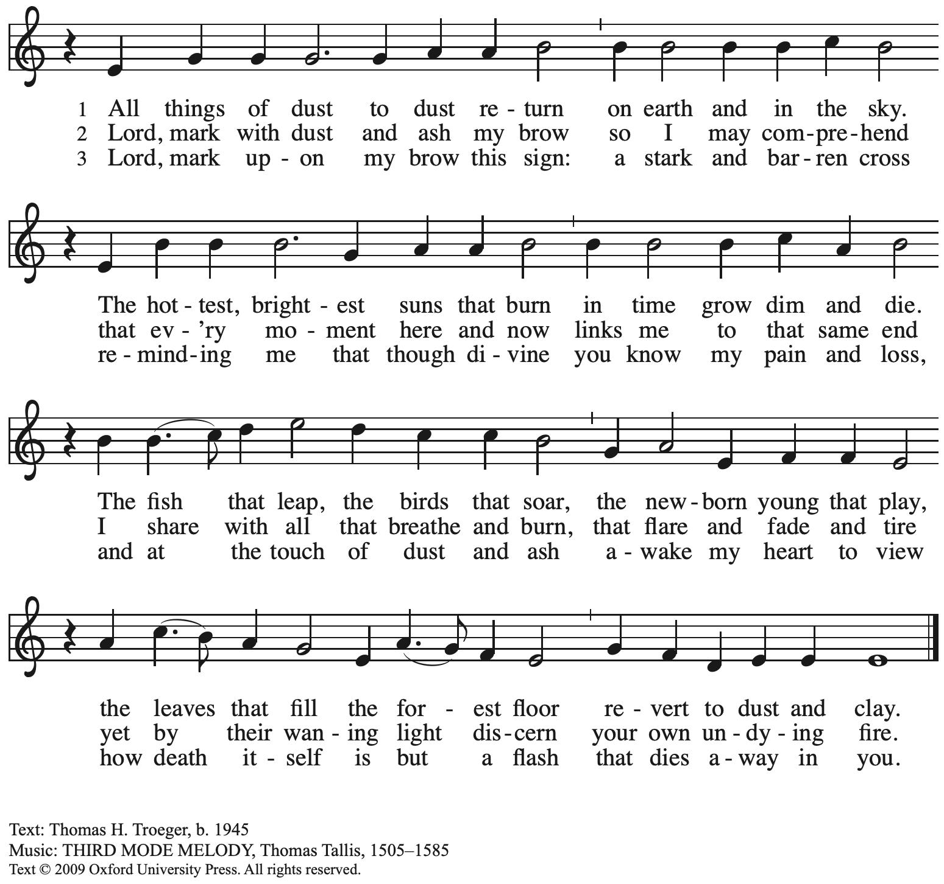
Reprinted with permission under OneLicense.net # A-722139.

Invitation to Lent

P: Friends in Christ, today with the whole church we enter the time of remembering Jesus’ passover from death to life, and our life in Christ is renewed.

We begin this holy season by acknowledging our need for repentance and for God’s mercy.
We are created to experience joy in communion with God, to love one another,
and to live in harmony with creation. But our sinful rebellion separates us from God,
our neighbors, and creation, so that we do not enjoy the life our creator intended.

As disciples of Jesus, we are called to a discipline that contends against evil
and resists whatever leads us away from love of God and neighbor.
I invite you, therefore, to the discipline of Lent—
self-examination and repentance, prayer and fasting, sacrificial giving and works of love—strengthened by the gifts of word and sacrament.
Let us continue our journey through these forty days
to the great Three Days of Jesus’ death and resurrection.

Confession of Sin

The presiding minister leads the following confession.

P: Let us confess our sin in the presence of God and of one another.

The assembly kneels or sits. Silence is kept for reflection and self-examination.

P: Most holy and merciful God,
C: we confess to you and to one another,
and before the whole company of heaven,
that we have sinned by our fault,
by our own fault,
by our own most grievous fault,
in thought, word, and deed,
by what we have done and by what we have left undone.

P: We have not loved you with our whole heart, and mind, and strength.
We have not loved our neighbors as ourselves.
We have not forgiven others as we have been forgiven.
C: Have mercy on us, O God.

P: We have neglected your call to serve as Christ served us.
We have not been true to the mind of Christ.
We have grieved your Holy Spirit.
C: Have mercy on us, O God.

P: Our past unfaithfulness, the pride, envy, hypocrisy, and apathy that have infected our lives,
we confess to you.
C: Have mercy on us, O God.

P: Our self-indulgent appetites and ways, and our exploitation of other people,
we confess to you.
C: Have mercy on us, O God.

P: Our negligence in prayer and worship, and our failure to share the faith that is in us,
we confess to you.
C: Have mercy on us, O God.

P: Our neglect of human need and suffering, and our indifference to injustice and cruelty,
we confess to you.
C: Have mercy on us, O God.

P: Our false judgments, our uncharitable thoughts toward our neighbors,
and our prejudice and contempt toward those who differ from us,
we confess to you.
C: Have mercy on us, O God.

P: Our waste and pollution of your creation, and our lack of concern for those who come after us, we confess to you.
C: Have mercy on us, O God.

P: Restore us, O God, and let your anger depart from us.
C: Hear us, O God, for your mercy is great.

Imposition of Ashes

P: Let us pray.
Almighty God, you have created us out of the dust of the earth.
May these ashes be a sign of our mortality and penitence,
reminding us that only by the cross of our Lord Jesus Christ are we given eternal life;
through the same Jesus Christ, our Savior and Lord.
C: Amen.

People may come forward and kneel or stand to receive the ashes.
Ministers mark the forehead of each person with a cross of ashes, saying:
Remember that you are dust, and to dust you shall return.

During the Imposition of Ashes, the assembly is invited to sing the penitential hymns.

Hymns during Imposition of Ashes

Savior, When in Dust to You ELW 601
Lord Jesus, Think on Me ELW 599

Hymn during Imposition of Ashes
Savior, When in Dust to You ELW 601

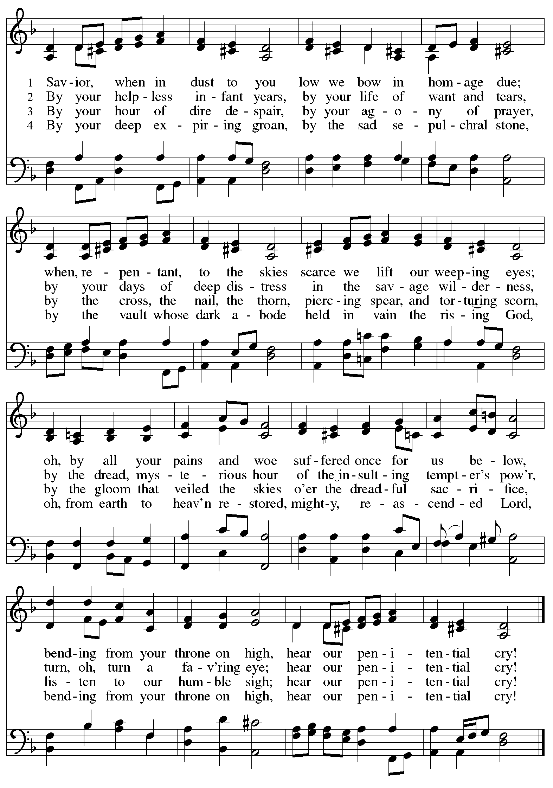
Hymn during Imposition of Ashes
Lord Jesus, Think on Me ELW 599

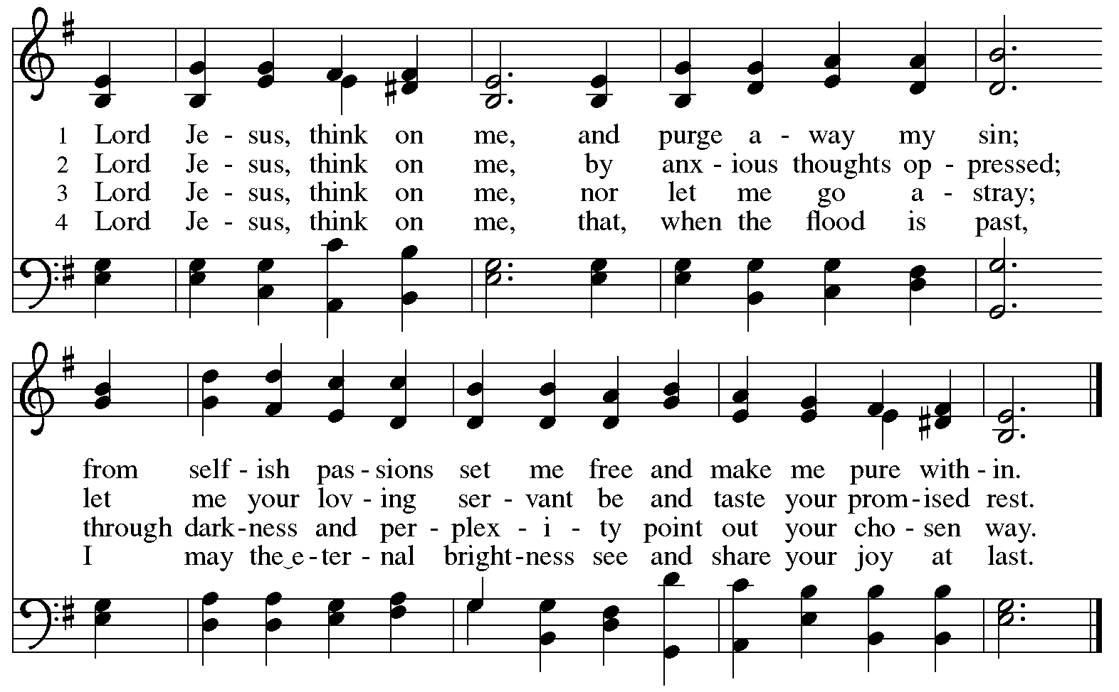

After those who desire ashes have received them, all may kneel or sit, and the minister continues.
P: Accomplish in us, O God, the work of your salvation,
C: that we may show forth your glory in the world.

P: By the cross and passion of your Son, our Savior,
C: bring us with all your saints to the joy of his resurrection.

The presiding minister addresses the assembly.
P: Almighty God have mercy on us, forgive us all our sins through our Lord Jesus Christ, strengthen us in all goodness, and by the power of the Holy Spirit keep us in eternal life.
C: Amen.

The service continues with the Prayers of the People.
Please rise as you are able.

Prayers of the People

A: Sustained by God’s abundant mercy, let us pray for the church, the world,
and all who are in need.

After each petition
A: Merciful God,
C: receive our prayer.

The presiding minister concludes the prayers:
P: We lift our prayers to you, O God, trusting in your steadfast love
and your promise to renew all creation; through Jesus Christ, our Savior and Lord.
C: Amen.

Please be seated.

Meal
God feeds us with the presence of Jesus Christ

Offering

We offer ourselves, our gifts, and our faithful service to God.
As the offering is gathered for the mission of the church, including the care of those in need,
the table is set for Holy Communion.

Music during the Offering

As the gifts are brought forward for presentation, please rise as you are able.

Offertory Prayer

A: Let us pray.
God our provider,
C: you have not fed us with bread alone but with words of grace and life.
Bless us, and these your gifts, which we receive from your bounty,
through Jesus Christ our Lord.
Amen.

Dialogue

P: The Lord be with you.
C: And also with you.

P: Lift up your hearts.
C: We lift them to the Lord.

P: Let us give thanks to the Lord our God.
C: It is right to give our thanks and praise.

Preface (Spoken by the presiding minister)

P: It is indeed right, our duty and our joy,
that we should at all times and in all places
give thanks and praise to you, almighty and merciful God,
through our Savior Jesus Christ.
You call your people to cleanse their hearts
and prepare with joy for the paschal feast,
that, renewed in the gift of baptism,
we may come to the fullness of your grace.
And so, with all the choirs of angels,
with the church on earth and the hosts of heaven,
we praise your name and join their unending hymn:

Sanctus (Spoken by the congregation)

C: Holy, holy, holy Lord,
God of power and might,
heaven and earth are full of your glory.
Hosanna in the highest.
Blessed is the one who comes in the name of the Lord.
Hosanna in the highest.

Eucharistic Prayer

P: Blessed are you, O God of the universe,
Your mercy is everlasting
and your faithfulness endures from age to age.

Praise to you for creating the heavens and the earth.
Praise to you for saving the earth from the waters of the flood.
Praise to you for bringing the Israelites safely through the sea.
Praise to you for leading your people through the wilderness
to the land of milk and honey.
Praise to you for the words and deeds of Jesus, your anointed one.
Praise to you for the death and resurrection of Christ.
Praise to you for your Spirit poured out on all nations.

P: In the night in which he was betrayed,
our Lord Jesus took bread, and gave thanks;
broke it, and gave it to his disciples, saying:
Take and eat; this is my body, given for you.
Do this for the remembrance of me.

Again, after supper, he took the cup, gave thanks,
and gave it for all to drink, saying:
This cup is the new covenant in my blood,
shed for you and for all people for the forgiveness of sin.
Do this for the remembrance of me.

With this bread and cup
we remember our Lord’s passover from death to life
as we proclaim the mystery of faith:
C: Christ has died.
Christ is risen.
Christ will come again.

P: O God of resurrection and new life:
Pour out your Holy Spirit on us
and on these gifts of bread and wine.
Bless this feast.
Grace our table with your presence.
C: Come, Holy Spirit.

P: Reveal yourself to us in the breaking of the bread.
Raise us up as the body of Christ for the world.
Breathe new life into us.
Send us forth,
burning with justice, peace, and love.
C: Come, Holy Spirit.

P: With your holy ones of all times and places,
with the earth and all its creatures,
with sun and moon and stars,
we praise you, O God,
blessed and holy Trinity,
now and forever.
C: Amen.

Lord’s Prayer

P: Gathered as one by the Holy Spirit, let us pray as Jesus taught us.
C: Our Father in heaven,
hallowed be your name,
your kingdom come,
your will be done,
on earth as in heaven.
Give us today our daily bread.
Forgive us our sins
as we forgive those who sin against us.
Save us from the time of trial
and deliver us from evil.
For the kingdom, the power,
and the glory are yours,
now and forever. Amen.

Fraction and Invitation

P: Come to the table of mercy;
receive God’s gifts of grace.

Agnus Dei/Lamb of God (Spoken by the congregation)

C: Lamb of God, you take away the sin of the world. Have mercy on us.
Lamb of God, you take away the sin of the world. Have mercy on us.
Lamb of God, you take away the sin of the world. Grant us peace.

Please be seated.

Holy Communion
- All who seek God and desire a deeper and stronger life in Christ are welcome to receive Holy Communion.
- Worshipers from the pulpit side will proceed forward first, followed by the center section, and then the lectern side.
- Please inform an usher if you would like the ministers to bring Communion to you.
- Holy Communion will be served with bread and wine/grape juice.
- The presiding minister will first distribute the bread (host) to each communicant. Please indicate if you require a gluten-free host.
- Once you have consumed the bread, please pick up an empty glass from the tray next to the presiding minister. The Communion Assistant will pour wine from the chalice or grape juice from the cruet into your glass.
- Please step to the side to consume the wine or grape juice.
- As you return to your pew, glasses may be returned to the empty trays on either side of the center aisle.
- A blessing will be provided for anyone who does not yet receive the sacrament.
- All are invited to join in singing the hymns during Holy Communion.

Hymn during Holy Communion
Just As I Am, without One Plea ELW 592

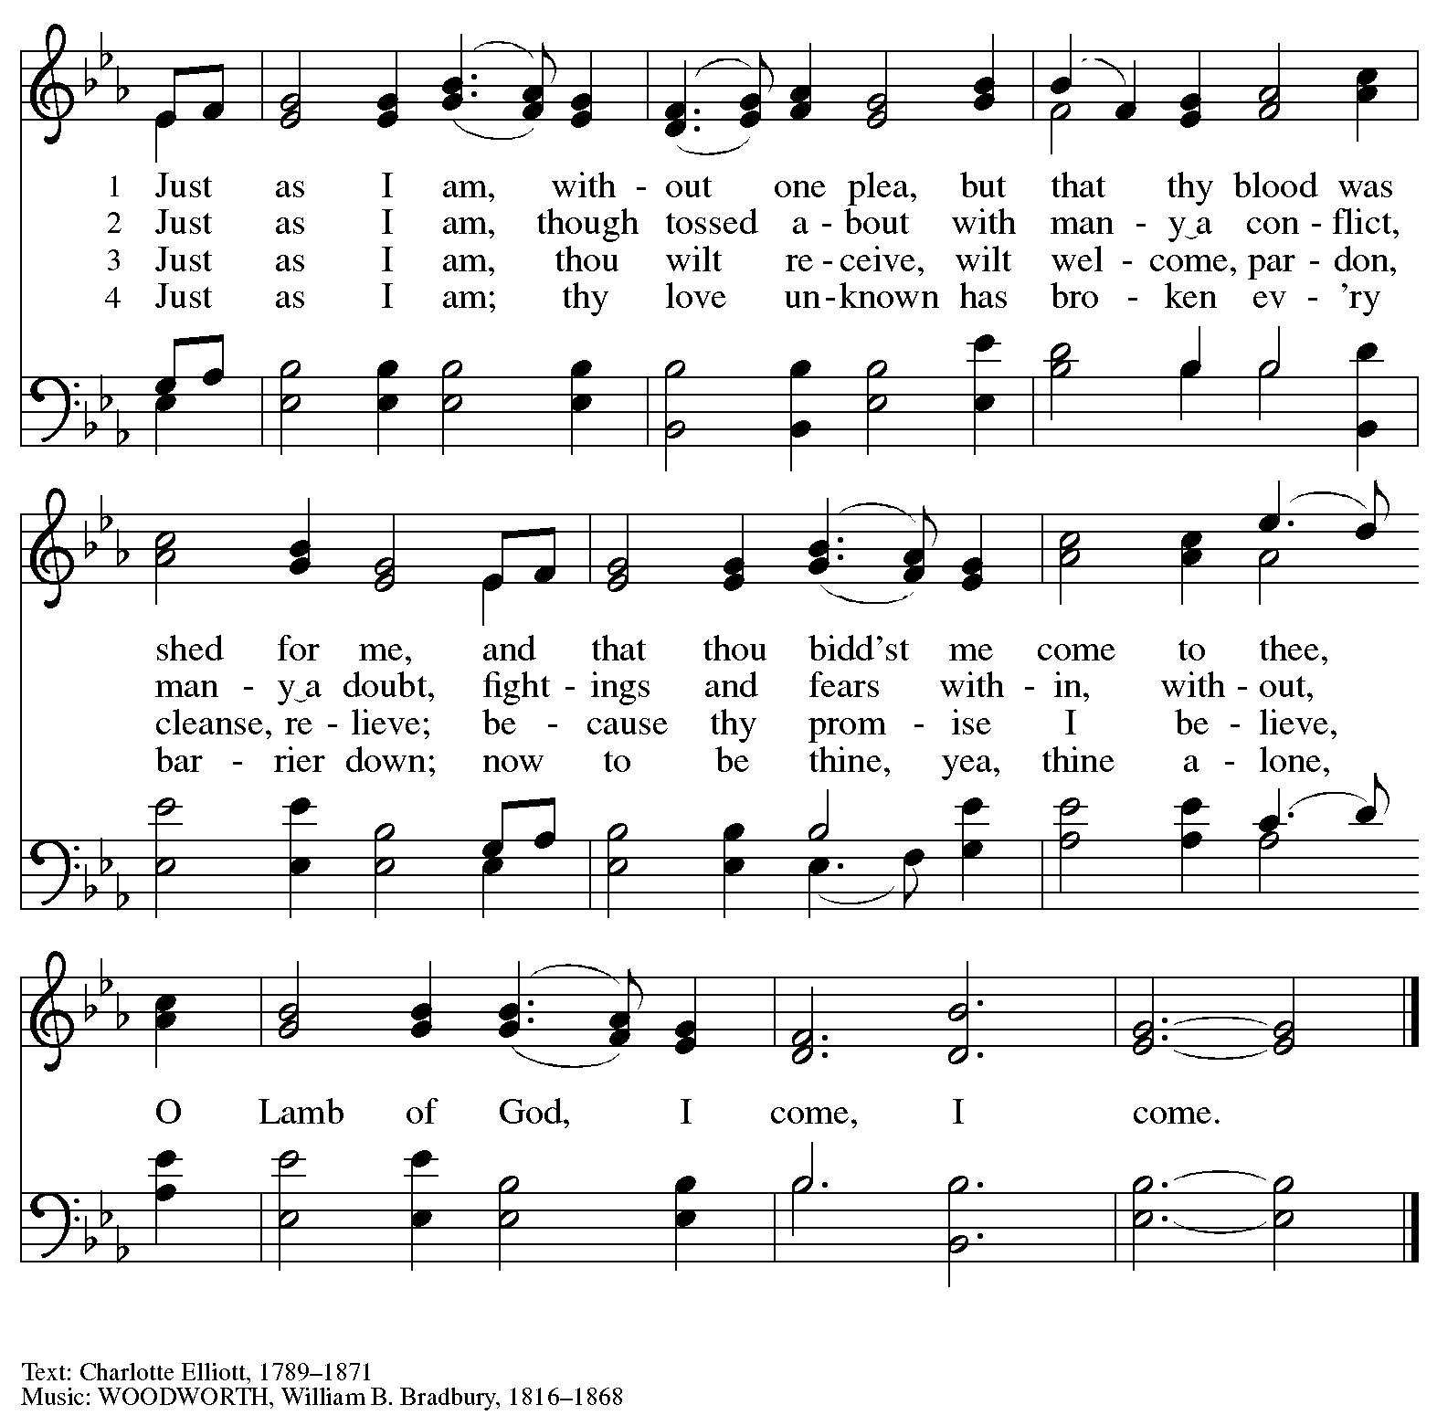

Hymn during Holy Communion
Softly and Tenderly Jesus Is Calling ELW 608

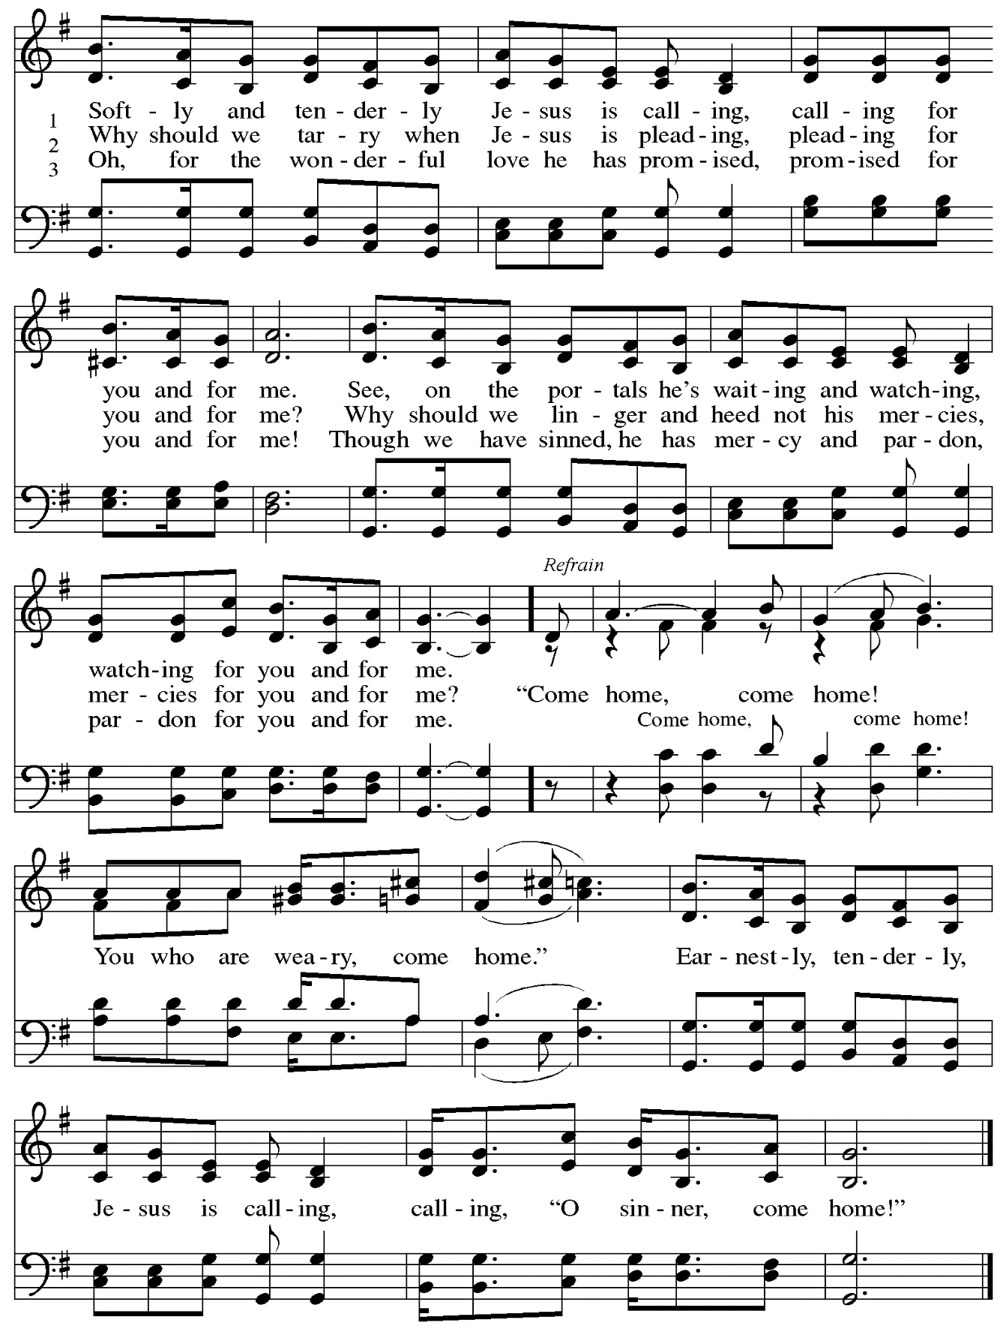
Hymn during Holy Communion
Christ, the Life of All the Living ELW 339

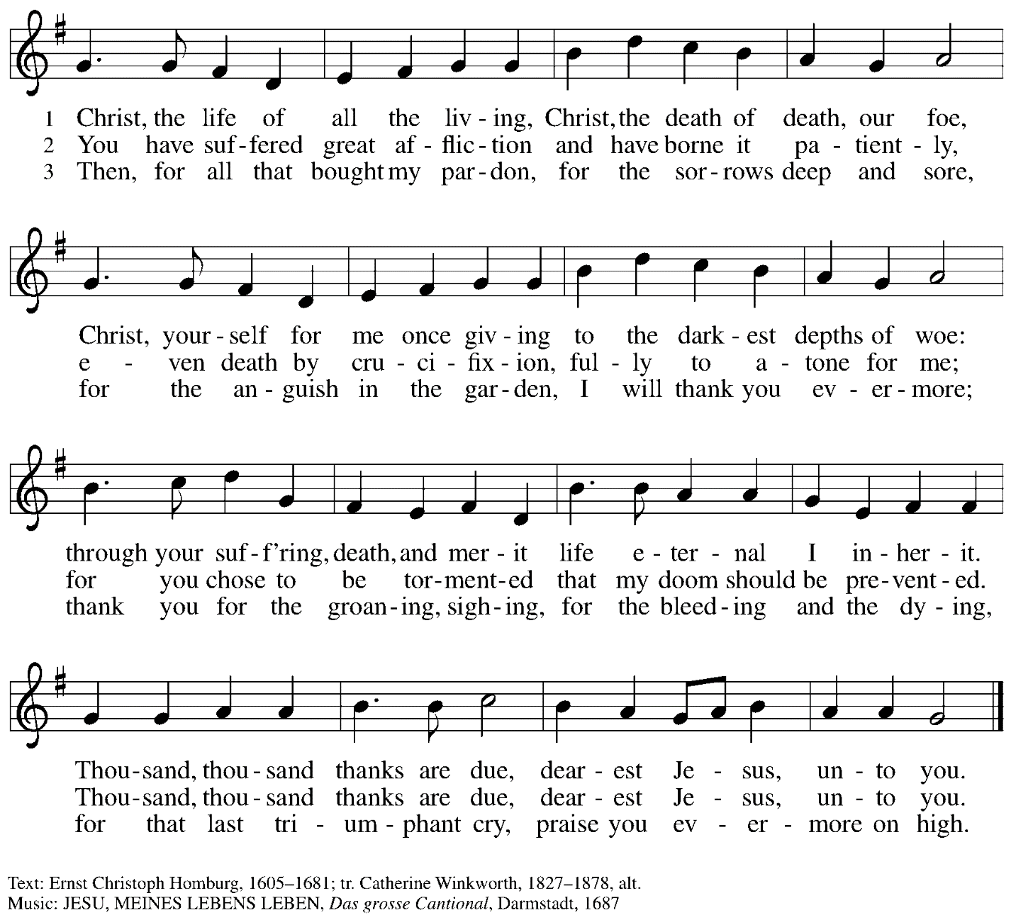

When all have returned to their places, please rise as you are able.

Blessing

P: The body and blood of our Lord Jesus Christ strengthen you and keep you in his grace.
C: Amen.

Prayer

A: Let us pray.

A brief silence is kept.

A: Merciful God, accompany our journey through these forty days.
Renew us in the gift of Baptism, that we may provide for those who are poor,
pray for those in need, fast from self-indulgence,
and above all that we may find our treasure in the life of your Son,
Jesus Christ, our Savior and Lord,
who lives and reigns with you and the Holy Spirit,
one God, now and forever.
C: Amen.

Sending
God blesses us and sends us in mission to the world.

Benediction

P: Almighty God, Father, ☩ Son, and Holy Spirit, bless you now and forever.
C: Amen.

Dismissal

A: Go forth into the world to serve God with gladness;
be of good courage;
hold fast to that which is good;
render to no one evil for evil;
strengthen the fainthearted; support the weak;
help the afflicted; honor all people;
love and serve God, rejoicing in the power of the Holy Spirit.
C: Thanks be to God.

Abbreviations
P: Pastor/Presiding Minister
A: Assisting Minister
L: Lector
C: Congregation

ELW: Evangelical Lutheran Worship hymnal
TFF: This Far by Faith hymnal
ACS: All Creation Sings hymnal

Those serving in worship today

Assisting Minister Jeff Denlinger
Organ Jimmi Kocher-Hillmer
Audio-Visual Ministers Colten Rohleder
David Rollinson
Cantor Joseph Paetz
Lector Pastor Deb Byrum
Presiding Minister The Rev. Ross I. Carmichael

Liturgy and Hymnody Acknowledgements

From SundaysandSeasons.com. Copyright © 2023 Augsburg Fortress. All rights reserved. Reprinted under OneLicense.net # A-722139.
Used by permission of Augsburg Fortress.

Savior, When in Dust to You – Text: Robert Grant, 1779-1838, alt. Music: ABERYSTWYTH, Joseph Parry, 1841-1903.

Softly and Tenderly Jesus Is Calling – Text: Will L. Thompson, 1847-1909. Music: THOMPSON, Will L. Thompson.

St. Andrew Lutheran Church Announcements
February 22^{ns}, 2023

- Welcome to Worship at St. Andrew on + Ash Wednesday, February 22nd, 2023 – The season of Lent begins today. We thank Jimmi Kocher-Hillmer for leading the music on organ this evening. Masks are optional at St. Andrew when Allegheny County’s Covid-19 community level is in the low and medium categories. Worship attendees are invited to make a name tag at the back of the worship space if you would like.
- St. Andrew Gathers for Worship with Holy Communion on Sundays at 10:00 a.m.
- Water and Spirit: Devotions for Lent 2023 Available at Church Entrances – The season of Lent begins today with Ash Wednesday. In this time the Church invites us into the Lenten disciplines of fasting (giving something up for Lent), almsgiving (generosity and charitable giving), and prayer. A new resource is available to support the St. Andrew congregation in the discipline of prayer this season. Water and the Spirit: Devotions for Lent 2023 offers simple daily readings, reflections, and prayers from Ash Wednesday through Holy Week. These are available at each entrance to the church - please pick one up to aid in your observation of Lent this year.

