+ Fifth Sunday after Epiphany
February 5, 2023

St. Andrew Lutheran Church
304 Morewood Ave.
Pittsburgh, PA 15213
St_andrewELCA@verizon.net
www.standrewpittsburgh.org

+ Fifth Sunday after Epiphany
Order for Worship

Light shines in the darkness for the upright, the psalmist sings. Isaiah declares that when we loose the bonds of injustice and share our bread with the hungry, the light breaks forth like the dawn. In another passage from the Sermon on the Mount, Jesus, the light of the world, calls his followers to let the light of their good works shine before others. Through Baptism we are sent into the world to shine with the light of Christ.

- Masks are optional at St. Andrew when Covid-19 community level in Allegheny County is in the low and medium categories.
- Worship Services are live streamed to multiple online platforms. By attending worship, you agree that your image and voice may be broadcast.

The festival of Epiphany and the season that follows emphasize God’s ongoing revelation of Jesus Christ to people of all nations. In this spirit, St. Andrew’s worship music throughout the season will feature hymns and songs that reflect the rich variety of contributions that people of various lands, cultures, and languages have made to the hymnody of the global Christian church. “In sharing one another’s music, we share more than music. Music of various cultures brings us a glimpse of one another’s experience of God. As any culture connects its experience of the holy to its music, a unique context for God’s presence is created – we experience together the way God weaves a varied, diverse tapestry of revelation among us. The church’s song is a great place to experience that sharing.”
Evangelical Lutheran Worship: Musician’s Guide, Augsburg Fortress, 2007. p. 63

Welcome to St. Andrew!
- St. Andrew Lutheran Congregation welcomes all who are seeking a place of healing and wholeness, a nurturing, faith-forming spiritual home. Our community embraces people of all ages, ethnicities, cultures, abilities, sexual orientations, gender identities and expressions, and family constellations. Come and See!
- Everyone is invited to make a nametag at the black bookcase in the back of the worship space if they would like.
- Worship “toolkits” to help children engage with the service are available in the black bookcase at the back of the worship space. There are “reader” and “pre-reader” resources available in each kit. Please feel free to use the kits for/with your children during worship.
- St. Andrew has returned to serving the sacrament of Holy Communion with both (separate) elements, bread and wine/grape juice. The presiding minister will first distribute the bread (host). Please consume this and then pick up an empty glass from the tray next to the presiding minister. The Communion Assistant will pour wine from the chalice or grape juice from the cruet into your glass. Please step to the side to consume the wine or grape juice. As you return to your pew, glasses may be returned to the empty trays on either side of the center aisle.
- A restroom is available on the main level of the church, through the doors to the Social Hall and to the right in the main office.

Welcome

Prelude

Gathering
The Holy Spirit calls us together as the people of God.

Please rise as you are able.

P: Blessed be the holy Trinity, ☩ one God,
the fountain of living water,
the rock who gave us birth,
our light and our salvation.
C: Amen.

The presiding minister addresses the assembly
P: Joined to Christ in the waters of Baptism,
we are clothed with God's mercy and forgiveness.
Let us give thanks for the gift of Baptism.

Water may be poured into the font as the presiding minister gives thanks.

P: We give you thanks, O God,
for in the beginning your Spirit moved over the waters
and by your Word you created the world,
calling forth life in which you took delight.

Through the waters of the flood you delivered Noah and his family.
Through the sea you led your people Israel from slavery into freedom.
At the river your Son was baptized by John and anointed with the Holy Spirit.
By water and your Word you claim us as your children,
making us heirs of your promise and servants of all.

We praise you for the gift of water that sustains life,
and above all we praise you for the gift of new life in Jesus Christ.
Shower us with your Spirit,
and renew our lives with your forgiveness, grace, and love.

To you be given honor and praise
through Jesus Christ our Lord
in the unity of the Holy Spirit, now and forever.
C: Amen.

Gathering Hymn Gather Us In ELW 532

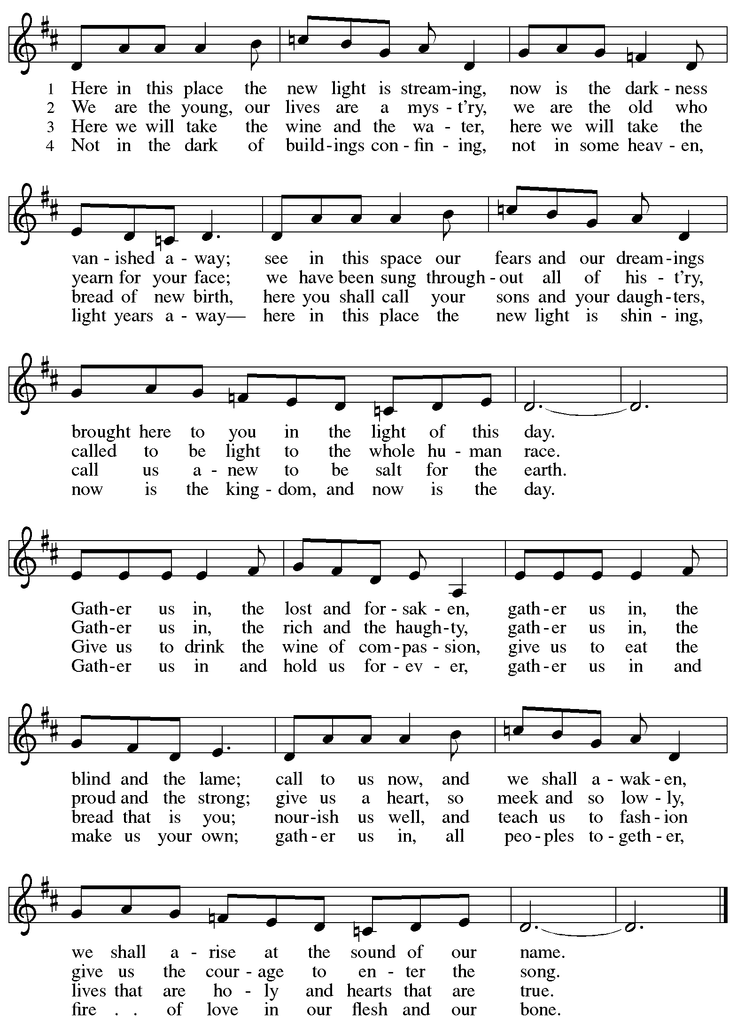

Greeting

P: The grace of our Lord Jesus Christ, the love of God,
and the communion of the Holy Spirit be with you all.
C: And also with you.

Hymn of Praise Glory to God, Glory in the Highest ELW 164

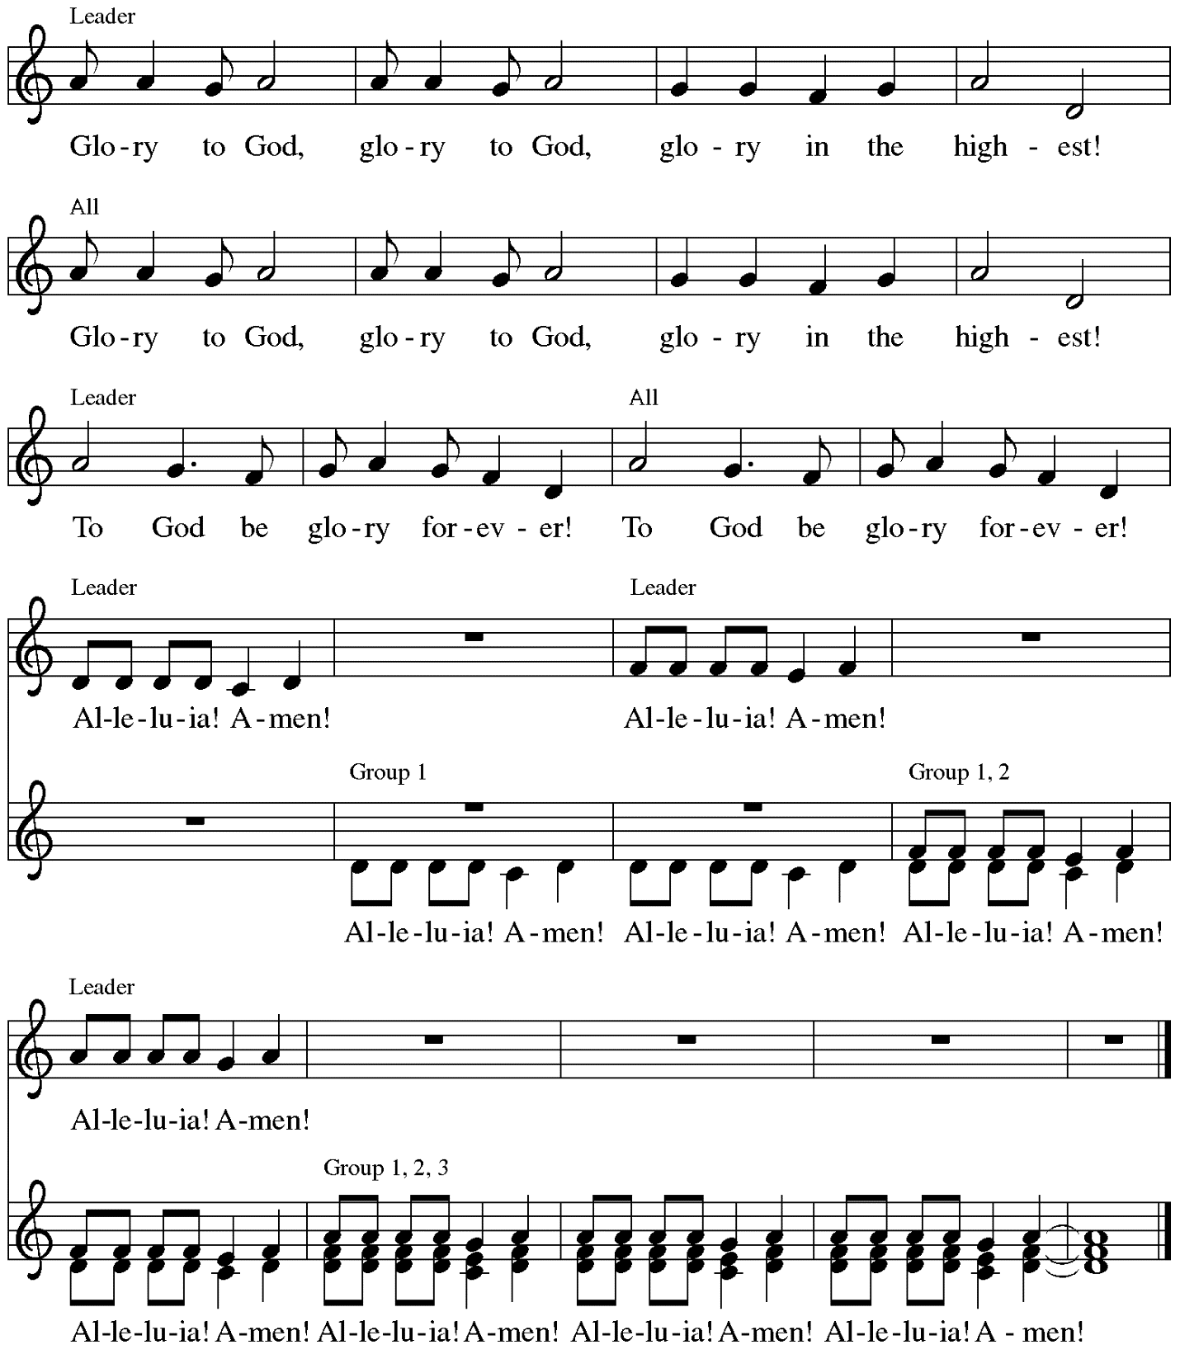

Music: Peruvian traditional

Prayer of the Day

P: The Lord be with you.
C: And also with you.

P: Let us pray.
Lord God, with endless mercy you receive the prayers of all who call upon you.
By your Spirit, show us the things we ought to do, and give us the grace and power to do them,
through Jesus Christ, our Savior and Lord.
C: Amen.

Please be seated.
Children are invited to join the adult leaders at the door and move to the office for Little Church; Big Faith. We ask that one additional adult from the congregation attend with the children.

Word
God speaks to us in Scripture reading, preaching, and song

First Reading – Isaiah 58: 1-12

¹Shout out, do not hold back!
Lift up your voice like a trumpet!
Announce to my people their rebellion,
to the house of Jacob their sins.
²Yet day after day they seek me
and delight to know my ways,
as if they were a nation that practiced righteousness
and did not forsake the ordinance of their God;
they ask of me righteous judgments,
they delight to draw near to God.
³“Why do we fast, but you do not see?
Why humble ourselves, but you do not notice?”
Look, you serve your own interest on your fast day,
and oppress all your workers.
⁴Look, you fast only to quarrel and to fight
and to strike with a wicked fist.
Such fasting as you do today
will not make your voice heard on high.
⁵Is such the fast that I choose,
a day to humble oneself?
Is it to bow down the head like a bulrush,
and to lie in sackcloth and ashes?
Will you call this a fast,
a day acceptable to the Lord?

⁶Is not this the fast that I choose:
to loose the bonds of injustice,
to undo the thongs of the yoke,
to let the oppressed go free,
and to break every yoke?
⁷Is it not to share your bread with the hungry,
and bring the homeless poor into your house;
when you see the naked, to cover them,
and not to hide yourself from your own kin?
⁸Then your light shall break forth like the dawn,
and your healing shall spring up quickly;
your vindicator shall go before you,
the glory of the Lord shall be your rear guard.
^{9a}Then you shall call, and the Lord will answer;
you shall cry for help, and the Lord will say, Here I am.
^{9b}If you remove the yoke from among you,
the pointing of the finger, the speaking of evil,
¹⁰if you offer your food to the hungry
and satisfy the needs of the afflicted,
then your light shall rise in the darkness
and your gloom be like the noonday.
¹¹The Lord will guide you continually,
and satisfy your needs in parched places,
and make your bones strong;
and you shall be like a watered garden,
like a spring of water,
whose waters never fail.
¹²Your ancient ruins shall be rebuilt;
you shall raise up the foundations of many generations;
you shall be called the repairer of the breach,
the restorer of streets to live in.
L: Word of God, word of life.
C: Thanks be to God.

Psalm 112: 1-9 Following page

The cantor will lead the singing of the psalm.
The congregation is invited to respond with the alternate verses in bold print,
and to join in singing the refrain.

Psalm tone

Psalm refrain

¹Hallelujah! Happy are they who | fear the Lord
and have great delight in | God’s commandments!
²Their descendants will be mighty | in the land;
the generation of the upright | will be blessed.
³Wealth and riches will be | in their house,
and their righteousness will | last forever.
⁴Light shines in the darkness | for the upright;
the righteous are merciful and full | of compassion. R
⁵It is good for them to be gener- | ous in lending
and to manage their af- | fairs with justice.
⁶For they will nev- | er be shaken;
the righteous will be kept in everlast- | ing remembrance.
⁷They will not be afraid of any | evil rumors;
their heart is steadfast, trusting | in the Lord.
⁸Their heart is established and | will not shrink,
until they see their desire up- | on their enemies.
⁹They have given freely to the poor, and their righteousness stands | fast forever;
they will hold up their | head with honor. R

Second Reading – 1 Corinthians 2: 1-12

¹When I came to you, kindred, I did not come proclaiming the mystery of God to you in lofty words or wisdom. ²For I decided to know nothing among you except Jesus Christ, and him crucified. ³And I came to you in weakness and in fear and in much trembling. ⁴My speech and my proclamation were not with plausible words of wisdom, but with a demonstration of the Spirit and of power, ⁵so that your faith might rest not on human wisdom but on the power of God.

⁶Yet among the mature we do speak wisdom, though it is not a wisdom of this age or of the rulers of this age, who are doomed to perish. ⁷But we speak God’s wisdom, secret and hidden,
which God decreed before the ages for our glory. ⁸None of the rulers of this age understood this;
for if they had, they would not have crucified the Lord of glory.
⁹But, as it is written,
“What no eye has seen, nor ear heard,
nor the human heart conceived,
what God has prepared for those who love God”—
¹⁰these things God has revealed to us through the Spirit; for the Spirit searches everything, even the depths of God. ¹¹For what human being knows what is truly human except the human spirit that is within? So also no one comprehends what is truly God’s except the Spirit of God.
¹²Now we have received not the spirit of the world, but the Spirit that is from God, so that we may understand the gifts bestowed on us by God.

L: Word of God, word of life.
C: Thanks be to God.

Please rise as you are able.

Gospel Acclamation Heleluyan / Hallelujah ELW 171

Heleluyan, heleluyan; hele, heleluyan.
Heleluyan, heleluyan; hele, heleluyan.

Hallelujah, hallelujah; halle, hallelujah.
Hallelujah, hallelujah; halle, hallelujah.

Music: Muscogee (Creek); transc. Charles H. Webb, b. 1933. Transcription © 1989 The United Methodist Publishing House, admin.
The Copyright Company. Reprinted with permission under OneLicense.net # A-722139.

Gospel – Matthew 5: 13-20

P: The holy Gospel according to St. Matthew.
C: Glory to you, O Lord.
[Jesus said:] ¹³“You are the salt of the earth; but if salt has lost its taste, how can its saltiness be restored? It is no longer good for anything, but is thrown out and trampled under foot.
¹⁴“You are the light of the world. A city built on a hill cannot be hid. ¹⁵No one after lighting a lamp puts it under the bushel basket, but on the lampstand, and it gives light to all in the house. ¹⁶In the same way, let your light shine before others, so that they may see your good works and give glory to your Father in heaven.
¹⁷“Do not think that I have come to abolish the law or the prophets; I have come not to abolish but to fulfill. ¹⁸For truly I tell you, until heaven and earth pass away, not one letter, not one stroke of a letter, will pass from the law until all is accomplished. ¹⁹Therefore, whoever breaks one of the least of these commandments, and teaches others to do the same, will be called least in

the kingdom of heaven; but whoever does them and teaches them will be called great in the kingdom of heaven. ²⁰For I tell you, unless your righteousness exceeds that of the scribes and Pharisees, you will never enter the kingdom of heaven.”

P: The Gospel of the Lord.
C: Praise to you, O Christ.

Please be seated.

Sermon

A time of silence for prayer and reflection follows the sermon.
When the Hymn of the Day begins, please rise as you are able.

Hymn of the Day Bring forth the Kingdom W&P 22
Following page

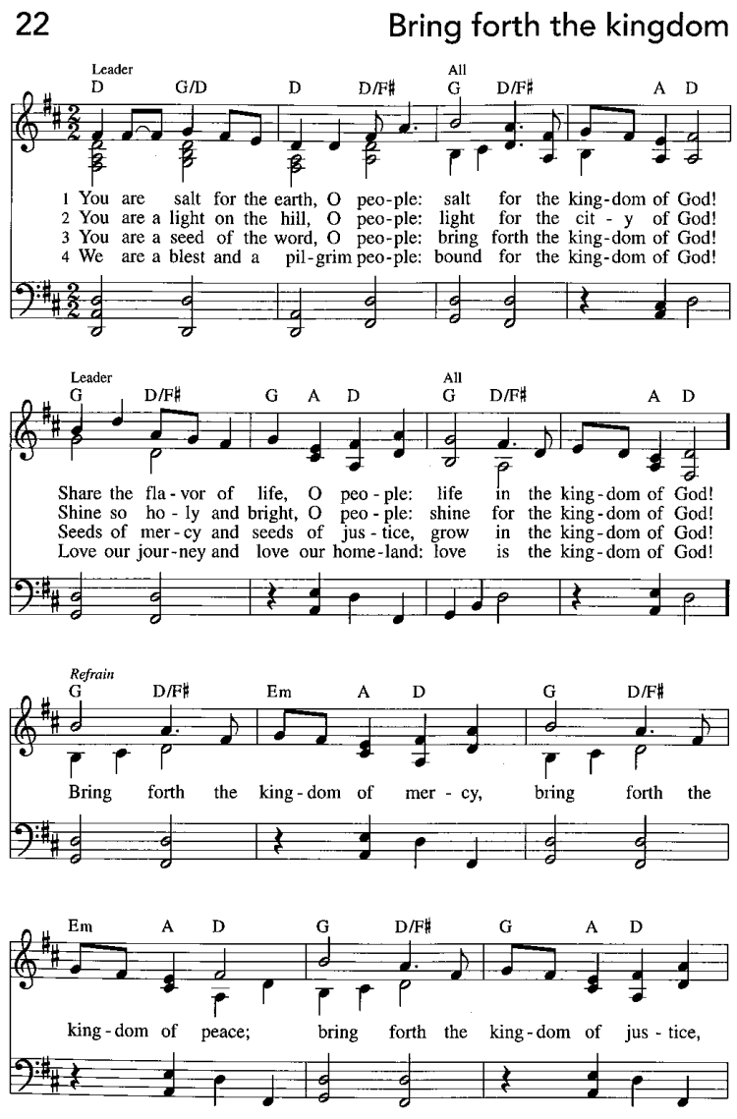
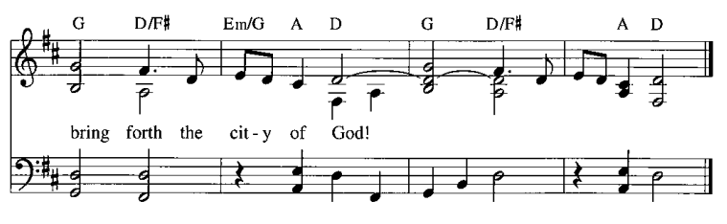

Apostles Creed

C: I believe in God, the Father almighty,
creator of heaven and earth.

I believe in Jesus Christ, God’s only Son, our Lord,
who was conceived by the Holy Spirit,
born of the virgin Mary,
suffered under Pontius Pilate,
was crucified, died, and was buried;
he descended to the dead.*
On the third day he rose again;
he ascended into heaven,
he is seated at the right hand of the Father,
and he will come to judge the living and the dead.

I believe in the Holy Spirit,
the holy catholic church,
the communion of saints,
the forgiveness of sins,
the resurrection of the body,
and the life everlasting. Amen.

*Or, “he descended into hell,” another translation of this text in widespread use.

Prayers of the People

A: Called together to follow Jesus, we pray for the church,
the world, and all who are in need.

After each petition
A: Merciful God,
C: receive our prayer.

The presiding minister concludes the prayers:
P: We bring these needs and hope to you, O God,
trusting in your wisdom, grace, and power
revealed in Jesus Christ, our Savior.
C: Amen.

Please be seated.

Meal

Offering

We offer ourselves, our gifts, and our faithful service to God.
As the offering is gathered for the mission of the church, including the care of those in need,
the table is set for Holy Communion.

On this first Sunday of the month, we invite the congregation to consider a donation to a second collection for a reparations fund that will be used to honor St. Andrew’s use of African American spiritual songs in our worship services. Please see the note in the announcements at the back of the bulletin for more information.

Music during the Offering

As the gifts are brought forward for presentation, please rise as you are able
and join in singing the Offertory Song.

Offertory Song ELW 523
Vamos todos al banquete / Let Us Go Now to the Banquet
v. 3

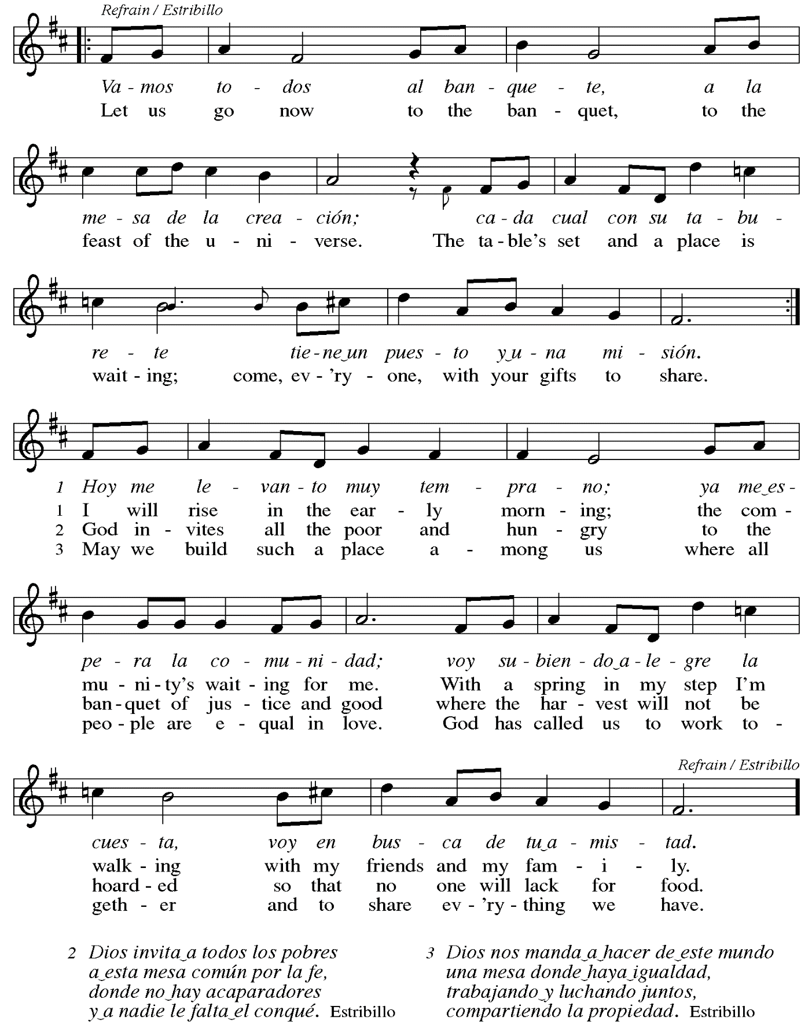

Offertory Prayer

A: Let us pray.
Liberating God,
C: you break the bonds of injustice
and set free those who are oppressed.
Receive these offerings in thanksgiving
for all your deeds of merciful power,
that they may serve in your work of justice and freedom.
You we magnify and adore, through Jesus our Savior.
Amen.

Dialogue

P: The Lord be with you.
C: And also with you.

P: Lift up your hearts.
C: We lift them to the Lord.

P: Let us give thanks to the Lord our God.
C: It is right to give our thanks and praise.

Preface (Spoken by the presiding minister)

P: It is indeed right, our duty and our joy,
that we should at all times and in all places
give thanks and praise to you, almighty and merciful God,
through our Savior Jesus Christ;
who on this day overcame death and the grave,
and by his glorious resurrection opened to us the way of everlasting life.
And so, with all the choirs of angels,
with the church on earth and the hosts of heaven,
we praise your name and join their unending hymn:

Sanctus Santo, Santo, Santo ELW 762
Refrain Only

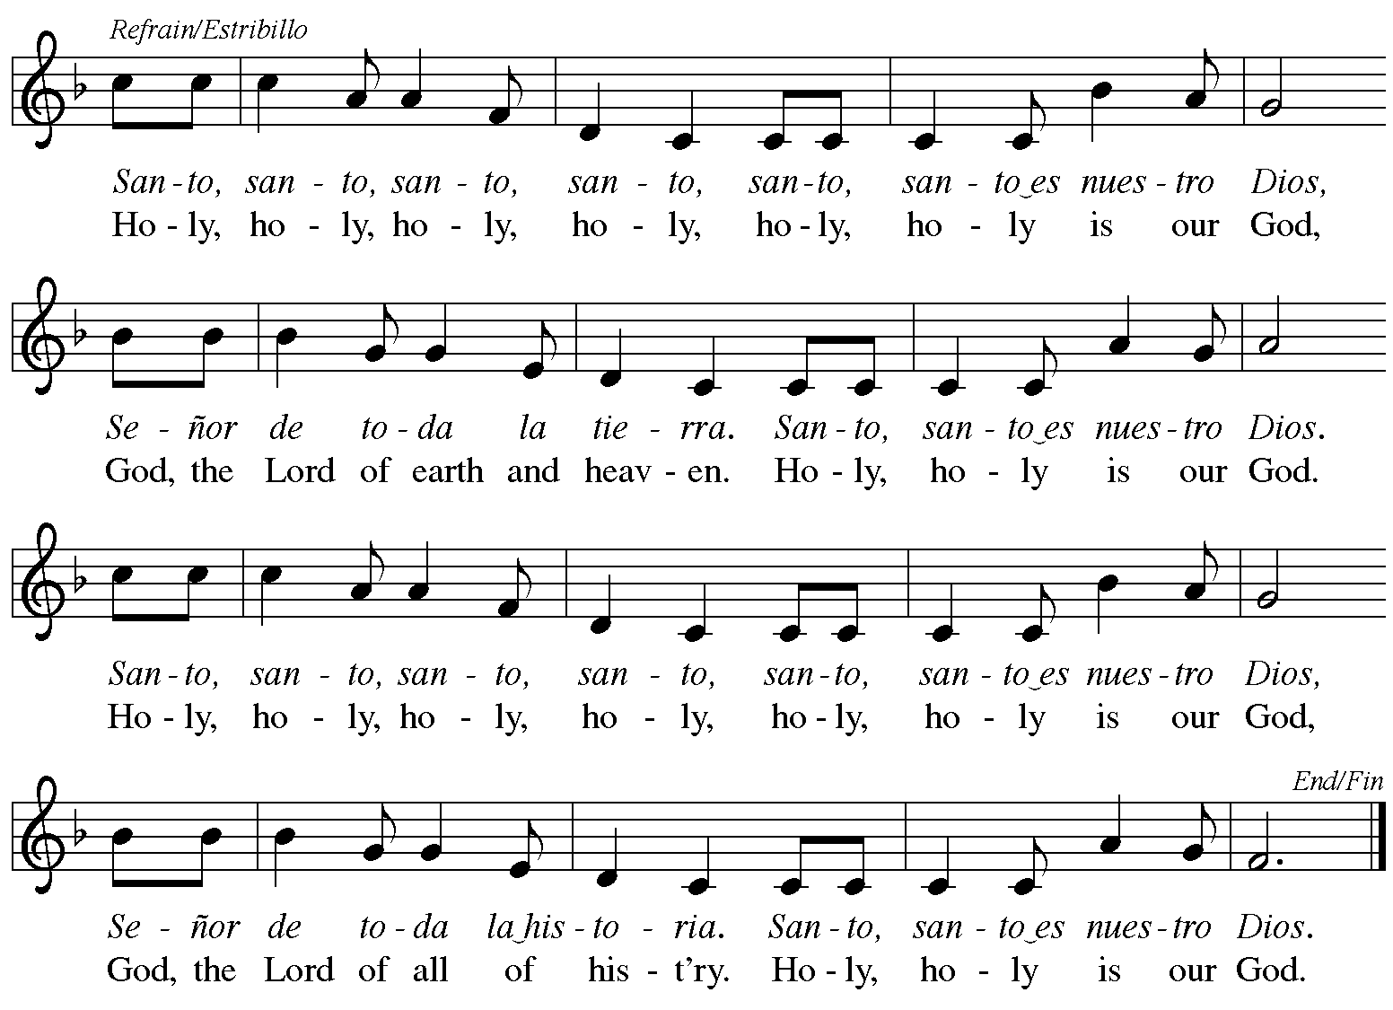
Reprinted with permission under OneLicense.net # A-722139.

Eucharistic Prayer

P: Blessed are you, O God,
creator of heaven and earth.
You rescued your covenant people,
led them on all their journeys,
and taught them by the prophets.
You so loved the world
that you gave your only Son,
so that everyone who believes in him
may not perish but may have eternal life.

In the night in which he was betrayed,
our Lord Jesus took bread,
and gave thanks; broke it,
and gave it to his disciples,
saying: Take and eat;
this is my body, given for you.
Do this for the remembrance of me.

Again, after supper,
he took the cup, gave thanks,
and gave it for all to drink,
saying: This cup
is the new covenant in my blood,
shed for you and for all people
for the forgiveness of sin.
Do this for the remembrance of me.

P: As often as we eat this bread
and drink this cup,
we proclaim the Lord’s death
until he comes.
C: Christ has died.
Christ is risen.
Christ will come again.

P: Pour out your Holy Spirit
in this meal and make us one,
in this community of faith
and with your people throughout the world.

Glory and praise to you, O God,
Author of Life,
Word made flesh,
Power of the Most High,
now and forever.
C: Amen.

Lord’s Prayer

P: Gathered as one by the Holy Spirit, let us pray as Jesus taught us.
C: Our Father in heaven,
hallowed be your name,
your kingdom come,
your will be done,
on earth as in heaven.
Give us today our daily bread.

Forgive us our sins
as we forgive those who sin against us.
Save us from the time of trial
and deliver us from evil.
For the kingdom, the power,
and the glory are yours,
now and forever. Amen.

Fraction and Invitation

P: These are the gifts of God for the people of God.
Come, share the feast.

Agnus Dei Lamb of God TFF 35

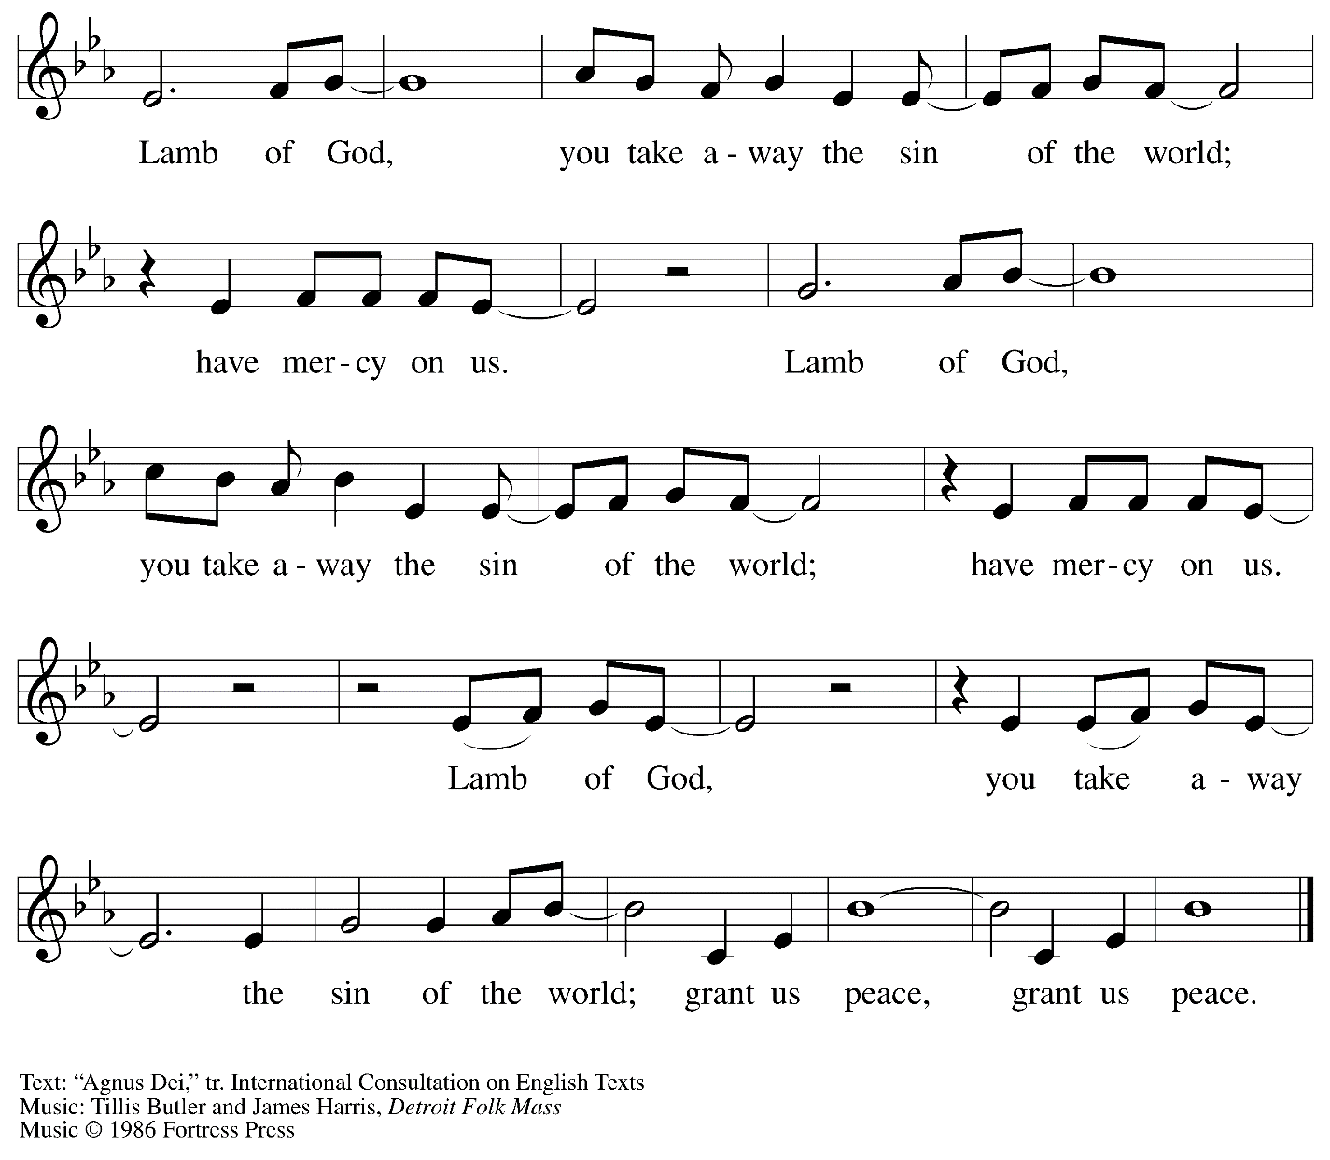
All rights reserved. Reprinted with permission under OneLicense.net # A-722139.

Please be seated.

Holy Communion
- All who seek God and desire a deeper and stronger life in Christ are welcome to receive Holy Communion.
- Worshipers from the pulpit side will proceed forward first, followed by the center section, and then the lectern side.
- Please inform an usher if you would like the ministers to bring Communion to you.
- Holy Communion will be served with bread and wine/grape juice.
- The presiding minister will first distribute the bread (host) to each communicant. Please indicate if you require a gluten-free host.
- Once you have consumed the bread, please pick up an empty glass from the tray next to the presiding minister. The Communion Assistant will pour wine from the chalice or grape juice from the cruet into your glass.
- Please step to the side to consume the wine or grape juice.
- As you return to your pew, glasses may be returned to the empty trays on either side of the center aisle.
- A blessing will be provided for anyone who does not yet receive the sacrament.
- All are invited to join in singing the hymns during Holy Communion.

Hymn during Holy Communion
Come Now, You Blessed ACS 1059

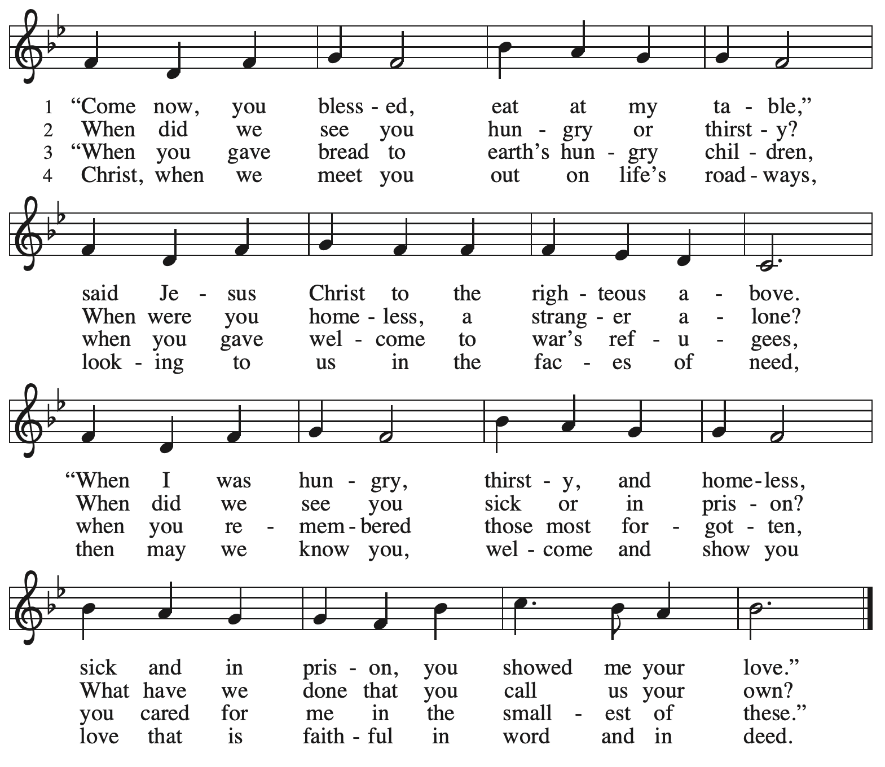

Hymn during Holy Communion
Come and Seek the Ways of Wisdom ACS 971

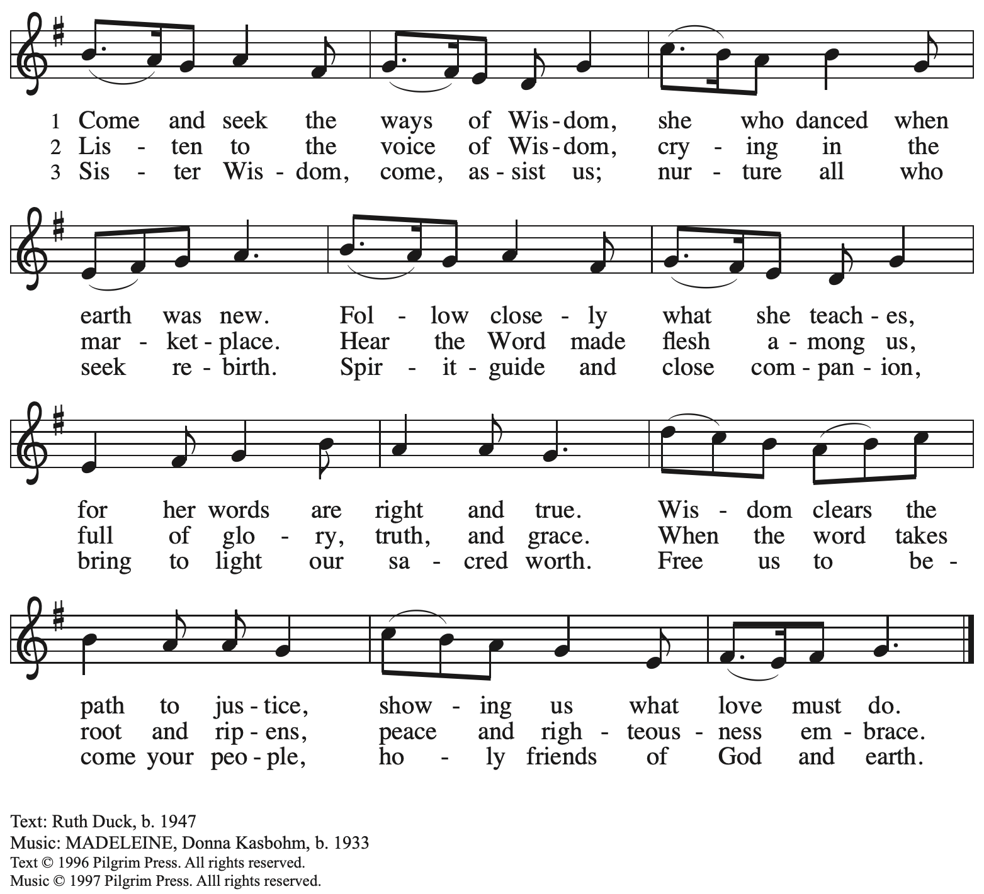
Reprinted with permission under OneLicense.net # A-722139.

Hymn during Holy Communion
How Clear Is Our Vocation, Lord ELW 580

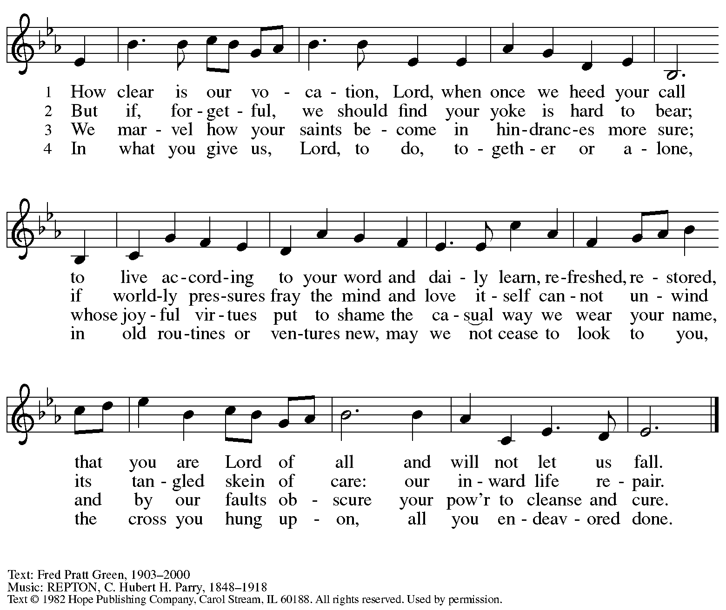
All rights reserved. Reprinted with permission under OneLicense.net # A-722139.

When all have returned to their places, please rise as you are able.

Blessing

P: The body and blood of our Lord Jesus Christ strengthen you and keep you in his grace.
C: Amen.

Prayer

A: Let us pray.
Holy One,
we thank you for the healing
that springs forth abundantly from this table.
Renew our commitment to do justice, love kindness,
and journey humbly with you,
through Jesus Christ, our Savior and Lord.
C: Amen.

Please be seated.

Sending

Announcements

Please rise as you are able.

Benediction

P: The Lord bless you and keep you.
The Lord’s face shine on you
with grace and mercy.
The Lord look upon you with favor
and ☩ give you peace.
C: Amen.

Sending Hymn This Little Light of Mine Following page

Dismissal

A: Go in peace. Serve the Lord.
C: Thanks be to God!

Sending Hymn This Little Light of Mine ELW 677

1 This little light of mine, I'm gonna let it shine;
this little light of mine, I'm gonna let it shine;
this little light of mine, I'm gonna let it shine,
let it shine, let it shine, let it shine.

2 Everywhere I go, I'm gonna let it shine;
everywhere I go, I'm gonna let it shine;
everywhere I go, I'm gonna let it shine,
let it shine, let it shine, let it shine.

3 Jesus gave it to me, I'm gonna let it shine;
Jesus gave it to me, I'm gonna let it shine;
Jesus gave it to me, I'm gonna let it shine,
let it shine, let it shine, let it shine.

Text: African American spiritual. Music: THIS JOY, African American spiritual.

Abbreviations

P: Pastor/Presiding Minister
A: Assisting Minister
L: Lector
C: Congregation

ELW: Evangelical Lutheran Worship hymnal
TFF: This Far by Faith hymnal
ACS: All Creation Sings hymnal
W&P: Worship & Praise hymnal

Those serving in worship today

Assisting Minister Tim Marker
Audio Visual Ministers Kristen Asplin
Colten Rohleder
Cantor Joy Givens
Lector Libby Marker
Minister of Music Laura Reynolds
Percussion Jimmi and Timothy Kocher-Hillmer
Presiding Minister The Rev. Ross I. Carmichael

Liturgy and Hymnody Acknowledgements

From SundaysandSeasons.com. Copyright © 2023 Augsburg Fortress. All rights reserved. Reprinted under OneLicense.net # A-722139.
Used by permission of Augsburg Fortress.

Gather Us In – Text: Marty Haugen, b. 1950. Music: GATHER US IN, Marty Haugen. Text and music © 1982 GIA Publications, Inc., 7404 S. Mason Ave., Chicago, IL 60638. www.giamusic.com. 800.442.3358. All rights reserved. Reprinted with permission under OneLicense.net # A-722139.

Bring forth the Kingdom – Text: Marty Haugen, b. 1950. Music: BRING FORTH THE KINGDOM, Marty Haugen. Text and music © 1986 Gia Publications, Inc. All rights reserved. Reprinted under OneLicense.net # A-722139.

Vamos todos al banquete / Let Us Go Now to the Banquet – Text: Guillermo Cuéllar, b. 1955, Misa popular salvadoreña; tr. Bret Hesla, b. 1957, and William Dexheimer Pharris, b. 1956. Music: VAMOS TODOS AL BANQUETE, Guillermo Cuéllar, b. 1955. Text and music © 1994, 1996 GIA Publications, Inc., 7404 S. Mason Ave., Chicago, IL 60638. www.giamusic.com. 800.442.3358. All rights reserved. Reprinted with permission under OneLicense.net #A-722139.

Come Now, You Blessed – Text: Ruth Duck, b. 1947. Music: MATTHEW 25, Emily R. Brink, b. 1940. Text © 1992 GIA Publications, Inc. giamusic.com. Music © 1994 Faith Alive Christian Resources. All rights reserved. Reprinted with permission under OneLicense.net # A-722139.

St. Andrew Lutheran Church Announcements
February 5th, 2023

- Welcome to Worship at St. Andrew on February 5th, 2023, the + Fifth Sunday after Epiphany – We are so glad you are here! Masks are optional at St. Andrew when Allegheny County’s Covid-19 community level is in the low and medium categories. Worship attendees are invited to make a name tag at the back of the worship space if you would like. All are welcome to a time of coffee and conversation in the Social Hall after worship.
- Today St. Andrew Resumes Additional Reparations Offering for Use of African American Spiritual Songs in Worship – Jesus' parable of the Good Samaritan from Luke's Gospel provides an example of how God's people are called to work for healing and repair for our neighbors independent of who or what caused harm. In light of this, the Worship Committee and Congregation Council of St. Andrew have made a commitment to reparations in regard to African American spiritual songs used in our worship. The text and music of most hymns is attributed to specific authors, with copyrights in place, usage reported, and royalties paid to those whose works are featured in worship. With African American spirituals, this is not possible. In response to many years of such uncredited use, St. Andrew will invite people of the congregation to give to a second collection for reparations during the offering. We originally planned to do this each week when a spiritual was sung, but after seeing initial logistics we are moving to a First Sunday of every month schedule for this special collection to allow for consistency and planning in giving. Funds received in our initial collections will be donated to our siblings at Bethel AME Church, whose land and building were taken from them in the 1950s, to fund the development they are planning in the Hill District.
- February Produce Distribution – Tuesday, February 7th, 5:30-7:00 p.m. – St. Andrew’s Monthly produce distribution will be coming up soon after the holidays, so if you would like to help on that day with unloading and setup (usually some time between 11:00 a.m. and 1:00 p.m.) or in the evening with the distribution from 5:30-7:00 p.m. please plan ahead! Sign up at: https://www.signupgenius.com/go/4090f45afaf2ba75-produce#/.
- Life of Faith Survey – Please Complete by Sunday, February 12th – St. Andrew has been participating in a project that explores the gap between faith (at church) and life (in the world). The foundational Lutheran understanding of vocation serves as the bridge for this consistent gap. (Vocation is often understood as “calling,” and the survey uses the terms interchangeably.) People of St. Andrew are invited to take the following survey, which asks questions about your beliefs about your own vocation or calling, as well as your experiences within your congregation. Some people in the congregation completed this survey last year. We are asking that everyone in the congregation to complete it this time, also, as the project is measuring changes over time. Please be assured that all answers are anonymous and your responses will be kept strictly confidential. Please find the survey here: https://www.surveymonkey.com/r/VB8F3FC. Paper copies can be made available for those who prefer that medium. Thank you for your time and participation!

- February Shelter Dinner at East End Cooperative Ministry - Thursday, February 16th, 6:30 p.m. – Each month, people of St. Andrew provide a meal for the guests of the shelter at East End Cooperative Ministry, 6140 Station St., 15206. If you would like to provide a portion of the meal or help serve, please sign up at: https://www.signupgenius.com/go/5080544AAAC22A1F58-shelter38.
- Worship for + Ash Wednesday, February 22nd, 7:00 p.m. – The observance of + Ash Wednesday marks the beginning of the season of Lent, a 40-day season of baptismal reflection and preparation for the celebration of the resurrection at Easter. St. Andrew will offer worship with Holy Communion and the Imposition of Ashes at 7:00 p.m. that day. The service will also be streamed online to Zoom, Facebook, and YouTube.
- Water and Spirit: Devotions for Lent 2023 Available at Church Entrances – The season of Lent begins with Ash Wednesday (February 22nd this year), and in this time the Church invites us into the Lenten disciplines of fasting (giving something up for Lent), almsgiving (generosity and charitable giving), and prayer. A new resource is available to support the St. Andrew congregation in the discipline of prayer this season. Water and the Spirit: Devotions for Lent 2023 offers simple daily readings, reflections, and prayers from Ash Wednesday through Holy Week. These are available at each entrance to the church - please pick one up in the next few weeks to aid in your observation of Lent this year.

