

**+ Sixth Sunday after Epiphany**

**February 12, 2023**



**St. Andrew Lutheran Church**

**304 Morewood Ave.**

**Pittsburgh, PA 15213**

[**St_andrewELCA@verizon.net**](mailto:St_andrewELCA@verizon.net)

[**www.standrewpittsburgh.org**](http://www.standrewpittsburgh.org)

**+ Sixth Sunday after Epiphany**

**Order for Worship**

*In today’s reading from Deuteronomy we are called to choose life by loving and obeying God. Much of today’s gospel reading echoes portions of the Ten Commandments. Jesus’ instructions to the crowd reveal a pattern of behavior that honors both God and the neighbor, resulting in life and health for the whole community. We too are invited to embrace these commandments, not out of fear of retribution, but because God has promised that to do so means life for us.*

* Masks are optional at St. Andrew when Covid-19 community level in Allegheny County is in the low and medium categories.
* Worship Services are live streamed to multiple online platforms. By attending worship, you agree that your image and voice may be broadcast.

*The festival of Epiphany and the season that follows emphasize God’s ongoing revelation of Jesus Christ to people of all nations. In this spirit, St. Andrew’s worship music throughout the season will feature hymns and songs that reflect the rich variety of contributions that people of various lands, cultures, and languages have made to the hymnody of the global Christian church. “In sharing one another’s music, we share more than music. Music of various cultures brings us a glimpse of one another’s experience of God. As any culture connects its experience of the holy to its music, a unique context for God’s presence is created – we experience together the way God weaves a varied, diverse tapestry of revelation among us. The church’s song is a great place to experience that sharing.”*

*Evangelical Lutheran Worship: Musician’s Guide*, Augsburg Fortress, 2007. p. 63

***Welcome to St. Andrew!***

* *St. Andrew Lutheran Congregation welcomes all who are seeking a place of healing and wholeness, a nurturing, faith-forming spiritual home. Our community embraces people of all ages, ethnicities, cultures, abilities, sexual orientations, gender identities and expressions, and family constellations. Come and See!*
* *Everyone is invited to make a nametag at the black bookcase in the back of the worship space if they would like.*
* *Worship “toolkits” to help children engage with the service are available in the black bookcase at the back of the worship space. There are “reader” and “pre-reader” resources available in each kit. Please feel free to use the kits for/with your children during worship.*
* *St. Andrew has recently returned to serving the sacrament of Holy Communion with both (separate) elements, bread and wine/grape juice. The presiding minister will first distribute the bread (host). Please consume this and then pick up an empty glass from the tray next to the presiding minister. The Communion Assistant will pour wine from the chalice or grape juice from the cruet into your glass. Please step to the side to consume the wine or grape juice. As you return to your pew, glasses may be returned to the empty trays on either side of the center aisle.*
* *A restroom is available on the main level of the church, through the doors to the Social Hall and to the right in the main office.*

**Welcome**

**Prelude**

**Gathering**

*The Holy Spirit calls us together as the people of God.*

**Thanksgiving for Baptism**

P: Blessed be the holy Trinity, ☩ one God,

the fountain of living water,

the rock who gave us birth,

our light and our salvation.

**C: Amen.**

*The presiding minister addresses the assembly*

P: Joined to Christ in the waters of Baptism,

we are clothed with God's mercy and forgiveness.

Let us give thanks for the gift of Baptism.

*Water may be poured into the font as the presiding minister gives thanks.*

P: We give you thanks, O God,

for in the beginning your Spirit moved over the waters

and by your Word you created the world,

calling forth life in which you took delight.

Through the waters of the flood you delivered Noah and his family.

Through the sea you led your people Israel from slavery into freedom.

At the river your Son was baptized by John and anointed with the Holy Spirit.

By water and your Word you claim us as your children,

making us heirs of your promise and servants of all.

We praise you for the gift of water that sustains life,

and above all we praise you for the gift of new life in Jesus Christ.

Shower us with your Spirit,

and renew our lives with your forgiveness, grace, and love.

To you be given honor and praise

through Jesus Christ our Lord

in the unity of the Holy Spirit, now and forever.

**C: Amen.**

**Gathering Hymn Son of God, Eternal Savior *ELW* 655**

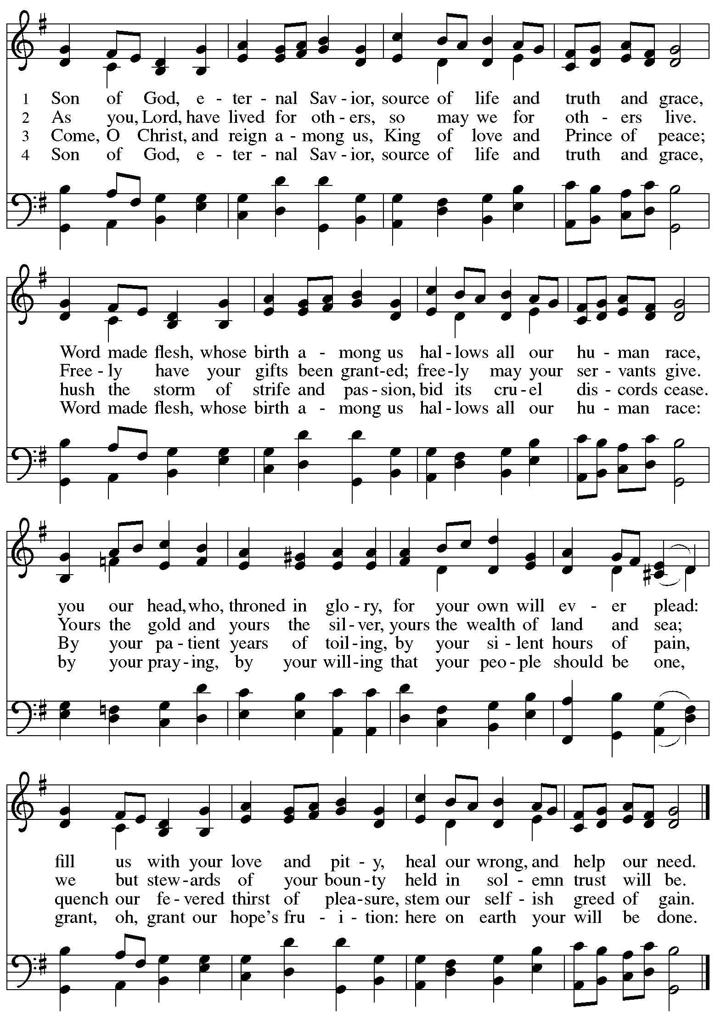

**Greeting**

P: The grace of our Lord Jesus Christ, the love of God,

and the communion of the Holy Spirit be with you all.

**C: And also with you.**

**Hymn of Praise Glory to God, Glory in the Highest *ELW* 164**

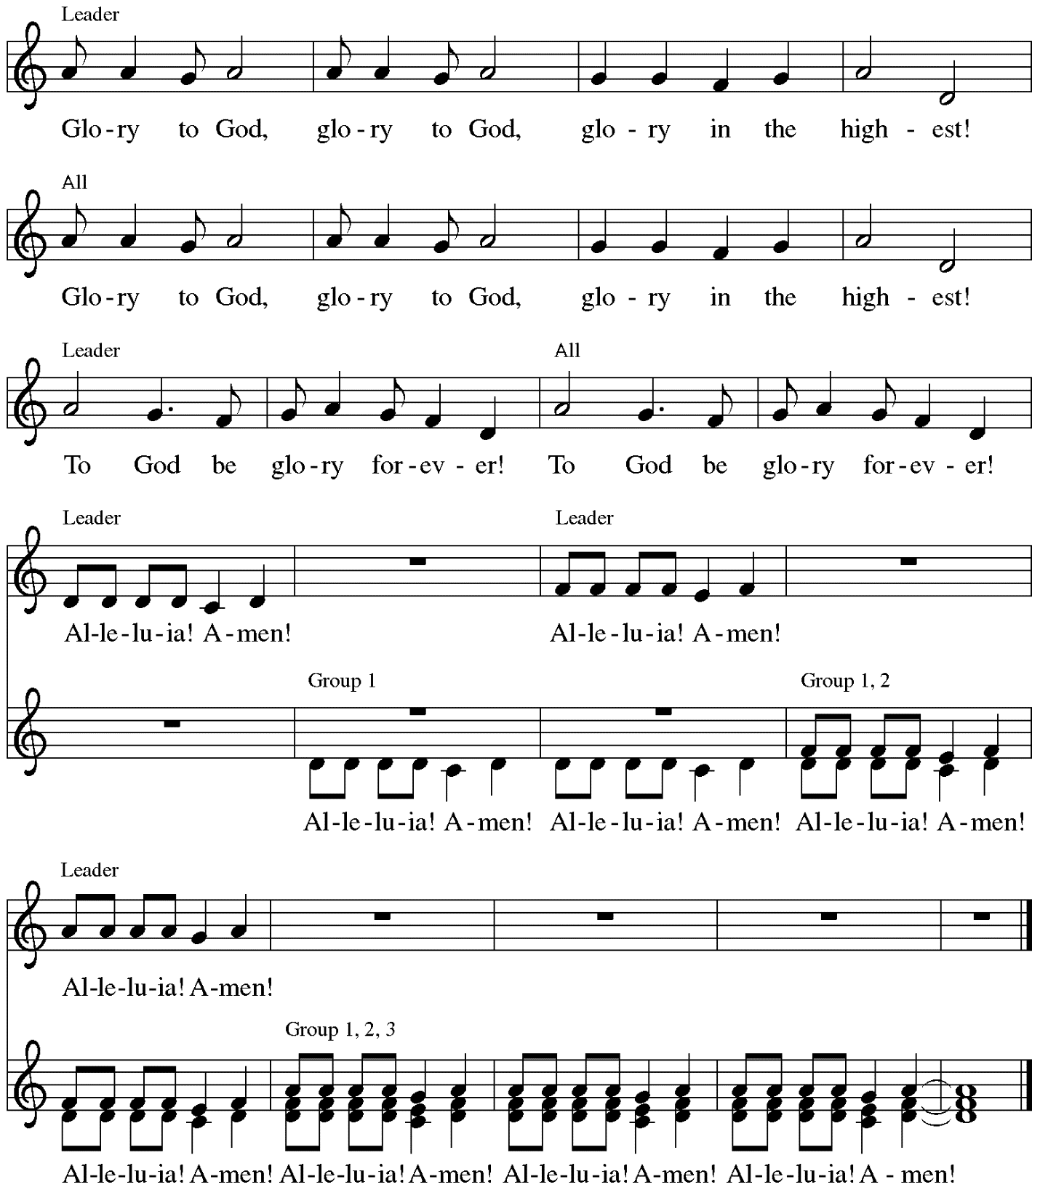

Music: Peruvian traditional

**Prayer of the Day**

P: The Lord be with you.

**C: And also with you.**

P: Let us pray.

O God, the strength of all who hope in you,

In our human weakness we accomplish nothing good without you.

Help us to see and understand the things we ought to do,

and give us grace and power to do them,

through Jesus Christ, our Savior and Lord.

**C: Amen.**

*Please be seated.*

*Children are invited to join the adult leaders at the door and move to the office for Little Church; Big Faith. We ask that one additional adult from the congregation attend with the children.*

**Word**

*God speaks to us in Scripture reading, preaching, and song*

**First Reading – Deuteronomy 30: 15-20**

[Moses said to the people:] 15See, I have set before you today life and prosperity, death and adversity. 16If you obey the commandments of the Lord your God that I am commanding you today, by loving the Lord your God, walking in God’s ways, and observing God’s commandments, decrees, and ordinances, then you shall live and become numerous, and the Lord your God will bless you in the land that you are entering to possess. 17But if your heart turns away and you do not hear, but are led astray to bow down to other gods and serve them,

18I declare to you today that you shall perish; you shall not live long in the land that you are crossing the Jordan to enter and possess. 19I call heaven and earth to witness against you today that I have set before you life and death, blessings and curses. Choose life so that you and your descendants may live, 20loving the Lord your God, obeying God, and holding fast to God; for that means life to you and length of days, so that you may live in the land that the Lord swore to give to your ancestors, to Abraham, to Isaac, and to Jacob.

L: Word of God, word of life.

**C: Thanks be to God.**

**Psalm 119: 1-8** *Following page*

*The cantor will lead the singing of the psalm.*

*The congregation is invited to respond with the alternate verses in bold print,*

*and to join in singing the refrain.*

*Psalm tone*



*Psalm refrain*



1Happy are they whose **|** way is blameless,  
  who follow the teaching **|** of the Lord!  
 2**Happy are they who observe | your decrees**  
  **and seek you with | all their hearts,**  
 3who never do **|** any wrong,  
  but always walk **|** in your ways.  
 4**You laid down | your commandments,**  
  **that we should | fully keep them. R**  
 5Oh, that my ways were made **|** so direct  
  that I might **|** keep your statutes!  
 6**Then I should not be | put to shame,**  
  **when I regard all | your commandments.**  
 7I will thank you with **|** a true heart,  
  when I have learned your **|** righteous judgments.  
 8**I will | keep your statutes;**  
  **do not utter- | ly forsake me. R**

**Second Reading – 1 Corinthians 3: 1-9**

1Kindred, I could not speak to you as spiritual people, but rather as people of the flesh, as infants in Christ. 2I fed you with milk, not solid food, for you were not ready for solid food. Even now you are still not ready, 3for you are still of the flesh. For as long as there is jealousy and

quarreling among you, are you not of the flesh, and behaving according to human inclinations?

4For when one says, “I belong to Paul,” and another, “I belong to Apollos,” are you not merely human?  
 5What then is Apollos? What is Paul? Servants through whom you came to believe, as the Lord assigned to each. 6I planted, Apollos watered, but God gave the growth. 7So neither the one who plants nor the one who waters is anything, but only God who gives the growth. 8The one who plants and the one who waters have a common purpose, and each will receive wages according to the labor of each. 9For we are God’s servants, working together; you are God’s field, God’s building.

L: Word of God, word of life.

**C: Thanks be to God.**

*Please rise as you are able.*

**Gospel Acclamation** **Heleluyan / Hallelujah *ELW*** **171**

**Heleluyan, heleluyan; hele, heleluyan.**

**Heleluyan, heleluyan; hele, heleluyan.**

**Hallelujah, hallelujah; halle, hallelujah.**

**Hallelujah, hallelujah; halle, hallelujah.**

Music: Muscogee (Creek); transc. Charles H. Webb, b. 1933. Transcription © 1989 The United Methodist Publishing House, admin.

The Copyright Company. Reprinted with permission under OneLicense.net # A-722139.

**Gospel – Matthew 5: 21-37**

P: The holy Gospel according to St. Matthew.

**C: Glory to you, O Lord.**

[Jesus said to the disciples:] 21“You have heard that it was said to those of ancient times, ‘You shall not murder’; and ‘whoever murders shall be liable to judgment.’ 22But I say to you that if you are angry with a sibling, you will be liable to judgment; and if you insult a sibling, you will be liable to the council; and if you say, ‘You fool,’ you will be liable to the hell of fire. 23So when you are offering your gift at the altar, if you remember that your sibling has something against you, 24leave your gift there before the altar and go; first be reconciled to your sibling, and then come and offer your gift. 25Come to terms quickly with your accuser while you are on the way to court with them, or your accuser may hand you over to the judge, and the judge to the guard, and you will be thrown into prison. 26Truly I tell you, you will never get out until you have paid the last penny.  
 27“You have heard that it was said, ‘You shall not commit adultery.’ 28But I say to you that everyone who looks at a woman with lust has already committed adultery with her in his heart. 29If your right eye causes you to sin, tear it out and throw it away; it is better for you to lose one of your members than for your whole body to be thrown into hell. 30And if your right hand causes you to sin, cut it off and throw it away; it is better for you to lose one of your members than for your whole body to go into hell.  
 31“It was also said, ‘Whoever divorces his wife, let him give her a certificate of divorce.’ 32But I say to you that anyone who divorces his wife, except on the ground of unchastity, causes her to commit adultery; and whoever marries a divorced woman commits adultery.  
 33“Again, you have heard that it was said to those of ancient times, ‘You shall not swear falsely, but carry out the vows you have made to the Lord.’ 34But I say to you, Do not swear at all, either by heaven, for it is the throne of God, 35or by the earth, for it is his footstool, or by Jerusalem, for it is the city of the great King. 36And do not swear by your head, for you cannot make one hair white or black. 37Let your word be ‘Yes, Yes’ or ‘No, No’; anything more than this comes from the evil one.”

P: The Gospel of the Lord.

**C: Praise to you, O Christ.**

*Please be seated.*

**Sermon**

*A time of silence for prayer and reflection follows the sermon.*

*When the Hymn of the Day begins, please rise as you are able.*

**Hymn of the Day O, That the Lord Would Guide My Ways *ELW* 772**

**1 Oh, that the Lord would guide my ways**

**to keep his statutes still!**

**Oh, that my God would grant me grace**

**to know and do God’s will!**

**2 Order my footsteps by your word**

**and make my heart sincere;**

**let sin have no dominion, Lord,**

**but keep my conscience clear.**

**3 Assist my soul, too apt to stray,**

**a stricter watch to keep;**

**and should I e'er forget your way,**

**restore your wand'ring sheep.**

**4 Help me to heed all your commands,**

**'tis a delightful road;**

**nor let my head or heart or hands**

**offend against my God.**

Text: Isaac Watts, 1647-1748, alt. Music: EVAN, William H. Havergal, 1793-1870.

**Apostles Creed**

**C: I believe in God, the Father almighty,**

**creator of heaven and earth.**

**I believe in Jesus Christ, God’s only Son, our Lord,**

**who was conceived by the Holy Spirit,**

**born of the virgin Mary,**

**suffered under Pontius Pilate,**

**was crucified, died, and was buried;**

**he descended to the dead.\***

**On the third day he rose again;**

**he ascended into heaven,**

**he is seated at the right hand of the Father,**

**and he will come to judge the living and the dead.**

**I believe in the Holy Spirit,**

**the holy catholic church,**

**the communion of saints,**

**the forgiveness of sins,**

**the resurrection of the body,**

**and the life everlasting. Amen.**

*Or, “he descended into hell,” another translation of this text in widespread use.

**Prayers of the People**

A: Called together to follow Jesus, we pray for the church, the world, and all who are in need.

*After each petition*

A: Merciful God,

**C: receive our prayer.**

*The presiding minister concludes the prayers:*

P: We bring these needs and hope to you, O God,

trusting in your wisdom, grace, and power

revealed in Jesus Christ, our Savior.

**C: Amen.**

*Please be seated.*

**Meal**

**Offering**

*We offer ourselves, our gifts, and our faithful service to God.*

*As the offering is gathered for the mission of the church, including the care of those in need,*

*the table is set for Holy Communion.*

**Music during the Offering**

*As the gifts are brought forward for presentation, please rise as you are able*

*and join in singing the Offertory Song.*

**Offertory Song *ELW* 523**

**Vamos todos al banquete / Let Us Go Now to the Banquet, v. 3**

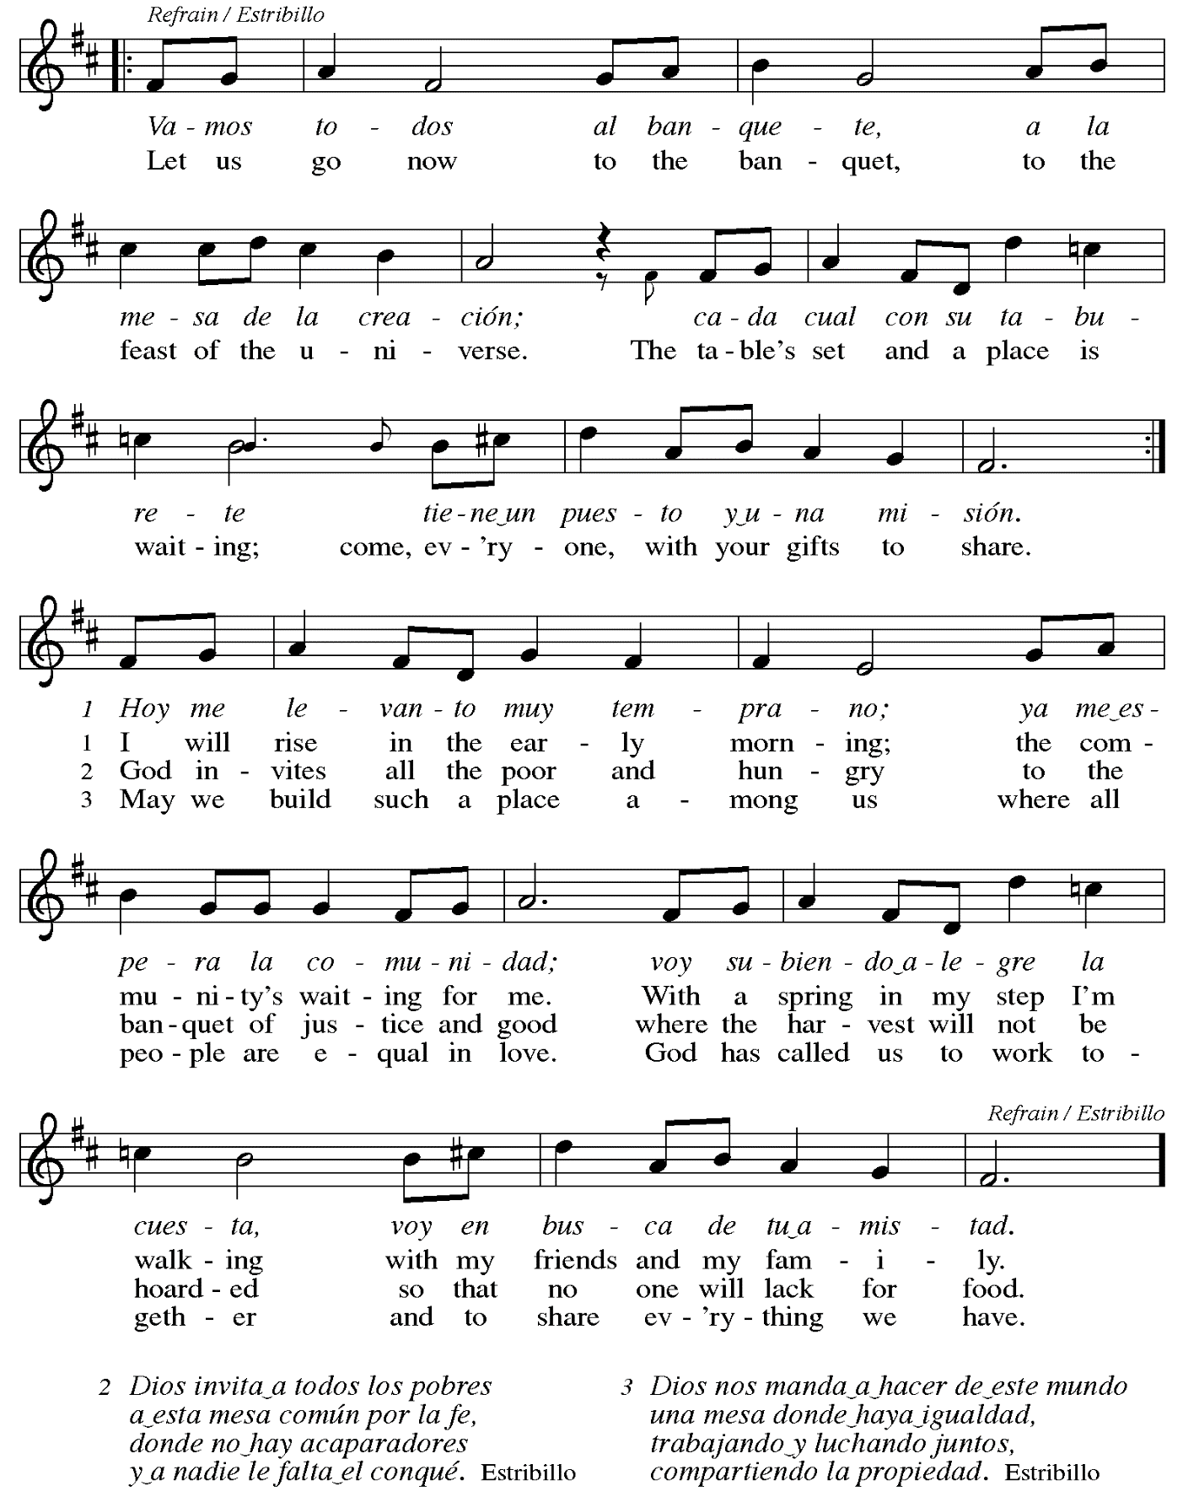

**Offertory Prayer**

A: Let us pray.

Liberating God,

**C: you break the bonds of injustice**

**and set free those who are oppressed.**

**Receive these offerings in thanksgiving**

**for all your deeds of merciful power,**

**that they may serve in your work of justice and freedom.**

**You we magnify and adore, through Jesus our Savior.**

**Amen.**

**Dialogue**

P: The Lord be with you.

**C: And also with you.**

P: Lift up your hearts.

**C: We lift them to the Lord.**

P: Let us give thanks to the Lord our God.

**C: It is right to give our thanks and praise.**

**Preface** *(Spoken by the presiding minister)*

P: It is indeed right, our duty and our joy,

that we should at all times and in all places

give thanks and praise to you, almighty and merciful God,

through our Savior Jesus Christ;

who on this day overcame death and the grave,

and by his glorious resurrection opened to us the way of everlasting life.

And so, with all the choirs of angels,

with the church on earth and the hosts of heaven,

we praise your name and join their unending hymn:

**Sanctus Santo, Santo, Santo *ELW*****762**

***Refrain Only***

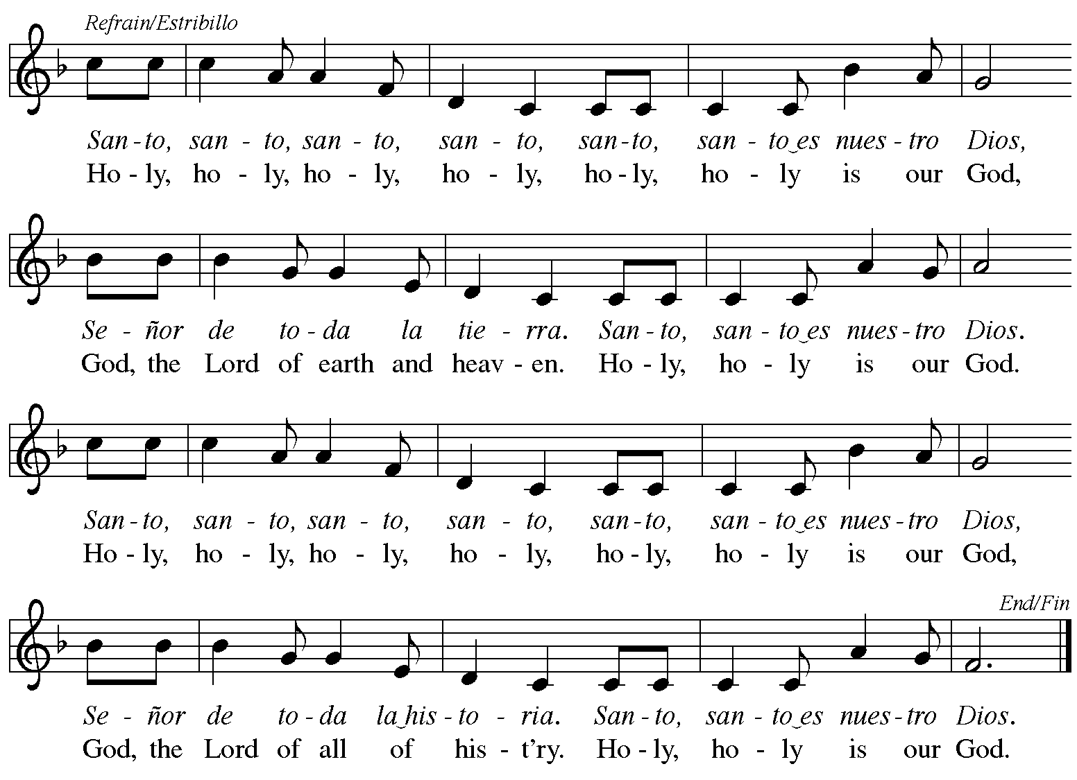



Reprinted with permission under OneLicense.net # A-722139.

**Eucharistic Prayer**

P: Blessed are you, O God,

creator of heaven and earth.

You rescued your covenant people,

led them on all their journeys,

and taught them by the prophets.

You so loved the world

that you gave your only Son,

so that everyone who believes in him

may not perish but may have eternal life.

In the night in which he was betrayed,

our Lord Jesus took bread,

and gave thanks; broke it,

and gave it to his disciples,

saying: Take and eat;

this is my body, given for you.

Do this for the remembrance of me.

Again, after supper,

he took the cup, gave thanks,

and gave it for all to drink,

saying: This cup

is the new covenant in my blood,

shed for you and for all people

for the forgiveness of sin.

Do this for the remembrance of me.

As often as we eat this bread

and drink this cup,

we proclaim the Lord’s death

until he comes.

**C: Christ has died.**

**Christ is risen.**

**Christ will come again.**

P: Pour out your Holy Spirit

in this meal and make us one,

in this community of faith

and with your people throughout the world.

Glory and praise to you, O God,

Author of Life,

Word made flesh,

Power of the Most High,

now and forever.

**C: Amen.**

**Lord’s Prayer**

P: Gathered as one by the Holy Spirit, let us pray as Jesus taught us.

**C: Our Father in heaven,**

**hallowed be your name,**

**your kingdom come,**

**your will be done,**

**on earth as in heaven.**

**Give us today our daily bread.**

**Forgive us our sins**

**as we forgive those** **who sin against us.**

**Save us from the time of trial**

**and deliver us from evil.**

**For the kingdom, the power,**

**and the glory are yours,**

**now and forever. Amen.**

**Fraction and Invitation**

P: These are the gifts of God for the people of God.

Come, share the feast.

**Agnus DeiLamb of God *TFF* 35**

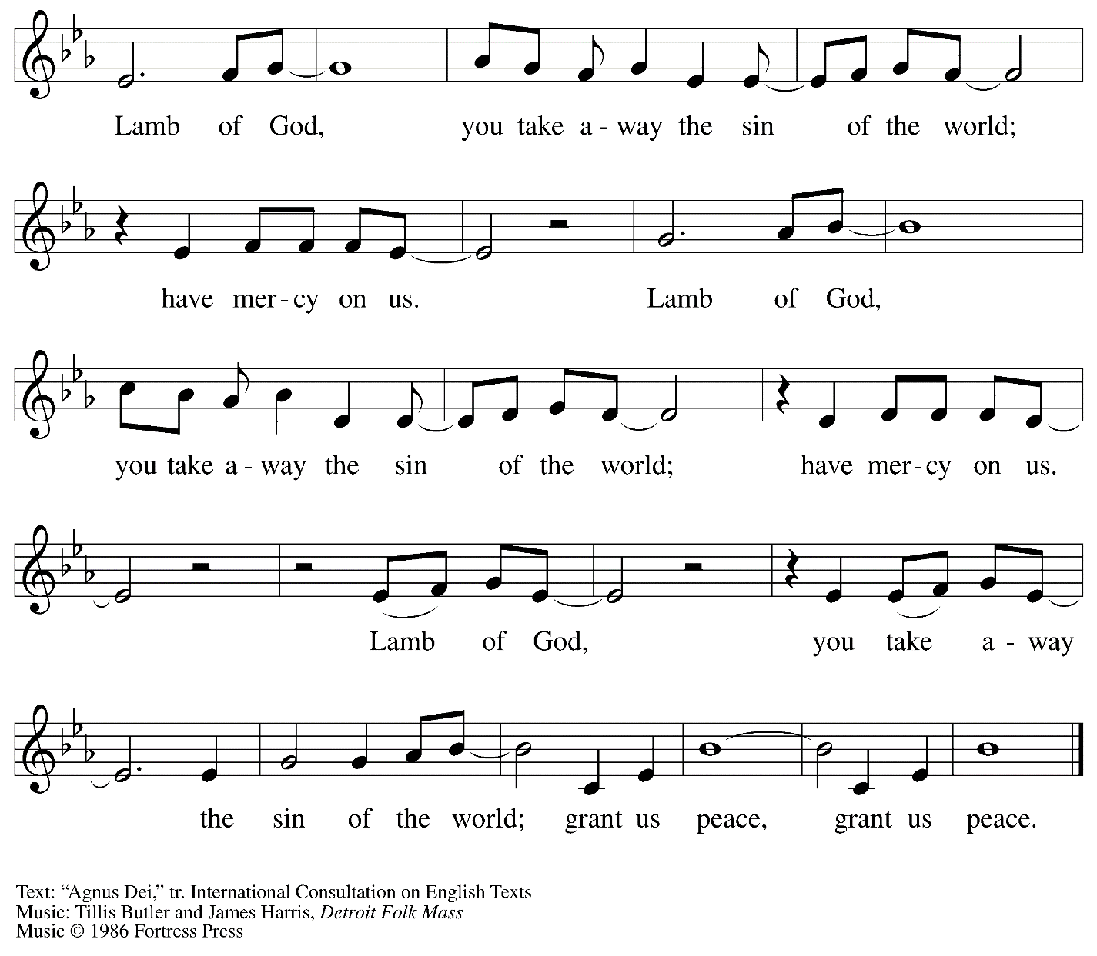

All rights reserved. Reprinted with permission under OneLicense.net # A-722139.

*Please be seated.*



**Holy Communion**

* *All who seek God and desire a deeper and stronger life in Christ are welcome to receive Holy Communion.*
* *Worshipers from the pulpit side will proceed forward first, followed by the center section, and then the lectern side.*
* *Please inform an usher if you would like the ministers to bring Communion to you.*
* *Holy Communion will be served with bread and wine/grape juice.*
* *The presiding minister will first distribute the bread (host) to each communicant. Please indicate if you require a gluten-free host.*
* *Once you have consumed the bread, please pick up an empty glass from the tray next to the presiding minister. The Communion Assistant will pour wine from the chalice or grape juice from the cruet into your glass.*
* *Please step to the side to consume the wine or grape juice.*
* *As you return to your pew, glasses may be returned to the empty trays on either side of the center aisle.*
* *A blessing will be provided for anyone who does not yet receive the sacrament.*
* *All are invited to join in singing the hymns during Holy Communion.*

**Hymn during Holy Communion**

**Spirit, Open My Heart *ACS* 1043**

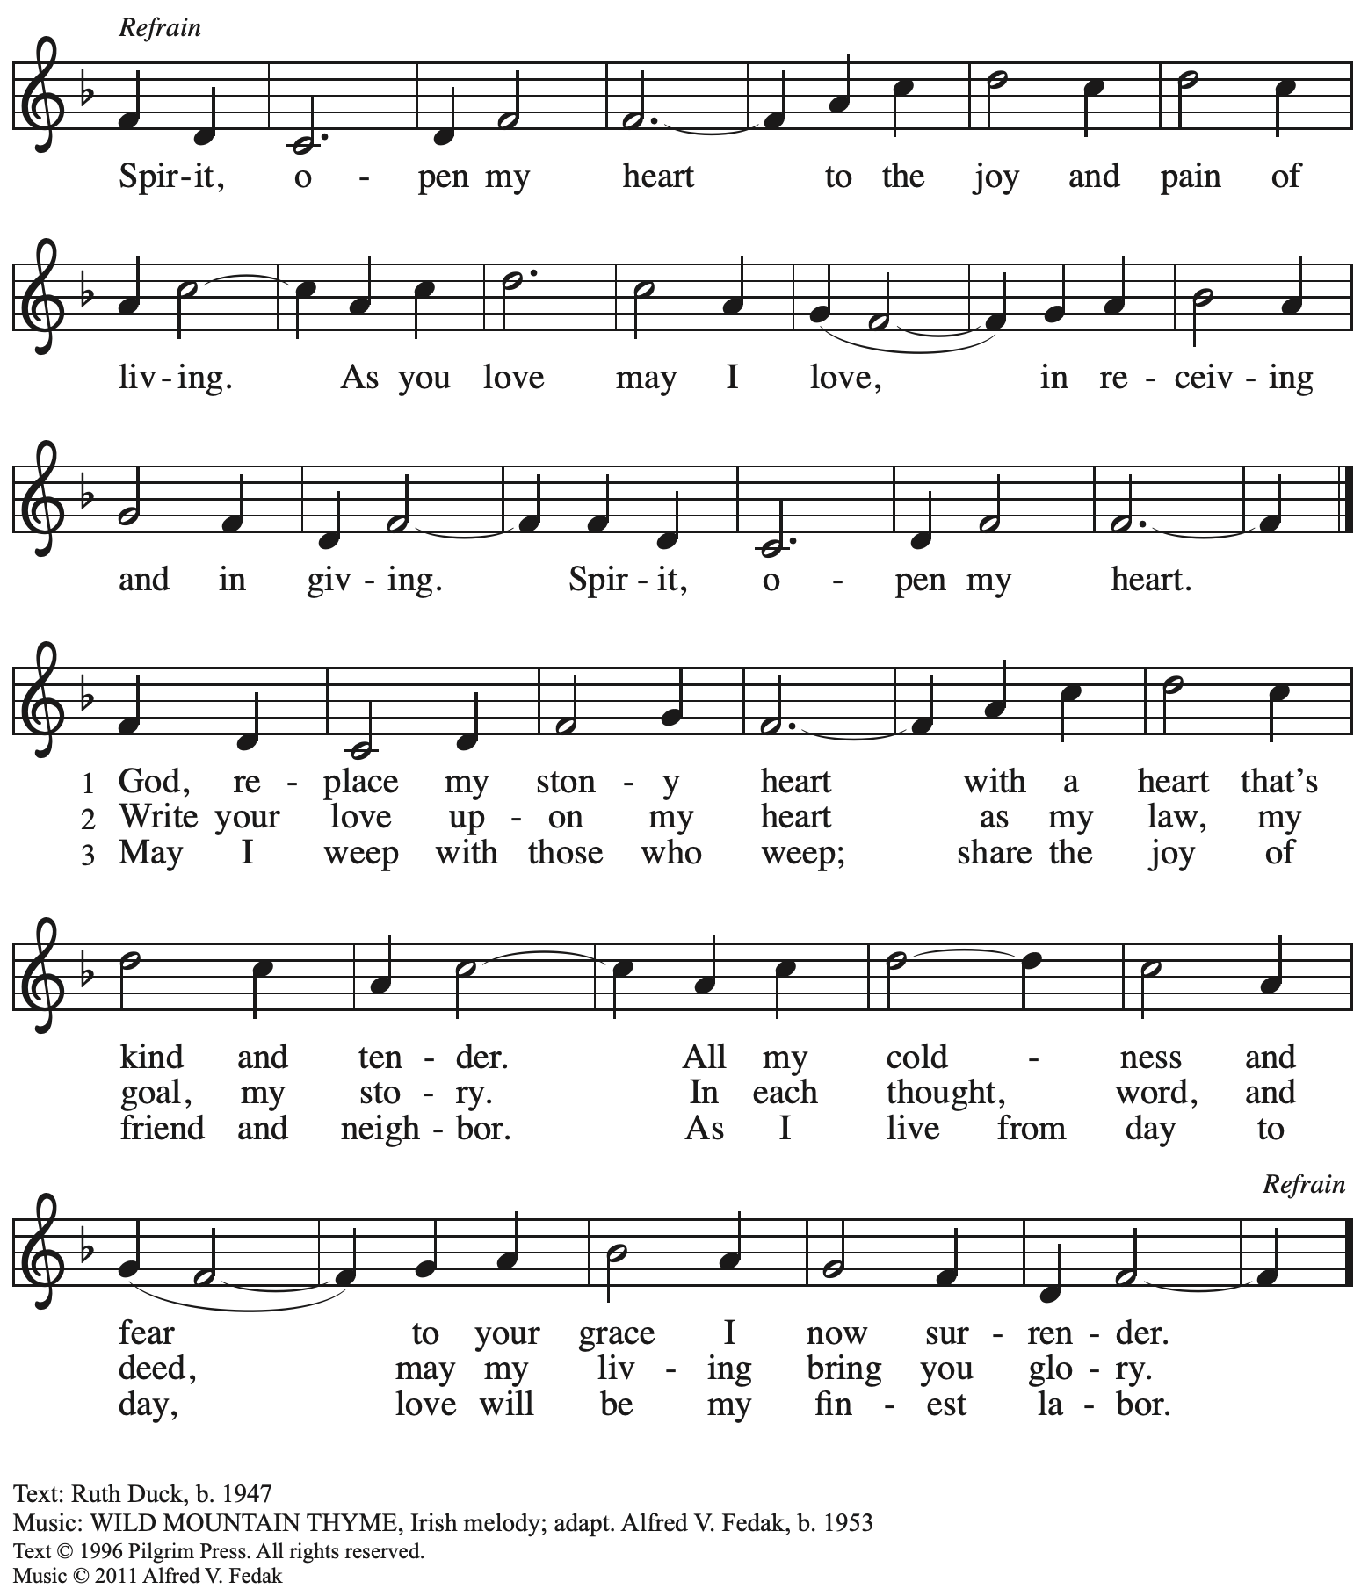

All rights reserved. Reprinted with permission under OneLicense.net # A-722139.

**Hymn during Holy Communion**

**Come Down, O Love Divine *ELW* 804**

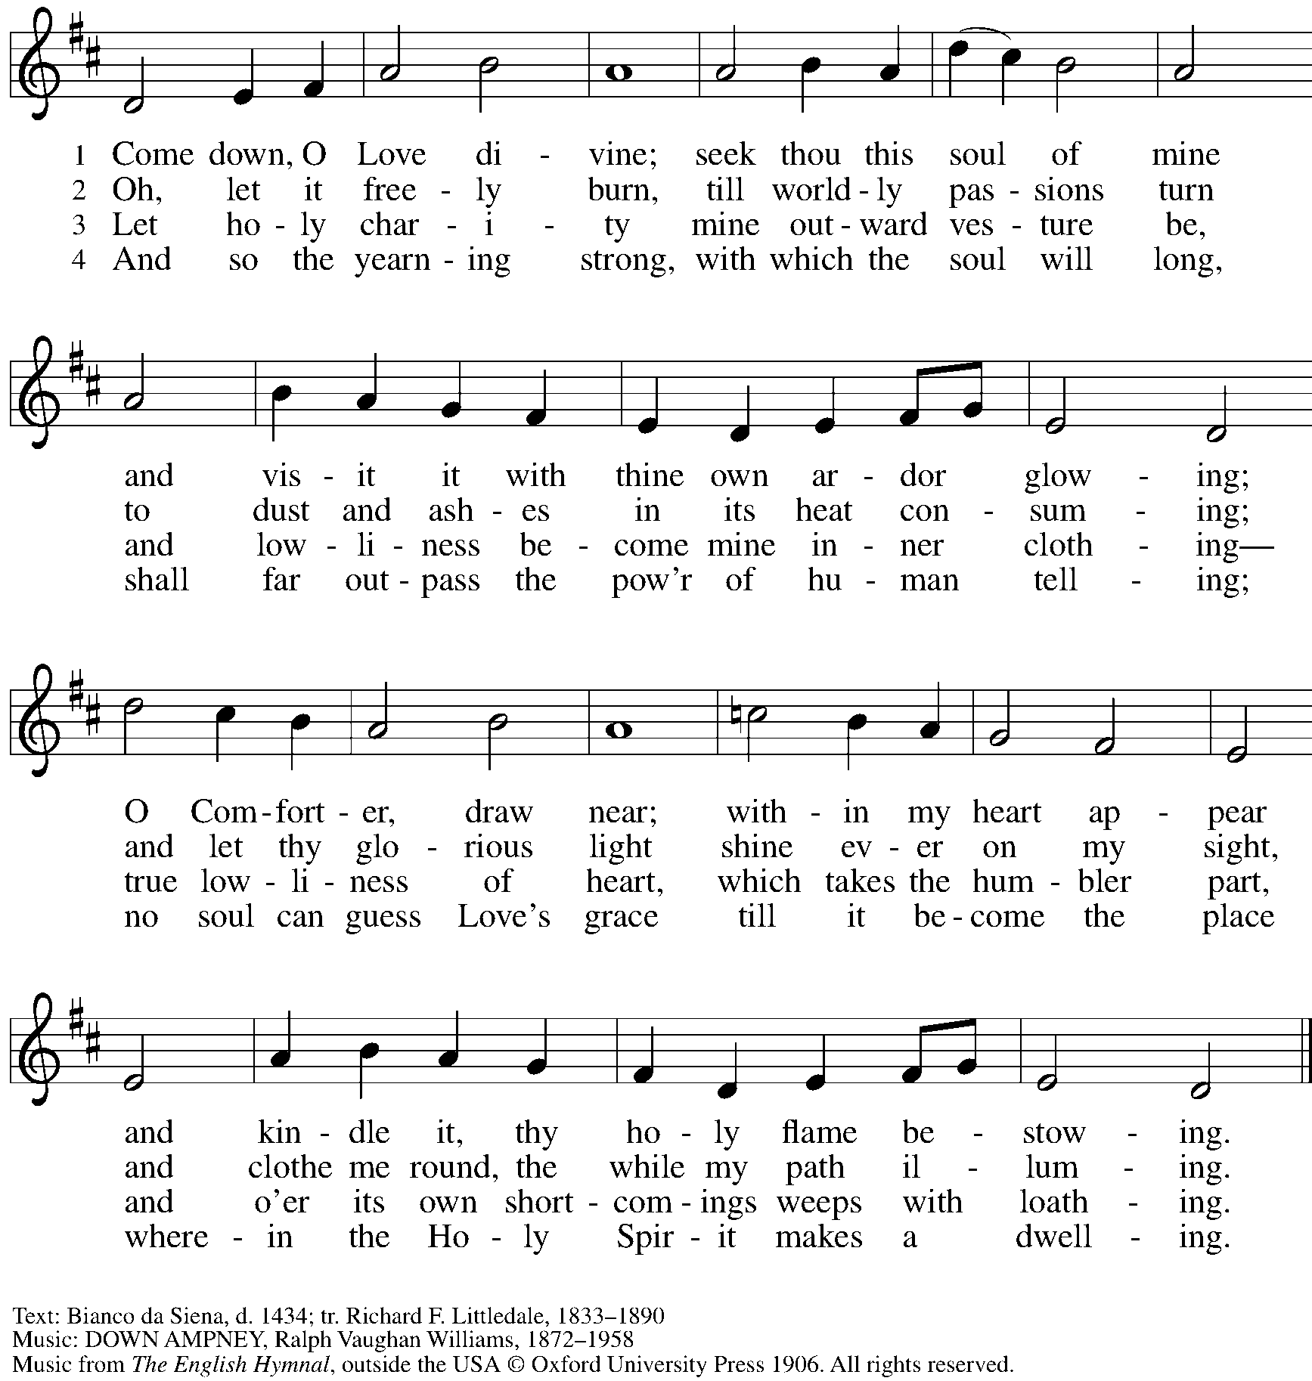

Reprinted with permission under OneLicense.net # A-722139.

**Hymn during Holy Communion**

**Healer of our Every Ill *ELW* 612**

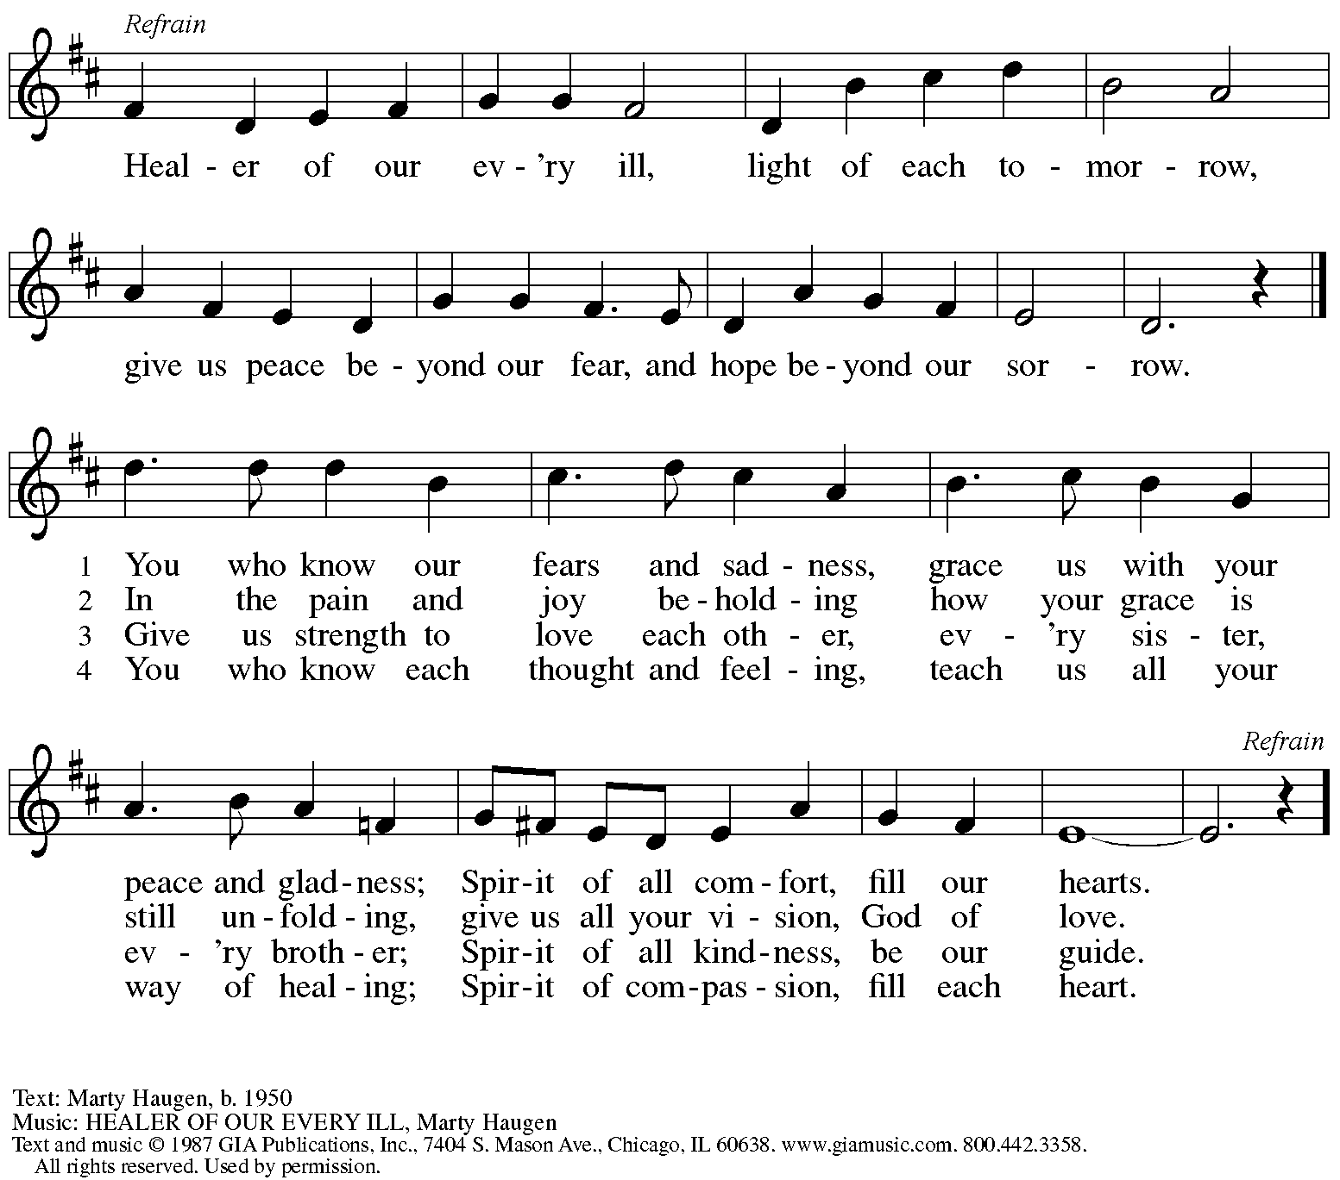

Reprinted under OneLicense.net # A-722139.

*When all have returned to their places, please rise as you are able.*

**Blessing**

P: The body and blood of our Lord Jesus Christ strengthen you and keep you in his grace.

**C: Amen.**

**Prayer**

A: Let us pray.

A: Holy One,

we thank you for the healing

that springs forth abundantly from this table.

Renew our commitment to do justice, love kindness,

and journey humbly with you,

through Jesus Christ, our Savior and Lord.

**C: Amen.**

*Please be seated.*

**Sending**

**Announcements**

*Please rise as you are able.*

**Benediction**

P: The Lord bless you and keep you.

The Lord’s face shine on you

with grace and mercy.

The Lord look upon you with favor

and ☩ give you peace.

**C: Amen.**

**Sending Hymn Praise the Lord, Rise up Rejoicing** *Following page*

**Dismissal**

A: Go in peace. Serve the Lord.

**C: Thanks be to God!**

**Sending Hymn Praise the Lord, Rise up Rejoicing *ELW* 544**

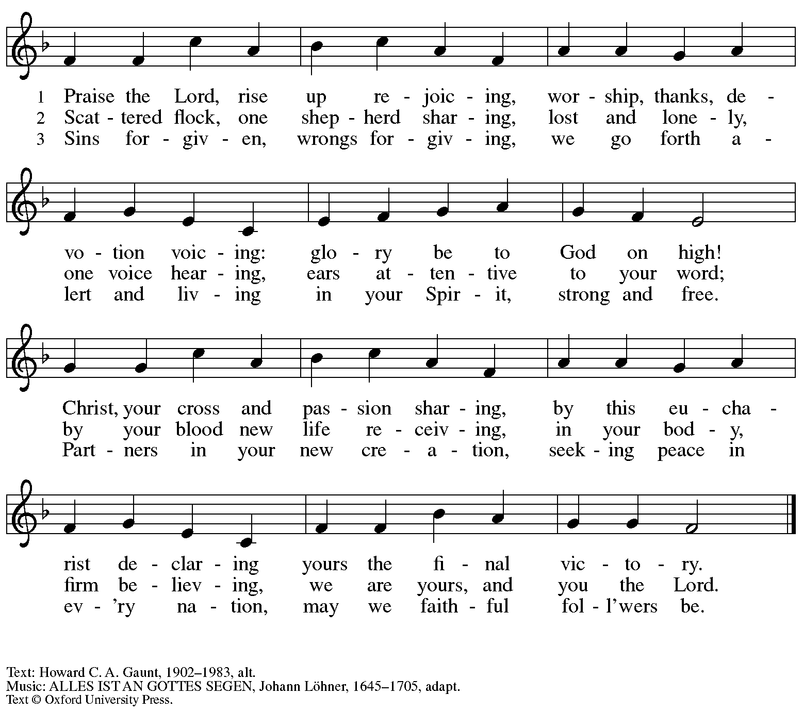

All rights reserved. Reprinted with permission under OneLicense.net # A-722139.

*Abbreviations*

P: Pastor/Presiding Minister

A: Assisting Minister

L: Lector

**C: Congregation**

***ELW*: *Evangelical Lutheran Worship* hymnal**

***TFF*: *This Far by Faith* hymnal**

***ACS*: *All Creation Sings* hymnal**

*Those serving in worship today*

Assisting Minister John Tymitz

Audio Visual Ministers Jason Galyardt

Dave Rollinson

Cantor Emily Duque

Lector Noël Marsh

Minister of Music Laura Reynolds

Presiding Minister The Rev. Ross I. Carmichael

*Liturgy and Hymnody Acknowledgements*

From SundaysandSeasons.com. Copyright © 2023 Augsburg Fortress. All rights reserved. Reprinted under OneLicense.net # A-722139.

Used by permission of Augsburg Fortress.

**Son of God, Eternal Savior** – Text: Somerset C. Lowry, 1855-1932. Music: IN BABILONE, *Oude en Nieuwe Hollantse Boerenlitiesen Contradansen*, 1710; arr. Julius Röntgen, 1855-1932.

**Vamos todos al banquete / Let Us Go Now to the Banquet** – Text: Guillermo Cuéllar, b. 1955, *Misa popular salvadoreña*; tr. Bret Hesla, b. 1957, and William Dexheimer Pharris, b. 1956. Music: VAMOS TODOS AL BANQUETE, Guillermo Cuéllar, b. 1955. Text and music © 1994, 1996 GIA Publications, Inc., 7404 S. Mason Ave., Chicago, IL 60638. [www.giamusic.com](http://www.giamusic.com). 800.442.3358. All rights reserved. Reprinted with permission under OneLicense.net #A-722139.

**St. Andrew Lutheran Church Announcements**

**February 12th, 2023**

* **Welcome to Worship at St. Andrew on February 12th, 2023, the + Sixth Sunday after Epiphany** –We are so glad you are here! Masks are optional at St. Andrew when Allegheny County’s Covid-19 community level is in the low and medium categories. Worship attendees are invited to make a name tag at the back of the worship space if you would like. All are welcome to a time of coffee and conversation in the Social Hall after worship.
* **Life of Faith Survey – Please Complete by the End of Today** – St. Andrew has been participating in a project that explores the gap between faith (at church) and life (in the world). The foundational Lutheran understanding of vocation serves as the bridge for this consistent gap. (Vocation is often understood as “calling,” and the survey uses the terms interchangeably.) People of St. Andrew are invited to take the following survey, which asks questions about your beliefs about your own vocation or calling, as well as your experiences within your congregation. **Some people in the congregation completed this survey last year. We are asking that everyone in the congregation to complete it this time, also, as the project is measuring changes over time.** Please be assured that all answers are anonymous and your responses will be kept strictly confidential. Please find the survey here: <https://www.surveymonkey.com/r/VB8F3FC>. Paper copies can be made available for those who prefer that medium. Thank you for your time and participation.
* **February Shelter Dinner at East End Cooperative Ministry - Thursday, February 16th, 6:30 p.m.**– Each month, people of St. Andrew provide a meal for the guests of the shelter at East End Cooperative Ministry, 6140 Station St., 15206. If you would like to provide a portion of the meal or help serve, please sign up at: <https://www.signupgenius.com/go/5080544AAAC22A1F58-shelter38>.
* **Farewell to the "Alleluia" and Burning of Palms Outside after Worship Next Sunday, February 19th**– The season after Epiphany concludes next Sunday with the Transfiguration of our Lord. We sing the Church's song of Easter joy, “Alleluia,” once more before putting it away during the season of Lent, which begins on Ash Wednesday, February 22nd. We invite everyone to gather outside right after worship on Sunday, February 19th, where we will offer a brief liturgy of farewell to the Alleluia and the burning of palms from last Palm Sunday to make the ashes for Ash Wednesday. If you have palms from last year’s Palm Sunday, please feel free to bring them for the fire.
* ***Water and Spirit: Devotions for Lent 2023* Available at Church Entrances**– The season of Lent begins with Ash Wednesday (February 22nd this year), and in this time the Church invites us into the Lenten disciplines of fasting (giving something up for Lent), almsgiving (generosity and charitable giving), and prayer. A new resource is available to support the St. Andrew congregation in the discipline of prayer this season. Water and the Spirit: Devotions for Lent 2023 offers simple daily readings, reflections, and prayers from Ash Wednesday through Holy Week. These are available at each entrance to the church - please pick one up in the next few weeks to aid in your observation of Lent this year.
* **Worship for + Ash Wednesday, February 22nd, 7:00 p.m.** – The observance of + Ash Wednesday marks the beginning of the season of Lent, a 40-day season of baptismal reflection and preparation for the celebration of the resurrection at Easter. St. Andrew will offer worship with Holy Communion and the Imposition of Ashes at 7:00 p.m. that day. The service will also be streamed online to Zoom, Facebook, and YouTube. If you would like to observe the liturgy with the Farewell to the Alleluia and Burning of the Palms in preparation for Ash Wednesday, the video will be posted on St. Andrew’s Facebook page.
* **Reminder –** **Congregational Meeting Sunday, March 5th, after Worship** – The next meeting of the congregation will be after worship on Sunday, March 5th. A zoom link will be provided for those who cannot attend in person. At this meeting, we receive reports from the past year, including a summary of the budget, and share information about upcoming initiatives. At this meeting, we will also vote on the amendments to the congregation’s constitution that were previously sent. No absentee or proxy votes can be accepted so please plan on attending!
* **Participate in the Choir Scheduled to Sing during Worship on the Third Sunday in Lent, March 12th** – St. Andrew’s choir is next preparing to sing during worship on Sunday, March 12th. All are welcome to take part! There will be two rehearsals, Sunday, March 5th, at 8:30 a.m. and Sunday, March 12th, at 8:30 a.m. The piece is “Prayer for Mercy, based off of Beethoven’s “Moonlight Sonata.” Minister of Music Laura Reynolds has recorded parts to help in your preparation, which can be found here:   
  <https://youtube.com/playlist?list=PLdo3pMOInGpV3Wicm1qi4hNK7CUIM32m->. Please let her know if you’d like to sing and plan to attend the upcoming rehearsals!