+ First Sunday in Lent
February 26, 2023

St. Andrew Lutheran Church
304 Morewood Ave.
Pittsburgh, PA 15213
St_andrewELCA@verizon.net
www.standrewpittsburgh.org

+ First Sunday in Lent
Order for Worship

Today’s Gospel tells of Jesus’ temptation in the desert.
His forty-day fast becomes the basis of our Lenten pilgrimage.
In the early church, Lent was a time of intense preparation for those to be baptized at the Easter Vigil. This catechetical focus on the meaning of faith is at the heart of our Lenten journey
to the baptismal waters of Easter. Hungry for God’s mercy, we receive the bread of life
to nourish us for the days ahead.

The season of Lent began on Ash Wednesday. Lent is a 40-day season focused on repentance, spiritual discipline, and baptismal reflection. We acknowledge our vulnerability and mortality, turn from sin, and return to God for forgiveness and renewal. The readings for the season evoke themes of desert and wilderness — Jesus’ 40-day temptation, the Israelites traveling and needing water, a valley of dry bones, the tomb of Lazarus. Instead of lush greenery we decorate the sanctuary with rocks and stones. There will be small stones available at the back of the sanctuary — we encourage everyone to pick one up each week. The stone may be thought of as sin, guilt, burden, whatever you would like to clean out and/or leave behind in order to make room for God and service to neighbor. We invite you to leave these stones with the others at the altar during the Sending Hymn each week, which throughout the season will be Bless Now, O God, the Journey - ELW 326. This hymn reminds us that when we are scattered in our daily lives and responsibilities, wherever we go in faith, God comes to meet us there to bring hope and peace. On the second through fifth Sundays, testimonies by the congregation’s leaders in the Life of Faith Initiative will precede the hymn. They will share about how they see God at work as they serve in their daily vocations and roles throughout the week. May God bless your journey through Lent!

- Masks are optional at St. Andrew when Covid-19 community level in Allegheny County is in the low and medium categories.
- Worship Services are live streamed to multiple online platforms. By attending worship, you agree that your image and voice may be broadcast.

Welcome to St. Andrew!

- St. Andrew Lutheran Congregation welcomes all who are seeking a place of healing and wholeness, a nurturing, faith-forming spiritual home. Our community embraces people of all ages, ethnicities, cultures, abilities, sexual orientations, gender identities and expressions, and family constellations. Come and See!
- Everyone is invited to make a nametag at the black bookcase in the back of the worship space if they would like.
- Worship “toolkits” to help children engage with the service are available in the black bookcase at the back of the worship space. There are “reader” and “pre-reader” resources available in each kit. Please feel free to use the kits for/with your children during worship.
- This Lenten season, St. Andrew returns to the Sharing of Peace during worship. More than a simple greeting, this practice and placement in the service derives from the Gospel of Matthew 5: 23-24 – “When you are offering your gift at the altar, if you remember that your sibling has something against you, leave your gift there before the altar and go; first be reconciled to your sibling, and then come and offer your gift.” We will once again have an opportunity to share an expression of Christ’s peace with those around us as a liturgical sign of our desire to be reconciled with our neighbors before offering our gifts and receiving Holy Communion. Please be mindful that some people will not be comfortable with sharing the peace; be sure to obtain consent before any physical expression of peace such as shaking hands or hugging.
- St. Andrew has returned to serving Holy Communion with both (separate) elements, bread and wine/grape juice. The presiding minister will distribute the bread (host). Please consume this and then pick up an empty glass from the tray. The Communion Assistant will pour wine or grape juice into your glass. Please step to the side to consume the wine or grape juice. As you return to your pew, glasses may be returned to the empty trays on either side of the center aisle.
- A restroom is available on the main level of the church, through the doors to the Social Hall and to the right in the main office.

Welcome

Gathering
The Holy Spirit calls us together as the people of God.

Centering Music Now Is the Time of Grace ACS 918
v. 1-2

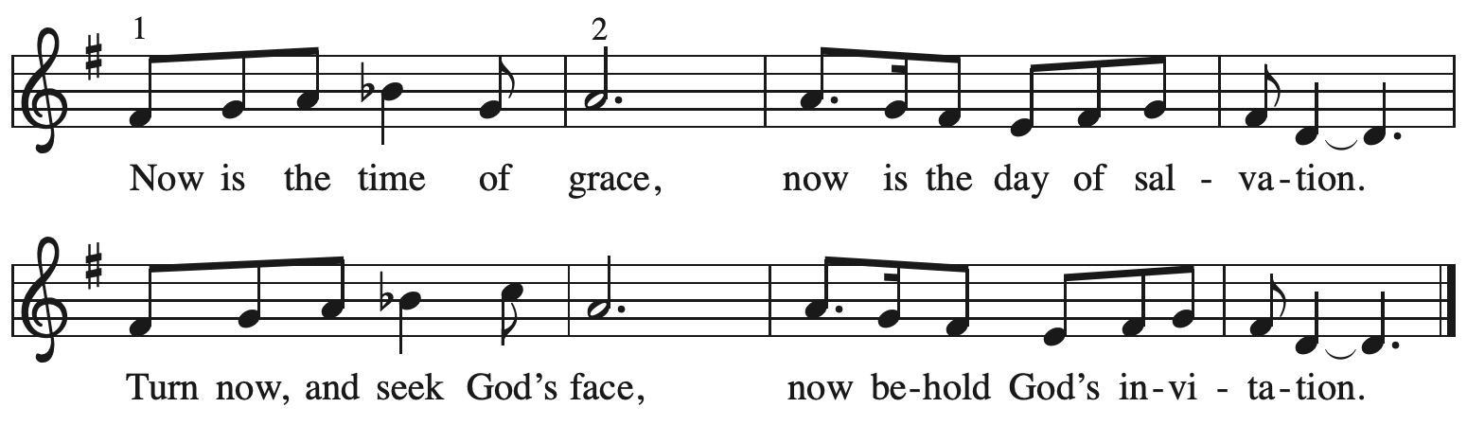

Verses — Leader
1 This is the fast that God would choose:
to loose the bonds of injustice,
to let the captives go free,
and to break the yoke of oppression. Refrain

2 Sharing your bread with the hungry
and welcoming homeless in,
offering hope and offering help,
this is what God requires. Refrain

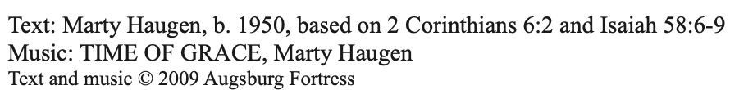
All rights reserved. Reprinted with permission under OneLicense.net # A-722139.

Please rise as you are able.

Confession and Forgiveness

P: Blessed be the holy Trinity, ☩ one God,
who journeys with us these forty days,
and sustains us with the gift of grace.
C: Amen.

P: Let us acknowledge before God and one another
our need for repentance and God’s mercy.

Silence is kept for reflection.

P: Holy God,
C: we confess to you our faults and failings.
Too often we neglect and do not trust your holy word;
we take for ourselves instead of giving to others;
we spoil rather than steward your creation;
we cause hurt though you call us to heal;
we choose fear over compassion.
Forgive us, renew us, and lead us,
as we seek to follow in your way of life.
Amen.

P: Hear the good news:
God so loved the world that God gave the only Son,
so that all may receive life.
This promise is for you!
God embraces you with divine mercy,
☩ forgives you in Christ’s name,
and revives you in the Spirit’s power.
C: Amen.

Gathering Hymn As the Sun with Longer Journey ELW 329

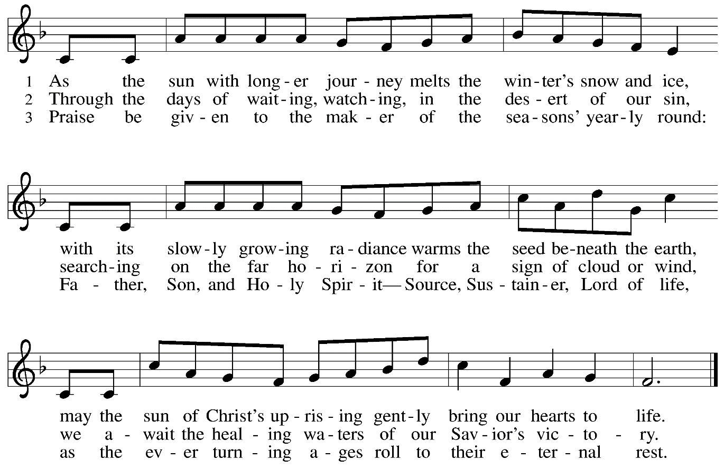
Greeting

P: The grace of our Lord Jesus Christ, the love of God,
and the communion of the Holy Spirit be with you all.
C: And also with you.

Kyrie

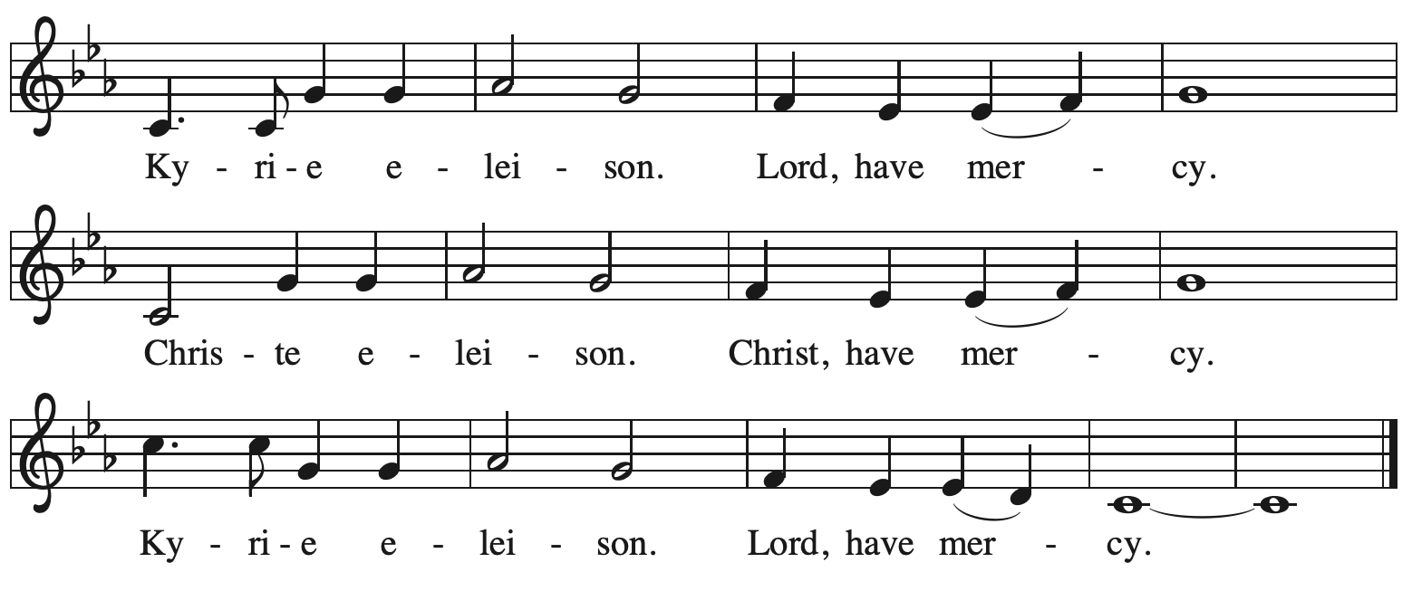

Prayer of the Day

P: The Lord be with you.
C: And also with you.

P: Let us pray.
Lord God, our strength, the struggle between good and evil rages within and around us,
and the devil and all the forces that defy you tempt us with empty promises.
Keep us steadfast in your word, and when we fall, raise us again
and restore us through your Son, Jesus Christ, our Savior and Lord,
who lives and reigns with you and the Holy Spirit, one God, now and forever.
C: Amen.

Please be seated.
Children are invited to join the adult leaders at the door and move to the office for Little Church; Big Faith. We ask that one additional adult from the congregation attend with the children.

Word
God speaks to us in Scripture reading, preaching, and song

First Reading – Genesis 2: 15-17; 3: 1-7

¹⁵The Lord God took the man and put him in the garden of Eden to till it and keep it. ¹⁶And the
Lord God commanded the man, “You may freely eat of every tree of the garden; ¹⁷but of the tree of the knowledge of good and evil you shall not eat, for in the day that you eat of it you shall die.”
^{3:1}Now the serpent was more crafty than any other wild animal that the Lord God had made. He said to the woman, “Did God say, ‘You shall not eat from any tree in the garden’?” ²The woman said to the serpent, “We may eat of the fruit of the trees in the garden; ³but God said, ‘You shall not eat of the fruit of the tree that is in the middle of the garden, nor shall you touch it, or you shall die.’ ” ⁴But the serpent said to the woman, “You will not die; ⁵for God knows that when you eat of it your eyes will be opened, and you will be like God, knowing good and evil.” ⁶So when the woman saw that the tree was good for food, and that it was a delight to the eyes, and that the tree was to be desired to make one wise, she took of its fruit and ate; and she also gave some to her husband, who was with her, and he ate. ⁷Then the eyes of both were opened, and they knew that they were naked; and they sewed fig leaves together and made loincloths for themselves.
L: Word of God, word of life.
C: Thanks be to God.

Psalm 32

The cantor will lead the singing of the psalm.
The congregation is invited to respond with the alternate verses in bold print,
and to join in singing the refrain.

Psalm tone

Psalm refrain

¹Happy are they whose transgressions | are forgiven,
and whose sin is | put away!
²Happy are they to whom the Lord im- | putes no guilt,
and in whose spirit there | is no guile!
³While I held my tongue, my bones with- | ered away,
because of my groaning | all day long.
⁴For your hand was heavy upon me | day and night;
my moisture was dried up as in the | heat of summer. R
⁵Then I acknowledged my sin to you, and did not con- | ceal my guilt.
I said, “I will confess my transgressions to the Lord.” Then you forgave me the guilt | of my sin.
⁶Therefore all the faithful will make their prayers to you in | time of trouble;
when the great waters overflow, they | shall not reach them.
⁷You are my hiding-place; you preserve | me from trouble;
you surround me with shouts | of deliverance.
⁸“I will instruct you and teach you in the way that | you should go;
I will guide you | with my eye. R
⁹Do not be like horse or mule, which have no | understanding;
who must be fitted with bit and bridle, or else they will | not stay near you.”
¹⁰Great are the tribulations | of the wicked;
but mercy embraces those who trust | in the Lord.
¹¹Be glad, you righteous, and rejoice | in the Lord;
shout for joy, all who are | true of heart. R

Second Reading – Romans 5: 12-19

¹²Just as sin came into the world through one man, and death came through sin, and so death spread to all because all have sinned—¹³sin was indeed in the world before the law, but sin is not reckoned when there is no law. ¹⁴Yet death exercised dominion from Adam to Moses, even over those whose sins were not like the transgression of Adam, who is a type of the one who was to come.
¹⁵But the free gift is not like the trespass. For if the many died through the one man’s trespass, much more surely have the grace of God and the free gift in the grace of the one man, Jesus Christ, abounded for the many. ¹⁶And the free gift is not like the effect of the one man’s sin. For the judgment following one trespass brought condemnation, but the free gift following many trespasses brings justification. ¹⁷If, because of the one man’s trespass, death exercised dominion through that one, much more surely will those who receive the abundance of grace and the free gift of righteousness exercise dominion in life through the one man, Jesus Christ.
¹⁸Therefore just as one man’s trespass led to condemnation for all, so one man’s act of righteousness leads to justification and life for all. ¹⁹For just as by the one man’s disobedience the many were made sinners, so by the one man’s obedience the many will be made righteous.

L: Word of God, word of life.
C: Thanks be to God.

Please rise as you are able.
Gospel Acclamation

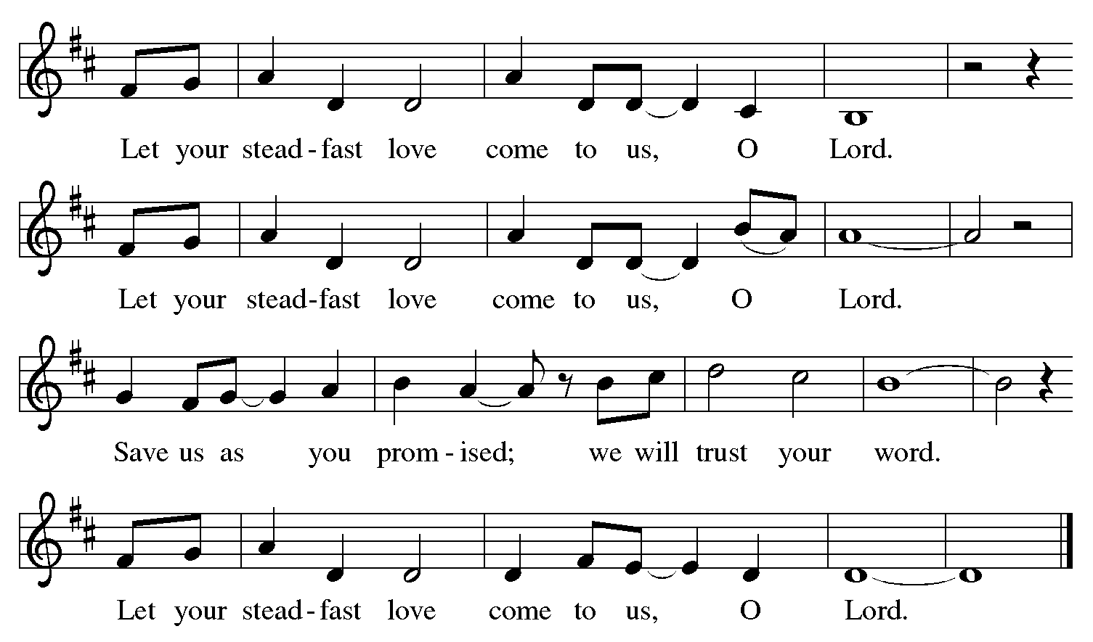

Gospel – Matthew 4: 1-11

P: The holy Gospel according to St. Matthew.
C: Glory to you, O Lord.
¹Jesus was led up by the Spirit into the wilderness to be tempted by the devil. ²He fasted forty days and forty nights, and afterwards he was famished. ³The tempter came and said to him, “If you are the Son of God, command these stones to become loaves of bread.” ⁴But he answered, “It is written,
‘One does not live by bread alone,
but by every word that comes from the mouth of God.’ ”
⁵Then the devil took him to the holy city and placed him on the pinnacle of the temple, ⁶saying to him, “If you are the Son of God, throw yourself down; for it is written,
‘The Lord will command God’s angels concerning you,’
and ‘On their hands they will bear you up,
so that you will not dash your foot against a stone.’ ”
⁷Jesus said to him, “Again it is written, ‘Do not put the Lord your God to the test.’ ”
⁸Again, the devil took him to a very high mountain and showed him all the kingdoms of the world and their splendor; ⁹and he said to him, “All these I will give you, if you will fall down and worship me.” ¹⁰Jesus said to him, “Away with you, Satan! for it is written,
‘Worship the Lord your God,
and serve only God.’ ”
¹¹Then the devil left him, and suddenly angels came and waited on him.

P: The Gospel of the Lord.
C: Praise to you, O Christ.

Please be seated.

Sermon

A time of silence for prayer and reflection follows the sermon.
When the Hymn of the Day begins, please rise as you are able.

Hymn of the Day When We Are Tested ACS 922

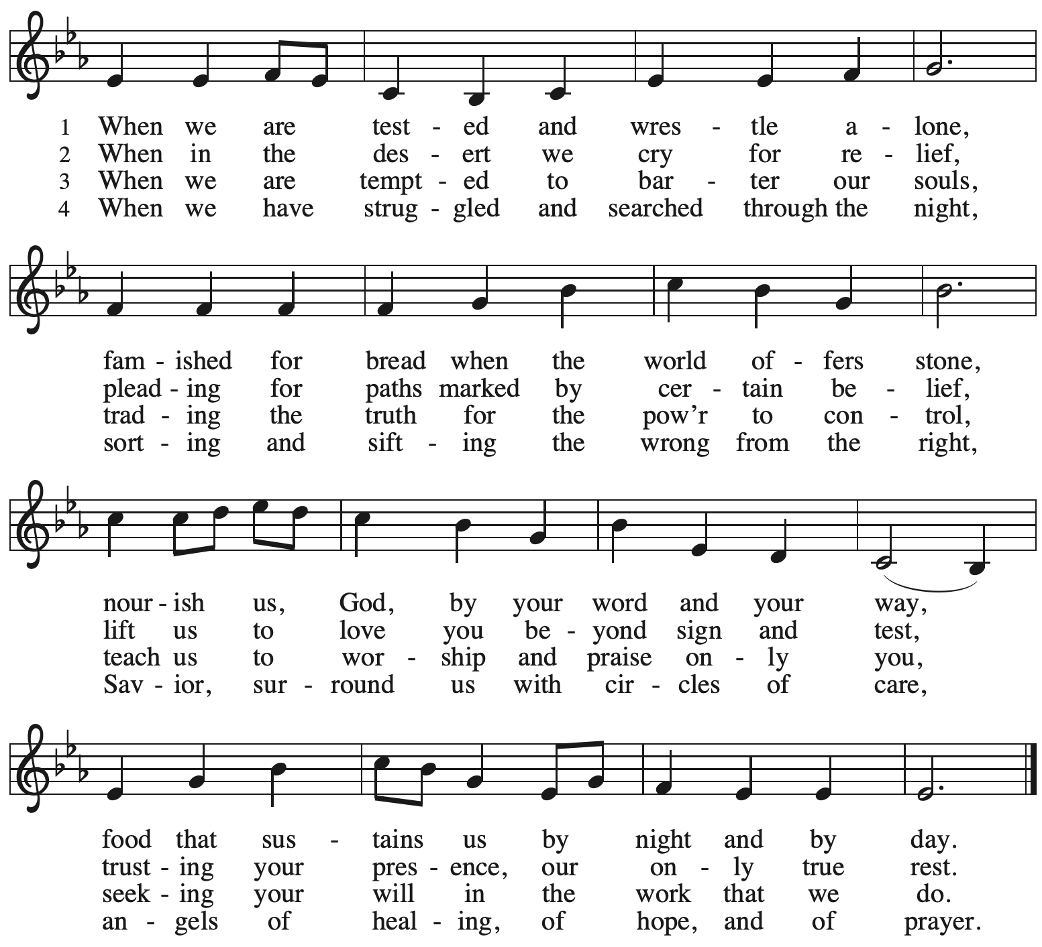

Apostles Creed

C: I believe in God, the Father almighty,
creator of heaven and earth.

I believe in Jesus Christ, God’s only Son, our Lord,
who was conceived by the Holy Spirit,
born of the virgin Mary,
suffered under Pontius Pilate,
was crucified, died, and was buried;
he descended to the dead.*
On the third day he rose again;
he ascended into heaven,
he is seated at the right hand of the Father,
and he will come to judge the living and the dead.

I believe in the Holy Spirit,
the holy catholic church,
the communion of saints,
the forgiveness of sins,
the resurrection of the body,
and the life everlasting. Amen.

*Or, “he descended into hell,” another translation of this text in widespread use.

Prayers of the People

A: Sustained by God’s abundant mercy, let us pray for the church, the world,
and all who are in need.

After each petition
A: Merciful God,
C: receive our prayer.

The presiding minister concludes the prayers:
P: We lift our prayers to you, O God,
trusting in your steadfast love
and your promise to renew all creation;
through Jesus Christ, our Savior and Lord.
C: Amen.

Peace

The presiding minister and the assembly greet one another in the peace of the risen Christ.
P: The peace of Christ be with you always.
C: And also with you.

The people may greet those around them with a sign of Christ’s peace and may say
Peace be with you or similar words. Please be mindful that not everyone will be comfortable with sharing the peace, so please seek consent before shaking hands or hugging. Other possible ways to share the peace include a simple bow with the verbal greeting of peace, or simply a verbal expression of peace.

When the greetings of peace have concluded, please be seated.

Meal
God feeds us with the presence of Jesus Christ

Offering

We offer ourselves, our gifts, and our faithful service to God.
As the offering is gathered for the mission of the church, including the care of those in need,
the table is set for Holy Communion.

Music during the Offering

As the gifts are brought forward for presentation, please rise as you are able.

Offertory Song

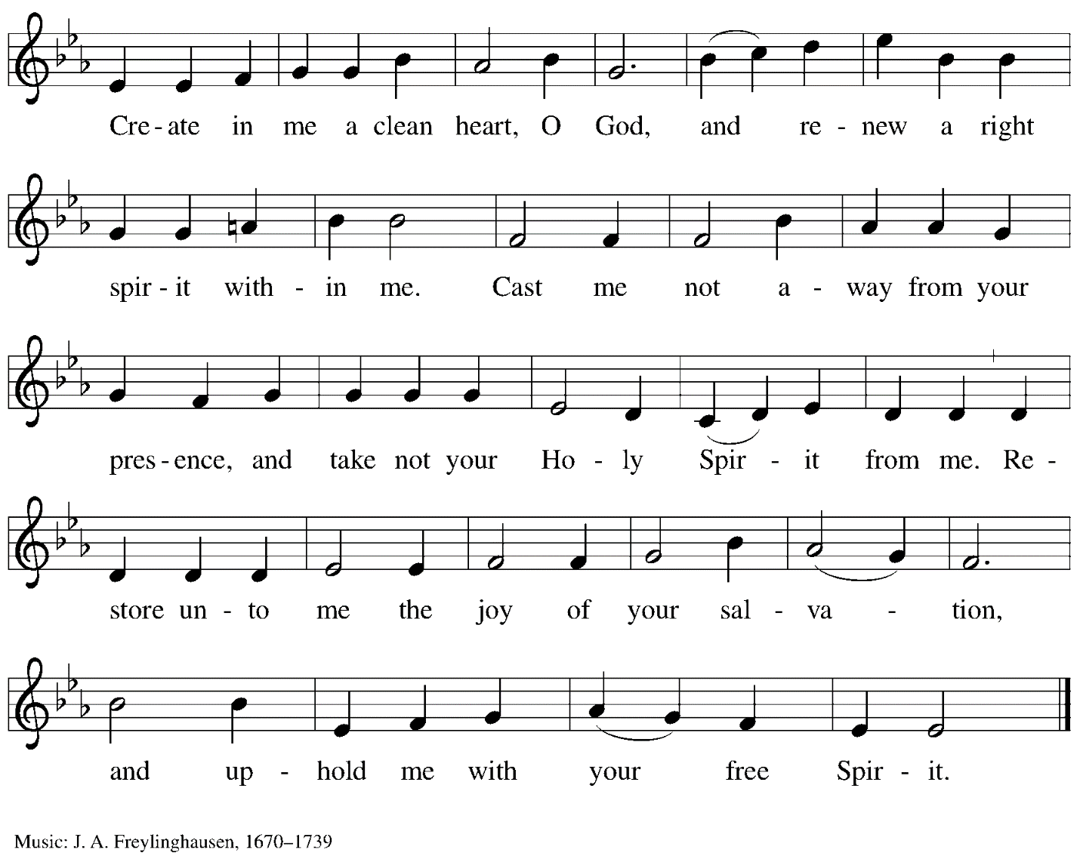

Offertory Prayer

A: Let us pray.
God our provider,
C: you have not fed us with bread alone
but with words of grace and life.
Bless us, and these your gifts,
which we receive from your bounty,
through Jesus Christ our Lord.
Amen.

Dialogue

P: The Lord be with you.
C: And also with you.

P: Lift up your hearts.
C: We lift them to the Lord.

P: Let us give thanks to the Lord our God.
C: It is right to give our thanks and praise.

Preface

P: It is indeed right, our duty and our joy …
… we praise your name and join their unending hymn:

Sanctus

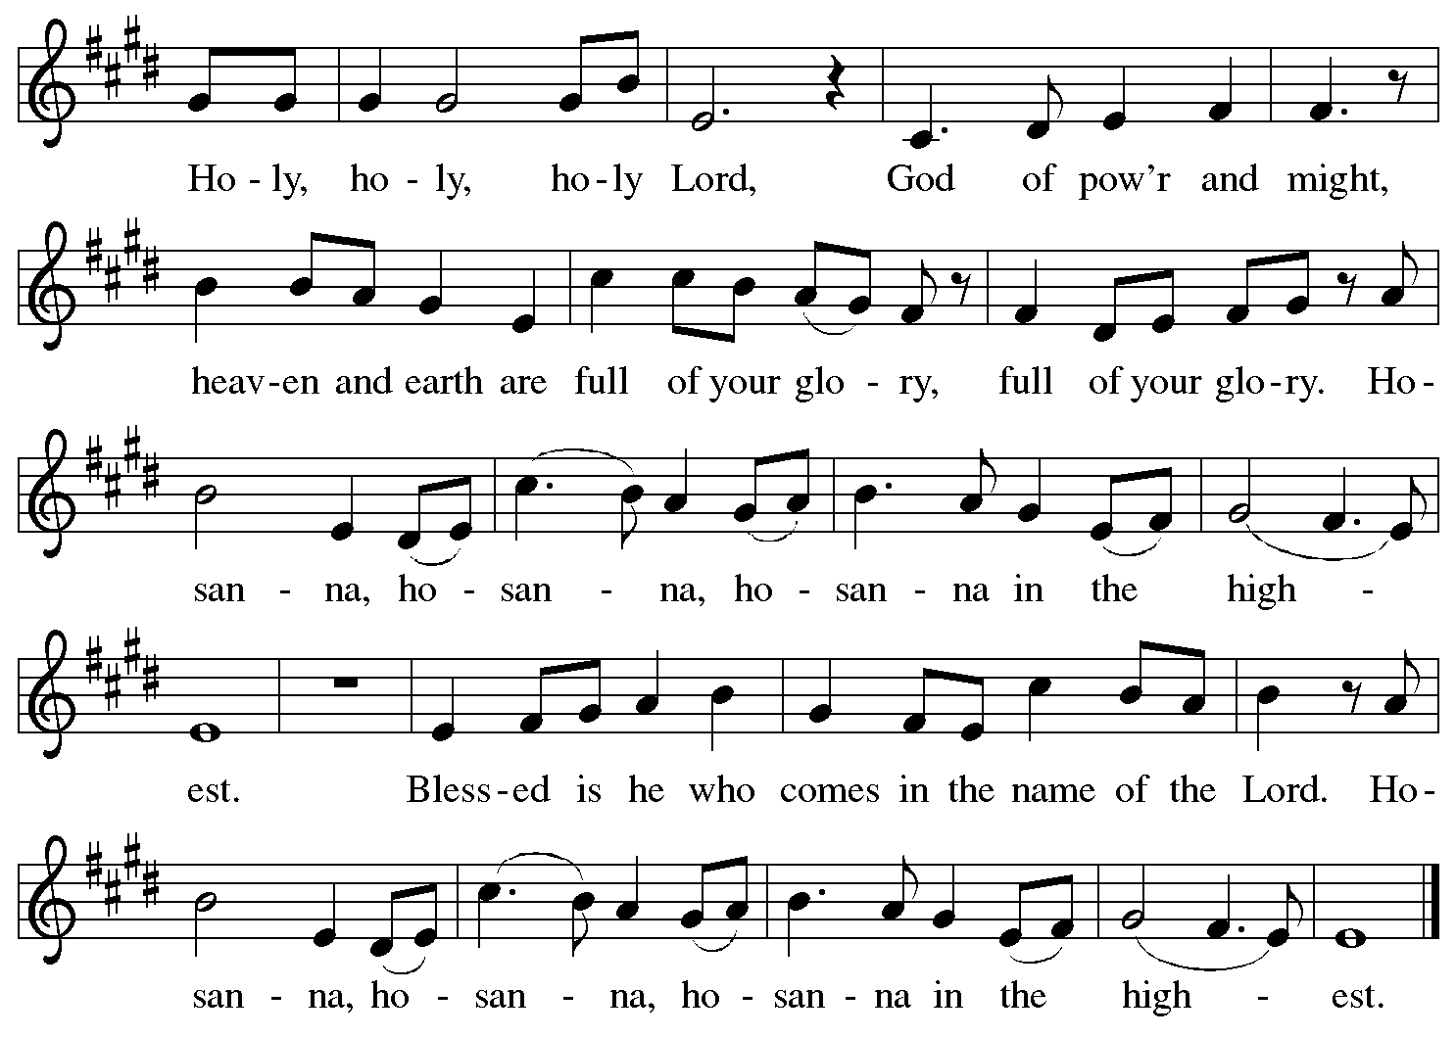

Eucharistic Prayer

P: Blessed are you, O God of the universe,
Your mercy is everlasting
and your faithfulness endures from age to age.

Praise to you for creating the heavens and the earth.
Praise to you for saving the earth from the waters of the flood.
Praise to you for bringing the Israelites safely through the sea.
Praise to you for leading your people through the wilderness
to the land of milk and honey.
Praise to you for the words and deeds of Jesus, your anointed one.
Praise to you for the death and resurrection of Christ.
Praise to you for your Spirit poured out on all nations.

P: In the night in which he was betrayed,
our Lord Jesus took bread, and gave thanks;
broke it, and gave it to his disciples, saying:
Take and eat; this is my body, given for you.
Do this for the remembrance of me.

Again, after supper, he took the cup, gave thanks,
and gave it for all to drink, saying:
This cup is the new covenant in my blood,
shed for you and for all people for the forgiveness of sin.
Do this for the remembrance of me.

With this bread and cup
we remember our Lord’s passover from death to life
as we proclaim the mystery of faith:
C: Christ has died.
Christ is risen.
Christ will come again.

P: O God of resurrection and new life:
Pour out your Holy Spirit on us
and on these gifts of bread and wine.
Bless this feast.
Grace our table with your presence.
C: Come, Holy Spirit.

P: Reveal yourself to us in the breaking of the bread.
Raise us up as the body of Christ for the world.
Breathe new life into us.
Send us forth,
burning with justice, peace, and love.
C: Come, Holy Spirit.

P: With your holy ones of all times and places,
with the earth and all its creatures,
with sun and moon and stars,
we praise you, O God,
blessed and holy Trinity,
now and forever.
C: Amen.

Lord’s Prayer

P: Gathered as one by the Holy Spirit, let us pray as Jesus taught us.
C: Our Father in heaven,
hallowed be your name,
your kingdom come,
your will be done,
on earth as in heaven.
Give us today our daily bread.
Forgive us our sins
as we forgive those who sin against us.
Save us from the time of trial
and deliver us from evil.
For the kingdom, the power,
and the glory are yours,
now and forever. Amen.

Fraction and Invitation

P: Come to the table of mercy;
receive God’s gifts of grace.

Agnus Dei/Lamb of God

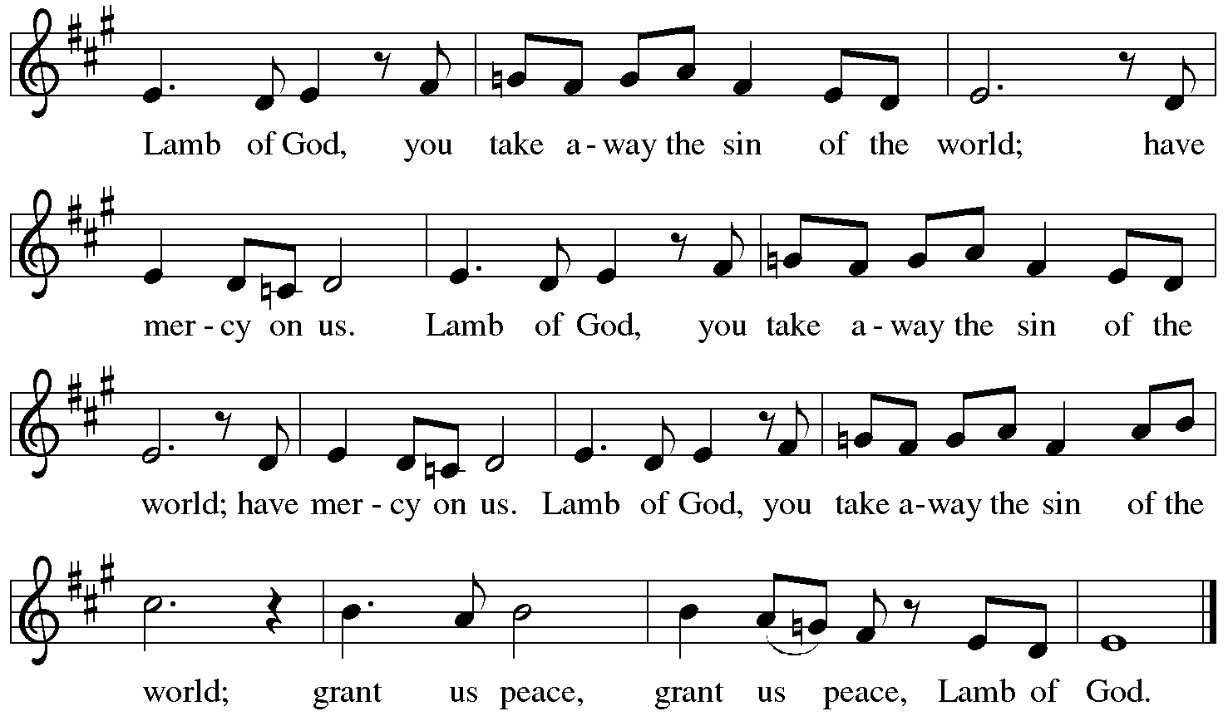

Please be seated.

Holy Communion
- All who seek God and desire a deeper and stronger life in Christ are welcome to receive Holy Communion.
- Worshipers from the pulpit side will proceed forward first, followed by the center section, and then the lectern side.
- Please inform an usher if you would like the ministers to bring Communion to you.
- Holy Communion will be served with bread and wine/grape juice.
- The presiding minister will first distribute the bread (host) to each communicant. Please indicate if you require a gluten-free host.
- Once you have consumed the bread, please pick up an empty glass from the tray next to the presiding minister. The Communion Assistant will pour wine from the chalice or grape juice from the cruet into your glass.
- Please step to the side to consume the wine or grape juice.
- As you return to your pew, glasses may be returned to the empty trays on either side of the center aisle.
- A blessing will be provided for anyone who does not yet receive the sacrament.
- All are invited to join in singing the hymns during Holy Communion.

Hymn during Holy Communion
By Your Hand You Feed Your People ELW 469

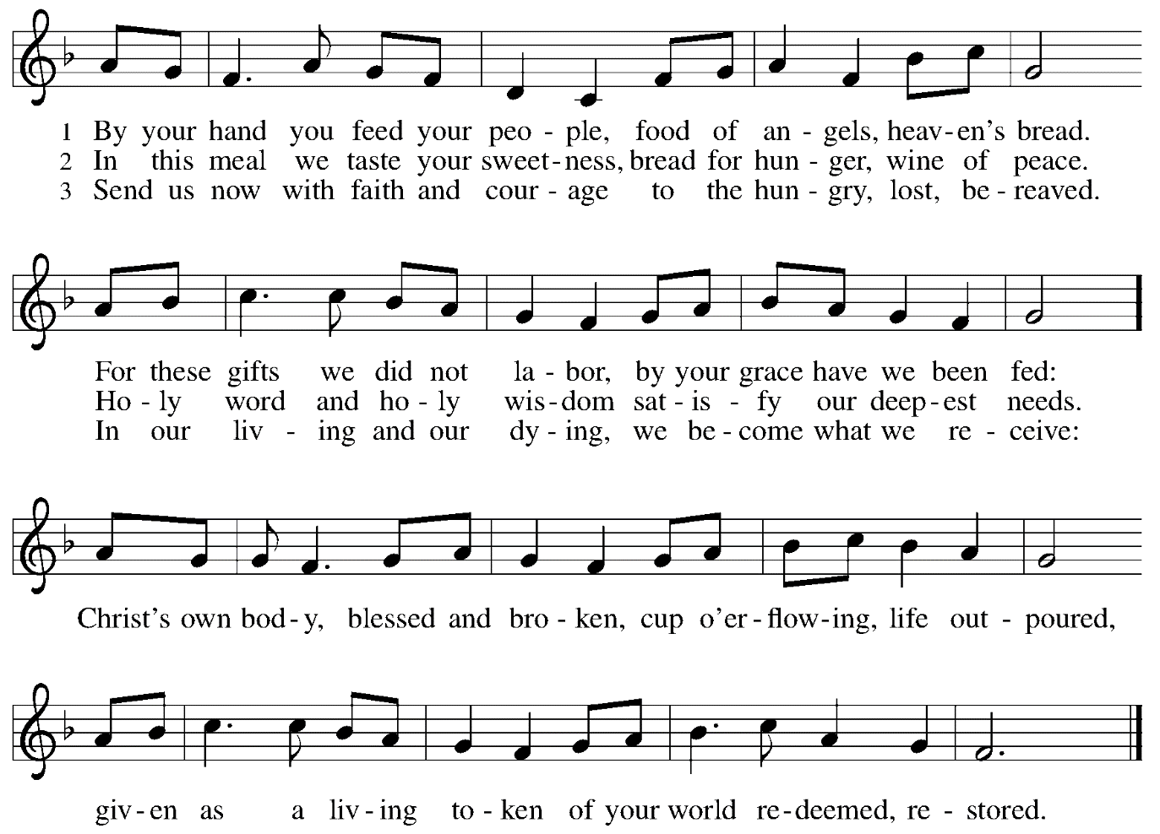

Hymn during Holy Communion
Jesus, Still Lead On ELW 624

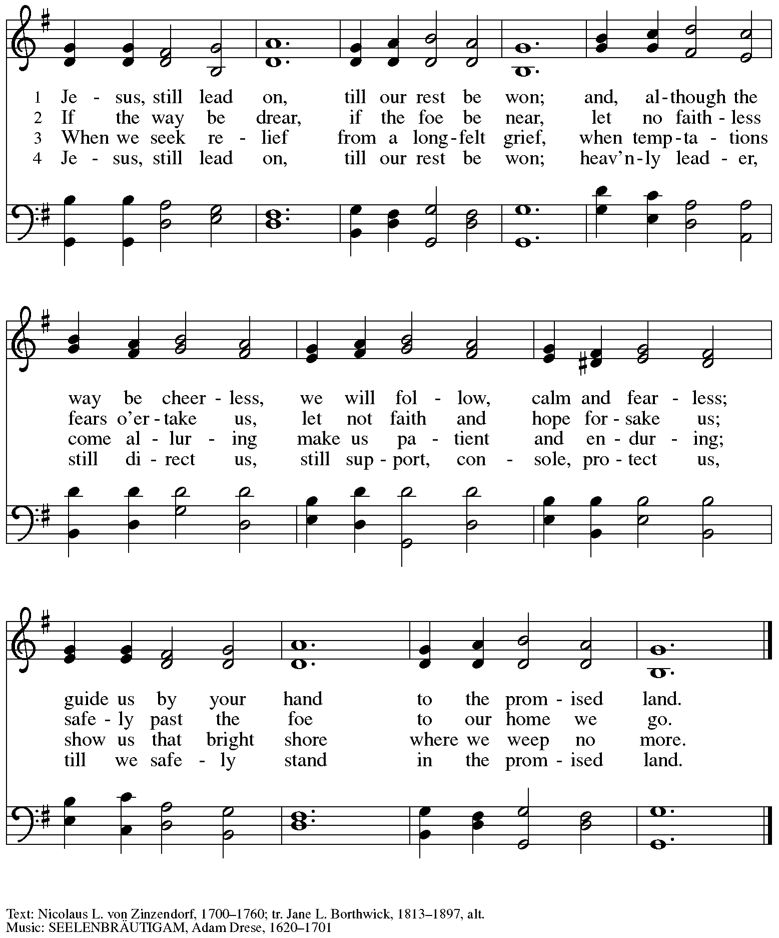

Hymn during Holy Communion
When Peace Like a River ELW 785

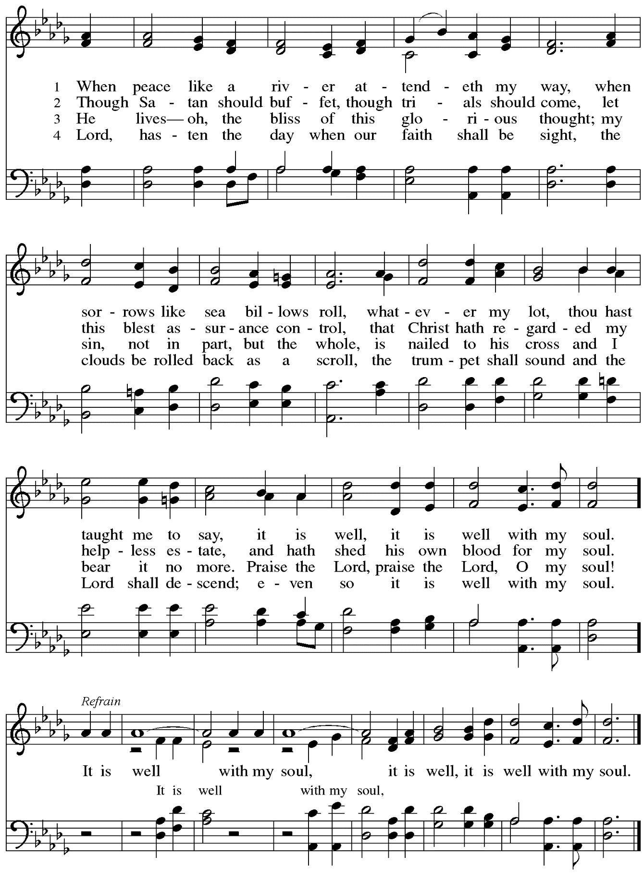
When all have returned to their places, please rise as you are able.

Blessing

P: The body and blood of our Lord Jesus Christ strengthen you and keep you in his grace.
C: Amen.

Prayer

A: Let us pray.
Compassionate God, you have fed us with the bread of heaven.
Sustain us in our Lenten pilgrimage: may our fasting be hunger for justice;
our alms, a making of peace; and our prayer, the song of grateful hearts,
through Jesus Christ, our Savior and Lord.
C: Amen.

Please be seated.

Sending
God blesses us and sends us in mission to the world.

Announcements

Please rise as you are able.

Benediction

P: The God of love; ☩ Christ, the resurrection and the life;
and the Holy Spirit of rebirth, bless you this Lent and always.
C: Amen.

Sending Hymn Bless Now, O God, the Journey Following page

If you picked up a stone from the bowl at the back of the sanctuary, please feel free to come forward and place it with the other rocks and stones at the altar during the Sending Hymn.

Dismissal

A: Go in peace. Serve in love.
C: Thanks be to God.

Sending Hymn Bless Now, O God, the Journey ELW 326

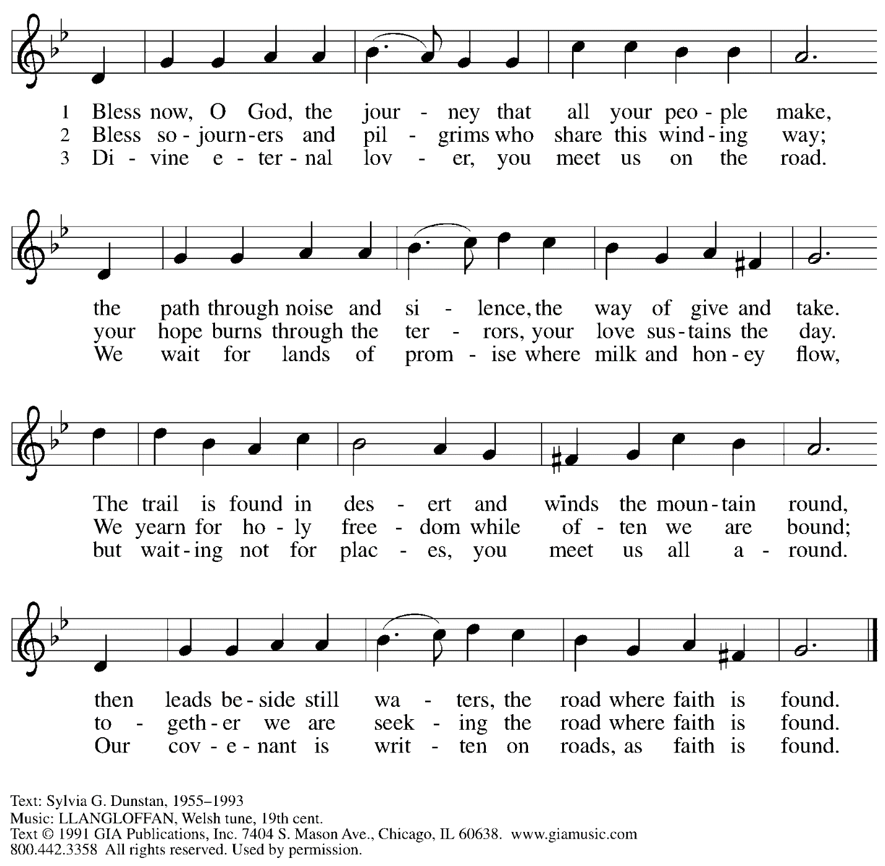
Reprinted under OneLicense.net # A-722139.

Abbreviations

P: Pastor/Presiding Minister
A: Assisting Minister
L: Lector
C: Congregation

ELW: Evangelical Lutheran Worship hymnal
ACS: All Creation Sings hymnal

Those serving in worship today

Assisting Minister Colleen Cooke
Piano Jeff Denlinger
Audio-Visual Ministers Kristen Asplin
Jason Galyardt
Cantor Timothy Kocher-Hillmer
Lector Kelly Spanninger
Preaching and Presiding Minister The Rev. Deborah Byrum

Liturgy and Hymnody Acknowledgements

From SundaysandSeasons.com. Copyright © 2023 Augsburg Fortress. All rights reserved. Reprinted under OneLicense.net # A-722139.
Used by permission of Augsburg Fortress.

As the Sun with Longer Journey – Text: John Patrick Earls, OSB, b. 1935. Music: NAGEL, Carl F. Schalk, b. 1929. Text © 1981 Order of Saint Benedict, admin. Liturgical Press, Collegeville, MN 56321. www.litpress.org. Music © 1995 Augsburg Fortress. All rights reserved. Reprinted with permission under OneLicense.net # A-722139.

When We Are Tested – Text: Ruth Duck, b. 1947. Music: SLANE, Irish traditional. Text © 1996 Hope Publishing Company, Carol Stream, IL 60188. All rights reserved. Reprinted under OneLicense.net # A-722139.

By Your Hand You Feed Your People – Text: Susan Briehl, b. 1952. Music: CAMROSE, Marty Haugen, b. 1950. Text and music © 2002 GIA Publications, Inc., 7404 S. Mason Ave., Chicago, IL 60638. www.giamusic.com. 800.442.3358. All rights reserved. Reprinted with permission under OneLicense.net # A-722139.

When Peace Like a River / It Is Well with My Soul – Text: Horatio G. Spafford, 1828-1888. Music: VILLE DU HAVRE, Philip P. Bliss, 1838-1876.

St. Andrew Lutheran Church Announcements
February 26th, 2023

- Welcome to Worship at St. Andrew on February 26th, 2023, the + First Sunday in Lent – We thank Pastor Deborah Byrum for preaching and presiding in worship today and Jeff Denlinger for leading the music on piano! Masks are optional at St. Andrew when Allegheny County’s Covid-19 community level is in the low and medium categories. Worship attendees are invited to make a name tag at the back of the worship space if you would like. All are invited to gather in the Social Hall after worship for food, drinks, and conversation.
- Unique Variations in Worship This Lent – Centering Music, Theme Hymn, Carrying Stones, and Returning to Sharing Peace – Worship services at St. Andrew will be slightly different throughout the season Lent. Instead of a traditional Prelude, the welcome will be followed by centering music, Now is the Time of Grace, led by the cantor, with the congregation invited to listen, reflect, and join in singing the refrain. We will also return to sharing the peace, hear testimonies on faith in daily life on the second through fifth Sundays, be sent for mission in the world with the theme hymn, Bless Now, O God, the Journey, and invite worshipers to pick up symbolic stones to leave at the altar during the sending each week. We pray for God's blessing as we journey together through this season.
- Water and Spirit: Devotions for Lent 2023 Available at Church Entrances – The season of Lent began on Ash Wednesday, February 22nd. In this time the Church invites us into the Lenten disciplines of fasting (giving something up for Lent), almsgiving (generosity and charitable giving), and prayer. A new resource is available to support the St. Andrew congregation in the discipline of prayer this season. Water and the Spirit: Devotions for Lent 2023 offers simple daily readings, reflections, and prayers from Ash Wednesday through Holy Week. A few are still available at the entrances to the church - please pick one up to aid in your observation of Lent this year.
- Meeting of the Congregation - Sunday, March 5th, after Worship – This first meeting of the year is an opportunity to review the ministry and reports of 2022, to hear updates on what the new council is working toward this year, and to approve updates and amendments to our congregation's constitution. No proxy or absentee votes can be accepted, so please plan to attend. Printed copies of the Annual Report will be available this Sunday for anyone who would like to read it in advance. Those who cannot be here in person are encouraged to attend using the Zoom link found in your “This Week at St. Andrew” email.
- Participate in the Choir Scheduled to Sing during Worship on the Third Sunday in Lent, March 12th – St. Andrew’s choir is next preparing to sing during worship on Sunday, March 12th. All are welcome to take part! There will be two rehearsals, Sunday, March 5th, at 8:30 a.m. and Sunday, March 12th, at 8:30 a.m. The piece is “Prayer for Mercy, based off of Beethoven’s “Moonlight Sonata.” Minister of Music Laura Reynolds has recorded parts to help in your preparation, which can be found here:
https://youtube.com/playlist?list=PLdo3pMOInGpV3Wicm1qi4hNK7CUIM32m-. Please let her know if you’d like to sing and plan to attend the upcoming rehearsals!
- Midweek Worship for Lent – Holden Evening Prayer Available Online Wednesdays, March 1st, 8th, 15th, 22nd, and 29th – During the season of Lent, many take on additional devotional practices, and it has been customary to offer a midweek prayer service each Wednesday prior to Holy Week. This year, several St. Andrew members have recorded a sung service of the Holden Evening Prayer service with Old Testament readings for each week. These videos will be available online at St. Andrew’s pages on Wednesdays, March 1st, 8th, 15th, 22nd, and 29th. We encourage you to access this beautiful service throughout the season.
- Ministry Opportunity – The Community Ministry Committee is seeking help to fill the mini pantry. Volunteer for one time, once a month, once every two months, or as often as you want. Contact Joyce Compton at jcompton28@gmail.com or 412-657-0584 if you have questions or would like to serve in this role.
- Lenten Food Drive – Help Fill St. Andrew’s Mini Free Pantry – We are collecting items for the Pantry during the Lenten season. Grab a brown bag from the back of the sanctuary or from the Social Hall and bring it back to the St. Andrew with an item or two for the pantry (no need to fill the bag completely).
Items should be shelf safe/stable (nothing fresh, frozen or that may go bad in severe weather.) Here are some things we suggest:
- Items in cans with flip top lids: (no items requiring a can opener)
- Tuna, sardines, or Vienna sausage, ravioli, soup that does not need to be diluted.
- Fruit or vegetables in single-serve, shelf safe containers
- Single serve peanut butter, cheese & cracker snacks, granola bars, beef jerky, raisin boxes, little cereal boxes, shelf stable milk (Horizon)
- Personal care items: Shampoo, body wash, deodorant, toothpaste, feminine products, toilet paper
Contact Joyce Compton at jcompton28@gmail.com or 412-657-0584 with questions.
Please return all items by Easter Sunday, April 9th.
- A Celebration of the Legacy of The Rev. Dr. Martin Luther King, Jr. - Sunday, March 26th, 4:00 p.m. – The Southwestern Pennsylvania Synod of the Evangelical Lutheran Church in America will be celebrating the legacy of The Rev. Dr. Martin Luther King, Jr. with an ecumenical service of Holy Communion with Bishops Abraham Allende and Kurt Kusserow presiding and The Rev. Dr. Asa Lee, President of Pittsburgh Theological Seminary, preaching. The event will take place on Sunday, March 26th, at 4:00 p.m. at Berkeley Hills Lutheran Church, 517 Sangree Road, Pittsburgh, PA 15237. Following the service there will be a program on equitable development and housing to accompany this year's theme of "A Home for All in the Beloved Community." Learn more at The Legacy of Dr. Martin Luther King Jr. — Southwestern Pennsylvania Synod (swpasynod.org).

