+ Transfiguration of our Lord
February 19, 2023

St. Andrew Lutheran Church
304 Morewood Ave.
Pittsburgh, PA 15213
St_andrewELCA@verizon.net
www.standrewpittsburgh.org

+ Transfiguration of our Lord
Order for Worship

Today’s festival is a bridge between the Advent-Christmas-Epiphany cycle that comes to a close today and the Lent-Easter cycle that begins in several days. On a high mountain Jesus is revealed as God’s beloved Son, echoing the words at his baptism. This vision of glory sustains us as Jesus faces his impending death in Jerusalem. We turn this week to Ash Wednesday and our yearly baptismal journey from Lent to Easter. We put aside the alleluia at the conclusion of today’s liturgy. This word of joy will be omitted during the penitential season of Lent and will be sung again in the joy of Easter.

- Masks are optional at St. Andrew when Covid-19 community level in Allegheny County is in the low and medium categories.
- Worship Services are live streamed to multiple online platforms. By attending worship, you agree that your image and voice may be broadcast.

The festival of Epiphany and the season that follows emphasize God’s ongoing revelation of Jesus Christ to people of all nations. In this spirit, St. Andrew’s worship music throughout the season will feature hymns and songs that reflect the rich variety of contributions that people of various lands, cultures, and languages have made to the hymnody of the global Christian church. “In sharing one another’s music, we share more than music. Music of various cultures brings us a glimpse of one another’s experience of God. As any culture connects its experience of the holy to its music, a unique context for God’s presence is created – we experience together the way God weaves a varied, diverse tapestry of revelation among us. The church’s song is a great place to experience that sharing.”
Evangelical Lutheran Worship: Musician’s Guide, Augsburg Fortress, 2007. p. 63

Welcome to St. Andrew!
- St. Andrew Lutheran Congregation welcomes all who are seeking a place of healing and wholeness, a nurturing, faith-forming spiritual home. Our community embraces people of all ages, ethnicities, cultures, abilities, sexual orientations, gender identities and expressions, and family constellations. Come and See!
- Everyone is invited to make a nametag at the black bookcase in the back of the worship space if they would like.
- Worship “toolkits” to help children engage with the service are available in the black bookcase at the back of the worship space. There are “reader” and “pre-reader” resources available in each kit. Please feel free to use the kits for/with your children during worship.
- St. Andrew has returned to serving Holy Communion with both (separate) elements, bread and wine/grape juice. The presiding minister will distribute the bread (host). Please consume this and then pick up an empty glass from the tray. The Communion Assistant will pour wine or grape juice into your glass. Please step to the side to consume the wine or grape juice. As you return to your pew, glasses may be returned to the empty trays on either side of the center aisle.
- A restroom is available on the main level of the church, through the doors to the Social Hall and to the right in the main office.

Welcome

Prelude The Song of Twilight Yoshinao Nakada

Gathering
The Holy Spirit calls us together as the people of God.

Please rise as you are able.

P: Blessed be the holy Trinity, ☩ one God,
the fountain of living water,
the rock who gave us birth,
our light and our salvation.
C: Amen.

The presiding minister addresses the assembly
P: Joined to Christ in the waters of Baptism,
we are clothed with God's mercy and forgiveness.
Let us give thanks for the gift of Baptism.

Water may be poured into the font as the presiding minister gives thanks.

P: We give you thanks, O God,
for in the beginning your Spirit moved over the waters
and by your Word you created the world,
calling forth life in which you took delight.

Through the waters of the flood you delivered Noah and his family.
Through the sea you led your people Israel from slavery into freedom.
At the river your Son was baptized by John and anointed with the Holy Spirit.
By water and your Word you claim us as your children,
making us heirs of your promise and servants of all.

We praise you for the gift of water that sustains life,
and above all we praise you for the gift of new life in Jesus Christ.
Shower us with your Spirit,
and renew our lives with your forgiveness, grace, and love.

To you be given honor and praise
through Jesus Christ our Lord
in the unity of the Holy Spirit, now and forever.
C: Amen.

Gathering Hymn O Morning Star, How Fair and Bright! ELW 308
v. 1-3

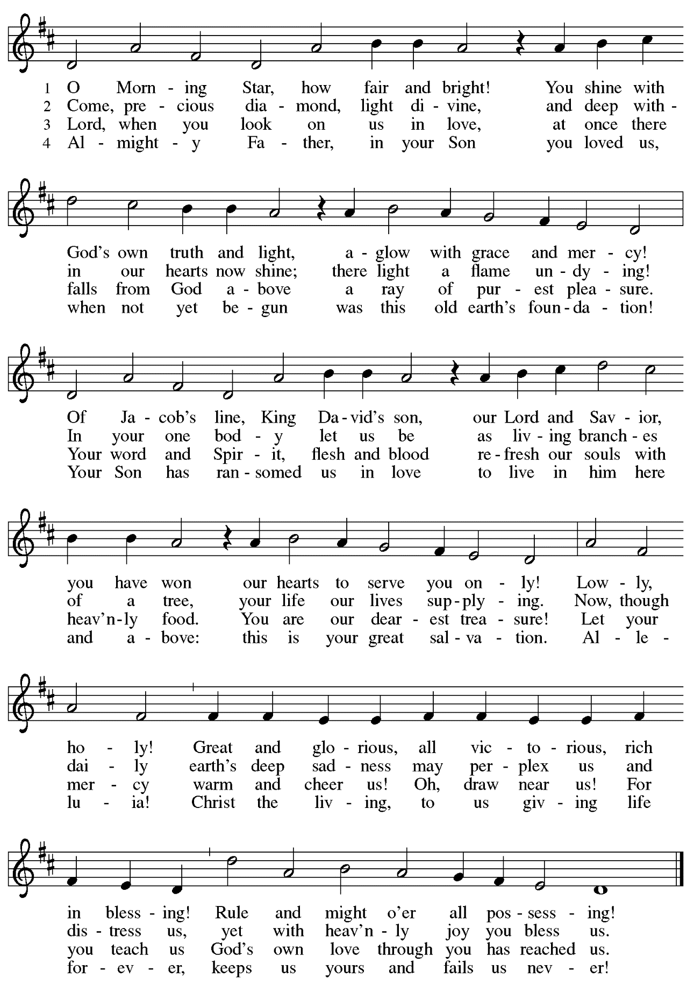
Greeting

P: The grace of our Lord Jesus Christ, the love of God,
and the communion of the Holy Spirit be with you all.
C: And also with you.

Hymn of Praise Glory to God, Glory in the Highest ELW 164

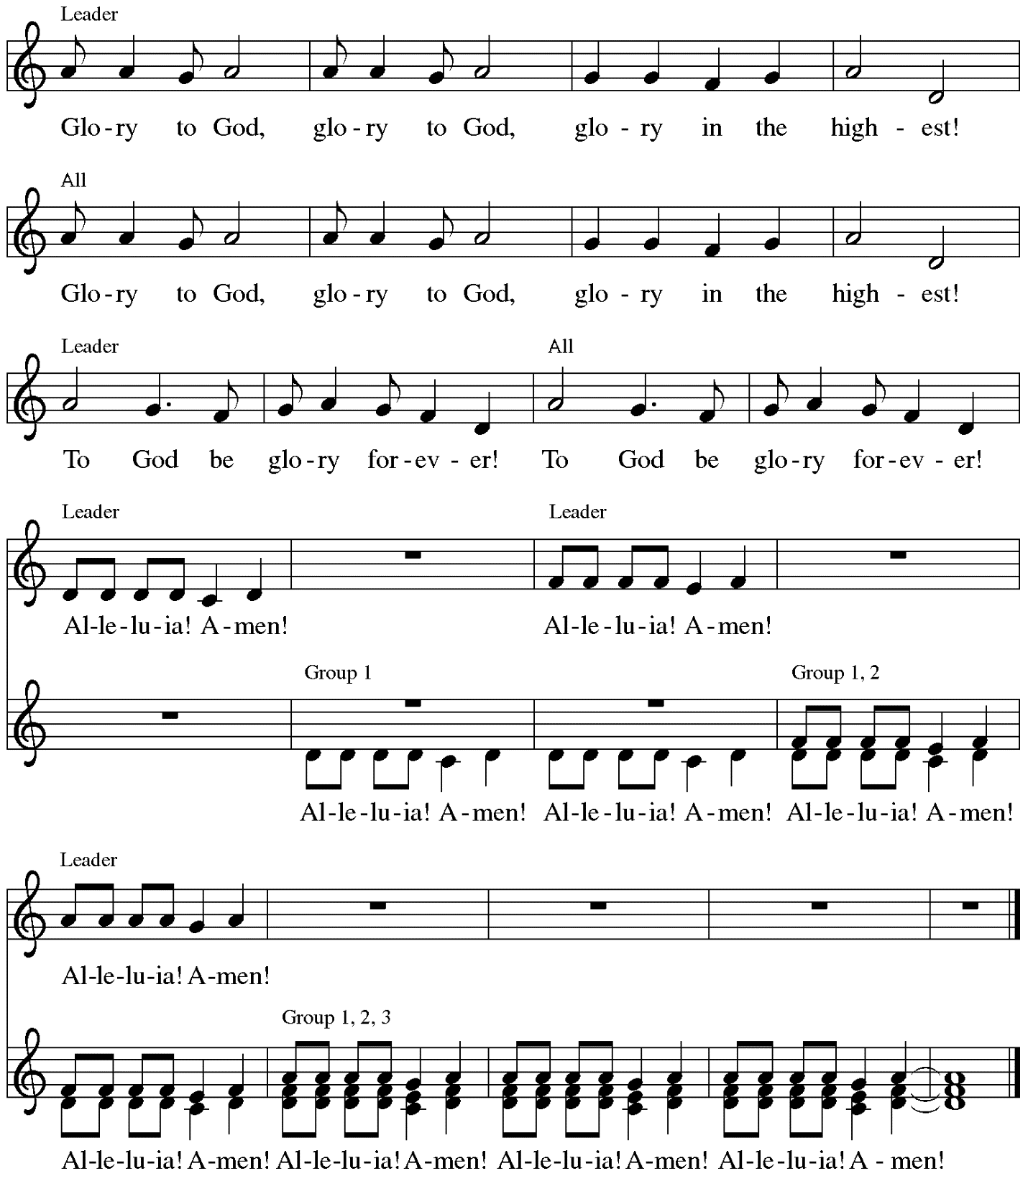

Music: Peruvian traditional

Prayer of the Day

P: The Lord be with you.
C: And also with you.

P: Let us pray.
O God, in the transfiguration of your Son you confirmed the mysteries of the faith by the witness of Moses and Elijah, and in the voice from the bright cloud declaring Jesus your beloved Son, you foreshadowed our adoption as your children. Make us heirs with Christ of your glory, and bring us to enjoy its fullness, through Jesus Christ, our Savior and Lord, who lives and reigns with you and the Holy Spirit, one God, now and forever.
C: Amen.

Please be seated.
Children are invited to join the adult leaders at the door and move to the office for Little Church; Big Faith. We ask that one additional adult from the congregation attend with the children.

Word
God speaks to us in Scripture reading, preaching, and song

First Reading – Exodus 24: 12-18

¹²The Lord said to Moses, “Come up to me on the mountain, and wait there; and I will give you the tablets of stone, with the law and the commandment, which I have written for their instruction.” ¹³So Moses set out with his assistant Joshua, and Moses went up into the mountain of God. ¹⁴To the elders he had said, “Wait here for us, until we come to you again; for Aaron and Hur are with you; whoever has a dispute may go to them.”
¹⁵Then Moses went up on the mountain, and the cloud covered the mountain. ¹⁶The glory of the Lord settled on Mount Sinai, and the cloud covered it for six days; on the seventh day the Lord called to Moses out of the cloud. ¹⁷Now the appearance of the glory of the Lord was like a devouring fire on the top of the mountain in the sight of the people of Israel. ¹⁸Moses entered the cloud, and went up on the mountain. Moses was on the mountain for forty days and forty nights.
L: Word of God, word of life.
C: Thanks be to God.

Psalm 2 Following page

The cantor will lead the singing of the psalm.
The congregation is invited to respond with the alternate verses in bold print,
and to join in singing the refrain.

Psalm tone

Psalm refrain

¹Why are the nations | in an uproar?
Why do the peoples mutter | empty threats?
²Why do the kings of the earth rise up in revolt, and the princes | plot together,
against the Lord and against the | Lord’s anointed?
³“Let us break their | yoke,” they say;
“let us cast off their | bonds from us.”
⁴God whose throne is in heav- | en is laughing;
the Lord holds them | in derision. R
⁵Then in wrath God | speaks to them,
and in rage fills | them with terror.
⁶“As for me, I have anoint- | ed my king
upon Zion, my | holy mountain.”
⁷Let me announce the decree | of the Lord,
who said to me, “You are my son; this day have I be- | gotten you.
⁸Ask of me, and I will give you the nations for | your inheritance
and the ends of the earth for | your possession. R
⁹You shall crush them with an | iron rod
and shatter them like a | piece of pottery.”
¹⁰And now, you | kings, be wise;
be warned, you rulers | of the earth.
¹¹Submit to the | Lord with fear,
and with trembling | bow in worship;
¹²lest the Lord be angry, and you perish in a sudden | blaze of wrath.
Happy are all who take ref- | uge in God! R

Second Reading – 2 Peter 1: 16-21

¹⁶For we did not follow cleverly devised myths when we made known to you the power and coming of our Lord Jesus Christ, but we had been eyewitnesses of his majesty. ¹⁷For he received honor and glory from God the Father when that voice was conveyed to him by the Majestic Glory, saying, “This is my Son, my Beloved, with whom I am well pleased.” ¹⁸We ourselves heard this voice come from heaven, while we were with him on the holy mountain.
¹⁹So we have the prophetic message more fully confirmed. You will do well to be attentive to this as to a lamp shining in a dark place, until the day dawns and the morning star rises in your hearts. ²⁰First of all you must understand this, that no prophecy of scripture is a matter of one’s own interpretation, ²¹because no prophecy ever came by human will, but individuals moved by the Holy Spirit spoke from God.

L: Word of God, word of life.
C: Thanks be to God.

Please rise as you are able.

Gospel Acclamation Heleluyan / Hallelujah ELW 171

Heleluyan, heleluyan; hele, heleluyan.
Heleluyan, heleluyan; hele, heleluyan.

Hallelujah, hallelujah; halle, hallelujah.
Hallelujah, hallelujah; halle, hallelujah.

Music: Muscogee (Creek); transc. Charles H. Webb, b. 1933. Transcription © 1989 The United Methodist Publishing House, admin.
The Copyright Company. Reprinted with permission under OneLicense.net # A-722139.

Gospel – Matthew 17: 1-9

P: The holy Gospel according to St. Matthew.
C: Glory to you, O Lord.
¹Jesus took with him Peter and James and his brother John and led them up a high mountain, by themselves. ²And he was transfigured before them, and his face shone like the sun, and his clothes became dazzling white. ³Suddenly there appeared to them Moses and Elijah, talking with him. ⁴Then Peter said to Jesus, “Lord, it is good for us to be here; if you wish, I will make three dwellings here, one for you, one for Moses, and one for Elijah.” ⁵While he was still speaking, suddenly a bright cloud overshadowed them, and from the cloud a voice said, “This is my Son, the Beloved; with him I am well pleased; listen to him!” ⁶When the disciples heard this, they fell to the ground and were overcome by fear. ⁷But Jesus came and touched them, saying, “Get up and do not be afraid.” ⁸And when they looked up, they saw no one except Jesus himself alone.
⁹As they were coming down the mountain, Jesus ordered them, “Tell no one about the vision until after the Son of Humanity has been raised from the dead.

P: The Gospel of the Lord.
C: Praise to you, O Christ.
Please be seated.

Sermon

A time of silence for prayer and reflection follows the sermon.
When the Hymn of the Day begins, please rise as you are able.

Hymn of the Day Shine, Jesus Shine ELW 671

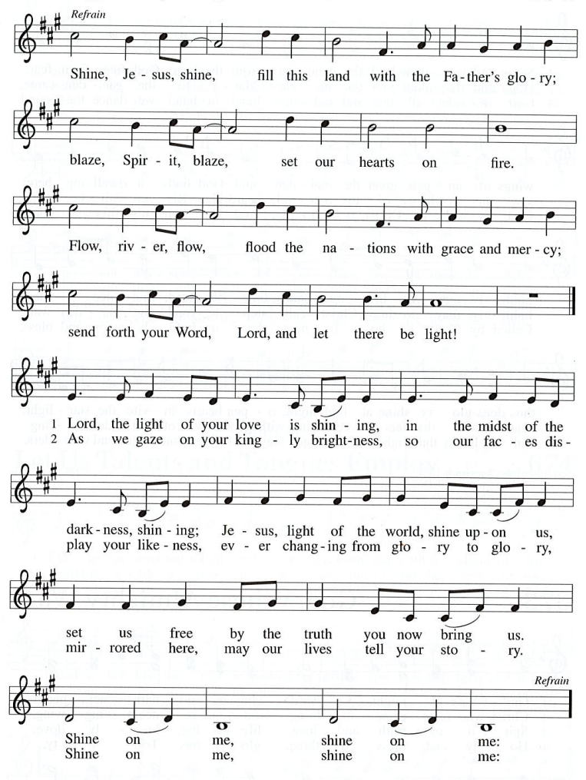
Apostles Creed

C: I believe in God, the Father almighty,
creator of heaven and earth.

I believe in Jesus Christ, God’s only Son, our Lord,
who was conceived by the Holy Spirit,
born of the virgin Mary,
suffered under Pontius Pilate,
was crucified, died, and was buried;
he descended to the dead.*
On the third day he rose again;
he ascended into heaven,
he is seated at the right hand of the Father,
and he will come to judge the living and the dead.

I believe in the Holy Spirit,
the holy catholic church,
the communion of saints,
the forgiveness of sins,
the resurrection of the body,
and the life everlasting. Amen.

*Or, “he descended into hell,” another translation of this text in widespread use.

Prayers of the People

A: Called together to follow Jesus, we pray for the church, the world, and all who are in need.

After each petition
A: Merciful God,
C: receive our prayer.

The presiding minister concludes the prayers:
P: We bring these needs and hope to you, O God,
trusting in your wisdom, grace, and power
revealed in Jesus Christ, our Savior.
C: Amen.

Please be seated.

Meal
God feeds us with the presence of Jesus Christ.

Offering

We offer ourselves, our gifts, and our faithful service to God.
As the offering is gathered for the mission of the church, including the care of those in need,
the table is set for Holy Communion.

Music during the Offering

As the gifts are brought forward for presentation, please rise as you are able
and join in singing the Offertory Song.

Offertory Song ELW 523
Vamos todos al banquete / Let Us Go Now to the Banquet
v. 3

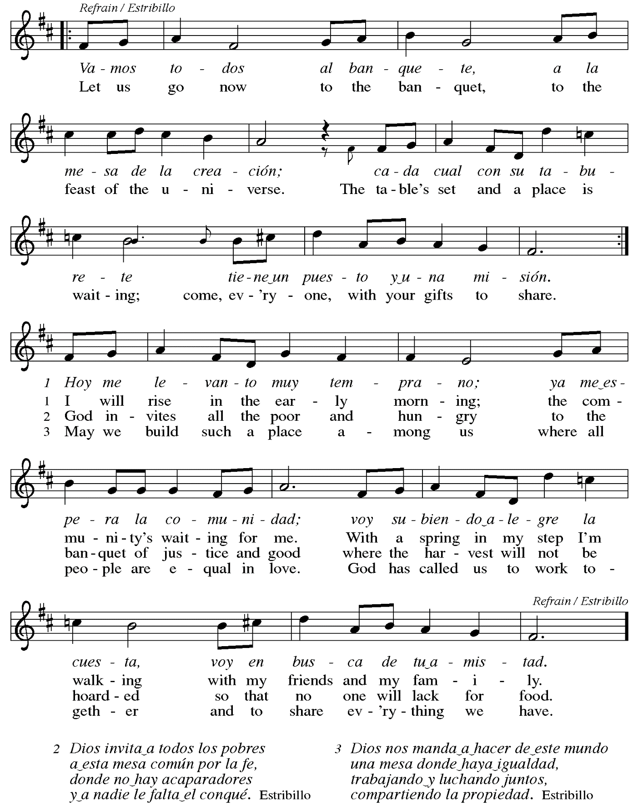

Offertory Prayer

A: Let us pray.
Liberating God,
C: you break the bonds of injustice
and set free those who are oppressed.
Receive these offerings in thanksgiving
for all your deeds of merciful power,
that they may serve in your work of justice and freedom.
You we magnify and adore, through Jesus our Savior.
Amen.

Dialogue

P: The Lord be with you.
C: And also with you.

P: Lift up your hearts.
C: We lift them to the Lord.

P: Let us give thanks to the Lord our God.
C: It is right to give our thanks and praise.

Preface (Spoken by the presiding minister)

P: It is indeed right, our duty and our joy,
that we should at all times and in all places
give thanks and praise to you, almighty and merciful God,
through our Savior Jesus Christ;
who on this day overcame death and the grave,
and by his glorious resurrection opened to us the way of everlasting life.
And so, with all the choirs of angels,
with the church on earth and the hosts of heaven,
we praise your name and join their unending hymn:

Sanctus Santo, Santo, Santo ELW 762
Refrain Only

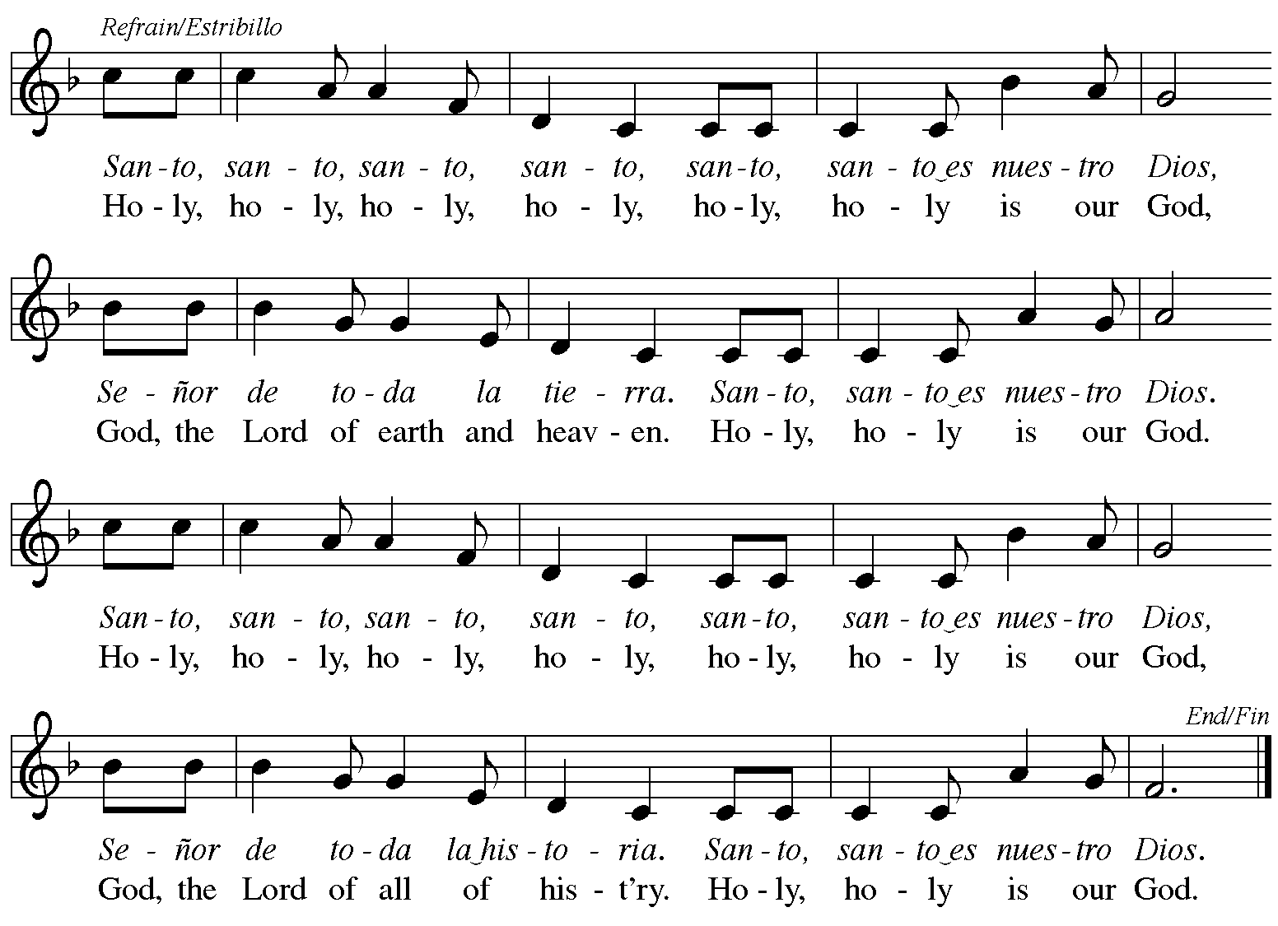
Reprinted with permission under OneLicense.net # A-722139.

Eucharistic Prayer

P: Blessed are you, O God,
creator of heaven and earth.
You rescued your covenant people,
led them on all their journeys,
and taught them by the prophets.
You so loved the world
that you gave your only Son,
so that everyone who believes in him
may not perish but may have eternal life.

In the night in which he was betrayed,
our Lord Jesus took bread,
and gave thanks; broke it,
and gave it to his disciples,
saying: Take and eat;
this is my body, given for you.
Do this for the remembrance of me.

Again, after supper,
he took the cup, gave thanks,
and gave it for all to drink,
saying: This cup
is the new covenant in my blood,
shed for you and for all people
for the forgiveness of sin.
Do this for the remembrance of me.

As often as we eat this bread
and drink this cup,
we proclaim the Lord’s death
until he comes.
C: Christ has died.
Christ is risen.
Christ will come again.

P: Pour out your Holy Spirit
in this meal and make us one,
in this community of faith
and with your people throughout the world.

Glory and praise to you, O God,
Author of Life,
Word made flesh,
Power of the Most High,
now and forever.
C: Amen.

Lord’s Prayer

P: Gathered as one by the Holy Spirit, let us pray as Jesus taught us.
C: Our Father in heaven,
hallowed be your name,
your kingdom come,
your will be done,
on earth as in heaven.
Give us today our daily bread.
Forgive us our sins
as we forgive those who sin against us.
Save us from the time of trial
and deliver us from evil.
For the kingdom, the power,
and the glory are yours,
now and forever. Amen.

Fraction and Invitation

P: These are the gifts of God for the people of God.
Come, share the feast.

Agnus Dei Lamb of God TFF 35

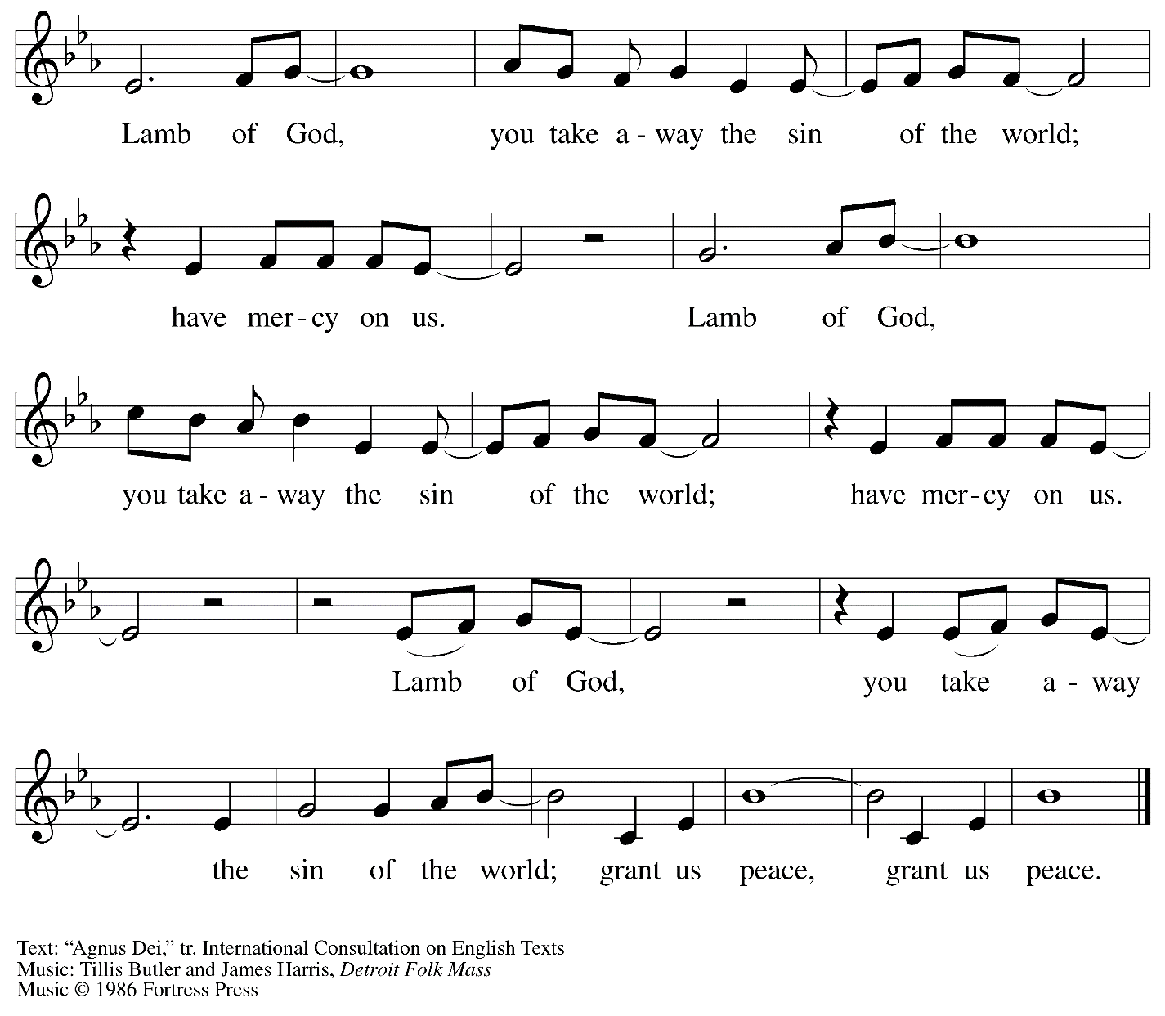
All rights reserved. Reprinted with permission under OneLicense.net # A-722139.

Please be seated.

Holy Communion
- All who seek God and desire a deeper and stronger life in Christ are welcome to receive Holy Communion.
- Worshipers from the pulpit side will proceed forward first, followed by the center section, and then the lectern side.
- Please inform an usher if you would like the ministers to bring Communion to you.
- Holy Communion will be served with bread and wine/grape juice.
- The presiding minister will first distribute the bread (host) to each communicant. Please indicate if you require a gluten-free host.
- Once you have consumed the bread, please pick up an empty glass from the tray next to the presiding minister. The Communion Assistant will pour wine from the chalice or grape juice from the cruet into your glass.
- Please step to the side to consume the wine or grape juice.
- As you return to your pew, glasses may be returned to the empty trays on either side of the center aisle.
- A blessing will be provided for anyone who does not yet receive the sacrament.
- All are invited to join in singing the hymns during Holy Communion.

Hymn during Holy Communion
Beautiful Savior ELW 838

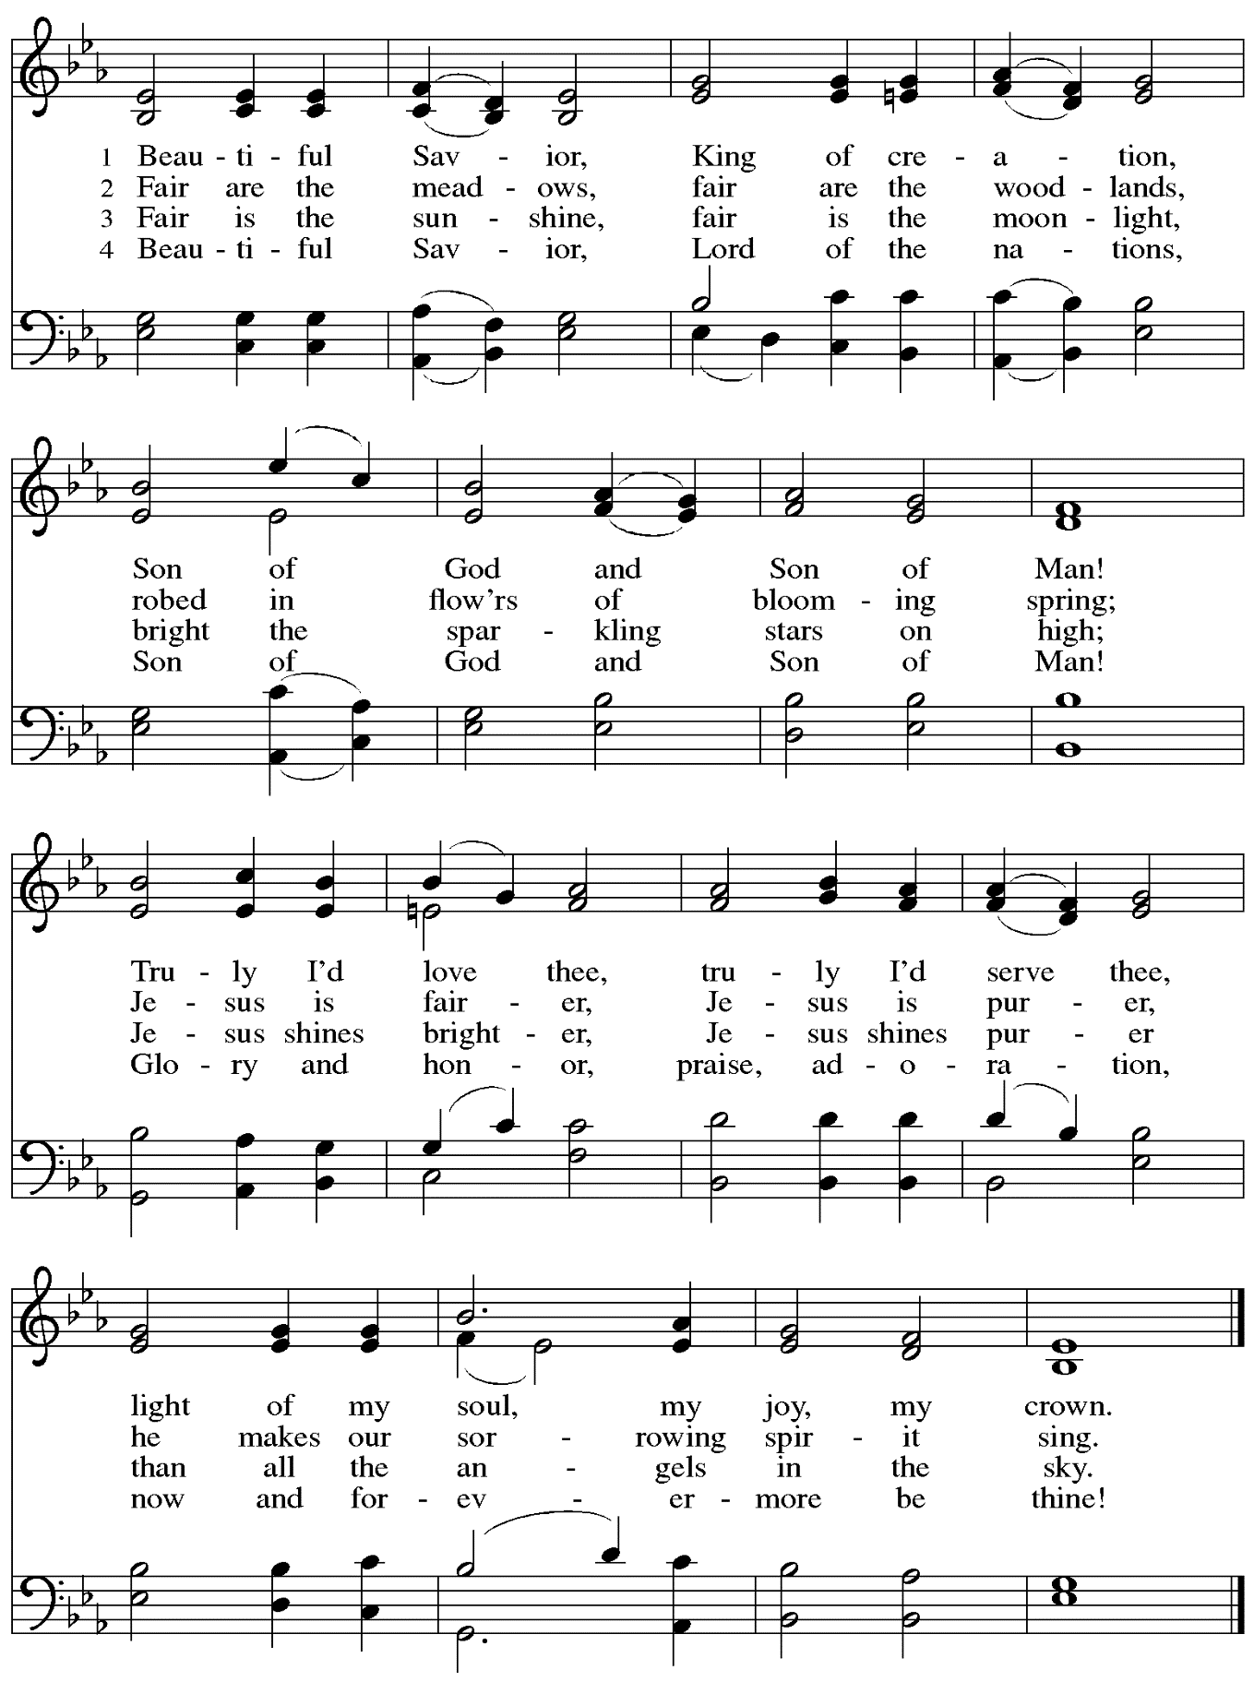
Hymn during Holy Communion
Bread of Life from Heaven ELW 474

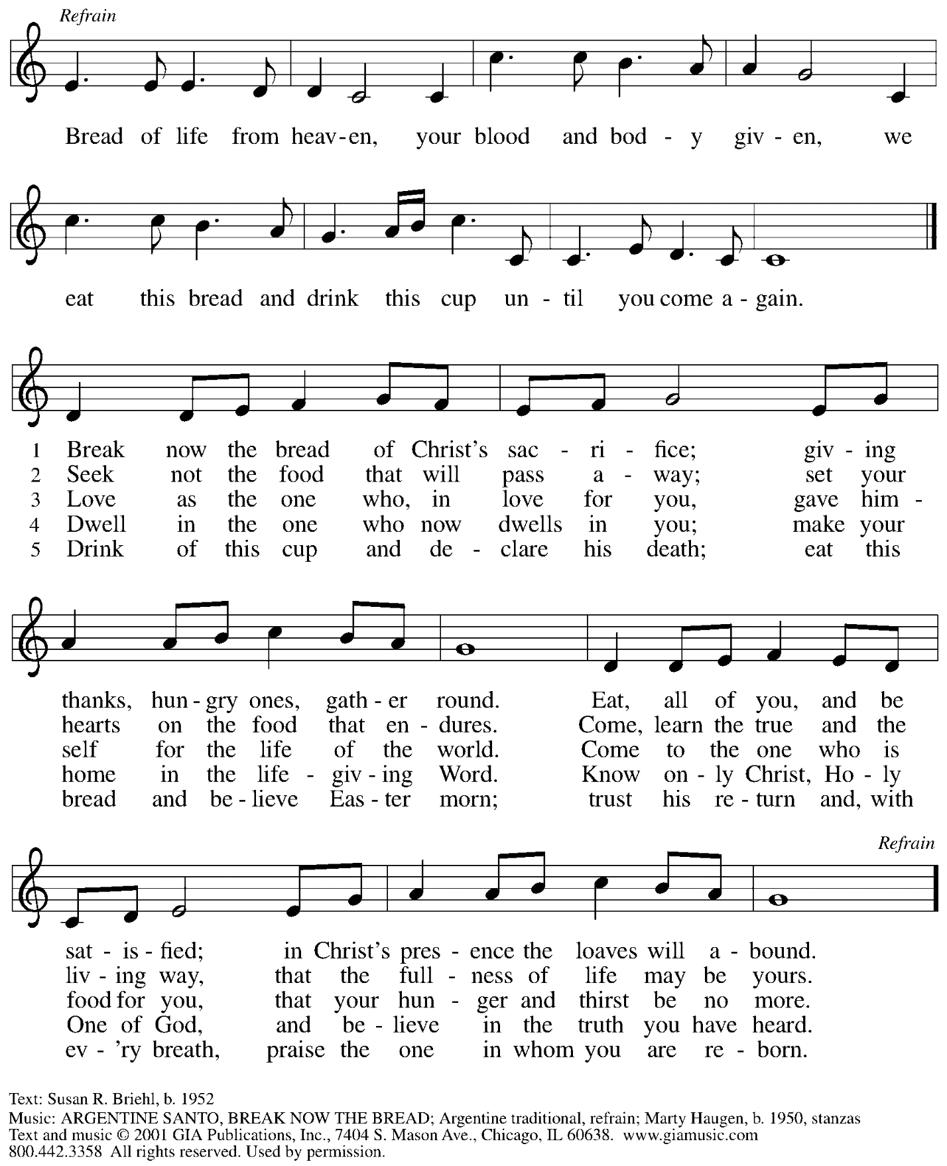
Reprinted with permission under OneLicense.net # A-722139.
Hymn during Holy Communion
In Thee Is Gladness ELW 867

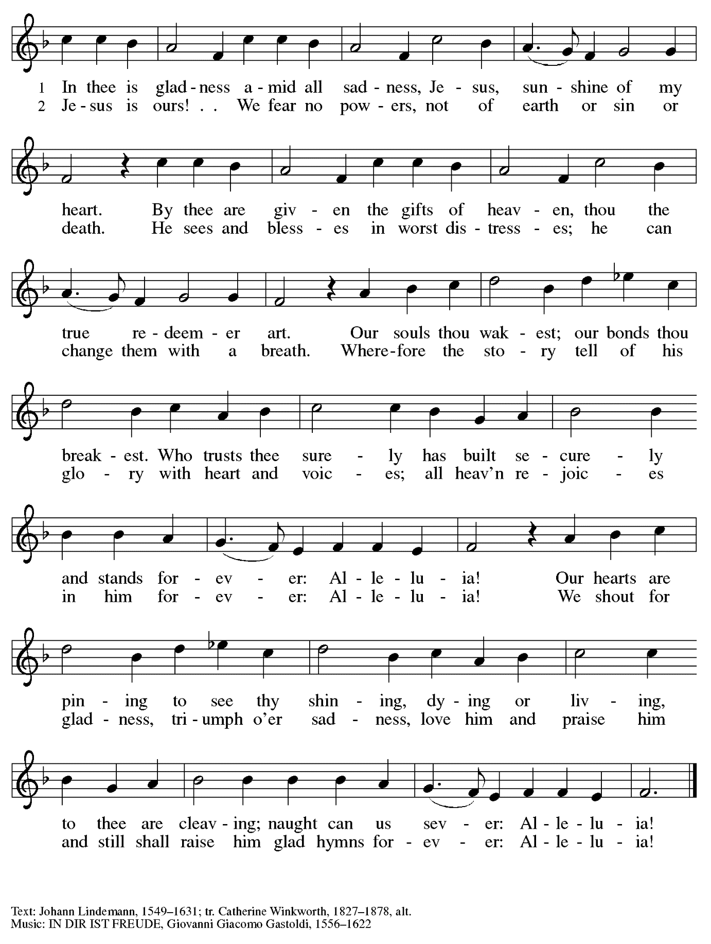
When all have returned to their places, please rise as you are able.

Blessing

P: The body and blood of our Lord Jesus Christ strengthen you and keep you in his grace.
C: Amen.

Prayer

A: Let us pray.

A: Holy One,
we thank you for the healing
that springs forth abundantly from this table.
Renew our commitment to do justice, love kindness,
and journey humbly with you,
through Jesus Christ, our Savior and Lord.
C: Amen.

Please be seated.

Sending
God blesses us and sends us in mission to the world.

Announcements

Please rise as you are able.

Benediction

P: The Lord bless you and keep you.
The Lord’s face shine on you
with grace and mercy.
The Lord look upon you with favor
and ☩ give you peace.
C: Amen.

Sending Hymn Alleluia, Song of Gladness Following page

Dismissal

A: Go in peace. Serve the Lord.
C: Thanks be to God!

Sending Hymn Alleluia, Song of Gladness ELW 318

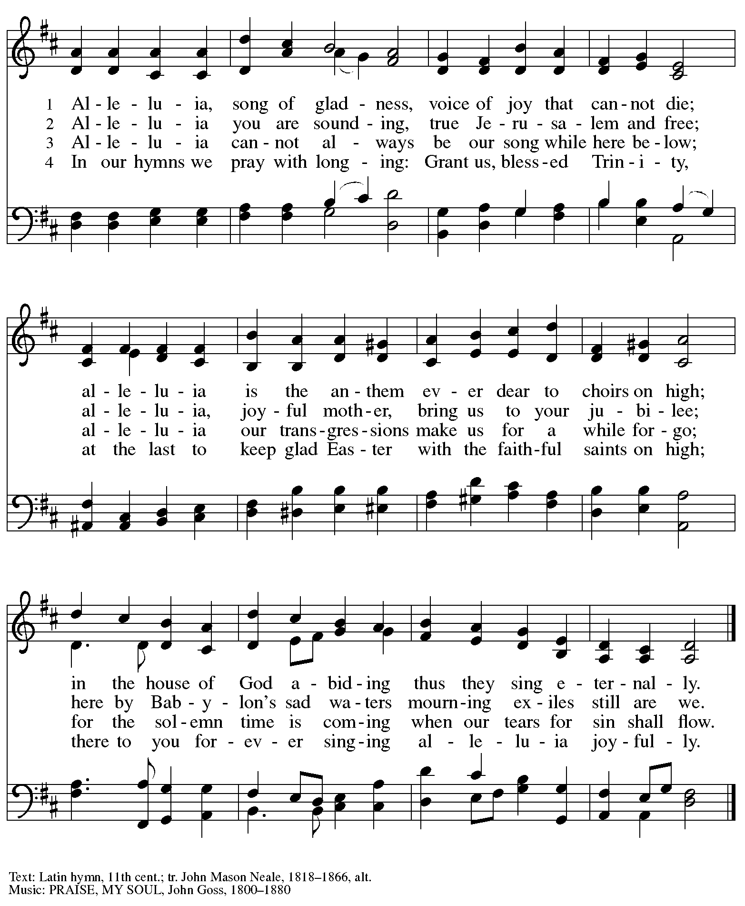

Abbreviations

P: Pastor/Presiding Minister
A: Assisting Minister
L: Lector
C: Congregation

ELW: Evangelical Lutheran Worship hymnal
TFF: This Far by Faith hymnal
ACS: All Creation Sings hymnal

Those serving in worship today

Prelude Sarita Doshi
Assisting Minister Timothy Kocher-Hillmer
Audio Visual Ministers Kristen Asplin
Joseph Paetz
Cantor David Rollinson
Lector Michael Chapman
Minister of Music Laura Reynolds
Presiding Minister The Rev. Ross I. Carmichael

Liturgy and Hymnody Acknowledgements

From SundaysandSeasons.com. Copyright © 2023 Augsburg Fortress. All rights reserved. Reprinted under OneLicense.net # A-722139.
Used by permission of Augsburg Fortress.

O Morning Star, How Fair and Bright! – Text: Philipp Nicolai, 1556-1608; tr. Lutheran Book of Worship. Music: WIE SCHÖN LEUCHTET, Philipp Nicolai. Text © 1978 Lutheran Book of Worship, admin. Augsburg Fortress. All rights reserved. Reprinted with permission under OneLicense.net # A-722139.

Shine, Jesus, Shine – Text: Graham Kendrick, b. 1950. Music: SHINE, JESUS, SHINE, Graham Kendrick. Text and music © 1987 Make Way
Music. All rights reserved. Reprinted with permission under CCLI # 11561207.

Vamos todos al banquete / Let Us Go Now to the Banquet – Text: Guillermo Cuéllar, b. 1955, Misa popular salvadoreña; tr. Bret Hesla, b. 1957, and William Dexheimer Pharris, b. 1956. Music: VAMOS TODOS AL BANQUETE, Guillermo Cuéllar, b. 1955. Text and music © 1994, 1996 GIA Publications, Inc., 7404 S. Mason Ave., Chicago, IL 60638. www.giamusic.com. 800.442.3358. All rights reserved. Reprinted with permission under OneLicense.net #A-722139.

Beautiful Savior – Text: Gesangbuch, Münster, 1677; tr. Joseph A. Seiss, 1823-1904. Music: SCHÖNSTER HERR, JESU, Silesian folk tune, 19th cent.

St. Andrew Lutheran Church Announcements
February 19th, 2023

- Welcome to Worship at St. Andrew on February 19th, 2023, the + Transfiguration of our Lord – We are so glad you are here! Masks are optional at St. Andrew when Allegheny County’s Covid-19 community level is in the low and medium categories. Worship attendees are invited to make a name tag at the back of the worship space if you would like. All are welcome to a time of coffee and conversation in the Social Hall after worship.
- Farewell to the "Alleluia" and Burning of Palms Outside after Worship Today – As the season after Epiphany concludes, we sing the Church's song of Easter joy, “Alleluia,” once more before putting it away during the season of Lent, which begins on Ash Wednesday, February 22nd. We invite everyone to gather outside at the back of the church, in the lower yard or on the ramps, right after worship today. We will offer a brief liturgy of farewell to the Alleluia and the burning of palms from last Palm Sunday to make the ashes for Ash Wednesday.
- Water and Spirit: Devotions for Lent 2023 Available at Church Entrances – The season of Lent begins with Ash Wednesday, and in this time the Church invites us into the Lenten disciplines of fasting (giving something up for Lent), almsgiving (generosity and charitable giving), and prayer. A new resource is available to support the St. Andrew congregation in the discipline of prayer this season. Water and the Spirit: Devotions for Lent 2023 offers simple daily readings, reflections, and prayers from Ash Wednesday through Holy Week. These are available at each entrance to the church - please pick one up to aid in your observation of Lent.
- Worship for + Ash Wednesday, February 22nd, 7:00 p.m. – The observance of + Ash Wednesday marks the beginning of the season of Lent, a 40-day season of baptismal reflection and preparation for the celebration of the resurrection at Easter. St. Andrew will offer worship with Holy Communion and the Imposition of Ashes at 7:00 p.m. that day. The service will also be streamed online to Zoom, Facebook, and YouTube.
- Congregational Meeting – Sunday, March 5th, after Worship – As announced via email or mailed letter in January, St. Andrew’s next meeting of the congregation will be held on Sunday, March 5th, after worship. We will provide a Zoom link for those who cannot be at the church in person. At this meeting, we review the ministries and financial reports from the previous year and provide an update on ongoing and upcoming ministries and initiatives. At this meeting, we will also review changes to the constitution of the congregation that were sent in January. No absentee or proxy votes can be accepted, so please plan to attend!
- Participate in the Choir Scheduled to Sing during Worship on the Third Sunday in Lent, March 12th – St. Andrew’s choir is next preparing to sing during worship on Sunday, March 12th. All are welcome to take part! There will be two rehearsals, Sunday, March 5th, at 8:30 a.m. and Sunday, March 12th, at 8:30 a.m. The piece is “Prayer for Mercy, based off of Beethoven’s “Moonlight Sonata.” Minister of Music Laura Reynolds has recorded parts to help in your preparation, which can be found here:
https://youtube.com/playlist?list=PLdo3pMOInGpV3Wicm1qi4hNK7CUIM32m-. Please let her know if you’d like to sing and plan to attend the upcoming rehearsals!
- Ministry Opportunity – The Community Ministry Committee is seeking help to fill the mini pantry. Volunteer for one time, once a month, once every two months, or as often as you want. Contact Joyce Compton at jcompton28@gmail.com or 412-657-0584 if you have questions or would like to serve in this role.
- Lenten Food Drive – Help Fill St. Andrew’s Mini Free Pantry – We are collecting items for the Pantry during the Lenten season. Grab a brown bag from the back of the sanctuary or from the Social Hall and bring it back to the St. Andrew with an item or two for the pantry (no need to fill the bag completely).
Items should be shelf safe/stable (nothing fresh, frozen or that may go bad in severe weather.) Here are some things we suggest:
- Items in cans with flip top lids: (no items requiring a can opener)
- Tuna, sardines, or Vienna sausage, ravioli, soup that does not need to be diluted.
- Fruit or vegetables in single-serve, shelf safe containers
- Single serve peanut butter, cheese & cracker snacks, granola bars, beef jerky, raisin boxes, little cereal boxes, shelf stable milk (Horizon)
- Personal care items: Shampoo, body wash, deodorant, toothpaste, feminine products, toilet paper
Contact Joyce Compton at jcompton28@gmail.com or 412-657-0584 with questions.
Please return all items by Easter Sunday, April 9th.
- Midweek Worship for Lent – Holden Evening Prayer Available Online – During the season of Lent, many take on additional devotional practices, and it has been customary to offer a midweek prayer service each Wednesday prior to Holy Week. This year, several St. Andrew members have recorded a sung service of the Holden Evening Prayer service with Old Testament readings for each week. These videos will be available online at St. Andrew’s Facebook and YouTube pages on Wednesdays, March 1st, 8th, 15th, 22nd, and 29th. We encourage you to access this beautiful service throughout the season.
- Bethel AME Church Hosts Lift Every Voice and Sing: Gospel Concert –
A Celebration of Black History Month through Music – Today, Sunday, February 19th, at 3:00 p.m. at Bethel AME Church, 2720 Webster Avenue, Pittsburgh, PA 15219 – The event will feature Rev. James Moore of Bethel AME Church, Bethel AME Church Choir, Bethlehem Baptist Church Choir, Pentecostal Temple Church Music Ministry, and Gospel Music Workshop of America – Pittsburgh Chapter.

