+ Second Sunday in Lent
March 5, 2023

St. Andrew Lutheran Church
304 Morewood Ave.
Pittsburgh, PA 15213
St_andrewELCA@verizon.net
www.standrewpittsburgh.org

+ Second Sunday in Lent
Order for Worship

During Lent we journey with all those around the world who will be baptized at the Easter Vigil. In today’s gospel Jesus tells Nicodemus that he must be born of water and Spirit. At the font we are a given a new birth as children of God. As God made a covenant with Abraham, in Baptism God promises to raise us up with Christ to new life. From worship we are sent forth to proclaim God’s love for all the world.

The season of Lent began on Ash Wednesday. Lent is a 40-day season focused on repentance, spiritual discipline, and baptismal reflection. We acknowledge our vulnerability and mortality, turn from sin, and return to God for forgiveness and renewal. The readings for the season evoke themes of desert and wilderness — Jesus’ 40-day temptation, the Israelites traveling and needing water, a valley of dry bones, the tomb of Lazarus. Instead of lush greenery, we decorate the sanctuary with rocks and stones. Small stones are available at the back of the sanctuary — we encourage everyone to pick one up each week. The stone may be thought of as sin, guilt, burden, whatever you would like to clean out and/or leave behind in order to make room for God and service to neighbor. We invite you to leave these stones with the others at the altar during the Sending Hymn each week, which throughout the season will be Bless Now, O God, the Journey - ELW 326. This hymn reminds us that when we are scattered in our daily lives and responsibilities, wherever we go in faith, God comes to meet us there to bring hope and peace. On the second through fifth Sundays, testimonies by the congregation’s leaders in the Life of Faith Initiative will precede the hymn. They will share about how they see God at work as they serve in their daily vocations and roles throughout the week. May God bless your journey through Lent!

- Masks are optional at St. Andrew when Covid-19 community level in Allegheny County is in the low and medium categories.
- Worship Services are live streamed to multiple online platforms. By attending worship, you agree that your image and voice may be broadcast.

Welcome to St. Andrew!

- St. Andrew Lutheran Congregation welcomes all who are seeking a place of healing and wholeness – a nurturing, faith-forming spiritual home. Our community embraces people of all ages, ethnicities, cultures, abilities, sexual orientations, gender identities and expressions, and family constellations. Come and See!

- Everyone is invited to make a nametag at the black bookcase in the back of the worship space if they would like.

- Worship “toolkits” to help children engage with the service are available in the black bookcase at the back of the worship space. There are “reader” and “pre-reader” resources available in each kit. Please feel free to use the kits for/with your children during worship.

- Little Church – Big Faith, a Bible lesson and activity for children, takes place after the prayer of the day. Children are invited to meet the adult leaders at the side door of the sanctuary to attend.

- This Lenten season, St. Andrew returns to the Sharing of Peace during worship. More than a simple greeting, this practice and placement in the service derives from the Gospel of Matthew 5: 23-24 – “When you are offering your gift at the altar, if you remember that your sibling has something against you, leave your gift there before the altar and go; first be reconciled to your sibling, and then come and offer your gift.” We will once again have an opportunity to share an expression of Christ’s peace with those around us as a liturgical sign of our desire to be reconciled with our neighbors before offering our gifts and receiving Holy Communion. Please be mindful that some people will not be comfortable with sharing the peace; be sure to obtain consent before any physical expression of peace such as shaking hands or hugging.

- St. Andrew has returned to serving Holy Communion with both (separate) elements, bread and wine/grape juice. The presiding minister will distribute the bread (host). Please consume this and then pick up an empty glass from the tray. The Communion Assistant will pour wine or grape juice into your glass. Please step to the side to consume the wine or grape juice. As you return to your pew, glasses may be returned to the empty trays on either side of the center aisle. Please feel free to kneel at the altar for prayer after receiving the sacrament.

- A restroom is available on the main level of the church, through the doors to the Social Hall and to the right in the main office.

Welcome

Gathering
The Holy Spirit calls us together as the people of God

Centering Music Now Is the Time of Grace ACS 918
v. 1-2

The verses will be sung by the cantor.
The congregation is invited to join in singing the refrain.

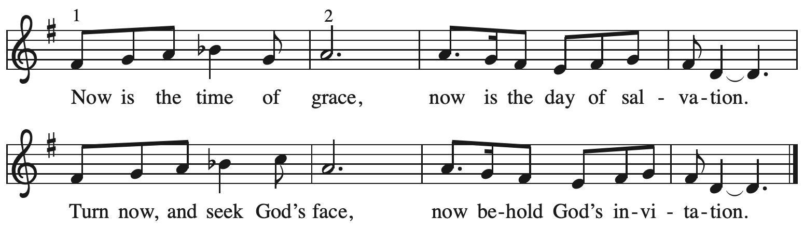

Verses — Leader
1 This is the fast that God would choose:
to loose the bonds of injustice,
to let the captives go free,
and to break the yoke of oppression. Refrain

2 Sharing your bread with the hungry
and welcoming homeless in,
offering hope and offering help,
this is what God requires. Refrain

All rights reserved. Reprinted with permission under OneLicense.net # A-722139.

Please rise as you are able.

Confession and Forgiveness

P: Blessed be the holy Trinity, ☩ one God,
who journeys with us these forty days,
and sustains us with the gift of grace.
C: Amen.

P: Let us acknowledge before God and one another
our need for repentance and God’s mercy.

Silence is kept for reflection.

P: Holy God,
C: we confess to you our faults and failings.
Too often we neglect and do not trust your holy word;
we take for ourselves instead of giving to others;
we spoil rather than steward your creation;
we cause hurt though you call us to heal;
we choose fear over compassion.
Forgive us, renew us, and lead us,
as we seek to follow in your way of life.
Amen.

P: Hear the good news:
God so loved the world that God gave the only Son,
so that all may receive life.
This promise is for you!
God embraces you with divine mercy,
☩ forgives you in Christ’s name,
and revives you in the Spirit’s power.
C: Amen.

Gathering Hymn This Is the Spirit’s Entry Now ELW 448

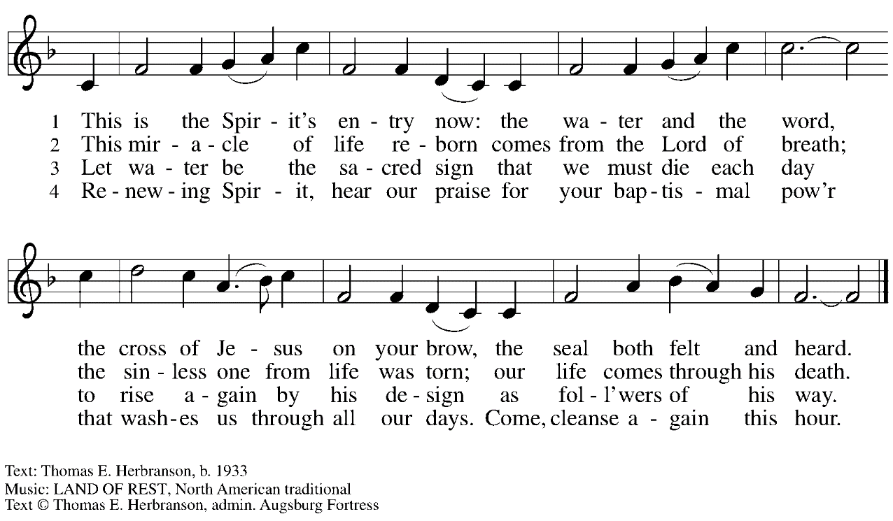
All rights reserved. Reprinted with permission under OneLicense.net # A-722139.

Greeting

P: The grace of our Lord Jesus Christ, the love of God,
and the communion of the Holy Spirit be with you all.
C: And also with you.

Kyrie

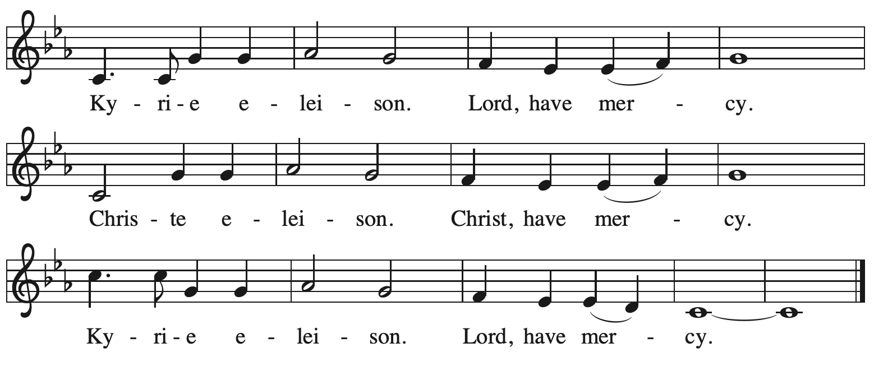

Prayer of the Day

P: The Lord be with you.
C: And also with you.

P: Let us pray.
O God, our leader and guide,
in the waters of Baptism you bring us to new birth to live as your children.
Strengthen our faith in your promises, that by your Spirit we may lift up your life to all the world through your Son, Jesus Christ, our Savior and Lord,
who lives and reigns with you and the Holy Spirit, one God, now and forever.
C: Amen.

Please be seated.
Children are invited to join the adult leaders at the door and move to the office for Little Church – Big Faith. We ask that one additional adult from the congregation attend with the children.

Word
God speaks to us in Scripture reading, preaching, and song

First Reading – Genesis 12: 1-4a

¹The Lord said to Abram, “Go from your country and your kindred and your father’s house to the land that I will show you. ²I will make of you a great nation, and I will bless you, and make your name great, so that you will be a blessing. ³I will bless those who bless you, and the one who curses you I will curse; and in you all the families of the earth shall be blessed.”
^{4a}So Abram went, as the Lord had told him; and Lot went with him.

L: Word of God, word of life.
C: Thanks be to God.

Psalm 121

The cantor will lead the singing of the psalm.
The congregation is invited to respond with the alternate verses in bold print,
and to join in singing the refrain.

Psalm tone

Psalm refrain

¹I lift up my eyes | to the hills;
from where is my | help to come?
²My help comes | from the Lord,
the maker of heav- | en and earth.
³The Lord will not let your | foot be moved
nor will the one who watches over you | fall asleep.
⁴Behold, the keep- | er of Israel
will neither slum- | ber nor sleep; R
⁵the Lord watches | over you;
the Lord is your shade at | your right hand;
⁶the sun will not strike | you by day,
nor the | moon by night.
⁷The Lord will preserve you | from all evil
and will | keep your life.
⁸The Lord will watch over your going out and your | coming in,
from this time forth for- | evermore. R
Second Reading – Romans 4: 1-5, 13-17

¹What then are we to say was gained by Abraham, our ancestor according to the flesh? ²For if Abraham was justified by works, he has something to boast about, but not before God. ³For what does the scripture say? “Abraham believed God, and it was reckoned to him as righteousness.” ⁴Now to one who works, wages are not reckoned as a gift but as something due. ⁵But to one who without works trusts him who justifies the ungodly, such faith is reckoned as righteousness.
¹³For the promise that he would inherit the world did not come to Abraham or to his descendants through the law but through the righteousness of faith. ¹⁴If it is the adherents of the law who are to be the heirs, faith is null and the promise is void. ¹⁵For the law brings wrath; but where there is no law, neither is there violation.
¹⁶For this reason it depends on faith, in order that the promise may rest on grace and be guaranteed to all his descendants, not only to the adherents of the law but also to those who share the faith of Abraham (for he is the father of all of us, ¹⁷as it is written, “I have made you the father of many nations”)—in the presence of the God in whom he believed, who gives life to the dead and calls into existence the things that do not exist.

L: Word of God, word of life.
C: Thanks be to God.

Please rise as you are able.

Gospel Acclamation

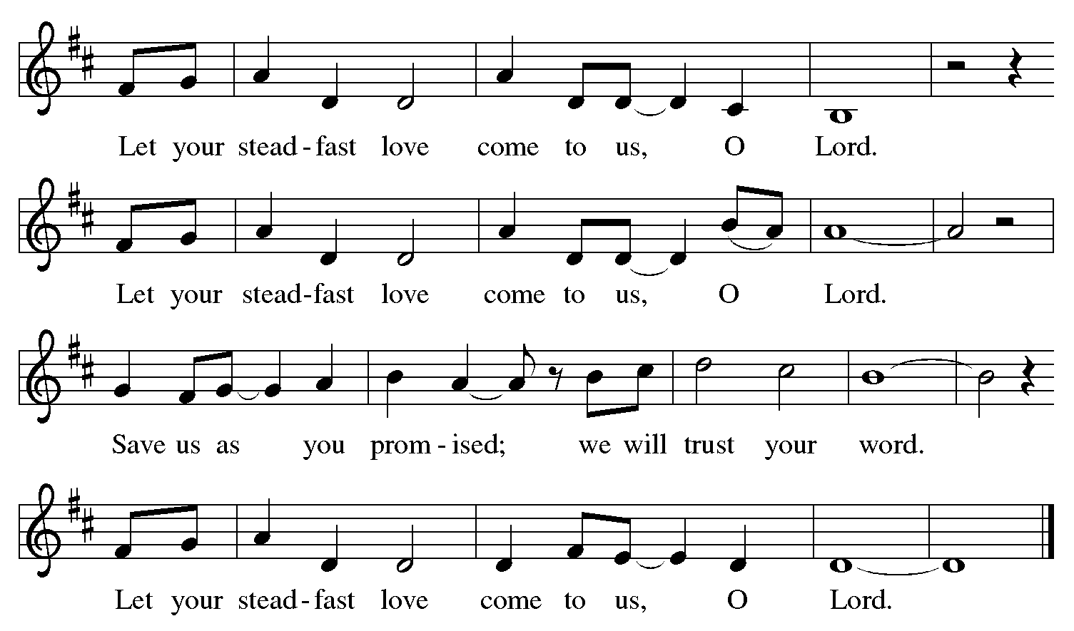

Gospel – John 3: 1-17

P: The holy Gospel according to St. John.
C: Glory to you, O Lord.
¹Now there was a Pharisee named Nicodemus, a leader of the Jews. ²He came to Jesus by night and said to him, “Rabbi, we know that you are a teacher who has come from God; for no one can do these signs that you do apart from the presence of God.” ³Jesus answered him, “Very truly, I tell you, no one can see the kingdom of God without being born from above.” ⁴Nicodemus said to him, “How can anyone be born after having grown old? Can one enter a second time into the mother’s womb and be born?” ⁵Jesus answered, “Very truly, I tell you, no one can enter the kingdom of God without being born of water and Spirit. ⁶What is born of the flesh is flesh, and what is born of the Spirit is spirit. ⁷Do not be astonished that I said to you, ‘You must be born from above.’ ⁸The wind blows where it chooses, and you hear the sound of it, but you do not know where it comes from or where it goes. So it is with everyone who is born of the Spirit.”
⁹Nicodemus said to him, “How can these things be?” ¹⁰Jesus answered him, “Are you a teacher of Israel, and yet you do not understand these things?
¹¹“Very truly, I tell you, we speak of what we know and testify to what we have seen; yet you do not receive our testimony. ¹²If I have told you about earthly things and you do not believe, how can you believe if I tell you about heavenly things? ¹³No one has ascended into heaven except the one who descended from heaven, the Son of Humanity. ¹⁴And just as Moses lifted up the serpent in the wilderness, so must the Son of Humanity be lifted up, ¹⁵that whoever believes in him may have eternal life.
¹⁶“For God so loved the world that God gave God’s only Son, so that everyone who believes in him may not perish but may have eternal life.
¹⁷“Indeed, God did not send the Son into the world to condemn the world, but in order that the world might be saved through him.”

P: The Gospel of the Lord.
C: Praise to you, O Christ.

Please be seated.

Sermon

A time of silence for prayer and reflection follows the sermon.
When the Hymn of the Day begins, please rise as you are able.

Hymn of the Day God Loved the World ELW 323

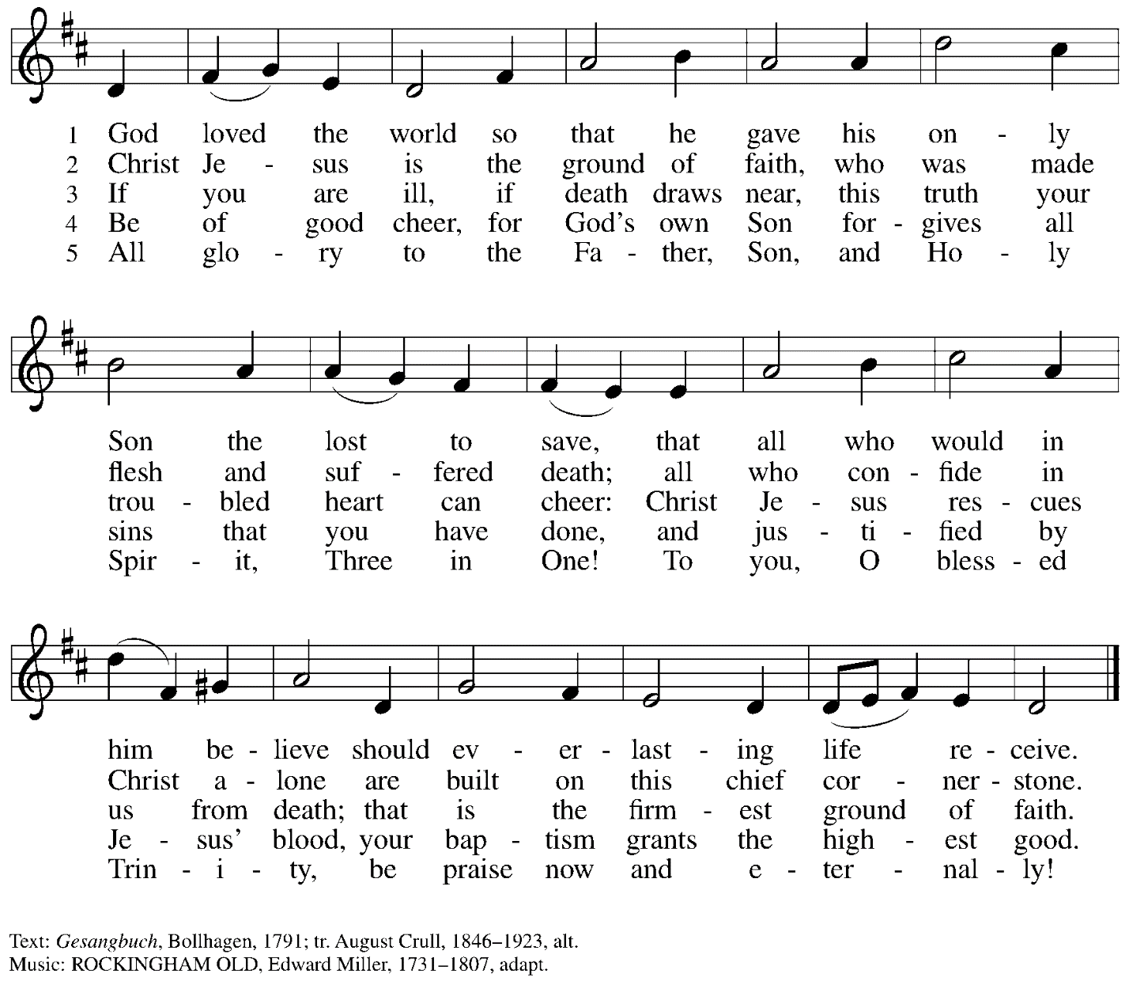

Apostles Creed

C: I believe in God, the Father almighty,
creator of heaven and earth.

I believe in Jesus Christ, God’s only Son, our Lord,
who was conceived by the Holy Spirit,
born of the virgin Mary,
suffered under Pontius Pilate,
was crucified, died, and was buried;
he descended to the dead.*
On the third day he rose again;
he ascended into heaven,
he is seated at the right hand of the Father,
and he will come to judge the living and the dead.

I believe in the Holy Spirit,
the holy catholic church,
the communion of saints,
the forgiveness of sins,
the resurrection of the body,
and the life everlasting. Amen.

*Or, “he descended into hell,” another translation of this text in widespread use.

Prayers of the People

A: Sustained by God’s abundant mercy, let us pray for the church, the world,
and all who are in need.

After each petition
A: Merciful God,
C: receive our prayer.

The presiding minister concludes the prayers:
P: We lift our prayers to you, O God,
trusting in your steadfast love and your promise to renew all creation;
through Jesus Christ, our Savior and Lord.
C: Amen.

Peace

The presiding minister and the assembly greet one another in the peace of the risen Christ.
P: The peace of Christ be with you always.
C: And also with you.

The people may greet those around them with a sign of Christ’s peace and may say
Peace be with you or similar words. Please be mindful that not everyone will be comfortable with sharing the peace, so please seek consent before shaking hands or hugging. Other possible ways to share the peace include a simple bow with the verbal greeting of peace, or simply a verbal expression of peace.

When the greetings of peace have concluded, please be seated.

Meal
God feeds us with the presence of Jesus Christ

Offering

We offer ourselves, our gifts, and our faithful service to God.
As the offering is gathered for the mission of the church, including the care of those in need,
the table is set for Holy Communion.

Music during the Offering

As the gifts are brought forward for presentation, please rise as you are able.

Offertory Song

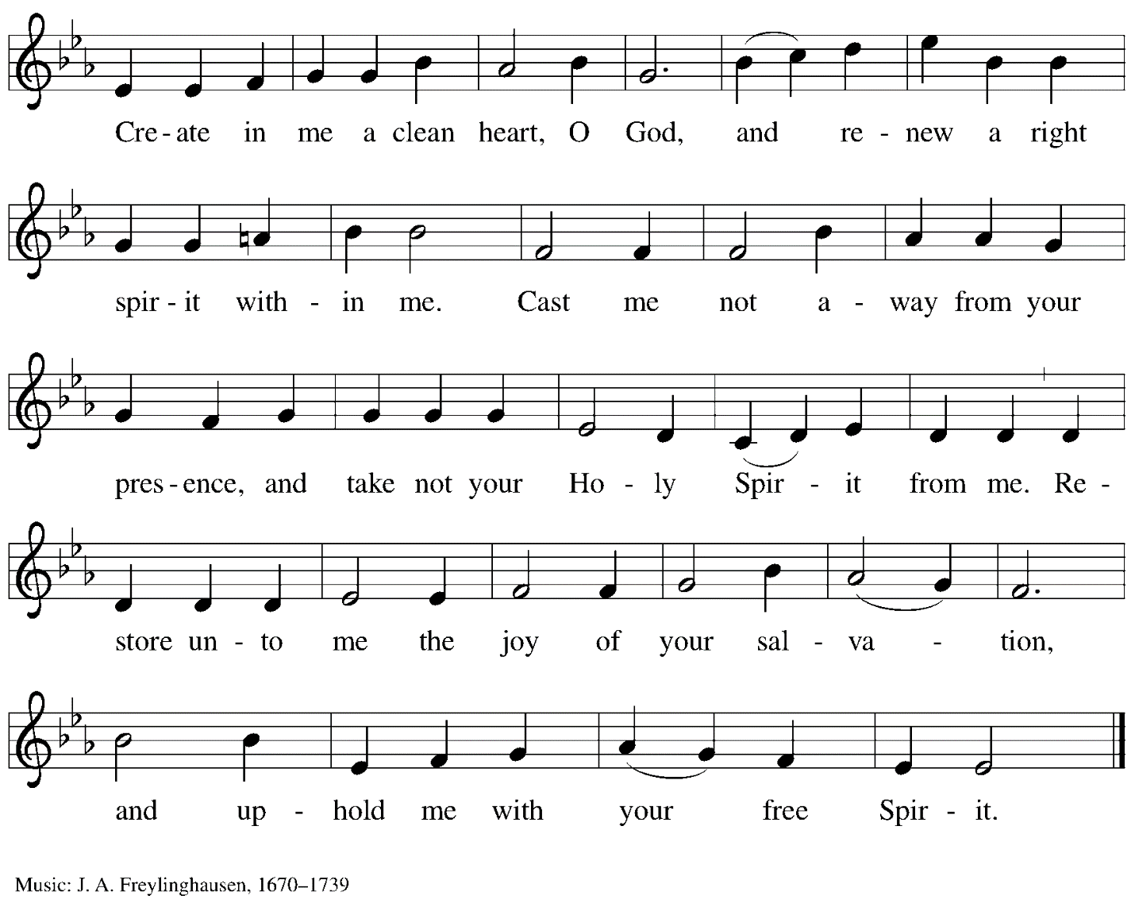

Offertory Prayer

A: Let us pray.
God our provider,
C: you have not fed us with bread alone
but with words of grace and life.
Bless us, and these your gifts,
which we receive from your bounty,
through Jesus Christ our Lord.
Amen.

Dialogue

P: The Lord be with you.
C: And also with you.

P: Lift up your hearts.
C: We lift them to the Lord.

P: Let us give thanks to the Lord our God.
C: It is right to give our thanks and praise.

Preface

P: It is indeed right, our duty and our joy…
… we praise your name and join their unending hymn:

Sanctus

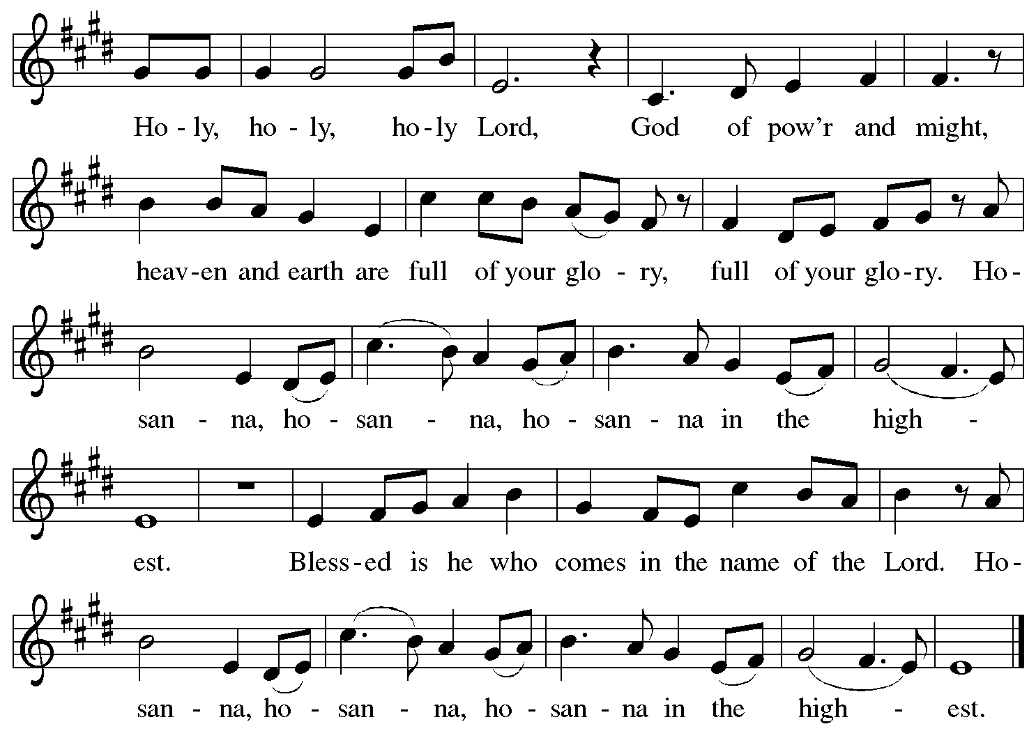

Eucharistic Prayer

P: Blessed are you, O God of the universe,
Your mercy is everlasting
and your faithfulness endures from age to age.

Praise to you for creating the heavens and the earth.
Praise to you for saving the earth from the waters of the flood.
Praise to you for bringing the Israelites safely through the sea.
Praise to you for leading your people through the wilderness
to the land of milk and honey.
Praise to you for the words and deeds of Jesus, your anointed one.
Praise to you for the death and resurrection of Christ.
Praise to you for your Spirit poured out on all nations.

In the night in which he was betrayed,
our Lord Jesus took bread, and gave thanks;
broke it, and gave it to his disciples, saying:
Take and eat; this is my body, given for you.
Do this for the remembrance of me.

Again, after supper, he took the cup, gave thanks,
and gave it for all to drink, saying:
This cup is the new covenant in my blood,
shed for you and for all people for the forgiveness of sin.
Do this for the remembrance of me.

With this bread and cup
we remember our Lord’s passover from death to life
as we proclaim the mystery of faith:
C: Christ has died.
Christ is risen.
Christ will come again.

P: O God of resurrection and new life:
Pour out your Holy Spirit on us
and on these gifts of bread and wine.
Bless this feast.
Grace our table with your presence.
C: Come, Holy Spirit.

P: Reveal yourself to us in the breaking of the bread.
Raise us up as the body of Christ for the world.
Breathe new life into us.
Send us forth,
burning with justice, peace, and love.
C: Come, Holy Spirit.

P: With your holy ones of all times and places,
with the earth and all its creatures,
with sun and moon and stars,
we praise you, O God,
blessed and holy Trinity,
now and forever.
C: Amen.

Lord’s Prayer

P: Gathered as one by the Holy Spirit, let us pray as Jesus taught us.
C: Our Father in heaven,
hallowed be your name,
your kingdom come,
your will be done,
on earth as in heaven.
Give us today our daily bread.
Forgive us our sins
as we forgive those who sin against us.
Save us from the time of trial
and deliver us from evil.
For the kingdom, the power,
and the glory are yours,
now and forever. Amen.

Fraction and Invitation

P: Come to the table of mercy;
receive God’s gifts of grace.

Agnus Dei/Lamb of God

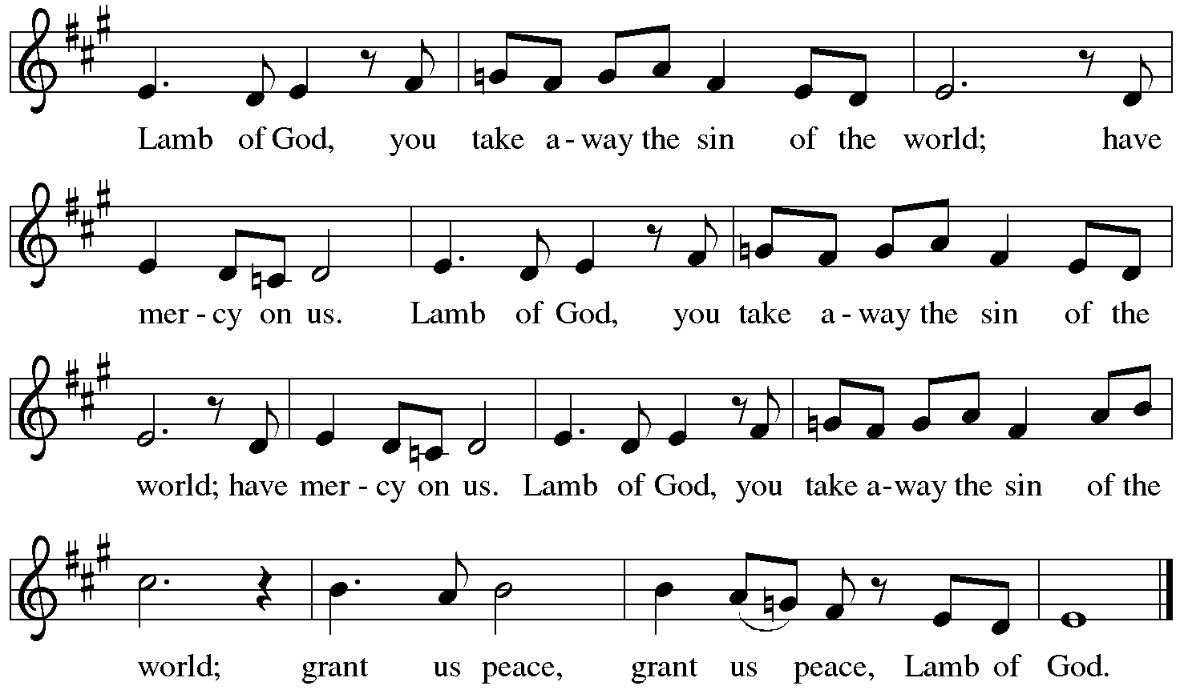

Please be seated.

Holy Communion
- All who seek God and desire a deeper and stronger life in Christ are welcome to receive Holy Communion.
- Worshipers from the pulpit side will proceed forward first, followed by the center section, and then the lectern side.
- Please inform an usher if you would like the ministers to bring Communion to you.
- Holy Communion will be served with bread and wine/grape juice.
- The presiding minister will first distribute the bread (host) to each communicant. Please indicate if you require a gluten-free host.
- Once you have consumed the bread, please pick up an empty glass from the tray next to the presiding minister. The Communion Assistant will pour wine from the chalice or grape juice from the cruet into your glass.
- Please step to the side to consume the wine or grape juice.
- Feel free to kneel at the altar rail for prayer after receiving the sacrament.
- As you return to your pew, glasses may be returned to the empty trays on either side of the center aisle.
- A blessing will be provided for anyone who does not yet receive the sacrament.
- All are invited to join in singing the hymns during Holy Communion.

Hymn during Holy Communion
Now We Join in Celebration ELW 462

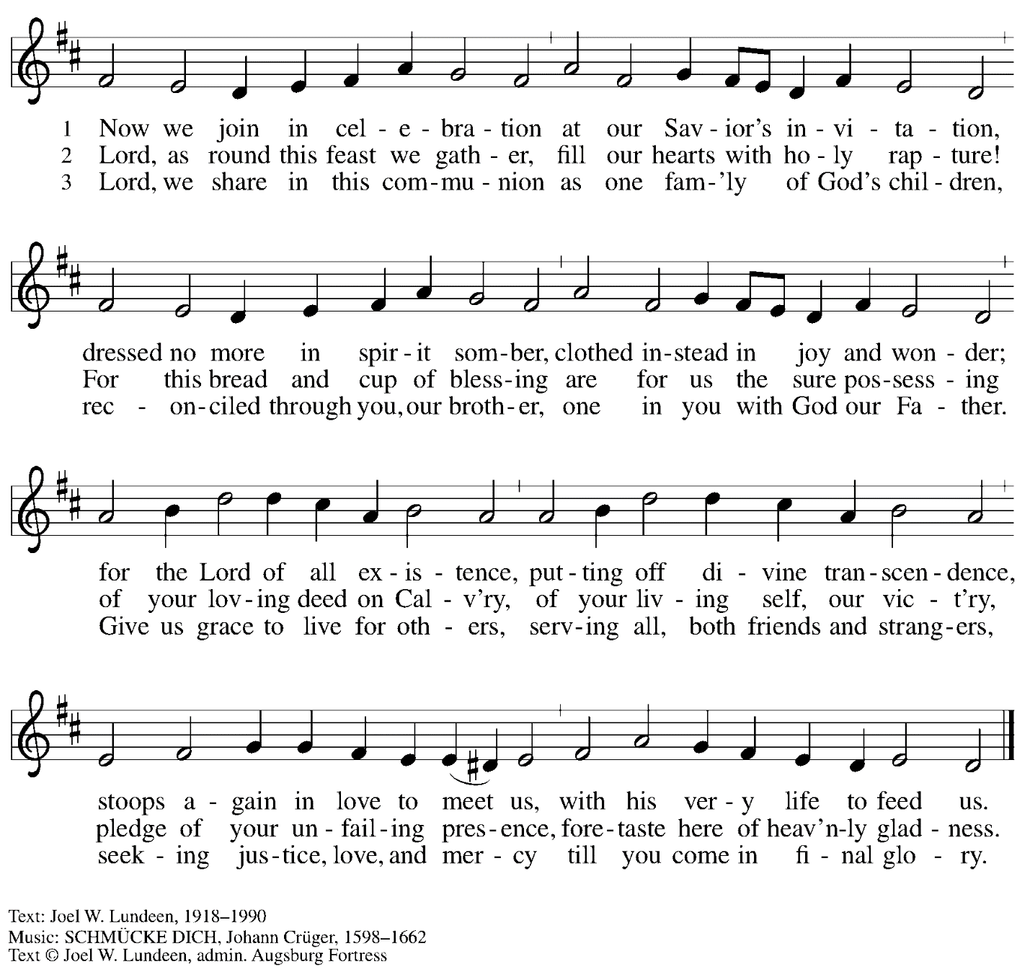
All rights reserved. Reprinted with permission under OneLicense.net # A-722139.

Hymn during Holy Communion
As the Wind Song ACS 943
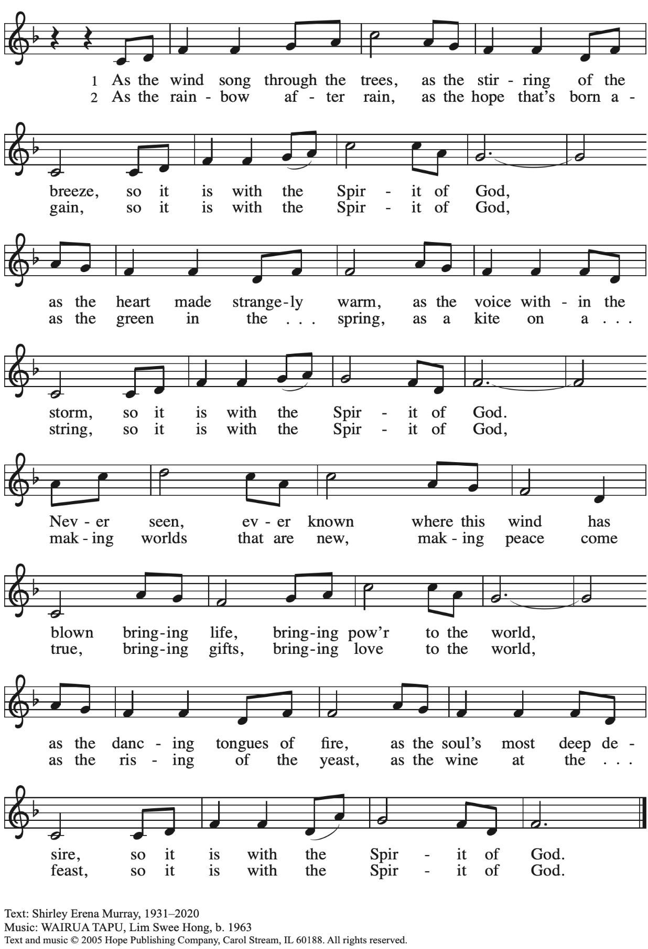
Reprinted under OneLicense.net # A-722139.
Hymn during Holy Communion
Mothering God, You Gave Me Birth ELW 735

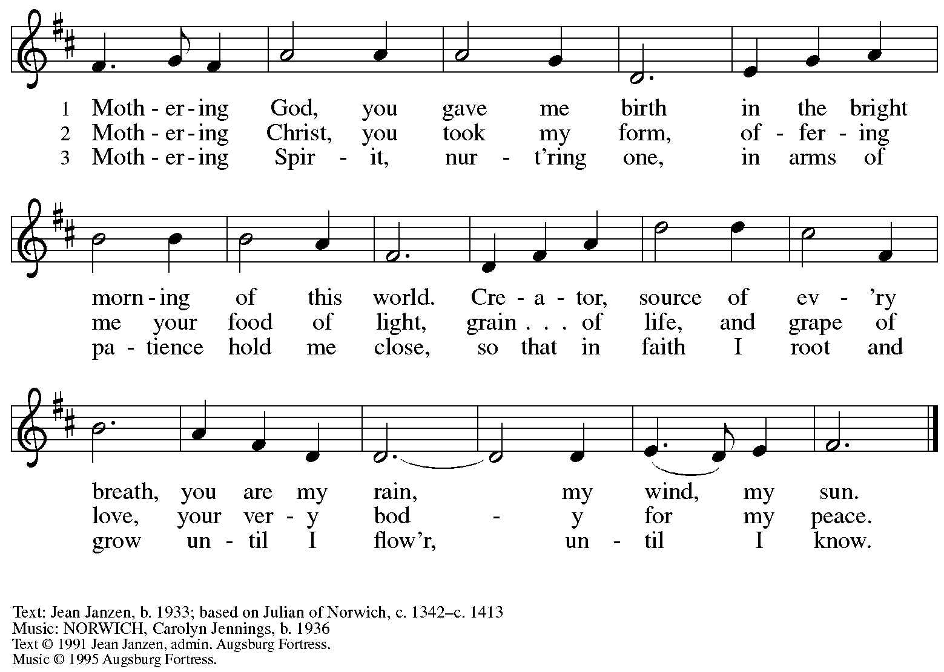
All rights reserved. Reprinted with permission under OneLicense.net #A-722139.

When all have returned to their places, please rise as you are able.

Blessing

P: The body and blood of our Lord Jesus Christ strengthen you and keep you in his grace.
C: Amen.

Prayer

A: Let us pray.
Compassionate God, you have fed us with the bread of heaven.
Sustain us in our Lenten pilgrimage: may our fasting be hunger for justice;
our alms, a making of peace; and our prayer, the song of grateful hearts,
through Jesus Christ, our Savior and Lord.
C: Amen.

Please be seated.

Sending
God blesses us and sends us in mission to the world

Announcements

Please rise as you are able.

Benediction

P: The God of love; ☩ Christ, the resurrection and the life;
and the Holy Spirit of rebirth, bless you this Lent and always.
C: Amen.

Sending Hymn Bless Now, O God, the Journey Following page

If you picked up a stone from the bowl at the back of the sanctuary, please feel free to come forward and place it with the other rocks and stones at the altar during the Sending Hymn.

Dismissal

A: Go in peace. Serve in love.
C: Thanks be to God.

Sending Hymn Bless Now, O God, the Journey ELW 326

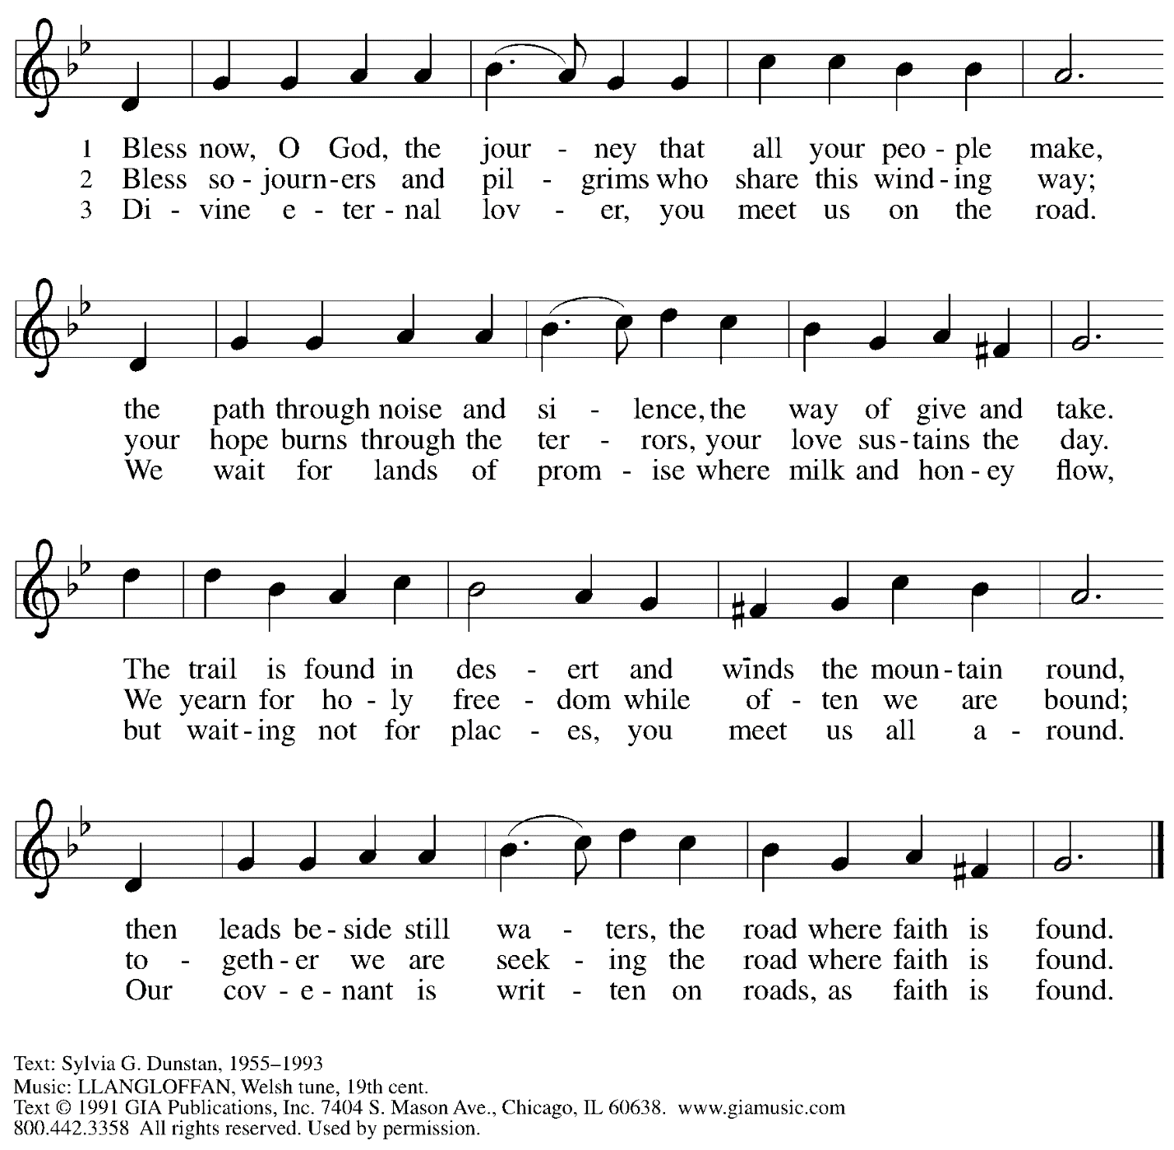
Reprinted under OneLicense.net # A-722139.

Abbreviations

P: Pastor/Presiding Minister
A: Assisting Minister
L: Lector
C: Congregation

ELW: Evangelical Lutheran Worship hymnal
ACS: All Creation Sings hymnal

Those serving in worship today

Assisting Minister Jimmi Kocher-Hillmer
Audio-Visual Ministers Kristen Asplin
Joseph Paetz
Cantor Maria Mangano
Lector Dixie Tymitz
Minister of Music Laura Reynolds
Presiding and Preaching Minister Pastor Ross I. Carmichael

Liturgy and Hymnody Acknowledgements

From SundaysandSeasons.com. Copyright © 2023 Augsburg Fortress. All rights reserved. Reprinted under OneLicense.net # A-722139.
Used by permission of Augsburg Fortress.

St. Andrew Lutheran Church Announcements
March 5th, 2023

- Welcome to Worship at St. Andrew on March 5th, 2023, the + Second Sunday in Lent – Masks are optional at St. Andrew when Allegheny County’s Covid-19 community level is in the low and medium categories. Worship attendees are invited to make a name tag at the back of the worship space if you would like. All are invited to gather in the Social Hall after worship for food, drinks, and conversation.
- Unique Variations in Worship This Lent – Centering Music, Theme Hymn, Carrying Stones, and Returning to Sharing Peace – Worship services at St. Andrew will be slightly different throughout the season of Lent. Instead of a traditional Prelude, the welcome will be followed by centering music, Now is the Time of Grace, led by the cantor, with the congregation invited to listen, reflect, and join in singing the refrain. We will also return to sharing the peace, hear testimonies on faith in daily life on the second through fifth Sundays, be sent for mission in the world with the theme hymn, Bless Now, O God, the Journey, and invite worshipers to pick up symbolic stones to leave at the altar during the sending each week. We pray for God's blessing as we journey together through this season.
- Meeting of the Congregation Today after Worship – This first meeting of the year is an opportunity to review the ministry and reports of 2022, to hear updates on what the new council is working toward this year, and to approve updates and amendments to our congregation's constitution. No proxy or absentee votes can be accepted, so please plan to attend. Printed copies of the Annual Report will be available this Sunday for anyone who would like to read it in advance. Those who cannot be here in person are encouraged to attend using the Zoom link found in your “This Week at St. Andrew” email.
- Monthly Produce Distribution – Tuesday, March 7th, 5:30-7:00 p.m. – Every month, St. Andrew hosts the distribution of fresh produce in partnership with the Greater Pittsburgh Community Food Bank. We would appreciate help setting up and unloading the truck, usually between 11:00 a.m. and 1:00 p.m. that day. We also invite people to help serve at the distribution in the evening. If you are interested, please sign up at https://www.signupgenius.com/go/4090f45afaf2ba75-produce1#/.
- Participate in the Choir Scheduled to Sing during Worship on the Third Sunday in Lent, March 12th – St. Andrew’s choir is next preparing to sing during worship on Sunday, March 12th and all are welcome to take part! The second rehearsal will be before worship next Sunday at 8:30 a.m. Minister of Music Laura Reynolds has recorded parts to help in your preparation, which can be found here:
https://youtube.com/playlist?list=PLdo3pMOInGpV3Wicm1qi4hNK7CUIM32m-.
- Midweek Worship for Lent – Holden Evening Prayer Available Online Wednesdays, March 8th, 15th, 22nd, and 29th – During the season of Lent, many take on additional devotional practices, and it has been customary to offer a midweek prayer service each Wednesday prior to Holy Week. This year, several St. Andrew members have recorded a sung service of the Holden Evening Prayer service with Old Testament readings for each week. These videos will be available online at St. Andrew’s pages on Wednesdays, March 8th, 15th, 22nd, and 29th. We encourage you to access this beautiful service throughout the season.
- Shelter Dinner at East End Cooperative Ministry – Thursday, March 16th, 6:30 p.m. – Each month, people of St. Andrew provide dinner for guests of East End Cooperative Ministry, 6140 Station St. (East Liberty) 15206. We invite you to prepare or purchase one menu item and bring it to the shelter by 6:00 p.m., or just come to help serve at 6:30 p.m. If you would like to participate, please sign up here: https://www.signupgenius.com/go/5080544AAAC22A1F58-shelter39.
- St. Andrew Saving Pull Tabs from Cans – St. Andrew continues to save pull tabs from all types of cans. They are recycled by Ronald McDonald House to benefit programs for children and families receiving care at Pittsburgh Children's Hospital. Tabs can be placed in the plastic drawer on the donations table in the social hall.
- Ministry Opportunity – The Community Ministry Committee is seeking help to fill the mini pantry. Volunteer for one time, once a month, once every two months, or as often as you want. Contact Joyce Compton at jcompton28@gmail.com or 412-657-0584 if you have questions or would like to serve in this role.
- Lenten Food Drive – Help Fill St. Andrew’s Mini Free Pantry – We are collecting items for the Pantry during the Lenten season. Grab a brown bag from the back of the sanctuary or from the Social Hall and bring it back to the St. Andrew with an item or two for the pantry (no need to fill the bag completely).
Items should be shelf safe/stable (nothing fresh, frozen or that may go bad in severe weather.) Here are some things we suggest:
- Items in cans with flip top lids: (no items requiring a can opener)
- Tuna, sardines, or Vienna sausage, ravioli, soup that does not need to be diluted.
- Fruit or vegetables in single-serve, shelf safe containers
- Single serve peanut butter, cheese & cracker snacks, granola bars, beef jerky, raisin boxes, little cereal boxes, shelf stable milk (Horizon)
- Personal care items: Shampoo, body wash, deodorant, toothpaste, feminine products, toilet paper
Contact Joyce Compton at jcompton28@gmail.com or 412-657-0584 with questions.
Please return all items by Easter Sunday, April 9th.
- A Celebration of the Legacy of The Rev. Dr. Martin Luther King, Jr. - Sunday, March 26th, 4:00 p.m. – The Southwestern Pennsylvania Synod of the Evangelical Lutheran Church in America will be celebrating the legacy of The Rev. Dr. Martin Luther King, Jr. with an ecumenical service of Holy Communion with Bishops Abraham Allende and Kurt Kusserow presiding and The Rev. Dr. Asa Lee, President of Pittsburgh Theological Seminary, preaching. The event will take place on Sunday, March 26th, at 4:00 p.m. at Berkeley Hills Lutheran Church, 517 Sangree Road, Pittsburgh, PA 15237. Following the service there will be a program on equitable development and housing to accompany this year's theme of "A Home for All in the Beloved Community." Learn more at The Legacy of Dr. Martin Luther King Jr. — Southwestern Pennsylvania Synod (swpasynod.org).

