+ Third Sunday in Lent
March 12, 2023

St. Andrew Lutheran Church
304 Morewood Ave.
Pittsburgh, PA 15213
St_andrewELCA@verizon.net
www.standrewpittsburgh.org

+ Third Sunday in Lent
Order for Worship

In today’s gospel the Samaritan woman asks Jesus for water, an image of our thirst for God. Jesus offers living water, a sign of God’s grace flowing from the waters of baptism. The early church used this gospel and those of the next two Sundays to deepen baptismal reflection during the final days of preparation before baptism at Easter. As we journey to the resurrection feast, Christ comes among us in word, bath, and meal—offering us the life-giving water of God’s mercy and forgiveness.

The season of Lent began on Ash Wednesday. Lent is a 40-day season focused on repentance, spiritual discipline, and baptismal reflection. We acknowledge our vulnerability and mortality, turn from sin, and return to God for forgiveness and renewal. The readings for the season evoke themes of desert and wilderness — Jesus’ 40-day temptation, the Israelites traveling and needing water, a valley of dry bones, the tomb of Lazarus. Instead of lush greenery we decorate the sanctuary with rocks and stones. There are small stones available at the back of the sanctuary and near the Morewood entrance — we encourage everyone to pick one up each week. The stone may be thought of as sin, guilt, burden, whatever you would like to clean out and/or leave behind in order to make room for God and service to neighbor. We invite you to leave these stones with the others at the altar during the Sending Hymn each week, which throughout the season will be Bless Now, O God, the Journey - ELW 326. This hymn reminds us that when we are scattered in our daily lives and responsibilities, wherever we go in faith, God comes to meet us there to bring hope and peace. On the second through fifth Sundays, testimonies by the congregation’s leaders in the Life of Faith Initiative will precede the hymn. They will share about how they see God at work as they serve in their daily vocations and roles throughout the week. May God bless your journey through Lent!

- Masks are optional at St. Andrew when Covid-19 community level in Allegheny County is in the low and medium categories.

- Worship Services are live streamed to multiple online platforms. By attending worship, you agree that your image and voice may be broadcast.

Welcome to St. Andrew!

- St. Andrew Lutheran Congregation welcomes all who are seeking a place of healing and wholeness, a nurturing, faith-forming spiritual home. Our community embraces people of all ages, ethnicities, cultures, abilities, sexual orientations, gender identities and expressions, and family constellations. Come and See!

- Everyone is invited to make a nametag at the black bookcase in the back of the worship space if they would like.

- Worship “toolkits” to help children engage with the service are available in the black bookcase at the back of the worship space. There are “reader” and “pre-reader” resources available in each kit. Please feel free to use the kits for/with your children during worship.

- Little Church – Big Faith, a Bible lesson and activity for children, takes place after the prayer of the day. Children are invited to meet the adult leaders at the side door of the sanctuary to attend.

- This Lenten season, St. Andrew returns to the Sharing of Peace during worship. More than a simple greeting, this practice and placement in the service derives from the Gospel of Matthew 5: 23-24 – “When you are offering your gift at the altar, if you remember that your sibling has something against you, leave your gift there before the altar and go; first be reconciled to your sibling, and then come and offer your gift.” We will once again have an opportunity to share an expression of Christ’s peace with those around us as a liturgical sign of our desire to be reconciled with our neighbors before offering our gifts and receiving Holy Communion. Please be mindful that some people will not be comfortable with sharing the peace; be sure to obtain consent before any physical expression of peace such as shaking hands or hugging.

- St. Andrew has returned to serving Holy Communion with both (separate) elements, bread and wine/grape juice. The presiding minister will distribute the bread (host). Please consume this and then pick up an empty glass from the tray. The Communion Assistant will pour wine or grape juice into your glass. Please step to the side to consume the wine or grape juice. As you return to your pew, glasses may be returned to the empty trays on either side of the center aisle.

- A restroom is available on the main level of the church, through the doors to the Social Hall and to the right in the main office.

Welcome

Gathering
The Holy Spirit calls us together as the people of God.

Centering Music Now Is the Time of Grace ACS 918
v. 1-2

The verses will be sung by the cantor. The congregation is invited to join in singing the refrain, which will be sung twice each time we come to it.

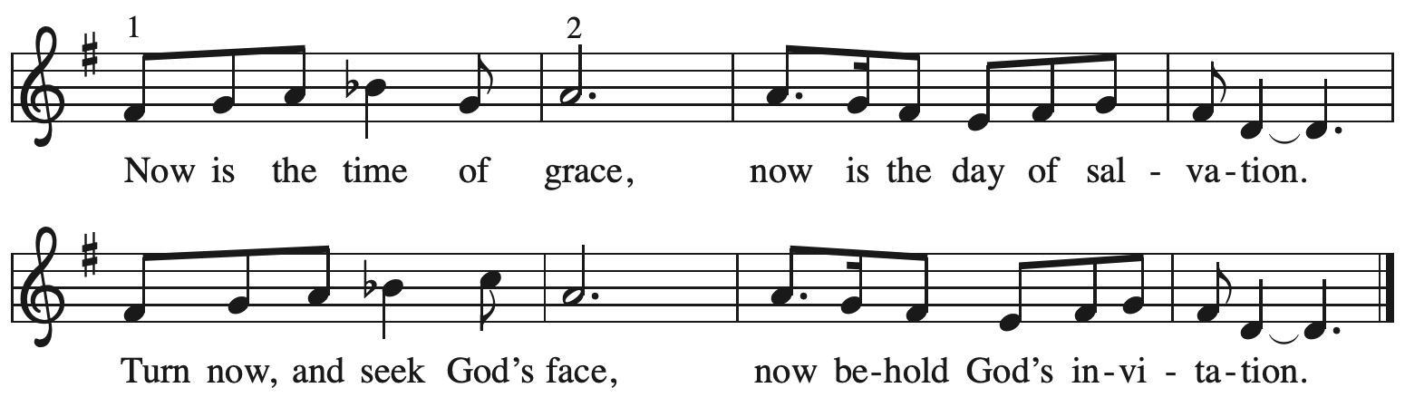

Verses — Leader

1 This is the fast that God would choose:
to loose the bonds of injustice,
to let the captives go free,
and to break the yoke of oppression. Refrain

2 Sharing your bread with the hungry
and welcoming homeless in,
offering hope and offering help,
this is what God requires. Refrain

All rights reserved. Reprinted with permission under OneLicense.net # A-722139.

Please rise as you are able.

Confession and Forgiveness

P: Blessed be the holy Trinity, ☩ one God,
who journeys with us these forty days,
and sustains us with the gift of grace.
C: Amen.

P: Let us acknowledge before God and one another
our need for repentance and God’s mercy.

Silence is kept for reflection.

P: Holy God,
C: we confess to you our faults and failings.
Too often we neglect and do not trust your holy word;
we take for ourselves instead of giving to others;
we spoil rather than steward your creation;
we cause hurt though you call us to heal;
we choose fear over compassion.
Forgive us, renew us, and lead us,
as we seek to follow in your way of life.
Amen.

P: Hear the good news:
God so loved the world that God gave the only Son,
so that all may receive life.
This promise is for you!
God embraces you with divine mercy,
☩ forgives you in Christ’s name,
and revives you in the Spirit’s power.
C: Amen.

Gathering Hymn Come to the Water of Life ACS 955

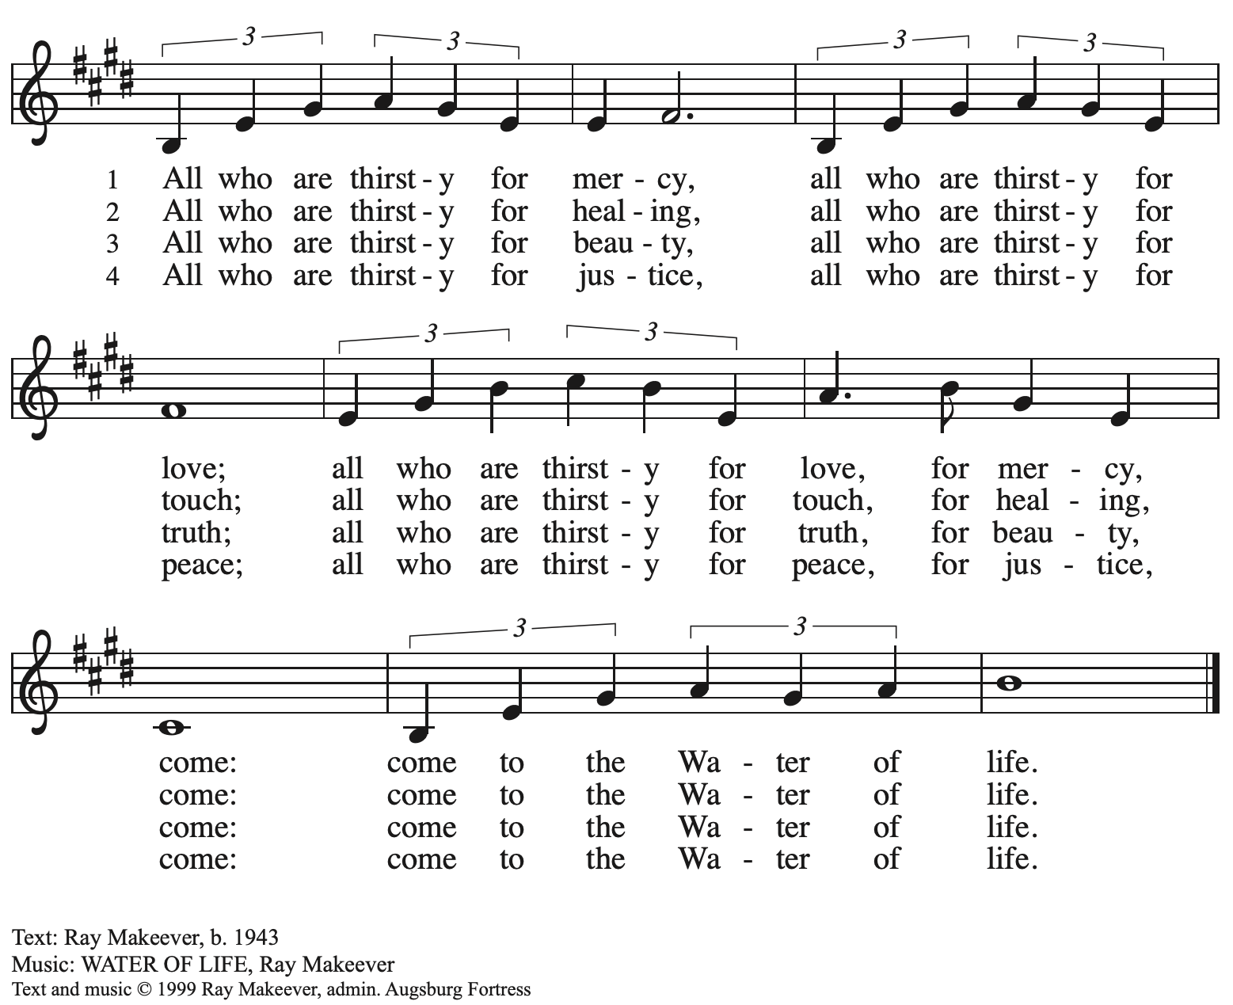
All rights reserved. Reprinted with permission under OneLicense.net #A-722139.

Greeting

P: The grace of our Lord Jesus Christ, the love of God,
and the communion of the Holy Spirit be with you all.
C: And also with you.

Kyrie Out of the Depths R. Frost
Based on Psalm 130: 1-5 Musical Offering by St. Andrew’s Choir
w. Maria Mangano, clarinet

Prayer of the Day

P: The Lord be with you.
C: And also with you.

P: Let us pray.
Merciful God, the fountain of living water,
you quench our thirst and wash away our sin. Give us this water always.
Bring us to drink from the well that flows with the beauty of your truth
through Jesus Christ, our Savior and Lord,
who lives and reigns with you and the Holy Spirit, one God, now and forever.
C: Amen.

Please be seated.
Children are invited to join the adult leaders at the door and move to the office for Little Church – Big Faith. We ask that one additional adult from the congregation attend with the children.

Word
God speaks to us in Scripture reading, preaching, and song

First Reading – Exodus 17: 1-7

¹From the wilderness of Sin the whole congregation of the Israelites journeyed by stages, as the Lord commanded. They camped at Rephidim, but there was no water for the people to drink. ²The people quarreled with Moses, and said, “Give us water to drink.” Moses said to them, “Why do you quarrel with me? Why do you test the Lord?” ³But the people thirsted there for water; and the people complained against Moses and said, “Why did you bring us out of Egypt, to kill us and our children and livestock with thirst?” ⁴So Moses cried out to the Lord, “What shall I do with this people? They are almost ready to stone me.” ⁵The Lord said to Moses, “Go on ahead of the people, and take some of the elders of Israel with you; take in your hand the staff with which you struck the Nile, and go. ⁶I will be standing there in front of you on the rock at Horeb. Strike the rock, and water will come out of it, so that the people may drink.” Moses did so, in the sight of the elders of Israel. ⁷He called the place Massah and Meribah, because the Israelites quarreled and tested the Lord, saying, “Is the Lord among us or not?”

L: Word of God, word of life.
C: Thanks be to God.

Psalm 95

The cantor will lead the singing of the psalm.
The congregation is invited to respond with the alternate verses in bold print,
and to join in singing the refrain.

Psalm tone
Psalm refrain
¹Come, let us sing | to the Lord;
let us shout for joy to the rock of | our salvation.
²Let us come before God’s presence | with thanksgiving
and raise a loud shout to the | Lord with psalms.
³For you, Lord, | are a great God,
and a great ruler a- | bove all gods.
⁴In your hand are the caverns | of the earth;
the heights of the hills are | also yours.
⁵The sea is yours, | for you made it,
and your hands have molded | the dry land.
⁶Come, let us worship | and bow down,
let us kneel before the | Lord our maker. R
⁷For the Lord is our God, and we are the people of God’s pasture
and the sheep | of God’s hand.
Oh, that today you would | hear God’s voice!
⁸“Harden | not your hearts,
as at Meribah, as on that day at Massah | in the desert.
⁹There your ancestors | tested me,
they put me to the test, though they had | seen my works.
¹⁰Forty years I loathed that gener- | ation, saying,
‘The heart of this people goes astray; they do not | know my ways.’
¹¹Indeed I swore | in my anger,
‘They shall never come | to my rest.’ ” R
Second Reading – Romans 5: 1-11

¹Since we are justified by faith, we have peace with God through our Lord Jesus Christ, ²through whom we have obtained access to this grace in which we stand; and we boast in our hope of sharing the glory of God. ³And not only that, but we also boast in our sufferings, knowing that suffering produces endurance, ⁴and endurance produces character, and character produces hope, ⁵and hope does not disappoint us, because God’s love has been poured into our hearts through the Holy Spirit that has been given to us.
⁶For while we were still weak, at the right time Christ died for the ungodly. ⁷Indeed, rarely will anyone die for a righteous person—though perhaps for a good person someone might actually dare to die. ⁸But God proves God’s love for us in that while we still were sinners Christ died for us. ⁹Much more surely then, now that we have been justified by his blood, will we be saved through him from the wrath of God. ¹⁰For if while we were enemies, we were reconciled to God through the death of God’s Son, much more surely, having been reconciled, will we be saved by his life. ¹¹But more than that, we even boast in God through our Lord Jesus Christ, through whom we have now received reconciliation.

L: Word of God, word of life.
C: Thanks be to God.

Please rise as you are able.

Gospel Acclamation

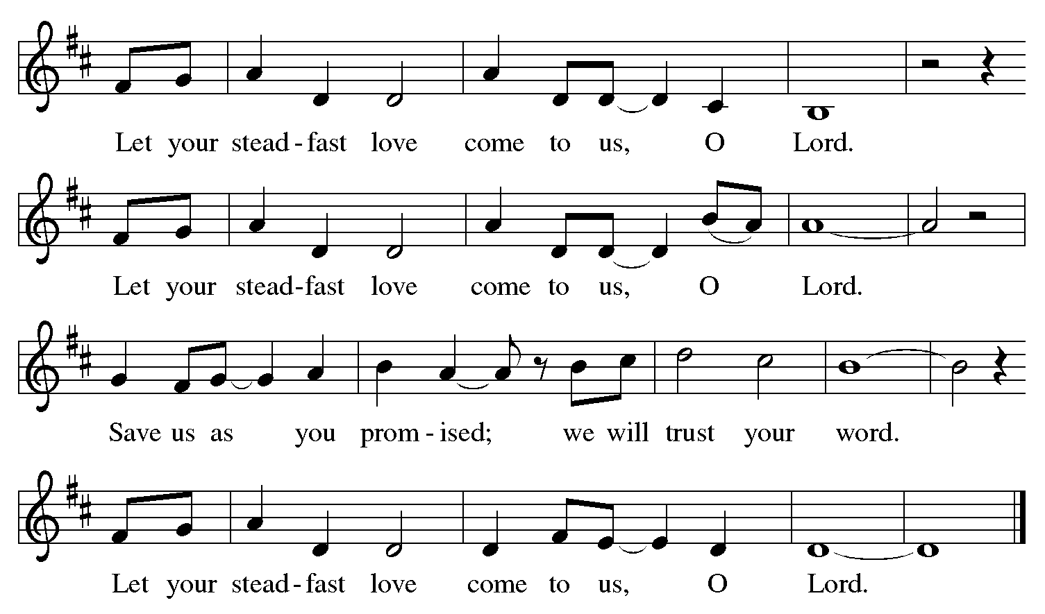

Gospel – John 4: 5-42

P: The holy Gospel according to St. John.
C: Glory to you, O Lord.
⁵[Jesus] came to a Samaritan city called Sychar, near the plot of ground that Jacob had given to his son Joseph.⁶Jacob’s well was there, and Jesus, tired out by his journey, was sitting by the well. It was about noon.
⁷A Samaritan woman came to draw water, and Jesus said to her, “Give me a drink.” ⁸(His disciples had gone to the city to buy food.) ⁹The Samaritan woman said to him, “How is it that you, a Jew, ask a drink of me, a woman of Samaria?” (Jews do not share things in common with Samaritans.) ¹⁰Jesus answered her, “If you knew the gift of God, and who it is that is saying to you, ‘Give me a drink,’ you would have asked him, and he would have given you living water.”
¹¹The woman said to him, “Sir, you have no bucket, and the well is deep. Where do you get that living water? ¹²Are you greater than our ancestor Jacob, who gave us the well, and with his sons and his flocks drank from it?” ¹³Jesus said to her, “Everyone who drinks of this water will be thirsty again, ¹⁴but those who drink of the water that I will give them will never be thirsty. The water that I will give will become in them a spring of water gushing up to eternal life.” ¹⁵The woman said to him, “Sir, give me this water, so that I may never be thirsty or have to keep coming here to draw water.”
¹⁶Jesus said to her, “Go, call your husband, and come back.” ¹⁷The woman answered him, “I have no husband.” Jesus said to her, “You are right in saying, ‘I have no husband;’ ¹⁸for you have had five husbands, and the one you have now is not your husband. What you have said is true!” ¹⁹The woman said to him, “Sir, I see that you are a prophet. ²⁰Our ancestors worshiped on this mountain, but you say that the place where people must worship is in Jerusalem.” ²¹Jesus said to her, “Woman, believe me, the hour is coming when you will worship the Father neither on this mountain nor in Jerusalem. ²²You worship what you do not know; we worship what we know, for salvation is from the Jews. ²³But the hour is coming, and is now here, when the true worshipers will worship the Father in spirit and truth, for the Father seeks such as these to worship him. ²⁴God is spirit, and those who worship him must worship in spirit and truth.” ²⁵The woman said to him, “I know that Messiah is coming” (who is called Christ). “When he comes, he will proclaim all things to us.” ²⁶Jesus said to her, “I am he, the one who is speaking to you.”
²⁷Just then his disciples came. They were astonished that he was speaking with a woman, but no one said, “What do you want?” or, “Why are you speaking with her?” ²⁸Then the woman left her water jar and went back to the city. She said to the people, ²⁹“Come and see a man who told me everything I have ever done! He cannot be the Messiah, can he?” ³⁰They left the city and were on their way to him.
³¹Meanwhile the disciples were urging him, “Rabbi, eat something.” ³²But he said to them, “I have food to eat that you do not know about.” ³³So the disciples said to one another, “Surely no one has brought him something to eat?” ³⁴Jesus said to them, “My food is to do the will of the one who sent me and to complete God’s work. ³⁵Do you not say, ‘Four months more, then comes the harvest?” But I tell you, look around you, and see how the fields are ripe for harvesting. ³⁶The reaper is already receiving wages and is gathering fruit for eternal life, so that sower and reaper may rejoice together. ³⁷For here the saying holds true, ‘One sows and another reaps.’ ³⁸I sent you to reap that for which you did not labor. Others have labored, and you have entered into their labor.”
³⁹Many Samaritans from that city believed in him because of the woman’s testimony, “He told me everything I have ever done.” ⁴⁰So when the Samaritans came to him, they asked him to stay with them; and he stayed there two days. ⁴¹And many more believed because of his word. ⁴²They said to the woman, “It is no longer because of what you said that we believe, for we have heard for ourselves, and we know that this is truly the Savior of the world.”

P: The Gospel of the Lord.
C: Praise to you, O Christ.

Please be seated.

Sermon

A time of silence for prayer and reflection follows the sermon.
When the Hymn of the Day begins, please rise as you are able.

Hymn of the Day I Heard the Voice of Jesus Say ELW 611

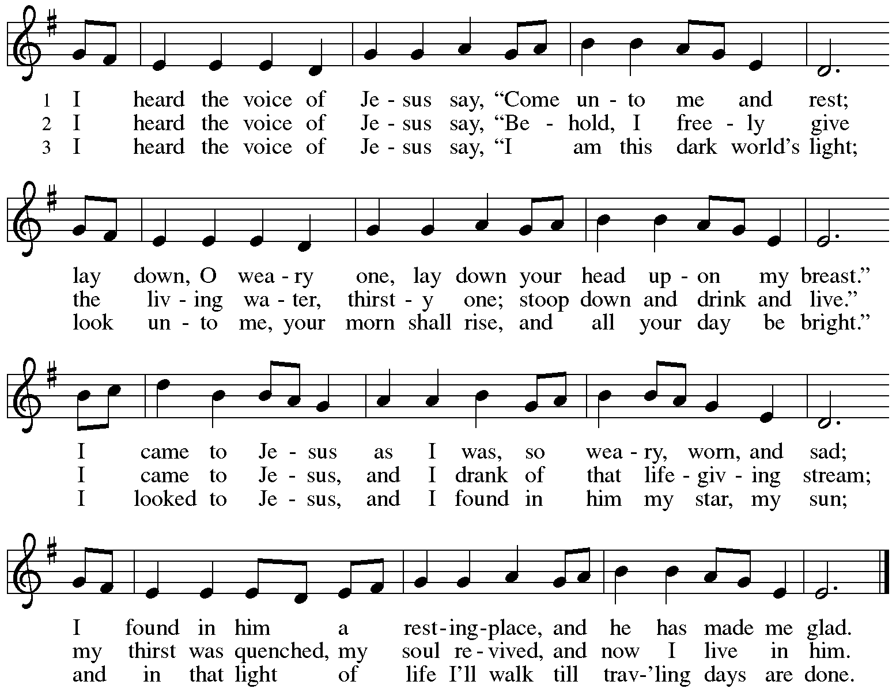
Text: Horatius Bonar, 1808-1889.
Music: KINGSFOLD, English folk tune

Apostles Creed

C: I believe in God, the Father almighty,
creator of heaven and earth.

I believe in Jesus Christ, God’s only Son, our Lord,
who was conceived by the Holy Spirit,
born of the virgin Mary,
suffered under Pontius Pilate,
was crucified, died, and was buried;
he descended to the dead.*
On the third day he rose again;
he ascended into heaven,
he is seated at the right hand of the Father,
and he will come to judge the living and the dead.

I believe in the Holy Spirit,
the holy catholic church,
the communion of saints,
the forgiveness of sins,
the resurrection of the body,
and the life everlasting. Amen.

*Or, “he descended into hell,” another translation of this text in widespread use.

Prayers of the People

A: Sustained by God’s abundant mercy, let us pray for the church, the world,
and all who are in need.

After each petition
A: Merciful God,
C: receive our prayer.

The presiding minister concludes the prayers:
P: We lift our prayers to you, O God, trusting in your steadfast love
and your promise to renew all creation; through Jesus Christ, our Savior and Lord.
C: Amen.

Please be seated.

Meal
God feeds us with the presence of Jesus Christ

Offering

We offer ourselves, our gifts, and our faithful service to God.
As the offering is gathered for the mission of the church, including the care of those in need,
the table is set for Holy Communion.

Music during the Offering

As the gifts are brought forward for presentation, please rise as you are able.

Offertory Song

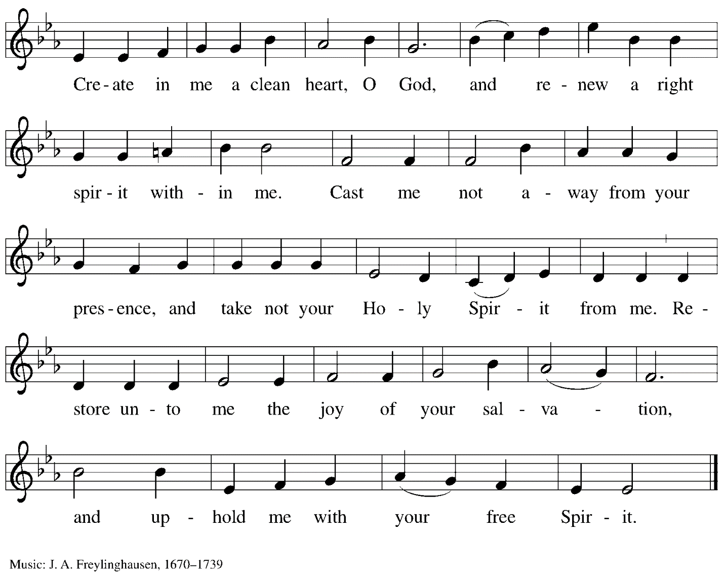

Offertory Prayer

A: Let us pray.
God our provider,
C: you have not fed us with bread alone
but with words of grace and life.
Bless us, and these your gifts,
which we receive from your bounty,
through Jesus Christ our Lord.
Amen.

Dialogue

P: The Lord be with you.
C: And also with you.

P: Lift up your hearts.
C: We lift them to the Lord.

P: Let us give thanks to the Lord our God.
C: It is right to give our thanks and praise.

Preface

P: It is indeed right, our duty and our joy…
… we praise your name and join their unending hymn:

Sanctus

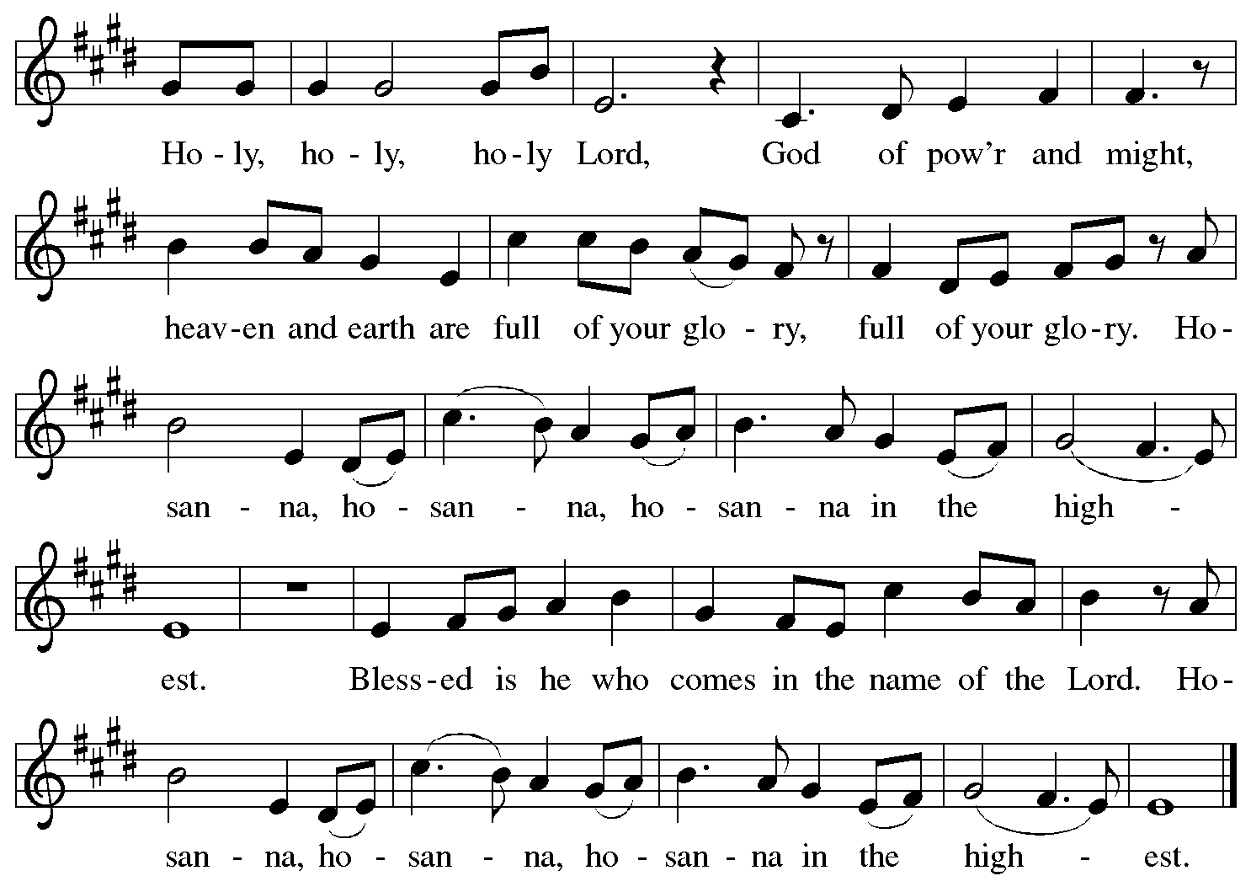

Eucharistic Prayer

P: Blessed are you, O God of the universe,
Your mercy is everlasting
and your faithfulness endures from age to age.

Praise to you for creating the heavens and the earth.
Praise to you for saving the earth from the waters of the flood.
Praise to you for bringing the Israelites safely through the sea.
Praise to you for leading your people through the wilderness
to the land of milk and honey.
Praise to you for the words and deeds of Jesus, your anointed one.
Praise to you for the death and resurrection of Christ.
Praise to you for your Spirit poured out on all nations.

P: In the night in which he was betrayed,
our Lord Jesus took bread, and gave thanks;
broke it, and gave it to his disciples, saying:
Take and eat; this is my body, given for you.
Do this for the remembrance of me.

Again, after supper, he took the cup, gave thanks,
and gave it for all to drink, saying:
This cup is the new covenant in my blood,
shed for you and for all people for the forgiveness of sin.
Do this for the remembrance of me.

With this bread and cup
we remember our Lord’s passover from death to life
as we proclaim the mystery of faith:
C: Christ has died.
Christ is risen.
Christ will come again.

P: O God of resurrection and new life:
Pour out your Holy Spirit on us
and on these gifts of bread and wine.
Bless this feast.
Grace our table with your presence.
C: Come, Holy Spirit.

P: Reveal yourself to us in the breaking of the bread.
Raise us up as the body of Christ for the world.
Breathe new life into us.
Send us forth,
burning with justice, peace, and love.
C: Come, Holy Spirit.

P: With your holy ones of all times and places,
with the earth and all its creatures,
with sun and moon and stars,
we praise you, O God,
blessed and holy Trinity,
now and forever.
C: Amen.

Lord’s Prayer

P: Gathered as one by the Holy Spirit, let us pray as Jesus taught us.
C: Our Father in heaven,
hallowed be your name,
your kingdom come,
your will be done,
on earth as in heaven.
Give us today our daily bread.
Forgive us our sins
as we forgive those who sin against us.
Save us from the time of trial
and deliver us from evil.
For the kingdom, the power,
and the glory are yours,
now and forever. Amen.

Fraction and Invitation

P: Come to the table of mercy;
receive God’s gifts of grace.

Agnus Dei/Lamb of God

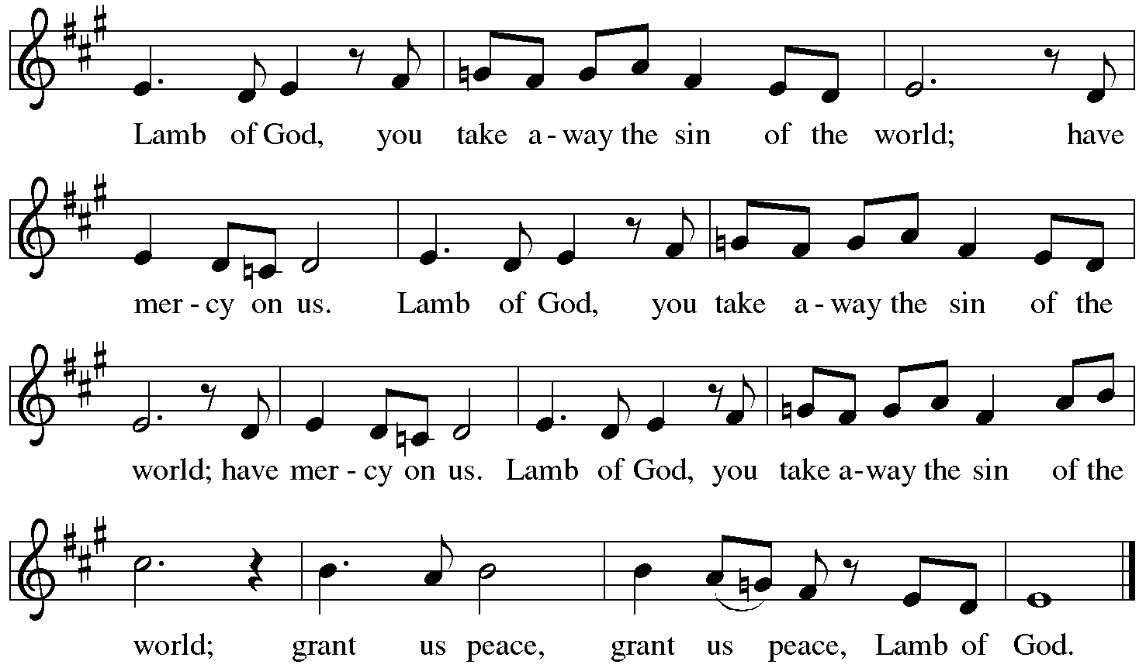

Please be seated.

Holy Communion
- All who seek God and desire a deeper and stronger life in Christ are welcome to receive Holy Communion.
- Worshipers from the pulpit side will proceed forward first, followed by the center section, and then the lectern side.
- Please inform an usher if you would like the ministers to bring Communion to you.
- Holy Communion will be served with bread and wine/grape juice.
- The presiding minister will first distribute the bread (host) to each communicant. Please indicate if you require a gluten-free host.
- Once you have consumed the bread, please pick up an empty glass from the tray next to the presiding minister. The Communion Assistant will pour wine from the chalice or grape juice from the cruet into your glass.
- Please step to the side to consume the wine or grape juice.
- Feel free to kneel at the altar rail for prayer after receiving the sacrament.
- As you return to your pew, glasses may be returned to the empty trays on either side of the center aisle.
- A blessing will be provided for anyone who does not yet receive the sacrament.
- All are invited to join in singing the hymns during Holy Communion.

Hymn during Holy Communion
As the Winter Days Grow Longer ACS 924

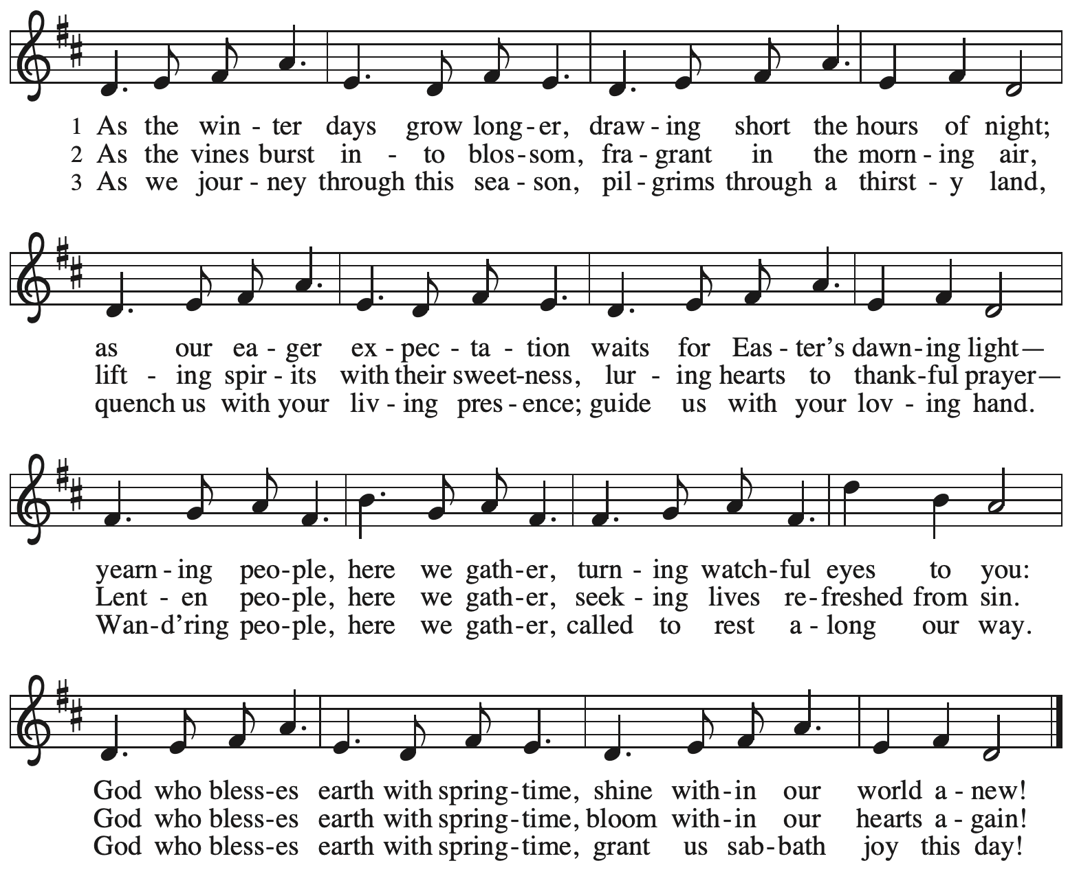
Reprinted with permission under OneLicense.net # A-722139.

Hymn during Holy Communion
Bread of Life from Heaven ELW 474

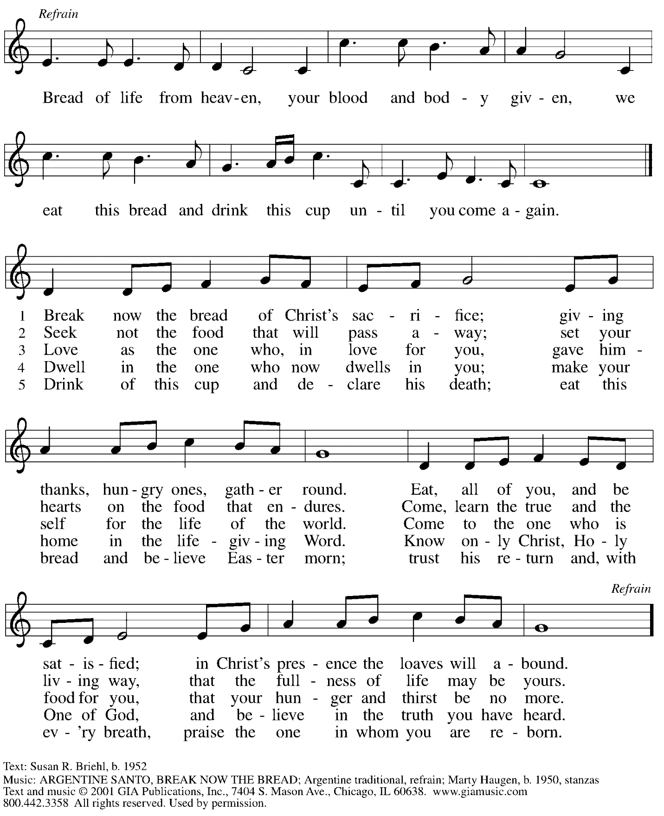
Reprinted under OneLicense.net # A-722139.
Hymn during Holy Communion
Come to Me, All Pilgrims Thirsty ELW 777

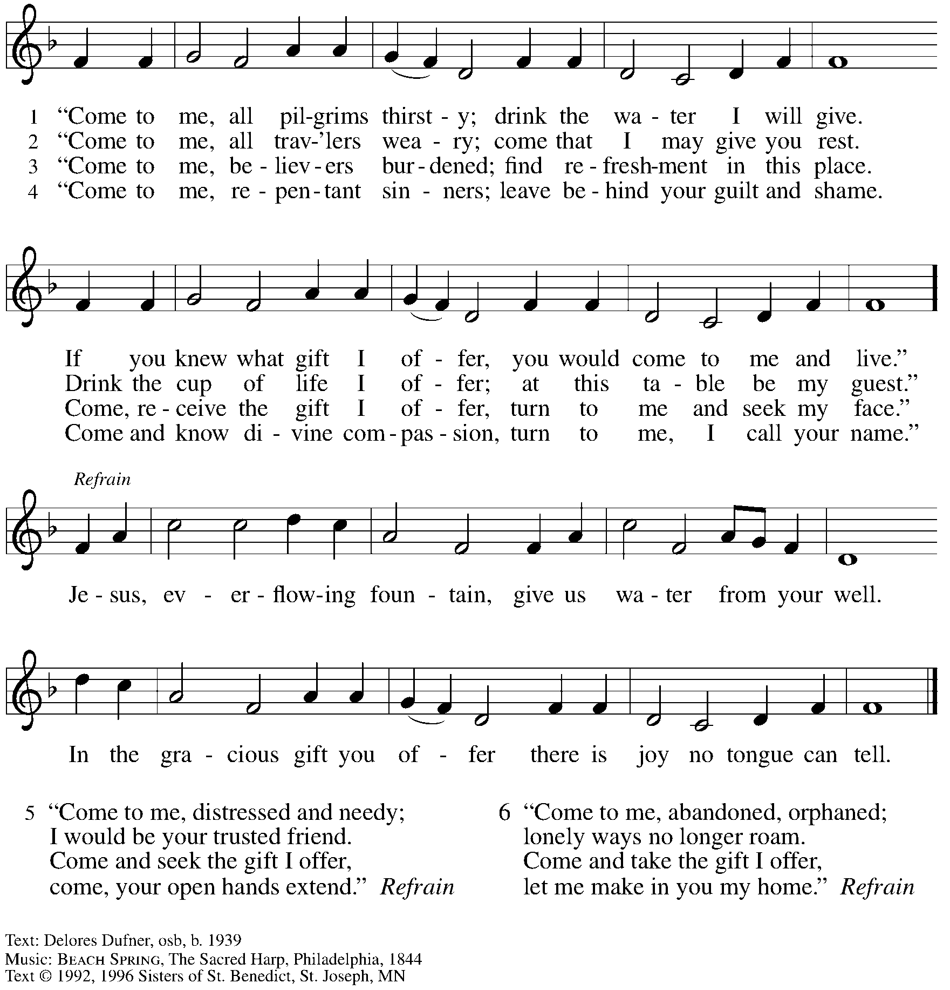
All rights reserved. Reprinted with permission under OneLicense.net # A-722139.

When all have returned to their places, please rise as you are able.

Blessing

P: The body and blood of our Lord Jesus Christ strengthen you and keep you in his grace.
C: Amen.

Prayer

A: Let us pray.
Compassionate God, you have fed us with the bread of heaven.
Sustain us in our Lenten pilgrimage: may our fasting be hunger for justice;
our alms, a making of peace; and our prayer, the song of grateful hearts,
through Jesus Christ, our Savior and Lord.
C: Amen.

Please be seated.

Sending
God blesses us and sends us in mission to the world.

Announcements

Reflection on Faith and Vocation in Daily Life Maria Mangano

Please rise as you are able.

Benediction

P: The God of love; ☩ Christ, the resurrection and the life;
and the Holy Spirit of rebirth, bless you this Lent and always.
C: Amen.

Sending Hymn Bless Now, O God, the Journey Following page

Dismissal

A: Go in peace. Serve in love.
C: Thanks be to God.

Sending Hymn Bless Now, O God, the Journey ELW 326

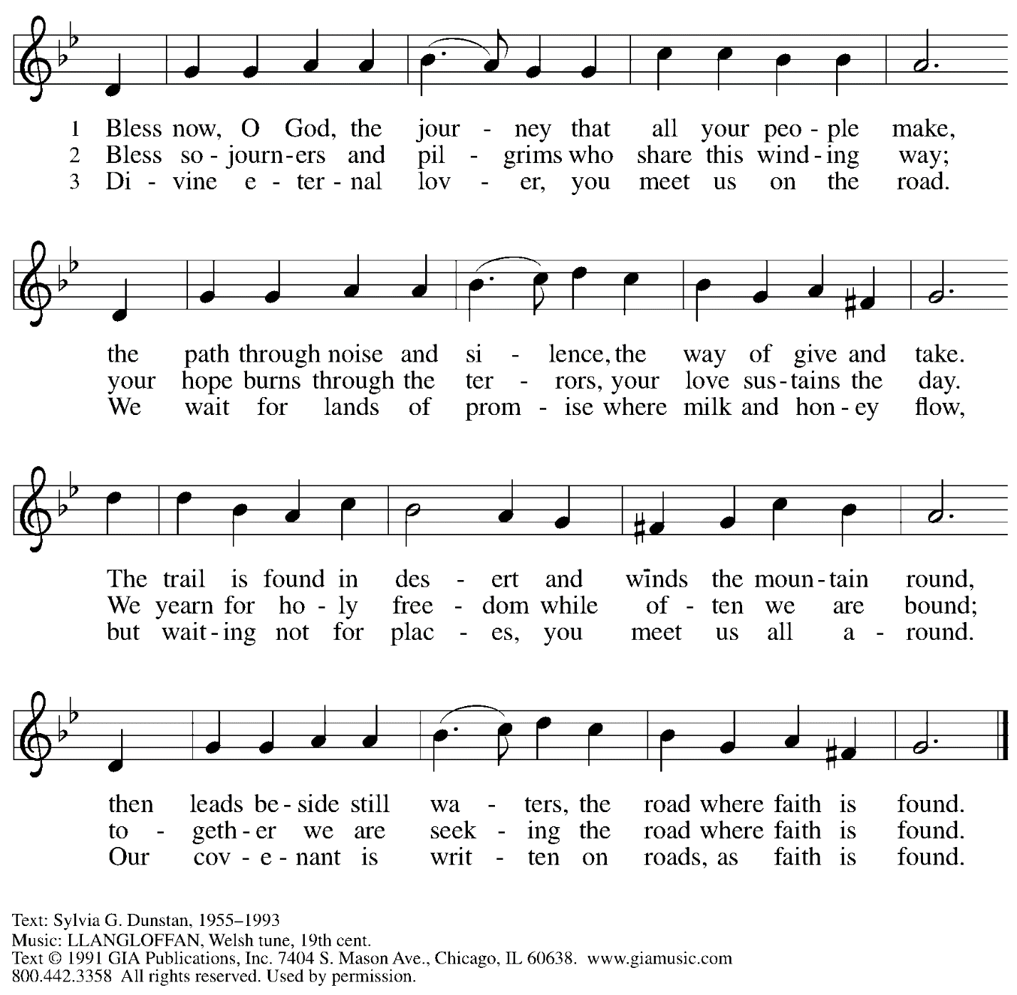
Reprinted under OneLicense.net # A-722139.

Abbreviations

P: Pastor/Presiding Minister
A: Assisting Minister
L: Lector
C: Congregation

ELW: Evangelical Lutheran Worship hymnal
ACS: All Creation Sings hymnal

Those serving in worship today

Assisting Minister Tim Marker
Audio-Visual Ministers Noël Marsh
David Rollinson
Cantor Richard Krug
Clarinet and Lector Maria Mangano
Minister of Music Laura Reynolds
Presiding Minister Pastor Ross I. Carmichael

Liturgy and Hymnody Acknowledgements

From SundaysandSeasons.com. Copyright © 2023 Augsburg Fortress. All rights reserved. Reprinted under OneLicense.net # A-722139.
Used by permission of Augsburg Fortress.

St. Andrew Lutheran Church Announcements
March 12th, 2023

- Welcome to Worship at St. Andrew on March 12th, 2023, the + Third Sunday in Lent – Masks are optional at St. Andrew when Allegheny County’s Covid-19 community level is in the low and medium categories. Worship attendees are invited to make a name tag at the back of the worship space if you would like. All are invited to gather in the Social Hall after worship for food, drinks, and conversation.
- Unique Variations in Worship This Lent – Centering Music, Theme Hymn, Carrying Stones, and Returning to Sharing Peace – Worship services at St. Andrew will be slightly different throughout the season Lent. Instead of a traditional Prelude, the welcome will be followed by centering music, Now is the Time of Grace, led by the cantor, with the congregation invited to listen, reflect, and join in singing the refrain. We will also return to sharing the peace, hear testimonies on faith in daily life on the second through fifth Sundays, be sent for mission in the world with the theme hymn, Bless Now, O God, the Journey, and invite worshipers to pick up symbolic stones to leave at the altar during the sending each week. We pray for God's blessing as we journey together through this season.
- Midweek Worship for Lent – Holden Evening Prayer Available Online Wednesdays, March 15th, 22nd, and 29th – During the season of Lent, many take on additional devotional practices, and it has been customary to offer a midweek prayer service each Wednesday prior to Holy Week. This year, several St. Andrew members have recorded a sung service of the Holden Evening Prayer service with Old Testament readings for each week. These videos will be available online at St. Andrew’s pages on Wednesdays, March 15th, 22nd, and 29th. We encourage you to access this beautiful service throughout the season.
- Shelter Dinner at East End Cooperative Ministry – Thursday, March 16th, 6:30 p.m. – Each month, people of St. Andrew provide dinner for guests of East End Cooperative Ministry, 6140 Station St. (East Liberty) 15206. We invite you to prepare or purchase one menu item and bring it to the shelter by 6:00 p.m., or just come to help serve at 6:30 p.m. If you would like to participate, please sign up here: https://www.signupgenius.com/go/5080544AAAC22A1F58-shelter39.
- Brunch after Worship on Sunday, March 19th – Fairmont Pittsburgh Hotel – The next gathering of St. Andrew’s brunch/dinner “club” will be after worship on Sunday, March 19th – all are welcome! The Fairmont is located at 510 Market St., 15222. Please contact Kelly Spanninger at pkspanninger@verizon.net to reserve a place!
- St. Andrew Jail Ministry – St. Andrew has had a long history of participation in the ministry program at the Allegheny County Jail. Until the program was abruptly put on hold at the beginning of the Covid pandemic, a group of volunteers from St. Andrew was leading a worship service at the jail on Sunday mornings, typically about one Sunday a month. The jail is hoping to resume this program, probably sometime in April. If any of the previous volunteers are still interested and available, please contact Lester Prince (lprince@comcast.net). New volunteers are also needed. The first step for new volunteers is to complete an online application, which can be accessed here: https://www.foundationofhope.org/get-involved/volunteer-application/.
On the application form, indicate that the program that you are interested in volunteering with is “Chaplaincy Worship.” Feel free to contact Lester Prince with any questions.
- St. Andrew Saving Pull Tabs from Cans – St. Andrew continues to save pull tabs from all types of cans. They are recycled by Ronald McDonald House to benefit programs for children and families receiving care at Pittsburgh Children's Hospital. Tabs can be placed in the plastic drawer on the donations table in the social hall.
- Ministry Opportunity – Help with Restocking the Little Pantry – The Community Ministry Committee is seeking help to restock the outdoor pantry with items from the shelves in the social hall. Volunteer for one time, once a month, once every two months, or as often as you want. Contact Joyce Compton at jcompton28@gmail.com or 412-657-0584 if you have questions or would like to serve in this role.
- Lenten Food Drive – Help Fill St. Andrew’s Mini Free Pantry – We are collecting items for the Pantry during the Lenten season. Grab a brown bag from the back of the sanctuary or from the Social Hall and bring it back to the St. Andrew with an item or two for the pantry (no need to fill the bag completely). Items should be shelf safe/stable (nothing fresh, frozen or that may go bad in severe weather.) Here are some things we suggest:
- Items in cans with flip top lids: (no items requiring a can opener)
- Tuna, sardines, or Vienna sausage, ravioli, soup that does not need to be diluted.
- Fruit or vegetables in single-serve, shelf safe containers
- Single serve peanut butter, cheese & cracker snacks, granola bars, beef jerky, raisin boxes, little cereal boxes, shelf stable milk (Horizon)
- Personal care items: Shampoo, body wash, deodorant, toothpaste, feminine products, toilet paper
Contact Joyce Compton at jcompton28@gmail.com or 412-657-0584 with questions.
Please return all items by Easter Sunday, April 9th.
- Faith-Based Event on Housing Insecurity – Saturday, March 25th, 12:00 - 3:00 p.m. - Hot Metal Bridge Faith Community – The event will be in three one-hour sessions: 1) Ministry of presence to those facing housing insecurity in the South Side neighborhood of Hot Metal, 2) Introduction to the ELCA Housing Resource Guide with Deacon Brooke De Jong and Evie Landrau (ELCA World Hunger Network / Engagement), and 3) Housing Advocacy in PA with Tracey DePasquale of Lutheran Advocacy Ministry of Pennsylvania (LAMPa).
- A Celebration of the Legacy of The Rev. Dr. Martin Luther King, Jr. - Sunday, March 26th, 4:00 p.m. – The Southwestern Pennsylvania Synod of the Evangelical Lutheran Church in America will be celebrating the legacy of The Rev. Dr. Martin Luther King, Jr. with an ecumenical service of Holy Communion with Bishops Abraham Allende and Kurt Kusserow presiding and The Rev. Dr. Asa Lee, President of Pittsburgh Theological Seminary, preaching. The event will take place on Sunday, March 26th, at 4:00 p.m. at Berkeley Hills Lutheran Church, 517 Sangree Road, Pittsburgh, PA 15237. Following the service there will be a program on equitable development and housing to accompany this year's theme of "A Home for All in the Beloved Community." Learn more at The Legacy of Dr. Martin Luther King Jr. — Southwestern Pennsylvania Synod (swpasynod.org).

