+ Fourth Sunday in Lent
March 19, 2023

St. Andrew Lutheran Church
304 Morewood Ave.
Pittsburgh, PA 15213
St_andrewELCA@verizon.net
www.standrewpittsburgh.org

+ Fourth Sunday in Lent
Order for Worship

In the history of the Christian church, Baptism has sometimes been called enlightenment.
The gospel for this Sunday is the story of the man born blind healed by Christ.
“I was blind, now I see,” declares the man.
In Baptism God opens our eyes to see the truth of who we are: God’s beloved children.
As David was anointed king of Israel, in Baptism God anoints our head with oil,
and calls us to bear witness to the light of Christ in our daily lives.

The season of Lent began on Ash Wednesday. Lent is a 40-day season focused on repentance, spiritual discipline, and baptismal reflection. We acknowledge our vulnerability and mortality, turn from sin, and return to God for forgiveness and renewal. The readings for the season evoke themes of desert and wilderness — Jesus’ 40-day temptation, the Israelites traveling and needing water, a valley of dry bones, the tomb of Lazarus. Instead of lush greenery we decorate the sanctuary with rocks and stones. There are small stones available at the back of the sanctuary and near the Morewood entrance — we encourage everyone to pick one up each week. The stone may be thought of as sin, guilt, burden, whatever you would like to clean out and/or leave behind in order to make room for God and service to neighbor. We invite you to leave these stones with the others at the altar during the Sending Hymn each week, which throughout the season will be Bless Now, O God, the Journey - ELW 326. This hymn reminds us that when we are scattered in our daily lives and responsibilities, wherever we go in faith, God comes to meet us there to bring hope and peace. On the second through fifth Sundays, testimonies by the congregation’s leaders in the Life of Faith Initiative will precede the hymn. They will share about how they see God at work as they serve in their daily vocations and roles throughout the week. May God bless your journey through Lent!

- Masks are optional at St. Andrew when Covid-19 community level in Allegheny County is in the low and medium categories.

- Worship Services are live streamed to multiple online platforms. By attending worship, you agree that your image and voice may be broadcast.

Welcome to St. Andrew!

- St. Andrew Lutheran Congregation welcomes all who are seeking a place of healing and wholeness, a nurturing, faith-forming spiritual home. Our community embraces people of all ages, ethnicities, cultures, abilities, sexual orientations, gender identities and expressions, and family constellations. Come and See!

- Everyone is invited to make a nametag at the black bookcase in the back of the worship space if they would like. You are welcome to use just your first name and preferred pronouns if desired. There are stickers indicating pronouns on the bookcase if you would like to include them on your name tag.

- Worship “toolkits” to help children engage with the service are available in the black bookcase at the back of the worship space. There are “reader” and “pre-reader” resources available in each kit. Please feel free to use the kits for/with your children during worship.

- Little Church – Big Faith, a Bible lesson and activity for children, takes place after the prayer of the day. Children are invited to meet the adult leaders at the side door of the sanctuary to attend.

- This Lenten season, St. Andrew returns to the Sharing of Peace during worship. More than a simple greeting, this practice and placement in the service derives from the Gospel of Matthew 5: 23-24 – “When you are offering your gift at the altar, if you remember that your sibling has something against you, leave your gift there before the altar and go; first be reconciled to your sibling, and then come and offer your gift.” We will once again have an opportunity to share an expression of Christ’s peace with those around us as a liturgical sign of our desire to be reconciled with our neighbors before offering our gifts and receiving Holy Communion. Please be mindful that some people will not be comfortable with sharing the peace; be sure to obtain consent before any physical expression of peace such as shaking hands or hugging.

- St. Andrew has returned to serving Holy Communion with both (separate) elements, bread and wine/grape juice. The presiding minister will distribute the bread (host). Please consume this and then pick up an empty glass from the tray. The Communion Assistant will pour wine or grape juice into your glass. Please step to the side to consume the wine or grape juice. As you return to your pew, glasses may be returned to the empty trays on either side of the center aisle.

- A restroom is available on the main level of the church, through the doors to the Social Hall and to the right in the main office.

Welcome

Gathering
The Holy Spirit calls us together as the people of God.

Centering Music Now Is the Time of Grace ACS 918
v. 1-2

The verses will be sung by the cantor. The congregation is invited to join in singing the refrain, which will be sung twice each time we come to it.

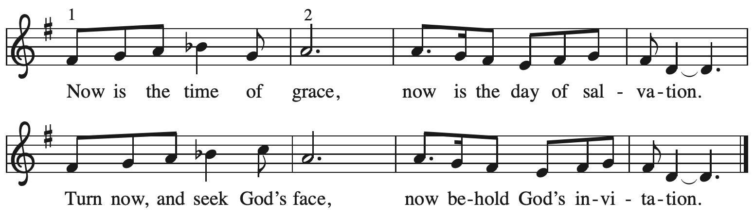

Verses — Leader

1 This is the fast that God would choose:
to loose the bonds of injustice,
to let the captives go free,
and to break the yoke of oppression. Refrain

2 Sharing your bread with the hungry
and welcoming homeless in,
offering hope and offering help,
this is what God requires. Refrain

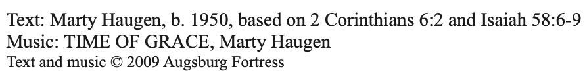
All rights reserved. Reprinted with permission under OneLicense.net # A-722139.

Please rise as you are able.

Confession and Forgiveness

P: Blessed be the holy Trinity, ☩ one God,
who journeys with us these forty days,
and sustains us with the gift of grace.
C: Amen.

P: Let us acknowledge before God and one another
our need for repentance and God’s mercy.

Silence is kept for reflection.

P: Holy God,
C: we confess to you our faults and failings.
Too often we neglect and do not trust your holy word;
we take for ourselves instead of giving to others;
we spoil rather than steward your creation;
we cause hurt though you call us to heal;
we choose fear over compassion.
Forgive us, renew us, and lead us,
as we seek to follow in your way of life.
Amen.

P: Hear the good news:
God so loved the world that God gave God’s only Son,
so that all may receive life.
This promise is for you!
God embraces you with divine mercy,
☩ forgives you in Christ’s name,
and revives you in the Spirit’s power.
C: Amen.

Gathering Hymn Awake, O Sleeper, Rise from Death ELW 452

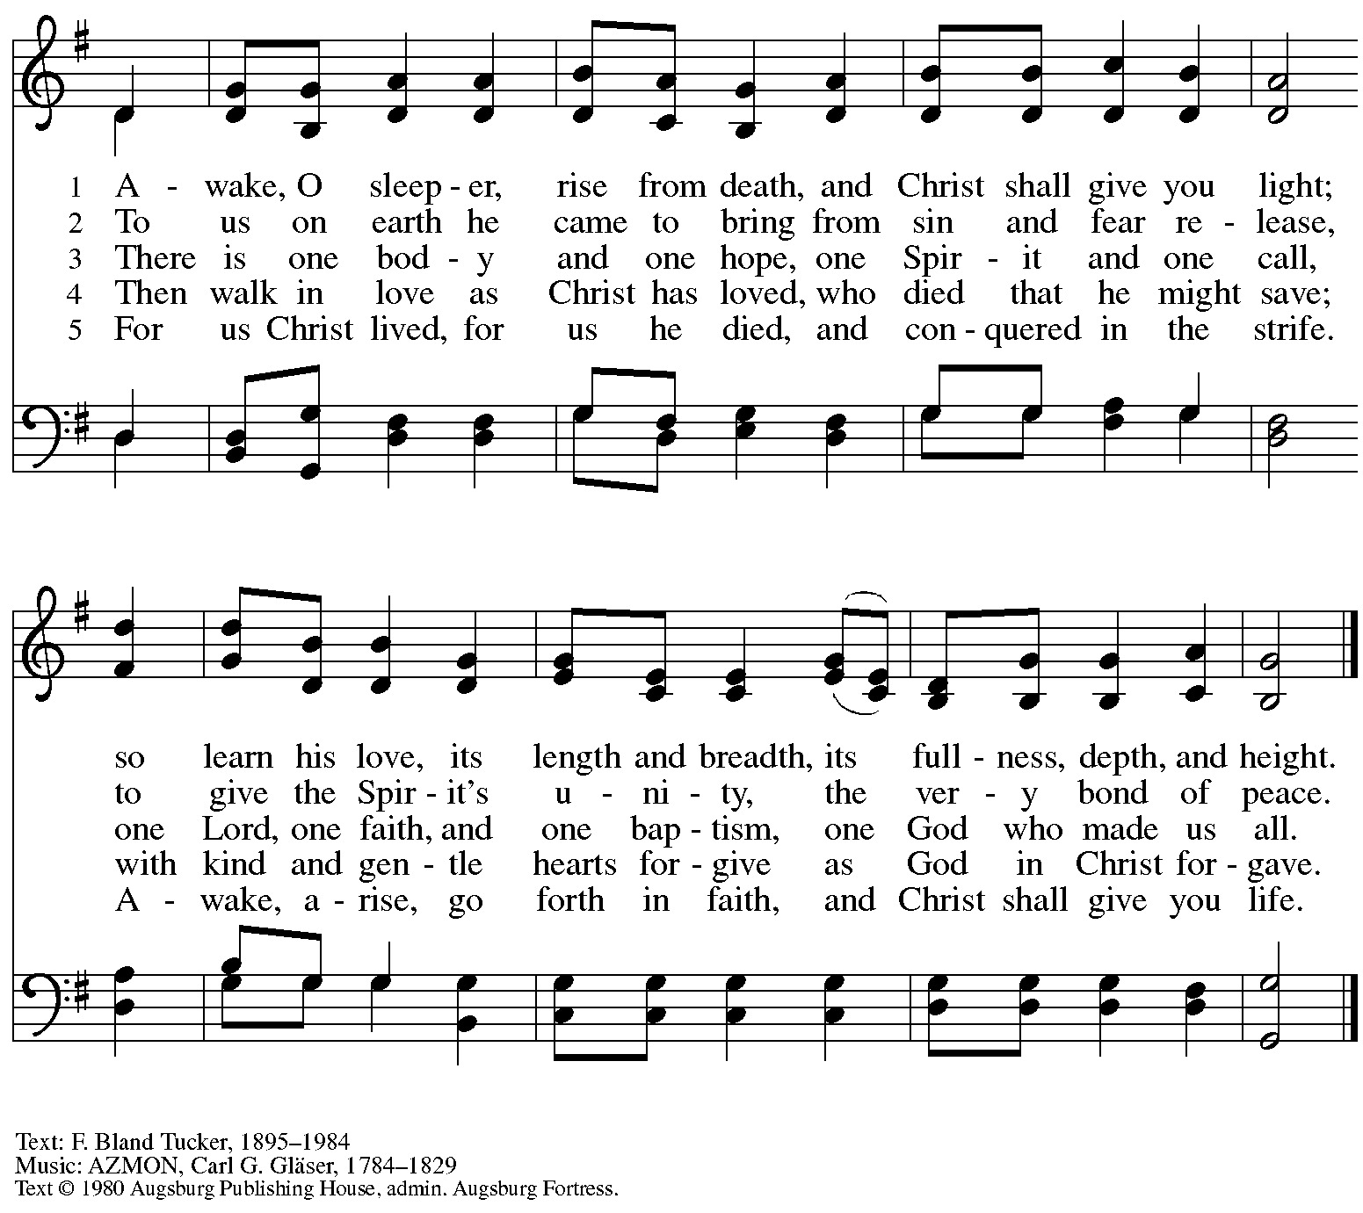
All rights reserved. Reprinted with permission under OneLicense.net #A-722139.

Greeting

P: The grace of our Lord Jesus Christ, the love of God,
and the communion of the Holy Spirit be with you all.
C: And also with you.

Kyrie

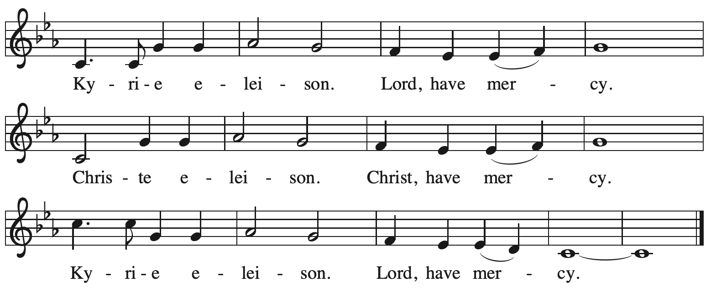

Prayer of the Day

P: The Lord be with you.
C: And also with you.

P: Let us pray.
Bend your ear to our prayers, Lord Christ, and come among us.
By your gracious life and death for us, bring light into the darkness of our hearts,
and anoint us with your Spirit, for you live and reign with the Father and the Holy Spirit,
one God, now and forever.
C: Amen.

Please be seated.
Children are invited to join the adult leaders at the door and move to the office for Little Church – Big Faith. We ask that one additional adult from the congregation attend with the children.

Word
God speaks to us in Scripture reading, preaching, and song

First Reading – 1 Samuel 16: 1-13

¹The Lord said to Samuel, “How long will you grieve over Saul? I have rejected him from being king over Israel. Fill your horn with oil and set out; I will send you to Jesse the Bethlehemite, for I have provided for myself a king among his sons.” ²Samuel said, “How can I go? If Saul hears of it, he will kill me.” And the Lord said, “Take a heifer with you, and say, ‘I have come to sacrifice to the Lord.’ ³Invite Jesse to the sacrifice, and I will show you what you shall do; and you shall anoint for me the one whom I name to you.” ⁴Samuel did what the Lord commanded, and came to Bethlehem. The elders of the city came to meet him trembling, and said, “Do you come peaceably?” ⁵He said, “Peaceably; I have come to sacrifice to the Lord; sanctify yourselves and come with me to the sacrifice.” And he sanctified Jesse and his sons and invited them to the sacrifice.
⁶When they came, he looked on Eliab and thought, “Surely the Lord’s anointed is now before the Lord.” ⁷But the Lord said to Samuel, “Do not look on his appearance or on the height of his stature, because I have rejected him; for the Lord does not see as mortals see; they look on the outward appearance, but the Lord looks on the heart.” ⁸Then Jesse called Abinadab, and made him pass before Samuel. He said, “Neither has the Lord chosen this one.” ⁹Then Jesse made Shammah pass by. And he said, “Neither has the Lord chosen this one.” ¹⁰Jesse made seven of his sons pass before Samuel, and Samuel said to Jesse, “The Lord has not chosen any of these.” ¹¹Samuel said to Jesse, “Are all your sons here?” And he said, “There remains yet the youngest, but he is keeping the sheep.” And Samuel said to Jesse, “Send and bring him; for we will not sit down until he comes here.” ¹²He sent and brought him in. Now he was ruddy, and had beautiful eyes, and was handsome. The Lord said, “Rise and anoint him; for this is the one.”
¹³Then Samuel took the horn of oil, and anointed him in the presence of his brothers; and the spirit of the Lord came mightily upon David from that day forward. Samuel then set out and went to Ramah.

L: Word of God, word of life.
C: Thanks be to God.

Psalm 23 The King of Love My Shepherd Is ELW 502

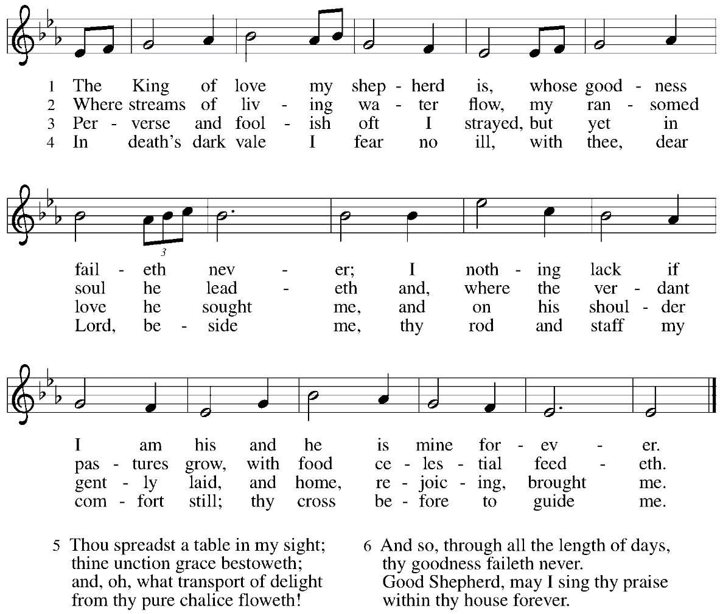

Second Reading – Ephesians 5: 8-14

⁸Once you were darkness, but now in the Lord you are light. Live as children of light—
⁹for the fruit of the light is found in all that is good and right and true. ¹⁰Try to find out what is pleasing to the Lord. ¹¹Take no part in the unfruitful works of darkness, but instead expose them.
¹²For it is shameful even to mention what such people do secretly; ¹³but everything exposed by the light becomes visible, ¹⁴for everything that becomes visible is light. Therefore it says,
“Sleeper, awake!
Rise from the dead,
and Christ will shine on you.”

L: Word of God, word of life.
C: Thanks be to God.

Please rise as you are able.

Gospel Acclamation

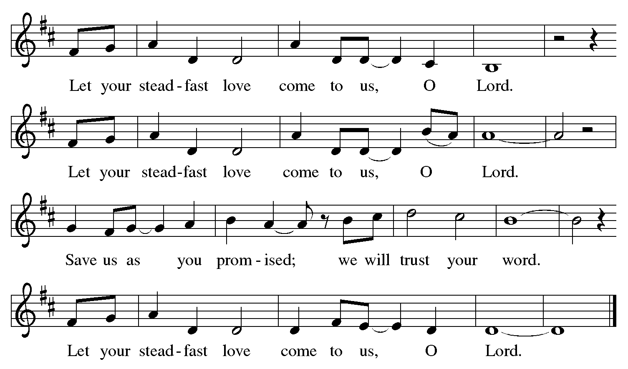

Gospel – John 9: 1-41

P: The holy Gospel according to St. John.
C: Glory to you, O Lord.
¹As [Jesus] walked along, he saw a man blind from birth. ²His disciples asked him, “Rabbi, who sinned, this man or his parents, that he was born blind?” ³Jesus answered, “Neither this man nor his parents sinned; he was born blind so that God’s works might be revealed in him. ⁴We must work the works of the one who sent me while it is day; night is coming when no one can work. ⁵As long as I am in the world, I am the light of the world.” ⁶When he had said this, he spat on the ground and made mud with the saliva and spread the mud on the man’s eyes, ⁷saying to him, “Go, wash in the pool of Siloam” (which means Sent). Then he went and washed and came back able to see. ⁸The neighbors and those who had seen him before as a beggar began to ask, “Is this not the man who used to sit and beg?” ⁹Some were saying, “It is he.” Others were saying, “No, but it is someone like him.” He kept saying, “I am the man.” ¹⁰But they kept asking him, “Then how were your eyes opened?” ¹¹He answered, “The man called Jesus made mud, spread it on my eyes, and said to me, ‘Go to Siloam and wash.’ Then I went and washed and received my sight.” ¹²They said to him, “Where is he?” He said, “I do not know.”
¹³They brought to the Pharisees the man who had formerly been blind. ¹⁴Now it was a sabbath day when Jesus made the mud and opened his eyes. ¹⁵Then the Pharisees also began to ask him how he had received his sight. He said to them, “He put mud on my eyes. Then I washed, and now I see.” ¹⁶Some of the Pharisees said, “This man is not from God, for he does not observe the sabbath.” But others said, “How can a man who is a sinner perform such signs?” And they were divided. ¹⁷So they said again to the blind man, “What do you say about him? It was your eyes he opened.” He said, “He is a prophet.”
¹⁸The Jews did not believe that he had been blind and had received his sight until they called the parents of the man who had received his sight ¹⁹and asked them, “Is this your son, who you say was born blind? How then does he now see?” ²⁰His parents answered, “We know that this is our son, and that he was born blind; ²¹but we do not know how it is that now he sees, nor do we know who opened his eyes. Ask him; he is of age. He will speak for himself.” ²²His parents said this because they were afraid of Jesus’ opponents from the Jewish leadership; for they had already agreed that anyone who confessed Jesus to be the Messiah would be put out of the synagogue. ²³Therefore his parents said, “He is of age; ask him.”
²⁴So for the second time they called the man who had been blind, and they said to him, “Give glory to God! We know that this man is a sinner.” ²⁵He answered, “I do not know whether he is a sinner. One thing I do know, that though I was blind, now I see.” ²⁶They said to him, “What did he do to you? How did he open your eyes?” ²⁷He answered them, “I have told you already, and you would not listen. Why do you want to hear it again? Do you also want to become his disciples?” ²⁸Then they reviled him, saying, “You are his disciple, but we are disciples of Moses. ²⁹We know that God has spoken to Moses, but as for this man, we do not know where he comes from.” ³⁰The man answered, “Here is an astonishing thing! You do not know where he comes from, and yet he opened my eyes. ³¹We know that God does not listen to sinners, but God does listen to one who worships God and obeys God’s will. ³²Never since the world began has it been heard that anyone opened the eyes of a person born blind. ³³If this man were not from God, he could do nothing.” ³⁴They answered him, “You were born entirely in sins, and are you trying to teach us?” And they drove him out.
³⁵Jesus heard that they had driven him out, and when he found him, he said, “Do you believe in the Son of Humanity?” ³⁶He answered, “And who is he, sir? Tell me, so that I may believe in him.” ³⁷Jesus said to him, “You have seen him, and the one speaking with you is he.” ³⁸He said, “Lord, I believe.” And he worshiped him. ³⁹Jesus said, “I came into this world for judgment so that those who do not see may see, and those who do see may become blind.” ⁴⁰Some of the Pharisees near him heard this and said to him, “Surely we are not blind, are we?” ⁴¹Jesus said to them, “If you were blind, you would not have sin. But now that you say, ‘We see,’ your sin remains.”

P: The Gospel of the Lord.
C: Praise to you, O Christ.

Please be seated.

Sermon

A time of silence for prayer and reflection follows the sermon.
When the Hymn of the Day begins, please rise as you are able.

Hymn of the Day Praise the One Who Breaks the Darkness ELW 843

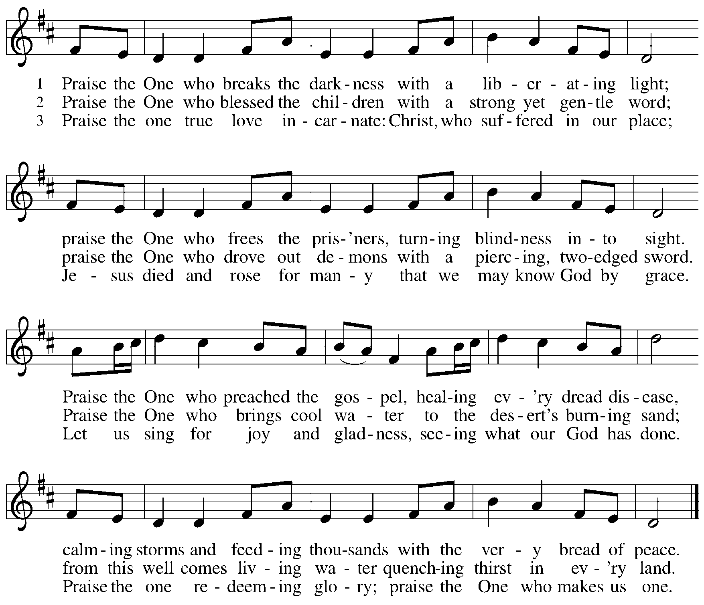

Apostles Creed

C: I believe in God, the Father almighty,
creator of heaven and earth.

I believe in Jesus Christ, God’s only Son, our Lord,
who was conceived by the Holy Spirit,
born of the virgin Mary,
suffered under Pontius Pilate,
was crucified, died, and was buried;
he descended to the dead.*
On the third day he rose again;
he ascended into heaven,
he is seated at the right hand of the Father,
and he will come to judge the living and the dead.

I believe in the Holy Spirit,
the holy catholic church,
the communion of saints,
the forgiveness of sins,
the resurrection of the body,
and the life everlasting. Amen.

*Or, “he descended into hell,” another translation of this text in widespread use.

Prayers of the People

A: Sustained by God’s abundant mercy, let us pray for the church, the world,
and all who are in need.

After each petition
A: Merciful God,
C: receive our prayer.

The presiding minister concludes the prayers:
P: We lift our prayers to you, O God,
trusting in your steadfast love
and your promise to renew all creation;
through Jesus Christ, our Savior and Lord.
C: Amen.

Peace

The presiding minister and the assembly greet one another in the peace of the risen Christ.
P: The peace of Christ be with you always.
C: And also with you.

The people may greet those around them with a sign of Christ’s peace and may say
Peace be with you or similar words. Please be mindful that not everyone will be comfortable with sharing the peace, so please seek consent before shaking hands or hugging. Other possible ways to share the peace include a simple bow with the verbal greeting of peace, or simply a verbal expression of peace.

When the greetings of peace have concluded, please be seated.

Meal
God feeds us with the presence of Jesus Christ

Offering

We offer ourselves, our gifts, and our faithful service to God.
As the offering is gathered for the mission of the church, including the care of those in need,
the table is set for Holy Communion.

Music during the Offering

As the gifts are brought forward for presentation, please rise as you are able.

Offertory Song

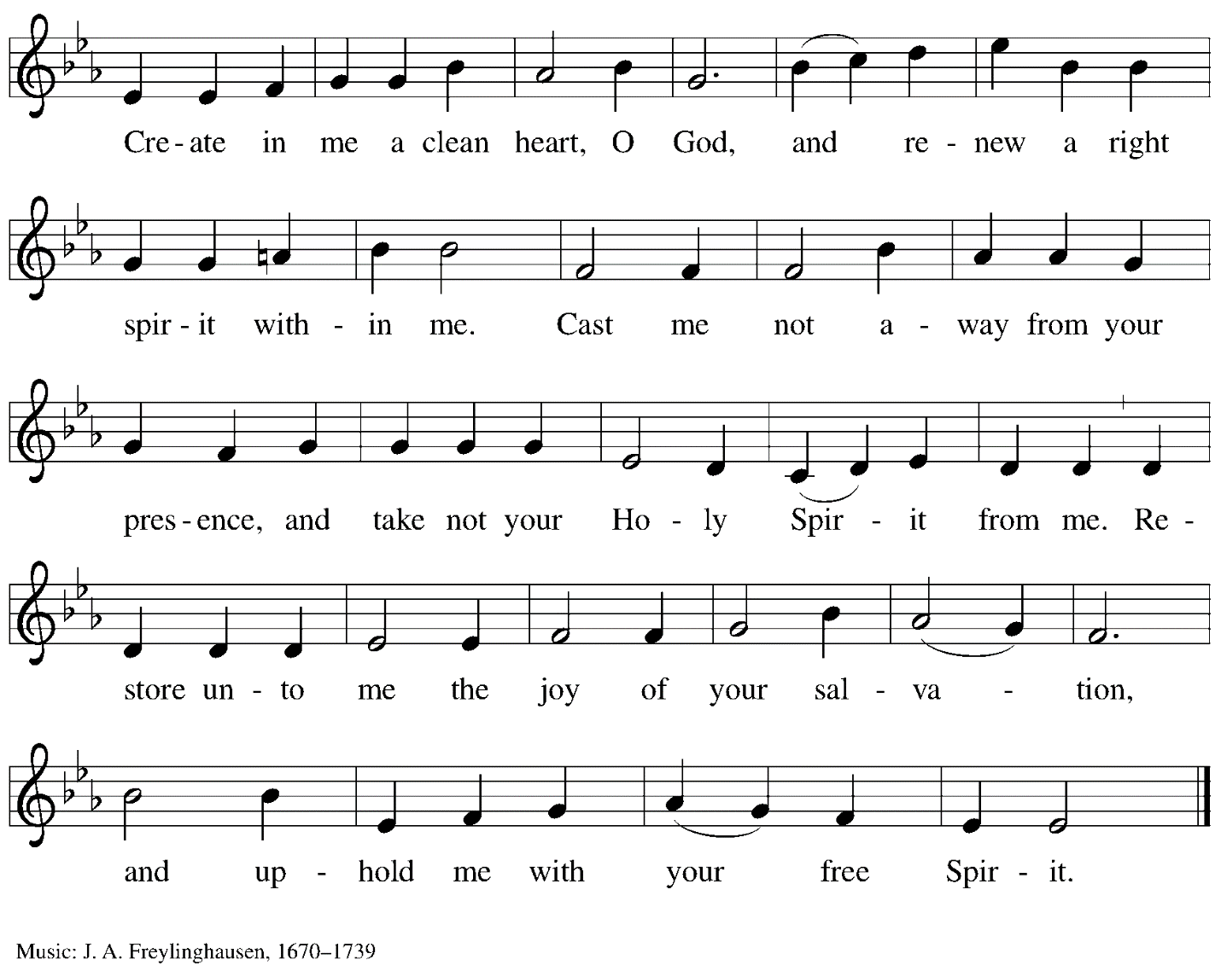

Offertory Prayer

A: Let us pray.
God our provider,
C: you have not fed us with bread alone
but with words of grace and life.
Bless us, and these your gifts,
which we receive from your bounty,
through Jesus Christ our Lord. Amen.

Dialogue

P: The Lord be with you.
C: And also with you.

P: Lift up your hearts.
C: We lift them to the Lord.

P: Let us give thanks to the Lord our God.
C: It is right to give our thanks and praise.

Preface

P: It is indeed right, our duty and our joy…
… we praise your name and join their unending hymn:

Sanctus

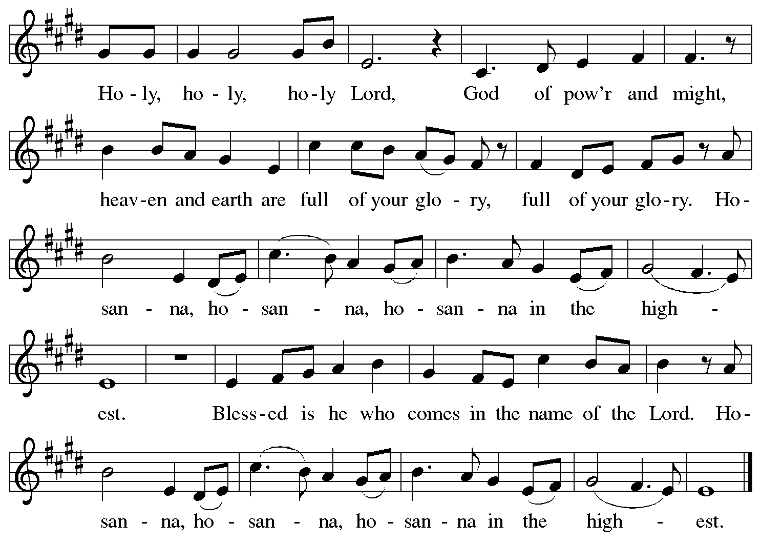

Eucharistic Prayer

P: Blessed are you, O God of the universe,
Your mercy is everlasting
and your faithfulness endures from age to age.

Praise to you for creating the heavens and the earth.
Praise to you for saving the earth from the waters of the flood.
Praise to you for bringing the Israelites safely through the sea.
Praise to you for leading your people through the wilderness
to the land of milk and honey.
Praise to you for the words and deeds of Jesus, your anointed one.
Praise to you for the death and resurrection of Christ.
Praise to you for your Spirit poured out on all nations.

In the night in which he was betrayed,
our Lord Jesus took bread, and gave thanks;
broke it, and gave it to his disciples, saying:
Take and eat; this is my body, given for you.
Do this for the remembrance of me.

Again, after supper, he took the cup, gave thanks,
and gave it for all to drink, saying:
This cup is the new covenant in my blood,
shed for you and for all people for the forgiveness of sin.
Do this for the remembrance of me.

With this bread and cup
we remember our Lord’s passover from death to life
as we proclaim the mystery of faith:
C: Christ has died.
Christ is risen.
Christ will come again.

P: O God of resurrection and new life:
Pour out your Holy Spirit on us
and on these gifts of bread and wine.
Bless this feast.
Grace our table with your presence.
C: Come, Holy Spirit.

P: Reveal yourself to us in the breaking of the bread.
Raise us up as the body of Christ for the world.
Breathe new life into us.
Send us forth,
burning with justice, peace, and love.
C: Come, Holy Spirit.

P: With your holy ones of all times and places,
with the earth and all its creatures,
with sun and moon and stars,
we praise you, O God,
blessed and holy Trinity,
now and forever.
C: Amen.

Lord’s Prayer

P: Gathered as one by the Holy Spirit, let us pray as Jesus taught us.
C: Our Father in heaven,
hallowed be your name,
your kingdom come,
your will be done,
on earth as in heaven.
Give us today our daily bread.
Forgive us our sins
as we forgive those who sin against us.
Save us from the time of trial
and deliver us from evil.
For the kingdom, the power,
and the glory are yours,
now and forever. Amen.

Fraction and Invitation

P: Come to the table of mercy;
receive God’s gifts of grace.

Agnus Dei/Lamb of God

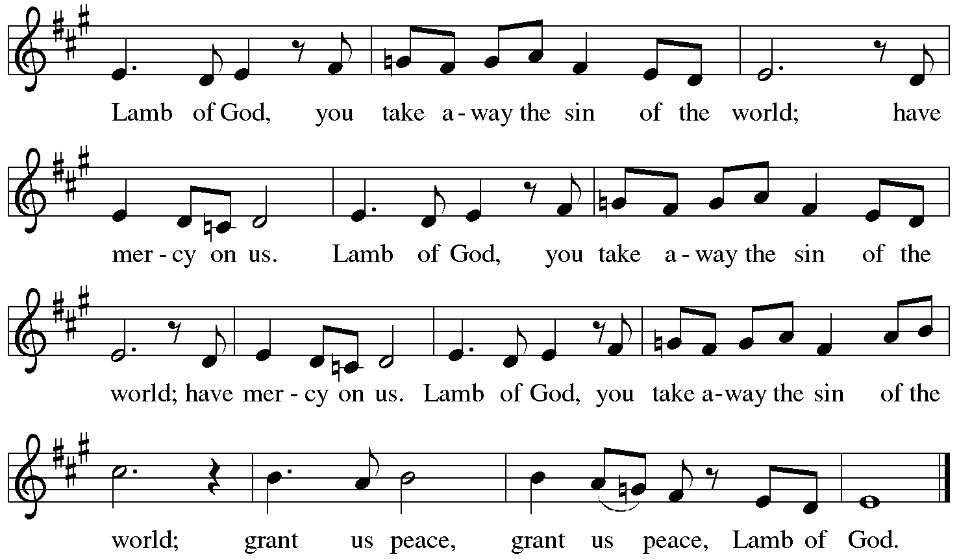

Please be seated.

Holy Communion
- All who seek God and desire a deeper and stronger life in Christ are welcome to receive Holy Communion.
- Worshipers from the pulpit side will proceed forward first, followed by the center section, and then the lectern side.
- Please inform an usher if you would like the ministers to bring Communion to you.
- Holy Communion will be served with bread and wine/grape juice.
- The presiding minister will first distribute the bread (host) to each communicant. Please indicate if you require a gluten-free host.
- Once you have consumed the bread, please pick up an empty glass from the tray next to the presiding minister. The Communion Assistant will pour wine from the chalice or grape juice from the cruet into your glass.
- Please step to the side to consume the wine or grape juice.
- Feel free to kneel at the altar rail for prayer after receiving the sacrament.
- As you return to your pew, glasses may be returned to the empty trays on either side of the center aisle.
- A blessing will be provided for anyone who does not yet receive the sacrament.
- All are invited to join in singing the hymns during Holy Communion.

Hymn during Holy Communion
Let My Spirit Always Sing ACS 1020

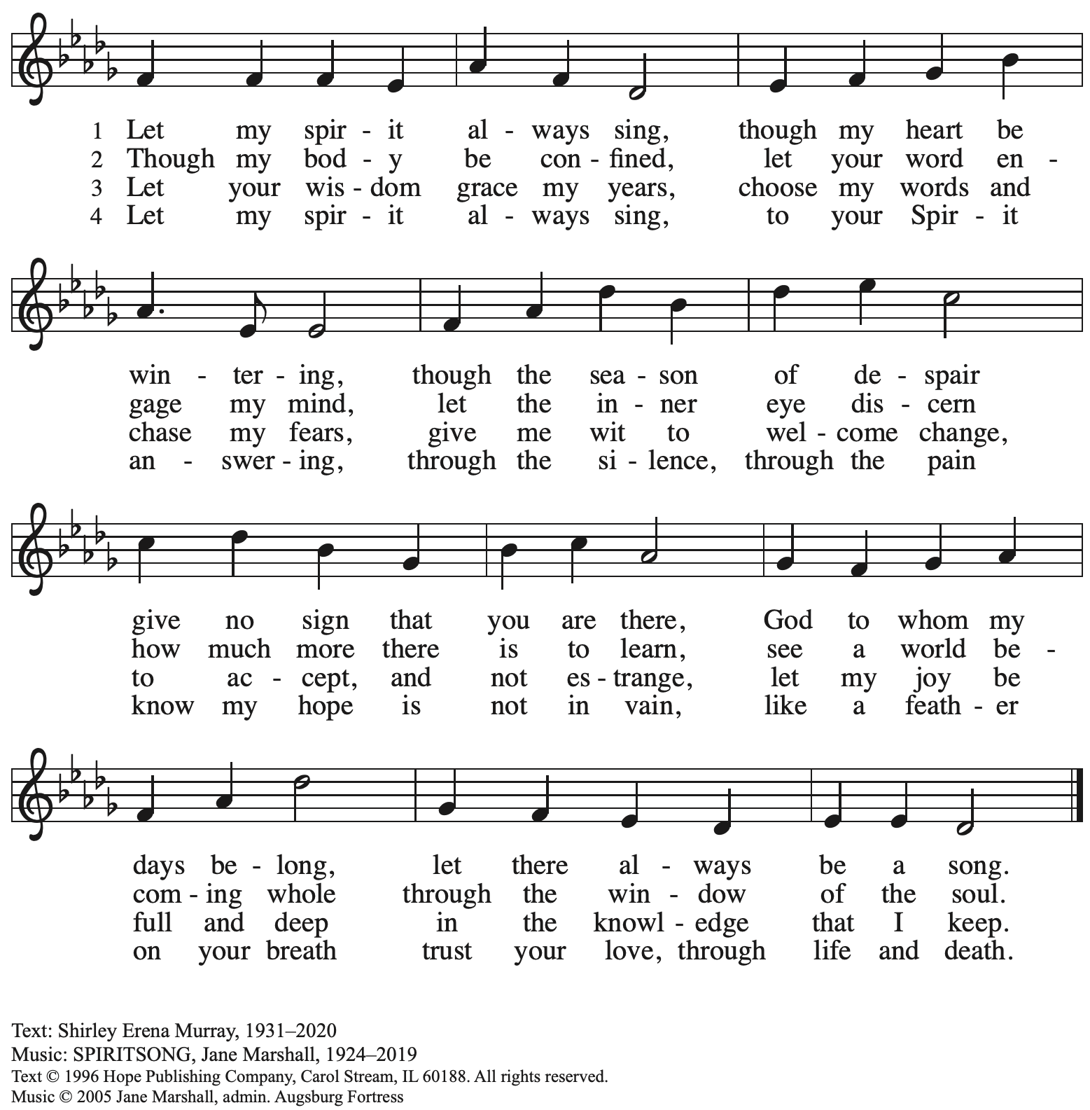
Reprinted with permission under OneLicense.net # A-722139.

Hymn during Holy Communion
God, Whose Almighty Word ELW 673

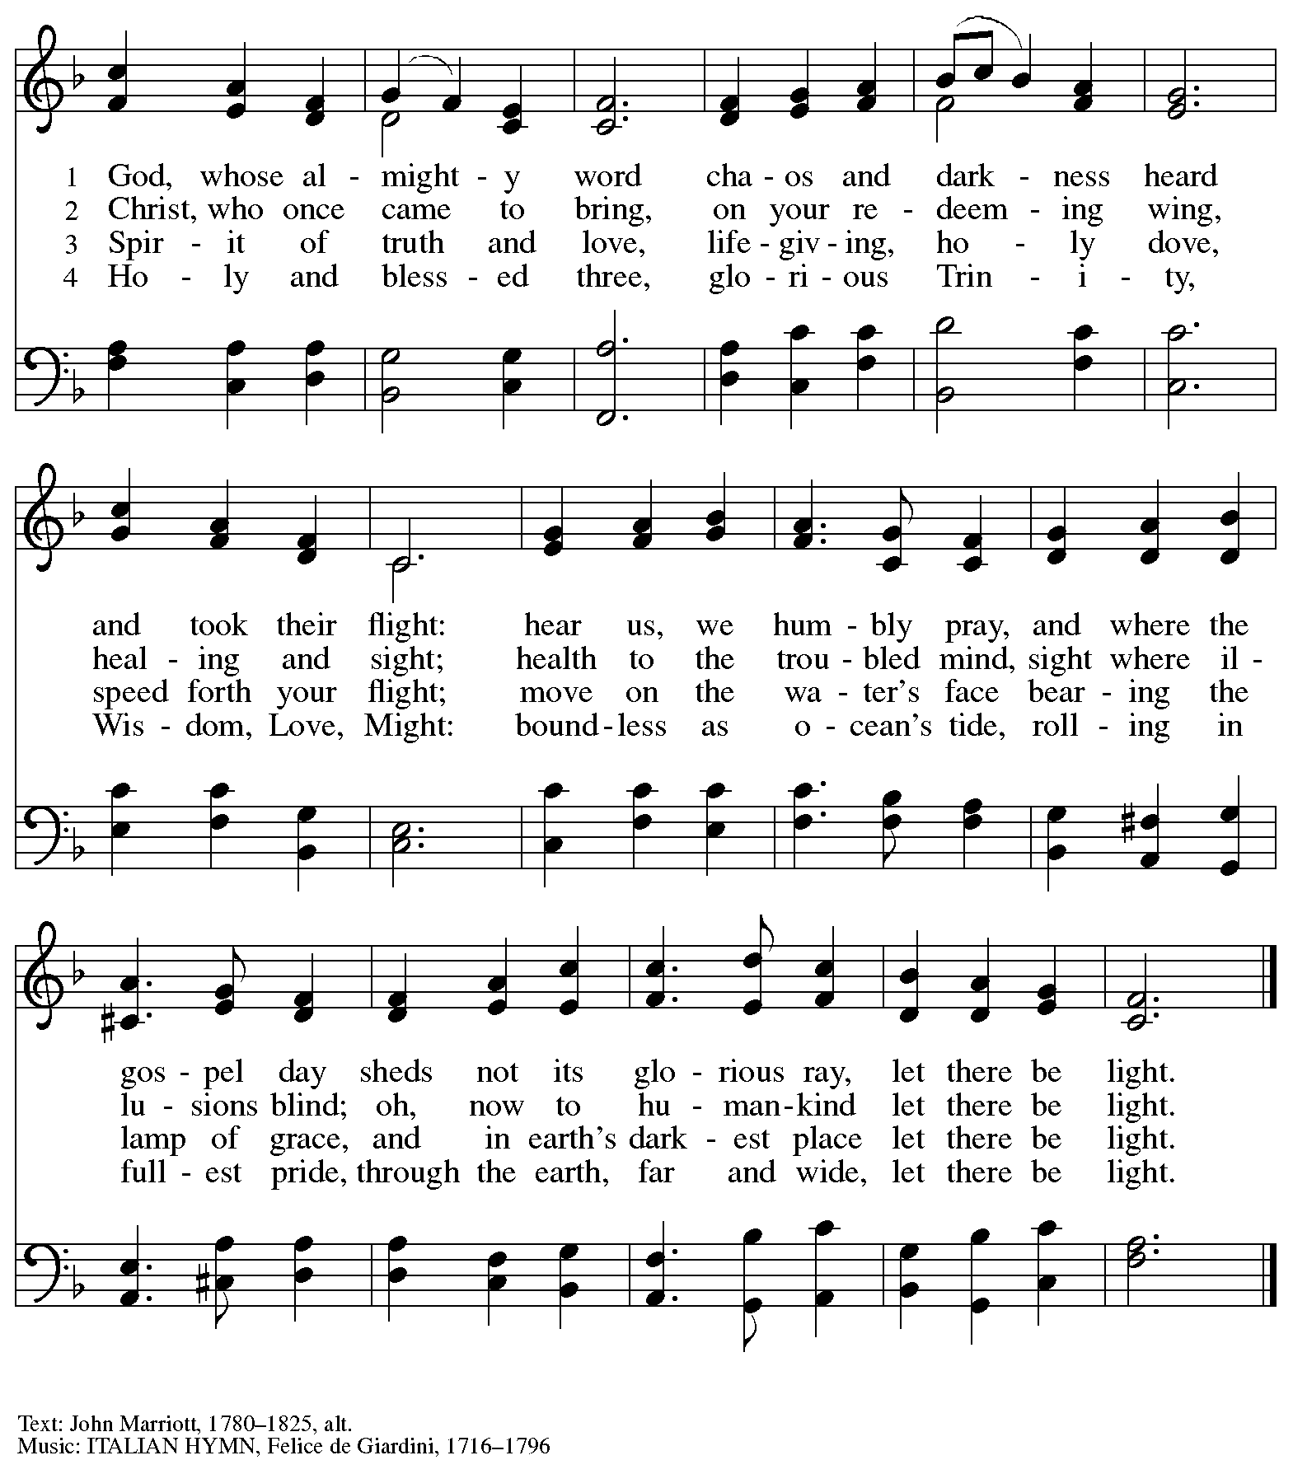

Hymn during Holy Communion
Amazing Grace, How Sweet the Sound ELW 779

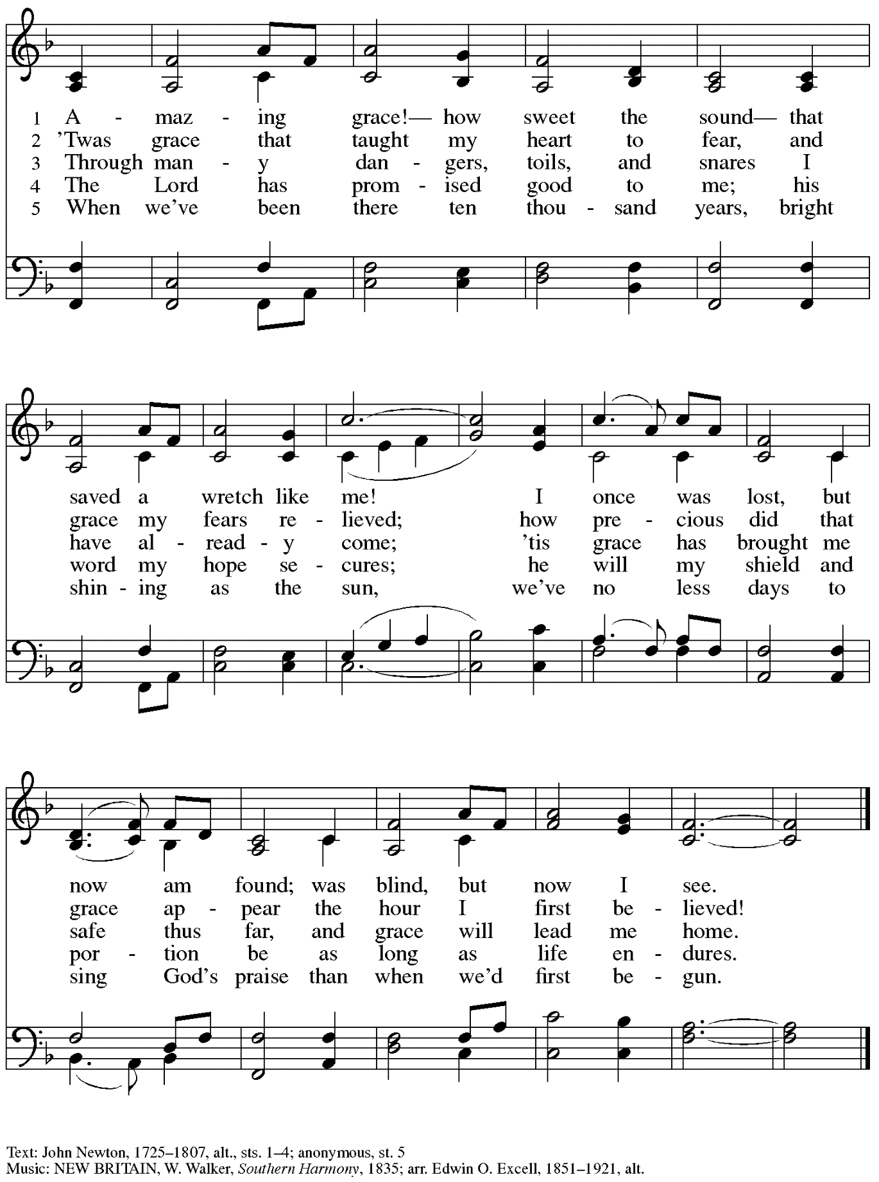

When all have returned to their places, please rise as you are able.

Blessing

P: The body and blood of our Lord Jesus Christ strengthen you and keep you in his grace.
C: Amen.

Prayer

A: Let us pray.
Compassionate God, you have fed us with the bread of heaven.
Sustain us in our Lenten pilgrimage: may our fasting be hunger for justice;
our alms, a making of peace; and our prayer, the song of grateful hearts,
through Jesus Christ, our Savior and Lord.
C: Amen.

Please be seated.

Sending
God blesses us and sends us in mission to the world.

Announcements

Reflection on Faith and Vocation in Daily Life Alda Maria Gonzaga

Please rise as you are able.

Benediction

P: The God of love;
☩ Christ, the resurrection and the life;
and the Holy Spirit of rebirth,
bless you this Lent and always.
C: Amen.

Sending Hymn Bless Now, O God, the Journey Following page

Dismissal

A: Go in peace. Serve in love.
C: Thanks be to God.

Sending Hymn Bless Now, O God, the Journey ELW 326

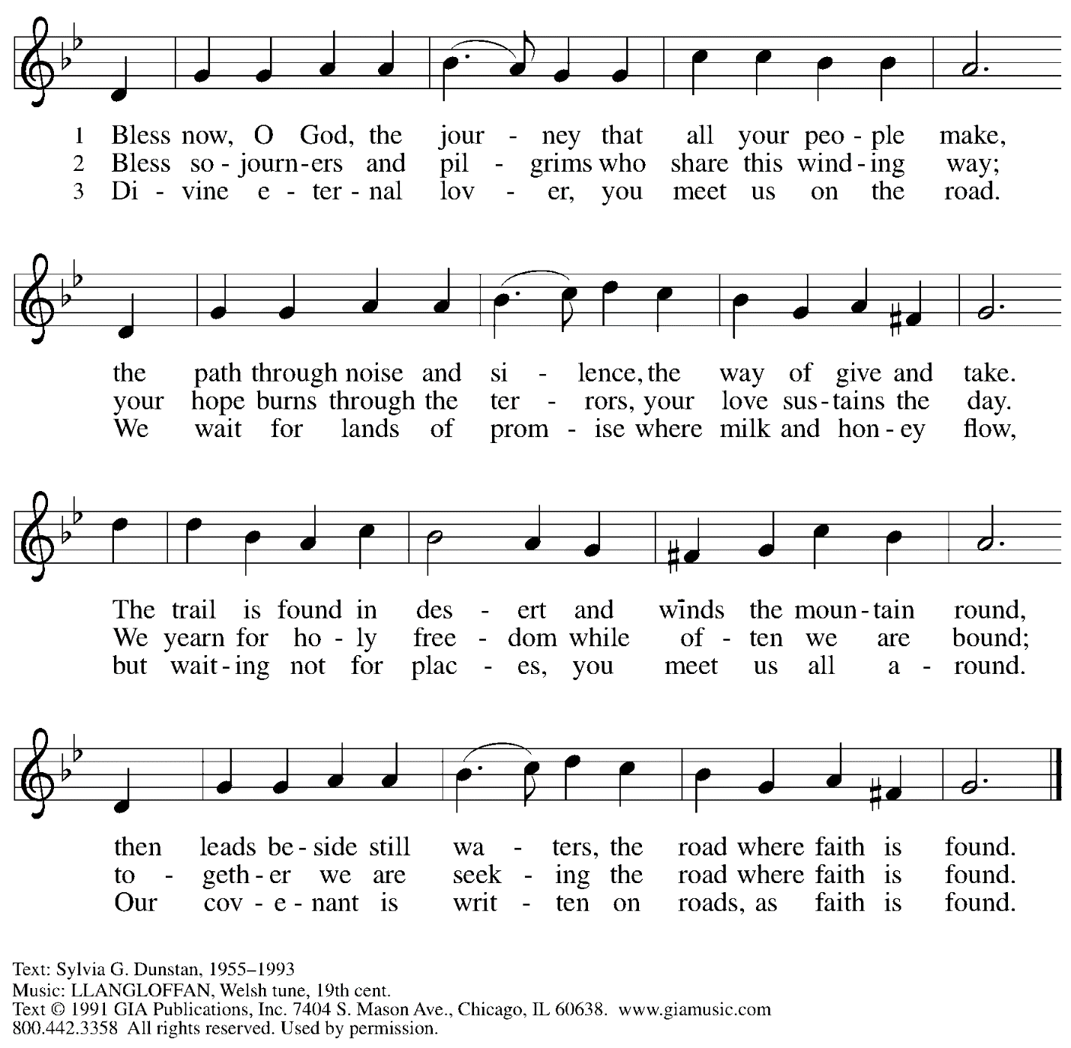
Reprinted under OneLicense.net # A-722139.

Abbreviations

P: Pastor/Presiding Minister
A: Assisting Minister
L: Lector
C: Congregation

ELW: Evangelical Lutheran Worship hymnal
ACS: All Creation Sings hymnal

Those serving in worship today

Assisting Minister Timothy Kocher-Hillmer
Audio-Visual Ministers Jason Galyardt
David Rollinson
Cantor Ian Brown
Clarinet Maria Mangano
Lector Lindsay Baxter
Minister of Music Laura Reynolds
Presiding Minister Pastor Ross I. Carmichael

Liturgy and Hymnody Acknowledgements

From SundaysandSeasons.com. Copyright © 2023 Augsburg Fortress. All rights reserved. Reprinted under OneLicense.net # A-722139.
Used by permission of Augsburg Fortress.

The King of Love My Shepherd Is – Text: Henry W. Baker, 1821-1877. Music: ST. COLOMBA, Irish tune.

Praise the One Who Breaks the Darkness – Text: Rusty Edwards, b. 1955. Music: NETTLETON, J. Wyeth, Repository of Sacred Music, Part II, 1813. Text © 1987 Hope Publishing Company, Carol Stream, IL 60188. All rights reserved. Reprinted with permission under OneLicense.net # A-722139.

St. Andrew Lutheran Church Announcements
March 19th, 2023

- Welcome to Worship at St. Andrew on March 19th, 2023, the + Fourth Sunday in Lent – Masks are optional at St. Andrew when Allegheny County’s Covid-19 community level is in the low and medium categories. Worship attendees are invited to make a name tag at the back of the worship space if you would like. All are invited to gather in the Social Hall after worship for food, drinks, and conversation.
- Unique Variations in Worship This Lent – Centering Music, Theme Hymn, Carrying Stones, and Returning to Sharing Peace – Worship services at St. Andrew will be slightly different throughout the season Lent. Instead of a traditional Prelude, the welcome will be followed by centering music, Now is the Time of Grace, led by the cantor, with the congregation invited to listen, reflect, and join in singing the refrain. We will also return to sharing the peace, hear testimonies on faith in daily life on the second through fifth Sundays, be sent for mission in the world with the theme hymn, Bless Now, O God, the Journey, and invite worshipers to pick up symbolic stones to leave at the altar during the sending each week. We pray for God's blessing as we journey together through this season.
- Brunch Gathering Today after Worship at the Fairmont Pittsburgh Hotel – St. Andrew’s brunch/dinner “club” will meet after worship today, Sunday, March 19th – all are welcome! The Fairmont is located at 510 Market St., 15222. Please let Kelly Spanninger know if you plan to come!
- Midweek Worship for Lent – Holden Evening Prayer Available Online, Wednesdays, March 22nd and 29th – During the season of Lent, many take on additional devotional practices, and it has been customary to offer a midweek prayer service each Wednesday prior to Holy Week. This year, several St. Andrew members have recorded a sung service of the Holden Evening Prayer service with Old Testament readings for each week. These videos will be available online at St. Andrew’s pages on Wednesdays, March 22nd and 29th. We encourage you to access this beautiful service throughout the season.
- Opportunity for Ministry at Allegheny County Jail – St. Andrew has had a long history of participation in the ministry program at the Allegheny County Jail. Until the program was abruptly put on hold at the beginning of the Covid pandemic, a group of volunteers from St. Andrew was leading a worship service at the jail on Sunday mornings, typically about one Sunday a month. The jail is hoping to resume this program, probably sometime in April. If any of the previous volunteers are still interested and available, please contact Lester Prince (lprince@comcast.net). New volunteers are also needed. The first step for new volunteers is to complete an online application, which can be accessed here: https://www.foundationofhope.org/get-involved/volunteer-application/. On the application form, indicate that the program that you are interested in volunteering with is “Chaplaincy Worship.” Feel free to contact Lester Prince with any questions.
- St. Andrew Saving Pull Tabs from Cans – St. Andrew continues to save pull tabs from all types of cans. They are recycled by Ronald McDonald House to benefit programs for children and families receiving care at Pittsburgh Children's Hospital. Tabs can be placed in the plastic drawer on the donations table in the social hall.
- Ministry Opportunity – Help with Restocking the Little Pantry – The Community Ministry Committee is seeking help to restock the outdoor pantry with items from the shelves in the social hall. Volunteer for one time, once a month, once every two months, or as often as you want. Contact Joyce Compton at jcompton28@gmail.com or 412-657-0584 if you have questions or would like to serve in this role.
- Lenten Food Drive – Help Fill St. Andrew’s Mini Free Pantry – We are collecting items for the Pantry during the Lenten season. Grab a brown bag from the back of the sanctuary or from the Social Hall and bring it back to the St. Andrew with an item or two for the pantry (no need to fill the bag completely). Items should be shelf safe/stable (nothing fresh, frozen or that may go bad in severe weather.) Here are some things we suggest:
- Items in cans with flip top lids: (no items requiring a can opener)
- Tuna, sardines, or Vienna sausage, ravioli, soup that does not need to be diluted.
- Fruit or vegetables in single-serve, shelf safe containers
- Single serve peanut butter, cheese & cracker snacks, granola bars, beef jerky, raisin boxes, little cereal boxes, shelf stable milk (Horizon)
- Personal care items: Shampoo, body wash, deodorant, toothpaste, feminine products, toilet paper
Contact Joyce Compton at jcompton28@gmail.com or 412-657-0584 with questions.
Please return all items by Easter Sunday, April 9th.
- Faith-Based Event on Housing Insecurity – Saturday, March 25th, 12:00 - 3:00 p.m. - Hot Metal Bridge Faith Community - The event will be in three one-hour sessions:
1) Ministry of presence to those facing housing insecurity in the South Side neighborhood of Hot Metal, 2) Introduction to the ELCA Housing Resource Guide with Deacon Brooke De Jong and Evie Landrau (ELCA World Hunger Network / Engagement), and 3) Housing Advocacy in PA with Tracey DePasquale of Lutheran Advocacy Ministry of Pennsylvania (LAMPa).
- A Celebration of the Legacy of The Rev. Dr. Martin Luther King, Jr. - Sunday, March 26th, 4:00 p.m. – The Southwestern Pennsylvania Synod of the Evangelical Lutheran Church in America will be celebrating the legacy of The Rev. Dr. Martin Luther King, Jr. with an ecumenical service of Holy Communion with Bishops Abraham Allende and Kurt Kusserow presiding and The Rev. Dr. Asa Lee, President of Pittsburgh Theological Seminary, preaching. The event will take place on Sunday, March 26th, at 4:00 p.m. at Berkeley Hills Lutheran Church, 517 Sangree Road, Pittsburgh, PA 15237. Following the service there will be a program on equitable development and housing to accompany this year's theme of "A Home for All in the Beloved Community." Learn more at The Legacy of Dr. Martin Luther King Jr. — Southwestern Pennsylvania Synod (swpasynod.org).
- Work Day – Saturday, April 1st, 9:00 a.m. – 12:00 noon – People of St. Andrew are invited to come to the church on Saturday, April 1st to help spruce up the building and grounds in preparation for Holy Week and Easter. There will be indoor and outdoor tasks – come for a little or as much as you would like. Thank you for your care for St. Andrew’s facilities!
Flowers for Easter
St. Andrew will be ordering Lilies (6 inch, five bloom)
Tulips (6 inch)
Daffodils (6 inch)
to decorate the worship space for Easter Sunday, April 9th, and the Easter season.
If you would like to sponsor and dedicate flowers, please order using this form.
Suggested Donation: $7.00 each Order by: Sunday, April 2nd

Please submit payment with order, checks may be made out payable to:
St. Andrew Lutheran Church

Name __________________________________________
In Honor of __________________________________________
In Memory of __________________________________________
In Appreciation/Love for __________________________________________

Number of Lilies ________
Number of Tulips ________
Number of Daffodils ________

