+ Fifth Sunday in Lent
March 26, 2023

St. Andrew Lutheran Church
304 Morewood Ave.
Pittsburgh, PA 15213
St_andrewELCA@verizon.net
www.standrewpittsburgh.org

Fifth Sunday in Lent
Order for Worship

In today’s gospel Jesus reveals his power over death by raising Lazarus from the dead.
The prophet Ezekiel prophesies God breathing new life into dry bones.
To those in exile or living in the shadows of death,
these stories proclaim God’s promise of resurrection.
In Baptism we die with Christ that we might also be raised with him to new life.
At the Easter Vigil the church will welcome the newly baptized
as we remember God’s unfailing promise in our Baptism.

The season of Lent began on Ash Wednesday. Lent is a 40-day season focused on repentance, spiritual discipline, and baptismal reflection. We acknowledge our vulnerability and mortality, turn from sin, and return to God for forgiveness and renewal. The readings for the season evoke themes of desert and wilderness — Jesus’ 40-day temptation, the Israelites traveling and needing water, a valley of dry bones, the tomb of Lazarus. Instead of lush greenery, we decorate the sanctuary with rocks and stones. There are small stones available at the back of the sanctuary and near the Morewood entrance — we encourage everyone to pick one up each week. The stone may be thought of as sin, guilt, burden, whatever you would like to clean out and/or leave behind in order to make room for God and service to neighbor. We invite you to leave these stones with the others at the altar or by the Baptismal font during the Sending Hymn, Bless Now, O God, the Journey - ELW 326. This hymn reminds us that when we are scattered in our daily lives and responsibilities, wherever we go in faith, God comes to meet us there to bring hope and peace. On the second through fifth Sundays, testimonies by the congregation’s leaders in the Life of Faith Initiative will precede the hymn. They will share about how they see God at work as they serve in their daily vocations and roles throughout the week. May God bless your journey through Lent!

- Masks are optional at St. Andrew when Covid-19 community level in Allegheny County is in the low and medium categories.

- Worship Services are live streamed to multiple online platforms. By attending worship, you agree that your image and voice may be broadcast.

Welcome to St. Andrew!

- St. Andrew Lutheran Congregation welcomes all who are seeking a place of healing and wholeness, a nurturing, faith-forming spiritual home. Our community embraces people of all ages, ethnicities, cultures, abilities, sexual orientations, gender identities and expressions, and family constellations. Come and See!

- Everyone is invited to make a nametag at the black bookcase in the back of the worship space if they would like. You are welcome to use just your first name and preferred pronouns if desired. There are stickers indicating pronouns on the bookcase if you would like to include them on your name tag.

- Worship “toolkits” to help children engage with the service are available in the black bookcase at the back of the worship space. There are “reader” and “pre-reader” resources available in each kit. Please feel free to use the kits for/with your children during worship.

- Little Church – Big Faith, a Bible lesson and activity for children, takes place after the prayer of the day. Children are invited to meet the adult leaders at the side door of the sanctuary to attend.

- This Lenten season, St. Andrew returns to the Sharing of Peace during worship. More than a simple greeting, this practice and placement in the service derives from the Gospel of Matthew 5: 23-24 – “When you are offering your gift at the altar, if you remember that your sibling has something against you, leave your gift there before the altar and go; first be reconciled to your sibling, and then come and offer your gift.” We will once again have an opportunity to share an expression of Christ’s peace with those around us as a liturgical sign of our desire to be reconciled with our neighbors before offering our gifts and receiving Holy Communion. Please be mindful that some people will not be comfortable with sharing the peace; be sure to obtain consent before any physical expression of peace such as shaking hands or hugging.

- St. Andrew has returned to serving Holy Communion with both (separate) elements, bread and wine/grape juice. The presiding minister will distribute the bread (host). Please consume this and then pick up an empty glass from the tray. The Communion Assistant will pour wine or grape juice into your glass. Please step to the side to consume the wine or grape juice. As you return to your pew, glasses may be returned to the empty trays on either side of the center aisle.

- A restroom is available on the main level of the church, through the doors to the Social Hall and to the right in the main office.

Welcome

Gathering
The Holy Spirit calls us together as the people of God.

Centering Music Now Is the Time of Grace ACS 918
v. 1-3

The verses will be sung by the cantor. The congregation is invited to join in singing the refrain, which will be sung twice each time we come to it.

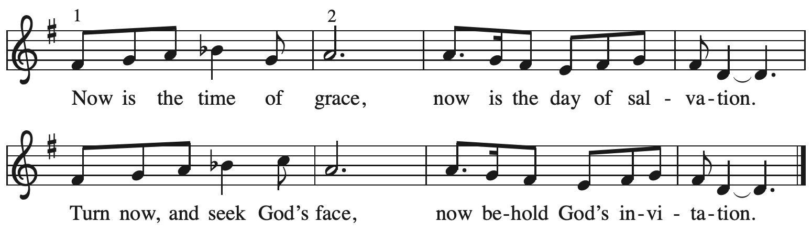

Verses — Leader

1 This is the fast that God would choose:
to loose the bonds of injustice,
to let the captives go free,
and to break the yoke of oppression. Refrain

2 Sharing your bread with the hungry
and welcoming homeless in,
offering hope and offering help,
this is what God requires. Refrain

3 Then shall your light break forth as dawn,
and healing shall come to you quickly;
then you shall call and God shall answer,
God's love shall go before you. Refrain

All rights reserved. Reprinted with permission under OneLicense.net # A-722139.

Please rise as you are able.
Confession and Forgiveness

P: Blessed be the holy Trinity, ☩ one God,
who journeys with us these forty days,
and sustains us with the gift of grace.
C: Amen.

P: Let us acknowledge before God and one another
our need for repentance and God’s mercy.

Silence is kept for reflection.

P: Holy God,
C: we confess to you our faults and failings.
Too often we neglect and do not trust your holy word;
we take for ourselves instead of giving to others;
we spoil rather than steward your creation;
we cause hurt though you call us to heal;
we choose fear over compassion.
Forgive us, renew us, and lead us,
as we seek to follow in your way of life.
Amen.

P: Hear the good news:
God so loved the world that God gave the only Son,
so that all may receive life.
This promise is for you!
God embraces you with divine mercy,
☩ forgives you in Christ’s name,
and revives you in the Spirit’s power.
C: Amen.

Gathering Hymn We Are Baptized in Christ Jesus ELW 451

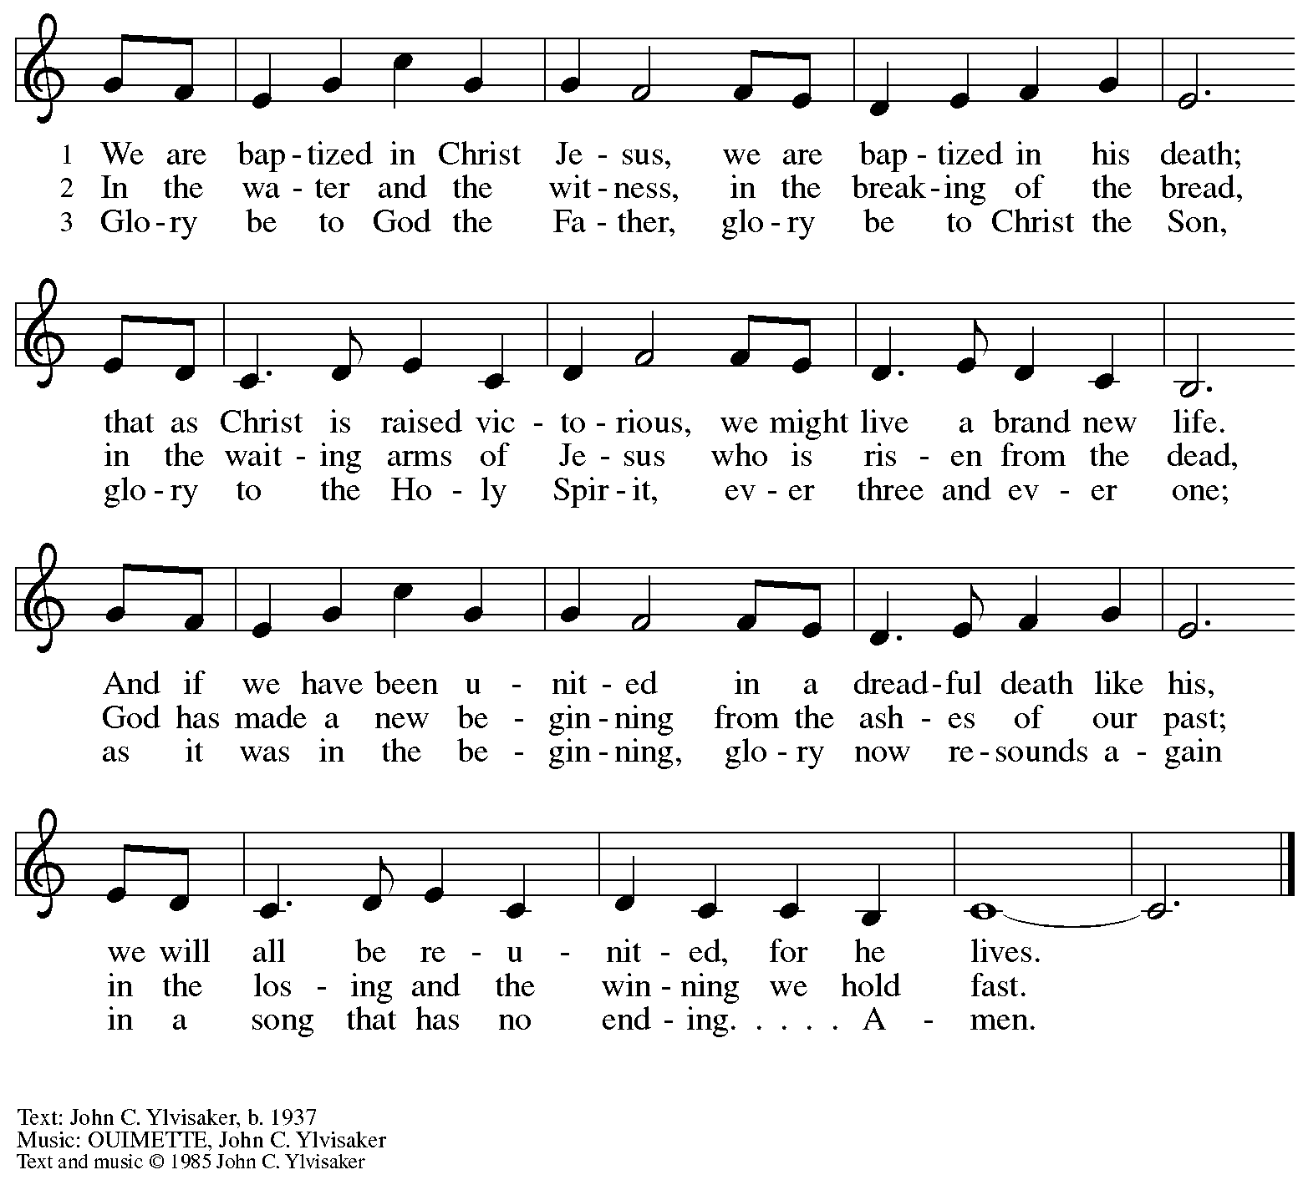
All rights reserved. Reprinted with permission under OneLicense.net #A-722139.

Greeting

P: The grace of our Lord Jesus Christ, the love of God,
and the communion of the Holy Spirit be with you all.
C: And also with you.

Kyrie

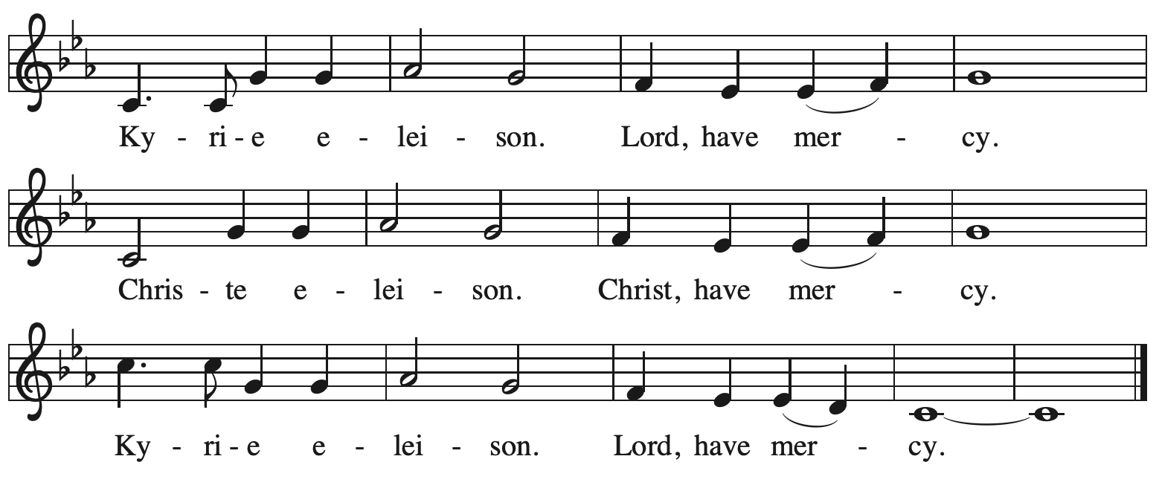

Prayer of the Day

P: The Lord be with you.
C: And also with you.

P: Let us pray.
Almighty God, your Son came into the world to save us all from sin and death.
Breathe upon us the power of your Spirit, that we may be raised to new life in Christ
and serve you in righteousness all our days, through Jesus Christ, our Savior and Lord,
who lives and reigns with you and the Holy Spirit, one God, now and forever.
C: Amen.

Please be seated.
Children are invited to join the adult leaders at the door and move to the office for Little Church – Big Faith. We ask that one additional adult from the congregation attend with the children.

Word
God speaks to us in Scripture reading, preaching, and song

First Reading – Ezekiel 37: 1-14

¹The hand of the Lord came upon me, and he brought me out by the spirit of the Lord and set me down in the middle of a valley; it was full of bones. ²He led me all around them; there were very many lying in the valley, and they were very dry. ³He said to me, “Mortal, can these bones live?” I answered, “O Lord God, you know.” ⁴Then he said to me, “Prophesy to these bones, and say to them: O dry bones, hear the word of the Lord. ⁵Thus says the Lord God to these bones: I will cause breath to enter you, and you shall live. ⁶I will lay sinews on you, and will cause flesh
to come upon you, and cover you with skin, and put breath in you, and you shall live; and you shall know that I am the Lord.”
⁷So I prophesied as I had been commanded; and as I prophesied, suddenly there was a noise, a rattling, and the bones came together, bone to its bone. ⁸I looked, and there were sinews on them, and flesh had come upon them, and skin had covered them; but there was no breath in them. ⁹Then he said to me, “Prophesy to the breath, prophesy, mortal, and say to the breath: Thus says the Lord God: Come from the four winds, O breath, and breathe upon these slain, that they may live.” ¹⁰I prophesied as he commanded me, and the breath came into them, and they lived, and stood on their feet, a vast multitude.
¹¹Then he said to me, “Mortal, these bones are the whole house of Israel. They say, ‘Our bones are dried up, and our hope is lost; we are cut off completely.’ ¹²Therefore prophesy, and say to them, Thus says the Lord God: I am going to open your graves, and bring you up from your graves, O my people; and I will bring you back to the land of Israel. ¹³And you shall know that I am the Lord, when I open your graves, and bring you up from your graves, O my people. ¹⁴I will put my spirit within you, and you shall live, and I will place you on your own soil; then you shall know that I, the Lord, have spoken and will act, says the Lord.”

L: Word of God, word of life.
C: Thanks be to God.

Psalm 130

The cantor will lead the singing of the psalm.
The congregation is invited to respond with the alternate verses in bold print,
and to join in singing the refrain.

Psalm tone

Psalm refrain

¹Out | of the depths
I cry to | you, O Lord;
²O Lord, | hear my voice!
Let your ears be attentive to the voice of my | supplication.
³If you were to keep watch | over sins,
O Lord, | who could stand?
⁴Yet with you | is forgiveness,
in order that you | may be feared. R
⁵I wait for you, O Lord; | my soul waits;
in your word | is my hope.
⁶My soul waits for the Lord more than those who keep watch | for the morning,
more than those who keep watch | for the morning.
⁷O Israel, wait for the Lord, for with the Lord there is | steadfast love;
with the Lord there is plen- | teous redemption.
⁸For the Lord shall | redeem Israel
from | all their sins. R

Second Reading – Romans 8: 6-11

⁶To set the mind on the flesh is death, but to set the mind on the Spirit is life and peace. ⁷For this reason the mind that is set on the flesh is hostile to God; it does not submit to God’s law—indeed it cannot, ⁸and those who are in the flesh cannot please God.
⁹But you are not in the flesh; you are in the Spirit, since the Spirit of God dwells in you. Anyone who does not have the Spirit of Christ does not belong to him. ¹⁰But if Christ is in you, though the body is dead because of sin, the Spirit is life because of righteousness. ¹¹If the Spirit of the one who raised Jesus from the dead dwells in you, the one who raised Christ from the dead will give life to your mortal bodies also through God’s Spirit that dwells in you.

L: Word of God, word of life.
C: Thanks be to God.

Please rise as you are able.

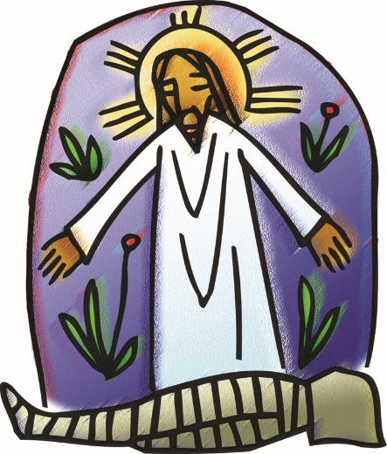
Gospel Acclamation

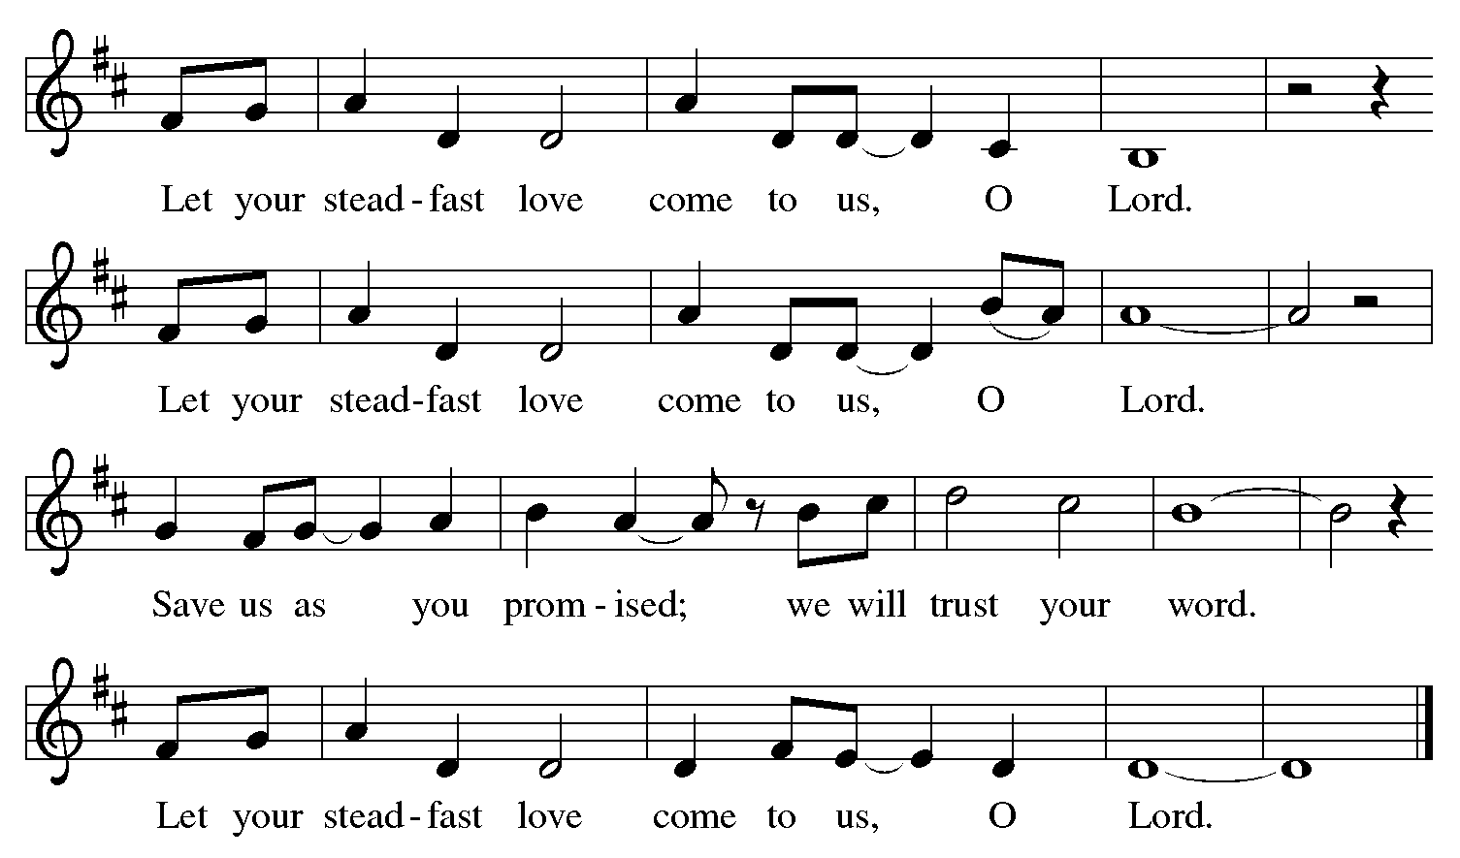

Gospel – John 11: 1-45

P: The holy Gospel according to St. John.
C: Glory to you, O Lord.
¹Now a certain man was ill, Lazarus of Bethany, the village of Mary and her sister Martha.
²Mary was the one who anointed the Lord with perfume and wiped his feet with her hair; her brother Lazarus was ill. ³So the sisters sent a message to Jesus, “Lord, he whom you love is ill.” ⁴But when Jesus heard it, he said, “This illness does not lead to death; rather it is for God’s glory, so that the Son of God may be glorified through it.” ⁵Accordingly, though Jesus loved Martha and her sister and Lazarus, ⁶after having heard that Lazarus was ill, he stayed two days longer in the place where he was.
⁷Then after this he said to the disciples, “Let us go to Judea again.” ⁸The disciples said to him, “Rabbi, the Jewish leaders were just now trying to stone you, and are you going there again?” ⁹Jesus answered, “Are there not twelve hours of daylight? Those who walk during the day do not stumble, because they see the light of this world. ¹⁰But those who walk at night stumble, because the light is not in them.” ¹¹After saying this, he told them, “Our friend Lazarus has fallen asleep, but I am going there to awaken him.” ¹²The disciples said to him, “Lord, if he has fallen asleep, he will be all right.” ¹³Jesus, however, had been speaking about his death, but they thought that he was referring merely to sleep. ¹⁴Then Jesus told them plainly, “Lazarus is dead. ¹⁵For your sake I am glad I was not there, so that you may believe. But let us go to him.” ¹⁶Thomas, who was called the Twin, said to his fellow disciples, “Let us also go, that we may die with him.”
¹⁷When Jesus arrived, he found that Lazarus had already been in the tomb four days. ¹⁸Now Bethany was near Jerusalem, some two miles away, ¹⁹and many of the Jewish people had come to Martha and Mary to console them about their brother. ²⁰When Martha heard that Jesus was coming, she went and met him, while Mary stayed at home. ²¹Martha said to Jesus, “Lord, if you had been here, my brother would not have died. ²²But even now I know that God will give you whatever you ask.” ²³Jesus said to her, “Your brother will rise again.” ²⁴Martha said to him, “I know that he will rise again in the resurrection on the last day.” ²⁵Jesus said to her, “I am the resurrection and the life. Those who believe in me, even though they die, will live, ²⁶and everyone who lives and believes in me will never die. Do you believe this?” ²⁷She said to him, “Yes, Lord, I believe that you are the Messiah, the Son of God, the one coming into the world.”
²⁸When she had said this, she went back and called her sister Mary, and told her privately, “The Teacher is here and is calling for you.” ²⁹And when she heard it, she got up quickly and went to him. ³⁰Now Jesus had not yet come to the village, but was still at the place where Martha had met him. ³¹The Jewish people who were with her in the house, consoling her, saw Mary get up quickly and go out. They followed her because they thought that she was going to the tomb to weep there. ³²When Mary came where Jesus was and saw him, she knelt at his feet and said to him, “Lord, if you had been here, my brother would not have died.” ³³When Jesus saw her weeping, and the Jewish people who came with her also weeping, he was greatly disturbed in spirit and deeply moved. ³⁴He said, “Where have you laid him?” They said to him, “Lord, come and see.” ³⁵Jesus began to weep. ³⁶So the Jewish people said, “See how he loved him!” ³⁷But some of them said, “Could not he who opened the eyes of the blind man have kept this man from dying?”
³⁸Then Jesus, again greatly disturbed, came to the tomb. It was a cave, and a stone was lying against it. ³⁹Jesus said, “Take away the stone.” Martha, the sister of the dead man, said to him, “Lord, already there is a stench because he has been dead four days.” ⁴⁰Jesus said to her, “Did I not tell you that if you believed, you would see the glory of God?” ⁴¹So they took away the stone. And Jesus looked upward and said, “Father, I thank you for having heard me. ⁴²I knew that you always hear me, but I have said this for the sake of the crowd standing here, so that they may believe that you sent me.” ⁴³When he had said this, he cried with a loud voice, “Lazarus, come out!” ⁴⁴The dead man came out, his hands and feet bound with strips of cloth, and his face wrapped in a cloth. Jesus said to them, “Unbind him, and let him go.”
⁴⁵Many of the Jewish people therefore, who had come with Mary and had seen what Jesus did, believed in him.

P: The Gospel of the Lord.
C: Praise to you, O Christ.

Please be seated.

Sermon

A time of silence for prayer and reflection follows the sermon.
When the Hymn of the Day begins, please rise as you are able.

Hymn of the Day Jesus Is a Rock in a Weary Land ELW 333

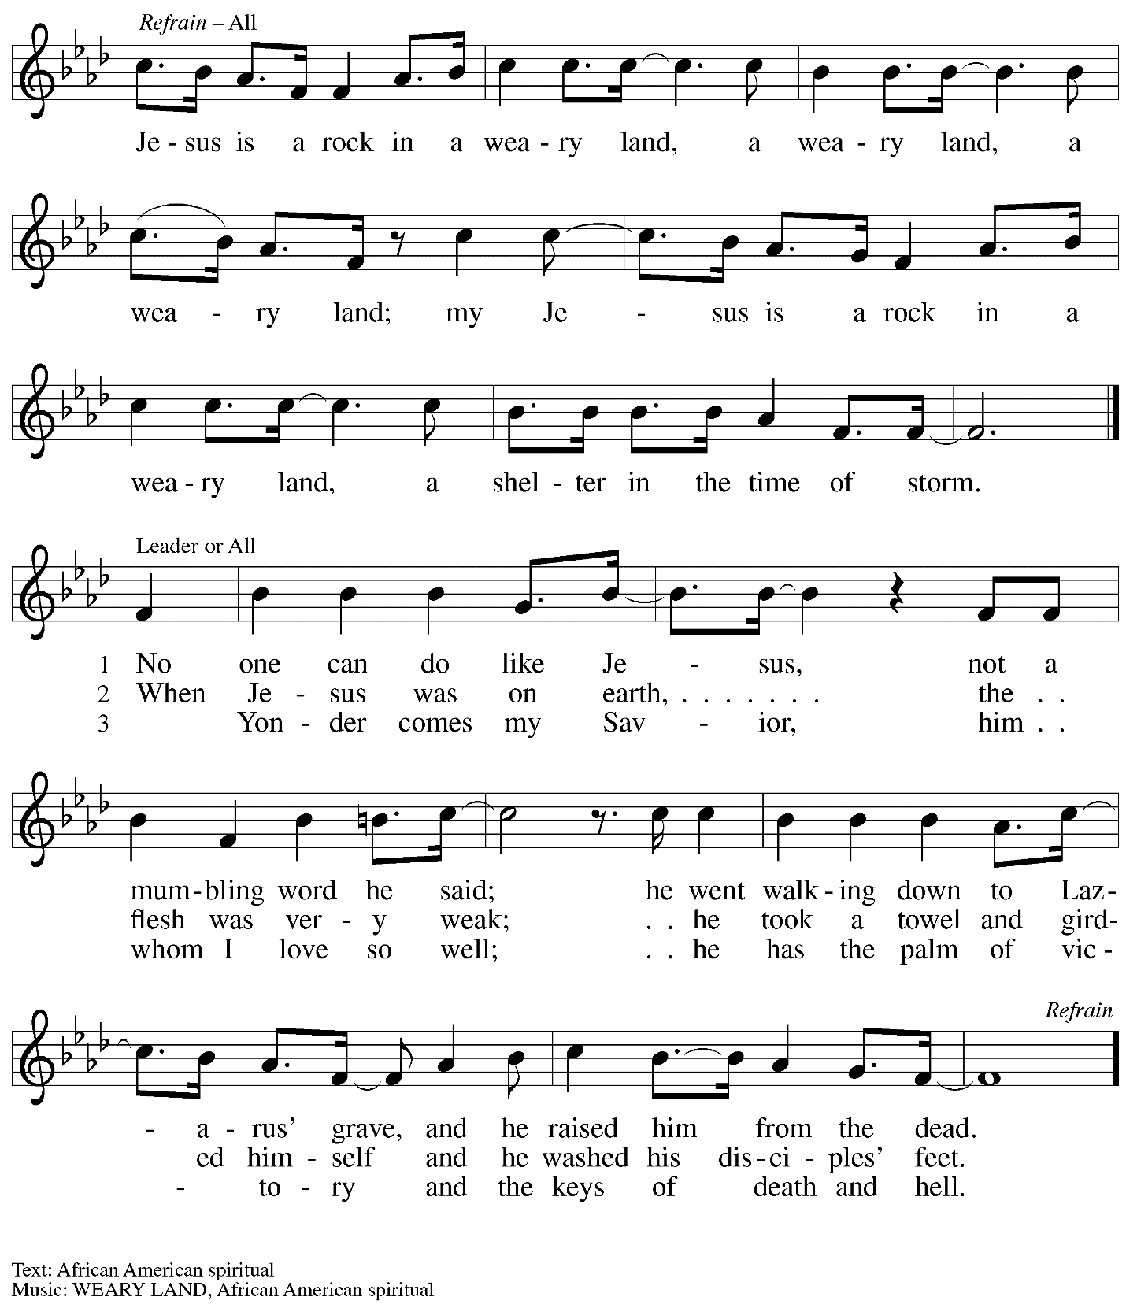

Apostles Creed

C: I believe in God, the Father almighty,
creator of heaven and earth.

I believe in Jesus Christ, God’s only Son, our Lord,
who was conceived by the Holy Spirit,
born of the virgin Mary,
suffered under Pontius Pilate,
was crucified, died, and was buried;
he descended to the dead.*
On the third day he rose again;
he ascended into heaven,
he is seated at the right hand of the Father,
and he will come to judge the living and the dead.

I believe in the Holy Spirit,
the holy catholic church,
the communion of saints,
the forgiveness of sins,
the resurrection of the body,
and the life everlasting. Amen.

*Or, “he descended into hell,” another translation of this text in widespread use.

Prayers of the People

A: Sustained by God’s abundant mercy, let us pray for the church, the world,
and all who are in need.

After each petition
A: Merciful God,
C: receive our prayer.

The presiding minister concludes the prayers:
P: We lift our prayers to you, O God, trusting in your steadfast love
and your promise to renew all creation; through Jesus Christ, our Savior and Lord.
C: Amen.

Peace

The presiding minister and the assembly greet one another in the peace of the risen Christ.
P: The peace of Christ be with you always.
C: And also with you.

The people may greet those around them with a sign of Christ’s peace and may say
Peace be with you or similar words. Please be mindful that not everyone will be comfortable with sharing the peace, so please seek consent before shaking hands or hugging. Other possible ways to share the peace include a simple bow with the verbal greeting of peace, or simply a verbal expression of peace.

When the greetings of peace have concluded, please be seated.

Meal
God feeds us with the presence of Jesus Christ

Offering

We offer ourselves, our gifts, and our faithful service to God.
As the offering is gathered for the mission of the church, including the care of those in need,
the table is set for Holy Communion.

Music during the Offering

As the gifts are brought forward for presentation, please rise as you are able.

Offertory Song

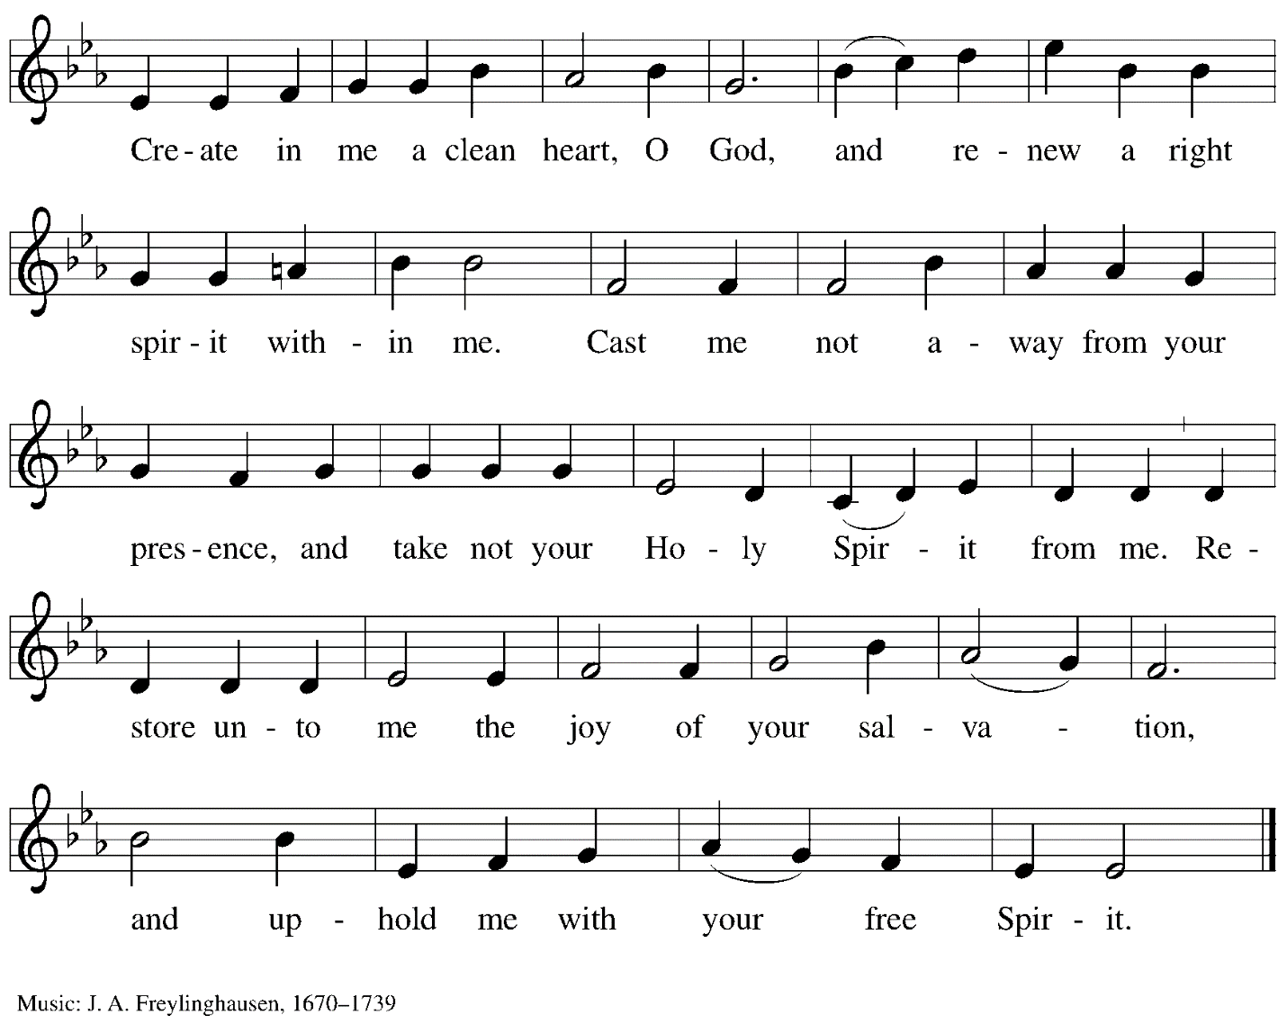

Offertory Prayer

A: Let us pray.
God our provider,
C: you have not fed us with bread alone
but with words of grace and life.
Bless us, and these your gifts,
which we receive from your bounty,
through Jesus Christ our Lord.
Amen.

Dialogue

P: The Lord be with you.
C: And also with you.

P: Lift up your hearts.
C: We lift them to the Lord.

P: Let us give thanks to the Lord our God.
C: It is right to give our thanks and praise.

Preface

P: It is indeed right, our duty and our joy…
… we praise your name and join their unending hymn:

Sanctus

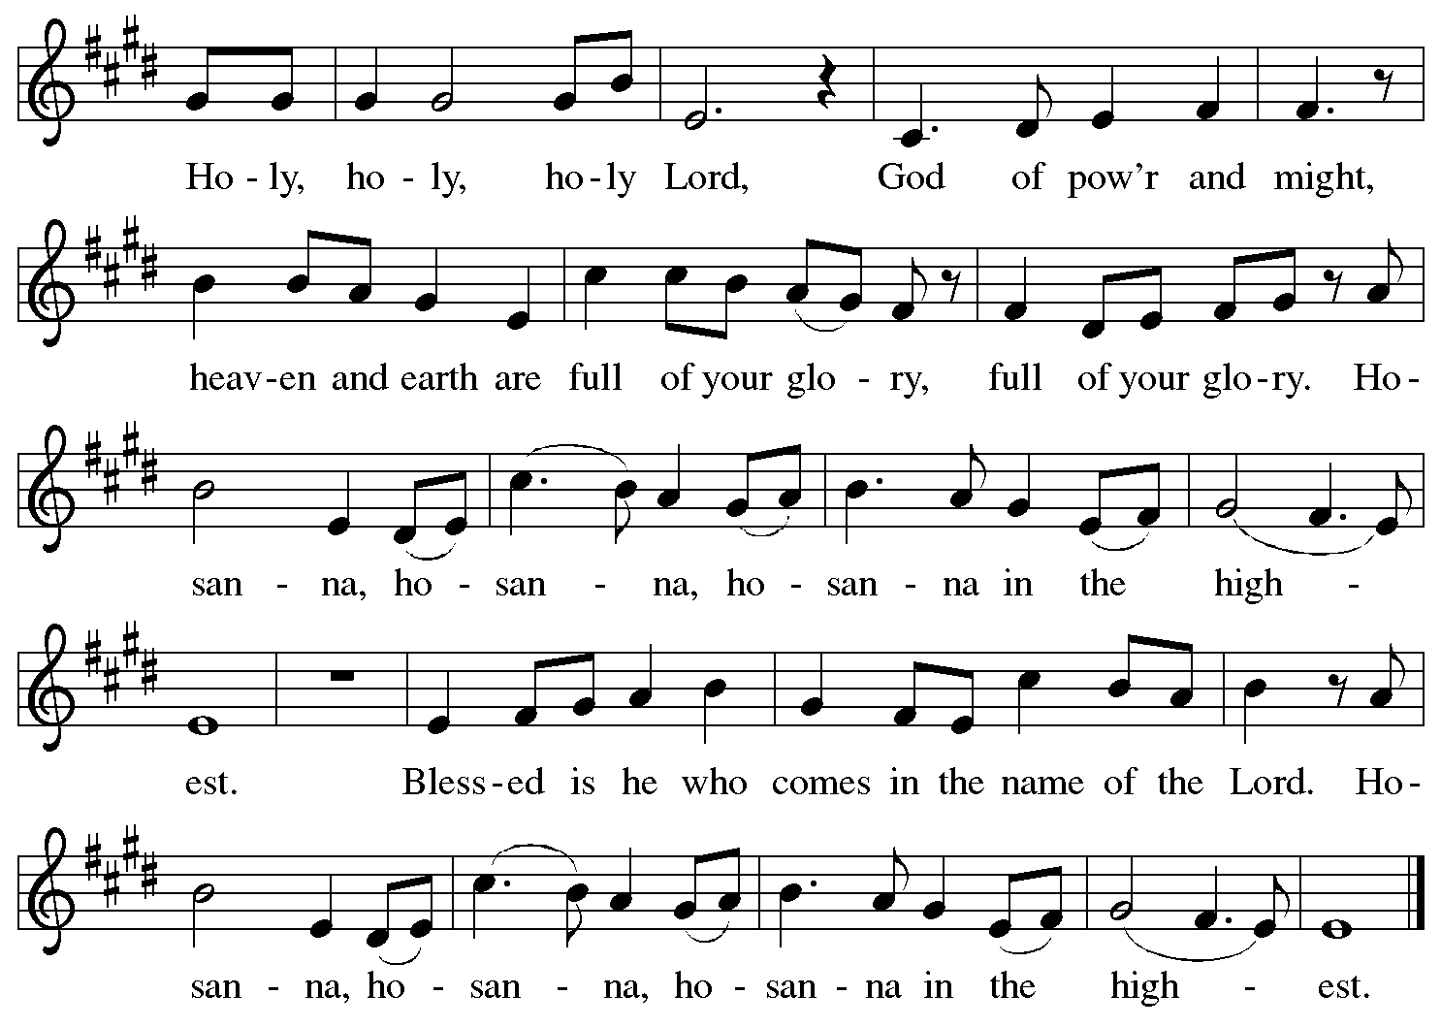

Eucharistic Prayer

P: Blessed are you, O God of the universe,
Your mercy is everlasting
and your faithfulness endures from age to age.

Praise to you for creating the heavens and the earth.
Praise to you for saving the earth from the waters of the flood.
Praise to you for bringing the Israelites safely through the sea.
Praise to you for leading your people through the wilderness
to the land of milk and honey.
Praise to you for the words and deeds of Jesus, your anointed one.
Praise to you for the death and resurrection of Christ.
Praise to you for your Spirit poured out on all nations.

In the night in which he was betrayed,
our Lord Jesus took bread, and gave thanks;
broke it, and gave it to his disciples, saying:
Take and eat; this is my body, given for you.
Do this for the remembrance of me.

Again, after supper, he took the cup, gave thanks,
and gave it for all to drink, saying:
This cup is the new covenant in my blood,
shed for you and for all people for the forgiveness of sin.
Do this for the remembrance of me.

With this bread and cup
we remember our Lord’s passover from death to life
as we proclaim the mystery of faith:
C: Christ has died.
Christ is risen.
Christ will come again.

P: O God of resurrection and new life:
Pour out your Holy Spirit on us
and on these gifts of bread and wine.
Bless this feast.
Grace our table with your presence.
C: Come, Holy Spirit.

P: Reveal yourself to us in the breaking of the bread.
Raise us up as the body of Christ for the world.
Breathe new life into us.
Send us forth,
burning with justice, peace, and love.
C: Come, Holy Spirit.

P: With your holy ones of all times and places,
with the earth and all its creatures,
with sun and moon and stars,
we praise you, O God,
blessed and holy Trinity,
now and forever.
C: Amen.

Lord’s Prayer

P: Gathered as one by the Holy Spirit, let us pray as Jesus taught us.
C: Our Father in heaven,
hallowed be your name,
your kingdom come,
your will be done,
on earth as in heaven.
Give us today our daily bread.
Forgive us our sins
as we forgive those who sin against us.
Save us from the time of trial
and deliver us from evil.
For the kingdom, the power,
and the glory are yours,
now and forever. Amen.

Fraction and Invitation

P: Come to the table of mercy;
receive God’s gifts of grace.

Agnus Dei/Lamb of God

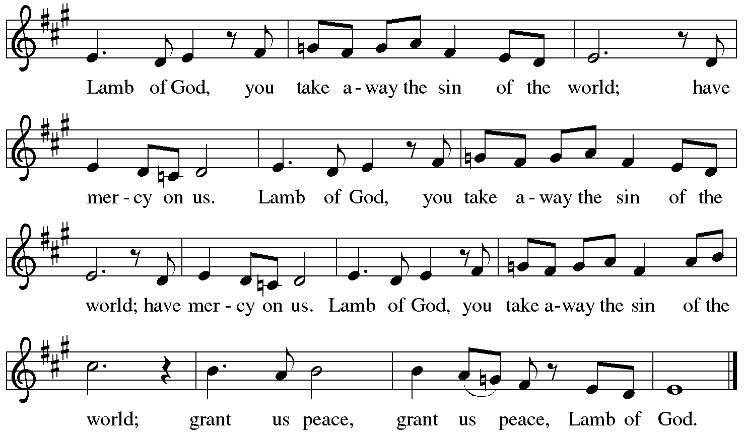

Please be seated.

Holy Communion
- All who seek God and desire a deeper and stronger life in Christ are welcome to receive Holy Communion.
- Worshipers from the pulpit side will proceed forward first, followed by the center section, and then the lectern side.
- Please inform an usher if you would like the ministers to bring Communion to you.
- Holy Communion will be served with bread and wine/grape juice.
- The presiding minister will first distribute the bread (host) to each communicant. Please indicate if you require a gluten-free host.
- Once you have consumed the bread, please pick up an empty glass from the tray next to the presiding minister. The Communion Assistant will pour wine from the chalice or grape juice from the cruet into your glass.
- Please step to the side to consume the wine or grape juice.
- Feel free to kneel at the altar rail for prayer after receiving the sacrament.
- As you return to your pew, glasses may be returned to the empty trays on either side of the center aisle.
- A blessing will be provided for anyone who does not yet receive the sacrament.
- All are invited to join in singing the hymns during Holy Communion.

Hymn during Holy Communion
Christ Is the Life ACS 927

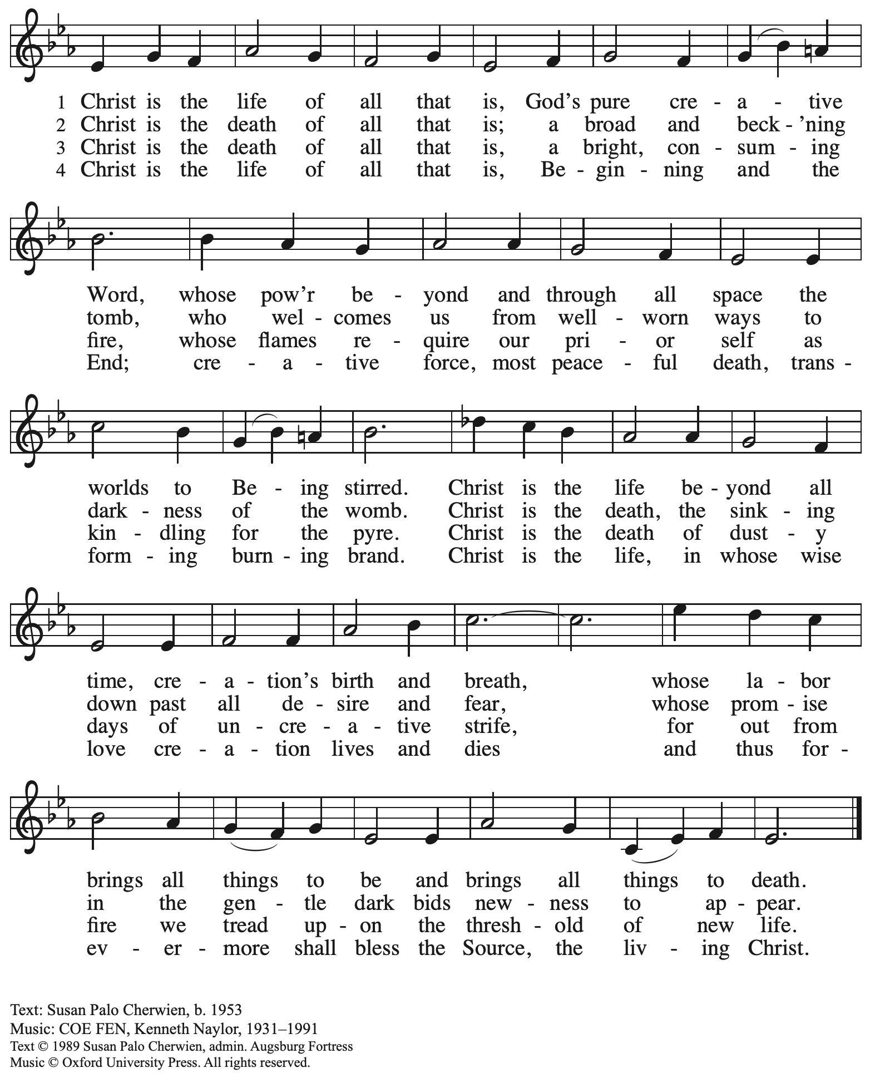
Reprinted with permission under OneLicense.net # A-722139.

Hymn during Holy Communion
I Received the Living God ELW 477

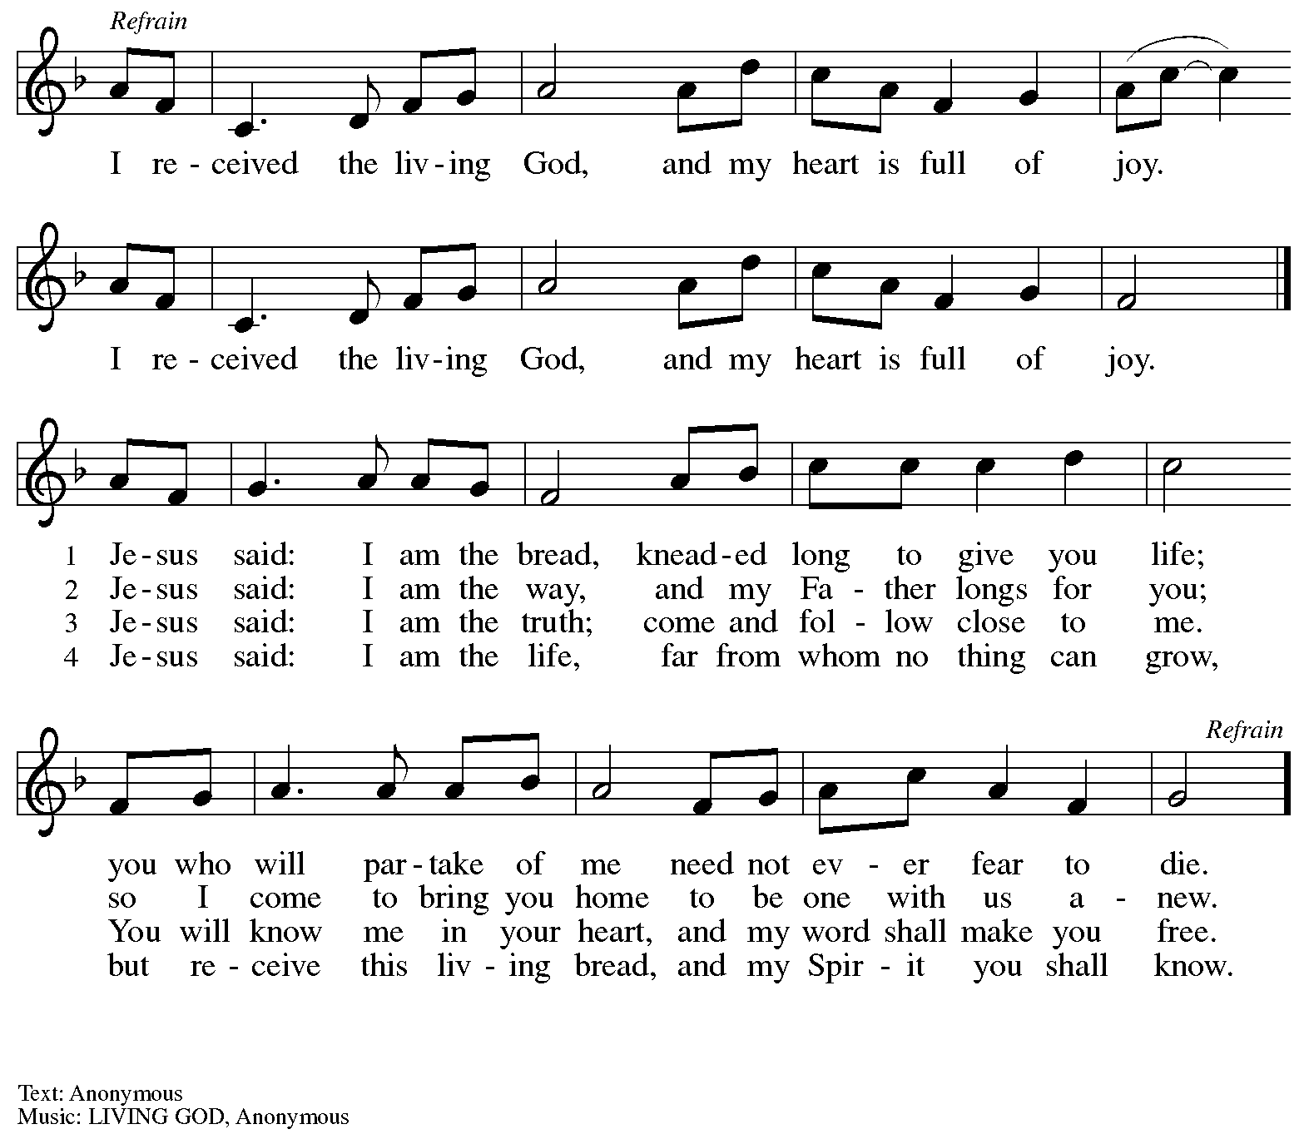

Hymn during Holy Communion
I Am the Bread of Life ELW 485

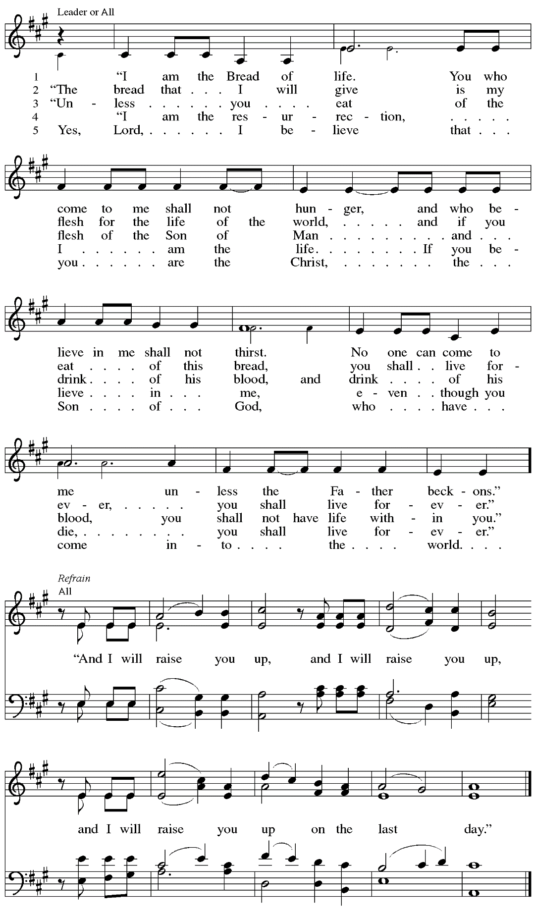

When all have returned to their places, please rise as you are able.

Blessing

P: The body and blood of our Lord Jesus Christ strengthen you and keep you in his grace.
C: Amen.

Prayer

A: Let us pray.
Compassionate God, you have fed us with the bread of heaven.
Sustain us in our Lenten pilgrimage: may our fasting be hunger for justice;
our alms, a making of peace; and our prayer, the song of grateful hearts,
through Jesus Christ, our Savior and Lord.
C: Amen.

Please be seated.

Sending
God blesses us and sends us in mission to the world.

Announcements

Reflection on Faith and Vocation in Daily Life Jeff Denlinger

Please rise as you are able.

Benediction

P: The God of love; ☩ Christ, the resurrection and the life;
and the Holy Spirit of rebirth, bless you this Lent and always.
C: Amen.

Sending Hymn Bless Now, O God, the Journey Following page

Dismissal

A: Go in peace. Serve in love.
C: Thanks be to God.

Sending Hymn Bless Now, O God, the Journey ELW 326

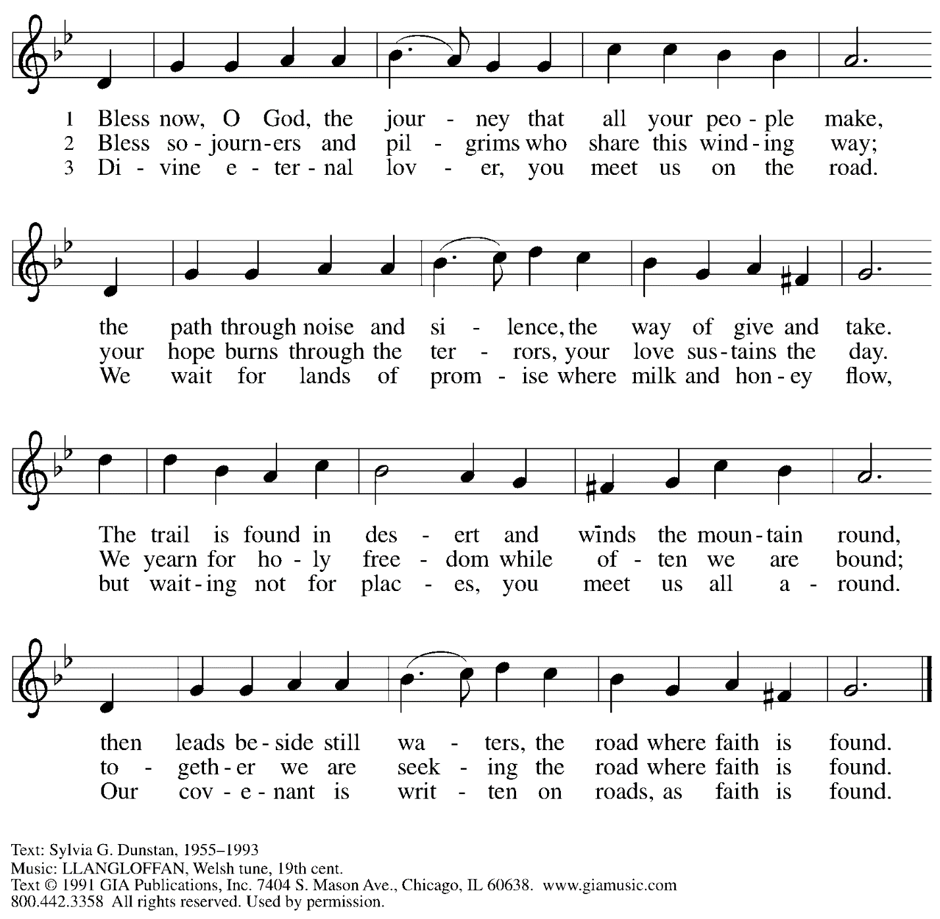
Reprinted under OneLicense.net # A-722139.

Abbreviations

P: Pastor/Presiding Minister
A: Assisting Minister
L: Lector
C: Congregation

ELW: Evangelical Lutheran Worship hymnal
ACS: All Creation Sings hymnal

Those serving in worship today

Assisting Minister Jimmi Kocher-Hillmer
Audio-Visual Ministers Kristen Asplin
Joseph Paetz
Cantor Noël Marsh
Lector Alda Maria Gonzaga
Recorder Timothy Kocher-Hillmer
Minister of Music Laura Reynolds
Presiding Minister Pastor Ross I. Carmichael

Liturgy and Hymnody Acknowledgements

From SundaysandSeasons.com. Copyright © 2023 Augsburg Fortress. All rights reserved. Reprinted under OneLicense.net # A-722139.
Used by permission of Augsburg Fortress.

I Am the Bread of Life – Text: Suzanne Toolan, RSM, b. 1927, based on John 6. Music: I AM THE BREAD, Suzanne Toolan, RSM. Text and music © 1966, 1970, 1986, 1993 GIA Publications, Inc., 7404 S. Mason Ave., Chicago, IL 60638. www.giamusic.com. 800.442.3358. All rights reserved. Reprinted with permission under OneLicense.net # A-722139.

St. Andrew Lutheran Church Announcements
March 26th, 2023

- Welcome to Worship at St. Andrew on March 26th, 2023, the + Fifth Sunday in Lent – Masks are optional at St. Andrew when Allegheny County’s Covid-19 community level is in the low and medium categories. Worship attendees are invited to make a name tag at the back of the worship space if you would like. All are invited to gather in the Social Hall after worship for food, drinks, and conversation.
- Unique Variations in Worship This Lent – Centering Music, Theme Hymn, Carrying Stones, and Returning to Sharing Peace – Worship services at St. Andrew are slightly different this Lenten season. Instead of a traditional Prelude, the welcome will be followed by centering music, Now is the Time of Grace, led by the cantor, with the congregation invited to listen, reflect, and join in singing the refrain. We are also sharing the peace, hearing testimonies on faith in daily life, being sent for mission in the world with the theme hymn, Bless Now, O God, the Journey, and inviting worshipers to pick up symbolic stones to leave at the altar or the baptismal font during the sending each week. We pray for God's blessing as we journey together through this season.
- Pittsburgh's LGBTQIA+ Chorus Invites You to 2023 Cabaret: Flying Free with RCC! – Today at 2:00 p.m. – Join Renaissance City Choir at East Liberty Presbyterian Church (116 S. Highland Ave., 15206) for its annual Cabaret production—Flying Free, a joyful menagerie of solo, ensemble, and full chorus renditions of your favorite bird-themed tunes by the Beatles, Bette Midler, Dolly Parton, Prince, Elton John, and many more! There is a matinee performance today, Sunday, March 26th at 2:00 p.m. Visit rccpittsburgh.com for tickets and more information. The matinee and livestream are Pay-What-You-Can.
- A Celebration of the Legacy of The Rev. Dr. Martin Luther King, Jr. – Sunday, March 26th, 4:00 p.m. – The Southwestern Pennsylvania Synod of the Evangelical Lutheran Church in America will be celebrating the legacy of The Rev. Dr. Martin Luther King, Jr. with an ecumenical service of Holy Communion with Bishops Abraham Allende and Kurt Kusserow presiding and The Rev. Dr. Asa Lee, President of Pittsburgh Theological Seminary, preaching. The event will take place on Sunday, March 26th, at 4:00 p.m. at Berkeley Hills Lutheran Church, 517 Sangree Road, Pittsburgh, PA 15237. Following the service there will be a program on equitable development and housing to accompany this year's theme of "A Home for All in the Beloved Community." Learn more at The Legacy of Dr. Martin Luther King Jr. — Southwestern Pennsylvania Synod (swpasynod.org).
- Midweek Worship for Lent – Holden Evening Prayer Available Online Wednesday, March 29th – During the season of Lent, many take on additional devotional practices, and it has been customary to offer a midweek prayer service each Wednesday prior to Holy Week. This year, several St. Andrew members have recorded a sung service of the Holden Evening Prayer service with Old Testament readings for each week. The last video will be available online at St. Andrew’s pages on Wednesday, March 29th. We encourage you to access this beautiful service throughout the season.
- Work Day – Saturday, April 1st, 9:00 a.m. – 12:00 noon – People of St. Andrew are invited to come to the church on Saturday, April 1st to help spruce up the building and grounds in preparation for Holy Week and Easter. There will be indoor and outdoor tasks – come for a little or as much as you would like. Thank you for your care for St. Andrew’s facilities!
- Worship Schedule for Holy Week – April 2nd - April 9th – With Palm Sunday / Sunday of the Passion, next week, the church enters into the contemplation of the passion, death, and resurrection of our Savior Jesus Christ. Our primary means for this reflection is through the service of the Triduum – the Great Three Days of Holy Week – one service that unfolds in three parts: Maundy Thursday, Good Friday, and the Vigil of Easter. The service schedule for Holy Week is:
  - Palm Sunday - Sunday of the Passion, April 2nd, 10:00 a.m. - Worship with Blessing of Palms, Matthew's Passion reading, and Holy Communion.
  - Triduum – Maundy Thursday, April 6th, 7:00 p.m. – Worship with Holy Communion
  - Holy Week Service for Children – Good Friday, April 7th, 5:30 p.m. – At this service, we tell the story of Maundy Thursday and Good Friday through four interactive stations designed for the young ones of the community.
  - Triduum – Good Friday, April 7th, 7:00 p.m. – Service of Shadows and Stones – In relative darkness, we hear Gospel accounts of the crucifixion, sing prayerful, meditative hymns, and leave stones at the foot of the cross as we honor our crucified Savior.
  - Triduum – The Vigil of Easter, April 8th, 5:00 p.m. – The church tells God’s story of salvation through worship, word, sacrament, and song as we gather around a fire, hear stories of God’s faithfulness throughout the ages, give thanks for the gift of Baptism, and move into the celebration of the resurrection with Holy Communion
  - The Resurrection of our Lord – Easter Sunday, April 9th, 10:00 a.m. – We join the church throughout the world in proclaiming the good news of Christ’s Easter resurrection! (Please note that Little Church – Big Faith will not meet during these services, nor will there be a coffee hour.)
- New Christ in Our Home Devotional Booklets (April – June) Available at Church Entrances – Christ in our Home is a booklet that offers a daily Bible reading with a short reflection and prayers, along with additional prayer concerns and readings for those who would like to expand their devotional practices. These are available at each entrance to the church, and we encourage people of the congregation to take one!
- St. Andrew Jail Ministry – St. Andrew has had a long history of participation in the ministry program at the Allegheny County Jail. Until the program was abruptly put on hold at the beginning of the Covid pandemic, a group of volunteers from St. Andrew was leading a worship service at the jail on Sunday mornings, typically about one Sunday a month. The jail is hoping to resume this program, probably sometime in April. If any of the previous volunteers are still interested and available, please contact Lester Prince (lprince@comcast.net). New volunteers are also needed. The first step for new volunteers is to complete an online application, which can be accessed here: https://www.foundationofhope.org/get-involved/volunteer-application/.
On the application form, indicate that the program that you are interested in volunteering with is “Chaplaincy Worship.” Feel free to contact Lester Prince with any questions.
- St. Andrew Saving Pull Tabs from Cans – St. Andrew continues to save pull tabs from all types of cans. They are recycled by Ronald McDonald House to benefit programs for children and families receiving care at Pittsburgh Children's Hospital. Tabs can be placed in the plastic drawer on the donations table in the social hall.
- Ministry Opportunity – Help Fill the Little Pantry – The Community Ministry Committee is seeking help to fill the mini pantry. Volunteer for one time, once a month, once every two months, or as often as you want. Contact Joyce Compton at jcompton28@gmail.com or 412-657-0584 if you have questions or would like to serve!
- Lenten Food Drive – Help Fill St. Andrew’s Mini Free Pantry – We are collecting items for the Pantry during the Lenten season. Grab a brown bag from the back of the sanctuary or from the Social Hall and bring it back to the St. Andrew with an item or two for the pantry (no need to fill the bag completely). Items should be shelf safe/stable (nothing fresh, frozen or that may go bad in severe weather.) Here are some things we suggest:
- Items in cans with flip top lids: (no items requiring a can opener)
- Tuna, sardines, or Vienna sausage, ravioli, soup that does not need to be diluted.
- Fruit or vegetables in single-serve, shelf safe containers
- Single serve peanut butter, cheese & cracker snacks, granola bars, beef jerky, raisin boxes, little cereal boxes, shelf stable milk (Horizon)
- Personal care items: Shampoo, body wash, deodorant, toothpaste, feminine products, toilet paper
Contact Joyce Compton at jcompton28@gmail.com or 412-657-0584 with questions.
Please return all items by Easter Sunday, April 9th.

Flowers for Easter
St. Andrew will be ordering Lilies (6 inch, five bloom)
Tulips (6 inch)
Daffodils (6 inch)
to decorate the worship space for Easter Sunday, April 9th, and the Easter season.
If you would like to sponsor and dedicate flowers, please order using this form.
Suggested Donation: $7.00 each Order by: Sunday, April 2nd

Please submit payment with order, checks may be made out payable to:
St. Andrew Lutheran Church

Name __________________________________________
In Honor of __________________________________________
In Memory of __________________________________________
In Appreciation/Love for __________________________________________

Number of Lilies ________
Number of Tulips ________
Number of Daffodils ________

