+ Palm Sunday / Sunday of the Passion
April 2, 2023

St. Andrew Lutheran Church
304 Morewood Ave.
Pittsburgh, PA 15213
St_andrewELCA@verizon.net
www.standrewpittsburgh.org

+ Palm Sunday / Sunday of the Passion
Order for Worship

Today, we encounter the paradox that defines our faith:
Jesus Christ is glorified king and humiliated servant. We too are full of paradox:
like Peter, we fervently desire to follow Christ, but find ourselves afraid, denying God.
We wave palms in celebration today as Christ comes into our midst, and we follow with trepidation as his path leads to death on the cross.
Amid it all we are invited into this paradoxical promise of life through Christ’s broken body
and love poured out in a meal of bread and wine.
We begin this week that stands at the center of the church year,
anticipating the completion of God’s astounding work of salvation.

- Masks are optional at St. Andrew when Covid-19 community level in Allegheny County is in the low and medium categories.

- Worship Services are live streamed to multiple online platforms. By attending worship, you agree that your image and voice may be broadcast.

Welcome to St. Andrew!

- St. Andrew Lutheran Congregation welcomes all who are seeking a place of healing and wholeness, a nurturing, faith-forming spiritual home. Our community embraces people of all ages, ethnicities, cultures, abilities, sexual orientations, gender identities and expressions, and family constellations. Come and See!

- Everyone is invited to make a nametag at the black bookcase in the back of the worship space if they would like. You are welcome to use just your first name and preferred pronouns if desired. There are stickers indicating pronouns on the bookcase if you would like to include them on your name tag.

- Worship “toolkits” to help children engage with the service are available in the black bookcase at the back of the worship space. There are “reader” and “pre-reader” resources available in each kit. Please feel free to use the kits for/with your children during worship.

- Little Church – Big Faith, a Bible lesson and activity for children, takes place after the prayer of the day. Children are invited to meet the adult leaders at the side door of the sanctuary to attend.

- St. Andrew has returned to the Sharing of Peace during worship. More than a simple greeting, this practice and placement in the service derives from the Gospel of Matthew 5: 23-24 – “When you are offering your gift at the altar, if you remember that your sibling has something against you, leave your gift there before the altar and go; first be reconciled to your sibling, and then come and offer your gift.” We once again have an opportunity to share an expression of Christ’s peace with those around us as a liturgical sign of our desire to be reconciled with our neighbors before offering our gifts and receiving Holy Communion. Please be mindful that some people will not be comfortable with sharing the peace; be sure to obtain consent before any physical expression of peace such as shaking hands or hugging.

- St. Andrew has also resumed serving Holy Communion with both (separate) elements, bread (gluten-free available) and wine/grape juice. The presiding minister will distribute the bread (host). Please consume this and then pick up an empty glass from the tray. The Communion Assistant will pour wine or grape juice into your glass. Please step to the side to consume the wine or grape juice. Feel free to kneel at the altar rail for prayer after receiving the elements. As you return to your pew, glasses may be returned to the empty trays on either side of the center aisle.

- A restroom is available on the main level of the church, through the doors to the Social Hall and to the right in the main office.

Gathering
The Holy Spirit calls us together as the people of God.

The congregation gathers in the social hall so that all who are able may enter in procession. Palm branches are distributed before the service begins.

The presiding minister begins
P: Blessed is the one who comes in the name of the Lord!
C: Hosanna in the highest!

P: Blessed is the one who comes in the name of the Lord!
C: Hosanna in the highest!

P: Blessed is the one who comes in the name of the Lord!
C: Hosanna in the highest!

Processional Gospel Matthew 21: 1-11

P: The holy Gospel according to Matthew.
C: Glory to you, O Lord.

¹When they had come near Jerusalem and had reached Bethphage, at the Mount of Olives, Jesus sent two disciples, ²saying to them, “Go into the village ahead of you, and immediately you will find a donkey tied, and a colt with her; untie them and bring them to me. ³If anyone says anything to you, just say this, ‘The Lord needs them.’ And he will send them immediately.”
⁴This took place to fulfill what had been spoken through the prophet, saying,
⁵“Tell the daughter of Zion,
Look, your king is coming to you,
humble, and mounted on a donkey,
and on a colt, the foal of a donkey.”
⁶The disciples went and did as Jesus had directed them; ⁷they brought the donkey and the colt, and put their cloaks on them, and he sat on them. ⁸A very large crowd spread their cloaks on the road, and others cut branches from the trees and spread them on the road. ⁹The crowds that went ahead of him and that followed were shouting,
“Hosanna to the Son of David!
Blessed is the one who comes in the name of the Lord!
Hosanna in the highest heaven!”
¹⁰When he entered Jerusalem, the whole city was in turmoil, asking, “Who is this?” ¹¹The crowds were saying, “This is the prophet Jesus from Nazareth in Galilee.”

P: The Gospel of the Lord.
C: Praise to you, O Christ.

Blessing of the Palms

The presiding minister and the congregation greet each other.
P: The Lord be with you.
C: And also with you.

P: Let us pray.

A brief silence is kept.

P: We praise you, O God,
for redeeming the world through our savior Jesus Christ.
Today he entered the holy city in triumph
and was proclaimed Messiah and king
by those who spread garments and branches along his way.
Bless these branches and those who carry them.
Grant us grace to follow our Lord in the way of the cross,
so that, joined to his death and resurrection,
we enter into life with you;
through the same Jesus Christ,
who lives and reigns with you and the Holy Spirit,
one God, now and forever.
C: Amen.

Procession

The assisting minister addresses the assembly.
A: Let us go forth in peace.
C: In the name of Christ. Amen.

The congregation follows the cross and ministers into the church.
“All Glory, Laud, and Honor,” ELW 344 is sung as the people process into the church.

Processional Hymn All Glory, Laud, and Honor ELW 344

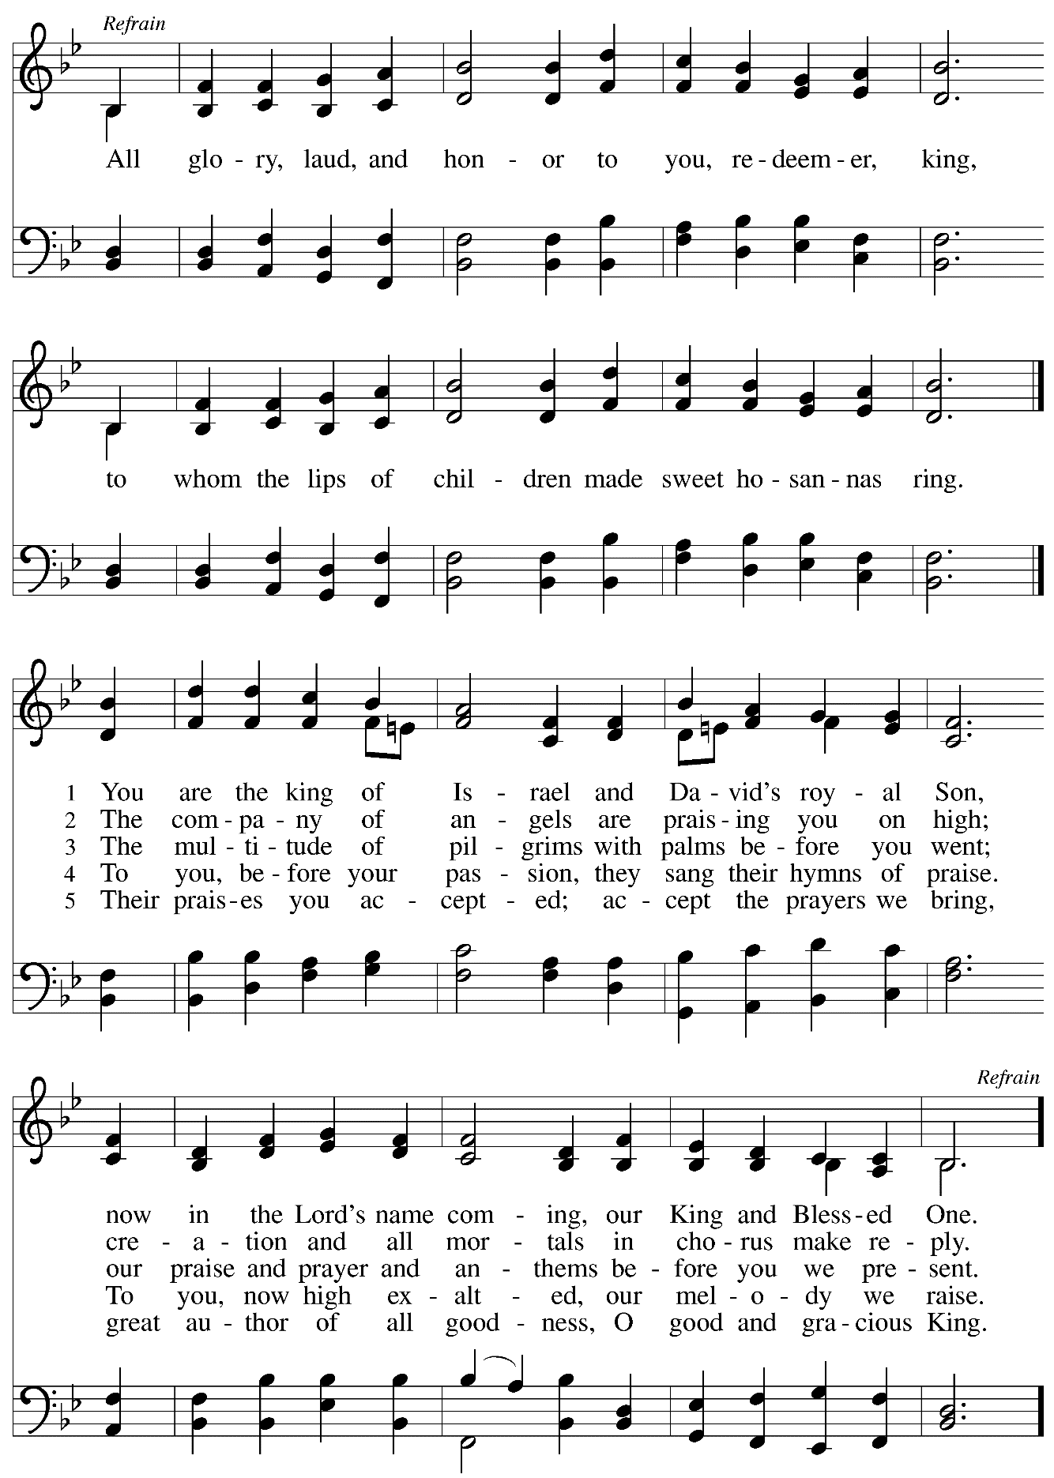
Prayer of the Day

P: As we now enter into the contemplation of the passion of our Lord Jesus Christ
and meditate on the salvation of the world through his sufferings, death, burial, and resurrection,
let us pray.

Silence is kept.

P: Everlasting God,
in your endless love for the human race, you sent our Lord Jesus
to take on our nature and to suffer death on the cross.
In your mercy, enable us to share in his obedience to your will
and in the glorious victory of his resurrection;
through the one who lives and reigns with you and the Holy Spirit,
one God, now and forever.
C: Amen.

Please be seated.
Children are invited to join the adult leaders at the door and move to the office for Little Church – Big Faith. We ask that one additional adult from the congregation attend with the children.

Word
God speaks to us in Scripture reading, preaching, and song

First Reading – Isaiah 50: 9-4a

⁴The Lord God has given me
the tongue of a teacher,
that I may know how to sustain
the weary with a word.
Morning by morning the Lord wakens—
wakens my ear
to listen as those who are taught.
⁵The Lord God has opened my ear,
and I was not rebellious,
I did not turn backward.
⁶I gave my back to those who struck me,
and my cheeks to those who pulled out the beard;
I did not hide my face
from insult and spitting.
⁷The Lord God helps me;
therefore I have not been disgraced;
therefore I have set my face like flint,
and I know that I shall not be put to shame;
⁸the one who vindicates me is near.
Who will contend with me?
Let us stand up together.
Who are my adversaries?
Let them confront me.
^{9a}It is the Lord God who helps me;
who will declare me guilty?

L: Word of God, word of life.
C: Thanks be to God.

Psalm 31: 9-16

The cantor will lead the singing of the psalm.
The congregation is invited to respond with the alternate verses in bold print,
and to join in singing the refrain.

Psalm tone

Psalm refrain

⁹Have mercy on me, O Lord, for I | am in trouble;
my eye is consumed with sorrow, and also my throat | and my belly.
¹⁰For my life is wasted with grief, and my | years with sighing;
my strength fails me because of affliction, and my bones | are consumed.
¹¹I am the scorn of all my enemies, a disgrace to my neighbors, a dismay to | my acquaintances;
when they see me in the street | they avoid me.
¹²Like the dead I am forgotten, | out of mind;
I am as useless as a | broken pot. R
¹³For I have heard the whispering of the crowd; fear is | all around;
they put their heads together against me; they plot to | take my life.
¹⁴But as for me, I have trusted in | you, O Lord.
I have said, “You | are my God.
¹⁵My times are | in your hand;
rescue me from the hand of my enemies, and from those who | persecute me.
¹⁶Let your face shine up- | on your servant;
save me in your | steadfast love.” R

Second Reading – Philippians 2: 5-11

⁵Let the same mind be in you that was in Christ Jesus,
⁶who, though he was in the form of God,
did not regard equality with God
as something to be exploited,
⁷but emptied himself,
taking the form of a slave,
being born in human likeness.
And being found in human form,
⁸he humbled himself
and became obedient to the point of death—
even death on a cross.
⁹Therefore God also highly exalted him
and gave him the name
that is above every name,
¹⁰so that at the name of Jesus
every knee should bend,
in heaven and on earth and under the earth,
¹¹and every tongue should confess
that Jesus Christ is Lord,
to the glory of God the Father.

L: Word of God, word of life.
C: Thanks be to God.

Please rise as you are able.

Gospel Acclamation Pave the Way with Branches ACS 928

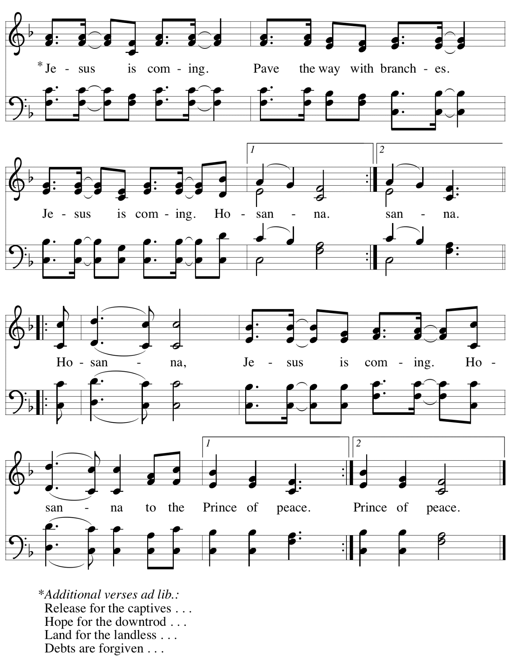

Gospel – Matthew 26: 1 – 27: 66

L: The passion of our Lord Jesus Christ according to St. Matthew.

The passion narrative is read in parts by several members of the congregation.

At various places in the reading, verses of the hymn “Go to Dark Gethsemane,” ELW 347,
will be sung by the congregation.

Please be seated for the reading.

Narrator: When Jesus had finished saying all these things …

Narrator: He replied,
Jesus: You have said so.

Go to Dark Gethsemane – v. 1 ELW 347

C: Go to dark Gethsemane,
all who feel the tempter's pow'r;
your Redeemer's conflict see.
Watch with him one bitter hour;
turn not from his griefs away;
learn from Jesus Christ to pray.

Narrator: While they were eating …

Narrator: Then all the disciples deserted him and fled.

Go to Dark Gethsemane – v. 2 ELW 347

C: Follow to the judgment hall,
view the Lord of life arraigned;
oh, the wormwood and the gall!
Oh, the pangs his soul sustained!
Shun not suff'ring, shame, or loss;
learn from him to bear the cross.

Narrator: Those who had arrested Jesus …

Narrator: … he handed him over to be crucified.

Go to Dark Gethsemane – v. 3 ELW 347

C: Calv'ry's mournful mountain climb;
there, adoring at his feet,
mark that miracle of time,
God's own sacrifice complete.
"It is finished!" hear him cry;
learn from Jesus Christ to die.

Narrator: Then the soldiers of the governor took Jesus …

Narrator: … by sealing the stone.

Go to Dark Gethsemane – v. 4 ELW 347

C: Early hasten to the tomb,
where they laid his breathless clay;
all is solitude and gloom.
Who has taken him away?
Christ is ris'n! He meets our eyes.
Savior, teach us so to rise.

A period of silence for prayer and reflection follows the Passion reading.
The service continues with the prayers of the people. Please rise as you are able.

Prayers of the People

A: Sustained by God’s abundant mercy, let us pray for the church, the world,
and all who are in need.

After each petition
A: Merciful God,
C: receive our prayer.

The presiding minister concludes the prayers:
P: We lift our prayers to you, O God, trusting in your steadfast love
and your promise to renew all creation; through Jesus Christ, our Savior and Lord.
C: Amen.

Peace

The presiding minister and the assembly greet one another in the peace of the risen Christ.
P: The peace of Christ be with you always.
C: And also with you.

The people may greet those around them with a sign of Christ’s peace and may say
Peace be with you or similar words. Please be mindful that not everyone will be comfortable with sharing the peace, so please seek consent before shaking hands or hugging. Other possible ways to share the peace include a simple bow with the verbal greeting of peace, or simply a verbal expression of peace.

When the greetings of peace have concluded, please be seated.

Meal
God feeds us with the presence of Jesus Christ

Offering

We offer ourselves, our gifts, and our faithful service to God.
As the offering is gathered for the mission of the church, including the care of those in need,
the table is set for Holy Communion.

Music during the Offering

As the gifts are brought forward for presentation, please rise as you are able.

Offertory Song

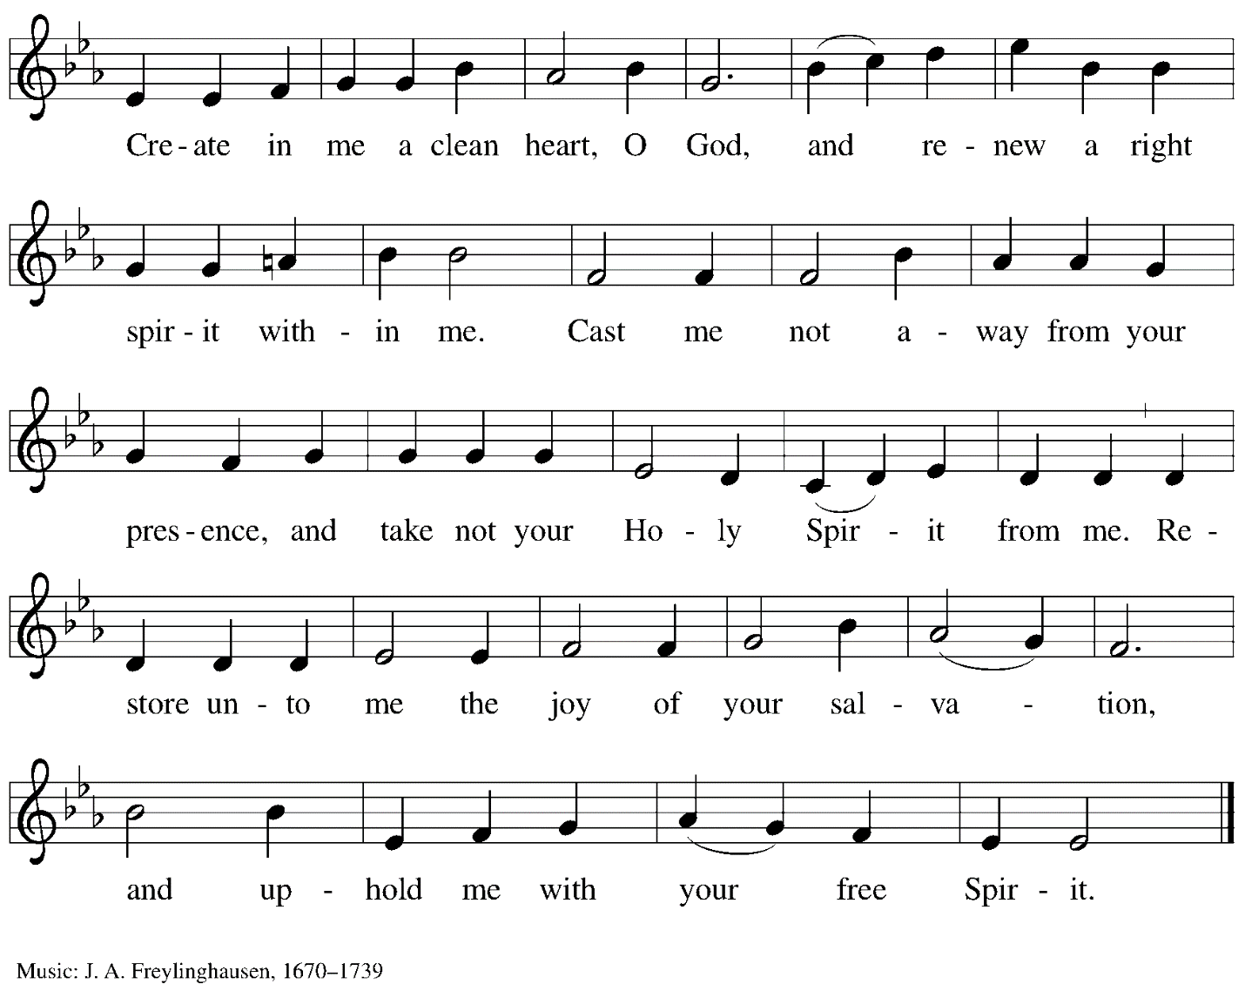

Offertory Prayer

A: Let us pray.
God our provider,
C: you have not fed us with bread alone
but with words of grace and life.
Bless us, and these your gifts,
which we receive from your bounty,
through Jesus Christ our Lord.
Amen.

Dialogue

P: The Lord be with you.
C: And also with you.

P: Lift up your hearts.
C: We lift them to the Lord.

P: Let us give thanks to the Lord our God.
C: It is right to give our thanks and praise.

Preface

P: It is indeed right, our duty and our joy…
… we praise your name and join their unending hymn:

Sanctus

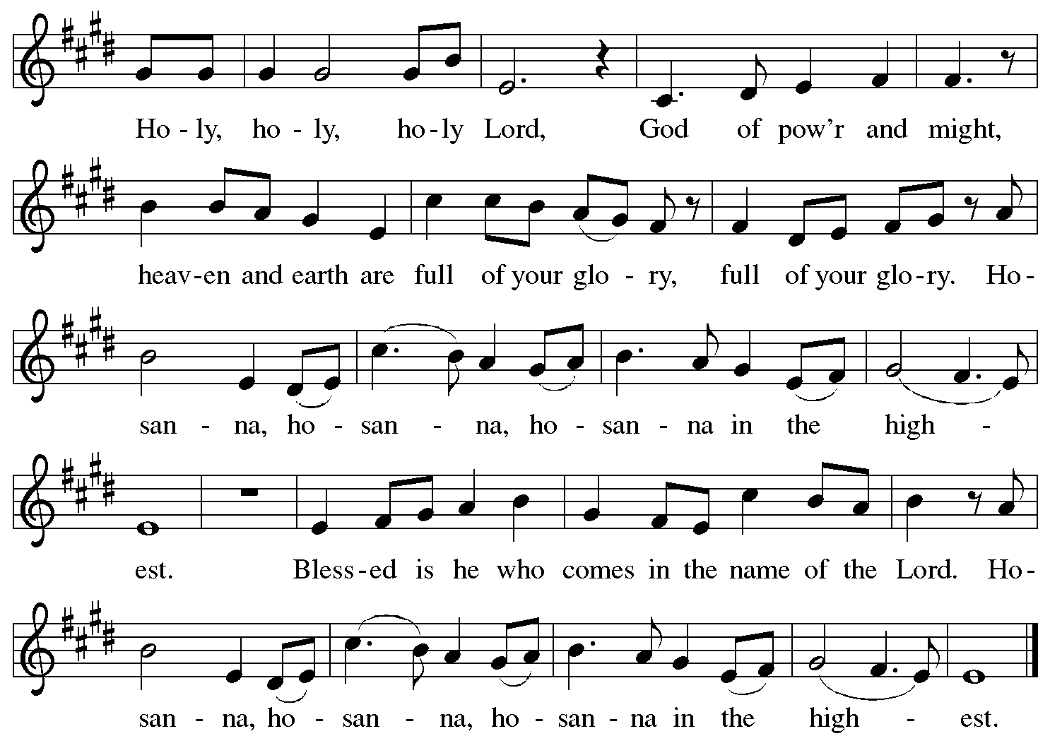

Eucharistic Prayer

P: Blessed are you, O God of the universe,
Your mercy is everlasting
and your faithfulness endures from age to age.

Praise to you for creating the heavens and the earth.
Praise to you for saving the earth from the waters of the flood.
Praise to you for bringing the Israelites safely through the sea.
Praise to you for leading your people through the wilderness
to the land of milk and honey.
Praise to you for the words and deeds of Jesus, your anointed one.
Praise to you for the death and resurrection of Christ.
Praise to you for your Spirit poured out on all nations.

In the night in which he was betrayed,
our Lord Jesus took bread, and gave thanks;
broke it, and gave it to his disciples, saying:
Take and eat; this is my body, given for you.
Do this for the remembrance of me.

Again, after supper, he took the cup, gave thanks,
and gave it for all to drink, saying:
This cup is the new covenant in my blood,
shed for you and for all people for the forgiveness of sin.
Do this for the remembrance of me.

With this bread and cup
we remember our Lord’s passover from death to life
as we proclaim the mystery of faith:
C: Christ has died.
Christ is risen.
Christ will come again.

P: O God of resurrection and new life:
Pour out your Holy Spirit on us
and on these gifts of bread and wine.
Bless this feast.
Grace our table with your presence.
C: Come, Holy Spirit.

P: Reveal yourself to us in the breaking of the bread.
Raise us up as the body of Christ for the world.
Breathe new life into us.
Send us forth,
burning with justice, peace, and love.
C: Come, Holy Spirit.

P: With your holy ones of all times and places,
with the earth and all its creatures,
with sun and moon and stars,
we praise you, O God,
blessed and holy Trinity,
now and forever.
C: Amen.

Lord’s Prayer

P: Gathered as one by the Holy Spirit, let us pray as Jesus taught us.
C: Our Father in heaven,
hallowed be your name,
your kingdom come,
your will be done,
on earth as in heaven.
Give us today our daily bread.
Forgive us our sins
as we forgive those who sin against us.
Save us from the time of trial
and deliver us from evil.
For the kingdom, the power,
and the glory are yours,
now and forever. Amen.

Fraction and Invitation

P: Come to the table of mercy;
receive God’s gifts of grace.

Agnus Dei/Lamb of God

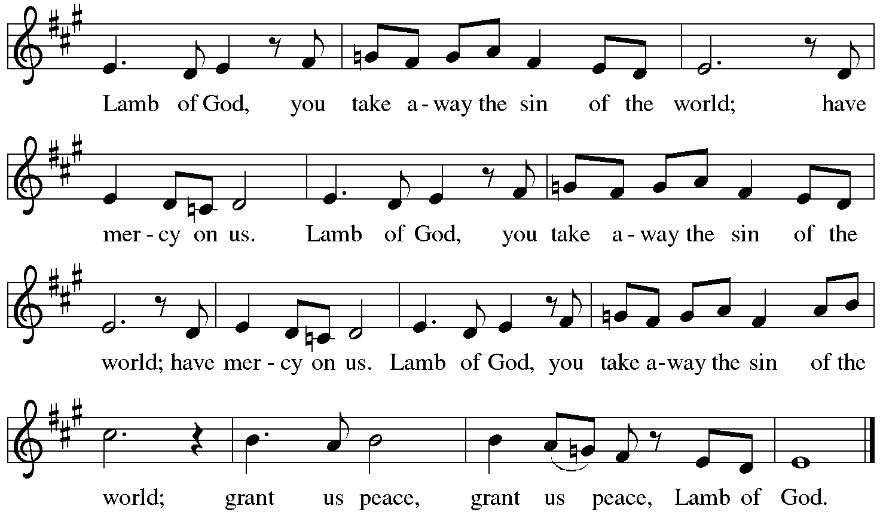

Please be seated.

Holy Communion
- All who seek God and desire a deeper and stronger life in Christ are welcome to receive Holy Communion.
- Worshipers from the pulpit side will proceed forward first, followed by the center section, and then the lectern side.
- Please inform an usher if you would like the ministers to bring Communion to you.
- Holy Communion will be served with bread and wine/grape juice.
- The presiding minister will first distribute the bread (host) to each communicant. Please indicate if you require a gluten-free host.
- Once you have consumed the bread, please pick up an empty glass from the tray next to the presiding minister. The Communion Assistant will pour wine from the chalice or grape juice from the cruet into your glass.
- Please step to the side to consume the wine or grape juice.
- Feel free to kneel at the altar rail for prayer after receiving the sacrament.
- As you return to your pew, glasses may be returned to the empty trays on either side of the center aisle.
- A blessing will be provided for anyone who does not yet receive the sacrament.
- All are invited to join in singing the hymns during Holy Communion.

Hymn during Holy Communion
Lamb of God, Pure and Sinless ELW 357

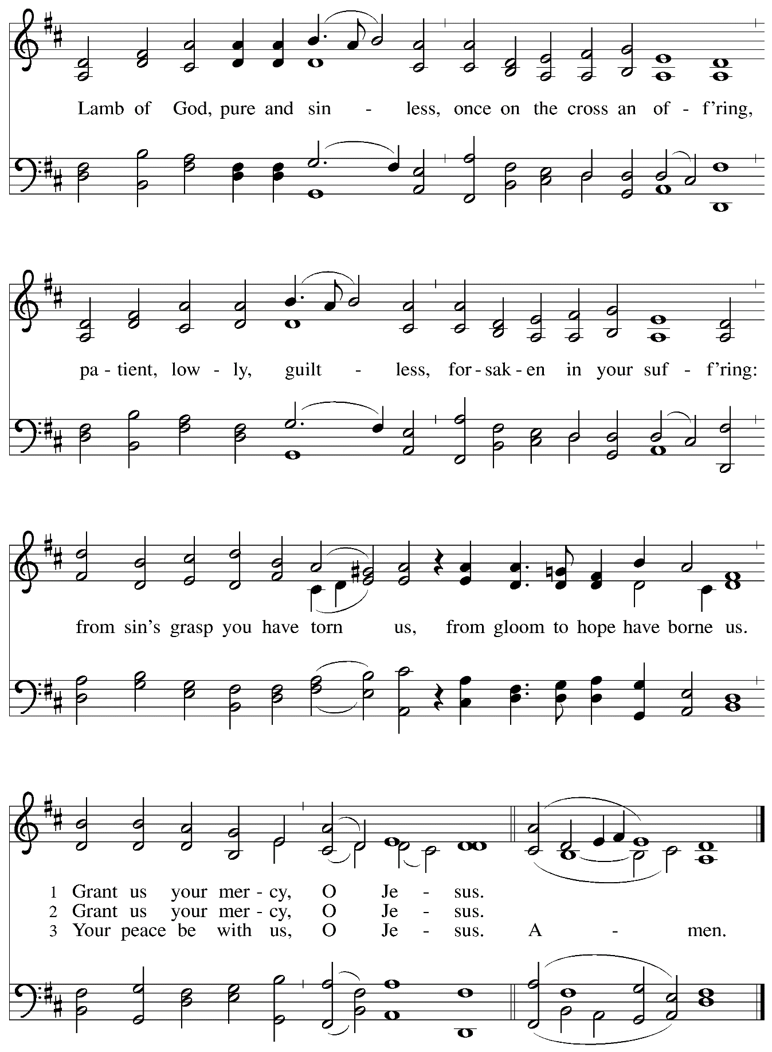
Hymn during Holy Communion
In the Cross of Christ I Glory ELW 324

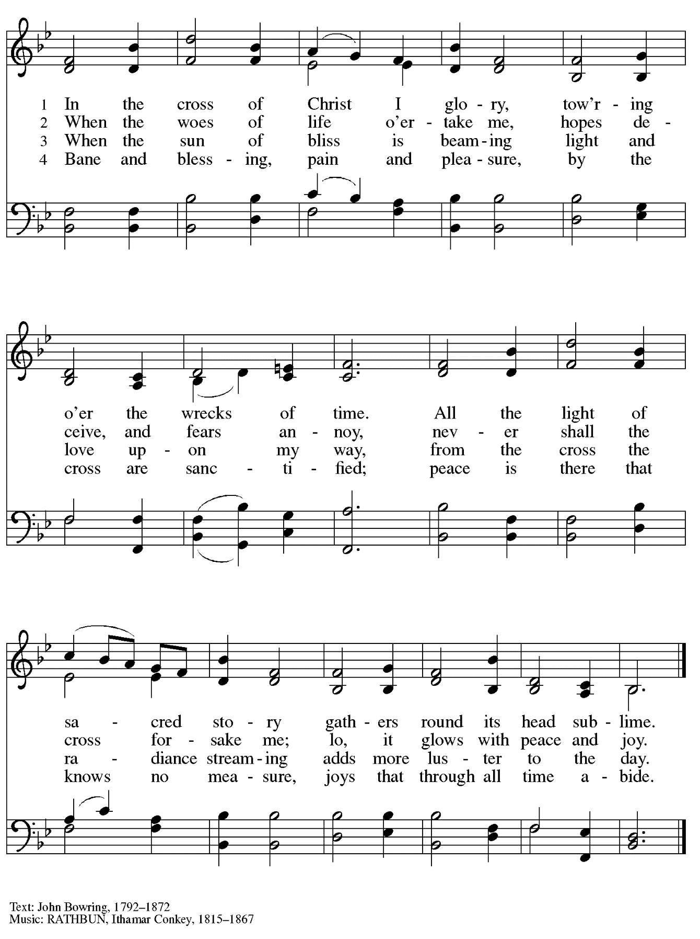
Hymn during Holy Communion
Lamb of God – Your Only Son ELW 336

No downloads are available for this hymn.
Please see the red Evangelical Lutheran Worship hymnal found in the pews.

Hymn during Holy Communion
Stay with Me ELW 348

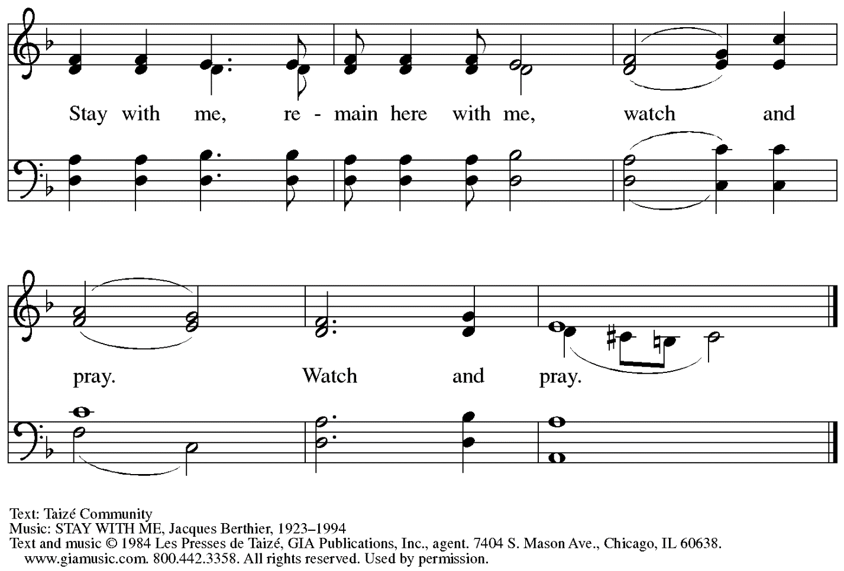
Reprinted under OneLicense.net # A-722139.

When all have returned to their places, please rise as you are able.

Blessing

P: The body and blood of our Lord Jesus Christ strengthen you and keep you in his grace.
C: Amen.

Prayer

A: Let us pray.
Compassionate God,
you have fed us with the bread of heaven.
Sustain us in our Lenten pilgrimage: may our fasting be hunger for justice;
our alms, a making of peace; and our prayer, the song of grateful hearts,
through Jesus Christ, our Savior and Lord.
C: Amen.

Please be seated.

Sending
God blesses us and sends us in mission to the world.

Announcements

Please rise as you are able.

Benediction

P: The God of love;
☩ Christ, the resurrection and the life;
and the Holy Spirit of rebirth,
bless you this Lent and always.
C: Amen.

Sending Hymn Beneath the Cross of Jesus Following page

Dismissal

A: Go in peace. Christ is with you.
C: Thanks be to God.

Sending Hymn Beneath the Cross of Jesus ELW 338

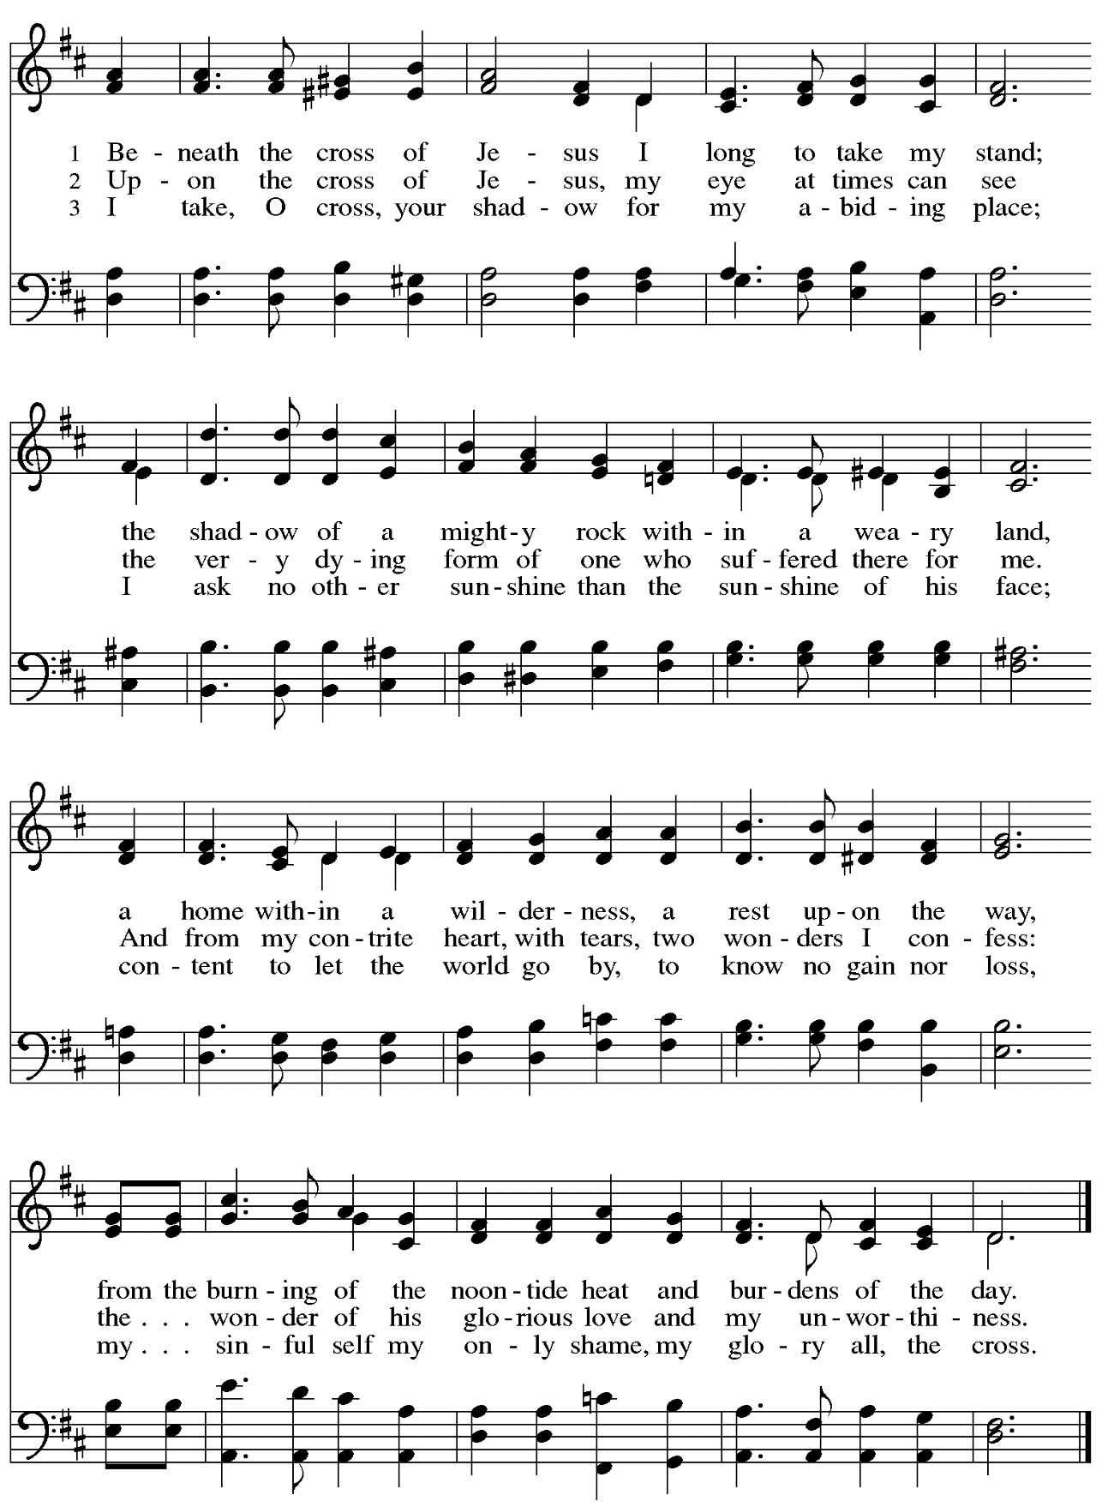
Abbreviations

P: Pastor/Presiding Minister
A: Assisting Minister
L: Lector
C: Congregation

ELW: Evangelical Lutheran Worship hymnal
ACS: All Creation Sings hymnal

Those serving in worship today

Assisting Minister Jeff Denlinger
Audio-Visual Ministers Kristen Asplin
Colten Rohleder
Cantor David Rollinson
Crucifer Adam Stoller
Lector Emily Duque
Passion Narrative Readers Joyce Compton
Colleen Cooke
Jeff Denlinger
Emily Duque
The Rev. Dr. Paul F. Koch
Kelly Spanninger
Minister of Music Laura Reynolds
Presiding Minister Pastor Ross I. Carmichael

Liturgy and Hymnody Acknowledgements

From SundaysandSeasons.com. Copyright © 2023 Augsburg Fortress. All rights reserved. Reprinted under OneLicense.net # A-722139.
Used by permission of Augsburg Fortress.

All Glory, Laud, and Honor – Text: Theodulph of Orleans, c. 760-821; tr. John Mason Neale, 1818-1866, alt. Music: VALET WILL ICH DIR GEBEN, Melchior Teschner, 1584-1635.

Pave the Way with Branches – Text: Bret Hesla, b. 1957. Music: PAVE THE WAY, Bret Hesla. Text and music © 1999 Bret Hesla, admin. Augsburg Fortress. All rights reserved. Reprinted with permission under OneLicense.net # A-722139.

Go to Dark Gethsemane – Text: James Montgomery, 1771-1854. Music: GETHSEMANE, Richard Redhead, 1820-1901.

Lamb of God, Pure and Sinless – Text: Nikolaus Decius, 1485-1550; tr. composite. Music: O LAMM GOTTES, UNSCHULDIG, Nikolaus Decius. Text © 1978, 1999 Augsburg Fortress.

Beneath the Cross of Jesus – Elizabeth C. Clephane, 1830-1869. Music: ST. CHRISTOPHER, Frederick C. Maker, 1844-1927.

St. Andrew Lutheran Church Announcements
April 2nd, 2023

- Welcome to Worship at St. Andrew on April 2nd, 2023, + Palm Sunday / Sunday of the Passion – Masks are optional at St. Andrew when Allegheny County’s Covid-19 community level is in the low and medium categories. Worship attendees are invited to make a name tag at the back of the worship space if you would like. All are invited to gather in the Social Hall after worship for food, drinks, and conversation.
- Worship Schedule for Holy Week – With today’s service, the church enters into the contemplation of the passion, death, and resurrection of our Savior Jesus Christ. Our primary means for this reflection is through the service of the Triduum – the Great Three Days of Holy Week – one service that unfolds in three parts: Maundy Thursday, Good Friday, and the Vigil of Easter. The service schedule for the upcoming week is:
  - Triduum – Maundy Thursday, April 6th, 7:00 p.m. – Worship with Holy Communion
  - Holy Week Service for Children – Good Friday, April 7th, 5:30 p.m. – At this service, we tell the story of Maundy Thursday and Good Friday through four interactive stations designed for the young ones of the community.
  - Triduum – Good Friday, April 7th, 7:00 p.m. – Service of Shadows and Stones – In relative darkness, we hear Gospel accounts of the crucifixion, sing prayerful, meditative hymns, and leave stones at the foot of the cross as we honor our crucified Savior.
  - Triduum – The Vigil of Easter, April 8th, 5:00 p.m. – The church tells God’s story of salvation through worship, word, sacrament, and song as we gather around a fire, hear stories of God’s faithfulness throughout the ages, give thanks for the gift of Baptism, and move into the celebration of the resurrection with Holy Communion
  - The Resurrection of our Lord – Easter Sunday, April 9th, 10:00 a.m. – We join the church throughout the world in proclaiming the fullness of the good news in Christ’s Easter resurrection! (Please note that Little Church; Big Faith will not meet during these services, nor will there be a coffee hour.)
- Monthly Produce Distribution – Tuesday, April 4th, 5:30-7:00 p.m. – St. Andrew’s monthly distribution of fresh produce (in partnership with Greater Pittsburgh Community Food Bank) will be this Tuesday, April 4th, from 5:30-7:00 p.m. We would also appreciate help with unloading and setup earlier in the day, usually some time between 10:30 a.m. and 1:00 p.m. Please sign up at this link if you would like to participate: https://www.signupgenius.com/go/4090F45AFAF2BA75-produce2.
- St. Andrew Jail Ministry – St. Andrew has had a long history of participation in the ministry program at the Allegheny County Jail. Until the program was abruptly put on hold at the beginning of the Covid pandemic, a group of volunteers from St. Andrew was leading a worship service at the jail on Sunday mornings, typically about one Sunday a month. The jail is hoping to resume this program, probably sometime in April. If any of the previous volunteers are still interested and available, please contact Lester Prince (lprince@comcast.net). New volunteers are also needed.
The first step for new volunteers is to complete an online application, which can be accessed here: https://www.foundationofhope.org/get-involved/volunteer-application/. On the application form, indicate that the program that you are interested in volunteering with is “Chaplaincy Worship.” Feel free to contact Lester Prince with any questions.
- St. Andrew Saving Pull Tabs from Cans – St. Andrew continues to save pull tabs from all types of cans. They are recycled by Ronald McDonald House to benefit programs for children and families receiving care at Pittsburgh Children's Hospital. Tabs can be placed in the plastic drawer on the donations table in the social hall.
- Lenten Food Drive – Help Fill St. Andrew’s Mini Free Pantry – We have been collecting items for the Pantry this Lenten season. Brown bags are still available from the back of the sanctuary or in the Social Hall to fill with an item or two for the pantry (no need to fill the bag completely) and return to St. Andrew. Items should be shelf safe/stable (nothing fresh, frozen or that may go bad in severe weather.) Here are some things we suggest:
- Items in cans with flip top lids: (no items requiring a can opener)
- Tuna, sardines, or Vienna sausage, ravioli, soup that does not need to be diluted.
- Fruit or vegetables in single-serve, shelf safe containers
- Single serve peanut butter, cheese & cracker snacks, granola bars, beef jerky, raisin boxes, little cereal boxes, shelf stable milk (Horizon)
- Personal care items: Shampoo, body wash, deodorant, toothpaste, feminine products, toilet paper
Contact Joyce Compton at jcompton28@gmail.com or 412-657-0584 with questions.
Please return all items by Easter Sunday, April 9th.

