+ Second Sunday of Easter
April 16, 2023
St. Andrew Lutheran Church
304 Morewood Ave.
Pittsburgh, PA 15213
St_andrewELCA@verizon.net
www.standrewpittsburgh.org

+ Second Sunday of Easter
Order for Worship

In this week’s Gospel the risen Christ appears to the disciples and offers them the gift of peace. Even amid doubts and questions, we experience the resurrection in our Sunday gathering around word and meal, and in our everyday lives. Throughout the coming Sundays of Easter, the first two readings will be from the Acts of the Apostles and the first letter of Peter.
Even as the early Christians proclaimed the resurrection, we rejoice in the new birth
and living hope we receive in Baptism.

- Masks are optional at St. Andrew when Covid-19 community level in Allegheny County is in the low and medium categories.

- Worship Services are live streamed to multiple online platforms. By attending worship, you agree that your image and voice may be broadcast.

Welcome to St. Andrew!

- St. Andrew Lutheran congregation welcomes all who are seeking a place of healing and wholeness – a nurturing, faith-forming spiritual home. Our community embraces people of all ages, ethnicities, cultures, abilities, sexual orientations, gender identities and expressions, and family constellations. Come and See!

- Everyone is invited to make a nametag at the black bookcase in the back of the worship space if they would like. There are stickers indicating pronouns on the bookcase if you would like to include them on your name tag.

- Worship “toolkits” to help children engage with the service are available in the bookcase at the back of the worship space. There are “reader” and “pre-reader” resources available in each kit. Please feel free to use them for/with your children during worship.

- Holy Communion is served with bread (gluten-free available) and wine or grape juice. The presiding minister will distribute the bread (host). Please consume this and then pick up an empty glass from the tray. The Communion Assistant will pour wine or grape juice into your glass. Please step to the side to consume the wine or grape juice. Feel free to kneel at the altar for prayer and reflection. As you return to your pew, glasses may be returned to the empty trays on either side of the center aisle.

- A restroom is available on the main level of the church, through the doors to the Social Hall and to the right in the main office.

Pre-Service Music

Welcome

Prelude

Gathering
The Holy Spirit calls us together as the people of God.

Confession and Forgiveness

Please rise as you are able.
All may make the sign of the cross, the sign that is marked at Baptism,
as the presiding minister begins.

P: Blessed be the holy Trinity,
☩ one God,
who creates, redeems, and sustains us
and all of creation.
C: Amen.

P: Let us confess our sin in the presence of God and of one another.

Silence is kept for reflection

P: To you, O God,
C: all hearts are open, to you all desires known.
We come to you, confessing our sins.
Forgive us in your mercy, and remember us in your love.
Show us your ways; teach us your paths; and lead us in justice and truth,
for the sake of your goodness in Jesus Christ our Savior.
Amen.

P: By water and the Holy Spirit God gives you a new birth,
and through the death and resurrection of ☩ Jesus Christ,
God forgives you all your sins.
The God of mercy and might strengthen you in all goodness
and keep you in eternal life.
C: Amen.

Gathering Hymn Christ the Lord Is Risen Today; Alleluia! ELW 369

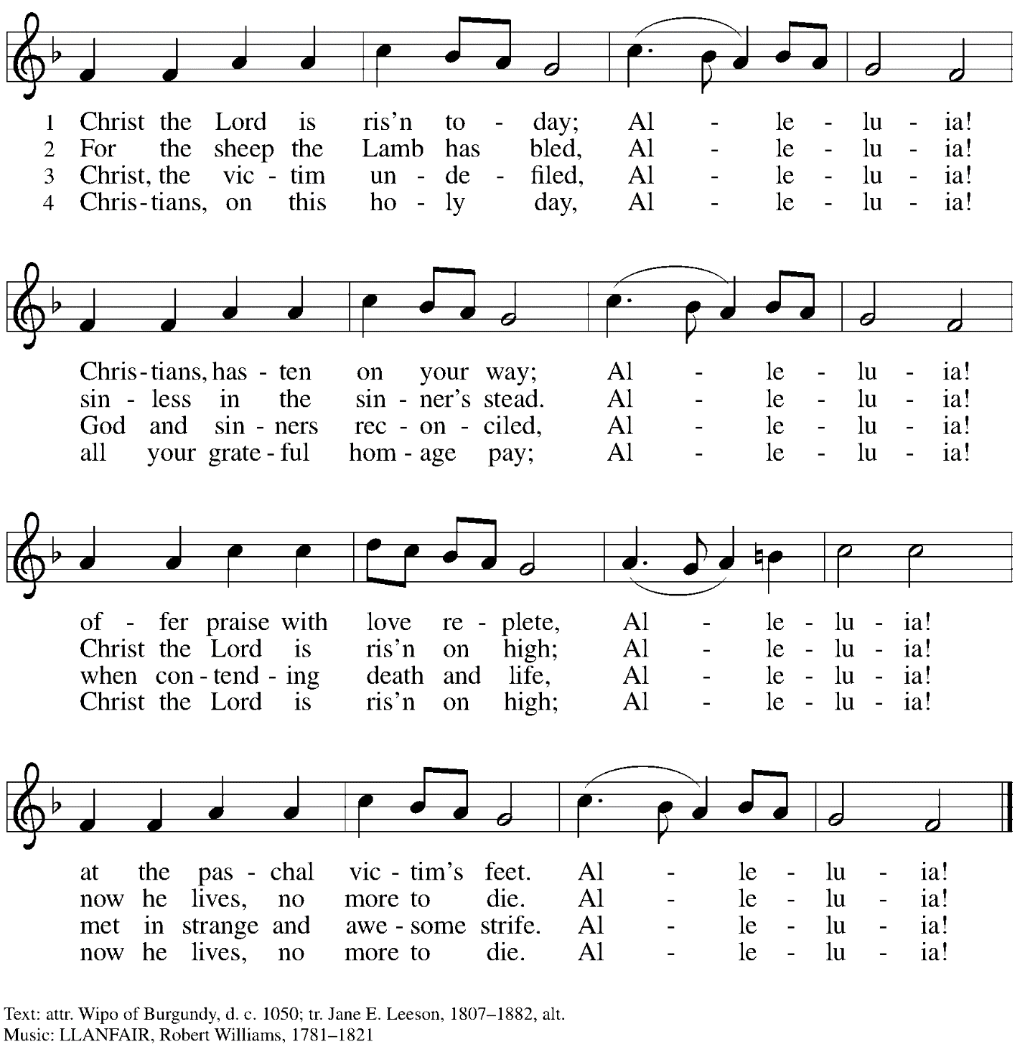

Greeting

P: The grace of our Lord Jesus Christ, the love of God,
and the communion of the Holy Spirit be with you all.
C: And also with you.

Hymn of Praise Now the Feast and Celebration ELW 167

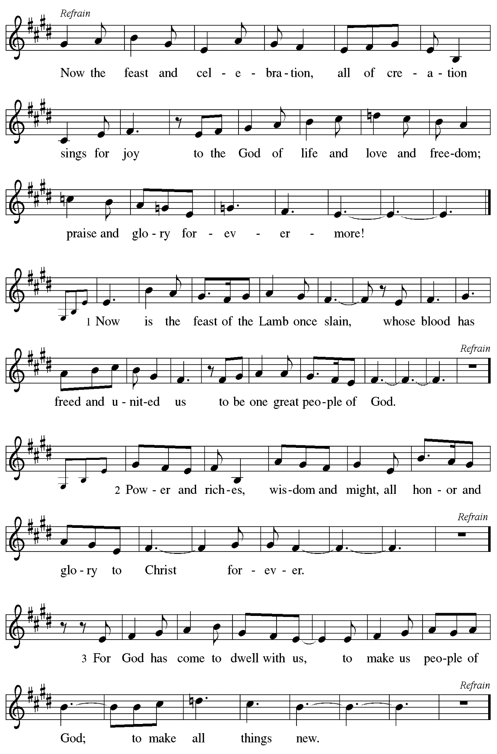
Prayer of the Day

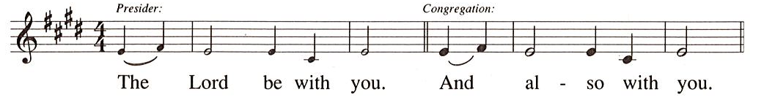

P: Let us pray.
Almighty and eternal God, the strength of those who believe and the hope of those who doubt, may we, who have not seen, have faith in you and receive the fullness of Christ’s blessing,
the one who lives and reigns with you and the Holy Spirit, one God, now and forever.
C: Amen.

Please be seated. Children are invited to join the adult leaders at the door and move to the office for Little Church – Big Faith, a Bible lesson and activity. We ask that one additional adult from the congregation attend with the children.

Word
God speaks to us in Scripture reading, preaching, and song

First Reading – Acts 2: 14a, 22-32

^{14a}Peter, standing with the eleven, raised his voice and addressed [the crowd], ²²“You that are Israelites, listen to what I have to say: Jesus of Nazareth, a man attested to you by God with deeds of power, wonders, and signs that God did through him among you, as you yourselves know—²³this man, handed over to you according to the definite plan and foreknowledge of God, you crucified and killed by the hands of those outside the law. ²⁴But God raised him up, having freed him from death, because it was impossible for him to be held in its power. ²⁵For David says concerning him,
‘I saw the Lord always before me,
for he is at my right hand so that I will not be shaken;
²⁶therefore my heart was glad, and my tongue rejoiced;
moreover my flesh will live in hope.
²⁷For you will not abandon my soul to Hades,
or let your Holy One experience corruption.
²⁸You have made known to me the ways of life;
you will make me full of gladness with your presence.’
²⁹“Fellow Israelites, I may say to you confidently of our ancestor David that he both died and was buried, and his tomb is with us to this day. ³⁰Since he was a prophet, he knew that God had sworn with an oath to him that he would put one of his descendants on his throne. ³¹Foreseeing this, David spoke of the resurrection of the Messiah, saying,
‘He was not abandoned to Hades,
nor did his flesh experience corruption.’
³²This Jesus God raised up, and of that all of us are witnesses.”

L: Word of God, word of life.
C: Thanks be to God.

Psalm 16

The psalm will be sung responsively, led by the cantor with the congregation invited to respond with the bold verses and refrain.

Psalm tone

Psalm refrain
¹Protect me, O God, for I take ref- | uge in you;
I have said to the Lord, “You are my Lord, my good a- | bove all other.”
²All my delight is in the godly that are | in the land,
upon those who are noble a- | mong the people.
³But those who run after | other gods
shall have their troubles | multiplied.
⁴I will not pour out drink offerings | to such gods,
never take their names up- | on my lips. R
⁵O Lord, you are my portion | and my cup;
it is you who up- | hold my lot.
⁶My boundaries enclose a | pleasant land;
indeed, I have a | rich inheritance.
⁷I will bless the Lord who | gives me counsel;
my heart teaches me night | after night.
⁸I have set the Lord al- | ways before me;
because God is at my right hand, I shall | not be shaken. R
⁹My heart, therefore, is glad, and my spir- | it rejoices;
my body also shall | rest in hope.
¹⁰For you will not abandon me | to the grave,
nor let your holy one | see the pit.
¹¹You will show me the | path of life;
in your presence there is fullness of joy, and in your right hand are pleasures
for- | evermore. R

Second Reading – 1 Peter 1: 3-9

³Blessed be the God and Father of our Lord Jesus Christ! By God’s great mercy, God has given us a new birth into a living hope through the resurrection of Jesus Christ from the dead, ⁴and into an inheritance that is imperishable, undefiled, and unfading, kept in heaven for you, ⁵who are being protected by the power of God through faith for a salvation ready to be revealed in the last time. ⁶In this you rejoice, even if now for a little while you have had to suffer various trials, ⁷so that the genuineness of your faith—being more precious than gold that, though perishable, is tested by fire—may be found to result in praise and glory and honor when Jesus Christ is revealed. ⁸Although you have not seen him, you love him; and even though you do not see him now, you believe in him and rejoice with an indescribable and glorious joy, ⁹for you are receiving the outcome of your faith, the salvation of your souls.

L: Word of God, word of life.
C: Thanks be to God.

Please rise as you are able.

Gospel Acclamation

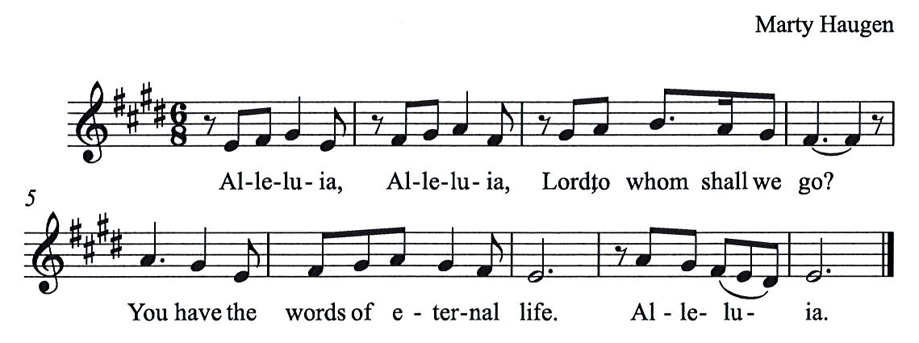

Gospel – John 20: 19-31

P: The holy Gospel according to St. John.
C: Glory to you, O Lord.

¹⁹When it was evening on that day, the first day of the week, and the doors of the house where the disciples had met were locked for fear of Jesus’ opponents, Jesus came and stood among them and said, “Peace be with you.” ²⁰After he said this, he showed them his hands and his side. Then the disciples rejoiced when they saw the Lord. ²¹Jesus said to them again, “Peace be with you. As the Father has sent me, so I send you.” ²²When he had said this, he breathed on them and said to them, “Receive the Holy Spirit. ²³If you forgive the sins of any, they are forgiven them; if you retain the sins of any, they are retained.”
²⁴But Thomas (who was called the Twin), one of the twelve, was not with them when Jesus came. ²⁵So the other disciples told him, “We have seen the Lord.” But he said to them, “Unless I see the mark of the nails in his hands, and put my finger in the mark of the nails and my hand in his side, I will not believe.”
²⁶A week later his disciples were again in the house, and Thomas was with them. Although the doors were shut, Jesus came and stood among them and said, “Peace be with you.” ²⁷Then he said to Thomas, “Put your finger here and see my hands. Reach out your hand and put it in my side. Do not doubt but believe.” ²⁸Thomas answered him, “My Lord and my God!” ²⁹Jesus said to him, “Have you believed because you have seen me? Blessed are those who have not seen and yet have come to believe.”
³⁰Now Jesus did many other signs in the presence of his disciples, which are not written in this book. ³¹But these are written so that you may come to believe that Jesus is the Messiah, the Son of God, and that through believing you may have life in his name.

P: The Gospel of the Lord.
C: Praise to you, O Christ.

Please be seated.

Sermon

A time of silence for prayer and reflection follows the sermon.
When the hymn of the day begins, please rise as you are able.

Hymn of the Day We Walk by Faith Following page

Hymn of the Day We Walk by Faith ELW 635

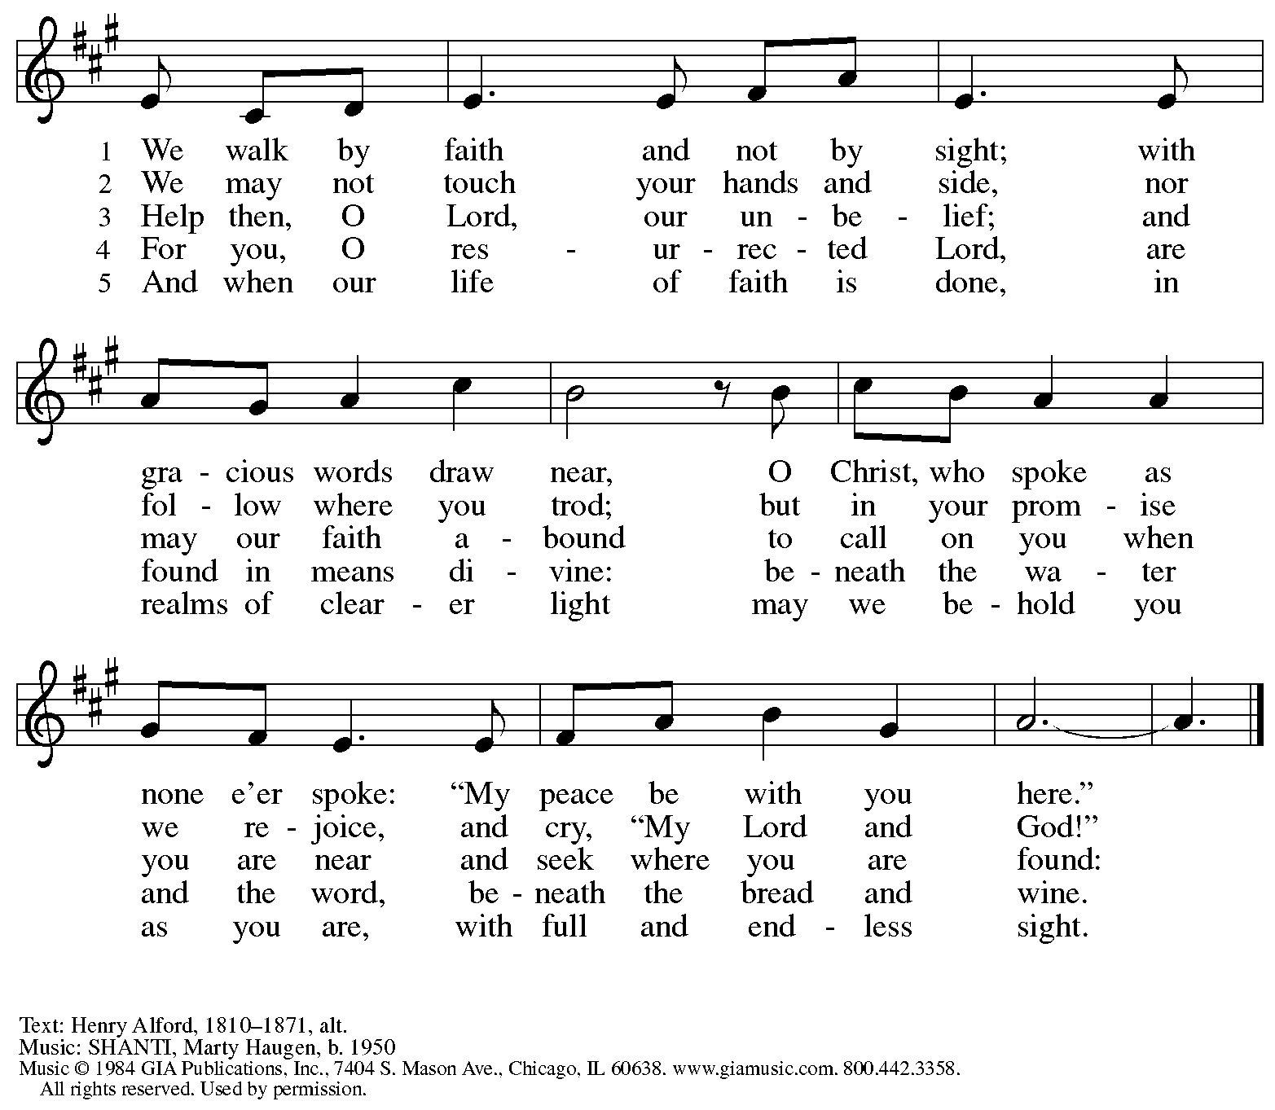
Reprinted under OneLicense.net # A-722139.

Nicene Creed

C: We believe in one God,
the Father, the Almighty,
maker of heaven and earth,
of all that is, seen and unseen.

We believe in one Lord, Jesus Christ,
The only Son of God,
eternally begotten of the Father,
God from God, Light from Light,
true God from true God,
begotten, not made,
of one Being with the Father;
through him all things were made.
For us and for our salvation
he came down from heaven,
was incarnate of the Holy Spirit and the virgin Mary
and became truly human.
For our sake he was crucified under Pontius Pilate;
he suffered death and was buried.
On the third day he rose again
in accordance with the scriptures;
he ascended into heaven
and is seated at the right hand of the Father.
He will come again in glory to judge the living and the dead,
and his kingdom will have no end.

We believe in the Holy Spirit, the Lord, the giver of life,
who proceeds from the Father and the Son,*
who with the Father and the Son is worshiped and glorified,
who has spoken through the prophets.
We believe in one holy catholic and apostolic church.
We acknowledge one baptism for the forgiveness of sins.
We look for the resurrection of the dead,
and the life of the world to come. Amen.

*Or, “who proceeds from the Father.” The phrase “and the Son” is a later addition to the creed.

Prayers of the People

A: United in the joy and hope of the resurrection, let us pray for the church, the world,
and all who are in need.

After each petition
A Gracious God,
C: receive our prayer.

The presiding minister concludes the prayers
P: We lift these prayers to you O God, trusting in your abundant mercy,
through Jesus Christ our risen Savior.
C: Amen.

Peace

The presiding minister and the assembly greet one another in the peace of the risen Christ.
P: The peace of Christ be with you always.
C: And also with you.

The people may greet those around them with a sign of Christ’s peace and may say
Peace be with you or similar words. Please be mindful that not everyone will be comfortable with sharing the peace, so please seek consent before shaking hands or hugging. Other possible ways to share the peace include a simple bow with the verbal greeting of peace, or simply a verbal expression of peace.

When the greetings of peace have concluded, please be seated.

Meal
God feeds us with the presence of Jesus Christ

Offering

We offer ourselves, our gifts, and our faithful service to God.
As the offering is gathered for the mission of the church, including the care of those in need,
the table is set for Holy Communion.

Music during the Offering

As the gifts are brought forward for presentation, please rise as you are able.

Offertory Song As the Grains of Wheat ELW 184

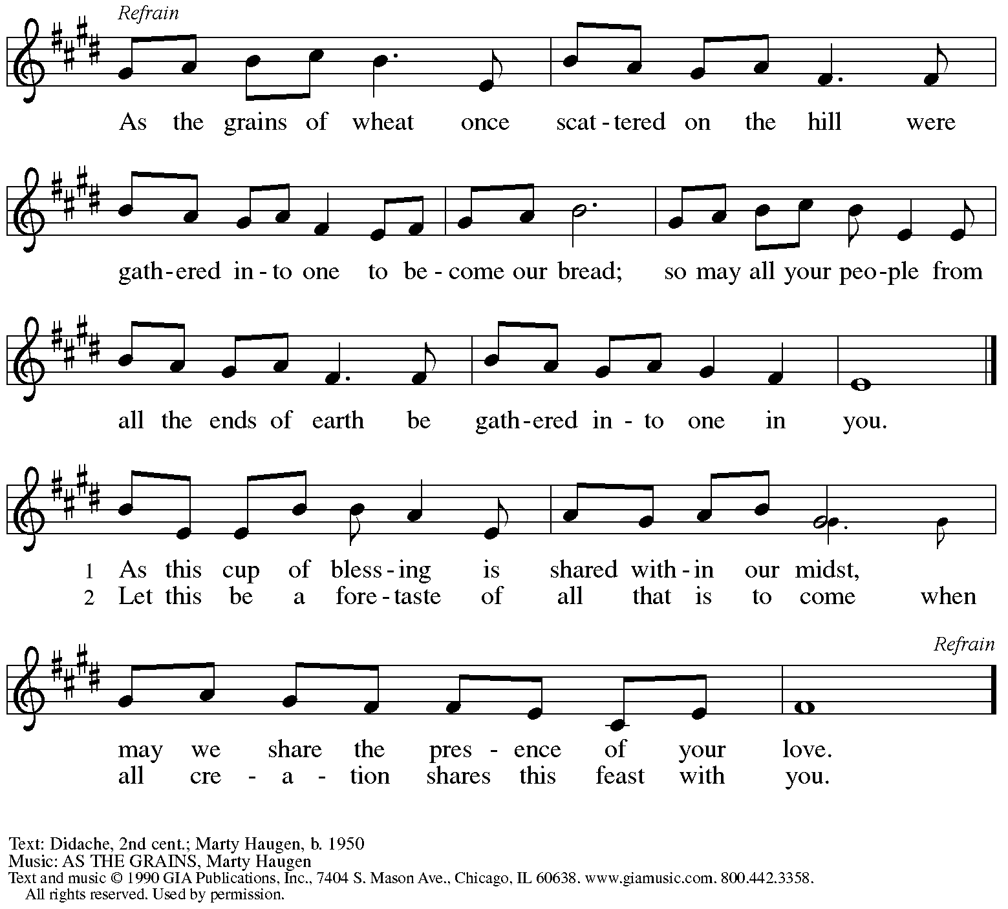
Reprinted under OneLicense.net # A-722139.

Offertory Prayer

A: Let us pray.
Blessed are you, O God,
C: ruler of heaven and earth.
Day by day you shower us with blessings.
As you have raised us to new life in Christ,
give us glad and generous hearts,
ready to praise you and to respond to those in need,
through Jesus Christ, our Savior and Lord.
Amen.

Dialogue HS p. 14

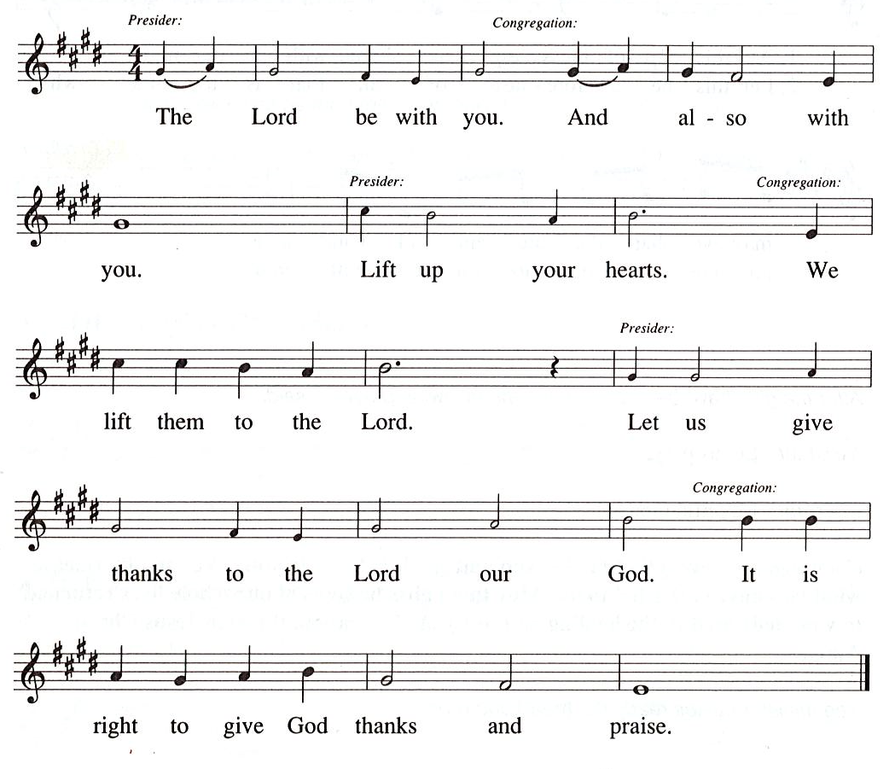

Preface (Sung by the presiding minister)

P: It is our duty and delight
that we should everywhere and always
offer thanks and praise to you, O God,
through Jesus Christ,
who by his death on the cross
and his glorious resurrection
broke the bonds of sin and death
and gave life to all creation.
And so with the church on earth,
all creation and the hosts of heaven,
we praise your name and join their unending hymn:

Sanctus HS p. 15

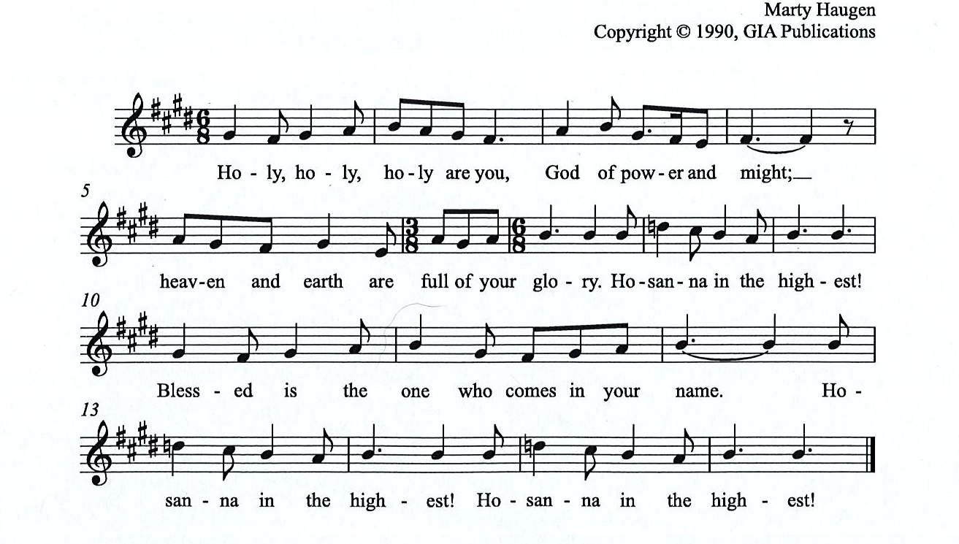

Eucharistic Prayer

P: You are indeed holy, almighty and merciful God, …
… Do this for the remembrance of me.

For as often as we eat of this bread and drink from this cup,
we proclaim the Lord’s death until he comes.

(Presiding minister sings)
Christ has died. Christ is risen. Christ will come, come again.
C:
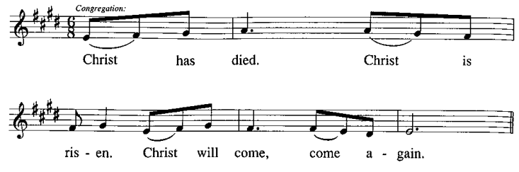
P: Remembering, therefore, his salutary command, …
… and be given our inheritance with all your saints.

To you, O God, Father, Son, and Holy Spirit,
be all honor and glory in your holy church, now and forever.
C:
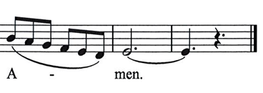

Lord’s Prayer

P: Gathered as one by the Holy Spirit, let us pray as Jesus taught us.
C: Our Father in heaven,
hallowed be your name,
your kingdom come,
your will be done,
on earth as in heaven.
Give us today our daily bread.
Forgive us our sins
as we forgive those
who sin against us.
Save us from the time of trial
and deliver us from evil.
For the kingdom, the power,
and the glory are yours,
now and forever. Amen.

Fraction and Invitation

P: Alleluia! Christ is risen!
C: Christ is risen indeed! Alleluia! Alleluia!

P: This is the feast of victory for our God. Alleluia! Alleluia!
Come, share the feast.

Agnus Dei / Lamb of God Following Page

Agnus Dei / Lamb of God HS p. 18

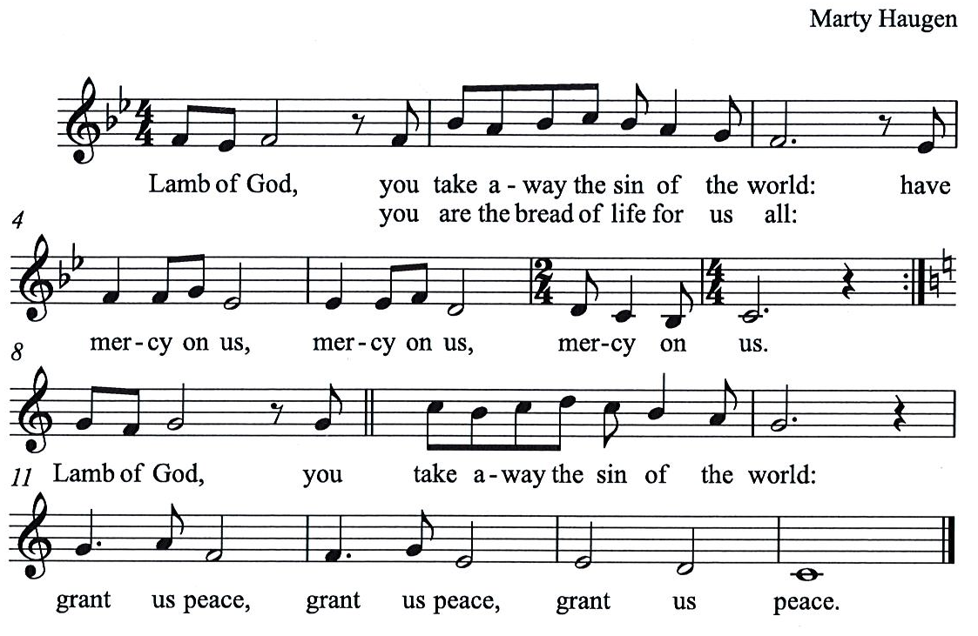

Please be seated.

Holy Communion
- All who seek God and desire a deeper and stronger life in Christ are welcome to receive Holy Communion.
- Worshipers from the pulpit side will proceed forward first, followed by the center section, and then the lectern side.
- Please inform an usher if you would like the ministers to bring Communion to you.
- Holy Communion will be served with bread and wine/grape juice.
- The presiding minister will first distribute the bread (host) to each communicant. Please indicate if you require a gluten-free host.
- Once you have consumed the bread, please pick up an empty glass from the tray next to the presiding minister. The Communion Assistant will pour wine from the chalice or grape juice from the cruet into your glass.
- Please step to the side to consume the wine or grape juice.
- Feel free to kneel at the altar rail for prayer after receiving the sacrament.
- As you return to your pew, glasses may be returned to the empty trays on either side of the center aisle.
- A blessing will be provided for anyone who does not yet receive the sacrament.
- All are invited to join in singing the hymns during Holy Communion.

Hymns during Holy Communion
Soul, Adorn Yourself with Gladness ELW 488

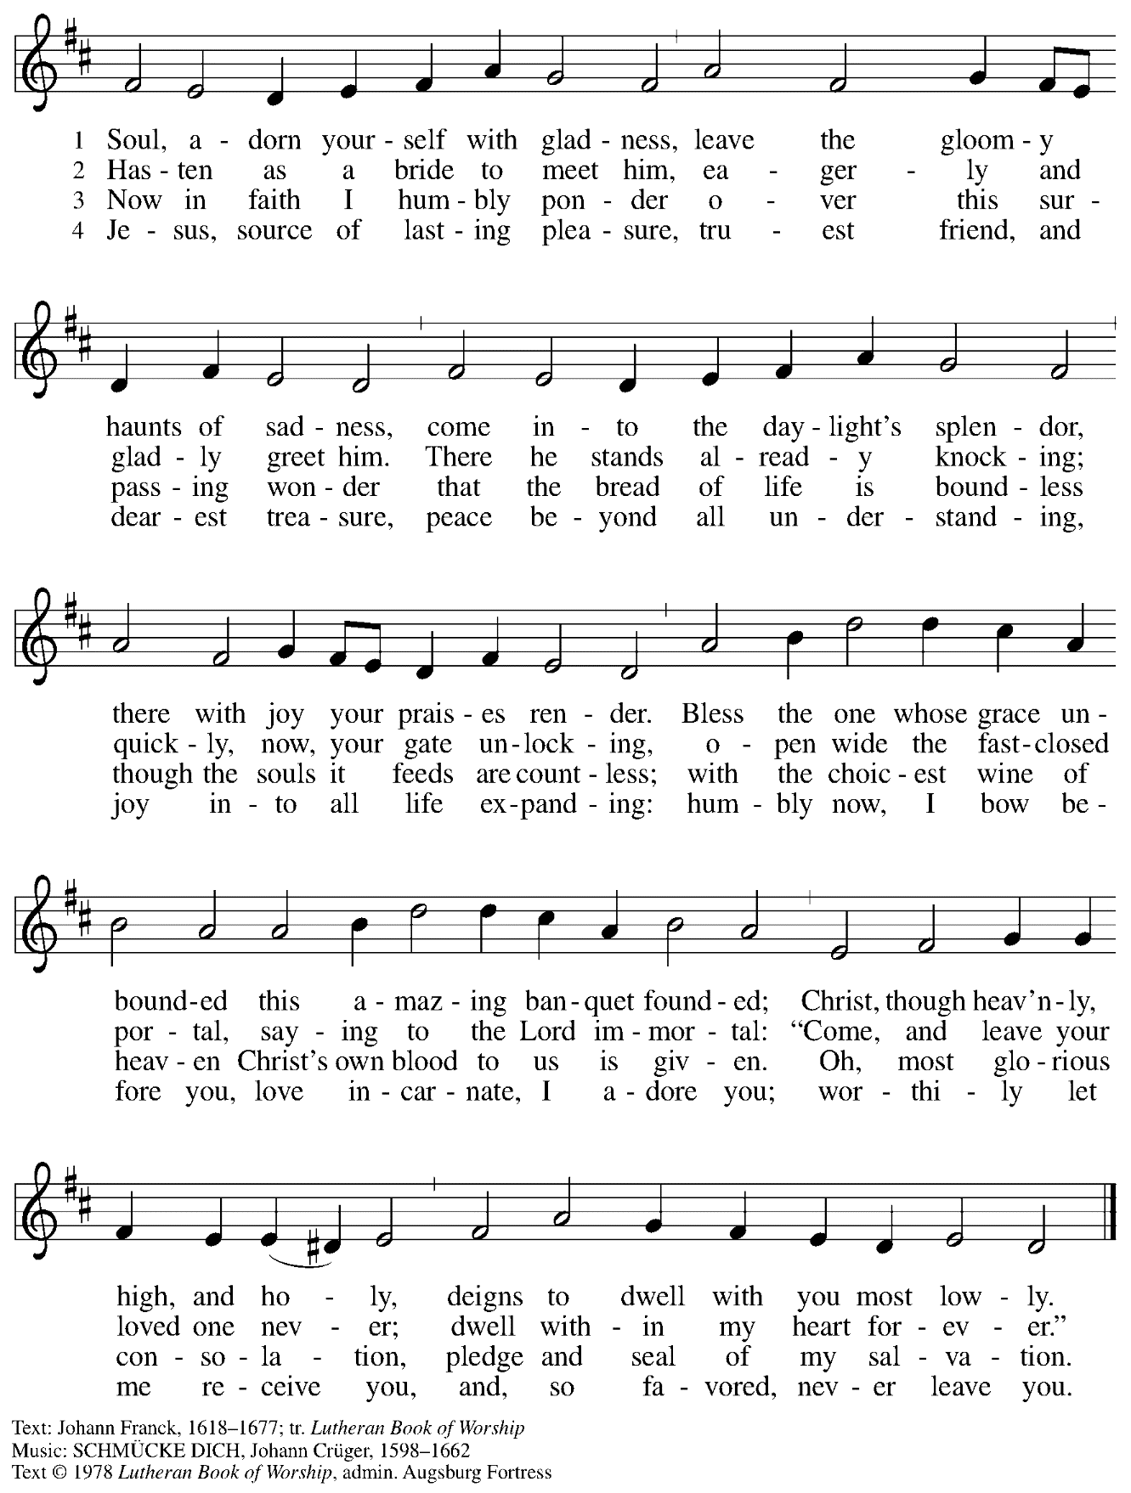
All rights reserved. Reprinted under OneLicense.net # A-722139.
Hymns during Holy Communion
Christ Has Risen While Earth Slumbers ACS 938

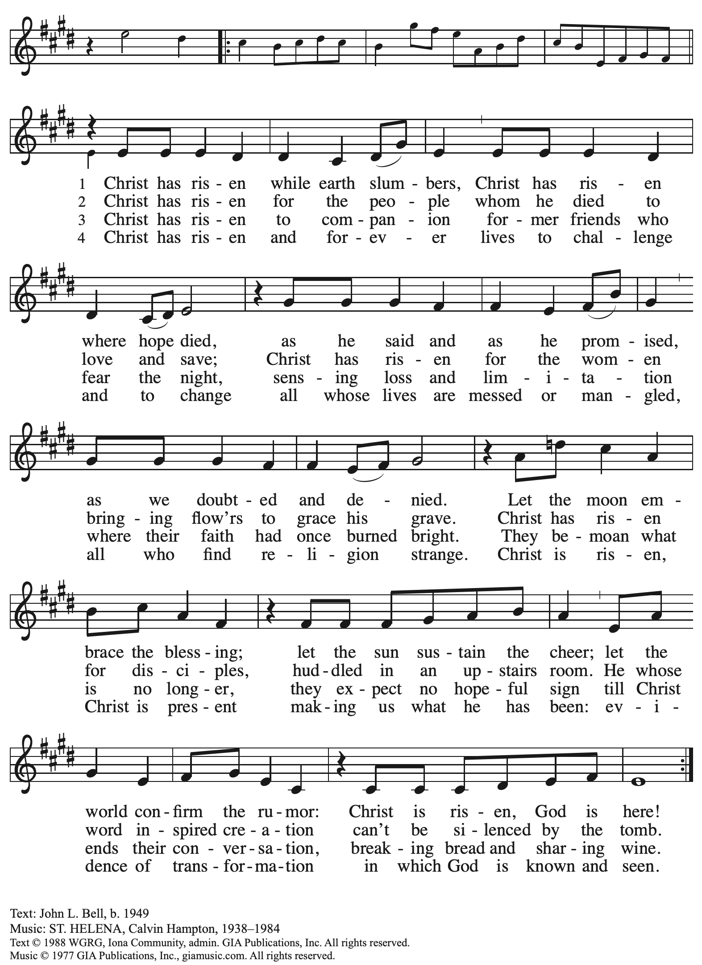
Reprinted with permission under OneLicense.net # A-722139.
When all have returned to their places, please rise as you are able.

Blessing

P: The body and blood of our Lord Jesus Christ strengthen you and keep you in his grace.
C: Amen.

Prayer

A: Let us pray. Life-giving God,
in the mystery of Christ’s resurrection, you send light to conquer darkness,
water to give new life, and the bread of life to nourish your people.
Send us forth as witnesses to your Son’s resurrection,
that we may show your glory to all the world,
through Jesus Christ, our risen Lord.
C: Amen.

Please be seated.

Sending

Announcements

Please rise as you are able.

Benediction

P: May our glorious God grant you a spirit of wisdom
to know and love the risen Christ.

Almighty God, holy One, ☩ holy Three,
bless you now and forever.
C:
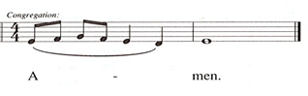

Sending Hymn We Have Seen the Lord Following page

Sending Hymn We Have Seen the Lord ELW 869

[A leader sings the words in parentheses.]
(Nimemwona Bwana.)
Nimemwona Bwana. (Nimemwona)
Nimemwona Bwana. (Nimemwona Bwana.)
Nimemwona Bwana, anapendeza.

(We have seen the Lord.)
We have seen the Lord. (God is mighty.)
We have seen the Lord. (God is powerful.)
We have seen the Lord, God with us, Jesus Christ.

(We have seen the Lord.)
We have seen the Lord. (God is lowly.)
We have seen the Lord. (God is merciful.)
We have seen the Lord, God with us, Jesus Christ.

(We have seen the Lord.)
We have seen the Lord. (God is gracious.)
We have seen the Lord. (God is wonderful.)
We have seen the Lord, God with us, Jesus Christ.

Text: Tanzanian traditional; tr. Jeff Sartain, b. 1962. Music: NIMEMWONA BWANA, Tanzanian tune; arr. Mark Sedio, b. 1954.
English text and arrangement © 2003 Concordia Publishing House. All rights reserved. Reprinted with permission under OneLicense.net # A-722139.

Dismissal

A: Alleluia! Christ is risen!
C: Christ is risen indeed! Alleluia! Alleluia!

A: Go in peace. Share the good news!
C: Thanks be to God!

Postlude

Abbreviations

P: Pastor/Presiding Minister
A: Assisting Minister
L: Lector
C: Congregation

ELW: Evangelical Lutheran Worship hymnal
ACS: All Creation Sings hymnal
HS: Hymnal Supplement

Those serving in worship today

Altar Care Beverley Chapman
Assisting Minister Tim Marker
Audio-Visual Ministers Kristen Asplin
David Rollinson
Cantor Colten Rohleder
Lector The Rev. Dr. Paul F. Koch
Minister of Music Laura Reynolds
Presiding Minister Pastor Ross I. Carmichael

Liturgy and Hymnody Acknowledgements

From SundaysandSeasons.com. Copyright © 2023 Augsburg Fortress. All rights reserved. Reprinted under OneLicense.net # A-722139.
Used by permission of Augsburg Fortress.

Now the Feast and Celebration –Text: Marty Haugen, b. 1950. Music: NOW THE FEAST AND CELEBRATION, Marty Haugen. Text and music © 1990 GIA Publications, Inc. 7404 Mason Ave. Chicago, IL 60638. www.giamusic.com. 800.442.3358. All rights reserved. Reprinted with permission under OneLicense.net # A-722139.

As the Grains of Wheat – Text: Didache, 2nd cent.; Marty Haugen, b. 1950. Music: Marty Haugen. Text and Music © 1990 GIA Publications, Inc. 7404 Mason Ave. Chicago, IL 60638. www.giamusic.com. 800.442.3358. All rights reserved. Reprinted with permission under OneLicense.net # A-722139.

St. Andrew Lutheran Church Announcements
April 16th, 2023

- Happy Easter! Welcome to worship at St. Andrew on April 16th, 2023, as we continue to celebrate Christ’s Resurrection! – We are so glad you are here to share in this festive season, and we offer a special welcome to all visitors and guests who are here for the first time! Masks are optional at St. Andrew when Allegheny County’s Covid-19 community level is in the low and medium categories. Worship attendees are invited to make a name tag at the back of the worship space if you would like. There are worship “toolkits” to help children engage with worship and “busy bags” for younger children available in the bookcase at the back of the sanctuary. Please feel free to take one to use with/for your children. Everyone is invited to gather in the Social Hall after worship for food, drinks, and conversation .We pray that everyone has a blessed Easter season!
- Shelter Dinner at East End Cooperative Ministry – Thursday, April 20th, 6:30 p.m. – Each month, people of St. Andrew provide dinner for guests of East End Cooperative Ministry, 6140 Station St. (East Liberty), 15206. We invite you to prepare or purchase one menu item and bring it to the shelter by 6:00 p.m., or just come to help serve at 6:30 p.m. If you would like to participate, please sign up here: https://www.signupgenius.com/go/4090F45AFAF2BA75-eecm.
- St. Andrew Brunch/Dinner Club – Anyone in the congregation is invited to gather for a meal and conversation with friends from St. Andrew at the monthly brunch/dinner club. The next gathering will be after worship on Sunday, April 23rd, at the Fairmont Pittsburgh Hotel, 510 Market St., 15222. Please contact Kelly Spanninger at pkspanninger@verizon.net to let her know if you plan to attend.
- St. Andrew Jail Ministry – St. Andrew has had a long history of participation in the ministry program at the Allegheny County Jail. Until the program was put on hold at the beginning of the Covid pandemic, a group of volunteers from St. Andrew was leading a worship service at the jail on Sunday mornings, typically about one Sunday a month. The jail is hoping to resume this program soon. If any of the previous volunteers are still interested and available, please contact Lester Prince (lprince@comcast.net). New volunteers are also needed. The first step for new volunteers is to complete an online application, which can be accessed here: https://www.foundationofhope.org/get-involved/volunteer-application/. On the application form, indicate that the program that you are interested in volunteering with is “Chaplaincy Worship.” Feel free to contact Lester Prince with any questions.

