+ Third Sunday of Easter
April 23, 2023
St. Andrew Lutheran Church
304 Morewood Ave.
Pittsburgh, PA 15213
St_andrewELCA@verizon.net
www.standrewpittsburgh.org

+ Third Sunday of Easter
Order for Worship

Today’s gospel begins with two disciples walking to Emmaus, overcome with sadness, loss, and disappointment. They had hoped Jesus, who was crucified, would be the one to redeem Israel! Yet the risen Christ walks with them and then opens their eyes in the breaking of the bread.
Each Sunday our hearts burn within us as the scriptures are proclaimed and Christ appears to us as bread is broken and wine is poured. The story of Emmaus becomes the pattern of our worship each Lord’s day.

- Masks are optional at St. Andrew when Covid-19 community level in Allegheny County is in the low and medium categories.

- Worship Services are live streamed to multiple online platforms. By attending worship, you agree that your image and voice may be broadcast.

Welcome to St. Andrew!

- St. Andrew Lutheran congregation welcomes all who are seeking a place of healing and wholeness – a nurturing, faith-forming spiritual home. Our community embraces people of all ages, ethnicities, cultures, abilities, sexual orientations, gender identities and expressions, and family constellations. Come and See!

- Everyone is invited to make a nametag at the black bookcase in the back of the worship space if they would like. There are stickers indicating pronouns on the bookcase if you would like to include them on your name tag.

- Children are invited to attend Little Church – Big Faith, a Bible lesson and activity, during worship (after the Prayer of the Day). The group returns to the worship space for the liturgy of Holy Communion.

- Worship “toolkits” to help children engage with the service, along with “busy bags” for younger children, are available in the bookcase at the back of the sanctuary. Please feel free to take one to use with/for your children.

- Holy Communion is served with bread (gluten-free available) and wine or grape juice. The presiding minister will distribute the bread (host). Please consume this and then pick up an empty glass from the tray. The Communion Assistant will pour wine or grape juice into your glass. Please step to the side to consume the wine or grape juice. Feel free to kneel at the altar for prayer and reflection. As you return to your pew, glasses may be returned to the empty trays on either side of the center aisle.

- A restroom is available on the main level of the church, through the doors to the Social Hall and to the right in the main office.

Pre-Service Music

Welcome

Prelude

Gathering
The Holy Spirit calls us together as the people of God.

Confession and Forgiveness

Please rise as you are able.
All may make the sign of the cross, the sign that is marked at Baptism,
as the presiding minister begins.

P: Blessed be the holy Trinity,
☩ one God,
who creates, redeems, and sustains us
and all of creation.
C: Amen.

P: Let us confess our sin in the presence of God and of one another.

Silence is kept for reflection

P: To you, O God,
C: all hearts are open, to you all desires known.
We come to you, confessing our sins.
Forgive us in your mercy, and remember us in your love.
Show us your ways; teach us your paths; and lead us in justice and truth,
for the sake of your goodness in Jesus Christ our Savior.
Amen.

P: By water and the Holy Spirit God gives you a new birth,
and through the death and resurrection of ☩ Jesus Christ,
God forgives you all your sins.
The God of mercy and might strengthen you in all goodness
and keep you in eternal life.
C: Amen.

Gathering Hymn That Easter Day with Joy Was Bright ELW 384

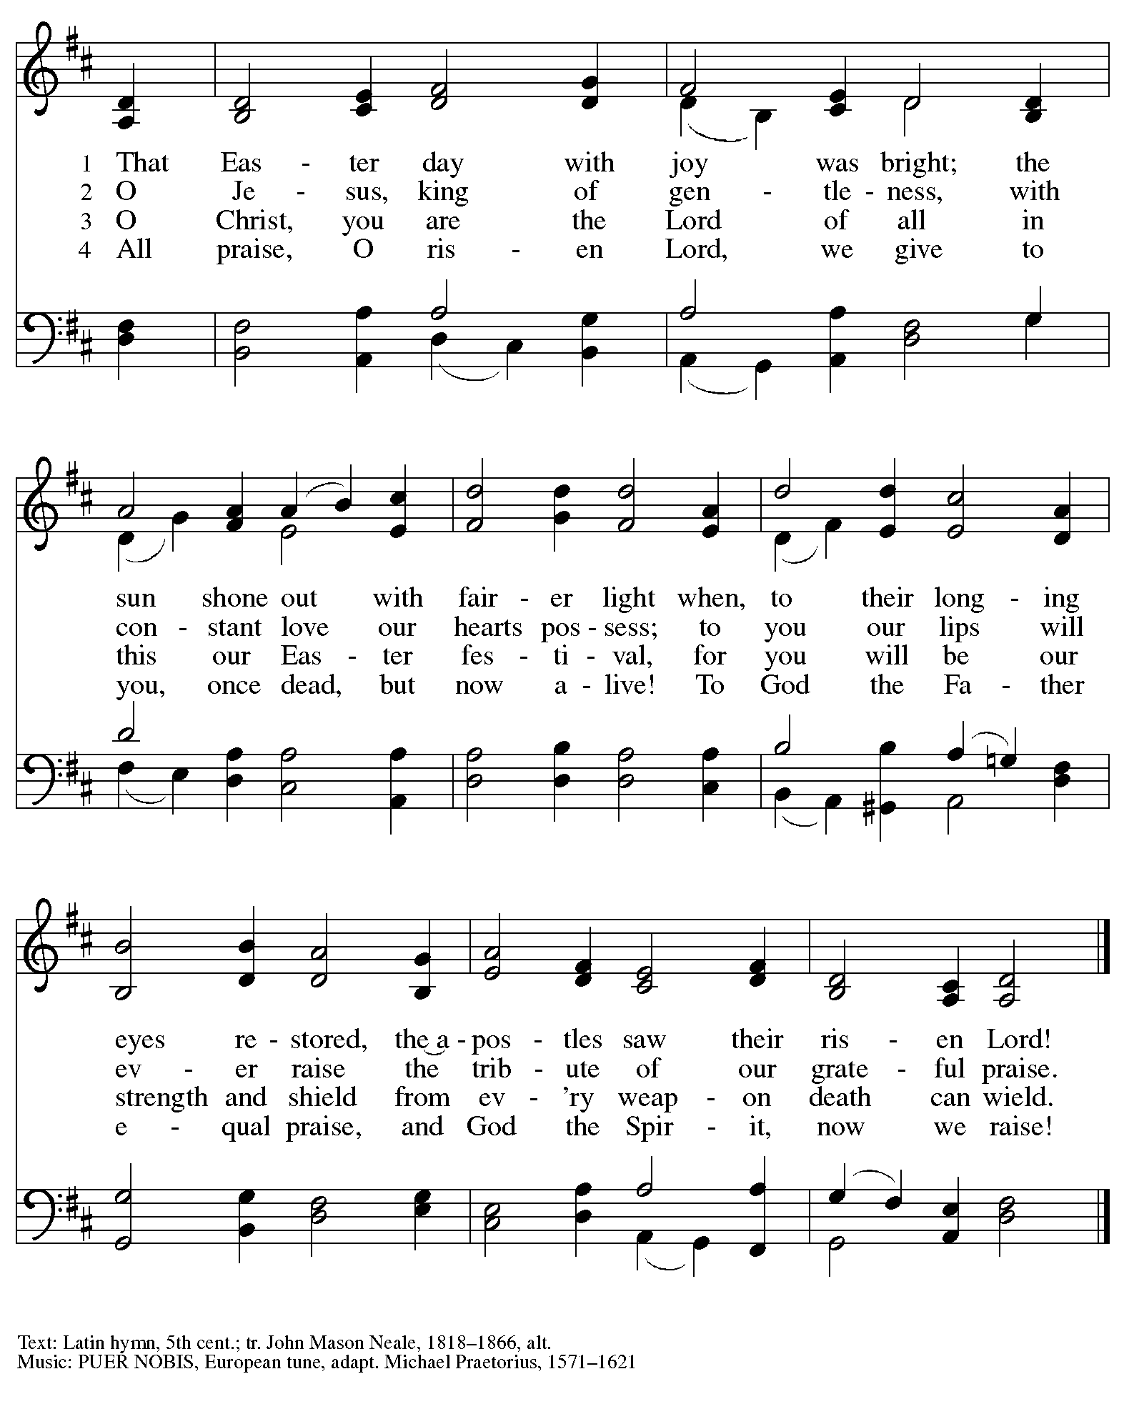

Greeting

P: The grace of our Lord Jesus Christ, the love of God,
and the communion of the Holy Spirit be with you all.
C: And also with you.

Hymn of Praise Now the Feast and Celebration HS p. 4-5

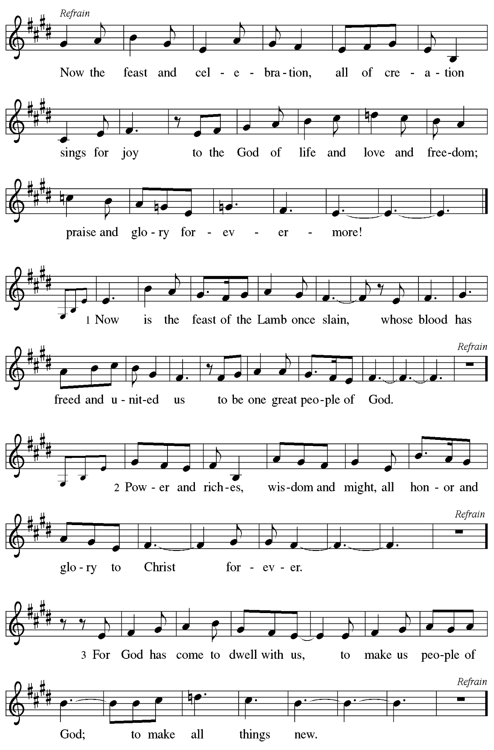

Prayer of the Day

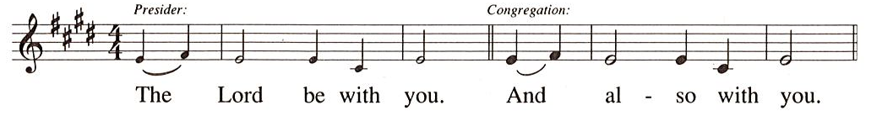

P: Let us pray.
O God, your Son makes himself known to all his disciples in the breaking of bread.
Open the eyes of our faith, that we may see him in his redeeming work,
the one who lives and reigns with you and the Holy Spirit, one God, now and forever.
C: Amen.

Please be seated.
Children are invited to join the adult leaders at the door and move to the office for Little Church – Big Faith. We ask that one additional adult from the congregation attend with the children.

Word
God speaks to us in Scripture reading, preaching, and song

First Reading – Acts 2: 14a, 36-41

^{14a}Peter, standing with the eleven, raised his voice and addressed [the crowd], ³⁶“Therefore let the entire house of Israel know with certainty that God has made him both Lord and Messiah, this Jesus whom you crucified.”
³⁷Now when they heard this, they were cut to the heart and said to Peter and to the other apostles, “Brothers, what should we do?” ³⁸Peter said to them, “Repent, and be baptized every one of you in the name of Jesus Christ so that your sins may be forgiven; and you will receive the gift of the Holy Spirit. ³⁹For the promise is for you, for your children, and for all who are far away, everyone whom the Lord our God calls to God.” ⁴⁰And he testified with many other arguments and exhorted them, saying, “Save yourselves from this corrupt generation.” ⁴¹So those who welcomed his message were baptized, and that day about three thousand persons were added.

L: Word of God, word of life.
C: Thanks be to God.

Psalm 116: 1-4, 12-19

The psalm will be sung responsively, led by the cantor,
with the congregation invited to respond with the bold verses and refrain.

Psalm tone

Psalm refrain

¹I love the Lord, who has | heard my voice,
and listened to my | supplication,
²for the Lord has given | ear to me
whenev- | er I called.
³The cords of death entangled me; the anguish of the grave | came upon me;
I came to | grief and sorrow.
⁴Then I called upon the name | of the Lord:
“O Lord, I pray you, | save my life.” R
¹²How shall I re- | pay the Lord
for all the good things God has | done for me?
¹³I will lift the cup | of salvation
and call on the name | of the Lord.
¹⁴I will fulfill my vows | to the Lord
in the presence of | all God’s people.
¹⁵Precious in your | sight, O Lord,
is the death | of your servants.
¹⁶O Lord, truly I | am your servant;
I am your servant, the child of your handmaid; you have freed me | from my bonds.
¹⁷I will offer you the sacrifice | of thanksgiving
and call upon the name | of the Lord. R
¹⁸I will fulfill my vows | to the Lord
in the presence of | all God’s people,
¹⁹in the courts of | the Lord’s house,
in the midst of you, O Jerusalem. | Hallelujah! R

Second Reading – 1 Peter 1: 17-23

¹⁷If you invoke as Father the one who judges all people impartially according to their deeds, live in reverent fear during the time of your exile. ¹⁸You know that you were ransomed from the futile ways inherited from your ancestors, not with perishable things like silver or gold, ¹⁹but with the precious blood of Christ, like that of a lamb without defect or blemish. ²⁰He was destined before the foundation of the world, but was revealed at the end of the ages for your sake. ²¹Through him you have come to trust in God, who raised him from the dead and gave him glory, so that your faith and hope are set on God.
²²Now that you have purified your souls by your obedience to the truth so that you have genuine mutual love, love one another deeply from the heart. ²³You have been born anew, not of perishable but of imperishable seed, through the living and enduring word of God.

L: Word of God, word of life.
C: Thanks be to God.

Please rise as you are able.

Gospel Acclamation

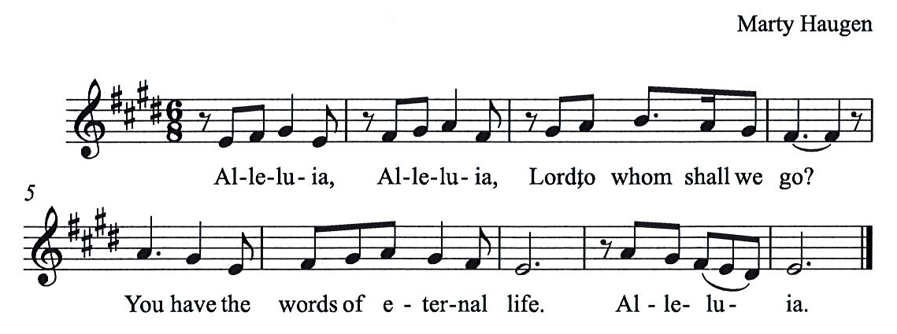

Gospel – Luke 24: 13-35

P: The holy Gospel according to St. Luke.
C: Glory to you, O Lord.

¹³Now on that same day [when Jesus had appeared to Mary Magdalene,] two [disciples] were going to a village called Emmaus, about seven miles from Jerusalem, ¹⁴and talking with each other about all these things that had happened. ¹⁵While they were talking and discussing, Jesus himself came near and went with them, ¹⁶but their eyes were kept from recognizing him. ¹⁷And he said to them, “What are you discussing with each other while you walk along?” They stood still, looking sad. ¹⁸Then one of them, whose name was Cleopas, answered him, “Are you the only stranger in Jerusalem who does not know the things that have taken place there in these days?” ¹⁹He asked them, “What things?” They replied, “The things about Jesus of Nazareth,
who was a prophet mighty in deed and word before God and all the people, ²⁰and how our chief priests and leaders handed him over to be condemned to death and crucified him. ²¹But we had hoped that he was the one to redeem Israel. Yes, and besides all this, it is now the third day since these things took place. ²²Moreover, some women of our group astounded us. They were at the tomb early this morning, ²³and when they did not find his body there, they came back and told us that they had indeed seen a vision of angels who said that he was alive. ²⁴Some of those who were with us went to the tomb and found it just as the women had said; but they did not see him.” ²⁵Then he said to them, “Oh, how foolish you are, and how slow of heart to believe all that the prophets have declared! ²⁶Was it not necessary that the Messiah should suffer these things and then enter into his glory?” ²⁷Then beginning with Moses and all the prophets, he interpreted to them the things about himself in all the scriptures.
²⁸As they came near the village to which they were going, he walked ahead as if he were going on. ²⁹But they urged him strongly, saying, “Stay with us, because it is almost evening and the day is now nearly over.” So he went in to stay with them. ³⁰When he was at the table with them, he took bread, blessed and broke it, and gave it to them. ³¹Then their eyes were opened, and they recognized him; and he vanished from their sight. ³²They said to each other, “Were not our hearts burning within us while he was talking to us on the road, while he was opening the scriptures to us?” ³³That same hour they got up and returned to Jerusalem; and they found the eleven and their companions gathered together. ³⁴They were saying, “The Lord has risen indeed, and he has appeared to Simon!” ³⁵Then they told what had happened on the road, and how he had been made known to them in the breaking of the bread.

P: The Gospel of the Lord.
C: Praise to you, O Christ.

Please be seated.

Sermon

A time of silence for prayer and reflection follows the sermon.
When the hymn of the day begins, please rise as you are able.

Hymn of the Day Day of Arising Following page

Hymn of the Day Day of Arising ELW 374

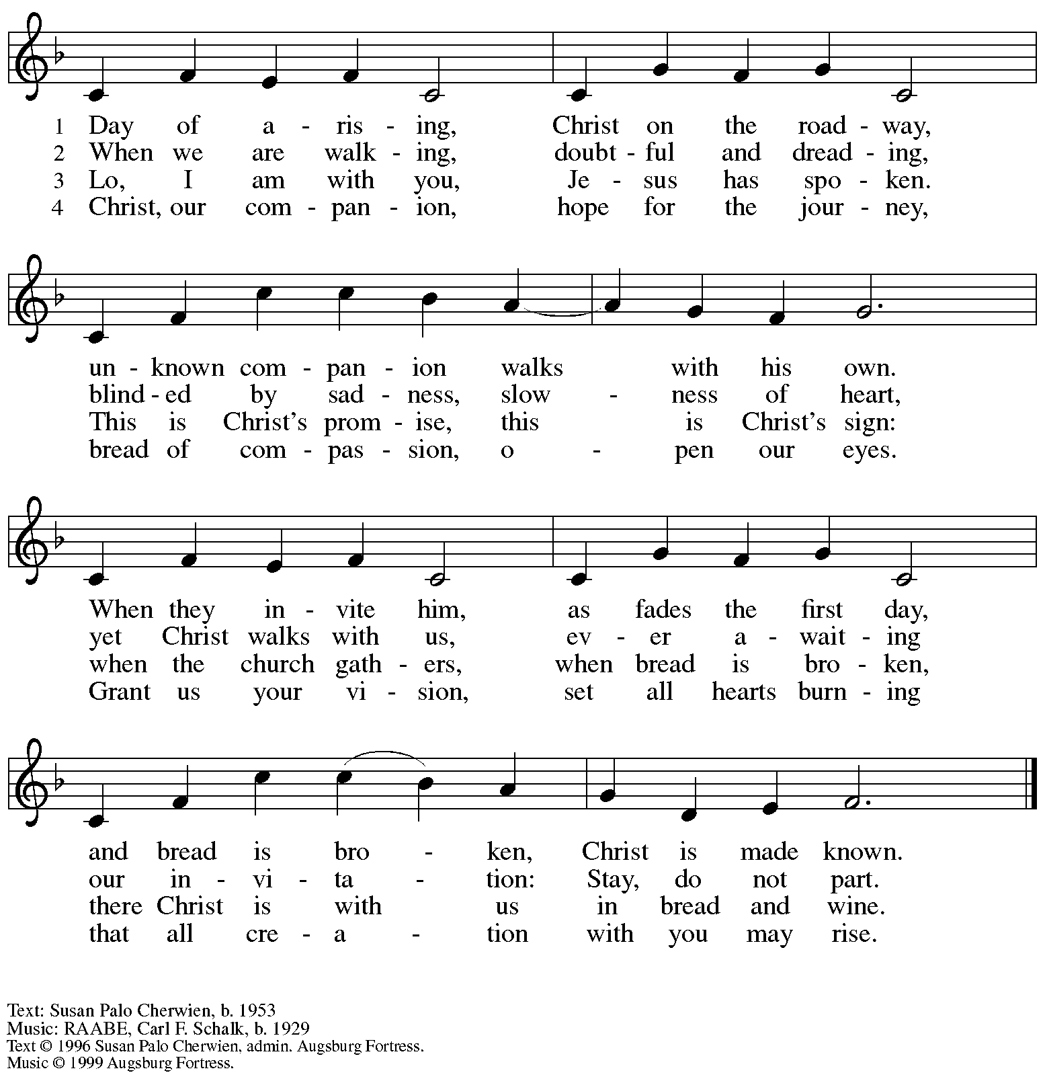
All rights reserved. Reprinted with permission under OneLicense.net # A-722139.

Nicene Creed

C: We believe in one God,
the Father, the Almighty,
maker of heaven and earth,
of all that is, seen and unseen.

We believe in one Lord, Jesus Christ,
The only Son of God,
eternally begotten of the Father,
God from God, Light from Light,
true God from true God,
begotten, not made,
of one Being with the Father;
through him all things were made.
For us and for our salvation
he came down from heaven,
was incarnate of the Holy Spirit and the virgin Mary
and became truly human.
For our sake he was crucified under Pontius Pilate;
he suffered death and was buried.
On the third day he rose again
in accordance with the scriptures;
he ascended into heaven
and is seated at the right hand of the Father.
He will come again in glory to judge the living and the dead,
and his kingdom will have no end.

We believe in the Holy Spirit, the Lord, the giver of life,
who proceeds from the Father and the Son,*
who with the Father and the Son is worshiped and glorified,
who has spoken through the prophets.
We believe in one holy catholic and apostolic church.
We acknowledge one baptism for the forgiveness of sins.
We look for the resurrection of the dead,
and the life of the world to come. Amen.

*Or, “who proceeds from the Father.” The phrase “and the Son” is a later addition to the creed.

Prayers of the People

A: United in the joy and hope of the resurrection, let us pray for the church, the world,
and all who are in need.

After each petition
A: Gracious God,
C: receive our prayer.

The presiding minister concludes the prayers
P: We lift these prayers to you O God, trusting in your abundant mercy,
through Jesus Christ our risen Savior.
C: Amen.

Peace

The presiding minister and the assembly greet one another in the peace of the risen Christ.
P: The peace of Christ be with you always.
C: And also with you.

The people may greet those around them with a sign of Christ’s peace and may say
Peace be with you or similar words. Please be mindful that not everyone will be comfortable with sharing the peace, so please seek consent before shaking hands or hugging. Other possible ways to share the peace include a simple bow with the verbal greeting of peace, or simply a verbal expression of peace.

When the greetings of peace have concluded, please be seated.

Meal
God feeds us with the presence of Jesus Christ

Offering

We offer ourselves, our gifts, and our faithful service to God.
As the offering is gathered for the mission of the church, including the care of those in need,
the table is set for Holy Communion.

Music during the Offering

As the gifts are brought forward for presentation, please rise as you are able.

Offertory Song As the Grains of Wheat ELW 184

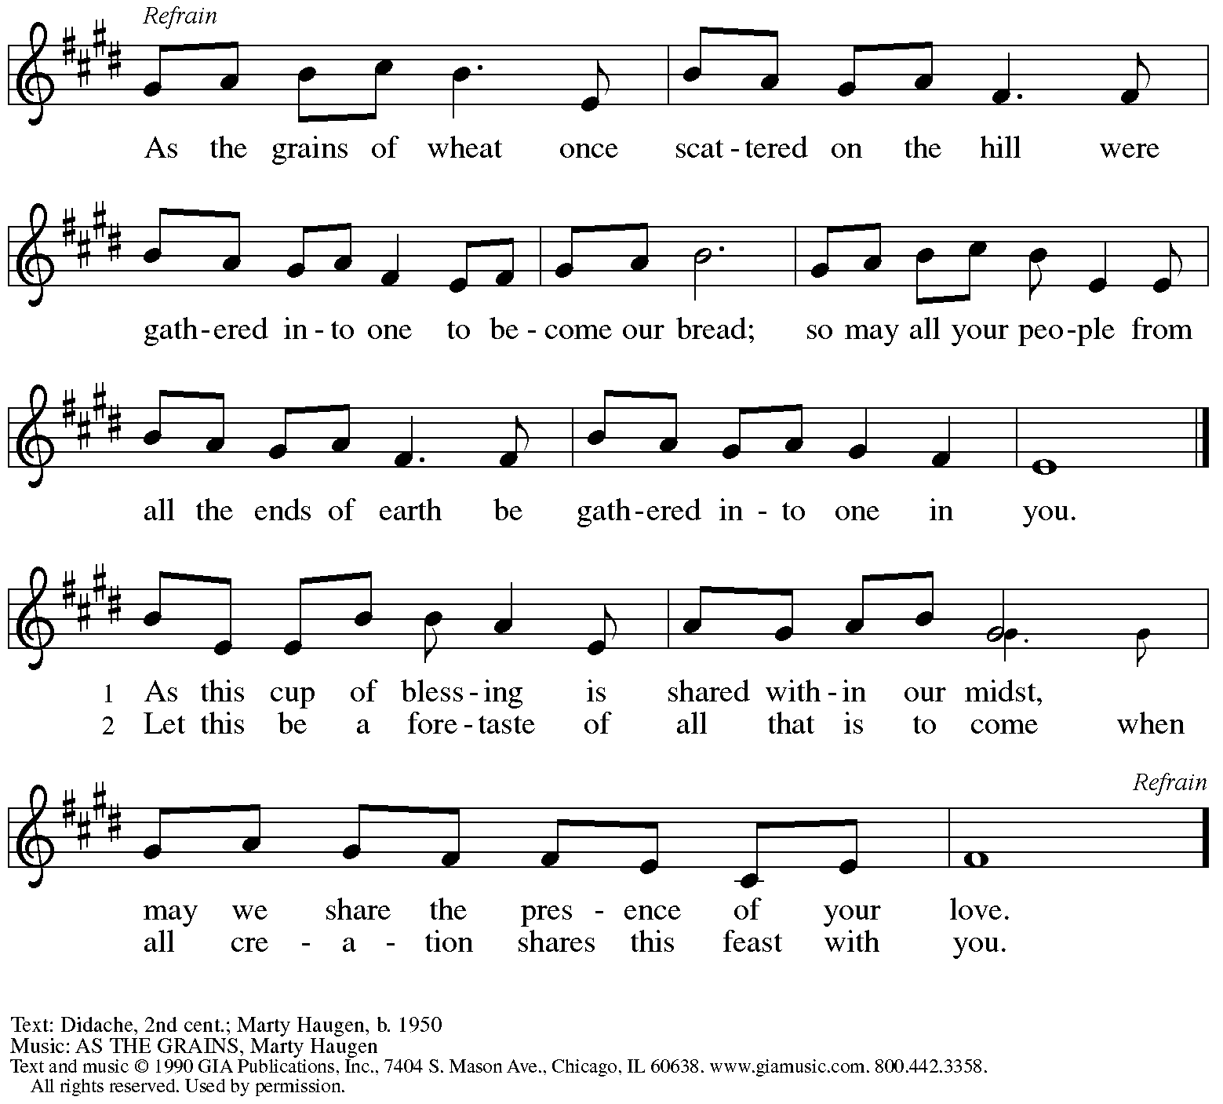
Reprinted under OneLicense.net # A-722139.

Offertory Prayer

A: Let us pray.
Blessed are you, O God,
C: ruler of heaven and earth.
Day by day you shower us with blessings.
As you have raised us to new life in Christ,
give us glad and generous hearts,
ready to praise you and to respond to those in need,
through Jesus Christ, our Savior and Lord.
Amen.

Dialogue HS p. 14

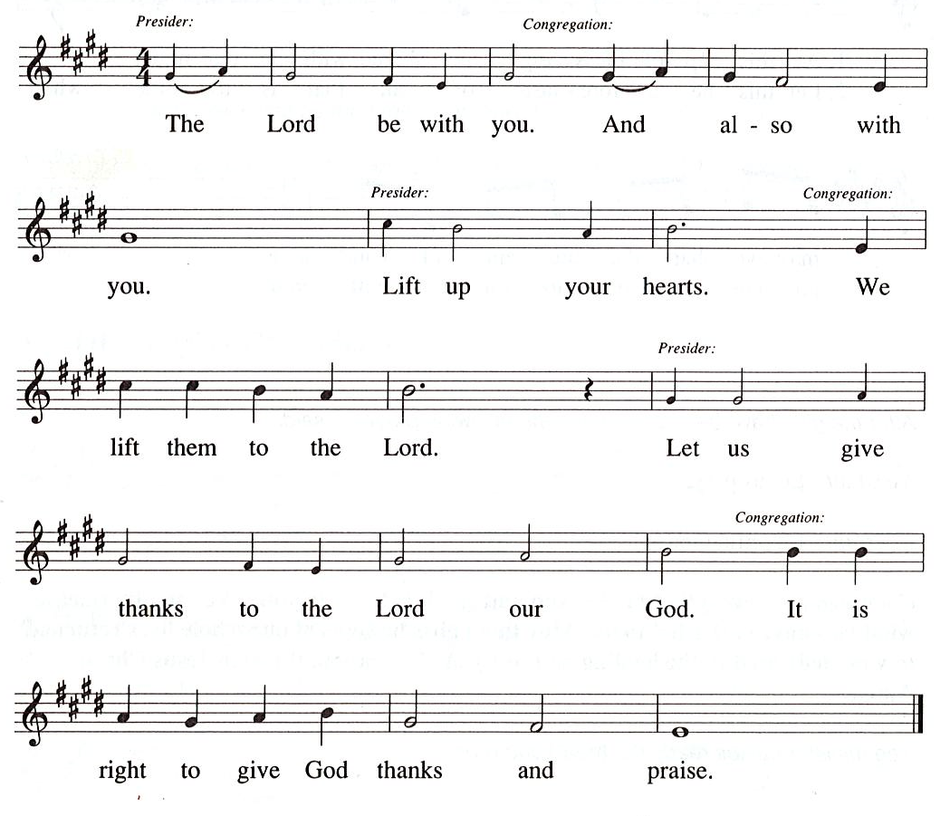

Preface (Sung by the presiding minister)

P: It is our duty and delight
that we should everywhere and always
offer thanks and praise to you, O God,
through Jesus Christ,
who by his death on the cross
and his glorious resurrection
broke the bonds of sin and death
and gave life to all creation.
And so with the church on earth,
all creation and the hosts of heaven,
we praise your name and join their unending hymn:

Sanctus HS p. 15

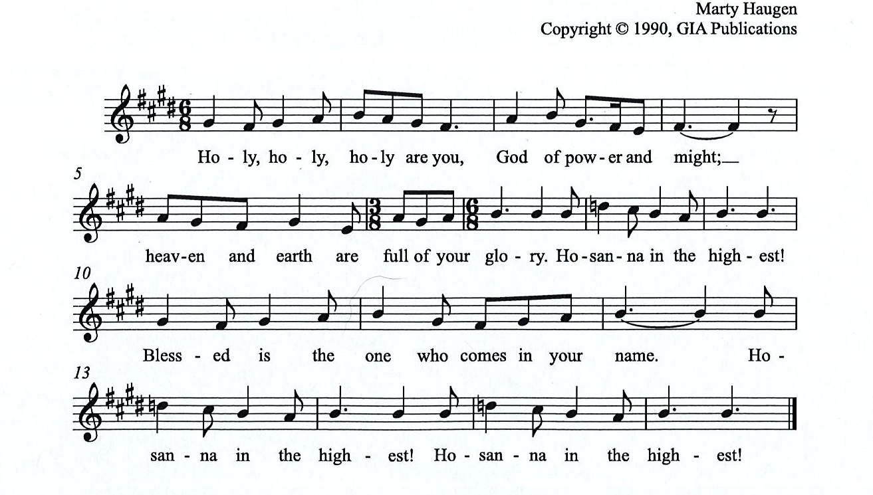

Eucharistic Prayer

P: You are indeed holy, almighty and merciful God, …
… Do this for the remembrance of me.

For as often as we eat of this bread and drink from this cup,
we proclaim the Lord’s death until he comes.

(Presiding minister sings)
Christ has died. Christ is risen. Christ will come, come again.
C:
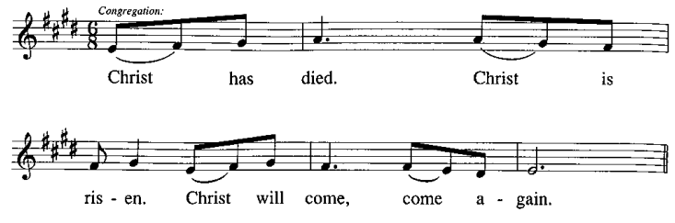
P: Remembering, therefore, his salutary command, …
… and be given our inheritance with all your saints.

To you, O God, Father, Son, and Holy Spirit,
be all honor and glory in your holy church, now and forever.
C:
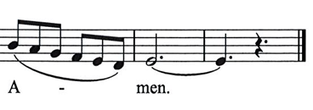

Lord’s Prayer

P: Gathered as one by the Holy Spirit, let us pray as Jesus taught us.
C: Our Father in heaven,
hallowed be your name,
your kingdom come,
your will be done,
on earth as in heaven.
Give us today our daily bread.
Forgive us our sins
as we forgive those
who sin against us.
Save us from the time of trial
and deliver us from evil.
For the kingdom, the power,
and the glory are yours,
now and forever. Amen.

Fraction and Invitation

P: Alleluia! Christ is risen!
C: Christ is risen indeed! Alleluia! Alleluia!

P: This is the feast of victory for our God. Alleluia! Alleluia!
Come, share the feast.

Agnus Dei / Lamb of God Following Page

Agnus Dei / Lamb of God HS p. 18

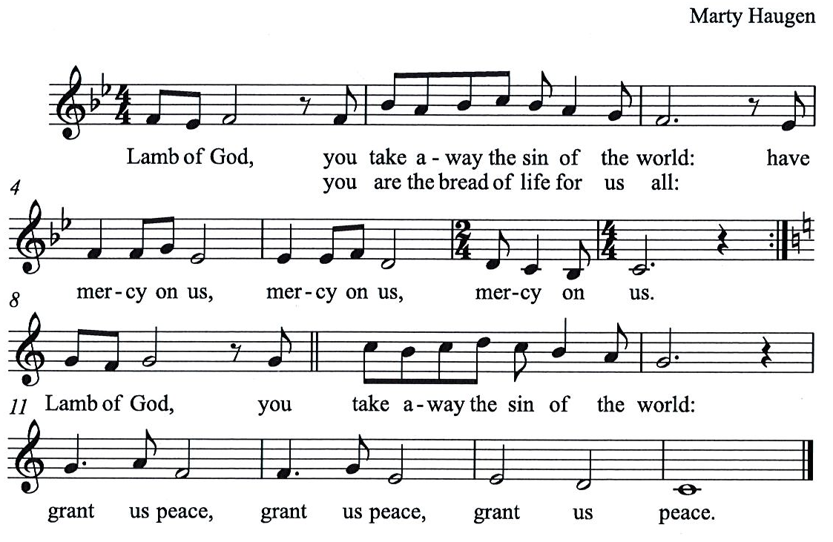

Please be seated.

Holy Communion
- All who seek God and desire a deeper and stronger life in Christ are welcome to receive Holy Communion.
- Worshipers from the pulpit side will proceed forward first, followed by the center section, and then the lectern side.
- Please inform an usher if you would like the ministers to bring Communion to you.
- Holy Communion will be served with bread and wine/grape juice.
- The presiding minister will first distribute the bread (host) to each communicant. Please indicate if you require a gluten-free host.
- Once you have consumed the bread, please pick up an empty glass from the tray next to the presiding minister. The Communion Assistant will pour wine from the chalice or grape juice from the cruet into your glass.
- Please step to the side to consume the wine or grape juice.
- Feel free to kneel at the altar rail for prayer after receiving the sacrament.
- As you return to your pew, glasses may be returned to the empty trays on either side of the center aisle.
- A blessing will be provided for anyone who does not yet receive the sacrament.
- All are invited to join in singing the hymns during Holy Communion.

Hymns during Holy Communion
I Want Jesus to Walk with Me ELW 325

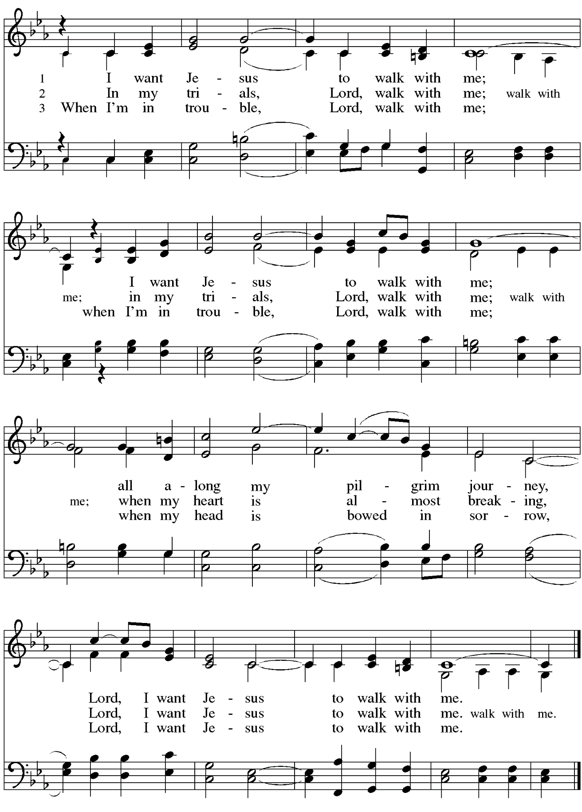
Hymns during Holy Communion
O Jesus, Joy of Loving Hearts ELW 658

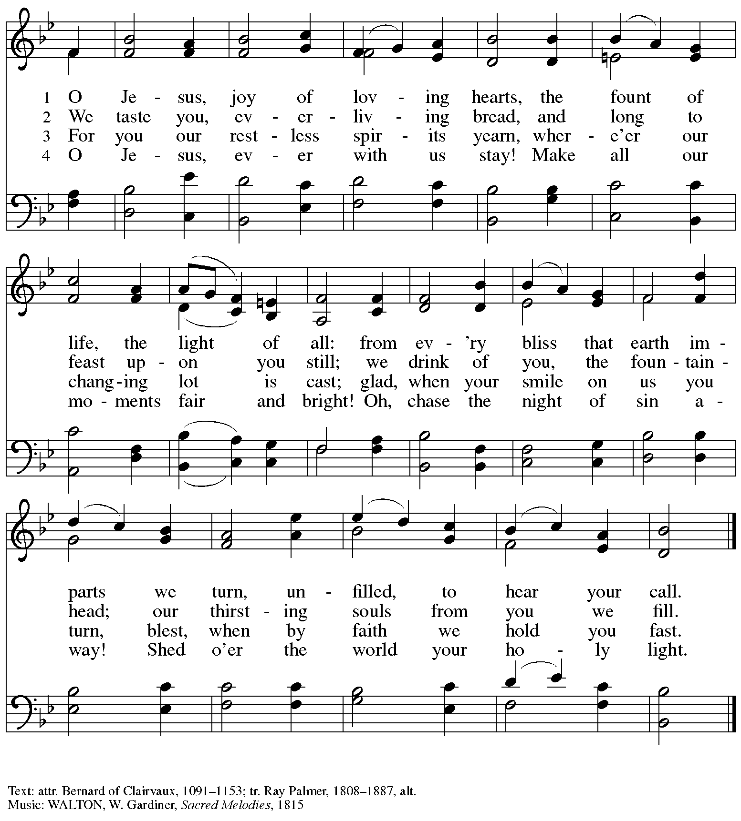

Hymns during Holy Communion
Abide with Me ELW 629
v. 1, 3-4

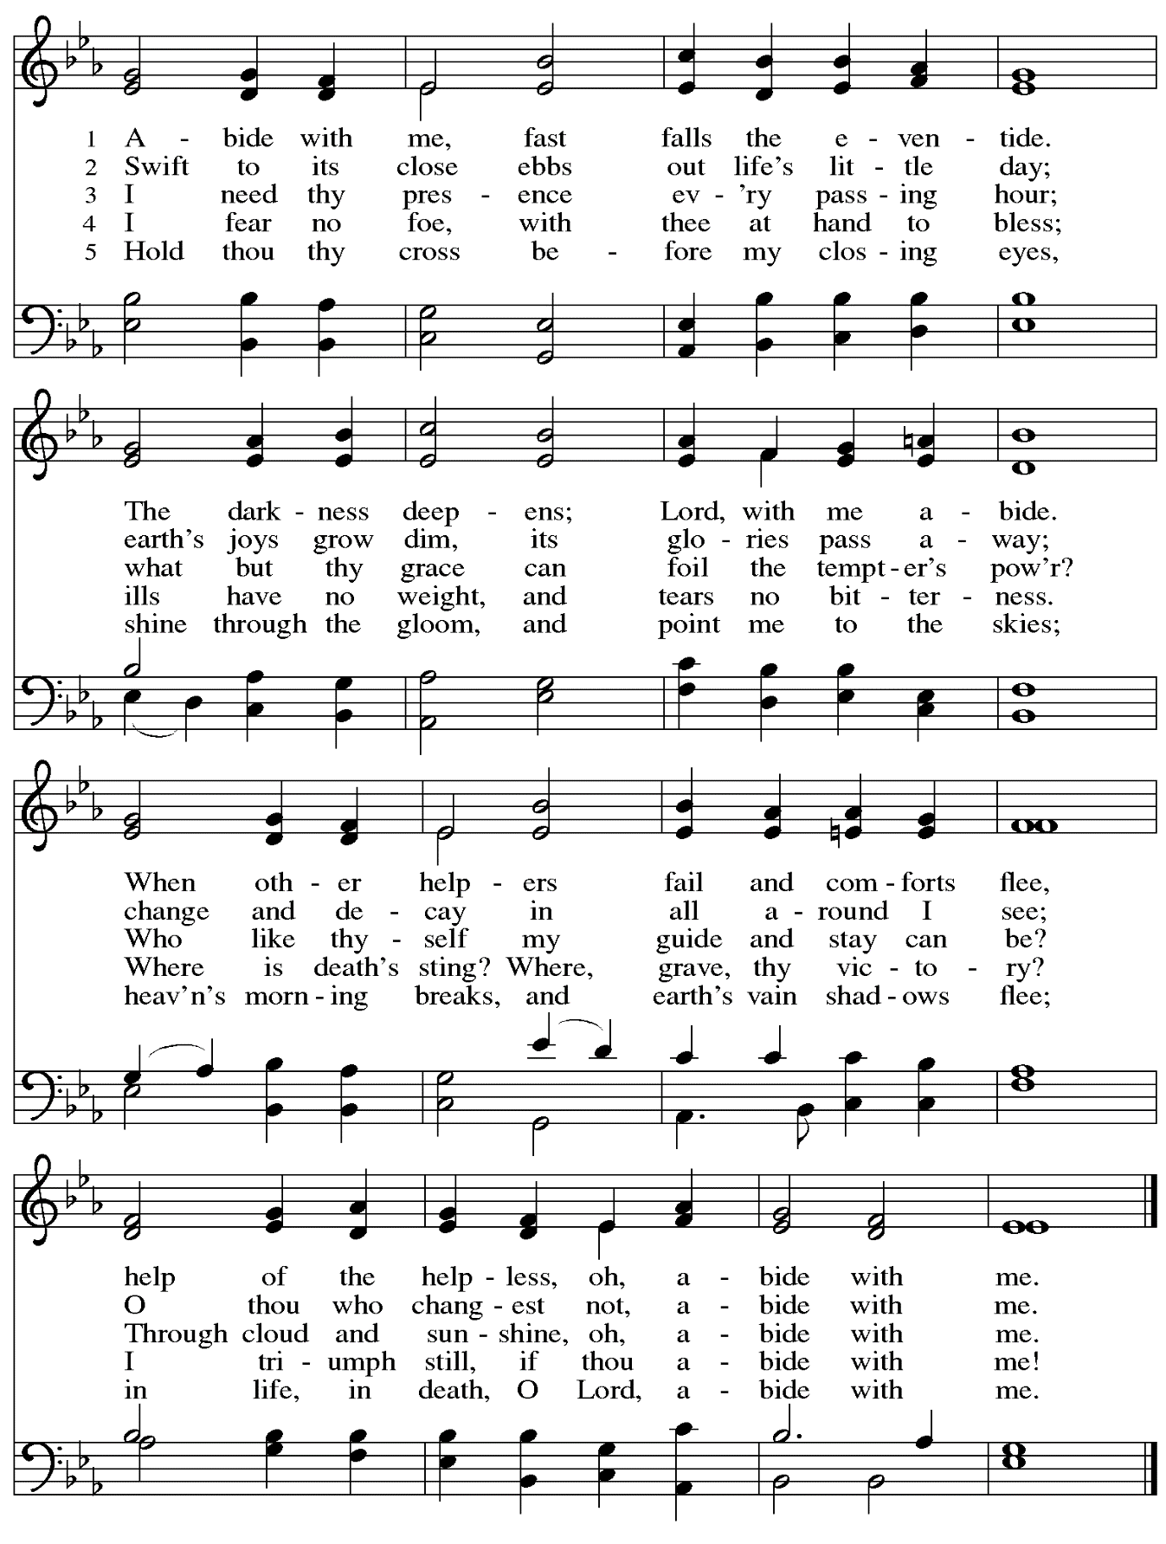

When all have returned to their places, please rise as you are able.

Blessing

P: The body and blood of our Lord Jesus Christ strengthen you and keep you in his grace.
C: Amen.

Prayer

A: Let us pray. Life-giving God,
in the mystery of Christ’s resurrection, you send light to conquer darkness,
water to give new life, and the bread of life to nourish your people.
Send us forth as witnesses to your Son’s resurrection,
that we may show your glory to all the world,
through Jesus Christ, our risen Lord.
C: Amen.

Please be seated.

Sending

Announcements

Please rise as you are able.

Benediction

P: May our glorious God grant you a spirit of wisdom
to know and love the risen Christ.

Almighty God, holy One, ☩ holy Three,
bless you now and forever.
C:
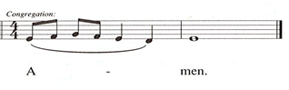

Sending Hymn Let Us Talents and Tongues Employ Following page

Sending Hymn Let Us Talents and Tongues Employ ELW 674

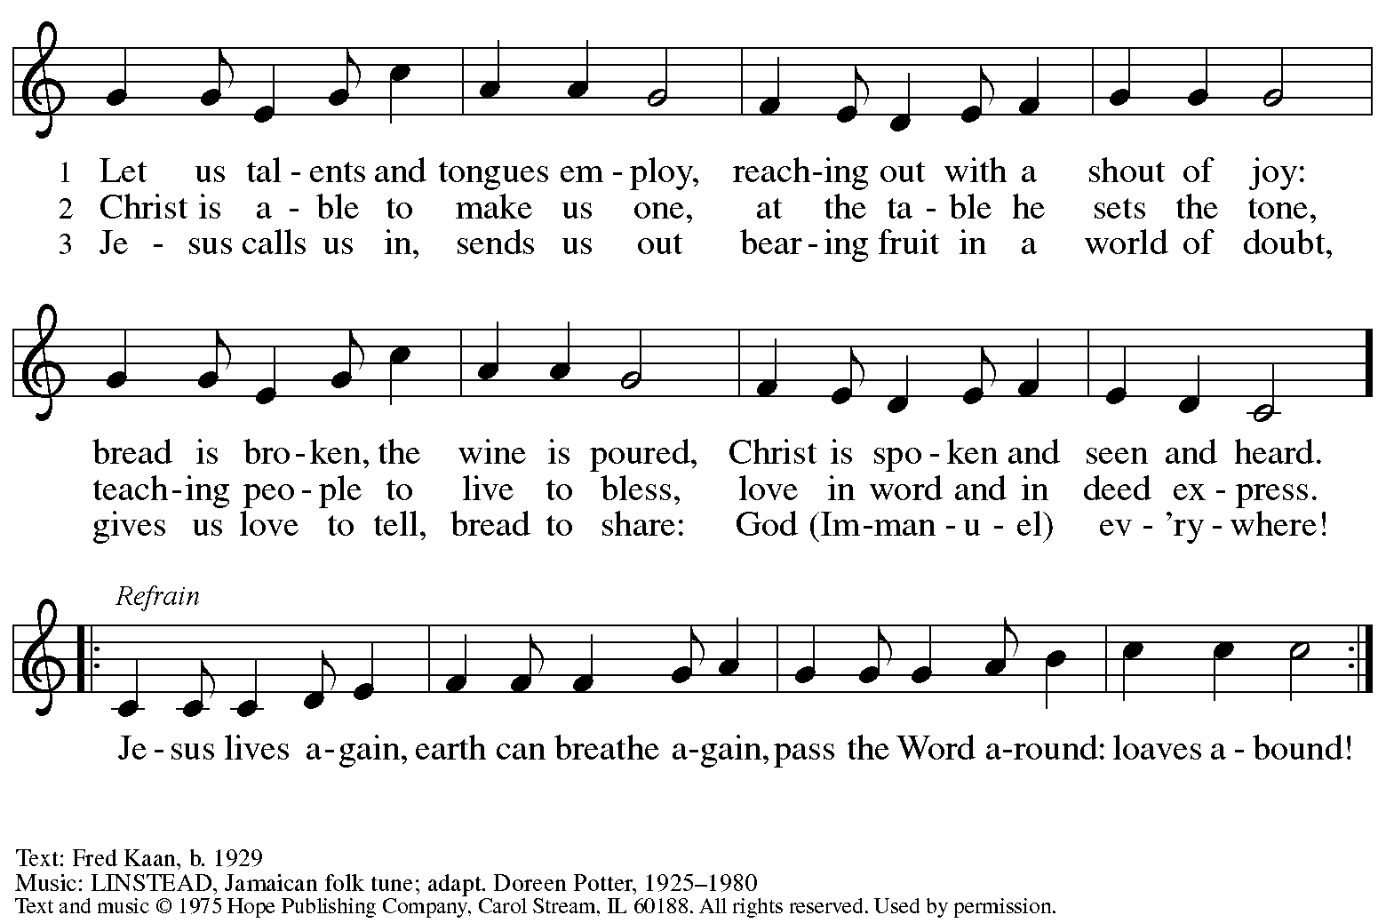
Reprinted under OneLicense.net # A-722139.

Dismissal

A: Alleluia! Christ is risen!
C: Christ is risen indeed! Alleluia! Alleluia!

A: Go in peace. Share the good news!
C: Thanks be to God!

Postlude

Abbreviations

P: Pastor/Presiding Minister
A: Assisting Minister
L: Lector
C: Congregation

ELW: Evangelical Lutheran Worship hymnal
HS: Hymnal Supplement

Those serving in worship today

Altar Care Jodie Minor
Assisting Minister The Rev. Deobrah M. Byrum
Audio-Visual Ministers Kristen Asplin
Joseph Paetz
Cantor Emily Duque
Lector Wendy Hermann
Minister of Music Laura Reynolds
Preaching and Presiding Minister The Rev. Peter D. Asplin

Liturgy and Hymnody Acknowledgements

From SundaysandSeasons.com. Copyright © 2023 Augsburg Fortress. All rights reserved. Reprinted under OneLicense.net # A-722139.
Used by permission of Augsburg Fortress.

Now the Feast and Celebration –Text: Marty Haugen, b. 1950. Music: NOW THE FEAST AND CELEBRATION, Marty Haugen. Text and music © 1990 GIA Publications, Inc. 7404 Mason Ave. Chicago, IL 60638. www.giamusic.com. 800.442.3358. All rights reserved. Reprinted with permission under OneLicense.net # A-722139.

As the Grains of Wheat – Text: Didache, 2nd cent.; Marty Haugen, b. 1950. Music: Marty Haugen. Text and Music © 1990 GIA Publications, Inc. 7404 Mason Ave. Chicago, IL 60638. www.giamusic.com. 800.442.3358. All rights reserved. Reprinted with permission under OneLicense.net # A-722139.

I Want Jesus to Walk with Me – Text: African American spiritual. Music: SOJOURNER, African American spiritual, arr. hymnal version. Arr © 2006 Augsburg Fortress. All rights reserved. Reprinted with permission under OneLicense.net # A-722139.

Abide with Me – Text: Henry F. Lyte, 1793-1847. Music: EVENTIDE, William H. Monk, 1823-1889.

St. Andrew Lutheran Church Announcements
April 23rd, 2023

- Happy Easter! Welcome to worship at St. Andrew on April 23rd, 2023, the + Third Sunday of Easter, as we continue to celebrate Christ’s Resurrection! – We are so glad you are here to share in this festive season, and we offer a special welcome to all visitors and guests who are here for the first time! Masks are optional at St. Andrew when Allegheny County’s Covid-19 community level is in the low and medium categories. Worship attendees are invited to make a name tag at the back of the worship space if you would like. There are worship “toolkits” to help children engage with worship and “busy bags” for younger children available in the bookcase at the back of the sanctuary. Please feel free to take one to use with/for your children. We pray that everyone has a blessed Easter season!
- St. Andrew Brunch/Dinner Club Today after Worship – Gather for a meal and conversation with friends from St. Andrew at the monthly brunch/dinner club after worship today! We will meet at the Fairmont Pittsburgh Hotel, 510 Market St., 15222. Please speak with Kelly Spanninger to let her know if you plan to attend.
- Seeking Help with Sunday Coffee Hour – Many in the St. Andrew community enjoy the opportunity to gather for coffee, snacks and conversation after worship each week. We are looking for help with setup / preparation and cleanup each week and the whole process is pretty simple! If you would like to contribute, either for one time or on a rotating monthly schedule, please contact Pastor Ross Carmichael at PastorRCarmichael@gmail.com.
- May Produce Distribution - Tuesday, May 2nd, 5:30-7:00 p.m. – Each month, St. Andrew hosts the distribution of produce to local households in partnership with Greater Pittsburgh Community Food Bank. Our next date will be Tuesday, May 2nd. We invite people to help with unloading the truck and setup, usually sometime between 10:30 a.m. and 1:00 p.m. (We will call those who sign up to share a more precise time when we hear from the food bank). Then all are welcome to help with the distribution and get to know one another and our neighbors from 5:30-7:00 p.m. Please sign up at https://www.signupgenius.com/go/4090F45AFAF2BA75-produce3.
- Bethel AME Church Invites St. Andrew to Family and Friends Saturday, May 6th, 2023 – Due to the Pittsburgh Marathon, Bethel AME is moving its regular Sunday service to Saturday, May 6th, at 11:00 a.m., followed by a lunch after the service. For those who have expressed a desire to meet our friends from Bethel and worship with them, this is a great opportunity to do so! Bethel is located at 2720 Webster Avenue, 15219. Dress is casual, blue, purple, and silver. Come join in family, fellowship, fun, and love!
- Southwestern Pennsylvania Synod Seeks Stories about "Church Grandparents" for Wayfarer Publication – Have you experienced a cross-generational friendship with an older adult in the church? Share your experience of "Church Grandparents" with Synod Communicator using this link: Church Grandparents (google.com)
- St. Andrew Jail Ministry – St. Andrew has had a long history of participation in the ministry program at the Allegheny County Jail. Until the program was put on hold at the beginning of the Covid pandemic, a group of volunteers from St. Andrew was leading a worship service at the jail on Sunday mornings, typically about one Sunday a month. The jail is hoping to resume this program soon. If any of the previous volunteers are still interested and available, please contact Lester Prince (lprince@comcast.net). New volunteers are also needed. The first step for new volunteers is to complete an online application, which can be accessed here: https://www.foundationofhope.org/get-involved/volunteer-application/. On the application form, indicate that the program that you are interested in volunteering with is “Chaplaincy Worship.” Feel free to contact Lester Prince with any questions.
- Camp Agapé Spring Work Day - Saturday, May 6th, 10:00 a.m. - 4:00 p.m. – Lunch will be provided. Please RSVP to campinfo@campagape.org or 724-356-2308.
- Lutherlyn – Camp Opportunities
  - Still Seeking Summer Camp Staff: Cabin Leaders, Lifeguards, Kitchen Staff, and Maintenance – For more information, visit Summer Employment (lutherlyn.com)
  - Spring Work Day - Saturday, April 29th, 9:00 a.m. - 4:00 p.m. – For more information, visit Lutherlyn Work Days : Volunteer Opportunities : Support : Camp Lutherlyn
  - Camp Blast - A Day of Fun That Highlights All the Camp Has to Offer - Saturday, May 13th, 11:00 a.m. - 4:00 p.m. – Visit Camp Blast (lutherlyn.com) for more information.
  - Summer Camp – To see all the programs available, click here: Summer Camp Home (lutherlyn.com)

