+ Fourth Sunday of Easter
April 30, 2023
St. Andrew Lutheran Church
304 Morewood Ave.
Pittsburgh, PA 15213
St_andrewELCA@verizon.net
www.standrewpittsburgh.org

+ Fourth Sunday of Easter
Order for Worship

Today is often called “Good Shepherd Sunday.”
Jesus is identified as the “gate” of the sheep in John’s gospel.
The risen Christ opens the way to abundant life.
He anoints our heads with oil and guides us beside the still waters of our Baptism.
Each Sunday he spreads a feast before us amid the world’s violence and war.
We go forth to be signs of the resurrection and extend God’s tender care to all creation.

- Masks are optional at St. Andrew when Covid-19 community level in Allegheny County is in the low and medium categories.

- Worship Services are live streamed to multiple online platforms. By attending worship, you agree that your image and voice may be broadcast.

Welcome to St. Andrew!

- St. Andrew Lutheran congregation welcomes all who are seeking a place of healing and wholeness – a nurturing, faith-forming spiritual home. Our community embraces people of all ages, ethnicities, cultures, abilities, sexual orientations, gender identities and expressions, and family constellations. Come and See!

- Everyone is invited to make a nametag at the black bookcase in the back of the worship space if they would like. There are stickers indicating pronouns on the bookcase if you would like to include them on your name tag.

- Children are invited to attend Little Church – Big Faith, a Bible lesson and activity, during worship (after the Prayer of the Day). The group returns to the worship space for the liturgy of Holy Communion.

- Worship “toolkits” to help children engage with the service, along with “busy bags” for younger children, are available in the bookcase at the back of the sanctuary. Please feel free to take one to use with/for your children.

- Holy Communion is served with bread (gluten-free available) and wine or grape juice. The presiding minister will distribute the bread (host). Please consume this and then pick up an empty glass from the tray. The Communion Assistant will pour wine or grape juice into your glass. Please step to the side to consume the wine or grape juice. Feel free to kneel at the altar for prayer and reflection. As you return to your pew, glasses may be returned to the empty trays on either side of the center aisle.

- A restroom is available on the main level of the church, through the doors to the Social Hall and to the right in the main office.

Pre-Service Music

Welcome

Prelude

Gathering
The Holy Spirit calls us together as the people of God.

Confession and Forgiveness

Please rise as you are able.
All may make the sign of the cross, the sign that is marked at Baptism,
as the presiding minister begins.

P: Blessed be the holy Trinity,
☩ one God,
who creates, redeems, and sustains us
and all of creation.
C: Amen.

P: Let us confess our sin in the presence of God and of one another.

Silence is kept for reflection

P: To you, O God,
C: all hearts are open, to you all desires known.
We come to you, confessing our sins.
Forgive us in your mercy, and remember us in your love.
Show us your ways; teach us your paths; and lead us in justice and truth,
for the sake of your goodness in Jesus Christ our Savior.
Amen.

P: By water and the Holy Spirit God gives you a new birth,
and through the death and resurrection of ☩ Jesus Christ,
God forgives you all your sins.
The God of mercy and might strengthen you in all goodness
and keep you in eternal life.
C: Amen.

Gathering Hymn ELW 364
Mfurahini, haleluya / Christ Has Arisen, Alleluia
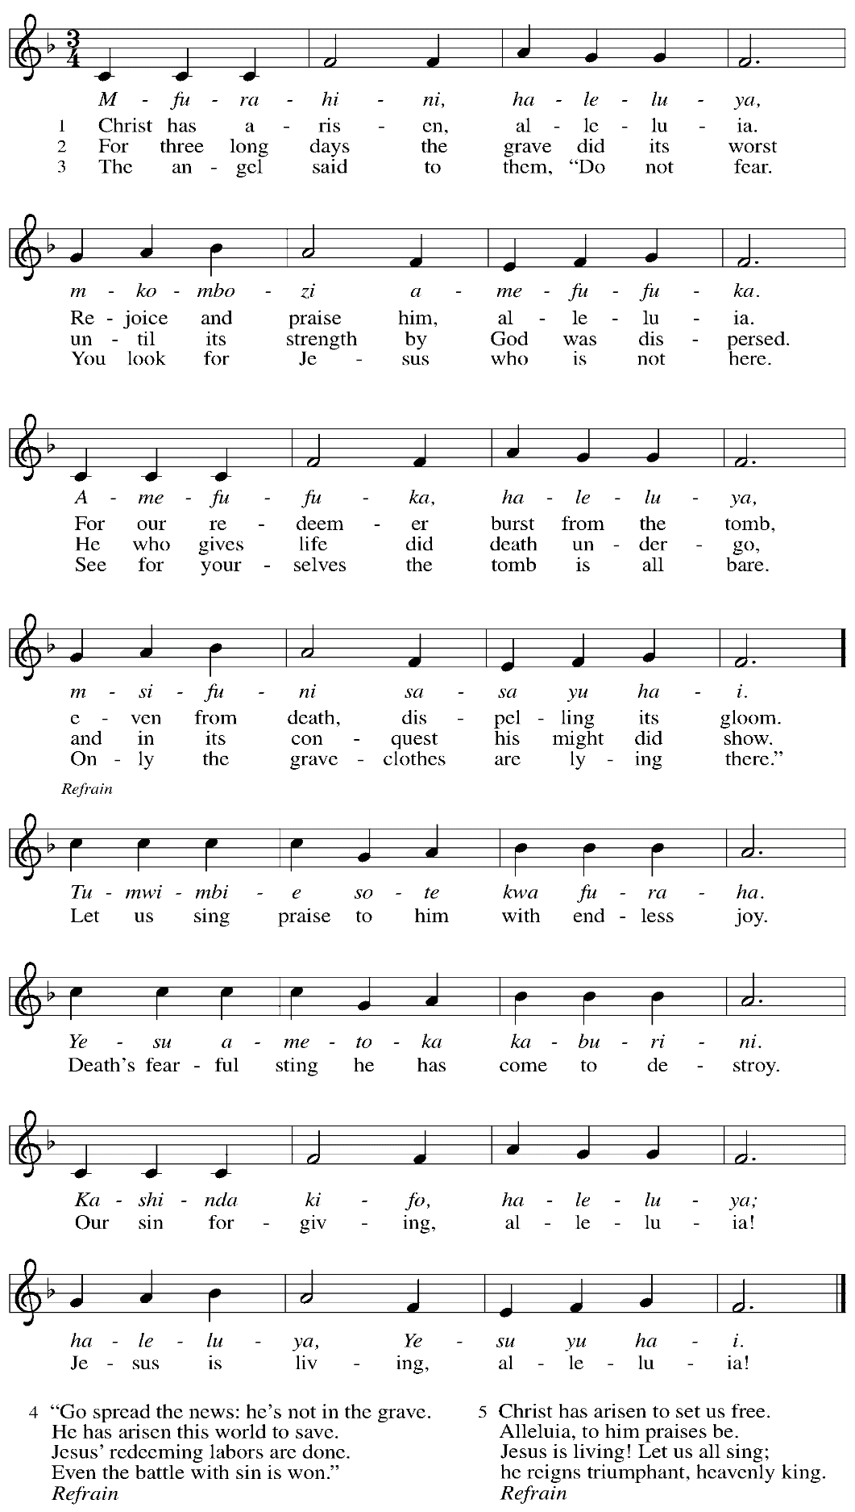
Greeting

P: The grace of our Lord Jesus Christ, the love of God,
and the communion of the Holy Spirit be with you all.
C: And also with you.

Hymn of Praise Now the Feast and Celebration HS p. 4-5

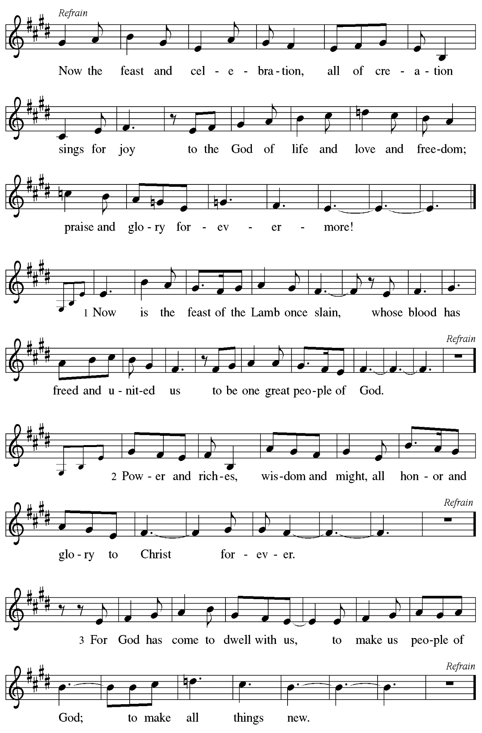

Prayer of the Day

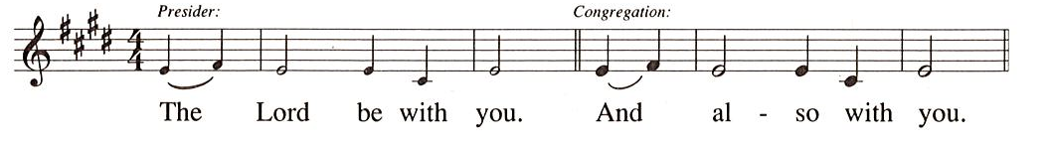

P: Let us pray.
O God our shepherd,
you know your sheep by name and lead us to safety through the valleys of death.
Guide us by your voice, that we may walk in certainty and security
to the joyous feast prepared in your house, through Jesus Christ, our Savior and Lord,
who lives and reigns with you and the Holy Spirit, one God, now and forever.
C: Amen.

Please be seated.
Children are invited to join the adult leaders at the door and move to the office for Little Church – Big Faith. We ask that one additional adult from the congregation attend with the children.

Word
God speaks to us in Scripture reading, preaching, and song

First Reading – Acts 2: 42-47

⁴²[The baptized] devoted themselves to the apostles’ teaching and fellowship, to the breaking of bread and the prayers.
⁴³Awe came upon everyone, because many wonders and signs were being done by the apostles. ⁴⁴All who believed were together and had all things in common; ⁴⁵they would sell their possessions and goods and distribute the proceeds to all, as any had need. ⁴⁶Day by day, as they spent much time together in the temple, they broke bread at home and ate their food with glad and generous hearts, ⁴⁷praising God and having the goodwill of all the people. And day by day the Lord added to their number those who were being saved.

L: Word of God, word of life.
C: Thanks be to God.

Psalm 23 Shepherd Me, O God Following Page

A paraphrase of Psalm 23, Shepherd Me, O God, will be sung by the cantor,
with the congregation invited to join in singing the refrain.

Psalm 23 Shepherd Me, O God ELW 780
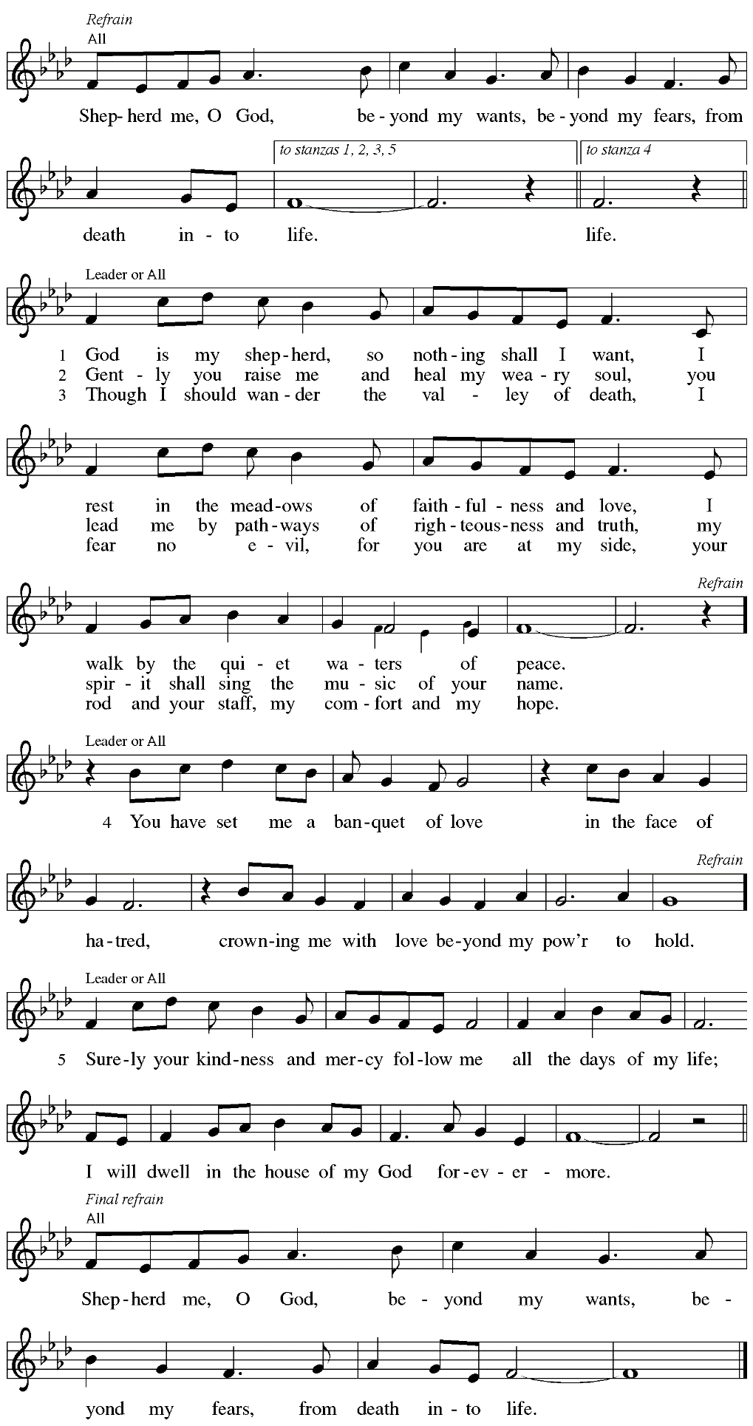

Second Reading – 1 Peter 2: 19-25

¹⁹It is a credit to you if, being aware of God, you endure pain while suffering unjustly. ²⁰If you endure when you are beaten for doing wrong, what credit is that? But if you endure when you do right and suffer for it, you have God’s approval. ²¹For to this you have been called, because Christ also suffered for you, leaving you an example, so that you should follow in his steps.
²²“He committed no sin,
and no deceit was found in his mouth.”
²³When he was abused, he did not return abuse; when he suffered, he did not threaten; but he entrusted himself to the one who judges justly. ²⁴He himself bore our sins in his body on the cross, so that, free from sins, we might live for righteousness; by his wounds you have been healed. ²⁵For you were going astray like sheep, but now you have returned to the shepherd and guardian of your souls.

L: Word of God, word of life.
C: Thanks be to God.

Please rise as you are able.

Gospel Acclamation

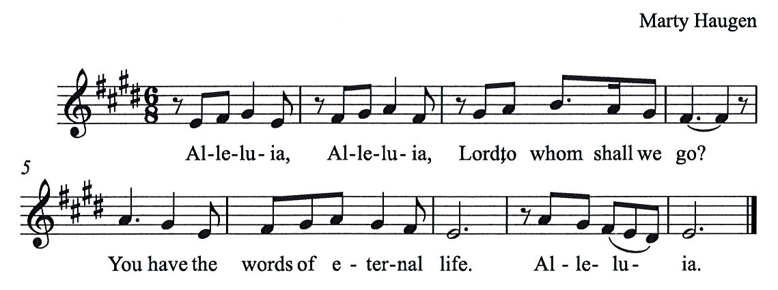

Gospel – John 10: 1-10

P: The holy Gospel according to St. John.
C: Glory to you, O Lord.

[Jesus said:] ¹“Very truly, I tell you, anyone who does not enter the sheepfold by the gate but climbs in by another way is a thief and a bandit. ²The one who enters by the gate is the shepherd of the sheep. ³The gatekeeper opens the gate for him, and the sheep hear his voice. He calls his own sheep by name and leads them out. ⁴When he has brought out all his own, he goes ahead of them, and the sheep follow him because they know his voice. ⁵They will not follow a stranger, but they will run from him because they do not know the voice of strangers.” ⁶Jesus used this figure of speech with them, but they did not understand what he was saying to them.
⁷So again Jesus said to them, “Very truly, I tell you, I am the gate for the sheep. ⁸All who came before me are thieves and bandits; but the sheep did not listen to them. ⁹I am the gate. Whoever enters by me will be saved, and will come in and go out and find pasture. ¹⁰The thief comes only to steal and kill and destroy. I came that they may have life, and have it abundantly.”

P: The Gospel of the Lord.
C: Praise to you, O Christ.

Please be seated.

Sermon

A time of silence for prayer and reflection follows the sermon.
When the hymn of the day begins, please rise as you are able.

Hymn of the Day Savior, like a Shepherd Lead Us ELW 789

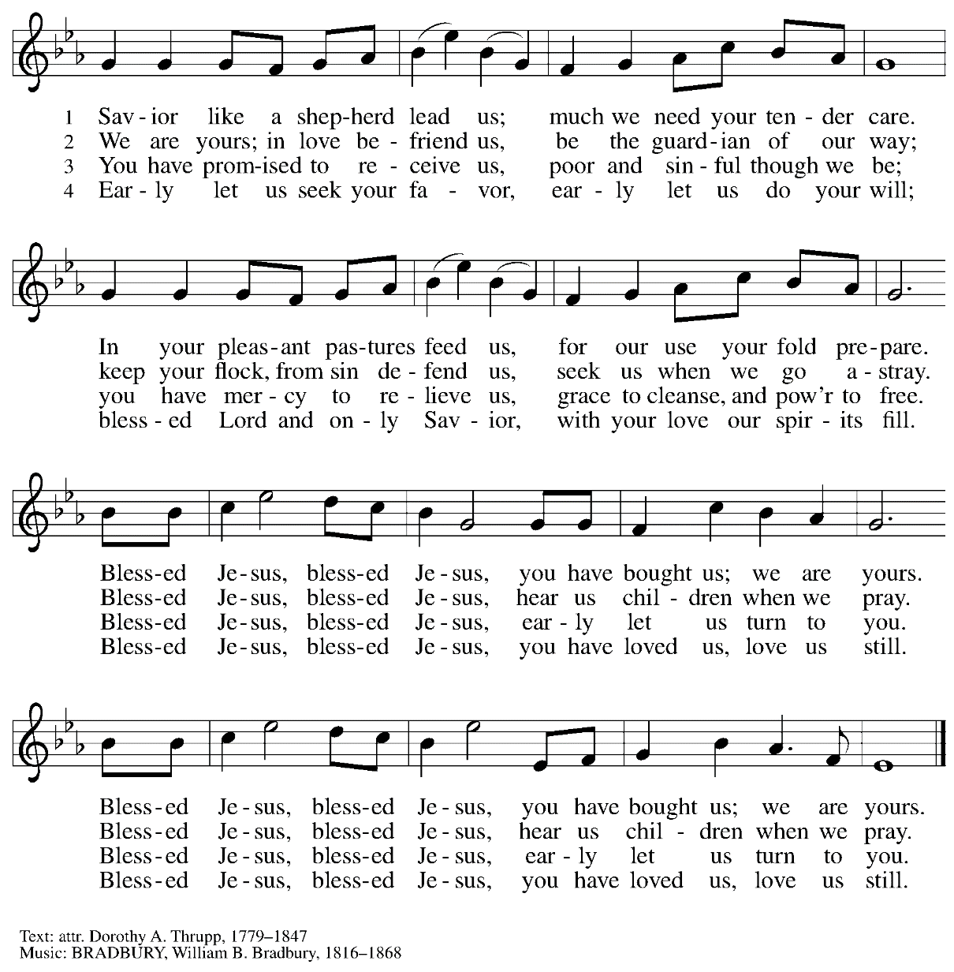

Nicene Creed

C: We believe in one God,
the Father, the Almighty,
maker of heaven and earth,
of all that is, seen and unseen.

We believe in one Lord, Jesus Christ,
The only Son of God,
eternally begotten of the Father,
God from God, Light from Light,
true God from true God,
begotten, not made,
of one Being with the Father;
through him all things were made.
For us and for our salvation
he came down from heaven,
was incarnate of the Holy Spirit and the virgin Mary
and became truly human.
For our sake he was crucified under Pontius Pilate;
he suffered death and was buried.
On the third day he rose again
in accordance with the scriptures;
he ascended into heaven
and is seated at the right hand of the Father.
He will come again in glory to judge the living and the dead,
and his kingdom will have no end.

We believe in the Holy Spirit, the Lord, the giver of life,
who proceeds from the Father and the Son,*
who with the Father and the Son is worshiped and glorified,
who has spoken through the prophets.
We believe in one holy catholic and apostolic church.
We acknowledge one baptism for the forgiveness of sins.
We look for the resurrection of the dead,
and the life of the world to come. Amen.

*Or, “who proceeds from the Father.” The phrase “and the Son” is a later addition to the creed.

Prayers of the People

A: United in the joy and hope of the resurrection, let us pray for the church, the world,
and all who are in need.

After each petition
A: Gracious God,
C: receive our prayer.

The presiding minister concludes the prayers
P: We lift these prayers to you O God, trusting in your abundant mercy,
through Jesus Christ our risen Savior.
C: Amen.

Peace

The presiding minister and the assembly greet one another in the peace of the risen Christ.
P: The peace of Christ be with you always.
C: And also with you.

The people may greet those around them with a sign of Christ’s peace and may say
Peace be with you or similar words. Please be mindful that not everyone will be comfortable with sharing the peace, so please seek consent before shaking hands or hugging. Other possible ways to share the peace include a simple bow with the verbal greeting of peace, or simply a verbal expression of peace.

When the greetings of peace have concluded, please be seated.

Meal
God feeds us with the presence of Jesus Christ

Offering

We offer ourselves, our gifts, and our faithful service to God.
As the offering is gathered for the mission of the church, including the care of those in need,
the table is set for Holy Communion.

Music during the Offering

As the gifts are brought forward for presentation, please rise as you are able.

Offertory Song As the Grains of Wheat ELW 184

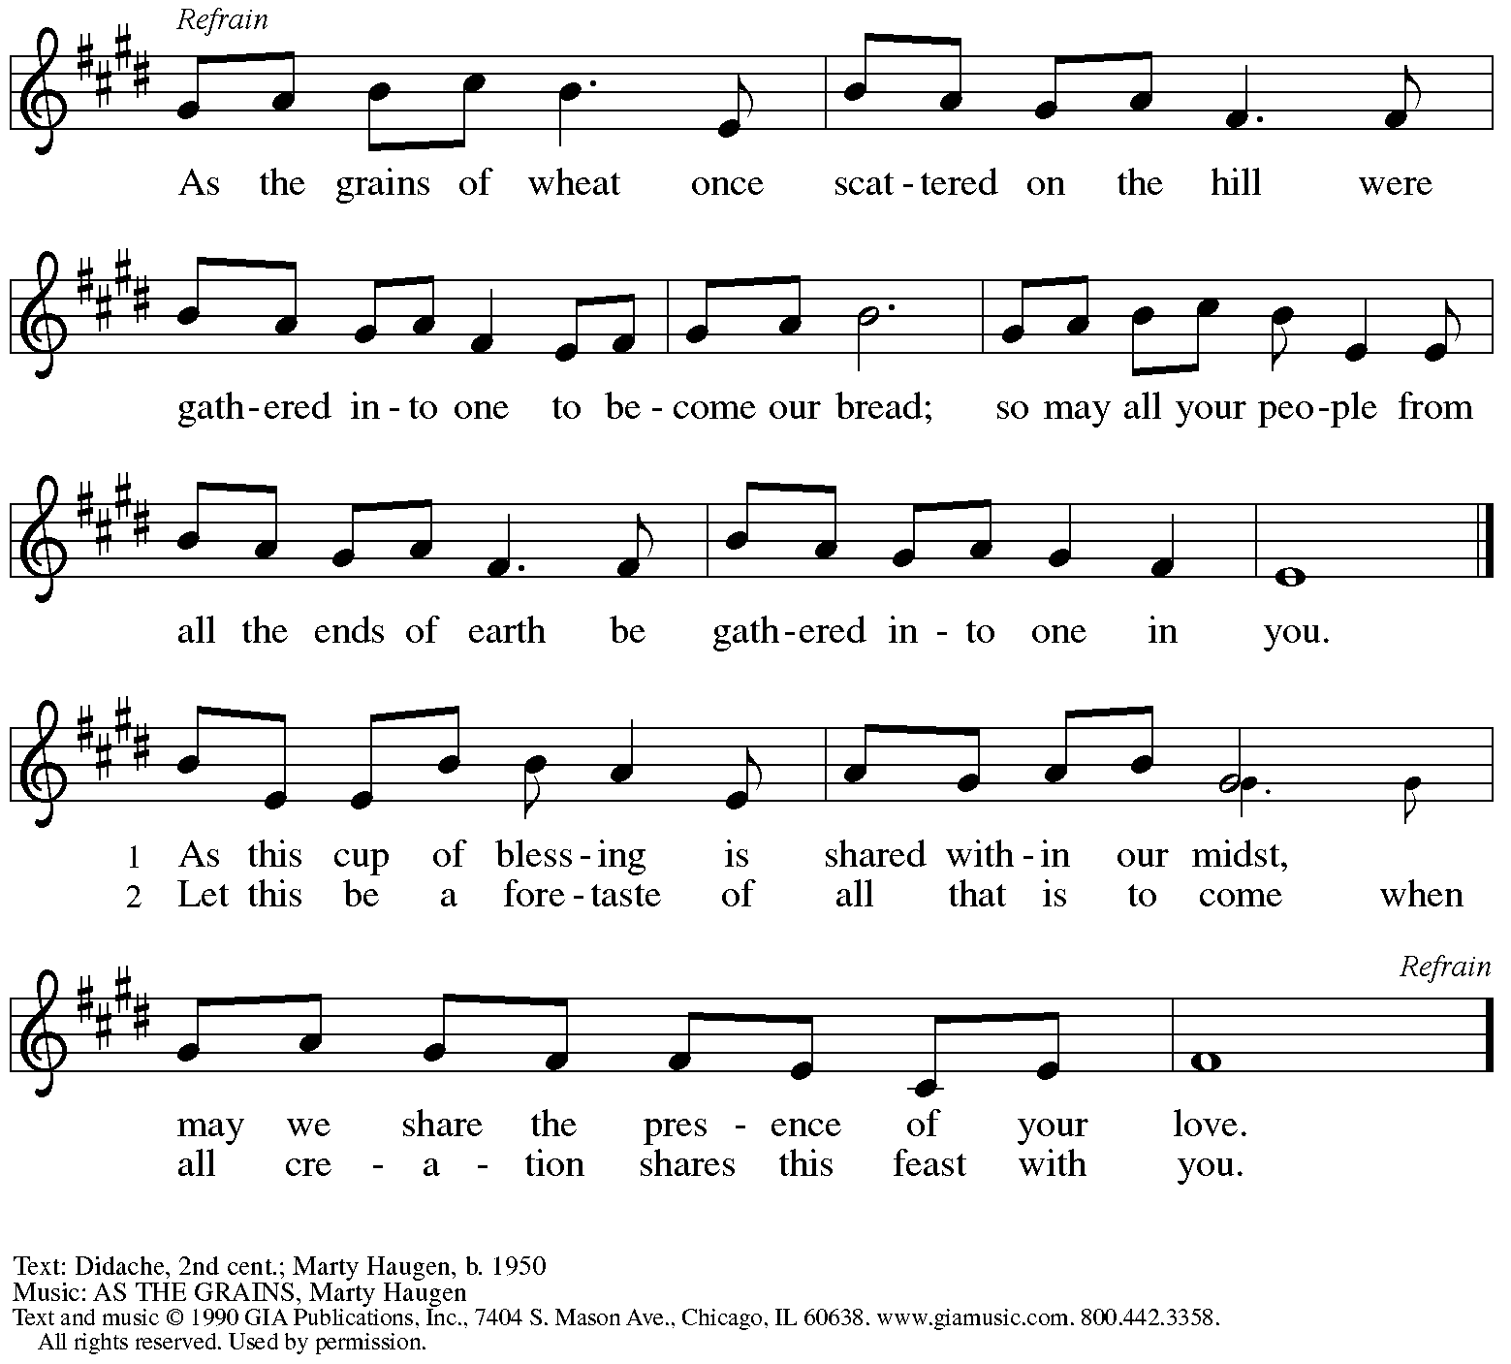
Reprinted under OneLicense.net # A-722139.

Offertory Prayer

A: Let us pray.
Blessed are you, O God,
C: ruler of heaven and earth.
Day by day you shower us with blessings.
As you have raised us to new life in Christ,
give us glad and generous hearts,
ready to praise you and to respond to those in need,
through Jesus Christ, our Savior and Lord.
Amen.

Dialogue HS p. 14

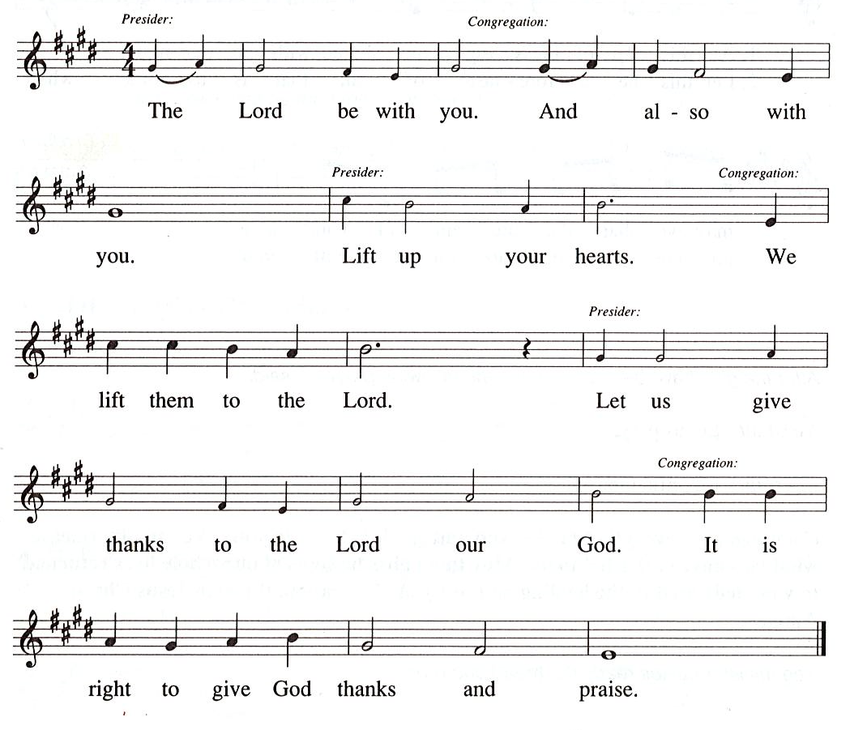

Preface (Sung by the presiding minister)

P: It is our duty and delight
that we should everywhere and always
offer thanks and praise to you, O God,
through Jesus Christ,
who by his death on the cross
and his glorious resurrection
broke the bonds of sin and death
and gave life to all creation.
And so with the church on earth,
all creation and the hosts of heaven,
we praise your name and join their unending hymn:

Sanctus HS p. 15

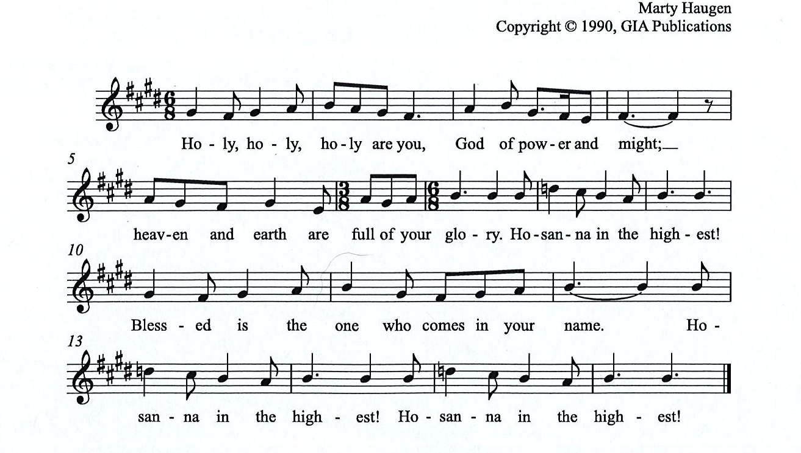

Eucharistic Prayer

P: You are indeed holy, almighty and merciful God, …
… Do this for the remembrance of me.

For as often as we eat of this bread and drink from this cup,
we proclaim the Lord’s death until he comes.

(Presiding minister sings)
Christ has died. Christ is risen. Christ will come, come again.
C:
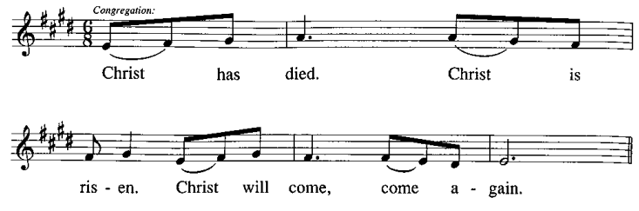
P: Remembering, therefore, his salutary command, …
… and be given our inheritance with all your saints.

To you, O God, Father, Son, and Holy Spirit,
be all honor and glory in your holy church, now and forever.
C:
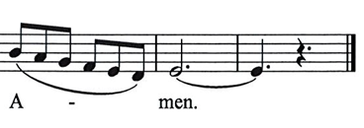

Lord’s Prayer

P: Gathered as one by the Holy Spirit, let us pray as Jesus taught us.
C: Our Father in heaven,
hallowed be your name,
your kingdom come,
your will be done,
on earth as in heaven.
Give us today our daily bread.
Forgive us our sins
as we forgive those
who sin against us.
Save us from the time of trial
and deliver us from evil.
For the kingdom, the power,
and the glory are yours,
now and forever. Amen.

Fraction and Invitation

P: Alleluia! Christ is risen!
C: Christ is risen indeed! Alleluia! Alleluia!

P: This is the feast of victory for our God. Alleluia! Alleluia!
Come, share the feast.

Agnus Dei / Lamb of God Following Page

Agnus Dei / Lamb of God HS p. 18

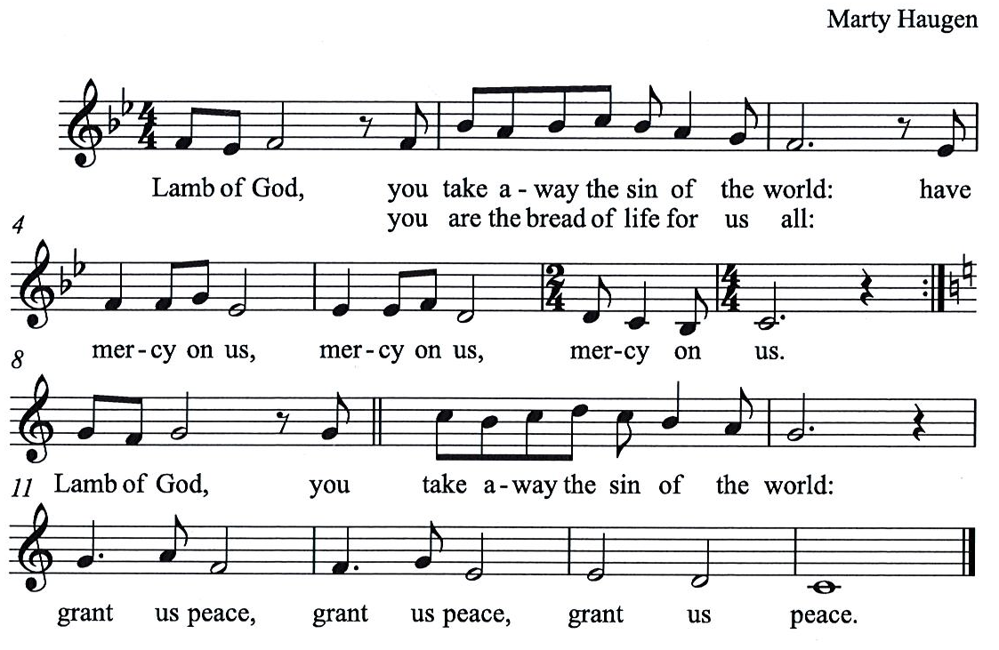

Please be seated.

Holy Communion
- All who seek God and desire a deeper and stronger life in Christ are welcome to receive Holy Communion.
- Worshipers from the pulpit side will proceed forward first, followed by the center section, and then the lectern side.
- Please inform an usher if you would like the ministers to bring Communion to you.
- Holy Communion will be served with bread and wine/grape juice.
- The presiding minister will first distribute the bread (host) to each communicant. Please indicate if you require a gluten-free host.
- Once you have consumed the bread, please pick up an empty glass from the tray next to the presiding minister. The Communion Assistant will pour wine from the chalice or grape juice from the cruet into your glass.
- Please step to the side to consume the wine or grape juice.
- Feel free to kneel at the altar rail for prayer after receiving the sacrament.
- As you return to your pew, glasses may be returned to the empty trays on either side of the center aisle.
- A blessing will be provided for anyone who does not yet receive the sacrament.
- All are invited to join in singing the hymns during Holy Communion.

Hymns during Holy Communion
The King of Love My Shepherd Is ELW 502

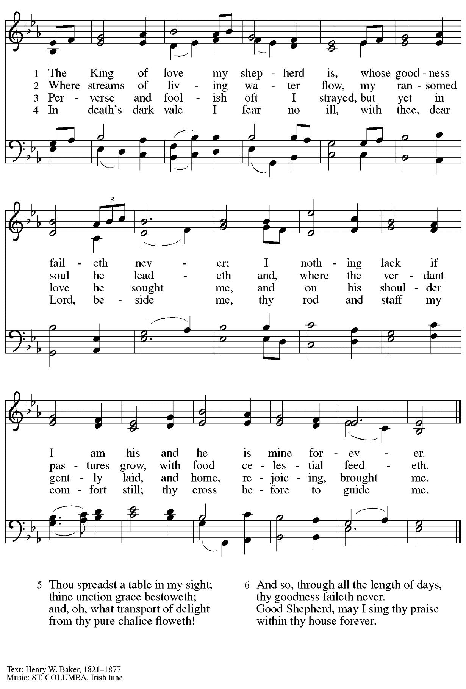

Hymns during Holy Communion
Have No Fear, Little Flock ELW 764

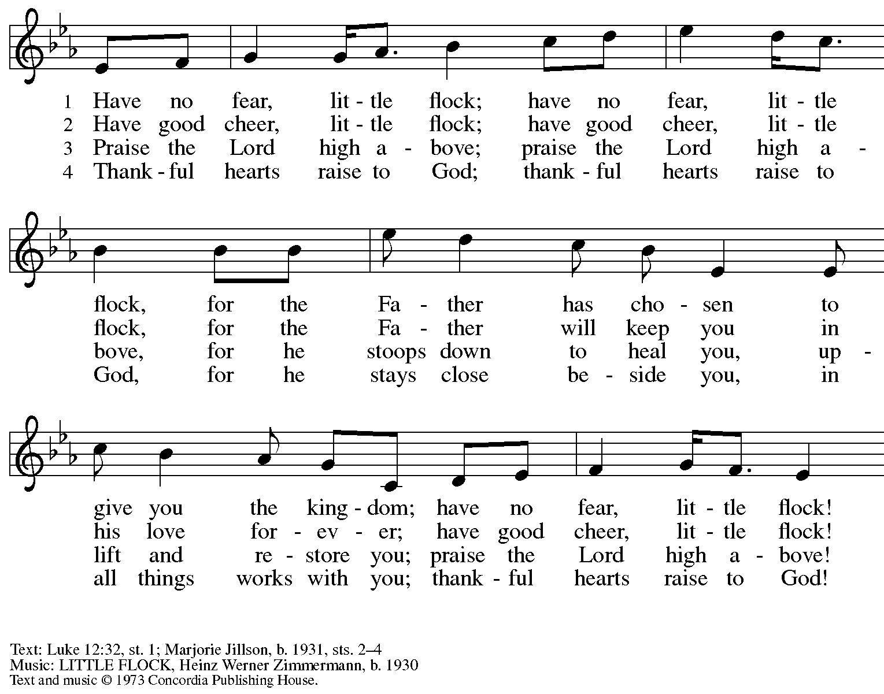
All rights reserved. Reprinted with permission under OneLicense.net # A-722139.

Hymns during Holy Communion
Day by Day ELW 790

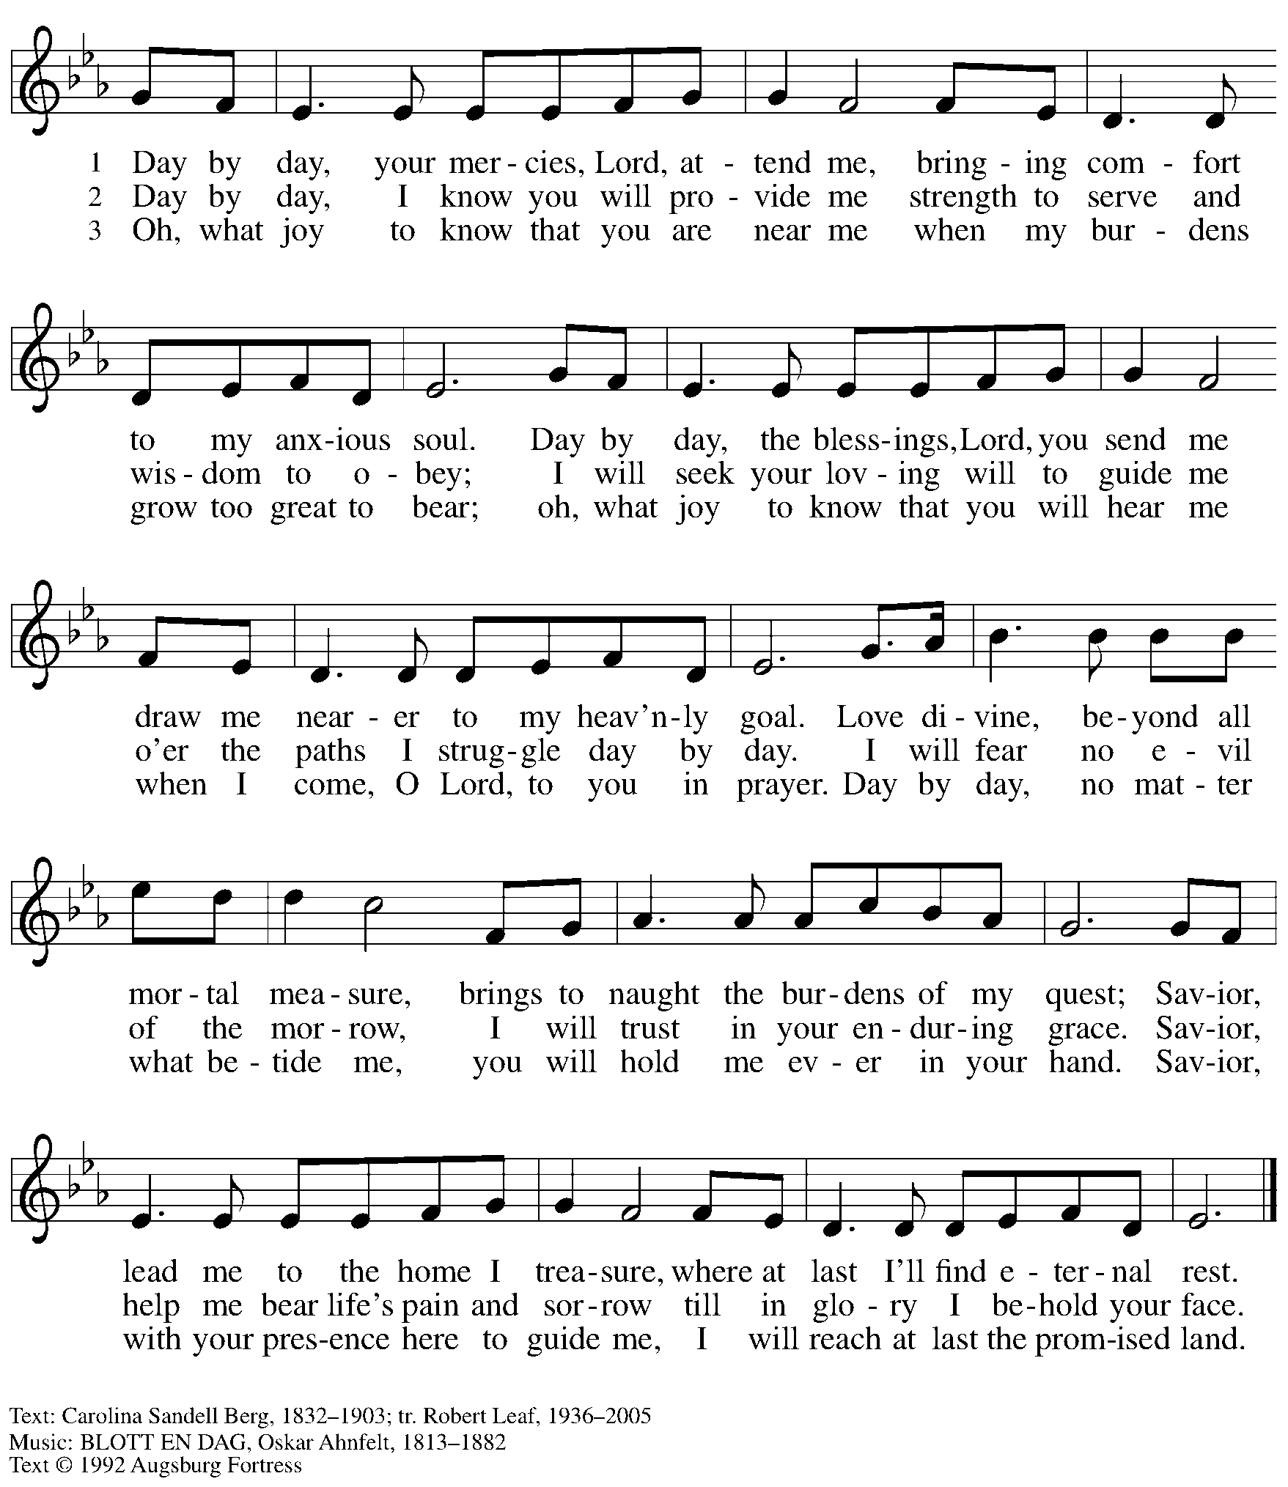
All rights reserved. Reprinted with permission under OneLicense.net # A-722139.

When all have returned to their places, please rise as you are able.

Blessing

P: The body and blood of our Lord Jesus Christ strengthen you and keep you in his grace.
C: Amen.

Prayer

A: Let us pray. Life-giving God,
in the mystery of Christ’s resurrection, you send light to conquer darkness,
water to give new life, and the bread of life to nourish your people.
Send us forth as witnesses to your Son’s resurrection,
that we may show your glory to all the world,
through Jesus Christ, our risen Lord.
C: Amen.

Please be seated.

Sending

Announcements

Please rise as you are able.

Benediction

P: May our glorious God grant you a spirit of wisdom
to know and love the risen Christ.

Almighty God, holy One, ☩ holy Three,
bless you now and forever.
C:
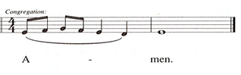

Sending Hymn Build a Longer Table Following Page

Sending Hymn Build a Longer Table ACS 1062

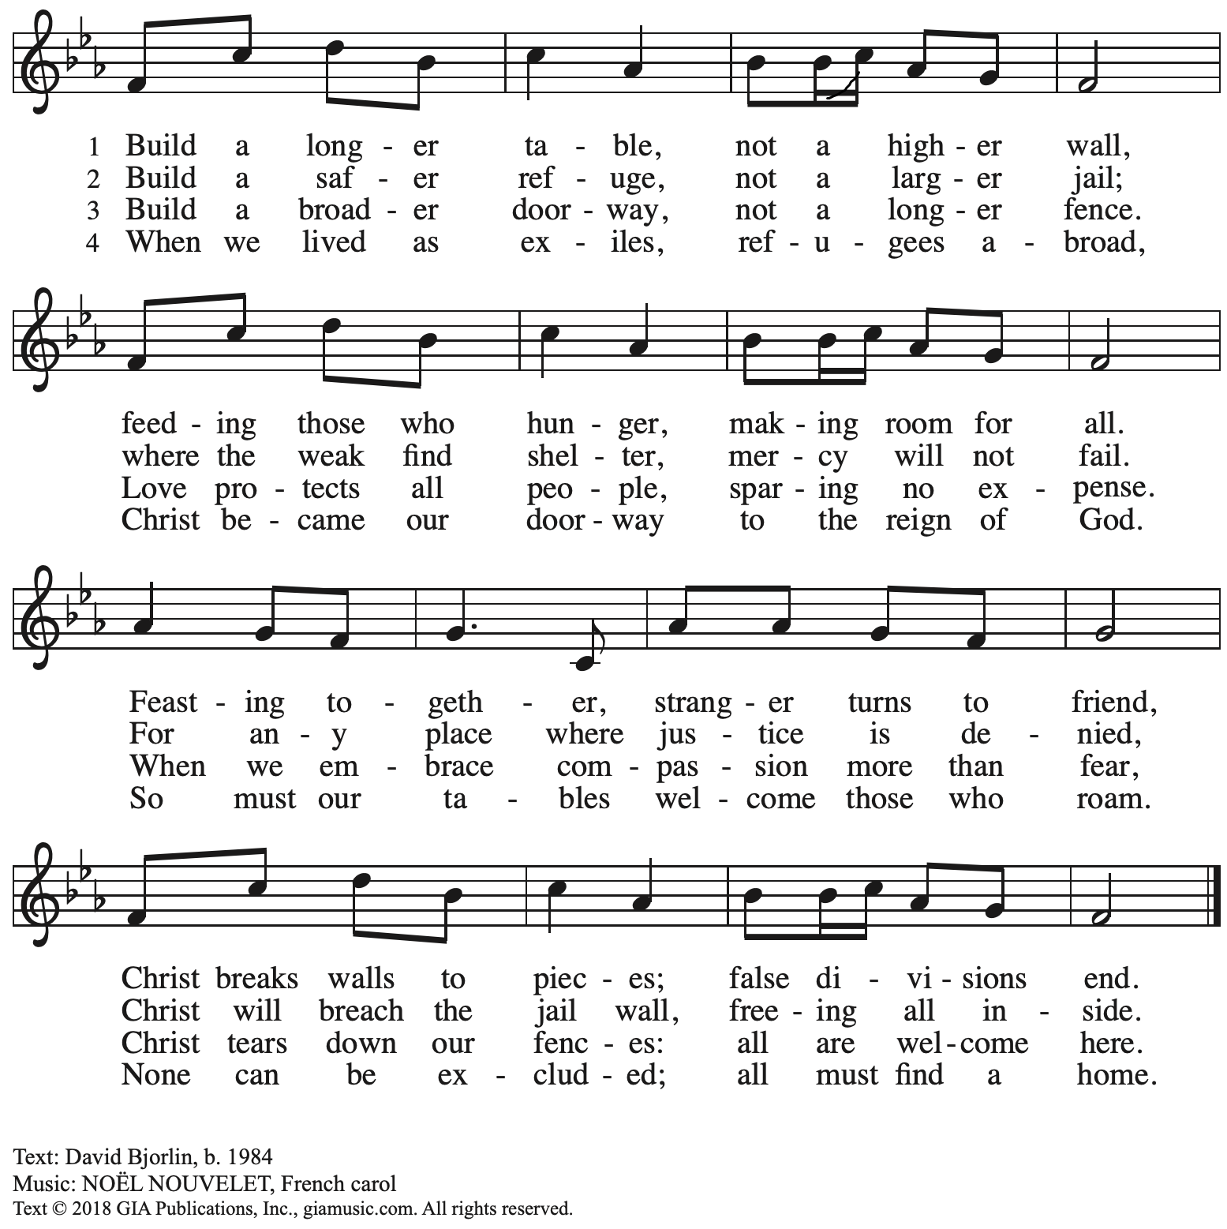
Reprinted with permission under OneLicense.net # A-722139.

Dismissal

A: Alleluia! Christ is risen!
C: Christ is risen indeed! Alleluia! Alleluia!

A: Go in peace. Share the good news!
C: Thanks be to God!

Postlude
Abbreviations

P: Pastor/Presiding Minister
A: Assisting Minister
L: Lector
C: Congregation

ACS: All Creation Sings hymnal
ELW: Evangelical Lutheran Worship hymnal
HS: Hymnal Supplement

Those serving in worship today

Altar Care Jodie Minor
Assisting Minister Timothy Kocher-Hillmer
Audio-Visual Ministers Jason Galyardt
David Rollinson
Cantor Joy Givens
Lector Ty Best
Minister of Music Laura Reynolds
Presiding Minister Pastor Ross Carmichael

Liturgy and Hymnody Acknowledgements

From SundaysandSeasons.com. Copyright © 2023 Augsburg Fortress. All rights reserved. Reprinted under OneLicense.net # A-722139.
Used by permission of Augsburg Fortress.

Mfurahini, haleluya / Christ Has Arisen, Alleluia – Text: Bernard Kyamanywa, b. 1938; tr. Howard S. Olson, b. 1922. Music: MFURAHINI, HALELUYA, Tanzanian traditional. Text © 1968 Lutheran Theological College, Makumira, Tanzania, admin. Augsburg Fortress. Tr. © 1977 Howard S. Olson, admin. Augsburg Fortress. All rights reserved. Reprinted with permission under Onelicense.net # A-722139.

Now the Feast and Celebration –Text: Marty Haugen, b. 1950. Music: NOW THE FEAST AND CELEBRATION, Marty Haugen. Text and music © 1990 GIA Publications, Inc. 7404 Mason Ave. Chicago, IL 60638. www.giamusic.com. 800.442.3358. All rights reserved. Reprinted with permission under OneLicense.net # A-722139.

Shepherd Me, O God – Text: Marty Haugen, b. 1950, based on Psalm 23. Music: SHEPHERD ME, Marty Haugen. Text and music © 1986 GIA Publications, Inc., 7404 S. Mason Ave., Chicago, IL 60638. www.giamusic.com. 800.442.3358. All rights reserved. Reprinted with permission under OneLicense.net # A-722139.

As the Grains of Wheat – Text: Didache, 2nd cent.; Marty Haugen, b. 1950. Music: Marty Haugen. Text and Music © 1990 GIA Publications, Inc. 7404 Mason Ave. Chicago, IL 60638. www.giamusic.com. 800.442.3358. All rights reserved. Reprinted with permission under OneLicense.net # A-722139.

St. Andrew Lutheran Church Announcements
April 30th, 2023

- Happy Easter! Welcome to worship at St. Andrew on April 30th, 2023, the + Fourth Sunday of Easter, as we continue to celebrate Christ’s Resurrection! – We are so glad you are here to share in this festive season, and we offer a special welcome to all visitors and guests who are here for the first time! Masks are optional at St. Andrew when Allegheny County’s Covid-19 community level is in the low and medium categories. Worship attendees are invited to make a name tag at the back of the worship space if you would like. There are worship “toolkits” to help children engage with worship and “busy bags” for younger children available in the bookcase at the back of the sanctuary. Please feel free to take one to use with/for your children. We pray that everyone has a blessed Easter season!
- Pennsylvania Interfaith Impact Network (PIIN) Invites You to its 2023 Issues Assembly Today, Sunday, April 30th, from 1:30 – 4:30 p.m. – This event, which is being held at Pittsburgh Mennonite Church, 2018 S. Braddock Ave., Pittsburgh, PA 15218, is free and lunch and beverages will be provided.
- Seeking Help with Sunday Coffee Hour – Many in the St. Andrew community enjoy the opportunity to gather for coffee, snacks and conversation after worship each week. We are looking for help with setup / preparation and cleanup each week and the whole process is pretty simple! If you would like to contribute, either for one time or on a rotating monthly schedule, please contact Pastor Ross Carmichael at PastorRCarmichael@gmail.com.
- May Produce Distribution - Tuesday, May 2nd, 5:30-7:00 p.m. – Each month, St. Andrew hosts the distribution of produce to local households in partnership with Greater Pittsburgh Community Food Bank. Our next date will be Tuesday, May 2nd. We invite people to help with unloading the truck and setup, usually sometime between 10:30 a.m. and 1:00 p.m. (We will call those who sign up to share a more precise time when we hear from the food bank). Then all are welcome to help with the distribution and get to know one another and our neighbors from 5:30-7:00 p.m. Please sign up at https://www.signupgenius.com/go/4090F45AFAF2BA75-produce3.
- Bethel AME Church Invites St. Andrew to Family and Friends Saturday, May 6th, 2023 – Due to the Pittsburgh Marathon, Bethel AME is moving its regular Sunday service to Saturday, May 6th, at 11:00 a.m., followed by a lunch after the service. For those who have expressed a desire to meet our friends from Bethel and worship with them, this is a great opportunity to do so! Bethel is located at 2720 Webster Avenue, 15219. Dress is casual, blue, purple, and silver. Come join in family, fellowship, fun, and love!
- Marathon Sunday Transportation Challenges - May 7th, 2023 – The Pittsburgh Marathon will be held on Sunday morning, May 7th, 2023. St. Andrew is located within the marathon route, and unfortunately the city puts up barriers to mark off the route for the entirety of the event. This makes it difficult for people to attend worship unless you live near the church or drive downtown to catch Bigelow Blvd so please plan ahead! The course maps are available here Pittsburgh Marathon (thepittsburghmarathon.com),and the full marathon route is here Marathon_Full_2023 (p3r.org). We will still plan to hold worship in person on that day, but it will also be available by Zoom, Facebook, and YouTube for those who cannot be here.
- Returning to Monthly Reparations Offering Sunday, May 14th – With the events of Palm Sunday and Holy Week, St. Andrew did not take its second collection for restorative justice/reparations on the first Sunday of April. With the first Sunday of May being Marathon Sunday, we will hold the May collection on Sunday, May 14th. We will then resume our regular schedule for this collection, on the first Sunday of each month, on Sunday, June 4th.
- Monthly Shelter Dinner at East End Cooperative Ministry – Thursday, May 18th, 6:30 p.m. – Each month, members of St. Andrew provide and serve a meal for the guests of the shelter at East End Cooperative Ministry (EECM), 6140 Station St., 15206. Anyone can sign up to prepare or purchase a portion of the meal to bring to EECM at 6:00 p.m. that day, or just come to help serve the meal at 6:30 p.m. Please sign up at https://www.signupgenius.com/go/5080544AAAC22A1F58-mayshelter1.
- St. Andrew Jail Ministry – St. Andrew has had a long history of participation in the ministry program at the Allegheny County Jail. Until the program was put on hold at the beginning of the Covid pandemic, a group of volunteers from St. Andrew was leading a worship service at the jail on Sunday mornings, typically about one Sunday a month. The jail is hoping to resume this program soon. If any of the previous volunteers are still interested and available, please contact Lester Prince (lprince@comcast.net). New volunteers are also needed.
The first step for new volunteers is to complete an online application, which can be accessed here: https://www.foundationofhope.org/get-involved/volunteer-application/. On the application form, indicate that the program that you are interested in volunteering with is “Chaplaincy Worship.” Feel free to contact Lester Prince with any questions.
- Interfaith Prayer Vigil to End Inhumane Conditions at Allegheny County Jail - Thursday, May 4th, 3:00 p.m. - City-County Building Portico, 414 Grant St., 15219 – Pennsylvania Interfaith Impact Network (PIIN) and community partners invite you to join in a call for moral and just reform at the Allegheny County Jail. After the vigil, the group will walk prayerfully to the May Jail Oversight Board Meeting across the street in the County Courthouse Fourth Floor Gold Room.

"On the National Day of Prayer, Thursday, May 4th at 3:00 p.m., PIIN will host its second Interfaith Prayer Vigil to honor the victims of death, abuse, and neglect, and to call for an end to the inhumane conditions at the Allegheny County Jail. We invite you to join us and stand for just, moral, and humane treatment for all God’s people!

PIIN’s Allegheny County Jail ((ACJ) Action Group was formed in September in response to the 17 deaths at the Allegheny County Jail since March 2020 and the county-commissioned survey which exposed inhumane conditions documented at the ACJ. PIIN has held monthly actions and sought to build relationships with the Allegheny County Jail Oversight Board, whose administrative powers and duties include the operation and maintenance of the prison and all alternative housing facilities, the oversight of the health and safekeeping of inmates and the confirmation of the chief executive's selection of a warden. (Title 61 – PA General Assembly).

PIIN has met with judges, council members, jail staff, and organizations to collaborate on real solutions to the problems at the jail. PIIN works with the Renewal Center to offer returning citizens the opportunity to participate in our Colorful Backgrounds EXPO re-entry program. We were proud to contribute to Allegheny County Controller Corey O’Connor’s recent recommendations to the jail.
- Camp Agape Spring Work Day - Saturday, May 6th, 10:00 a.m. - 4:00 p.m. – Lunch will be provided. Please RSVP to campinfo@campagape.org or 724-356-2308.
- Lutherlyn - Camp Opportunities
  - Still Seeking Summer Camp Staff: Cabin Leaders, Lifeguards, Kitchen Staff, and Maintenance – For more information, visit Summer Employment (lutherlyn.com)
  - Camp Blast - A Day of Fun That Highlights All the Camp Has to Offer - Saturday, May 13th, 11:00 a.m. - 4:00 p.m. – Visit Camp Blast (lutherlyn.com) for more information.
  - Summer Camp – To see all the programs available, click here: Summer Camp Home (lutherlyn.com)

