+ Triduum – Good Friday
Service of Shadows and Stones
April 7, 2023 – 7:00 p.m.
St. Andrew Lutheran Church
304 Morewood Ave.
Pittsburgh, PA 15213
St_andrewELCA@verizon.net
www.standrewpittsburgh.org
+ Triduum – Good Friday
Service of Shadows and Stones
Order for Worship

Life and death are side by side as we enter into Good Friday.
Jesus reveals the power and glory of God, even as he is put on trial and sentenced to death.
We carry stones this evening as we worship. They may symbolize our hurtful words and actions toward others, who are the image of Christ among us. They may stand for the burdens that we carry and the troubles of our darkest days. They may represent all that separates us from God and neighbor, all that we want to leave behind as we gather at the foot of the cross.
We will place the stones there, praying for the whole world and trusting that while we gather in solemn devotion, the tree around which we assemble is indeed a tree of life for all. The stones will make up the empty tomb at Easter, when God extends forgiveness and new life through the risen Christ. Worship for this evening concludes with adoration of the cross and the crucified Jesus, who brings the promise of salvation to the world. We depart silently, and we anticipate the culmination of the Three Days in the Easter Vigil.

- Masks are optional at St. Andrew when Covid-19 community level in Allegheny County is in the low and medium categories.

- Worship Services are live streamed to multiple online platforms. By attending worship, you agree that your image and voice may be broadcast.

Welcome to St. Andrew

St. Andrew Lutheran congregation welcomes all who are seeking a place of healing and wholeness – a nurturing, faith-forming spiritual home. Our community embraces people of all ages, ethnicities, cultures, abilities, sexual orientations, gender identities and expressions, and family constellations. Come and See!

A restroom is available on the main level of the church, through the doors to the Social Hall and to the right in the main office.

Worship begins in silence.
Please rise as you are able.

Invocation

P: In the name of the Father,
and of the ☩ Son,
and of the Holy Spirit.
C: Amen.

Dialogue (based on Lamentations 1: 12)

A: All you who pass this way,
C: look and see, the shadow of sin.

A: All you who pass this way,
C: look and see, the weight of the world.

A: All you who pass this way,
C: look and see, the suffering of our Savior.

A: All you who pass this way,
C: look and see, the sorrow of God’s people and of Jesus Christ.

A: Behold, the Lamb of God,
C: who takes away the sin of the world.

Prayer of the Day

P: Let us pray.

A brief silence is kept.

P: Almighty God,
look with loving mercy on your human family,
for whom our Lord Jesus Christ was willing to be betrayed,
to be given over to the hands of sinners, and to suffer death on the cross;
the one who now lives and reigns with you and the Holy Spirit,
one God, now and forever.
C: Amen.

Hymn Lamb of God Most Holy / Santo Cordero Following Page

Hymn Lamb of God Most Holy / Santo Cordero ACS 932

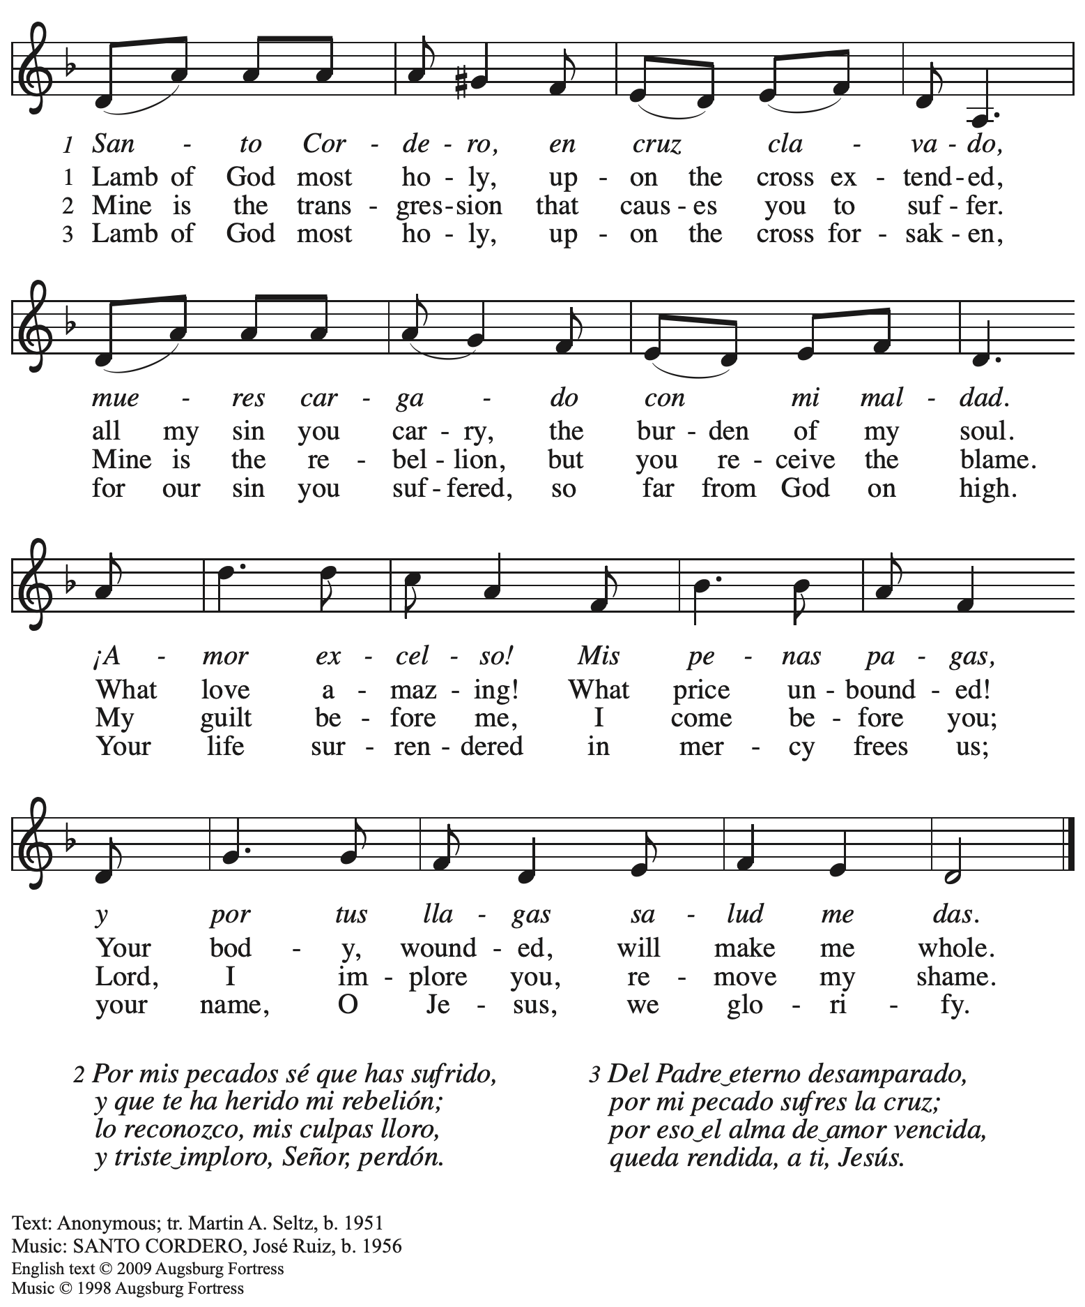
All rights reserved. Reprinted with permission under OneLicense.net # A-722139.

Please be seated.

Shadow of Condemnation

Reading Matthew 27: 32-42

³²As they went out, they came upon a man from Cyrene named Simon; they compelled this man to carry [Jesus’] cross. ³³And when they came to a place called Golgotha (which means Place of a Skull), ³⁴they offered him wine to drink, mixed with gall; but when he tasted it, he would not drink it. ³⁵And when they had crucified him, they divided his clothes among themselves by
casting lots; ³⁶then they sat down there and kept watch over him. ³⁷Over his head they put the charge against him, which read, “This is Jesus, the King of the Jews.”
³⁸Then two bandits were crucified with him, one on his right and one on his left. ³⁹Those who passed by derided him, shaking their heads ⁴⁰and saying, “You who would destroy the temple and build it in three days, save yourself! If you are the Son of God, come down from the cross.” ⁴¹In the same way the chief priests also, along with the scribes and elders, were mocking him, saying, ⁴²“He saved others; he cannot save himself. He is the King of Israel; let him come down from the cross now, and we will believe in him.”

Response Ah, Holy Jesus ELW 349
v. 1, 4

1 Ah, holy Jesus, how hast thou offended
that we to judge thee have in hate pretended?
By foes derided, by thine own rejected,
O most afflicted.

4 For me, kind Jesus, was thine incarnation,
thy mortal sorrow, and thy life's oblation;
thy death of anguish and thy bitter passion,
for my salvation.

Text: Johann Heermann, 1585-1647; tr. Robert Bridges, 1844-1930, alt. Music: HERZLIEBSTER JESU, Johann Crüger, 1598-1662.

Prayer

A: Let us pray.
Forgiving Christ,
when the world condemns us, when wrong is done to us,
when we carry the weight of things that feel too much to forgive,
come alongside us in the darkness,
and give us grace to be forgiven and forgiving.
C: Amen.

Shadow of Separation

Reading Luke 23: 39-43

³⁹One of the criminals who were hanged there kept deriding him and saying, “Are you not the Messiah? Save yourself and us!” ⁴⁰But the other rebuked him, saying, “Do you not fear God, since you are under the same sentence of condemnation? ⁴¹And we indeed have been condemned justly, for we are getting what we deserve for our deeds, but this man has done nothing wrong.”
⁴²Then he said, “Jesus, remember me when you come into your kingdom.” ⁴³He replied, “Truly I tell you, today you will be with me in Paradise.”

Response Jesus, Remember Me ELW 616

Jesus, Remember Me is a hymn in the Taizé style,
sung multiple times to aid in focused meditation.

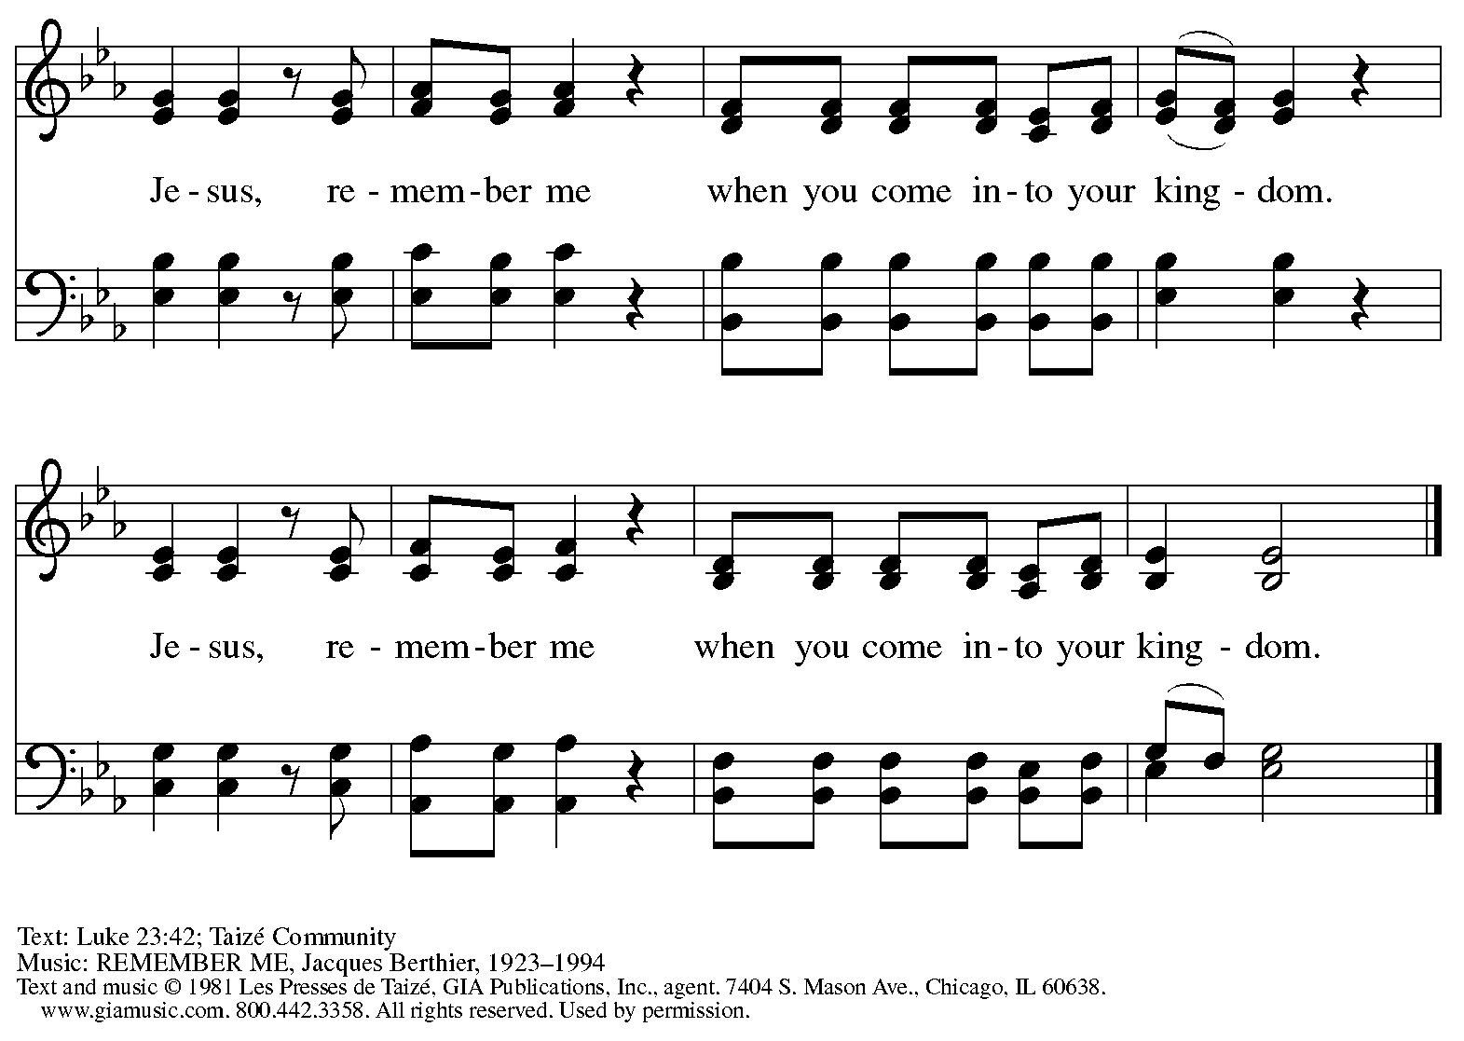
Reprinted with permission under OneLicense.net # A-722139.

Prayer

P: Let us pray.
P: Reconciling Christ,
we are weighed down by sin and separation, a world that is not at peace,
amid people who like us are seeking healing and wholeness.
You reached out to the one crucified beside you and welcomed him to God’s side.
Come alongside us in the darkness,
and bring grace and peace to everything in need of redemption.
C: Amen.

Shadow of Sorrow

Reading John 19: 25b-27
Meanwhile, standing near the cross of Jesus were his mother, and his mother's sister, Mary the wife of Clopas, and Mary Magdalene. ²⁶When Jesus saw his mother and the disciple whom he loved standing beside her, he said to his mother, “Woman, here is your son.” ²⁷Then he said to the disciple, “Here is your mother.” And from that hour the disciple took her into his own home.

Response Tree of Life and Awesome Mystery ELW 334
v. 1-2

1 Tree of Life and awesome myst'ry,
in your death we are reborn;
though you die in all of hist'ry,
still you rise with ev'ry morn,
still you rise with ev'ry morn.

2 We remember truth once spoken,
love passed on through act and word;
ev'ry person lost and broken
wears the body of our Lord,
wears the body of our Lord.

Text: Marty Haugen, b. 1950. Music: THOMAS, Marty Haugen. Text and Music © 1984 GIA Publications, Inc., 7404 S. Mason Ave., Chicago, IL 60638. www.giamusic.com. 800.442.3358. All rights reserved. Reprinted with permission under OneLicense.net # A-722139.

Prayer

A: Let us pray.
Loving Christ, we carry the pain, sorrow, and suffering of the people we love.
Our care for them is deep, and sometimes there is little we can do.
Come alongside us in the darkness,
and embrace the ones we love in your strong hands.
C: Amen.

Shadow of Despair

Reading Matthew 27: 45-49

⁴⁵From noon on, darkness came over the whole land until three in the afternoon. ⁴⁶And about three o'clock Jesus cried with a loud voice, “Eli, Eli, lema sabachthani?” that is, “My God, my God, why have you forsaken me?” ⁴⁷When some of the bystanders heard it, they said, “This man is calling for Elijah.” ⁴⁸At once one of them ran and got a sponge, filled it with sour wine, put it on a stick, and gave it to him to drink. ⁴⁹But the others said, “Wait, let us see whether Elijah will come to save him.”

Response O Lord, Hear My Prayer ELW 751

O Lord, Hear My Prayer is a hymn in the Taizé style,
sung multiple times to aid in focused meditation.

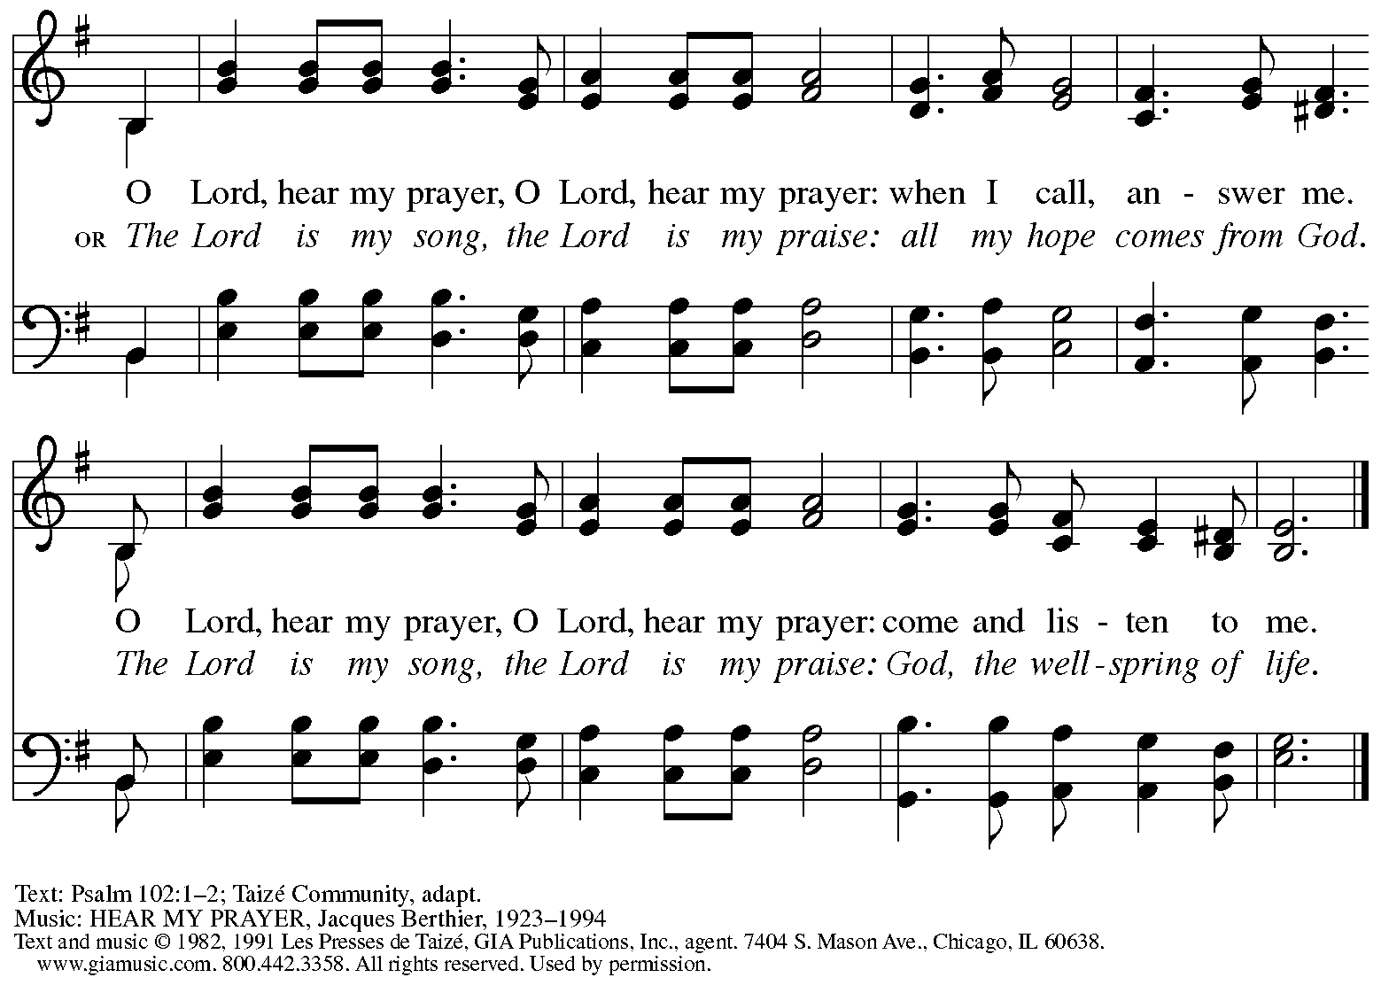
Reprinted under OneLicense.net # A-722139.

Prayer

P: Let us pray.
P: Lord Jesus Christ, you know what it is like to feel that God is far away.
You know what it is like to call out for God’s presence. Come alongside us in the darkness,
and enable us to call for God in all our need.
C: Amen.

Shadow of Suffering

Reading John 19: 28-29

²⁸After this, when Jesus knew that all was now finished, he said (in order to fulfill the scripture), “I am thirsty.” ²⁹A jar full of sour wine was standing there. So they put a sponge full of the wine on a branch of hyssop and held it to his mouth.

Response O Sacred Head, Now Wounded ELW 351
v. 1-3

1 O sacred head, now wounded,
with grief and shame weighed down,
now scornfully surrounded
with thorns, thine only crown;
O sacred head, what glory,
what bliss till now was thine!
Yet, though despised and gory,
I joy to call thee mine.

2 How pale thou art with anguish,
with sore abuse and scorn;
how does thy face now languish,
which once was bright as morn!
Thy grief and bitter passion
were all for sinners' gain;
mine, mine was the transgression,
but thine the deadly pain.

3 What language shall I borrow
to thank thee, dearest friend,
for this thy dying sorrow,
thy pity without end?
Oh, make me thine forever,
and should I fainting be,
Lord, let me never, never
outlive my love to thee.

Prayer

A: Let us pray.
Suffering Christ, in all our thirst, in all our sickness,
in all our longing, in all our pain, you are there.
Come alongside us in the darkness,
and accompany us through all of our suffering.
C: Amen.

Shadow of Death

Reading Luke 23: 44-49

⁴⁴It was now about noon, and darkness came over the whole land until three in the afternoon,
⁴⁵while the sun's light failed; and the curtain of the temple was torn in two. ⁴⁶Then Jesus, crying with a loud voice, said, “Father, into your hands I commend my spirit.” Having said this, he breathed his last. ⁴⁷When the centurion saw what had taken place, he praised God and said, “Certainly this man was innocent.” ⁴⁸And when all the crowds who had gathered there for this spectacle saw what had taken place, they returned home, beating their breasts. ⁴⁹But all his acquaintances, including the women who had followed him from Galilee, stood at a distance, watching these things.

Response Calvary ELW 354
Every Time I Think about Jesus
v. 1, 3-4

Refrain
Calvary, Calvary,
Calvary, Calvary,
Calvary, Calvary,
surely he died on Calvary.

1 Ev'ry time I think about Jesus,
ev'ry time I think about Jesus,
ev'ry time I think about Jesus;
surely he died on Calvary. Refrain

3 Don't you hear him say, "It is finished!"
Don't you hear him say, "It is finished!"
Don't you hear him say, "It is finished!"
Surely he died on Calvary. Refrain

4 Jesus furnished my salvation,
Jesus furnished my salvation,
Jesus furnished my salvation;
surely he died on Calvary. Refrain

Text: African American spiritual.
Music: CALVARY, African American spiritual.

Prayer

P: Let us pray.
Faithful Christ, even in death, you are there.
When we are afraid, when we mourn,
when we come to our own end, you are there, too.
Come alongside us in the darkness,
and carry us through death to life.
C: Amen.

Procession of the Cross

A large cross is carried in procession through the church and placed before the assembly.
The assembly faces the cross as it is brought forward.

The following dialogue is sung as procession begins, at its midpoint, and at the end,
with the assembly responding to the leader:

P: Behold, the life-giving cross, on which was hung the salvation of | the whole world.
C: Oh, come, let us | worship Christ.

When the cross has been placed in front of the altar, please be seated.

Adoration of the Cross

At this time, worshipers may come to the large cross to make a sign of reverence.
Reverencing the cross may include such actions as pausing before the cross, bowing,
kneeling before it for prayer, or touching it.

Solemn Reproaches

During the adoration of the cross, the cantors will intone the Solemn Reproaches,
a traditional element of Good Friday services based on the text of Micah 6: 3.
Each reproach will conclude with the words,
“… but you have prepared a cross for your Savior.”
The congregation is invited to join in singing the refrain, found on the following page:

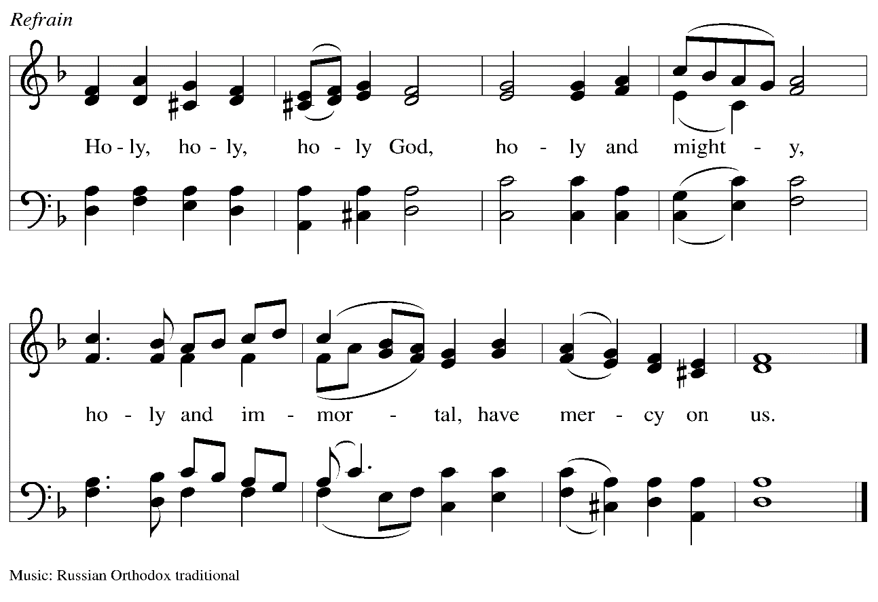

When all have returned to their places, after a brief silence, the presiding minister continues:

P: We adore you, O Christ, | and we bless you,
C: for by your cross you have re- | deemed the world.

Silence is kept for prayer and meditation.

All depart in silence.
If they have not done so earlier, worshipers may reverence the cross before they depart.

The service of the Triduum continues tomorrow with the Vigil of Easter at 5:00 p.m.

Abbreviations

P: Pastor/Presiding Minister
A: Assisting Minister
C: Congregation

ELW: Evangelical Lutheran Worship hymnal

Those serving in worship today

Assisting Minister The Rev. Deborah M. Byrum
Audio-Visual Minister Jason Galyardt
Cantors Emily Duque
Noël Marsh
Minister of Music Laura Reynolds
Presiding Minister Pastor Ross Carmichael

Liturgy and Hymnody Acknowledgements

From SundaysandSeasons.com. Copyright © 2023 Augsburg Fortress. All rights reserved. Reprinted under OneLicense.net # A-722139.
Used by permission of Augsburg Fortress.

O Sacred Head, Now Wounded – Text: Paul Gerhardt, 1607-1676, based on Arnulf of Louvain, d. 1250; tr. composite. Music: HERZLICH TUT MICH VERLANGEN, German melody, c. 1500; adapt. Hans Leo Hassler, 1564-1612; arr. Johann Sebastian Bach, 1685-1750.

St. Andrew Announcements
Friday, April 7th, 2023

- Welcome to Worship at St. Andrew on + Maundy Thursday, April 6th, 2023 – Masks are optional at St. Andrew when Allegheny County’s Covid-19 community level is in the low and medium categories.
- Worship Schedule for Holy Week – The service of the Triduum – the Great Three Days of Holy Week – continues tomorrow with the Vigil of Easter. The service schedule for the rest of the week is:
  - Triduum – The Vigil of Easter, April 8th, 5:00 p.m. – The church tells God’s story of salvation through worship, word, sacrament, and song as we gather around a fire, hear stories of God’s faithfulness throughout the ages, give thanks for the gift of Baptism, and move into the celebration of the resurrection with Holy Communion
  - The Resurrection of our Lord – Easter Sunday, April 9th, 10:00 a.m. – We join the church throughout the world in proclaiming the fullness of the good news in Christ’s Easter resurrection! (Please note that Little Church – Big Faith will not meet during these services, nor will there be a coffee hour.)

