+ The Resurrection of our Lord
Easter Sunday
April 9, 2023
St. Andrew Lutheran Church
304 Morewood Ave.
Pittsburgh, PA 15213
St_andrewELCA@verizon.net
www.standrewpittsburgh.org

+ The Resurrection of our Lord
Easter Sunday
Order for Worship

This is the day the Lord has made! Christ is risen, and through him all creation is made new! Indeed, “God shows no partiality” (Acts 10:34): Christ’s resurrection truly brings
the gift of new life. We sing hymns of praise, gather around sacred words,
and proclaim God’s faithfulness, power, and love in the feast of Holy Communion.
With the women at the tomb, we are astonished, elated, and grateful.
We depart with joy to proclaim the good news of God’s endless love.

- Masks are optional at St. Andrew when Covid-19 community level in Allegheny County is in the low and medium categories.

- Worship Services are live streamed to multiple online platforms. By attending worship, you agree that your image and voice may be broadcast.

Welcome to St. Andrew!

- St. Andrew Lutheran congregation welcomes all who are seeking a place of healing and wholeness – a nurturing, faith-forming spiritual home. Our community embraces people of all ages, ethnicities, cultures, abilities, sexual orientations, gender identities and expressions, and family constellations. Come and See!

- Everyone is invited to make a nametag at the black bookcase in the back of the worship space if they would like. There are stickers indicating pronouns on the bookcase if you would like to include them on your name tag.

- Worship “toolkits” to help children engage with the service are available in the bookcase at the back of the worship space. There are “reader” and “pre-reader” resources available in each kit. Please feel free to use them for/with your children during worship.

- St. Andrew has resumed the Sharing of Peace during worship. Please be mindful that some people will not be comfortable with sharing the peace; be sure to obtain consent before any physical expression of peace such as shaking hands or hugging.

- Holy Communion is served with bread (gluten-free available) and wine or grape juice. The presiding minister will distribute the bread (host). Please consume this and then pick up an empty glass from the tray. The Communion Assistant will pour wine or grape juice into your glass. Please step to the side to consume the wine or grape juice. Feel free to kneel at the altar for prayer and reflection. As you return to your pew, glasses may be returned to the empty trays on either side of the center aisle.

- A restroom is available on the main level of the church, through the doors to the Social Hall and to the right in the main office.

Pre-Service Music

Welcome

Gathering
The Holy Spirit calls us together as the people of God.

Children are invited to gather at the front of the worship space as the service begins,
as we welcome back the “Alleluia,” the Church’s song of Easter joy!

Raising the Alleluia

Once the Alleluias have been brought out, the presiding minister and congregation proclaim:
P: Alleluia! Christ is risen!
C: Christ is risen indeed! Alleluia! Alleluia!

Please rise as you are able and face the processional cross as the Processional Hymn begins.

Processional Hymn Jesus Christ Is Risen Today ELW 365

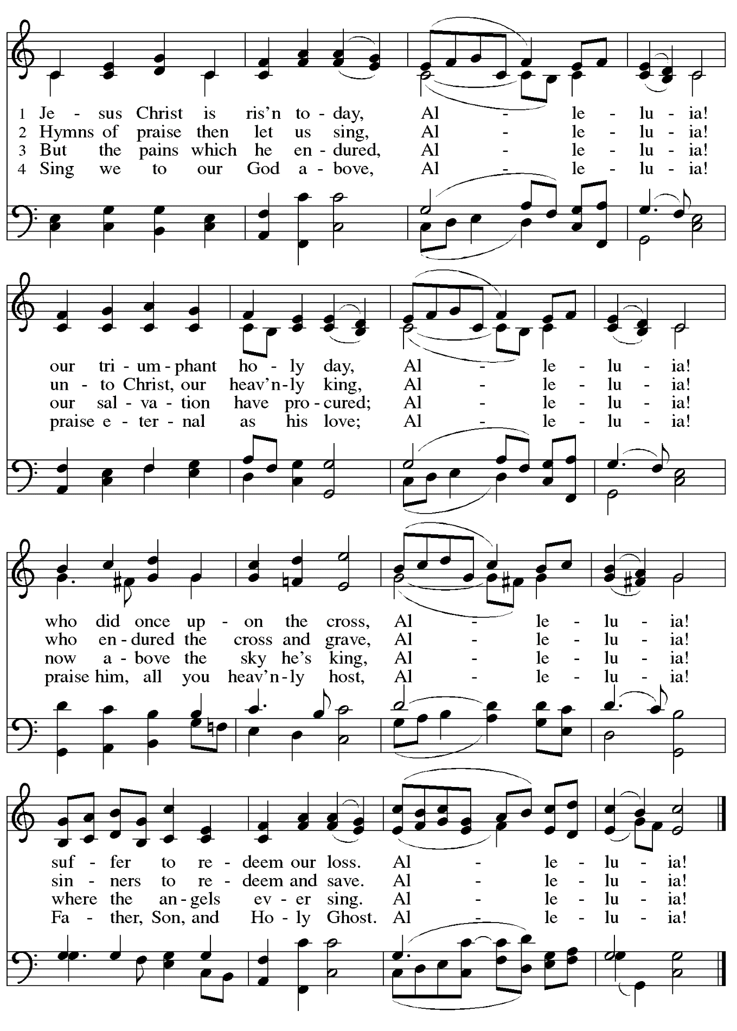
Greeting

P: The grace of our Lord Jesus Christ, the love of God,
and the communion of the Holy Spirit be with you all.
C: And also with you.

Hymn of Praise This Is the Feast ELW p. 149-150

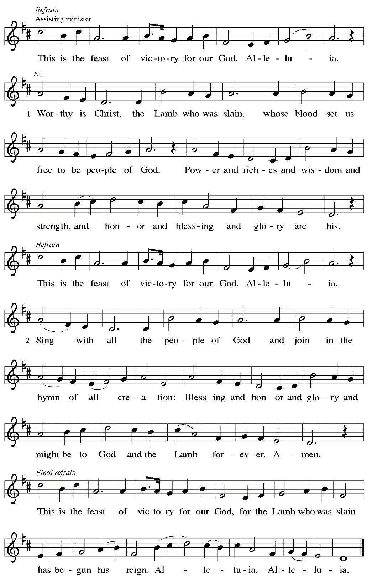

Prayer of the Day

P: The Lord be with you.
C: And also with you.

P: Let us pray.
O God, you gave your only Son to suffer death on the cross for our redemption,
and by his glorious resurrection you delivered us from the power of death.
Make us die every day to sin, that we may live with him forever in the joy of the resurrection, through your Son, Jesus Christ our Lord, who lives and reigns with you and the Holy Spirit,
one God, now and forever.
C: Amen.

Please be seated.

Word
God speaks to us in Scripture reading, preaching, and song

First Reading – Acts 10: 34-43

³⁴Peter began to speak to [the people]: “I truly understand that God shows no partiality, ³⁵but in every nation anyone who fears God and does what is right is acceptable to God. ³⁶You know the message God sent to the people of Israel, preaching peace by Jesus Christ—he is Lord of all. ³⁷That message spread throughout Judea, beginning in Galilee after the baptism that John announced: ³⁸how God anointed Jesus of Nazareth with the Holy Spirit and with power; how he went about doing good and healing all who were oppressed by the devil, for God was with him. ³⁹We are witnesses to all that he did both in Judea and in Jerusalem. They put him to death by hanging him on a tree; ⁴⁰but God raised him on the third day and allowed him to appear, ⁴¹not to all the people but to us who were chosen by God as witnesses, and who ate and drank with him after he rose from the dead. ⁴²He commanded us to preach to the people and to testify that he is the one ordained by God as judge of the living and the dead. ⁴³All the prophets testify about him that everyone who believes in him receives forgiveness of sins through his name.”

L: Word of God, word of life.
C: Thanks be to God.

Psalm 118: 1-12, 14-24

The psalm will be sung responsively, led by the cantor,
with the congregation responding with the bold verses and refrain.

Psalm tone

Psalm refrain

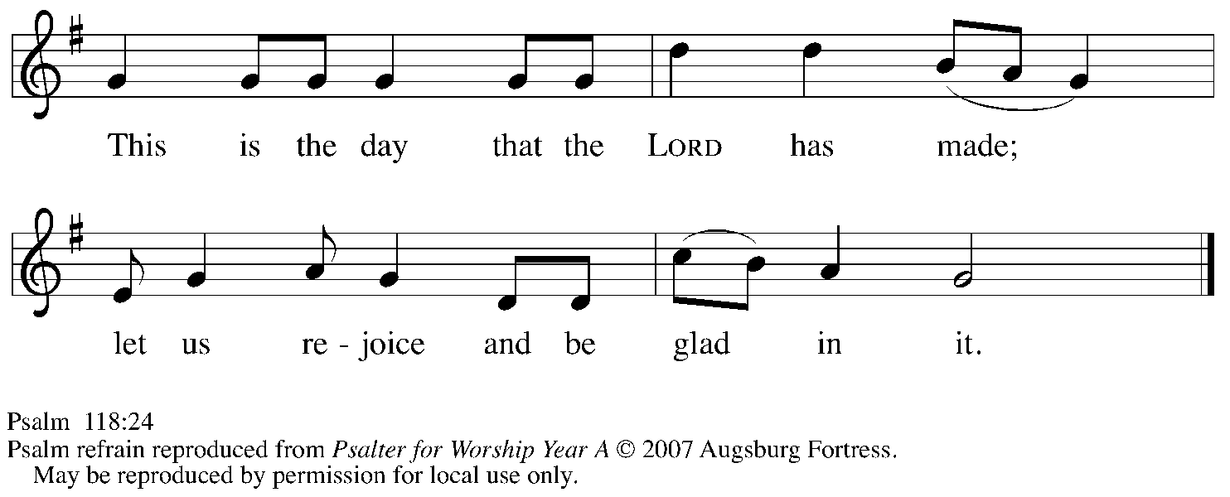

¹Give thanks to the Lord, for the | Lord is good;
God’s mercy en- | dures forever.
²Let Israel | now declare,
“God’s mercy en- | dures forever.”
¹⁴The Lord is my strength | and my song,
and has become | my salvation.
¹⁵Shouts of rejoicing and salvation echo in the tents | of the righteous:
“The right hand of the | Lord acts valiantly!
¹⁶The right hand of the Lord| is exalted!
The right hand of the | Lord acts valiantly!”
¹⁷I shall not | die, but live,
and declare the works | of the Lord. R
¹⁸The Lord indeed pun- | ished me sorely,
but did not hand me o- | ver to death.
¹⁹Open for me the | gates of righteousness;
I will enter them and give thanks | to the Lord.
²⁰“This is the gate | of the Lord;
here the righ- | teous may enter.”
²¹I give thanks to you, for you have | answered me
and you have become | my salvation. R
²²The stone that the build- | ers rejected
has become the chief | cornerstone.
²³By the Lord has | this been done;
it is marvelous | in our eyes.
²⁴This is the day that the | Lord has made;
let us rejoice and be | glad in it. R

Second Reading – Colossians 3: 1-4

¹If you have been raised with Christ, seek the things that are above, where Christ is, seated at the right hand of God. ²Set your minds on things that are above, not on things that are on earth, ³for you have died, and your life is hidden with Christ in God. ⁴When Christ who is your life is revealed, then you also will be revealed with him in glory.

L: Word of God, word of life.
C: Thanks be to God.

Please rise as you are able.

Gospel Acclamation

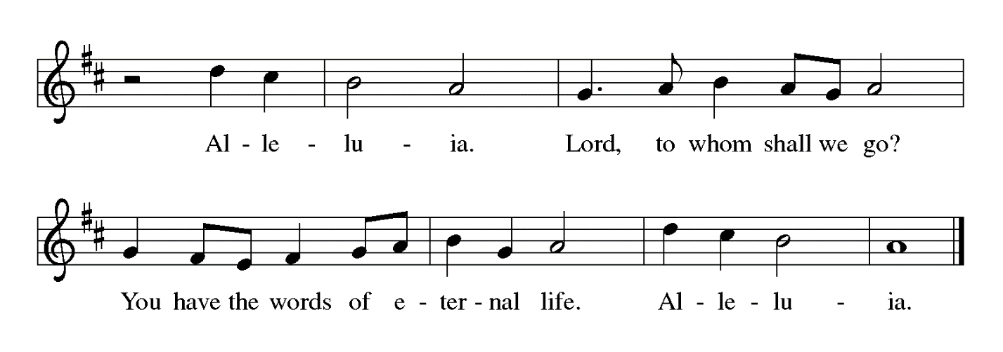

Gospel – Matthew 28: 1-10

P: The holy Gospel according to St. Matthew.
C: Glory to you, O Lord.

¹After the sabbath, as the first day of the week was dawning, Mary Magdalene and the other Mary went to see the tomb. ²And suddenly there was a great earthquake; for an angel of the Lord, descending from heaven, came and rolled back the stone and sat on it. ³His appearance was like lightning, and his clothing white as snow. ⁴For fear of him the guards shook and became like dead men. ⁵But the angel said to the women, “Do not be afraid; I know that you are looking for Jesus who was crucified. ⁶He is not here; for he has been raised, as he said. Come, see the place where he lay. ⁷Then go quickly and tell his disciples, ‘He has been raised from the dead, and indeed he is going ahead of you to Galilee; there you will see him.’ This is my message for you.” ⁸So they left the tomb quickly with fear and great joy, and ran to tell his disciples.
⁹Suddenly Jesus met them and said, “Greetings!” And they came to him, took hold of his feet, and worshiped him. ¹⁰Then Jesus said to them, “Do not be afraid; go and tell my brothers to go to Galilee; there they will see me.”

P: The Gospel of the Lord.
C: Praise to you, O Christ.

Please be seated.

Sermon

A time of silence for prayer and reflection follows the sermon.
When the hymn of the day begins, please rise as you are able.

Hymn of the Day Christ Is Risen! Alleluia! Following page

Hymn of the Day Christ Is Risen! Alleluia! ELW 382

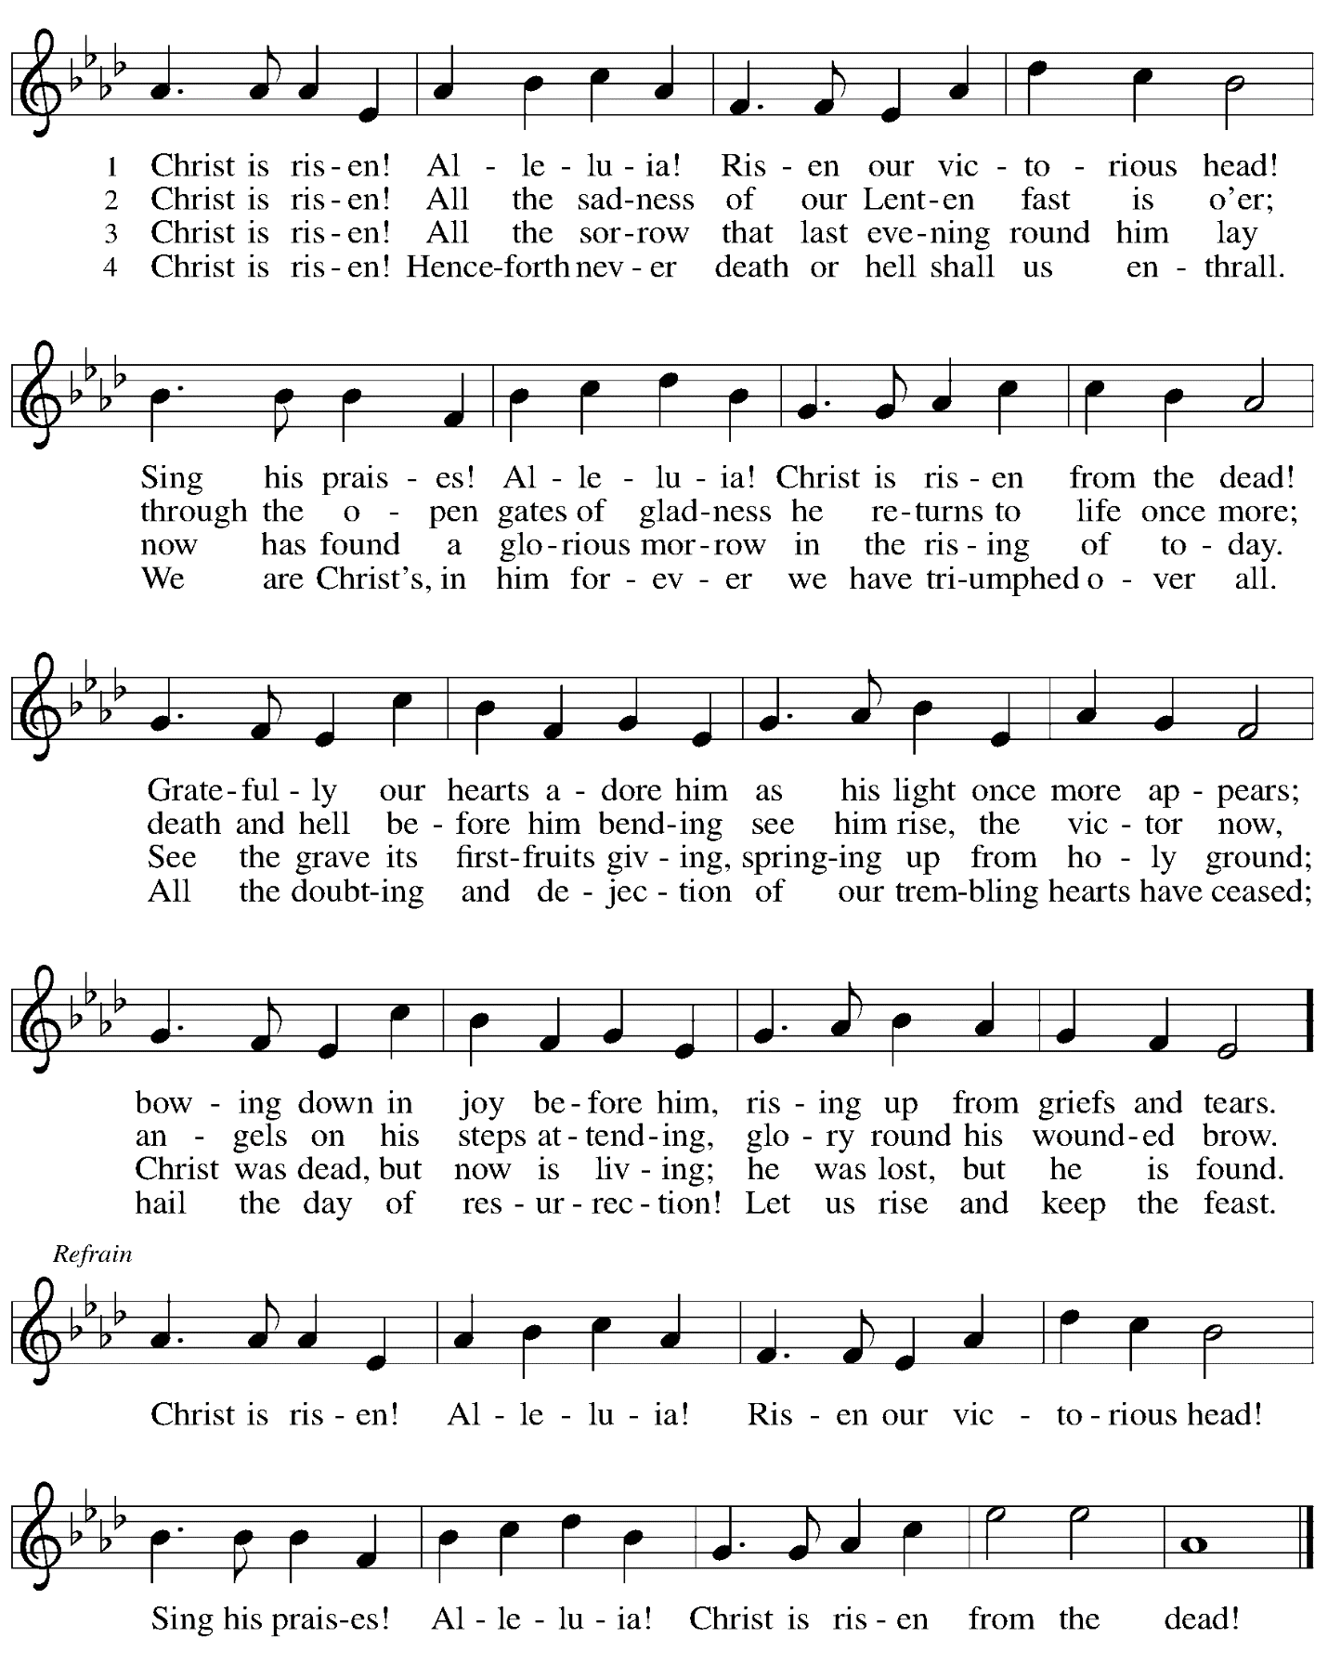

Nicene Creed

C: We believe in one God,
the Father, the Almighty,
maker of heaven and earth,
of all that is, seen and unseen.

We believe in one Lord, Jesus Christ,
the only Son of God,
eternally begotten of the Father,
God from God, Light from Light,
true God from true God,
begotten, not made,
of one Being with the Father;
through him all things were made.
For us and for our salvation
he came down from heaven,
was incarnate of the Holy Spirit and the virgin Mary
and became truly human.
For our sake he was crucified under Pontius Pilate;
he suffered death and was buried.
On the third day he rose again
in accordance with the scriptures;
he ascended into heaven
and is seated at the right hand of the Father.
He will come again in glory to judge the living and the dead,
and his kingdom will have no end.

We believe in the Holy Spirit, the Lord, the giver of life,
who proceeds from the Father and the Son,*
who with the Father and the Son is worshiped and glorified,
who has spoken through the prophets.
We believe in one holy catholic and apostolic church.
We acknowledge one baptism for the forgiveness of sins.
We look for the resurrection of the dead,
and the life of the world to come. Amen.

*Or, “who proceeds from the Father.” The phrase “and the Son” is a later addition to the creed.

Prayers of the People

P: United in the joy and hope of the resurrection, let us pray for the church, the world,
and all who are in need.

After each petition
P: Gracious God,
C: receive our prayer.

P: We lift these prayers to you O God, trusting in your abundant mercy,
through Jesus Christ our risen Savior.
C: Amen.

Peace

The presiding minister and the assembly greet one another in the peace of the risen Christ.
P: The peace of Christ be with you always.
C: And also with you.

The people may greet those around them with a sign of Christ’s peace and may say
Peace be with you or similar words. Please be mindful that not everyone will be comfortable with sharing the peace, so please seek consent before shaking hands or hugging. Other possible ways to share the peace include a simple bow with the verbal greeting of peace, or simply a verbal expression of peace.

When the greetings of peace have concluded, please be seated.

Meal

Offering

We offer ourselves, our gifts, and our faithful service to God.
As the offering is gathered for the mission of the church, including the care of those in need,
the table is set for Holy Communion.

Musical Offering O Praise the Living King! L. Larson
St. Andrew Choir L. van Beethoven

As the gifts are brought forward for presentation, please rise as you are able.

Offertory Song Let the Vineyards ELW 184

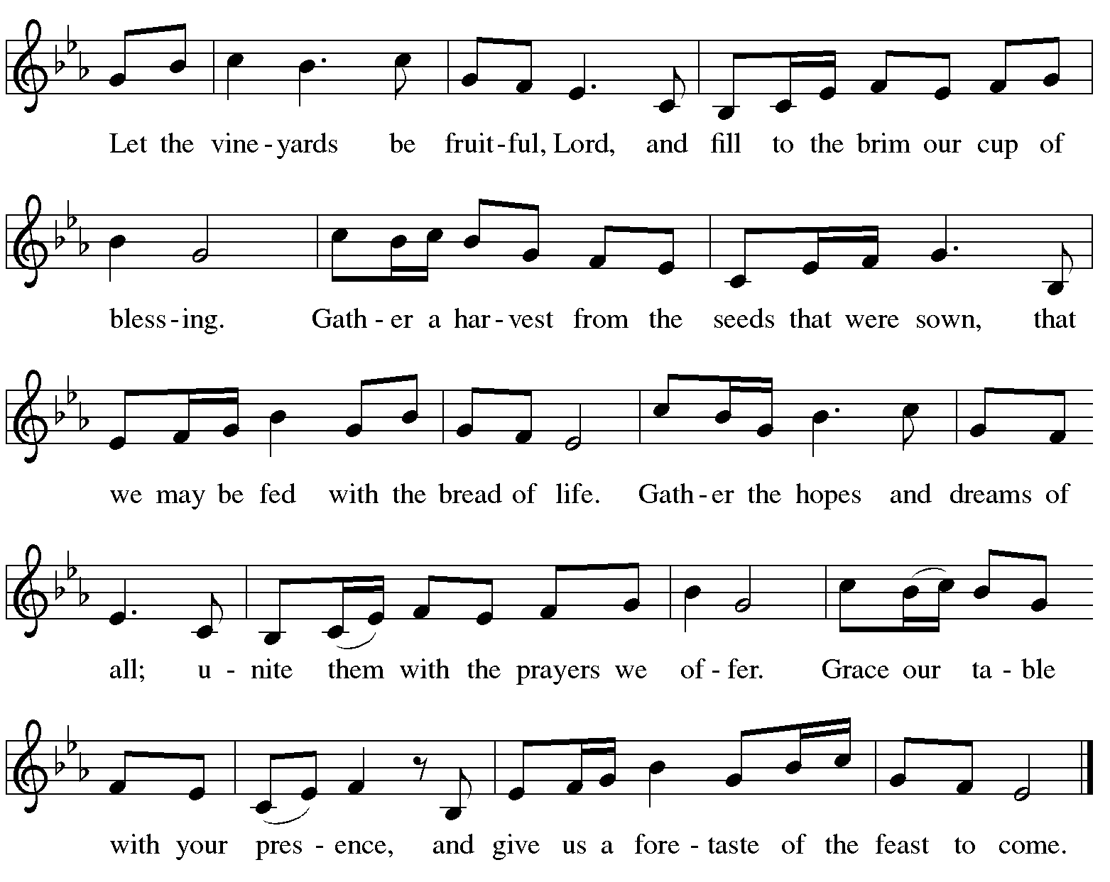

Offertory Prayer

A: Let us pray.
Blessed are you, O God,
C: ruler of heaven and earth.
Day by day you shower us with blessings.
As you have raised us to new life in Christ,
give us glad and generous hearts,
ready to praise you and to respond to those in need,
through Jesus Christ, our Savior and Lord.
Amen.

Dialogue

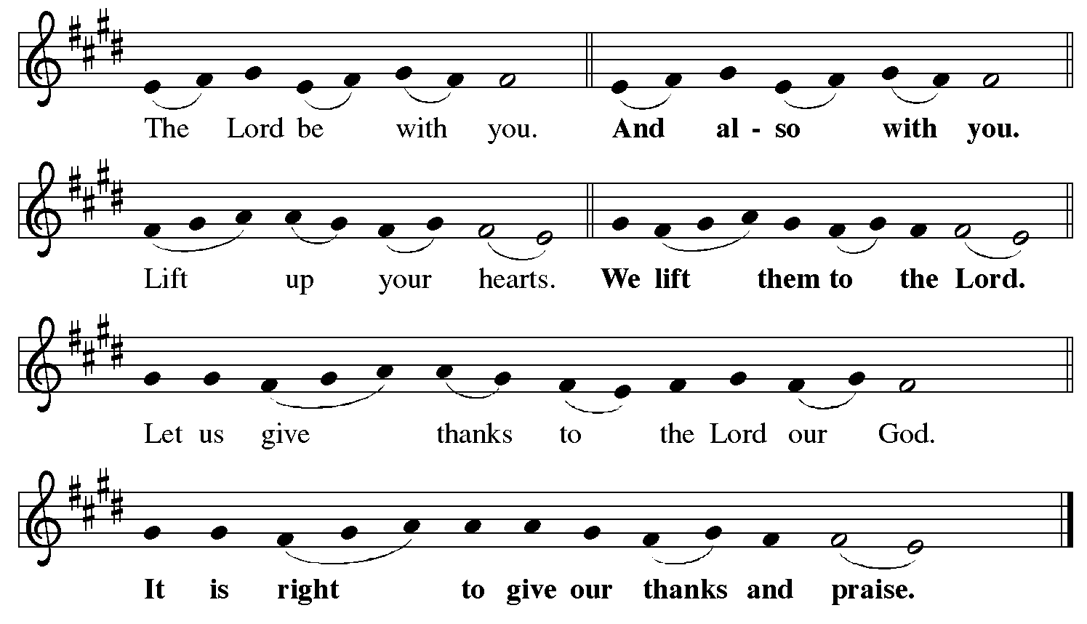

Preface (Sung by the presiding minister)

P: It is indeed right, our duty and our joy,
that we should at all times and in all places
give thanks and praise to you, almighty and merciful God,
for the glorious resurrection of our Savior Jesus Christ,
the true Paschal Lamb who gave himself to take away our sin;
who in dying has destroyed death,
and in rising has brought us to eternal life.
And so, with Mary Magdalene and Peter
and all the witnesses of the resurrection,
with earth and sea and all their creatures,
and with angels and archangels, cherubim and seraphim,
we praise your name and join their unending hymn:

Sanctus

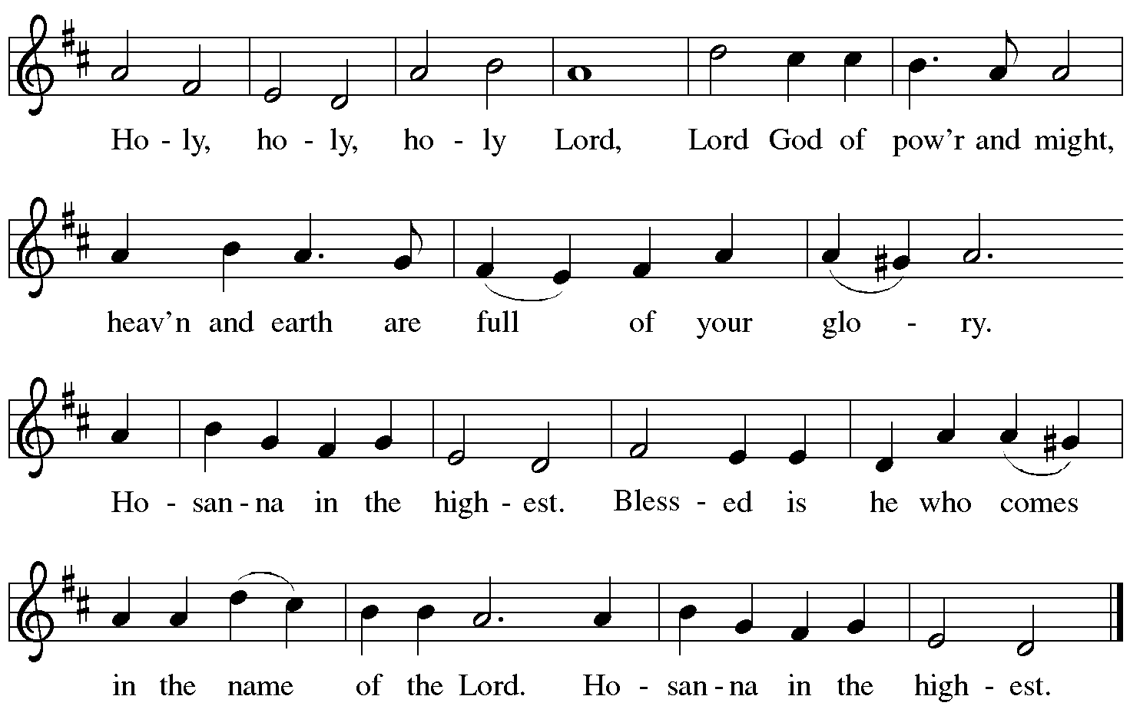

Eucharistic Prayer

P: Blessed are you, O God of the universe …
For Christ is risen:
C: Christ is risen indeed!

P: This is the day on which you gave light to the earth …
and that light is Christ:
C: Thanks be to God.

P: This is the day on which you broke the chains of death …
For Christ is risen:
C: Christ is risen indeed!

P: In the night in which he was betrayed …
… Do this for the remembrance of me.

Let us proclaim the mystery of faith.
C: Christ has died. Christ is risen. Christ will come again.

P: On this day send us the power of your Holy Spirit …
For that light is Christ:
C: Thanks be to God.

P: All holy and mighty and glorious God …
… for Christ is risen:
C: Christ is risen indeed!

P: Amen and Amen!
C: Amen and Amen!

Lord’s Prayer

P: Gathered as one by the Holy Spirit, let us pray as Jesus taught us.
C: Our Father in heaven,
hallowed be your name,
your kingdom come,
your will be done,
on earth as in heaven.
Give us today our daily bread.
Forgive us our sins
as we forgive those
who sin against us.
Save us from the time of trial
and deliver us from evil.
For the kingdom, the power,
and the glory are yours,
now and forever. Amen.

Fraction and Invitation

P: Alleluia! Christ is risen!
C: Christ is risen indeed! Alleluia! Alleluia!

P: This is the feast of victory for our God. Alleluia! Alleluia!
Come, share the feast.

Agnus Dei / Lamb of God Following Page

Agnus Dei / Lamb of God

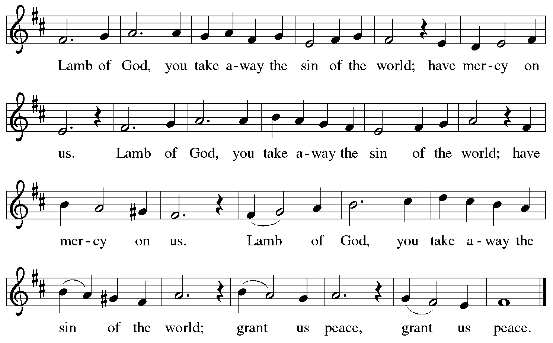

Please be seated.

Holy Communion
- All who seek God and desire a deeper and stronger life in Christ are welcome to receive Holy Communion.
- Worshipers from the pulpit side will proceed forward first, followed by the center section, and then the lectern side.
- Please inform an usher if you would like the ministers to bring Communion to you.
- Holy Communion will be served with bread and wine/grape juice.
- The presiding minister will first distribute the bread (host) to each communicant. Please indicate if you require a gluten-free host.
- Once you have consumed the bread, please pick up an empty glass from the tray next to the presiding minister. The Communion Assistant will pour wine from the chalice or grape juice from the cruet into your glass.
- Please step to the side to consume the wine or grape juice.
- Feel free to kneel at the altar rail for prayer after receiving the sacrament.
- As you return to your pew, glasses may be returned to the empty trays on either side of the center aisle.
- A blessing will be provided for anyone who does not yet receive the sacrament.
- All are invited to join in singing the hymns during Holy Communion.
Hymns during Holy Communion
Alleluia! Jesus Is Risen! ELW 377

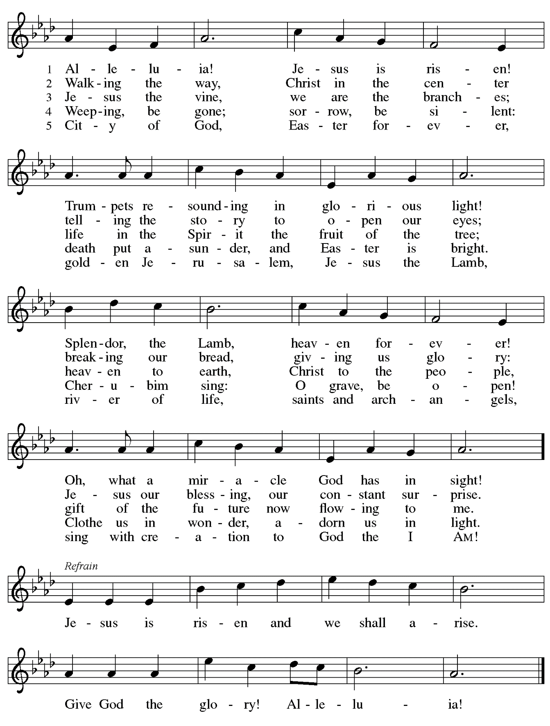

Hymns during Holy Communion
Now the Green Blade Rises ELW 379

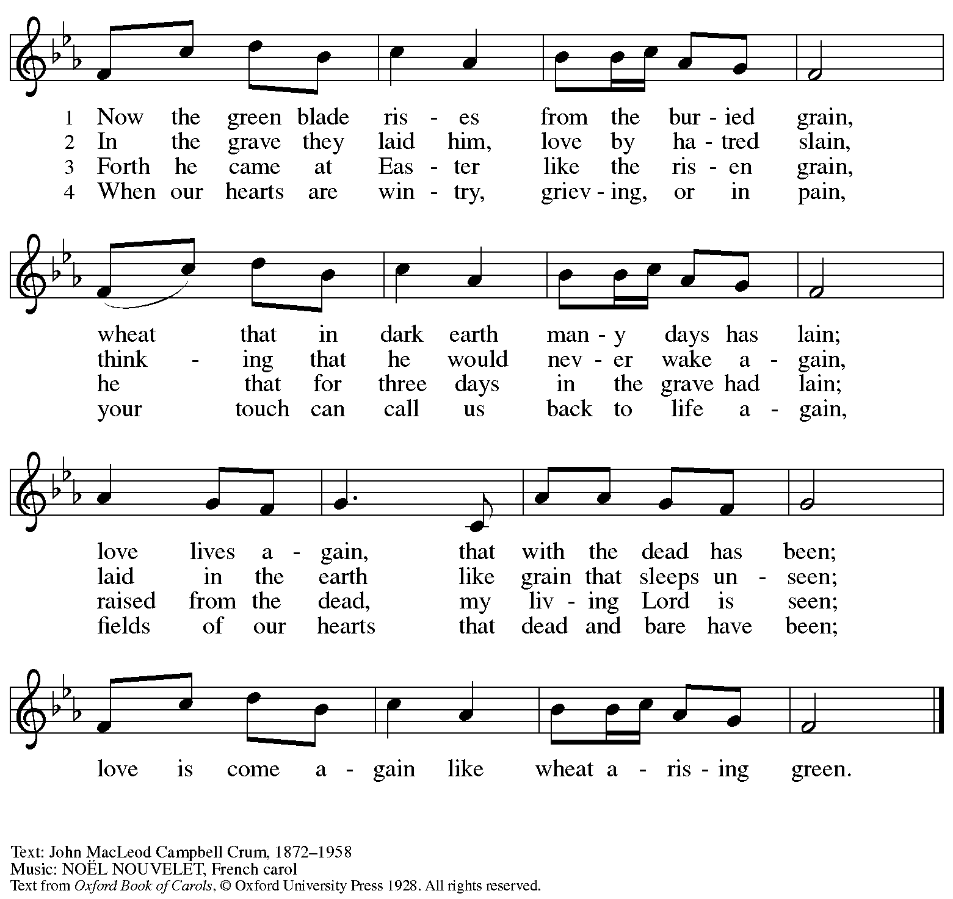
Reprinted with permission under OneLicense.net # A-722139.

Hymn during Holy Communion
Good Christian Friends, Rejoice and Sing! ELW 385

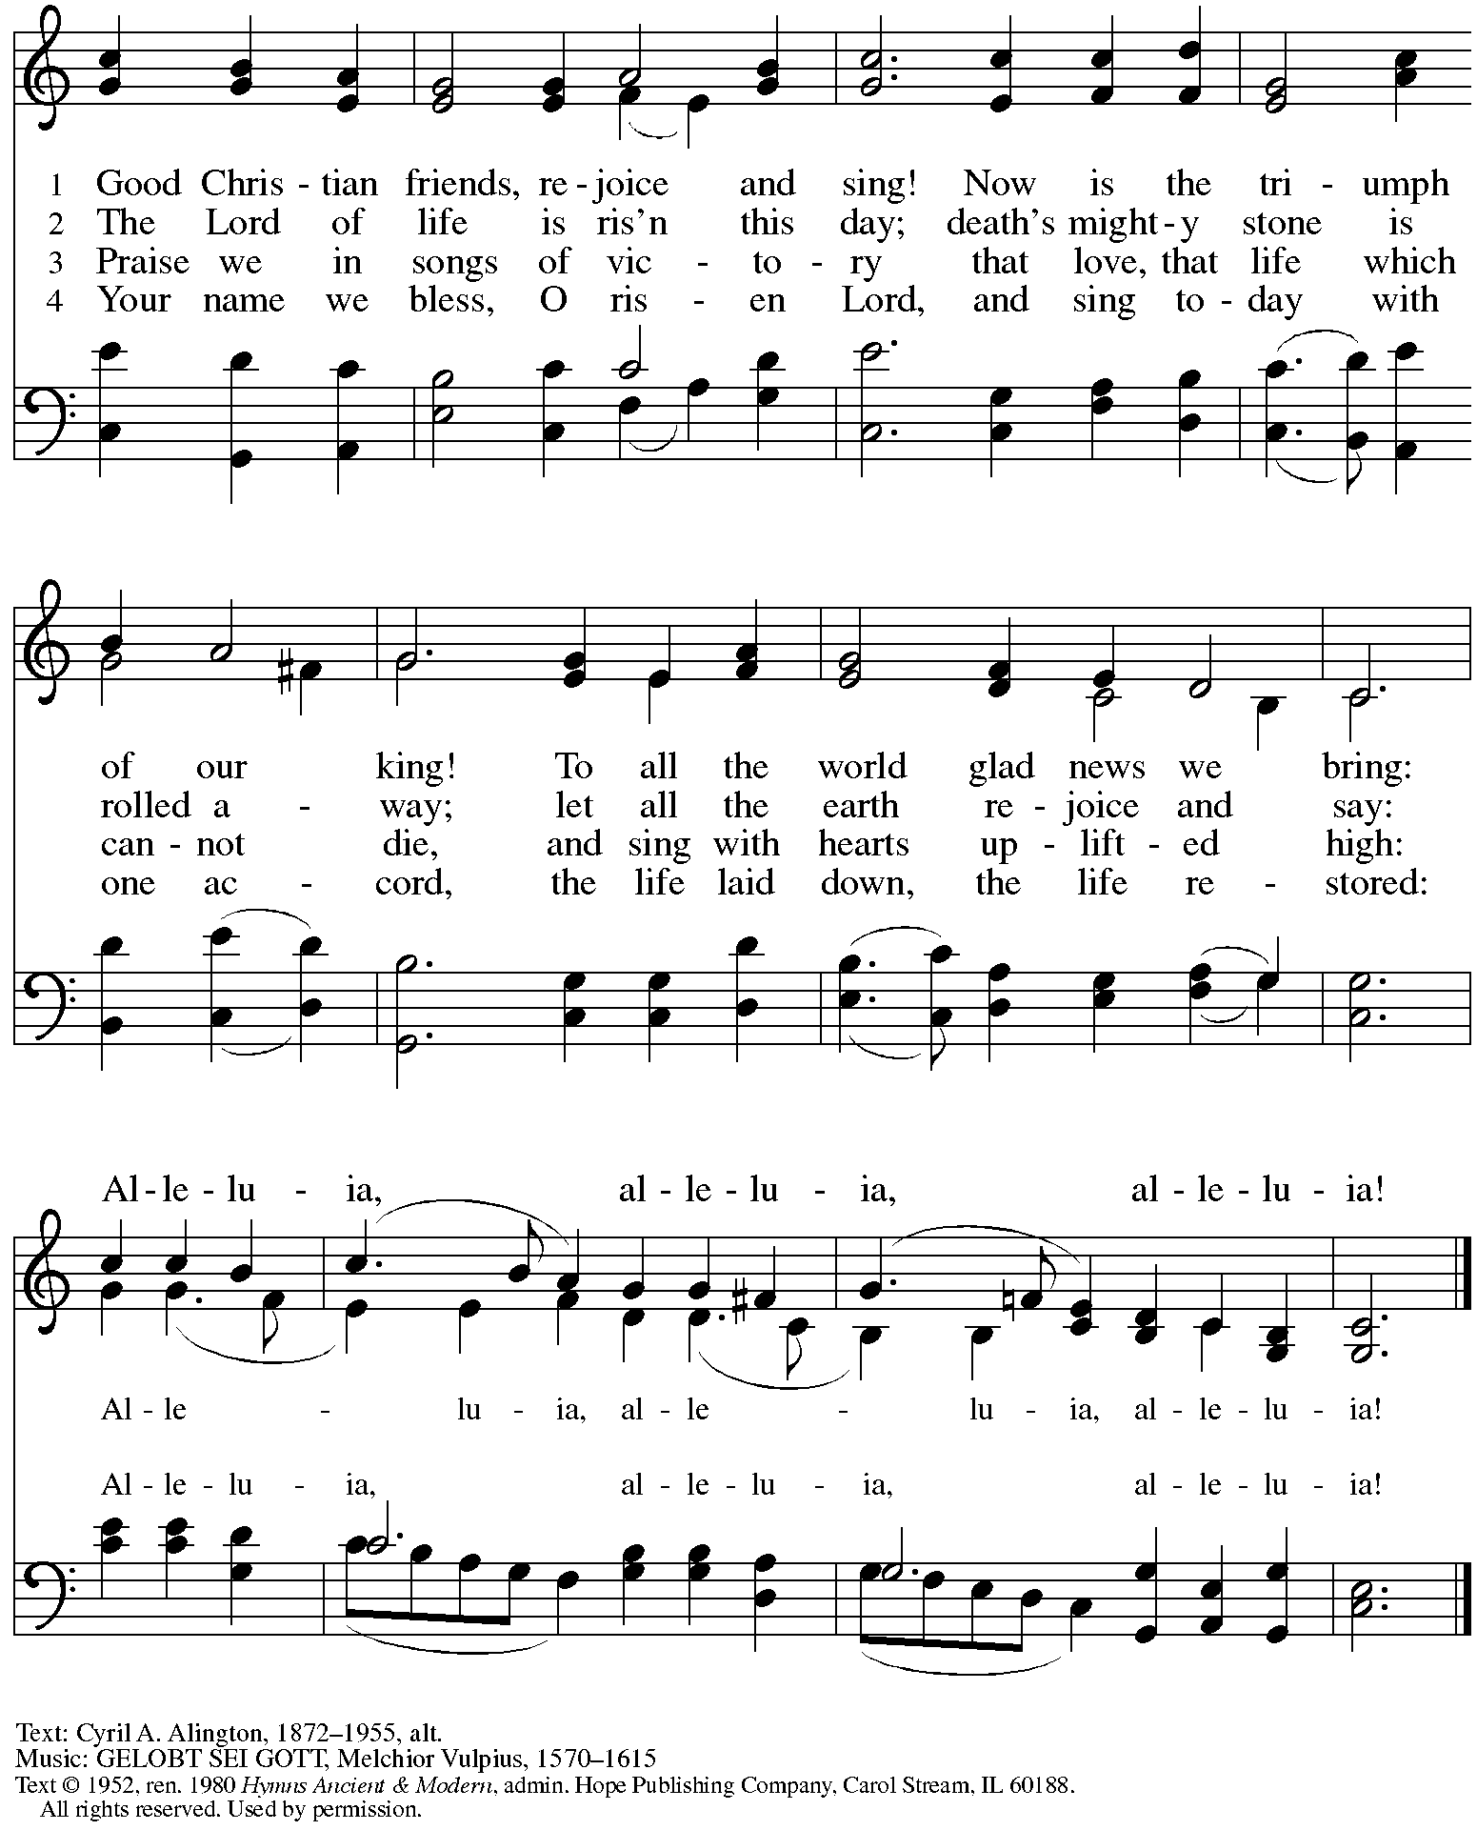
Reprinted under OneLicense.net #A-722139.
Hymns during Holy Communion
This Joyful Eastertide ELW 391

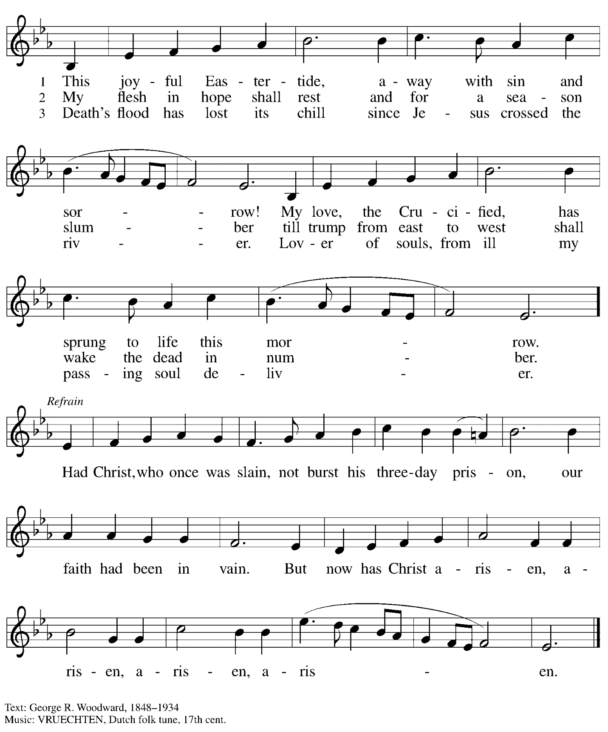

When all have returned to their places, please rise as you are able.

Blessing

P: The body and blood of our Lord Jesus Christ strengthen you and keep you in his grace.
C: Amen.

Prayer

A: Let us pray.
Life-giving God,
in the mystery of Christ’s resurrection, you send light to conquer darkness,
water to give new life, and the bread of life to nourish your people.
Send us forth as witnesses to your Son’s resurrection,
that we may show your glory to all the world,
through Jesus Christ, our risen Lord.
C: Amen.

Sending

Benediction

P: May our glorious God grant you a spirit of wisdom
to know and love the risen Christ.

Almighty God, holy One, ☩ holy Three,
bless you now and forever.
C: Amen.

Recessional Hymn Thine Is the Glory Following page

Dismissal

A: Alleluia! Christ is risen!
C: Christ is risen indeed! Alleluia! Alleluia!

A: Go in peace. Share the good news!
C: Thanks be to God!

Postlude

Recessional Hymn Thine Is the Glory ELW 376

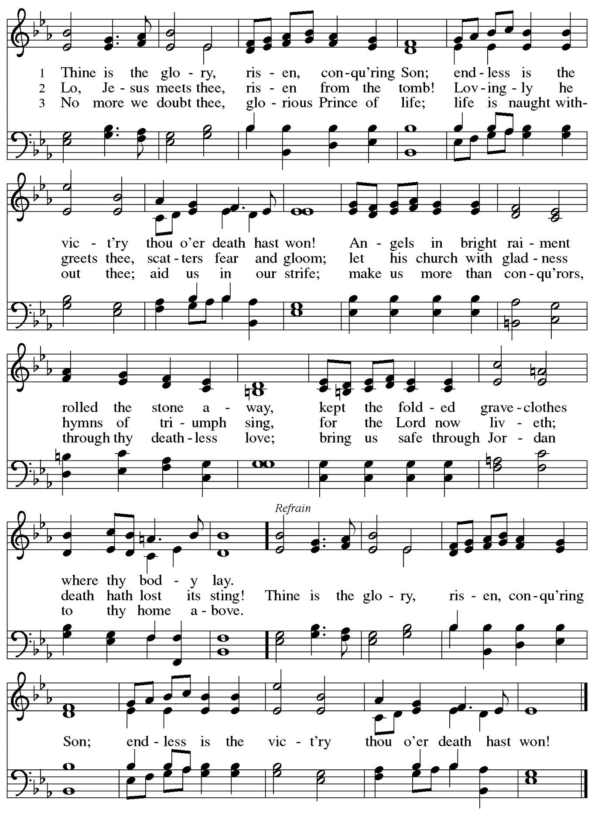
Abbreviations

P: Pastor/Presiding Minister
A: Assisting Minister
L: Lector
C: Congregation

ELW: Evangelical Lutheran Worship hymnal

Those serving in worship today

Altar Care Christy Ruhe
Assisting Minister Colleen Cooke
Audio-Visual Ministers Jason Galyardt
Joseph Paetz
Crucifer Isabel Doshi
Cantor Timothy Kocher-Hillmer
Lector Lester Prince
Clarinet Maria Mangano
Euphonium David Rollinson
French Horn Emily Duque
Trombone Matthew Tesch
Trumpet Steve Browne
Minister of Music Laura Reynolds
Presiding Minister Pastor Ross I. Carmichael

Liturgy and Hymnody Acknowledgements

From SundaysandSeasons.com. Copyright © 2023 Augsburg Fortress. All rights reserved. Reprinted under OneLicense.net # A-722139.
Used by permission of Augsburg Fortress.

Jesus Christ Is Risen Today –Text: Latin carol, 14th cent., sts. 1-3; tr. J. Walsh, Lyra Davidica, 1708, alt.; Charles Wesley, 1707-1788, st. 4. Music: EASTER HYMN, J. Walsh, Lyra Davidica, 1708.

Christ Is Risen! Alleluia! – Text: John S. B. Monsell, 1811-1875, alt. Music: MORGANLIED, Frederick C. Maker, 1844-1927.

Eucharistic Prayer, For the Resurrection of our Lord: Easter Day – Adapted from Pray, Praise, and Give Thanks: A Collection of Litanies, Laments, and Thanksgivings at Font and Table by Gail Ramshaw, copyright © 2017 Augsburg Fortress. All rights reserved. Reprinted with permission.

Let the Vineyards – Text: John W. Arthur, 1922-1980. Music: Ronald A. Nelson, b. 1927. Text and Music © 1978 Lutheran Book of Worship, admin. Augsburg Fortress.

Alleluia! Jesus Is Risen! – Text: Herbert F. Brokering, b. 1926. Music: David N. Johnson, 1922-1987. Text © 1995 Augsburg Fortress. Music © 1969 Contemporary Worship 1, admin. Augsburg Fortress. All rights reserved. Reprinted with permission under OneLicense.net # A722139.

Thine Is the Glory – Text: Edmund Budry, 1854-1932; tr. R Birch Hoyle, 1875-1939. Music: JUDAS MACCABEUS, George Frideric Handel, 1685-1759.

St. Andrew Lutheran Church Announcements
April 9th, 2023

- Happy Easter! Welcome to Worship at St. Andrew on April 9th, 2023, as we celebrate + The Resurrection of our Lord! – We are so glad you are here to share in this festive day, and we offer a special welcome to all visitors and guests who are here for the first time! Masks are optional at St. Andrew when Allegheny County’s Covid-19 community level is in the low and medium categories. Worship attendees are invited to make a name tag at the back of the worship space if you would like. There are worship “toolkits” to help children engage with worship and “busy bags” for younger children available in the bookcase at the back of the sanctuary. Please feel free to take one to use with/for your children. We pray that everyone has a blessed Easter season!
- Shelter Dinner at East End Cooperative Ministry – Thursday, April 20th, 6:30 p.m. – Each month, people of St. Andrew provide dinner for guests of East End Cooperative Ministry, 6140 Station St. (East Liberty), 15206. We invite you to prepare or purchase one menu item and bring it to the shelter by 6:00 p.m., or just come to help serve at 6:30 p.m. If you would like to participate, please sign up here:
- St. Andrew Jail Ministry – St. Andrew has had a long history of participation in the ministry program at the Allegheny County Jail. Until the program was put on hold at the beginning of the Covid pandemic, a group of volunteers from St. Andrew was leading a worship service at the jail on Sunday mornings, typically about one Sunday a month. The jail is hoping to resume this program soon. If any of the previous volunteers are still interested and available, please contact Lester Prince (lprince@comcast.net). New volunteers are also needed. The first step for new volunteers is to complete an online application, which can be accessed here: https://www.foundationofhope.org/get-involved/volunteer-application/. On the application form, indicate that the program that you are interested in volunteering with is “Chaplaincy Worship.” Feel free to contact Lester Prince with any questions.
- St. Andrew Saving Pull Tabs from Cans – St. Andrew continues to save pull tabs from all types of cans. They are recycled by Ronald McDonald House to benefit programs for children and families receiving care at Pittsburgh Children's Hospital. Tabs can be placed in the plastic drawer on the donations table in the social hall.

Easter Flowers Decorating the Chancel Have Been Given

In Appreciation / Love for
Janet by Colleen Cooke
Judy by C.E. Pino

In Honor of My Church Family by C.E. Pino
Susan Elizabeth Henkel by Colleen Cooke
Normae Herald
John T. Lutz and Betty Jean Lutz
Tom and Joan O’Donnell by Pat and John Lutz
St. Andrew’s Musicians by The Rev. Peter and Kristen Asplin

In Memory of John and Mary Bowen
Virginia Brozell by Janet Grzegorczyk
Frank and Marie Curl by Ginny and Tom Leech
Jack and Shirley Hays
Our Parents and Grandparents by Scott and Sue Gaugler
Ray and Leah by The Rev. Peter and Kristen Asplin
Sally, Rose, Sandy, Dorothy, Joe, and Rose
by Michael Smolleck and Arnie Rowlands

