+ Fifth Sunday of Easter
May 7, 2023
St. Andrew Lutheran Church
304 Morewood Ave.
Pittsburgh, PA 15213
St_andrewELCA@verizon.net
www.standrewpittsburgh.org

+ Fifth Sunday of Easter
Order for Worship

As we continue to celebrate the fifty days of Easter, today’s gospel includes Jesus’ promise that he goes to prepare a place for his followers in his Father’s house. Our Baptism commissions us to share Jesus’ mission in the world. As 1 Peter reminds us, we are a holy people, called to proclaim the one who called us out of darkness into light. In words and deeds we bear witness to the risen Christ – our Way, our Truth, our Life.

- Masks are optional at St. Andrew when Covid-19 community level in Allegheny County is in the low and medium categories.

- Worship Services are live streamed to multiple online platforms. By attending worship, you agree that your image and voice may be broadcast.

Welcome to St. Andrew!

- St. Andrew Lutheran congregation welcomes all who are seeking a place of healing and wholeness – a nurturing, faith-forming spiritual home. Our community embraces people of all ages, ethnicities, cultures, abilities, sexual orientations, gender identities and expressions, and family constellations. Come and See!

- Everyone is invited to make a nametag at the black bookcase in the back of the worship space if they would like. There are stickers indicating pronouns on the bookcase if you would like to include them on your name tag.

- Children are invited to attend Little Church – Big Faith, a Bible lesson and activity, during worship (after the Prayer of the Day). The group returns to the worship space for the liturgy of Holy Communion.

- Worship “toolkits” to help children engage with the service, along with “busy bags” for younger children, are available in the bookcase at the back of the sanctuary. Please feel free to take one to use with/for your children.

- Holy Communion is served with bread (gluten-free available) and wine or grape juice. The presiding minister will distribute the bread (host). Please consume this and then pick up an empty glass from the tray. The Communion Assistant will pour wine or grape juice into your glass. Please step to the side to consume the wine or grape juice. Feel free to kneel at the altar for prayer and reflection. As you return to your pew, glasses may be returned to the empty trays on either side of the center aisle.

- A restroom is available on the main level of the church, through the doors to the Social Hall and to the right in the main office.

Pre-Service Music

Welcome

Prelude

Gathering
The Holy Spirit calls us together as the people of God

Confession and Forgiveness

Please rise as you are able.
All may make the sign of the cross, the sign that is marked at Baptism,
as the presiding minister begins.

P: Blessed be the holy Trinity,
☩ one God,
who creates, redeems, and sustains us
and all of creation.
C: Amen.

P: Let us confess our sin in the presence of God and of one another.

Silence is kept for reflection

P: To you, O God,
C: all hearts are open, to you all desires known.
We come to you, confessing our sins.
Forgive us in your mercy, and remember us in your love.
Show us your ways; teach us your paths; and lead us in justice and truth,
for the sake of your goodness in Jesus Christ our Savior.
Amen.

P: By water and the Holy Spirit God gives you a new birth,
and through the death and resurrection of ☩ Jesus Christ,
God forgives you all your sins.
The God of mercy and might strengthen you in all goodness
and keep you in eternal life.
C: Amen.

Gathering Hymn Hallelujah! Jesus Lives! ELW 380

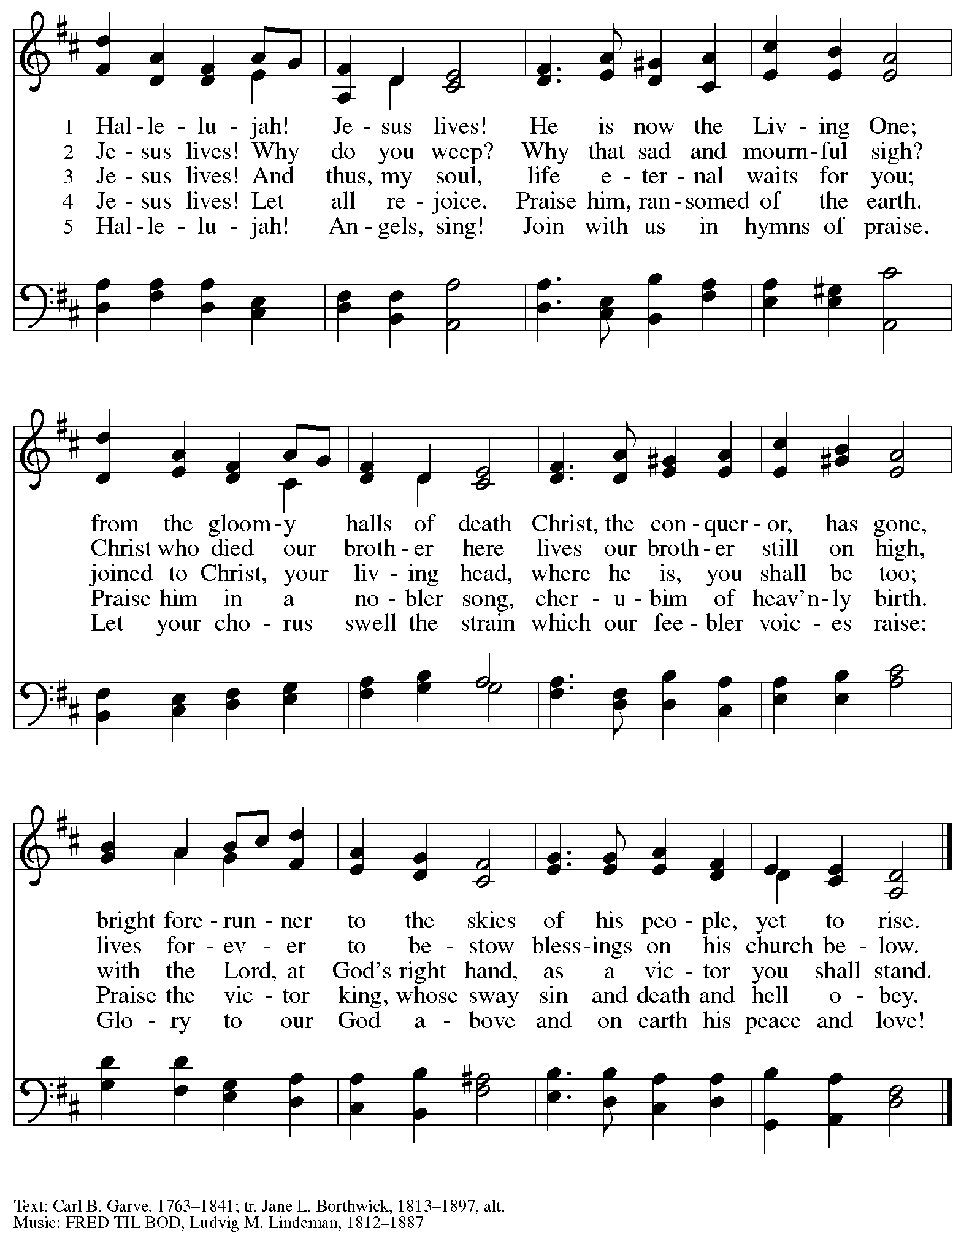

Greeting

P: The grace of our Lord Jesus Christ, the love of God,
and the communion of the Holy Spirit be with you all.
C: And also with you.

Hymn of Praise Now the Feast and Celebration HS p. 4-5

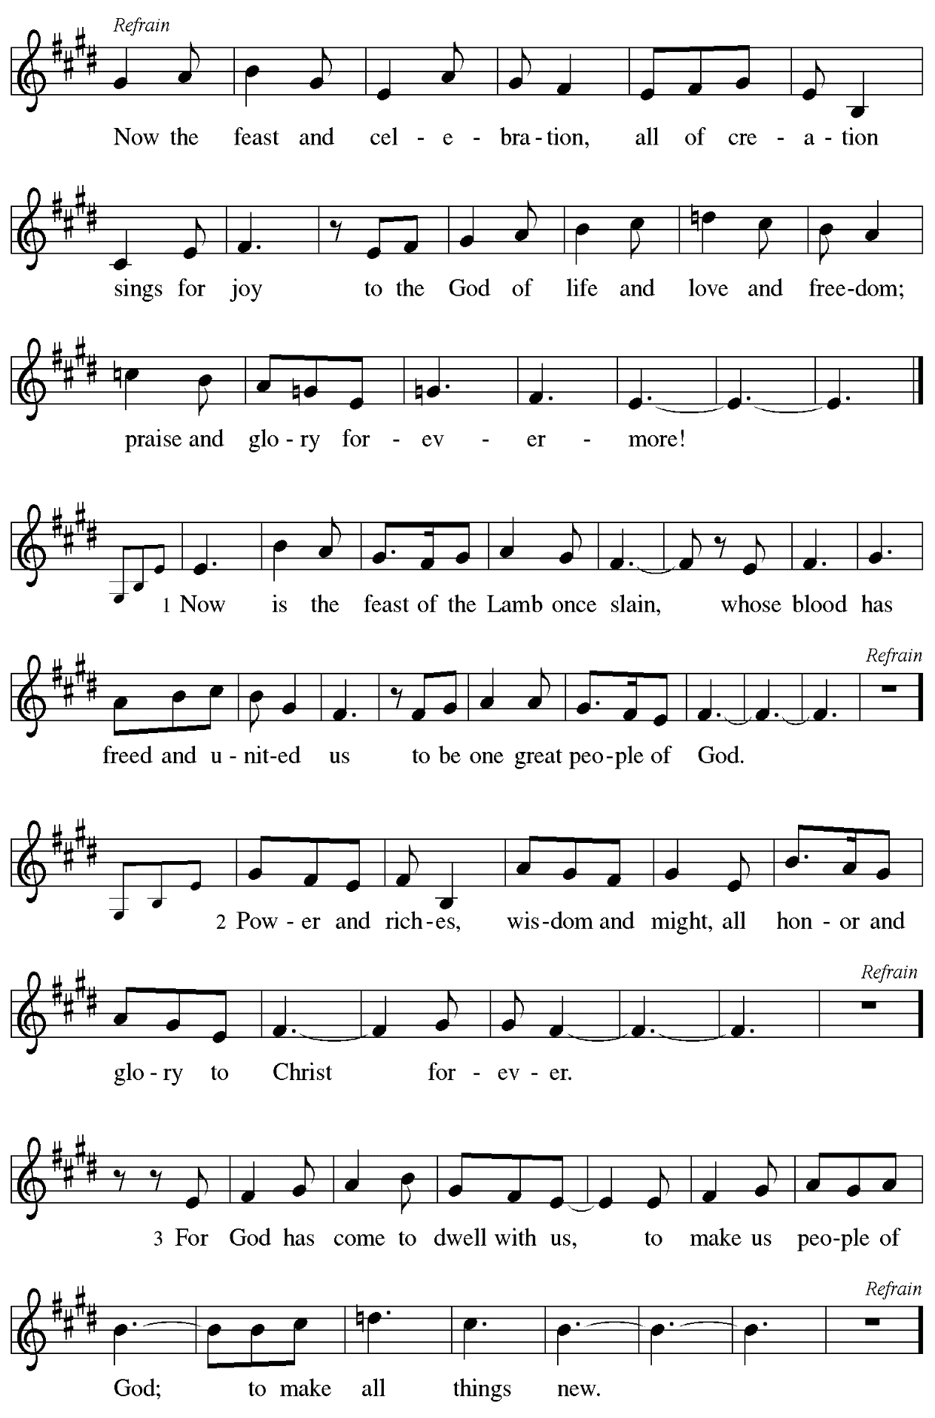

Prayer of the Day

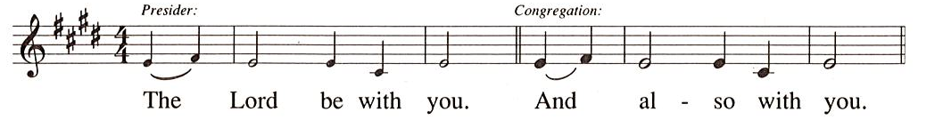

P: Let us pray.
Almighty God,
your Son Jesus Christ is the Way, the Truth, and the Life.
Give us grace to love one another, to follow in the way of his commandments,
and to share his risen life with all the world, for he lives and reigns
with you and the Holy Spirit, one God, now and forever.
C: Amen.

Please be seated.
Children are invited to join the adult leaders at the door and move to the office for Little Church – Big Faith. We ask that one additional adult from the congregation attend with the children.

Word
God speaks to us in Scripture reading, preaching, and song

First Reading – Acts 7: 55-60

⁵⁵Filled with the Holy Spirit, [Stephen] gazed into heaven and saw the glory of God and Jesus standing at the right hand of God. ⁵⁶“Look,” he said, “I see the heavens opened and the Son of Humanity standing at the right hand of God!” ⁵⁷But they covered their ears, and with a loud shout all rushed together against him. ⁵⁸Then they dragged him out of the city and began to stone him; and the witnesses laid their coats at the feet of a young man named Saul. ⁵⁹While they were stoning Stephen, he prayed, “Lord Jesus, receive my spirit.” ⁶⁰Then he knelt down and cried out in a loud voice, “Lord, do not hold this sin against them.” When he had said this, he died.

L: Word of God, word of life.
C: Thanks be to God.

Psalm 31: 1-5, 15-16

The psalm will be sung by the cantor,
with the congregation invited to join in singing the verses in bold and the refrain.

Psalm tone

Psalm refrain

¹In you, O Lord, have I taken refuge; let me never be | put to shame;
deliver me | in your righteousness.
²Incline your | ear to me;
make haste to de- | liver me.
³Be my strong rock, a castle to keep me safe, for you are my crag | and my stronghold;
for the sake of your name, lead | me and guide me.
⁴Take me out of the net that they have secretly | set for me,
for you are my tow- | er of strength. R
⁵Into your hands I com- | mend my spirit,
for you have redeemed me, O Lord, | God of truth.
¹⁵My times are | in your hand;
rescue me from the hand of my enemies, and from those who | persecute me.
¹⁶Let your face shine up- | on your servant;
save me in your | steadfast love.” R

Second Reading – 1 Peter 2: 19-25

²Like newborn infants, long for the pure, spiritual milk, so that by it you may grow into salvation—³if indeed you have tasted that the Lord is good.
⁴Come to him, a living stone, though rejected by mortals yet chosen and precious in God’s sight, and ⁵like living stones, let yourselves be built into a spiritual house, to be a holy priesthood, to offer spiritual sacrifices acceptable to God through Jesus Christ.

⁶For it stands in scripture:
“See, I am laying in Zion a stone,
a cornerstone chosen and precious;
and whoever believes in him will not be put to shame.”
⁷To you then who believe, he is precious; but for those who do not believe,
“The stone that the builders rejected
has become the very head of the corner,”
⁸and
“A stone that makes them stumble,
and a rock that makes them fall.”
They stumble because they disobey the word, as they were destined to do.
⁹But you are a chosen race, a royal priesthood, a holy nation, God’s own people, in order that you may proclaim the mighty acts of the one who called you out of darkness into God’s marvelous light.
¹⁰Once you were not a people,
but now you are God’s people;
once you had not received mercy,
but now you have received mercy.

L: Word of God, word of life.
C: Thanks be to God.

Please rise as you are able.

Gospel Acclamation

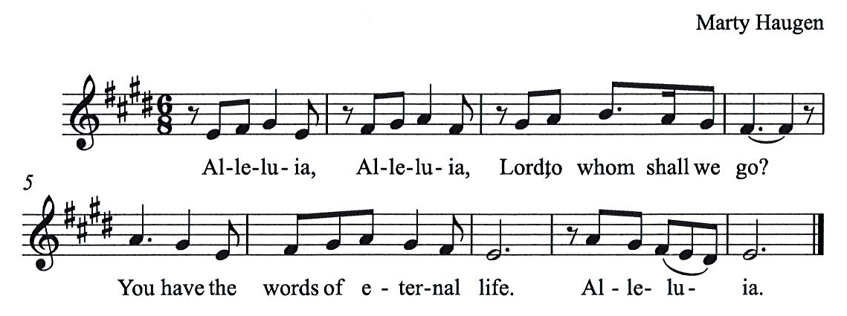

Gospel – John 14: 1-14

P: The holy Gospel according to St. John.
C: Glory to you, O Lord.

[Jesus said to the disciples:] ¹“Do not let your hearts be troubled. Believe in God, believe also in me. ²In my Father’s house there are many dwelling places. If it were not so, would I have told you that I go to prepare a place for you? ³And if I go and prepare a place for you, I will come again and will take you to myself, so that where I am, there you may be also. ⁴And you know the way to the place where I am going.” ⁵Thomas said to him, “Lord, we do not know where you are going. How can we know the way?” ⁶Jesus said to him, “I am the way, and the truth, and the life. No one comes to the Father except through me. ⁷If you know me, you will know my Father also. From now on you do know him and have seen him.”
⁸Philip said to him, “Lord, show us the Father, and we will be satisfied.” ⁹Jesus said to him, “Have I been with you all this time, Philip, and you still do not know me? Whoever has seen me has seen the Father. How can you say, ‘Show us the Father’? ¹⁰Do you not believe that I am in the Father and the Father is in me? The words that I say to you I do not speak on my own; but the Father who dwells in me does his works. ¹¹Believe me that I am in the Father and the Father is in me; but if you do not, then believe me because of the works themselves. ¹²Very truly, I tell you, the one who believes in me will also do the works that I do and, in fact, will do greater works than these, because I am going to the Father. ¹³I will do whatever you ask in my name, so that the Father may be glorified in the Son. ¹⁴If in my name you ask me for anything, I will do it.”

P: The Gospel of the Lord.
C: Praise to you, O Christ.

Please be seated.

Sermon

A time of silence for prayer and reflection follows the sermon.
When the hymn of the day begins, please rise as you are able.

Hymn of the Day You Are the Way Following page

Hymn of the Day You Are the Way ELW 758

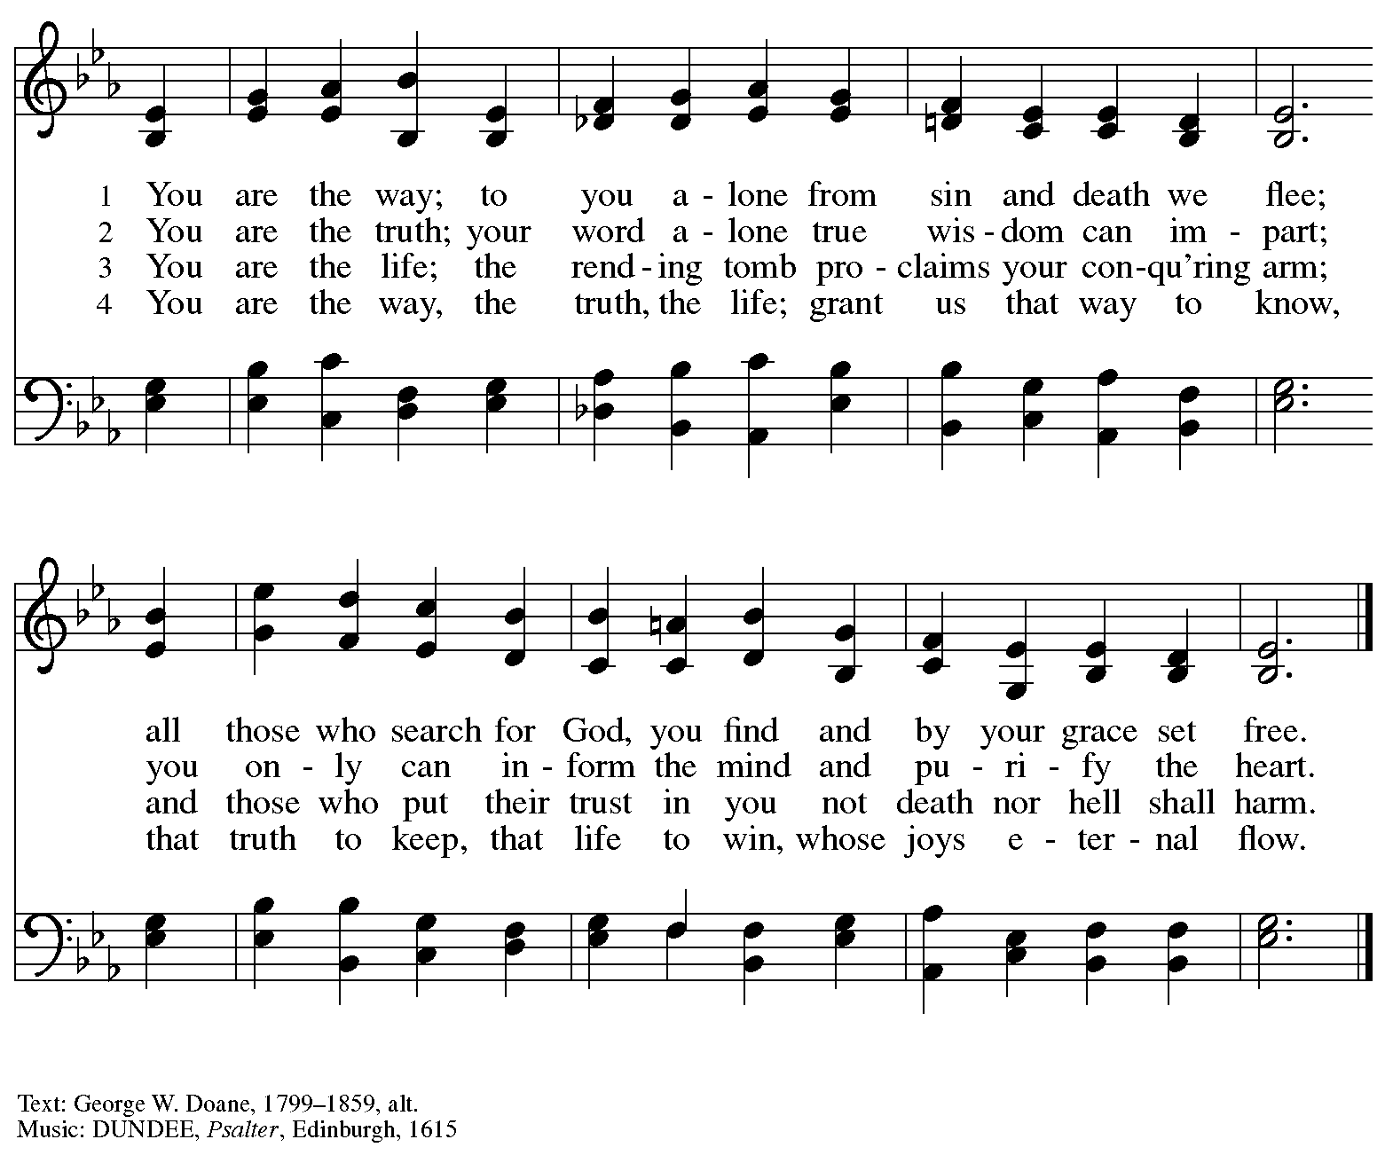

Nicene Creed

C: We believe in one God,
the Father, the Almighty,
maker of heaven and earth,
of all that is, seen and unseen.

We believe in one Lord, Jesus Christ,
The only Son of God,
eternally begotten of the Father,
God from God, Light from Light,
true God from true God,
begotten, not made,
of one Being with the Father;
through him all things were made.
For us and for our salvation
he came down from heaven,
was incarnate of the Holy Spirit and the virgin Mary
and became truly human.
For our sake he was crucified under Pontius Pilate;
he suffered death and was buried.
On the third day he rose again
in accordance with the scriptures;
he ascended into heaven
and is seated at the right hand of the Father.
He will come again in glory to judge the living and the dead,
and his kingdom will have no end.

We believe in the Holy Spirit, the Lord, the giver of life,
who proceeds from the Father and the Son,*
who with the Father and the Son is worshiped and glorified,
who has spoken through the prophets.
We believe in one holy catholic and apostolic church.
We acknowledge one baptism for the forgiveness of sins.
We look for the resurrection of the dead,
and the life of the world to come. Amen.

*Or, “who proceeds from the Father.” The phrase “and the Son” is a later addition to the creed.

Prayers of the People

P: United in the joy and hope of the resurrection, let us pray for the church, the world,
and all who are in need.

After each petition
P: Gracious God,
C: receive our prayer.

The presiding minister concludes the prayers
P: We lift these prayers to you O God, trusting in your abundant mercy,
through Jesus Christ our risen Savior.
C: Amen.

Peace

The presiding minister and the assembly greet one another in the peace of the risen Christ.
P: The peace of Christ be with you always.
C: And also with you.

The people may greet those around them with a sign of Christ’s peace and may say
Peace be with you or similar words. Please be mindful that not everyone will be comfortable with sharing the peace, so please seek consent before shaking hands or hugging. Other possible ways to share the peace include a simple bow with the verbal greeting of peace, or simply a verbal expression of peace.

When the greetings of peace have concluded, please be seated.

Meal
God feeds us with the presence of Jesus Christ

Offering

We offer ourselves, our gifts, and our faithful service to God.
As the offering is gathered for the mission of the church, including the care of those in need,
the table is set for Holy Communion.

Music during the Offering

As the gifts are brought forward for presentation, please rise as you are able.

Offertory Song As the Grains of Wheat ELW 465

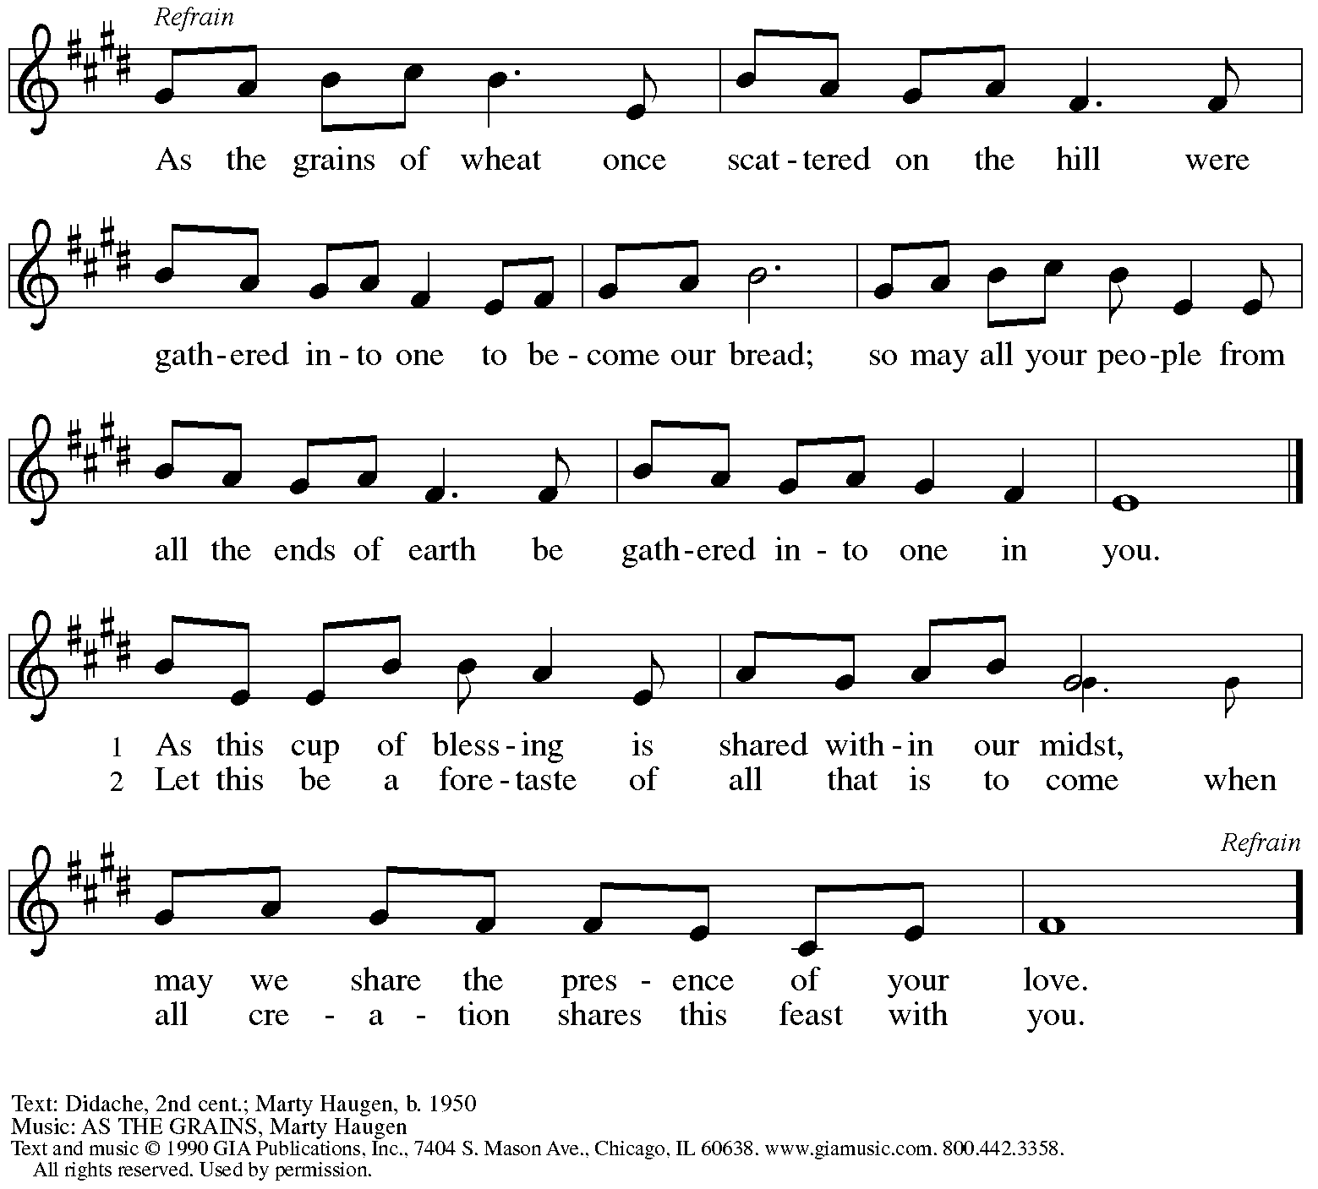
Reprinted under OneLicense.net # A-722139.

Offertory Prayer

P: Let us pray.
Blessed are you, O God,
C: ruler of heaven and earth.
Day by day you shower us with blessings.
As you have raised us to new life in Christ,
give us glad and generous hearts,
ready to praise you and to respond to those in need,
through Jesus Christ, our Savior and Lord.
Amen.

Dialogue HS p. 14

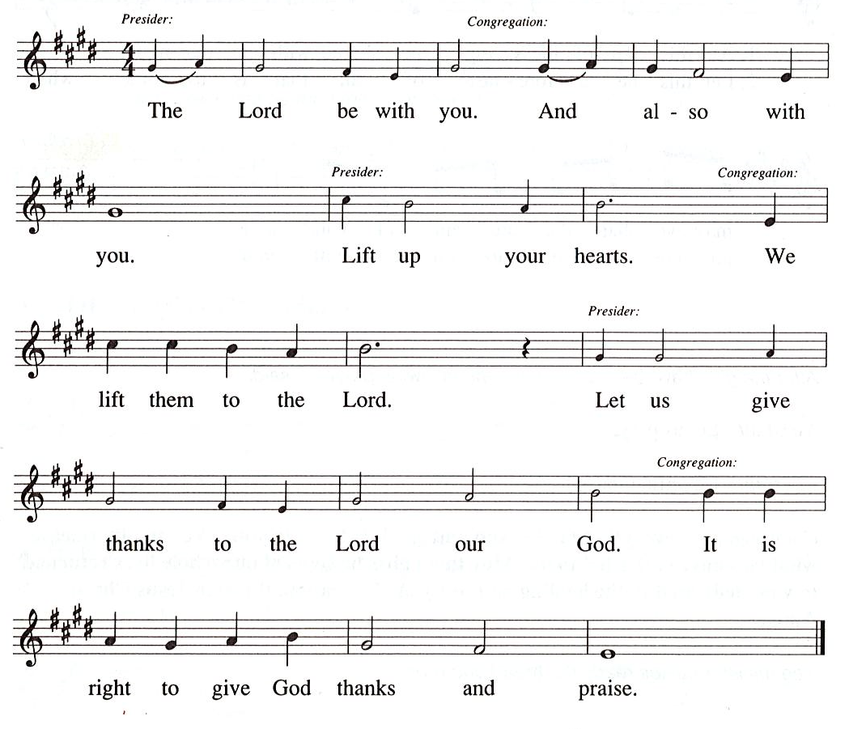

Preface (Sung by the presiding minister)

P: It is our duty and delight
that we should everywhere and always
offer thanks and praise to you, O God,
through Jesus Christ,
who by his death on the cross
and his glorious resurrection
broke the bonds of sin and death
and gave life to all creation.
And so with the church on earth,
all creation and the hosts of heaven,
we praise your name and join their unending hymn:

Sanctus HS p. 15

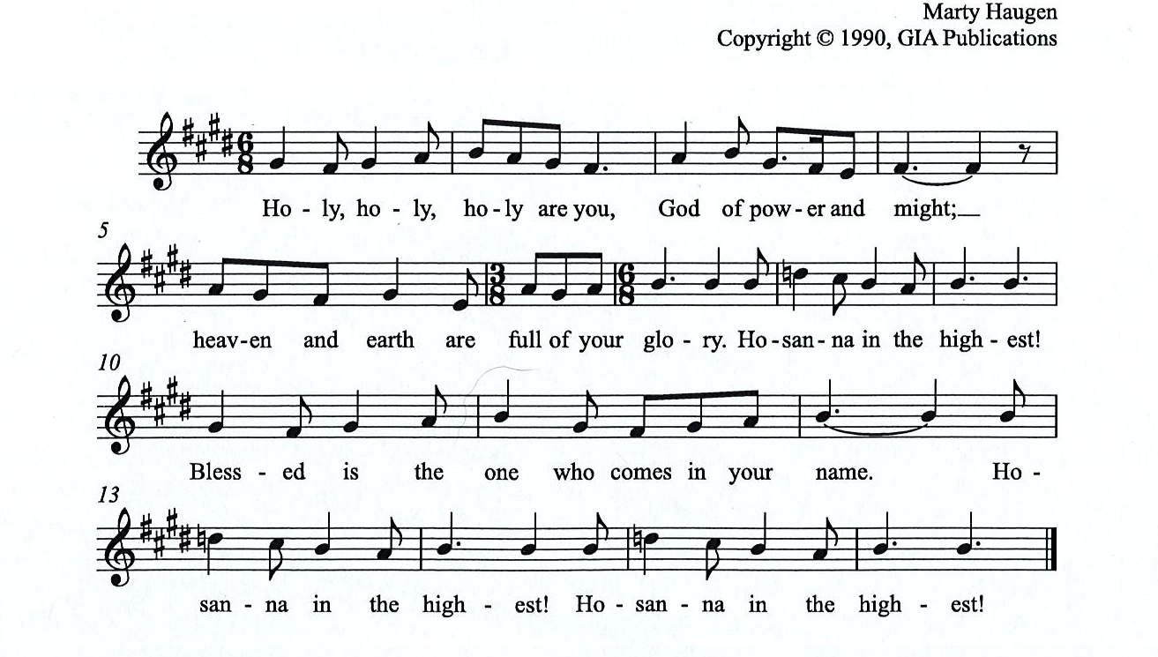

Eucharistic Prayer

P: You are indeed holy, almighty and merciful God, …
… Do this for the remembrance of me.

For as often as we eat of this bread and drink from this cup,
we proclaim the Lord’s death until he comes.

(Presiding minister sings)
Christ has died. Christ is risen. Christ will come, come again.
C:
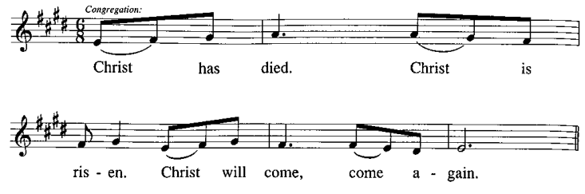
P: Remembering, therefore, his salutary command, …
… and be given our inheritance with all your saints.

To you, O God, Father, Son, and Holy Spirit,
be all honor and glory in your holy church, now and forever.
C:
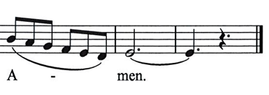

Lord’s Prayer

P: Gathered as one by the Holy Spirit, let us pray as Jesus taught us.
C: Our Father in heaven,
hallowed be your name,
your kingdom come,
your will be done,
on earth as in heaven.
Give us today our daily bread.
Forgive us our sins
as we forgive those
who sin against us.
Save us from the time of trial
and deliver us from evil.
For the kingdom, the power,
and the glory are yours,
now and forever. Amen.

Fraction and Invitation

P: Alleluia! Christ is risen!
C: Christ is risen indeed! Alleluia! Alleluia!

P: This is the feast of victory for our God. Alleluia! Alleluia!
Come, share the feast.

Agnus Dei / Lamb of God Following Page

Agnus Dei / Lamb of God HS p. 18

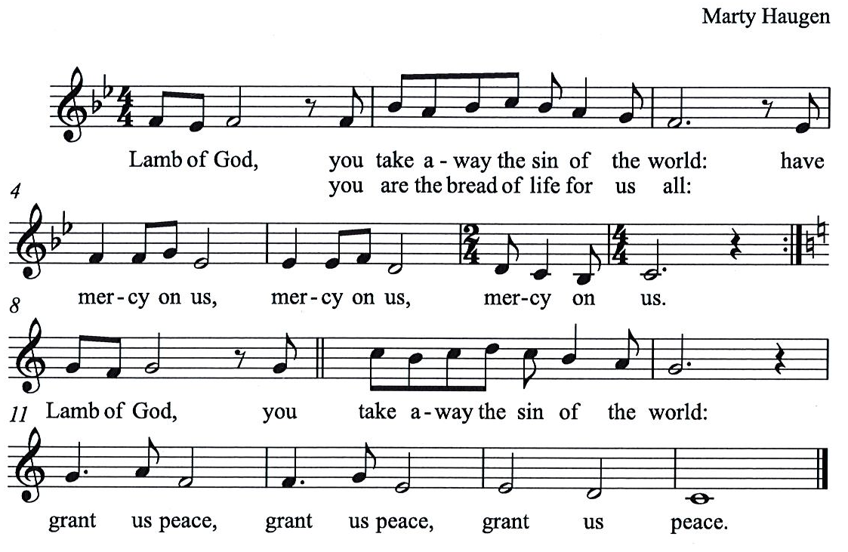

Please be seated.

Holy Communion
- All who seek God and desire a deeper and stronger life in Christ are welcome to receive Holy Communion.
- Worshipers from the pulpit side will proceed forward first, followed by the center section, and then the lectern side.
- Please inform an usher if you would like the ministers to bring Communion to you.
- Holy Communion will be served with bread and wine/grape juice.
- The presiding minister will first distribute the bread (host) to each communicant. Please indicate if you require a gluten-free host.
- Once you have consumed the bread, please pick up an empty glass from the tray next to the presiding minister. The Communion Assistant will pour wine from the chalice or grape juice from the cruet into your glass.
- Please step to the side to consume the wine or grape juice.
- Feel free to kneel at the altar rail for prayer after receiving the sacrament.
- As you return to your pew, glasses may be returned to the empty trays on either side of the center section.
- A blessing will be provided for anyone who does not yet receive the sacrament.
- All are invited to join in singing the hymns during Holy Communion.

Hymns during Holy Communion
I Received the Living God ELW 477

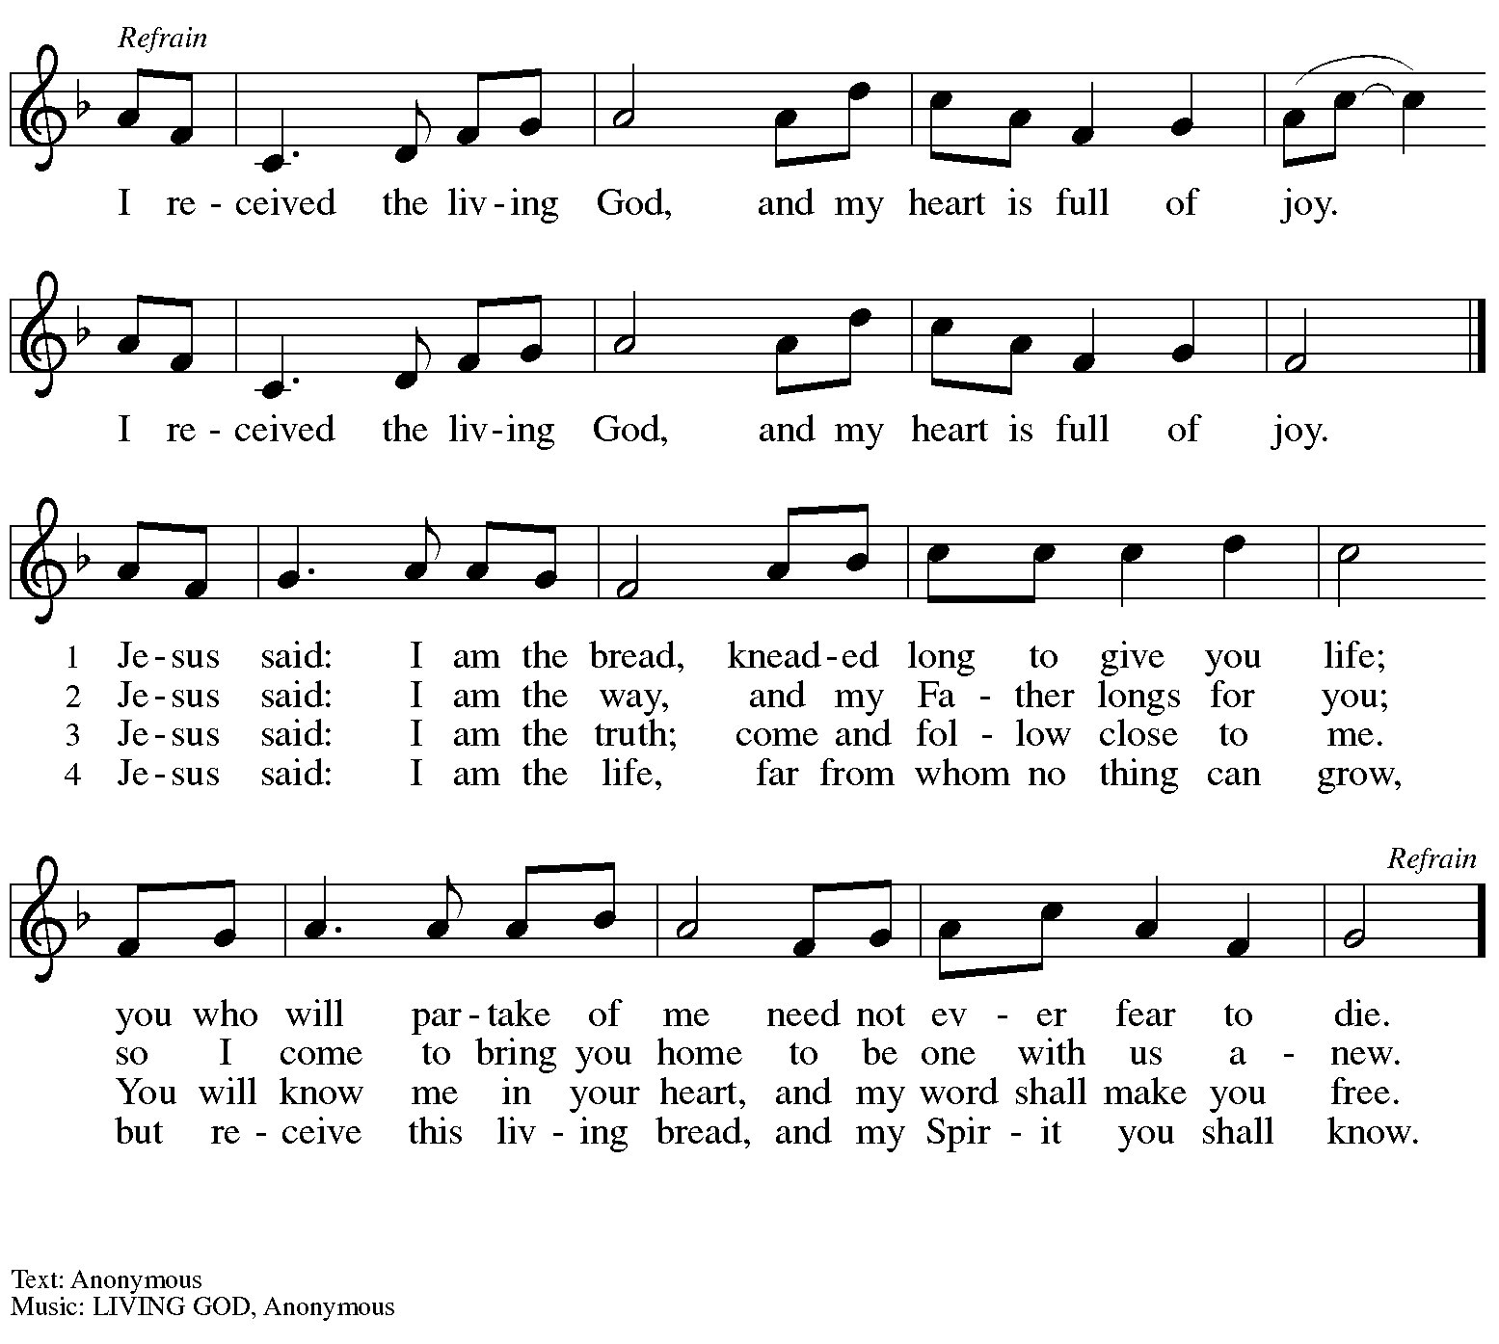

Hymns during Holy Communion
Come to the Table ELW 481

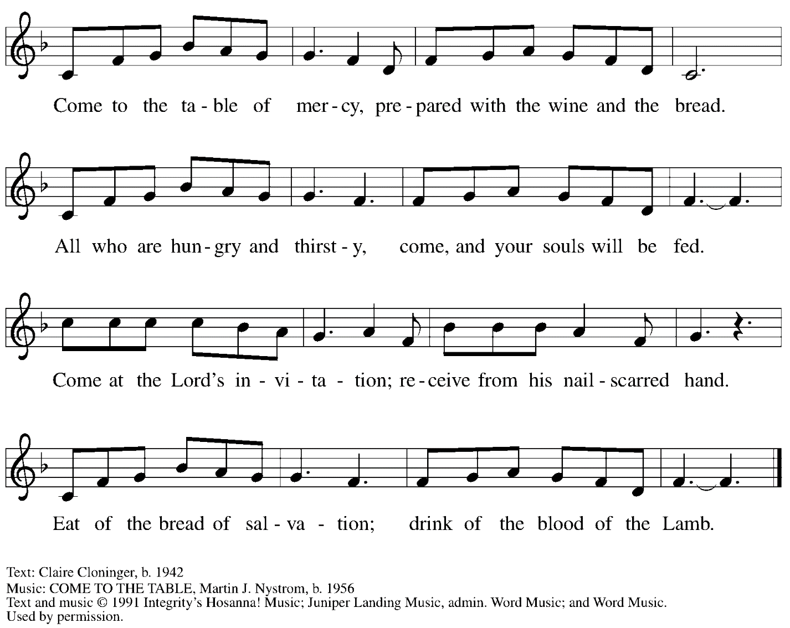
All rights reserved. Reprinted with permission under OneLicense.net # A-722139.

When all have returned to their places, please rise as you are able.

Blessing

P: The body and blood of our Lord Jesus Christ strengthen you and keep you in his grace.
C: Amen.

Prayer

P: Let us pray. Life-giving God,
in the mystery of Christ’s resurrection,
you send light to conquer darkness,
water to give new life,
and the bread of life to nourish your people.
Send us forth as witnesses to your Son’s resurrection,
that we may show your glory to all the world,
through Jesus Christ, our risen Lord.
C: Amen.

Please be seated.

Sending
God blesses us and sends us in mission to the world

Announcements

Please rise as you are able.

Benediction

P: May our glorious God grant you a spirit of wisdom
to know and love the risen Christ.

Almighty God, holy One, ☩ holy Three,
bless you now and forever.
C:
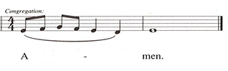

Sending Hymn I Know that My Redeemer Lives! Following Page

Dismissal

P: Alleluia! Christ is risen!
C: Christ is risen indeed! Alleluia! Alleluia!

P: Go in peace. Share the good news!
C: Thanks be to God!

Postlude

Sending Hymn I Know that My Redeemer Lives! ELW 619
v. 1-2, 4

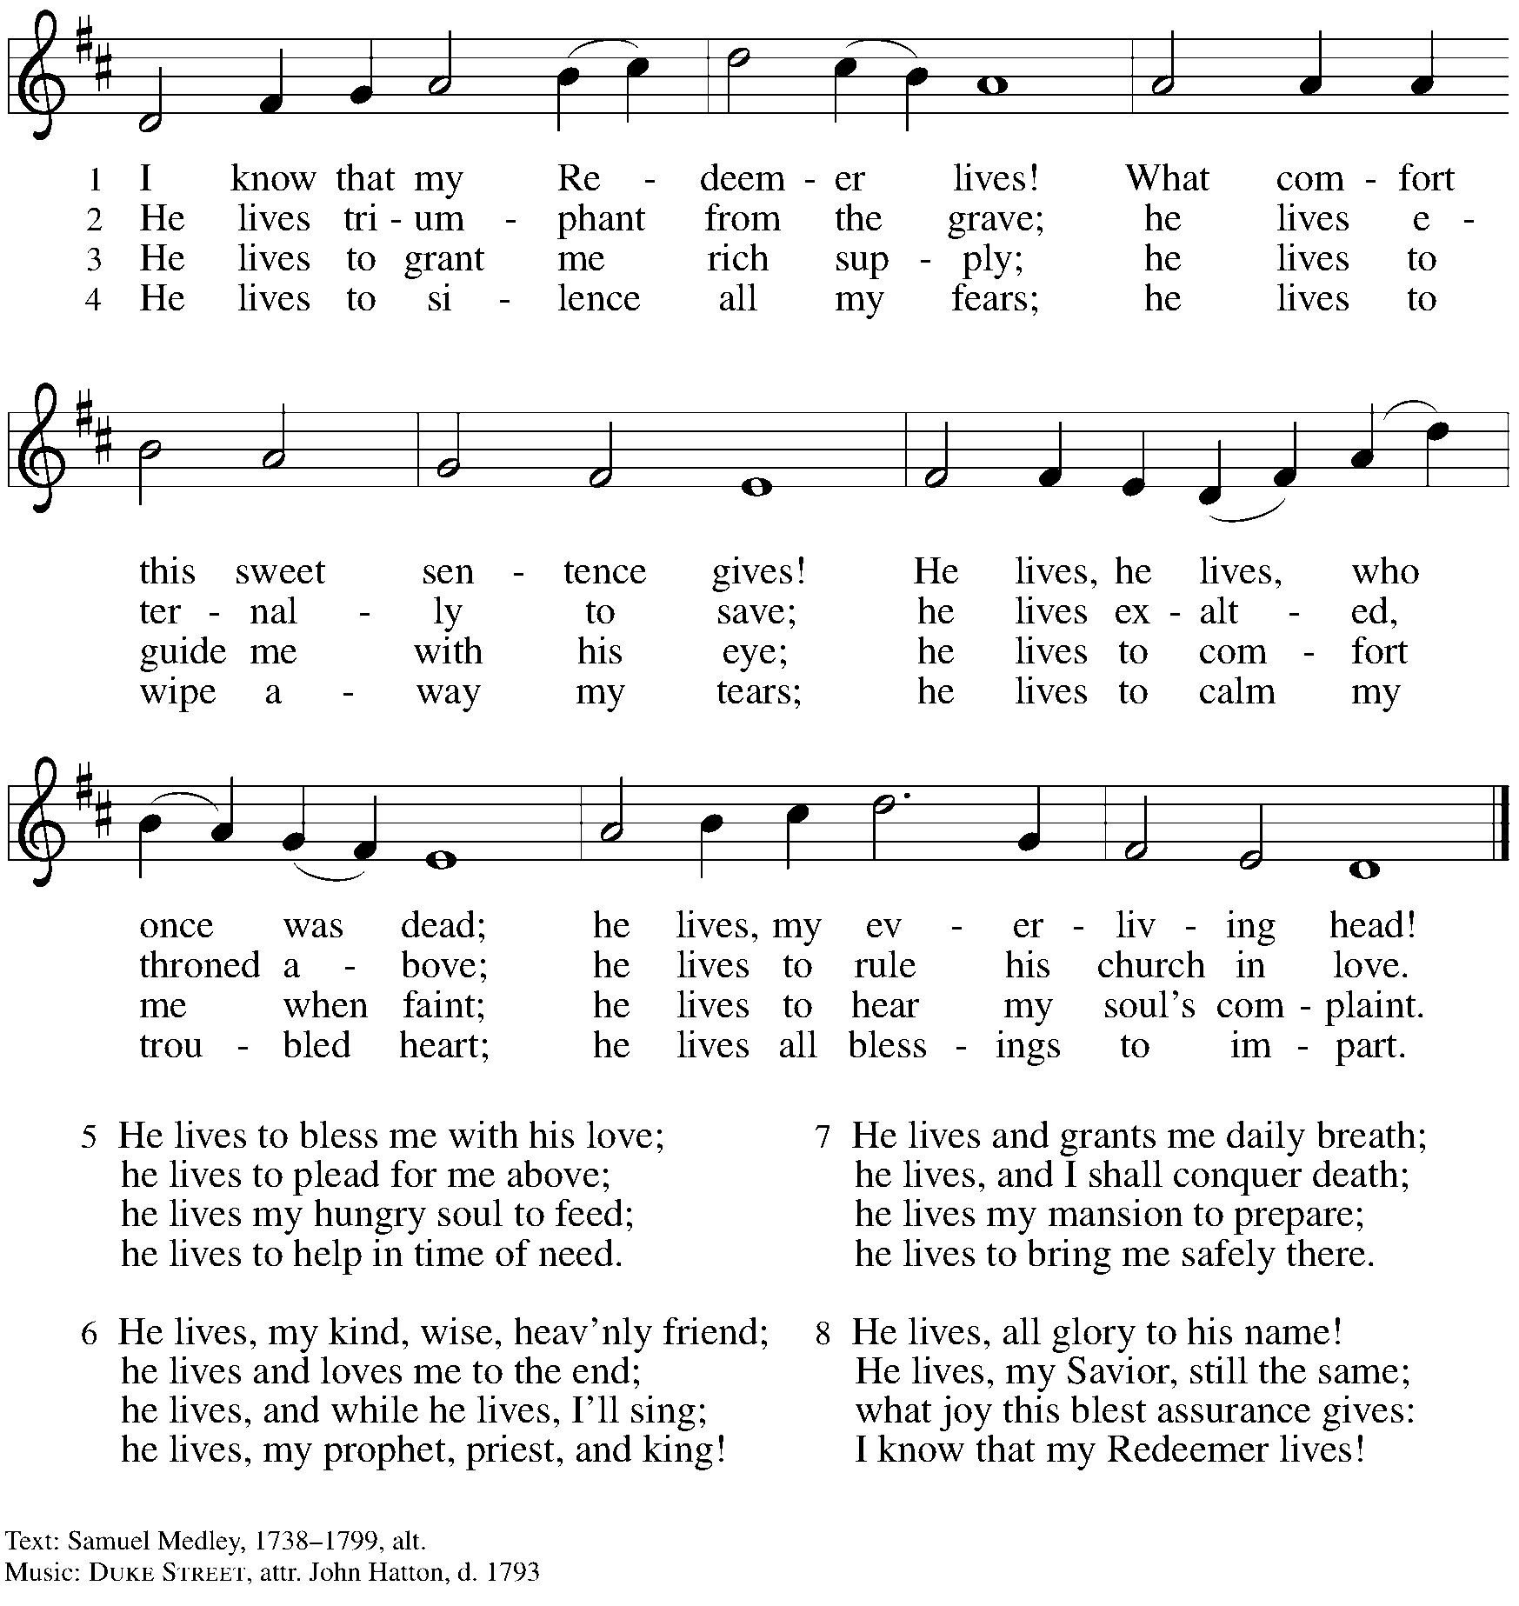
Reprinted with permission under OneLicense.net # A-722139.

Abbreviations

P: Pastor/Presiding Minister
L: Lector
C: Congregation

ACS: All Creation Sings hymnal
ELW: Evangelical Lutheran Worship hymnal
HS: Hymnal Supplement

Those serving in worship today

Altar Care Janet Grzegorczyk
Audio-Visual Ministers Kristen Asplin
Colten Rohleder
Cantor David Rollinson
Lector Kelly Spanninger
Minister of Music Laura Reynolds
Presiding Minister Pastor Ross Carmichael

Liturgy and Hymnody Acknowledgements

From SundaysandSeasons.com. Copyright © 2023 Augsburg Fortress. All rights reserved. Reprinted under OneLicense.net # A-722139.
Used by permission of Augsburg Fortress.

Now the Feast and Celebration –Text: Marty Haugen, b. 1950. Music: NOW THE FEAST AND CELEBRATION, Marty Haugen. Text and music © 1990 GIA Publications, Inc. 7404 Mason Ave. Chicago, IL 60638. www.giamusic.com. 800.442.3358. All rights reserved. Reprinted with permission under OneLicense.net # A-722139.

As the Grains of Wheat – Text: Didache, 2nd cent.; Marty Haugen, b. 1950. Music: Marty Haugen. Text and Music © 1990 GIA Publications, Inc. 7404 Mason Ave. Chicago, IL 60638. www.giamusic.com. 800.442.3358. All rights reserved. Reprinted with permission under OneLicense.net # A-722139.

St. Andrew Lutheran Church Announcements
May 7th, 2023

- Happy Easter! Welcome to worship at St. Andrew on May 7th, 2023, the + Fifth Sunday of Easter, as we continue to celebrate Christ’s Resurrection! – We are so glad you are here to share in this festive season, and we offer a special welcome to all visitors and guests who are here for the first time! Masks are optional at St. Andrew when Allegheny County’s Covid-19 community level is in the low and medium categories. Worship attendees are invited to make a name tag at the back of the worship space if you would like. There are worship “toolkits” to help children engage with worship and “busy bags” for younger children available in the bookcase at the back of the sanctuary. Please feel free to take one to use with/for your children. We pray that everyone has a blessed Easter season!
- Returning to Monthly Reparations Offering Sunday, May 14th – With the events of Palm Sunday and Holy Week, St. Andrew did not take its second collection for restorative justice/reparations on the first Sunday of April. With the first Sunday of May being Marathon Sunday, we will hold the May collection on Sunday, May 14th. We will then resume our regular schedule for this collection, on the first Sunday of each month, on Sunday, June 4th.
- Seeking Help with Sunday Coffee Hour – Many in the St. Andrew community enjoy the opportunity to gather for coffee, snacks and conversation after worship each week. We are looking for help with setup / preparation and cleanup each week and the whole process is pretty simple! If you would like to contribute, either for one time or on a rotating monthly schedule, please contact Pastor Ross Carmichael at PastorRCarmichael@gmail.com.
- May Shelter Dinner at East End Cooperative Ministry – Thursday, May 18th, 6:30 p.m. – Each month, St. Andrew provides a dinner for the guests of the Shelter at East End Cooperative Ministry, 6140 Station St., 15206. We invite people to sign up to prepare or purchase a portion of the meal, and to bring it to EECM at 6:00 p.m. We also invite people of the congregation to come and help serve the meal at 6:30 p.m. Please sign up at https://www.signupgenius.com/go/5080544AAAC22A1F58-mayshelter1.
- St. Andrew Jail Ministry – St. Andrew has had a long history of participation in the ministry program at the Allegheny County Jail. Until the program was put on hold at the beginning of the Covid pandemic, a group of volunteers from St. Andrew was leading a worship service at the jail on Sunday mornings, typically about one Sunday a month. The jail is hoping to resume this program soon. If any of the previous volunteers are still interested and available, please contact Lester Prince (lprince@comcast.net). New volunteers are also needed. The first step for new volunteers is to complete an online application, which can be accessed here: https://www.foundationofhope.org/get-involved/volunteer-application/. On the application form, indicate that the program that you are interested in volunteering with is “Chaplaincy Worship.” Feel free to contact Lester Prince with any questions.

