+ Sixth Sunday of Easter
May 14, 2023
St. Andrew Lutheran Church
304 Morewood Ave.
Pittsburgh, PA 15213
St_andrewELCA@verizon.net
www.standrewpittsburgh.org

+ Sixth Sunday of Easter
Order for Worship

Jesus does not abandon his followers.
Through the Holy Spirit, Jesus comes to abide with his disciples of every generation.
As Pentecost draws near, we are reminded that the risen Christ dwells in us as the Spirit of truth.
We receive this Spirit in Baptism and pray that in our gathering around the Lord’s table,
the Spirit will empower us to be the body of the risen Christ in the world today.

Welcome to St. Andrew!

- St. Andrew Lutheran congregation welcomes all who are seeking a place of healing and wholeness – a nurturing, faith-forming spiritual home. Our community embraces people of all ages, ethnicities, cultures, abilities, sexual orientations, gender identities and expressions, and family constellations. Come and See!

- Worship Services are live streamed to multiple online platforms. By attending worship, you agree that your image and voice may be broadcast.

- Everyone is invited to make a nametag at the black bookcase in the back of the worship space if they would like. There are stickers indicating pronouns on the bookcase if you would like to include them on your name tag.

- Children are invited to attend Little Church – Big Faith, a Bible lesson and activity, during worship (after the Prayer of the Day). The group returns to the worship space for the liturgy of Holy Communion.

- Worship “toolkits” to help children engage with the service, along with “busy bags” for younger children, are available in the bookcase at the back of the sanctuary. Please feel free to take one to use with/for your children.

- Holy Communion is served with bread (gluten-free available) and wine or grape juice. The presiding minister will distribute the bread (host). Please consume this and then pick up an empty glass from the tray. The Communion Assistant will pour wine or grape juice into your glass. Please step to the side to consume the wine or grape juice. Feel free to kneel at the altar for prayer and reflection. As you return to your pew, glasses may be returned to the empty trays on either side of the center section.

- A restroom is available on the main level of the church, through the doors to the Social Hall and to the right in the main office.

Pre-Service Music

Welcome

Prelude All Hail the Power of Jesus’ Name arr. Bober

Gathering
The Holy Spirit calls us together as the people of God

Confession and Forgiveness

Please rise as you are able.
All may make the sign of the cross, the sign that is marked at Baptism,
as the presiding minister begins.

P: Blessed be the holy Trinity,
☩ one God,
who creates, redeems, and sustains us
and all of creation.
C: Amen.

P: Let us confess our sin in the presence of God and of one another.

Silence is kept for reflection

P: To you, O God,
C: all hearts are open, to you all desires known.
We come to you, confessing our sins.
Forgive us in your mercy, and remember us in your love.
Show us your ways; teach us your paths; and lead us in justice and truth,
for the sake of your goodness in Jesus Christ our Savior.
Amen.

P: By water and the Holy Spirit God gives you a new birth,
and through the death and resurrection of ☩ Jesus Christ,
God forgives you all your sins.
The God of mercy and might strengthen you in all goodness
and keep you in eternal life.
C: Amen.

Gathering Hymn Christ Is Alive! Let Christians Sing ELW 389

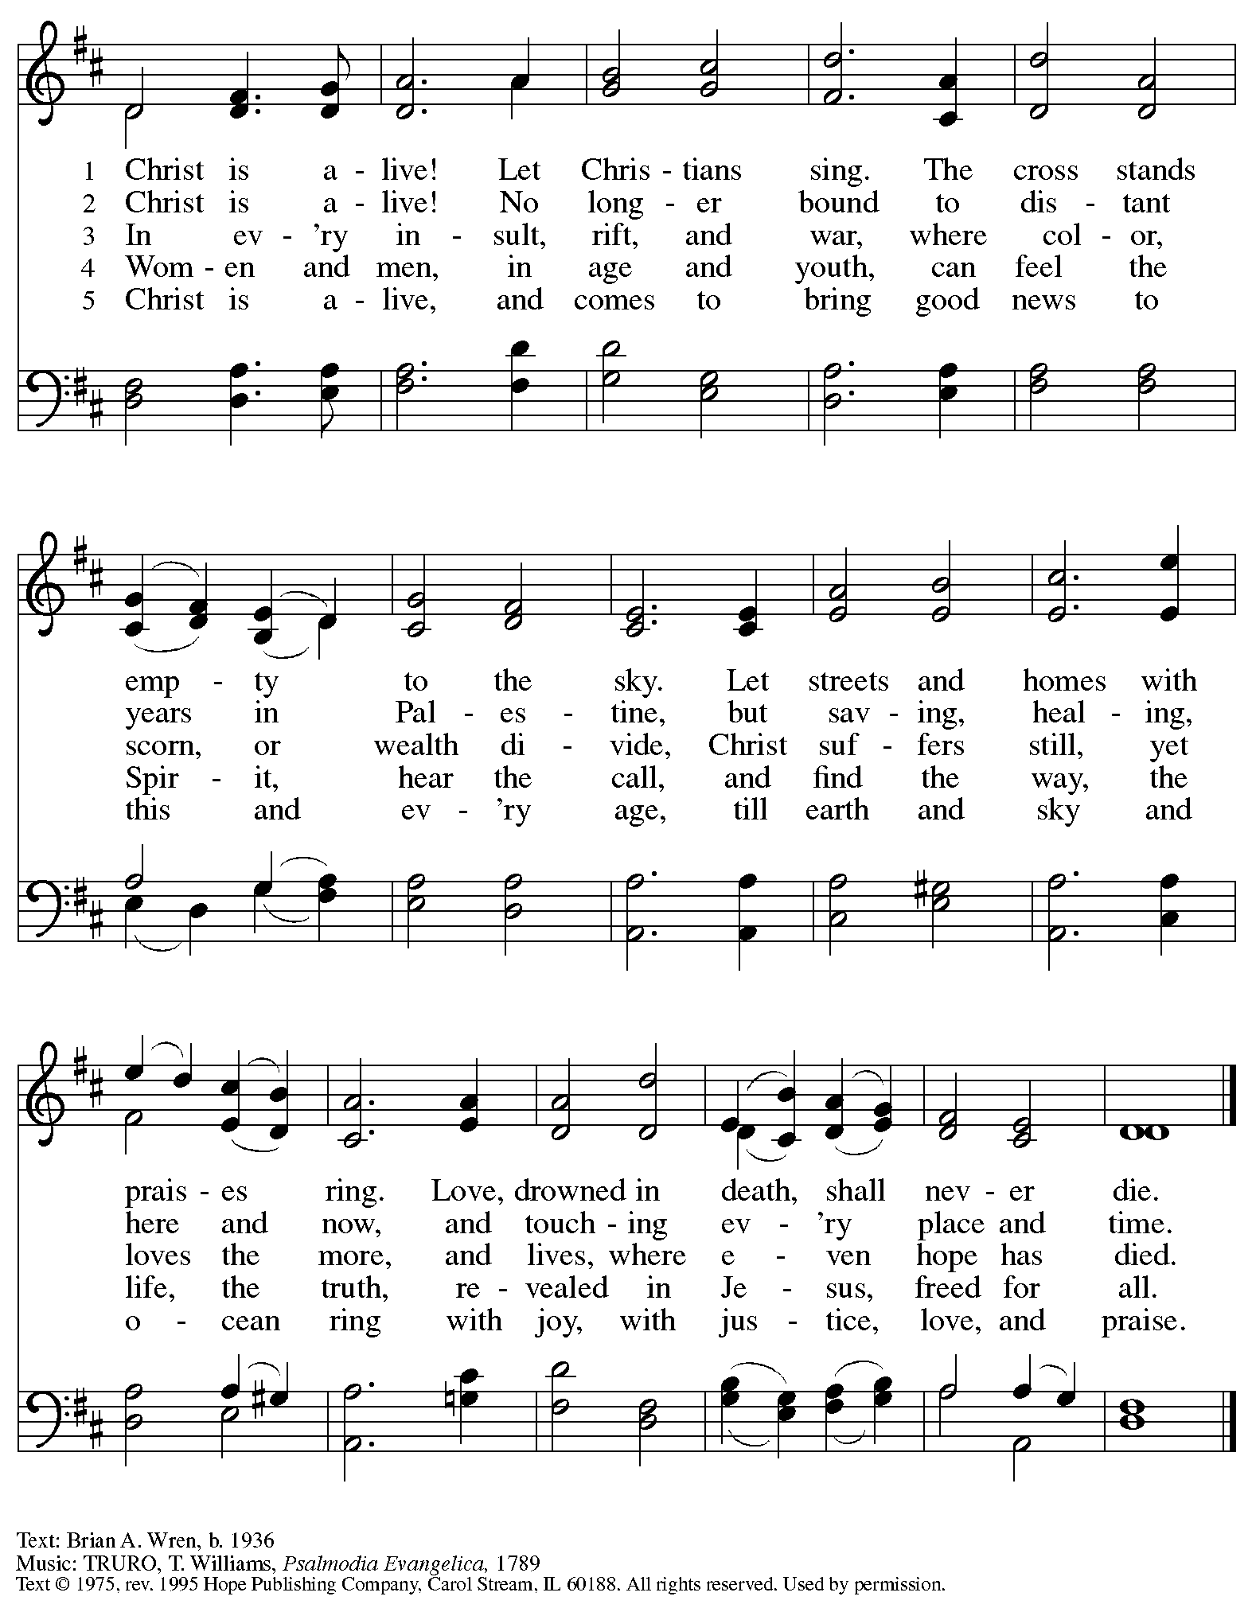
Reprinted under OneLicense.net # A-722139.
Greeting

P: The grace of our Lord Jesus Christ, the love of God,
and the communion of the Holy Spirit be with you all.
C: And also with you.

Hymn of Praise Now the Feast and Celebration HS p. 4-5

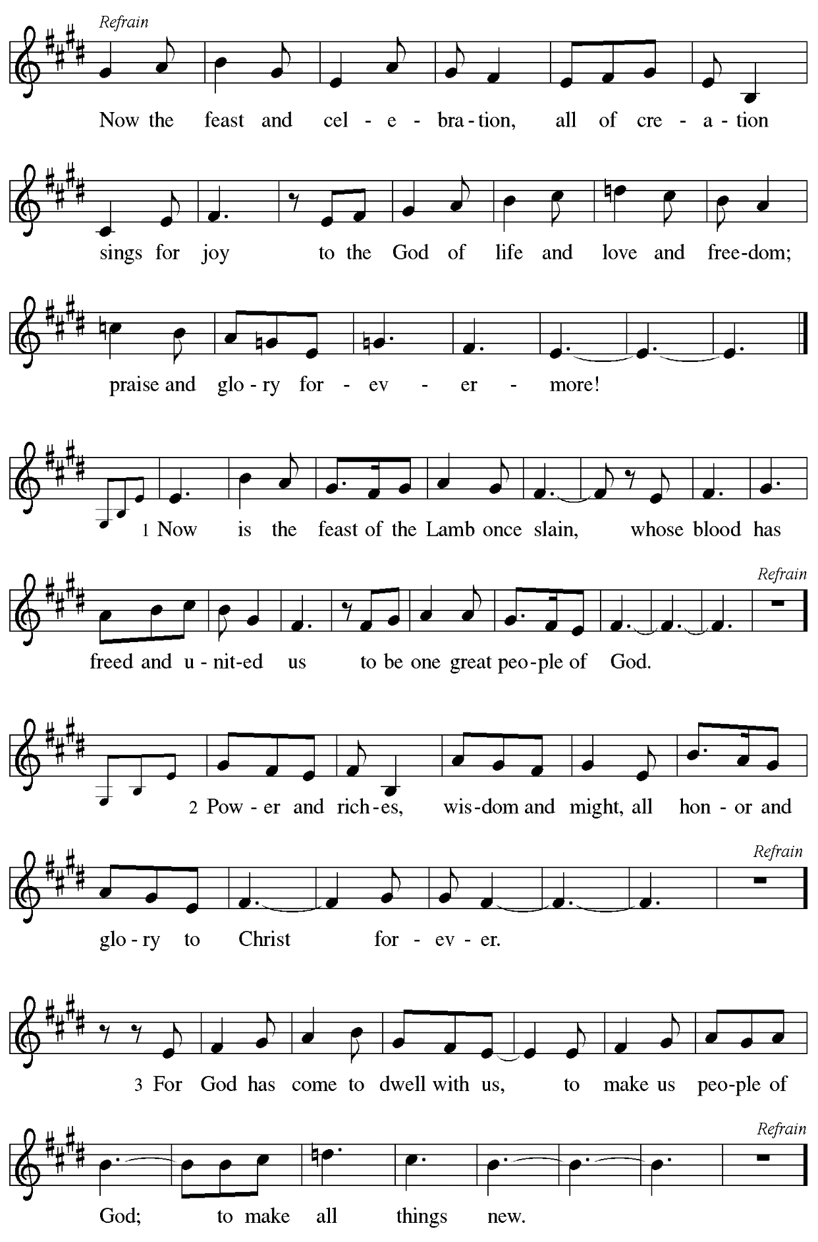

Prayer of the Day

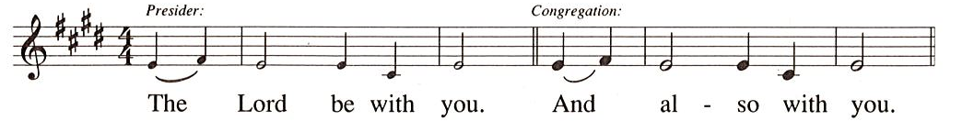

P: Let us pray.
Almighty and ever-living God,
you hold together all things in heaven and on earth.
In your great mercy receive the prayers of all your children,
and give to all the world the Spirit of your truth and peace,
through Jesus Christ, our Savior and Lord,
who lives and reigns with you and the Holy Spirit,
one God, now and forever.
C: Amen.

Please be seated.
Children are invited to join the adult leaders at the door and move to the office for Little Church – Big Faith. We ask that one additional adult from the congregation attend with the children.

Word
God speaks to us in Scripture reading, preaching, and song

First Reading – Acts 17: 22-31

²²Paul stood in front of the Areopagus and said, “Athenians, I see how extremely religious you are in every way. ²³For as I went through the city and looked carefully at the objects of your worship, I found among them an altar with the inscription, ‘To an unknown god.’ What therefore you worship as unknown, this I proclaim to you. ²⁴The God who made the world and everything in it, the one who is Lord of heaven and earth, does not live in shrines made by human hands,
²⁵nor is served by human hands, as though God needed anything, since God’s own self gives to all mortals life and breath and all things. ²⁶From one ancestor God made all nations to inhabit the whole earth, and God allotted the times of their existence and the boundaries of the places where they would live, ²⁷so that they would search for God and perhaps reach out for God and find God—though indeed God is not far from each one of us. ²⁸For ‘In God we live and move and have our being;’ as even some of your own poets have said,
‘For we too are his offspring.’
²⁹Since we are God’s offspring, we ought not to think that the deity is like gold, or silver, or stone, an image formed by the art and imagination of mortals. ³⁰While God has overlooked the times of human ignorance, now God commands all people everywhere to repent, ³¹because God has fixed a day on which God will have the world judged in righteousness by one whom God has appointed, and of this he has given assurance to all by raising him from the dead.”

L: Word of God, word of life.
C: Thanks be to God.

Psalm 66: 8-20

The psalm will be sung by the cantor,
with the congregation invited to join in singing the verses in bold and the refrain.

Psalm tone

Psalm refrain

⁸Bless our | God, you peoples;
let the sound of | praise be heard.
⁹Our God has kept us a- | mong the living
and has not allowed our | feet to slip. R
¹⁰For you, O God, have | tested us;
you have tried us just as sil- | ver is tried.
¹¹You brought us in- | to the net;
you laid heavy burdens up- | on our backs.
¹²You let people ride over our heads; we went through | fire and water,
but you brought us out into a place | of refreshment.
¹³I will enter your house | with burnt offerings
and will pay | you my vows—
¹⁴those that I promised | with my lips
and spoke with my mouth when I | was in trouble.
¹⁵I will offer you burnt offerings of fatlings with the | smoke of rams;
I will give you ox- | en and goats. R
¹⁶Come and listen, all you | who believe,
and I will tell you what God has | done for me.
¹⁷I called out to God | with my mouth,
and praised the Lord | with my tongue.
¹⁸If I had cherished evil | in my heart,
the Lord would | not have heard me;
¹⁹but in truth | God has heard me
and has attended to the sound | of my prayer.
²⁰Blessed be God, who has not reject- | ed my prayer,
nor withheld unfailing | love from me. R

Second Reading – 1 Peter 3: 13-22

¹³Who will harm you if you are eager to do what is good? ¹⁴But even if you do suffer for doing what is right, you are blessed. Do not fear what they fear, and do not be intimidated, ¹⁵but in your hearts sanctify Christ as Lord. Always be ready to make your defense to anyone who demands from you an accounting for the hope that is in you; ¹⁶yet do it with gentleness and reverence. Keep your conscience clear, so that, when you are maligned, those who abuse you for your good conduct in Christ may be put to shame. ¹⁷For it is better to suffer for doing good, if suffering should be God’s will, than to suffer for doing evil. ¹⁸For Christ also suffered for sins once for all, the righteous for the unrighteous, in order to bring you to God. He was put to death in the flesh, but made alive in the spirit, ¹⁹in which also he went and made a proclamation to the spirits in prison, ²⁰who in former times did not obey, when God waited patiently in the days of Noah, during the building of the ark, in which a few, that is, eight persons, were saved through water.
²¹And baptism, which this prefigured, now saves you—not as a removal of dirt from the body, but as an appeal to God for a good conscience, through the resurrection of Jesus Christ, ²²who has gone into heaven and is at the right hand of God, with angels, authorities, and powers made subject to him.

L: Word of God, word of life.
C: Thanks be to God.

Please rise as you are able.

Gospel Acclamation

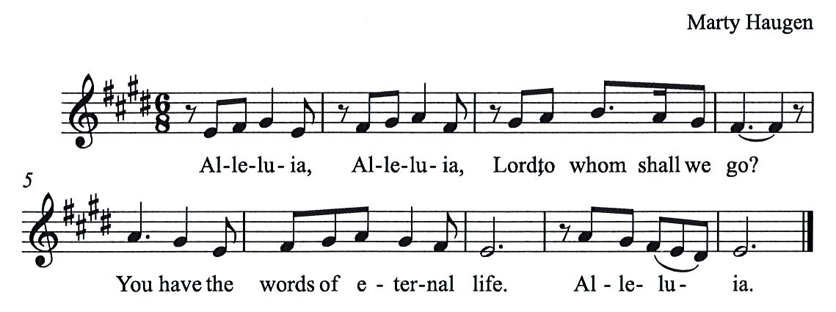

Gospel – John 14: 15-21

P: The holy Gospel according to St. John.
C: Glory to you, O Lord.

[Jesus said to the disciples:] ¹⁵“If you love me, you will keep my commandments. ¹⁶And I will ask the Father, and he will give you another Advocate, to be with you forever. ¹⁷This is the Spirit of truth, whom the world cannot receive, because it neither sees him nor knows him. You know him, because he abides with you, and he will be in you.
¹⁸“I will not leave you orphaned; I am coming to you. ¹⁹In a little while the world will no longer see me, but you will see me; because I live, you also will live. ²⁰On that day you will know that I am in my Father, and you in me, and I in you. ²¹They who have my commandments and keep them are those who love me; and those who love me will be loved by my Father, and I will love them and reveal myself to them.”

P: The Gospel of the Lord.
C: Praise to you, O Christ.

Please be seated.

Sermon

A time of silence for prayer and reflection follows the sermon.
When the hymn of the day begins, please rise as you are able.

Hymn of the Day Love Divine, All Loves Excelling Following page

Hymn of the Day Love Divine, All Loves Excelling ELW 631

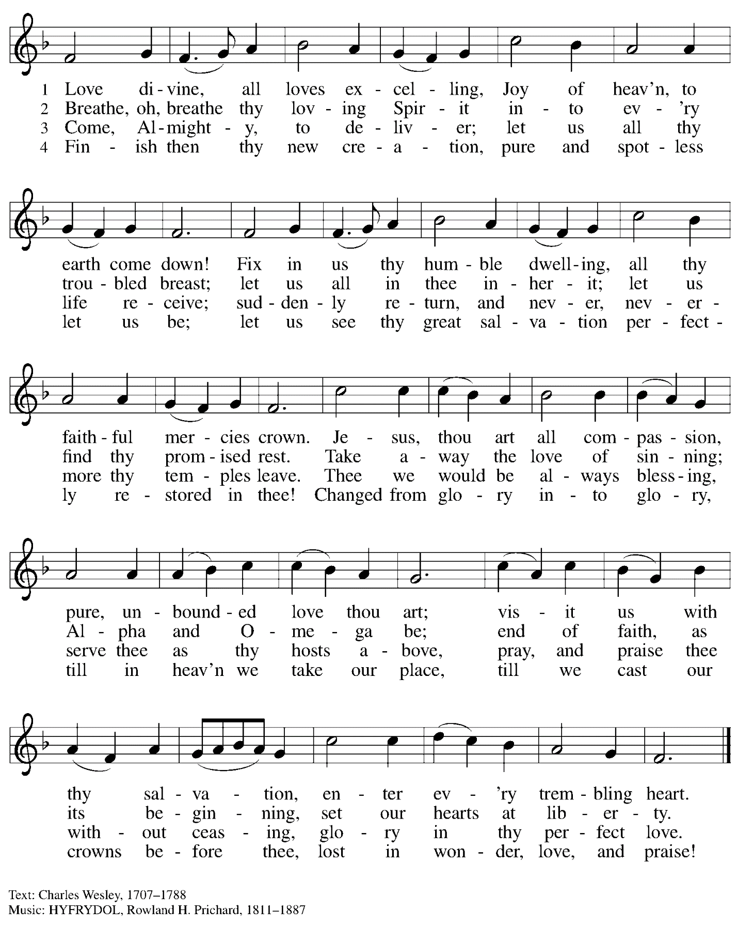

Nicene Creed

C: We believe in one God,
the Father, the Almighty,
maker of heaven and earth,
of all that is, seen and unseen.

We believe in one Lord, Jesus Christ,
The only Son of God,
eternally begotten of the Father,
God from God, Light from Light,
true God from true God,
begotten, not made,
of one Being with the Father;
through him all things were made.
For us and for our salvation
he came down from heaven,
was incarnate of the Holy Spirit and the virgin Mary
and became truly human.
For our sake he was crucified under Pontius Pilate;
he suffered death and was buried.
On the third day he rose again
in accordance with the scriptures;
he ascended into heaven
and is seated at the right hand of the Father.
He will come again in glory to judge the living and the dead,
and his kingdom will have no end.

We believe in the Holy Spirit, the Lord, the giver of life,
who proceeds from the Father and the Son,*
who with the Father and the Son is worshiped and glorified,
who has spoken through the prophets.
We believe in one holy catholic and apostolic church.
We acknowledge one baptism for the forgiveness of sins.
We look for the resurrection of the dead,
and the life of the world to come. Amen.

*Or, “who proceeds from the Father.” The phrase “and the Son” is a later addition to the creed.

Prayers of the People

A: United in the joy and hope of the resurrection, let us pray for the church, the world,
and all who are in need.

After each petition
A: Gracious God,
C: receive our prayer.

The presiding minister concludes the prayers
P: We lift these prayers to you O God, trusting in your abundant mercy,
through Jesus Christ our risen Savior.
C: Amen.

Peace

The presiding minister and the assembly greet one another in the peace of the risen Christ.
P: The peace of Christ be with you always.
C: And also with you.

The people may greet those around them with a sign of Christ’s peace and may say
Peace be with you or similar words. Please be mindful that not everyone will be comfortable with sharing the peace, so please seek consent before shaking hands or hugging. Other possible ways to share the peace include a simple bow with the verbal greeting of peace, or simply a verbal expression of peace.

When the greetings of peace have concluded, please be seated.

Meal
God feeds us with the presence of Jesus Christ

Offering

We offer ourselves, our gifts, and our faithful service to God.
As the offering is gathered for the mission of the church, including the care of those in need,
the table is set for Holy Communion.

Reparations Offering

Each month, St. Andrew invites people of the congregation to consider a donation to a second collection for a reparations fund in acknowledgment of St. Andrew’s use of African American spiritual songs in our worship services. Please see the note in the announcements at the back of the bulletin for more information.

Music during the Offering
Great is Thy Faithfulness arr. Ijames

As the gifts are brought forward for presentation, please rise as you are able.

Offertory Song As the Grains of Wheat ELW 465

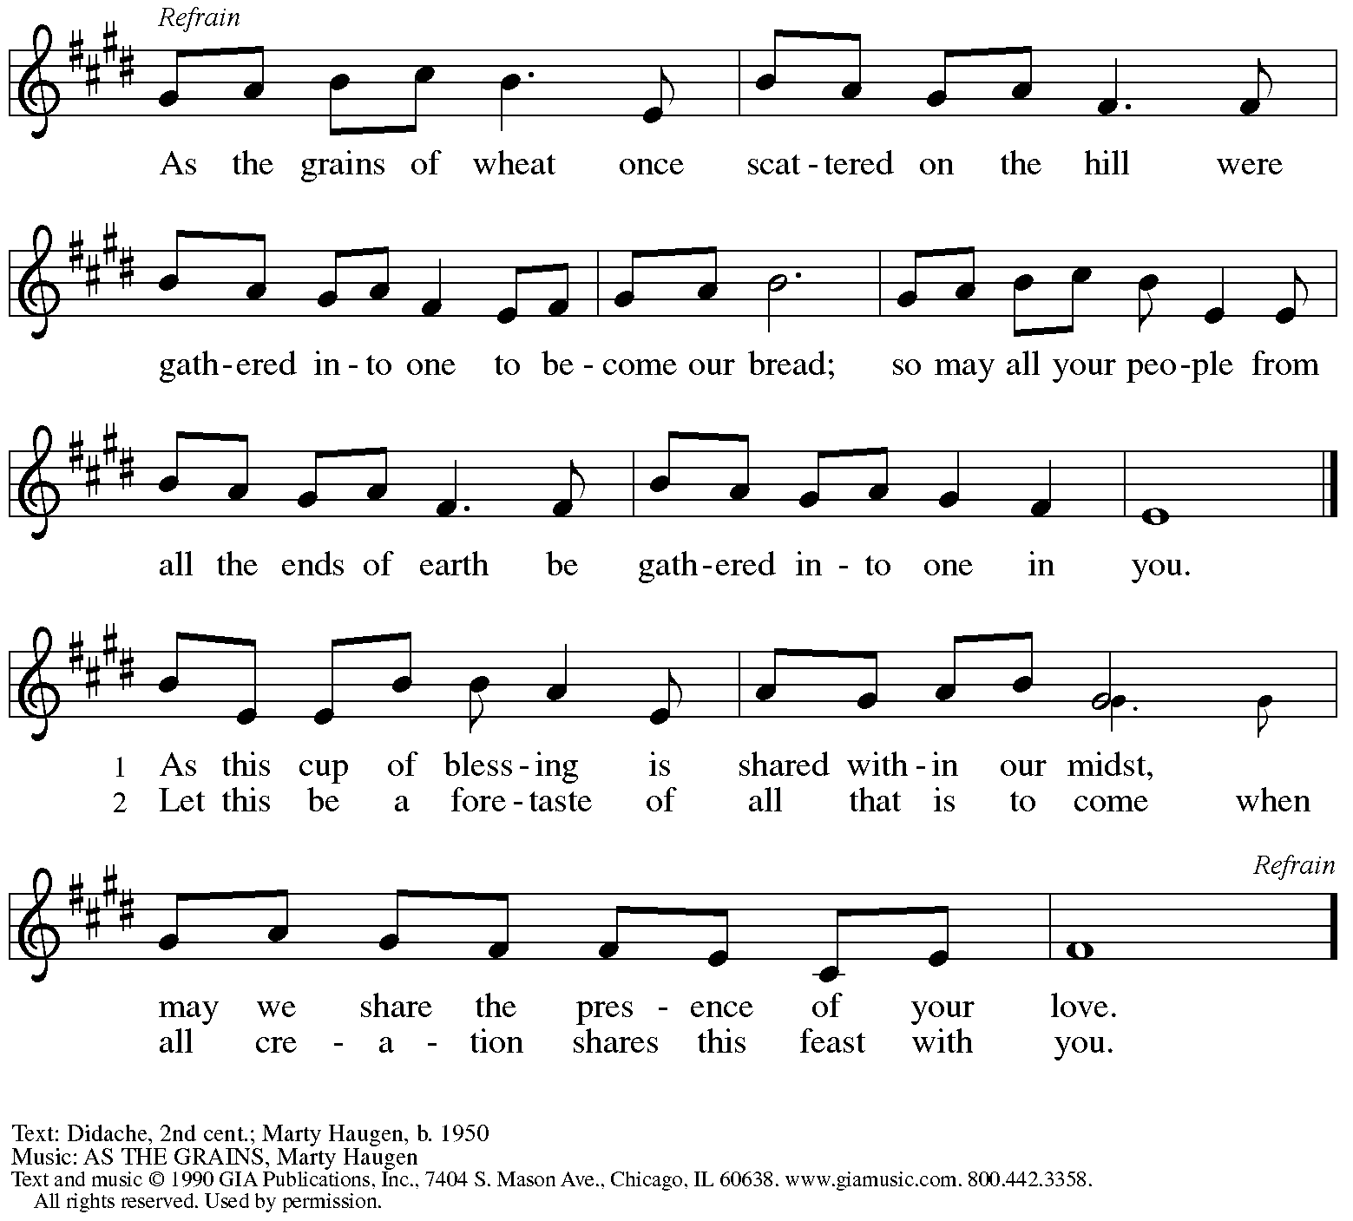
Reprinted under OneLicense.net # A-722139.

Offertory Prayer

A: Let us pray.
Blessed are you, O God,
C: ruler of heaven and earth.
Day by day you shower us with blessings.
As you have raised us to new life in Christ,
give us glad and generous hearts,
ready to praise you and to respond to those in need,
through Jesus Christ, our Savior and Lord.
Amen.

Dialogue HS p. 14

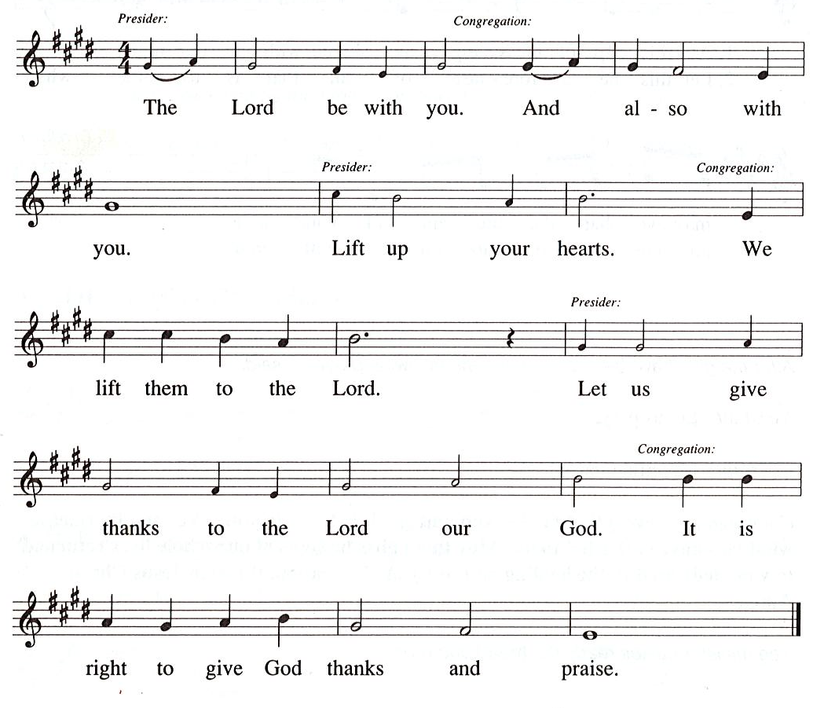

Preface (Sung by the presiding minister)

P: It is our duty and delight
that we should everywhere and always
offer thanks and praise to you, O God,
through Jesus Christ,
who by his death on the cross
and his glorious resurrection
broke the bonds of sin and death
and gave life to all creation.
And so with the church on earth,
all creation and the hosts of heaven,
we praise your name and join their unending hymn:

Sanctus HS p. 15

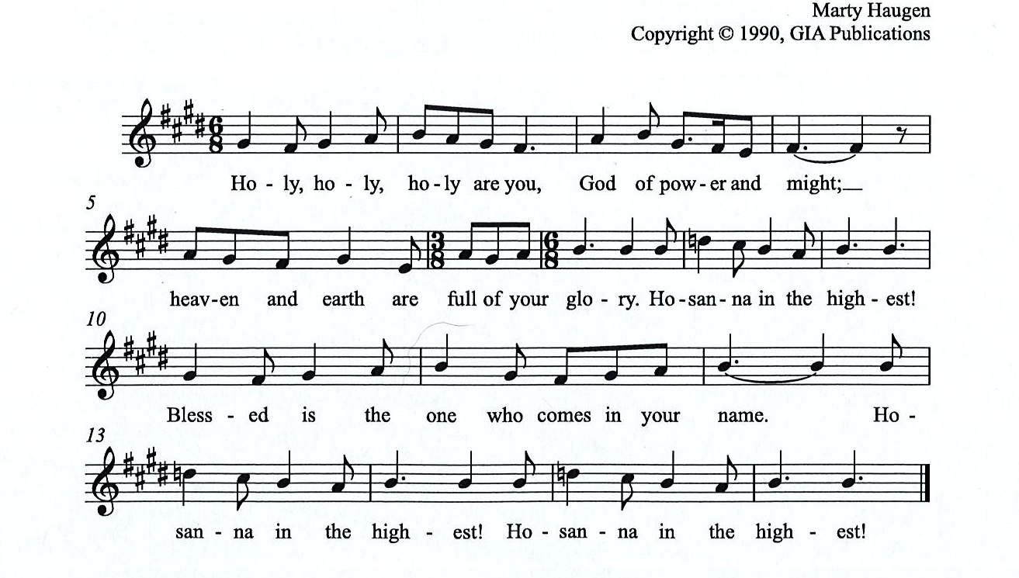

Eucharistic Prayer

P: You are indeed holy, almighty and merciful God, …
… Do this for the remembrance of me.

For as often as we eat of this bread and drink from this cup,
we proclaim the Lord’s death until he comes.

(Presiding minister sings)
Christ has died. Christ is risen. Christ will come, come again.
C:
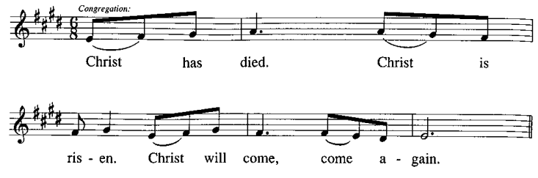
P: Remembering, therefore, his salutary command, …
… and be given our inheritance with all your saints.

To you, O God, Father, Son, and Holy Spirit,
be all honor and glory in your holy church, now and forever.
C:
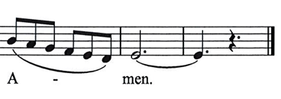

Lord’s Prayer

P: Gathered as one by the Holy Spirit, let us pray as Jesus taught us.
C: Our Father in heaven,
hallowed be your name,
your kingdom come,
your will be done,
on earth as in heaven.
Give us today our daily bread.
Forgive us our sins
as we forgive those
who sin against us.
Save us from the time of trial
and deliver us from evil.
For the kingdom, the power,
and the glory are yours,
now and forever. Amen.

Fraction and Invitation

P: Alleluia! Christ is risen!
C: Christ is risen indeed! Alleluia! Alleluia!

P: This is the feast of victory for our God. Alleluia! Alleluia!
Come, share the feast.

Agnus Dei / Lamb of God Following Page

Agnus Dei / Lamb of God HS p. 18

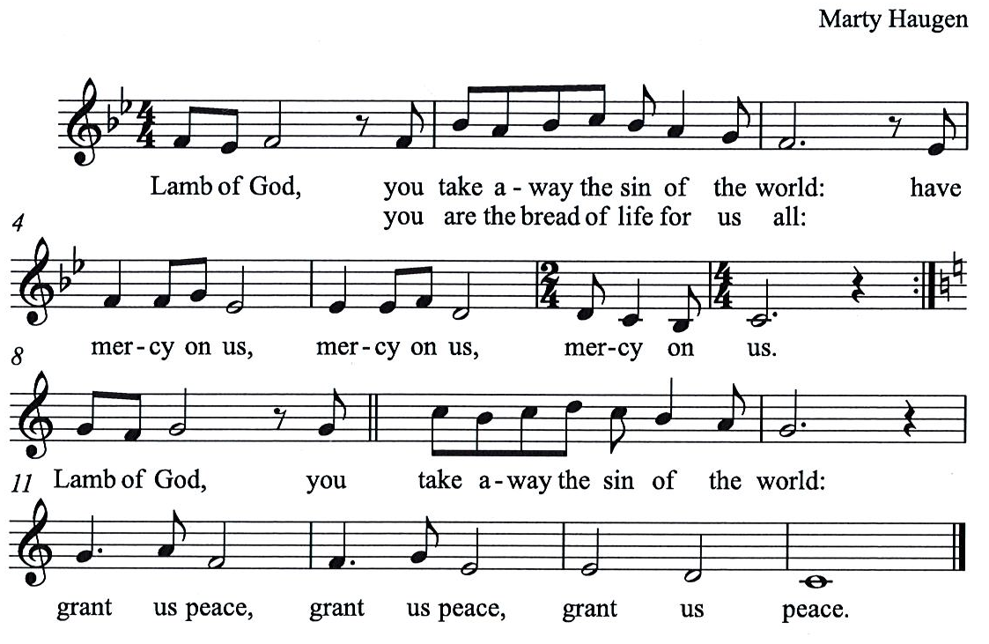

Please be seated.

Holy Communion
- All who seek God and desire a deeper and stronger life in Christ are welcome to receive Holy Communion.
- Worshipers from the pulpit side will proceed forward first, followed by the center section, and then the lectern side.
- Please inform an usher if you would like the ministers to bring Communion to you.
- Holy Communion will be served with bread and wine/grape juice.
- The presiding minister will first distribute the bread (host) to each communicant. Please indicate if you require a gluten-free host.
- Once you have consumed the bread, please pick up an empty glass from the tray next to the presiding minister. The Communion Assistant will pour wine from the chalice or grape juice from the cruet into your glass.
- Please step to the side to consume the wine or grape juice.
- Feel free to kneel at the altar rail for prayer after receiving the sacrament.
- As you return to your pew, glasses may be returned to the empty trays on either side of the center section.
- A blessing will be provided for anyone who does not yet receive the sacrament.
- All are invited to join in singing the hymns during Holy Communion.

Hymns during Holy Communion
Holy Spirit, Truth Divine ELW 398

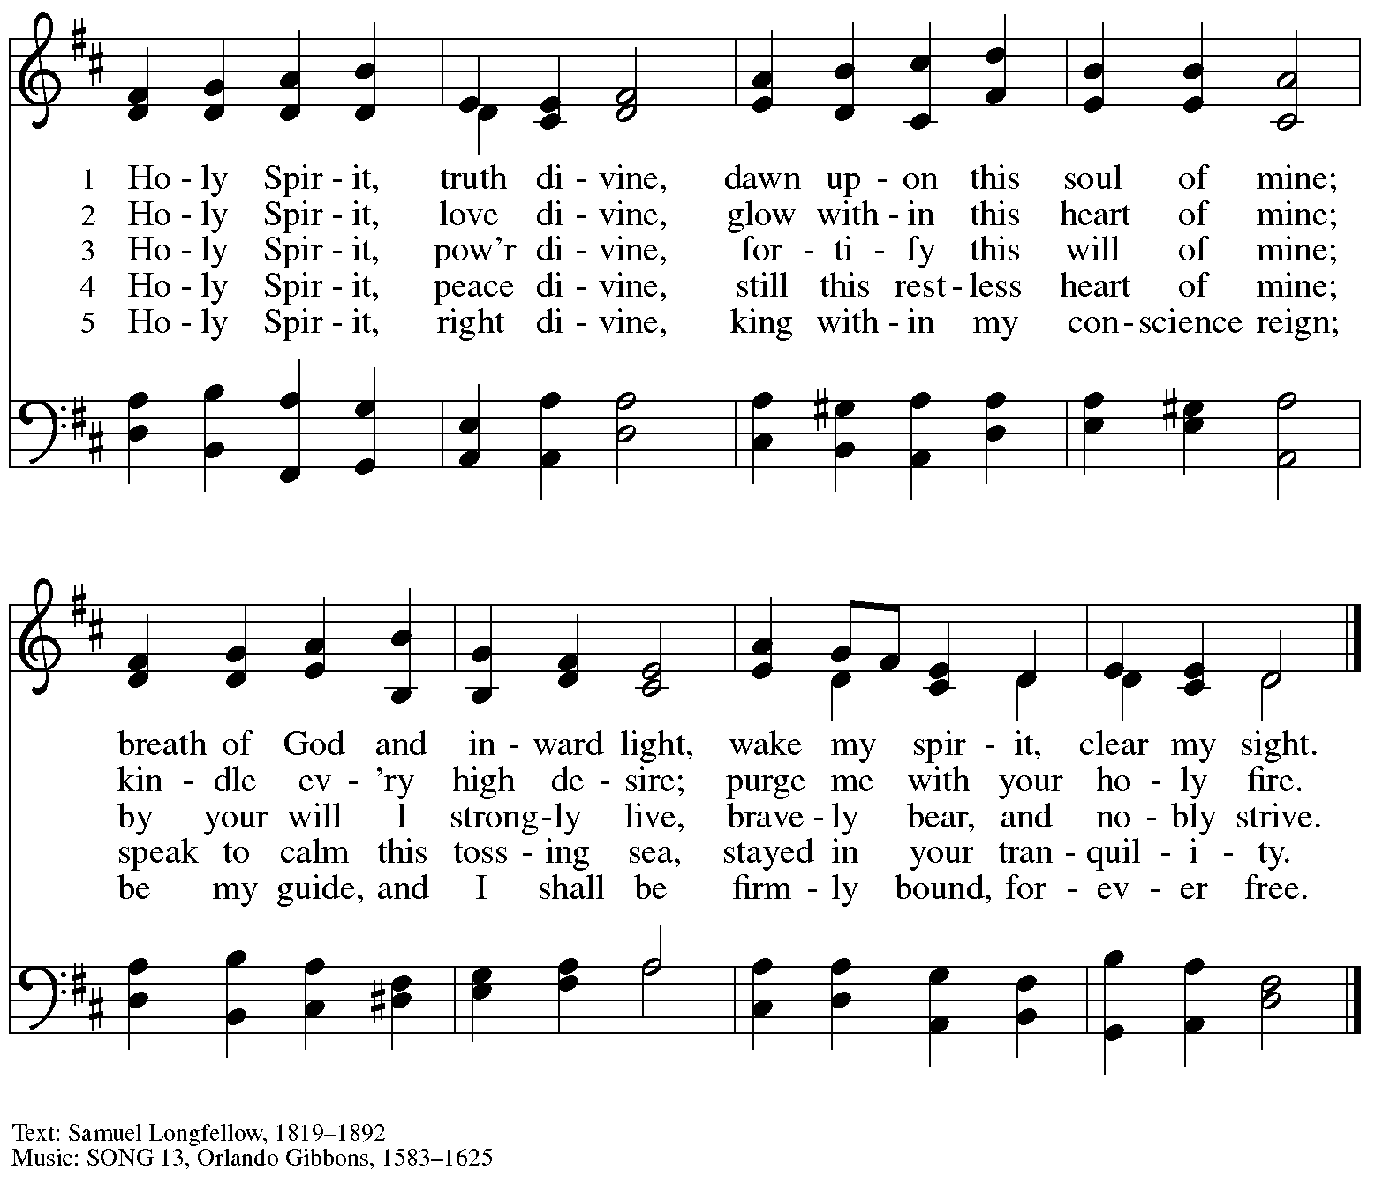

Hymns during Holy Communion
Thy Holy Wings ELW 613

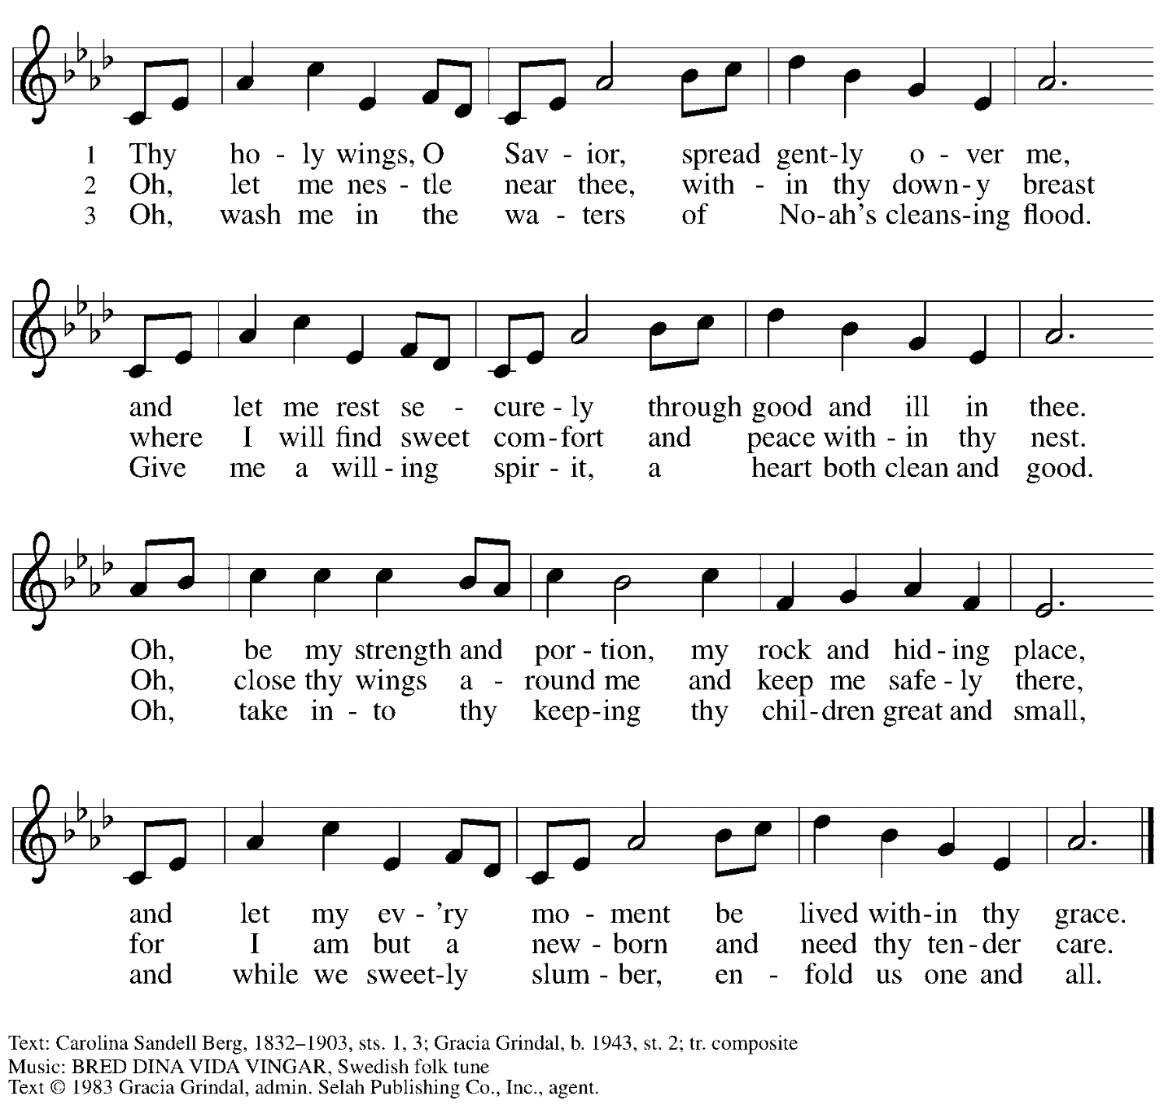
All rights reserved. Reprinted with permission under OneLicense.net # A-722139.

Hymns during Holy Communion
As a Mother Comforts Her Child ACS 1015

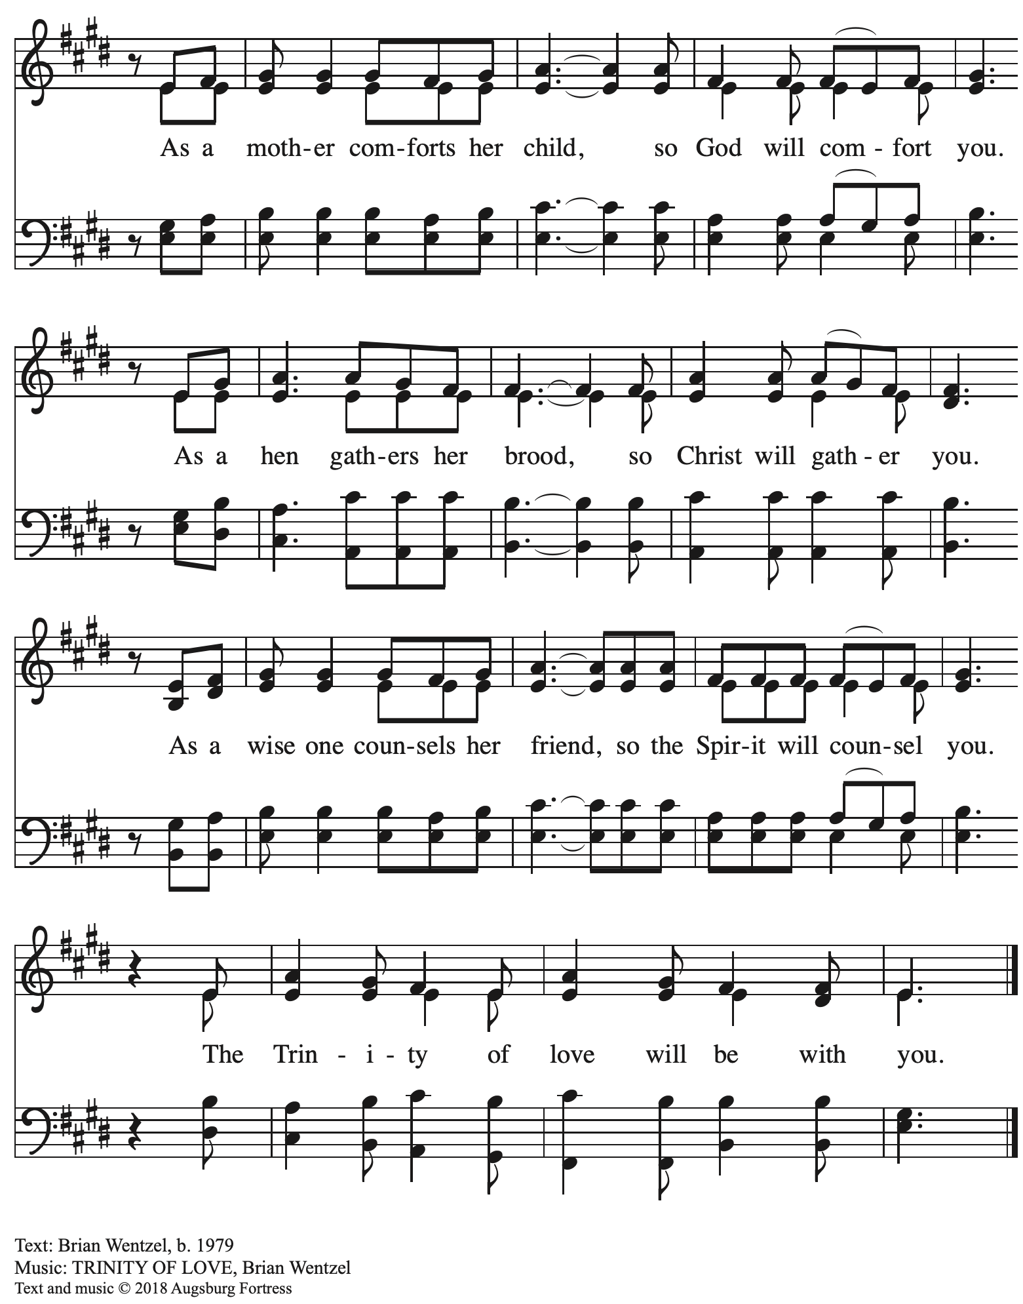
All rights reserved. Reprinted with permission under OneLicense.net # A-722139.

When all have returned to their places, please rise as you are able.

Blessing

P: The body and blood of our Lord Jesus Christ strengthen you and keep you in his grace.
C: Amen.

Prayer

A: Let us pray. Life-giving God,
in the mystery of Christ’s resurrection,
you send light to conquer darkness,
water to give new life,
and the bread of life to nourish your people.
A: Send us forth as witnesses to your Son’s resurrection,
that we may show your glory to all the world,
through Jesus Christ, our risen Lord.
C: Amen.

Please be seated.

Sending
God blesses us and sends us in mission to the world

Announcements

Please rise as you are able.

Benediction

P: May our glorious God grant you a spirit of wisdom
to know and love the risen Christ.

Almighty God, holy One, ☩ holy Three,
bless you now and forever.
C:
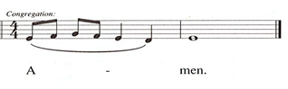

Sending Hymn Alleluia! Sing to Jesus ELW 392
v. 1-3

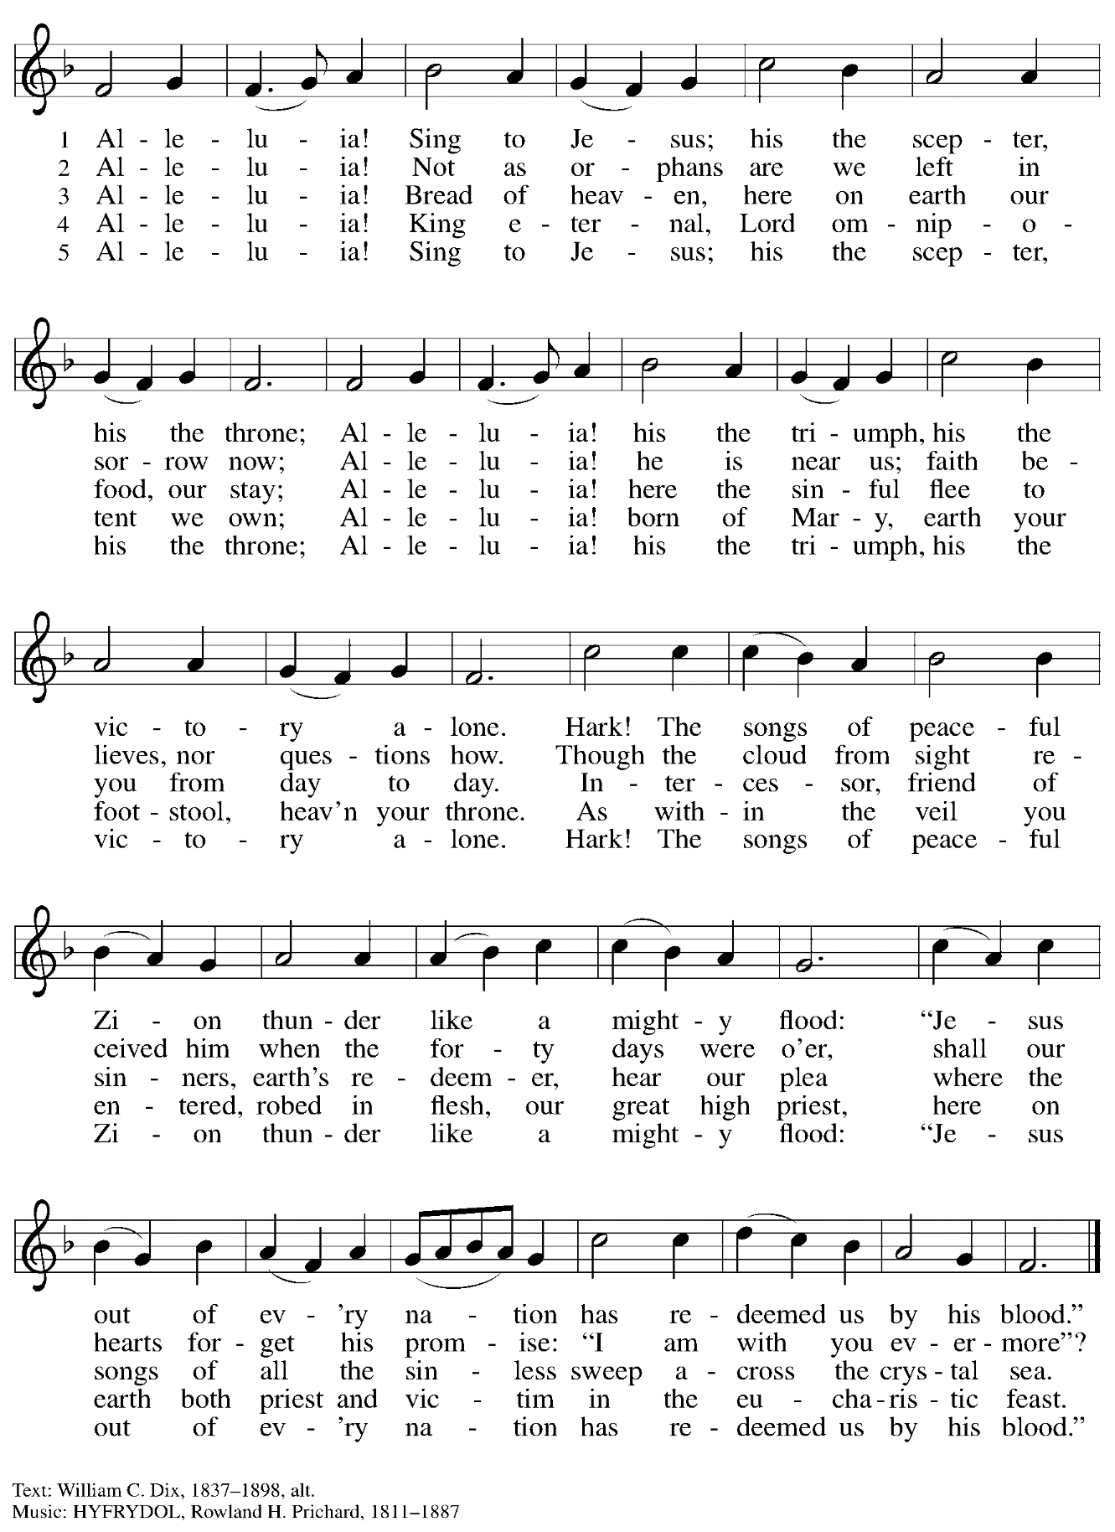
Dismissal

A: Alleluia! Christ is risen!
C: Christ is risen indeed! Alleluia! Alleluia!

A: Go in peace. Share the good news!
C: Thanks be to God!

Postlude

Abbreviations

P: Pastor/Presiding Minister
A: Assisting Minister
L: Lector
C: Congregation

ACS: All Creation Sings hymnal
ELW: Evangelical Lutheran Worship hymnal
HS: Hymnal Supplement

Those serving in worship today

Altar Care Christy Ruhe
Assisting Minister Jimmi Kocher-Hillmer
Audio-Visual Ministers Noël Marsh
Colten Rohleder
Cantor Mandy Best
Lector Jeff Denlinger
Minister of Music Laura Reynolds
Piano Sarita Gonzaga Doshi
Presiding Minister Pastor Ross Carmichael

Liturgy and Hymnody Acknowledgements

From SundaysandSeasons.com. Copyright © 2023 Augsburg Fortress. All rights reserved. Reprinted under OneLicense.net # A-722139.
Used by permission of Augsburg Fortress.

Now the Feast and Celebration –Text: Marty Haugen, b. 1950. Music: NOW THE FEAST AND CELEBRATION, Marty Haugen. Text and music © 1990 GIA Publications, Inc. 7404 Mason Ave. Chicago, IL 60638. www.giamusic.com. 800.442.3358. All rights reserved. Reprinted with permission under OneLicense.net # A-722139.

As the Grains of Wheat – Text: Didache, 2nd cent.; Marty Haugen, b. 1950. Music: Marty Haugen. Text and Music © 1990 GIA Publications, Inc. 7404 Mason Ave. Chicago, IL 60638. www.giamusic.com. 800.442.3358. All rights reserved. Reprinted with permission under OneLicense.net # A-722139.

St. Andrew Lutheran Church Announcements
May 14th, 2023

- Happy Easter! Welcome to worship at St. Andrew on May 14th, 2023, the + Sixth Sunday of Easter, as we continue to celebrate Christ’s Resurrection! – We are so glad you are here to share in this festive season, and we offer a special welcome to all visitors and guests who are here for the first time! Worship attendees are invited to make a name tag at the back of the worship space if you would like. There are worship “toolkits” to help children engage with worship and “busy bags” for younger children available in the bookcase at the back of the sanctuary. Please feel free to take one to use with/for your children. We pray that everyone has a blessed Easter season!
- St. Andrew Resumes Monthly Reparations Offering for Use of African American Spiritual Songs in Worship – Today, May 14th – Jesus' parable of the Good Samaritan from Luke's Gospel provides an example of how God's people are called to work for healing and repair for our neighbors, independent of who or what caused harm. In light of this, the Worship Committee and Congregation Council of St. Andrew have made a commitment to reparations in regard to African American spiritual songs used in our worship. The text and music of most hymns is attributed to specific authors, with copyrights in place, usage reported, and royalties paid to those whose works are featured in worship. With African American spirituals, this is not possible. In response to many years of such uncredited use, St. Andrew will invite people of the congregation to give to a second collection for reparations during the offering. We originally planned to do this each week when a spiritual was sung, but after seeing initial logistics we are moving to a First Sunday of every month schedule for this special collection to allow for consistency and planning in giving. Funds received in our initial collections will be donated to our siblings at Bethel AME Church, whose land and building were taken from them in the 1950s, to fund the development they are planning in the Hill District. With the events of Palm Sunday and Holy Week, St. Andrew did not take its second collection for restorative justice/reparations on the first Sunday of April. Due to Marathon Sunday this past week, we have scheduled this offering for today, May 14th. We will then resume our regular schedule for this collection on the first Sunday of each month, beginning June 4th.
- May Shelter Dinner at East End Cooperative Ministry – Thursday, May 18th, 6:30 p.m. – Each month, St. Andrew provides a dinner for the guests of the Shelter at East End Cooperative Ministry, 6140 Station St., 15206. We invite people to sign up to prepare or purchase a portion of the meal, and to bring it to EECM at 6:00 p.m. We also invite people of the congregation to come and help serve the meal at 6:30 p.m. Please sign up at https://www.signupgenius.com/go/5080544AAAC22A1F58-mayshelter1.
- Seeking Help with Sunday Coffee Hour – Many in the St. Andrew community enjoy the opportunity to gather for coffee, snacks and conversation after worship each week. We are looking for help with setup / preparation and cleanup each week and the whole process is pretty simple! If you would like to contribute, either for one time or on a rotating monthly schedule, please contact Pastor Ross Carmichael at PastorRCarmichael@gmail.com.
- St. Andrew Jail Ministry – St. Andrew has had a long history of participation in the ministry program at the Allegheny County Jail. Until the program was put on hold at the beginning of the Covid pandemic, a group of volunteers from St. Andrew was leading a worship service at the jail on Sunday mornings, typically about one Sunday a month. The jail is hoping to resume this program soon. If any of the previous volunteers are still interested and available, please contact Lester Prince (lprince@comcast.net). New volunteers are also needed. The first step for new volunteers is to complete an online application, which can be accessed here: https://www.foundationofhope.org/get-involved/volunteer-application/. On the application form, indicate that the program that you are interested in volunteering with is “Chaplaincy Worship.” Feel free to contact Lester Prince with any questions.
- Lutherlyn – Camp Opportunities
  - Still Seeking Summer Camp Staff: Cabin Leaders, Lifeguards, Kitchen Staff, and Maintenance – For more information, visit Summer Employment (lutherlyn.com)
  - Summer Camp – To see all the programs available, click here: Summer Camp Home (lutherlyn.com)

