+ Seventh Sunday of Easter
May 21, 2023
St. Andrew Lutheran Church
304 Morewood Ave.
Pittsburgh, PA 15213
St_andrewELCA@verizon.net
www.standrewpittsburgh.org

+ Seventh Sunday of Easter
Order for Worship

On the day of Ascension (celebrated in the Christian church this past Thursday), the risen Jesus assures the disciples that God’s Spirit will come and enable them to be Christ’s witnesses to the end of the earth. We acknowledge the Ascension at the beginning of worship today. In these Easter days between the Ascension and Pentecost, we gather with Jesus’ disciples, waiting for the Spirit to transform the church around the world. In today’s gospel, Jesus prays for his followers and for their mission in his name. Amid religious, social, and economic divisions, we seek the unity that Jesus had with his Father. Made one in Baptism, we go forth to live our faith in the world, eager for the unity that God intends for the whole human family.

Welcome to St. Andrew!

- St. Andrew Lutheran congregation welcomes all who are seeking a place of healing and wholeness – a nurturing, faith-forming spiritual home. Our community embraces people of all ages, ethnicities, cultures, abilities, sexual orientations, gender identities and expressions, and family constellations. Come and See!

- Worship Services are livestreamed to multiple online platforms. By attending worship, you agree that your image and voice may be broadcast.

- Everyone is invited to make a nametag at the black bookcase in the back of the worship space if they would like. There are stickers indicating pronouns on the bookcase if you would like to include them on your name tag.

- Children are invited to attend Little Church – Big Faith, a Bible lesson and activity, during worship (after the Prayer of the Day). The group returns to the worship space for the liturgy of Holy Communion.

- Worship “toolkits” to help children engage with the service, along with “busy bags” for younger children, are available in the bookcase at the back of the sanctuary. Please feel free to take one to use with/for your children.

- Holy Communion is served with bread (gluten-free available) and wine or grape juice. The presiding minister will distribute the bread (host). Please consume this and then pick up an empty glass from the tray. The Communion Assistant will pour wine or grape juice into your glass. Please step to the side to consume the wine or grape juice. Feel free to kneel at the altar for prayer and reflection. As you return to your pew, glasses may be returned to the empty trays on either side of the center section.

- A restroom is available on the main level of the church, through the doors to the Social Hall and to the right in the main office.

Pre-Service Music

Welcome

Prelude

Gathering
The Holy Spirit calls us together as the people of God

Celebrating the Ascension of our Lord

Please rise as you are able.
All may make the sign of the cross, the sign that is marked at Baptism,
as the presiding minister begins.

P: Blessed be the holy Trinity,
☩ one God,
who creates, redeems, and sustains us
and all of creation.
C: Amen.

Reading – Acts 1: 1-11

[Luke writes:] ¹In the first book, Theophilus, I wrote about all that Jesus did and taught from the beginning ²until the day when he was taken up to heaven, after giving instructions through the Holy Spirit to the apostles whom he had chosen. ³After his suffering he presented himself alive to them by many convincing proofs, appearing to them during forty days and speaking about the kingdom of God. ⁴While staying with them, he ordered them not to leave Jerusalem, but to wait there for the promise of the Father. “This,” he said, “is what you have heard from me; ⁵for John baptized with water, but you will be baptized with the Holy Spirit not many days from now.”
⁶So when they had come together, they asked him, “Lord, is this the time when you will restore the kingdom to Israel?” ⁷He replied, “It is not for you to know the times or periods that the Father has set by his own authority. ⁸But you will receive power when the Holy Spirit has come upon you; and you will be my witnesses in Jerusalem, in all Judea and Samaria, and to the ends of the earth.” ⁹When he had said this, as they were watching, he was lifted up, and a cloud took him out of their sight. ¹⁰While he was going and they were gazing up toward heaven, suddenly two men in white robes stood by them. ¹¹They said, “Men of Galilee, why do you stand looking up toward heaven? This Jesus, who has been taken up from you into heaven, will come in the same way as you saw him go into heaven.”

Prayer

P: The Lord be with you.
C: And also with you.
P: Let us pray.
Almighty God, your only Son was taken into the heavens and in your presence intercedes for us. Receive us and our prayers for all the world, and in the end bring everything into your glory, through Jesus Christ, our Sovereign and Lord, who lives and reigns with you and the Holy Spirit, one God, now and forever.

As the Gathering Hymn begins, the assisting minister extinguishes the Paschal candle as a symbol of Christ’s Ascension. The Church turns its focus ahead, toward its life and work together in community, empowered by the Holy Spirit coming at Pentecost.

Gathering Hymn A Hymn of Glory Let Us Sing! ELW 393

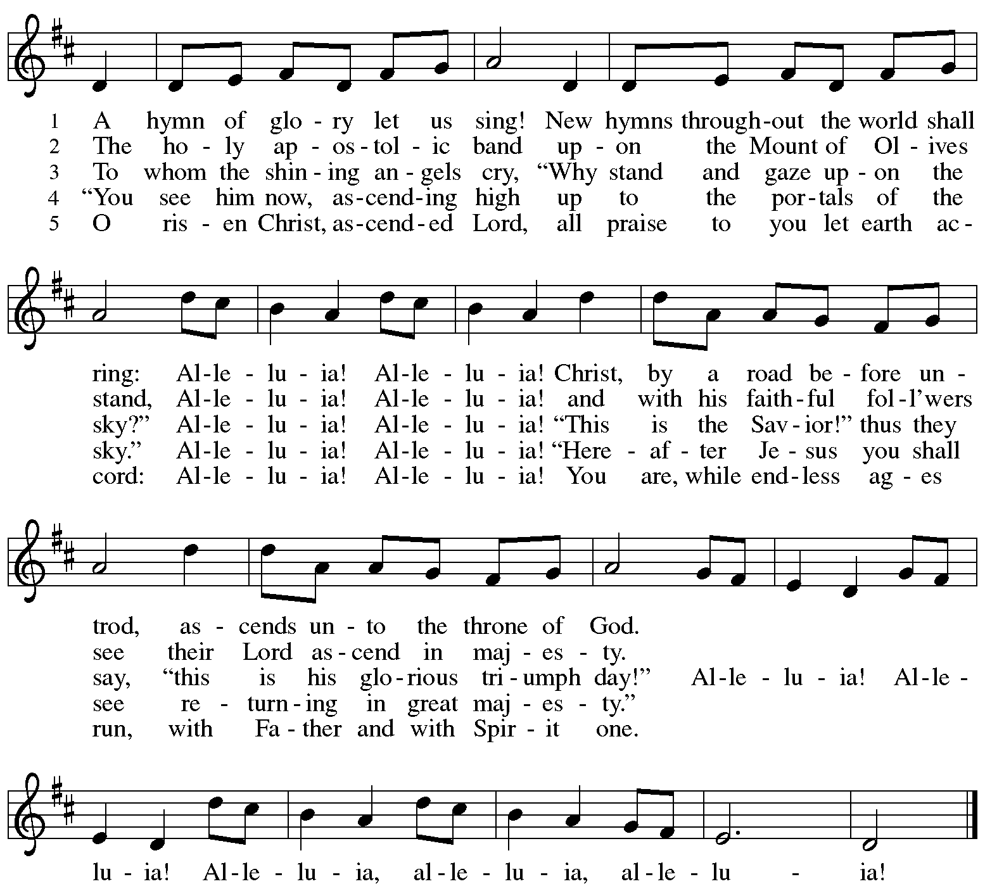

Greeting

P: The grace of our Lord Jesus Christ, the love of God,
and the communion of the Holy Spirit be with you all.
C: And also with you.

Hymn of Praise Now the Feast and Celebration HS p. 4-5

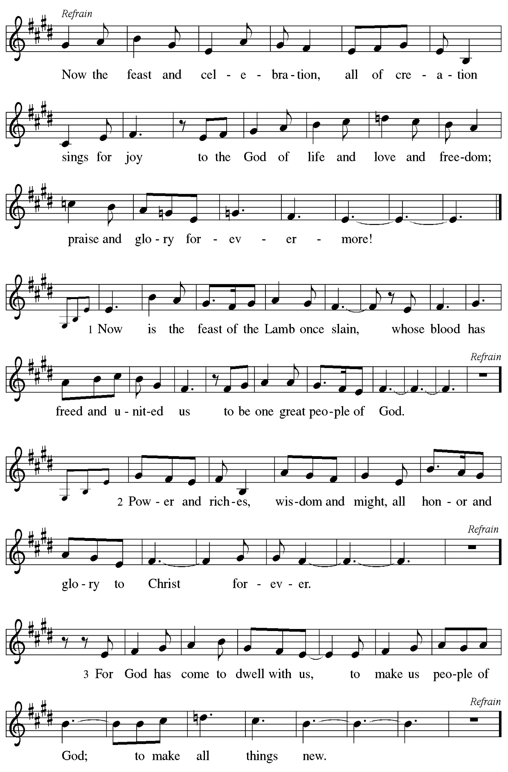

Prayer of the Day

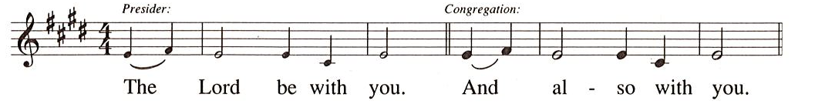

P: Let us pray.
O God of glory,
your Son Jesus Christ suffered for us and ascended to your right hand.
Unite us with Christ and each other in suffering and in joy,
that all the world may be drawn into your bountiful presence,
through Jesus Christ, our Savior and Lord,
who lives and reigns with you and the Holy Spirit, one God, now and forever.
C: Amen.

Please be seated.
Children are invited to join the adult leaders at the door and move to the office for Little Church – Big Faith. We ask that one additional adult from the congregation attend with the children.

Word
God speaks to us in Scripture reading, preaching, and song

First Reading – Acts 1: 6-14

⁶When [the apostles] had come together, they asked [Jesus], “Lord, is this the time when you will restore the kingdom to Israel?” ⁷He replied, “It is not for you to know the times or periods that the Father has set by his own authority. ⁸But you will receive power when the Holy Spirit has come upon you; and you will be my witnesses in Jerusalem, in all Judea and Samaria, and to the ends of the earth.” ⁹When he had said this, as they were watching, he was lifted up, and a cloud took him out of their sight. ¹⁰While he was going and they were gazing up toward heaven, suddenly two men in white robes stood by them. ¹¹They said, “Men of Galilee, why do you stand looking up toward heaven? This Jesus, who has been taken up from you into heaven, will come in the same way as you saw him go into heaven.”
¹²Then they returned to Jerusalem from the mount called Olivet, which is near Jerusalem, a sabbath day’s journey away. ¹³When they had entered the city, they went to the room upstairs where they were staying, Peter, and John, and James, and Andrew, Philip and Thomas, Bartholomew and Matthew, James son of Alphaeus, and Simon the Zealot, and Judas son of James. ¹⁴All these were constantly devoting themselves to prayer, together with certain women, including Mary the mother of Jesus, as well as his brothers.

L: Word of God, word of life.
C: Thanks be to God.

Psalm 68: 1-10, 32-35

The psalm will be sung by the cantor,
with the congregation invited to join in singing the verses in bold and the refrain.

Psalm tone

Psalm refrain

¹Let God arise, and let God’s ene- | mies be scattered;
let those who | hate God flee.
²As smoke is driven away, so you should drive | them away;
as the wax melts before the fire, so let the wicked perish at the pres- | ence of God.
³But let the righteous be glad and rejoice | before God;
let them also be mer- | ry and joyful.
⁴Sing to God, sing praises to God’s name; exalt the one who | rides the clouds;
I Am is that name, rejoice | before God! R
⁵In your holy habita- | tion, O God,
you are a father to orphans, defend- | er of widows;
⁶you give the solitary a home and bring forth prisoners | into freedom;
but the rebels shall live in | desert places.
⁷O God, when you went forth be- | fore your people,
when you marched | through the wilderness,
⁸the earth quaked, and the skies poured down rain, at the presence of God, the | God of
Sinai,
at the presence of God, the | God of Israel.
⁹You sent a bountiful | rain, O God;
you restored your inheritance | when it languished.
¹⁰Your people found their | home in it;
in your goodness, O God, you have made provision | for the poor. R
³²Sing to God, O kingdoms | of the earth;
sing praises | to the Lord.
³³You ride in the heavens, O God, in the | ancient heavens;
you send forth your voice, your | mighty voice.
³⁴Ascribe pow- | er to God,
whose majesty is over Israel; whose strength is | in the skies.
³⁵How wonderful you are in your holy places, O | God of Israel,
giving strength and power to your people! | Blessed be God! R

Second Reading – 1 Peter 4: 12-14; 5: 6-11

¹²Beloved, do not be surprised at the fiery ordeal that is taking place among you to test you, as though something strange were happening to you. ¹³But rejoice insofar as you are sharing Christ’s sufferings, so that you may also be glad and shout for joy when his glory is revealed. ¹⁴If you are reviled for the name of Christ, you are blessed, because the spirit of glory, which is the Spirit of God, is resting on you.

^{5:6}Humble yourselves therefore under the mighty hand of God, so that God may exalt you in due time. ⁷Cast all your anxiety on God, because God cares for you. ⁸Discipline yourselves, keep alert. Like a roaring lion your adversary the devil prowls around, looking for someone to devour. ⁹Resist him, steadfast in your faith, for you know that your siblings in all the world are undergoing the same kinds of suffering. ¹⁰And after you have suffered for a little while, the God of all grace, who has called you to God’s eternal glory in Christ, will restore, support, strengthen, and establish you. ¹¹To God be the power forever and ever. Amen.

L: Word of God, word of life.
C: Thanks be to God.

Please rise as you are able.

Gospel Acclamation

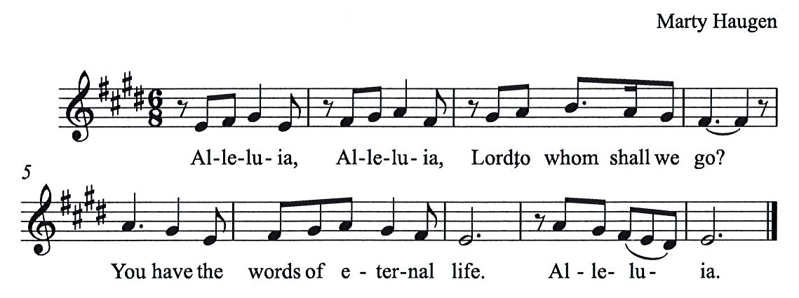

Gospel – John 17: 1-11

P: The holy Gospel according to St. John.
C: Glory to you, O Lord.

¹After Jesus had spoken these words [to his disciples], he looked up to heaven and said, “Father, the hour has come; glorify your Son so that the Son may glorify you, ²since you have given him authority over all people, to give eternal life to all whom you have given him. ³And this is eternal life, that they may know you, the only true God, and Jesus Christ whom you have sent. ⁴I glorified you on earth by finishing the work that you gave me to do. ⁵So now, Father, glorify me in your own presence with the glory that I had in your presence before the world existed.
⁶“I have made your name known to those whom you gave me from the world. They were yours, and you gave them to me, and they have kept your word. ⁷Now they know that everything you have given me is from you; ⁸for the words that you gave to me I have given to them, and they have received them and know in truth that I came from you; and they have believed that you sent me. ⁹I am asking on their behalf; I am not asking on behalf of the world, but on behalf of those whom you gave me, because they are yours. ¹⁰All mine are yours, and yours are mine; and I have been glorified in them. ¹¹And now I am no longer in the world, but they are in the world, and I am coming to you. Holy Father, protect them in your name that you have given me, so that they may be one, as we are one.”

P: The Gospel of the Lord.
C: Praise to you, O Christ.

Please be seated.

Sermon

A time of silence for prayer and reflection follows the sermon.
When the hymn of the day begins, please rise as you are able.

Hymn of the Day Following page

Hymn of the Day God Loved the World ELW 323
v. 1-2, 5

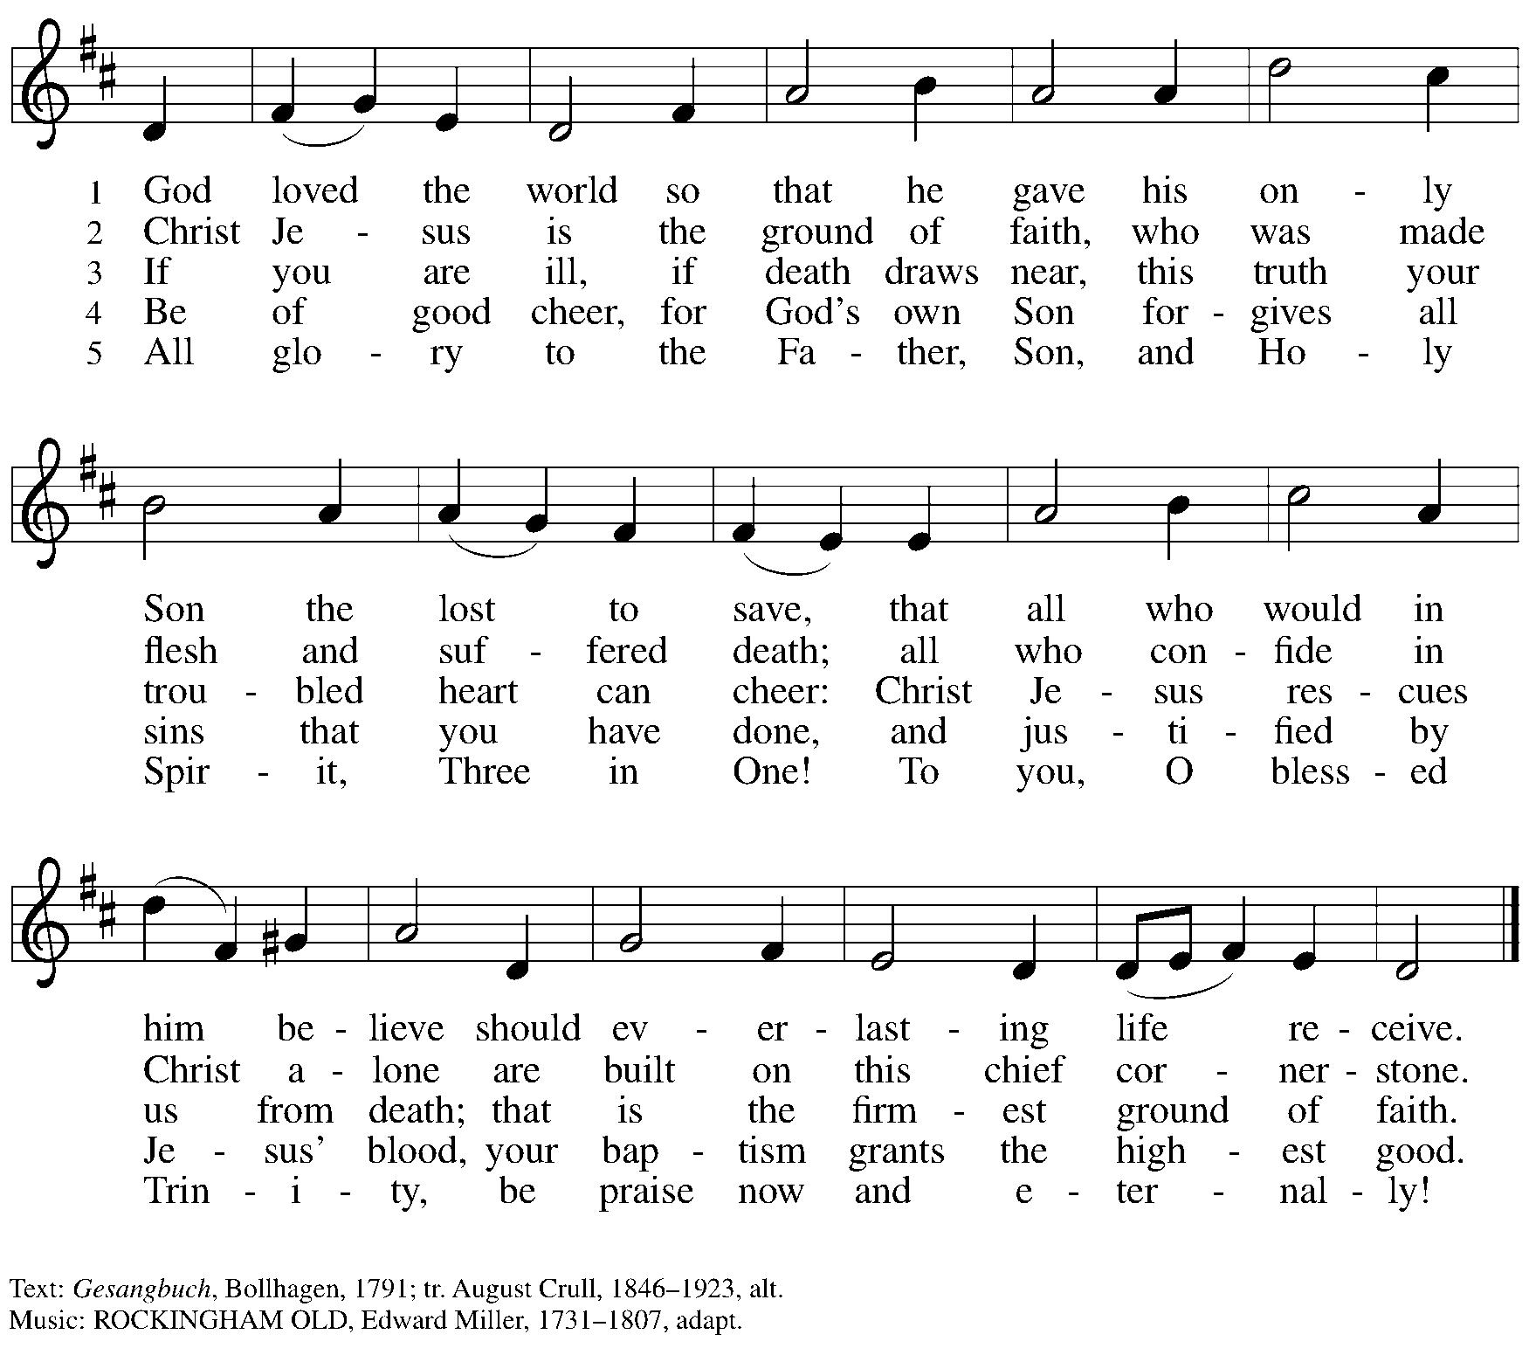

Nicene Creed

C: We believe in one God,
the Father, the Almighty,
maker of heaven and earth,
of all that is, seen and unseen.

We believe in one Lord, Jesus Christ,
The only Son of God,
eternally begotten of the Father,
God from God, Light from Light,
true God from true God,
begotten, not made,
of one Being with the Father;
through him all things were made.
For us and for our salvation
he came down from heaven,
was incarnate of the Holy Spirit and the virgin Mary
and became truly human.
For our sake he was crucified under Pontius Pilate;
he suffered death and was buried.
On the third day he rose again
in accordance with the scriptures;
he ascended into heaven
and is seated at the right hand of the Father.
He will come again in glory to judge the living and the dead,
and his kingdom will have no end.

We believe in the Holy Spirit, the Lord, the giver of life,
who proceeds from the Father and the Son,*
who with the Father and the Son is worshiped and glorified,
who has spoken through the prophets.
We believe in one holy catholic and apostolic church.
We acknowledge one baptism for the forgiveness of sins.
We look for the resurrection of the dead,
and the life of the world to come. Amen.

*Or, “who proceeds from the Father.” The phrase “and the Son” is a later addition to the creed.

Prayers of the People

A: United in the joy and hope of the resurrection, let us pray for the church, the world,
and all who are in need.

After each petition
A: Gracious God,
C: receive our prayer.

The presiding minister concludes the prayers
P: We lift these prayers to you O God,
trusting in your abundant mercy,
through Jesus Christ our risen Savior.
C: Amen.

Peace

The presiding minister and the assembly greet one another in the peace of the risen Christ.
P: The peace of Christ be with you always.
C: And also with you.

The people may greet those around them with a sign of Christ’s peace and may say
Peace be with you or similar words. Please be mindful that not everyone will be comfortable with sharing the peace, so please seek consent before shaking hands or hugging. Other possible ways to share the peace include a simple bow with the verbal greeting of peace, or simply a verbal expression of peace.

When the greetings of peace have concluded, please be seated.

Meal
God feeds us with the presence of Jesus Christ

Offering

We offer ourselves, our gifts, and our faithful service to God.
As the offering is gathered for the mission of the church, including the care of those in need,
the table is set for Holy Communion.

Music during the Offering

As the gifts are brought forward for presentation, please rise as you are able.

Offertory Song As the Grains of Wheat ELW 465

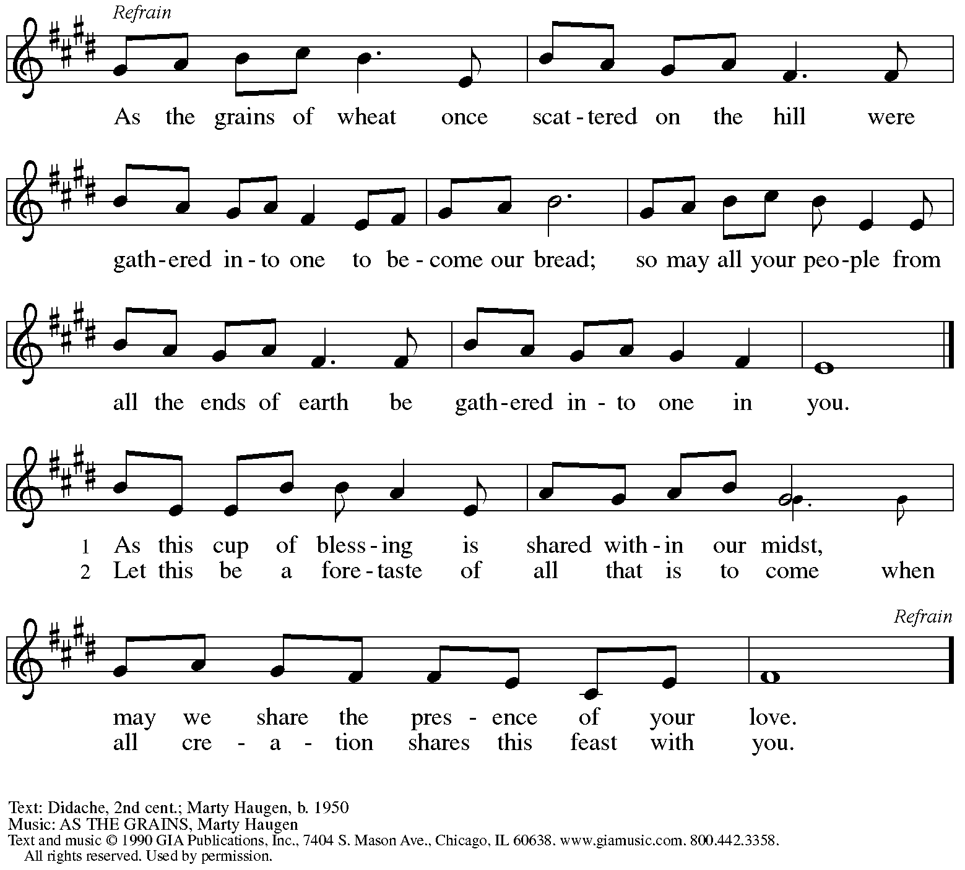
Reprinted under OneLicense.net # A-722139.

Offertory Prayer

A: Let us pray.
Blessed are you, O God,
C: ruler of heaven and earth.
Day by day you shower us with blessings.
As you have raised us to new life in Christ,
give us glad and generous hearts,
ready to praise you and to respond to those in need,
through Jesus Christ, our Savior and Lord.
Amen.

Dialogue HS p. 14

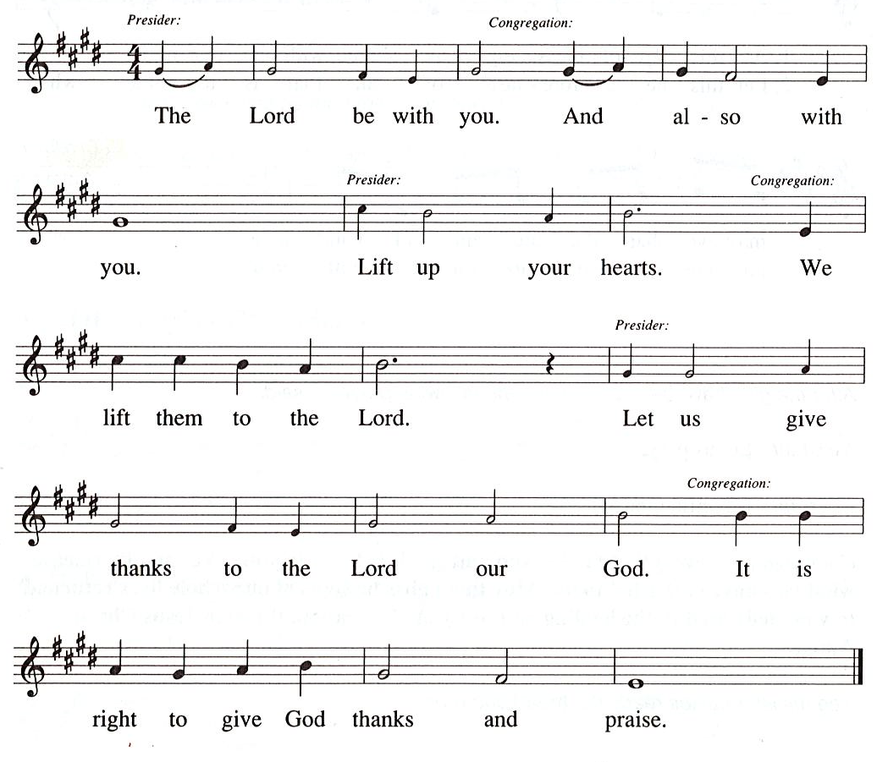

Preface (Sung by the presiding minister)

P: It is our duty and delight
that we should everywhere and always
offer thanks and praise to you, O God,
through Jesus Christ,
who by his death on the cross
and his glorious resurrection
broke the bonds of sin and death
and gave life to all creation.
And so with the church on earth,
all creation and the hosts of heaven,
we praise your name and join their unending hymn:

Sanctus HS p. 15

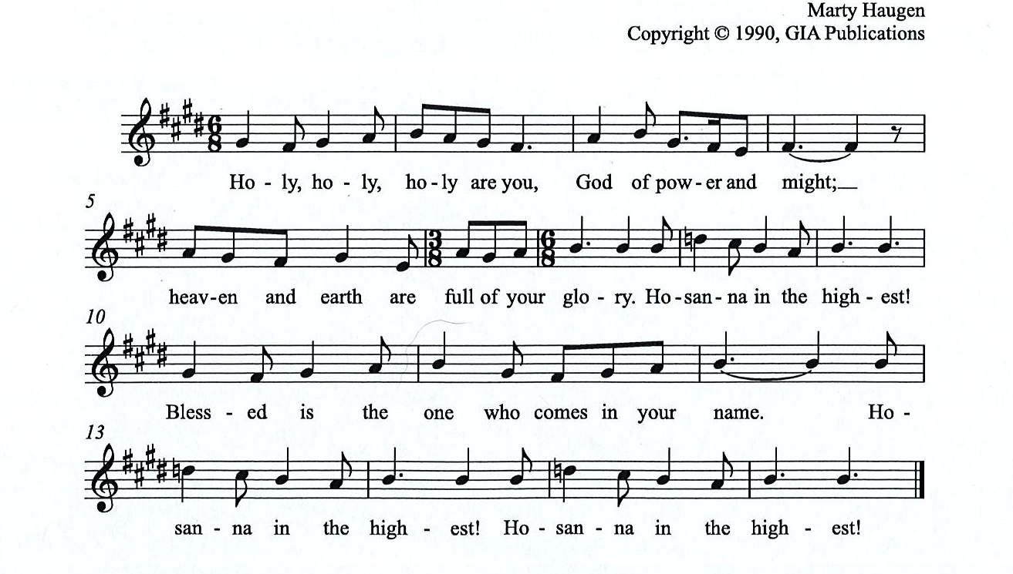

Eucharistic Prayer

P: You are indeed holy, almighty and merciful God, …
… Do this for the remembrance of me.

For as often as we eat of this bread and drink from this cup,
we proclaim the Lord’s death until he comes.

(Presiding minister sings)
Christ has died. Christ is risen. Christ will come, come again.
C:
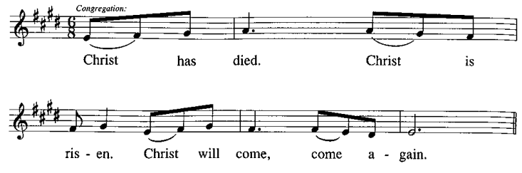

P: Remembering, therefore, his salutary command, …
… and be given our inheritance with all your saints.

To you, O God, Father, Son, and Holy Spirit,
be all honor and glory in your holy church, now and forever.
C:
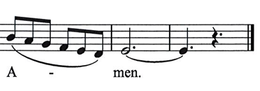

Lord’s Prayer

P: Gathered as one by the Holy Spirit, let us pray as Jesus taught us.
C: Our Father in heaven,
hallowed be your name,
your kingdom come,
your will be done,
on earth as in heaven.
Give us today our daily bread.
Forgive us our sins
as we forgive those
who sin against us.
Save us from the time of trial
and deliver us from evil.
For the kingdom, the power,
and the glory are yours,
now and forever. Amen.

Fraction and Invitation

P: This is the feast of victory for our God. Alleluia! Alleluia!
Come, share the feast.

Agnus Dei / Lamb of God Following Page

Agnus Dei / Lamb of God HS p. 18

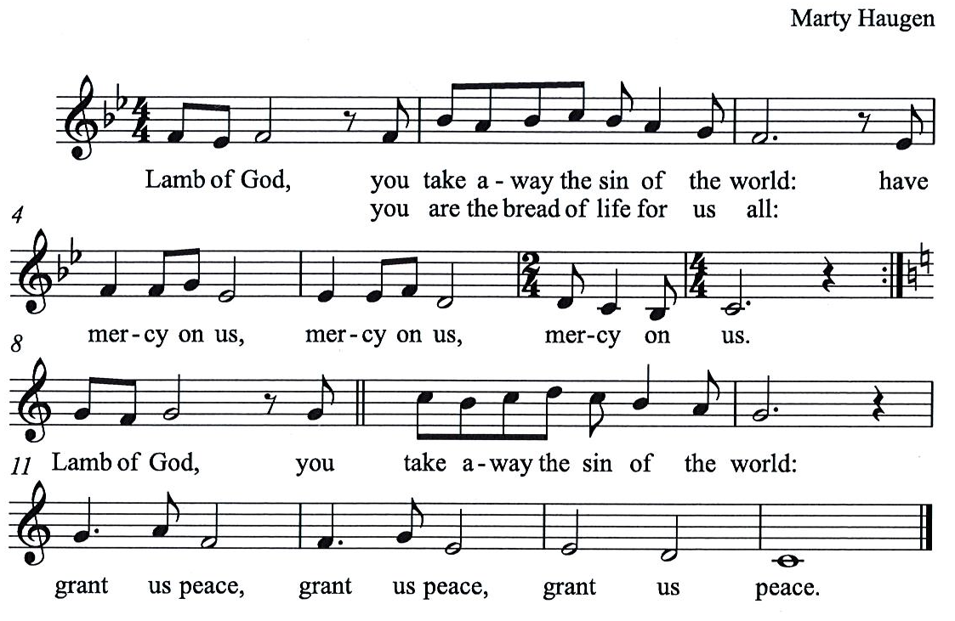

Please be seated.

Holy Communion
- All who seek God and desire a deeper and stronger life in Christ are welcome to receive Holy Communion.
- Worshipers from the pulpit side will proceed forward first, followed by the center section, and then the lectern side.
- Please inform an usher if you would like the ministers to bring Communion to you.
- Holy Communion will be served with bread and wine/grape juice.
- The presiding minister will first distribute the bread (host) to each communicant. Please indicate if you require a gluten-free host.
- Once you have consumed the bread, please pick up an empty glass from the tray next to the presiding minister. The Communion Assistant will pour wine from the chalice or grape juice from the cruet into your glass.
- Please step to the side to consume the wine or grape juice.
- Feel free to kneel at the altar rail for prayer after receiving the sacrament.
- As you return to your pew, glasses may be returned to the empty trays on either side of the center section.
- A blessing will be provided for anyone who does not yet receive the sacrament.
- All are invited to join in singing the hymns during Holy Communion.

Hymns during Holy Communion
Lord, Who the Night You Were Betrayed ELW 463

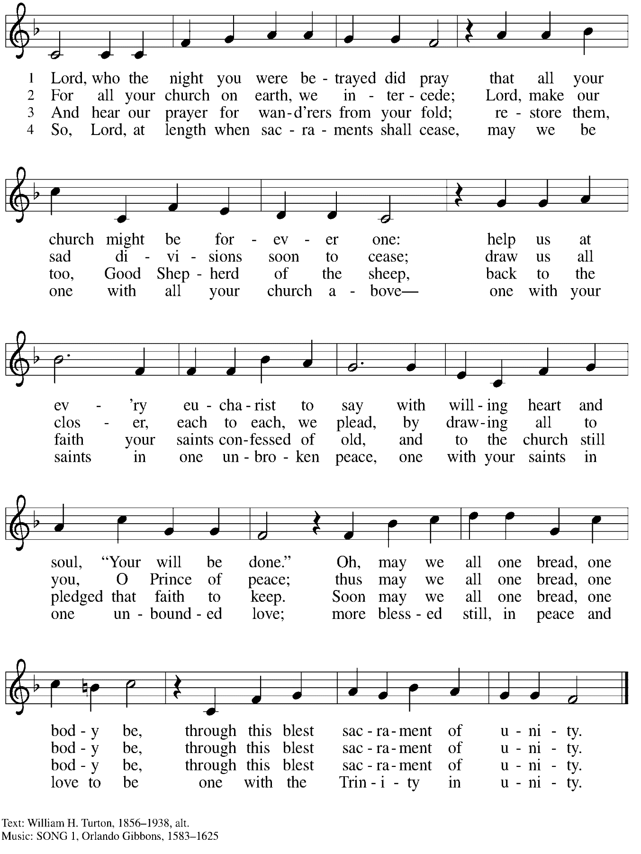
Hymns during Holy Communion
I Come with Joy ELW 482

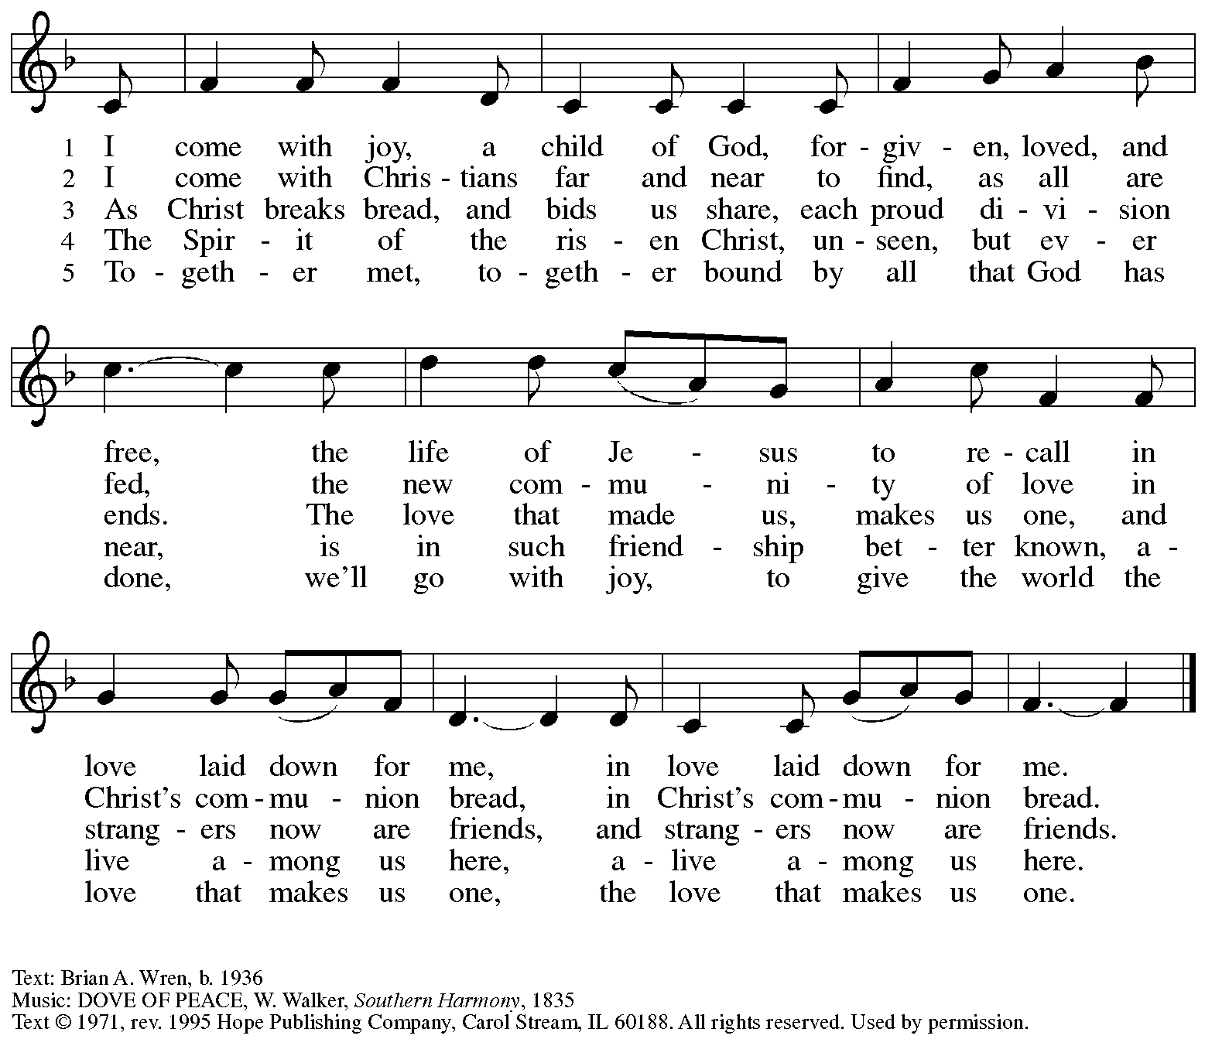
All rights reserved. Reprinted with permission under OneLicense.net # A-722139.

Hymns during Holy Communion
Christ, Our Peace ACS 1037

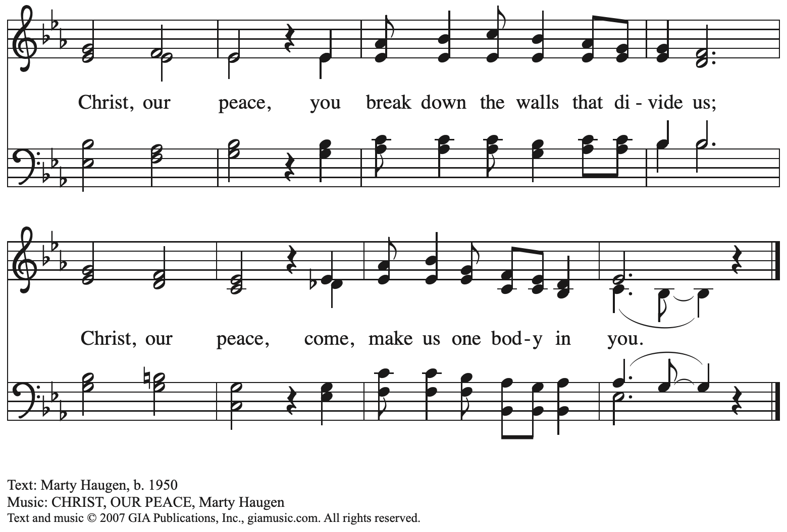
Reprinted with permission under OneLicense.net # A-722139.

When all have returned to their places, please rise as you are able.

Blessing

P: The body and blood of our Lord Jesus Christ strengthen you and keep you in his grace.
C: Amen.

Prayer

A: Let us pray. Life-giving God,
in the mystery of Christ’s resurrection,
you send light to conquer darkness, water to give new life,
and the bread of life to nourish your people.
Send us forth as witnesses to your Son’s resurrection,
that we may show your glory to all the world,
through Jesus Christ, our risen Lord.
C: Amen.

Please be seated.

Sending
God blesses us and sends us in mission to the world

Announcements

Please rise as you are able.

Farewell and Godspeed

Farewell and Godspeed is an affirmation of the corporate nature of our baptismal faith,
for use when people leave a congregation. Those moving on are invited to come forward
and gather at the baptismal font.

P: The Reeder Family is leaving our congregation, and, as they do, we wish to bid them farewell.

A reading from Exodus: The Lord said, “I am going to send an angel in front of you, to guard you on the way and to bring you to the place that I have prepared.”

In Holy Baptism, our Lord Jesus Christ received you and made you members of his church. When you came to this congregation, we rejoiced to welcome you into the mission we share
as the people of God. In this community, you have come to know and to share in God’s loving purpose for you and for all creation. God has blessed you in this congregation, and God has blessed us through you.

We encourage you to continue to receive and share in God’s gifts at St. Matthew’s Evangelical Lutheran Church in Crafton, united with us in the Body of Christ and the mission we share.

Let us pray.

Gracious God,
we thank you for the work and witness of your servants,
who have enriched this congregation and shared their gifts
with their colleagues, friends, family, and siblings in Christ.
Now bless and preserve them in this time of transition.
Day by day, guide them and give them what is needed,
bring them friends along the way
and a clear vision of that to which you are now calling them.
By your Holy Spirit be present in their pilgrimage
that they may travel with the one who is the way, the truth, and the life,
Jesus Christ our Lord.
C: Amen.

Congregational Refrain

The congregation is invited to join in singing the congregational refrain.

C: Christ goes before, and we are called to follow,
and all who follow find the way, the truth, the life.

Benediction

P: May our glorious God grant you a spirit of wisdom
to know and love the risen Christ.

Almighty God, holy One, ☩ holy Three,
bless you now and forever.
C:
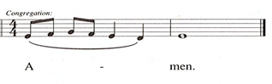

Sending Hymn Rise, O Sun of Righteousness Following page

Dismissal

A: Go in peace. Share the good news!
C: Thanks be to God!

Postlude

Sending Hymn Rise, O Sun of Righteousness ELW 657

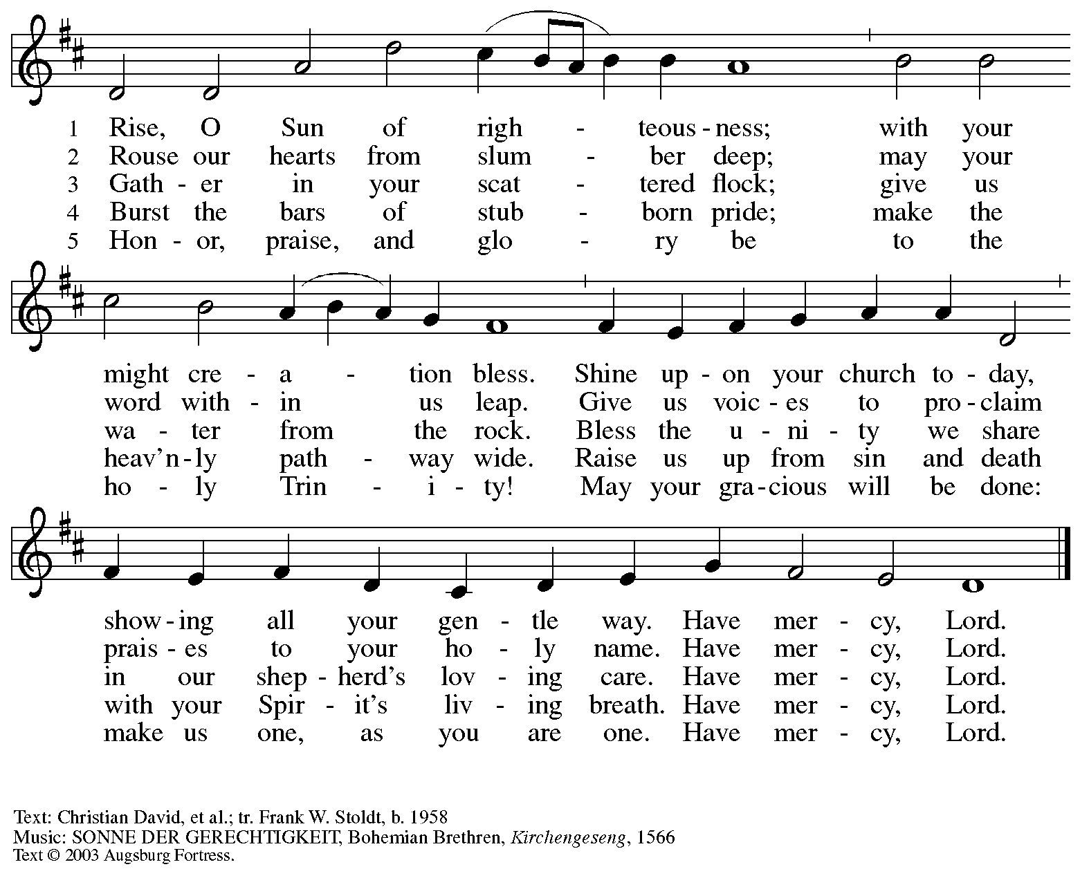
All rights reserved. Reprinted with permission under OneLicense.net # A-722139.

Abbreviations

P: Pastor/Presiding Minister
A: Assisting Minister
L: Lector
C: Congregation

ACS: All Creation Sings hymnal
ELW: Evangelical Lutheran Worship hymnal
HS: Hymnal Supplement

Those serving in worship today

Altar Care Beverley Chapman
Assisting Minister Jeff Denlinger
Audio-Visual Ministers Jason Galyardt
David Rollinson
Cantor C.E. Pino
Coffee Hour Colten Rohleder
Lector Christy Ruhe
Little Church – Big Faith Leader Sue Gaugler
Minister of Music Laura Reynolds
Presiding Minister Pastor Ross Carmichael

Liturgy and Hymnody Acknowledgements

From SundaysandSeasons.com. Copyright © 2023 Augsburg Fortress. All rights reserved. Reprinted under OneLicense.net # A-722139.
Used by permission of Augsburg Fortress.

A Hymn of Glory Let Us Sing! – Text: Bede, 673-735, tr. Lutheran Book of Worship. Music: LASST UNS ERFREUEN, Geistliche Kirchengesänge, Köln, 1623. Text © 1978 Lutheran Book of Worship, admin. Augsburg Fortress. All rights reserved. Reprinted with permission under OneLicense.net # A722139.

Now the Feast and Celebration –Text: Marty Haugen, b. 1950. Music: NOW THE FEAST AND CELEBRATION, Marty Haugen. Text and music © 1990 GIA Publications, Inc. 7404 Mason Ave. Chicago, IL 60638. www.giamusic.com. 800.442.3358. All rights reserved. Reprinted with permission under OneLicense.net # A-722139.

As the Grains of Wheat – Text: Didache, 2nd cent.; Marty Haugen, b. 1950. Music: Marty Haugen. Text and Music © 1990 GIA Publications, Inc. 7404 Mason Ave. Chicago, IL 60638. www.giamusic.com. 800.442.3358. All rights reserved. Reprinted with permission under OneLicense.net # A-722139.

St. Andrew Lutheran Church Announcements
May 21st, 2023

- Happy Easter! Welcome to worship at St. Andrew on May 21st, 2023, the + Seventh Sunday of Easter, as we remember Christ’s Ascension and await the coming of the Holy Spirit at Pentecost! – We are so glad you are here to share in this festive season, and we offer a special welcome to all visitors and guests who are here for the first time! Masks are optional at St. Andrew when Allegheny County’s Covid-19 community level is in the low and medium categories. Worship attendees are invited to make a name tag at the back of the worship space if you would like. There are worship “toolkits” to help children engage with worship and “busy bags” for younger children available in the bookcase at the back of the sanctuary. Please feel free to take one to use with/for your children. We pray that everyone has a blessed Easter season!
- Farewell and Godspeed to the Reeder Family! – Sarah and Matthew Reeder, along with their children, have shared in the community of St. Andrew for several years, and the congregation has been blessed by their presence. Now they are transferring their membership to a congregation closer to their home, St. Matthew’s Evangelical Lutheran Church in Crafton. At the close of worship today, we will have an opportunity to offer them our prayers and support and wish them well as they continue their life of faith and ministry in a new setting. Please wish them well when you see them today!
- Seeking Help with Sunday Coffee Hour – Many in the St. Andrew community enjoy the opportunity to gather for coffee, snacks and conversation after worship each week. We are looking for help with setup / preparation and cleanup each week and the whole process is pretty simple! If you would like to contribute, either for one time or on a rotating monthly schedule, please contact Pastor Ross Carmichael at PastorRCarmichael@gmail.com.
- St. Andrew Jail Ministry – St. Andrew has had a long history of participation in the ministry program at the Allegheny County Jail. Until the program was put on hold at the beginning of the Covid pandemic, a group of volunteers from St. Andrew was leading a worship service at the jail on Sunday mornings, typically about one Sunday a month. The jail is hoping to resume this program soon. If any of the previous volunteers are still interested and available, please contact Lester Prince (lprince@comcast.net). New volunteers are also needed. The first step for new volunteers is to complete an online application, which can be accessed here: https://www.foundationofhope.org/get-involved/volunteer-application/. On the application form, indicate that the program that you are interested in volunteering with is “Chaplaincy Worship.” Feel free to contact Lester Prince with any questions.

