+ Day of Pentecost
May 28, 2023
St. Andrew Lutheran Church
304 Morewood Ave.
Pittsburgh, PA 15213
St_andrewELCA@verizon.net
www.standrewpittsburgh.org

+ Day of Pentecost
Order for Worship

Pentecost derives its name from the Jewish festival celebrating the harvest
and the giving of the law on Mount Sinai fifty days after Passover.
Fifty days after Easter, we celebrate the Holy Spirit as God’s presence within and among us.
In Acts, the Spirit arrives in rushing wind and flame, bringing God’s presence to all people.
Paul reminds us that though we each have different capacities, we are unified in the Spirit
that equips us with these gifts. Jesus breathes the Holy Spirit on his disciples,
empowering them to forgive sin. We celebrate that we too are given the breath of the Holy Spirit
and sent out to proclaim God’s redeeming love to all the world.

Welcome to St. Andrew!

- St. Andrew Lutheran congregation welcomes all who are seeking a place of healing and wholeness – a nurturing, faith-forming spiritual home. Our community embraces people of all ages, ethnicities, cultures, abilities, sexual orientations, gender identities and expressions, and family constellations. Come and See!

- Worship Services are live streamed to multiple online platforms. By attending worship, you agree that your image and voice may be broadcast.

- Everyone is invited to make a nametag at the black bookcase in the back of the worship space if they would like. There are stickers indicating pronouns on the bookcase if you would like to include them on your name tag.

- Little Church – Big Faith, St. Andrew’s Bible lesson and activity for children, will not take place during worship today.

- Worship “toolkits” to help children engage with the service, along with “busy bags” for younger children, are available in the bookcase at the back of the sanctuary. Please feel free to take one to use with/for your children.

- Holy Communion is served with bread (gluten-free available) and wine or grape juice. The presiding minister will distribute the bread (host). Please consume this and then pick up an empty glass from the tray. The Communion Assistant will pour wine or grape juice into your glass. Please step to the side to consume the wine or grape juice. Feel free to kneel at the altar for prayer and reflection. As you return to your pew, glasses may be returned to the empty trays on either side of the center section.

- A restroom is available on the main level of the church, through the doors to the Social Hall and to the right in the main office.

Pre-Service Music

Welcome

Prelude As the Wind Song ACS 943

Gathering
The Holy Spirit calls us together as the people of God

Confession and Forgiveness

Please rise as you are able.
All may make the sign of the cross, the sign that is marked at Baptism,
as the presiding minister begins.

P: Blessed be the holy Trinity,
☩ one God,
who creates, redeems, and sustains us
and all of creation.
C: Amen.

P: Let us confess our sin in the presence of God and of one another.

Silence is kept for reflection

P: To you, O God,
C: all hearts are open, to you all desires known.
We come to you, confessing our sins.
Forgive us in your mercy, and remember us in your love.
Show us your ways; teach us your paths; and lead us in justice and truth,
for the sake of your goodness in Jesus Christ our Savior.
Amen.

P: By water and the Holy Spirit God gives you a new birth,
and through the death and resurrection of ☩ Jesus Christ,
God forgives you all your sins.
The God of mercy and might strengthen you in all goodness
and keep you in eternal life.
C: Amen.

Processional Hymn O Day Full of Grace ELW 627

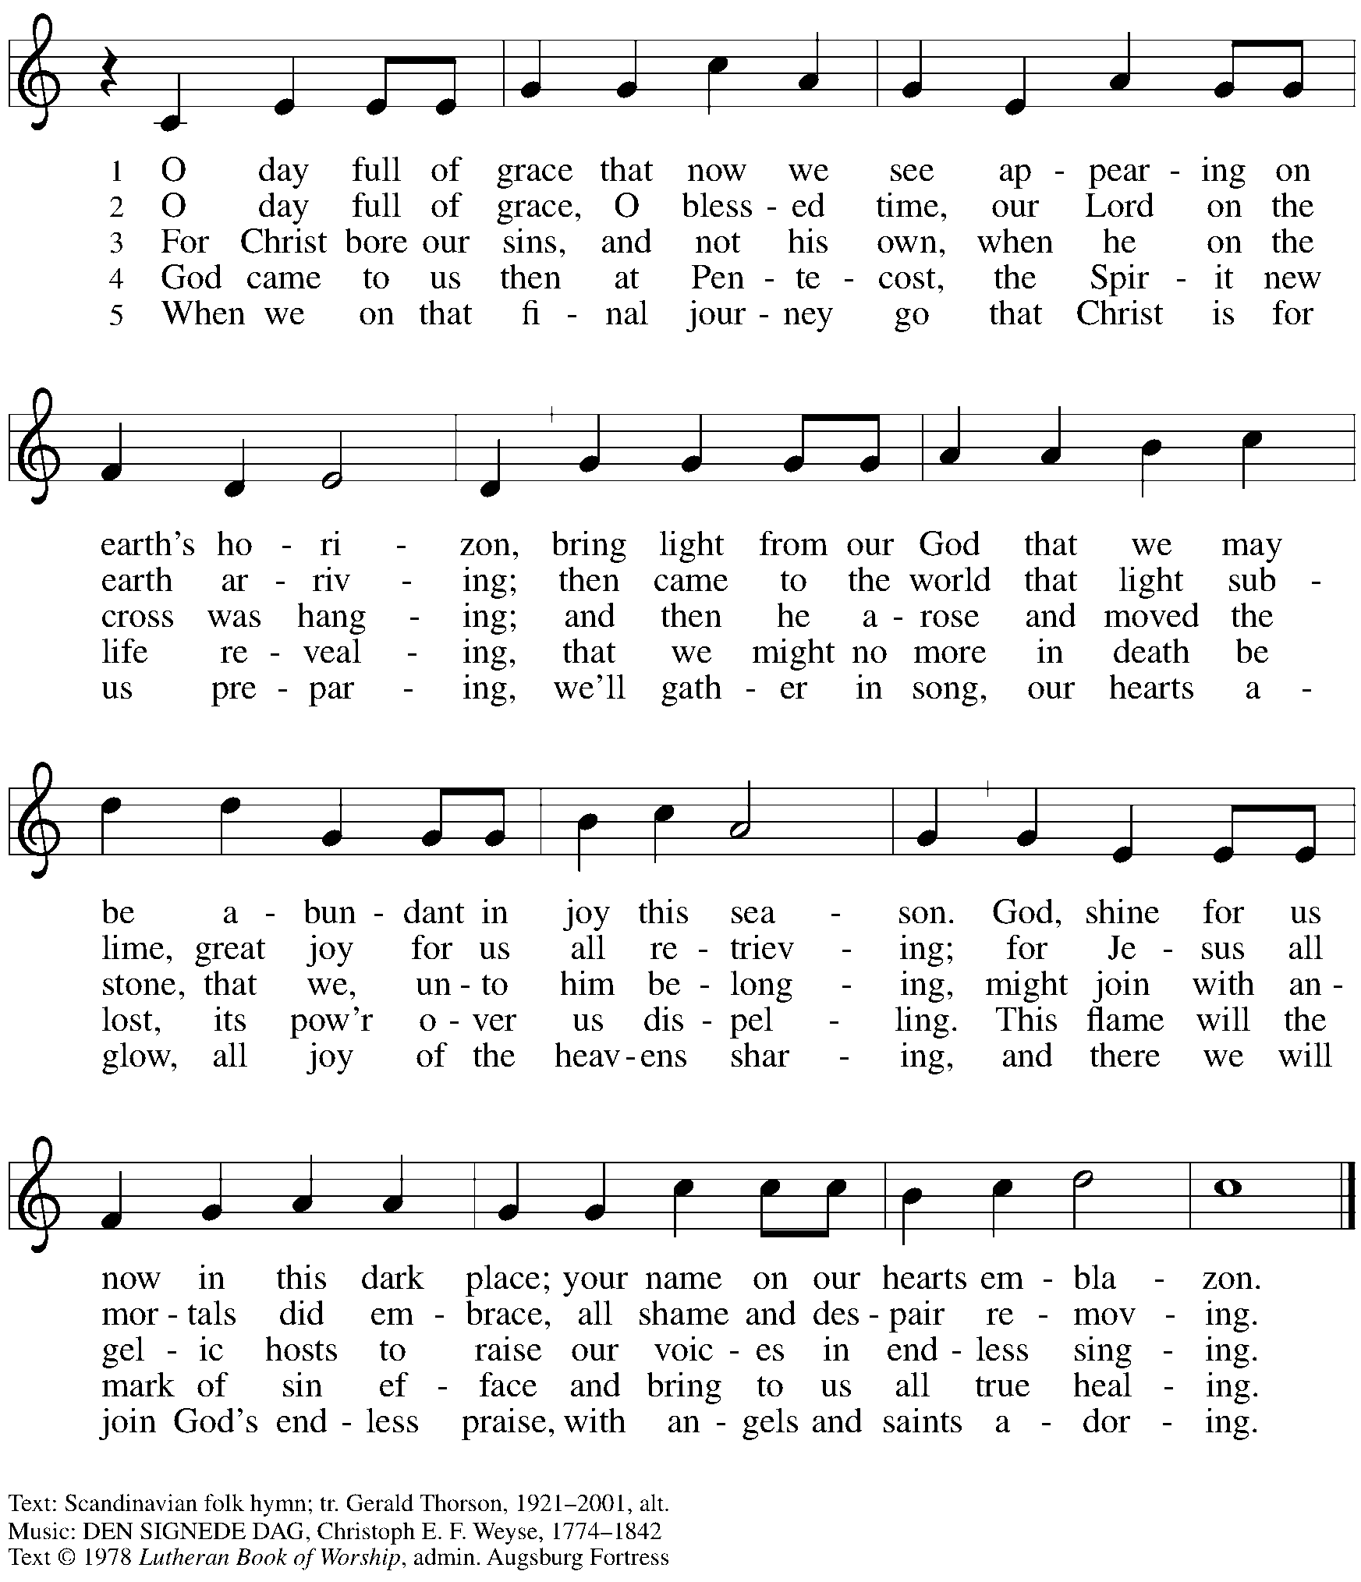
All rights reserved. Reprinted under OneLicense.net # A-722139.

Greeting

P: The grace of our Lord Jesus Christ, the love of God,
and the communion of the Holy Spirit be with you all.
C: And also with you.

Hymn of Praise Now the Feast and Celebration HS p. 4-5

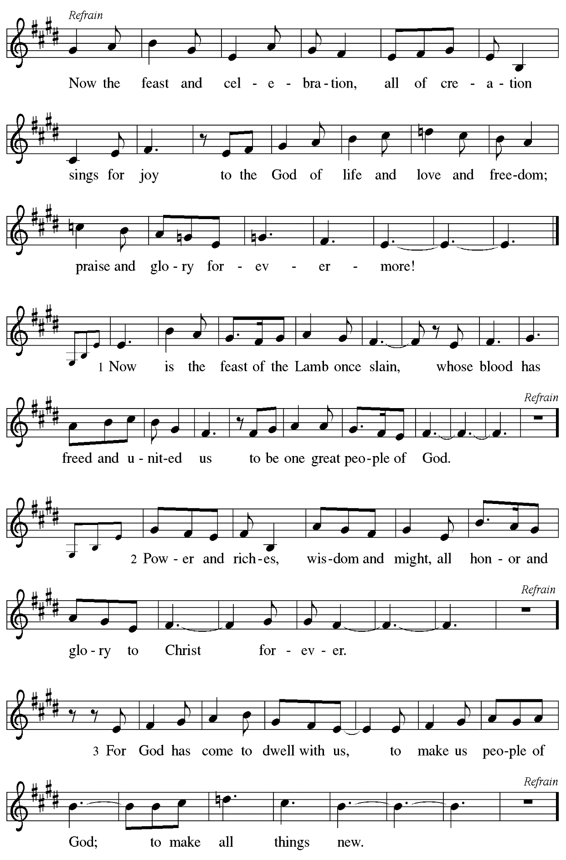

Prayer of the Day

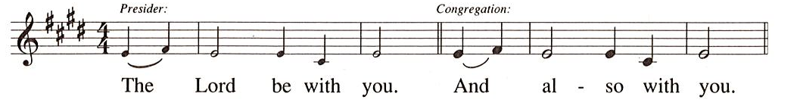

P: Let us pray.
O God,
on this day you open the hearts of your faithful people by sending into us your Holy Spirit. Direct us by the light of that Spirit, that we may have a right judgment in all things
and rejoice at all times in your peace, through Jesus Christ, your Son and our Lord,
who lives and reigns with you and the Holy Spirit, one God, now and forever.
C: Amen.

Please be seated.
Little Church – Big Faith, our Bible lesson and activity for children, will not be held today.

Word
God speaks to us in Scripture reading, preaching, and song

First Reading – Acts 2: 1-21

¹When the day of Pentecost had come, [the apostles] were all together in one place. ²And suddenly from heaven there came a sound like the rush of a violent wind, and it filled the entire house where they were sitting. ³Divided tongues, as of fire, appeared among them, and a tongue rested on each of them. ⁴All of them were filled with the Holy Spirit and began to speak in other languages, as the Spirit gave them ability.
⁵Now there were devout Jews from every nation under heaven living in Jerusalem. ⁶And at this sound the crowd gathered and was bewildered, because each one heard them speaking in the native language of each. ⁷Amazed and astonished, they asked, “Are not all these who are speaking Galileans? ⁸And how is it that we hear, each of us, in our own native language? ⁹Parthians, Medes, Elamites, and residents of Mesopotamia, Judea and Cappadocia, Pontus and Asia, ¹⁰Phrygia and Pamphylia, Egypt and the parts of Libya belonging to Cyrene, and visitors from Rome, both Jews and proselytes, ¹¹Cretans and Arabs—in our own languages we hear them speaking about God’s deeds of power.” ¹²All were amazed and perplexed, saying to one another, “What does this mean?” ¹³But others sneered and said, “They are filled with new wine.”
¹⁴But Peter, standing with the eleven, raised his voice and addressed them, “Men of Judea and all who live in Jerusalem, let this be known to you, and listen to what I say. ¹⁵Indeed, these are not drunk, as you suppose, for it is only nine o’clock in the morning. ¹⁶No, this is what was spoken through the prophet Joel:
¹⁷‘In the last days it will be, God declares,
that I will pour out my Spirit upon all flesh,
and your sons and your daughters shall prophesy,
and your young men shall see visions,
and your old men shall dream dreams.
¹⁸Even upon my slaves, both men and women,
in those days I will pour out my Spirit;
and they shall prophesy.
¹⁹And I will show portents in the heaven above
and signs on the earth below,
blood, and fire, and smoky mist.
²⁰The sun shall be turned to darkness
and the moon to blood,
before the coming of the Lord’s great and glorious day.
²¹Then everyone who calls on the name of the Lord shall be saved.’ ”

L: Word of God, word of life.
C: Thanks be to God.

Psalm 104: 24-34, 35b

The psalm will be sung by the cantor,
with the congregation invited to join in singing the verses in bold and the refrain.

Psalm tone

Psalm refrain

²⁴How manifold are your | works, O Lord!
In wisdom you have made them all; the earth is full | of your creatures.
²⁵Yonder is the sea, great and wide, with its swarms too man- | y to number,
living things both | small and great.
²⁶There go the ships | to and fro,
and Leviathan, which you made for the | sport of it.
²⁷All of them | look to you
to give them their food | in due season. R
²⁸You give it to them; they | gather it;
you open your hand, and they are filled | with good things.
²⁹When you hide your face, | they are terrified;
when you take away their breath, they die and return | to their dust.
³⁰You send forth your Spirit, and they | are created;
and so you renew the face | of the earth.
³¹May the glory of the Lord en- | dure forever;
O Lord, rejoice in | all your works. R
³²You look at the earth | and it trembles;
you touch the mountains | and they smoke.
³³I will sing to the Lord as long | as I live;
I will praise my God while I | have my being.
³⁴May these words of | mine please God.
I will rejoice | in the Lord.
^{35b}Bless the Lord, | O my soul.
Hal- | lelujah! R

Second Reading – 1 Corinthians 12: 3b-13

^{3b}No one can say “Jesus is Lord” except by the Holy Spirit.
⁴Now there are varieties of gifts, but the same Spirit; ⁵and there are varieties of services, but the same Lord; ⁶and there are varieties of activities, but it is the same God who activates all of them in everyone. ⁷To each is given the manifestation of the Spirit for the common good. ⁸To one is given through the Spirit the utterance of wisdom, and to another the utterance of knowledge according to the same Spirit, ⁹to another faith by the same Spirit, to another gifts of healing by the one Spirit, ¹⁰to another the working of miracles, to another prophecy, to another the discernment of spirits, to another various kinds of tongues, to another the interpretation of tongues. ¹¹All these are activated by one and the same Spirit, who allots to each one individually just as the Spirit chooses.
¹²For just as the body is one and has many members, and all the members of the body, though many, are one body, so it is with Christ. ¹³For in the one Spirit we were all baptized into one body—Jews or Greeks, slaves or free—and we were all made to drink of one Spirit.

L: Word of God, word of life.
C: Thanks be to God.

Please rise as you are able.

Gospel Acclamation

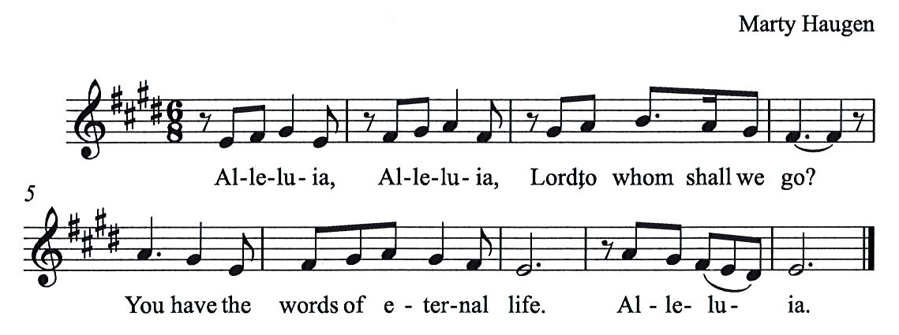

Gospel – John 20: 19-23

P: The holy Gospel according to St. John.
C: Glory to you, O Lord.

¹⁹When it was evening on that day, the first day of the week, and the doors of the house where the disciples had met were locked for fear of the Jews, Jesus came and stood among them and said, “Peace be with you.” ²⁰After he said this, he showed them his hands and his side. Then the disciples rejoiced when they saw the Lord. ²¹Jesus said to them again, “Peace be with you. As the Father has sent me, so I send you.” ²²When he had said this, he breathed on them and said to them, “Receive the Holy Spirit. ²³If you forgive the sins of any, they are forgiven them; if you retain the sins of any, they are retained.”

P: The Gospel of the Lord.
C: Praise to you, O Christ.

Please be seated.

Sermon

A time of silence for prayer and reflection follows the sermon.
When the hymn of the day begins, please rise as you are able.

Hymn of the Day Following page

Hymn of the Day O Spirit, All Embracing ACS 944

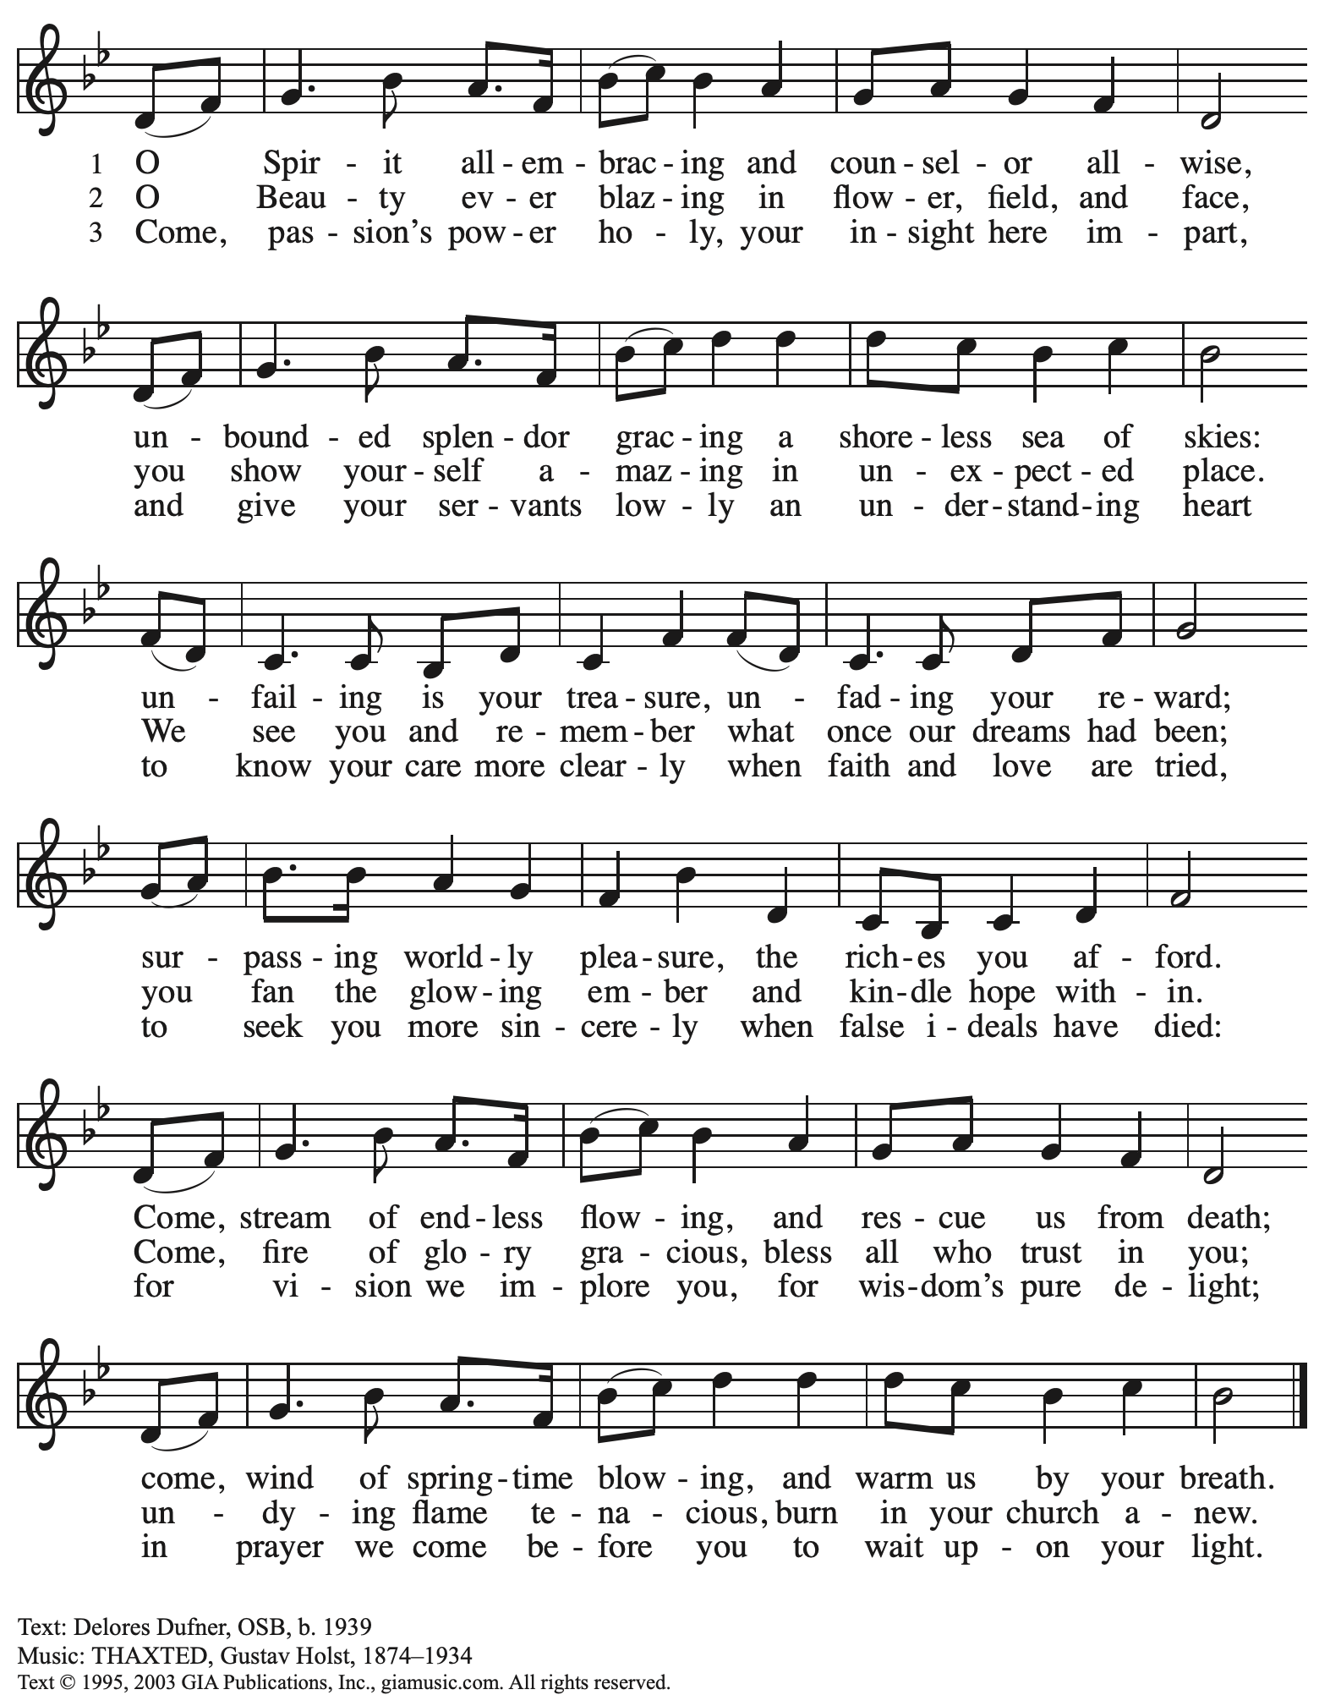
Reprinted with permission under OneLicense.net # A-722129.

Nicene Creed

C: We believe in one God,
the Father, the Almighty,
maker of heaven and earth,
of all that is, seen and unseen.

We believe in one Lord, Jesus Christ,
The only Son of God,
eternally begotten of the Father,
God from God, Light from Light,
true God from true God,
begotten, not made,
of one Being with the Father;
through him all things were made.
For us and for our salvation
he came down from heaven,
was incarnate of the Holy Spirit and the virgin Mary
and became truly human.
For our sake he was crucified under Pontius Pilate;
he suffered death and was buried.
On the third day he rose again
in accordance with the scriptures;
he ascended into heaven
and is seated at the right hand of the Father.
He will come again in glory to judge the living and the dead,
and his kingdom will have no end.

We believe in the Holy Spirit, the Lord, the giver of life,
who proceeds from the Father and the Son,*
who with the Father and the Son is worshiped and glorified,
who has spoken through the prophets.
We believe in one holy catholic and apostolic church.
We acknowledge one baptism for the forgiveness of sins.
We look for the resurrection of the dead,
and the life of the world to come. Amen.

*Or, “who proceeds from the Father.” The phrase “and the Son” is a later addition to the creed.

Prayers of the People

A: United in the joy and hope of the resurrection, and guide by the Holy Spirit,
let us pray for the church, the world, and all who are in need.

After each petition
A: Gracious God,
C: receive our prayer.

The presiding minister concludes the prayers
P: We lift these prayers to you O God, trusting in your abundant mercy,
through Jesus Christ our risen and ascended Savior.
C: Amen.

Peace

The presiding minister and the assembly greet one another in the peace of the risen Christ.
P: The peace of Christ be with you always.
C: And also with you.

The people may greet those around them with a sign of Christ’s peace and may say
Peace be with you or similar words. Please be mindful that not everyone will be comfortable with sharing the peace, so please seek consent before shaking hands or hugging. Other possible ways to share the peace include a simple bow with the verbal greeting of peace, or simply a verbal expression of peace.

When the greetings of peace have concluded, please be seated.

Meal
God feeds us with the presence of Jesus Christ

Offering

We offer ourselves, our gifts, and our faithful service to God.
As the offering is gathered for the mission of the church, including the care of those in need,
the table is set for Holy Communion.

Music during the Offering

As the gifts are brought forward for presentation, please rise as you are able.

Offertory Song As the Grains of Wheat ELW 184

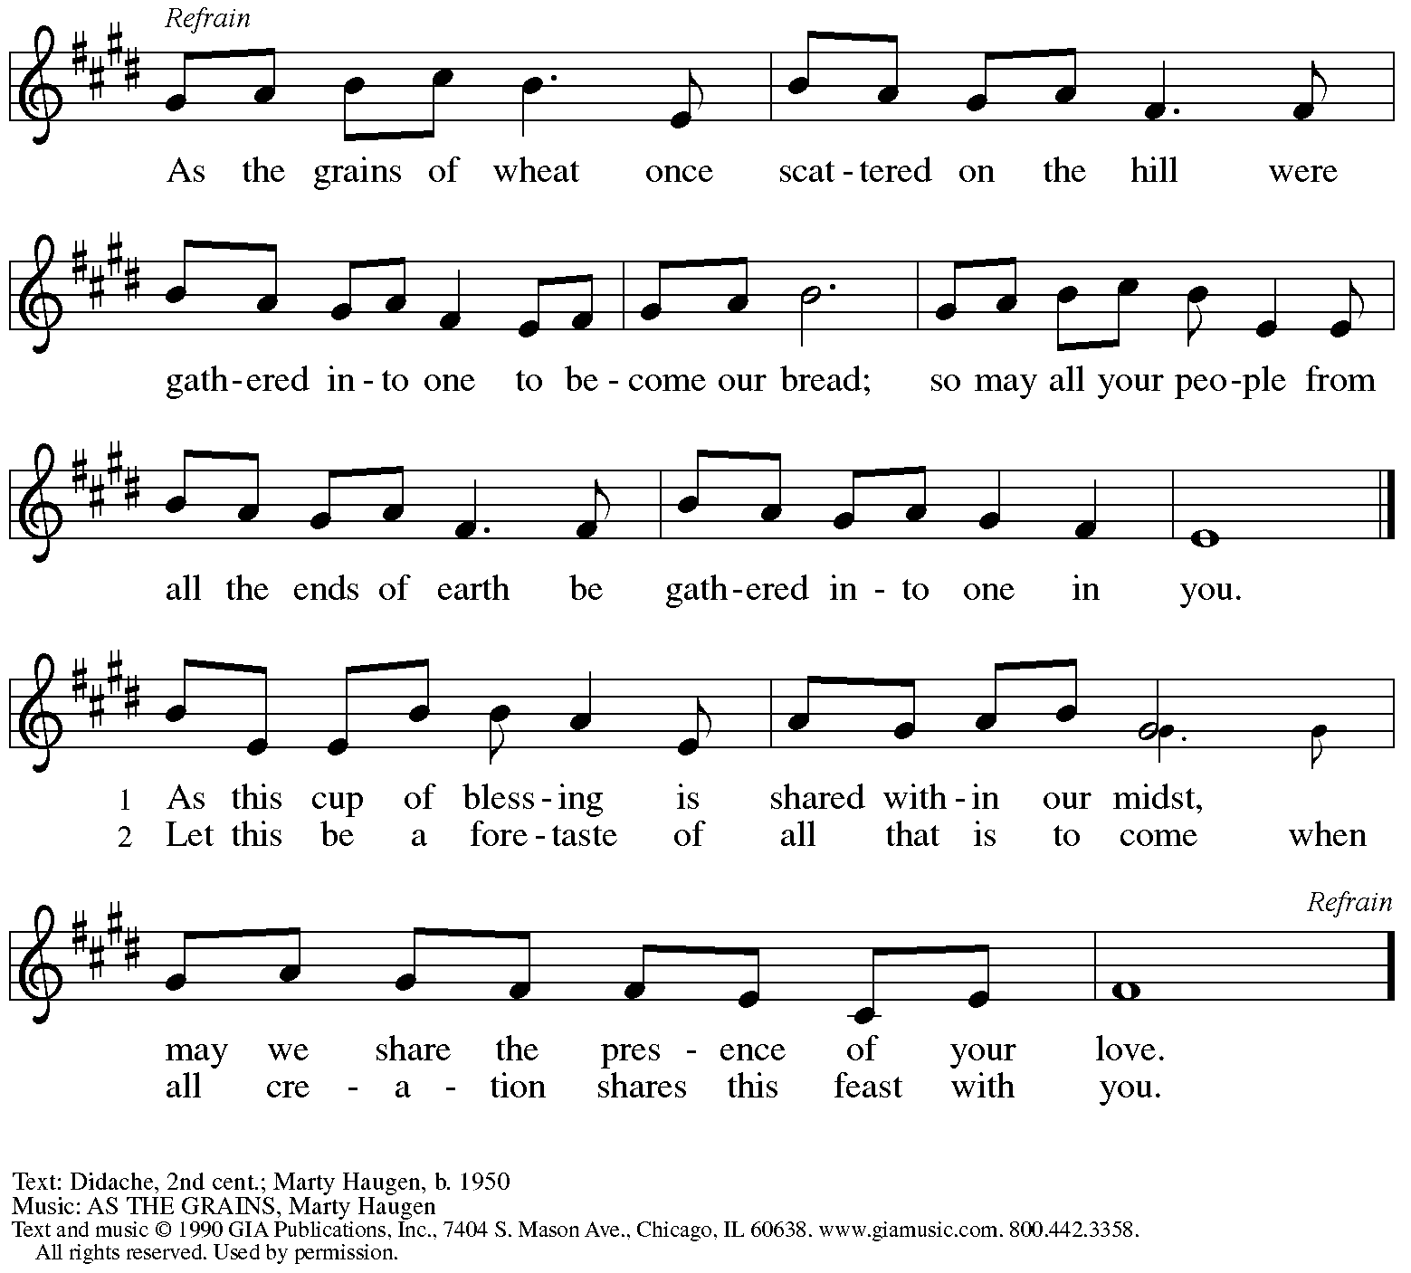
Reprinted under OneLicense.net # A-722139.

Offertory Prayer

A: Let us pray.
Blessed are you, O God,
C: ruler of heaven and earth.
Day by day you shower us with blessings.
As you have raised us to new life in Christ,
give us glad and generous hearts,
ready to praise you and to respond to those in need,
through Jesus Christ, our Savior and Lord.
Amen.

Dialogue HS p. 14

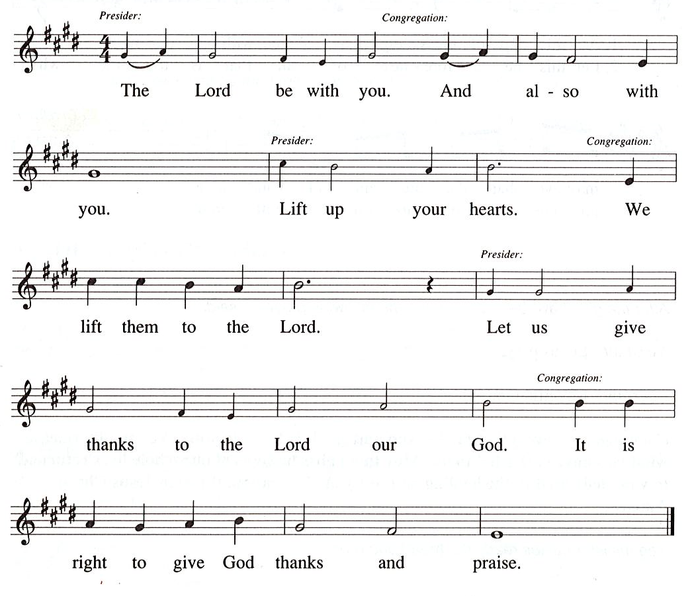

Preface (Sung by the presiding minister)

P: It is our duty and delight
that we should everywhere and always
offer thanks and praise to you, O God,
through Jesus Christ
and the Spirit, whom you poured out
upon the Church and your people:
And so with the church on earth,
all creation and the hosts of heaven,
we praise your name and join their unending hymn:

Sanctus HS p. 15

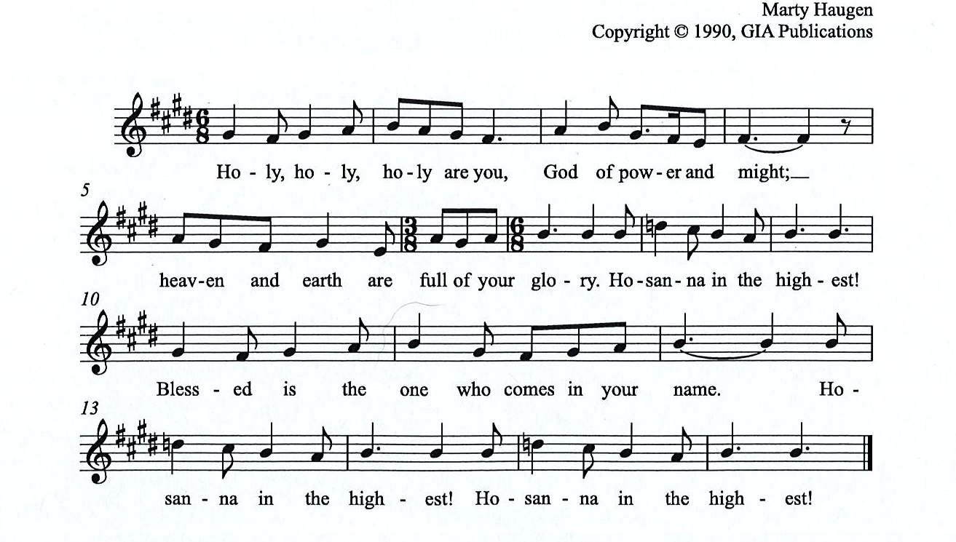

Eucharistic Prayer

P: You are indeed holy, almighty and merciful God, …
… Do this for the remembrance of me.

For as often as we eat of this bread and drink from this cup,
we proclaim the Lord’s death until he comes.

(Presiding minister sings)
Christ has died. Christ is risen. Christ will come, come again.
C:
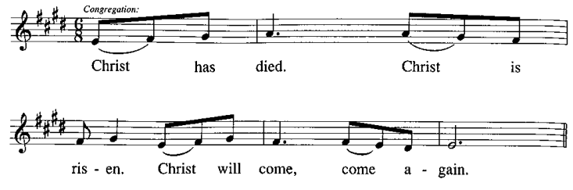
P: Remembering, therefore, his salutary command, …
… and be given our inheritance with all your saints.

To you, O God, Father, Son, and Holy Spirit,
be all honor and glory in your holy church, now and forever.
C:
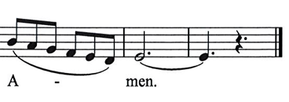

Lord’s Prayer

P: Gathered as one by the Holy Spirit, let us pray as Jesus taught us.
C: Our Father in heaven,
hallowed be your name,
your kingdom come,
your will be done,
on earth as in heaven.
Give us today our daily bread.
Forgive us our sins
as we forgive those
who sin against us.
Save us from the time of trial
and deliver us from evil.
For the kingdom, the power,
and the glory are yours,
now and forever. Amen.

Fraction and Invitation

P: This is the feast of victory for our God. Alleluia! Alleluia!
Come, share the feast.

Agnus Dei / Lamb of God Following Page

Agnus Dei / Lamb of God HS p. 18

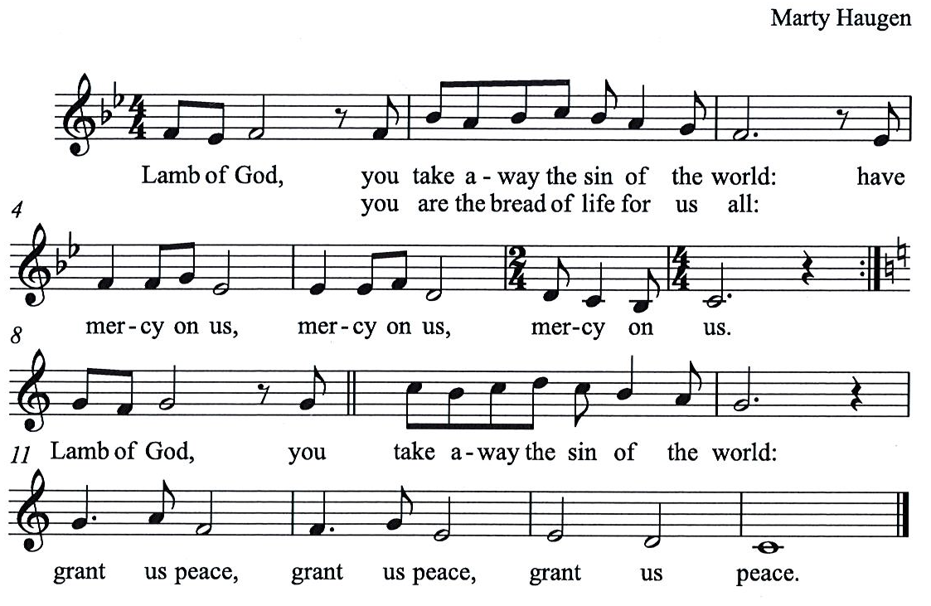

Please be seated.

Holy Communion
- All who seek God and desire a deeper and stronger life in Christ are welcome to receive Holy Communion.
- Worshipers from the pulpit side will proceed forward first, followed by the center section, and then the lectern side.
- Please inform an usher if you would like the ministers to bring Communion to you.
- Holy Communion will be served with bread and wine/grape juice.
- The presiding minister will first distribute the bread (host) to each communicant. Please indicate if you require a gluten-free host.
- Once you have consumed the bread, please pick up an empty glass from the tray next to the presiding minister. The Communion Assistant will pour wine from the chalice or grape juice from the cruet into your glass.
- Please step to the side to consume the wine or grape juice.
- Feel free to kneel at the altar rail for prayer after receiving the sacrament.
- As you return to your pew, glasses may be returned to the empty trays on either side of the center section.
- A blessing will be provided for anyone who does not yet receive the sacrament.
- All are invited to join in singing the hymns during Holy Communion.

Hymns during Holy Communion
Come Down, O Love Divine ELW 804

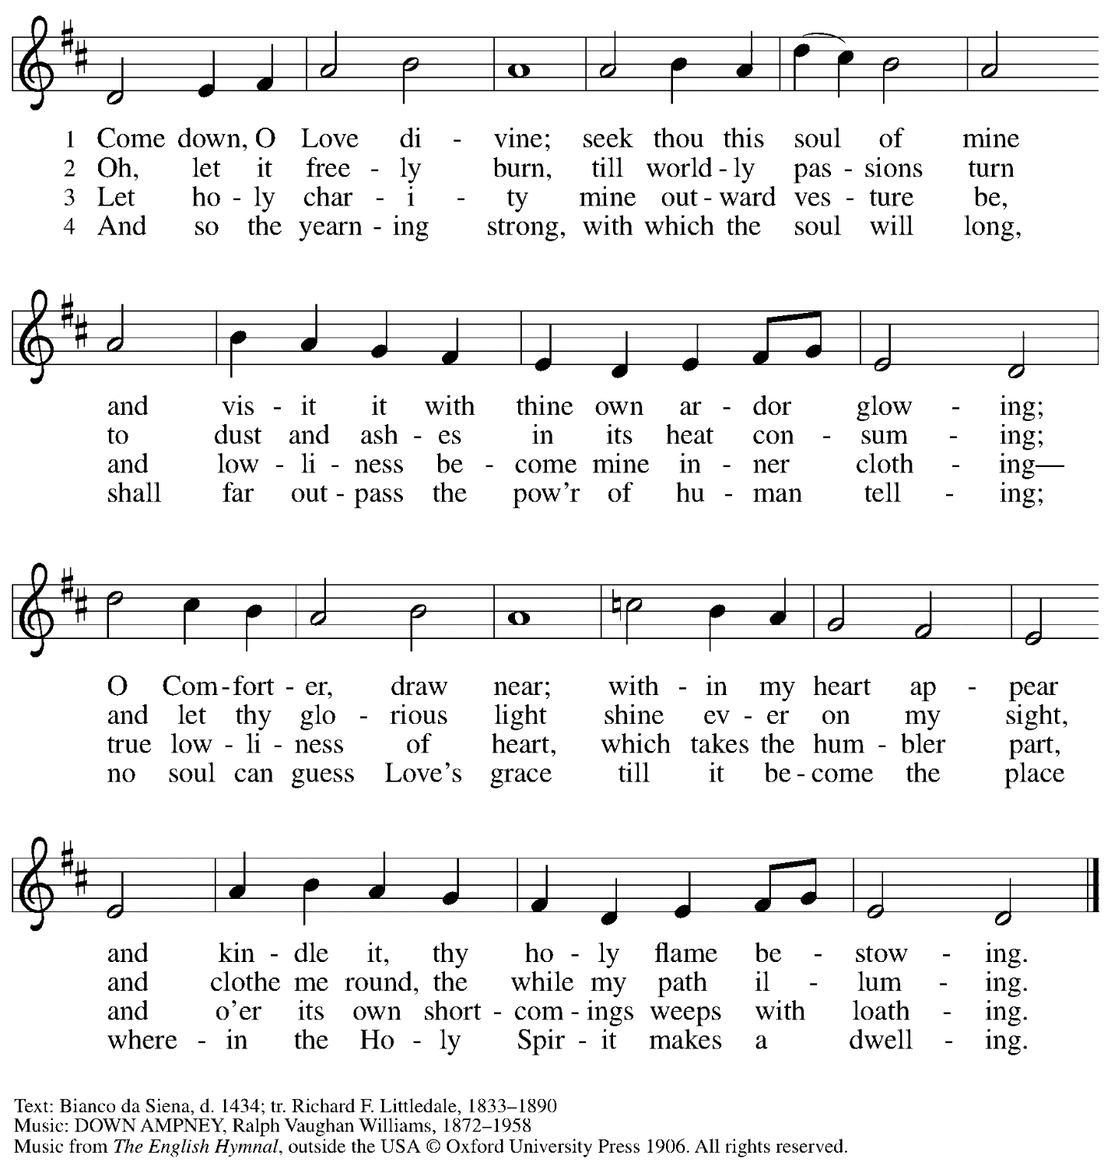
Reprinted with permission under OneLicense.net # A-722139.

Hymns during Holy Communion
Like the Murmur of the Dove’s Song ELW 403

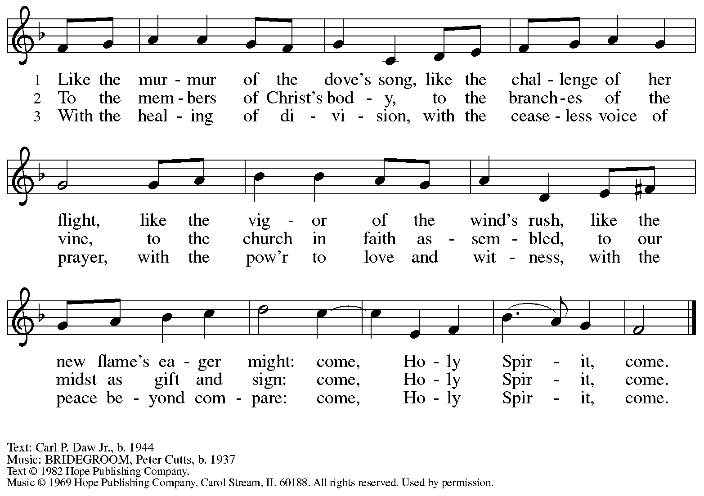
Reprinted with permission under OneLicense.net # A-722139.

Hymns during Holy Communion
Veni Sancte Spiritus ELW 406

The congregation is invited to continuously sing the ostinato printed below.
Verses will be sung by the cantor.

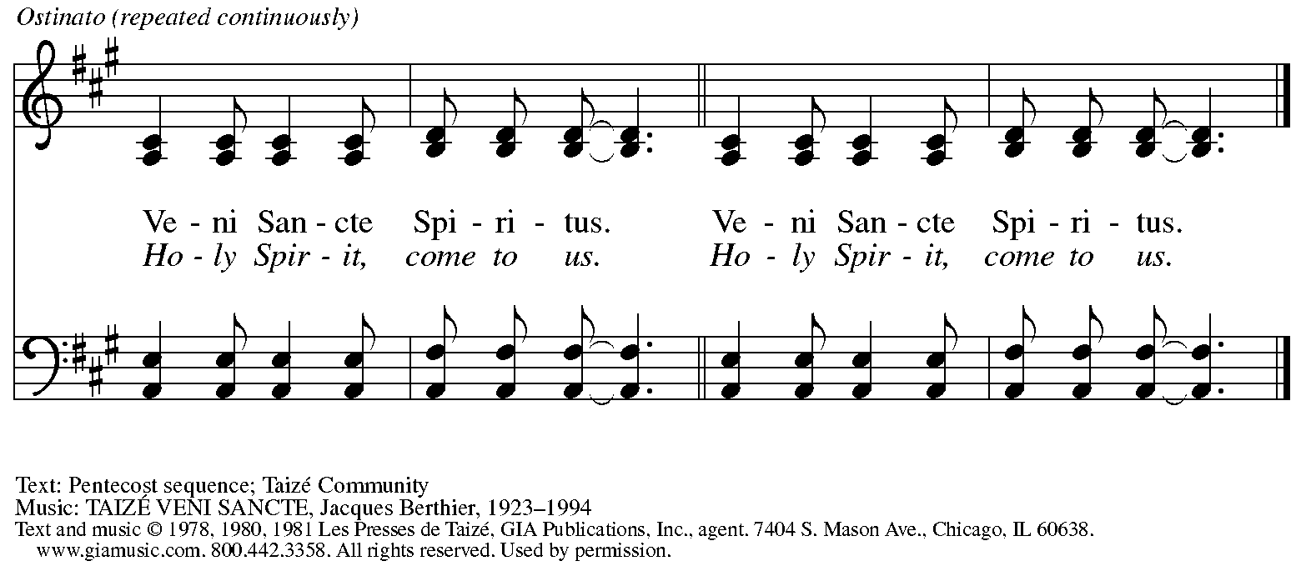
Reprinted with permission under OneLicense.net # A-722139.

When all have returned to their places, please rise as you are able.

Blessing

P: The body and blood of our Lord Jesus Christ strengthen you and keep you in his grace.
C: Amen.

Prayer

A: Let us pray.
God of abundance,
with this bread of life and cup of salvation you have united us with Christ,
making us one with all your people. Now send us forth in the power of your Spirit,
that we may proclaim your redeeming love to the world
and continue forever in the risen life of Jesus Christ, our Lord.
C: Amen.

Please be seated.

Sending
God blesses us and sends us in mission to the world

Announcements

Please rise as you are able.

Sending of the Gathered Church to be the Scattered Church in the World

The presiding minister describes the occasion for this sending blessing.
Then the congregation is invited into a time of prayer.

P: As we are sent … let us pray.
Blessed are you …
… now and forevermore.
C: Amen.

Congregational Refrain

All are invited to join in singing the congregational refrain.

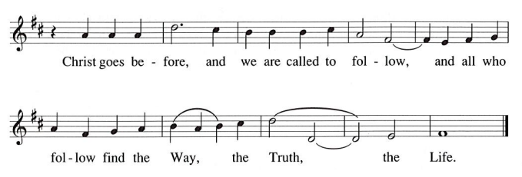

Benediction

P: May our glorious God grant you a spirit of wisdom
to know and love the risen Christ.

Almighty God, holy One, ☩ holy Three,
bless you now and forever.
C:
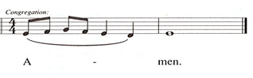

Sending Hymn Every Time I Feel the Spirit ACS 942

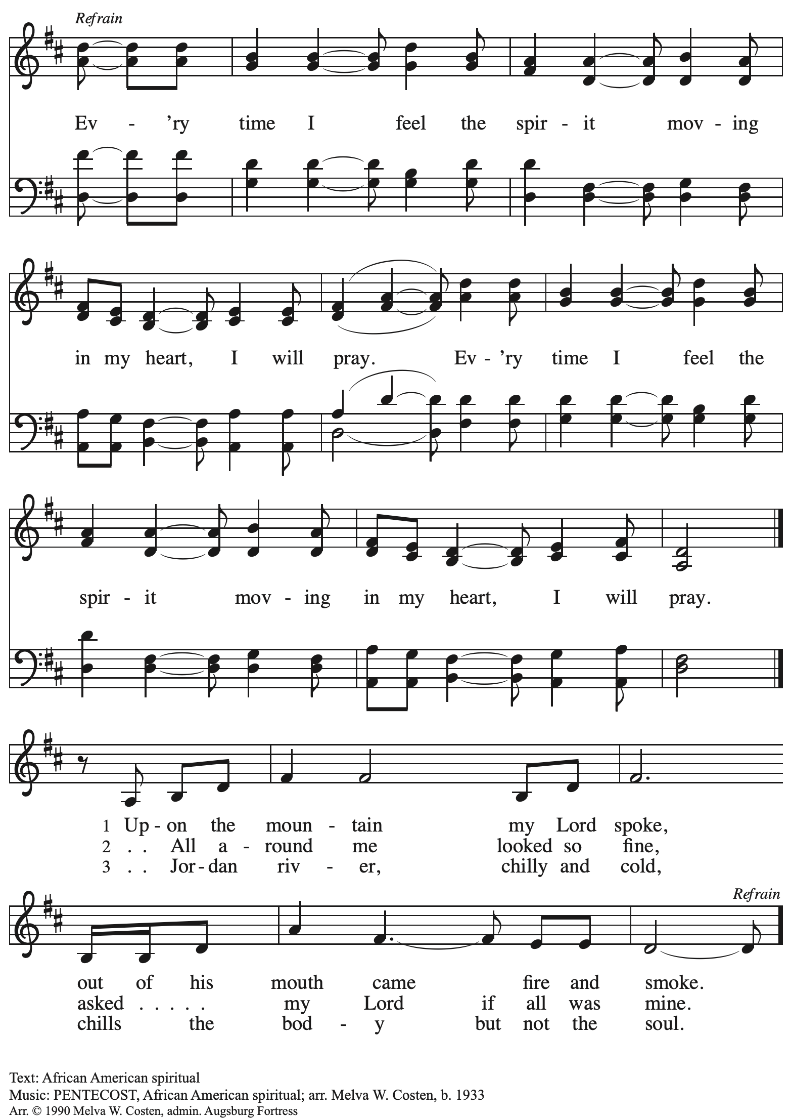
All rights reserved. Reprinted with permission under OneLicense.net # A-722139.

Dismissal

A: Go in peace. Share the good news!
C: Thanks be to God!

Postlude

Abbreviations

P: Pastor/Presiding Minister
A: Assisting Minister
L: Lector
C: Congregation

ACS: All Creation Sings hymnal
ELW: Evangelical Lutheran Worship hymnal
HS: Hymnal Supplement

Those serving in worship today

Altar Care
Assisting Minister Colleen Cooke
Audio-Visual Ministers Kristen Asplin
Joseph Paetz
Cantor Emily Duque
Lector Jeff Denlinger
Minister of Music Laura Reynolds
Organ Jimmi Kocher-Hillmer
Additional Instrumentation Jimmi and Timothy Kocher-Hillmer
Prelude Duet Emily Duque, Libby Marker
Presiding Minister Pastor Ross Carmichael

Liturgy and Hymnody Acknowledgements

From SundaysandSeasons.com. Copyright © 2023 Augsburg Fortress. All rights reserved. Reprinted under OneLicense.net # A-722139.
Used by permission of Augsburg Fortress.

Now the Feast and Celebration –Text: Marty Haugen, b. 1950. Music: NOW THE FEAST AND CELEBRATION, Marty Haugen. Text and music © 1990 GIA Publications, Inc. 7404 Mason Ave. Chicago, IL 60638. www.giamusic.com. 800.442.3358. All rights reserved. Reprinted with permission under OneLicense.net # A-722139.

As the Grains of Wheat – Text: Didache, 2nd cent.; Marty Haugen, b. 1950. Music: Marty Haugen. Text and Music © 1990 GIA Publications, Inc. 7404 Mason Ave. Chicago, IL 60638. www.giamusic.com. 800.442.3358. All rights reserved. Reprinted with permission under OneLicense.net # A-722139.

St. Andrew Lutheran Church Announcements
May 28th, 2023

- Welcome to worship at St. Andrew on May 28th, 2023, the + Day of Pentecost, as we celebrate God’s gift of the Holy Spirit! – We are so glad you are here to share in this festive day, and we offer a special welcome to all visitors and guests who are here for the first time! Worship attendees are invited to make a name tag at the back of the worship space if you would like. There are worship “toolkits” to help children engage with worship and “busy bags” for younger children available in the bookcase at the back of the sanctuary. Please feel free to take one to use with/for your children. We pray that everyone has a blessed Easter season!
- Monthly Reparations Offering Next Sunday, June 4th, during Worship – Jesus' parable of the Good Samaritan from Luke's Gospel provides an example of how God's people are called to work for healing and repair for our neighbors, independent of who or what caused harm. In light of this, the Worship Committee and Congregation Council of St. Andrew have made a commitment to reparations in regard to African American spiritual songs used in our worship. The text and music of most hymns is attributed to specific authors, with copyrights in place, usage reported, and royalties paid to those whose works are featured in worship. With African American spirituals, this is not possible. In response to many years of such uncredited use, St. Andrew will invite people of the congregation to give to a second collection for reparations during the offering. We originally planned to do this each week when a spiritual was sung, but after seeing initial logistics we are moving to a First Sunday of every month schedule for this special collection to allow for consistency and planning in giving. Funds received in our initial collections will be donated to our siblings at Bethel AME Church, whose land and building were taken from them in the 1950s, to fund the development they are planning in the Hill District.
- Little Church - Big Faith Summer Hiatus – St. Andrew's weekly Bible lesson and activity for children will not be held during worship this Sunday, May 28th. The group will meet once more, on Sunday, June 4th, before taking a break for the summer. Pastor Ross and Christian Education council liaison Colten Rohleder would appreciate parents/guardians sharing feedback from this year's classes as we begin planning for the fall. Thank you!
- June Produce Distribution – Tuesday, June 6th, 5:30-7:00 p.m. – St. Andrew’s monthly produce distribution in partnership with Greater Pittsburgh Community Food Bank is coming up next Tuesday, June 6th, from 5:30-7:00 p.m. We invite people from the congregation to come and help in the evening (greeting our neighbors, assisting with the distribution, registration, and cleanup) and earlier in the day to set up bring in the delivery, usually between 10:00 a.m. and 1:00 p.m. For anyone who signs up for the setup, we will notify you the day before when we are given the delivery truck’s estimated arrival time. Please sign up at https://www.signupgenius.com/go/4090F45AFAF2BA75-produce4.
- Renaissance City Choir Concert – Pittsburgh's Renaissance City Choir's "We Dream a World" LGBTQIA+ Pride Concert at East Liberty Presbyterian Church - June 10th and June 11th at 4:00 p.m.— Join the RCC as they sing for justice and "Stand Up" in pride and joy for the LGBTQIA+ community.
This year’s Pride Concert features selections from Dear Evan Hansen, Kinky Boots, the 2019 feature film Harriet, Considering Matthew Shepard, the Social Justice Songbook, and more — encouraging us all to love, support, and defend ourselves and our identities from those who seek to silence us. Can't join in person? Livestream tickets are also available so you can celebrate Pride with RCC from the comfort of your own home. To learn more and purchase tickets, visit: https://rccpittsburgh.ticketleap.com/rccpride23/.
- St. Andrew to Participate in Millvale Pride Event on Saturday, June 24th – June is Pride Month, and St. Andrew has traditionally taken part in Pride events in conjunction with other Reconciling in Christ congregations, staffing a booth at which we have shared conversation, resources, and information about the churches and our mission to share God's love with all our LGBTQIA+ siblings. St. Andrew will have a table at Millvale Pride on Saturday, June 24th. The event is from 12:00 p.m. to 8:00 p.m. No one stays the whole time (unless you want to!), but we usually invite people from the congregation to represent St. Andrew for stretches of 1-2 hours. More information about Millvale Pride can be found here: https://www.pridemillvale.org/. If you can be available and are willing to represent St. Andrew at the booth, please speak with Pastor Ross or Kelly Spanninger.
- St. Andrew Jail Ministry – St. Andrew has had a long history of participation in the ministry program at the Allegheny County Jail. Until the program was put on hold at the beginning of the Covid pandemic, a group of volunteers from St. Andrew was leading a worship service at the jail on Sunday mornings, typically about one Sunday a month. The jail is hoping to resume this program soon. If any of the previous volunteers are still interested and available, please contact Lester Prince (lprince@comcast.net). New volunteers are also needed. The first step for new volunteers is to complete an online application, which can be accessed here: https://www.foundationofhope.org/get-involved/volunteer-application/. On the application form, indicate that the program that you are interested in volunteering with is “Chaplaincy Worship.” Feel free to contact Lester Prince with any questions.
- Lutheran Campus Ministry in Greater Pittsburgh (LCMGP) 75th Anniversary Dinner - September 15th, 2023 7:00 p.m.at Le Mont – Join the LCMGP for its inaugural fundraising banquet as they celebrate the ministry's work in Greater Pittsburgh and among the universities of Pitt, Carnegie Mellon, Chatham, and Carlow for over the past 75+ years. Learn more about LCMGP, purchase tickets, or make a donation here: https://linktr.ee/LCMGP.

