+ Holy Trinity
June 4, 2023
St. Andrew Lutheran Church
304 Morewood Ave.
Pittsburgh, PA 15213
St_andrewELCA@verizon.net
www.standrewpittsburgh.org

+ Holy Trinity
Order for Worship

Though the word “trinity” is not found in the scriptures, today’s second reading includes the apostolic greeting featured in the liturgy: “The grace of our Lord Jesus Christ, the love of God, and the communion of the Holy Spirit be with you all.” In the gospel Jesus sends his disciples forth to baptize in the name of the Father, and the Son, and the Holy Spirit. More than a doctrine, the Trinity expresses the heart of our faith: we have experienced the God of creation made known in Jesus Christ and with us always through the Holy Spirit. We celebrate the mystery of the Holy Trinity in word and sacrament, as we profess the creed, and as we are sent into the world to bear witness to our faith.

Welcome to St. Andrew!

- St. Andrew Lutheran congregation welcomes all who are seeking a place of healing and wholeness – a nurturing, faith-forming spiritual home. Our community embraces people of all ages, ethnicities, cultures, abilities, sexual orientations, gender identities and expressions, and family constellations. Come and See!

- Worship Services are live streamed to multiple online platforms. By attending worship, you agree that your image and voice may be broadcast.

- Everyone is invited to make a nametag at the black bookcase in the back of the worship space if they would like. There are stickers indicating pronouns on the bookcase if you would like to include them on your name tag.

- Children are invited to attend Little Church – Big Faith, a Bible lesson and activity, during worship (after the Prayer of the Day). The group returns to the worship space for the liturgy of Holy Communion.

- Worship “toolkits” to help children engage with the service, along with “busy bags” for younger children, are available in the bookcase at the back of the sanctuary. Please feel free to take one to use with/for your children.

- Holy Communion is served with bread (gluten-free available) and wine or grape juice. The presiding minister will distribute the bread (host). Please consume this and then pick up an empty glass from the tray. The Communion Assistant will pour wine or grape juice into your glass. Please step to the side to consume the wine or grape juice. Feel free to kneel at the altar for prayer and reflection. As you return to your pew, glasses may be returned to the empty trays on either side of the center section.

- A restroom is available on the main level of the church, through the doors to the Social Hall and to the right in the main office.

Pre-Service Music

Welcome

Prelude Rejoice and Sing Zabel

Gathering
The Holy Spirit calls us together as the people of God

Confession and Forgiveness

Please rise as you are able.
All may make the sign of the cross, the sign that is marked at Baptism,
as the presiding minister begins.

P: Blessed be the holy Trinity,
☩ one God,
who creates, redeems, and sustains us
and all of creation.
C: Amen.

P: Let us confess our sin in the presence of God and of one another.

Silence is kept for reflection

P: To you, O God,
C: all hearts are open, to you all desires known.
We come to you, confessing our sins.
Forgive us in your mercy, and remember us in your love.
Show us your ways; teach us your paths; and lead us in justice and truth,
for the sake of your goodness in Jesus Christ our Savior.
Amen.

P: By water and the Holy Spirit God gives you a new birth,
and through the death and resurrection of ☩ Jesus Christ,
God forgives you all your sins.
The God of mercy and might strengthen you in all goodness
and keep you in eternal life.
C: Amen.

Gathering Hymn Holy, Holy, Holy, Lord God Almighty! ELW 413

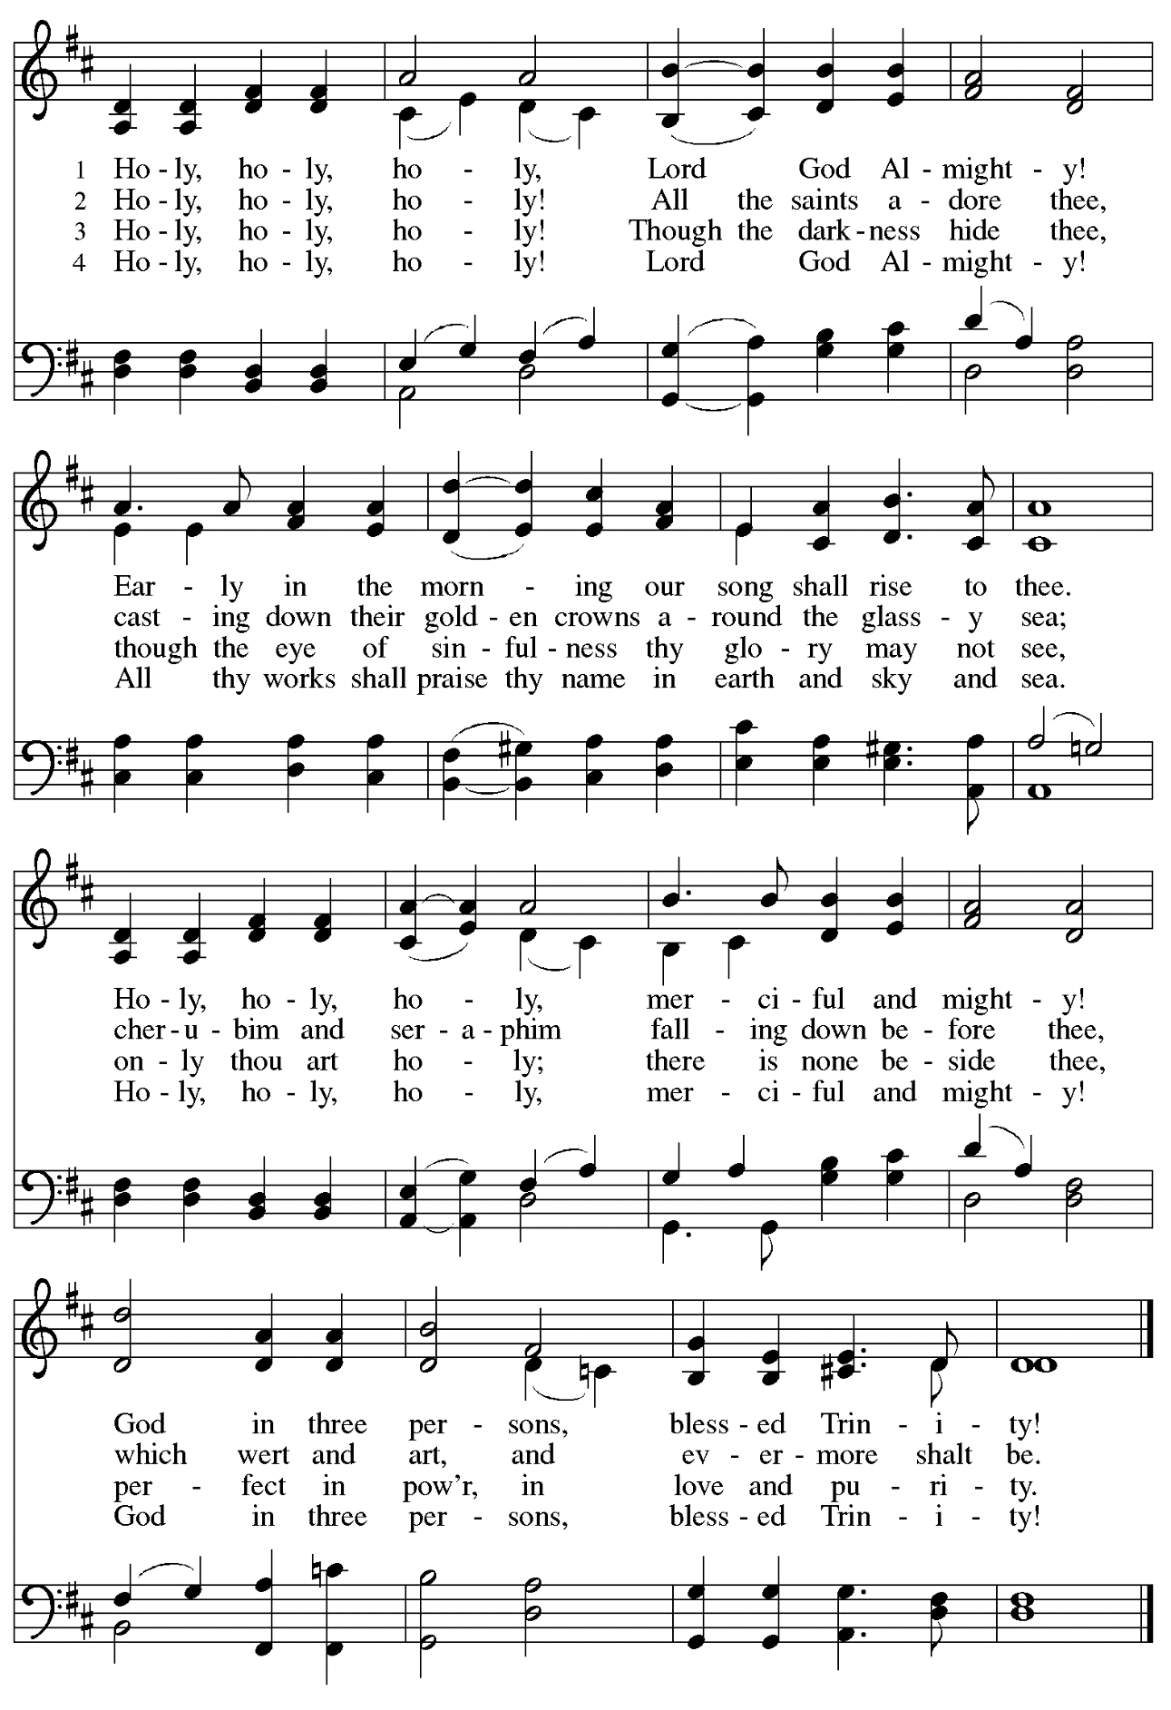
Greeting

P: The grace of our Lord Jesus Christ, the love of God,
and the communion of the Holy Spirit be with you all.
C: And also with you.

Hymn of Praise Glory to God ELW p. 148

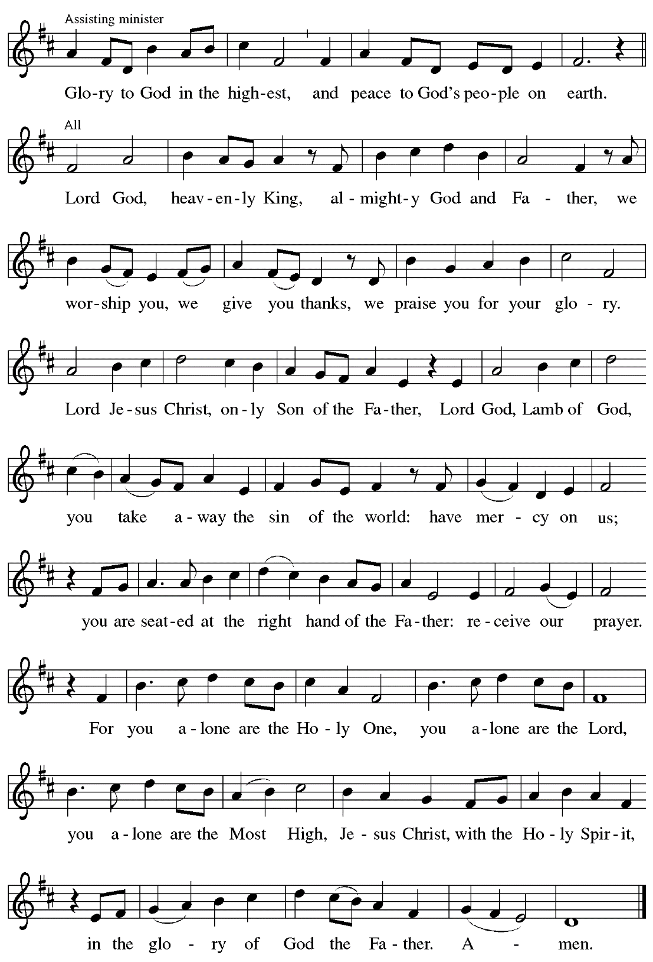

Prayer of the Day

P: The Lord be with you.
C: And also with you.

P: Let us pray.
Almighty Creator and ever-living God:
we worship your glory, eternal Three-in-One, and we praise your power, majestic One-in-Three. Keep us steadfast in this faith, defend us in all adversity, and bring us at last into your presence, where you live in endless joy and love, Father, Son, and Holy Spirit, one God, now and forever.
C: Amen.

Please be seated.
Children are invited to join the adult leaders at the door and move to the office for Little Church – Big Faith. We ask that one additional adult from the congregation attend with the children.

Word
God speaks to us in Scripture reading, preaching, and song

First Reading – Genesis 1: 1 – 2: 4a

¹In the beginning when God created the heavens and the earth, ²the earth was a formless void and darkness covered the face of the deep, while a wind from God swept over the face of the waters. ³Then God said, “Let there be light”; and there was light. ⁴And God saw that the light was good; and God separated the light from the darkness. ⁵God called the light Day, and the darkness God called Night. And there was evening and there was morning, the first day.
⁶And God said, “Let there be a dome in the midst of the waters, and let it separate the waters from the waters.” ⁷So God made the dome and separated the waters that were under the dome from the waters that were above the dome. And it was so. ⁸God called the dome Sky. And there was evening and there was morning, the second day.
⁹And God said, “Let the waters under the sky be gathered together into one place, and let the dry land appear.” And it was so. ¹⁰God called the dry land Earth, and the waters that were gathered together he called Seas. And God saw that it was good. ¹¹Then God said, “Let the earth put forth vegetation: plants yielding seed, and fruit trees of every kind on earth that bear fruit with the seed in it.” And it was so. ¹²The earth brought forth vegetation: plants yielding seed of every kind, and trees of every kind bearing fruit with the seed in it. And God saw that it was good. ¹³And there was evening and there was morning, the third day.
¹⁴And God said, “Let there be lights in the dome of the sky to separate the day from the night; and let them be for signs and for seasons and for days and years, ¹⁵and let them be lights in the dome of the sky to give light upon the earth.” And it was so. ¹⁶God made the two great lights—the greater light to rule the day and the lesser light to rule the night—and the stars. ¹⁷God set them in the dome of the sky to give light upon the earth, ¹⁸to rule over the day and over the night, and to separate the light from the darkness. And God saw that it was good. ¹⁹And there was evening and there was morning, the fourth day.
²⁰And God said, “Let the waters bring forth swarms of living creatures, and let birds fly above the earth across the dome of the sky.” ²¹So God created the great sea monsters and every living creature that moves, of every kind, with which the waters swarm, and every winged bird of every kind. And God saw that it was good. ²²God blessed them, saying, “Be fruitful and multiply and fill the waters in the seas, and let birds multiply on the earth.” ²³And there was evening and there was morning, the fifth day.
²⁴And God said, “Let the earth bring forth living creatures of every kind: cattle and creeping things and wild animals of the earth of every kind.” And it was so. ²⁵God made the wild animals of the earth of every kind, and the cattle of every kind, and everything that creeps upon the ground of every kind. And God saw that it was good.
²⁶Then God said, “Let us make humankind in our image, according to our likeness; and let them have dominion over the fish of the sea, and over the birds of the air, and over the cattle, and over all the wild animals of the earth, and over every creeping thing that creeps upon the earth.”
²⁷So God created humankind in God’s image,
in the image of God, God created them;
male and female God created them.
²⁸God blessed them, and God said to them, “Be fruitful and multiply, and fill the earth and subdue it; and have dominion over the fish of the sea and over the birds of the air and over every living thing that moves upon the earth.” ²⁹God said, “See, I have given you every plant yielding seed that is upon the face of all the earth, and every tree with seed in its fruit; you shall have them for food. ³⁰And to every beast of the earth, and to every bird of the air, and to everything that creeps on the earth, everything that has the breath of life, I have given every green plant for food.” And it was so. ³¹God saw everything that God had made, and indeed, it was very good. And there was evening and there was morning, the sixth day.
^{2:1}Thus the heavens and the earth were finished, and all their multitude. ²And on the seventh day God finished the work that God had done, and God rested on the seventh day from all the work that God had done. ³So God blessed the seventh day and hallowed it, because on it, God rested from all the work that God had done in creation.
^{4a}These are the generations of the heavens and the earth when they were created.

L: Word of God, word of life.
C: Thanks be to God.

Psalm 8

The psalm will be sung by the cantor,
with the congregation invited to join in singing the verses in bold and the refrain.

Psalm tone

Psalm refrain

¹O | Lord our Lord,
how majestic is your name in | all the earth!—
²you whose glory is chanted above the heavens out of the mouths of in- | fants and children;
you have set up a fortress against your enemies, to silence the foe | and avenger.
³When I consider your heavens, the work | of your fingers,
the moon and the stars you have set | in their courses,
⁴what are mere mortals that you should be mind- | ful of them,
human beings that you should | care for them? R
⁵Yet you have made them little less | than divine;
with glory and hon- | or you crown them.
⁶You have made them rule over the works | of your hands;
you have put all things un- | der their feet:
⁷all | flocks and cattle,
even the wild beasts | of the field,
⁸the birds of the air, the fish | of the sea,
and whatever passes along the paths | of the sea.
⁹O | Lord our Lord,
how majestic is your name in | all the earth! R

Second Reading – 2 Corinthians 13: 11-13

[Paul writes:] ¹¹Finally, kindred, farewell. Put things in order, listen to my appeal, agree with one another, live in peace; and the God of love and peace will be with you. ¹²Greet one another with a holy kiss. All the saints greet you.
¹³The grace of the Lord Jesus Christ, the love of God, and the communion of the Holy Spirit be with all of you.

L: Word of God, word of life.
C: Thanks be to God.

Please rise as you are able.

Gospel Acclamation

Gospel – Matthew 28: 16-20

P: The holy Gospel according to St. Matthew.
C: Glory to you, O Lord.

¹⁶Now the eleven disciples went to Galilee, to the mountain to which Jesus had directed them. ¹⁷When they saw him, they worshiped him; but some doubted. ¹⁸And Jesus came and said to them, “All authority in heaven and on earth has been given to me. ¹⁹Go therefore and make disciples of all nations, baptizing them in the name of the Father and of the Son and of the Holy Spirit, ²⁰and teaching them to obey everything that I have commanded you. And remember, I am with you always to the end of the age.”

P: The Gospel of the Lord.
C: Praise to you, O Christ.

Please be seated.

Sermon

A time of silence for prayer and reflection follows the sermon.
When the hymn of the day begins, please rise as you are able.

Hymn of the Day Go to the World Following page

Hymn of the Day Go to the World ACS 991

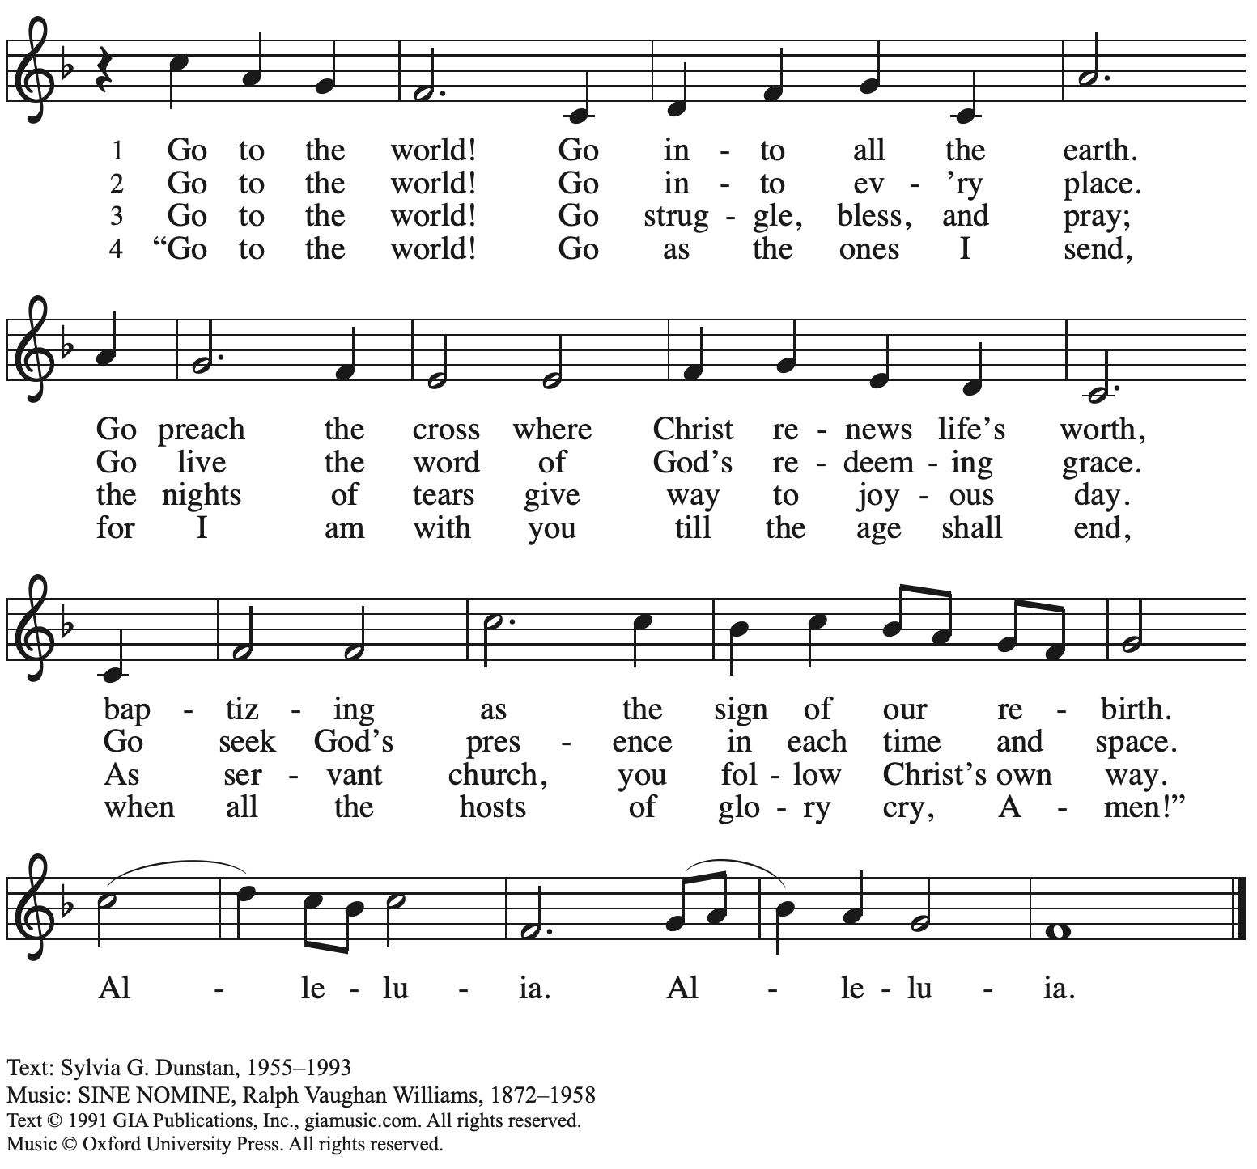
Reprinted with permission under OneLicense.net # A-722129.

Nicene Creed

C: We believe in one God,
the Father, the Almighty,
maker of heaven and earth,
of all that is, seen and unseen.

We believe in one Lord, Jesus Christ,
The only Son of God,
eternally begotten of the Father,
God from God, Light from Light,
true God from true God,
begotten, not made,
of one Being with the Father;
through him all things were made.
For us and for our salvation
he came down from heaven,
was incarnate of the Holy Spirit and the virgin Mary
and became truly human.
For our sake he was crucified under Pontius Pilate;
he suffered death and was buried.
On the third day he rose again
in accordance with the scriptures;
he ascended into heaven
and is seated at the right hand of the Father.
He will come again in glory to judge the living and the dead,
and his kingdom will have no end.

We believe in the Holy Spirit, the Lord, the giver of life,
who proceeds from the Father and the Son,*
who with the Father and the Son is worshiped and glorified,
who has spoken through the prophets.
We believe in one holy catholic and apostolic church.
We acknowledge one baptism for the forgiveness of sins.
We look for the resurrection of the dead,
and the life of the world to come. Amen.

*Or, “who proceeds from the Father.” The phrase “and the Son” is a later addition to the creed.

Prayers of the People

A: Trusting in God’s abundant mercy, let us offer our prayers for a world in need.

After each petition
A: God, in your mercy,
C: receive our prayer.

The presiding minister concludes the prayers
P: We lift these prayers to you O God, trusting in your goodness and grace,
through Jesus Christ our Savior.
C: Amen.

Peace

The presiding minister and the assembly greet one another in the peace of the risen Christ.
P: The peace of Christ be with you always.
C: And also with you.

The people may greet those around them with a sign of Christ’s peace and may say
Peace be with you or similar words. Please be mindful that not everyone will be comfortable with sharing the peace, so please seek consent before shaking hands or hugging. Other possible ways to share the peace include a simple bow with the verbal greeting of peace, or simply a verbal expression of peace.

When the greetings of peace have concluded, please be seated.

Meal
God feeds us with the presence of Jesus Christ

Offering

We offer ourselves, our gifts, and our faithful service to God.
As the offering is gathered for the mission of the church, including the care of those in need,
the table is set for Holy Communion.

Reparations Offering

On the first Sunday of each month, St. Andrew invites people of the congregation to consider a donation to a second collection for a reparations fund in acknowledgement of St. Andrew’s use of African American spiritual songs in our worship services. Please see the note in the announcements at the back of the bulletin for more information.

Music during the Offering
Piano/Organ Duet Prelude on Nicaea arr. Achterberg

As the gifts are brought forward for presentation, please rise as you are able.

Offertory Song Let the Vineyards Be Fruitful ELW 184

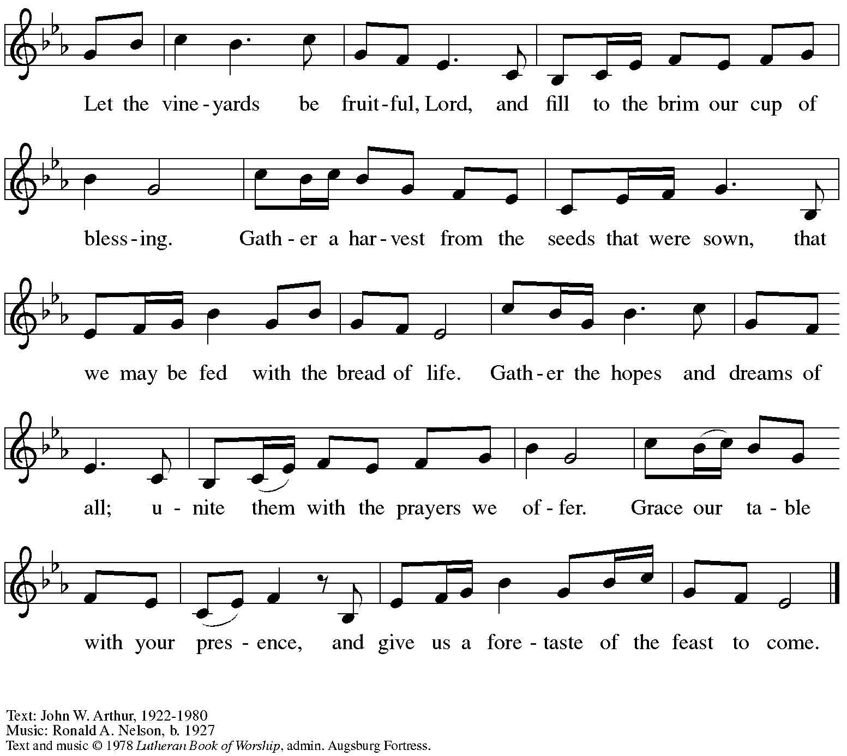
All rights reserved. Reprinted under OneLicense.net # A-722139.

Offertory Prayer

A: Let us pray.
God of all creation,
C: all you have made is good, and your love endures forever.
You bring forth bread from the earth and fruit from the vine.
Nourish us with these gifts,
that we might be for the world signs of your gracious presence
in Jesus Christ, our Savior and Lord.
Amen.

Dialogue ELW p. 152

Preface (Sung by the presiding minister)

P: It is indeed right, our duty and our joy …
… we praise your name and join their unending hymn:

Sanctus ELW p. 153

Eucharistic Prayer

P: Holy God, Holy One, Holy Three! …
… Your grace our path to rebirth.

So we cry, Mercy:
C: Mercy!

P: So we cry, Glory:
C: Glory!

P: So we cry, Blessing:
C: Blessing!

P: Holy God, we ask for your Spirit …
Make us, despite death, alive.

So we cry, Come, Come, Holy Spirit:
C: Come, Holy Spirit!

P: So the church shouts, Come, Holy Spirit:
C: Come, Holy Spirit!

P: So the earth pleads, Come, Holy Spirit:
C: Come, Holy Spirit!

P: You, Holy God, Holy One, Holy Three …
… Praise now, Praise tomorrow, praise forever.

So we cry, Amen, Amen:
C: Amen, amen!

Lord’s Prayer

P: Gathered as one by the Holy Spirit, let us pray as Jesus taught us.
C: Our Father in heaven,
hallowed be your name,
your kingdom come,
your will be done,
on earth as in heaven.
Give us today our daily bread.
Forgive us our sins
as we forgive those
who sin against us.
Save us from the time of trial
and deliver us from evil.

For the kingdom, the power,
and the glory are yours,
now and forever. Amen.

Fraction and Invitation

Agnus Dei / Lamb of God ELW p. 154

Please be seated.

Holy Communion
- All who seek God and desire a deeper and stronger life in Christ are welcome to receive Holy Communion.
- Worshipers from the pulpit side will proceed forward first, followed by the center section, and then the lectern side.
- Please inform an usher if you would like the ministers to bring Communion to you.
- Holy Communion will be served with bread and wine/grape juice.
- The presiding minister will first distribute the bread (host) to each communicant. Please indicate if you require a gluten-free host.
- Once you have consumed the bread, please pick up an empty glass from the tray next to the presiding minister. The Communion Assistant will pour wine from the chalice or grape juice from the cruet into your glass.
- Please step to the side to consume the wine or grape juice.
- Feel free to kneel at the altar rail for prayer after receiving the sacrament.
- As you return to your pew, glasses may be returned to the empty trays on either side of the center section.
- A blessing will be provided for anyone who does not yet receive the sacrament.
- All are invited to join in singing the hymns during Holy Communion.

Hymns during Holy Communion
When Long Before Time ELW 861

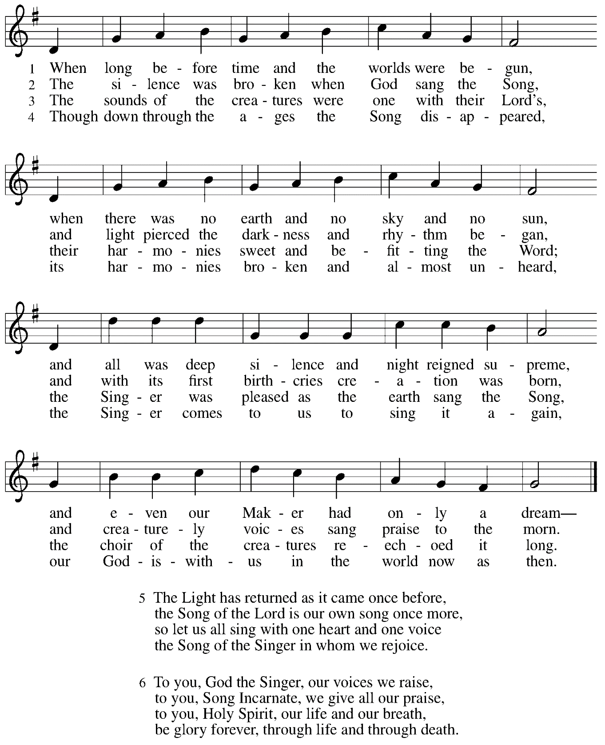

Hymns during Holy Communion
The Play of the Godhead ACS 946

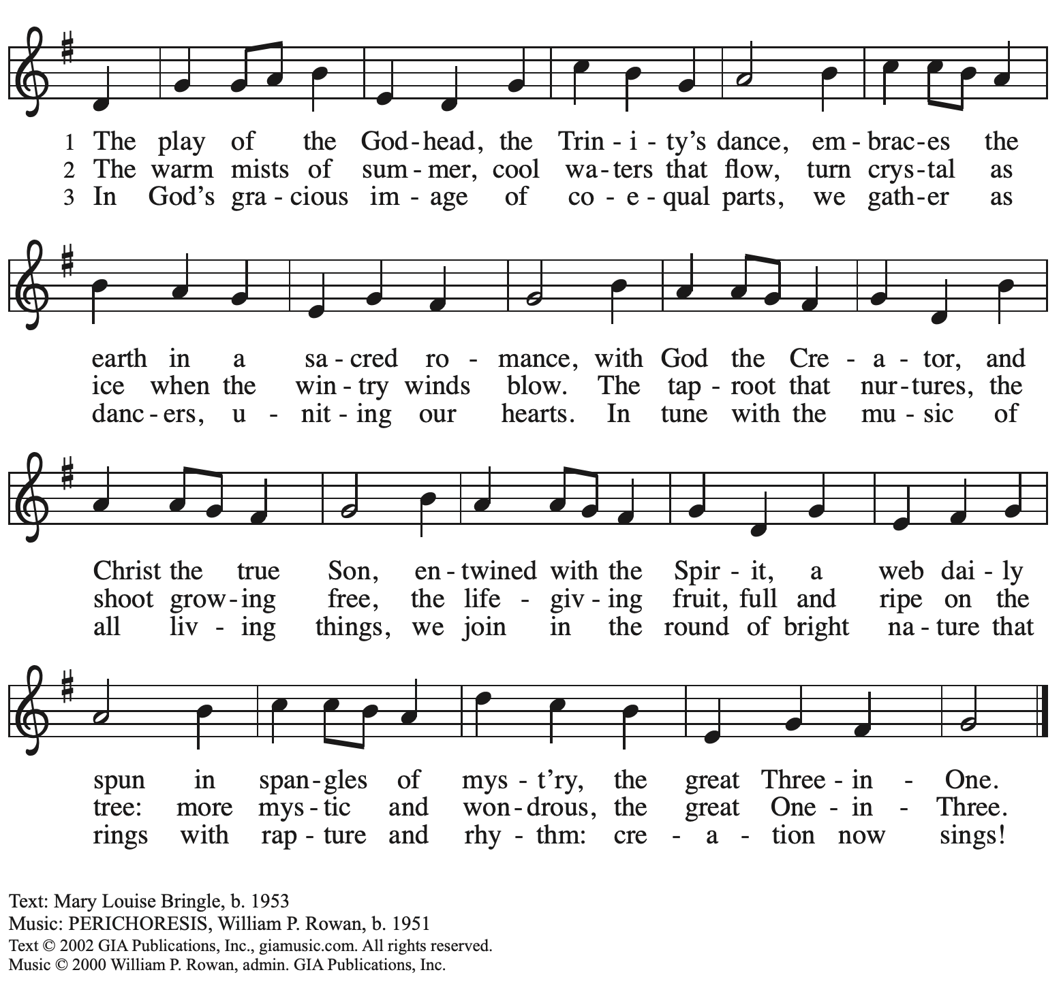
All rights reserved. Reprinted with permission under OneLicense.net # A-722139.

Hymns during Holy Communion
Come, Join the Dance of Trinity ELW 412

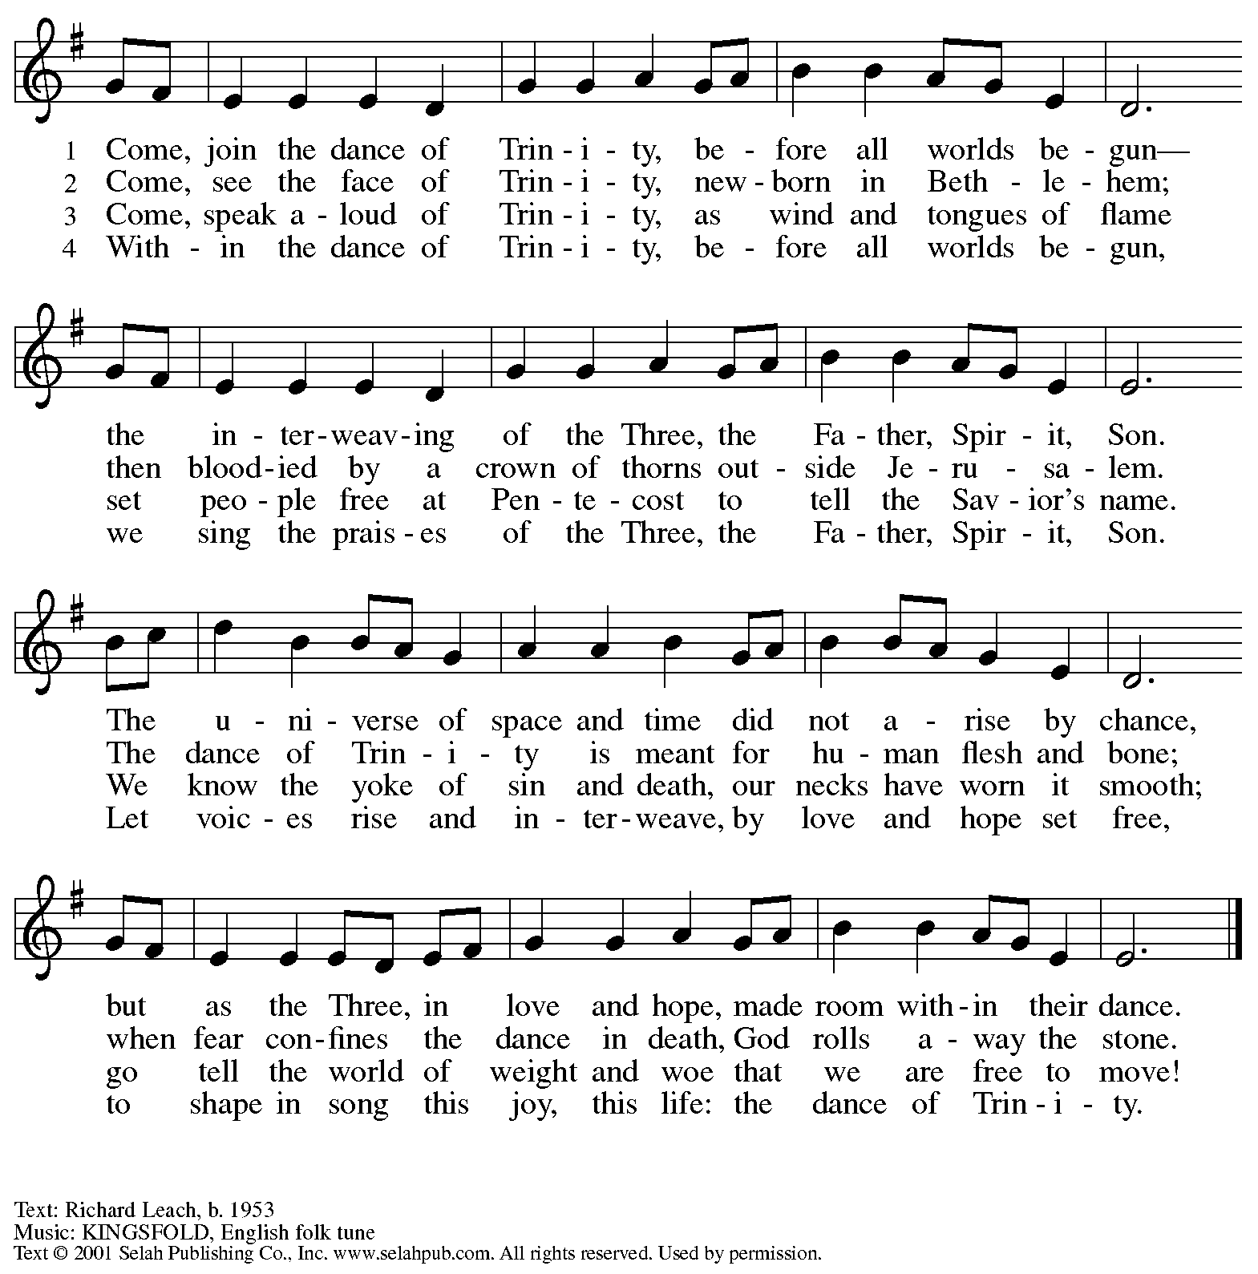
Reprinted with permission under OneLicense.net # A-722139.

When all have returned to their places, please rise as you are able.

Blessing

P: The body and blood of our Lord Jesus Christ strengthen you and keep you in his grace.
C: Amen.

Prayer

A: Let us pray. God of abundance,
with this bread of life and cup of salvation you have united us with Christ,
making us one with all your people. Now send us forth in the power of your Spirit,
that we may proclaim your redeeming love to the world
and continue forever in the risen life of Jesus Christ, our Lord.
C: Amen.

Please be seated.

Sending
God blesses us and sends us in mission to the world

Announcements

Please rise as you are able.

Benediction

P: The God of steadfastness and encouragement
grant you to live in harmony with one another,
in accordance with Christ Jesus.
C: Amen.

P: The God of hope fill you with all joy and peace in believing,
so that you may abound in hope by the power of the Holy Spirit.
C: Amen.

P: The God of all grace ☩ bless you now and forever.
C: Amen.

Sending Hymn Joyful, Joyful, We Adore Thee Following Page

Dismissal

A: Go in peace. Serve the Lord.
C: Thanks be to God!

Postlude

Sending Hymn Joyful, Joyful, We Adore Thee ELW 836

1 Joyful, joyful we adore thee,
God of glory, Lord of love!
Hearts unfold like flow'rs before thee,
praising thee, their sun above.
Melt the clouds of sin and sadness,
drive the gloom of doubt away.
Giver of immortal gladness,
fill us with the light of day.

2 All thy works with joy surround thee,
earth and heav'n reflect thy rays,
stars and angels sing around thee,
center of unbroken praise.
Field and forest, vale and mountain,
flow'ry meadow, flashing sea,
chanting bird, and flowing fountain
call us to rejoice in thee.

3 Thou art giving and forgiving,
ever blessing, ever blest,
wellspring of the joy of living,
ocean-depth of happy rest!
Thou our Father, Christ our brother,
Holy Spirit, three-in-one;
teach us how to love each other,
lift us to the joy divine!

Text: Henry van Dyke, 1852-1922. Music: HYMN TO JOY, Ludwig van Beethoven, 1770-1827, adapt.

Abbreviations

P: Pastor/Presiding Minister
A: Assisting Minister
L: Lector
C: Congregation

ACS: All Creation Sings hymnal
ELW: Evangelical Lutheran Worship hymnal

Those serving in worship today

Altar Care Janet Grzegorczyk
Assisting Minister John Tymitz
Audio-Visual Ministers Noël Marsh
Colten Rohleder
Cantor Maria Mangano
Lector Tim Marker
Minister of Music Laura Reynolds
Organ Jimmi Kocher-Hillmer
Presiding Minister Pastor Ross Carmichael

Liturgy and Hymnody Acknowledgements

From SundaysandSeasons.com. Copyright © 2023 Augsburg Fortress. All rights reserved. Reprinted under OneLicense.net # A-722139.
Used by permission of Augsburg Fortress.

When Long Before Time / The Singer and the Song – Text: Peter W.A. Davison, b. 1936. Music: THE SINGER AND THE SONG, Peter W.A. Davison; arr. George Black, 1931-2003. Text and Music © Peter W.A. Davison, admin. Augsburg Fortress. All rights reserved. Reprinted with permission under OneLicense.net # A-722139.

St. Andrew Lutheran Church Announcements
June 4th, 2023

- Welcome to Worship at St. Andrew on Holy Trinity Sunday, June 4th, 2023 – We are so glad you are here, and we offer a special welcome to all visitors and guests connecting for the first time! Worship attendees are invited to make a name tag at the back of the worship space if you would like. There are worship “toolkits” to help children engage with worship and “busy bags” for younger children available in the bookcase at the back of the sanctuary. Please feel free to take one to use with/for your children.
- Monthly Offering for Reparations Today during Worship – Jesus’ parable of the Good Samaritan from Luke's Gospel provides an example of how God's people are called to work for healing and repair for our neighbors, independent of who or what caused harm. In light of this, the Worship Committee and Congregation Council of St. Andrew have made a commitment to reparations in regard to African American spiritual songs used in our worship. The text and music of most hymns is attributed to specific authors, with copyrights in place, usage reported, and royalties paid to those whose works are featured in worship. With African American spirituals, this is not possible. In response to many years of such uncredited use, St. Andrew will invite people of the congregation to give to a second collection for reparations during the offering. Funds received in our collections will be donated to our siblings at Bethel AME Church, whose land and building were taken from them in the 1950s, to fund the development they are planning in the lower Hill District.
- Little Church - Big Faith Summer Hiatus – St. Andrew's weekly Bible lesson and activity for children will meet today during worship before taking a break for the summer. Pastor Ross and Christian Education council liaison Colten Rohleder would appreciate parents/guardians sharing feedback from this year's classes as we begin planning for the fall. Thank you!
- June Produce Distribution – Tuesday, June 6th, 5:30-7:00 p.m. – St. Andrew’s monthly produce distribution in partnership with Greater Pittsburgh Community Food Bank is coming up this Tuesday, June 6th, from 5:30-7:00 p.m. We invite people from the congregation to come and help in the evening (greeting our neighbors, assisting with the distribution, registration, and cleanup) and earlier in the day to set up bring in the delivery, usually between 10:00 a.m. and 1:00 p.m. For anyone who signs up for the setup, we will notify you the day before when we are given the delivery truck’s estimated arrival time. Please sign up at https://www.signupgenius.com/go/4090F45AFAF2BA75-produce4.
- Renaissance City Choir Concert – Pittsburgh's Renaissance City Choir's "We Dream a World" LGBTQIA+ Pride Concert at East Liberty Presbyterian Church - June 10th and June 11th at 4:00 p.m.— Join the RCC as they sing for justice and "Stand Up" in pride and joy for the LGBTQIA+ community. This year’s Pride Concert features selections from Dear Evan Hansen, Kinky Boots, the 2019 feature film Harriet, Considering Matthew Shepard, the Social Justice Songbook, and more— encouraging us all to love, support, and defend ourselves and our identities from those who seek to silence us. Can't join in person? Livestream tickets are also available so you can celebrate Pride with RCC from the comfort of your own home. To learn more and purchase tickets, visit: https://rccpittsburgh.ticketleap.com/rccpride23/.
- Monthly Shelter Dinner at East End Cooperative Ministry - Thursday, June 15th, 6:30 p.m. – Each month, members of St. Andrew provide and serve a meal for the guests of the shelter at East End Cooperative Ministry (EECM), 6140 Station St., 15206. Anyone can sign up to prepare or purchase a portion of the meal to bring to EECM at 6:00 p.m. that day, or just come to help serve the meal at 6:30 p.m. Please sign up at: https://www.signupgenius.com/go/5080544AAAC22A1F58-june5.
- St. Andrew to Participate in Millvale Pride Event on Saturday, June 24th – June is Pride Month, and St. Andrew has traditionally taken part in Pride events in conjunction with other Reconciling in Christ congregations, staffing a booth at which we have shared conversation, resources, and information about the churches and our mission to share God's love with all our LGBTQIA+ siblings. St. Andrew will have a table at Millvale Pride on Saturday, June 24th. The event is from 12:00 p.m. to 8:00 p.m. No one stays the whole time (unless you want to!), but we usually invite people from the congregation to represent St. Andrew for stretches of 1-2 hours. More information about Millvale Pride can be found here: https://www.pridemillvale.org/. If you can be available and are willing to represent St. Andrew at the booth, please speak with Pastor Ross or Kelly Spanninger.
- St. Andrew Updating Information - Please Respond! – St. Andrew is looking to update our records with information from newer attendees, as well as offering current members the opportunity to include current information. This includes name, preferred pronouns, email, phone number, birthdays, anniversaries, and more. The information will only be used within the congregation - for example to acknowledge celebrations and milestones in worship, in the prayers of the church, or in the weekly or monthly newsletter. Please fill out the form at: https://forms.gle/fTwpdG2uA7pYD2ta8.
- St. Andrew Jail Ministry – St. Andrew has had a long history of participation in the ministry program at the Allegheny County Jail. Until the program was put on hold at the beginning of the Covid pandemic, a group of volunteers from St. Andrew was leading a worship service at the jail on Sunday mornings, typically about one Sunday a month. The jail is hoping to resume this program soon. If any of the previous volunteers are still interested and available, please contact Lester Prince (lprince@comcast.net). New volunteers are also needed. The first step for new volunteers is to complete an online application, which can be accessed here: https://www.foundationofhope.org/get-involved/volunteer-application/. On the application form, indicate that the program that you are interested in volunteering with is “Chaplaincy Worship.” Feel free to contact Lester Prince with any questions.
- Lutheran Campus Ministry in Greater Pittsburgh (LCMGP) 75th Anniversary Dinner - September 15th, 2023 7:00 p.m. at Le Mont — Join the LCMGP for its inaugural fundraising banquet as they celebrate the ministry's work in Greater Pittsburgh and among the universities of Pitt, Carnegie Mellon, Chatham, and Carlow for over the past 75+ years. Learn more about LCMGP, purchase tickets, or make a donation here: https://linktr.ee/LCMGP.

