+ Second Sunday after Pentecost
June 11, 2023
St. Andrew Lutheran Church
304 Morewood Ave.
Pittsburgh, PA 15213
St_andrewELCA@verizon.net
www.standrewpittsburgh.org

+ Second Sunday after Pentecost
Order for Worship

Though Jesus was a devout practitioner of Judaism, he was criticized for eating with tax collectors and sinners, those deemed religiously nonobservant.
Jesus reminds his critics and us that mercy is to be at the heart of our religious practices.
God continues to be made known in those on the margins of society,
like Matthew the tax collector and the hemorrhaging woman.
As we gather each Lord’s day, we receive the healing that makes us well
and are sent forth to be signs of God’s mercy for the world.

Welcome to St. Andrew!

- St. Andrew Lutheran congregation welcomes all who are seeking a place of healing and wholeness – a nurturing, faith-forming spiritual home. Our community embraces people of all ages, ethnicities, cultures, abilities, sexual orientations, gender identities and expressions, and family constellations. Come and See!

- Worship Services are live streamed to multiple online platforms. By attending worship, you agree that your image and voice may be broadcast.

- Everyone is invited to make a nametag at the black bookcase in the back of the worship space if they would like. There are stickers indicating pronouns on the bookcase if you would like to include them on your name tag.

- Worship “toolkits” to help children engage with the service, along with “busy bags” for younger children, are available in the bookcase at the back of the sanctuary. Please feel free to take one to use with/for your children.

- Holy Communion is served with bread (gluten-free available) and wine or grape juice. The presiding minister will distribute the bread (host). Please consume this and then pick up an empty glass from the tray. The Communion Assistant will pour wine or grape juice into your glass. Please step to the side to consume the wine or grape juice. Feel free to kneel at the altar for prayer and reflection. As you return to your pew, glasses may be returned to the empty trays on either side of the center section.

- A restroom is available on the main level of the church, through the doors to the Social Hall and to the right in the main office.

Abbreviations
P: Pastor/Presiding Minister ACS: All Creation Sings hymnal
A: Assisting Minister ELW: Evangelical Lutheran Worship hymnal
L: Lector OLS: Of the Land and Seasons hymnal
C: Congregation

Pre-Service Music

Welcome

Prelude

Gathering
The Holy Spirit calls us together as the people of God

Confession and Forgiveness

Please rise as you are able.
All may make the sign of the cross, the sign that is marked at Baptism,
as the presiding minister begins.

P: Blessed be the holy Trinity, ☩ one God,
who forgives all our sin, whose mercy endures forever.
C: Amen.

P: Let us confess our sin in the presence of God and of one another.

Silence is kept for reflection

P: Most merciful God,
C: we confess that we are captive to sin and cannot free ourselves.
We have sinned against you in thought, word, and deed,
by what we have done and by what we have left undone.
We have rejected your guidance. We have avoided your pruning of our cluttered lives.
We have failed to maintain the tools of stewardship, outreach, and witness
you have provided for the nurture of your church.
For the sake of your Son, Jesus Christ, have mercy on us.
Forgive us, grant us discipline, and redirect us,
so that we may delight in your will and follow in your ways,
to the glory of your holy name.
Amen.

P: God, who is rich in mercy,
loved us even when we were dead in sin
and made us alive together with Christ.
By grace you have been saved.
In the name of ☩ Jesus Christ, your sins are forgiven.
Almighty God strengthen you with the Holy Spirit,
that Christ may live in your hearts through faith.
C: Amen.

Gathering Hymn O Day of Rest and Gladness ELW 521

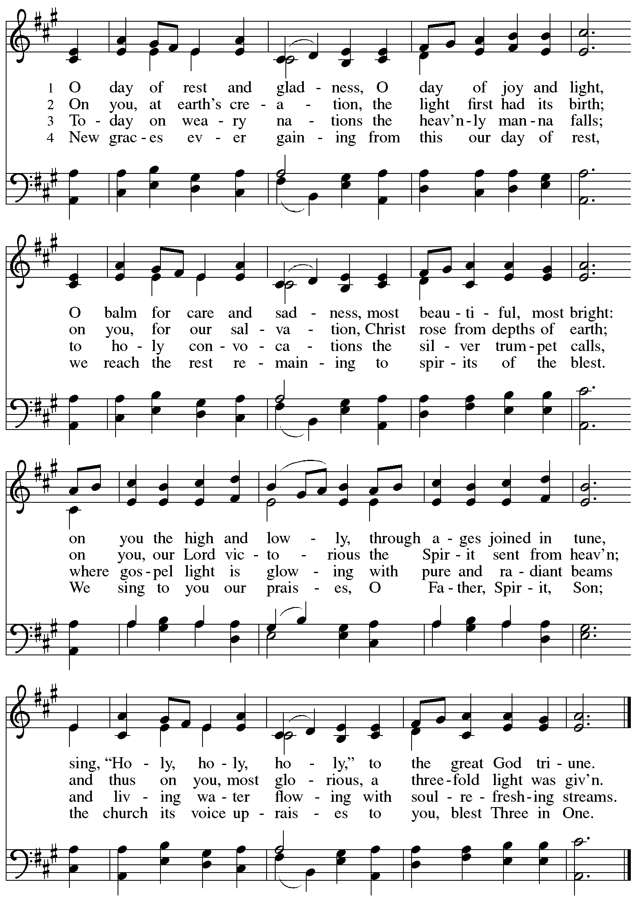

Greeting

P: The grace of our Lord Jesus Christ, the love of God,
and the communion of the Holy Spirit be with you all.
C: And also with you.

Hymn of Praise Oh, Sing of God’s Great Victory! OLS 3

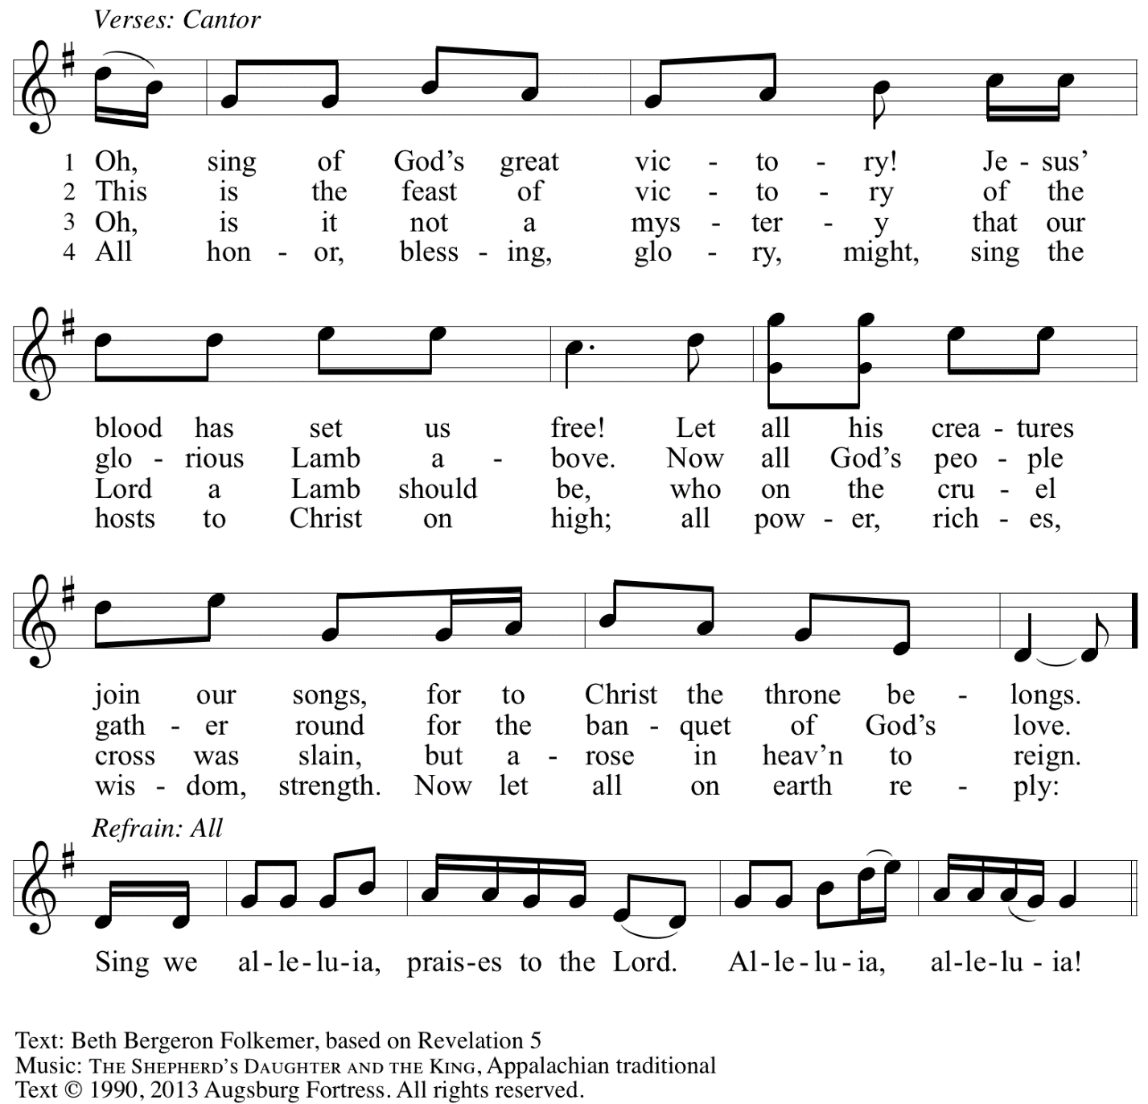
Reprinted with permission under OneLicense.net # A-722139.

Prayer of the Day

P: The Lord be with you.
C: And also with you.

P: Let us pray.
O God, you are the source of life and the ground of our being.
By the power of your Spirit bring healing to this wounded world,
and raise us to new life through your Son, Jesus Christ, our Savior and Lord.
C: Amen.

Please be seated.

Word
God speaks to us in Scripture reading, preaching, and song

First Reading – Hosea 5: 15 – 6: 6

¹⁵I will return again to my place
until they acknowledge their guilt and seek my face.
In their distress they will beg my favor:
^{6:1}“Come, let us return to the Lord;
for it is God who has torn, and God will heal us;
God has struck down, and God will bind us up.
²After two days God will revive us;
on the third day God will raise us up,
that we may live before the Lord.
³Let us know, let us press on to know the Lord;
the Lord’s appearing is as sure as the dawn;
the Lord will come to us like the showers,
like the spring rains that water the earth.”
⁴What shall I do with you, O Ephraim?
What shall I do with you, O Judah?
Your love is like a morning cloud,
like the dew that goes away early.
⁵Therefore I have hewn them by the prophets,
I have killed them by the words of my mouth,
and my judgment goes forth as the light.
⁶For I desire steadfast love and not sacrifice,
the knowledge of God rather than burnt offerings.

L: Word of God, word of life.
C: Thanks be to God.

Psalm 50: 7-15

The psalm will be sung by the cantor,
with the congregation invited to join in singing the verses in bold and the refrain.

Psalm tone

Psalm refrain

⁷“Listen, my people, and I will speak: Israel, I will bear wit- | ness against you;
for I am | God, your God.
⁸I do not accuse you because | of your sacrifices;
your burnt offerings are al- | ways before me.
⁹I will not accept a calf | from your stalls,
nor goats | from your pens;
¹⁰for all the wild animals of the for- | est are mine,
the cattle on a | thousand hills. R
¹¹I know every bird | of the mountains,
and the creatures of the | fields are mine.
¹²If I were hungry, I | would not tell you,
for the whole world is mine and all | that is in it.
¹³Do you think I eat the | flesh of bulls,
or drink the | blood of goats?
¹⁴Offer to God a sacrifice | of thanksgiving
and make good your vows to | the Most High.
¹⁵Call upon me in the | day of trouble;
I will deliver you, and you shall | honor me. R

Second Reading – Romans 4: 13-25

¹³The promise that he would inherit the world did not come to Abraham or to his descendants through the law but through the righteousness of faith. ¹⁴If it is the adherents of the law who are to be the heirs, faith is null and the promise is void. ¹⁵For the law brings wrath; but where there is no law, neither is there violation.
¹⁶For this reason it depends on faith, in order that the promise may rest on grace and be guaranteed to all his descendants, not only to the adherents of the law but also to those who share the faith of Abraham (for he is the father of all of us, ¹⁷as it is written, “I have made you the father of many nations”)—in the presence of the God in whom he believed, who gives life to the dead and calls into existence the things that do not exist. ¹⁸Hoping against hope, he believed that he would become “the father of many nations,” according to what was said, “So numerous shall your descendants be.” ¹⁹He did not weaken in faith when he considered his own body, which was already as good as dead (for he was about a hundred years old), or when he considered the barrenness of Sarah’s womb. ²⁰No distrust made him waver concerning the promise of God, but he grew strong in his faith as he gave glory to God, ²¹being fully convinced that God was able to do what God had promised. ²²Therefore his faith “was reckoned to him as righteousness.” ²³Now the words, “it was reckoned to him,” were written not for his sake alone, ²⁴but for ours also. It will be reckoned to us who believe in the one who raised Jesus our Lord from the dead, ²⁵who was handed over to death for our trespasses and was raised for our justification.

L: Word of God, word of life.
C: Thanks be to God.

Please rise as you are able.

Gospel Acclamation O God, Whose Word Well-Planted OLS 4
v. 1-2

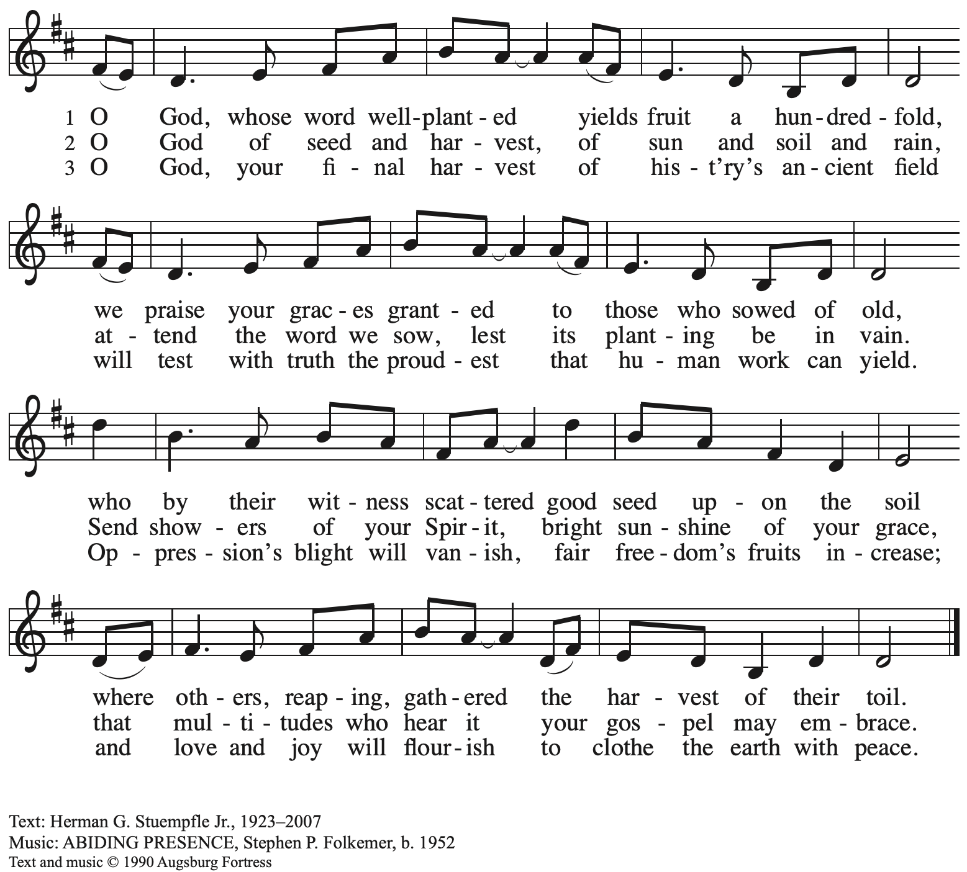
All rights reserved. Reprinted under OneLicense.net # A-722139.

Gospel – Matthew 9: 9-13, 18-26

P: The holy Gospel according to St. Matthew.
C: Glory to you, O Lord.

⁹As Jesus was walking along, he saw a man called Matthew sitting at the tax booth; and he said to him, “Follow me.” And he got up and followed him.
¹⁰And as he sat at dinner in the house, many tax collectors and sinners came and were sitting with him and his disciples. ¹¹When the Pharisees saw this, they said to his disciples, “Why does your teacher eat with tax collectors and sinners?” ¹²But when he heard this, he said, “Those who are well have no need of a physician, but those who are sick. ¹³Go and learn what this means, ‘I desire mercy, not sacrifice.’ For I have come to call not the righteous but sinners.”
¹⁸While he was saying these things to them, suddenly a leader of the synagogue came in and knelt before him, saying, “My daughter has just died; but come and lay your hand on her, and she will live.” ¹⁹And Jesus got up and followed him, with his disciples. ²⁰Then suddenly a woman who had been suffering from hemorrhages for twelve years came up behind him and touched the fringe of his cloak, ²¹for she said to herself, “If I only touch his cloak, I will be made well.” ²²Jesus turned, and seeing her he said, “Take heart, daughter; your faith has made you well.” And instantly the woman was made well. ²³When Jesus came to the leader’s house and saw the flute players and the crowd making a commotion, ²⁴he said, “Go away; for the girl is not dead but sleeping.” And they laughed at him. ²⁵But when the crowd had been put outside, he went in and took her by the hand, and the girl got up. ²⁶And the report of this spread throughout that district.

P: The Gospel of the Lord.
C: Praise to you, O Christ.

Please be seated.

Sermon

A time of silence for prayer and reflection follows the sermon.
When the hymn of the day begins, please rise as you are able.

Hymn of the Day Following page

Hymn of the Day O Christ, the Healer, We Have Come ELW 610

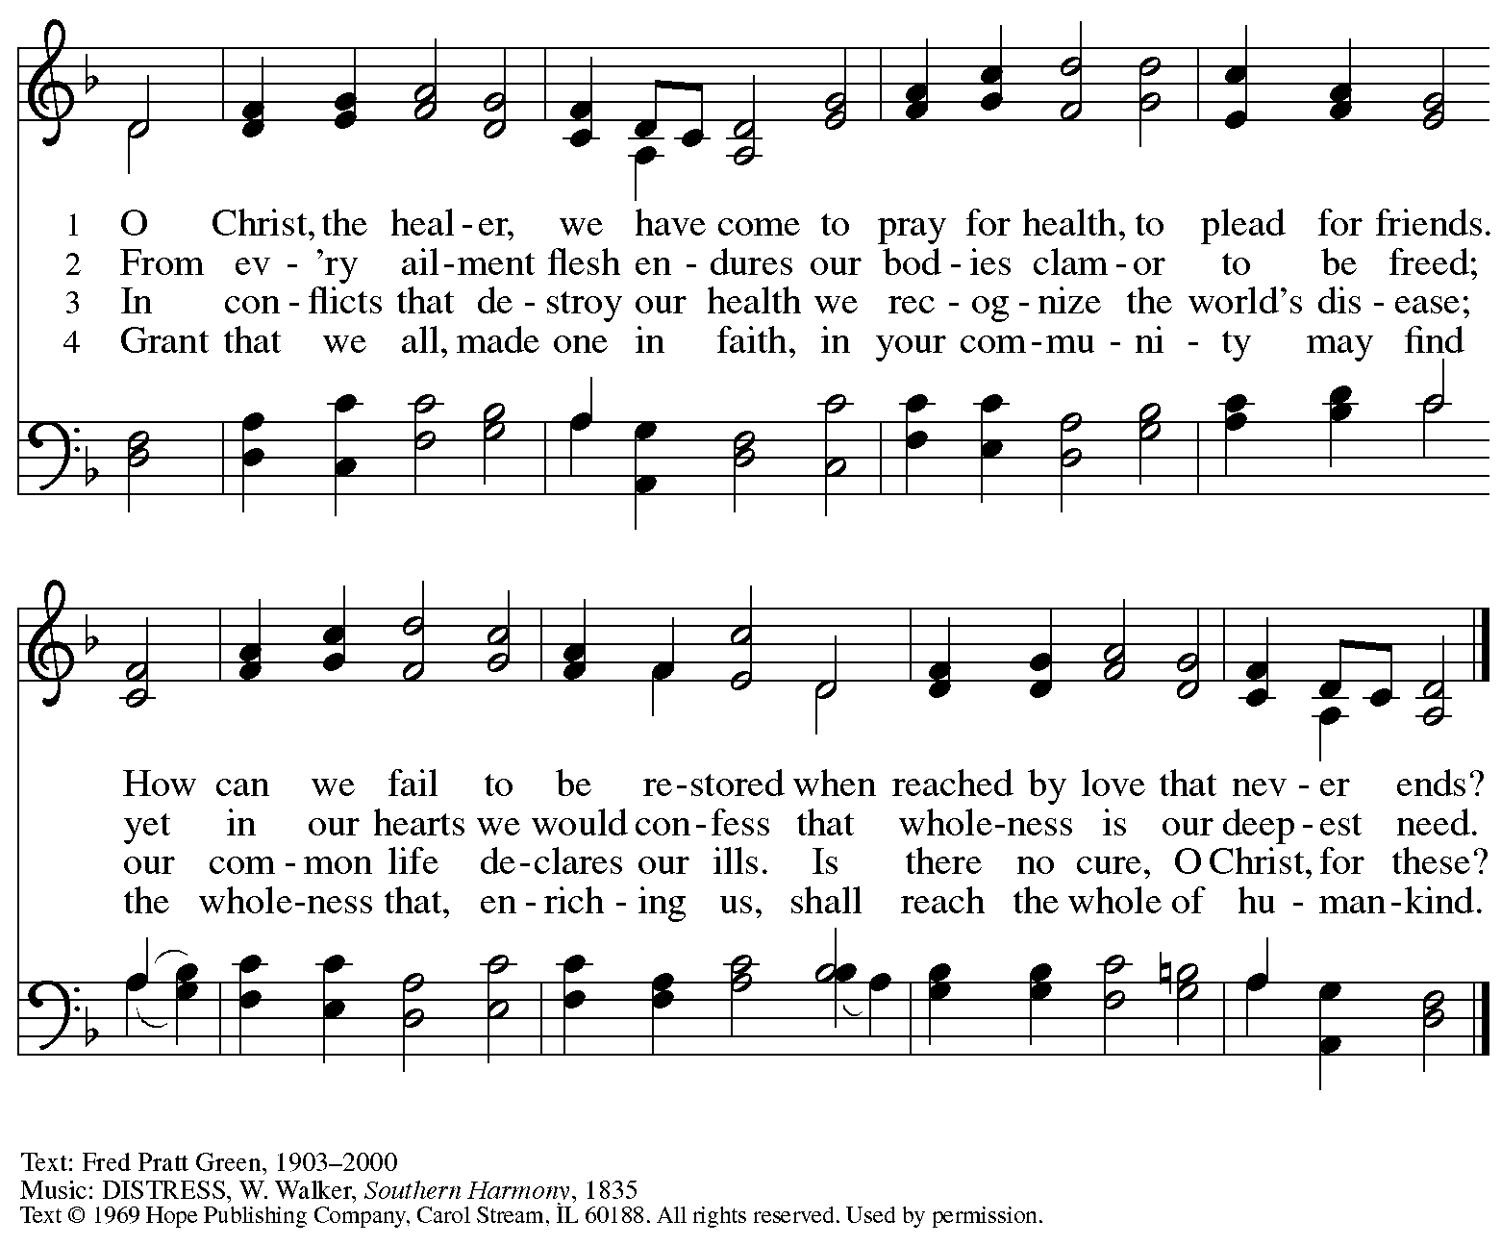
Reprinted with permission under OneLicense.net # A-722129.

Prayers of the People

A: With the whole people of God in Christ Jesus, let us pray for the church, the world,
those in need, and all of God’s creation.

After each petition
A: God, in your mercy,
C: receive our prayer.

The presiding minister concludes the prayers
P: Into your hands, gracious God, we commend all for whom we pray,
trusting in your abundant mercy, through Jesus Christ our Savior.
C: Amen.

Peace

The presiding minister and the assembly greet one another in the peace of the risen Christ.
P: The peace of Christ be with you always.
C: And also with you.

The people may greet those around them with a sign of Christ’s peace and may say
Peace be with you or similar words. Please be mindful that not everyone will be comfortable with sharing the peace, so please seek consent before shaking hands or hugging. Other possible ways to share the peace include a simple bow with the verbal greeting of peace, or simply a verbal expression of peace.

When the greetings of peace have concluded, please be seated.

Meal
God feeds us with the presence of Jesus Christ

Offering

We offer ourselves, our gifts, and our faithful service to God.
As the offering is gathered for the mission of the church, including the care of those in need,
the table is set for Holy Communion.

Music during the Offering

As the gifts are brought forward for presentation, please rise as you are able.

Offertory Song Accept, O Lord, the Gifts We Bring OLS 5

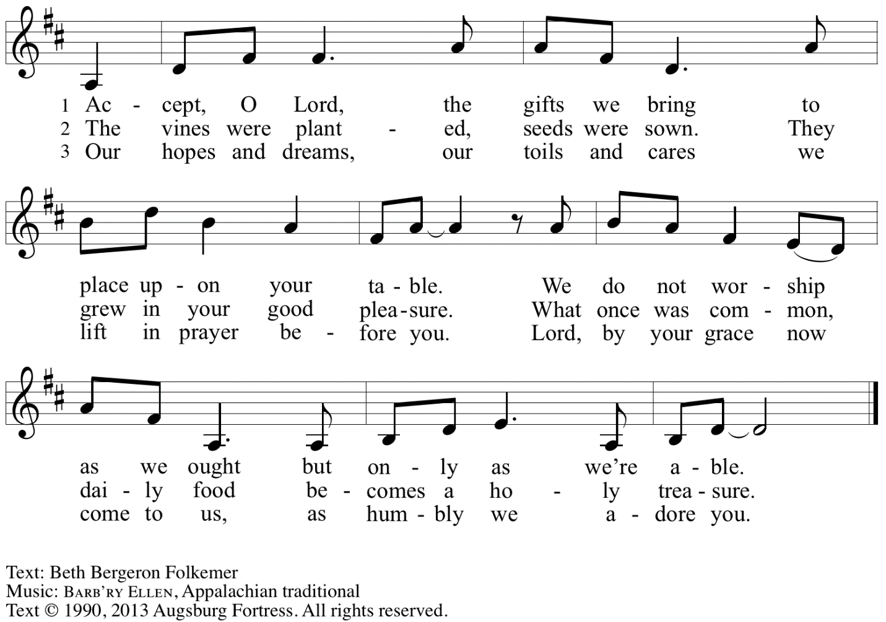
Reprinted under OneLicense.net # A-722139.

Offertory Prayer

A: Let us pray.
Gracious God,
C: you bless us with gifts of guidance, new life,
Growth in grace, and fruitful labor.
Accept the first fruits of time and toil,
field and orchard, that we offer here.
Bless and multiply these gifts
to our nurture and the care of your creation;
for the sake of your Son,
Jesus Christ, our Lord.
Amen.

Dialogue

P: The Lord be with you.
C: And also with you.

P: Lift up your hearts.
C: We lift them to the Lord.

P: Let us give thanks to the Lord our God.
C: It is right to give our thanks and praise.

Preface

P: It is indeed right, our duty and our joy …
… we praise your name and join in adoring song:

Sanctus Holy, Holy, Holy OLS 6

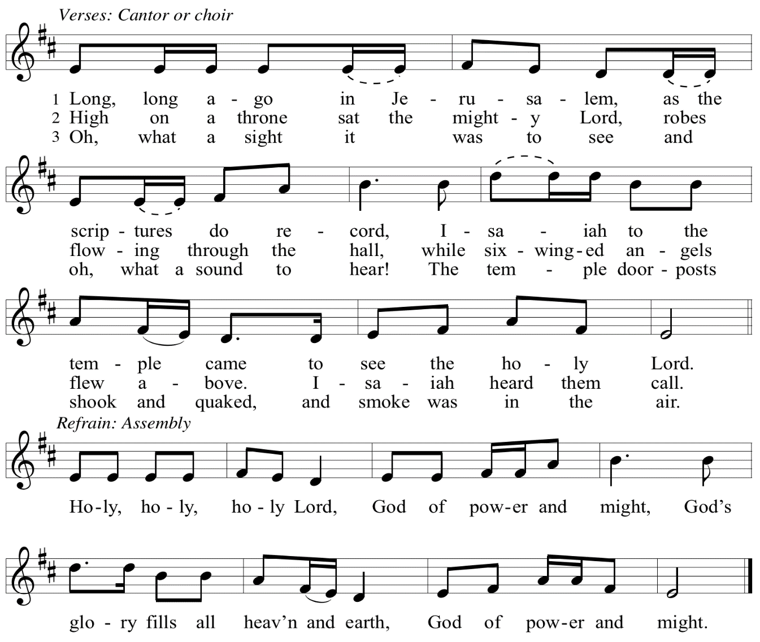
Eucharistic Prayer

P: You are indeed holy, God of power and might,
and your glory fills the whole earth …
… and nurture us to become what you have made us –
your beloved people, the body of your Son, the temple of your Spirit.

Through your Son, in your Spirit, with all your people,
we give you thanks and praise,
O source of our life and fountain of all Good,
now and forever.
C: Amen.

Lord’s Prayer

P: Gathered as one by the Holy Spirit, let us pray as Jesus taught us.
C: Our Father in heaven,
hallowed be your name,
your kingdom come,
your will be done,
on earth as in heaven.
Give us today our daily bread.
Forgive us our sins
as we forgive those
who sin against us.
Save us from the time of trial
and deliver us from evil.
For the kingdom, the power,
and the glory are yours,
now and forever. Amen.

Fraction and Invitation

P: Just as this broken bread was first scattered on the hills,
then was brought together and became one,
so let your church be brought together
from the ends of the earth into your reign,
for yours are the glory and the power
through Jesus Christ forever.
C: Amen.

Agnus Dei / Lamb of God OLS 7
O Lamb of God, to Earth You Came

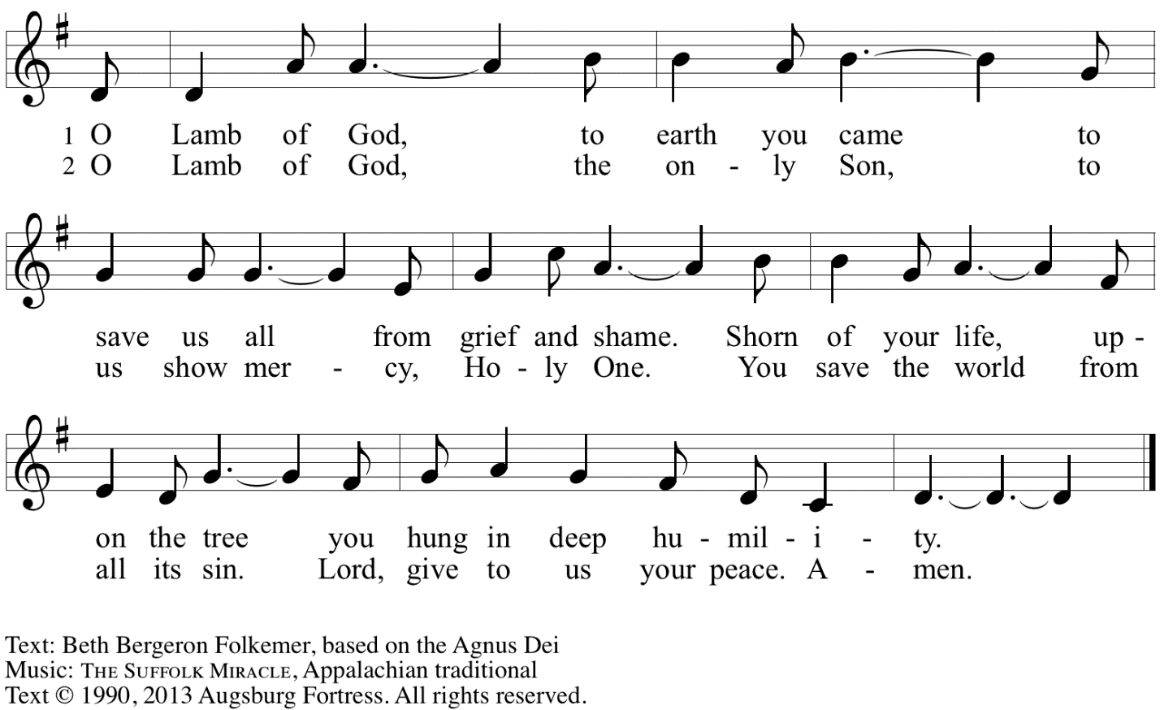
Reprinted with permission under OneLicense.net A# A-722139.

Please be seated.

Holy Communion
- All who seek God and desire a deeper and stronger life in Christ are welcome to receive Holy Communion.
- Worshipers from the pulpit side will proceed forward first, followed by the center section, and then the lectern side.
- Please inform an usher if you would like the ministers to bring Communion to you.
- Holy Communion will be served with bread and wine/grape juice.
- The presiding minister will first distribute the bread (host) to each communicant. Please indicate if you require a gluten-free host.
- Once you have consumed the bread, please pick up an empty glass from the tray next to the presiding minister. The Communion Assistant will pour wine from the chalice or grape juice from the cruet into your glass.
- Please step to the side to consume the wine or grape juice.
- Feel free to kneel at the altar rail for prayer after receiving the sacrament.
- As you return to your pew, glasses may be returned to the empty trays on either side of the center section.
- A blessing will be provided for anyone who does not yet receive the sacrament.
- All are invited to join in singing the hymns during Holy Communion.
Hymns during Holy Communion
We Praise You for the Life That Stirs OLS 9

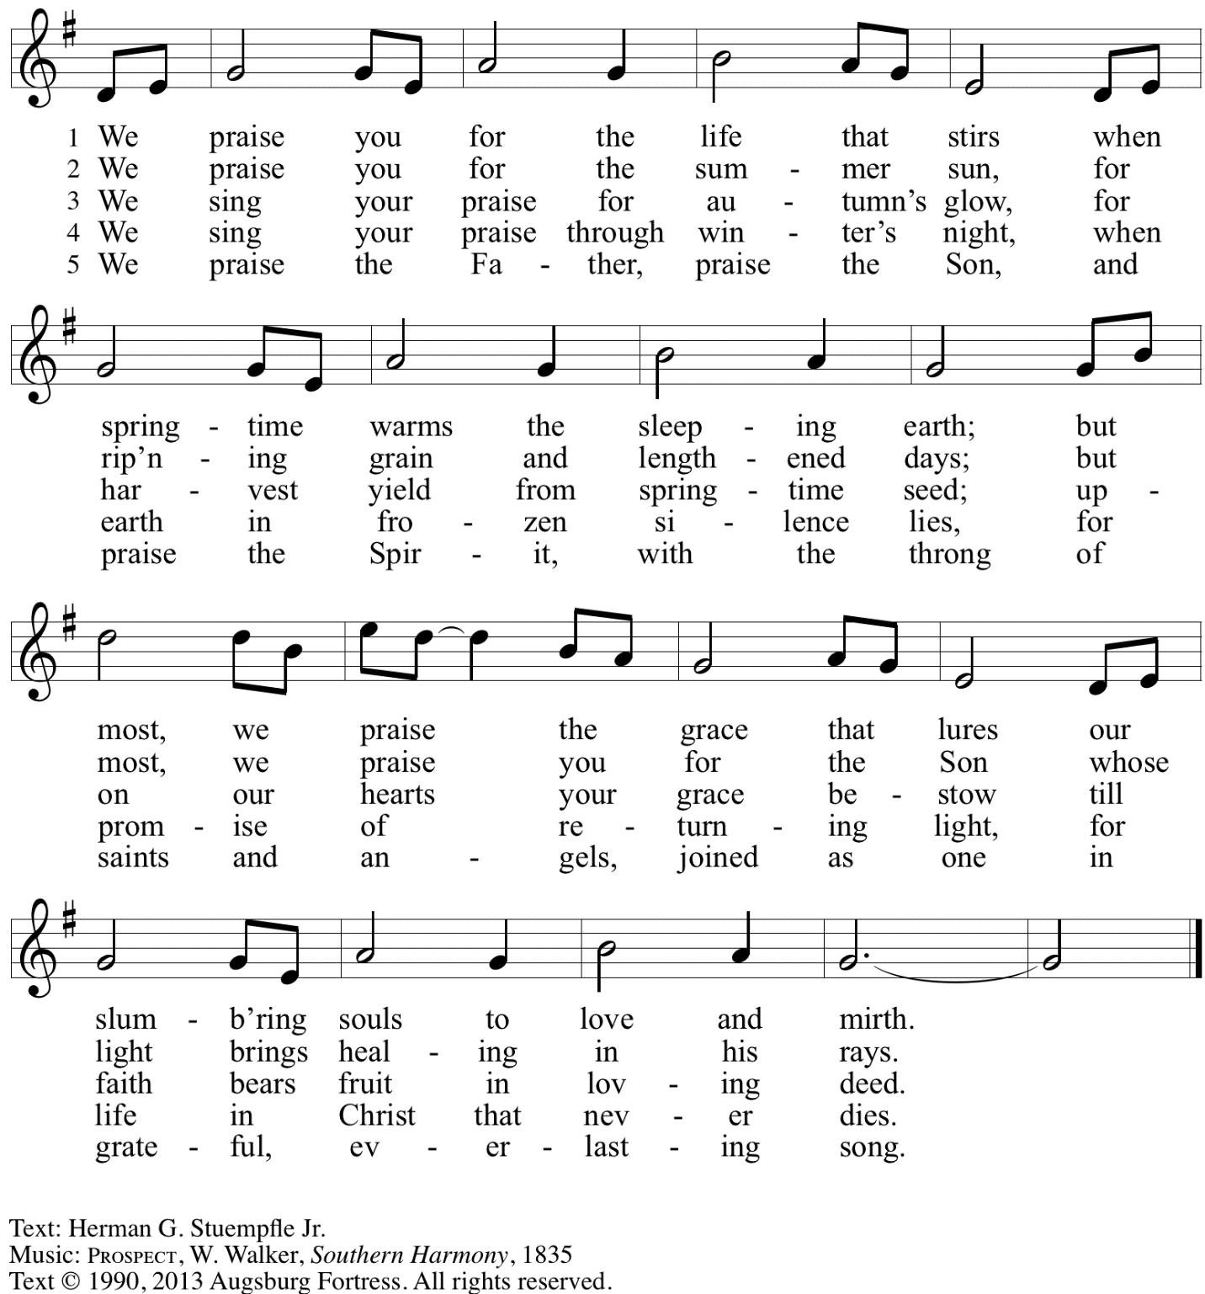
Reprinted with permission under OneLicense.net # A-722139.

Hymns during Holy Communion
Jesus Calls Us; o’er the Tumult ELW 696

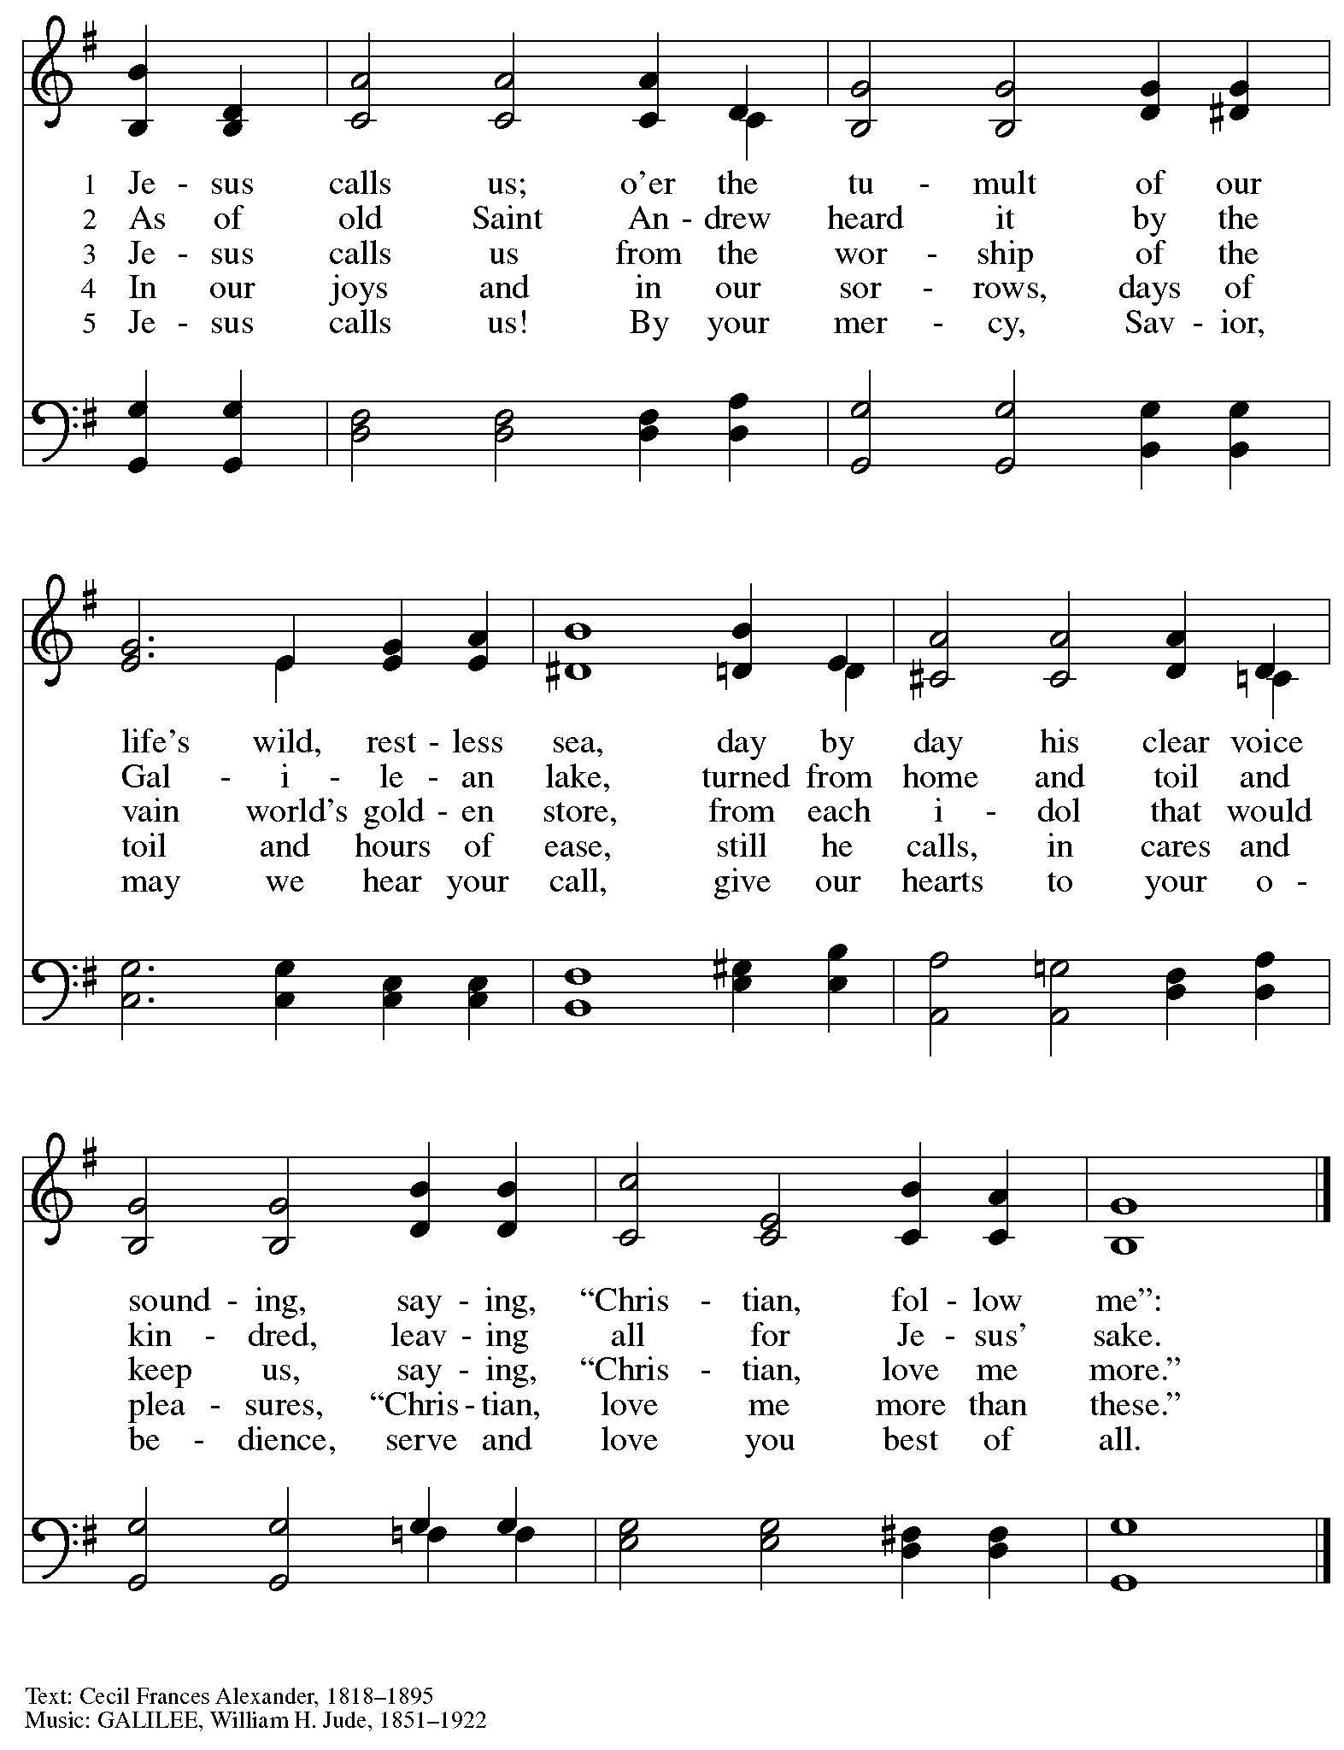

Hymns during Holy Communion
Draw Us in the Spirit’s Tether ELW 470

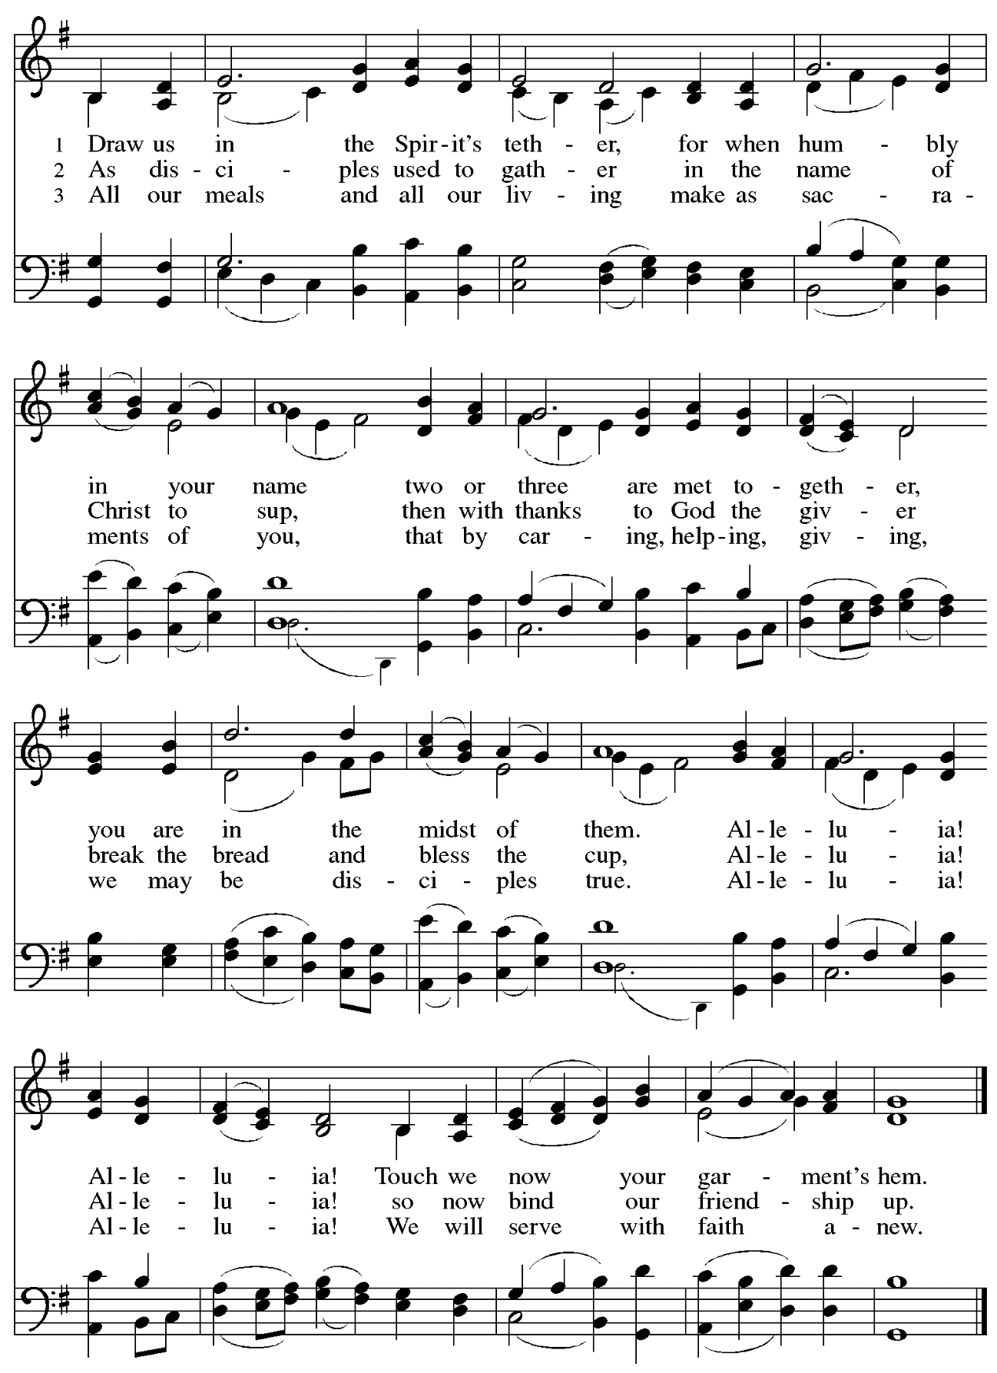

When all have returned to their places, please rise as you are able.

Blessing

P: The body and blood of our Lord Jesus Christ strengthen you and keep you in his grace.
C: Amen.

Prayer

A: Let us pray. Gracious God,
we give you thanks for your pruning, planting, and nurture.
We rejoice that you have used the harvest of field and vineyard
to renew and sustain us.
Lead us as we go from this life-giving meal
into lives of grateful service to you and your cherished creation;
through Jesus Christ, your Son, our Lord.
C: Amen.

Please be seated.

Sending
God blesses us and sends us in mission to the world

Announcements

Please rise as you are able.

Benediction

P: The God of steadfastness and encouragement
grant you to live in harmony with one another,
in accordance with Christ Jesus.
C: Amen.

P: The God of hope fill you with all joy and peace in believing,
so that you may abound in hope by the power of the Holy Spirit.
C: Amen.

P: The God of all grace ☩ bless you now and forever.
C: Amen.

Sending Hymn I’m So Glad Jesus Lifted Me ELW 860

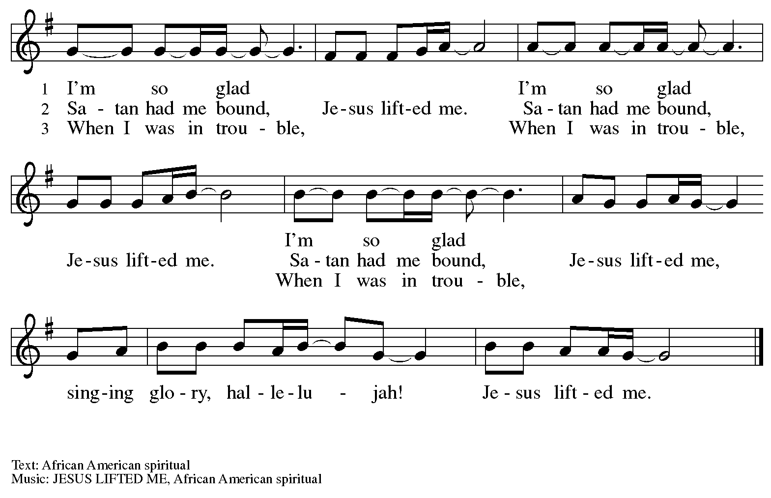

Dismissal

A: Go in peace. Serve the Lord.
C: Thanks be to God!

Postlude

Those serving in worship today

Altar Care Christy Ruhe
Assisting Minister Timothy Kocher-Hillmer
Audio-Visual Ministers David Rollinson
Jason Galyardt
Cantor Ian Brown
Lector Sue Gaugler
Minister of Music Laura Reynolds
Presiding Minister Pastor Ross Carmichael

Liturgy and Hymnody Acknowledgements

From SundaysandSeasons.com. Copyright © 2023 Augsburg Fortress. All rights reserved. Reprinted under OneLicense.net # A-722139.
Used by permission of Augsburg Fortress.

O Christ, Your Heart, Compassionate – Text: Herman Stuempfle Jr., 1923-2007. Music: ELLACOMBE, German melody, 18th cent.; adapt. X.L. Hartig, Melodien zum Mainzer Gesangbuche, 1833. Text © 2000 GIA Publications, Inc., 7404 S. Mason Ave., Chicago, IL 60638. www.giamusic.com. 800.442.3358.

Holy, Holy, Holy / Long, Long Ago in Jerusalem – Text: Beth Bergeron Folkemer, based on the Sanctus. Music: SHADY GROVE, Appalachian traditional. Text © 1990, 2013, Augsburg Fortress. All rights reserved. Reprinted with permission under OneLicense.net # A-722139.

Draw Us in the Spirit’s Tether – Text: Percy Dearmer, 1867-1936, alt. Music: UNION SEMINARY, Harold Friedell, 1905-1958. Text from Songs of Praise Enlarged Edition, © Oxford University Press 1931. Music © 1957, 1985 H.W. Gray, admin. CPP/Belwin. All rights reserved. Reprinted with permission under OneLicense.net # A-722139.

St. Andrew Lutheran Church Announcements
June 11th, 2023

- Welcome to worship at St. Andrew on the Second Sunday after Pentecost, June 11th, 2023 – We are so glad you are here, and we offer a special welcome to all visitors and guests connecting for the first time! Worship attendees are invited to make a name tag at the back of the worship space if you would like. There are worship “toolkits” to help children engage with worship and “busy bags” for younger children available in the bookcase at the back of the sanctuary. Please feel free to take one to use with/for your children.
- Christ in Our Home Devotional Booklets for July – September Now Available at Church Entrances – Throughout the year, St. Andrew makes available to the congregation Christ in Our Home, a booklet with daily Bible readings, reflections, and prayers. The next edition, for July – September 2023, is now available at the church entrances. Please take one to enhance your spiritual practice!

St. Andrew Lutheran Church Announcements
June 11th, 2023 continued

- Join the RCC as they sing for justice and "Stand Up" in pride and joy for the LGBTQIA+ community. This year’s Pride Concert features selections from Dear Evan Hansen, Kinky Boots, the 2019 feature film Harriet, Considering Matthew Shepard, the Social Justice Songbook, and more— encouraging us all to love, support, and defend ourselves and our identities from those who seek to silence us. Can't join in person? Livestream tickets are also available so you can celebrate Pride with RCC from the comfort of your own home. To learn more and purchase tickets, visit: https://rccpittsburgh.ticketleap.com/rccpride23/.
- Monthly Shelter Dinner at East End Cooperative Ministry - Thursday, June 15th, 6:30 p.m. – Each month, members of St. Andrew provide and serve a meal for the guests of the shelter at East End Cooperative Ministry (EECM), 6140 Station St., 15206. Anyone can sign up to prepare or purchase a portion of the meal to bring to EECM at 6:00 p.m. that day, or just come to help serve the meal at 6:30 p.m. Please sign up at: https://www.signupgenius.com/go/5080544AAAC22A1F58-june5.
- St. Andrew to Participate in Millvale Pride Event on Saturday, June 24th – June is Pride Month, and St. Andrew has traditionally taken part in Pride events in conjunction with other Reconciling in Christ congregations, staffing a booth at which we have shared conversation, resources, and information about the churches and our mission to share God's love with all our LGBTQIA+ siblings. St. Andrew will have a table at Millvale Pride on Saturday, June 24th. The event is from 12:00 p.m. to 8:00 p.m. No one stays the whole time (unless you want to!), but we usually invite people from the congregation to represent St. Andrew for stretches of 1-2 hours. More information about Millvale Pride can be found here: https://www.pridemillvale.org/. If you can be available and are willing to represent St. Andrew at the booth, please sign up at https://forms.gle/QHfFXPrMeGxGciye9.
- St. Andrew Updating Information - Please Respond! – St. Andrew is looking to update our records with information from newer attendees, as well as offering current members the opportunity to include current information. This includes name, preferred pronouns, email, phone number, birthdays, anniversaries, and more. The information will only be used within the congregation - for example to acknowledge celebrations and milestones in worship, in the prayers of the church, or in the weekly or monthly newsletter. Please fill out the form at: https://forms.gle/fTwpdG2uA7pYD2ta8.
- Lutheran Campus Ministry in Greater Pittsburgh (LCMGP) 75th Anniversary Dinner - September 15th, 2023 7:00 p.m. at Le Mont – Join the LCMGP for its inaugural fundraising banquet as they celebrate the ministry's work in Greater Pittsburgh and among the universities of Pitt, Carnegie Mellon, Chatham, and Carlow for over the past 75+ years. Learn more about LCMGP, purchase tickets, or make a donation here: https://linktr.ee/LCMGP.

