+ Third Sunday after Pentecost
June 18, 2023
St. Andrew Lutheran Church
304 Morewood Ave.
Pittsburgh, PA 15213
St_andrewELCA@verizon.net
www.standrewpittsburgh.org

+ Third Sunday after Pentecost
Order for Worship

Moses tells the Israelites that they are called to be a priestly kingdom and a holy people.
Jesus sends out the disciples as laborers into the harvest.
In Baptism we too are anointed for ministry, sharing God’s compassion with our needy world. From the Lord’s table we go forth to proclaim the good news, to heal the sick,
and to share our bread with the hungry.

Welcome to St. Andrew!

- St. Andrew Lutheran congregation welcomes all who are seeking a place of healing and wholeness – a nurturing, faith-forming spiritual home. Our community embraces people of all ages, ethnicities, cultures, abilities, sexual orientations, gender identities and expressions, and family constellations. Come and See!

- Worship Services are live streamed to multiple online platforms. By attending worship, you agree that your image and voice may be broadcast.

- Everyone is invited to make a nametag at the black bookcase in the back of the worship space if they would like. There are stickers indicating pronouns on the bookcase if you would like to include them on your name tag.

- Worship “toolkits” to help children engage with the service, along with “busy bags” for younger children, are available in the bookcase at the back of the sanctuary. Please feel free to take one to use with/for your children.

- Holy Communion is served with bread (gluten-free available) and wine or grape juice. The presiding minister will distribute the bread (host). Please consume this and then pick up an empty glass from the tray. The Communion Assistant will pour wine or grape juice into your glass. Please step to the side to consume the wine or grape juice. Feel free to kneel at the altar for prayer and reflection. As you return to your pew, glasses may be returned to the empty trays on either side of the center section.

- A restroom is available on the main level of the church, through the doors to the Social Hall and to the right in the main office.

Abbreviations
P: Pastor/Presiding Minister ACS: All Creation Sings hymnal
A: Assisting Minister ELW: Evangelical Lutheran Worship hymnal
L: Lector OLS: Of the Land and Seasons hymnal
C: Congregation

Pre-Service Music

Welcome

Prelude

Gathering
The Holy Spirit calls us together as the people of God

Invocation

P: Blessed be the holy Trinity, ☩ one God,
who forgives all our sin, whose mercy endures forever.
C: Amen.

Commemoration of the Emanuel Nine

The “Emanuel Nine,” of blessed and eternal memory, were nine gifted, loving, and faithful people who spent their lives striving for excellence, connection, and the presence of God, and their last moments in study of God’s word. They leave a legacy of grace, resistance, family, and faith.

Gracious God, in remembering their lives and witness, we are called to a wider understanding of the Spirit’s work in the world …

In lives of faithful dedication, your servants:

The Rev. Clementa C. Pinckney
Cynthia Marie Graham Hurd
The Rev. Daniel Lee Simmons
The Rev. DePayne Middleton-Doctor
Ethel Lee Lance
The Rev. Myra Singleton Quarles Thompson
The Rev. Sharonda Coleman-Singleton
Susie Jackson, and
Tywanza Kibwe Diop Sanders

lived by your promises, sharing their gifts with those in their families and communities. May we not forget their lives, taken too soon. We share their names and their witness, so that the world comes to know of your spirit at work in and through them.

We ask this in the name of Jesus.
C: Amen.

Litany of Confession and Lament

P: Remembering the lives and witness of the Emanuel Nine, let us join the whole church in confession and lament.

Save us, O God, from ourselves,
from racism often cloaked in pious words,
from the machinations of white supremacy hidden in calls for civility,
from micro aggressions thinly veiled in arrogance,
from apologies when they do not give way to action,
from forgiveness without facing the truth,
from reconciliation without reparation.
Save us, O God.
C: Save us, O God.

P: Deliver us, O God, from expecting siblings of color to continue to bear this emotional work, which is not theirs to do. Deliver us, O God.
C: Deliver us, O God.

The litany continues, after each confession and lament
P: God, have mercy.
C: God have mercy.

The litany concludes
Grateful for the long arc of history that by your will that bends toward justice, we pray:
Grant us wisdom,
give us courage for the facing of these days,
by the power of the Spirit, all for the sake of the kin-dom that we share in Christ Jesus.
C: Amen.

Gathering Hymn God Alone Be Praised Following page

Gathering Hymn God Alone Be Praised ACS 1023

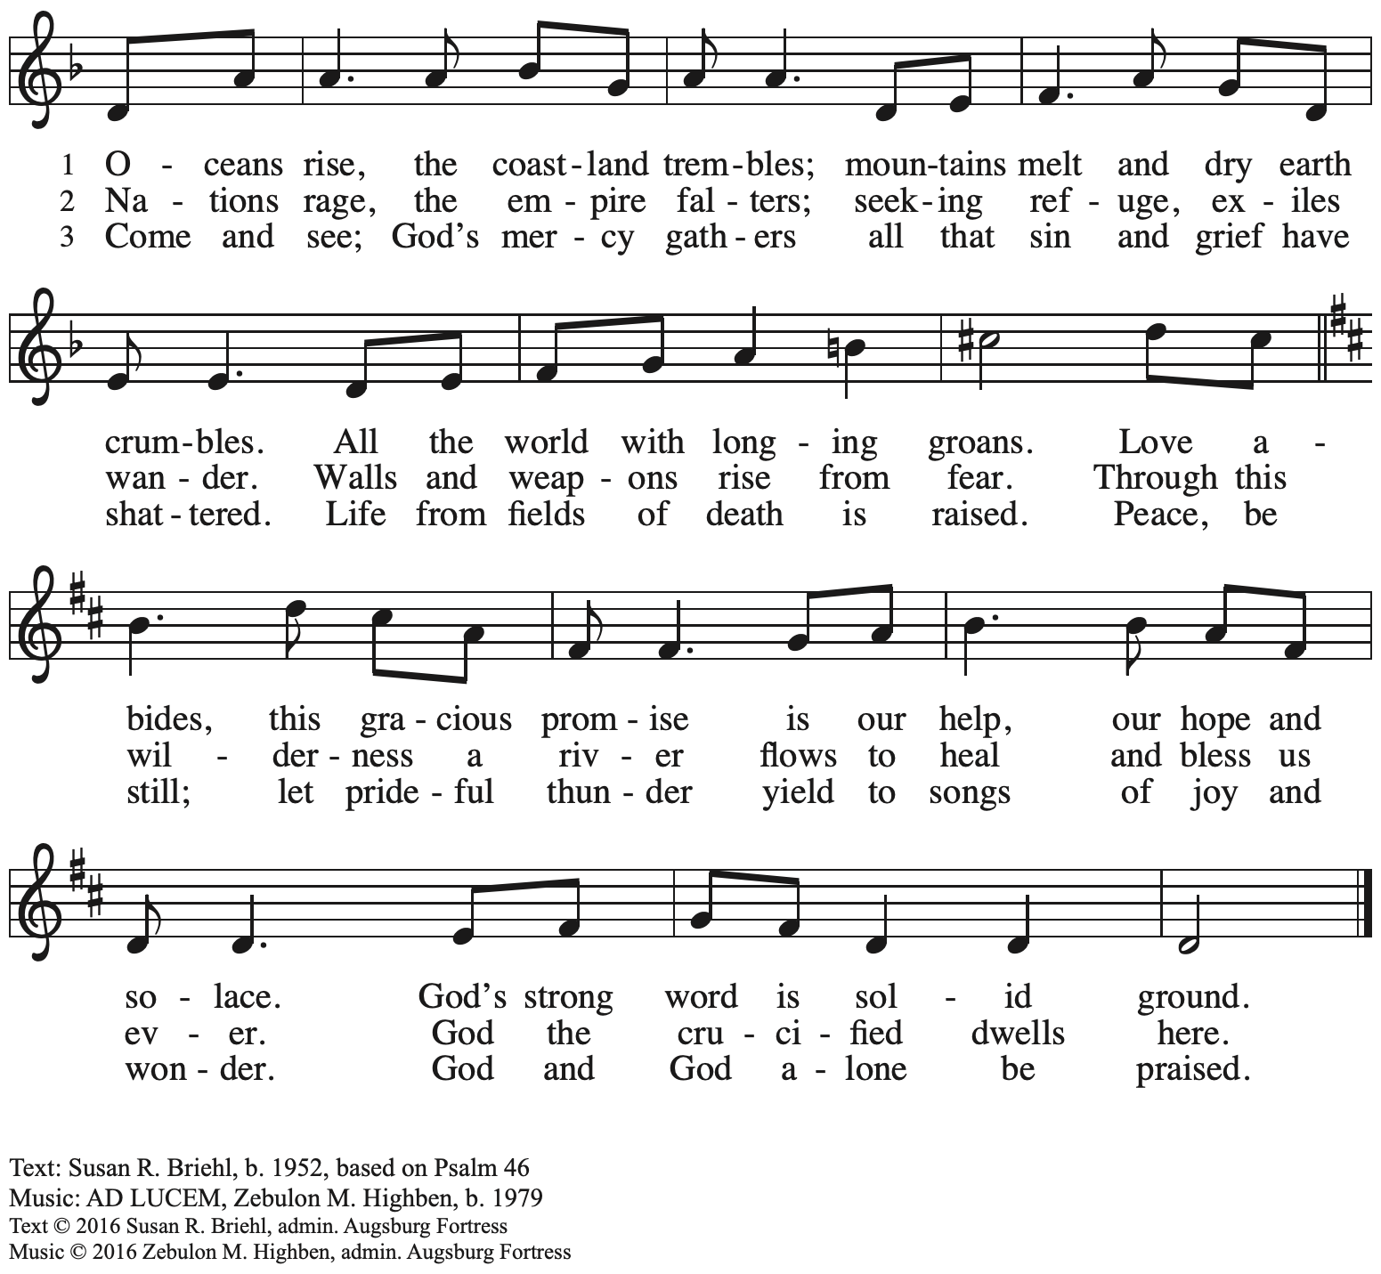
All rights reserved. Reprinted under OneLicense.net # A-722139.

Greeting

P: The grace of our Lord Jesus Christ, the love of God,
and the communion of the Holy Spirit be with you all.
C: And also with you.

Hymn of Praise Oh, Sing of God’s Great Victory! OLS 3

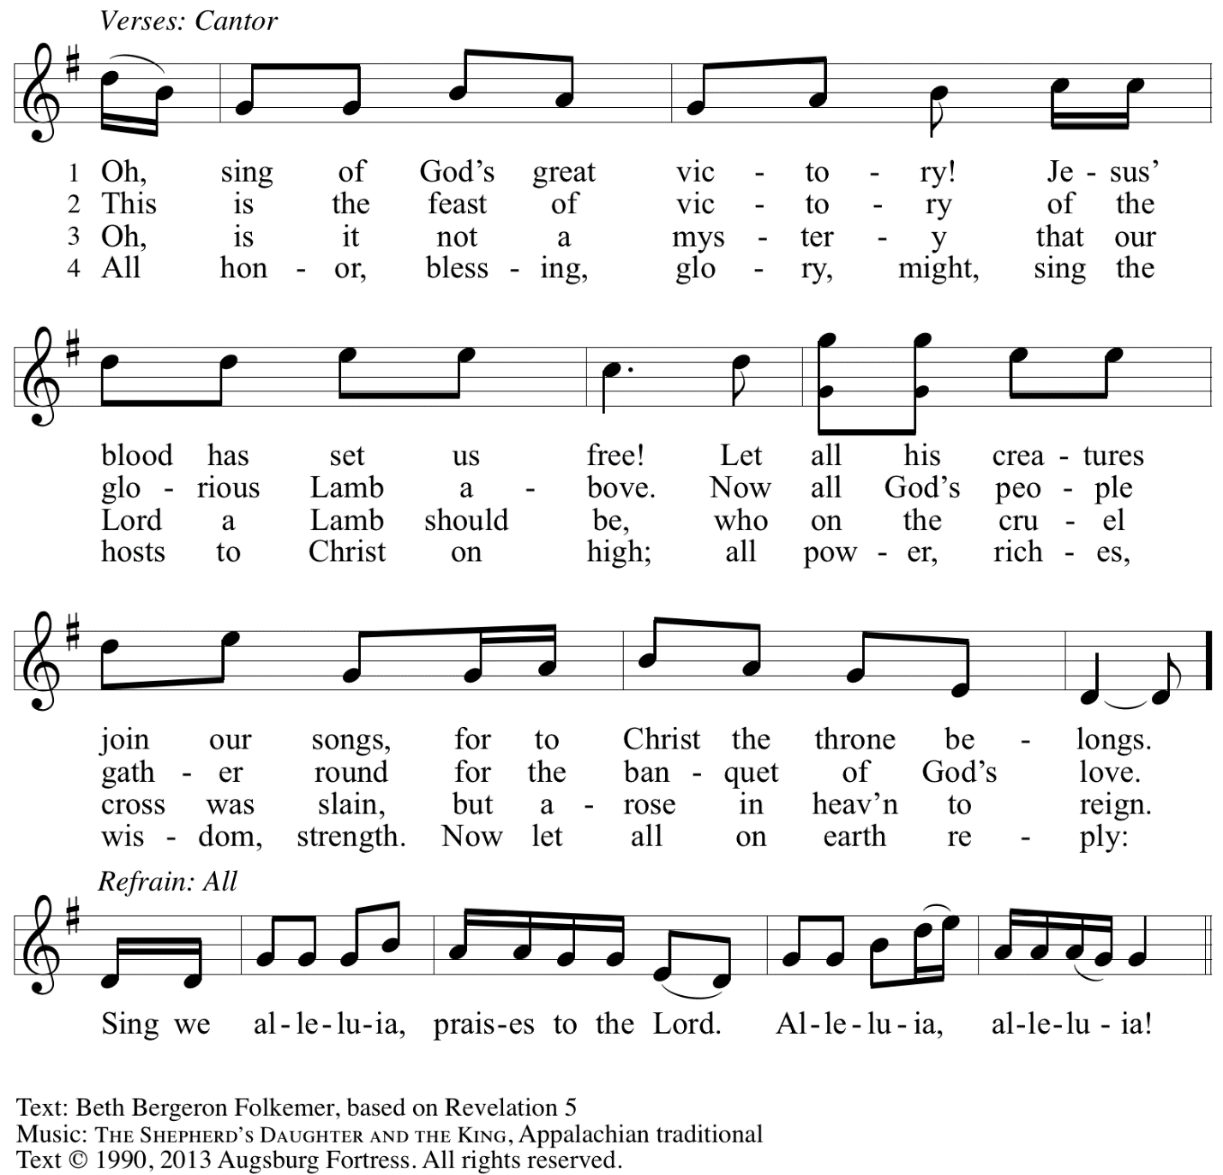
Reprinted with permission under OneLicense.net # A-722139.

Prayer of the Day

P: The Lord be with you.
C: And also with you.

P: Let us pray.
God of compassion,
you have opened the way for us and brought us to yourself.
Pour your love into our hearts, that, overflowing with joy,
we may freely share the blessings of your realm
and faithfully proclaim the good news of your Son,
Jesus Christ, our Savior and Lord.
C: Amen.

Please be seated.

Word
God speaks to us in Scripture reading, preaching, and song

First Reading – Exodus 19: 2-8a

²[The Israelites] had journeyed from Rephidim, entered the wilderness of Sinai, and camped in the wilderness; Israel camped there in front of the mountain.³Then Moses went up to God; the Lord called to him from the mountain, saying, “Thus you shall say to the house of Jacob, and tell the Israelites: ⁴You have seen what I did to the Egyptians, and how I bore you on eagles’ wings and brought you to myself. ⁵Now therefore, if you obey my voice and keep my covenant, you shall be my treasured possession out of all the peoples. Indeed, the whole earth is mine, ⁶but you shall be for me a priestly kingdom and a holy nation. These are the words that you shall speak to the Israelites.”
⁷So Moses came, summoned the elders of the people, and set before them all these words that the Lord had commanded him. ^{8a}The people all answered as one: “Everything that the Lord has spoken we will do.”

L: Word of God, word of life.
C: Thanks be to God.

Psalm 100

The psalm will be sung by the cantor,
with the congregation invited to join in singing the verses in bold and the refrain.

Psalm tone

Psalm refrain

¹Make a joyful noise to the Lord, | all you lands!
²Serve the Lord with gladness; come into God’s presence | with a song.
³Know that the Lord is God, our maker to whom | we belong;
we are God’s people and the sheep | of God’s pasture. R
⁴Enter the gates of the Lord with thanksgiving and the | courts with praise;
give thanks and bless God’s | holy name.
⁵Good indeed is the Lord, whose steadfast love is | everlasting,
whose faithfulness endures from | age to age. R

Second Reading – Romans 5: 1-8

¹Since we are justified by faith, we have peace with God through our Lord Jesus Christ, ²through whom we have obtained access to this grace in which we stand; and we boast in our hope of sharing the glory of God. ³And not only that, but we also boast in our sufferings, knowing that suffering produces endurance, ⁴and endurance produces character, and character produces hope, ⁵and hope does not disappoint us, because God’s love has been poured into our hearts through the Holy Spirit that has been given to us.
⁶For while we were still weak, at the right time Christ died for the ungodly. ⁷Indeed, rarely will anyone die for a righteous person—though perhaps for a good person someone might actually dare to die. ⁸But God proves God’s love for us in that while we still were sinners Christ died for us.

L: Word of God, word of life.
C: Thanks be to God.

Please rise as you are able.

Gospel Acclamation O God, Whose Word Well-Planted OLS 4
v. 1-2

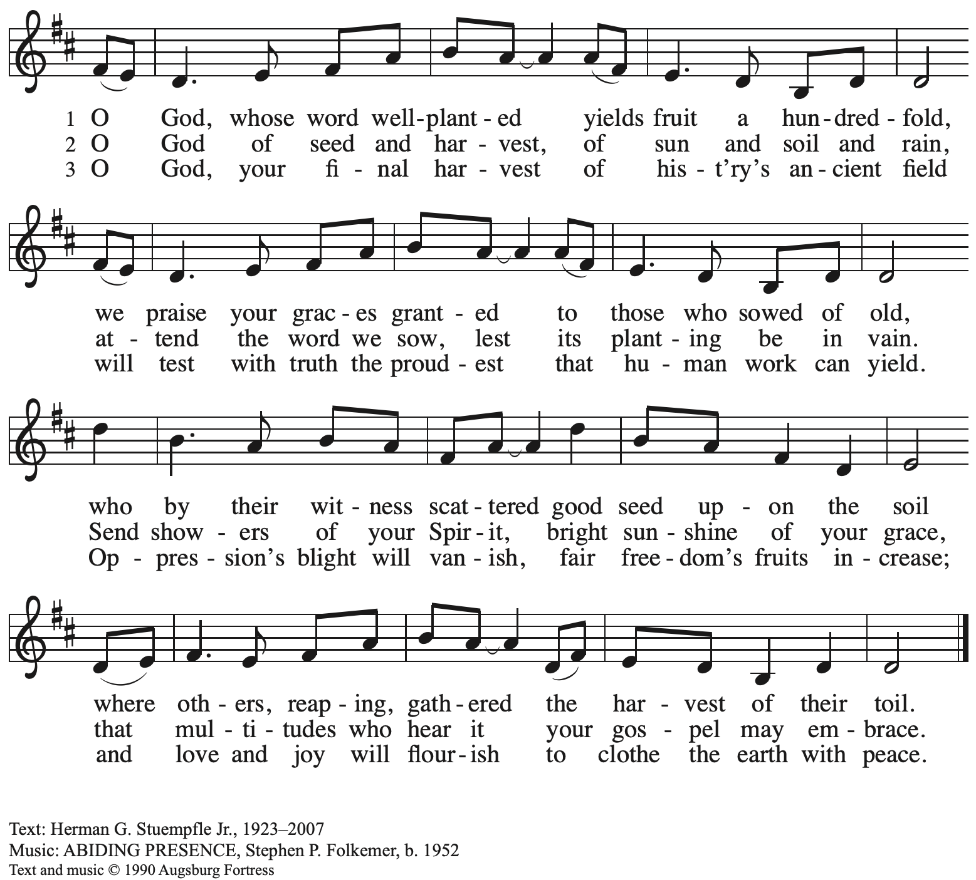
All rights reserved. Reprinted under OneLicense.net # A-722139.

Gospel – Matthew 9: 35 – 10: 8

P: The holy Gospel according to St. Matthew.
C: Glory to you, O Lord.

³⁵Jesus went about all the cities and villages, teaching in their synagogues, and proclaiming the good news of the kingdom, and curing every disease and every sickness. ³⁶When he saw the crowds, he had compassion for them, because they were harassed and helpless, like sheep without a shepherd. ³⁷Then he said to his disciples, “The harvest is plentiful, but the laborers are few; ³⁸therefore ask the Lord of the harvest to send out laborers into his harvest.”
^{10:1}Then Jesus summoned his twelve disciples and gave them authority over unclean spirits, to cast them out, and to cure every disease and every sickness. ²These are the names of the twelve apostles: first, Simon, also known as Peter, and his brother Andrew; James son of Zebedee, and his brother John; ³Philip and Bartholomew; Thomas and Matthew the tax collector; James son of Alphaeus, and Thaddaeus; ⁴Simon the Cananaean, and Judas Iscariot, the one who betrayed him.
⁵These twelve Jesus sent out with the following instructions: “Go nowhere among the Gentiles, and enter no town of the Samaritans, ⁶but go rather to the lost sheep of the house of Israel. ⁷As you go, proclaim the good news, ‘The kingdom of heaven has come near.’ ⁸Cure the sick, raise the dead, cleanse the lepers, cast out demons. You received without payment; give without payment.

P: The Gospel of the Lord.
C: Praise to you, O Christ.

Please be seated.

Sermon

A time of silence for prayer and reflection follows the sermon.
When the hymn of the day begins, please rise as you are able.

Hymn of the Day O Christ, Your Heart, Compassionate Following page

Hymn of the Day O Christ, Your Heart, Compassionate ELW 722

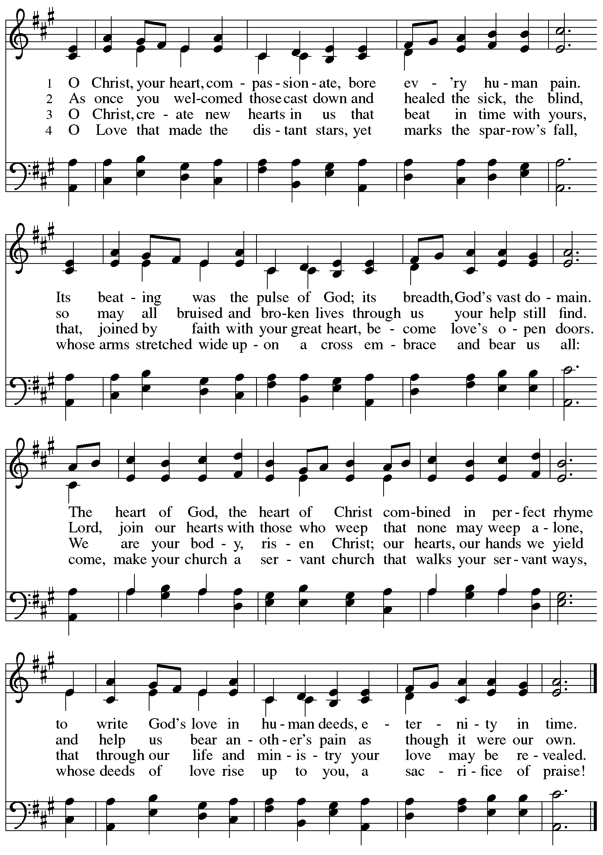

Prayers of the People

A: With the whole people of God in Christ Jesus, let us pray for the church, the world,
those in need, and all of God’s creation.

After each petition
A: God, in your mercy,
C: receive our prayer.

The presiding minister concludes the prayers
P: Into your hands, gracious God, we commend all for whom we pray,
trusting in your abundant mercy, through Jesus Christ our Savior.
C: Amen.

Peace

The presiding minister and the assembly greet one another in the peace of the risen Christ.
P: The peace of Christ be with you always.
C: And also with you.

The people may greet those around them with a sign of Christ’s peace and may say
Peace be with you or similar words. Please be mindful that not everyone will be comfortable with sharing the peace, so please seek consent before shaking hands or hugging. Other possible ways to share the peace include a simple bow with the verbal greeting of peace, or simply a verbal expression of peace.

When the greetings of peace have concluded, please be seated.

Meal
God feeds us with the presence of Jesus Christ

Offering

We offer ourselves, our gifts, and our faithful service to God.
As the offering is gathered for the mission of the church, including the care of those in need,
the table is set for Holy Communion.

Music during the Offering

As the gifts are brought forward for presentation, please rise as you are able.

Offertory Song Accept, O Lord, the Gifts We Bring OLS 5

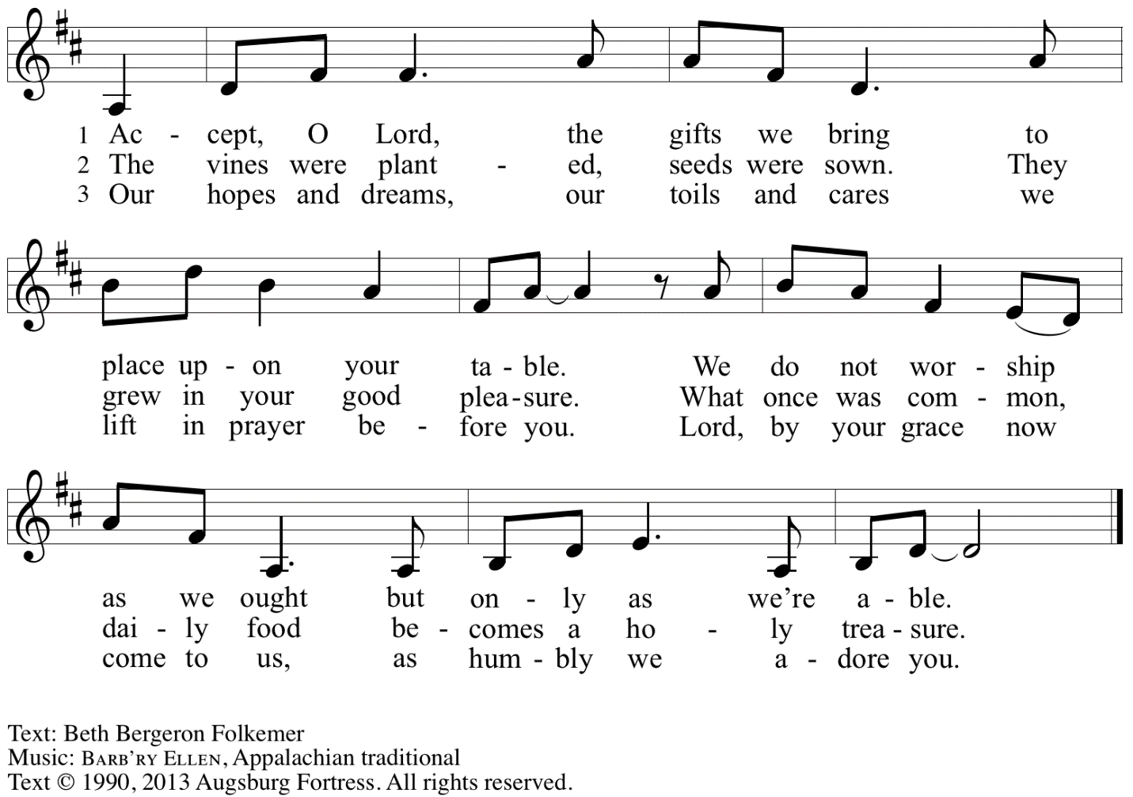
Reprinted under OneLicense.net # A-722139.

Offertory Prayer

A: Let us pray.
Gracious God,
C: you bless us with gifts of guidance, new life,
growth in grace, and fruitful labor.
Accept the first fruits of time and toil, field and orchard,
that we offer here. Bless and multiply these gifts to our nurture
and the care of your creation;
for the sake of your Son, Jesus Christ, our Lord.
Amen.

Dialogue

P: The Lord be with you.
C: And also with you.

P: Lift up your hearts.
C: We lift them to the Lord.

P: Let us give thanks to the Lord our God.
C: It is right to give our thanks and praise.

Preface

P: It is indeed right, our duty and our joy …
… we praise your name and join in adoring song:

Sanctus Holy, Holy, Holy OLS 6

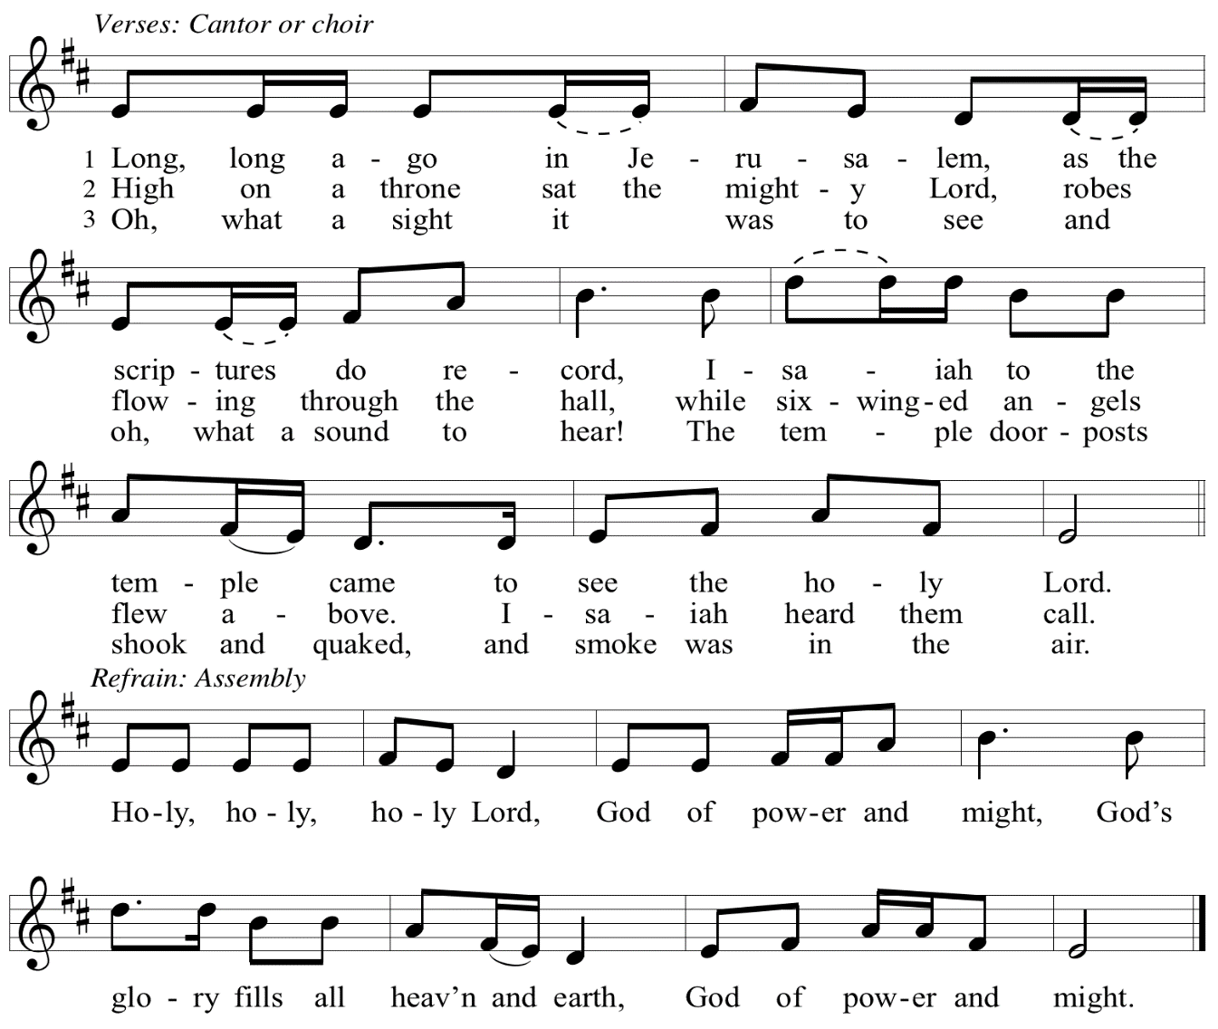

Eucharistic Prayer

P: You are indeed holy, God of power and might
and your glory fills the whole earth …
… and nurture us to become what you have made us –
your beloved people, the body of your Son, the temple of your Spirit.

Through your Son, in your Spirit, with all your people,
we give you thanks and praise,
O source of our life and fountain of all good,
now and forever.
C: Amen.

Lord’s Prayer

P: Gathered as one by the Holy Spirit, let us pray as Jesus taught us.
C: Our Father in heaven,
hallowed be your name,
your kingdom come,
your will be done,
on earth as in heaven.
Give us today our daily bread.
Forgive us our sins
as we forgive those
who sin against us.
Save us from the time of trial
and deliver us from evil.
For the kingdom, the power,
and the glory are yours,
now and forever. Amen.

Fraction and Invitation

P: Just as this broken bread was first scattered on the hills,
then was brought together and became one,
so let your church be brought together
from the ends of the earth into your reign,
for yours are the glory and the power
through Jesus Christ forever.
C: Amen.

Agnus Dei / Lamb of God OLS 7
O Lamb of God, to Earth You Came

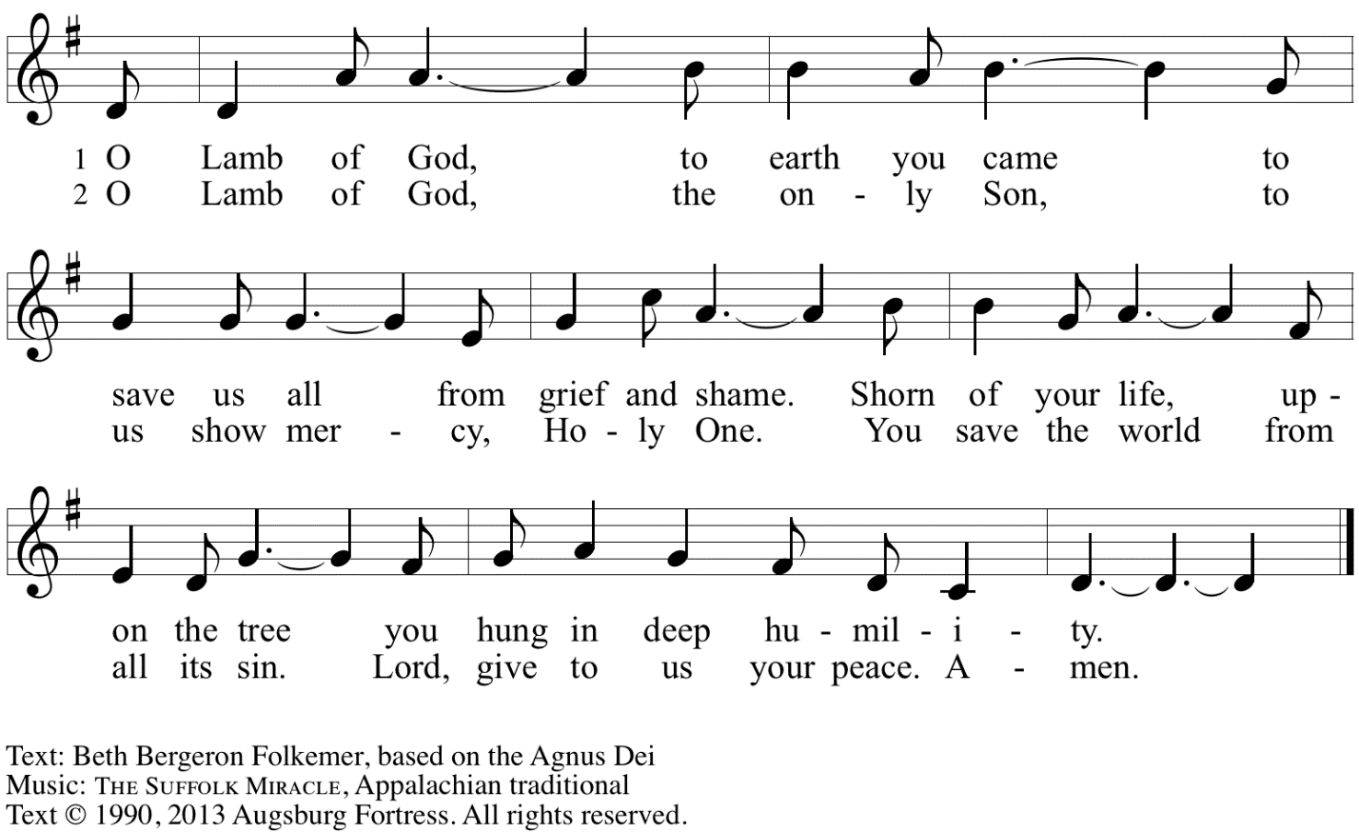
Reprinted with permission under OneLicense.net A# A-722139.

Please be seated.

Holy Communion
- All who seek God and desire a deeper and stronger life in Christ are welcome to receive Holy Communion.
- Worshipers from the pulpit side will proceed forward first, followed by the center section, and then the lectern side.
- Please inform an usher if you would like the ministers to bring Communion to you.
- Holy Communion will be served with bread and wine/grape juice.
- The presiding minister will first distribute the bread (host) to each communicant. Please indicate if you require a gluten-free host.
- Once you have consumed the bread, please pick up an empty glass from the tray next to the presiding minister. The Communion Assistant will pour wine from the chalice or grape juice from the cruet into your glass.
- Please step to the side to consume the wine or grape juice.
- Feel free to kneel at the altar rail for prayer after receiving the sacrament.
- As you return to your pew, glasses may be returned to the empty trays on either side of the center section.
- A blessing will be provided for anyone who does not yet receive the sacrament.
- All are invited to join in singing the hymns during Holy Communion.

Hymns during Holy Communion
We Praise You for the Life That Stirs OLS 9

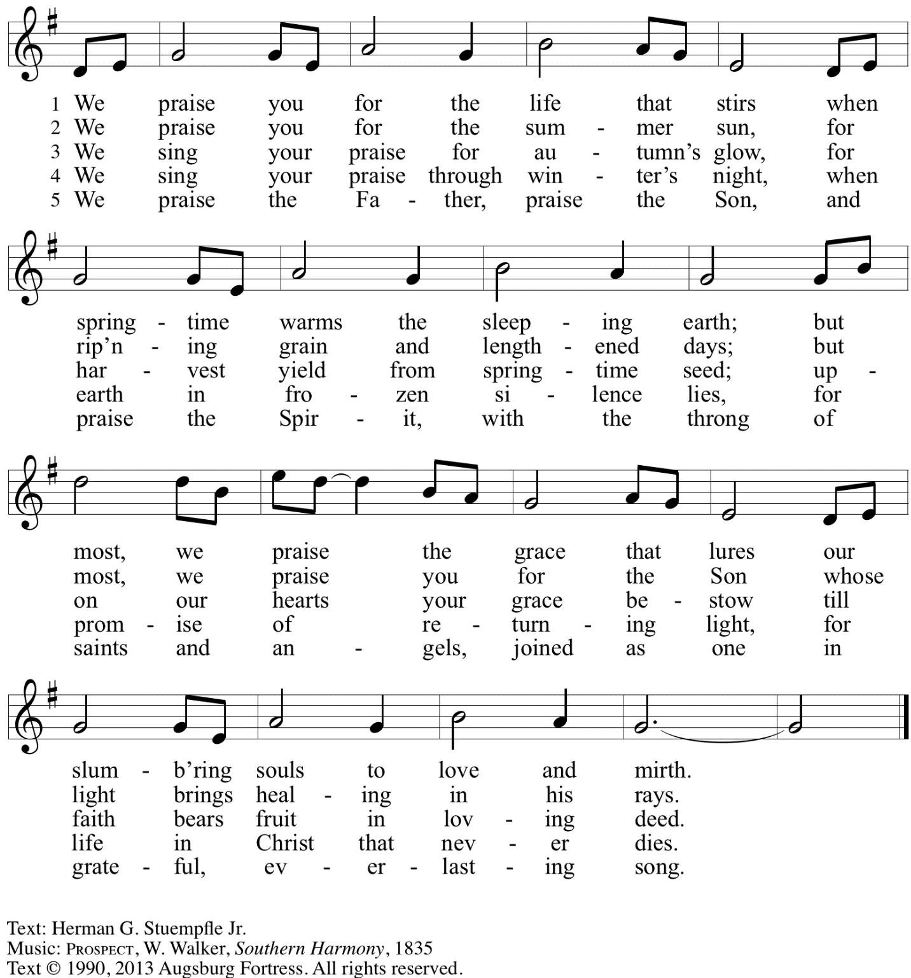
Reprinted with permission under OneLicense.net # A-722139.

Hymns during Holy Communion
Strengthen for Service, Lord ELW 497

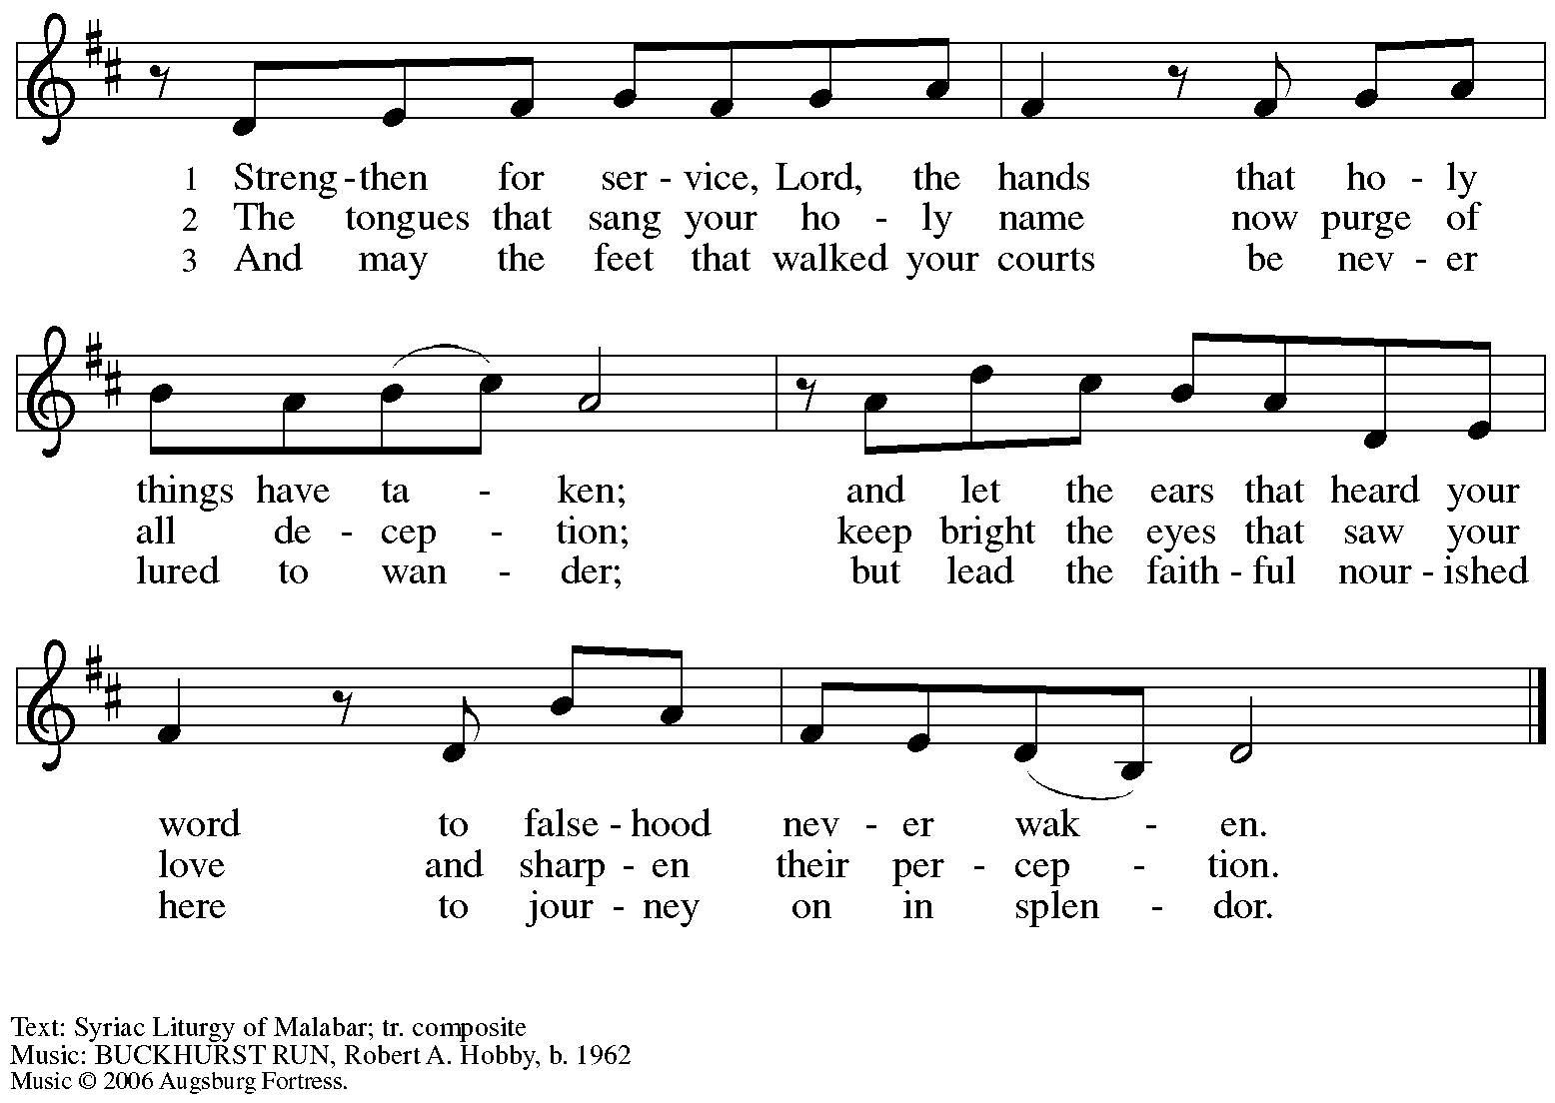
All rights reserved. Reprinted with permission under OneLicense.net # A-722139.

Hymns during Holy Communion
By Your Hand You Feed Your People ELW 469

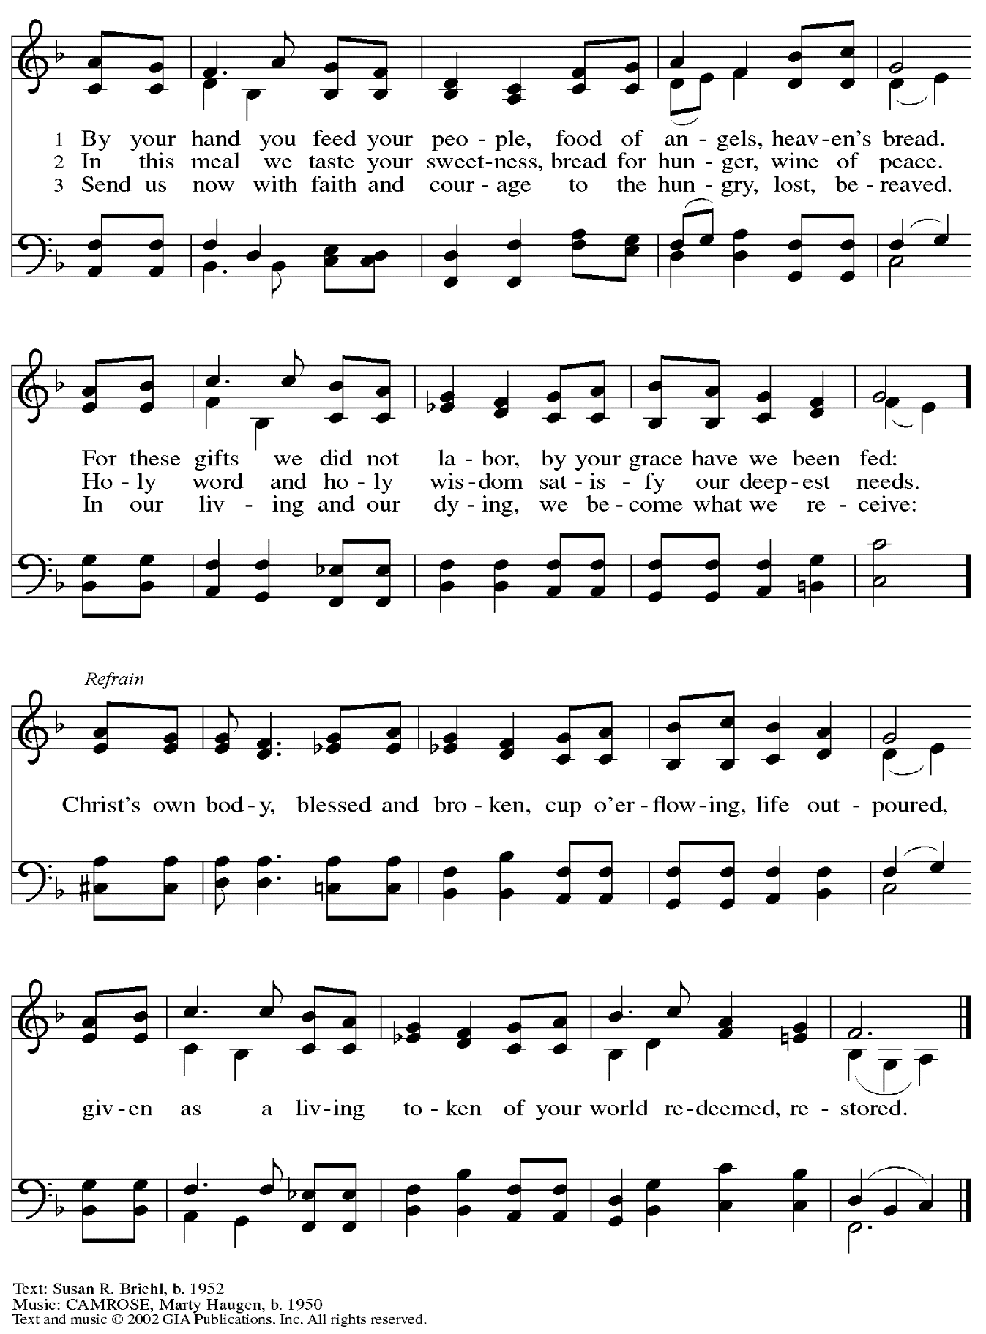
Reprinted with permission under OneLicense.net # A-722139.

When all have returned to their places, please rise as you are able.

Blessing

P: The body and blood of our Lord Jesus Christ strengthen you and keep you in his grace.
C: Amen.

Prayer

A: Let us pray. Gracious God,
we give you thanks for your pruning, planting, and nurture.
We rejoice that you have used the harvest of field and vineyard
to renew and sustain us.
Lead us as we go from this life-giving meal
into lives of grateful service to you and your cherished creation;
through Jesus Christ, your Son, our Lord.
C: Amen.

Please be seated.

Sending
God blesses us and sends us in mission to the world

Announcements

Please rise as you are able.

Benediction

P: The God of steadfastness and encouragement
grant you to live in harmony with one another,
in accordance with Christ Jesus.
C: Amen.

P: The God of hope fill you with all joy and peace in believing,
so that you may abound in hope by the power of the Holy Spirit.
C: Amen.

P: The God of all grace ☩ bless you now and forever.
C: Amen.

Sending Hymn Hallelujah! We Sing Your Praises ELW 535

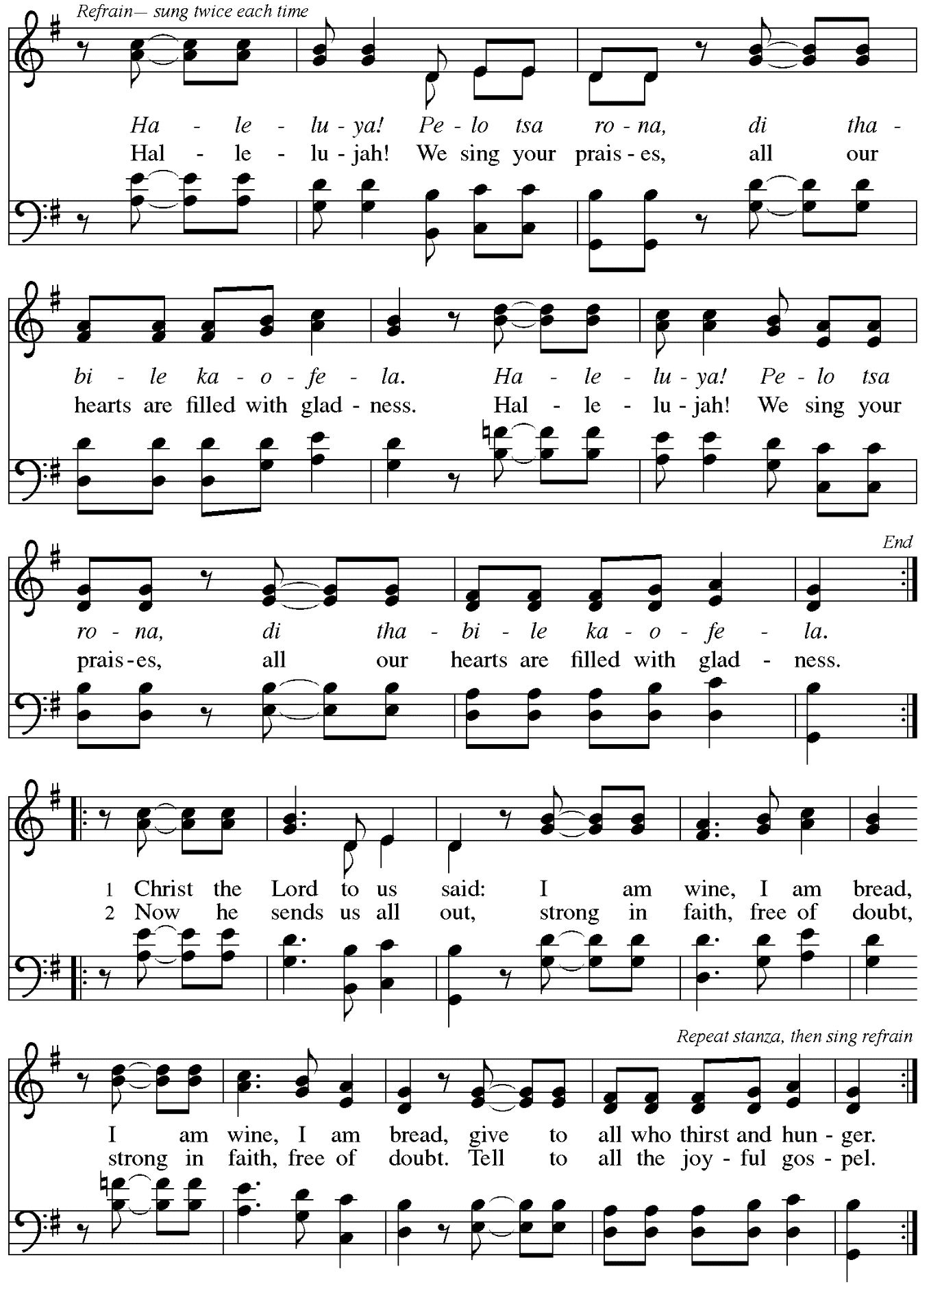

Dismissal

A: Go in peace. Serve the Lord.
C: Thanks be to God!

Postlude

Those serving in worship today

Altar Care Beverley Chapman
Assisting Minister Tim Marker
Audio-Visual Ministers Noël Marsh
Kristen Asplin
Cantor Libby Marker
Lector David Rollinson
Minister of Music Laura Reynolds
Presiding Minister Pastor Ross Carmichael

Liturgy and Hymnody Acknowledgements

From SundaysandSeasons.com. Copyright © 2023 Augsburg Fortress. All rights reserved. Reprinted under OneLicense.net # A-722139.
Used by permission of Augsburg Fortress.

Holy, Holy, Holy / Long, Long Ago in Jerusalem – Text: Beth Bergeron Folkemer, based on the Sanctus. Music: SHADY GROVE, Appalachian traditional. Text © 1990, 2013, Augsburg Fortress. All rights reserved. Reprinted with permission under OneLicense.net # A-722139.

Hallelujah! We Sing Your Praises – Text: South African; tr. Freedom Is Coming, 1984. Music: HALELUYA! PELO TSA RONA, South African; arr. Freedom Is Coming. English text and arr. © 1984 Utryck, admin. Walton Music Corp. All rights reserved. Reprinted with permission under OneLicense.net # A-722139.

Please use this QR code to link to online announcements!

St. Andrew Lutheran Church Announcements
June 18th, 2023

- Welcome to worship at St. Andrew on the Third Sunday after Pentecost, June 18th, 2023 – We are so glad you are here, and we offer a special welcome to all visitors and guests connecting for the first time! Worship attendees are invited to make a name tag at the back of the worship space if you would like. There are worship “toolkits” to help children engage with worship and “busy bags” for younger children available in the bookcase at the back of the sanctuary. Please feel free to take one to use with/for your children.
- Commemoration of the Martyrdom of the Emanuel Nine – June 17th, Observed in Worship Today – On June 17th, 2015, nine saints of God were shot and killed during their Bible study at Mother Emanuel African Methodist Episcopal Church in Charleston, SC. Two of the pastors at Mother Emanuel were graduates of Lutheran Theological Southern Seminary of our Evangelical Lutheran Church in America (ELCA), and the shooter had been confirmed in one of our denomination’s congregations. As the ELCA web site states, “Our relationship to the shooter, as well as two of the slain, reminds us both of our complicity and our calling. Together we confess that we are in bondage to the sins of racism and white supremacy,” and we pray that God would continue to lead us in ways of repentance and renewal. Today St. Andrew joins the whole church in confession and repentance, honoring the memory of the martyrs of the Emanuel Nine, and naming our renewed dedication to racial justice and reconciliation among all God’s beloved people. We pray that the church may more fully live out the promise we proclaim, that Jesus Christ “has broken down the dividing wall, the hostility that is between us.” (Ephesians 2: 15)
- Information and Listening Session Today after Worship – We invite everyone to stay after worship today for an initial informational and listening session regarding a ministry opportunity with which the congregation has been presented, as outlined in the recent letter to the congregation.
- Christ in Our Home Devotional Booklets for July – September Now Available at Church Entrances – Throughout the year, St. Andrew makes available to the congregation Christ in Our Home, a booklet with daily Bible readings, reflections, and prayers. The next edition, for July – September 2023, is now available at the church entrances. Please take one to enhance your spiritual practice!
- St. Andrew to Participate in Millvale Pride Event on Saturday, June 24th – June is Pride Month, and St. Andrew has traditionally taken part in Pride events in conjunction with other Reconciling in Christ congregations, staffing a booth at which we have shared conversation, resources, and information about the churches and our mission to share God's love with all our LGBTQIA+ siblings. St. Andrew will have a table at Millvale Pride on Saturday, June 24th. The event is from 12:00 p.m. to 8:00 p.m. No one stays the whole time (unless you want to!), but we usually invite people from the congregation to represent St. Andrew for stretches of 1-2 hours. More information about Millvale Pride can be found here: https://www.pridemillvale.org/. If you can be available and are willing to represent St. Andrew at the booth, please sign up at https://forms.gle/QHfFXPrMeGxGciye9.
- St. Andrew Updating Information - Please Respond! – St. Andrew is looking to update our records with information from newer attendees, as well as offering current members the opportunity to include current information. This includes name, preferred pronouns, email, phone number, birthdays, anniversaries, and more. The information will only be used within the congregation - for example to acknowledge celebrations and milestones in worship, in the prayers of the church, or in the weekly or monthly newsletter. Please fill out the form at: https://forms.gle/fTwpdG2uA7pYD2ta8.

Emanuel Nine, martyrs, 2015

On June 17, 2015, Clementa C. Pinckney, Cynthia Marie Graham Hurd, Susie Jackson, Ethel Lee Lance, DePayne Middleton-Doctor, Tywanza Sanders, Daniel Lee Simmons, Sharonda Coleman-Singleton, and Myra Thompson were murdered by a self-professed white supremacist while they were gathered for Bible study and prayer at the Emanuel African Methodist Episcopal Church (often referred to as Mother Emanuel) in Charleston, South Carolina. Pastors Pinckney and Simmons were both graduates of the Lutheran Theological Southern Seminary. A resolution to commemorate June 17 as a day of repentance for the martyrdom of the Emanuel Nine was adopted by the Churchwide Assembly of the Evangelical Lutheran Church in America on August 8, 2019. Congregations of the ELCA are encouraged reaffirm their commitment to repenting of the sins of racism and white supremacy which continue to plague this church, to venerate the martyrdom of the Emanuel Nine, and to mark this day of penitence with study and prayer.

