+ Fourth Sunday after Pentecost
June 25, 2023
St. Andrew Lutheran Church
304 Morewood Ave.
Pittsburgh, PA 15213
St_andrewELCA@verizon.net
www.standrewpittsburgh.org

+ Fourth Sunday after Pentecost
Order for Worship

God does not promise that the path of a disciple will be easy. Jeremiah feels the pain of rejection from those who do not want to hear what he has to say. Jesus declares that his words may bring stark division. Even so, we need not be afraid, for God accounts for each hair on our heads (Matthew 10: 30). Though we may experience rejection, frustration, division, and death, God’s grace and love make us a new creation each day. Marked with the cross of Christ and filled with holy food, we are sent from worship to witness to the good news of Jesus in the world each day.

Welcome to St. Andrew!

- St. Andrew Lutheran congregation welcomes all who are seeking a place of healing and wholeness – a nurturing, faith-forming spiritual home. Our community embraces people of all ages, ethnicities, cultures, abilities, sexual orientations, gender identities and expressions, and family constellations. Come and See!

- Worship Services are live streamed to multiple online platforms. By attending worship, you agree that your image and voice may be broadcast.

- Everyone is invited to make a nametag at the black bookcase in the back of the worship space if they would like. There are stickers indicating pronouns on the bookcase if you would like to include them on your name tag.

- Worship “toolkits” to help children engage with the service, along with “busy bags” for younger children, are available in the bookcase at the back of the sanctuary. Please feel free to take one to use with/for your children.

- Holy Communion is served with bread (gluten-free available) and wine or grape juice. The presiding minister will distribute the bread (host). Please consume this and then pick up an empty glass from the tray. The Communion Assistant will pour wine or grape juice into your glass. Please step to the side to consume the wine or grape juice. Feel free to kneel at the altar for prayer and reflection. As you return to your pew, glasses may be returned to the empty trays on either side of the center section.

- A restroom is available on the main level of the church, through the doors to the Social Hall and to the right in the main office.

Abbreviations
P: Pastor/Presiding Minister ACS: All Creation Sings hymnal
A: Assisting Minister ELW: Evangelical Lutheran Worship hymnal
L: Lector OLS: Of the Land and Seasons hymnal
C: Congregation

Pre-Service Music

Welcome

Prelude

Gathering
The Holy Spirit calls us together as the people of God

Confession and Forgiveness

Please rise as you are able.
All may make the sign of the cross, the sign that is marked at Baptism,
as the presiding minister begins.

P: Blessed be the holy Trinity, ☩ one God,
who forgives all our sin, whose mercy endures forever.
C: Amen.

P: Let us confess our sin in the presence of God and of one another.

Silence is kept for reflection

P: Most merciful God,
C: we confess that we are captive to sin and cannot free ourselves.
We have sinned against you in thought, word, and deed,
by what we have done and by what we have left undone.
We have rejected your guidance. We have avoided your pruning of our cluttered lives.
We have failed to maintain the tools of stewardship, outreach, and witness
you have provided for the nurture of your church.
For the sake of your Son, Jesus Christ, have mercy on us.
Forgive us, grant us discipline, and redirect us,
so that we may delight in your will and follow in your ways,
to the glory of your holy name.
Amen.

P: God, who is rich in mercy,
loved us even when we were dead in sin
and made us alive together with Christ.
By grace you have been saved.
In the name of ☩ Jesus Christ, your sins are forgiven.
Almighty God strengthen you with the Holy Spirit,
that Christ may live in your hearts through faith.
C: Amen.

Gathering Hymn We Are Baptized in Christ Jesus ELW 451

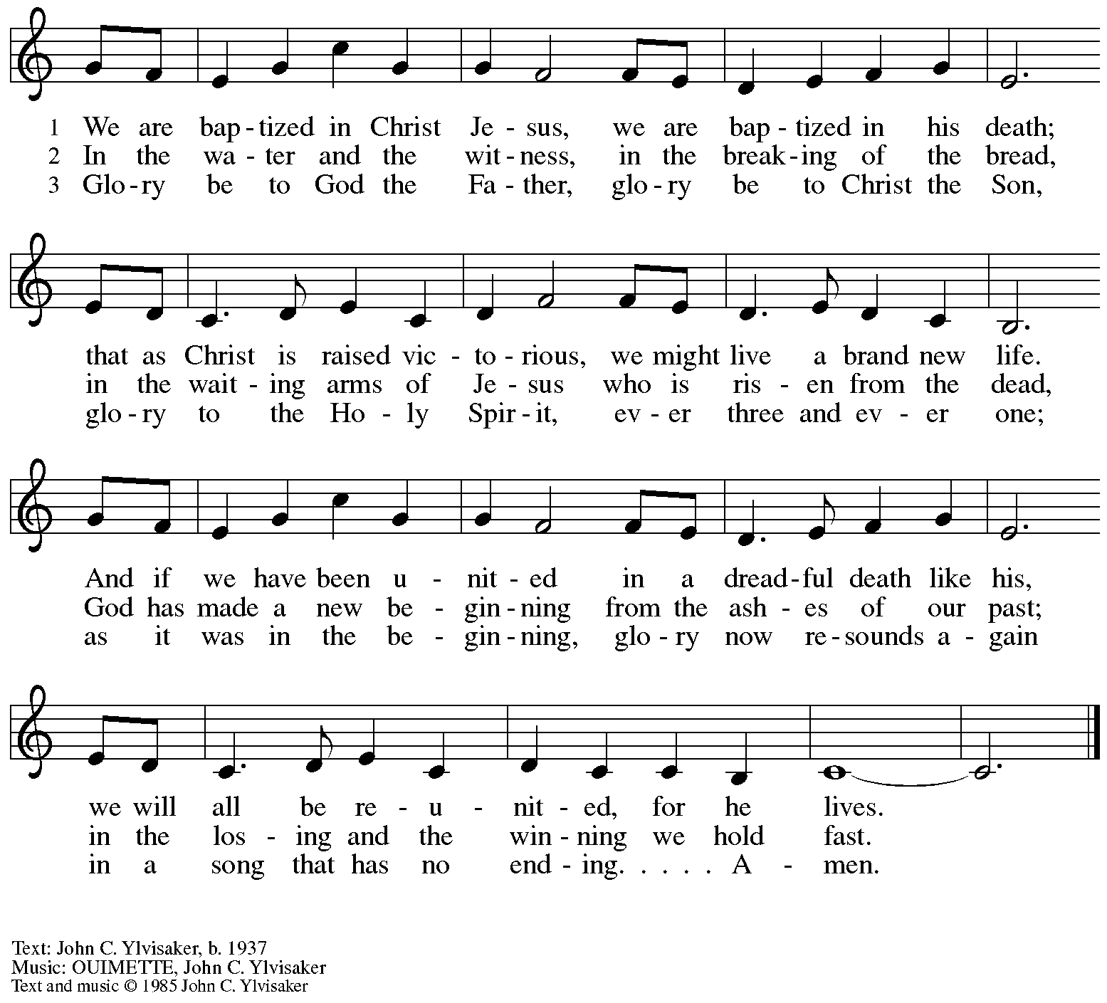
All rights reserved. Reprinted with permission under OneLicense.net #A-722139.

Greeting

P: The grace of our Lord Jesus Christ, the love of God,
and the communion of the Holy Spirit be with you all.
C: And also with you.

Hymn of Praise Oh, Sing of God’s Great Victory! OLS 3

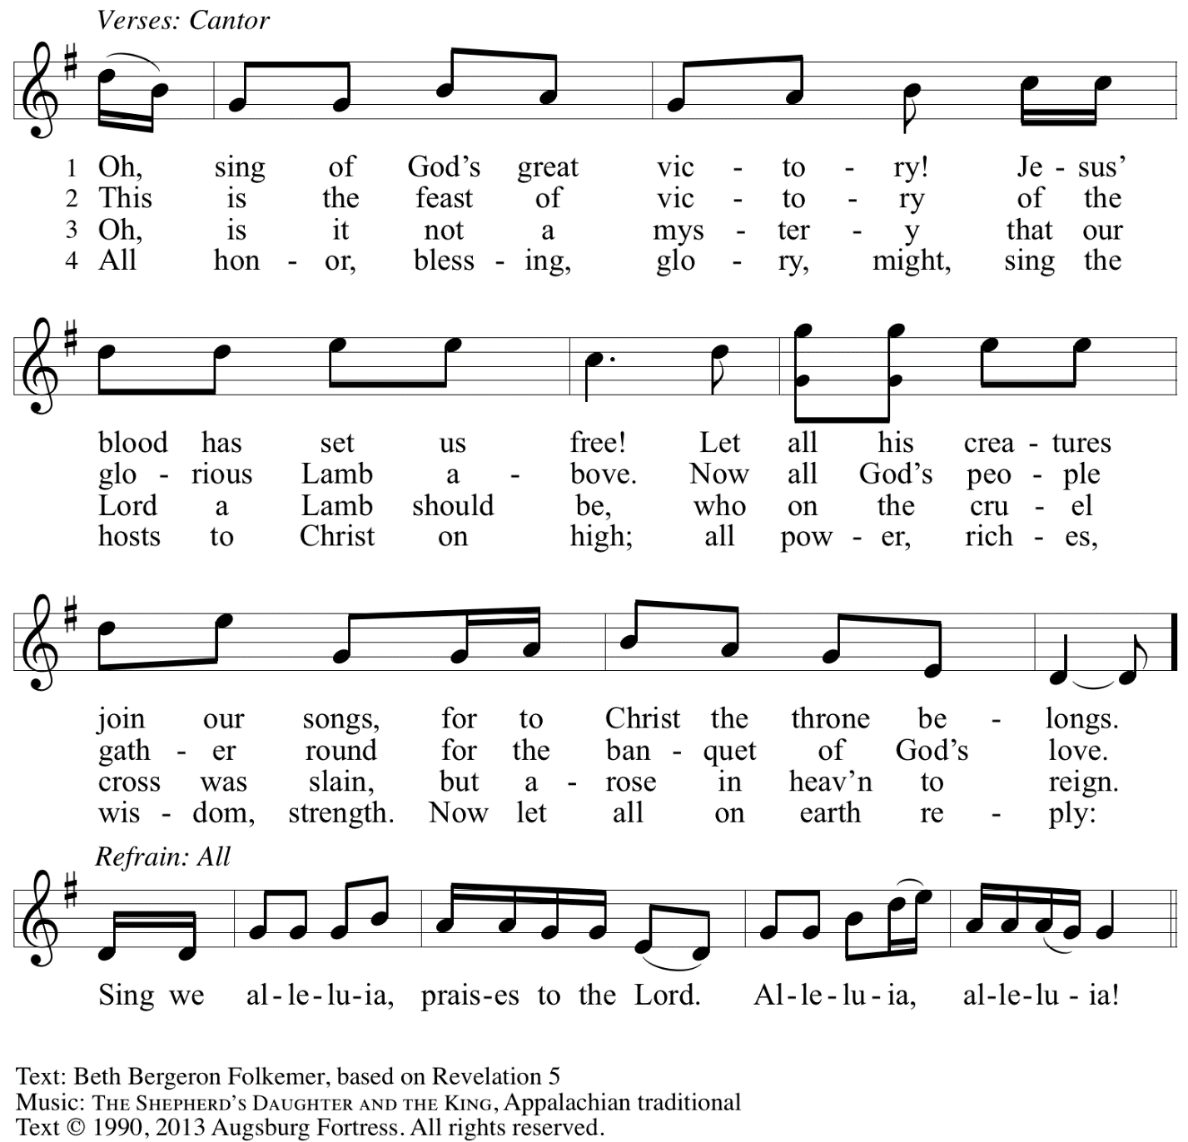
Reprinted with permission under OneLicense.net # A-722139.

Prayer of the Day

P: The Lord be with you.
C: And also with you.

P: Let us pray.
Teach us, good Lord God, to serve you as you deserve, to give and not to count the cost,
to struggle and not to heed the wounds, to toil and not to seek for rest,
to labor and not to ask for reward, except that of knowing that we do your will,
through Jesus Christ, our Savior and Lord.
C: Amen.

Please be seated.

Word
God speaks to us in Scripture reading, preaching, and song

First Reading – Jeremiah 20: 7-13

⁷O Lord, you have enticed me,
and I was enticed;
you have overpowered me,
and you have prevailed.
I have become a laughingstock all day long;
everyone mocks me.
⁸For whenever I speak, I must cry out,
I must shout, “Violence and destruction!”
For the word of the Lord has become for me
a reproach and derision all day long.
⁹If I say, “I will not mention the Lord,
or speak any more in God’s name,”
then within me there is something like a burning fire
shut up in my bones;
I am weary with holding it in,
and I cannot.
¹⁰For I hear many whispering:
“Terror is all around!
Denounce him! Let us denounce him!”
All my close friends
are watching for me to stumble.
“Perhaps he can be enticed,
and we can prevail against him,
and take our revenge on him.”
¹¹But the Lord is with me like a dread warrior;
therefore my persecutors will stumble,
and they will not prevail.
They will be greatly shamed,
for they will not succeed.
Their eternal dishonor
will never be forgotten.
¹²O Lord of hosts, you test the righteous,
you see the heart and the mind;
let me see your retribution upon them,
for to you I have committed my cause.

¹³Sing to the Lord;
praise the Lord!
For the Lord has delivered the life of the needy
from the hands of evildoers.

L: Word of God, word of life.
C: Thanks be to God.

Psalm 69: 7-10 [11-15] 16-18

The psalm will be sung by the cantor,
with the congregation invited to join in singing the refrain.

Psalm refrain

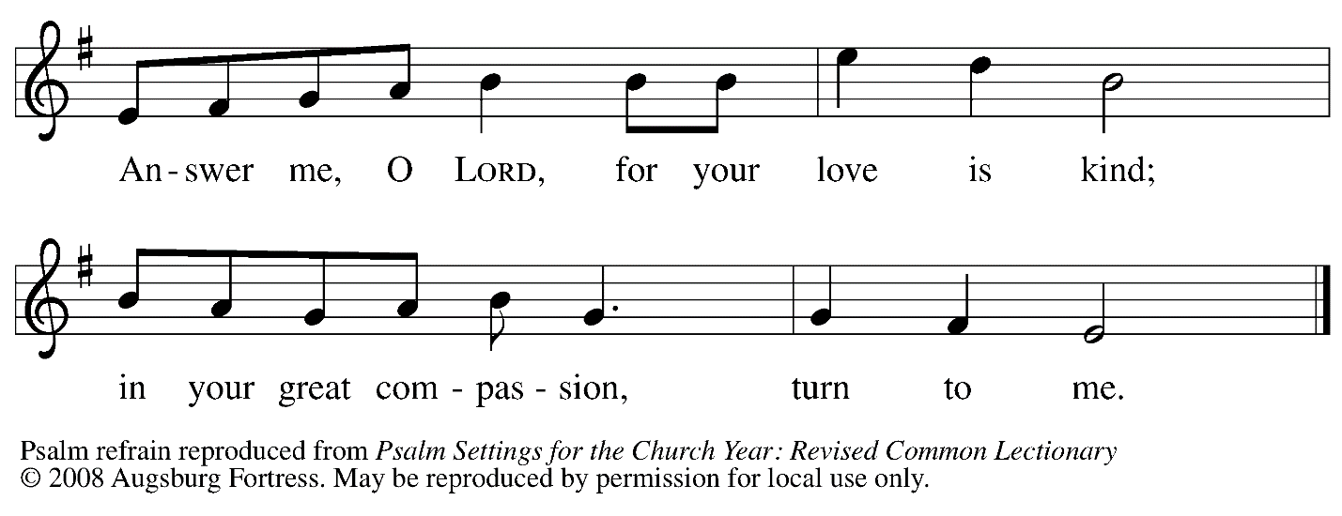

⁷Surely, for your sake I have suf- | fered reproach,
and shame has cov- | ered my face.
⁸I have become a stranger to | my own kindred,
an alien to my | mother’s children.
⁹Zeal for your house has eat- | en me up;
the scorn of those who scorn you has fall- | en upon me.
¹⁰I humbled my- | self with fasting,
but that was turned to | my reproach. R

Psalm refrain

[ ¹¹I put on | sackcloth also,
and became a by- | word among them.
¹²Those who sit at the gate mur- | mur against me,
and the drunkards make | songs about me.
¹³But as for me, this is my prayer to you, at the time you have | set, O Lord:
“In your great mercy, O God, answer me with your un- | failing help.
¹⁴Save me from the mire; do not | let me sink;
let me be rescued from those who hate me and out of | the deep waters.
¹⁵Let not the torrent of waters wash over me, neither let the deep swal- | low me up;
do not let the pit shut its | mouth upon me. R
] ¹⁶Answer me, O Lord, for your | love is kind;
in your great compassion, | turn to me.
¹⁷Hide not your face | from your servant;
be swift and answer me, for I am | in distress.
¹⁸Draw near to me | and redeem me;
because of my enemies de- | liver me. R

Second Reading – Romans 6: 1b-11

^{1b}Should we continue in sin in order that grace may abound? ²By no means! How can we who died to sin go on living in it? ³Do you not know that all of us who have been baptized into Christ Jesus were baptized into his death? ⁴Therefore we have been buried with him by baptism into death, so that, just as Christ was raised from the dead by the glory of the Father, so we too might walk in newness of life.
⁵For if we have been united with him in a death like his, we will certainly be united with him in a resurrection like his. ⁶We know that our old self was crucified with him so that the body of sin might be destroyed, and we might no longer be enslaved to sin. ⁷For whoever has died is freed from sin. ⁸But if we have died with Christ, we believe that we will also live with him. ⁹We know that Christ, being raised from the dead, will never die again; death no longer has dominion over him. ¹⁰The death he died, he died to sin, once for all; but the life he lives, he lives to God. ¹¹So you also must consider yourselves dead to sin and alive to God in Christ Jesus.

L: Word of God, word of life.
C: Thanks be to God.

Please rise as you are able.

Gospel Acclamation O God, Whose Word Well-Planted OLS 4
v. 1-2

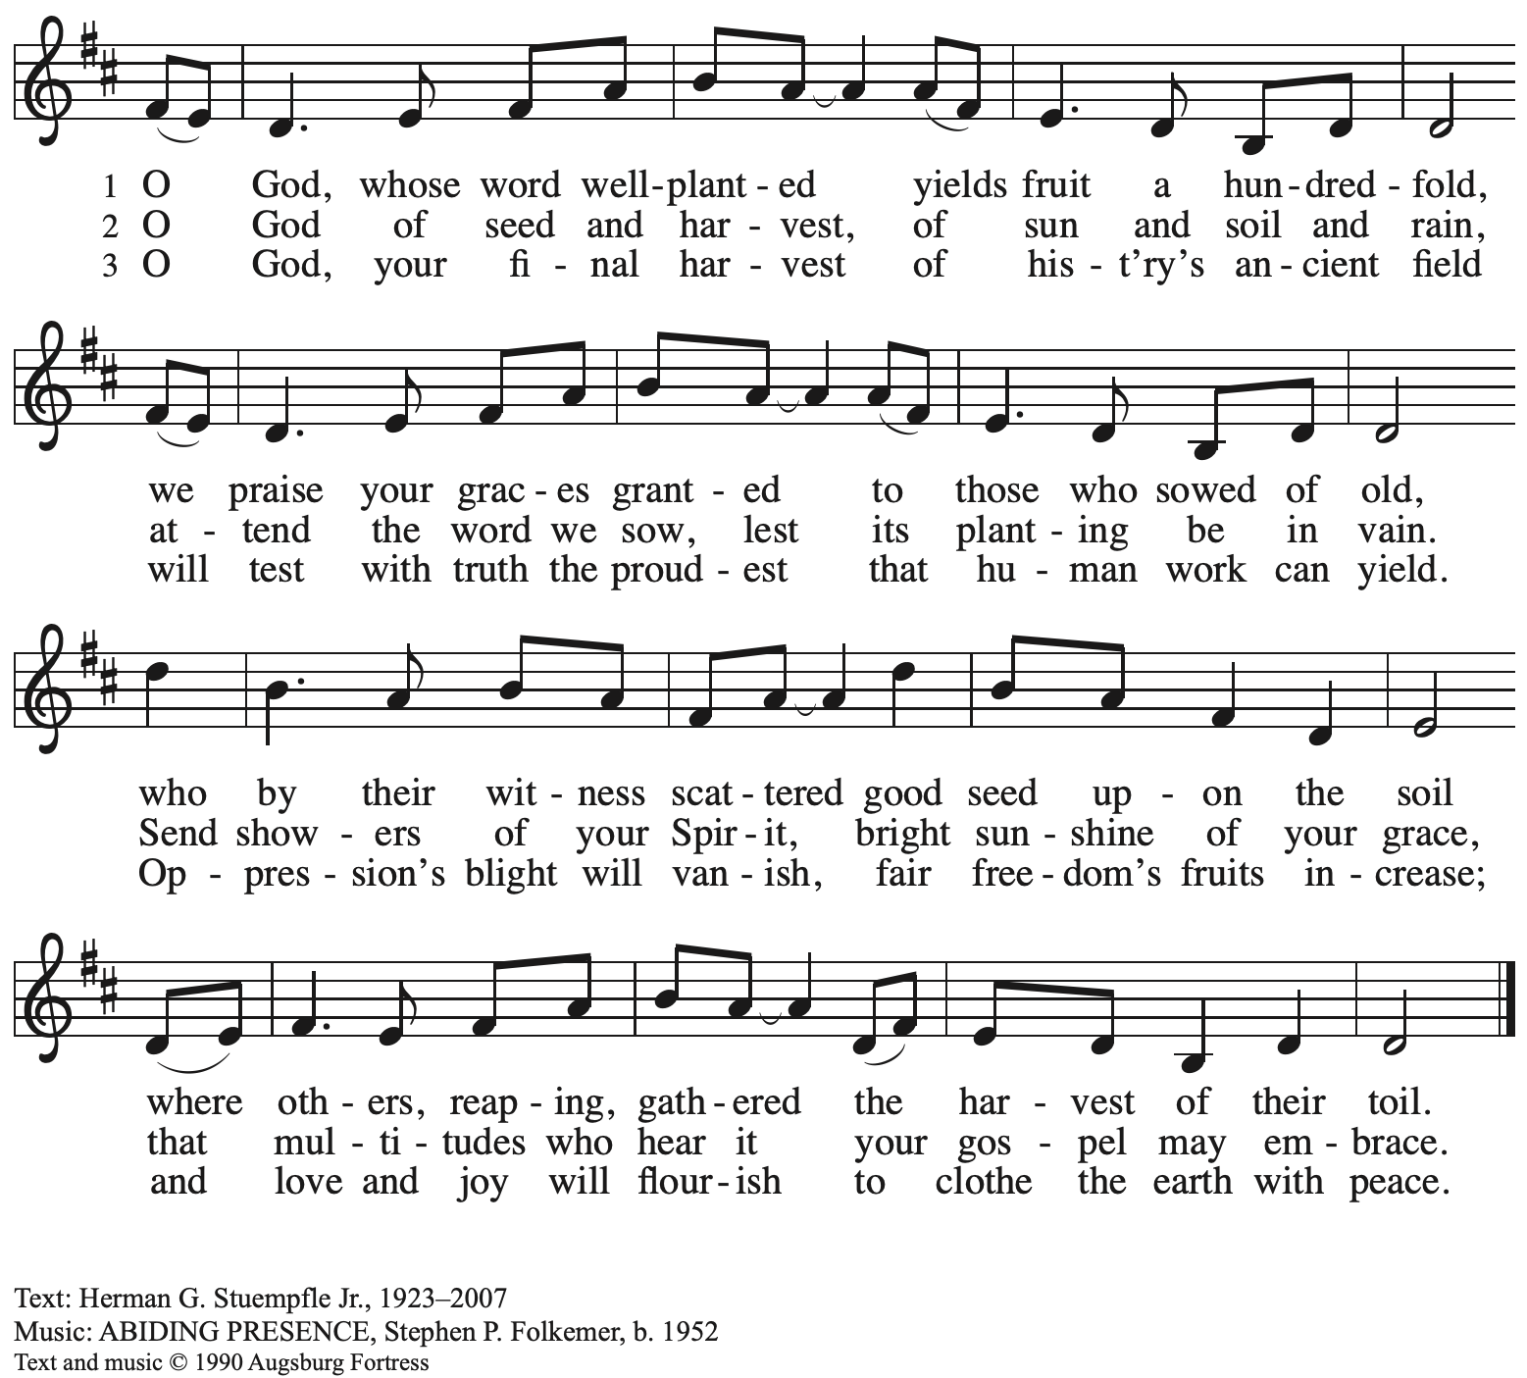
All rights reserved. Reprinted under OneLicense.net # A-722139.

Gospel – Matthew 10: 24-39

P: The holy Gospel according to St. Matthew.
C: Glory to you, O Lord.

[Jesus said to the twelve:] ²⁴“A disciple is not above the teacher, nor a slave above the master; ²⁵it is enough for the disciple to be like the teacher, and the slave like the master. If they have called the master of the house Beelzebul, how much more will they malign those of his household!
²⁶“So have no fear of them; for nothing is covered up that will not be uncovered, and nothing secret that will not become known. ²⁷What I say to you in the dark, tell in the light; and what you hear whispered, proclaim from the housetops. ²⁸Do not fear those who kill the body but cannot kill the soul; rather fear the one who can destroy both soul and body in hell. ²⁹Are not two sparrows sold for a penny? Yet not one of them will fall to the ground apart from your Father. ³⁰And even the hairs of your head are all counted. ³¹So do not be afraid; you are of more value than many sparrows.
³²“Everyone therefore who acknowledges me before others, I also will acknowledge before my Father in heaven; ³³but whoever denies me before others, I also will deny before my Father in heaven.
³⁴“Do not think that I have come to bring peace to the earth; I have not come to bring peace, but a sword.
³⁵For I have come to set a man against his father,
and a daughter against her mother,
and a daughter-in-law against her mother-in-law;
³⁶and one’s foes will be members of one’s own household.
³⁷Whoever loves father or mother more than me is not worthy of me; and whoever loves son or daughter more than me is not worthy of me; ³⁸and whoever does not take up the cross and follow me is not worthy of me. ³⁹Those who find their life will lose it, and those who lose their life for my sake will find it.”

P: The Gospel of the Lord.
C: Praise to you, O Christ.

Please be seated.

Sermon

A time of silence for prayer and reflection follows the sermon.
When the hymn of the day begins, please rise as you are able.

Hymn of the Day Will You Come and Follow Me Following page

Hymn of the Day Will You Come and Follow Me ELW 798

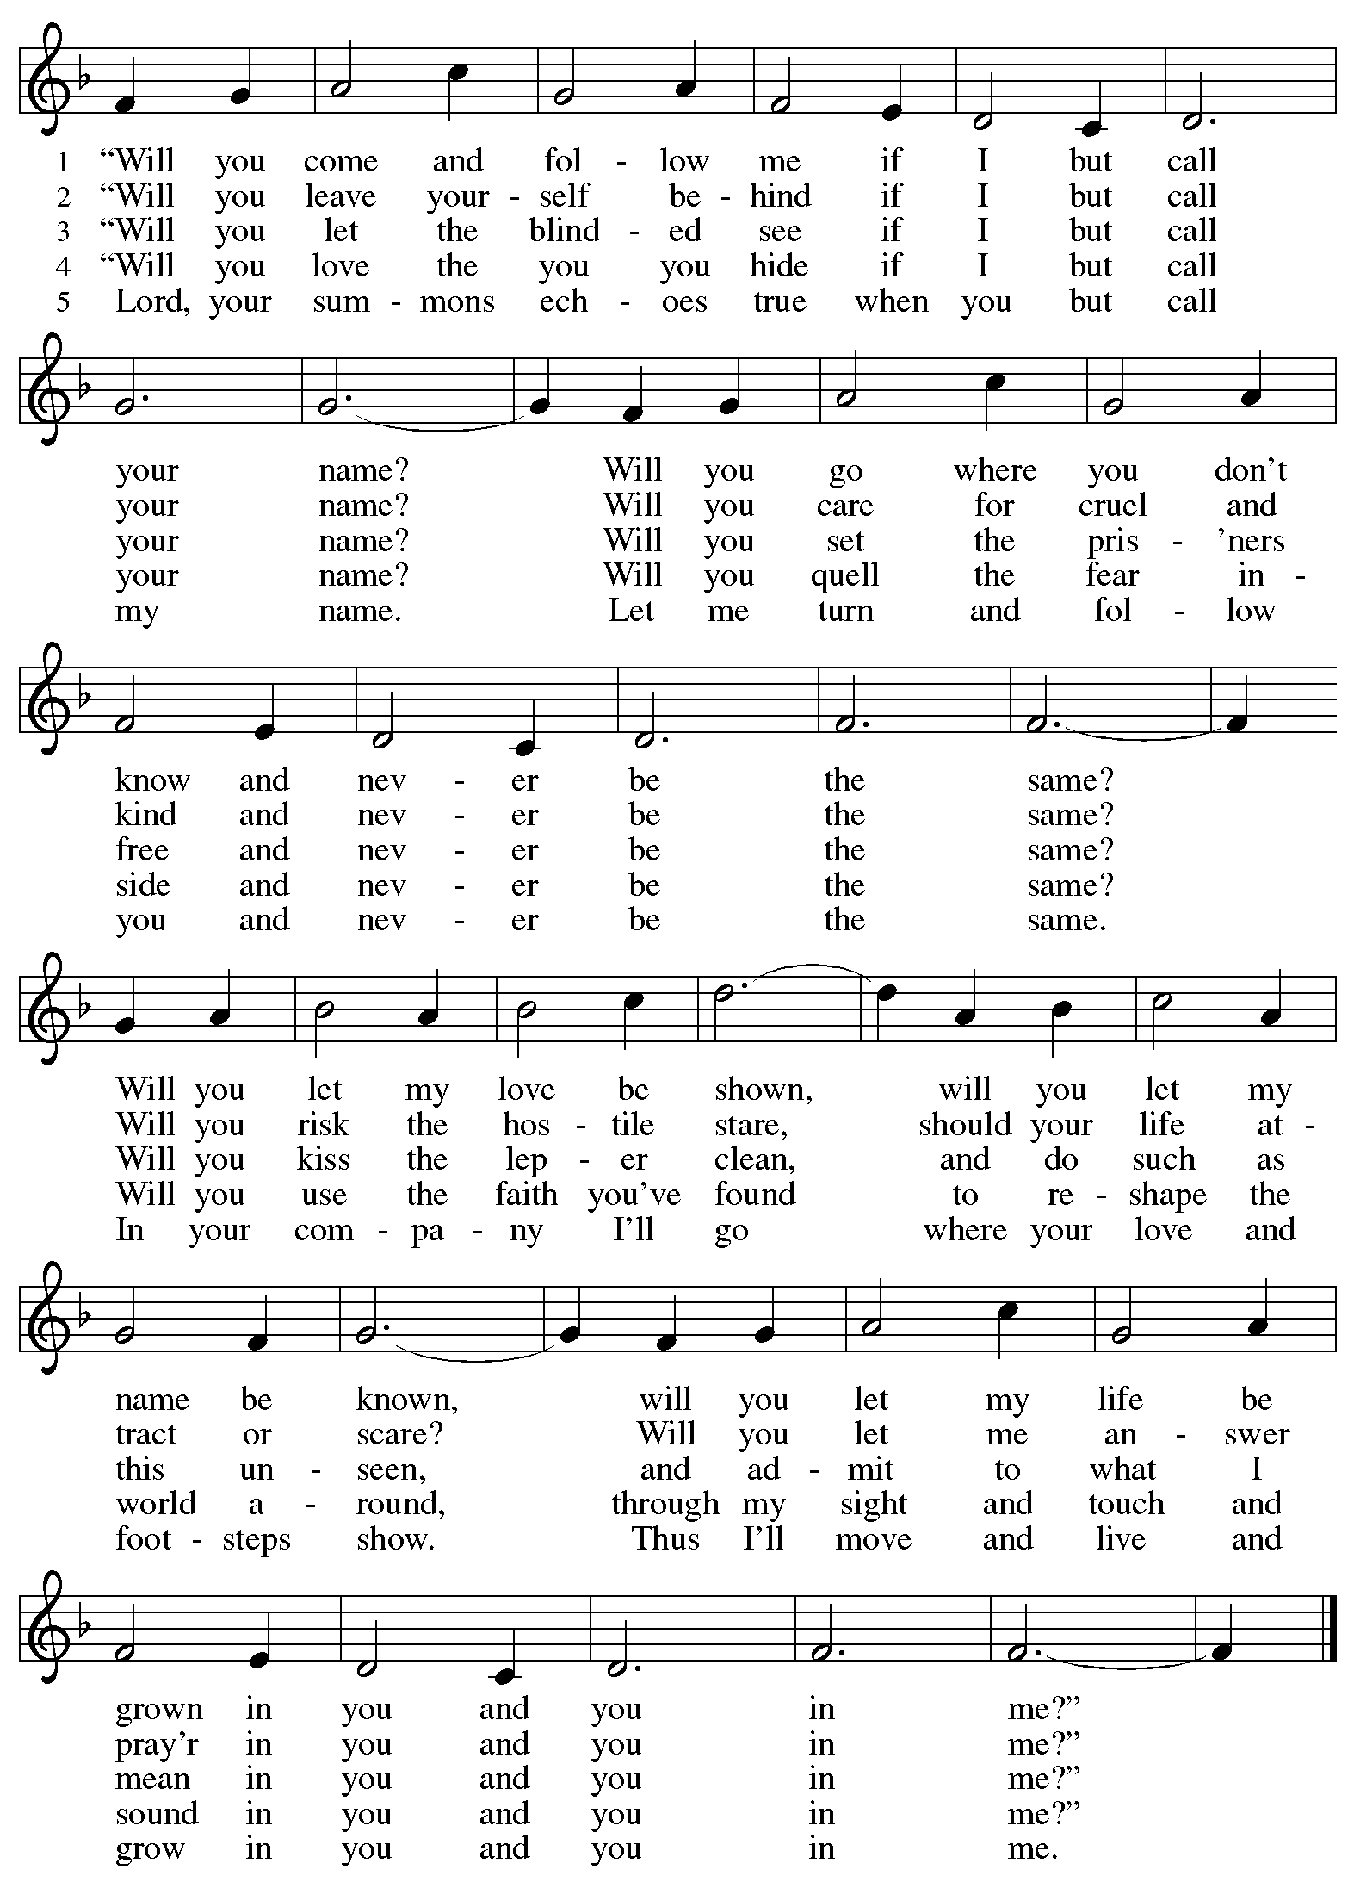

Prayers of the People

A: With the whole people of God in Christ Jesus, let us pray for the church, the world,
those in need, and all of God’s creation.

After each petition
A: God, in your mercy,
C: receive our prayer.

The presiding minister concludes the prayers
P: Into your hands, gracious God, we commend all for whom we pray,
trusting in your abundant mercy, through Jesus Christ our Savior.
C: Amen.

Peace

The presiding minister and the assembly greet one another in the peace of the risen Christ.
P: The peace of Christ be with you always.
C: And also with you.

The people may greet those around them with a sign of Christ’s peace and may say
Peace be with you or similar words. Please be mindful that not everyone will be comfortable with sharing the peace, so please seek consent before shaking hands or hugging. Other possible ways to share the peace include a simple bow with the verbal greeting of peace, or simply a verbal expression of peace.

When the greetings of peace have concluded, please be seated.

Meal
God feeds us with the presence of Jesus Christ

Offering

We offer ourselves, our gifts, and our faithful service to God.
As the offering is gathered for the mission of the church, including the care of those in need,
the table is set for Holy Communion.

Music during the Offering
Lord of All Hopefulness

As the gifts are brought forward for presentation, please rise as you are able.

Offertory Song Accept, O Lord, the Gifts We Bring OLS 5

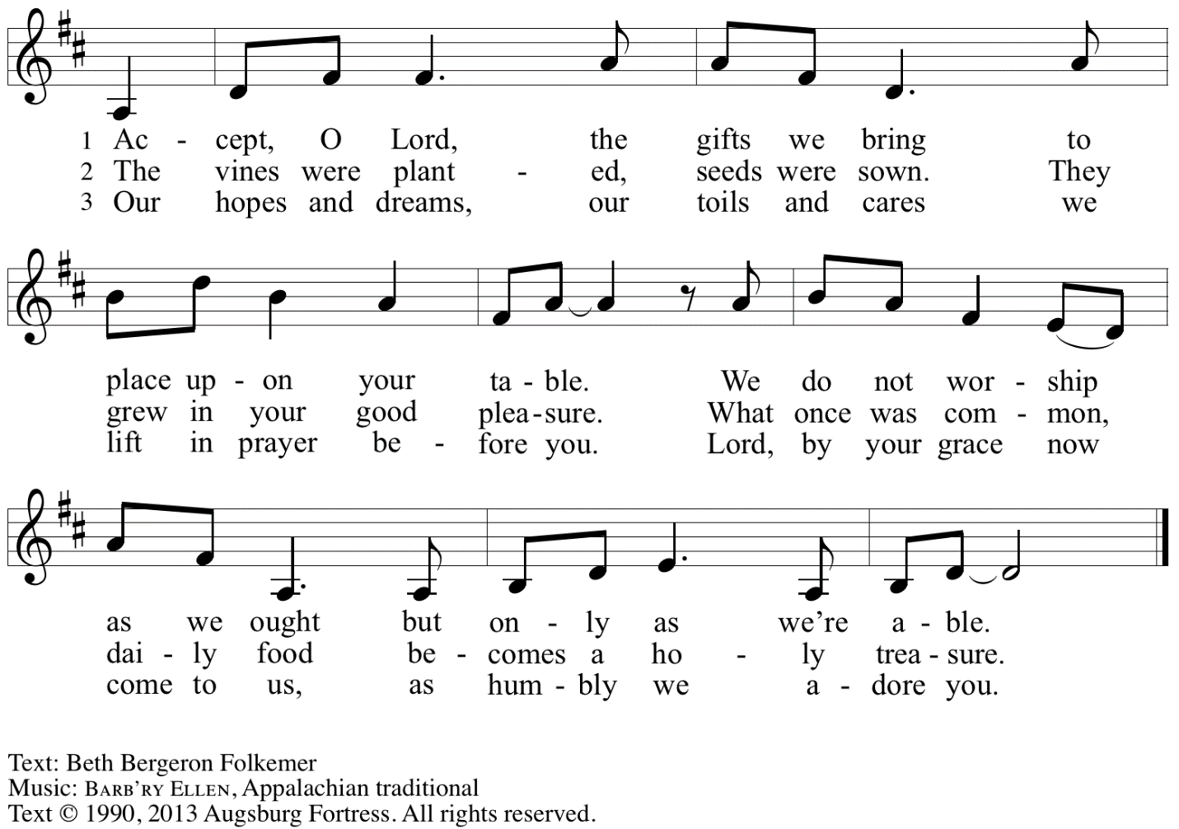
Reprinted under OneLicense.net # A-722139.

Offertory Prayer

A: Let us pray.
Gracious God,
C: you bless us with gifts of guidance, new life,
growth in grace, and fruitful labor.
Accept the first fruits of time and toil, field and orchard,
that we offer here. Bless and multiply these gifts to our nurture
and the care of your creation;
for the sake of your Son, Jesus Christ, our Lord.
Amen.

Dialogue

P: The Lord be with you.
C: And also with you.

P: Lift up your hearts.
C: We lift them to the Lord.

P: Let us give thanks to the Lord our God.
C: It is right to give our thanks and praise.

Preface

P: It is indeed right, our duty and our joy …
… we praise your name and join in adoring song:

Sanctus Holy, Holy, Holy OLS 6

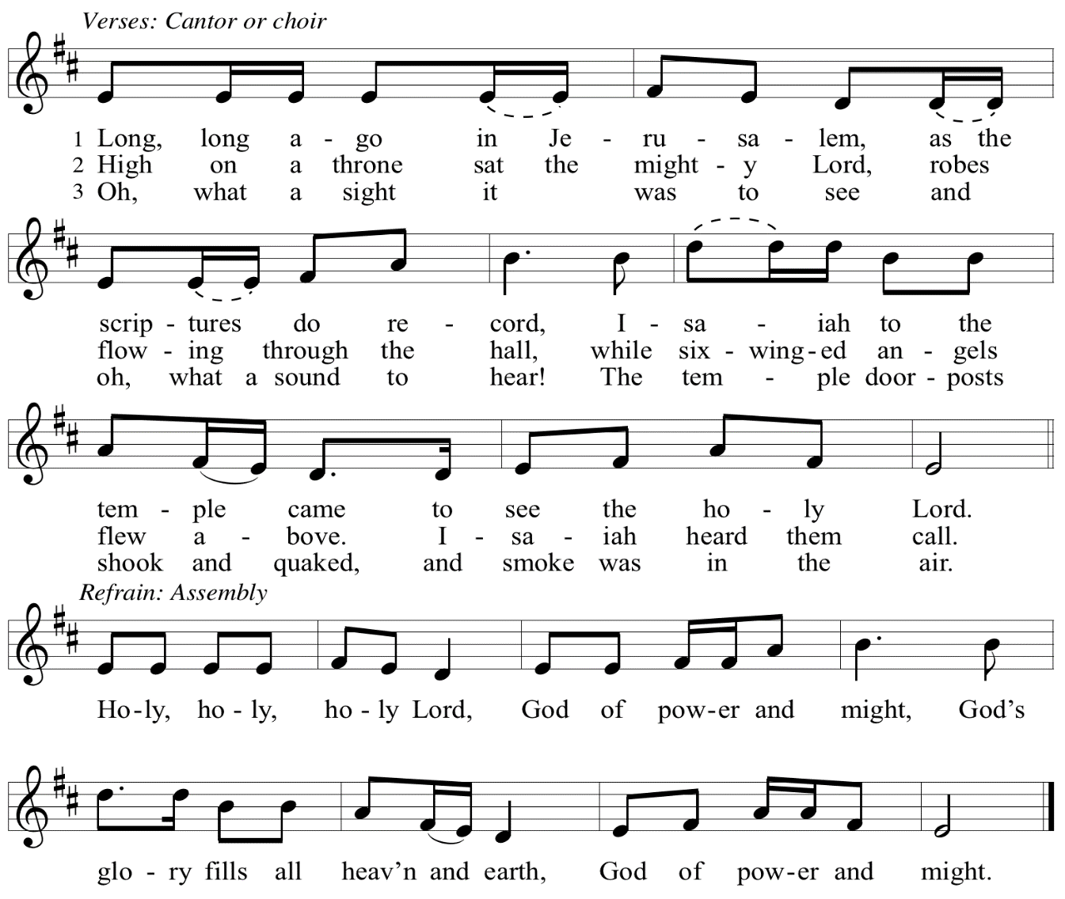
Eucharistic Prayer

P: You are indeed holy, God of power and might
and your glory fills the whole earth …
… and nurture us to become what you have made us –
your beloved people, the body of your Son, the temple of your Spirit.

Through your Son, in your Spirit, with all your people,
we give you thanks and praise,
O source of our life and fountain of all good,
now and forever.
C: Amen.

Lord’s Prayer

P: Gathered as one by the Holy Spirit, let us pray as Jesus taught us.
C: Our Father in heaven,
hallowed be your name,
your kingdom come,
your will be done,
on earth as in heaven.
Give us today our daily bread.
Forgive us our sins
as we forgive those
who sin against us.
Save us from the time of trial
and deliver us from evil.
For the kingdom, the power,
and the glory are yours,
now and forever. Amen.

Fraction and Invitation

P: Just as this broken bread was first scattered on the hills,
then was brought together and became one,
so let your church be brought together
from the ends of the earth into your reign,
for yours are the glory and the power
through Jesus Christ forever.
C: Amen.

Agnus Dei / Lamb of God OLS 7
O Lamb of God, to Earth You Came

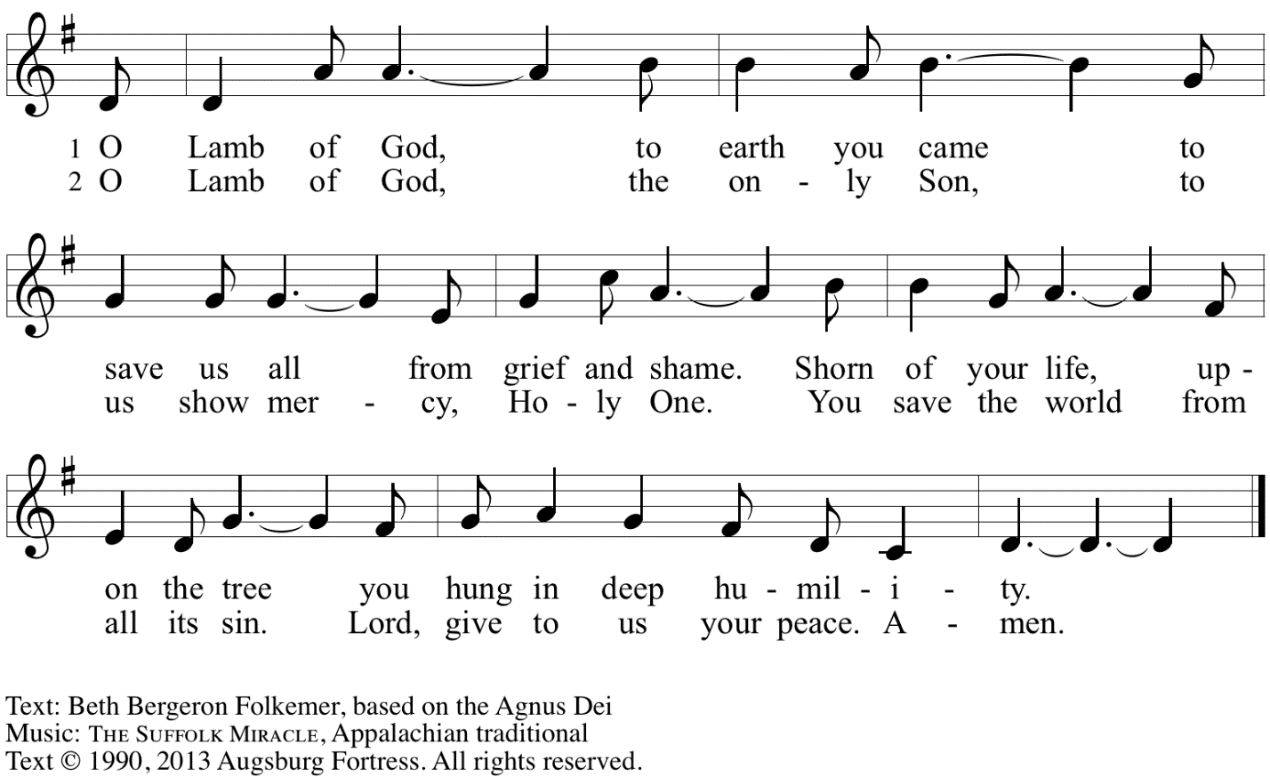
Reprinted with permission under OneLicense.net A# A-722139.

Please be seated.

Holy Communion
- All who seek God and desire a deeper and stronger life in Christ are welcome to receive Holy Communion.
- Worshipers from the pulpit side will proceed forward first, followed by the center section, and then the lectern side.
- Please inform an usher if you would like the ministers to bring Communion to you.
- Holy Communion will be served with bread and wine/grape juice.
- The presiding minister will first distribute the bread (host) to each communicant. Please indicate if you require a gluten-free host.
- Once you have consumed the bread, please pick up an empty glass from the tray next to the presiding minister. The Communion Assistant will pour wine from the chalice or grape juice from the cruet into your glass.
- Please step to the side to consume the wine or grape juice.
- Feel free to kneel at the altar rail for prayer after receiving the sacrament.
- As you return to your pew, glasses may be returned to the empty trays on either side of the center section.
- A blessing will be provided for anyone who does not yet receive the sacrament.
- All are invited to join in singing the hymns during Holy Communion.

Hymns during Holy Communion
We Praise You for the Life That Stirs OLS 9

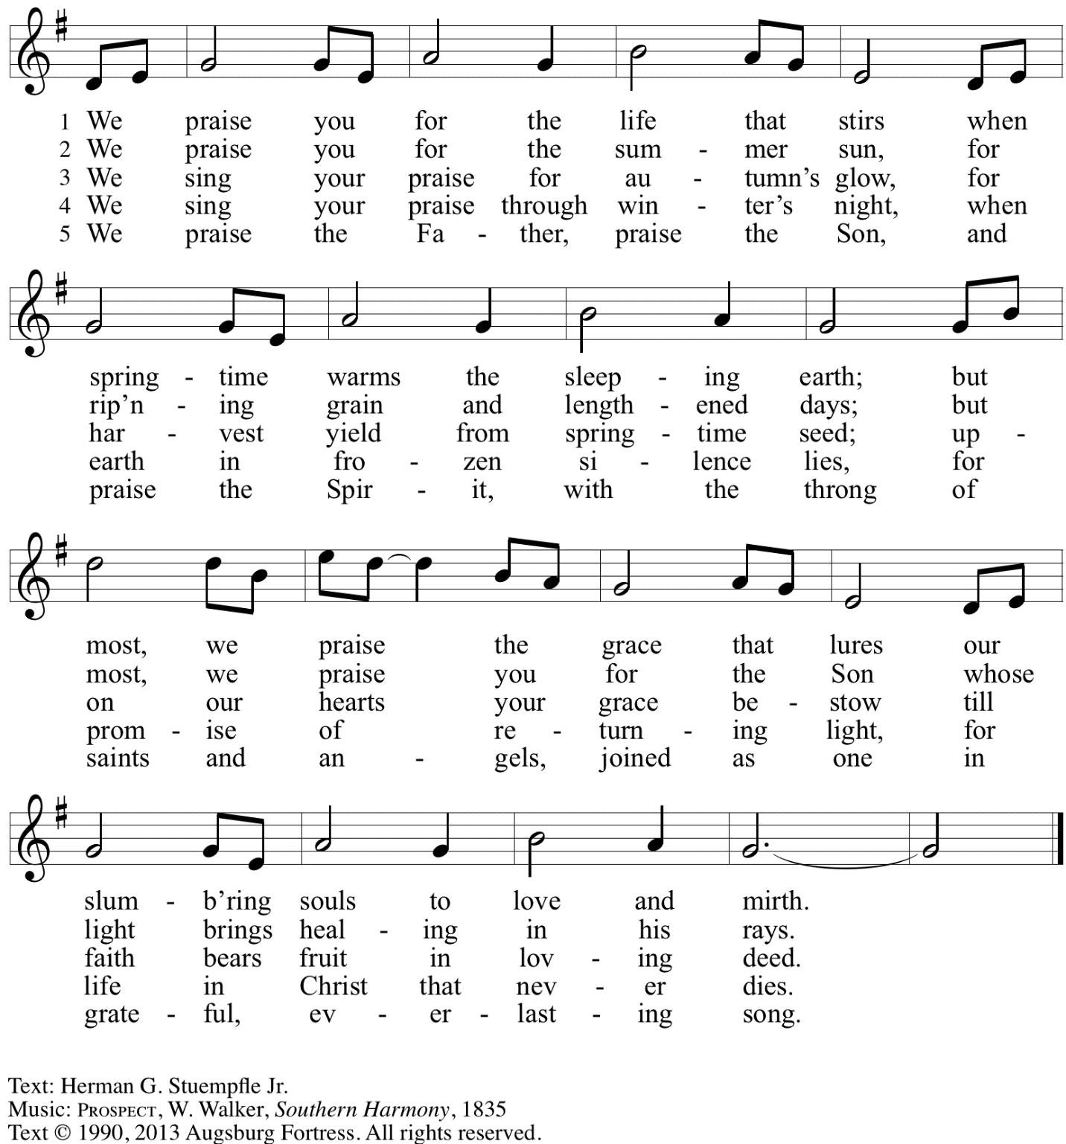
Reprinted with permission under OneLicense.net # A-722139.

Hymns during Holy Communion
By Gracious Powers ELW 626

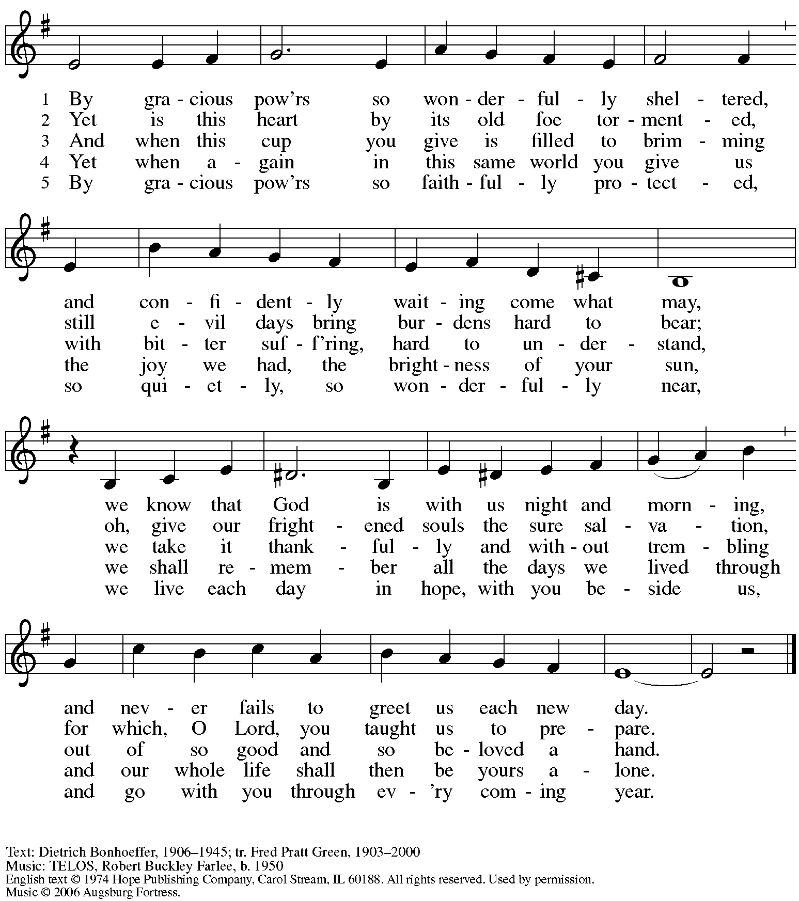
Reprinted with permission under OneLicense.net # A-722139.

Hymns during Holy Communion
Take Up Your Cross, the Savior Said ELW 667

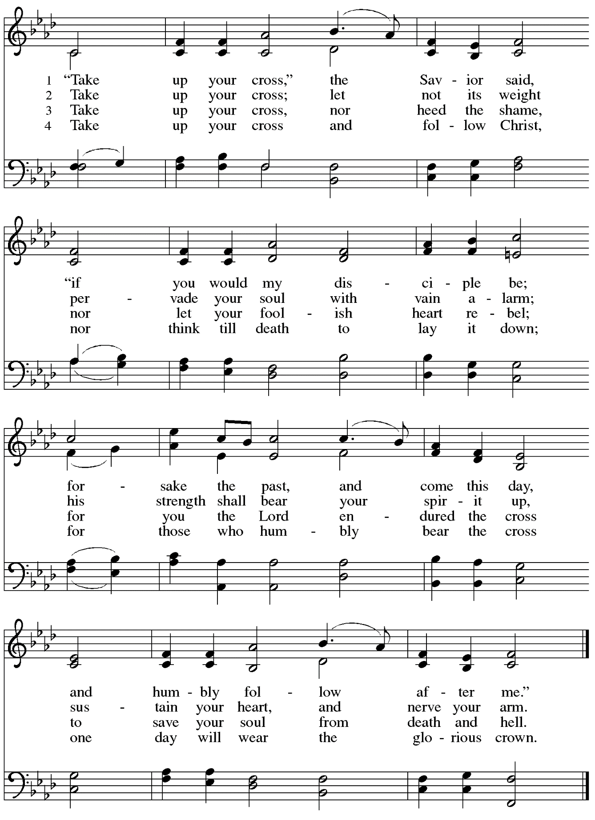

When all have returned to their places, please rise as you are able.

Blessing

P: The body and blood of our Lord Jesus Christ strengthen you and keep you in his grace.
C: Amen.

Prayer

A: Let us pray. Gracious God,
we give you thanks for your pruning, planting, and nurture.
We rejoice that you have used the harvest of field and vineyard
to renew and sustain us.
Lead us as we go from this life-giving meal
into lives of grateful service to you and your cherished creation;
through Jesus Christ, your Son, our Lord.
C: Amen.

Please be seated.

Sending
God blesses us and sends us in mission to the world

Announcements

Please rise as you are able.

Benediction

P: The God of steadfastness and encouragement
grant you to live in harmony with one another,
in accordance with Christ Jesus.
C: Amen.

P: The God of hope fill you with all joy and peace in believing,
so that you may abound in hope by the power of the Holy Spirit.
C: Amen.

P: The God of all grace ☩ bless you now and forever.
C: Amen.

Sending Hymn Bwana awabariki / May God Bless Us ACS 986

For this hymn, the cantor and congregation will sing the first two lines 3 times,
and then the third line 3 times.

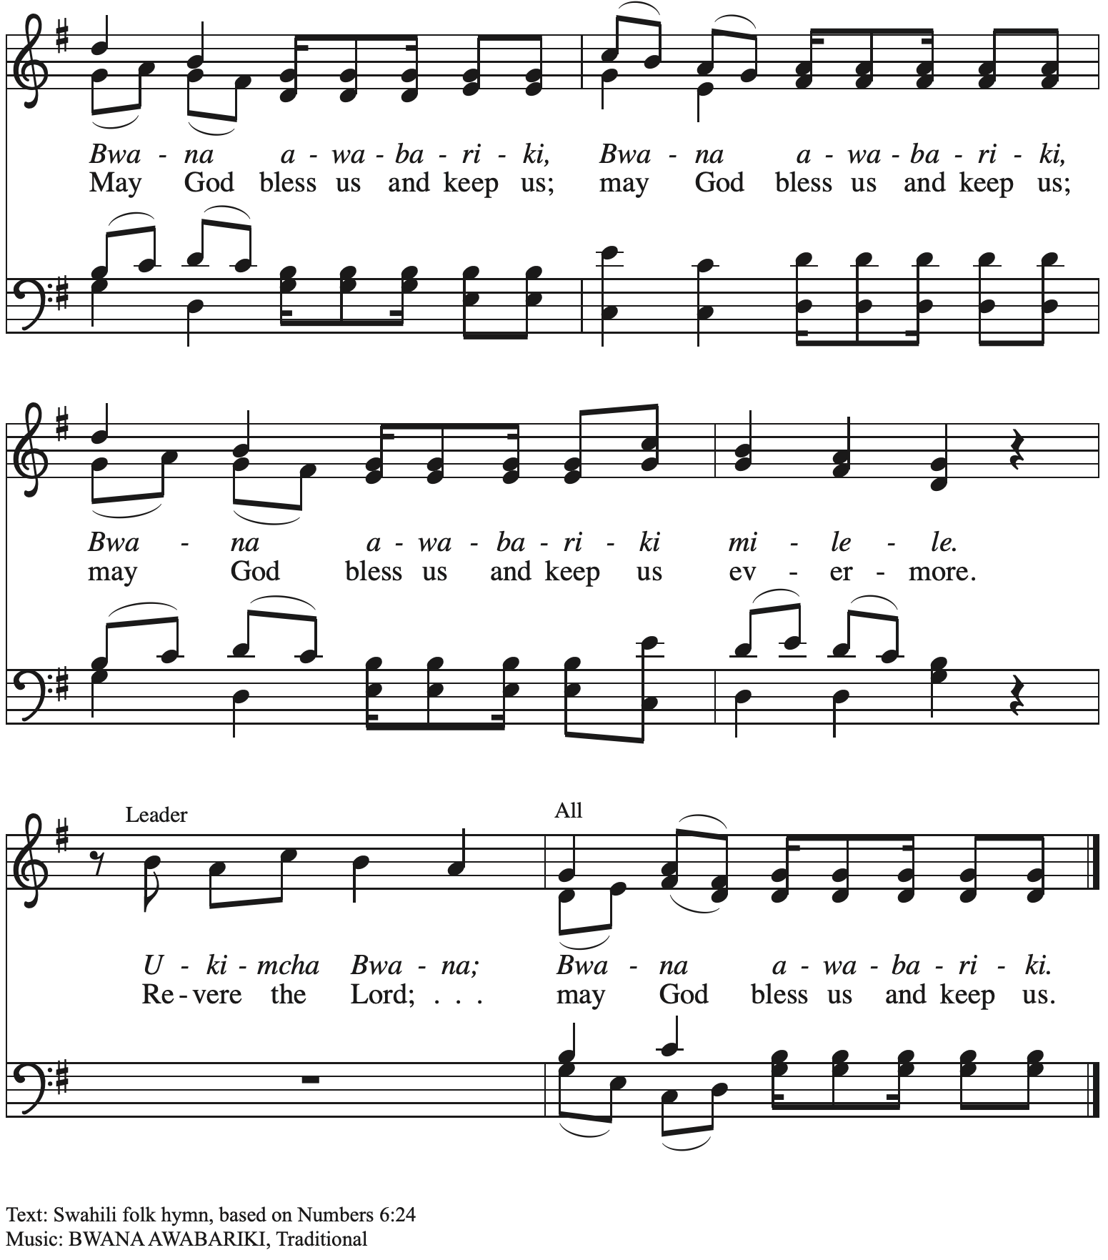

Dismissal

A: Go in peace. Serve the Lord.
C: Thanks be to God!

Postlude

Those serving in worship today

Altar Care Janet Grzegorczyk
Assisting Minister Mandy Best
Audio-Visual Ministers Noël Marsh
Colten Rohleder
Cantor Joseph Paetz
Vocalist Jonathan Paetz
Lector Maria Mangano
Minister of Music Laura Reynolds
Presiding Minister Pastor Ross Carmichael

Liturgy and Hymnody Acknowledgements

From SundaysandSeasons.com. Copyright © 2023 Augsburg Fortress. All rights reserved. Reprinted under OneLicense.net # A-722139.
Used by permission of Augsburg Fortress.

Will You Come and Follow Me – The Summons – Text: John L. Bell, b. 1949. Music: KELVINGROVE, Scottish traditional. Text © 1987 Iona Community, GIA Publications, Inc., agent. 7404 S. Mason Ave., Chicago, IL 60638. www.giamusic.com. 800.442.3358. All rights reserved. Reprinted with permission under OneLicense.net # A-722139.

Holy, Holy, Holy / Long, Long Ago in Jerusalem – Text: Beth Bergeron Folkemer, based on the Sanctus. Music: SHADY GROVE, Appalachian traditional. Text © 1990, 2013, Augsburg Fortress. All rights reserved. Reprinted with permission under OneLicense.net # A-722139.

Take Up Your Cross, the Savior Said – Text: Charles W. Everest, 1814-1977, alt. Music: BOURBON, W. Hauser, Hesperian Harp, 1848; arr. hymnal version. Arr. © 2006 Augsburg Fortress. All rights reserved. Reprinted with permission under OneLice.nse.net # A-722139.

St. Andrew Lutheran Church Announcements
June 25th, 2023

- Welcome to worship at St. Andrew on the Fourth Sunday after Pentecost, June 25th, 2023 – We are so glad you are here, and we offer a special welcome to all visitors and guests connecting for the first time! Worship attendees are invited to make a name tag at the back of the worship space if you would like. There are worship “toolkits” to help children engage with worship and “busy bags” for younger children available in the bookcase at the back of the sanctuary. Please feel free to take one to use with/for your children.
- Christ in Our Home Devotional Booklets for July – September Now Available at Church Entrances – Throughout the year, St. Andrew makes available to the congregation Christ in Our Home, a booklet with daily Bible readings, reflections, and prayers. The next edition, for July – September 2023, is now available at the church entrances. Please take one to enhance your spiritual practice!
- Monthly Offering for Reparations Next Sunday, July 2, during Worship – Jesus’ parable of the Good Samaritan from Luke's Gospel provides an example of how God's people are called to work for healing and repair for our neighbors, independent of who or what caused harm. In light of this, the Worship Committee and Congregation Council of St. Andrew have made a commitment to reparations in regard to African American spiritual songs used in our worship. The text and music of most hymns is attributed to specific authors, with copyrights in place, usage reported, and royalties paid to those whose works are featured in worship. With African American spirituals, this is not possible. In response to many years of such uncredited use, St. Andrew will invite people of the congregation to give to a second collection for reparations during the offering. Funds received in our collections will be donated to our siblings at Bethel AME Church, whose land and building were taken from them in the 1950s, to fund the development they are planning in the lower Hill District.
- July Produce Distribution – Second Tuesday Due to July 4th Holiday – St. Andrew’s fresh produce distribution in partnership with Greater Pittsburgh Community Food Bank is normally scheduled for the first Tuesday of each month, but in July it will be on the second Tuesday, July 11th, due to the July 4th holiday. If you would like to sign up in advance, please do so here: https://www.signupgenius.com/go/4090F45AFAF2BA75-produce5.
- St. Andrew Updating Information - Please Respond! – St. Andrew is looking to update our records with information from newer attendees, as well as offering current members the opportunity to include current information. This includes name, preferred pronouns, email, phone number, birthdays, anniversaries, and more. The information will only be used within the congregation - for example to acknowledge celebrations and milestones in worship, in the prayers of the church, or in the weekly or monthly newsletter. Please fill out the form at: https://forms.gle/fTwpdG2uA7pYD2ta8.

