+ Fifth Sunday after Pentecost
July 2, 2023
St. Andrew Lutheran Church
304 Morewood Ave.
Pittsburgh, PA 15213
St_andrewELCA@verizon.net
www.standrewpittsburgh.org

+ Fifth Sunday after Pentecost
Order for Worship

The welcome of Baptism is for all God’s children.
This baptismal gift frees us from the power of sin and death.
In today’s gospel, Christ promises that the disciple who gives a cup of cold water
to the little ones serves Christ himself. From worship we are sent on our baptismal mission:
to serve the little ones of this world and to be a sign of God’s merciful welcome.

Welcome to St. Andrew!

- St. Andrew Lutheran congregation welcomes all who are seeking a place of healing and wholeness – a nurturing, faith-forming spiritual home. Our community embraces people of all ages, ethnicities, cultures, abilities, sexual orientations, gender identities and expressions, and family constellations. Come and See!

- Worship Services are live streamed to multiple online platforms. By attending worship, you agree that your image and voice may be broadcast.

- Everyone is invited to make a nametag at the black bookcase in the back of the worship space if they would like. There are stickers indicating pronouns on the bookcase if you would like to include them on your name tag.

- Worship “toolkits” to help children engage with the service, along with “busy bags” for younger children, are available in the bookcase at the back of the sanctuary. Please feel free to take one to use with/for your children.

- Holy Communion is served with bread (gluten-free available) and wine or grape juice. The presiding minister will distribute the bread (host). Please consume this and then pick up an empty glass from the tray. The Communion Assistant will pour wine or grape juice into your glass. Please step to the side to consume the wine or grape juice. Feel free to kneel at the altar for prayer and reflection. As you return to your pew, glasses may be returned to the empty trays on either side of the center section.

- A restroom is available on the main level of the church, through the doors to the Social Hall and to the right in the main office.

Abbreviations
P: Pastor/Presiding Minister ACS: All Creation Sings hymnal
A: Assisting Minister ELW: Evangelical Lutheran Worship hymnal
L: Lector OLS: Of the Land and Seasons hymnal
C: Congregation

Pre-Service Music

Welcome

Prelude

Gathering
The Holy Spirit calls us together as the people of God

Confession and Forgiveness

Please rise as you are able.
All may make the sign of the cross, the sign that is marked at Baptism,
as the presiding minister begins.

P: Blessed be the holy Trinity, ☩ one God,
who forgives all our sin, whose mercy endures forever.
C: Amen.

P: Let us confess our sin in the presence of God and of one another.

Silence is kept for reflection

P: Most merciful God,
C: we confess that we are captive to sin and cannot free ourselves.
We have sinned against you in thought, word, and deed,
by what we have done and by what we have left undone.
We have rejected your guidance. We have avoided your pruning of our cluttered lives.
We have failed to maintain the tools of stewardship, outreach, and witness
you have provided for the nurture of your church.
For the sake of your Son, Jesus Christ, have mercy on us.
Forgive us, grant us discipline, and redirect us,
so that we may delight in your will and follow in your ways,
to the glory of your holy name.
Amen.

P: God, who is rich in mercy,
loved us even when we were dead in sin
and made us alive together with Christ.
By grace you have been saved.
In the name of ☩ Jesus Christ, your sins are forgiven.
Almighty God strengthen you with the Holy Spirit,
that Christ may live in your hearts through faith.
C: Amen.

Gathering Hymn As We Gather at Your Table ELW 522

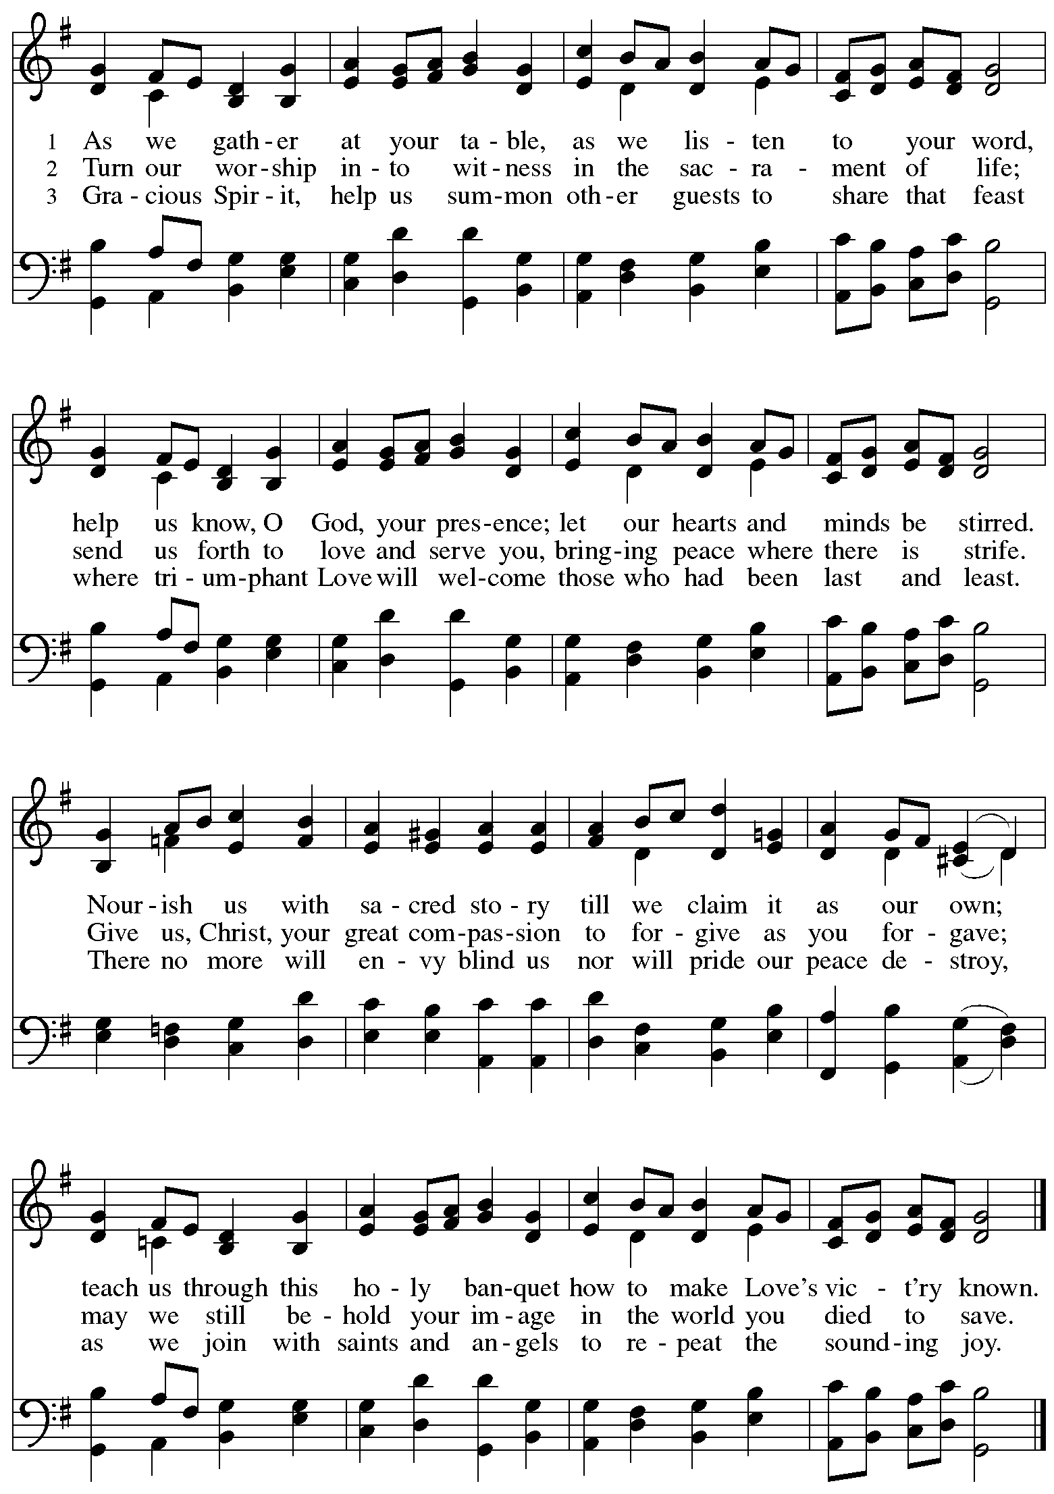

Greeting

P: The grace of our Lord Jesus Christ, the love of God,
and the communion of the Holy Spirit be with you all.
C: And also with you.

Hymn of Praise Oh, Sing of God’s Great Victory! OLS 3

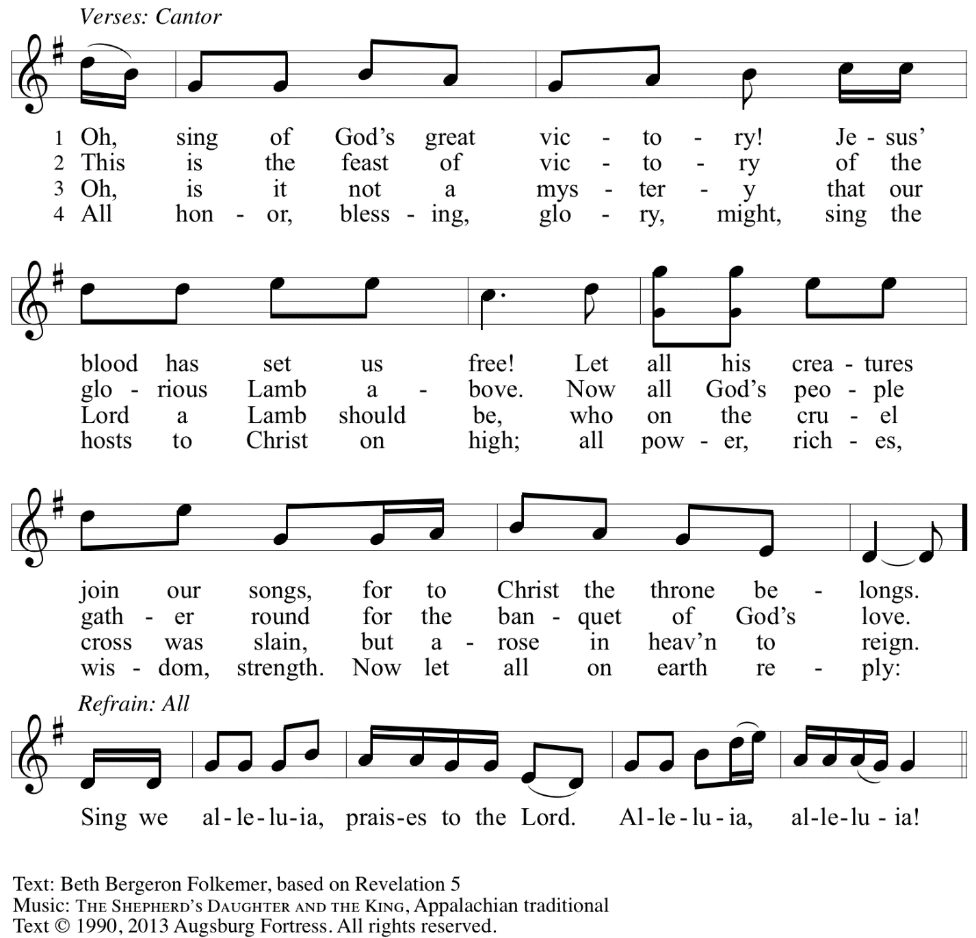
Reprinted with permission under OneLicense.net # A-722139.

Prayer of the Day

P: The Lord be with you.
C: And also with you.

P: Let us pray. O God,
you direct our lives by your grace, and your words of justice and mercy reshape the world.
Mold us into a people who welcome your word and serve one another,
through Jesus Christ, our Savior and Lord.
C: Amen.

Please be seated.

Word
God speaks to us in Scripture reading, preaching, and song

First Reading – Jeremiah 28: 5-9

⁵The prophet Jeremiah spoke to the prophet Hananiah in the presence of the priests and all the people who were standing in the house of the Lord; ⁶and the prophet Jeremiah said, “Amen! May the Lord do so; may the Lord fulfill the words that you have prophesied, and bring back to this place from Babylon the vessels of the house of the Lord, and all the exiles. ⁷But listen now to this word that I speak in your hearing and in the hearing of all the people. ⁸The prophets who preceded you and me from ancient times prophesied war, famine, and pestilence against many countries and great kingdoms. ⁹As for the prophet who prophesies peace, when the word of that prophet comes true, then it will be known that the Lord has truly sent the prophet.”

L: Word of God, word of life.
C: Thanks be to God.

Psalm 89: 1-4, 15-18

The psalm will be sung by the cantor,
with the congregation invited to join in singing the verses in bold and the refrain.

Psalm tone

Psalm refrain

¹Your love, O Lord, forever | will I sing;
from age to age my mouth will pro- | claim your faithfulness.
²For I am persuaded that your steadfast love is estab- | lished forever;
you have set your faithfulness firmly | in the heavens.
³“I have made a covenant with my | chosen one;
I have sworn an oath to Da- | vid my servant:
⁴‘I will establish your | line forever,
and preserve your throne for all | generations.’ ” R
¹⁵Happy are the people who know the | festal shout!
They walk, O Lord, in the light | of your presence.
¹⁶They rejoice daily | in your name;
they are jubilant | in your righteousness.
¹⁷For you are the glory | of their strength,
and by your favor our might | is exalted.
¹⁸Truly, our shield belongs | to the Lord;
our king to the Holy | One of Israel. R

Second Reading – Romans 6: 12-23

¹²Do not let sin exercise dominion in your mortal bodies, to make you obey their passions. ¹³No longer present your members to sin as instruments of wickedness, but present yourselves to God as those who have been brought from death to life, and present your members to God as instruments of righteousness. ¹⁴For sin will have no dominion over you, since you are not under law but under grace.
¹⁵What then? Should we sin because we are not under law but under grace? By no means! ¹⁶Do you not know that if you present yourselves to anyone as obedient slaves, you are slaves of the one whom you obey, either of sin, which leads to death, or of obedience, which leads to righteousness? ¹⁷But thanks be to God that you, having once been slaves of sin, have become obedient from the heart to the form of teaching to which you were entrusted, ¹⁸and that you, having been set free from sin, have become slaves of righteousness. ¹⁹I am speaking in human terms because of your natural limitations. For just as you once presented your members as slaves to impurity and to greater and greater iniquity, so now present your members as slaves to righteousness for sanctification.
²⁰When you were slaves of sin, you were free in regard to righteousness. ²¹So what advantage did you then get from the things of which you now are ashamed? The end of those things is death. ²²But now that you have been freed from sin and enslaved to God, the advantage you get is sanctification. The end is eternal life. ²³For the wages of sin is death, but the free gift of God is eternal life in Christ Jesus our Lord.

L: Word of God, word of life.
C: Thanks be to God.

Please rise as you are able.

Gospel Acclamation O God, Whose Word Well-Planted OLS 4
v. 1-2

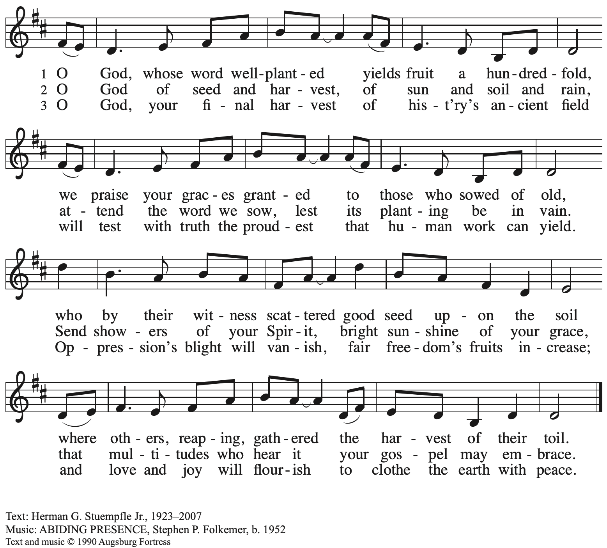
All rights reserved. Reprinted with permission under OneLicense.net # A-722139.

Gospel – Matthew 10: 40-42

P: The holy Gospel according to St. Matthew.
C: Glory to you, O Lord.

[Jesus said to the twelve:] ⁴⁰“Whoever welcomes you welcomes me, and whoever welcomes me welcomes the one who sent me. ⁴¹Whoever welcomes a prophet in the name of a prophet will receive a prophet’s reward; and whoever welcomes a righteous person in the name of a righteous person will receive the reward of the righteous; ⁴²and whoever gives even a cup of cold water to one of these little ones in the name of a disciple—truly I tell you, none of these will lose their reward.”

P: The Gospel of the Lord.
C: Praise to you, O Christ.

Please be seated.

Sermon

A time of silence for prayer and reflection follows the sermon.
When the hymn of the day begins, please rise as you are able.

Hymn of the Day All Are Welcome Following page

Hymn of the Day All Are Welcome ELW 641

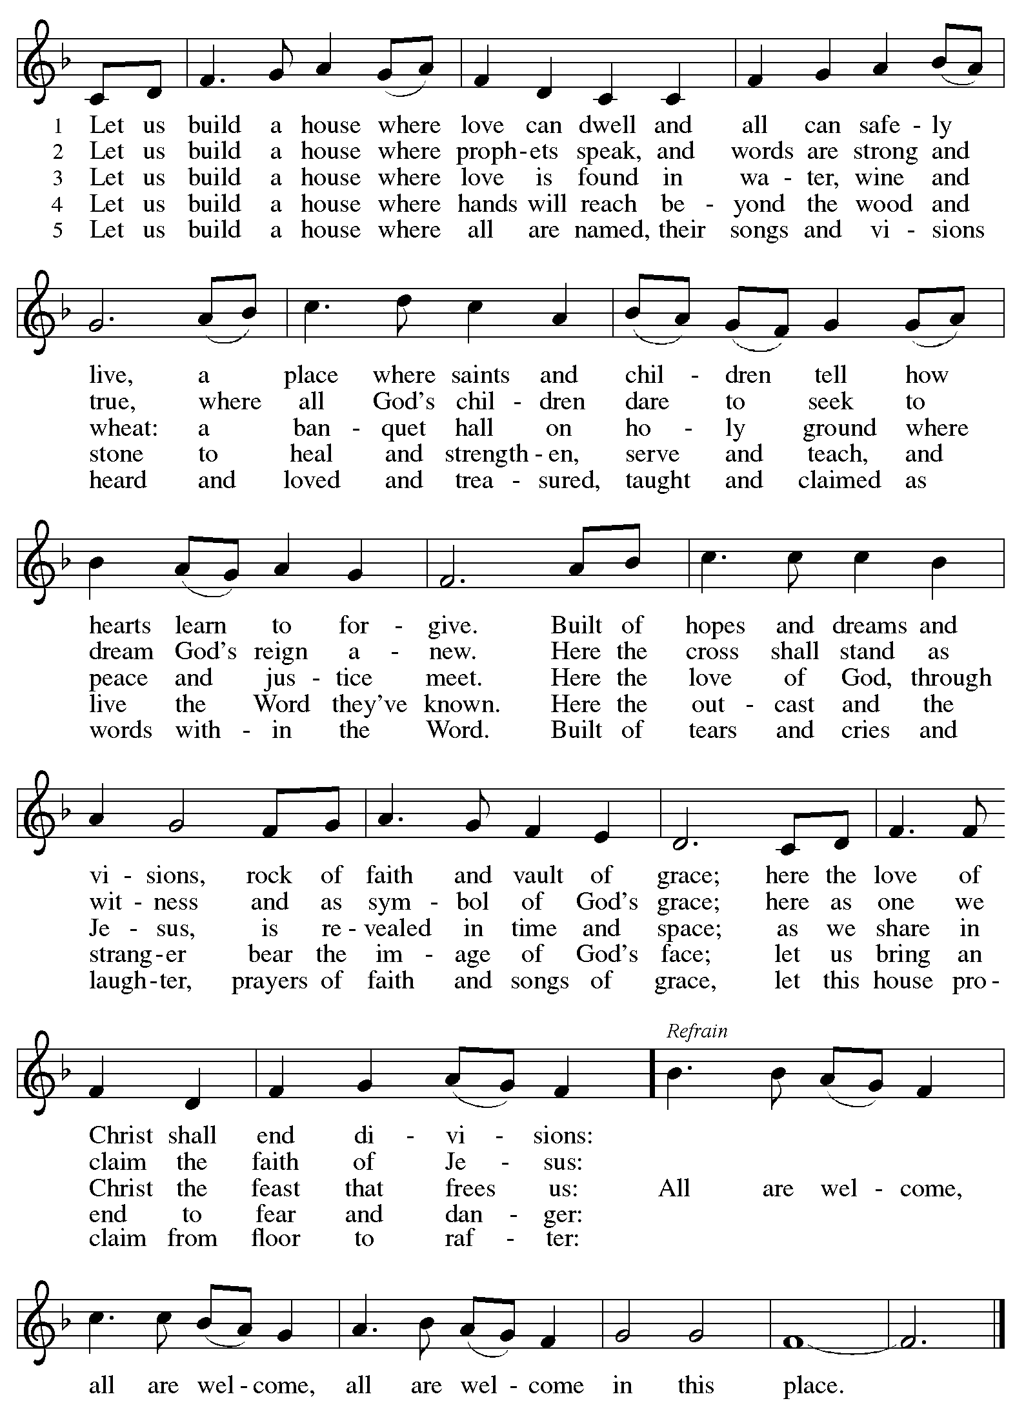

Prayers of the People

A: With the whole people of God in Christ Jesus, let us pray for the church, the world,
those in need, and all of God’s creation.

After each petition
A: God, in your mercy,
C: receive our prayer.

The presiding minister concludes the prayers
P: Into your hands, gracious God, we commend all for whom we pray,
trusting in your abundant mercy, through Jesus Christ our Savior
C: Amen.

Peace

The presiding minister and the assembly greet one another in the peace of the risen Christ.
P: The peace of Christ be with you always.
C: And also with you.

The people may greet those around them with a sign of Christ’s peace and may say
Peace be with you or similar words. Please be mindful that not everyone will be comfortable with sharing the peace, so please seek consent before shaking hands or hugging. Other possible ways to share the peace include a simple bow with the verbal greeting of peace, or simply a verbal expression of peace.

When the greetings of peace have concluded, please be seated.

Meal
God feeds us with the presence of Jesus Christ

Offering

We offer ourselves, our gifts, and our faithful service to God.
As the offering is gathered for the mission of the church, including the care of those in need,
the table is set for Holy Communion.

Reparations Offering

On the first Sunday of each month, St. Andrew invites people of the congregation to consider a donation to a second collection for a reparations fund in acknowledgement of St. Andrew’s use of African American spiritual songs in our worship services. Please see the note in the announcements at the back of the bulletin for more information.

Music during the Offering

As the gifts are brought forward for presentation, please rise as you are able.

Offertory Song Accept, O Lord, the Gifts We Bring OLS 5

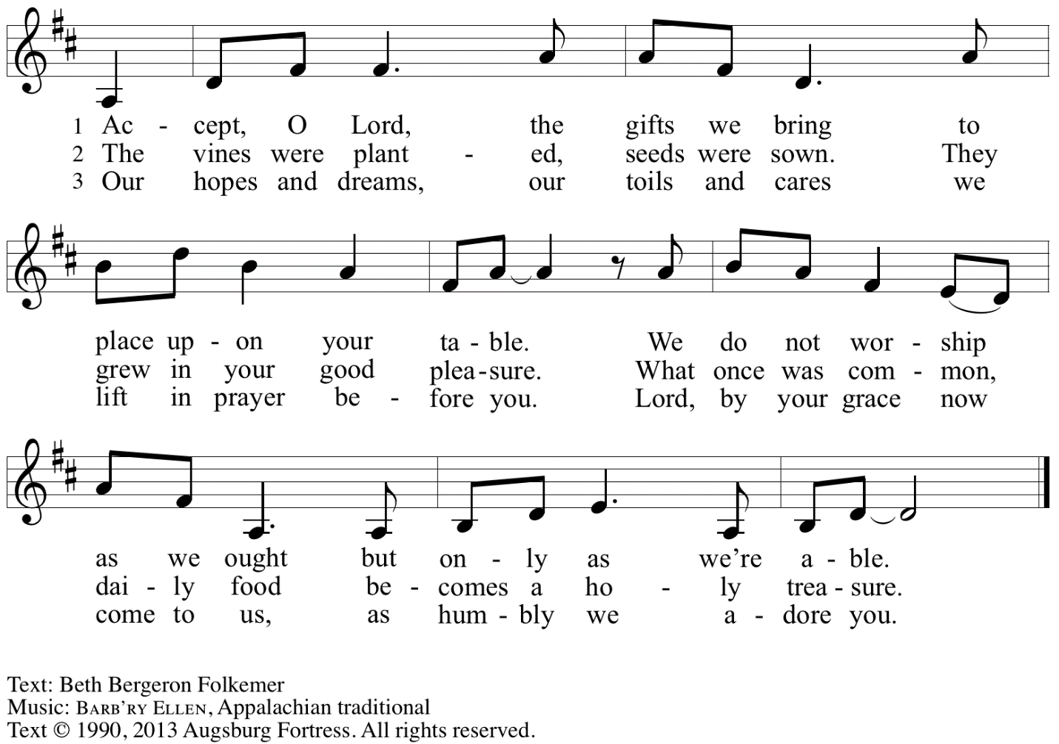
Reprinted with permission under OneLicense.net # A-722139.

Offertory Prayer

A: Let us pray.
Gracious God,
C: you bless us with gifts of guidance, new life,
Growth in grace, and fruitful labor.
Accept the first fruits of time and toil, field and orchard,
that we offer here. Bless and multiply these gifts to our nurture
and the care of your creation;
for the sake of your Son, Jesus Christ, our Lord.
Amen.

Dialogue

P: The Lord be with you.
C: And also with you.

P: Lift up your hearts.
C: We lift them to the Lord.

P: Let us give thanks to the Lord our God.
C: It is right to give our thanks and praise.

Preface

P: It is indeed right, our duty and our joy …
… we praise your name and join in adoring song:

Sanctus Holy, Holy, Holy OLS 6

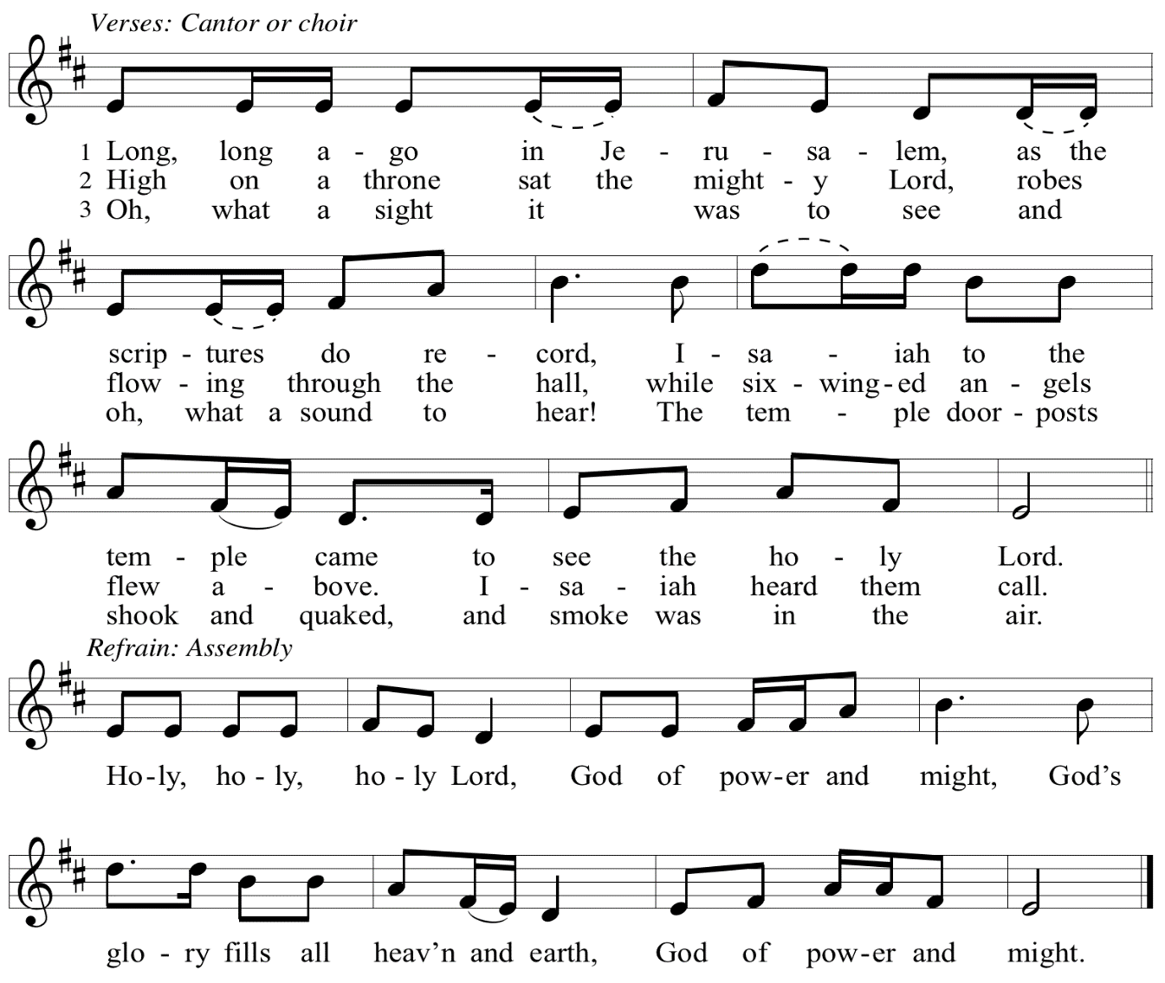

Eucharistic Prayer

P: You are indeed holy, God of power and might
and your glory fills the whole earth …
… and nurture us to become what you have made us –
your beloved people, the body of your Son, the temple of your Spirit.

Through your Son, in your Spirit, with all your people,
we give you thanks and praise,
O source of our life and fountain of all good,
now and forever.
C: Amen.

Lord’s Prayer

P: Gathered as one by the Holy Spirit, let us pray as Jesus taught us.
C: Our Father in heaven,
hallowed be your name,
your kingdom come,
your will be done,
on earth as in heaven.
Give us today our daily bread.
Forgive us our sins
as we forgive those
who sin against us.
Save us from the time of trial
and deliver us from evil.
For the kingdom, the power,
and the glory are yours,
now and forever. Amen.

Fraction and Invitation

P: Just as this broken bread was first scattered on the hills,
then was brought together and became one,
so let your church be brought together
from the ends of the earth into your reign,
for yours are the glory and the power
through Jesus Christ forever.
C: Amen.

Agnus Dei / Lamb of God OLS 7
O Lamb of God, to Earth You Came

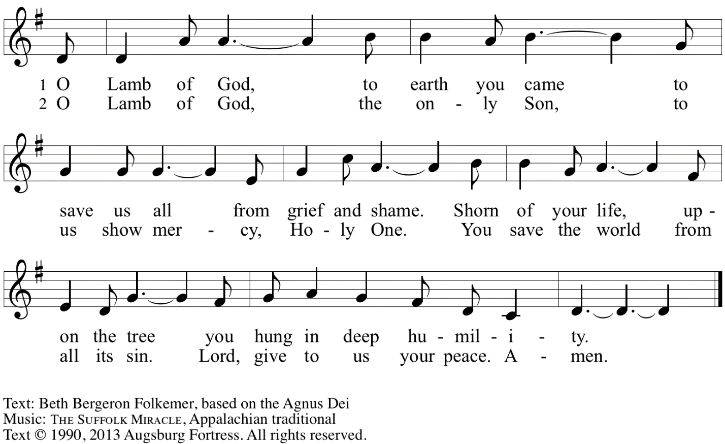
Reprinted with permission under OneLicense.net # A-722139.

Please be seated.

Holy Communion
- All who seek God and desire a deeper and stronger life in Christ are welcome to receive Holy Communion.
- Worshipers from the pulpit side will proceed forward first, followed by the center section, and then the lectern side.
- Please inform an usher if you would like the ministers to bring Communion to you.
- Holy Communion will be served with bread and wine/grape juice.
- The presiding minister will first distribute the bread (host) to each communicant. Please indicate if you require a gluten-free host.
- Once you have consumed the bread, please pick up an empty glass from the tray next to the presiding minister. The Communion Assistant will pour wine from the chalice or grape juice from the cruet into your glass.
- Please step to the side to consume the wine or grape juice.
- Feel free to kneel at the altar rail for prayer after receiving the sacrament.
- As you return to your pew, glasses may be returned to the empty trays on either side of the center section.
- A blessing will be provided for anyone who does not yet receive the sacrament.
- All are invited to join in singing the hymns during Holy Communion.

Hymns during Holy Communion
We Praise You for the Life That Stirs OLS 9

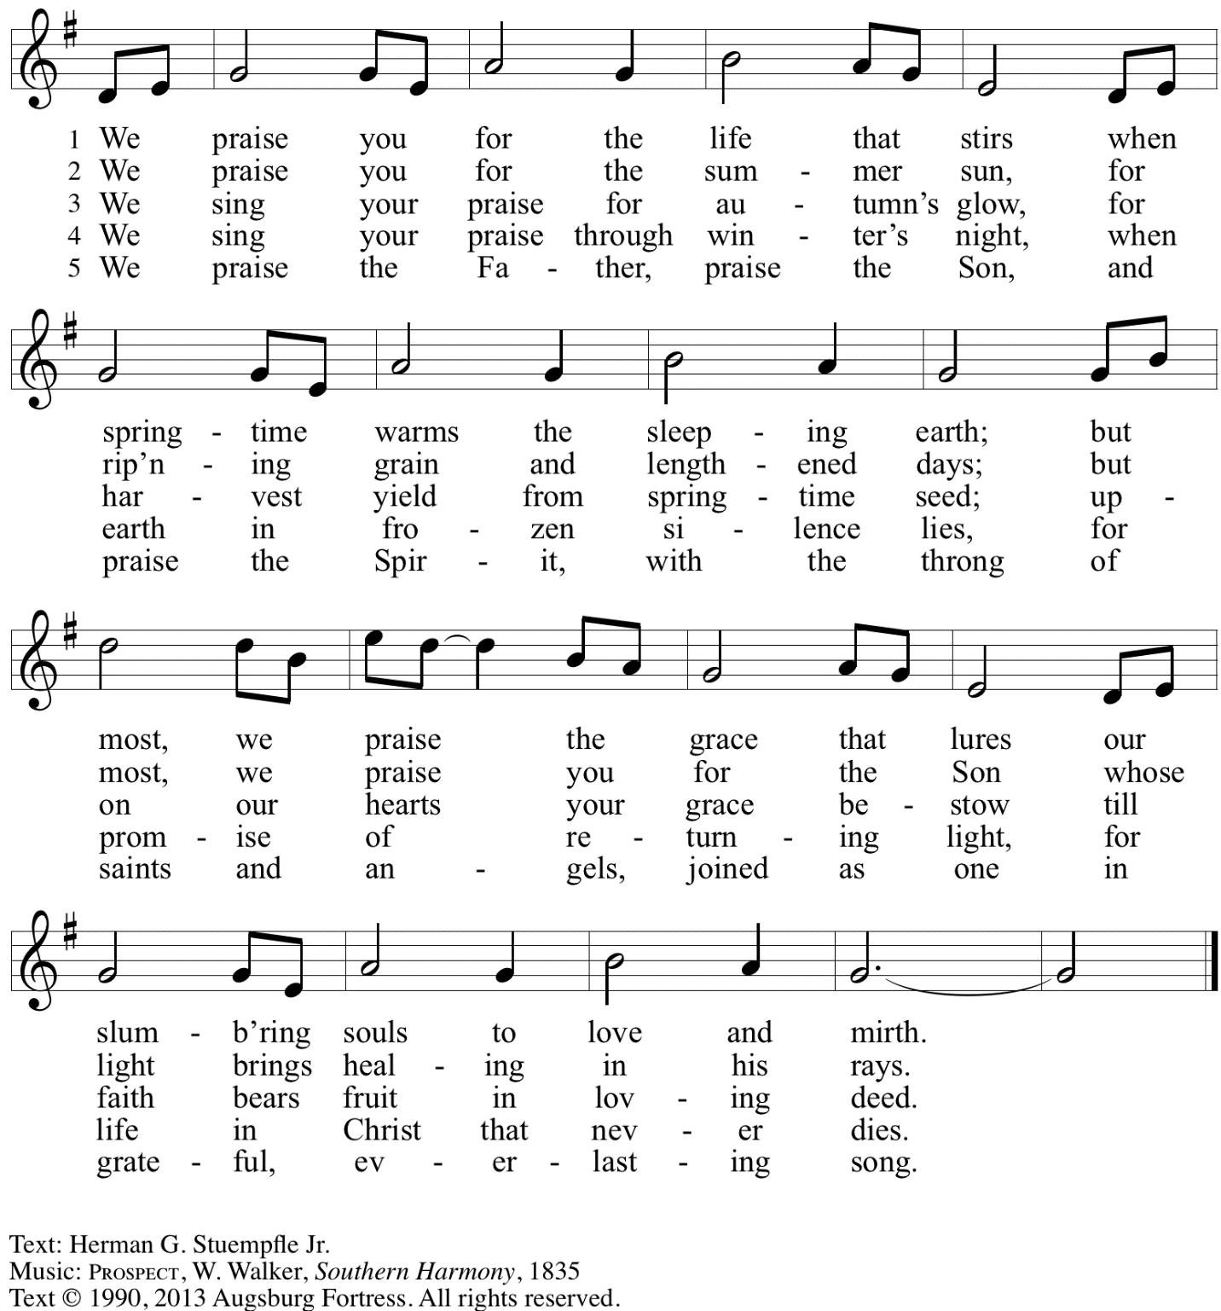
Reprinted with permission under OneLicense.net # A-722139.

Hymns during Holy Communion
All Who Hunger, Gather Gladly ELW 461

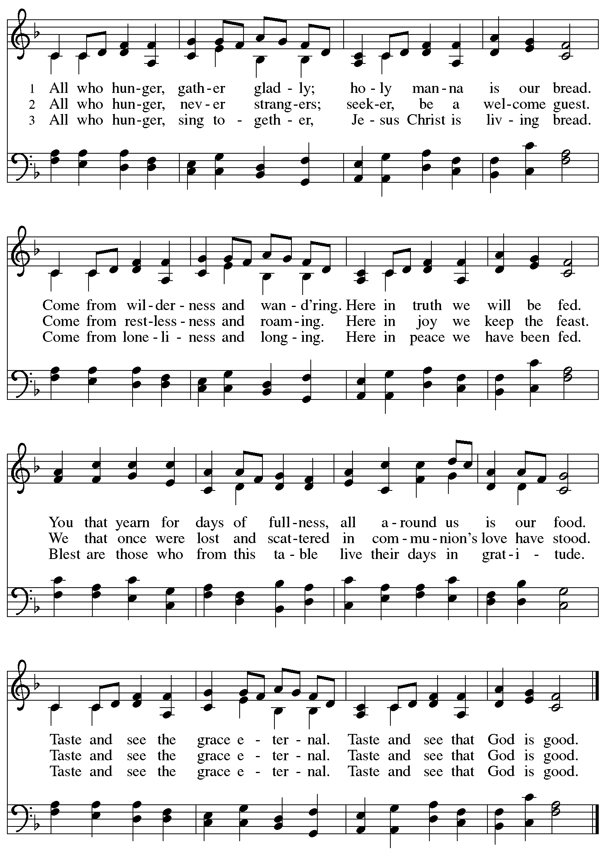

Hymns during Holy Communion
Lord, Speak to Us, That We May Speak ELW 676

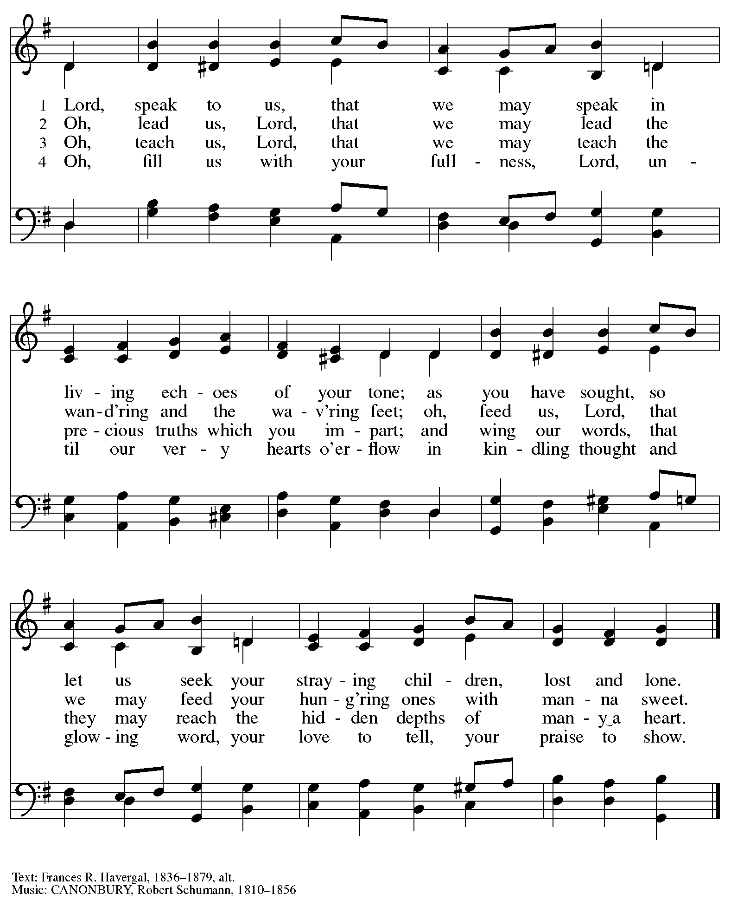

When all have returned to their places, please rise as you are able.

Blessing

P: The body and blood of our Lord Jesus Christ strengthen you and keep you in his grace.
C: Amen.

Prayer

A: Let us pray. Gracious God,
we give you thanks for your pruning, planting, and nurture.
We rejoice that you have used the harvest of field and vineyard
to renew and sustain us.
Lead us as we go from this life-giving meal
into lives of grateful service to you and your cherished creation;
through Jesus Christ, your Son, our Lord.
C: Amen.

Please be seated.

Sending
God blesses us and sends us in mission to the world

Announcements

Please rise as you are able.

Benediction

P: The God of steadfastness and encouragement
grant you to live in harmony with one another,
in accordance with Christ Jesus.
C: Amen.

P: The God of hope fill you with all joy and peace in believing,
so that you may abound in hope by the power of the Holy Spirit.
C: Amen.

P: The God of all grace ☩ bless you now and forever.
C: Amen.

Sending Hymn God Be with You Till We Meet Again ELW 536

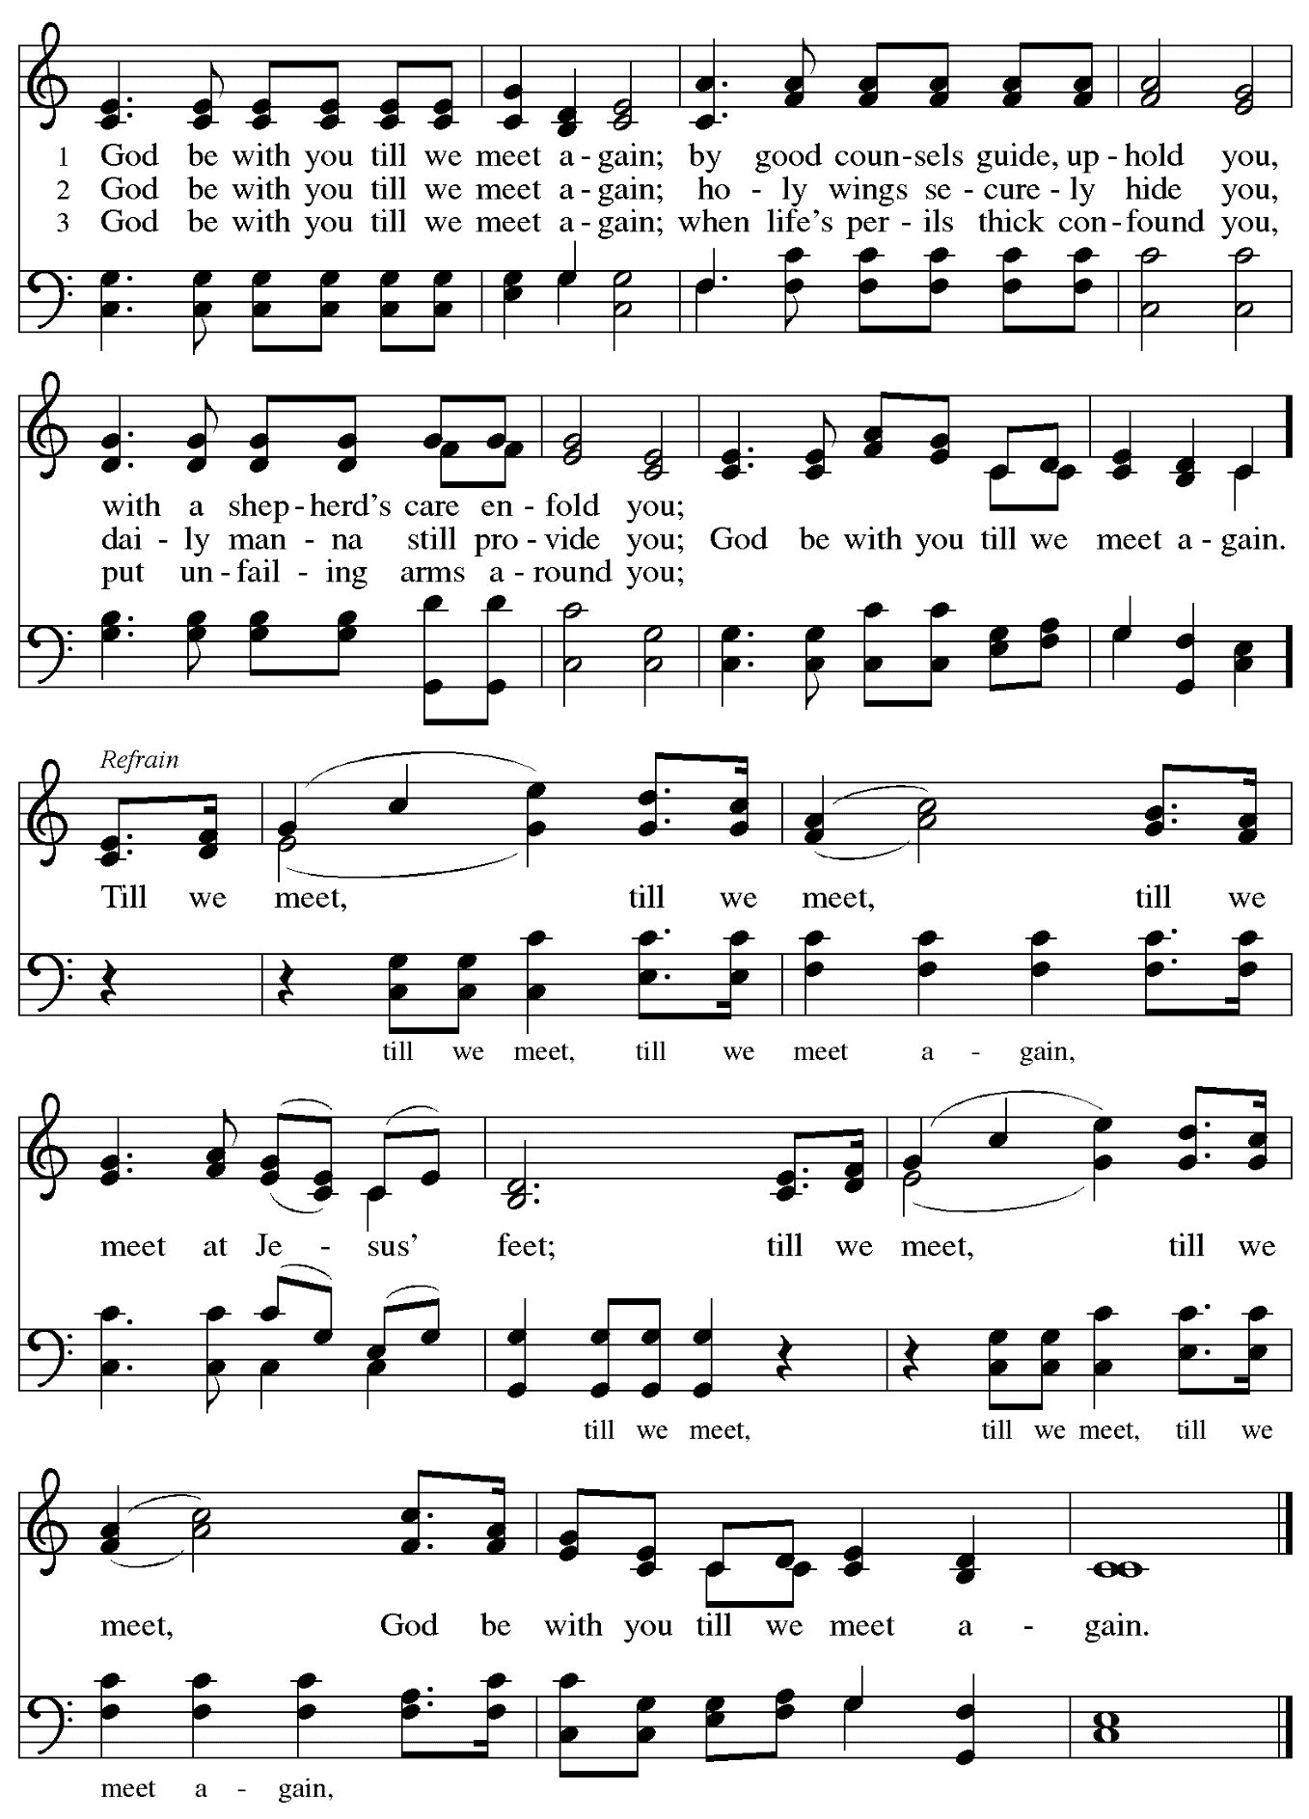

Dismissal

A: Go in peace. Serve the Lord.
C: Thanks be to God!

Postlude

Those serving in worship today

Altar Care Jodie Minor
Assisting Minister Jimmi Kocher-Hillmer
Audio-Visual Ministers David Rollinson
Jason Galyardt
Cantor Colten Rohleder
Lector Lester Prince
Minister of Music Laura Reynolds
Preaching and Presiding Minister The Rev. Deborah M. Byrum

Liturgy and Hymnody Acknowledgements

From SundaysandSeasons.com. Copyright © 2023 Augsburg Fortress. All rights reserved. Reprinted under OneLicense.net # A-722139.
Used by permission of Augsburg Fortress.

As We Gather at Your Table – Text: Carl P. Daw, Jr., b. 1944. Music: IN BABILONE, Oude en Nieuwe Hollantse Boerenlities en Contradansen, 1710; arr. Julius Röntgen, 1855-1932. Text © 1989 Hope Publishing Company, Carol Stream, IL 60188. All rights reserved. Reprinted with permission under OneLicense.net # A-722139.

All Are Welcome – Text: Marty Haugen, b. 1950. Music: TWO OAKS, Marty Haugen. Text and music © 1994 GIA Publications, Inc., 7404 S. Mason Ave., Chicago, IL 60638. www.giamusic.com. 800.442.3358. All rights reserved. Reprinted with permission under OneLicense.net # A-722139.

Holy, Holy, Holy / Long, Long Ago in Jerusalem – Text: Beth Bergeron Folkemer, based on the Sanctus. Music: SHADY GROVE, Appalachian traditional. Text © 1990, 2013, Augsburg Fortress. All rights reserved. Reprinted with permission under OneLicense.net # A-722139.

All Who Hunger, Gather Gladly – Text: Sylvia G. Dunstan, 1955-1993. Music: HOLY MANNA, W. Moore, Columbian Harmony, 1825; arr. hymnal version. Text © 1991 GIA Publications, Inc., 7404 S. Mason Ave., Chicago, IL 60638. www.giamusic.com. 800.442.3358. Arr. © 2003 Augsburg Fortress. All rights reserved. Reprinted with permission under OneLicense.net # A-722139.

God Be with You Till We Meet Again – Text: Jeremiah E. Rankin, 1828-1904. Music: GOD BE WITH YOU, William G. Tomer, 1833-1896.

Please use the QR code below to link to St. Andrew’s Announcements online!

St. Andrew Lutheran Church Announcements
July 2nd, 2023

- Welcome to worship at St. Andrew on the Fifth Sunday after Pentecost, July 2nd, 2023 – We are so glad you are here, and we offer a special welcome to all visitors and guests connecting for the first time! Worship attendees are invited to make a name tag at the back of the worship space if you would like. There are worship “toolkits” to help children engage with worship and “busy bags” for younger children available in the bookcase at the back of the sanctuary. Please feel free to take one to use with/for your children.
- Welcome Back, Pastor Deborah Byrum! – Today we welcome The Rev. Deborah L. Byrum, a pastor and member of St. Andrew, who will be preaching and leading worship today! We thank her for sharing her gifts!
- Monthly Reparations Offering Today, July 2nd, during Worship – Jesus’ parable of the Good Samaritan from Luke's Gospel provides an example of how God's people are called to work for healing and repair for our neighbors, independent of who or what caused harm. In light of this, St. Andrew has made a commitment to reparations in regard to African American spiritual songs used in our worship. The text and music of most hymns is attributed to specific authors, with copyrights in place, usage reported, and royalties paid to those whose works are featured in worship. With African American spirituals, this is not possible. In response to many years of such uncredited use, St. Andrew will invite people of the congregation to give to a second collection for reparations during the offering. Funds received in our collections will be donated to our siblings at Bethel AME Church, whose land and building were taken from them in the 1950s, to fund the development they are planning in the lower Hill District.
- July Produce Distribution – Second Tuesday, July 11th, Due to July 4th Holiday – St. Andrew’s fresh produce distribution in partnership with Greater Pittsburgh Community Food Bank is normally scheduled for the first Tuesday of each month, but in July it will be on the second Tuesday, July 11th, due to the July 4th holiday. If you would like to sign up in advance, please do so here: https://www.signupgenius.com/go/4090F45AFAF2BA75-produce5.
- Shelter Dinner at East End Cooperative Ministry – Thursday, July 18th, 6:30 p.m. –
The congregation’s monthly dinner for guests of the shelter at East End Cooperative Ministry (6140 Station St., 15206) will be Thursday, July 18th. We ask anyone dropping off food to deliver it by 6:00 p.m. so that service can begin at 6:30 p.m. If you would like to contribute a portion of the meal, or would like to help serve, please sign up here:
https://www.signupgenius.com/go/5080544AAAC22A1F58-july
- Christ in Our Home Devotional Booklets for July – September Available at Church Entrances – Throughout the year, St. Andrew makes available to the congregation Christ in Our Home, a booklet with daily Bible readings, reflections, and prayers. The July – September 2023 edition is available at the church entrances. Please take one!
- St. Andrew Updating Information - Please Respond! – St. Andrew is looking to update our records with current information and contact information from newer attendees, such as name, preferred pronouns, email, phone number, birthdays, anniversaries, and more. The information will only be used within the congregation. Please fill out the form at: https://forms.gle/fTwpdG2uA7pYD2ta8.

Stand Up for Fairness for All Pennsylvanians

This month, the nation's largest organization devoted to the rights of LGBTQ+ Americans declared a "state of emergency" in the U.S. amidst a growing number of dangerous and discriminatory policies. In Pennsylvania, more than half a million LGBTQ+ residents are vulnerable to discrimination every day because of a lack of express and enduring statutory protections at the state level. Tell your lawmakers it's time to make our Commonwealth a safe place for everyone to live, love and work as their authentic selves without fear of discrimination.

Pennsylvania remains the only state in the Northeast without an inclusive statewide nondiscrimination law. Passage of protections in Pennsylvania is a critical step to ensure LGBTQ people are treated with dignity in employment, housing, and public spaces.

Contact your lawmakers here.

Sign up here to join fellow Lutherans working for protections for LGBTQ+ Pennsylvanians and receive alerts about rallies and other opportunities to act. Please include FAIRNESS in the subject line.

The seven Pennsylvania bishops of the Evangelical Lutheran Church in America released a letter in support of legislation that would prohibit such discrimination.

"At this moment there is an opportunity for us to add our voices in support of legislation that could provide continuing legal protection for one particularly vulnerable group of our people," the bishops state in their letter "Fairness for All Pennsylvanians."
Read the full letter.

The letter points to the imagery of the "peaceable kingdom," described in Isaiah 11: 6, in which "the wolf shall live with the lamb, the leopard shall lie down with the kid, the calf and the lion and the fatling together, and a little child shall lead them." The words anticipate a renewal of all creation in which the identity of each creature remains but none experiences any harm from the others. "It is the fulfillment of this vision for which people of faith yearn, and toward which they call their neighbors," the bishops say in the letter. "The work of public advocacy, at its best, replaces the timid silence of resignation to what is, with a bold voice giving expression to what could be."

We recognize that the links above are not accessible on the printed page but we wanted to be sure to publish the information. Please see your “This Week at St. Andrew” email or scan the QR code above to access the clickable links. Thank you for your Advocacy!

