4

+ Sixth Sunday after Pentecost
July 9, 2023
St. Andrew Lutheran Church
304 Morewood Ave.
Pittsburgh, PA 15213
St_andrewELCA@verizon.net
www.standrewpittsburgh.org

+ Sixth Sunday after Pentecost
Order for Worship

In this week’s Gospel, Jesus says that the mystery of God’s way is sometimes hidden from the wise and intelligent. Jesus associates with those who are often excluded from the religious community. Like the apostle Paul, we struggle with our own selfish desires and seek God’s mercy and forgiveness. We gather to be refreshed by Christ’s invitation: “Come to me, all you who are weary.” Gathered around word, water, and meal, we find rest for our souls.

Welcome to St. Andrew!

- St. Andrew Lutheran congregation welcomes all who are seeking a place of healing and wholeness – a nurturing, faith-forming spiritual home. Our community embraces people of all ages, ethnicities, cultures, abilities, sexual orientations, gender identities and expressions, and family constellations. Come and See!

- Worship Services are live streamed to multiple online platforms. By attending worship, you agree that your image and voice may be broadcast.

- Everyone is invited to make a nametag at the black bookcase in the back of the worship space if they would like. There are stickers indicating pronouns on the bookcase if you would like to include them on your name tag.

- Worship “toolkits” to help children engage with the service, along with “busy bags” for younger children, are available in the bookcase at the back of the sanctuary. Please feel free to take one to use with/for your children.

- Holy Communion is served with bread (gluten-free available) and wine or grape juice. The presiding minister will distribute the bread (host). Please consume this and then pick up an empty glass from the tray. The Communion Assistant will pour wine or grape juice into your glass. Please step to the side to consume the wine or grape juice. Feel free to kneel at the altar for prayer and reflection. As you return to your pew, glasses may be returned to the empty trays on either side of the center section.

- A restroom is available on the main level of the church, through the doors to the Social Hall and to the right in the main office.

Abbreviations
P: Pastor/Presiding Minister ACS: All Creation Sings hymnal
A: Assisting Minister ELW: Evangelical Lutheran Worship hymnal
L: Lector OLS: Of the Land and Seasons hymnal
C: Congregation

Pre-Service Music

Welcome

Prelude

Gathering
The Holy Spirit calls us together as the people of God

Confession and Forgiveness

Please rise as you are able.
All may make the sign of the cross, the sign that is marked at Baptism,
as the presiding minister begins.

P: Blessed be the holy Trinity, ☩ one God,
who forgives all our sin, whose mercy endures forever.
C: Amen.

P: Let us confess our sin in the presence of God and of one another.

Silence is kept for reflection

P: Most merciful God,
C: we confess that we are captive to sin and cannot free ourselves.
We have sinned against you in thought, word, and deed,
by what we have done and by what we have left undone.
We have rejected your guidance. We have avoided your pruning of our cluttered lives.
We have failed to maintain the tools of stewardship, outreach, and witness
you have provided for the nurture of your church.
For the sake of your Son, Jesus Christ, have mercy on us.
Forgive us, grant us discipline, and redirect us,
so that we may delight in your will and follow in your ways,
to the glory of your holy name.
Amen.

P: God, who is rich in mercy,
loved us even when we were dead in sin
and made us alive together with Christ.
By grace you have been saved.
In the name of ☩ Jesus Christ, your sins are forgiven.
Almighty God strengthen you with the Holy Spirit,
that Christ may live in your hearts through faith.
C: Amen.

Gathering Hymn Day by Day ELW 790

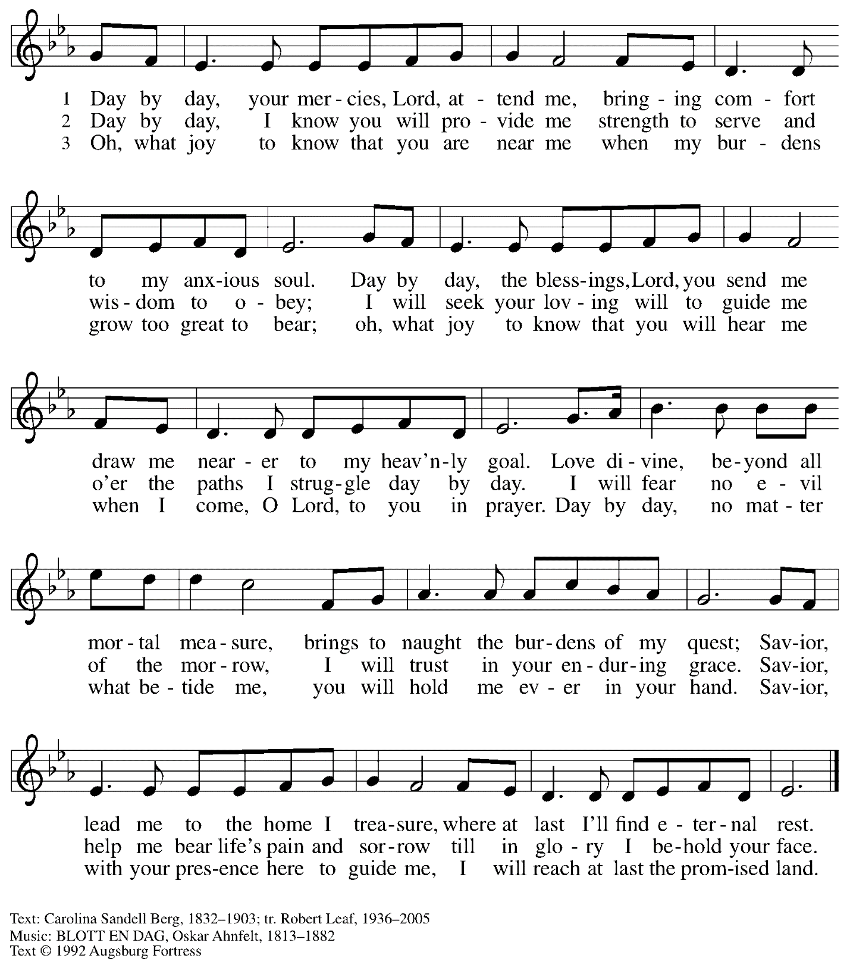
All rights reserved. Reprinted with permission under OneLicense.net # A-722139.

Greeting

P: The grace of our Lord Jesus Christ, the love of God,
and the communion of the Holy Spirit be with you all.
C: And also with you.

Hymn of Praise Oh, Sing of God’s Great Victory! OLS 3

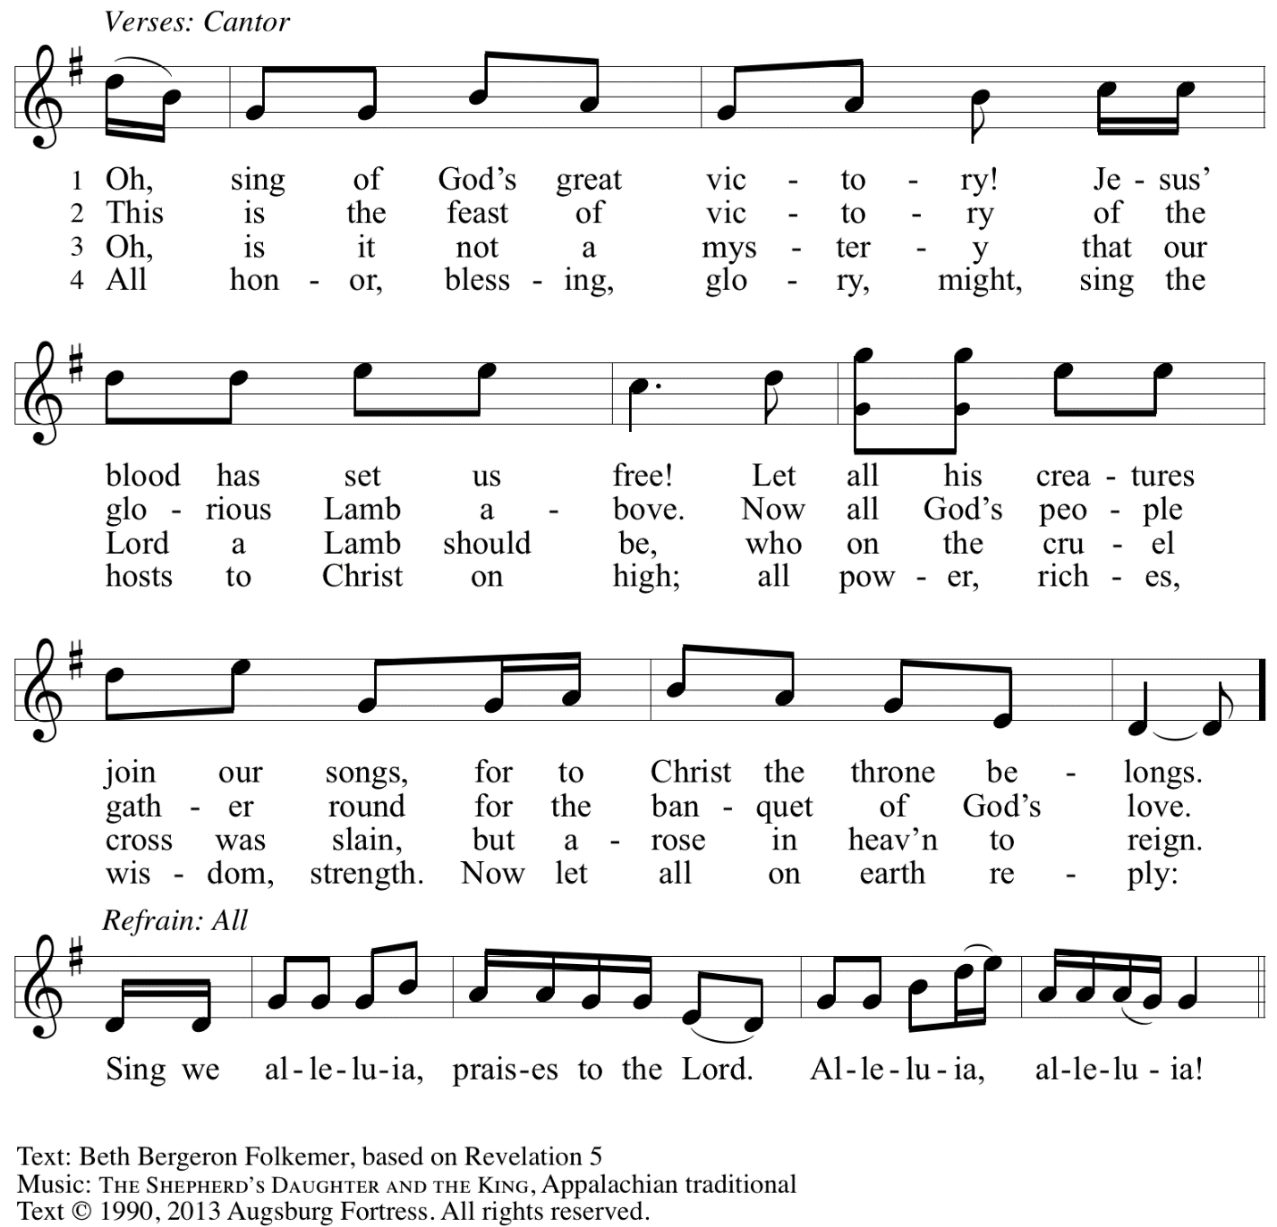
Reprinted with permission under OneLicense.net # A-722139.

Prayer of the Day

P: The Lord be with you.
C: And also with you.

P: Let us pray.
You are great, O God, and greatly to be praised.
You have made us for yourself, and our hearts are restless until they rest in you.
Grant that we may believe in you, call upon you, know you, and serve you,
through your Son, Jesus Christ, our Savior and Lord.
C: Amen.

Please be seated.

Word
God speaks to us in Scripture reading, preaching, and song

First Reading – Zechariah 9: 9-12

⁹Rejoice greatly, O daughter Zion!
Shout aloud, O daughter Jerusalem!
Lo, your king comes to you;
triumphant and victorious is he,
humble and riding on a donkey,
on a colt, the foal of a donkey.
¹⁰He will cut off the chariot from Ephraim
and the war-horse from Jerusalem;
and the battle bow shall be cut off,
and he shall command peace to the nations;
his dominion shall be from sea to sea,
and from the River to the ends of the earth.

¹¹As for you also, because of the blood of my covenant with you,
I will set your prisoners free from the waterless pit.
¹²Return to your stronghold, O prisoners of hope;
today I declare that I will restore to you double.

L: Word of God, word of life.
C: Thanks be to God.

Psalm 145: 8-14

The psalm will be led by the cantor,
with the congregation invited to sing the alternate verses and the refrain.

Psalm tone

Psalm refrain

Second Reading – Romans 7: 15-25a

¹⁵I do not understand my own actions. For I do not do what I want, but I do the very thing I hate. ¹⁶Now if I do what I do not want, I agree that the law is good. ¹⁷But in fact it is no longer I that do it, but sin that dwells within me. ¹⁸For I know that nothing good dwells within me, that is, in my flesh. I can will what is right, but I cannot do it. ¹⁹For I do not do the good I want, but the evil I do not want is what I do.
²⁰Now if I do what I do not want, it is no longer I that do it, but sin that dwells within me.
²¹So I find it to be a law that when I want to do what is good, evil lies close at hand. ²²For I delight in the law of God in my inmost self, ²³but I see in my members another law at war with the law of my mind, making me captive to the law of sin that dwells in my members. ²⁴Wretched man that I am! Who will rescue me from this body of death? ^{25a}Thanks be to God through Jesus Christ our Lord!

L: Word of God, word of life.
C: Thanks be to God.

Please rise as you are able.

Gospel Acclamation O God, Whose Word Well-Planted OLS 4
v. 1-2

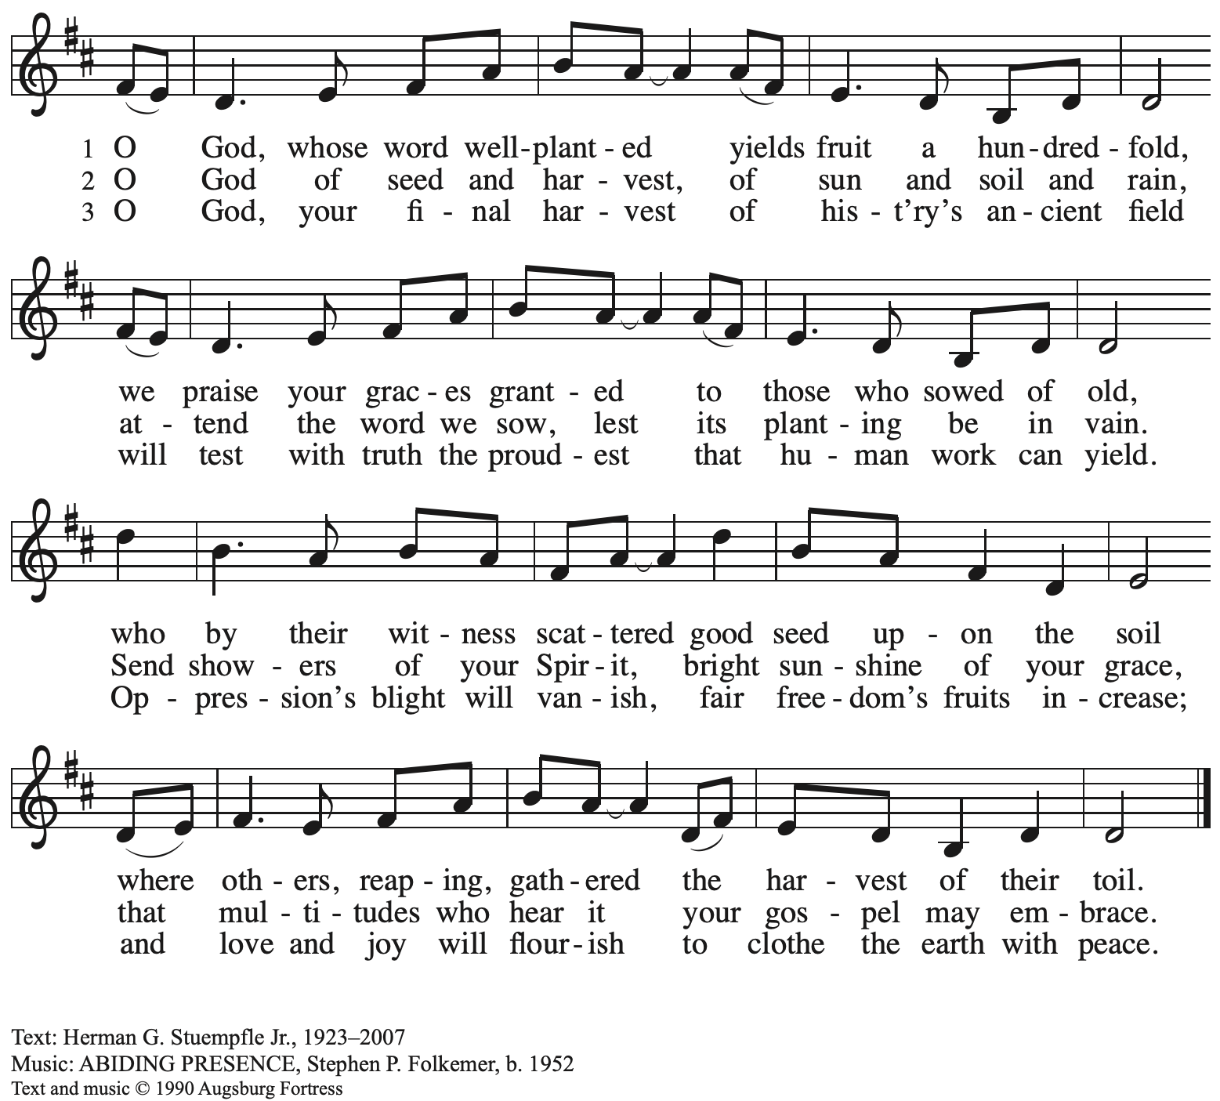
All rights reserved. Reprinted with permission under OneLicense.net # A-722139.

Gospel – Matthew 11: 16-19, 25-30

P: The holy Gospel according to St. Matthew.
C: Glory to you, O Lord.

[Jesus spoke to the crowd saying:] ¹⁶“To what will I compare this generation? It is like children sitting in the marketplaces and calling to one another,
¹⁷‘We played the flute for you, and you did not dance;
we wailed, and you did not mourn.’
¹⁸For John came neither eating nor drinking, and they say, ‘He has a demon’; ¹⁹the Son of Humanity came eating and drinking, and they say, ‘Look, a glutton and a drunkard, a friend of tax collectors and sinners!’ Yet wisdom is vindicated by her deeds.”
²⁵At that time Jesus said, “I thank you, Father, Lord of heaven and earth, because you have hidden these things from the wise and the intelligent and have revealed them to infants; ²⁶yes, Father, for such was your gracious will. ²⁷All things have been handed over to me by my Father; and no one knows the Son except the Father, and no one knows the Father except the Son and anyone to whom the Son chooses to reveal him.
²⁸“Come to me, all you that are weary and are carrying heavy burdens, and I will give you rest. ²⁹Take my yoke upon you, and learn from me; for I am gentle and humble in heart, and you will find rest for your souls. ³⁰For my yoke is easy, and my burden is light.”

P: The Gospel of the Lord.
C: Praise to you, O Christ.

Please be seated.

Sermon

A time of silence for prayer and reflection follows the sermon.
When the hymn of the day begins, please rise as you are able.

Hymn of the Day Come to Me, O Weary Traveler ACS 1017

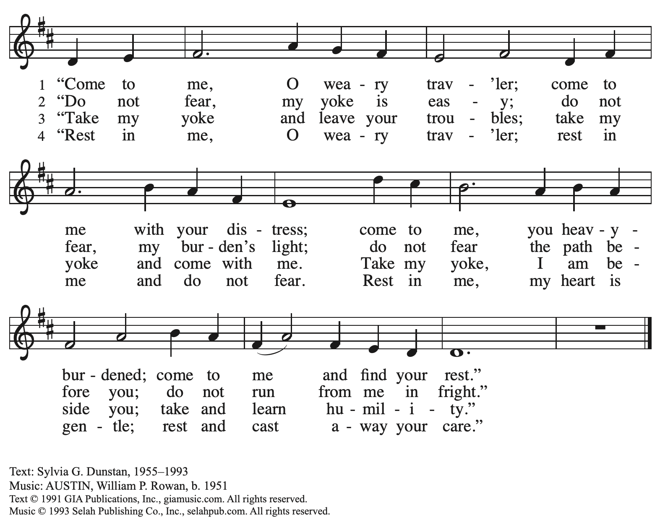
Reprinted with permission under OneLicense.net # A-722139.

Prayers of the People

A: With the whole people of God in Christ Jesus, let us pray for the church, the world,
those in need, and all of God’s creation.

After each petition
A: God, in your mercy,
C: receive our prayer.

The presiding minister concludes the prayers
P: Into your hands, gracious God, we commend all for whom we pray,
trusting in your abundant mercy, through Jesus Christ our Savior
C: Amen.

Peace

The presiding minister and the assembly greet one another in the peace of the risen Christ.
P: The peace of Christ be with you always.
C: And also with you.

The people may greet those around them with a sign of Christ’s peace and may say
Peace be with you or similar words. Please be mindful that not everyone will be comfortable with sharing the peace, so please seek consent before shaking hands or hugging. Other possible ways to share the peace include a simple bow with the verbal greeting of peace, or simply a verbal expression of peace.

When the greetings of peace have concluded, please be seated.

Meal
God feeds us with the presence of Jesus Christ

Offering

We offer ourselves, our gifts, and our faithful service to God.
As the offering is gathered for the mission of the church, including the care of those in need,
the table is set for Holy Communion.

Music during the Offering

As the gifts are brought forward for presentation, please rise as you are able.

Offertory Song Accept, O Lord, the Gifts We Bring OLS 5

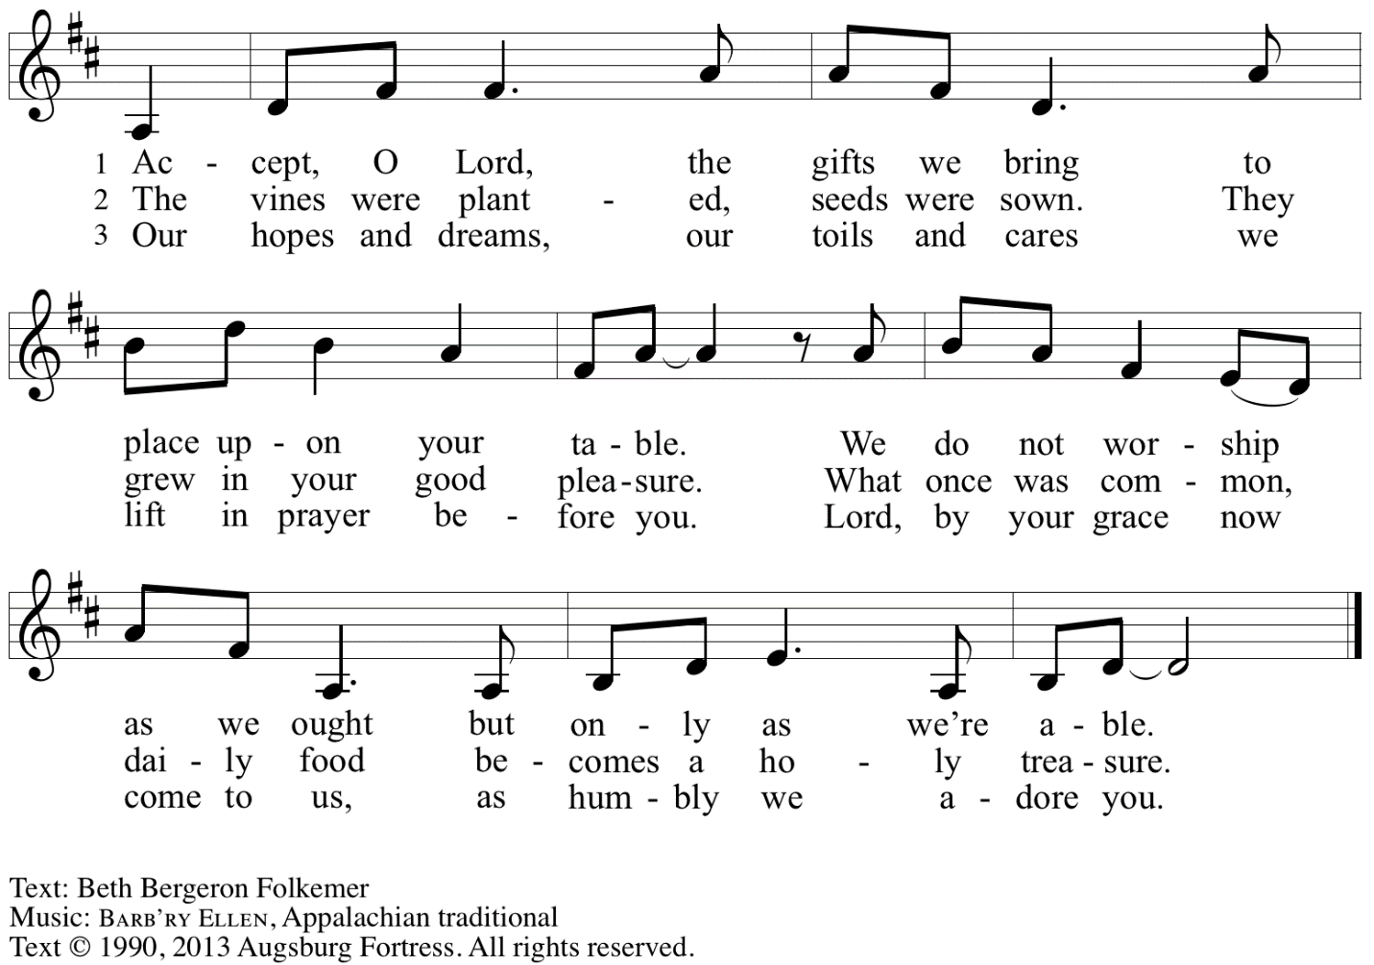
Reprinted with permission under OneLicense.net # A-722139.

Offertory Prayer

A: Let us pray.
Gracious God,
C: you bless us with gifts of guidance, new life,
Growth in grace, and fruitful labor.
Accept the first fruits of time and toil, field and orchard,
that we offer here. Bless and multiply these gifts to our nurture
and the care of your creation;
for the sake of your Son, Jesus Christ, our Lord.
Amen.

Dialogue

P: The Lord be with you.
C: And also with you.

P: Lift up your hearts.
C: We lift them to the Lord.

P: Let us give thanks to the Lord our God.
C: It is right to give our thanks and praise.

Preface

P: It is indeed right, our duty and our joy …
… we praise your name and join in adoring song:

Sanctus Holy, Holy, Holy OLS 6

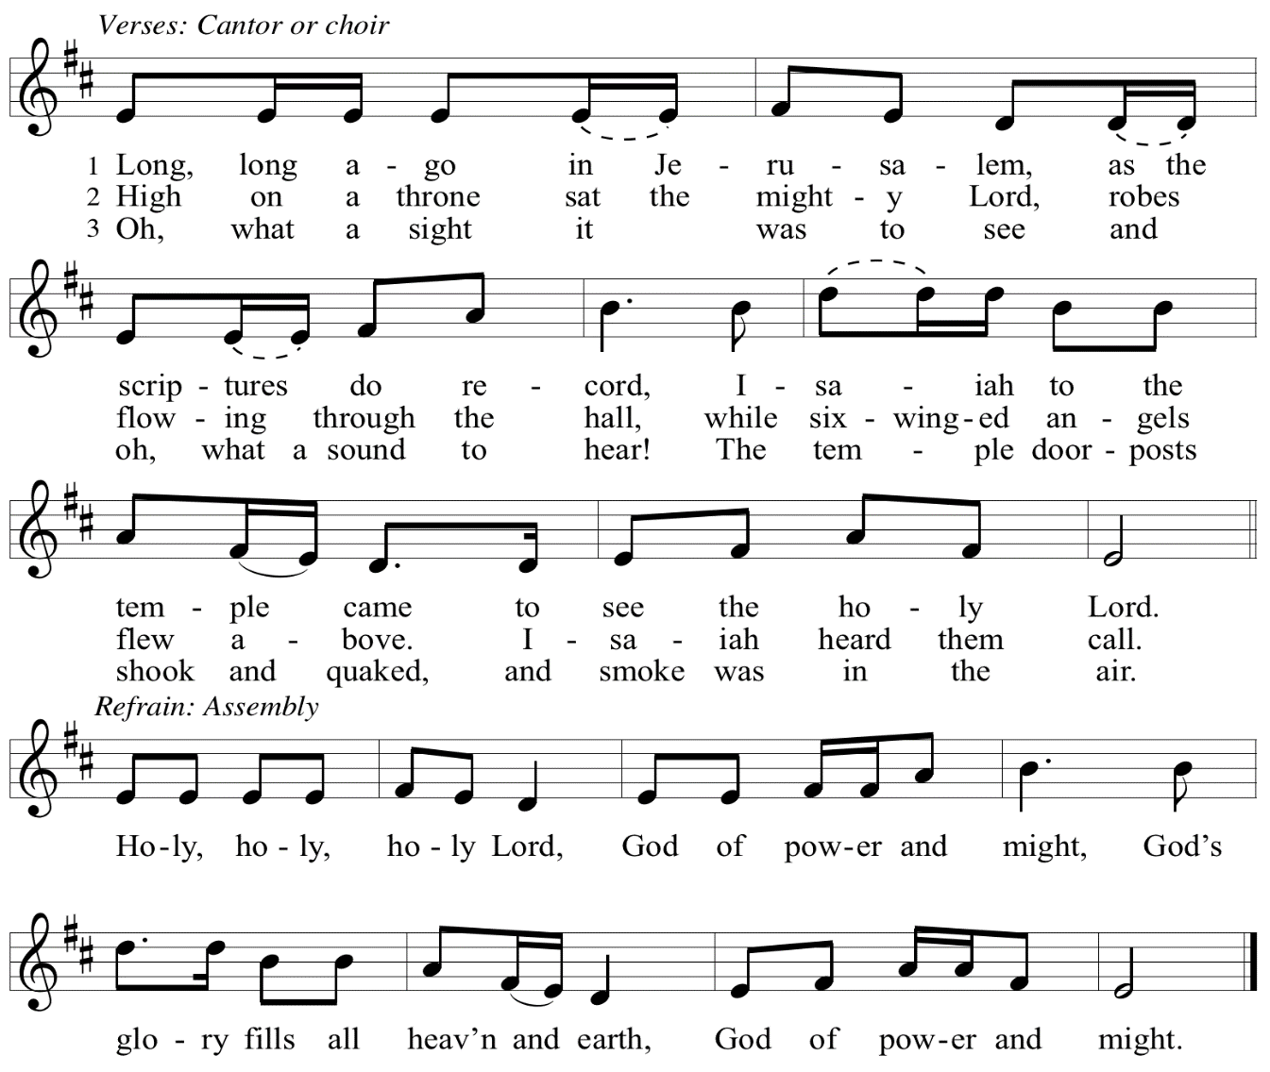

Eucharistic Prayer

P: You are indeed holy, God of power and might
and your glory fills the whole earth …
… and nurture us to become what you have made us –
your beloved people, the body of your Son, the temple of your Spirit.

Through your Son, in your Spirit, with all your people,
we give you thanks and praise,
O source of our life and fountain of all good,
now and forever.
C: Amen.

Lord’s Prayer

P: Gathered as one by the Holy Spirit, let us pray as Jesus taught us.
C: Our Father in heaven,
hallowed be your name,
your kingdom come,
your will be done,
on earth as in heaven.
Give us today our daily bread.
Forgive us our sins
as we forgive those
who sin against us.
Save us from the time of trial
and deliver us from evil.
For the kingdom, the power,
and the glory are yours,
now and forever. Amen.

Fraction and Invitation

P: Just as this broken bread was first scattered on the hills,
then was brought together and became one,
so let your church be brought together
from the ends of the earth into your reign,
for yours are the glory and the power
through Jesus Christ forever.
C: Amen.

Agnus Dei / Lamb of God OLS 7
O Lamb of God, to Earth You Came

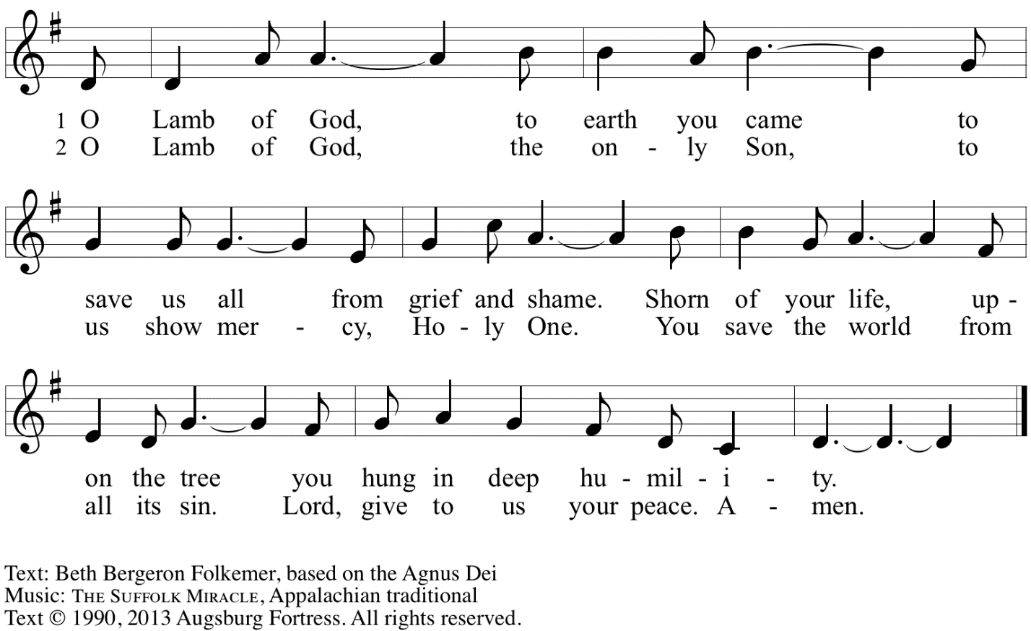
Reprinted with permission under OneLicense.net # A-722139.

Please be seated.

Holy Communion
- All who seek God and desire a deeper and stronger life in Christ are welcome to receive Holy Communion.
- Worshipers from the pulpit side will proceed forward first, followed by the center section, and then the lectern side.
- Please inform an usher if you would like the ministers to bring Communion to you.
- Holy Communion will be served with bread and wine/grape juice.
- The presiding minister will first distribute the bread (host) to each communicant. Please indicate if you require a gluten-free host.
- Once you have consumed the bread, please pick up an empty glass from the tray next to the presiding minister. The Communion Assistant will pour wine from the chalice or grape juice from the cruet into your glass.
- Please step to the side to consume the wine or grape juice.
- Feel free to kneel at the altar rail for prayer after receiving the sacrament.
- As you return to your pew, glasses may be returned to the empty trays on either side of the center section.
- A blessing will be provided for anyone who does not yet receive the sacrament.
- All are invited to join in singing the hymns during Holy Communion.

Hymns during Holy Communion
We Praise You for the Life That Stirs OLS 9

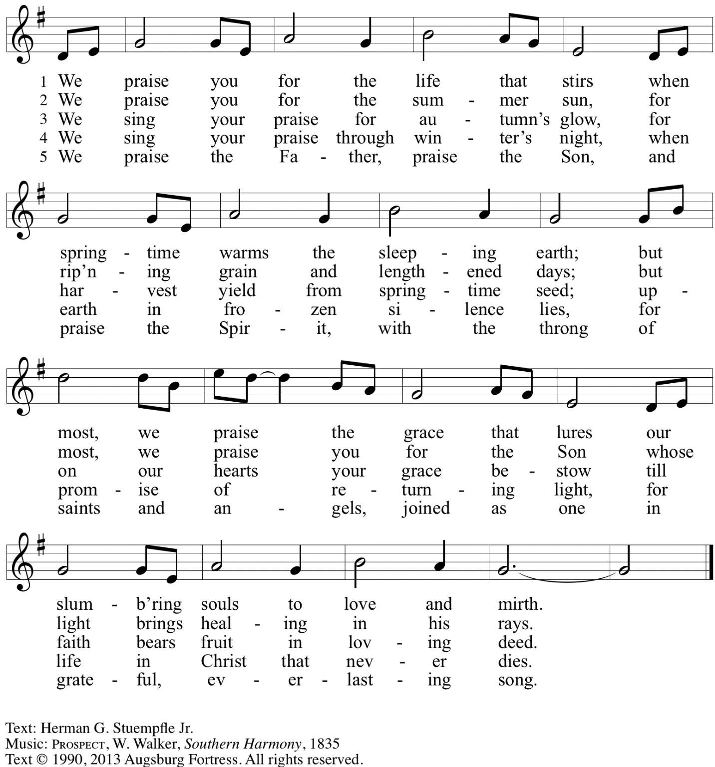
Reprinted with permission under OneLicense.net # A-722139.

Hymns during Holy Communion
I Heard the Voice of Jesus Say ELW 611

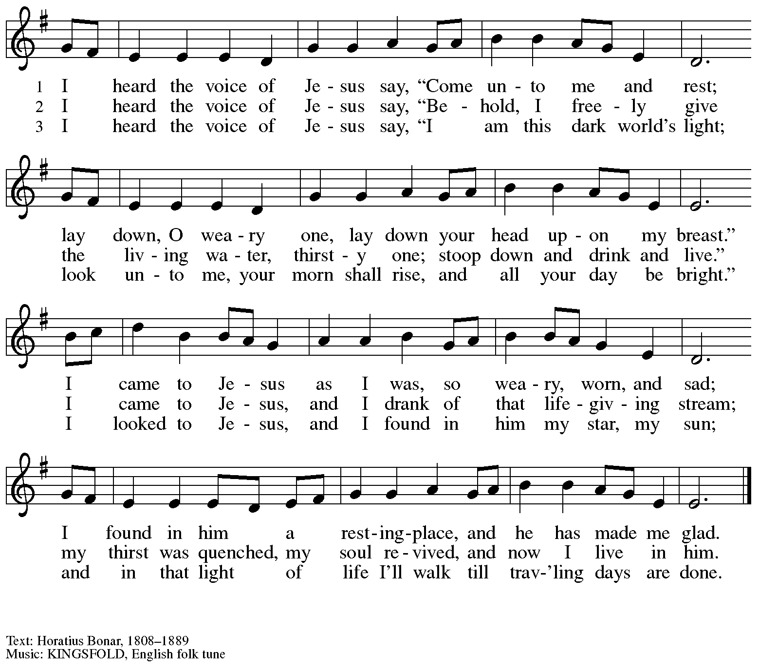

Hymns during Holy Communion
Look Who Gathers at Christ’s Table ACS 977

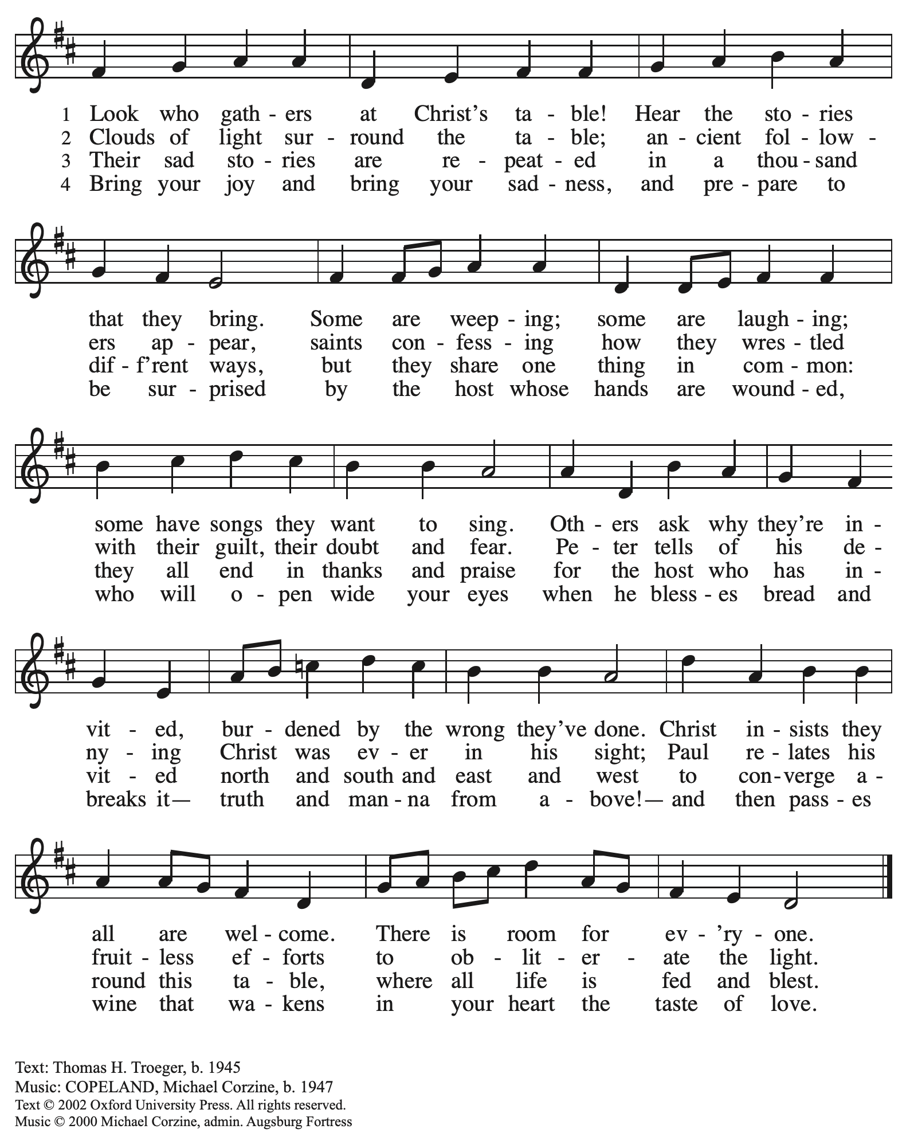
All rights reserved. Reprinted with permission under OneLicense.net # A-722139.

When all have returned to their places, please rise as you are able.

Blessing

P: The body and blood of our Lord Jesus Christ strengthen you and keep you in his grace.
C: Amen.

Prayer

A: Let us pray. Gracious God,
we give you thanks for your pruning, planting, and nurture.
We rejoice that you have used the harvest of field and vineyard
to renew and sustain us.
Lead us as we go from this life-giving meal
into lives of grateful service to you and your cherished creation;
through Jesus Christ, your Son, our Lord.
C: Amen.

Please be seated.

Sending
God blesses us and sends us in mission to the world

Announcements

Please rise as you are able.

Benediction

P: The God of steadfastness and encouragement
grant you to live in harmony with one another,
in accordance with Christ Jesus.
C: Amen.

P: The God of hope fill you with all joy and peace in believing,
so that you may abound in hope by the power of the Holy Spirit.
C: Amen.

P: The God of all grace ☩ bless you now and forever.
C: Amen.

Sending Hymn Just a Closer Walk with Thee ELW 697

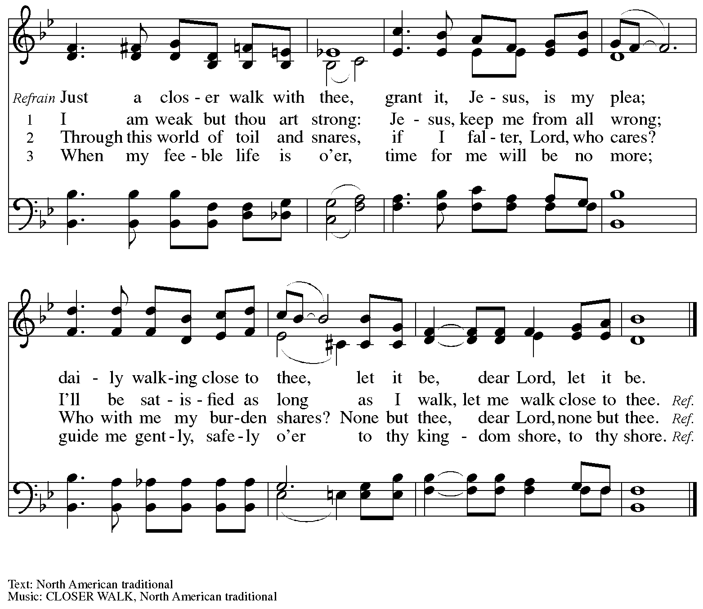

Dismissal

A: Go in peace. Serve the Lord.
C: Thanks be to God!

Postlude

Those serving in worship today

Altar Care Beverley Chapman
Assisting Minister Jeff Denlinger
Audio-Visual Ministers Noël Marsh
Colten Rohleder
Cantor Timothy Kocher-Hillmer
Lector Colleen Cooke
Minister of Music Laura Reynolds
Preaching and Presiding Minister Pastor Ross Carmichael

Liturgy and Hymnody Acknowledgements

From SundaysandSeasons.com. Copyright © 2023 Augsburg Fortress. All rights reserved. Reprinted under OneLicense.net # A-722139.
Used by permission of Augsburg Fortress.

Holy, Holy, Holy / Long, Long Ago in Jerusalem – Text: Beth Bergeron Folkemer, based on the Sanctus. Music: SHADY GROVE, Appalachian traditional. Text © 1990, 2013, Augsburg Fortress. All rights reserved. Reprinted with permission under OneLicense.net # A-722139.

Please use the QR code below to link to St. Andrew’s Announcements online!

St. Andrew Lutheran Church Announcements
July 9th, 2023

- Welcome to worship at St. Andrew on the Sixth Sunday after Pentecost, July 9th, 2023 – We are so glad you are here, and we offer a special welcome to all visitors and guests connecting for the first time! Worship attendees are invited to make a name tag at the back of the worship space if you would like. There are worship “toolkits” to help children engage with worship and “busy bags” for younger children available in the bookcase at the back of the sanctuary. Please feel free to take one to use with/for your children.
- July Produce Distribution – Second Tuesday, July 11th, Due to July 4th Holiday – St. Andrew’s fresh produce distribution in partnership with Greater Pittsburgh Community Food Bank is normally scheduled for the first Tuesday of each month, but in July it will be on the second Tuesday, July 11th, from 5:30-7:00 p.m. We also appreciate help with setup and unloading earlier in the day, usually some time between 10:00 a.m. and 1:00 p.m. If you would like to sign up in advance, please do so here: https://www.signupgenius.com/go/4090F45AFAF2BA75-produce5.
- Shelter Dinner at East End Cooperative Ministry – Thursday, July 20th, 6:30 p.m. –
The congregation’s monthly dinner for guests of the shelter at East End Cooperative Ministry (6140 Station St., 15206) will be Thursday, July 20th. We ask anyone dropping off food to deliver it by 6:00 p.m. so that service can begin at 6:30 p.m. If you would like to contribute a portion of the meal, or would like to help serve, please sign up here:
https://www.signupgenius.com/go/5080544AAAC22A1F58-july
- Christ in Our Home Devotional Booklets for July – September Available at Church Entrances – Throughout the year, St. Andrew makes available to the congregation Christ in Our Home, a booklet with daily Bible readings, reflections, and prayers. The July – September 2023 edition is available at the church entrances. Please take one!
- St. Andrew Updating Information - Please Respond! – St. Andrew is looking to update our records with current information and contact information from newer attendees, such as name, preferred pronouns, email, phone number, birthdays, anniversaries, and more. The information will only be used within the congregation. Please fill out the form at: https://forms.gle/fTwpdG2uA7pYD2ta8.

Stand Up for Fairness for All Pennsylvanians

This month, the nation's largest organization devoted to the rights of LGBTQ+ Americans declared a "state of emergency" in the U.S. amidst a growing number of dangerous and discriminatory policies. In Pennsylvania, more than half a million LGBTQ+ residents are vulnerable to discrimination every day because of a lack of express and enduring statutory protections at the state level. Tell your lawmakers it's time to make our Commonwealth a safe place for everyone to live, love and work as their authentic selves without fear of discrimination.

Pennsylvania remains the only state in the Northeast without an inclusive statewide nondiscrimination law. Passage of protections in Pennsylvania is a critical step to ensure LGBTQ people are treated with dignity in employment, housing, and public spaces.

Contact your lawmakers here.

Sign up here to join fellow Lutherans working for protections for LGBTQ+ Pennsylvanians and receive alerts about rallies and other opportunities to act. Please include FAIRNESS in the subject line.

The seven Pennsylvania bishops of the Evangelical Lutheran Church in America released a letter in support of legislation that would prohibit such discrimination.

"At this moment there is an opportunity for us to add our voices in support of legislation that could provide continuing legal protection for one particularly vulnerable group of our people," the bishops state in their letter "Fairness for All Pennsylvanians."
Read the full letter.

The letter points to the imagery of the "peaceable kingdom," described in Isaiah 11: 6, in which "the wolf shall live with the lamb, the leopard shall lie down with the kid, the calf and the lion and the fatling together, and a little child shall lead them." The words anticipate a renewal of all creation in which the identity of each creature remains but none experiences any harm from the others. "It is the fulfillment of this vision for which people of faith yearn, and toward which they call their neighbors," the bishops say in the letter. "The work of public advocacy, at its best, replaces the timid silence of resignation to what is, with a bold voice giving expression to what could be."

We recognize that the links above are not accessible on the printed page but we wanted to be sure to publish the information. Please see your “This Week at St. Andrew” email or scan the QR code above to access the clickable links. Thank you for your Advocacy!

