+ Eighth Sunday after Pentecost
July 23, 2023
St. Andrew Lutheran Church
304 Morewood Ave.
Pittsburgh, PA 15213
St_andrewELCA@verizon.net
www.standrewpittsburgh.org

+ Eighth Sunday after Pentecost
Order for Worship

Today’s Gospel addresses an age-old question: why is there evil in the world?
In the parable of the weeds and the wheat, Jesus suggests that both grow together until the harvest. With the apostle Paul, we long for the day when all creation will be set free from bondage and suffering. Having both weeds and wheat within us, we humbly place our hopes in the promises of God, and from the Lord’s table we are sent out to bear the fruit of justice and mercy in the world.
Welcome to St. Andrew!

- St. Andrew Lutheran congregation welcomes all who are seeking a place of healing and wholeness – a nurturing, faith-forming spiritual home. Our community embraces people of all ages, ethnicities, cultures, abilities, sexual orientations, gender identities and expressions, and family constellations. Come and See!

- Worship Services are live streamed to multiple online platforms. By attending worship, you agree that your image and voice may be broadcast.

- Everyone is invited to make a nametag at the black bookcase in the back of the worship space if they would like. There are stickers indicating pronouns on the bookcase if you would like to include them on your name tag.

- Worship “toolkits” to help children engage with the service, along with “busy bags” for younger children, are available in the bookcase at the back of the sanctuary. Please feel free to take one to use with/for your children.

- Holy Communion is served with bread (gluten-free available) and wine or grape juice. The presiding minister will distribute the bread (host). Please consume this and then pick up an empty glass from the tray. The Communion Assistant will pour wine or grape juice into your glass. Please step to the side to consume the wine or grape juice. Feel free to kneel at the altar for prayer and reflection. As you return to your pew, glasses may be returned to the empty trays on either side of the center section.

- A restroom is available on the main level of the church, through the doors to the Social Hall and to the right in the main office.

Abbreviations
P: Pastor/Presiding Minister ACS: All Creation Sings hymnal
A: Assisting Minister ELW: Evangelical Lutheran Worship hymnal
L: Lector
C: Congregation

Pre-Service Music

Welcome

Prelude Faithfulness Raney

Gathering
The Holy Spirit calls us together as the people of God

Confession and Forgiveness

Please rise as you are able.
All may make the sign of the cross, the sign that is marked at Baptism,
as the presiding minister begins.

P: Blessed be the holy Trinity, ☩ one God,
who greets us in this and every season, whose word never fails, whose promise is sure.
C: Amen.

P: Let us confess our sin in the presence of God and of our neighbors.

P: Merciful God,
C: we confess that we have sinned.
We have hurt our community.
We have squandered your blessings.
We have hoarded your bounty.
In the name of Jesus, forgive us and grant us your mercy. Amen.

Silence is kept for reflection.

P: Righteous God,
we confess that we have sinned.
We have failed to be honest.
We have lacked the courage to speak.
We have spoken falsely.
In the name of Jesus, forgive us and grant us your mercy. Amen.

Silence is kept for reflection.

P: God is a cup of cold water when we thirst.
God offers boundless grace when we fail.
Claim the gift of God’s mercy:
you are freed and forgiven in the name of ☩ Jesus Christ.
C: Amen.

Gathering Hymn Praise and Thanksgiving ELW 689

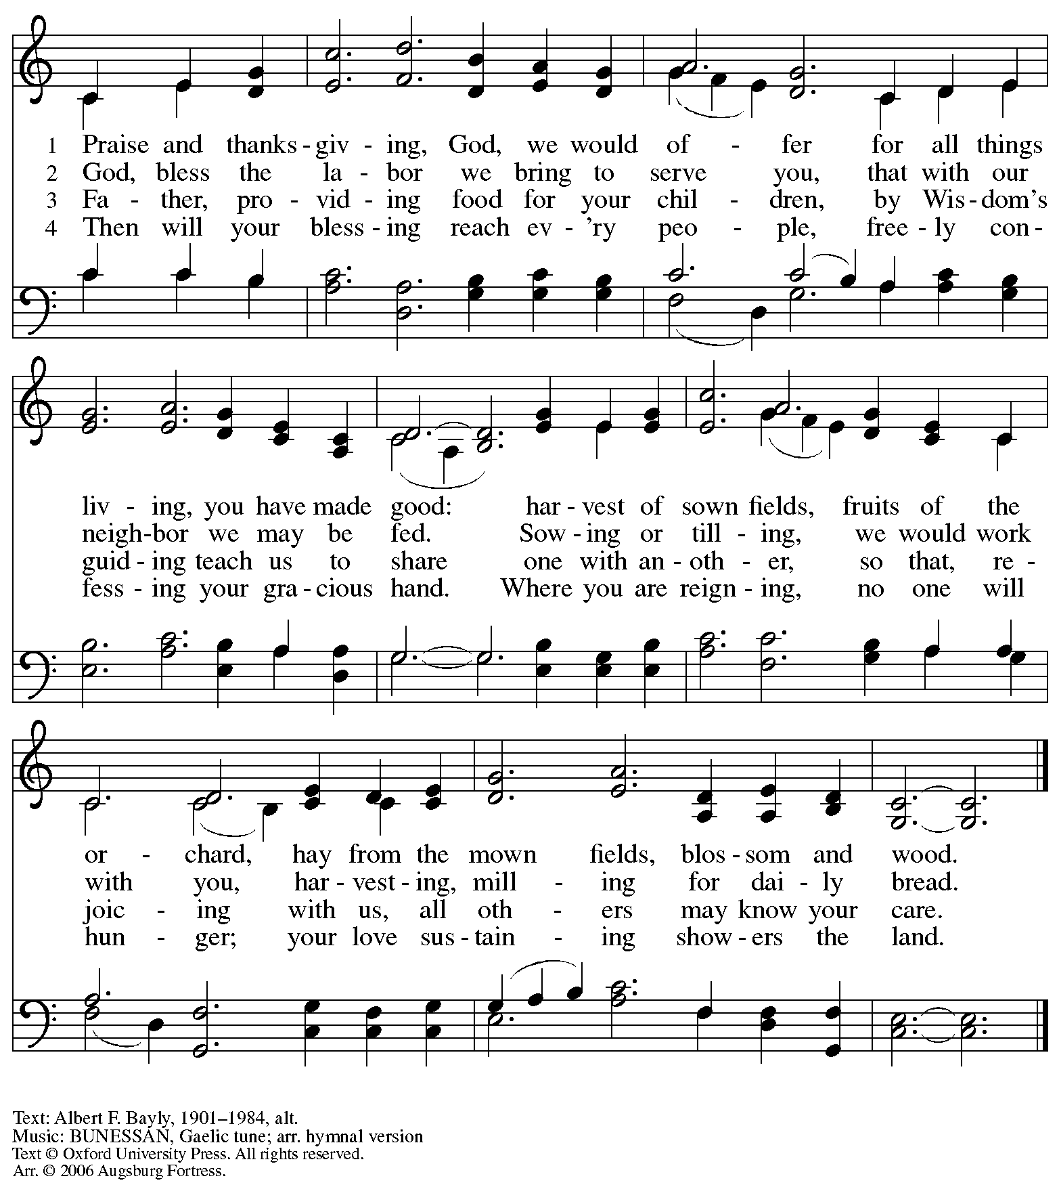
Reprinted with permission under OneLicense.net # A-722139.

Greeting

P: The grace of our Lord Jesus Christ, the love of God,
and the communion of the Holy Spirit be with you all.
C: And also with you.

Prayer of the Day

P: Let us pray.
Faithful God, most merciful judge,
you care for your children with firmness and compassion.
By your Spirit nurture us who live in your kingdom,
that we may be rooted in the way of your Son, Jesus Christ, our Savior
C: Amen.

Please be seated.

Word
God speaks to us in Scripture reading, preaching, and song

First Reading – Isaiah 44: 6-8

⁶Thus says the Lord, the King of Israel,
and God’s Redeemer, the Lord of hosts:
I am the first and I am the last;
besides me there is no god.
⁷Who is like me? Let them proclaim it,
let them declare and set it forth before me.
Who has announced from of old the things to come?
Let them tell us what is yet to be.
⁸Do not fear, or be afraid;
have I not told you from of old and declared it?
You are my witnesses!
Is there any god besides me?
There is no other rock; I know not one.

L: Word of God, word of life.
C: Thanks be to God.

Psalm 86: 11-17

The psalm will be sung by two cantors.

Teach me your way, O Lord, and I will walk in your truth. (Ps. 86: 11)
Second Reading – Romans 8: 12-25

¹²So then, kindred, we are debtors, not to the flesh, to live according to the flesh—¹³for if you live according to the flesh, you will die; but if by the Spirit you put to death the deeds of the body, you will live. ¹⁴For all who are led by the Spirit of God are children of God. ¹⁵For you did not receive a spirit of slavery to fall back into fear, but you have received a spirit of adoption. When we cry, “Abba! Father!” ¹⁶it is that very Spirit bearing witness with our spirit that we are children of God, ¹⁷and if children, then heirs, heirs of God and joint heirs with Christ—if, in fact, we suffer with him so that we may also be glorified with him.
¹⁸I consider that the sufferings of this present time are not worth comparing with the glory about to be revealed to us. ¹⁹For the creation waits with eager longing for the revealing of the children of God; ²⁰for the creation was subjected to futility, not of its own will but by the will of the one who subjected it, in hope ²¹that the creation itself will be set free from its bondage to decay and will obtain the freedom of the glory of the children of God. ²²We know that the whole creation has been groaning in labor pains until now; ²³and not only the creation, but we ourselves, who have the first fruits of the Spirit, groan inwardly while we wait for adoption, the redemption of our bodies. ²⁴For in hope we were saved. Now hope that is seen is not hope. For who hopes for what is seen? ²⁵But if we hope for what we do not see, we wait for it with patience.

L: Word of God, word of life.
C: Thanks be to God.

Please rise as you are able.

Gospel Acclamation Lord, Let My Heart Be Good Soil ELW 512

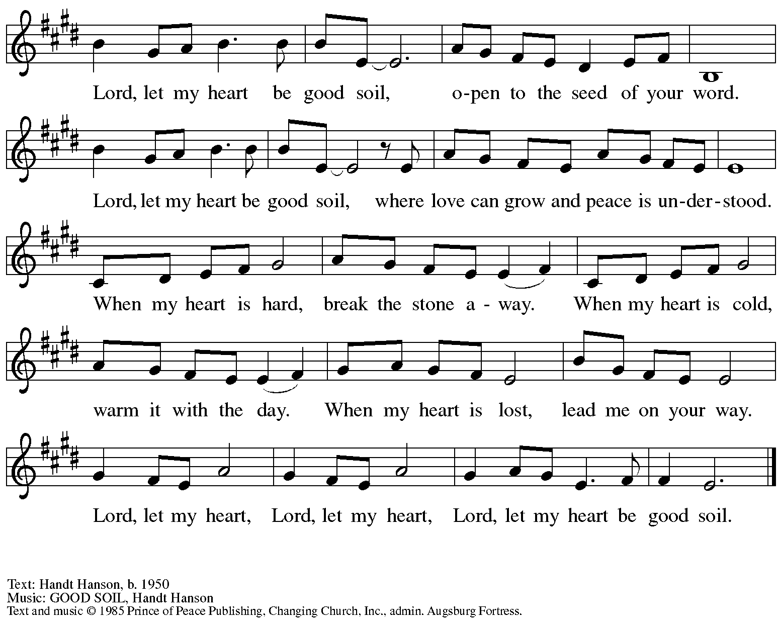
All rights reserved. Reprinted with permission under OneLicense.net # A-722139.

Gospel – Matthew 13: 24-30, 36-43

P: The holy Gospel according to St. Matthew.
C: Glory to you, O Lord.

²⁴[Jesus] put before [the crowds] another parable: “The kingdom of heaven may be compared to someone who sowed good seed in his field; ²⁵but while everybody was asleep, an enemy came and sowed weeds among the wheat, and then went away. ²⁶So when the plants came up and bore grain, then the weeds appeared as well. ²⁷And the slaves of the householder came and said to him, ‘Master, did you not sow good seed in your field? Where, then, did these weeds come from?’ ²⁸He answered, ‘An enemy has done this.’ The slaves said to him, ‘Then do you want us to go and gather them?’ ²⁹But he replied, ‘No; for in gathering the weeds you would uproot the wheat along with them. ³⁰Let both of them grow together until the harvest; and at harvest time I will tell the reapers, Collect the weeds first and bind them in bundles to be burned, but gather the wheat into my barn.’”
³⁶Then he left the crowds and went into the house. And his disciples approached him, saying, “Explain to us the parable of the weeds of the field.” ³⁷He answered, “The one who sows the good seed is the Son of Humanity; ³⁸the field is the world, and the good seed are the children of the kingdom; the weeds are the children of the evil one, ³⁹and the enemy who sowed them is the devil; the harvest is the end of the age, and the reapers are angels. ⁴⁰Just as the weeds are collected and burned up with fire, so will it be at the end of the age. ⁴¹The Son of Humanity will send his angels, and they will collect out of his kingdom all causes of sin and all evildoers, ⁴²and they will throw them into the furnace of fire, where there will be weeping and gnashing of teeth. ⁴³Then the righteous will shine like the sun in the kingdom of their Father. Let anyone with ears listen!”

P: The Gospel of the Lord.
C: Praise to you, O Christ.

Please be seated.

Sermon

A time of silence for prayer and reflection follows the sermon.
When the hymn of the day begins, please rise as you are able.

Hymn of the Day The Reign of God, Like Farmer’s Field Following page
v. 1, 5

Hymn of the Day The Reign of God, Like Farmer’s Field ACS 952
v. 1, 5

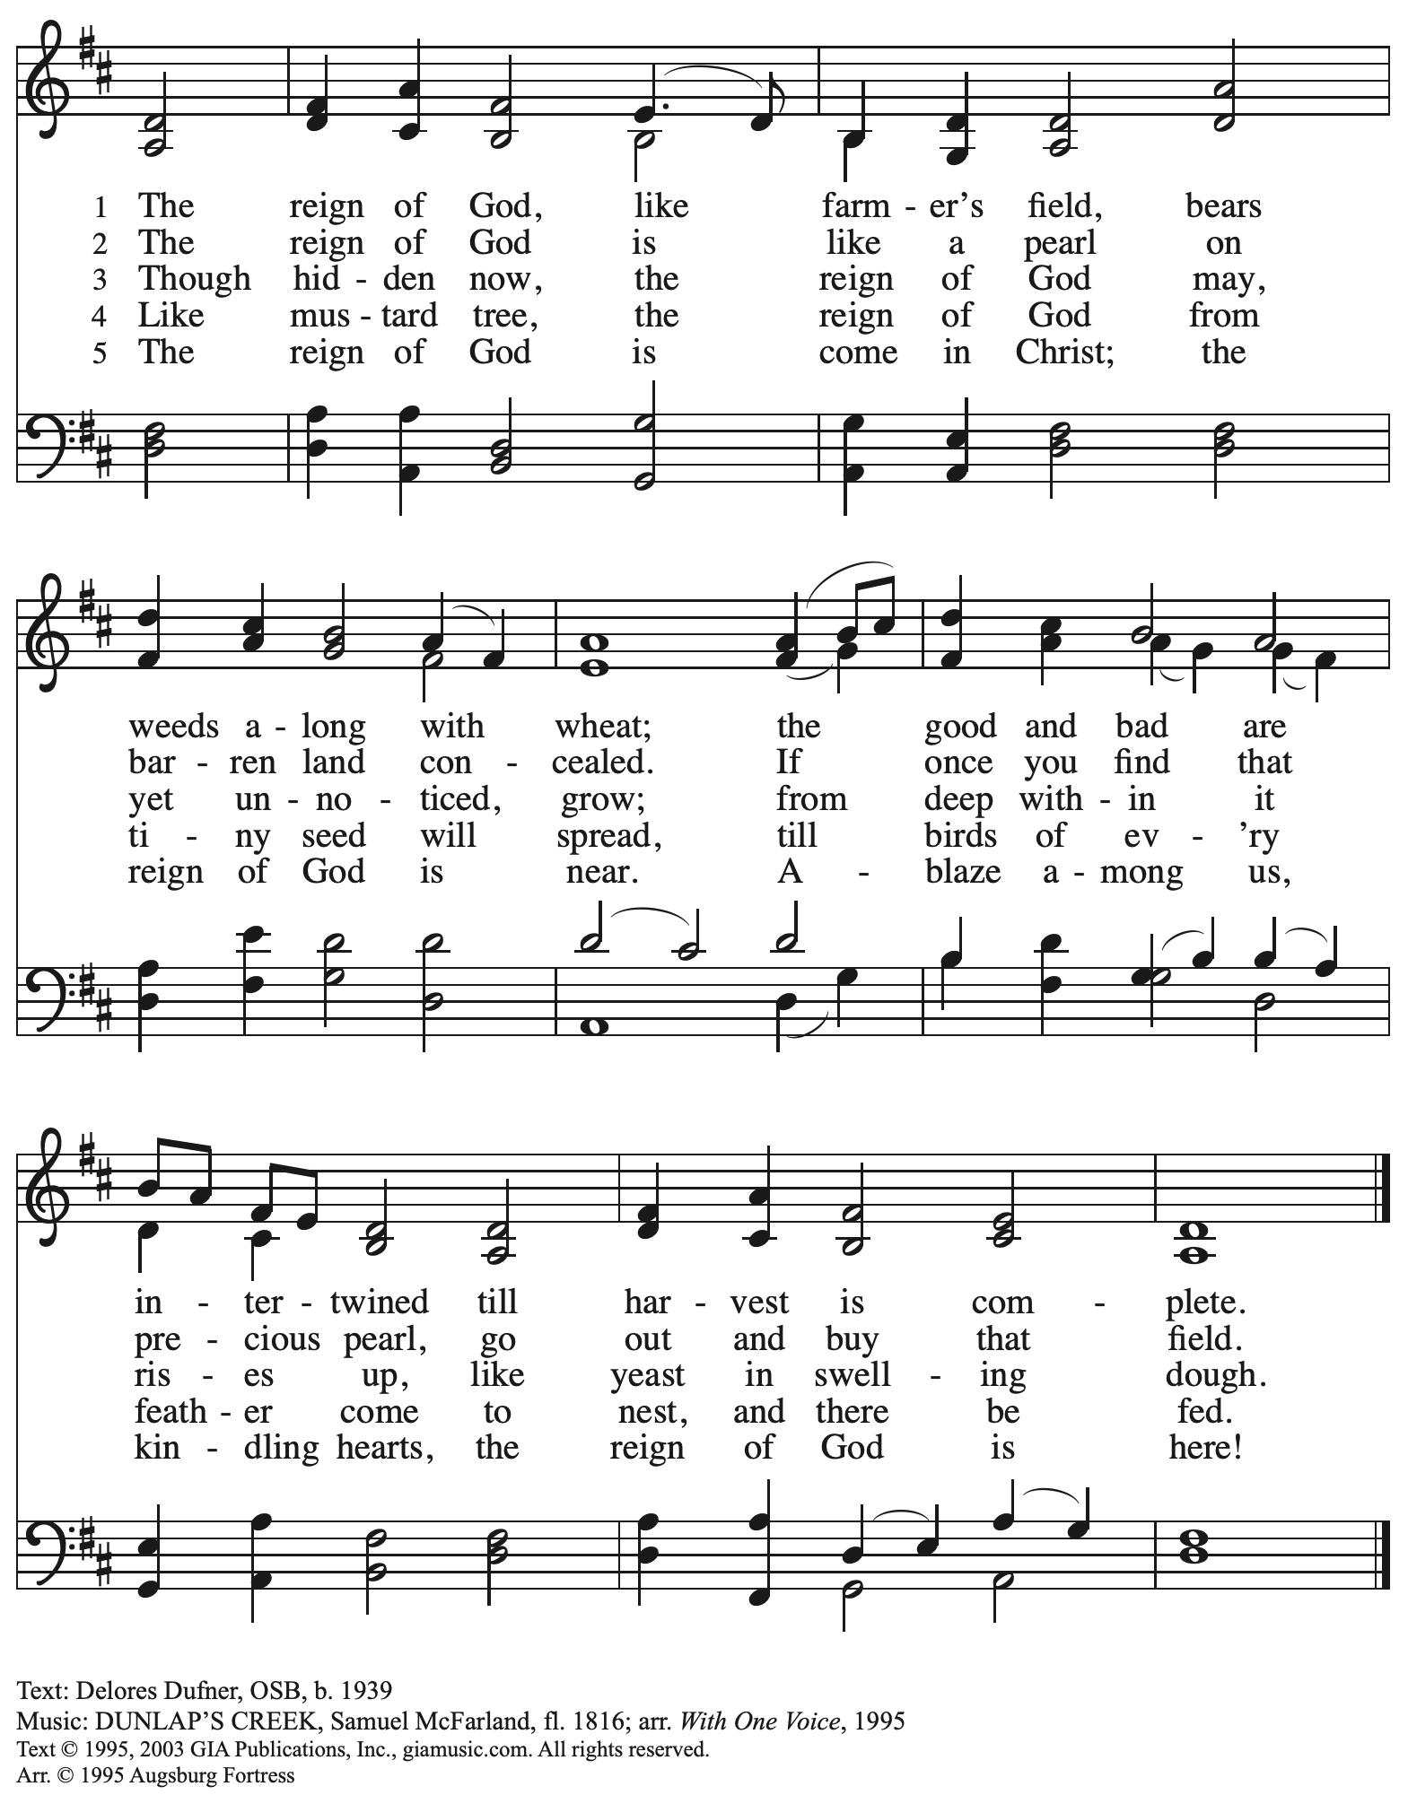
Reprinted with permission under OneLicense.net # A-722139.

Prayers of the People

A: Confident that God receives our joys and concerns, let us offer our prayers for the church,
those in need, and all of God’s creation.

After each petition
A: Hear us, O God;
C: Your mercy is great.

The presiding minister concludes the prayers
P: Into your hands, O God, we commend all for whom we pray,
in the name of the one who reconciled all creation with you, Jesus Christ our Savior.
C: Amen.

Peace

The presiding minister and the assembly greet one another in the peace of the risen Christ.
P: The peace of Christ be with you always.
C: And also with you.

The people may greet those around them with a sign of Christ’s peace and may say
Peace be with you or similar words. Please be mindful that not everyone will be comfortable with sharing the peace, so please seek consent before shaking hands or hugging. Other possible ways to share the peace include a simple bow with the verbal greeting of peace, or simply a verbal expression of peace.

When the greetings of peace have concluded, please be seated.

Meal
God feeds us with the presence of Jesus Christ

Offering

We offer ourselves, our gifts, and our faithful service to God.
As the offering is gathered for the mission of the church, including the care of those in need,
the table is set for Holy Communion.

Music during the Offering

As the gifts are brought forward for presentation, please rise as you are able.

Offertory Song ELW 680
Aramos nuestros campos / We Plow the Fields and Scatter

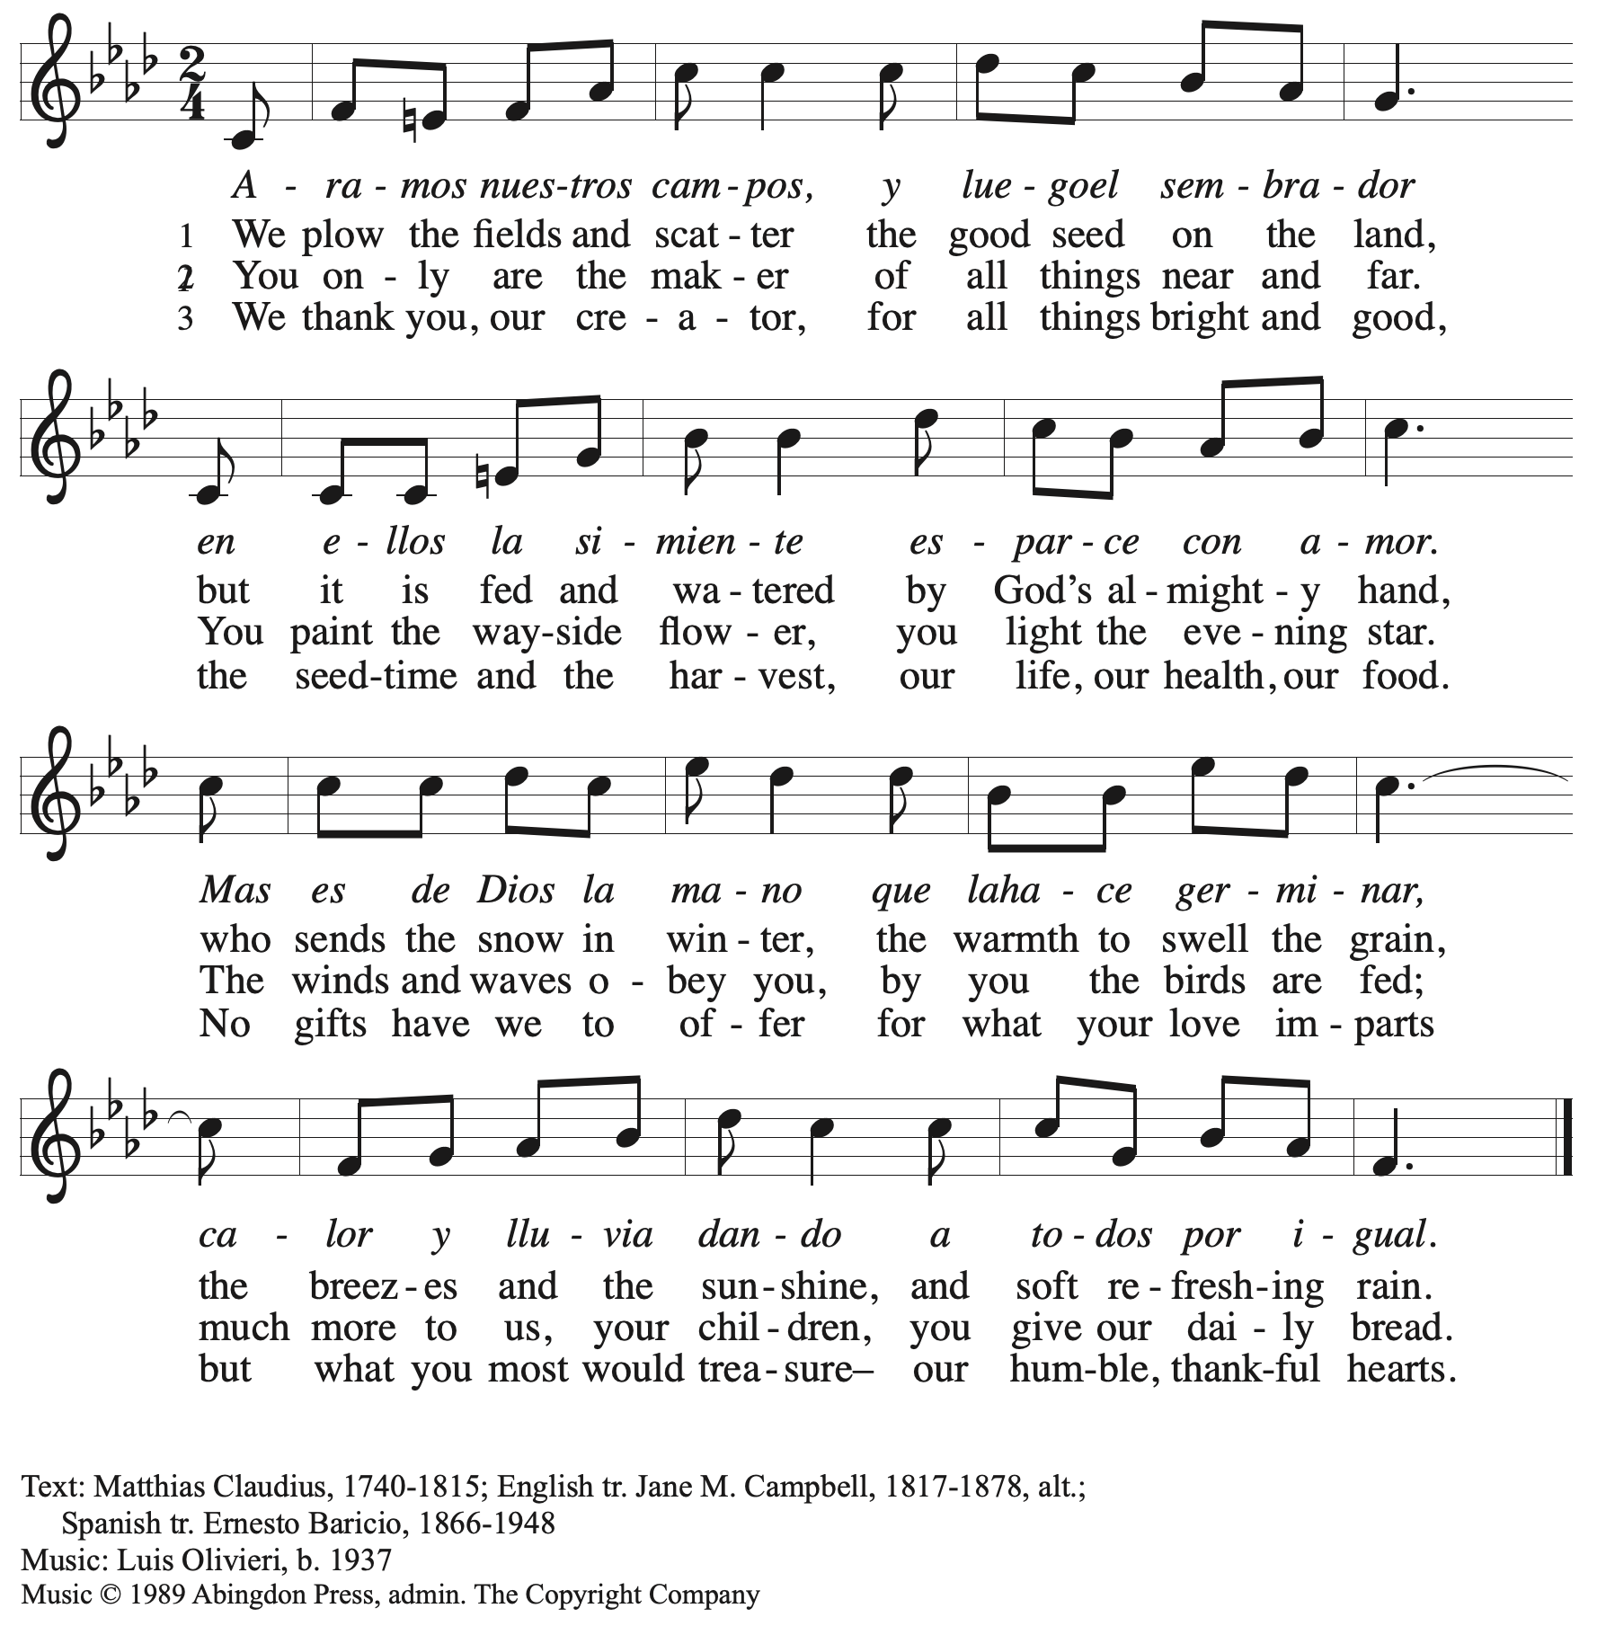
All rights reserved. Reprinted with permission under OneLicense.net # A-722139.

Offertory Prayer

A: Let us pray.
God of field and forest, sea and sky,
C: you are the giver of all good things.
Sustain us with these gifts of your creation,
and multiply your graciousness in us,
that the world may be fed with your love,
through Jesus Christ, our Savior and Lord.
Amen.

Dialogue

P: The Lord be with you.
C: And also with you.

P: Lift up your hearts.
C: We lift them to the Lord.

P: Let us give thanks to the Lord our God.
C: It is right to give our thanks and praise.

Preface

P: It is indeed right, our duty and our joy …
… we praise your name and join their unending hymn:

Sanctus

C: Holy, holy, holy Lord, God of power and might,
Heaven and earth are full of your glory; Hosanna in the highest!
Blessed is the one who comes in the name of the Lord!
Hosanna in the highest!

Eucharistic Prayer

P: Holy, mighty, and merciful Lord …
… to whom, with you and the Holy Spirit,
be all honor and glory, now and forever.
C: Amen.

Lord’s Prayer

P: Gathered as one by the Holy Spirit, let us pray as Jesus taught us.
C: Our Father in heaven,
hallowed be your name,
your kingdom come,
your will be done,
on earth as in heaven.
Give us today our daily bread.
Forgive us our sins
as we forgive those
who sin against us.
Save us from the time of trial
and deliver us from evil.
For the kingdom, the power,
and the glory are yours,
now and forever. Amen.

Fraction and Invitation

Agnus Dei / Lamb of God

C: Lamb of God, you take away the sin of the world; have mercy on us.
Lamb of God, you take away the sin of the world; have mercy on us.
Lamb of God, you take away the sin of the world; grant us peace.

Please be seated.

Holy Communion
- All who seek God and desire a deeper and stronger life in Christ are welcome to receive Holy Communion.
- Worshipers from the pulpit side will proceed forward first, followed by the center section, and then the lectern side.
- Please inform an usher if you would like the ministers to bring Communion to you.
- Holy Communion will be served with bread and wine/grape juice.
- The presiding minister will first distribute the bread (host) to each communicant. Please indicate if you require a gluten-free host.
- Once you have consumed the bread, please pick up an empty glass from the tray next to the presiding minister. The Communion Assistant will pour wine from the chalice or grape juice from the cruet into your glass.
- Please step to the side to consume the wine or grape juice.
- Feel free to kneel at the altar rail for prayer after receiving the sacrament.
- As you return to your pew, glasses may be returned to the empty trays on either side of the center section.
- A blessing will be provided for anyone who does not yet receive the sacrament.
- All are invited to join in singing the hymns during Holy Communion.

Hymns during Holy Communion
As the Grains of Wheat ELW 465

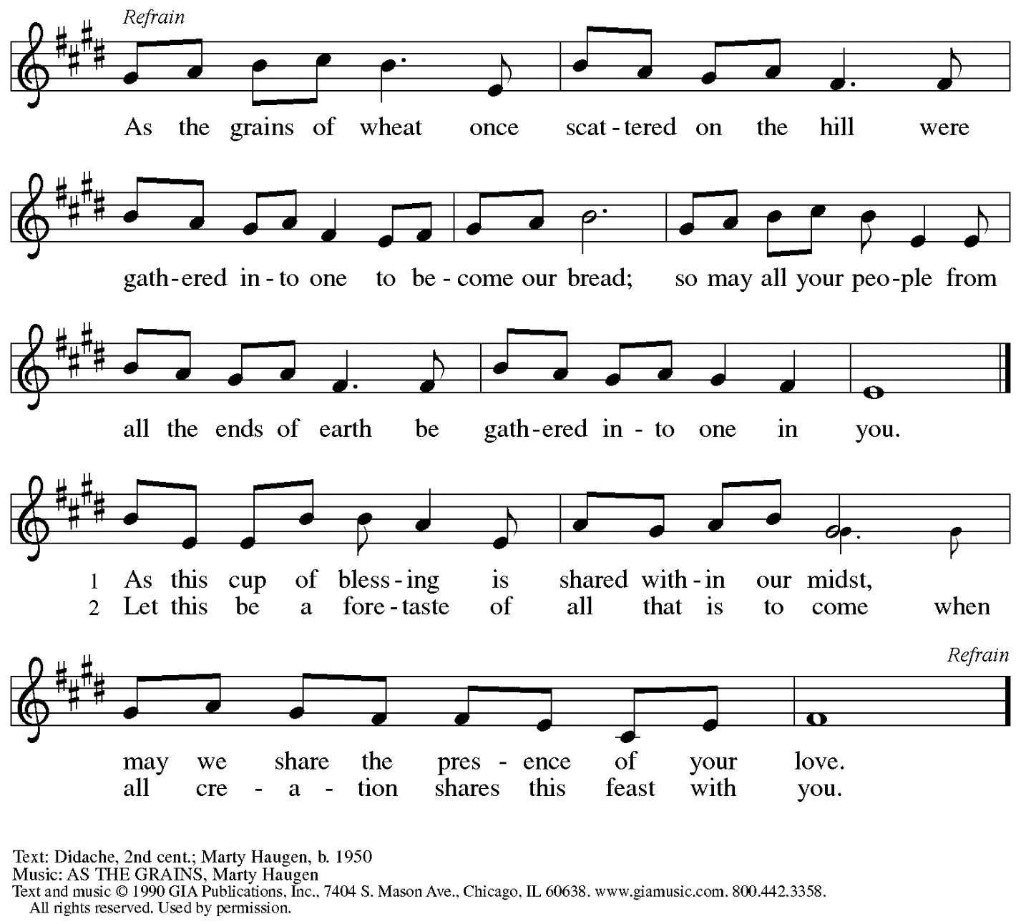
Reprinted with permission under OneLicense.net # A-722139.

Hymns during Holy Communion
The Word of God Is Source and Seed ELW 506

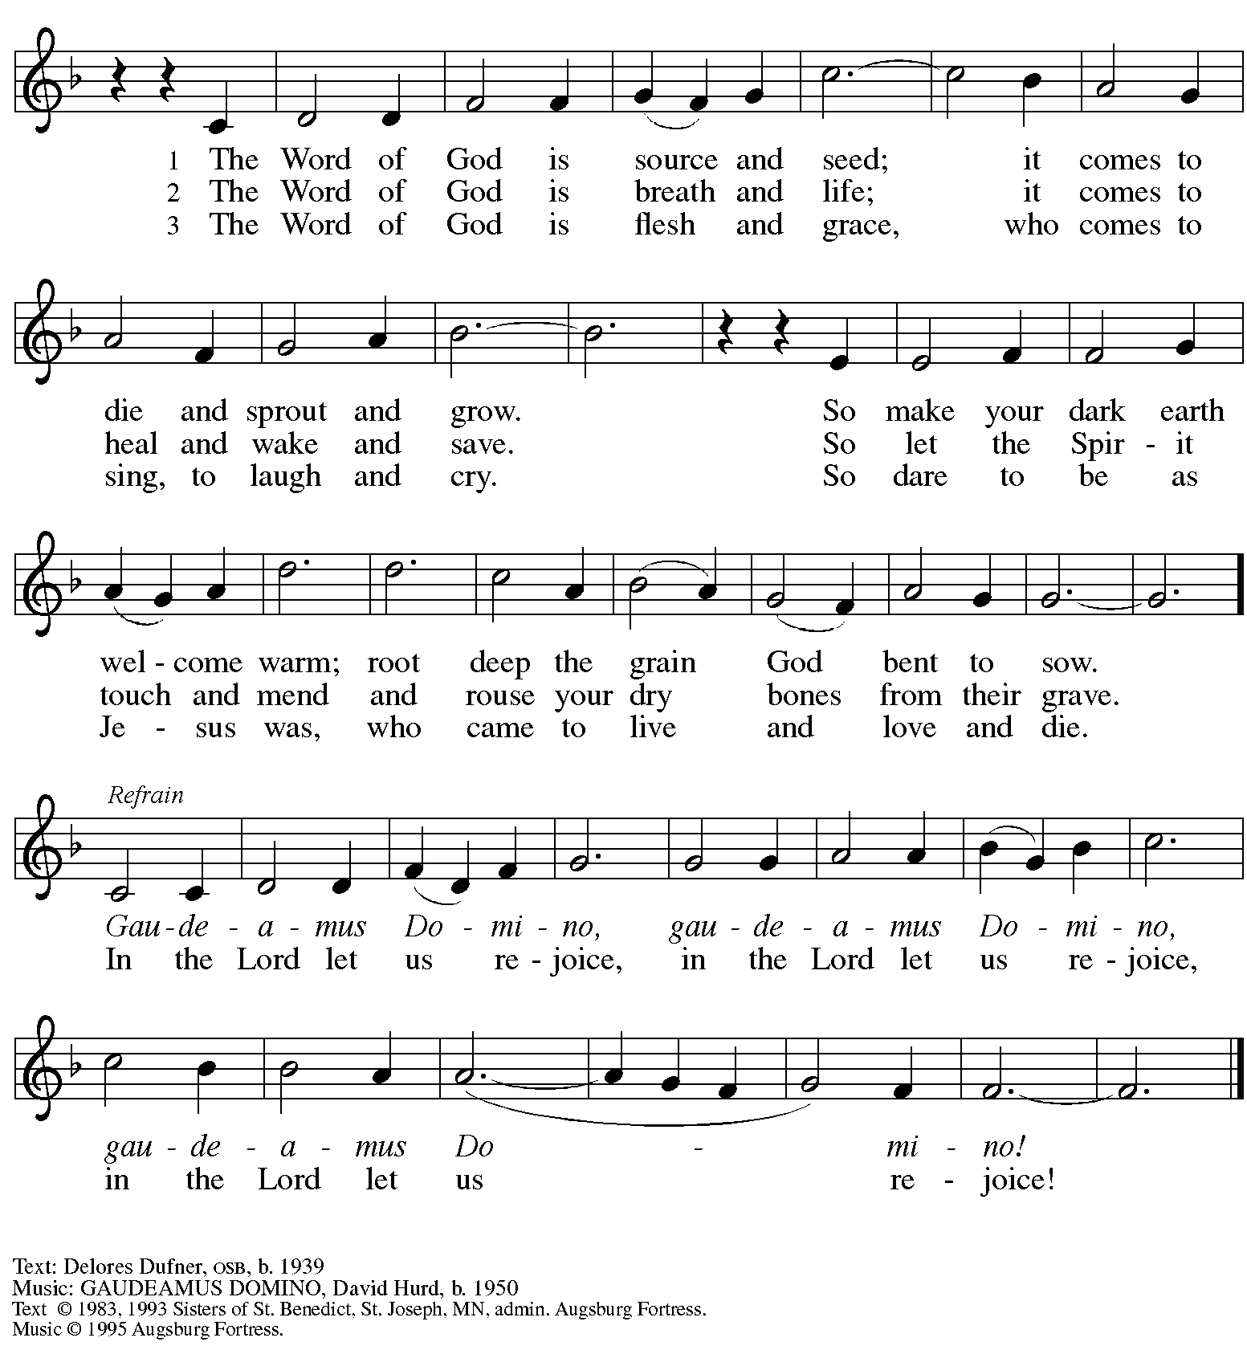
All rights reserved. Reprinted with permission under OneLicense.net # A-722139.

Hymns during Holy Communion
Almighty God, Your Word Is Cast ELW 516

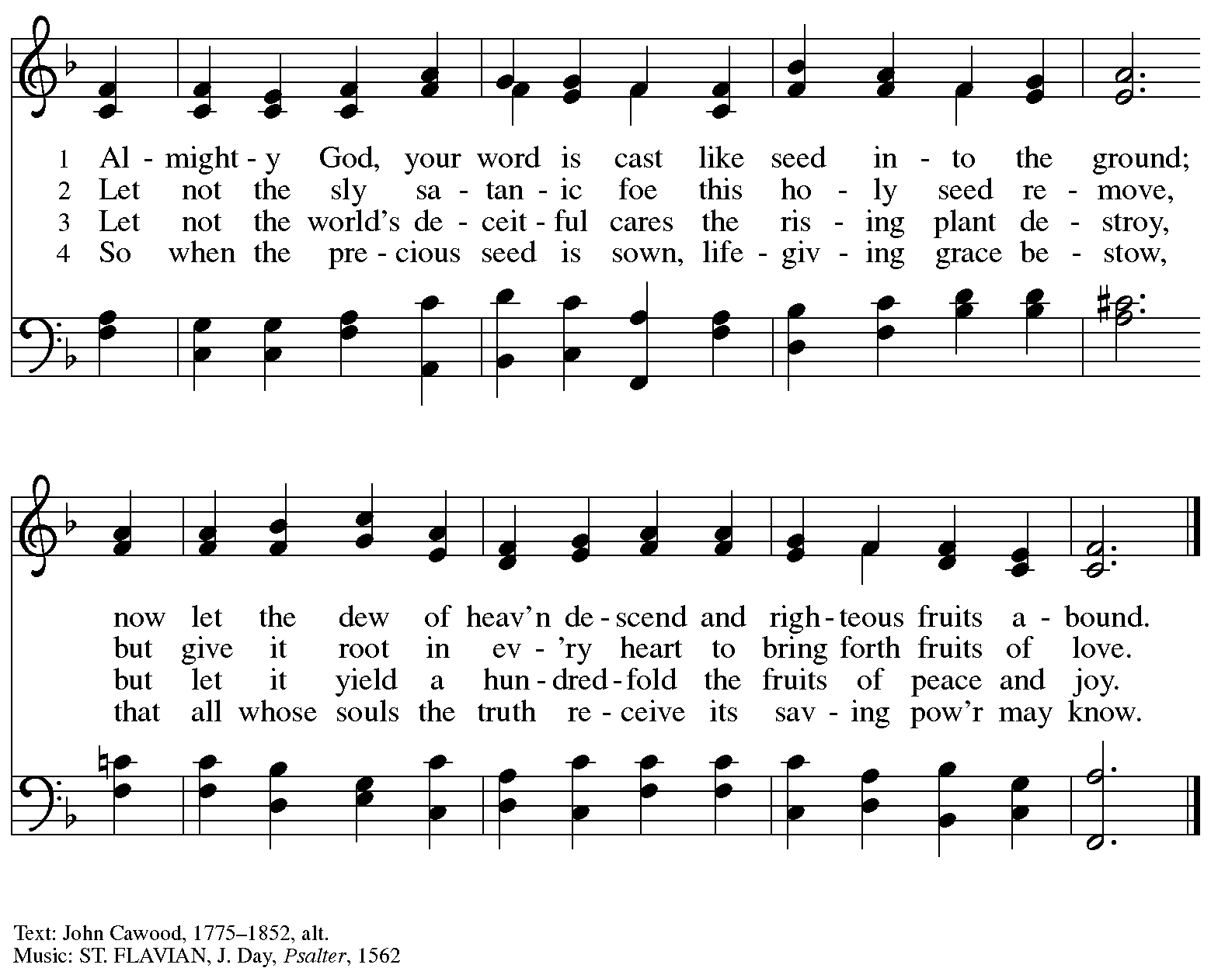

When all have returned to their places, please rise as you are able.

Blessing

P: The body and blood of our Lord Jesus Christ strengthen you and keep you in his grace.
C: Amen.

Prayer

A: Let us pray.
We thank you, generous God,
for the refreshment we have received
at your banquet table.
Send us now to spread your generosity into all the world,
through the one who is our dearest treasure,
Jesus Christ, our Savior and Lord.
C: Amen.

Please be seated.

Sending
God blesses us and sends us in mission to the world

Announcements

Please rise as you are able.

Benediction

P: The God who calls across the cosmos
and works through the smallest seed
☩ bless, keep, and sustain you,
now and to the end of the age.
C: Amen.

Sending Hymn Spread, Oh, Spread, Almighty Word Following page

Dismissal

A: Go in peace. Serve the Lord.
C: Thanks be to God!

Postlude

Sending Hymn Spread, Oh, Spread, Almighty Word ELW 663

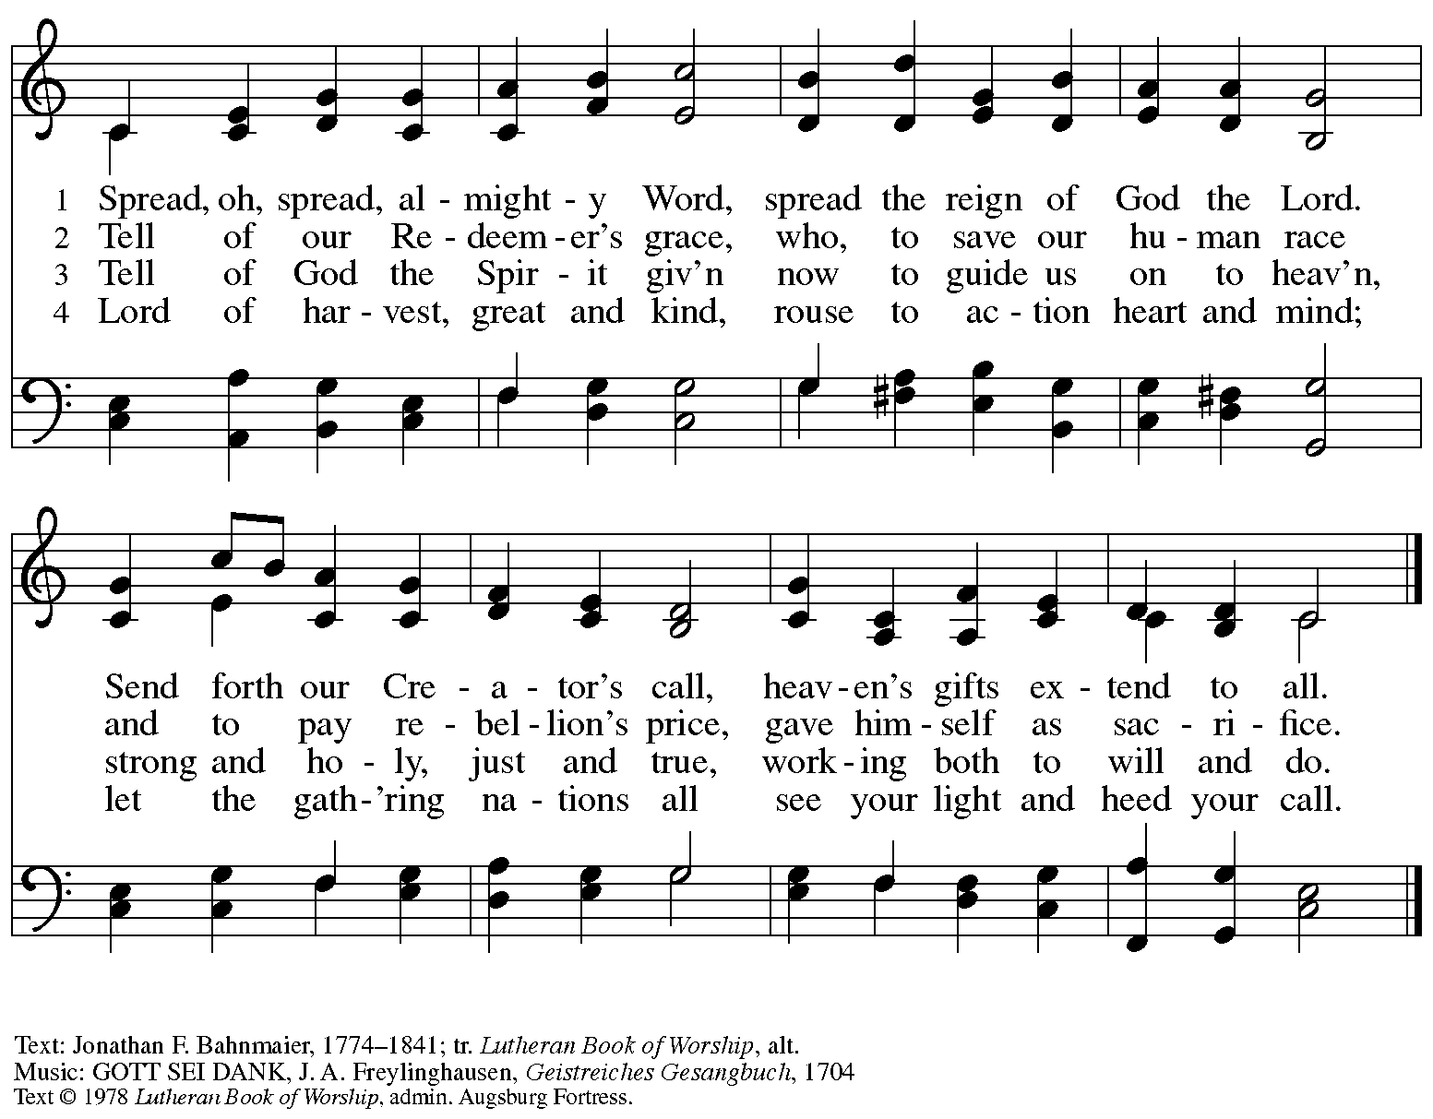
All rights reserved. Reprinted with permission under OneLicense.net # A722139.

Those serving in worship today

Altar Care Jodie Minor
Assisting Minister Timothy Kocher-Hillmer
Audio-Visual Ministers Kristen Asplin
David Rollinson
Cantor Noël Marsh
Assisting Musician Emily Duque
Lector Libby Marker
Minister of Music Laura Reynolds
Preaching and Presiding Minister Pastor Ross Carmichael

Liturgy and Hymnody Acknowledgements

From SundaysandSeasons.com. Copyright © 2023 Augsburg Fortress. All rights reserved. Reprinted under OneLicense.net # A-722139.
Used by permission of Augsburg Fortress.

Please use the QR code below to link to St. Andrew’s Announcements online!

St. Andrew Lutheran Church Announcements
July 23rd, 2023

- Welcome to worship at St. Andrew on the Eighth Sunday after Pentecost, July 23rd, 2023 – We are so glad you are here, and we offer a special welcome to all visitors and guests connecting for the first time! Worship attendees are invited to make a name tag at the back of the worship space if you would like. There are worship “toolkits” to help children engage with worship and “busy bags” for younger children available in the bookcase at the back of the sanctuary. Please feel free to take one to use with/for your children.
- Christ in Our Home Devotional Booklets for July – September Available at Church Entrances – Throughout the year, St. Andrew makes available to the congregation Christ in Our Home, a booklet with daily Bible readings, reflections, and prayers. The July – September 2023 edition is available at the church entrances. Please take one!
- St. Andrew Updating Information - Please Respond! – St. Andrew is looking to update our records with current information and contact information from newer attendees, such as name, preferred pronouns, email, phone number, birthdays, anniversaries, and more. The information will only be used within the congregation. Please fill out the form at: https://forms.gle/fTwpdG2uA7pYD2ta8.

Stand Up for Fairness for All Pennsylvanians

This month, the nation's largest organization devoted to the rights of LGBTQ+ Americans declared a "state of emergency" in the U.S. amidst a growing number of dangerous and discriminatory policies. In Pennsylvania, more than half a million LGBTQ+ residents are vulnerable to discrimination every day because of a lack of express and enduring statutory protections at the state level. Tell your lawmakers it's time to make our Commonwealth a safe place for everyone to live, love and work as their authentic selves without fear of discrimination.

Pennsylvania remains the only state in the Northeast without an inclusive statewide nondiscrimination law. Passage of protections in Pennsylvania is a critical step to ensure LGBTQ people are treated with dignity in employment, housing, and public spaces.

Contact your lawmakers here.

Sign up here to join fellow Lutherans working for protections for LGBTQ+ Pennsylvanians and receive alerts about rallies and other opportunities to act. Please include FAIRNESS in the subject line.

The seven Pennsylvania bishops of the Evangelical Lutheran Church in America released a letter in support of legislation that would prohibit such discrimination.

"At this moment there is an opportunity for us to add our voices in support of legislation that could provide continuing legal protection for one particularly vulnerable group of our people," the bishops state in their letter "Fairness for All Pennsylvanians."
Read the full letter.

The letter points to the imagery of the "peaceable kingdom," described in Isaiah 11: 6, in which "the wolf shall live with the lamb, the leopard shall lie down with the kid, the calf and the lion and the fatling together, and a little child shall lead them." The words anticipate a renewal of all creation in which the identity of each creature remains but none experiences any harm from the others. "It is the fulfillment of this vision for which people of faith yearn, and toward which they call their neighbors," the bishops say in the letter. "The work of public advocacy, at its best, replaces the timid silence of resignation to what is, with a bold voice giving expression to what could be."

We recognize that the links above are not accessible on the printed page but we wanted to be sure to publish the information. Please see your “This Week at St. Andrew” email or scan the QR code above to access the clickable links. Thank you for your Advocacy!

