+ Ninth Sunday after Pentecost
July 30, 2023
St. Andrew Lutheran Church
304 Morewood Ave.
Pittsburgh, PA 15213
St_andrewELCA@verizon.net
www.standrewpittsburgh.org

+ Ninth Sunday after Pentecost
Order for Worship

As Solomon, a king of Israel, prayed for wisdom, we seek to more deeply know the treasures of faith. In today’s gospel Jesus offers everyday images that reveal to us the reign of God: a tree that becomes a sheltering home, yeast that is secretly added and expands, a treasured pearl, a net that gains a great catch. Even as we seek the riches of God’s reign, the great surprise is that God finds us first!
Welcome to St. Andrew!

- St. Andrew Lutheran congregation welcomes all who are seeking a place of healing and wholeness – a nurturing, faith-forming spiritual home. Our community embraces people of all ages, ethnicities, cultures, abilities, sexual orientations, gender identities and expressions, and family constellations. Come and See!

- Worship Services are live streamed to multiple online platforms. By attending worship, you agree that your image and voice may be broadcast.

- Everyone is invited to make a nametag at the black bookcase in the back of the worship space if they would like. There are stickers indicating pronouns on the bookcase if you would like to include them on your name tag.

- Worship “toolkits” to help children engage with the service, along with “busy bags” for younger children, are available in the bookcase at the back of the sanctuary. Please feel free to take one to use with/for your children.

- Holy Communion is served with bread (gluten-free available) and wine or grape juice. The presiding minister will distribute the bread (host). Please consume this and then pick up an empty glass from the tray. The Communion Assistant will pour wine or grape juice into your glass. Please step to the side to consume the wine or grape juice. Feel free to kneel at the altar for prayer and reflection. As you return to your pew, glasses may be returned to the empty trays on either side of the center section.

- A restroom is available on the main level of the church, through the doors to the Social Hall and to the right in the main office.

Abbreviations
P: Pastor/Presiding Minister ACS: All Creation Sings hymnal
A: Assisting Minister ELW: Evangelical Lutheran Worship hymnal
L: Lector W&P: Worship and Praise hymnal
C: Congregation

Pre-Service Music

Welcome

Prelude

Gathering
The Holy Spirit calls us together as the people of God

Confession and Forgiveness

Please rise as you are able.
All may make the sign of the cross, the sign that is marked at Baptism,
as the presiding minister begins.

P: Blessed be the holy Trinity, ☩ one God,
who greets us in this and every season, whose word never fails, whose promise is sure.
C: Amen.

P: Let us confess our sin in the presence of God and of our neighbors.

Silence is kept for reflection.

P: Merciful God,
C: we confess that we have sinned.
We have hurt our community.
We have squandered your blessings.
We have hoarded your bounty.
In the name of Jesus, forgive us and grant us your mercy. Amen.

Silence is kept for reflection.

P: Righteous God,
we confess that we have sinned.
We have failed to be honest.
We have lacked the courage to speak.
We have spoken falsely.
In the name of Jesus, forgive us and grant us your mercy. Amen.

P: God is a cup of cold water when we thirst.
God offers boundless grace when we fail.
Claim the gift of God’s mercy:
you are freed and forgiven in the name of ☩ Jesus Christ.
C: Amen.

Gathering Hymn Be Thou My Vision ELW 793

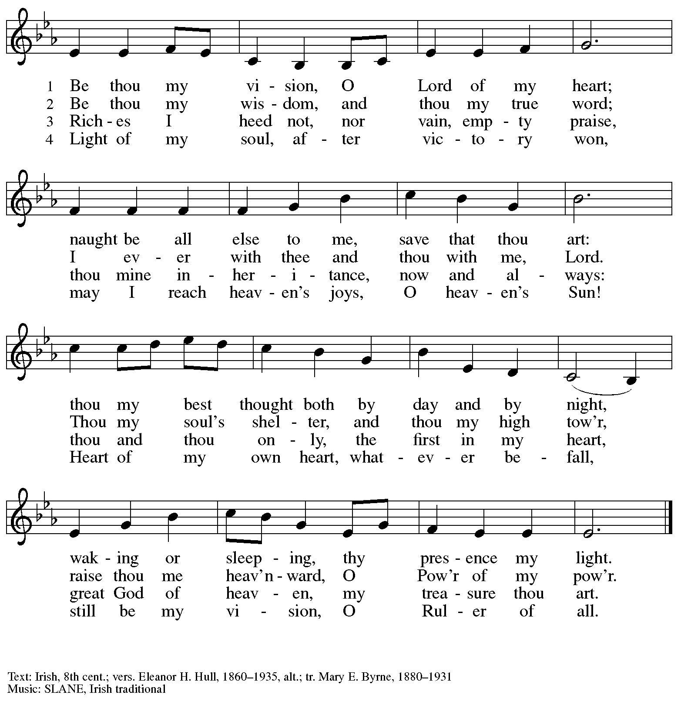

Greeting

P: The grace of our Lord Jesus Christ, the love of God,
and the communion of the Holy Spirit be with you all.
C: And also with you.

Prayer of the Day

P: Let us pray. Beloved and sovereign God, through the death and resurrection of your Son,
you bring us into your reign of justice and mercy. By your Spirit, give us your wisdom,
that we may treasure the life that comes from Jesus Christ, our Savior and Lord.
C: Amen.

Please be seated.

Word
God speaks to us in Scripture reading, preaching, and song

First Reading – 1 Kings 3: 5-12

⁵At Gibeon the Lord appeared to Solomon in a dream by night; and God said, “Ask what I should give you.” ⁶And Solomon said, “You have shown great and steadfast love to your servant my father David, because he walked before you in faithfulness, in righteousness, and in uprightness of heart toward you; and you have kept for him this great and steadfast love, and have given him a son to sit on his throne today. ⁷And now, O Lord my God, you have made your servant king in place of my father David, although I am only a little child; I do not know how to go out or come in. ⁸And your servant is in the midst of the people whom you have chosen, a great people, so numerous they cannot be numbered or counted. ⁹Give your servant therefore an understanding mind to govern your people, able to discern between good and evil; for who can govern this your great people?”
¹⁰It pleased the Lord that Solomon had asked this. ¹¹God said to him, “Because you have asked this, and have not asked for yourself long life or riches, or for the life of your enemies, but have asked for yourself understanding to discern what is right, ¹²I now do according to your word. Indeed I give you a wise and discerning mind; no one like you has been before you and no one like you shall arise after you.”

L: Word of God, word of life.
C: Thanks be to God.

Psalm 119: 129-136

The psalm will be led by the cantor, with the congregation invited to join in singing the alternate verses (in bold) and refrain.

Psalm tone

Psalm refrain

¹²⁹Your de- | crees are wonderful;
therefore I obey them with | all my heart.
¹³⁰When your word is opened | it gives light;
it gives understanding | to the simple.
¹³¹I open my | mouth and pant
because I long for | your commandments.
¹³²Turn to me and be gra- | cious to me,
as you always do to those who | love your name. R
¹³³Order my footsteps | in your word;
let no iniquity have dominion | over me.
¹³⁴Rescue me from those | who oppress me,
and I will keep | your commandments.
¹³⁵Let your face shine up- | on your servant
and teach | me your statutes.
¹³⁶My eyes shed | streams of tears,
because people do not | keep your teaching. R

Second Reading – Romans 8: 26-39

²⁶The Spirit helps us in our weakness; for we do not know how to pray as we ought, but that very Spirit intercedes with sighs too deep for words. ²⁷And God, who searches the heart, knows what is the mind of the Spirit, because the Spirit intercedes for the saints according to the will of God.
²⁸We know that all things work together for good for those who love God, who are called according to God’s purpose. ²⁹For those whom God foreknew, God also predestined to be conformed to the image of God’s Son, in order that he might be the firstborn within a large family. ³⁰And those whom God predestined, God also called; and those whom God called, God also justified; and those whom God justified, God also glorified.
³¹What then are we to say about these things? If God is for us, who is against us? ³²The one who did not withhold God’s own Son, but gave him up for all of us, will God not with him also give us everything else? ³³Who will bring any charge against God’s elect? It is God who justifies. ³⁴Who is to condemn? It is Christ Jesus, who died, yes, who was raised, who is at the right hand of God, who indeed intercedes for us. ³⁵Who will separate us from the love of Christ? Will hardship, or distress, or persecution, or famine, or nakedness, or peril, or sword? ³⁶As it is written,
“For your sake we are being killed all day long;
we are accounted as sheep to be slaughtered.”
³⁷No, in all these things we are more than conquerors through the one who loved us. ³⁸For I am convinced that neither death, nor life, nor angels, nor rulers, nor things present, nor things to come, nor powers, ³⁹nor height, nor depth, nor anything else in all creation, will be able to separate us from the love of God in Christ Jesus our Lord.

L: Word of God, word of life.
C: Thanks be to God.

Please rise as you are able.

Gospel Acclamation Lord, Let My Heart Be Good Soil ELW 512

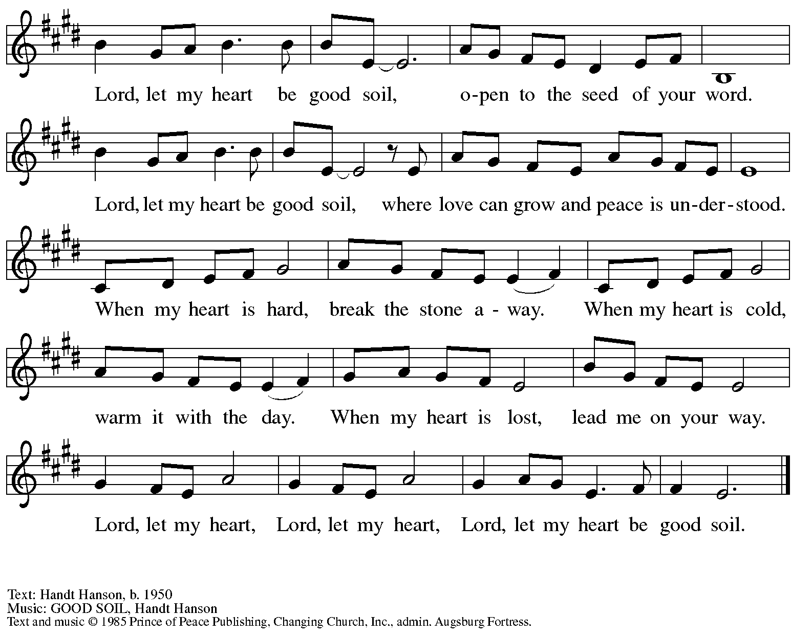
All rights reserved. Reprinted with permission under OneLicense.net # A-722139.

Gospel – Matthew 13: 31-33, 44-52

P: The holy Gospel according to St. Matthew.
C: Glory to you, O Lord.

³¹[Jesus] put before [the crowds] another parable: “The kingdom of heaven is like a mustard seed that someone took and sowed in his field;³²it is the smallest of all the seeds, but when it has grown it is the greatest of shrubs and becomes a tree, so that the birds of the air come and make nests in its branches.”
³³He told them another parable: “The kingdom of heaven is like yeast that a woman took and mixed in with three measures of flour until all of it was leavened.”
⁴⁴“The kingdom of heaven is like treasure hidden in a field, which someone found and hid; then in his joy he goes and sells all that he has and buys that field.
⁴⁵“Again, the kingdom of heaven is like a merchant in search of fine pearls; ⁴⁶on finding one pearl of great value, he went and sold all that he had and bought it.
⁴⁷“Again, the kingdom of heaven is like a net that was thrown into the sea and caught fish of every kind; ⁴⁸when it was full, they drew it ashore, sat down, and put the good into baskets but threw out the bad. ⁴⁹So it will be at the end of the age. The angels will come out and separate the evil from the righteous ⁵⁰and throw them into the furnace of fire, where there will be weeping and gnashing of teeth.
⁵¹“Have you understood all this?” They answered, “Yes.” ⁵²And he said to them, “Therefore every scribe who has been trained for the kingdom of heaven is like the master of a household who brings out of his treasure what is new and what is old.”
P: The Gospel of the Lord.
C: Praise to you, O Christ.

Please be seated.

Sermon

A time of silence for prayer and reflection follows the sermon.
When the hymn of the day begins, please rise as you are able.

Hymn of the Day The Reign of God, Like Farmer’s Field Following page
v. 2-5

Hymn of the Day The Reign of God, Like Farmer’s Field ACS 952
v. 2-5

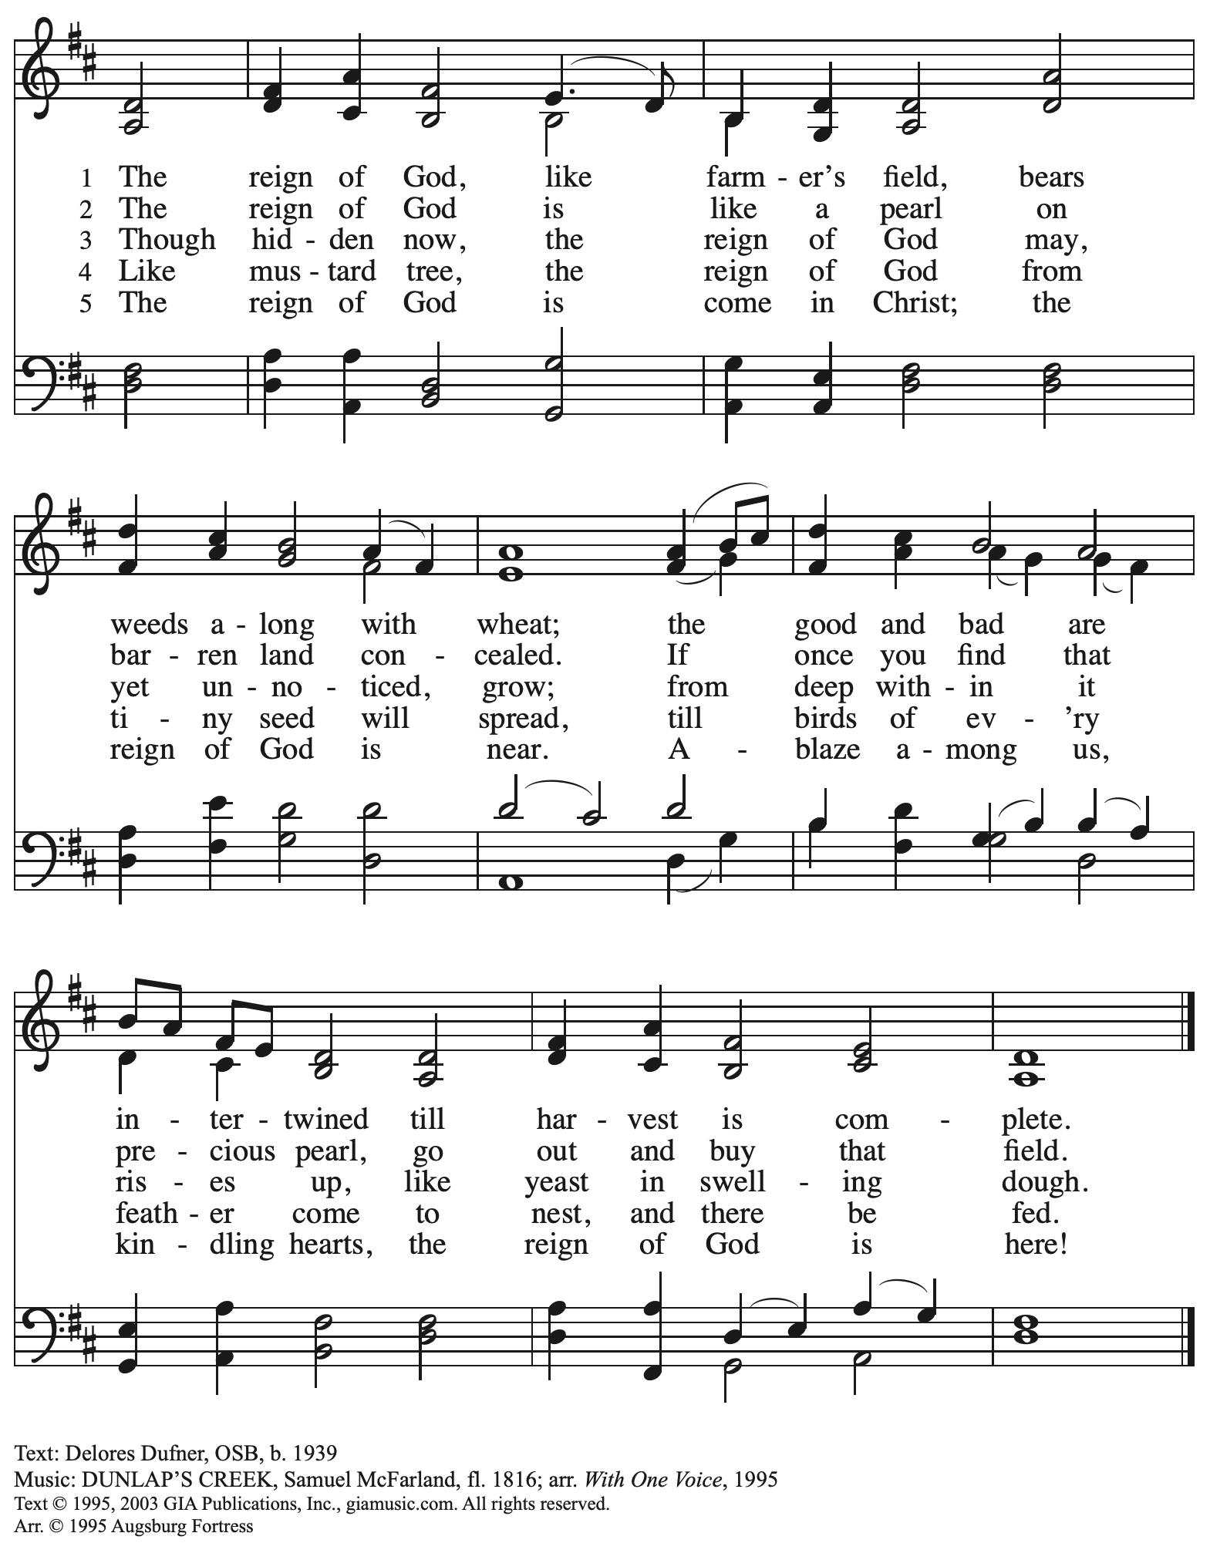
Reprinted with permission under OneLicense.net # A-722139.

Prayers of the People

A: Confident that God receives our joys and concerns, let us offer our prayers for the church,
those in need, and all of God’s creation.

After each petition
A: Hear us, O God;
C: Your mercy is great.

The presiding minister concludes the prayers
P: Into your hands, O God, we commend all for whom we pray,
in the name of the one who reconciled all creation with you, Jesus Christ our Savior.
C: Amen.

Peace

The presiding minister and the assembly greet one another in the peace of the risen Christ.
P: The peace of Christ be with you always.
C: And also with you.

The people may greet those around them with a sign of Christ’s peace and may say
Peace be with you or similar words. Please be mindful that not everyone will be comfortable with sharing the peace, so please seek consent before shaking hands or hugging. Other possible ways to share the peace include a simple bow with the verbal greeting of peace, or simply a verbal expression of peace.

When the greetings of peace have concluded, please be seated.

Meal
God feeds us with the presence of Jesus Christ

Offering

We offer ourselves, our gifts, and our faithful service to God.
As the offering is gathered for the mission of the church, including the care of those in need,
the table is set for Holy Communion.

Music during the Offering

As the gifts are brought forward for presentation, please rise as you are able.

Offertory Song ELW 680
Aramos nuestros campos / We Plow the Fields and Scatter

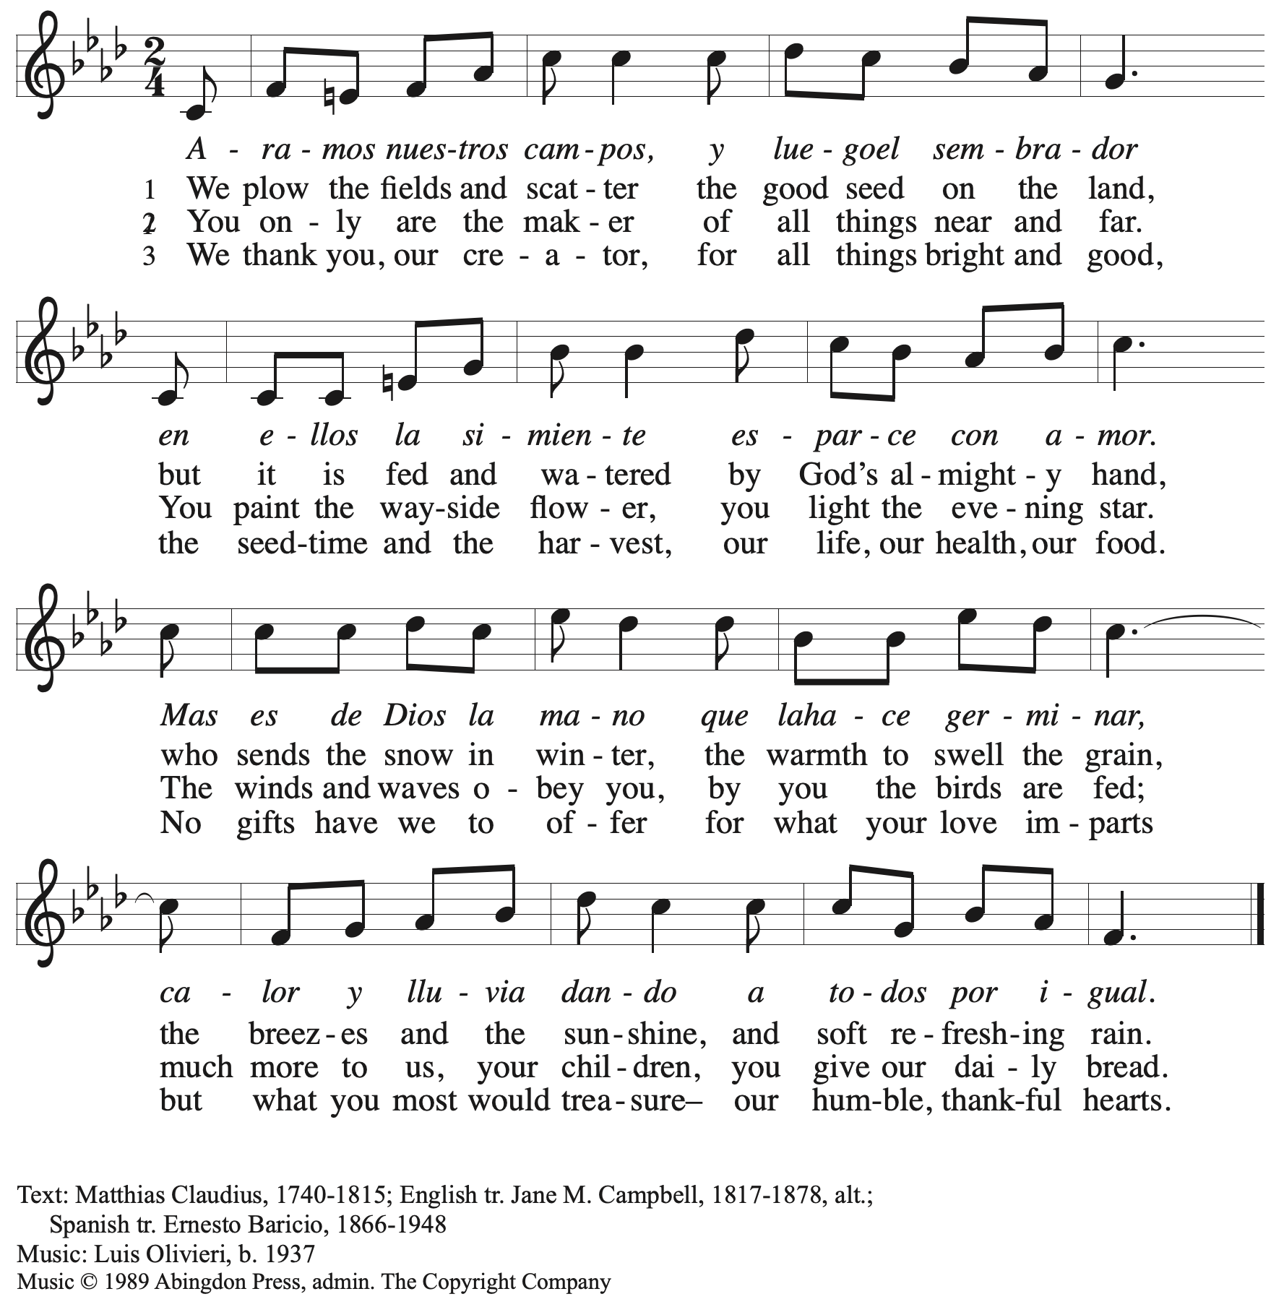
All rights reserved. Reprinted with permission under OneLicense.net # A-722139.

Offertory Prayer

A: Let us pray.
God of field and forest, sea and sky,
C: you are the giver of all good things.
Sustain us with these gifts of your creation,
and multiply your graciousness in us,
that the world may be fed with your love,
through Jesus Christ, our Savior and Lord.
Amen.

Dialogue

P: The Lord be with you.
C: And also with you.

P: Lift up your hearts.
C: We lift them to the Lord.

P: Let us give thanks to the Lord our God.
C: It is right to give our thanks and praise.

Preface

P: It is indeed right, our duty and our joy …
… we praise your name and join their unending hymn:

Sanctus

C: Holy, holy, holy Lord, God of power and might,
Heaven and earth are full of your glory; Hosanna in the highest!
Blessed is the one who comes in the name of the Lord!
Hosanna in the highest!

Eucharistic Prayer

P: Holy, mighty, and merciful Lord …
… to whom, with you and the Holy Spirit,
be all honor and glory, now and forever.
C: Amen.

Lord’s Prayer

P: Gathered as one by the Holy Spirit, let us pray as Jesus taught us.
C: Our Father in heaven,
hallowed be your name,
your kingdom come,
your will be done,
on earth as in heaven.
Give us today our daily bread.
Forgive us our sins
as we forgive those
who sin against us.
Save us from the time of trial
and deliver us from evil.
For the kingdom, the power,
and the glory are yours,
now and forever. Amen.

Fraction and Invitation

Agnus Dei / Lamb of God

C: Lamb of God, you take away the sin of the world; have mercy on us.
Lamb of God, you take away the sin of the world; have mercy on us.
Lamb of God, you take away the sin of the world; grant us peace.

Please be seated.

Holy Communion
- All who seek God and desire a deeper and stronger life in Christ are welcome to receive Holy Communion.
- Worshipers from the pulpit side will proceed forward first, followed by the center section, and then the lectern side.
- Please inform an usher if you would like the ministers to bring Communion to you.
- Holy Communion will be served with bread and wine/grape juice.
- The presiding minister will first distribute the bread (host) to each communicant. Please indicate if you require a gluten-free host.
- Once you have consumed the bread, please pick up an empty glass from the tray next to the presiding minister. The Communion Assistant will pour wine from the chalice or grape juice from the cruet into your glass.
- Please step to the side to consume the wine or grape juice.
- Feel free to kneel at the altar rail for prayer after receiving the sacrament.
- As you return to your pew, glasses may be returned to the empty trays on either side of the center section.
- A blessing will be provided for anyone who does not yet receive the sacrament.
- All are invited to join in singing the hymns during Holy Communion.

Hymns during Holy Communion
We Eat the Bread of Teaching ELW 518

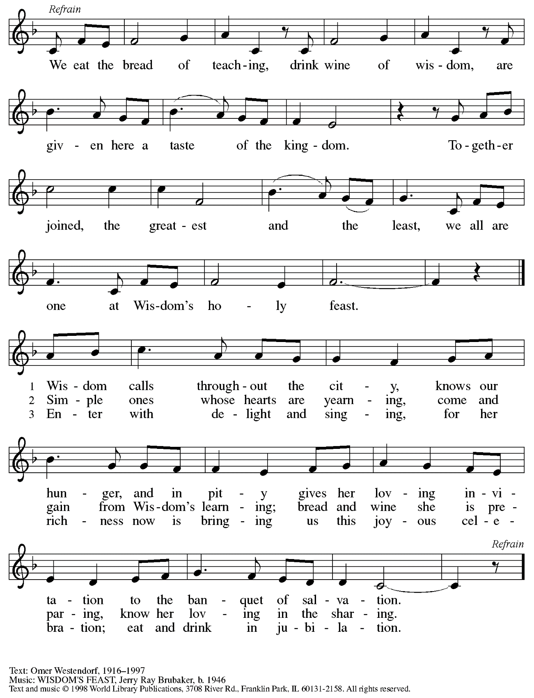
Reprinted with permission under OneLicense.net # A-722139.

Hymns during Holy Communion
What Is the World Like ACS 1047

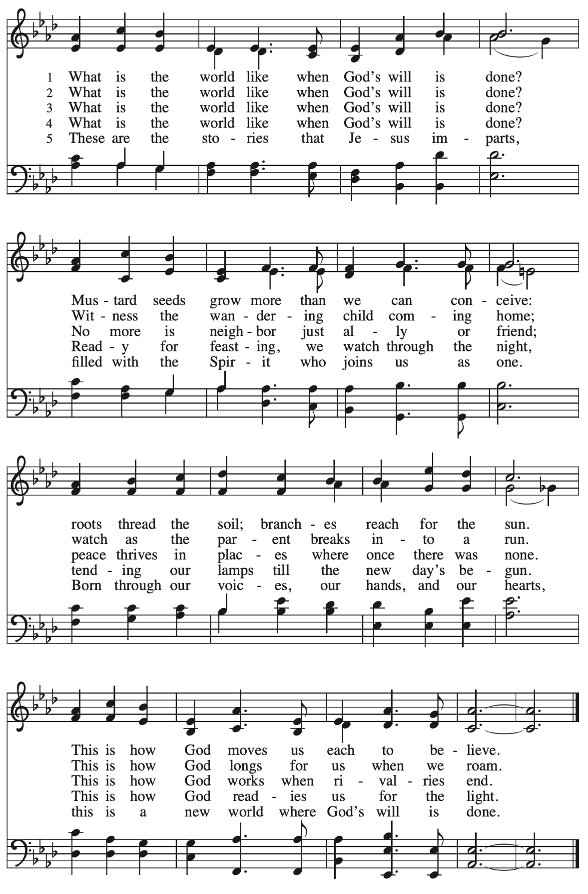

Hymns during Holy Communion
Come, Holy Spirit, Descend ACS 980

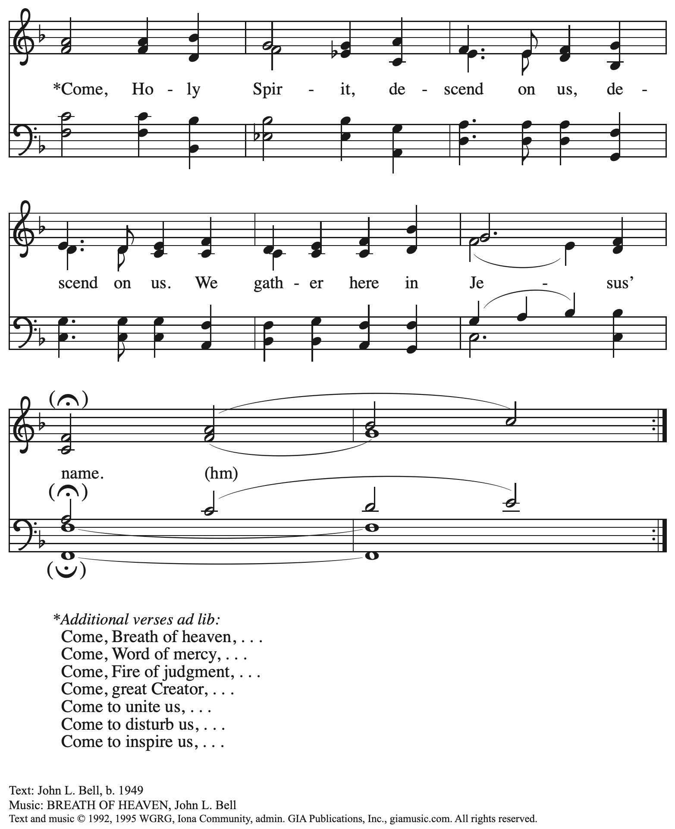
Reprinted with permission under OneLicense.net # A-722139.

When all have returned to their places, please rise as you are able.

Blessing

P: The body and blood of our Lord Jesus Christ strengthen you and keep you in his grace.
C: Amen.

Prayer

A: Let us pray.
We thank you, generous God,
for the refreshment we have received
at your banquet table.
Send us now to spread your generosity into all the world,
through the one who is our dearest treasure,
Jesus Christ, our Savior and Lord.
C: Amen.

Please be seated.

Sending
God blesses us and sends us in mission to the world

Announcements

Please rise as you are able.

Benediction

P: The God who calls across the cosmos
and works through the smallest seed
☩ bless, keep, and sustain you,
now and to the end of the age.
C: Amen.

Sending Hymn Bring forth the Kingdom Following page

Dismissal

A: Go in peace. Serve the Lord.
C: Thanks be to God!

Postlude

Sending Hymn Bring forth the Kingdom W&P 22

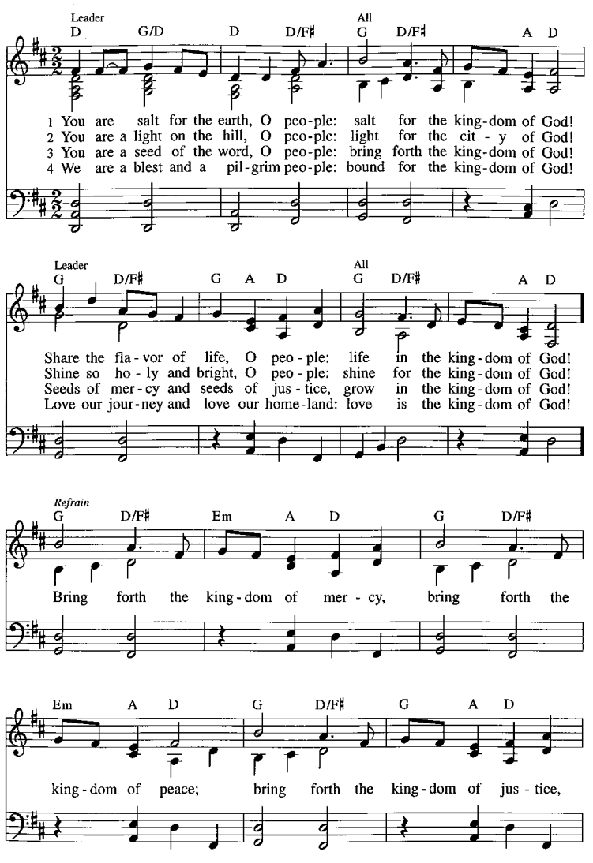
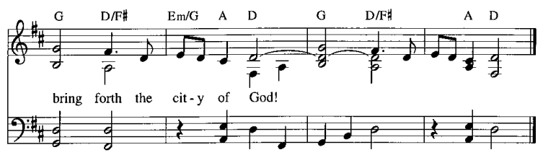
Those serving in worship today

Altar Care Jodie Minor
Assisting Minister Tim Marker
Audio-Visual Ministers Jason Galyardt
David Rollinson
Cantor Joy Givens
Lector Michael Chapman
Minister of Music Laura Reynolds
Preaching and Presiding Minister Pastor Ross Carmichael

Liturgy and Hymnody Acknowledgements

From SundaysandSeasons.com. Copyright © 2023 Augsburg Fortress. All rights reserved. Reprinted under OneLicense.net # A-722139.
Used by permission of Augsburg Fortress.

What Is the World Like – Text: Adam M. L. Tice, b. 1979. Music: NEW WORLD, Sally Ann Morris, b. 1952. Text and music © 2009 GIA Publications, Inc., giamusic.com. All rights reserved. Reprinted with permission under OneLicense.net # A-722139.

Bring forth the Kingdom – Matthew 5: 13-15; Marty Haugen, b. 1950. Music: Marty Haugen, b. 1950. Text and music © 1986, GIA Publications, Inc. giamusic.com. All rights reserved. Reprinted with permission under OneLicense.net # A-722139.

Please use the QR code below to link to St. Andrew’s Announcements online!

St. Andrew Lutheran Church Announcements
July 30th, 2023

- Welcome to worship at St. Andrew on the Ninth Sunday after Pentecost, July 30th, 2023 – We are so glad you are here, and we offer a special welcome to all visitors and guests connecting for the first time! Worship attendees are invited to make a name tag at the back of the worship space if you would like. There are worship “toolkits” to help children engage with worship and “busy bags” for younger children available in the bookcase at the back of the sanctuary. Please feel free to take one to use with/for your children.
- August Produce Distribution – Tuesday, August 1st, 2023 – St. Andrew's monthly produce distribution in partnership with Greater Pittsburgh Community Food Bank is coming up Tuesday, August 1st, from 5:30-7:00 p.m. We invite people from the congregation to come and help in the evening (greeting our neighbors, assisting with the distribution, registration, and cleanup) and earlier in the day to set up tables and bring in the delivery, usually between 10:00 a.m. and 1:00 p.m. For anyone who signs up for the setup, we will notify you the day before when we are given the delivery truck's estimated arrival time. If you would like to sign up in advance, please do so here: https://www.signupgenius.com/go/4090F45AFAF2BA75-produce6.
- Macedonia Family and Community Enrichment Center (FACE) Seeking Donations of Household Items – Macedonia Family and Community Enrichment Center (FACE) serves families experiencing hardship in our community. Their mission is to encourage the development of healthy families. They have been seeing an increase in requests for household items that people are not able to afford. Many necessities cannot be purchased with supplemental food benefits (SNAP). Macedonia FACE is seeking donations of household items such as toilet paper and paper towels, shampoo/conditioner (Black haircare), soap, feminine hygiene products, and cleaning products (laundry soap, dish soap, disinfecting wipes). Items can be left on the table next to the pantry shelves in St. Andrew's Social Hall.
- Lutheran Campus Ministry in Greater Pittsburgh (LCMGP) 75th Anniversary Dinner – Friday, September 15th, 2023 7:30 p.m. at Le Mont – Join the LCMGP for its inaugural fundraising banquet as they celebrate the ministry's work in Greater Pittsburgh and among the universities of Pitt, Carnegie Mellon, Chatham, and Carlow for over the past 75+ years. Learn more about LCMGP, purchase tickets, or make a donation here.
- St. Andrew Is Updating Information – Please Respond! – St. Andrew is looking to update our records with information from newer attendees, as well as offering current members the opportunity to include current information. This includes name, preferred pronouns, email, phone number, birthdays, anniversaries, and more. The information will only be used within the congregation - for example to acknowledge celebrations and milestones in worship, in the prayers of the church, or in the weekly or monthly newsletter. Please fill out the form at: https://forms.gle/fTwpdG2uA7pYD2ta8.
Stand Up for Fairness for All Pennsylvanians

This month, the nation's largest organization devoted to the rights of LGBTQ+ Americans declared a "state of emergency" in the U.S. amidst a growing number of dangerous and discriminatory policies. In Pennsylvania, more than half a million LGBTQ+ residents are vulnerable to discrimination every day because of a lack of express and enduring statutory protections at the state level. Tell your lawmakers it's time to make our Commonwealth a safe place for everyone to live, love and work as their authentic selves without fear of discrimination.

Pennsylvania remains the only state in the Northeast without an inclusive statewide nondiscrimination law. Passage of protections in Pennsylvania is a critical step to ensure LGBTQ people are treated with dignity in employment, housing, and public spaces.

Contact your lawmakers here.

Sign up here to join fellow Lutherans working for protections for LGBTQ+ Pennsylvanians and receive alerts about rallies and other opportunities to act. Please include FAIRNESS in the subject line.

The seven Pennsylvania bishops of the Evangelical Lutheran Church in America released a letter in support of legislation that would prohibit such discrimination.

"At this moment there is an opportunity for us to add our voices in support of legislation that could provide continuing legal protection for one particularly vulnerable group of our people," the bishops state in their letter "Fairness for All Pennsylvanians."
Read the full letter.

The letter points to the imagery of the "peaceable kingdom," described in Isaiah 11: 6, in which "the wolf shall live with the lamb, the leopard shall lie down with the kid, the calf and the lion and the fatling together, and a little child shall lead them." The words anticipate a renewal of all creation in which the identity of each creature remains but none experiences any harm from the others. "It is the fulfillment of this vision for which people of faith yearn, and toward which they call their neighbors," the bishops say in the letter. "The work of public advocacy, at its best, replaces the timid silence of resignation to what is, with a bold voice giving expression to what could be."

We recognize that the links above are not accessible on the printed page but we wanted to be sure to publish the information. Please see your “This Week at St. Andrew” email or scan the QR code above to access the clickable links. Thank you for your Advocacy!

