+ Tenth Sunday after Pentecost
August 6, 2023

St. Andrew Lutheran Church
304 Morewood Ave.
Pittsburgh, PA 15213
St_andrewELCA@verizon.net
www.standrewpittsburgh.org

+ Tenth Sunday after Pentecost
Order for Worship

In today’s first reading God invites all who are hungry or thirsty to receive food and drink without cost. Jesus feeds the hungry multitude and reveals the abundance of God. At the eucharistic table we remember all who are hungry or poor in our world today. As we share the bread of life, we are sent forth to give ourselves away as bread for the hungry.
Welcome to St. Andrew!

- St. Andrew Lutheran congregation welcomes all who are seeking a place of healing and wholeness – a nurturing, faith-forming spiritual home. Our community embraces people of all ages, ethnicities, cultures, abilities, sexual orientations, gender identities and expressions, and family constellations. Come and See!

- Worship Services are live streamed to multiple online platforms. By attending worship, you agree that your image and voice may be broadcast.

- Everyone is invited to make a nametag at the black bookcase in the back of the worship space if they would like. There are stickers indicating pronouns on the bookcase if you would like to include them on your name tag.

- Worship “toolkits” to help children engage with the service, along with “busy bags” for younger children, are available in the bookcase at the back of the sanctuary. Please feel free to take one to use with/for your children.

- Holy Communion is served with bread (gluten-free available) and wine or grape juice. The presiding minister will distribute the bread (host). Please consume this and then pick up an empty glass from the tray. The Communion Assistant will pour wine or grape juice into your glass. Please step to the side to consume the wine or grape juice. Feel free to kneel at the altar for prayer and reflection. As you return to your pew, glasses may be returned to the empty trays on either side of the center section.

- A restroom is available on the main level of the church, through the doors to the Social Hall and to the right in the main office.

Abbreviations
P: Pastor/Presiding Minister ACS: All Creation Sings hymnal
A: Assisting Minister ELW: Evangelical Lutheran Worship hymnal
L: Lector
C: Congregation

Pre-Service Music

Welcome

Prelude

Gathering
The Holy Spirit calls us together as the people of God

Confession and Forgiveness

Please rise as you are able.
All may make the sign of the cross, the sign that is marked at Baptism,
as the presiding minister begins.

P: Blessed be the holy Trinity, ☩ one God,
who greets us in this and every season, whose word never fails, whose promise is sure.
C: Amen.

P: Let us confess our sin in the presence of God and of our neighbors.

Silence is kept for reflection.

P: Merciful God,
C: we confess that we have sinned.
We have hurt our community.
We have squandered your blessings.
We have hoarded your bounty.
In the name of Jesus, forgive us and grant us your mercy. Amen.

Silence is kept for reflection.

P: Righteous God,
we confess that we have sinned.
We have failed to be honest.
We have lacked the courage to speak.
We have spoken falsely.
In the name of Jesus, forgive us and grant us your mercy. Amen.

P: God is a cup of cold water when we thirst.
God offers boundless grace when we fail.
Claim the gift of God’s mercy:
you are freed and forgiven in the name of ☩ Jesus Christ.
C: Amen.

Gathering Hymn All Who Hunger, Gather Gladly ELW 461

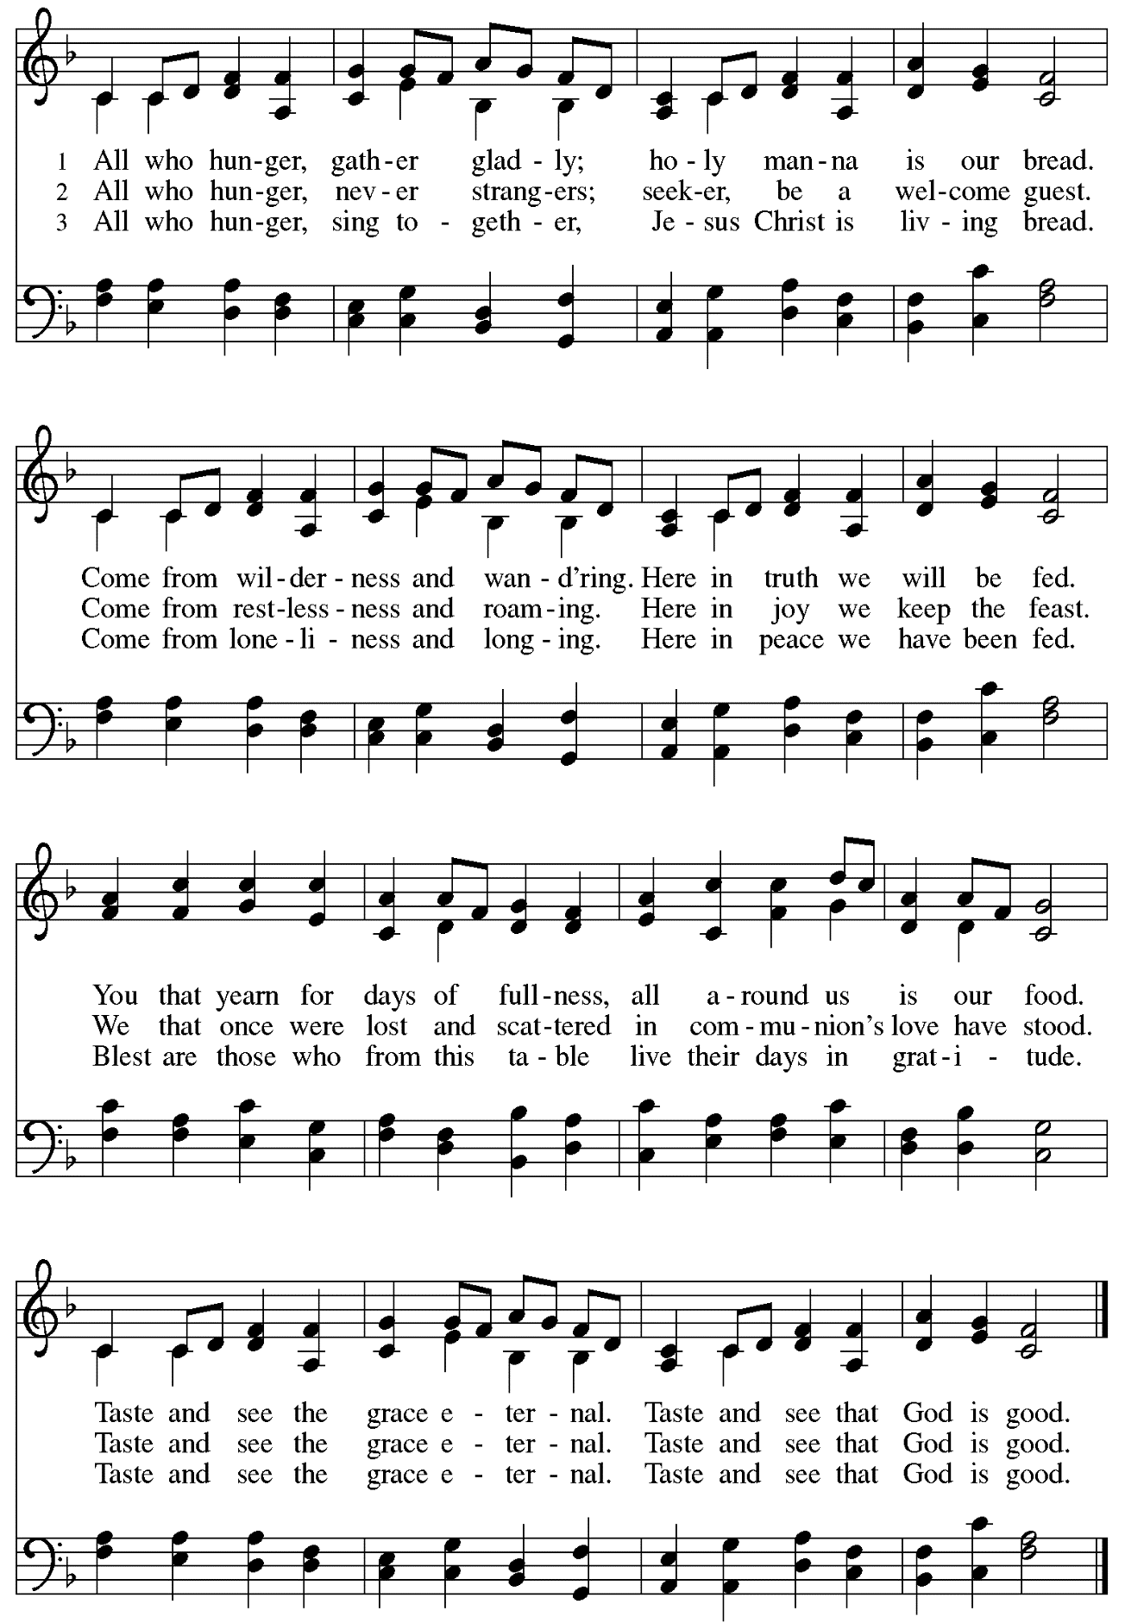

Greeting

P: The grace of our Lord Jesus Christ, the love of God,
and the communion of the Holy Spirit be with you all.
C: And also with you.

Prayer of the Day

P: Let us pray. Glorious God, your generosity waters the world with goodness,
and you cover creation with abundance.
Awaken in us a hunger for the food that satisfies both body and spirit,
and with this food fill all the starving world;
through your Son, Jesus Christ, our Savior and Lord.
C: Amen.

Please be seated.

Word
God speaks to us in Scripture reading, preaching, and song

First Reading – Isaiah 55: 1-5

¹Ho, everyone who thirsts,
come to the waters;
and you that have no money,
come, buy and eat!
Come, buy wine and milk
without money and without price.
²Why do you spend your money for that which is not bread,
and your labor for that which does not satisfy?
Listen carefully to me, and eat what is good,
and delight yourselves in rich food.
³Incline your ear, and come to me;
listen, so that you may live.
I will make with you an everlasting covenant,
my steadfast, sure love for David.
⁴See, I made him a witness to the peoples,
a leader and commander for the peoples.
⁵See, you shall call nations that you do not know,
and nations that do not know you shall run to you,
because of the Lord your God, the Holy One of Israel,
for the Lord has glorified you.

L: Word of God, word of life. C: Thanks be to God.
Psalm 145: 8-9, 14-21

The psalm will be led by the cantor, with the congregation invited to join in singing the alternate verses (in bold) and refrain.

Psalm tone

Psalm refrain

⁸The Lord is gracious and full | of compassion,
slow to anger and abounding in | steadfast love.
⁹Lord, you are | good to all,
and your compassion is over | all your works. R
¹⁴The Lord upholds all | those who fall
and lifts up those who | are bowed down.
¹⁵The eyes of all wait upon | you, O Lord,
and you give them their food | in due season.
¹⁶You open | wide your hand
and satisfy the desire of every | living thing.
¹⁷You are righteous in | all your ways
and loving in | all your works. R
¹⁸You are near to all who | call upon you,
to all who call up- | on you faithfully.
¹⁹You fulfill the desire of | those who fear you;
you hear their | cry and save them.
²⁰You watch over all | those who love you,
but all the wicked you | shall destroy.
²¹My mouth shall speak the praise | of the Lord;
let all flesh bless God’s holy name forev- | er and ever. R

Second Reading – Romans 9: 1-5

¹I am speaking the truth in Christ—I am not lying; my conscience confirms it by the Holy Spirit—²I have great sorrow and unceasing anguish in my heart. ³For I could wish that I myself were accursed and cut off from Christ for the sake of my own people, my kindred according to the flesh. ⁴They are Israelites, and to them belong the adoption, the glory, the covenants, the giving of the law, the worship, and the promises; ⁵to them belong the patriarchs, and from them, according to the flesh, comes the Messiah, who is over all, God blessed forever. Amen.

L: Word of God, word of life.
C: Thanks be to God.

Please rise as you are able.

Gospel Acclamation Lord, Let My Heart Be Good Soil ELW 512

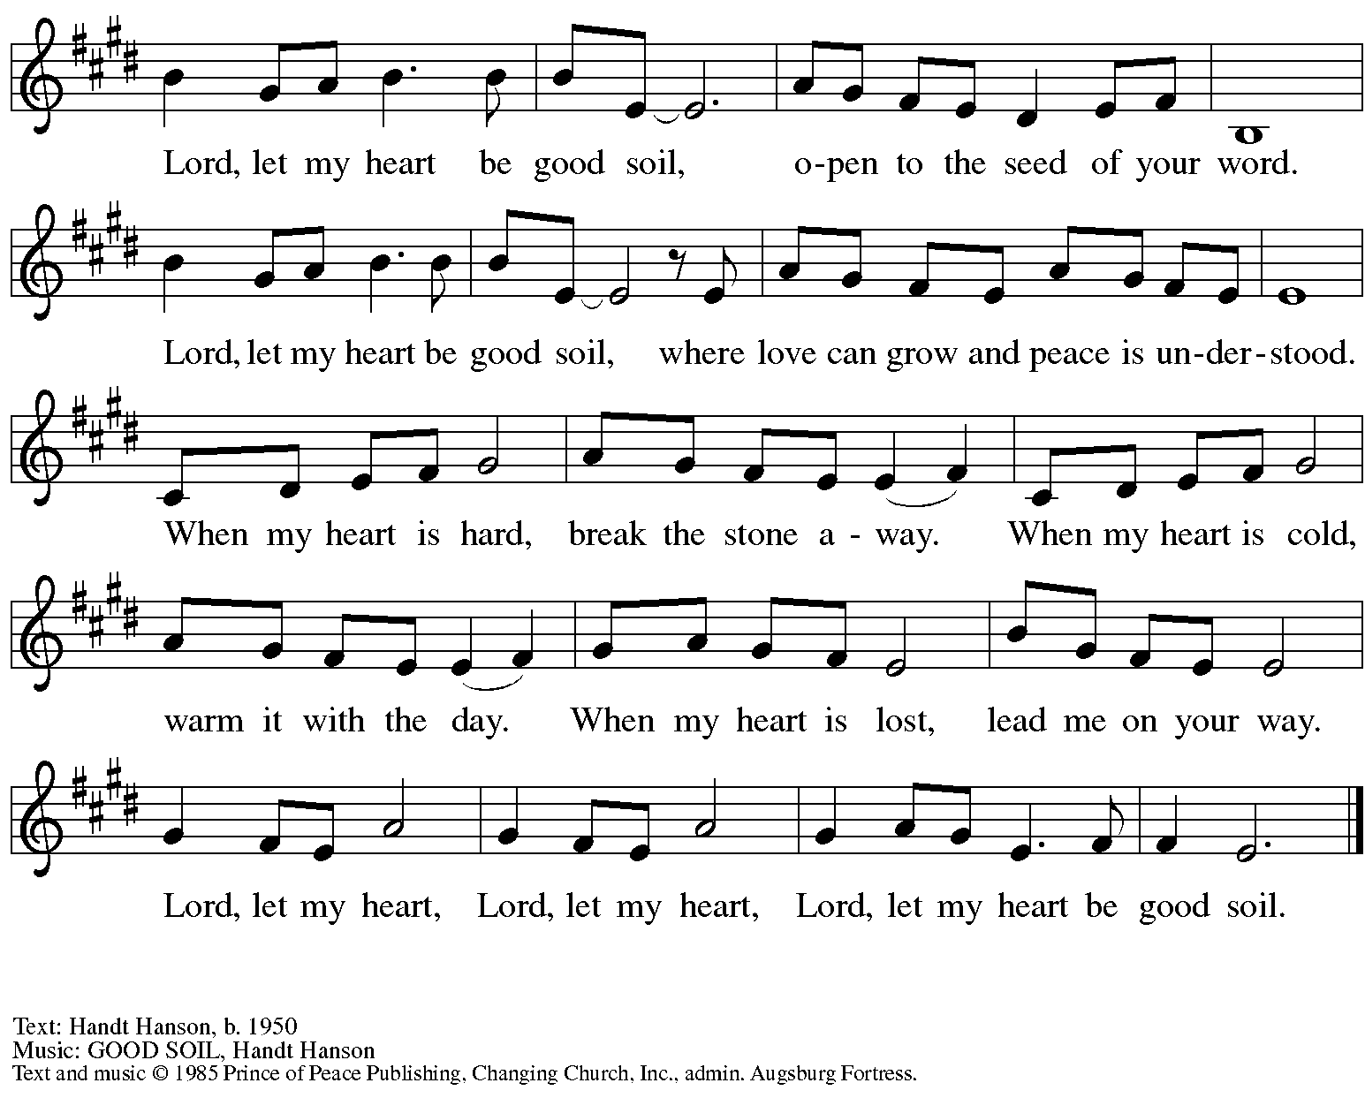
All rights reserved. Reprinted with permission under OneLicense.net # A-722139.

Gospel – Matthew 14: 13-21

P: The holy Gospel according to St. Matthew.
C: Glory to you, O Lord.

¹³Now when Jesus heard [about the beheading of John the Baptist], he withdrew from there in a boat to a deserted place by himself. But when the crowds heard it, they followed him on foot from the towns. ¹⁴When he went ashore, he saw a great crowd; and he had compassion for them and cured their sick. ¹⁵When it was evening, the disciples came to him and said, “This is a deserted place, and the hour is now late; send the crowds away so that they may go into the villages and buy food for themselves.” ¹⁶Jesus said to them, “They need not go away; you give them something to eat.” ¹⁷They replied, “We have nothing here but five loaves and two fish.” ¹⁸And he said, “Bring them here to me.” ¹⁹Then he ordered the crowds to sit down on the grass. Taking the five loaves and the two fish, he looked up to heaven, and blessed and broke the loaves, and gave them to the disciples, and the disciples gave them to the crowds. ²⁰And all ate and were filled; and they took up what was left over of the broken pieces, twelve baskets full. ²¹And those who ate were about five thousand men, besides women and children.
P: The Gospel of the Lord.
C: Praise to you, O Christ.

Please be seated.

Sermon

A time of silence for prayer and reflection follows the sermon.
When the hymn of the day begins, please rise as you are able.

Hymn of the Day Following page
Loaves Were Broken, Words Were Spoken

Hymn of the Day ACS 966
Loaves Were Broken, Words Were Spoken

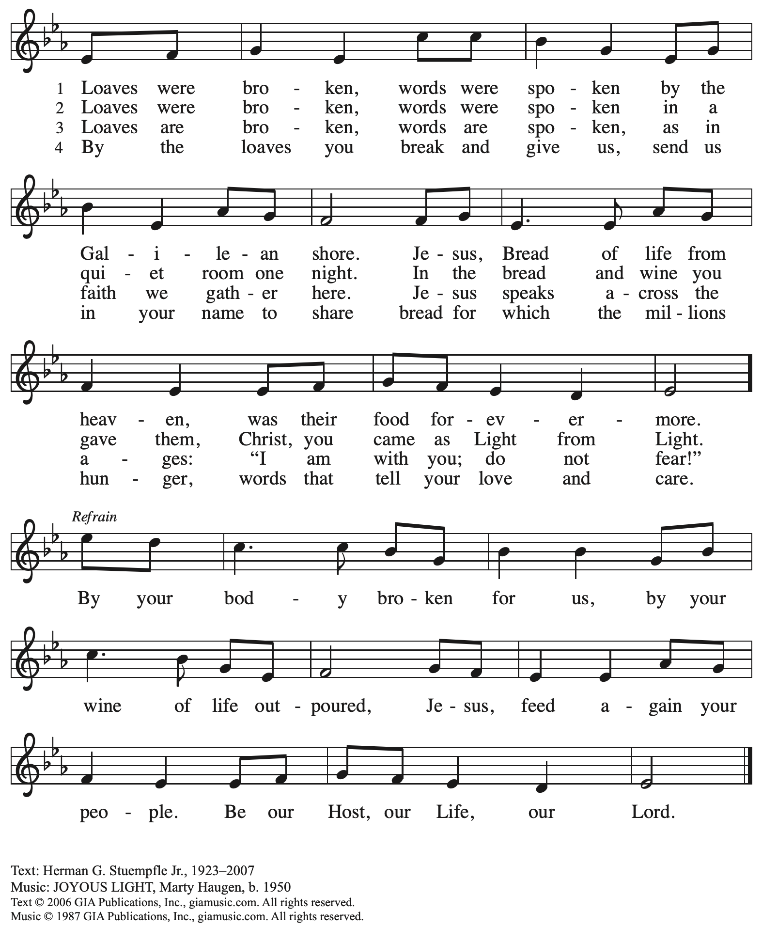
Reprinted with permission under OneLicense.net # A-722139.

Affirmation of Baptism
We remember and proclaim the promises of our Baptism

Those making affirmation may gather with the ministers at the font.

The presiding minister addresses the assembly with these or similar words.
P: Dear friends, we give thanks for the gift of Baptism and for these people,
one with us in the body of Christ, who are making public affirmation of their Baptism.

Those making affirmation are presented by a sponsor or another representative of the congregation:
I present name/s, who desire to make public affirmation of their Baptism.

The presiding minister may continue with prayer.
P: Let us pray.
Merciful God, we thank you for these siblings in Christ,
whom you have made your own by water and the Word in Baptism.
You have called them to yourself -
enlighten them with the gifts of your Spirit,
and nourish them in this community of faith.
Uphold your servants in the gifts and promises of Baptism,
and unite the hearts of all whom you have brought to new birth.
We ask this in the name of Christ.
C: Amen.

Profession of Faith

The presiding minister addresses those making public affirmation of Baptism.
The assembly may stand as able and join in the responses.

P: I ask you to profess your faith in Christ Jesus, reject sin, and confess the faith of the church.

Do you renounce the devil and all the forces that defy God?
Response:
C: I renounce them.

Do you renounce the powers of this world that rebel against God?
Response:
C: I renounce them.

Do you renounce the ways of sin that draw you from God?
Response:
C: I renounce them.

The presiding minister addresses the candidates and the assembly.
P: Do you believe in God the Father?
C: I believe in God, the Father almighty,
creator of heaven and earth.

P: Do you believe in Jesus Christ, the Son of God?
C: I believe in Jesus Christ, God’s only Son, our Lord,
who was conceived by the Holy Spirit,
born of the virgin Mary,
suffered under Pontius Pilate,
was crucified, died, and was buried;
he descended to the dead.*
On the third day he rose again;
he ascended into heaven,
he is seated at the right hand of the Father,
and he will come to judge the living and the dead.

P: Do you believe in God the Holy Spirit?
C: I believe in the Holy Spirit,
the holy catholic church,
the communion of saints,
the forgiveness of sins,
the resurrection of the body,
and the life everlasting.

*Or, “he descended into hell,” another translation of this text in widespread use.

Affirmation of Baptism

The presiding minister addresses those making public affirmation of Baptism.
P: You have made public profession of your faith.
Do you intend to continue in the covenant God made with you in Holy Baptism:
to live among God’s faithful people,
to hear the word of God and share in the Lord’s supper,
to proclaim the good news of God in Christ through word and deed,
to serve all people, following the example of Jesus,
and to strive for justice and peace in all the earth?

Each person responds:
I do, and I ask God to help and guide me.

The minister addresses the assembly.
P: People of God, do you promise to support these siblings
and pray for them in their life in Christ?
P: We do, and we ask God to help and guide us.

The presiding minister prays for God’s blessing.
P: Let us pray.
We give you thanks, O God, that through water and the Holy Spirit you give us new birth, cleanse us from sin, and raise us to eternal life.

The blessing may be repeated for each person. The minister may lay both hands on the head of the person and say:
P: Stir up in name the gift of your Holy Spirit: the spirit of wisdom and understanding, the spirit of counsel and might, the spirit of knowledge and the fear of the Lord, the spirit of joy in your presence, both now and forever.
C: Amen.

Those making public affirmation stand and face the assembly.
A representative of the congregation addresses the assembly.
A: Let us rejoice with these siblings in Christ.
C: We rejoice with you in the life of Baptism.
Together we will give thanks and praise to God
and proclaim the good news to all the world.

The congregation is invited to join in singing St. Andrew’s congregational refrain:

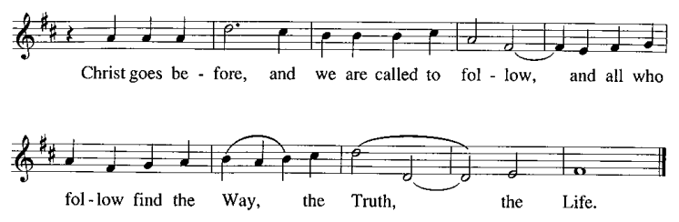

After all have returned to their places, worship continues with the Prayers of the People.

Prayers of the People

A: Confident that God receives our joys and concerns, let us offer our prayers for the church,
those in need, and all of God’s creation.

After each petition
A: Hear us, O God;
C: Your mercy is great.

The presiding minister concludes the prayers
P: Into your hands, O God, we commend all for whom we pray,
in the name of the one who reconciled all creation with you, Jesus Christ our Savior.
C: Amen.

Peace

The presiding minister and the assembly greet one another in the peace of the risen Christ.
P: The peace of Christ be with you always.
C: And also with you.

The people may greet those around them with a sign of Christ’s peace and may say
Peace be with you or similar words. Please be mindful that not everyone will be comfortable with sharing the peace, so please seek consent before shaking hands or hugging. Other possible ways to share the peace include a simple bow with the verbal greeting of peace, or simply a verbal expression of peace.

When the greetings of peace have concluded, please be seated.

Meal
God feeds us with the presence of Jesus Christ

Offering

We offer ourselves, our gifts, and our faithful service to God.
As the offering is gathered for the mission of the church, including the care of those in need,
the table is set for Holy Communion.

Reparations Offering

On the first Sunday of each month, St. Andrew invites people of the congregation to consider a donation to a second collection for a reparations fund in acknowledgement of St. Andrew’s use of African American spiritual songs in our worship services. Please see the note in the announcements at the back of the bulletin for more information.

Music during the Offering

As the gifts are brought forward for presentation, please rise as you are able.

Offertory Song ELW 680
Aramos nuestros campos / We Plow the Fields and Scatter

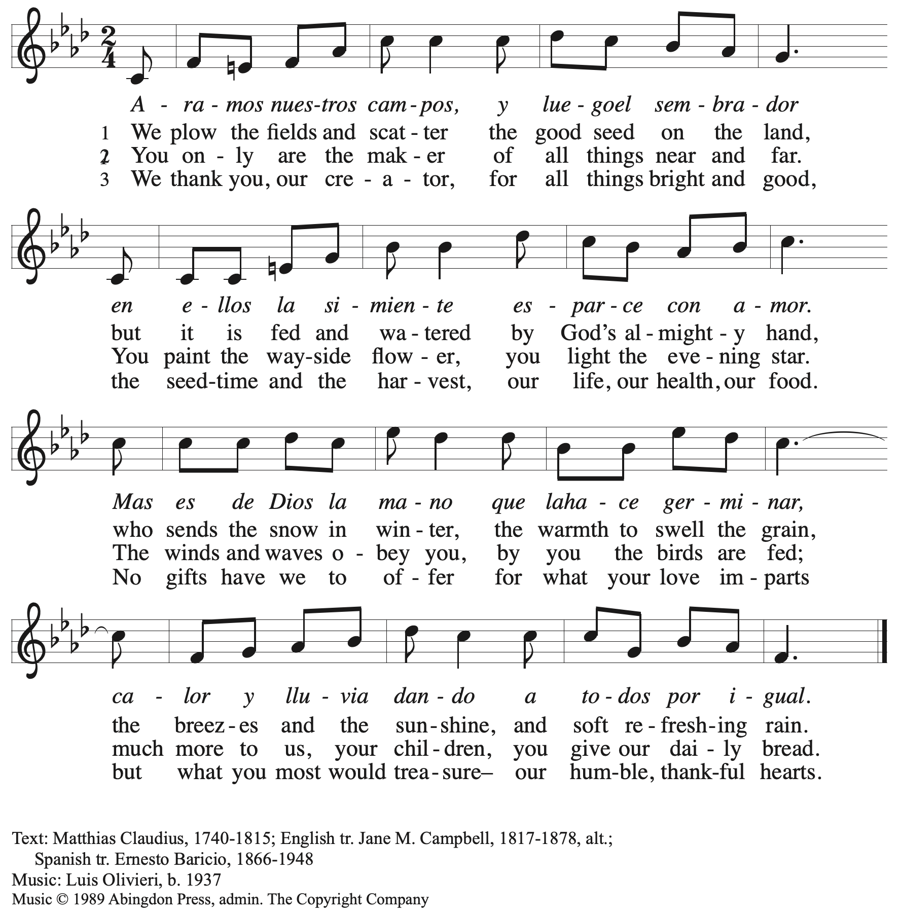
All rights reserved. Reprinted with permission under OneLicense.net # A-722139.

Offertory Prayer

A: Let us pray.
God of field and forest, sea and sky,
C: you are the giver of all good things.
Sustain us with these gifts of your creation,
and multiply your graciousness in us,
that the world may be fed with your love,
through Jesus Christ, our Savior and Lord.
Amen.

Dialogue

P: The Lord be with you.
C: And also with you.

P: Lift up your hearts.
C: We lift them to the Lord.

P: Let us give thanks to the Lord our God.
C: It is right to give our thanks and praise.

Preface

P: It is indeed right, our duty and our joy …
… we praise your name and join their unending hymn:

Sanctus

C: Holy, holy, holy Lord, God of power and might,
Heaven and earth are full of your glory; Hosanna in the highest!
Blessed is the one who comes in the name of the Lord!
Hosanna in the highest!

Eucharistic Prayer

P: Holy, mighty, and merciful Lord …
… to whom, with you and the Holy Spirit,
be all honor and glory, now and forever.
C: Amen.

Lord’s Prayer

P: Gathered as one by the Holy Spirit, let us pray as Jesus taught us.
C: Our Father in heaven,
hallowed be your name,
your kingdom come,
your will be done,
on earth as in heaven.
Give us today our daily bread.
Forgive us our sins
as we forgive those
who sin against us.
Save us from the time of trial
and deliver us from evil.
For the kingdom, the power,
and the glory are yours,
now and forever. Amen.

Fraction and Invitation

Agnus Dei / Lamb of God

C: Lamb of God, you take away the sin of the world; have mercy on us.
Lamb of God, you take away the sin of the world; have mercy on us.
Lamb of God, you take away the sin of the world; grant us peace.

Please be seated.

Holy Communion
- All who seek God and desire a deeper and stronger life in Christ are welcome to receive Holy Communion.
- Worshipers from the pulpit side will proceed forward first, followed by the center section, and then the lectern side.
- Please inform an usher if you would like the ministers to bring Communion to you.
- Holy Communion will be served with bread and wine/grape juice.
- The presiding minister will first distribute the bread (host) to each communicant. Please indicate if you require a gluten-free host.
- Once you have consumed the bread, please pick up an empty glass from the tray next to the presiding minister. The Communion Assistant will pour wine from the chalice or grape juice from the cruet into your glass.
- Please step to the side to consume the wine or grape juice.
- Feel free to kneel at the altar rail for prayer after receiving the sacrament.
- As you return to your pew, glasses may be returned to the empty trays on either side of the center section.
- A blessing will be provided for anyone who does not yet receive the sacrament.
- All are invited to join in singing the hymns during Holy Communion.

Hymns during Holy Communion
Come, Let Us Eat ELW 491

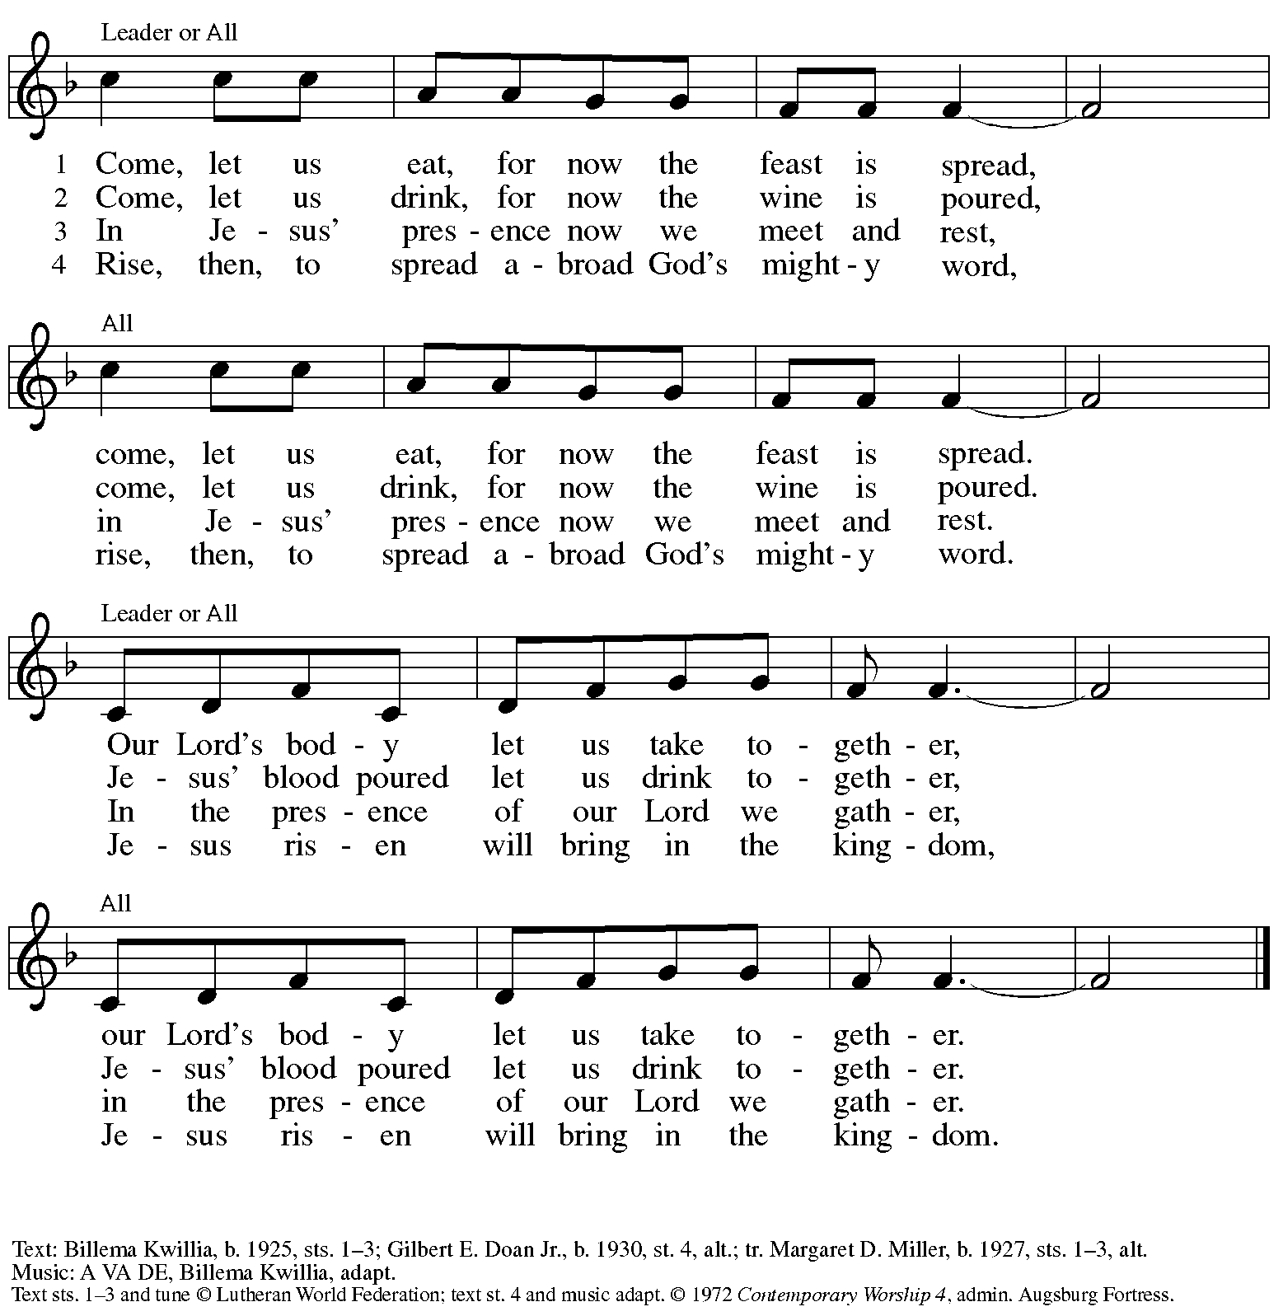
All rights reserved. Reprinted with permission under OneLicense.net # A-722139.

Hymns during Holy Communion
Break Now the Bread of Life ELW 515

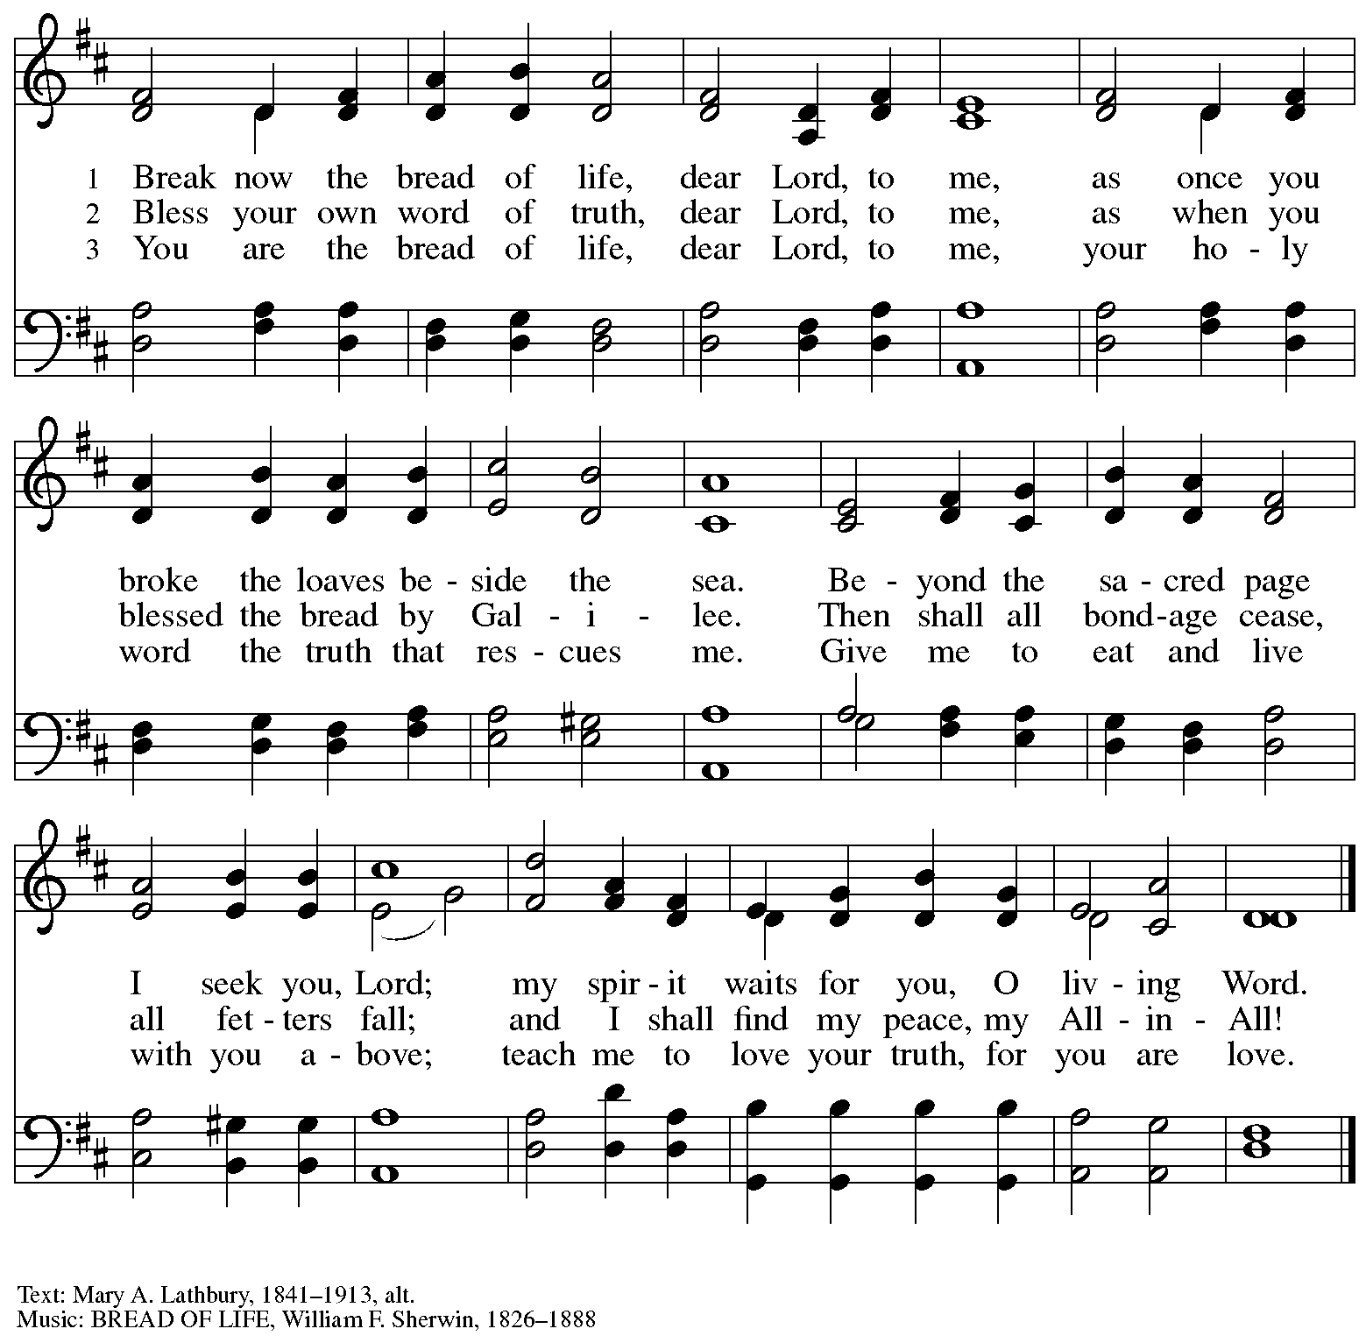

Hymns during Holy Communion
Lord, Whose Love in Humble Service ELW 712

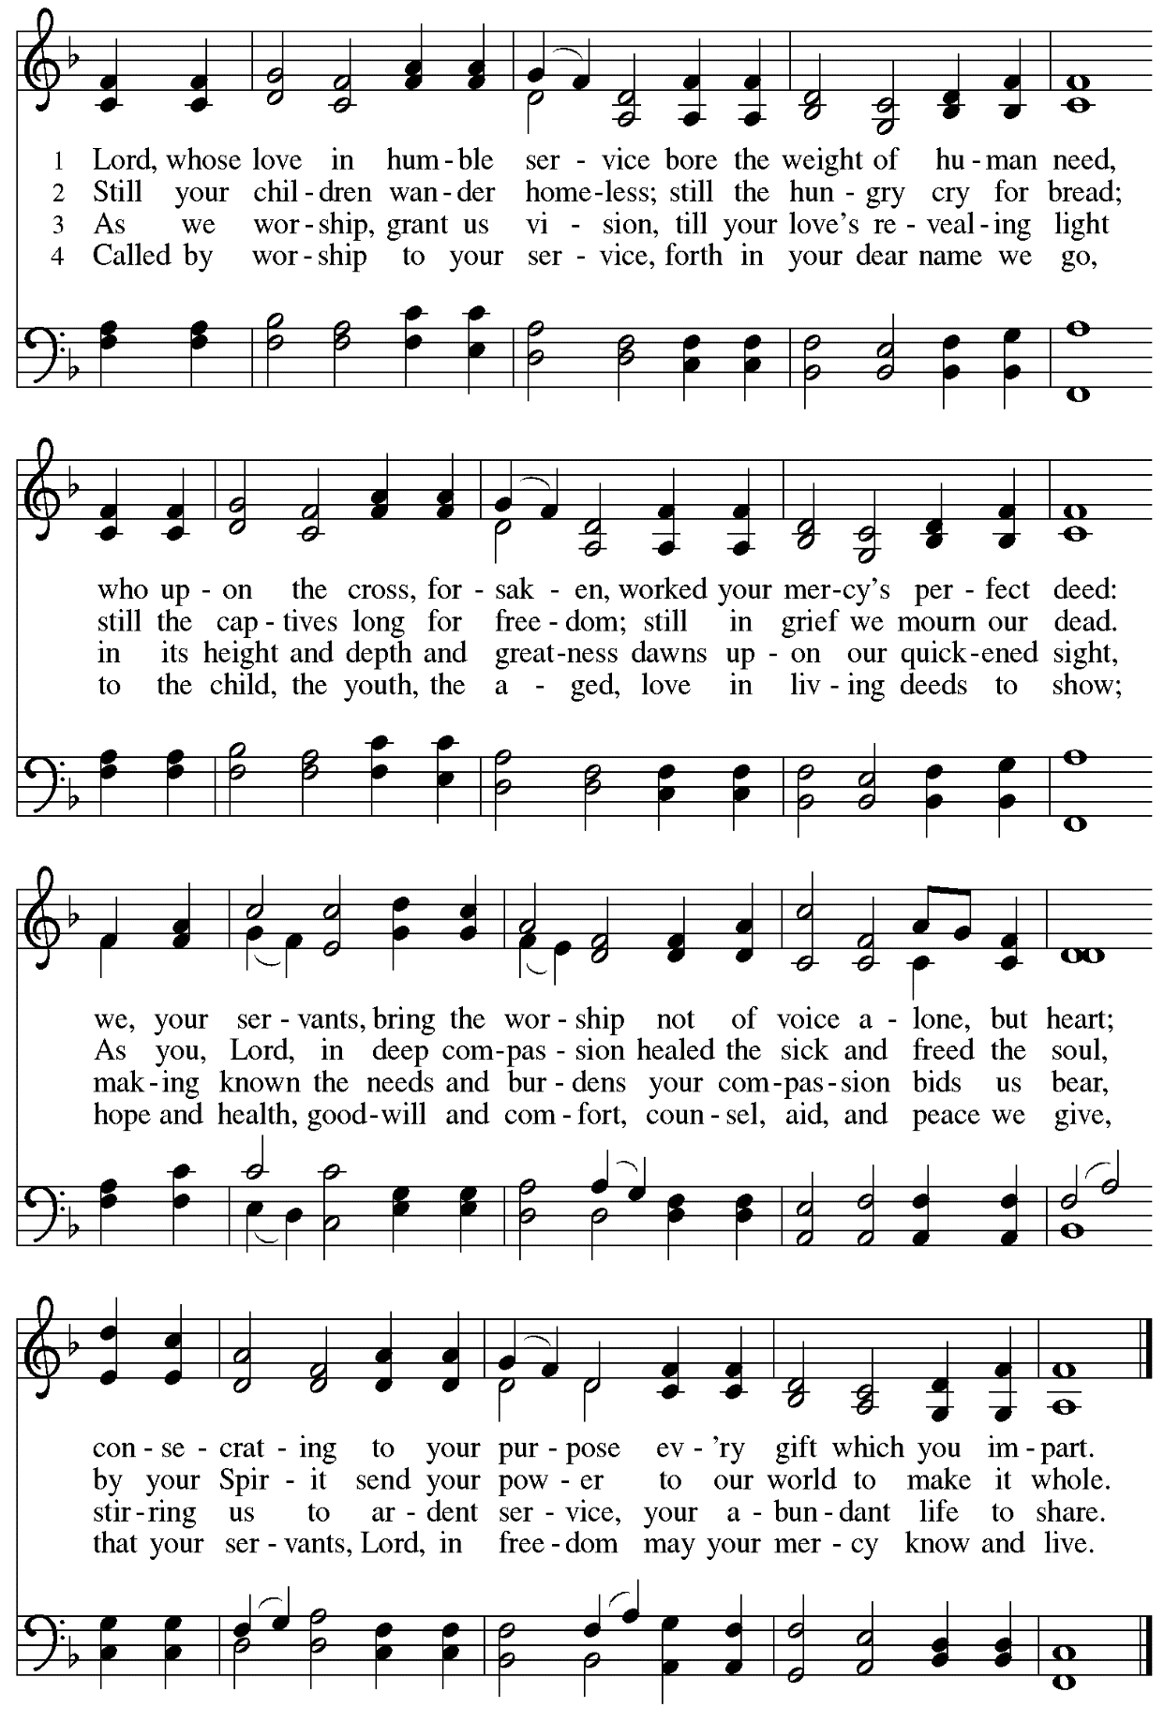

When all have returned to their places, please rise as you are able.

Blessing

P: The body and blood of our Lord Jesus Christ strengthen you and keep you in his grace.
C: Amen.

Prayer

A: Let us pray.
We thank you, generous God,
for the refreshment we have received
at your banquet table.
Send us now to spread your generosity into all the world,
through the one who is our dearest treasure,
Jesus Christ, our Savior and Lord.
C: Amen.

Please be seated.

Sending
God blesses us and sends us in mission to the world

Announcements

Please rise as you are able.

Benediction

P: The God who calls across the cosmos
and works through the smallest seed
☩ bless, keep, and sustain you,
now and to the end of the age.
C: Amen.

Sending Hymn Praise the One Who Breaks the Darkness Following page

Dismissal

A: Go in peace. Serve the Lord.
C: Thanks be to God!

Postlude

Sending Hymn Praise the One Who Breaks the Darkness ELW 843

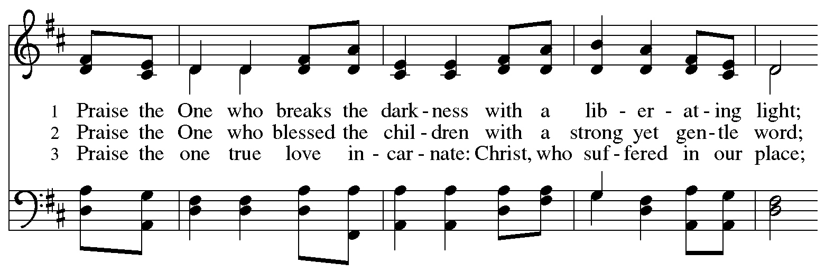
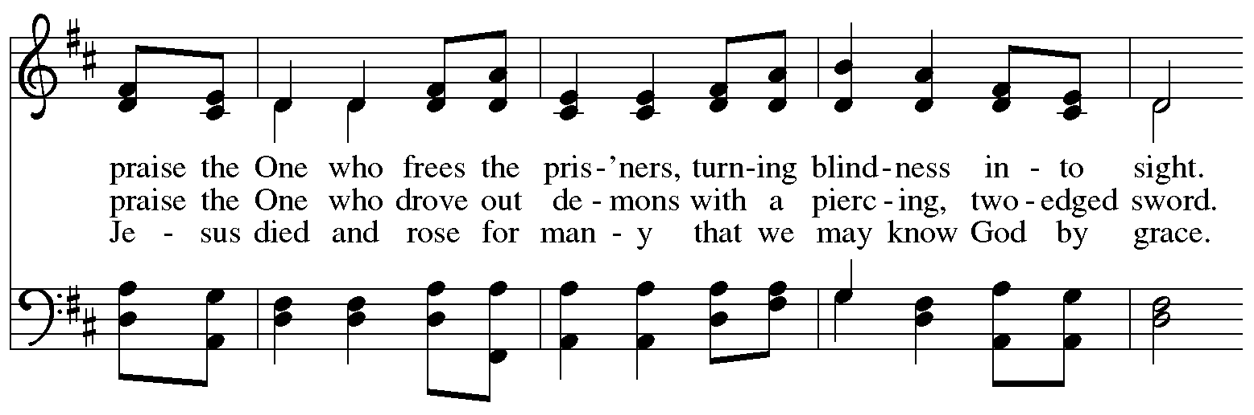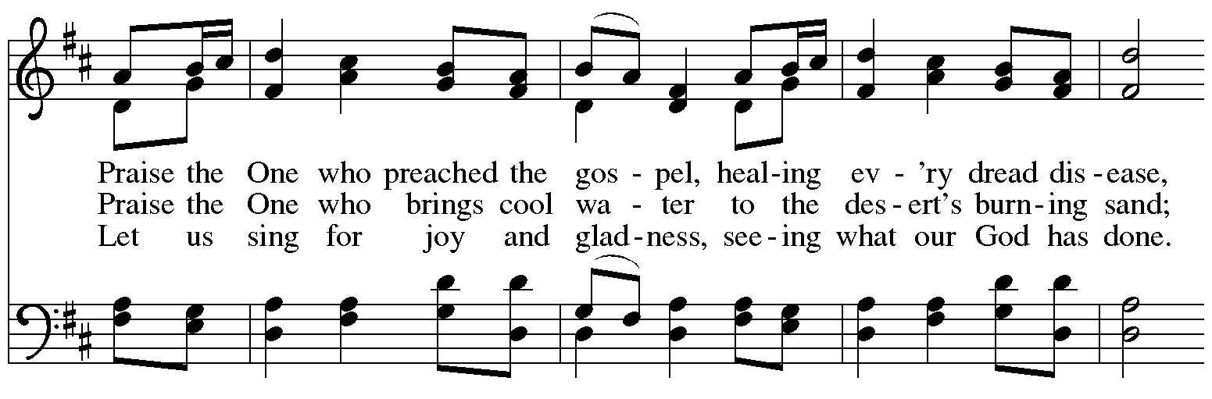
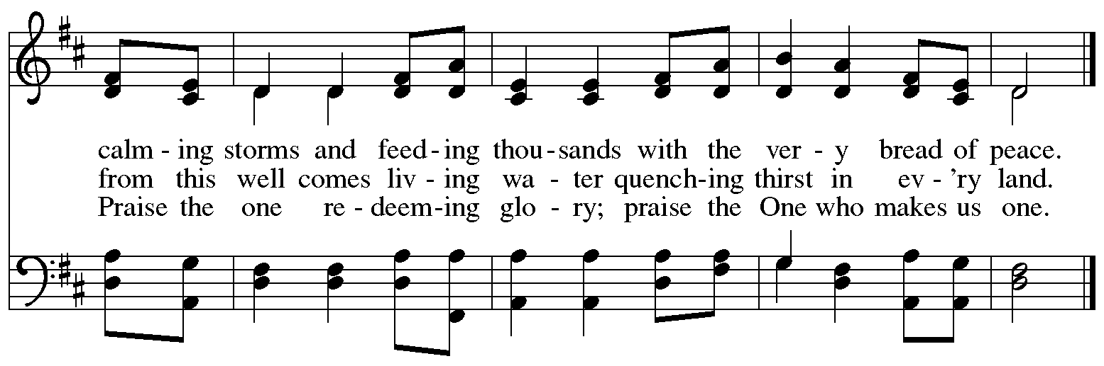
Those serving in worship today

Altar Care Janet Grzegorczyk
Assisting Minister Mandy Best
Audio-Visual Ministers Kristen Asplin
David Rollinson
Cantor Maria Mangano
Lector Tim Marker
Minister of Music Laura Reynolds
Preaching and Presiding Minister Pastor Ross Carmichael

Liturgy and Hymnody Acknowledgements

From SundaysandSeasons.com. Copyright © 2023 Augsburg Fortress. All rights reserved. Reprinted under OneLicense.net # A-722139.
Used by permission of Augsburg Fortress.

All Who Hunger, Gather Gladly – Text: Sylvia G. Dunstan, 1955-1993. Music: W. Moore, Columbian Harmony, 1825; arr. hymnal version. Text © 1991 GIA Publications, Inc., giamusic.com. 800.442.3358. Arr © 2003 Augsburg Fortress. All rights reserved. Reprinted with permission under OneLicense.net # A-722139.

Lord, Whose Love in Humble Service – Albert F. Bayly, 1901-1984. Music: BEACH SPRING, The Sacred Harp, Philadelphia, 1844; arr. Selected Hymns, 1985. Text © 1961 Oxford University Press. Music © Augsburg Fortress. All rights reserved. Reprinted with permission under OneLicense.net # A-722139.

Praise the One Who Breaks the Darkness – Text: Rusty Edwards, b. 1955. Music: NETTLETON, J. Wyeth, Repository of Sacred Music, Part II, 1813. Text © 1987 Hope Publishing Company, Carol Stream, IL 60188. All rights reserved. Reprinted with permission under OneLicense.net # A-722139.

Please use the QR code below to link to St. Andrew’s Announcements online!

St. Andrew Lutheran Church Announcements
August 6th, 2023

- Welcome to worship at St. Andrew on the Tenth Sunday after Pentecost, August 6th, 2023 – We are so glad you are here, and we offer a special welcome to all visitors and guests connecting for the first time! Worship attendees are invited to make a name tag at the back of the worship space if you would like. There are worship “toolkits” to help children engage with worship and “busy bags” for younger children available in the bookcase at the back of the sanctuary. Please feel free to take one to use with/for your children.
- Welcome New Members Chris, Dan and Rich, Leanne and Jonathan! – In worship today, Chris, Dan and Rich will affirm their Baptism, becoming new members of the St. Andrew congregation. This is an opportunity for all of us to remember our baptismal promises and to pray for and support these new friends in Christ. We also welcome Leanne and Jonathan, who have transferred from Rejoice! Lutheran Church in Omaha. Thanks be to God for these siblings in Christ!
- Monthly Reparations Offering Today, August 6th, during Worship – Jesus’ parable of the Good Samaritan from Luke's Gospel provides an example of how God's people are called to work for healing and repair for our neighbors, independent of who or what caused harm. In light of this, St. Andrew has made a commitment to reparations in regard to African American spiritual songs used in our worship. The text and music of most hymns is attributed to specific authors, with copyrights in place, usage reported, and royalties paid to those whose works are featured in worship. With African American spirituals, this is not possible. In response to many years of such uncredited use, St. Andrew will invite people of the congregation to give to a second collection for reparations during the offering. Funds received in our collections will be donated to our siblings at Bethel AME Church, whose land and building were taken from them in the 1950s, to fund the development they are planning in the lower Hill District.
- August Shelter Dinner at East End Cooperative Ministry – Thursday, August 17th, 6:30 p.m. – Each month, people of St. Andrew prepare and serve a dinner for guests of the Shelter at East End Cooperative Ministry (EECM), 6140 Station St., Pittsburgh 15206. This month’s dinner will be Thursday, August 17th. We ask people from the congregation to provide one portion of the meal. Anyone dropping off food can bring it to the shelter at 6:00 p.m. so that service can begin at 6:30 p.m. If you would like to contribute a portion of the meal, or would simply like to help serve, please sign up here:
- Macedonia Family and Community Enrichment Center (FACE) Seeking Donations of Household Items – Macedonia Family and Community Enrichment Center (FACE) serves families experiencing hardship in our community. Their mission is to encourage the development of healthy families. They have been seeing an increase in requests for household items that people are not able to afford. Many necessities cannot be purchased with supplemental food benefits (SNAP). Macedonia FACE is seeking donations of household items such as toilet paper and paper towels, shampoo/conditioner (Black haircare), soap, feminine hygiene products, and cleaning products (laundry soap, dish soap, disinfecting wipes). Items can be left on the table next to the pantry shelves in St. Andrew's Social Hall.
- Lutheran Campus Ministry in Greater Pittsburgh (LCMGP) 75th Anniversary Dinner – Friday, September 15th, 2023, 7:30 p.m. at Le Mont – Join the LCMGP for its inaugural fundraising banquet as they celebrate the ministry's work in Greater Pittsburgh and among the universities of Pitt, Carnegie Mellon, Chatham, and Carlow for over the past 75+ years. Learn more about LCMGP, purchase tickets, or make a donation here.
- St. Andrew Is Updating Information – Please Respond! – St. Andrew is looking to update our records with information from newer attendees, as well as offering current members the opportunity to include current information. This includes name, preferred pronouns, email, phone number, birthdays, anniversaries, and more. The information will only be used within the congregation - for example to acknowledge celebrations and milestones in worship, in the prayers of the church, or in the weekly or monthly newsletter. Please fill out the form at: https://forms.gle/fTwpdG2uA7pYD2ta8.
Stand Up for Fairness for All Pennsylvanians

This month, the nation's largest organization devoted to the rights of LGBTQ+ Americans declared a "state of emergency" in the U.S. amidst a growing number of dangerous and discriminatory policies. In Pennsylvania, more than half a million LGBTQ+ residents are vulnerable to discrimination every day because of a lack of express and enduring statutory protections at the state level. Tell your lawmakers it's time to make our Commonwealth a safe place for everyone to live, love and work as their authentic selves without fear of discrimination.

Pennsylvania remains the only state in the Northeast without an inclusive statewide nondiscrimination law. Passage of protections in Pennsylvania is a critical step to ensure LGBTQ people are treated with dignity in employment, housing, and public spaces.

Contact your lawmakers here.

Sign up here to join fellow Lutherans working for protections for LGBTQ+ Pennsylvanians and receive alerts about rallies and other opportunities to act. Please include FAIRNESS in the subject line.

The seven Pennsylvania bishops of the Evangelical Lutheran Church in America released a letter in support of legislation that would prohibit such discrimination.

"At this moment there is an opportunity for us to add our voices in support of legislation that could provide continuing legal protection for one particularly vulnerable group of our people," the bishops state in their letter "Fairness for All Pennsylvanians."
Read the full letter.

The letter points to the imagery of the "peaceable kingdom," described in Isaiah 11: 6, in which "the wolf shall live with the lamb, the leopard shall lie down with the kid, the calf and the lion and the fatling together, and a little child shall lead them." The words anticipate a renewal of all creation in which the identity of each creature remains but none experiences any harm from the others. "It is the fulfillment of this vision for which people of faith yearn, and toward which they call their neighbors," the bishops say in the letter. "The work of public advocacy, at its best, replaces the timid silence of resignation to what is, with a bold voice giving expression to what could be."

We recognize that the links above are not accessible on the printed page but we wanted to be sure to publish the information. Please see your “This Week at St. Andrew” email or scan the QR code above to access the clickable links. Thank you for your Advocacy!

