+ Twelfth Sunday after Pentecost
August 20, 2023

St. Andrew Lutheran Church
304 Morewood Ave.
Pittsburgh, PA 15213
St_andrewELCA@verizon.net
www.standrewpittsburgh.org

+ Twelfth Sunday after Pentecost
Order for Worship

In Isaiah we hear that God’s house shall be a house of prayer for all people and that God will gather the outcasts of Israel. The Canaanite woman in today’s gospel is a Gentile, an outsider, who is unflinching in her request that Jesus heal her daughter. Jesus commends her bold faith, which encourages us to ask: how might our church further extend its mission to those on the margins of society? In our gathering around word and meal we receive strength to be signs of comfort, healing, and justice for those in need.
Welcome to St. Andrew!

- St. Andrew Lutheran congregation welcomes all who are seeking a place of healing and wholeness – a nurturing, faith-forming spiritual home. Our community embraces people of all ages, ethnicities, cultures, abilities, sexual orientations, gender identities and expressions, and family constellations. Come and See!

- Worship Services are live streamed to multiple online platforms. By attending worship, you agree that your image and voice may be broadcast.

- Everyone is invited to make a nametag at the black bookcase in the back of the worship space if they would like. There are stickers indicating pronouns on the bookcase if you would like to include them on your name tag.

- Worship “toolkits” to help children engage with the service, along with “busy bags” for younger children, are available in the bookcase at the back of the sanctuary. Please feel free to take one to use with/for your children.

- Holy Communion is served with bread (gluten-free available) and wine or grape juice. The presiding minister will distribute the bread (host). Please consume this and then pick up an empty glass from the tray. The Communion Assistant will pour wine or grape juice into your glass. Please step to the side to consume the wine or grape juice. Feel free to kneel at the altar for prayer and reflection. As you return to your pew, glasses may be returned to the empty trays on either side of the center section.

- A restroom is available on the main level of the church, through the doors to the Social Hall and to the right in the main office.

Abbreviations
P: Pastor/Presiding Minister ACS: All Creation Sings hymnal
A: Assisting Minister ELW: Evangelical Lutheran Worship hymnal
L: Lector DATH: Dancing at the Harvest hymnal
C: Congregation

Pre-Service Music

Welcome

Prelude Just as I Am, I Come Elliott / Arr. McDonald

Gathering
The Holy Spirit calls us together as the people of God

Confession and Forgiveness

Please rise as you are able.
All may make the sign of the cross, the sign that is marked at Baptism,
as the presiding minister begins.

P: Blessed be the holy Trinity, ☩ one God,
who greets us in this and every season, whose word never fails, whose promise is sure.
C: Amen.

P: Let us confess our sin in the presence of God and of our neighbors.

Silence is kept for reflection.

P: Merciful God,
C: we confess that we have sinned.
We have hurt our community.
We have squandered your blessings.
We have hoarded your bounty.
In the name of Jesus, forgive us and grant us your mercy. Amen.

Silence is kept for reflection.

P: Righteous God,
we confess that we have sinned.
We have failed to be honest.
We have lacked the courage to speak.
We have spoken falsely.
In the name of Jesus, forgive us and grant us your mercy. Amen.

P: God is a cup of cold water when we thirst.
God offers boundless grace when we fail.
Claim the gift of God’s mercy:
you are freed and forgiven in the name of ☩ Jesus Christ.
C: Amen.

Gathering Hymn Look Who Gathers at Christ’s Table ACS 977

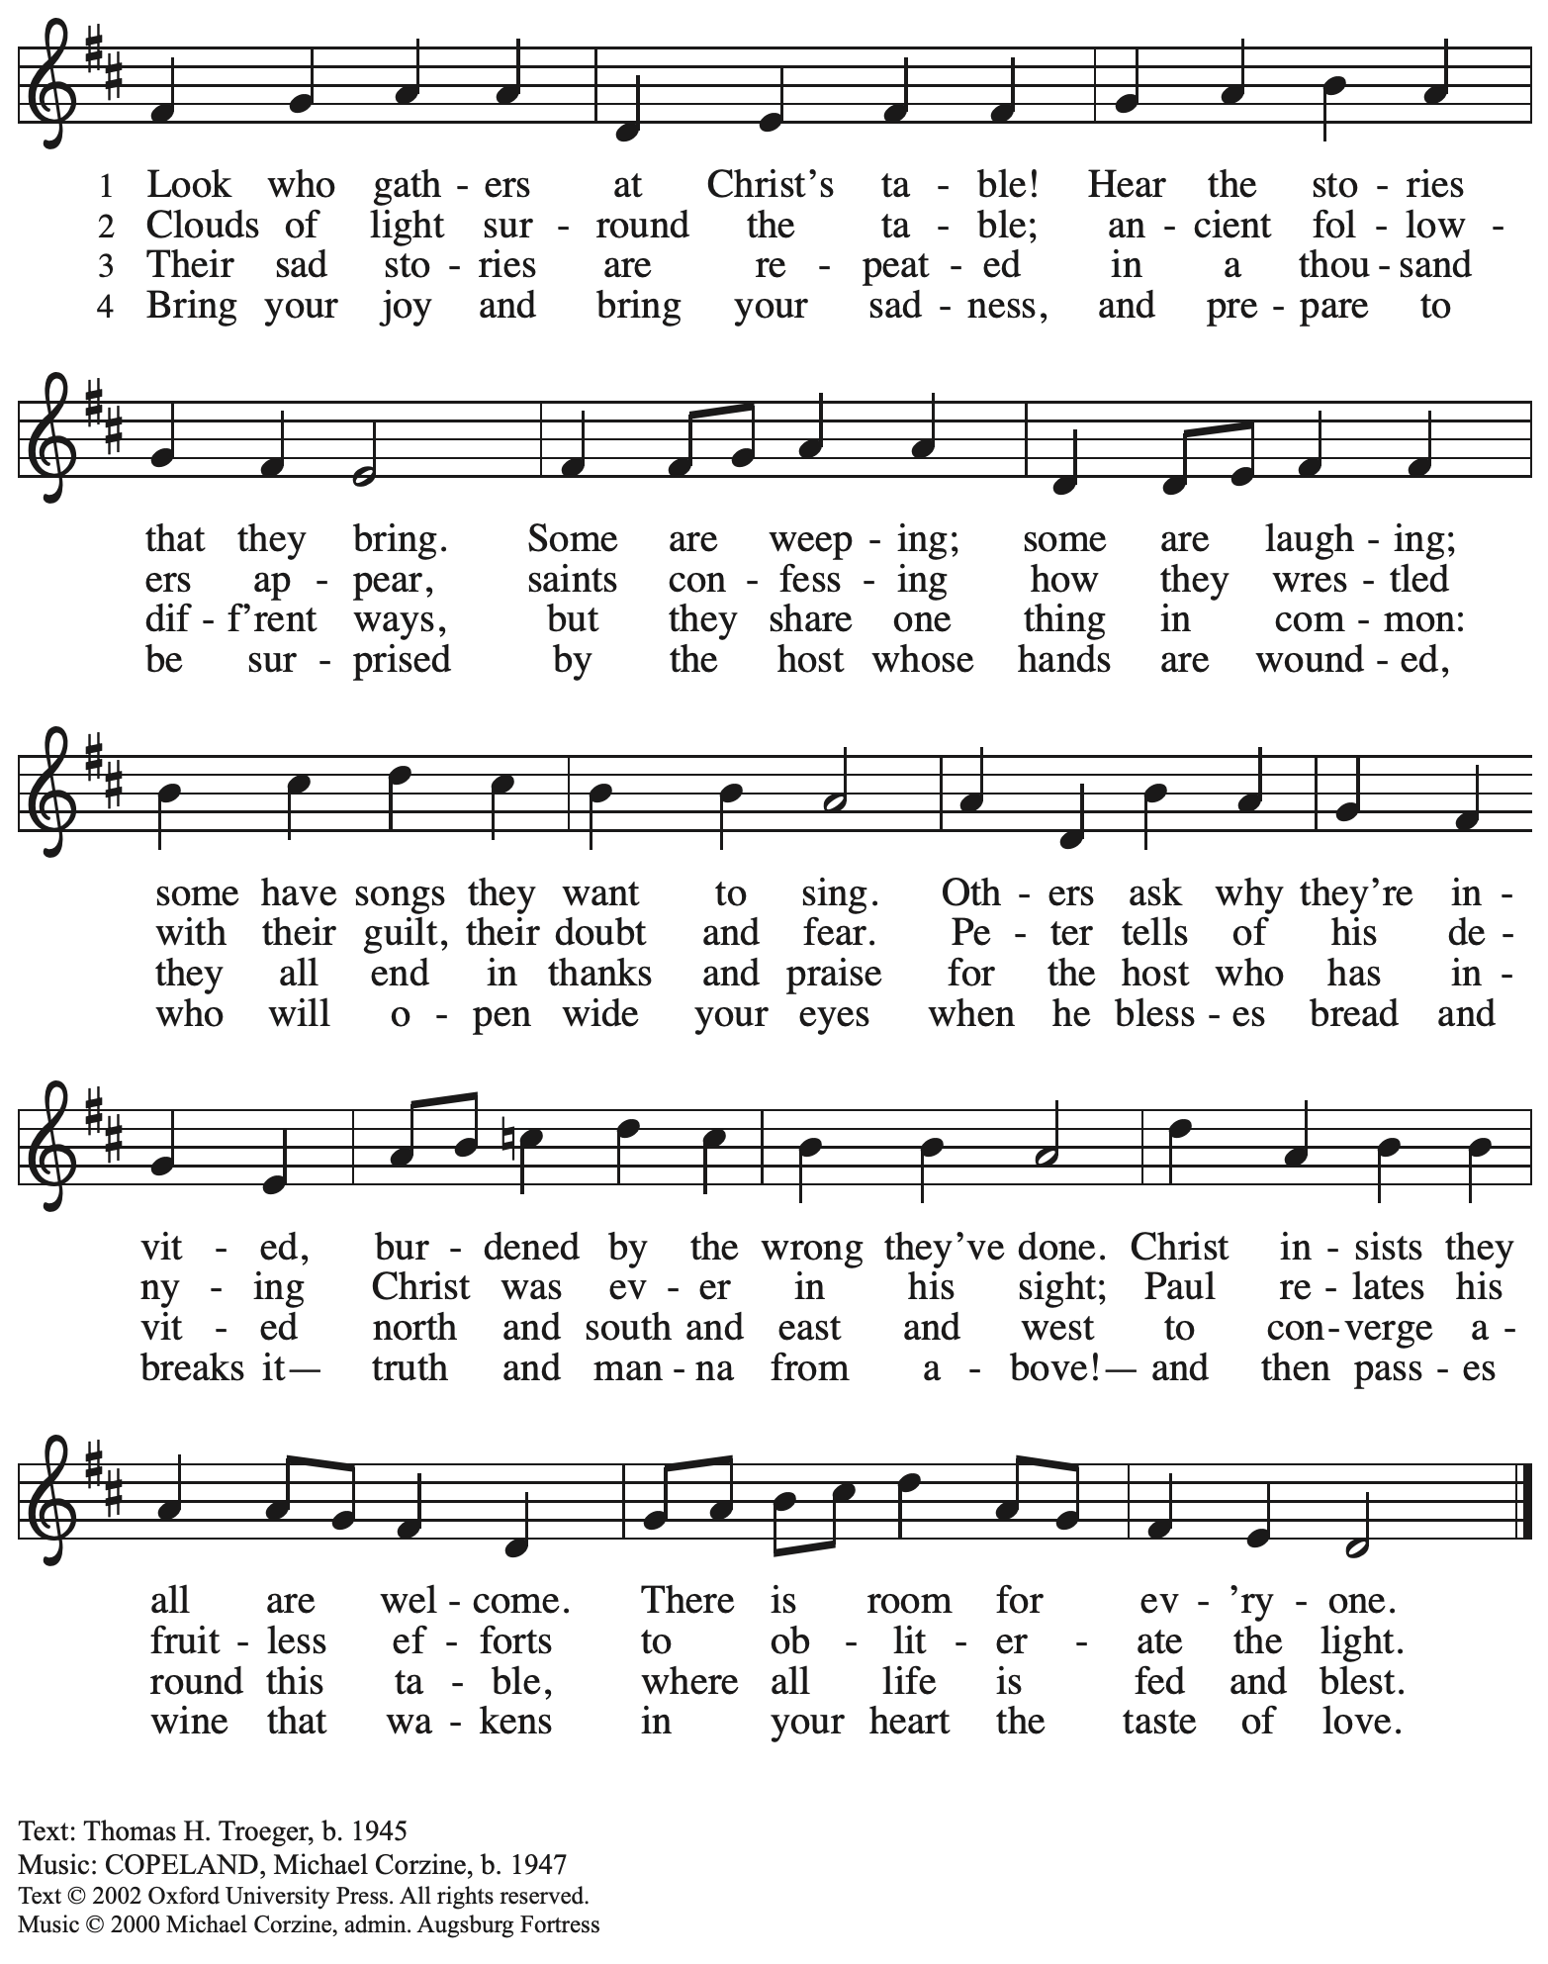
Reprinted with permission under OneLicense.net # A-722139.

Greeting

P: The grace of our Lord Jesus Christ, the love of God,
and the communion of the Holy Spirit be with you all.
C: And also with you.

Prayer of the Day

P: Let us pray.
God of all peoples, your arms reach out to embrace all those who call upon you.
Teach us as disciples of your Son to love the world with compassion and constancy,
that your name may be known throughout the earth, through Jesus Christ, our Savior and Lord.
C: Amen.

Please be seated.

Local Mission Focus Lutheran Campus Ministry in Greater Pittsburgh

A representative from Lutheran Campus Ministry in Greater Pittsburgh and their student organization, PSALM (Pittsburgh Students Active in Lutheran Ministry), will share stories about their mission and work with students from several local universities.

Word
God speaks to us in Scripture reading, preaching, and song

First Reading – Isaiah 56: 1, 6-8

¹Thus says the Lord:
Maintain justice, and do what is right,
for soon my salvation will come,
and my deliverance be revealed.

⁶And the foreigners who join themselves to the Lord,
to minister to the Lord, to love the name of the Lord,
and to be God’s servants,
all who keep the sabbath, and do not profane it,
and hold fast my covenant—
⁷these I will bring to my holy mountain,
and make them joyful in my house of prayer;
their burnt offerings and their sacrifices
will be accepted on my altar;
for my house shall be called a house of prayer
for all peoples.
⁸Thus says the Lord God,
who gathers the outcasts of Israel,
I will gather others to them
besides those already gathered.

L: Word of God, word of life.
C: Thanks be to God.

Psalm 67 Let All the People Praise DATH 38

Psalm 67 will be sung using the hymn version Let All the People Praise. The congregation is invited to sing all parts of the psalm.

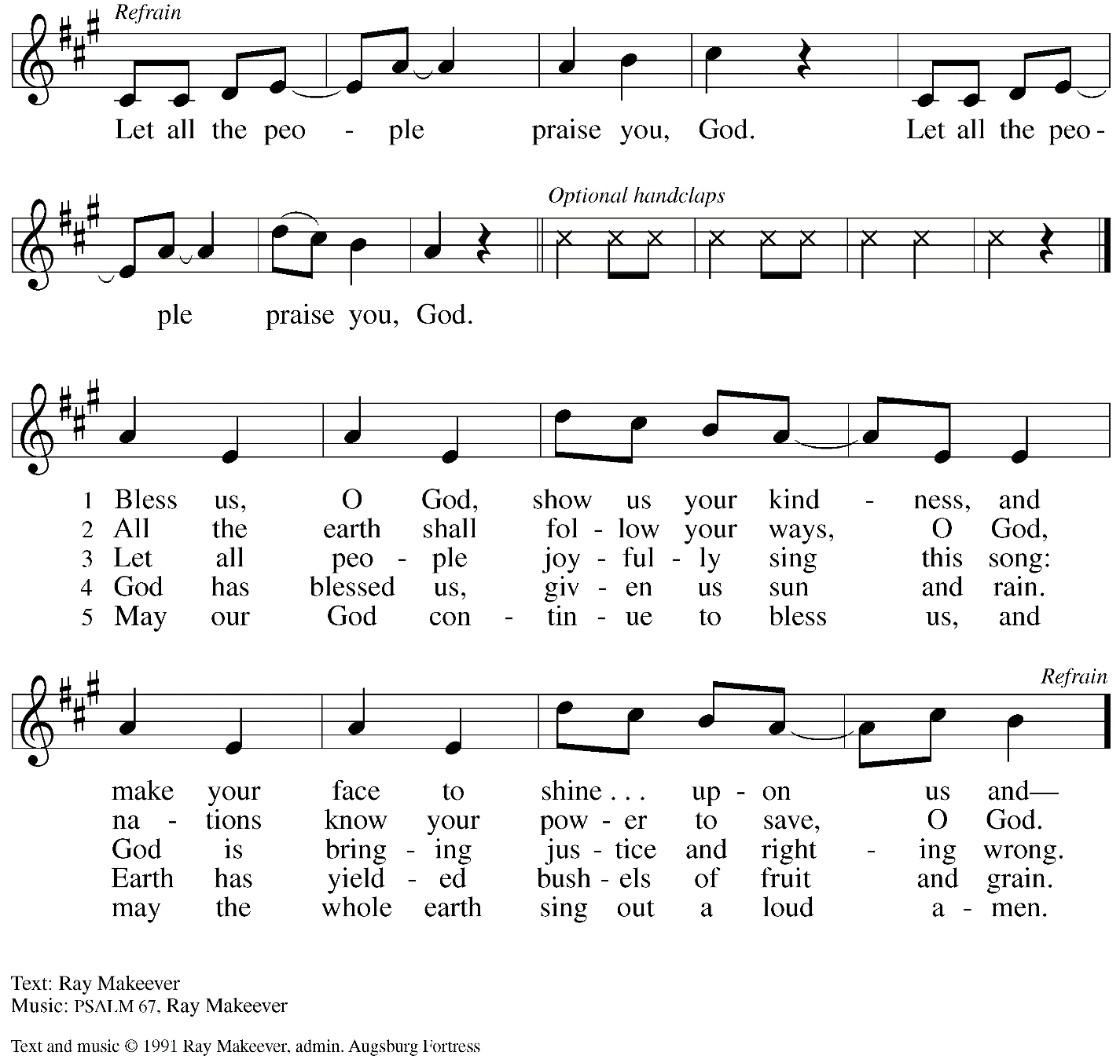
All rights reserved. Reprinted with permission under OneLicense.net # A-722139.

Second Reading – Romans 10: 5-15

[Paul writes:] ¹I ask, then, has God rejected God’s people? By no means! I myself am an Israelite, a descendant of Abraham, a member of the tribe of Benjamin. ^{2a}God has not rejected God’s people whom God foreknew.
²⁹For the gifts and the calling of God are irrevocable. ³⁰Just as you were once disobedient to God but have now received mercy because of their disobedience, ³¹so they have now been disobedient in order that, by the mercy shown to you, they too may now receive mercy. ³²For God has imprisoned all in disobedience so that God may be merciful to all.

L: Word of God, word of life.
C: Thanks be to God.

Please rise as you are able.

Gospel Acclamation Lord, Let My Heart Be Good Soil ELW 512

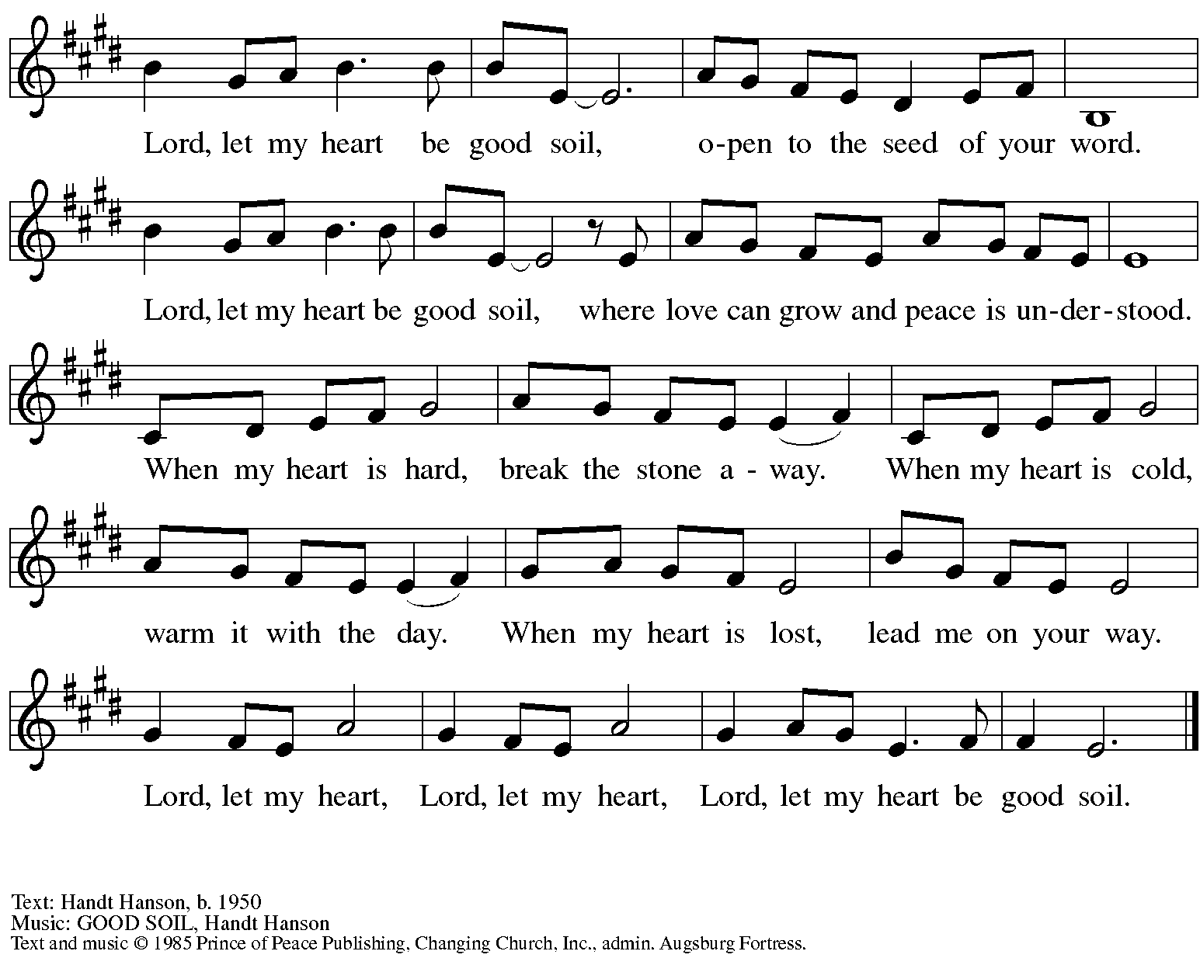
All rights reserved. Reprinted with permission under OneLicense.net # A-722139.

Gospel – Matthew 15: 10-28

P: The holy Gospel according to St. Matthew.
C: Glory to you, O Lord.

¹⁰[Jesus] called the crowd to him and said to them, “Listen and understand:¹¹it is not what goes into the mouth that defiles a person, but it is what comes out of the mouth that defiles.” ¹²Then the disciples approached and said to him, “Do you know that the Pharisees took offense when they heard what you said?” ¹³He answered, “Every plant that my heavenly Father has not planted will be uprooted. ¹⁴Let them alone; they are blind guides of the blind. And if one blind person guides another, both will fall into a pit.” ¹⁵But Peter said to him, “Explain this parable to us.”
¹⁶Then he said, “Are you also still without understanding? ¹⁷Do you not see that whatever goes into the mouth enters the stomach, and goes out into the sewer? ¹⁸But what comes out of the mouth proceeds from the heart, and this is what defiles. ¹⁹For out of the heart come evil intentions, murder, adultery, fornication, theft, false witness, slander. ²⁰These are what defile a person, but to eat with unwashed hands does not defile.”
²¹Jesus left that place and went away to the district of Tyre and Sidon. ²²Just then a Canaanite woman from that region came out and started shouting, “Have mercy on me, Lord, Son of David; my daughter is tormented by a demon.” ²³But he did not answer her at all. And his disciples came and urged him, saying, “Send her away, for she keeps shouting after us.” ²⁴He answered, “I was sent only to the lost sheep of the house of Israel.” ²⁵But she came and knelt before him, saying, “Lord, help me.” ²⁶He answered, “It is not fair to take the children’s food and throw it to the dogs.” ²⁷She said, “Yes, Lord, yet even the dogs eat the crumbs that fall from their masters’ table.” ²⁸Then Jesus answered her, “Woman, great is your faith! Let it be done for you as you wish.” And her daughter was healed instantly.
P: The Gospel of the Lord.
C: Praise to you, O Christ.

Please be seated.

Sermon The Rev. Brian Bennett

A time of silence for prayer and reflection follows the sermon.
When the hymn of the day begins, please rise as you are able.

Hymn of the Day There’s a Wideness in God’s Mercy Following page

Hymn of the Day There’s a Wideness in God’s Mercy ELW 588

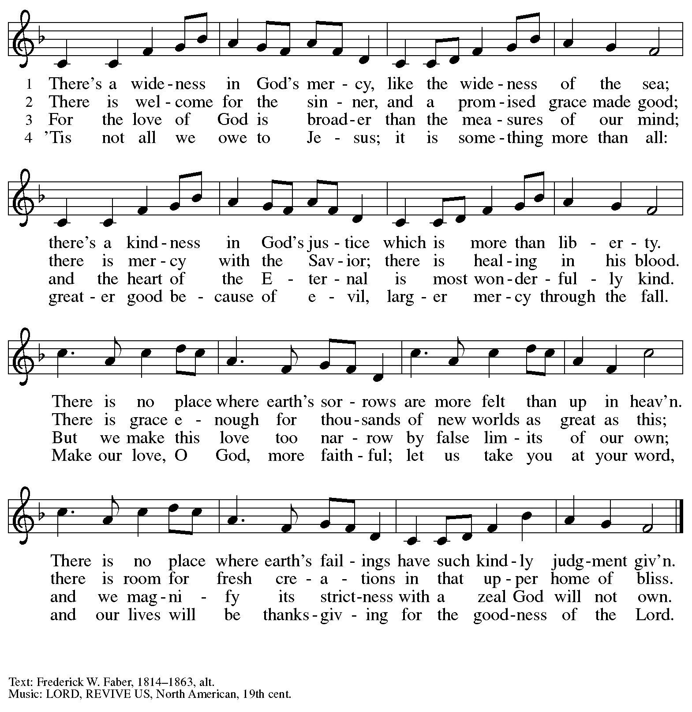

Reprinted with permission under OneLicense.net # A-722139.

Prayers of the People

A: Confident that God receives our joys and concerns, let us offer our prayers for the church,
those in need, and all of God’s creation.

After each petition
A: Hear us, O God;
C: Your mercy is great.

The presiding minister concludes the prayers
P: Into your hands, O God, we commend all for whom we pray,
in the name of the one who reconciled all creation with you, Jesus Christ our Savior.
C: Amen.

Peace

The presiding minister and the assembly greet one another in the peace of the risen Christ.
P: The peace of Christ be with you always.
C: And also with you.

The people may greet those around them with a sign of Christ’s peace and may say
Peace be with you or similar words. Please be mindful that not everyone will be comfortable with sharing the peace, so please seek consent before shaking hands or hugging. Other possible ways to share the peace include a simple bow with the verbal greeting of peace, or simply a verbal expression of peace.

When the greetings of peace have concluded, please be seated.

Meal
God feeds us with the presence of Jesus Christ

Offering

We offer ourselves, our gifts, and our faithful service to God.
As the offering is gathered for the mission of the church, including the care of those in need,
the table is set for Holy Communion.

Music during the Offering

As the gifts are brought forward for presentation, please rise as you are able.

Offertory Song ELW 680
Aramos nuestros campos / We Plow the Fields and Scatter

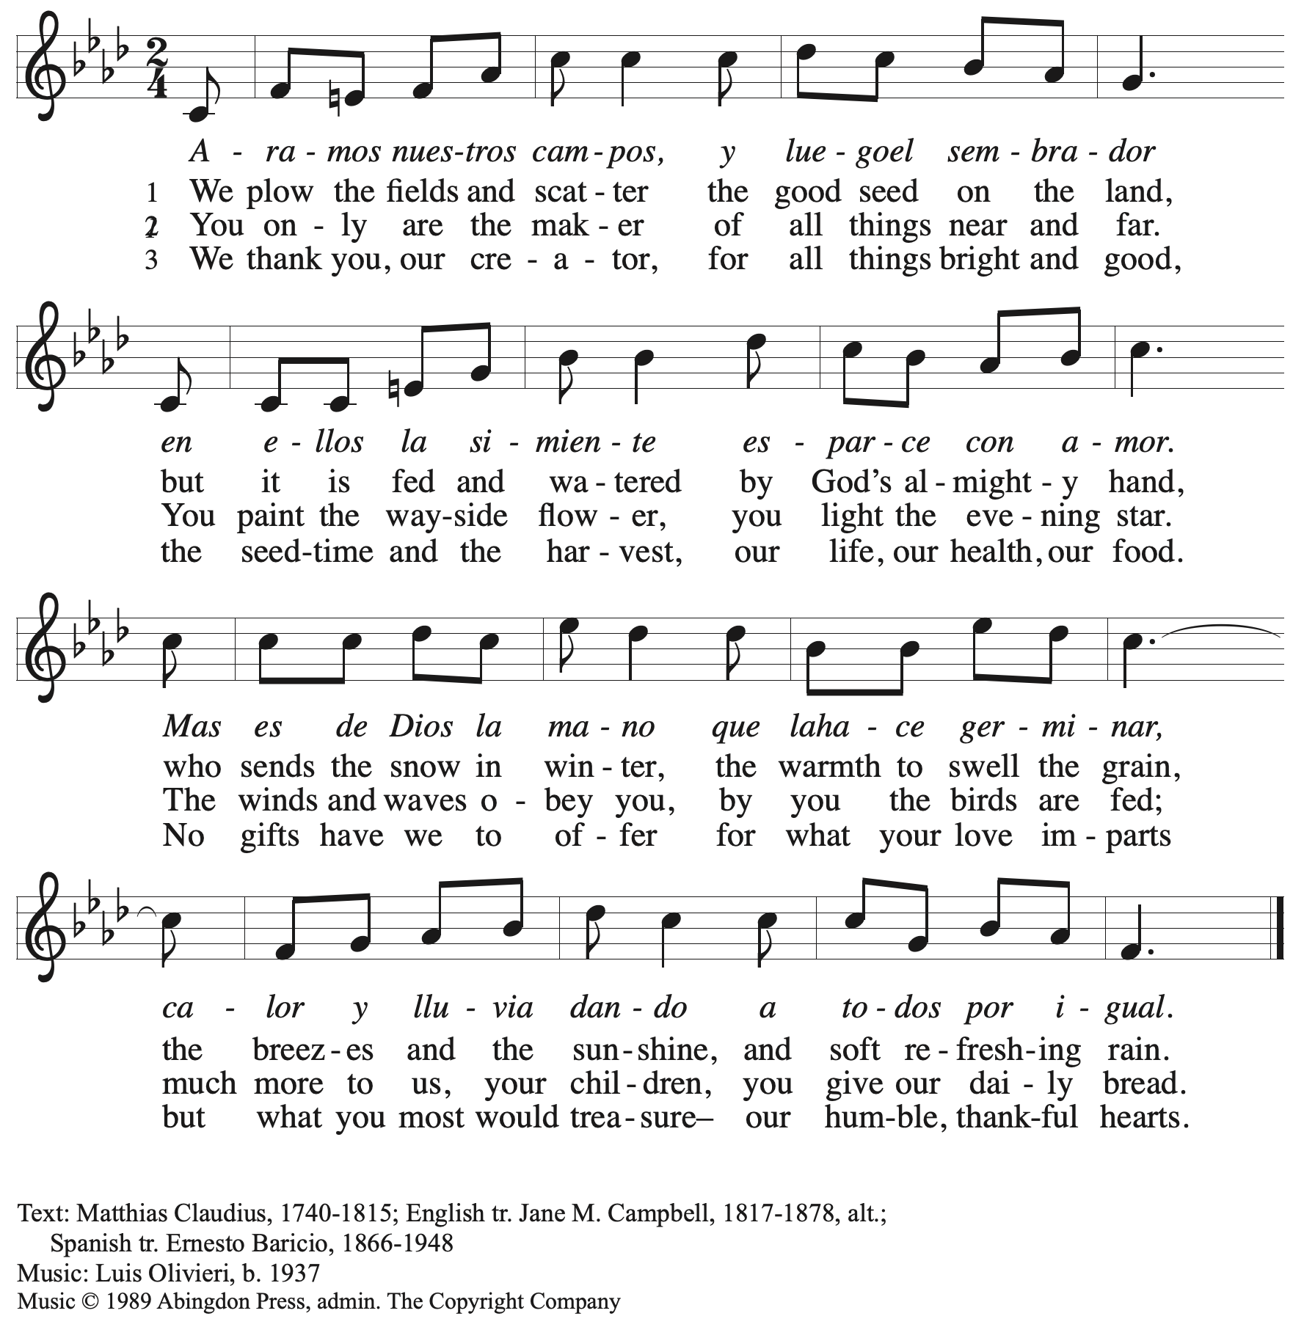
All rights reserved. Reprinted with permission under OneLicense.net # A-722139.

Offertory Prayer

A: Let us pray.
God of field and forest, sea and sky,
C: you are the giver of all good things.
Sustain us with these gifts of your creation,
and multiply your graciousness in us,
that the world may be fed with your love,
through Jesus Christ, our Savior and Lord.
Amen.

Dialogue

P: The Lord be with you.
C: And also with you.

P: Lift up your hearts.
C: We lift them to the Lord.

P: Let us give thanks to the Lord our God.
C: It is right to give our thanks and praise.

Preface

P: It is indeed right, our duty and our joy …
… we praise your name and join their unending hymn:

Sanctus

C: Holy, holy, holy Lord, God of power and might,
Heaven and earth are full of your glory; Hosanna in the highest!
Blessed is the one who comes in the name of the Lord!
Hosanna in the highest!

Eucharistic Prayer

P: Holy, mighty, and merciful Lord …
… to whom, with you and the Holy Spirit,
be all honor and glory, now and forever.
C: Amen.

Lord’s Prayer

P: Gathered as one by the Holy Spirit, let us pray as Jesus taught us.
C: Our Father in heaven,
hallowed be your name,
your kingdom come,
your will be done,
on earth as in heaven.
Give us today our daily bread.
Forgive us our sins
as we forgive those
who sin against us.
Save us from the time of trial
and deliver us from evil.
For the kingdom, the power,
and the glory are yours,
now and forever. Amen.

Fraction and Invitation

Agnus Dei / Lamb of God

C: Lamb of God, you take away the sin of the world; have mercy on us.
Lamb of God, you take away the sin of the world; have mercy on us.
Lamb of God, you take away the sin of the world; grant us peace.

Please be seated.

Holy Communion
- All who seek God and desire a deeper and stronger life in Christ are welcome to receive Holy Communion.
- Worshipers from the pulpit side will proceed forward first, followed by the center section, and then the lectern side.
- Please inform an usher if you would like the ministers to bring Communion to you.
- Holy Communion will be served with bread and wine/grape juice.
- The presiding minister will first distribute the bread (host) to each communicant. Please indicate if you require a gluten-free host.
- Once you have consumed the bread, please pick up an empty glass from the tray next to the presiding minister. The Communion Assistant will pour wine from the chalice or grape juice from the cruet into your glass.
- Please step to the side to consume the wine or grape juice.
- Feel free to kneel at the altar rail for prayer after receiving the sacrament.
- As you return to your pew, glasses may be returned to the empty trays on either side of the center section.
- A blessing will be provided for anyone who does not yet receive the sacrament.
- All are invited to join in singing the hymns during Holy Communion.

Hymns during Holy Communion
Spirit, Open My Heart ACS 1043

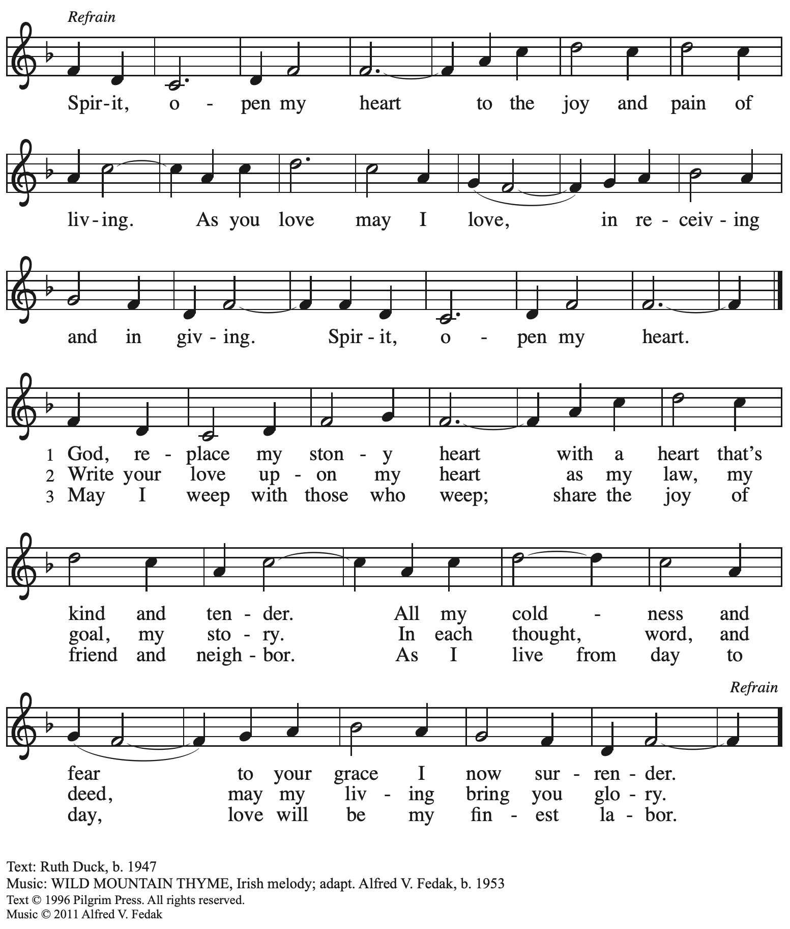
Reprinted with permission under OneLicense.net # A-722139.
Hymns during Holy Communion
Commonwealth Is God’s Commandment ACS 1036

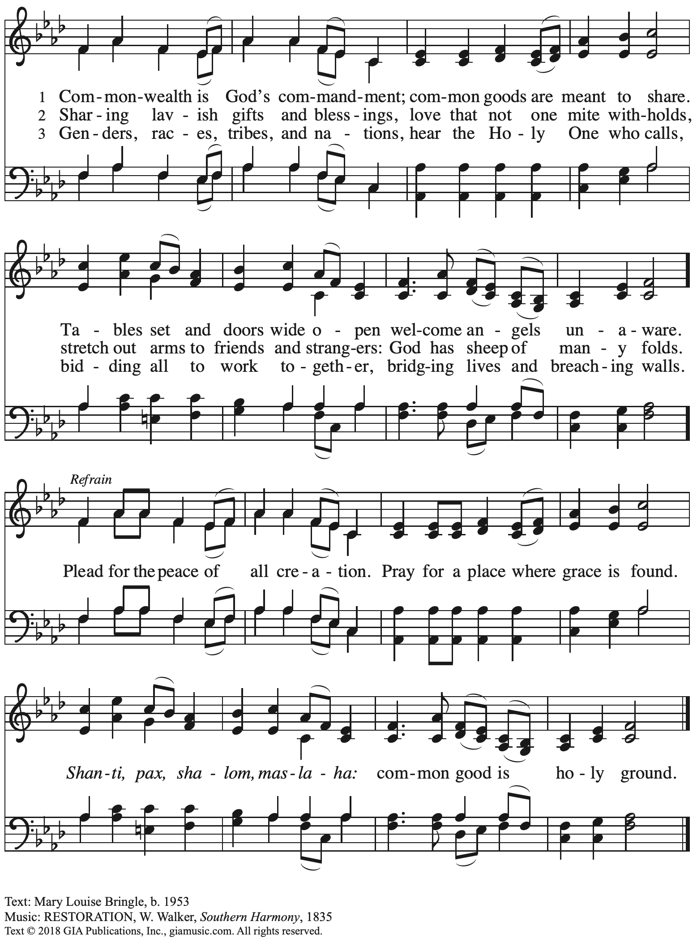
Reprinted with permission under OneLicense.net # A-722139.
Hymns during Holy Communion
Abide with Me ELW 629
v. 1-3

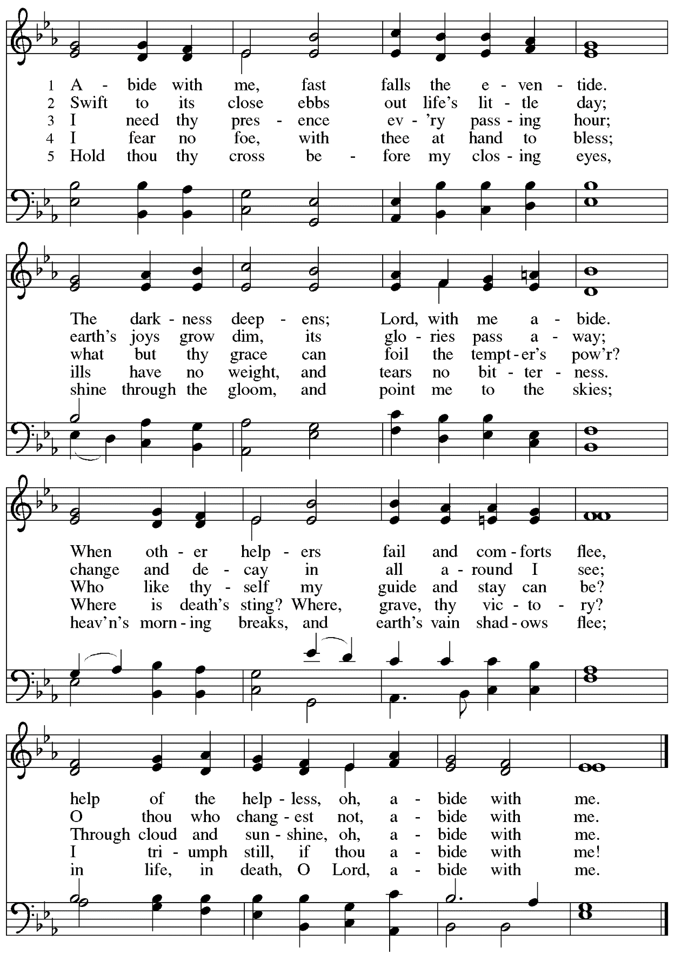

When all have returned to their places, please rise as you are able.

Blessing

P: The body and blood of our Lord Jesus Christ strengthen you and keep you in his grace.
C: Amen.

Prayer

A: Let us pray.
We thank you, generous God,
for the refreshment we have received
at your banquet table.
Send us now to spread your generosity into all the world,
through the one who is our dearest treasure,
Jesus Christ, our Savior and Lord.
C: Amen.

Please be seated.

Sending
God blesses us and sends us in mission to the world

Announcements

Please rise as you are able.

Benediction

P: The God who calls across the cosmos
and works through the smallest seed
☩ bless, keep, and sustain you,
now and to the end of the age.
C: Amen.

Sending Hymn Build a Longer Table Following page

Dismissal

A: Go in peace. Serve the Lord.
C: Thanks be to God!

Postlude

Sending Hymn Build a Longer Table ACS 1062

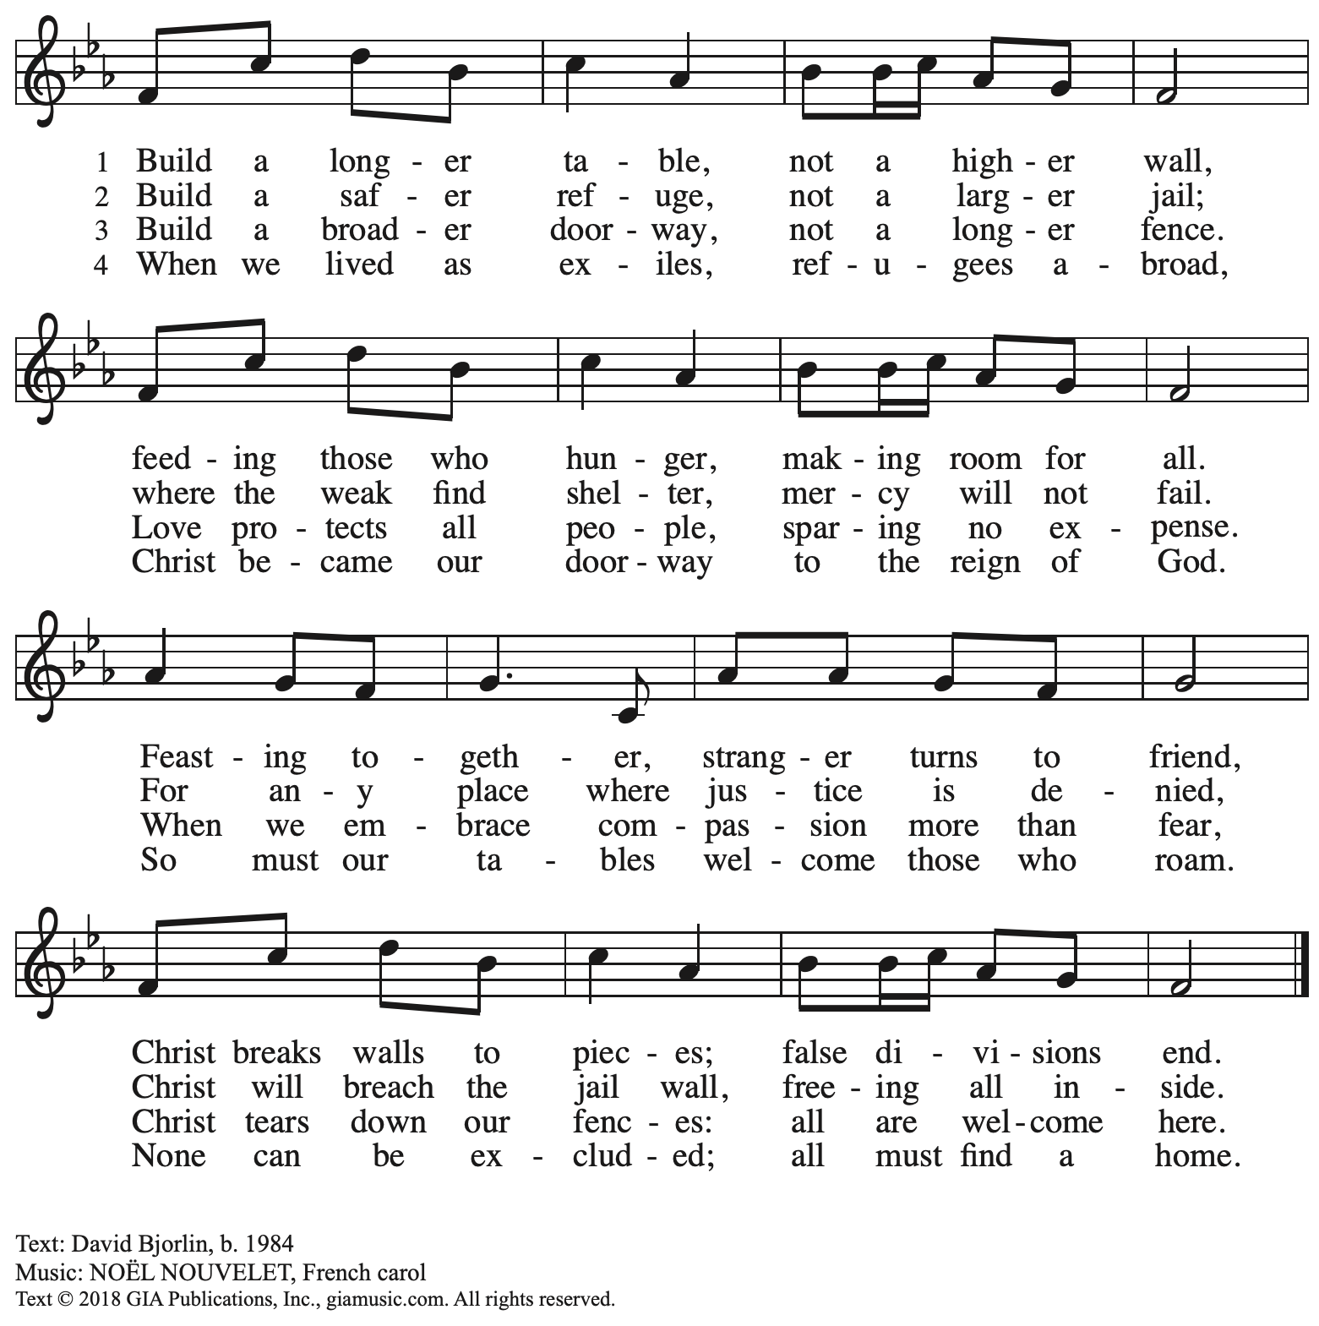
Reprinted with permission under OneLicense.net # A-722139.

Those serving in worship today

Altar Care Christy Ruhe
Announcements Colleen Cooke
Assisting Minister Jimmi Kocher-Hillmer
Audio-Visual Ministers Kristen Asplin
Joseph Paetz
Cantor Ian Brown
Lector Dixie Tymitz
Special Music Timothy Kocher-Hillmer
Colten Rohleder
Minister of Music Laura Reynolds
Preaching Minister The Rev. Brian Bennett
Presiding Minister The Rev. Ross I. Carmichael

Liturgy and Hymnody Acknowledgements

From SundaysandSeasons.com. Copyright © 2023 Augsburg Fortress. All rights reserved. Reprinted under OneLicense.net # A-722139.
Used by permission of Augsburg Fortress.

Abide with Me – Text: Henry F. Lyte, 1793-1847. Music: EVENTIDE, William H. Monk, 1823-1889.

Please use the QR code below to link to St. Andrew’s Announcements online!

St. Andrew Lutheran Church Announcements
August 20th, 2023

- Welcome to worship at St. Andrew on the Twelfth Sunday after Pentecost, August 20th, 2023 – We are so glad you are here, and we offer a special welcome to all visitors here or online for the first time! Worship attendees are invited to make a name tag at the back of the worship space if you would like. There are worship “toolkits” to help children engage with worship and “busy bags” for younger children available in the bookcase at the back of the sanctuary. Please feel free to take one to use with/for your children.
- Welcome, Lutheran Campus Ministry in Greater Pittsburgh and PSALM (Pittsburgh Students Active in Lutheran Ministry) – Today we welcome representative of our local partner mission organization, Lutheran Campus Ministry of Greater Pittsburgh and PSALM. Based at the Lutheran University Center on Forbes Avenue, they serve students from Carlow University, Carnegie Mellon University, Chatham University, and the University of Pittsburgh. We thank Pastor Brian Bennett for serving as our guest preacher today. Please welcome them back to St. Andrew!
- Macedonia Family and Community Enrichment Center (FACE) Seeking Donations of Household Items – Macedonia Family and Community Enrichment Center (FACE) which serves families experiencing hardship in our community, has seen an increase in requests for household items that people are not able to afford. Many necessities cannot be purchased with supplemental food benefits (SNAP). Macedonia FACE is seeking donations of household items such as toilet paper and paper towels, shampoo/conditioner (Black haircare), soap, feminine hygiene products, and cleaning products (laundry soap, dish soap, disinfecting wipes). Items can be left on the table next to the pantry shelves in St. Andrew's Social Hall.
- September Produce Distribution – Tuesday, September 5th, 5:30-7:00 p.m. – St. Andrew’s monthly produce distribution in partnership with Greater Pittsburgh Community Food Bank is coming up Tuesday, September 5th, from 5:30-7:00 p.m. We invite people from the congregation to come and help in the evening (greeting our neighbors, assisting with the distribution, registration, and cleanup) and earlier in the day to set up tables and bring in the delivery, usually between 10:00 a.m. and 1:00 p.m. For anyone who signs up for the setup, we will notify you the day before when we are given the delivery truck's estimated arrival time. If you would like to sign up, please do so here:
https://www.signupgenius.com/go/4090F45AFAF2BA75-produce7.
- Little Church; Big Faith Resumes during Worship Sunday, September 10th – St. Andrew will resume offering Little Church; Big Faith, a time of Bible stories and activities for children, during worship on Sunday, September 10th. After the prayer of the day, we will invite children to gather with their leader at the door at the left of the worship space – the group will then proceed to the activity room off the Social Hall. We ask that one additional parent remain with the group each week in order to fulfill the requirements of St. Andrew’s child protection policy.
- Cross-Generational Activity for Children, Youth, Parents / Guardians, and All Who are Interested – after Worship on Sundays, September 17th, October 1st, October 15th, and October 29th – In the past, children and youth of St. Andrew have helped created art for banners that adorn the worship space in the season of Advent, and we would like to create banners for a new church year. We invite children, youth, parents / guardians to gather after worship on the Sundays listed above to hear an Advent reading, talk about its imagery, and work together on an artistic representation of the text, which will be used to make four new banners, one for each week of the Advent season. While we hope for primary input from children and youth, we encourage everyone in the congregation to stay to support them and share in the St. Andrew community on these Sundays! Please speak with Christian Education liaison Colten Rohleder or Jimmi Kocher-Hillmer if you have questions.
- Lutheran Campus Ministry in Greater Pittsburgh (LCMGP) 75th Anniversary Dinner – Friday, September 15th, 2023 7:30 p.m. at Le Mont – Join the LCMGP for its inaugural fundraising banquet as they celebrate the ministry's work in Greater Pittsburgh and among the universities of Pitt, Carnegie Mellon, Chatham, and Carlow for over the past 75+ years. Learn more about LCMGP, purchase tickets, or make a donation here.
Stand Up for Fairness for All Pennsylvanians

This month, the nation's largest organization devoted to the rights of LGBTQ+ Americans declared a "state of emergency" in the U.S. amidst a growing number of dangerous and discriminatory policies. In Pennsylvania, more than half a million LGBTQ+ residents are vulnerable to discrimination every day because of a lack of express and enduring statutory protections at the state level. Tell your lawmakers it's time to make our Commonwealth a safe place for everyone to live, love and work as their authentic selves without fear of discrimination.

Pennsylvania remains the only state in the Northeast without an inclusive statewide nondiscrimination law. Passage of protections in Pennsylvania is a critical step to ensure LGBTQ people are treated with dignity in employment, housing, and public spaces.

Contact your lawmakers here.

Sign up here to join fellow Lutherans working for protections for LGBTQ+ Pennsylvanians and receive alerts about rallies and other opportunities to act. Please include FAIRNESS in the subject line.

The seven Pennsylvania bishops of the Evangelical Lutheran Church in America released a letter in support of legislation that would prohibit such discrimination.

"At this moment there is an opportunity for us to add our voices in support of legislation that could provide continuing legal protection for one particularly vulnerable group of our people," the bishops state in their letter "Fairness for All Pennsylvanians."
Read the full letter.

The letter points to the imagery of the "peaceable kingdom," described in Isaiah 11: 6, in which "the wolf shall live with the lamb, the leopard shall lie down with the kid, the calf and the lion and the fatling together, and a little child shall lead them." The words anticipate a renewal of all creation in which the identity of each creature remains but none experiences any harm from the others. "It is the fulfillment of this vision for which people of faith yearn, and toward which they call their neighbors," the bishops say in the letter. "The work of public advocacy, at its best, replaces the timid silence of resignation to what is, with a bold voice giving expression to what could be."

We recognize that the links above are not accessible on the printed page but we wanted to be sure to publish the information. Please see your “This Week at St. Andrew” email or scan the QR code above to access the clickable links. Thank you for your Advocacy!

