+ Thirteenth Sunday after Pentecost
August 27, 2023

St. Andrew Lutheran Church
304 Morewood Ave.
Pittsburgh, PA 15213
St_andrewELCA@verizon.net
www.standrewpittsburgh.org

+ Thirteenth Sunday after Pentecost
Order for Worship

In the book of Isaiah, God’s people are advised to look to their spiritual ancestors as the rock from which they were hewn. Jesus declares that the church will be built on the rock of Peter’s bold confession of faith. God’s word of reconciliation and God’s mercy are keys to the church’s mission. Paul urges us to not be conformed to this world but to offer our bodies as a living sacrifice, using our individual gifts to build up the body of Christ. From the table we go forth to offer our spiritual worship through word and deed.
Welcome to St. Andrew!

- St. Andrew Lutheran congregation welcomes all who are seeking a place of healing and wholeness – a nurturing, faith-forming spiritual home. Our community embraces people of all ages, ethnicities, cultures, abilities, sexual orientations, gender identities and expressions, and family constellations. Come and See!

- Worship Services are live streamed to multiple online platforms. By attending worship, you agree that your image and voice may be broadcast.

- Everyone is invited to make a nametag at the black bookcase in the back of the worship space if they would like. There are stickers indicating pronouns on the bookcase if you would like to include them on your name tag.

- Worship “toolkits” to help children engage with the service, along with “busy bags” for younger children, are available in the bookcase at the back of the sanctuary. Please feel free to take one to use with/for your children.

- Holy Communion is served with bread (gluten-free available) and wine or grape juice. The presiding minister will distribute the bread (host). Please consume this and then pick up an empty glass from the tray. The Communion Assistant will pour wine or grape juice into your glass. Please step to the side to consume the wine or grape juice. Feel free to kneel at the altar for prayer and reflection. As you return to your pew, glasses may be returned to the empty trays on either side of the center section.

- A restroom is available on the main level of the church, through the doors to the Social Hall and to the right in the main office.

Abbreviations
P: Pastor/Presiding Minister ACS: All Creation Sings hymnal
A: Assisting Minister ELW: Evangelical Lutheran Worship hymnal
L: Lector
C: Congregation

Pre-Service Music

Welcome

Prelude Bless We the Name of the Lord M. Burkhardt

Gathering
The Holy Spirit calls us together as the people of God

Confession and Forgiveness

Please rise as you are able.
All may make the sign of the cross, the sign that is marked at Baptism,
as the presiding minister begins.

P: Blessed be the holy Trinity, ☩ one God,
who greets us in this and every season, whose word never fails, whose promise is sure.
C: Amen.

P: Let us confess our sin in the presence of God and of our neighbors.

Silence is kept for reflection.

P: Merciful God,
C: we confess that we have sinned.
We have hurt our community.
We have squandered your blessings.
We have hoarded your bounty.
In the name of Jesus, forgive us and grant us your mercy. Amen.

Silence is kept for reflection.

P: Righteous God,
we confess that we have sinned.
We have failed to be honest.
We have lacked the courage to speak.
We have spoken falsely.
In the name of Jesus, forgive us and grant us your mercy. Amen.

P: God is a cup of cold water when we thirst.
God offers boundless grace when we fail.
Claim the gift of God’s mercy:
you are freed and forgiven in the name of ☩ Jesus Christ.
C: Amen.

Gathering Hymn Christ Is Made the Sure Foundation ELW 645

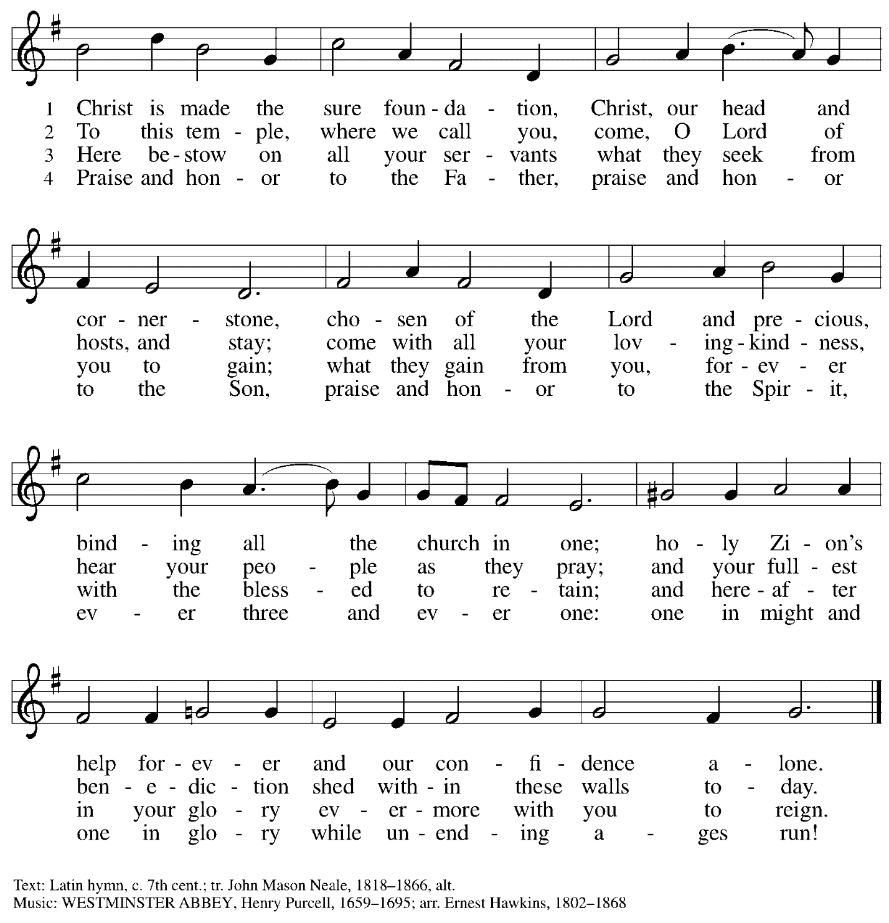

Greeting

P: The grace of our Lord Jesus Christ, the love of God,
and the communion of the Holy Spirit be with you all.
C: And also with you.

Prayer of the Day

P: Let us pray.
O God, with all your faithful followers of every age, we praise you, the rock of our life.
Be our strong foundation and form us into the body of your Son,
that we may gladly minister to all the world, through Jesus Christ, our Savior and Lord.
C: Amen.

Please be seated.

Word
God speaks to us in Scripture reading, preaching, and song

First Reading – Isaiah 51: 1-6

¹Listen to me, you that pursue righteousness,
you that seek the Lord.
Look to the rock from which you were hewn,
and to the quarry from which you were dug.
²Look to Abraham your father
and to Sarah who bore you;
for he was but one when I called him,
but I blessed him and made him many.
³For the Lord will comfort Zion;
the Lord will comfort all her waste places,
and will make her wilderness like Eden,
her desert like the garden of the Lord;
joy and gladness will be found in her,
thanksgiving and the voice of song.
⁴Listen to me, my people,
and give heed to me, my nation;
for a teaching will go out from me,
and my justice for a light to the peoples.
⁵I will bring near my deliverance swiftly,
my salvation has gone out
and my arms will rule the peoples;
the coastlands wait for me,
and for my arm they hope.
⁶Lift up your eyes to the heavens,
and look at the earth beneath;
for the heavens will vanish like smoke,
the earth will wear out like a garment,
and those who live on it will die like gnats;
but my salvation will be forever,
and my deliverance will never be ended.

L: Word of God, word of life.
C: Thanks be to God.

Psalm 138

The psalm will be led by the cantor, with the congregation invited to join in singing the alternate verses (in bold) and refrain.

Psalm tone

Psalm refrain

¹I will give thanks to you, O Lord, with | my whole heart;
before the gods I will | sing your praise.
²I will bow down toward your holy temple and praise your name, because of your
steadfast | love and faithfulness;
for you have glorified your name and your word a- | bove all things.
³When I called, you | answered me;
you increased my | strength within me.
⁴All the rulers of the earth will praise | you, O Lord,
when they have heard the words | of your mouth. R
⁵They will sing of the ways | of the Lord,
that great is the glory | of the Lord.
⁶The Lord is high, yet cares | for the lowly,
perceiving the haughty | from afar.
⁷Though I walk in the midst of trouble, you | keep me safe;
you stretch forth your hand against the fury of my enemies; your right | hand shall save me.
⁸You will make good your pur- | pose for me;
O Lord, your steadfast love endures forever; do not abandon the works | of your
hands. R

Second Reading – Romans 12: 1-8

¹I appeal to you therefore, kindred, by the mercies of God, to present your bodies as a living sacrifice, holy and acceptable to God, which is your spiritual worship. ²Do not be conformed to this world, but be transformed by the renewing of your minds, so that you may discern what is the will of God—what is good and acceptable and perfect.
³For by the grace given to me I say to everyone among you not to think of yourself more highly than you ought to think, but to think with sober judgment, each according to the measure of faith that God has assigned. ⁴For as in one body we have many members, and not all the members have the same function, ⁵so we, who are many, are one body in Christ, and individually we are members one of another. ⁶We have gifts that differ according to the grace given to us: prophecy, in proportion to faith; ⁷ministry, in ministering; the teacher, in teaching; ⁸the exhorter, in exhortation; the giver, in generosity; the leader, in diligence; the compassionate, in
cheerfulness.

L: Word of God, word of life.
C: Thanks be to God.

Please rise as you are able.

Gospel Acclamation Lord, Let My Heart Be Good Soil ELW 512

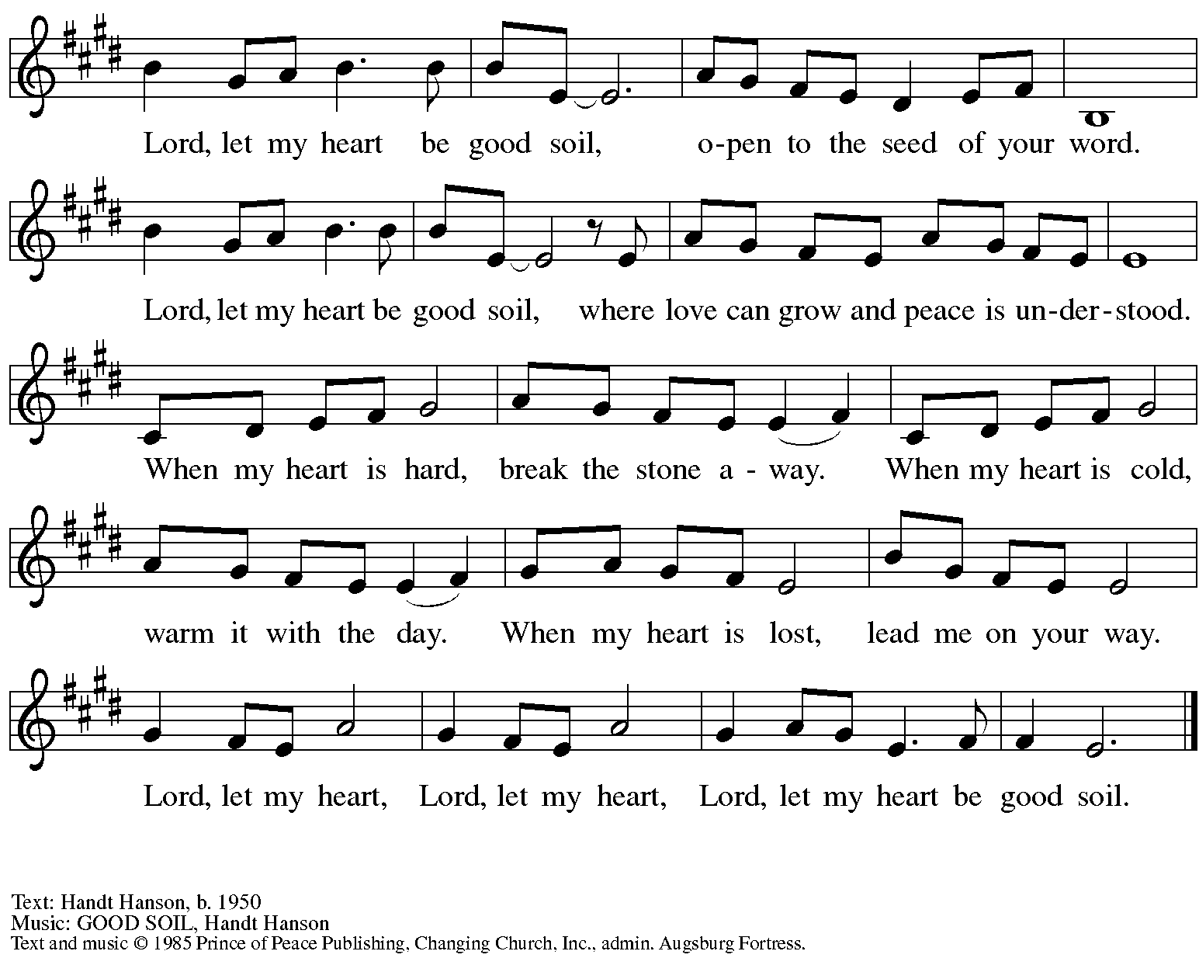
All rights reserved. Reprinted with permission under OneLicense.net # A-722139.

Gospel – Matthew 16: 13-20

P: The holy Gospel according to St. Matthew.
C: Glory to you, O Lord.

¹³Now when Jesus came into the district of Caesarea Philippi, he asked his disciples, “Who do people say that the Son of Humanity is?” ¹⁴And they said, “Some say John the Baptist, but others Elijah, and still others Jeremiah or one of the prophets.” ¹⁵He said to them, “But who do you say that I am?” ¹⁶Simon Peter answered, “You are the Messiah, the Son of the living God.” ¹⁷And Jesus answered him, “Blessed are you, Simon son of Jonah! For flesh and blood has not revealed this to you, but my Father in heaven. ¹⁸And I tell you, you are Peter, and on this rock I will build my church, and the gates of Hades will not prevail against it. ¹⁹I will give you the keys of the kingdom of heaven, and whatever you bind on earth will be bound in heaven, and whatever you loose on earth will be loosed in heaven.” ²⁰Then he sternly ordered the disciples not to tell anyone that he was the Messiah.
P: The Gospel of the Lord.
C: Praise to you, O Christ.

Please be seated.

Sermon

A time of silence for prayer and reflection follows the sermon.
When the hymn of the day begins, please rise as you are able.

Hymn of the Day The Church’s One Foundation Following page

Hymn of the Day The Church’s One Foundation ELW 654

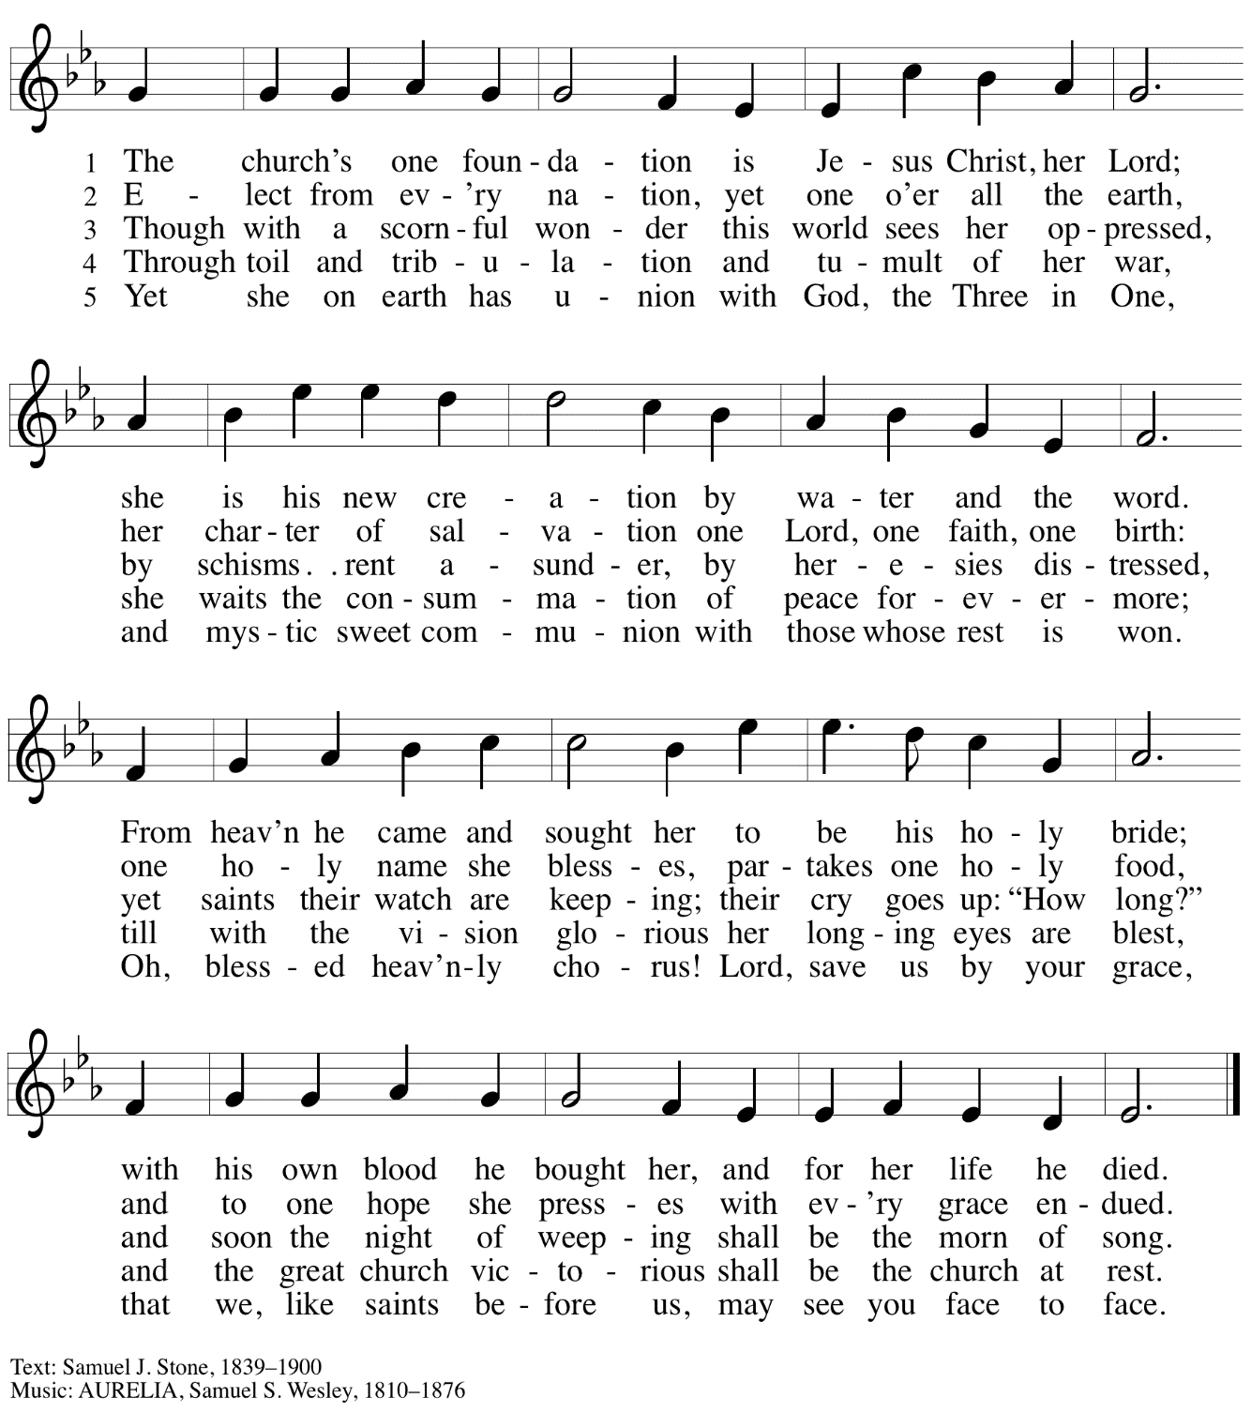

Prayers of the People

A: Confident that God receives our joys and concerns, let us offer our prayers for the church,
those in need, and all of God’s creation.

After each petition
A: Hear us, O God;
C: Your mercy is great.

The presiding minister concludes the prayers
P: Into your hands, O God, we commend all for whom we pray,
in the name of the one who reconciled all creation with you, Jesus Christ our Savior.
C: Amen.

Peace

The presiding minister and the assembly greet one another in the peace of the risen Christ.
P: The peace of Christ be with you always.
C: And also with you.

The people may greet those around them with a sign of Christ’s peace and may say
Peace be with you or similar words. Please be mindful that not everyone will be comfortable with sharing the peace, so please seek consent before shaking hands or hugging. Other possible ways to share the peace include a simple bow with the verbal greeting of peace, or simply a verbal expression of peace.

When the greetings of peace have concluded, please be seated.

Meal
God feeds us with the presence of Jesus Christ

Offering

We offer ourselves, our gifts, and our faithful service to God.
As the offering is gathered for the mission of the church, including the care of those in need,
the table is set for Holy Communion.

Music during the Offering

As the gifts are brought forward for presentation, please rise as you are able.

Offertory Song ELW 680
Aramos nuestros campos / We Plow the Fields and Scatter

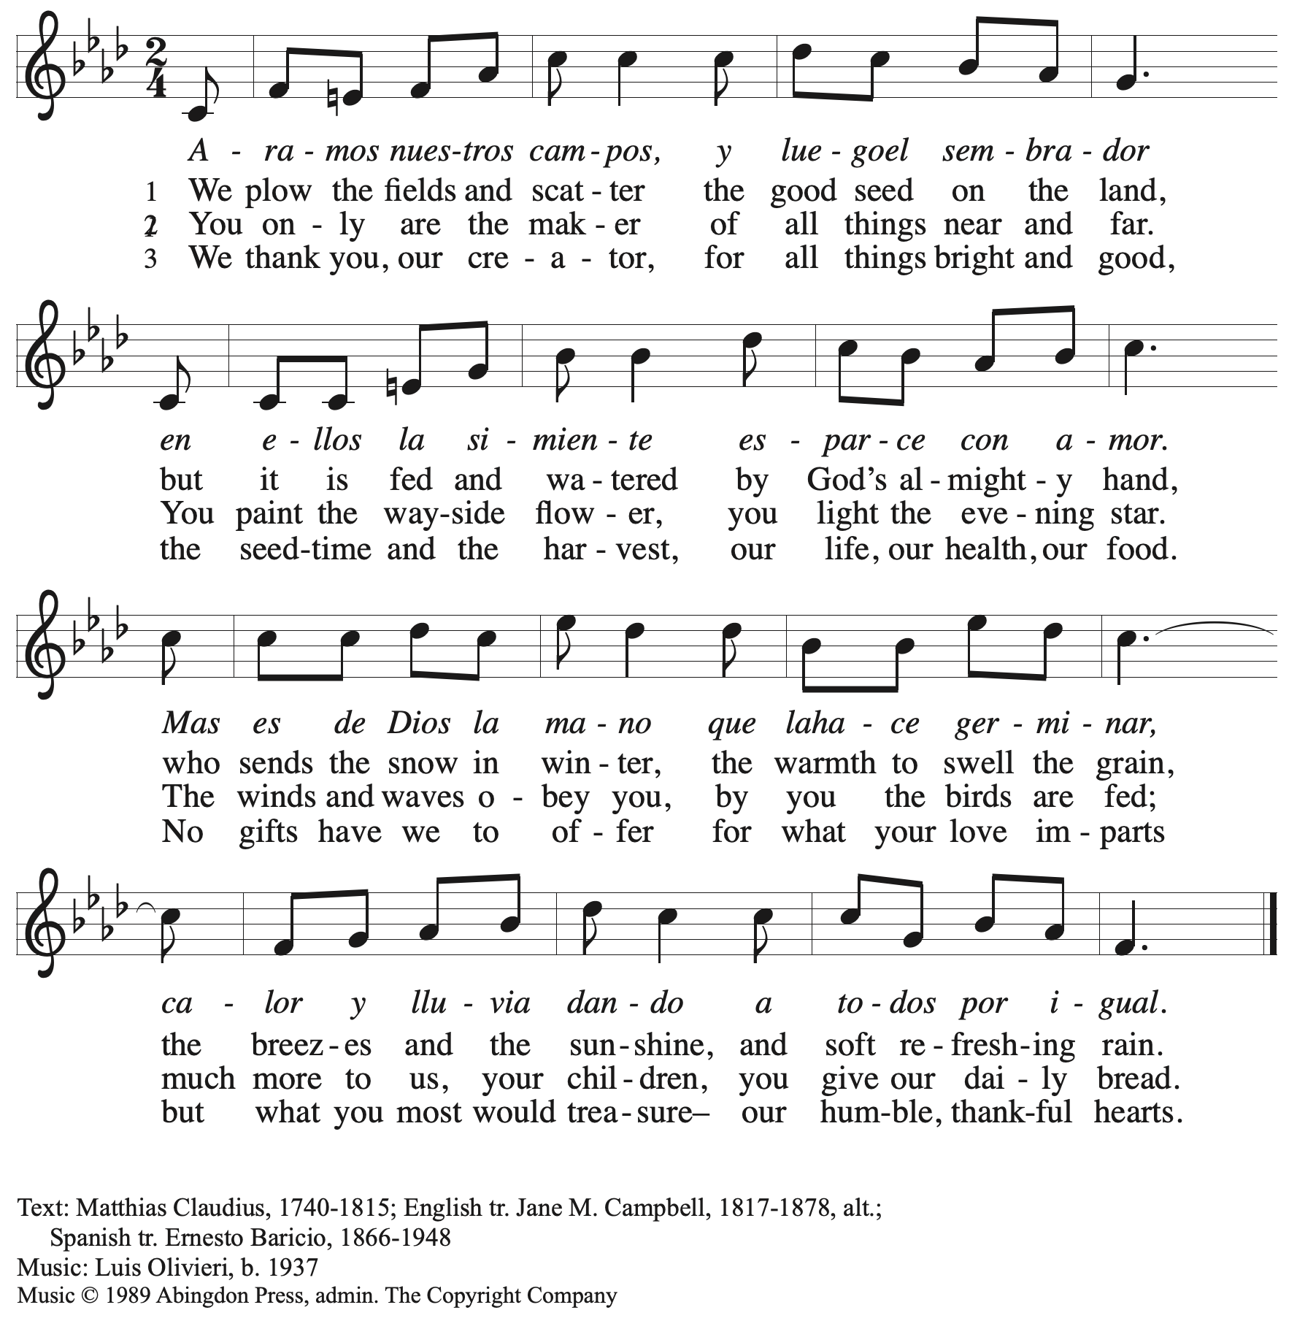
All rights reserved. Reprinted with permission under OneLicense.net # A-722139.

Offertory Prayer

A: Let us pray.
God of field and forest, sea and sky,
C: you are the giver of all good things.
Sustain us with these gifts of your creation,
and multiply your graciousness in us,
that the world may be fed with your love,
through Jesus Christ, our Savior and Lord.
Amen.

Dialogue

P: The Lord be with you.
C: And also with you.

P: Lift up your hearts.
C: We lift them to the Lord.

P: Let us give thanks to the Lord our God.
C: It is right to give our thanks and praise.

Preface

P: It is indeed right, our duty and our joy …
… we praise your name and join their unending hymn:

Sanctus

C: Holy, holy, holy Lord, God of power and might,
Heaven and earth are full of your glory; Hosanna in the highest!
Blessed is the one who comes in the name of the Lord!
Hosanna in the highest!

Eucharistic Prayer

P: Holy, mighty, and merciful Lord …
… to whom, with you and the Holy Spirit,
be all honor and glory, now and forever.
C: Amen.

Lord’s Prayer

P: Gathered as one by the Holy Spirit, let us pray as Jesus taught us.
C: Our Father in heaven,
hallowed be your name,
your kingdom come,
your will be done,
on earth as in heaven.
Give us today our daily bread.
Forgive us our sins
as we forgive those
who sin against us.
Save us from the time of trial
and deliver us from evil.
For the kingdom, the power,
and the glory are yours,
now and forever. Amen.

Fraction and Invitation

Agnus Dei / Lamb of God

C: Lamb of God, you take away the sin of the world; have mercy on us.
Lamb of God, you take away the sin of the world; have mercy on us.
Lamb of God, you take away the sin of the world; grant us peace.

Please be seated.

Holy Communion
- All who seek God and desire a deeper and stronger life in Christ are welcome to receive Holy Communion.
- Worshipers from the pulpit side will proceed forward first, followed by the center section, and then the lectern side.
- Please inform an usher if you would like the ministers to bring Communion to you.
- Holy Communion will be served with bread and wine/grape juice.
- The presiding minister will first distribute the bread (host) to each communicant. Please indicate if you require a gluten-free host.
- Once you have consumed the bread, please pick up an empty glass from the tray next to the presiding minister. The Communion Assistant will pour wine from the chalice or grape juice from the cruet into your glass.
- Please step to the side to consume the wine or grape juice.
- Feel free to kneel at the altar rail for prayer after receiving the sacrament.
- As you return to your pew, glasses may be returned to the empty trays on either side of the center section.
- A blessing will be provided for anyone who does not yet receive the sacrament.
- All are invited to join in singing the hymns during Holy Communion.

Hymns during Holy Communion
God Alone Be Praised ACS 1023

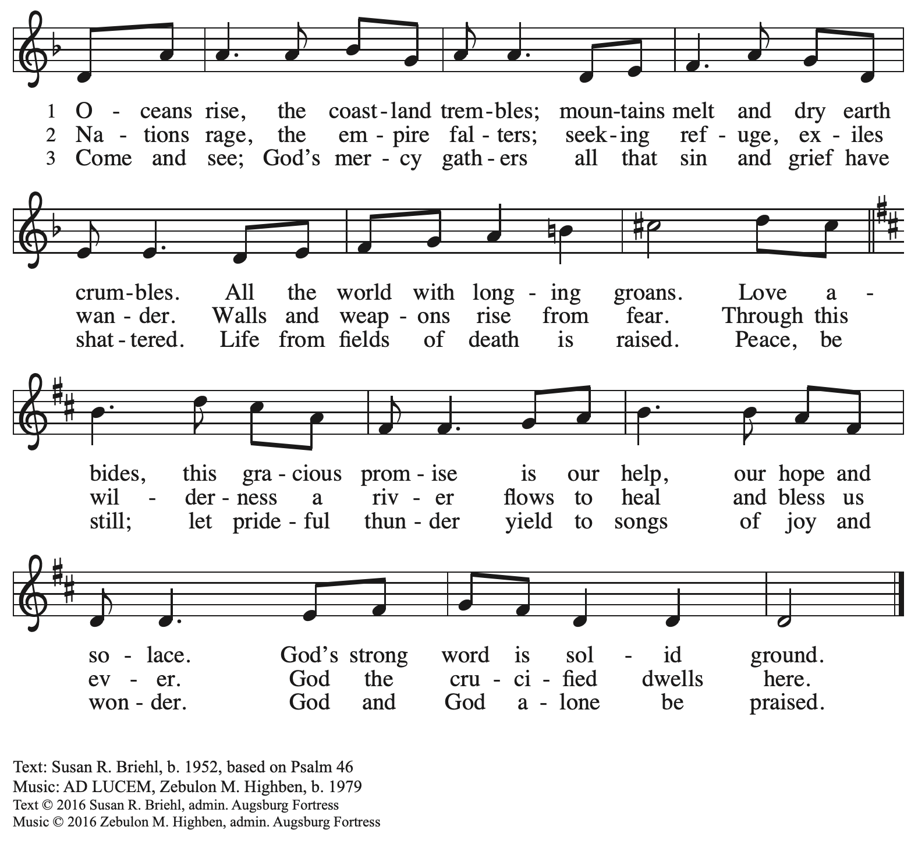
All rights reserved. Reprinted with permission under OneLicense.net # A-722139.

Hymns during Holy Communion
This Is Christ’s Body ACS 967

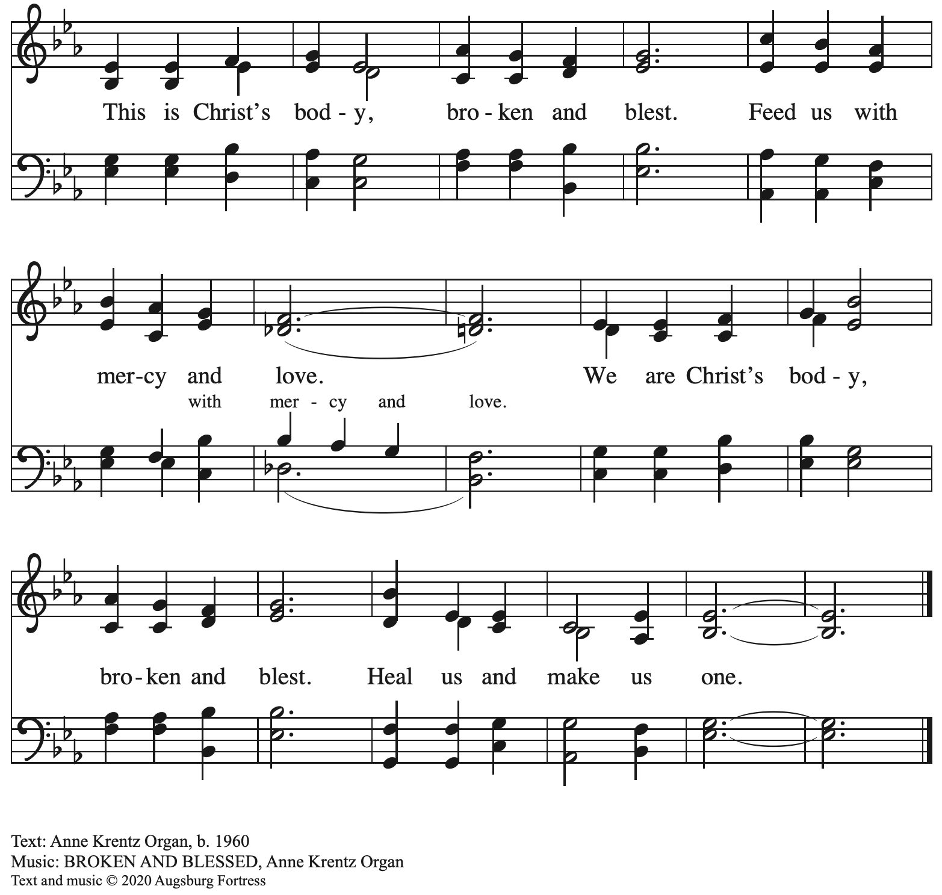
All rights reserved. Reprinted with permission under OneLicense.net # A-722139.

Hymns during Holy Communion
Take My Life, That I May Be ELW 685

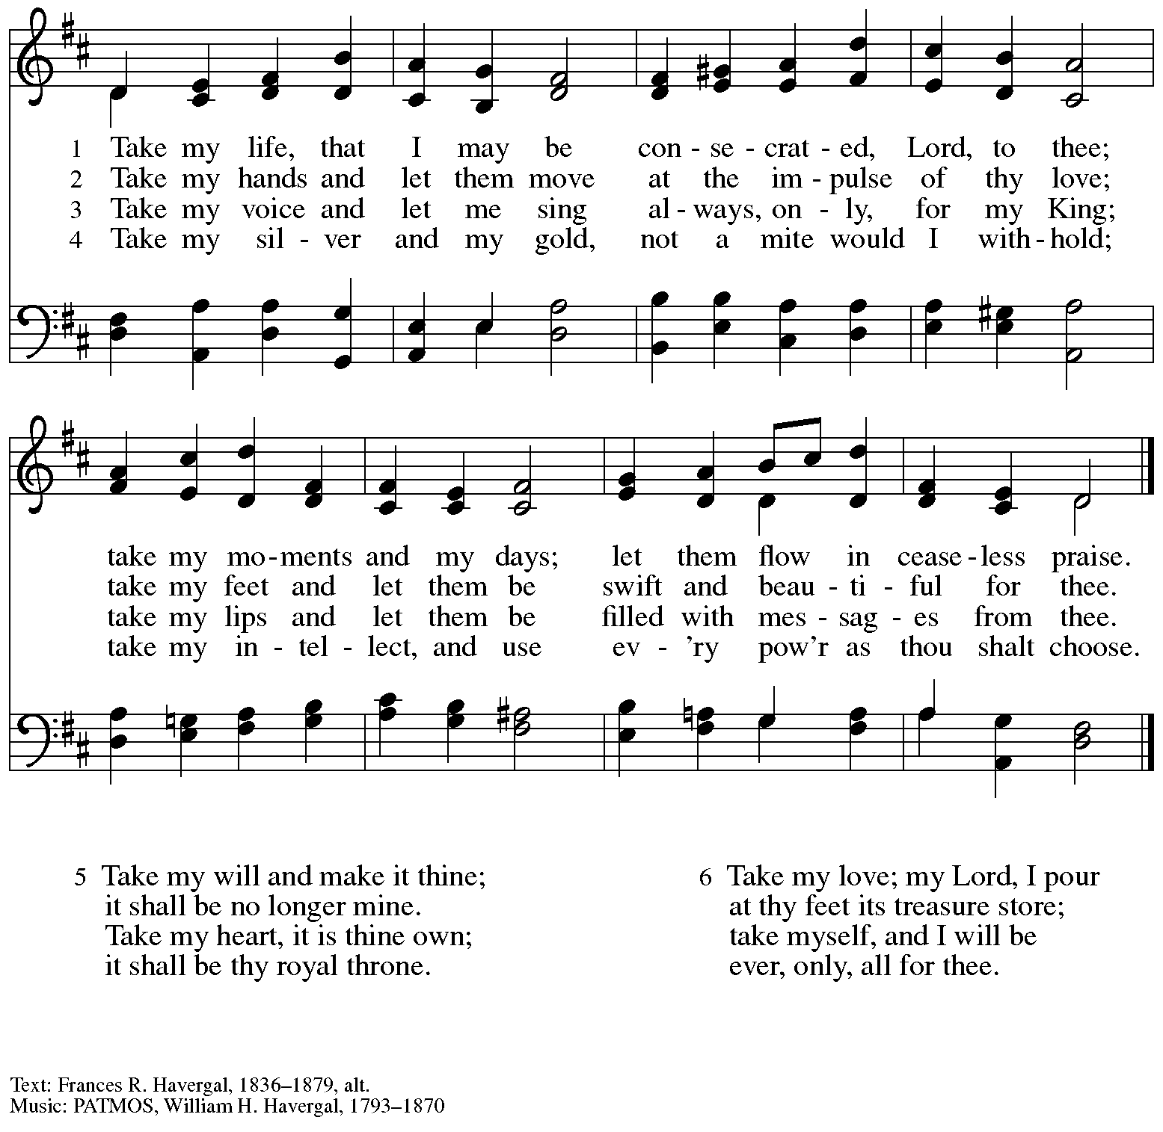

When all have returned to their places, please rise as you are able.

Blessing

P: The body and blood of our Lord Jesus Christ strengthen you and keep you in his grace.
C: Amen.

Prayer

A: Let us pray.
We thank you, generous God,
for the refreshment we have received
at your banquet table.
Send us now to spread your generosity into all the world,
through the one who is our dearest treasure,
Jesus Christ, our Savior and Lord.
C: Amen.

Please be seated.

Sending
God blesses us and sends us in mission to the world

Announcements

Please rise as you are able.
We invite students of any age, teachers, Sunday School teachers, professors, administrators,
and all who work in education to come forward and gather by the baptismal font.

Blessing of Students, Teachers, and All Who Work in Education

The presiding minister describes the occasion for the blessing.
The congregation is invited to join in the dialogue and prayer.

P: For the marvels of your creation,
C: we praise you, O God.

P: For the opportunity to explore and study,
C: we praise you, O God.

P: For your Word and its stories of your love and faithfulness,
C: we praise you, O God.

P: For wisdom and insight regarding all you have made,
C: we praise you, O God.

P: For those who guide us: teachers and mentors, residential life staff and administrators,
colleagues and friends.
C: we praise you, O God.

P: Teach us your ways and guide us in your path,
for you are the creator of all that is seen and unseen.
C: Amen.

P: Let us pray for all who are beginning a new school year,
that they will be blessed in their vocations.

Almighty God, you give us wisdom and knowledge.
Grant all who study and learn, teach and guide,
your gifts of joy and insight, diligence and openness,
that all may grow in what is good and honest and true.
Support all who teach, all who learn, and all who support them,
that together we may know and follow your ways;
through Jesus Christ our Lord.
C: Amen.

Benediction

P: The God who calls across the cosmos
and works through the smallest seed
☩ bless, keep, and sustain you,
now and to the end of the age.
C: Amen.

Sending Hymn We All Are One in Mission Following page

Dismissal

A: Go in peace. Serve the Lord.
C: Thanks be to God!

Postlude

Sending Hymn We All Are One in Mission ELW 576

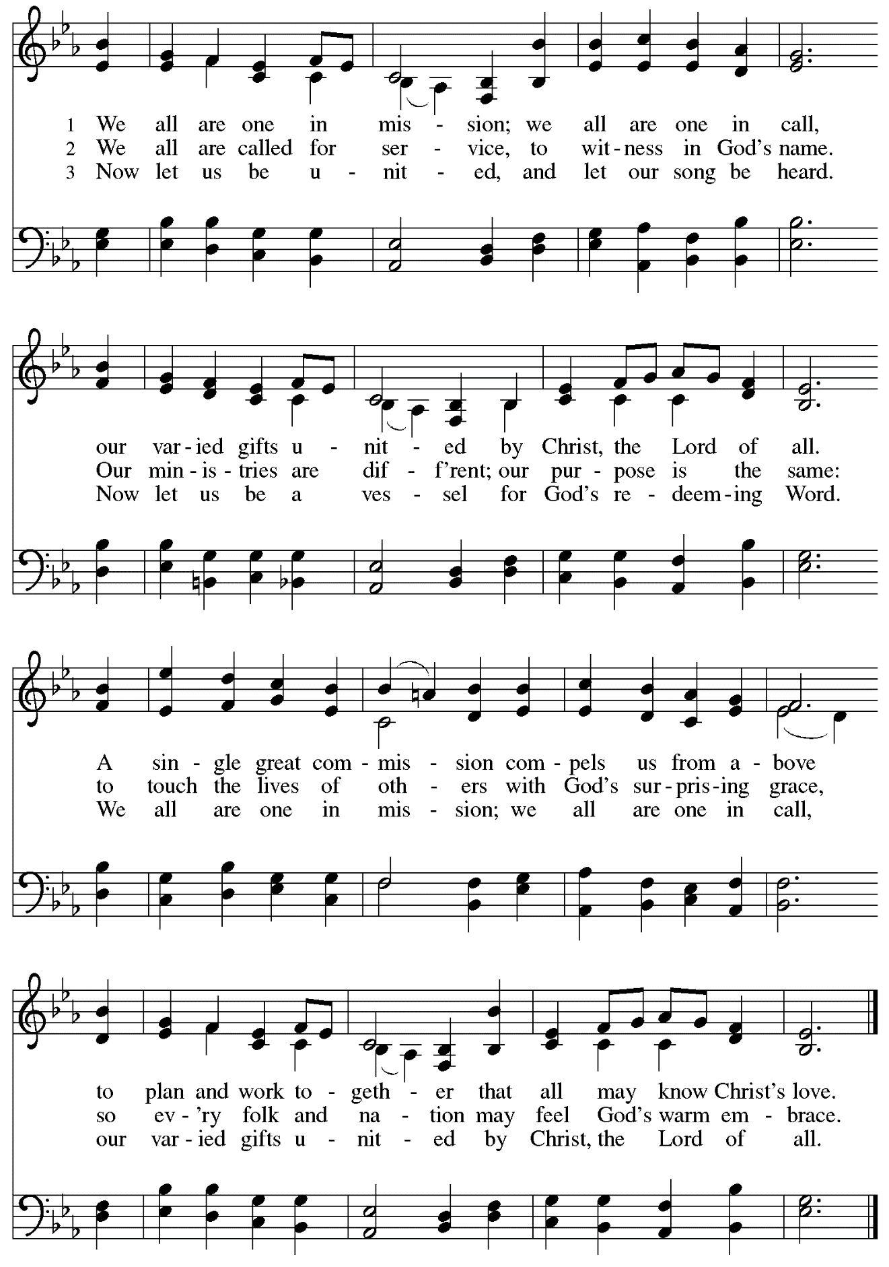
Those serving in worship today

Altar Care Jodie Minor
Assisting Minister and Lector Colleen Cooke
Audio-Visual Ministers Noël Marsh
David Rollinson
Cantor and Announcements Richard Krug
Minister of Music Laura Reynolds
Presiding Minister The Rev. Ross I. Carmichael

Liturgy and Hymnody Acknowledgements

From SundaysandSeasons.com. Copyright © 2023 Augsburg Fortress. All rights reserved. Reprinted under OneLicense.net # A-722139.
Used by permission of Augsburg Fortress.

We All Are One in Mission – Text: Rusty Edwards, b. 1955. Music: Finnish folk tune; arr. hymnal version. Text © 1986 Hope Publishing Company. Music Arr. © 2006 Augsburg Fortress. All rights reserved. Reprinted with permission under OneLicense.net # A-722139.

Please use the QR code below to link to St. Andrew’s Announcements online!

St. Andrew Lutheran Church Announcements
August 27th, 2023

- Welcome to worship at St. Andrew on the Thirteenth Sunday after Pentecost, August 27th, 2023 – We are so glad you are here, and we offer a special welcome to all visitors here or online for the first time! Worship attendees are invited to make a name tag at the back of the worship space if you would like. There are worship “toolkits” to help children engage with worship and “busy bags” for younger children available in the bookcase at the back of the sanctuary. Please feel free to take one to use with/for your children.
- September Produce Distribution – Tuesday, September 5th, 5:30-7:00 p.m. – St. Andrew’s monthly produce distribution in partnership with Greater Pittsburgh Community Food Bank is coming up Tuesday, September 5th, from 5:30-7:00 p.m. We invite people from the congregation to come and help in the evening (greeting our neighbors, assisting with the distribution, registration, and cleanup) and earlier in the day to set up tables and bring in the delivery, usually between 10:00 a.m. and 1:00 p.m. For anyone who signs up for the setup, we will notify you the day before when we are given the delivery truck's estimated arrival time. If you would like to sign up, please do so here:
https://www.signupgenius.com/go/4090F45AFAF2BA75-produce7.
- Looking for People to Set Up Coffee Hour, Starting September 10th – In order to facilitate conversation and community-building, St. Andrew seeks to have Coffee Hour after worship beginning Sunday, September 10th. Usually this can be provided by one person or family unit signing up per week. The tasks include preparing the coffee maker and starting its brew cycle along with setting out snacks, napkins, plates, etc. before worship. After worship tasks include bringing out creamer and cold drinks (water, juice boxes for children) and cleanup. It would be especially helpful to have signups for September 10th, which is God's Work-Our Hands Sunday and will include a congregational service activity, and Sunday, September 17th, the first of our intergenerational gatherings with the children of Little Church; Big Faith to prepare Advent banners. We invite you to consider serving – please sign up here: https://www.signupgenius.com/go/5080b4aafaf2cabf85-coffee#/.
- Little Church; Big Faith Activities for Children Resume during Worship on Sunday, September 10th – St. Andrew will resume offering Little Church; Big Faith, a time of Bible stories and activities for children, during worship on Sunday, September 10th. After the prayer of the day, we will invite children to gather with their leader at the door at the left of the worship space – the group will then proceed to the activity room off the Social Hall. We ask that one additional parent remain with the group each week in order to fulfill the requirements of St. Andrew’s child protection policy.
- God’s Work – Our Hands Sunday, September 10th – Service Activity for the Whole Congregation after Worship – Each year, the Evangelical Lutheran Church in America encourages member congregations to participate in God’s Work – Our Hands Sunday, an opportunity to unite with the larger church in service to our communities (For more on God’s Work – Our Hands, please visit elca.org./dayofservice. On Sunday, September 10th, we will be assembling Personal Care Kits for Lutheran World Relief. These Personal Care Kits provide basic hygiene items to refugees, people affected by natural disasters, and other displaced people. Donations can be dropped off at the church prior to or on the 10th and we will assemble the kits after church that Sunday. In addition to helping assemble the kits, we also need donations of new, unused kit items:

- Light-weight bath-size towels (20” X 40” to 52” X 27”), dark color recommended
- Bath-size bars of soap equaling 8 to 9 oz, any brand, in original wrapping; no mini or hotel size bars
- Adult-size toothbrushes
- Sturdy combs. There are many different types of hair texture, so no picks or fine-toothed combs
- Metal nail clippers (attached file optional)
- Cardboard boxes to pack and ship kits

Because LWR provides services around the world as an impartial humanitarian organization, they require that items “not have any religious symbols, messages, U.S. flags, patriotic or military symbols, or references to the armed forces, including camouflage.”
- Lutheran Campus Ministry in Greater Pittsburgh (LCMGP) 75th Anniversary Dinner – Friday, September 15th, 2023 7:00 p.m. at Le Mont – Join the LCMGP for its inaugural fundraising banquet as they celebrate the ministry's work in Greater Pittsburgh and among the universities of Pitt, Carnegie Mellon, Chatham, and Carlow for over the past 75+ years. Learn more about LCMGP, purchase tickets, or make a donation here.
- Cross-Generational Activity (Preparing Advent Banners!) for Children, Youth, Parents/Guardians, and All in the Congregation – After Worship on Sundays, September 17th, October 1st, October 15th, and October 29th – In the past, children and youth of St. Andrew have helped created art for banners that adorn the worship space in the season of Advent, and we would like to create banners for a new church year. We invite children, youth, parents / guardians to gather after worship on the Sundays listed above to hear an Advent reading, talk about its imagery, and work together on an artistic representation of the text, which will be used to make four new banners, one for each week of the Advent season. While we hope for primary input from children and youth, we encourage everyone in the congregation to stay to support them and share in the St. Andrew community on these Sundays! Please speak with Christian Education liaison Colten Rohleder or Jimmi Kocher-Hillmer if you have questions.
- Renew the Pews! – Saturday, September 23rd, 9:00 a.m. – If you would like to help in a small way to renew the sanctuary, we will be steam cleaning and replacing some of the buttons on the pew cushions on Sept. 23rd, starting at 9:00 a.m.
We need steam or carpet cleaners, and helping hands to do the work. Please let Kristen Asplin know at president@standrewpittsburgh.org if you can help out or let us borrow your equipment.
- Sanctuary: Arts + Honors – An LGBTQIA+ Art Show Honoring Safe Spaces, Hosted by Hot Metal Bridge Faith Community, September 15th – 22nd with Opening Reception Thursday, September 14th, at 7:00 p.m. – St. Andrew is happy to be a co-sponsor of “Sanctuary: Arts + Honors,” an LGBTQIA+ art show and celebration of safe spaces this September 15th-22nd. This show will celebrate sanctuaries of spiritual and emotional healing, moments, and communities where we have been able to flourish as our full selves. Additionally, the show will bestow an annual award upon a local organization that has worked to create safety for the queer community. BikePGH will be the inaugural recipient of the Sanctuary Award for their work to champion inclusive gatherings and communities, and their advocacy for all people. Hot Metal Bridge Faith Community is located at 2700 Jane Street, 15203. For more information about the event and to purchase tickets, please click here: https://www.sanctuarypgh.com/.
- St. Andrew Is Updating Information – Please Respond! – St. Andrew is looking to update our records with information from newer attendees, as well as offering current members the opportunity to include current information. This includes name, preferred pronouns, email, phone number, birthdays, anniversaries, and more. The information will only be used within the congregation - for example to acknowledge celebrations and milestones in worship, in the prayers of the church, or in the weekly or monthly newsletter. Please fill out the form at: https://forms.gle/fTwpdG2uA7pYD2ta8.
Stand Up for Fairness for All Pennsylvanians

This month, the nation's largest organization devoted to the rights of LGBTQ+ Americans declared a "state of emergency" in the U.S. amidst a growing number of dangerous and discriminatory policies. In Pennsylvania, more than half a million LGBTQ+ residents are vulnerable to discrimination every day because of a lack of express and enduring statutory protections at the state level. Tell your lawmakers it's time to make our Commonwealth a safe place for everyone to live, love and work as their authentic selves without fear of discrimination.

Pennsylvania remains the only state in the Northeast without an inclusive statewide nondiscrimination law. Passage of protections in Pennsylvania is a critical step to ensure LGBTQ people are treated with dignity in employment, housing, and public spaces.

Contact your lawmakers here.

Sign up here to join fellow Lutherans working for protections for LGBTQ+ Pennsylvanians and receive alerts about rallies and other opportunities to act. Please include FAIRNESS in the subject line.

The seven Pennsylvania bishops of the Evangelical Lutheran Church in America released a letter in support of legislation that would prohibit such discrimination.

"At this moment there is an opportunity for us to add our voices in support of legislation that could provide continuing legal protection for one particularly vulnerable group of our people," the bishops state in their letter "Fairness for All Pennsylvanians."
Read the full letter.

The letter points to the imagery of the "peaceable kingdom," described in Isaiah 11: 6, in which "the wolf shall live with the lamb, the leopard shall lie down with the kid, the calf and the lion and the fatling together, and a little child shall lead them." The words anticipate a renewal of all creation in which the identity of each creature remains but none experiences any harm from the others. "It is the fulfillment of this vision for which people of faith yearn, and toward which they call their neighbors," the bishops say in the letter. "The work of public advocacy, at its best, replaces the timid silence of resignation to what is, with a bold voice giving expression to what could be."

We recognize that the links above are not accessible on the printed page but we wanted to be sure to publish the information. Please see your “This Week at St. Andrew” email or scan the QR code above to access the clickable links. Thank you for your Advocacy!

