+ Fifteenth Sunday after Pentecost
September 10th, 2023
10:00 a.m.

St. Andrew Lutheran Church
304 Morewood Ave.
Pittsburgh, PA 15213
St_andrewELCA@verizon.net
www.standrewpittsburgh.org

+ Fifteenth Sunday after Pentecost
Order for Worship

This week’s readings address the fact that relationships and life in community cannot be experienced without conflict. Jesus’ words in today’s Gospel are often used in situations of church conflict and discipline. The prophet Ezekiel warns “the wicked” to turn from their ways, and the apostle Paul reminds us that love is the fulfilling of the law. We gather in the name of Christ, assured that he is present among us with gifts of peace and reconciliation.

Welcome to St. Andrew!

- St. Andrew Lutheran congregation welcomes all who are seeking a place of healing and wholeness – a nurturing, faith-forming spiritual home. Our community embraces people of all ages, ethnicities, cultures, abilities, sexual orientations, gender identities and expressions, and family constellations. Come and See!

- Worship Services are live streamed to multiple online platforms. By attending worship, you agree that your image and voice may be broadcast.

- Everyone is invited to make a nametag at the black bookcase in the back of the worship space if they would like. There are stickers indicating pronouns on the bookcase if you would like to include them on your name tag.

- Worship “toolkits” to help children engage with the service, along with “busy bags” for younger children, are available in the bookcase at the back of the sanctuary. Please feel free to take one to use with/for your children.

- Children are invited to attend Little Church – Big Faith, a Bible lesson and activity, during worship (after the Prayer of the Day). The group returns to the worship space for the liturgy of Holy Communion.

- Holy Communion is served with bread (gluten-free available) and wine or grape juice. The presiding minister will distribute the bread (host). Please consume this and then pick up an empty glass from the tray. The Communion Assistant will pour wine or grape juice into your glass. Please step to the side to consume the wine or grape juice. Feel free to kneel at the altar for prayer and reflection. As you return to your pew, glasses may be returned to the empty trays on either side of the center section.

- A restroom is available on the main level of the church, through the doors to the Social Hall and to the right in the main office.

Abbreviations
P: Pastor/Presiding Minister ACS: All Creation Sings hymnal
A: Assisting Minister ELW: Evangelical Lutheran Worship hymnal
L: Lector
C: Congregation

Pre-Service Music

Welcome

Prelude The Gift of Love arr. H. Hopson

Gathering
The Holy Spirit calls us together as the people of God

Confession and Forgiveness

Please rise as you are able. All may make the sign of the cross,
the sign that is marked at Baptism, as the presiding minister begins.

P: Blessed be the God who made us,
☩ Jesus Christ who bears the cross,
and the Holy Spirit who guides and sustains us.
C: Amen.

P: Let us humble ourselves before God, confessing our sin.

Silence is kept for reflection.

P: Steadfast and faithful God,
C: you have revealed the ways of justice,
yet we fail to follow you.
We are overwhelmed
by the world’s violence and suffering.
We are afraid to risk what we have
for the sake of others.
For the harm we have caused,
known and unknown, forgive us.
For the unjust demands we place on others
and your creation, forgive us.
For the ways we turn away
from you and our neighbor, forgive us.
Lead us back to you, and set us on healthy, fruitful paths;
in the name of Jesus Christ, our Savior. Amen.

P: Beloved in Christ, God’s mercy stretches beyond all understanding,
God’s compassion is beyond compare.
In Jesus, God is always making a new way for us.
In ☩ Christ, you have been and always will be forgiven.
C: Amen.

Gathering Hymn As We Gather at Your Table ELW 522

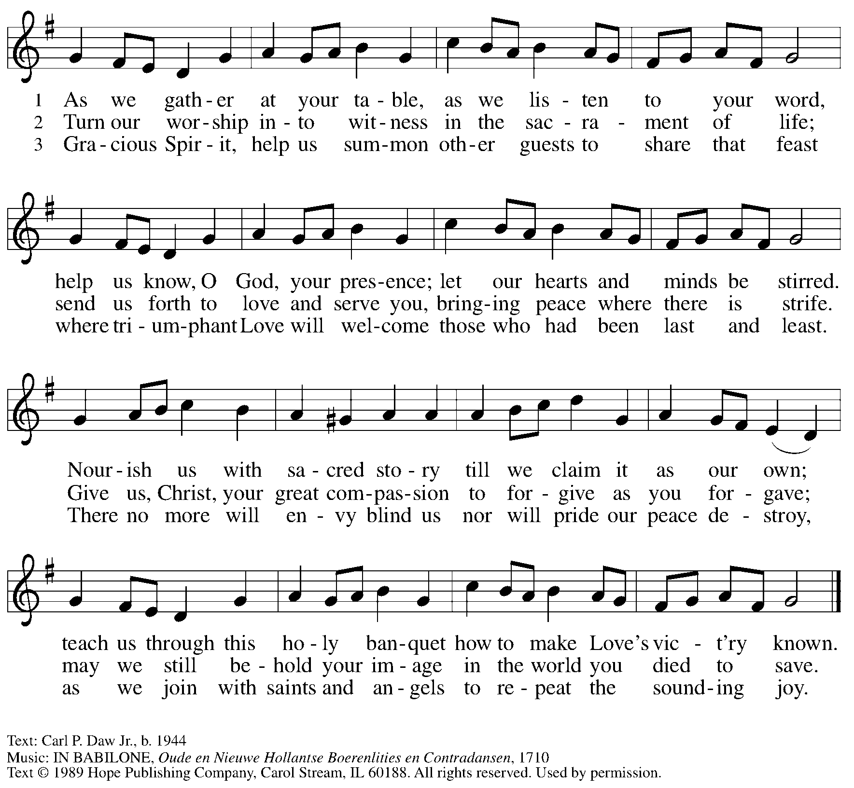
Reprinted with permission under OneLicense.net #A-722139.

Greeting

P: The grace of our Lord Jesus Christ, the love of God,
and the communion of the Holy Spirit be with you all.
C: And also with you.

Hymn of Praise ELW p. 176

Prayer of the Day

P: Let us pray.
O Lord God, enliven and preserve your church with your perpetual mercy.
Without your help, we mortals will fail; remove far from us everything that is harmful,
and lead us toward all that gives life and salvation, through Jesus Christ, our Savior and Lord.
C: Amen.

Please be seated.
Children are invited to join the adult leaders at the door and move to the office for Little Church – Big Faith. We ask that one additional adult from the congregation attend with the children.

Word
God speaks to us in Scripture reading, preaching, and song

First Reading – Ezekiel 33: 7-11

⁷So you, mortal, I have made a sentinel for the house of Israel; whenever you hear a word from my mouth, you shall give them warning from me. ⁸If I say to the wicked, “O wicked ones, you shall surely die,” and you do not speak to warn the wicked to turn from their ways, the wicked shall die in their iniquity, but their blood I will require at your hand. ⁹But if you warn the wicked to turn from their ways, and they do not turn from their ways, the wicked shall die in their iniquity, but you will have saved your life.
¹⁰Now you, mortal, say to the house of Israel, Thus you have said: “Our transgressions and our sins weigh upon us, and we waste away because of them; how then can we live?” ¹¹Say to them, As I live, says the Lord God, I have no pleasure in the death of the wicked, but that the wicked turn from their ways and live; turn back, turn back from your evil ways; for why will you die, O house of Israel?

L: Word of God, word of life.
C: Thanks be to God.

Psalm 119: 33-40

The psalm will be sung by the cantor, with the congregation invited to join in singing the alternate verses (in bold) and the refrain.

Psalm tone

Psalm refrain

¹Give judgment for me, O Lord, for I have lived | with integrity;
I have trusted in the Lord and | have not faltered.
²Test me, O | Lord, and try me;
examine my heart | and my mind.
³For your steadfast love is be- | fore my eyes;
I have walked faithful- | ly with you.
⁴I have not sat | with the worthless,
nor do I consort with | the deceitful. R
⁵I have hated the company of | evildoers;
I will not sit down | with the wicked.
⁶I will wash my hands in inno- | cence, O Lord,
that I may go in procession | round your altar,
⁷singing aloud a song | of thanksgiving
and recounting all your won- | derful deeds.
⁸Lord, I love the house in | which you dwell
and the place where your glo- | ry abides. R

Second Reading – Romans 13: 8-14

⁸Owe no one anything, except to love one another; for the one who loves another has fulfilled the law. ⁹The commandments, “You shall not commit adultery; You shall not murder; You shall not steal; You shall not covet”; and any other commandment, are summed up in this word, “Love your neighbor as yourself.” ¹⁰Love does no wrong to a neighbor; therefore love is the fulfilling of the law.

¹¹Besides this, you know what time it is, how it is now the moment for you to wake from sleep. For salvation is nearer to us now than when we became believers; ¹²the night is far gone, the day is near. Let us then lay aside the works of darkness and put on the armor of light; ¹³let us live honorably as in the day, not in reveling and drunkenness, not in debauchery and licentiousness, not in quarreling and jealousy. ¹⁴Instead, put on the Lord Jesus Christ, and make no provision for the flesh, to gratify its desires.

L: Word of God, word of life.
C: Thanks be to God.

Please rise as you are able.

Gospel Acclamation ELW p. 179

Gospel – Matthew 18: 15-20

P: The holy Gospel according to St. Matthew.
C: Glory to you, O Lord.

[Jesus said to the disciples:] ¹⁵“If another member of the church sins against you, go and point out the fault when the two of you are alone. If the member listens to you, you have regained that one. ¹⁶But if you are not listened to, take one or two others along with you, so that every word may be confirmed by the evidence of two or three witnesses. ¹⁷If the member refuses to listen to them, tell it to the church; and if the offender refuses to listen even to the church, let such a one be to you as a Gentile and a tax collector. ¹⁸Truly I tell you, whatever you bind on earth will be bound in heaven, and whatever you loose on earth will be loosed in heaven. ¹⁹Again, truly I tell you, if two of you agree on earth about anything you ask, it will be done for you by my Father in heaven. ²⁰For where two or three are gathered in my name, I am there among them.”
P: The Gospel of the Lord.
C: Praise to you, O Christ.

Please be seated.

Sermon

A time of silence for prayer and reflection follows the sermon.
When the hymn of the day begins, please rise as you are able.

Hymn of the Day God, When Human Bonds Are Broken ELW 603
v. 1-2, 4-5

1 God, when human bonds are broken
and we lack the love or skill
to restore the hope of healing,
give us grace and make us still.

2 Through that stillness, with your Spirit
come into our world of stress,
for the sake of Christ forgiving
all the failures we confess.

4 Send us, God of new beginnings,
humbly hopeful into life.
Use us as a means of blessing:
make us stronger, give us faith.

5 Give us faith to be more faithful,
give us hope to be more true,
give us love to go on learning:
God, encourage and renew!

Text: Fred Kaan, b. 1929. Music: MERTON, William H. Monk, 1823-1899. Text © 1989 Hope Publishing Company, Carol Stream, IL 60188. All rights reserved. Reprinted with permission under OneLicense.net # A-722139.

Prayers of the People

A: Remembering the caring and generous works of God, we pray for the church,
the needs of our neighbors, and all creation.

After each petition
A: Merciful God,
C: receive our prayer.

The presiding minister concludes the prayers
P: Remember us according to your steadfast love, O God,
as we offer these prayers and those of our hearts,
trusting in your abundant mercy made known through Jesus Christ our Savior.
C: Amen.

Peace

The presiding minister and the assembly greet one another in the peace of the risen Christ.
P: The peace of Christ be with you always.
C: And also with you.

The people may greet those around them with a sign of Christ’s peace and may say
Peace be with you or similar words. Please be mindful that not everyone will be comfortable with sharing the peace, so please seek consent before shaking hands or hugging. Other possible ways to share the peace include a simple bow with the verbal greeting of peace, or simply a verbal expression of peace.

When the greetings of peace have concluded, please be seated.

Meal
God feeds us with the presence of Jesus Christ

Offering

We offer ourselves, our gifts, and our faithful service to God.
As the offering is gathered for the mission of the church, including the care of those in need,
the table is set for Holy Communion.

Music during the Offering

As the gifts are brought forward for presentation, please rise as you are able.

Offertory Song Toma, oh Dios, mi voluntad ELW 583
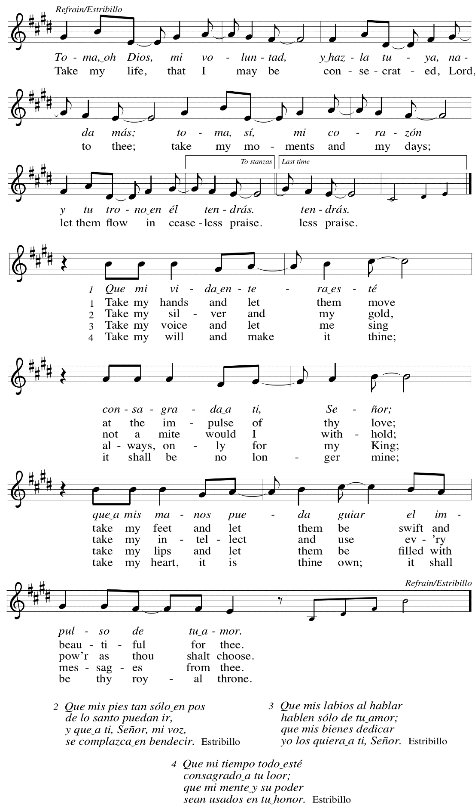
Offertory Prayer

A: Let us pray.
God of all creation,
C: all you have made is good, and your love endures forever.
You bring forth bread from the earth and fruit from the vine.
Nourish us with these gifts,
that we might be for the world signs of your gracious presence
in Jesus Christ, our Savior and Lord.
Amen.

Dialogue

P: The Lord be with you.
C: And also with you.

P: Lift up your hearts.
C: We lift them to the Lord.

P: Let us give thanks to the Lord our God.
C: It is right to give our thanks and praise.

Preface

P: It is indeed right, our duty and our joy,
that we should at all times and in all places
give thanks and praise to you, almighty and merciful God,
through our Savior Jesus Christ;
who on this day overcame death and the grave,
and by his glorious resurrection opened to us the way of everlasting life.
And so, with all the choirs of angels,
with the church on earth and the hosts of heaven,
we praise your name and join their unending hymn:

Sanctus ELW p. 181

Eucharistic Prayer

P: Holy God, holy and mighty, holy and immortal, …
… Do this for the remembrance of me.

Together as the body of Christ,
we proclaim the Lord’s death until he comes.
C: Christ has died. Christ is risen. Christ will come again.

P: With this bread and cup …
… all our sins and sorrows will be no more.
C: Amen. Come, Lord Jesus.

P: Holy God, holy and merciful one, holy and compassionate, …
… sharing your bounty with all the world.
C: Amen. Come, Holy Spirit.

… Holy and benevolent God, …
… with the Holy Spirit, in your holy church, now and forever.
C: Amen.

Lord’s Prayer

P: Gathered as one by the Holy Spirit, let us pray as Jesus taught us.
C: Our Father in heaven,
hallowed be your name,
your kingdom come,
your will be done,
on earth as in heaven.
Give us today our daily bread.
Forgive us our sins
as we forgive those
who sin against us.
Save us from the time of trial
and deliver us from evil.
For the kingdom, the power,
and the glory are yours,
now and forever. Amen.

Fraction and Invitation

Agnus Dei / Lamb of God ELW p. 182

Please be seated.

Holy Communion
- All who seek God and desire a deeper and stronger life in Christ are welcome to receive Holy Communion.
- Worshipers from the pulpit side will proceed forward first, followed by the center section, and then the lectern side.
- Please inform an usher if you would like the ministers to bring Communion to you.
- Holy Communion will be served with bread and wine/grape juice.
- The presiding minister will first distribute the bread (host) to each communicant. Please indicate if you require a gluten-free host.
- Once you have consumed the bread, please pick up an empty glass from the tray next to the presiding minister. The Communion Assistant will pour wine from the chalice or grape juice from the cruet into your glass.
- Please step to the side to consume the wine or grape juice.
- Feel free to kneel at the altar rail for prayer after receiving the sacrament.
- As you return to your pew, glasses may be returned to the empty trays on either side of the center section.
- A blessing will be provided for anyone who does not yet receive the sacrament.
- All are invited to join in singing the hymns during Holy Communion.

Hymns during Holy Communion ELW 648
Beloved, God’s Chosen

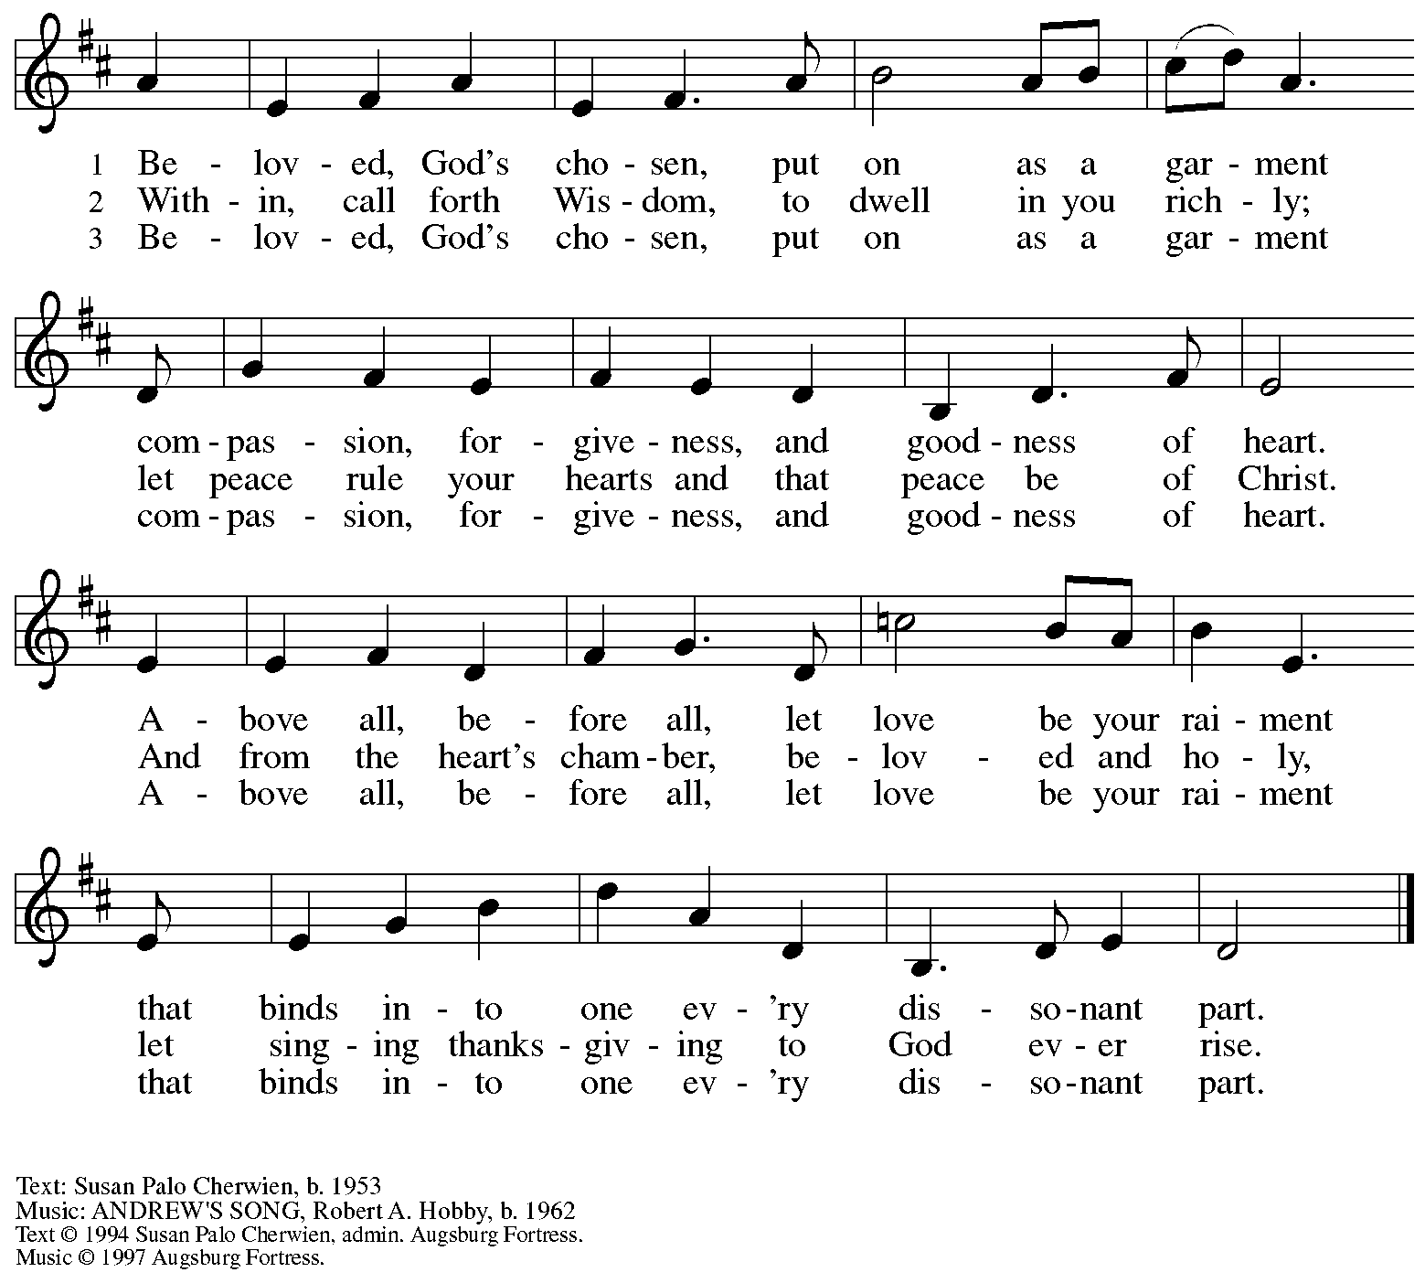
All rights reserved. Reprinted with permission under OneLicense.net # A-722139.

Hymns during Holy Communion ACS 931
Donde hay caridad y amor / Where Charity and Love Are Shown
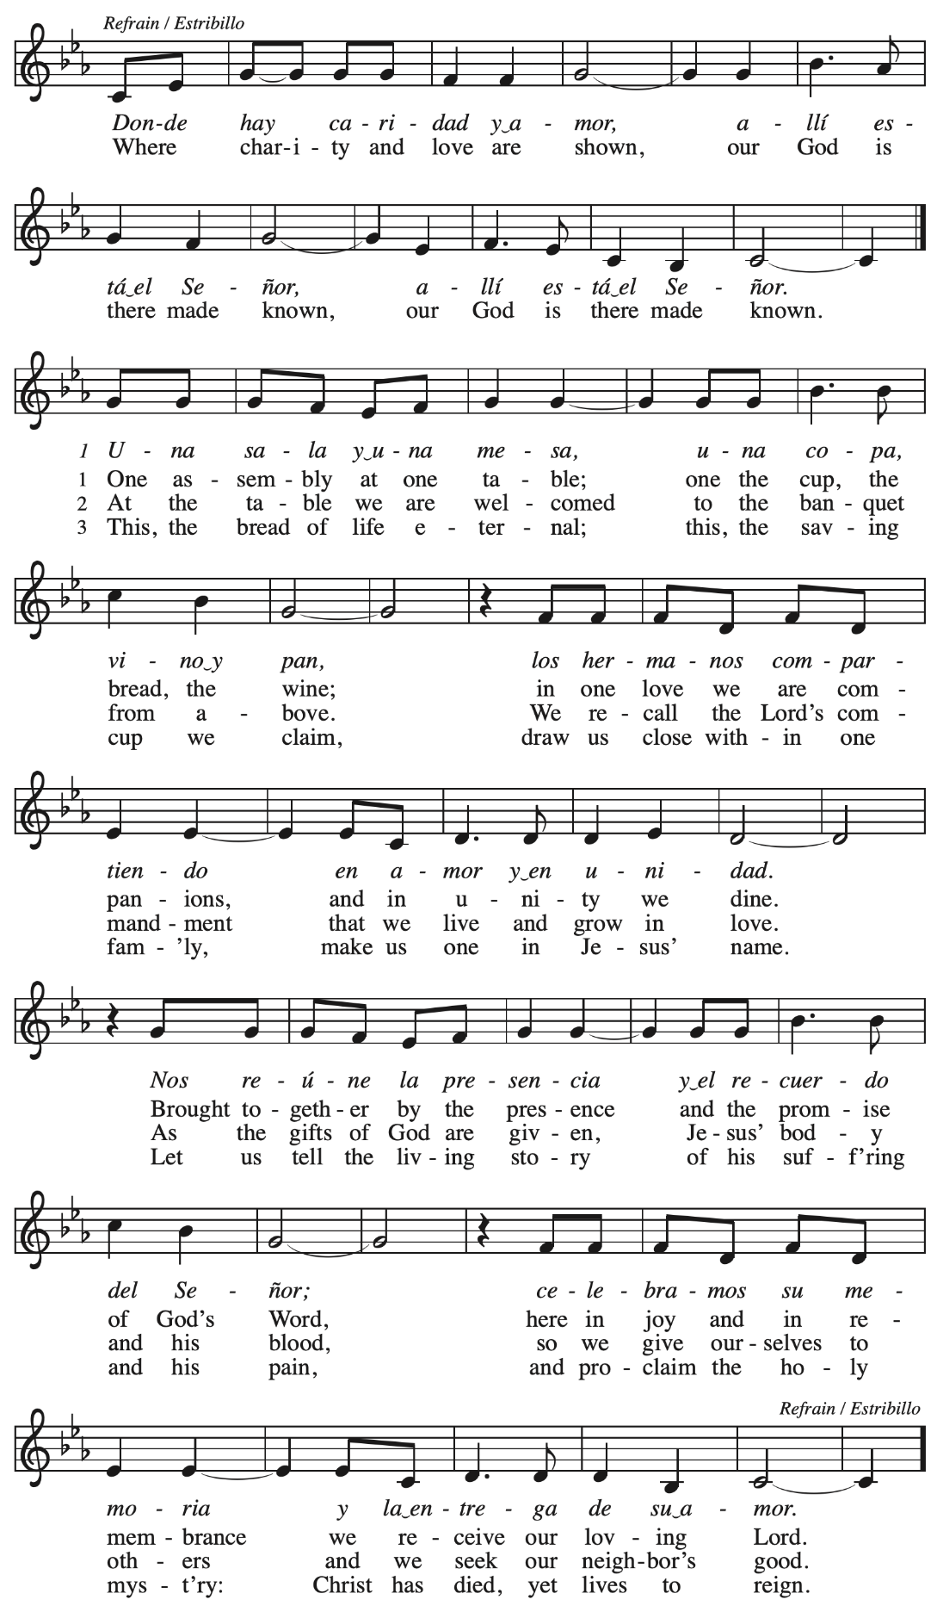
Hymns during Holy Communion
Blest Be the Tie That Binds ELW 656

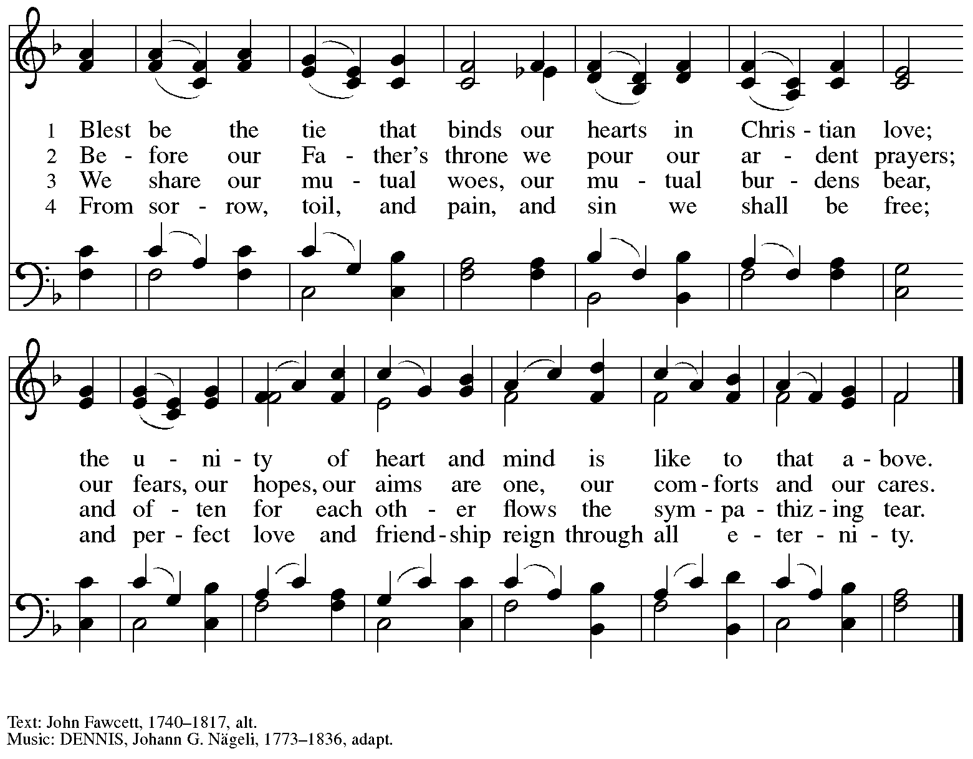

When all have returned to their places, please rise as you are able.

Blessing

P: The body and blood of our Lord Jesus Christ strengthen you and keep you in his grace.
C: Amen.

Prayer

A: Let us pray. We give you thanks, almighty God,
that you have refreshed us through the healing power of this gift of life.
In your mercy, strengthen us through this gift,
in faith toward you and in fervent love toward one another;
for the sake of Jesus Christ our Lord.
C: Amen.

Please be seated.

Sending
God blesses us and sends us in mission to the world

Announcements

Please rise as you are able.

Benediction

P: The God of steadfastness and encouragement
grant you to live in harmony with one another,
in accordance with Christ Jesus.
C: Amen.

P: The God of hope fill you with all joy and peace in believing,
so that you may abound in hope by the power of the Holy Spirit.
C: Amen.

P: The God of all grace ☩ bless you now and forever.
C: Amen.

Sending Hymn God’s Work, Our Hands Following page

Dismissal

A: Go in peace. Serve the Lord.
C: Thanks be to God!

Postlude

Sending Hymn God’s Work, Our Hands ACS 1000

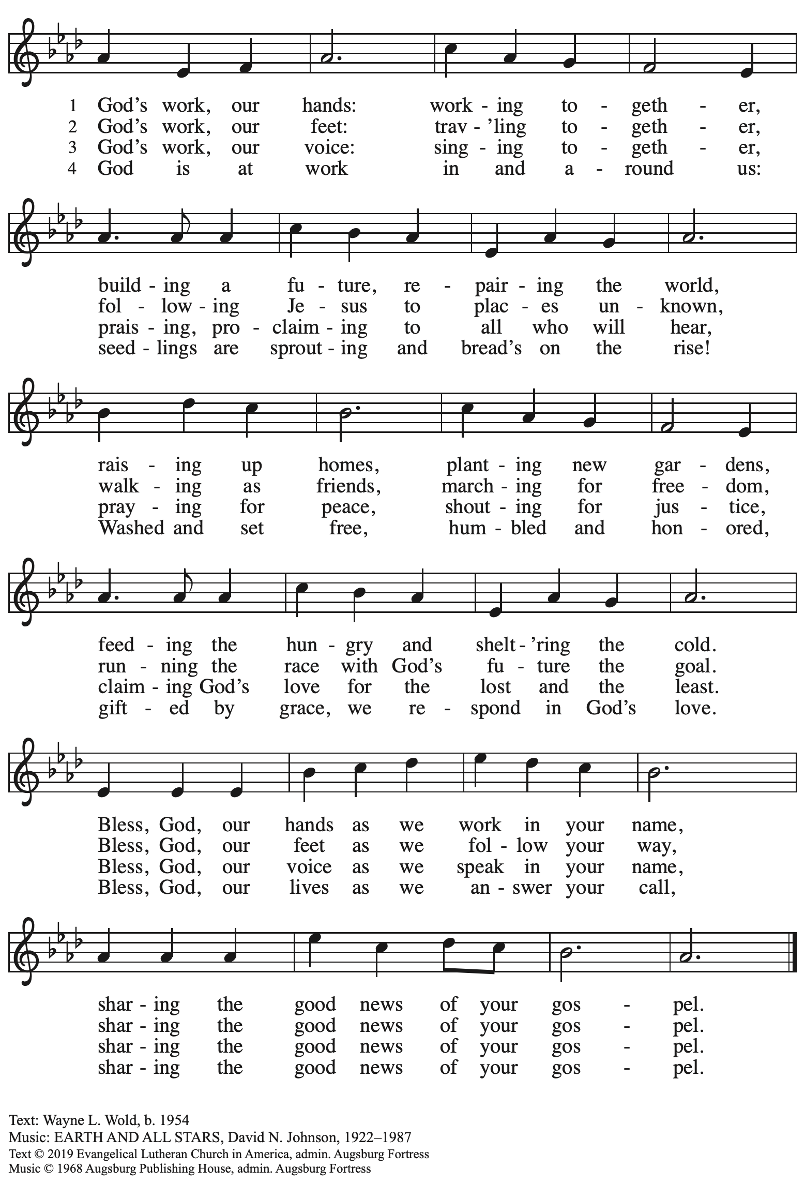
All rights reserved. Reprinted with permission under OneLicense.net # A-722139.

Those serving in worship today

Altar Care Beverley Chapman
Announcements Sharon Koch
Assisting Minister Timothy Kocher-Hillmer
Audio-Visual Ministers Kristen Asplin
Jospeh Paetz
Cantor Maria Mangano
Duet The Rev. Peter and Kristen Asplin
Lector Alda Maria Gonzaga
Little Church – Big Faith Leader Colten Rohleder
Minister of Music Laura Reynolds
Presiding Minister The Rev. Ross I. Carmichael

Liturgy and Hymnody Acknowledgements

From SundaysandSeasons.com. Copyright © 2023 Augsburg Fortress. All rights reserved. Reprinted under OneLicense.net # A-722139.
Used by permission of Augsburg Fortress.

Toma, oh Dios, mi voluntad – Text: Frances R. Havergal, 1836-1879, adapt.; Spanish text: Vincent Mendoza, 1875-1955. Music: TOMA MI VOLUNTAD, William Dexheimer Pharris, b. 1956. All rights reserved. Reprinted with permission under OneLicense.net # A-722139.

Donde hay caridad y amor / Where Charity and Love Are Shown – Text: Joaquín Madurga, 1938-2017; tr. Martin A. Seltz, b. 1951. Music: DONDE HAY CARIDAD, Joaquín Madurga. Text and music © 1981, 2009 Joaquín Madurga. Published by OCP, 5536 N. Hassalo, Portland, OR 97213. All rights reserved. Reprinted with permission under OneLicense.net # A-722139.

Please use the QR code below to link to St. Andrew’s Announcements online!

St. Andrew Lutheran Church Announcements
September 10th, 2023

- Welcome to worship at St. Andrew on the Fifteenth Sunday after Pentecost, September 10th, 2023 – We are so glad you are here, and we offer a special welcome to all visitors here or online for the first time! Worship attendees are invited to make a name tag at the back of the worship space if you would like. There are worship “toolkits” to help children engage with worship and “busy bags” for younger children available in the bookcase at the back of the sanctuary. Please feel free to take one to use with/for your children. We invite everyone to stay after worship for coffee and conversation in the Social Hall, next to the sanctuary.
- Little Church – Big Faith Resumes during Worship Today – St. Andrew resumes Little Church – Big Faith, a time of Bible stories and activities for children, during worship today. After the prayer of the day, we will invite children to gather with their leader at the door at the left of the worship space – the group will then proceed to the activity room off the Social Hall. We ask that one additional parent remain with the group each week in order to fulfill the requirements of St. Andrew’s child protection policy.
- Today Is “God’s Work, Our Hands” Sunday – Please stay for a Service Activity after Worship – Each year, the Evangelical Lutheran Church in America encourages member congregations to participate in God’s Work, Our Hands Sunday, an opportunity to unite with the larger church in service to our communities (For more on God’s Work, Our Hands, please visit elca.org./dayofservice. After worship today we will be assembling Personal Care Kits for Lutheran World Relief. These Personal Care Kits provide basic hygiene items to refugees, people affected by natural disasters, and other displaced people. Donations can be dropped off at the church prior to or on the 10th and we will assemble the kits after church that Sunday. In addition to helping assemble the kits, we also need donations of new, unused kit items:

- Light-weight bath-size towels (20” X 40” to 52” X 27”), dark color recommended
- Bath-size bars of soap equaling 8 to 9 oz, any brand, in original wrapping; no mini or hotel size bars
- Adult-size toothbrushes
- Sturdy combs. There are many different types of hair texture, so no picks or fine-toothed combs
- Metal nail clippers (attached file optional)
- Cardboard boxes to pack and ship kits

Because LWR provides services around the world as an impartial humanitarian organization, they require that items “not have any religious symbols, messages, U.S. flags, patriotic or military symbols, or references to the armed forces, including camouflage.”
- Looking for People to Set Up Coffee Hour – In order to facilitate conversation and
community-building, St. Andrew seeks to have Coffee Hour after worship. Usually this can be provided by one person or family unit signing up per week. The tasks include preparing the coffee maker and starting its brew cycle along with setting out snacks, napkins, plates, etc. before worship. After worship tasks include bringing out creamer and cold drinks (water, juice boxes for children) and cleanup. It would be especially helpful to have this covered next Sunday, September 17th, the first of our intergenerational gatherings with the children of Little Church; Big Faith to prepare Advent banners. We invite you to consider serving – please sign up here: https://www.signupgenius.com/go/5080b4aafaf2cabf85-coffee#/.
- Sanctuary: Arts + Honors – An LGBTQIA+ Art Show Honoring Safe Spaces, Hosted by Hot Metal Bridge Faith Community, September 15th – 22nd with Opening Reception Thursday, September 14th, at 7:00 p.m. – St. Andrew is happy to be a co-sponsor of “Sanctuary: Arts + Honors,” an LGBTQIA+ art show and celebration of safe spaces this September 15th-22nd. This show will celebrate sanctuaries of spiritual and emotional healing, moments, and communities where we have been able to flourish as our full selves. Additionally, the show will bestow an annual award upon a local organization that has worked to create safety for the queer community. BikePGH will be the inaugural recipient of the Sanctuary Award for their work to champion inclusive gatherings and communities, and their advocacy for all people. Hot Metal Bridge Faith Community is located at 2700 Jane Street, 15203. For more information about the event and to purchase tickets, please click here: https://www.sanctuarypgh.com/.
- Lutheran Campus Ministry in Greater Pittsburgh (LCMGP) 75th Anniversary Dinner – Friday, September 15th, 7:30 p.m. at Le Mont – Join the LCMGP for its inaugural fundraising banquet as they celebrate the ministry's work in Greater Pittsburgh and among the universities of Pitt, Carnegie Mellon, Chatham, and Carlow for over the past 75+ years. Learn more about LCMGP, purchase tickets, or make a donation here.
- Cross-Generational Activity (Advent Banner Preparation!) for Children, Youth, Parents / Guardians, and the Whole Congregation – after Worship on Sundays, September 17th, October 1st, October 15th, and October 29th – In the past, children and youth of St. Andrew have helped created art for banners that adorn the worship space in the season of Advent, and we would like to create banners for a new church year. We invite children, youth, parents / guardians to gather after worship on the Sundays listed above to hear an Advent reading, talk about its imagery, and work together on an artistic representation of the text, which will be used to make four new banners, one for each week of the Advent season. While we hope for primary input from children and youth, we encourage everyone in the congregation to stay to support them and share in the St. Andrew community on these Sundays! Please speak with Christian Education liaison Colten Rohleder or Jimmi Kocher-Hillmer if you have questions.
- Monthly Dinner for Guests of East End Cooperative Ministry – Thursday, September 21st, 6:30 p.m. – People of St. Andrew provide a meal for guests of the shelter at East End Cooperative Ministry (EECM) on the third Thursday of every month. This month’s dinner will be on September 21st at 6:30 pm. Each person is asked to cook or bring one portion of the meal to EECM (6140 Station St., 15206) at 6:00 p.m. Others are welcome to come and help serve the meal. If you would like to contribute, please sign up here: https://www.signupgenius.com/go/5080544AAAC22A1F58-shelter40.
- St. Andrew Is Updating Information – Please Respond! – St. Andrew is looking to update our records with information from newer attendees, as well as offering current members the opportunity to include current information. This includes name, preferred pronouns, email, phone number, birthdays, anniversaries, and more. The information will only be used within the congregation - for example to acknowledge celebrations and milestones in worship, in the prayers of the church, or in the weekly or monthly newsletter. Please fill out the form at: https://forms.gle/fTwpdG2uA7pYD2ta8.

