+ Sixteenth Sunday after Pentecost
September 17th, 2023
10:00 a.m.

St. Andrew Lutheran Church
304 Morewood Ave.
Pittsburgh, PA 15213
St_andrewELCA@verizon.net
www.standrewpittsburgh.org

+ Sixteenth Sunday after Pentecost
Order for Worship

In this week’s second reading, Paul questions why we judge one another, since we all come before the judgment of God. Yet we do sin against one another, and Jesus’ challenge that we forgive seventy-seven times reveals God’s boundless mercy. When we hear the words of forgiveness in worship and sign ourselves with the cross, we are renewed in baptism to be signs of reconciliation in the world.

Welcome to St. Andrew!

- St. Andrew Lutheran congregation welcomes all who are seeking a place of healing and wholeness – a nurturing, faith-forming spiritual home. Our community embraces people of all ages, ethnicities, cultures, abilities, sexual orientations, gender identities and expressions, and family constellations. Come and See!

- Worship Services are live streamed to multiple online platforms. By attending worship, you agree that your image and voice may be broadcast.

- Everyone is invited to make a nametag at the black bookcase in the back of the worship space if they would like. There are stickers indicating pronouns on the bookcase if you would like to include them on your name tag.

- Worship “toolkits” to help children engage with the service, along with “busy bags” for younger children, are available in the bookcase at the back of the sanctuary. Please feel free to take one to use with/for your children.

- Children are invited to attend Little Church – Big Faith, a Bible lesson and activity, during worship (after the Prayer of the Day). The group returns to the worship space for the liturgy of Holy Communion.

- Holy Communion is served with bread (gluten-free available) and wine or grape juice. The presiding minister will distribute the bread (host). Please consume this and then pick up an empty glass from the tray. The Communion Assistant will pour wine or grape juice into your glass. Please step to the side to consume the wine or grape juice. Feel free to kneel at the altar for prayer and reflection. As you return to your pew, glasses may be returned to the empty trays on either side of the center section.

- A restroom is available on the main level of the church, through the doors to the Social Hall and to the right in the main office.

Abbreviations
P: Pastor/Presiding Minister ACS: All Creation Sings hymnal
A: Assisting Minister ELW: Evangelical Lutheran Worship hymnal
L: Lector
C: Congregation

Pre-Service Music

Welcome

Prelude

Gathering
The Holy Spirit calls us together as the people of God

Confession and Forgiveness

Please rise as you are able. All may make the sign of the cross,
the sign that is marked at Baptism, as the presiding minister begins.

P: Blessed be the God who made us,
☩ Jesus Christ who bears the cross,
and the Holy Spirit who guides and sustains us.
C: Amen.

P: Let us humble ourselves before God, confessing our sin.

Silence is kept for reflection.

P: Steadfast and faithful God,
C: you have revealed the ways of justice,
yet we fail to follow you.
We are overwhelmed
by the world’s violence and suffering.
We are afraid to risk what we have
for the sake of others.
For the harm we have caused,
known and unknown, forgive us.
For the unjust demands we place on others
and your creation, forgive us.
For the ways we turn away
from you and our neighbor, forgive us.
Lead us back to you, and set us on healthy, fruitful paths;
in the name of Jesus Christ, our Savior. Amen.

P: Beloved in Christ, God’s mercy stretches beyond all understanding,
God’s compassion is beyond compare.
In Jesus, God is always making a new way for us.
In ☩ Christ, you have been and always will be forgiven.
C: Amen.

Gathering Hymn God Is Here! ELW 526

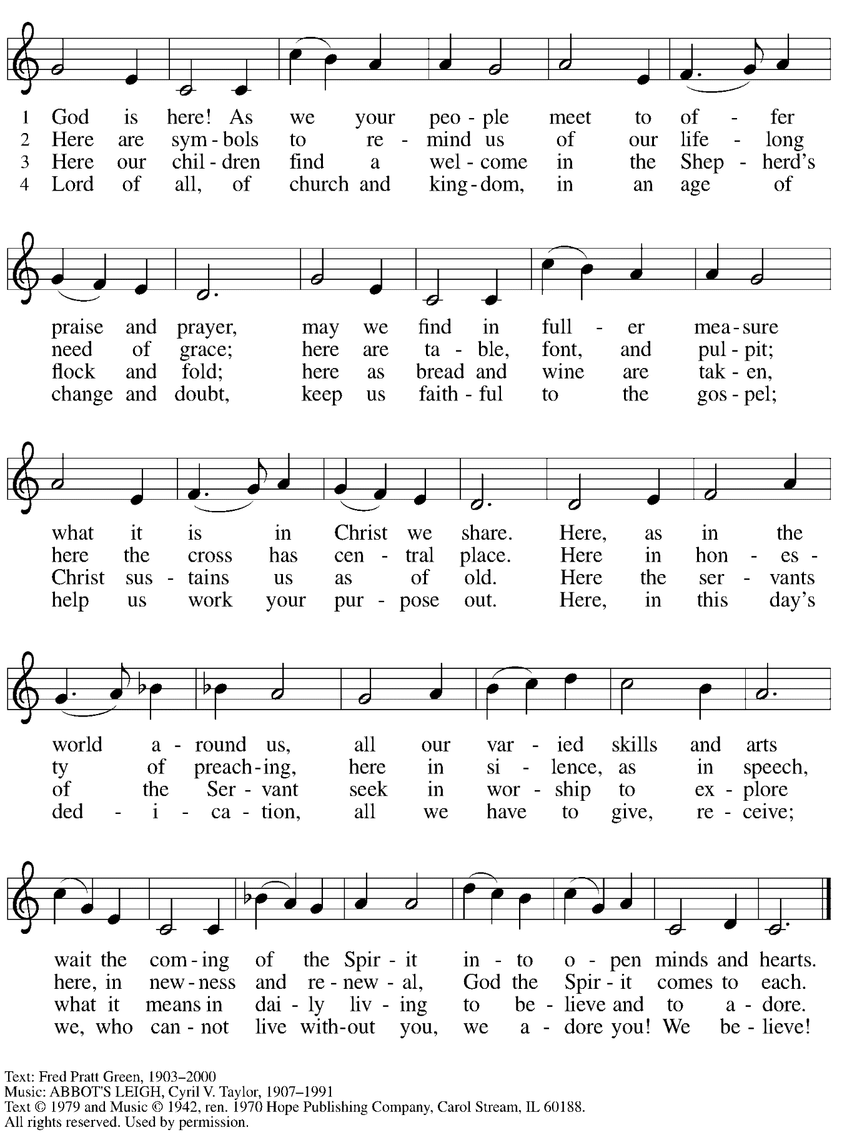
Reprinted with permission under OneLicense.net # A-722139.

Greeting

P: The grace of our Lord Jesus Christ, the love of God,
and the communion of the Holy Spirit be with you all.
C: And also with you.

Hymn of Praise ELW p. 176

Prayer of the Day

P: The Lord be with you.
C: And also with you.

P: Let us pray.
O Lord God, merciful judge, you are the inexhaustible fountain of forgiveness.
Replace our hearts of stone with hearts that love and adore you,
that we may delight in doing your will, through Jesus Christ, our Savior and Lord.
C: Amen.

Please be seated.
Children are invited to join the adult leaders at the door and move to the office for Little Church – Big Faith. We ask that one additional adult from the congregation attend with the children.

Word
God speaks to us in Scripture reading, preaching, and song

First Reading – Genesis 50: 15-21

¹⁵Realizing that their father was dead, Joseph’s brothers said, “What if Joseph still bears a grudge against us and pays us back in full for all the wrong that we did to him?” ¹⁶So they approached Joseph, saying, “Your father gave this instruction before he died, ¹⁷‘Say to Joseph: I beg you, forgive the crime of your brothers and the wrong they did in harming you.’ Now therefore please forgive the crime of the servants of the God of your father.” Joseph wept when they spoke to him. ¹⁸Then his brothers also wept, fell down before him, and said, “We are here as your slaves.” ¹⁹But Joseph said to them, “Do not be afraid! Am I in the place of God? ²⁰Even though you intended to do harm to me, God intended it for good, in order to preserve a numerous people, as God is doing today. ²¹So have no fear; I myself will provide for you and your little ones.” In this way he reassured them, speaking kindly to them.

L: Word of God, word of life.
C: Thanks be to God.

Psalm 103: [1-7] 8-13

The psalm will be sung by the cantor, with the congregation invited to join in singing the alternate verses (in bold) and the refrain.

Psalm tone

Psalm refrain

¹Bless the Lord, | O my soul,
and all that is within me, bless God’s | holy name.
²Bless the Lord, | O my soul,
and forget not | all God’s benefits—
³who forgives | all your sins
and heals all | your diseases;
⁴who redeems your life | from the grave
and crowns you with steadfast | love and mercy; R
⁵who satisfies your desires | with good things
so that your youth is renewed | like an eagle’s.
⁶O Lord, you provide | vindication
and justice for all who | are oppressed.
⁷You made known your | ways to Moses
and your works to the chil- | dren of Israel.
⁸Lord, you are full of compas- | sion and mercy,
slow to anger and abounding in | steadfast love; R
⁹you will not al- | ways accuse us,
nor will you keep your an- | ger forever.
¹⁰You have not dealt with us according | to our sins,
nor repaid us according to | our iniquities.
¹¹For as the heavens are high a- | bove the earth,
so great is your steadfast love for | those who fear you.
¹²As far as the east is | from the west,
so far have you removed our transgres- | sions from us.
¹³As a father has compassion | for his children,
so you have compassion for those who fear | you, O Lord. R

Second Reading – Romans 14: 1-12

¹Welcome those who are weak in faith, but not for the purpose of quarreling over opinions.
²Some believe in eating anything, while the weak eat only vegetables. ³Those who eat must not despise those who abstain, and those who abstain must not pass judgment on those who eat; for God has welcomed them. ⁴Who are you to pass judgment on servants of another? It is before their own lord that they stand or fall. And they will be upheld, for the Lord is able to make them stand.
⁵Some judge one day to be better than another, while others judge all days to be alike. Let all be fully convinced in their own minds. ⁶Those who observe the day, observe it in honor of the Lord. Also those who eat, eat in honor of the Lord, since they give thanks to God; while those who abstain, abstain in honor of the Lord and give thanks to God.
⁷We do not live to ourselves, and we do not die to ourselves. ⁸If we live, we live to the Lord, and if we die, we die to the Lord; so then, whether we live or whether we die, we are the Lord’s. ⁹For to this end Christ died and lived again, so that he might be Lord of both the dead and the living.
¹⁰Why do you pass judgment on your brother or sister? Or you, why do you despise your brother or sister? For we will all stand before the judgment seat of God.
¹¹For it is written,
“As I live, says the Lord, every knee shall bow to me,
and every tongue shall give praise to God.”
¹²So then, each of us will be accountable to God

L: Word of God, word of life.
C: Thanks be to God.

Please rise as you are able.

Gospel Acclamation Aleluya ELW p. 179

Gospel – Matthew 18: 21-35

P: The holy Gospel according to St. Matthew.
C: Glory to you, O Lord.

²¹Peter came and said to [Jesus], “Lord, if another member of the church sins against me, how often should I forgive? As many as seven times?” ²²Jesus said to him, “Not seven times, but, I tell you, seventy-seven times.
²³“For this reason the kingdom of heaven may be compared to a king who wished to settle accounts with his slaves. ²⁴When he began the reckoning, one who owed him ten thousand talents was brought to him; ²⁵and, as he could not pay, his lord ordered him to be sold, together with his wife and children and all his possessions, and payment to be made. ²⁶So the slave fell on his knees before him, saying, ‘Have patience with me, and I will pay you everything.’
²⁷And out of pity for him, the lord of that slave released him and forgave him the debt. ²⁸But that same slave, as he went out, came upon one of his fellow slaves who owed him a hundred denarii; and seizing him by the throat, he said, ‘Pay what you owe.’ ²⁹Then his fellow slave fell down and pleaded with him, ‘Have patience with me, and I will pay you.’ ³⁰But he refused; then he went and threw him into prison until he would pay the debt. ³¹When his fellow slaves saw what had happened, they were greatly distressed, and they went and reported to their lord all that had taken place. ³²Then his lord summoned him and said to him, ‘You wicked slave! I forgave you all that debt because you pleaded with me. ³³Should you not have had mercy on your fellow slave, as I had mercy on you?’ ³⁴And in anger his lord handed him over to be tortured until he would pay his entire debt. ³⁵So my heavenly Father will also do to every one of you, if you do not forgive your sibling from your heart.”
P: The Gospel of the Lord.
C: Praise to you, O Christ.

Please be seated.

Sermon

A time of silence for prayer and reflection follows the sermon.
When the hymn of the day begins, please rise as you are able.

Hymn of the Day Forgive Our Sins as We Forgive ELW 605

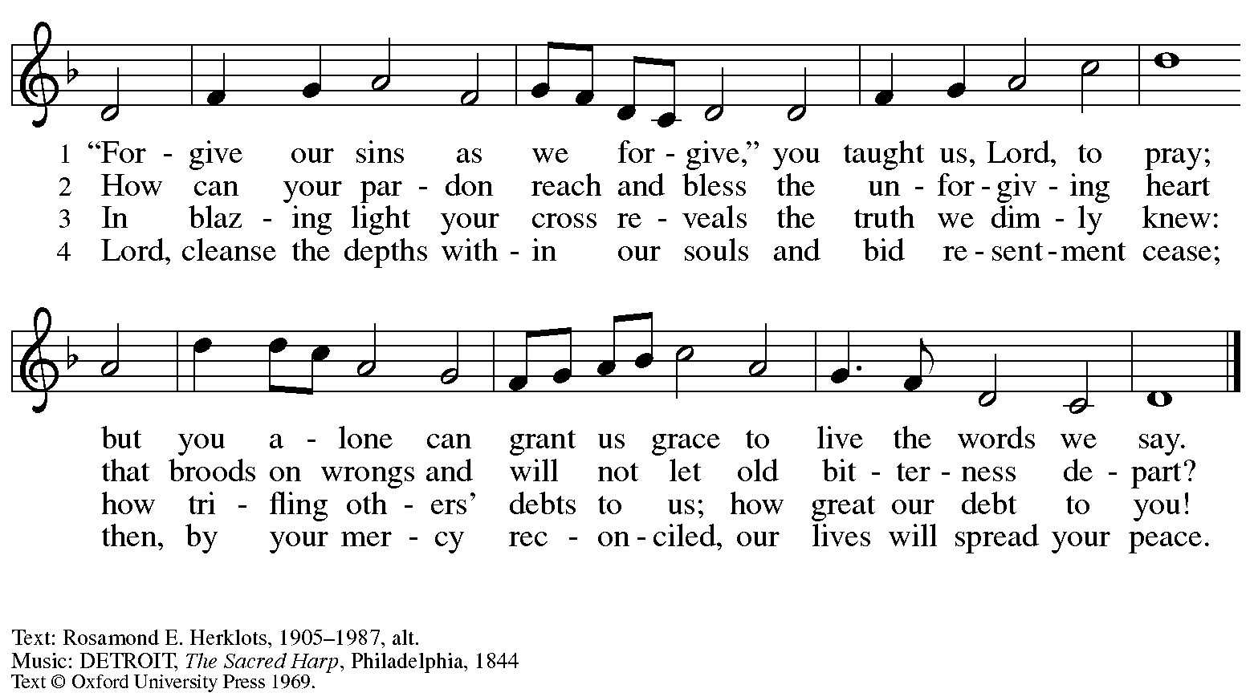
All rights reserved. Reprinted under OneLicense.net # A-722139.

Prayers of the People

A: Remembering the caring and generous works of God, we pray for the church,
the needs of our neighbors, and all creation.

After each petition
A: Merciful God,
C: receive our prayer.

The presiding minister concludes the prayers
P: Remember us according to your steadfast love, O God,
as we offer these prayers and those of our hearts,
trusting in your abundant mercy made known through Jesus Christ our Savior.
C: Amen.

Peace

The presiding minister and the assembly greet one another in the peace of the risen Christ.
P: The peace of Christ be with you always.
C: And also with you.

The people may greet those around them with a sign of Christ’s peace and may say
Peace be with you or similar words. Please be mindful that not everyone will be comfortable with sharing the peace, so please seek consent before shaking hands or hugging. Other possible ways to share the peace include a simple bow with the verbal greeting of peace, or simply a verbal expression of peace.

When the greetings of peace have concluded, please be seated.

Meal
God feeds us with the presence of Jesus Christ

Offering

We offer ourselves, our gifts, and our faithful service to God.
As the offering is gathered for the mission of the church, including the care of those in need,
the table is set for Holy Communion.

Music during the Offering

As the gifts are brought forward for presentation, please rise as you are able.

Offertory Song Toma, oh Dios, mi voluntad ELW 583
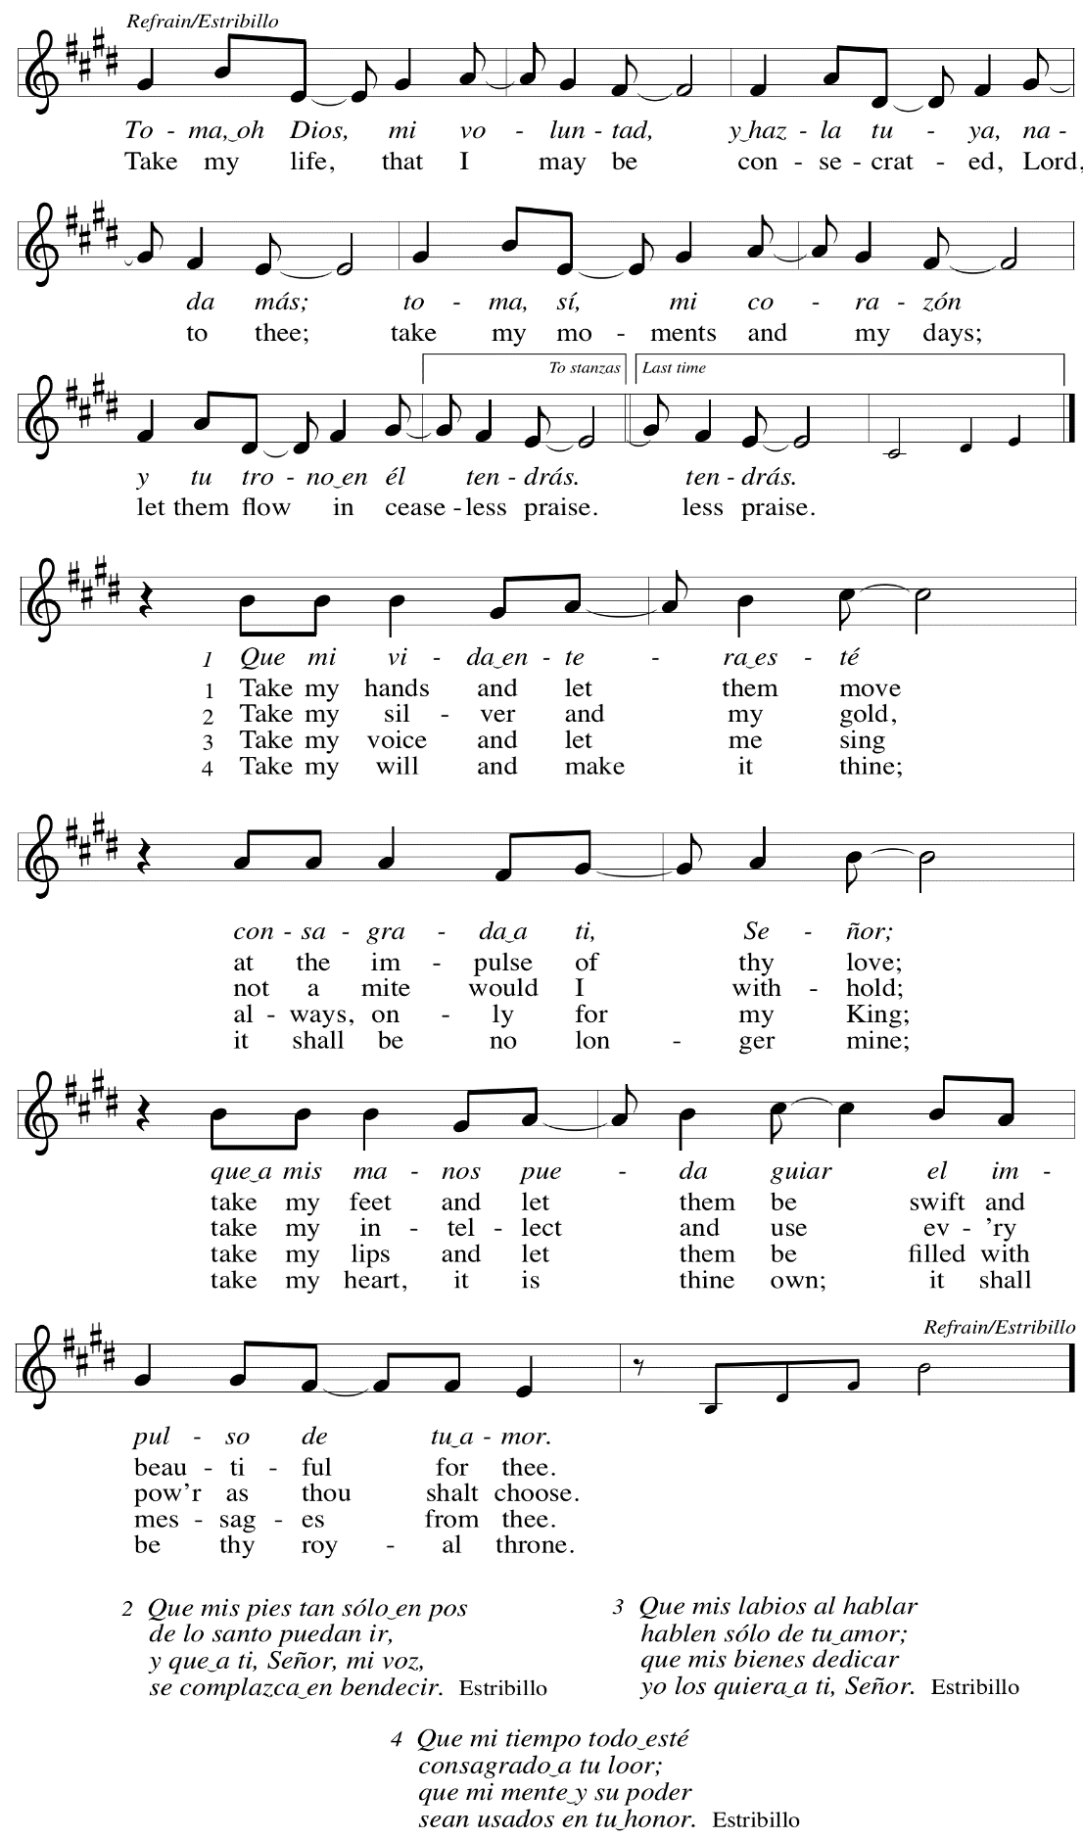

Offertory Prayer

A: Let us pray.
God of all creation,
C: all you have made is good, and your love endures forever.
You bring forth bread from the earth and fruit from the vine.
Nourish us with these gifts,
that we might be for the world signs of your gracious presence
in Jesus Christ, our Savior and Lord.
Amen.

Dialogue

P: The Lord be with you.
C: And also with you.

P: Lift up your hearts.
C: We lift them to the Lord.

P: Let us give thanks to the Lord our God.
C: It is right to give our thanks and praise.

Preface

P: It is indeed right, our duty and our joy,
that we should at all times and in all places
give thanks and praise to you, almighty and merciful God,
through our Savior Jesus Christ;
who on this day overcame death and the grave,
and by his glorious resurrection opened to us the way of everlasting life.
And so, with all the choirs of angels,
with the church on earth and the hosts of heaven,
we praise your name and join their unending hymn:

Sanctus ELW p. 181

Eucharistic Prayer

P: Holy God, holy and mighty, holy and immortal, …
… Do this for the remembrance of me.

Together as the body of Christ,
we proclaim the Lord’s death until he comes.
C: Christ has died. Christ is risen. Christ will come again.

P: With this bread and cup …
… all our sins and sorrows will be no more.
C: Amen. Come, Lord Jesus.

P: Holy God, holy and merciful one, holy and compassionate, …
… sharing your bounty with all the world.
C: Amen. Come, Holy Spirit.

… Holy and benevolent God, …
… with the Holy Spirit, in your holy church, now and forever.
C: Amen.

Lord’s Prayer

P: Gathered as one by the Holy Spirit, let us pray as Jesus taught us.
C: Our Father in heaven,
hallowed be your name,
your kingdom come,
your will be done,
on earth as in heaven.
Give us today our daily bread.
Forgive us our sins
as we forgive those
who sin against us.
Save us from the time of trial
and deliver us from evil.
For the kingdom, the power,
and the glory are yours,
now and forever. Amen.

Fraction and Invitation

Agnus Dei / Lamb of God ELW p. 182

Please be seated.

Holy Communion
- All who seek God and desire a deeper and stronger life in Christ are welcome to receive Holy Communion.
- Worshipers from the pulpit side will proceed forward first, followed by the center section, and then the lectern side.
- Please inform an usher if you would like the ministers to bring Communion to you.
- Holy Communion will be served with bread and wine/grape juice.
- The presiding minister will first distribute the bread (host) to each communicant. Please indicate if you require a gluten-free host.
- Once you have consumed the bread, please pick up an empty glass from the tray next to the presiding minister. The Communion Assistant will pour wine from the chalice or grape juice from the cruet into your glass.
- Please step to the side to consume the wine or grape juice.
- Feel free to kneel at the altar rail for prayer after receiving the sacrament.
- As you return to your pew, glasses may be returned to the empty trays on either side of the center section.
- A blessing will be provided for anyone who does not yet receive the sacrament.
- All are invited to join in singing the hymns during Holy Communion.

Hymns during Holy Communion
Where Charity and Love Prevail ELW 359

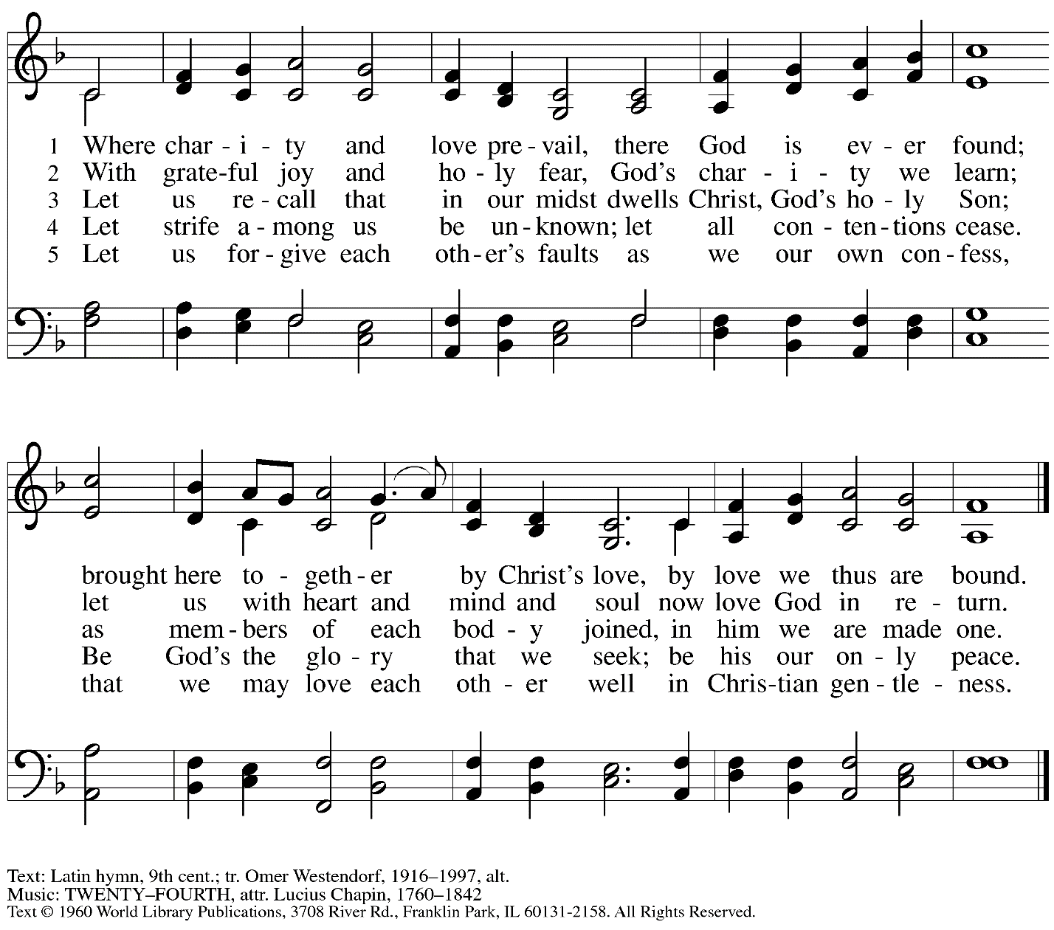
Reprinted with permission under OneLicense.net # A-722139.

Hymns during Holy Communion
I Come with Joy ELW 482

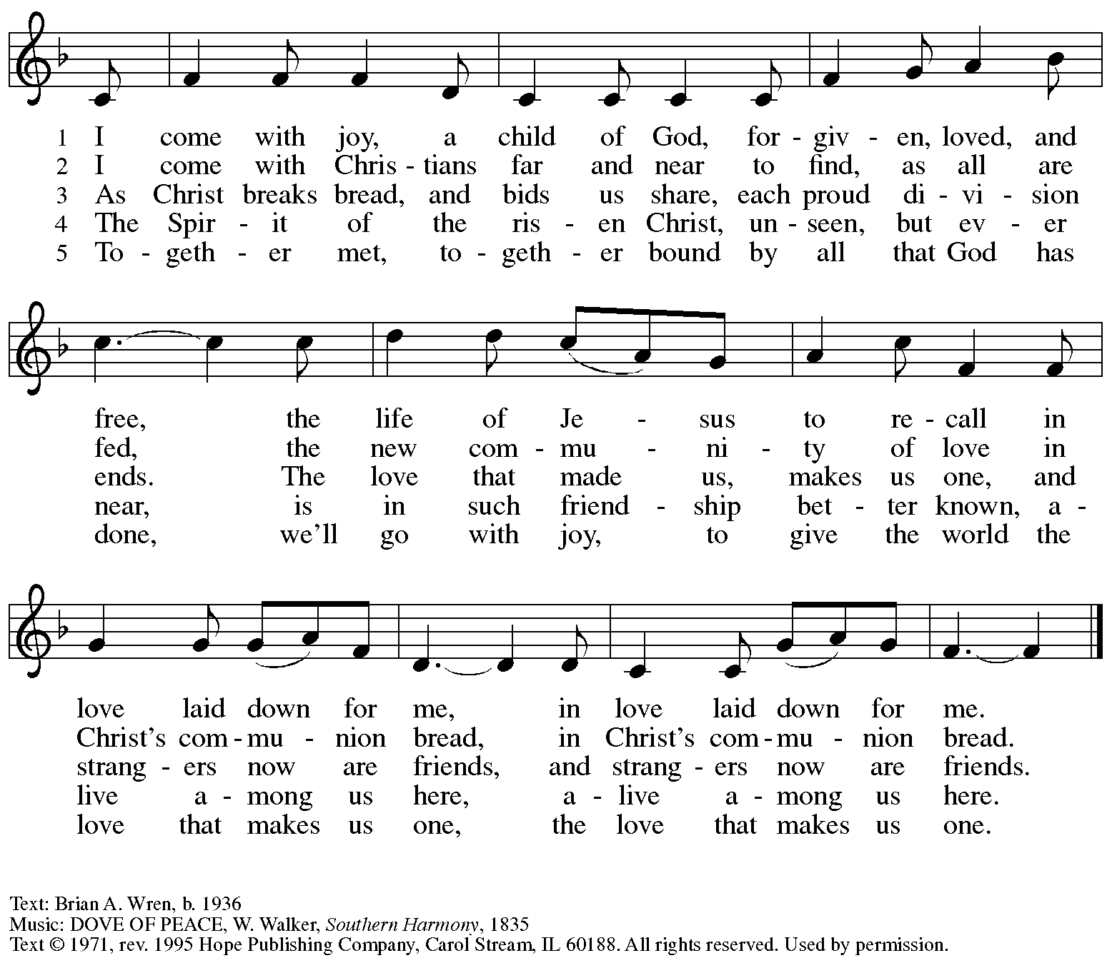
Reprinted with permission under OneLicense.net # A-722139.

Hymns during Holy Communion
Before the Waters Nourished Earth ACS 1049

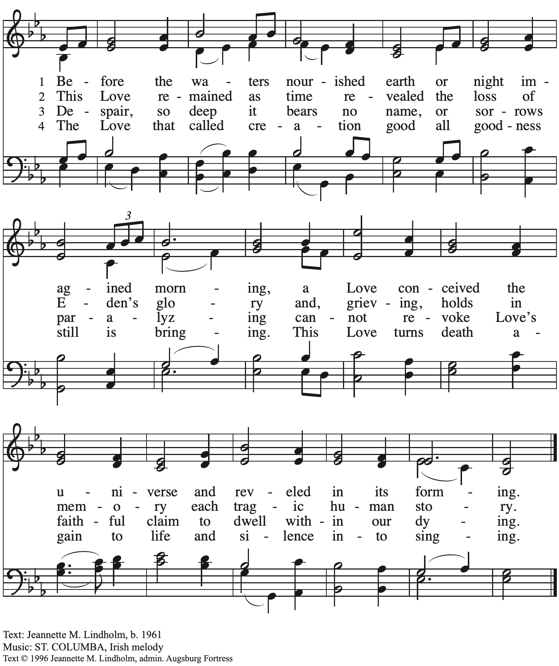
All rights reserved. Reprinted with permission under OneLicense.net # A-722139.

When all have returned to their places, please rise as you are able.

Blessing

P: The body and blood of our Lord Jesus Christ strengthen you and keep you in his grace.
C: Amen.

Prayer

A: Let us pray.
We give you thanks, almighty God,
that you have refreshed us through the healing power of this gift of life.
In your mercy, strengthen us through this gift,
in faith toward you and in fervent love toward one another;
for the sake of Jesus Christ our Lord.
C: Amen.
Please be seated.

Sending
God blesses us and sends us in mission to the world

Announcements

Please rise as you are able.

Benediction

P: The God of steadfastness and encouragement
grant you to live in harmony with one another,
in accordance with Christ Jesus.
C: Amen.

P: The God of hope fill you with all joy and peace in believing,
so that you may abound in hope by the power of the Holy Spirit.
C: Amen.

P: The God of all grace ☩ bless you now and forever.
C: Amen.

Sending Hymn Go, My Children, with My Blessing Following page

Sending Hymn Go, My Children, with My Blessing ELW 543

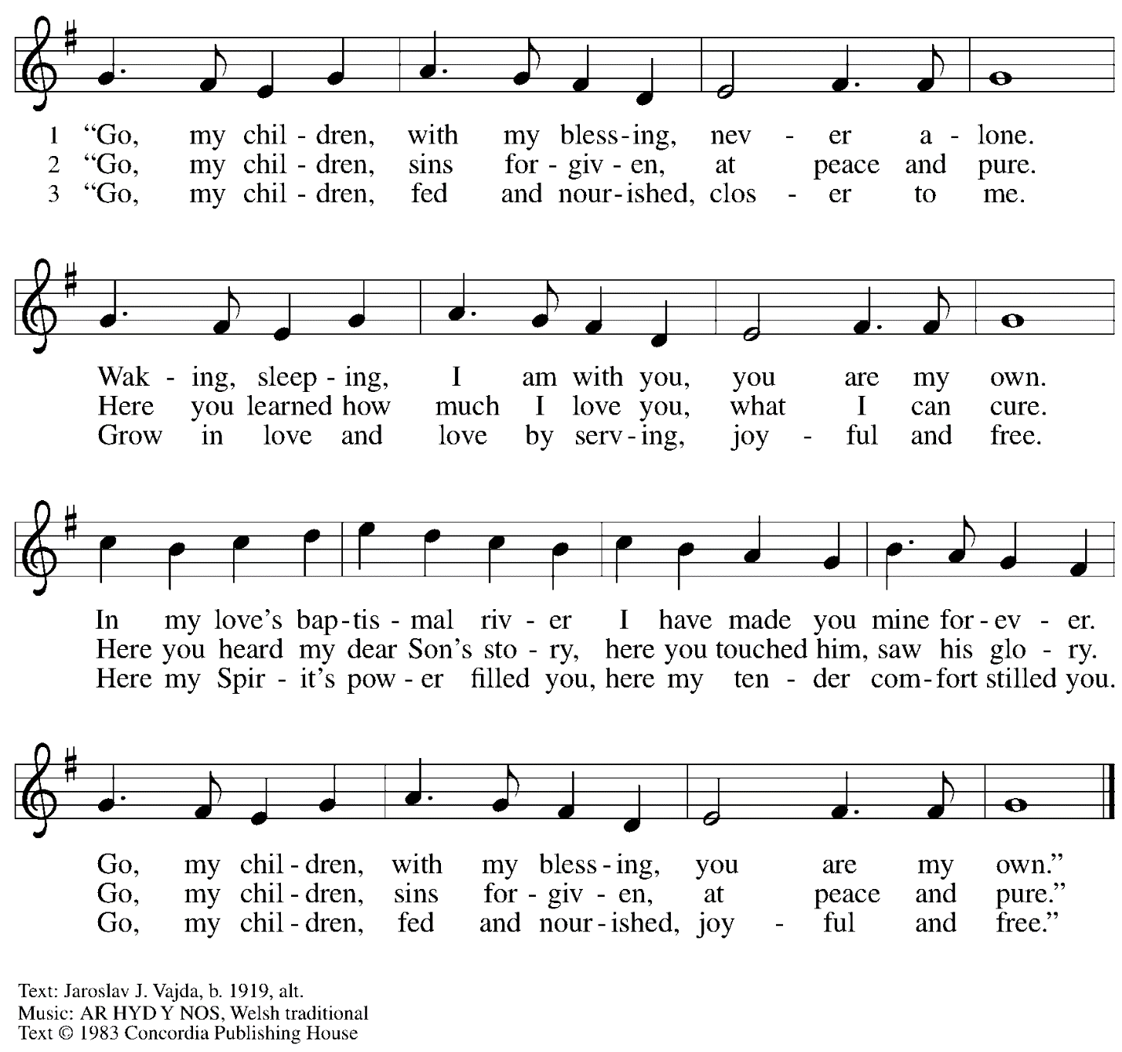
All rights reserved. Reprinted with permission under OneLicense.net # A-722139.

Dismissal

A: Go in peace. Serve the Lord.
C: Thanks be to God!

Postlude

Those serving in worship today

Altar Care Christy Ruhe
Announcements Colleen Cooke
Assisting Minister Tim Marker
Audio-Visual Ministers Kristen Asplin
Colten Rohleder
Cantor Emily Duque
Lector Pastor Paul Koch
Little Church – Big Faith Leader Maria Mangano
Minister of Music Laura Reynolds
Presiding Minister The Rev. Ross I. Carmichael

Liturgy and Hymnody Acknowledgements

From SundaysandSeasons.com. Copyright © 2023 Augsburg Fortress. All rights reserved. Reprinted under OneLicense.net # A-722139.
Used by permission of Augsburg Fortress.

Toma, oh Dios, mi voluntad – Text: Frances R. Havergal, 1836-1879, adapt.; Spanish text: Vincent Mendoza, 1875-1955. Music: TOMA MI VOLUNTAD, William Dexheimer Pharris, b. 1956. All rights reserved. Reprinted with permission under OneLicense.net # A-722139.

Please use the QR code below to link to St. Andrew’s Announcements online!

St. Andrew Lutheran Church Announcements
September 17th, 2023

- Welcome to Worship at St. Andrew on the Fifteenth Sunday after Pentecost, September 17th, 2023 – We are so glad you are here, and we offer a special welcome to all guests who are here or online for the first time! Worship attendees are invited to make a name tag at the back of the worship space if you would like. Children are invited to take part in Little Church – Big Faith, a time of Bible stories and activities, during worship after the Prayer of the Day. There are also worship “toolkits” to help children engage with worship and “busy bags” for younger children available in the bookcase at the back of the sanctuary. Please feel free to take one to use with your children. We invite everyone to stay after worship for coffee and conversation in the Social Hall next to the sanctuary.

- After Worship Today: Cross-Generational Activity (Advent Banner Preparation!) for Children, Youth, Parents / Guardians, and the Whole Congregation– In the past, children and youth of St. Andrew have helped create art for banners that adorn the worship space in the season of Advent, and we would like to make banners for a new church year. We invite children, youth, parents / guardians to gather after worship to hear an Advent reading, talk about its imagery, and work together on an artistic representation of the text, which will be used to make four new banners, one for each week of the Advent season. While we hope for primary input from children and youth, we encourage everyone in the congregation to stay to support them and share in the St. Andrew community on these Sundays! Please speak with Christian Education liaison Colten Rohleder or Jimmi Kocher-Hillmer if you have questions. We will continue with three more of these gatherings on Sundays, October 1st, October 15th, and October 29th.
- Looking for People to Set Up Coffee Hour – In order to facilitate conversation and
community-building, St. Andrew seeks to have Coffee Hour after worship each week. Usually this can be provided by one person or family unit signing up per week. The tasks include preparing the coffee maker and starting its brew cycle along with setting out snacks, napkins, plates, etc. before worship. After worship tasks include bringing out creamer and cold drinks (water, juice boxes for children) and cleanup. We invite you to consider serving – please sign up here: https://www.signupgenius.com/go/5080b4aafaf2cabf85-coffee#/.
- Monthly Dinner for Guests of East End Cooperative Ministry – Thursday, September 21st, 6:30 p.m. – People of St. Andrew provide a meal for guests of the shelter at East End Cooperative Ministry (EECM) on the third Thursday of every month. This month’s dinner will be on September 21st at 6:30 pm. Each person is asked to cook or bring one portion of the meal to EECM (6140 Station St., 15206) at 6:00 p.m. Others are welcome to come and help serve the meal. If you would like to contribute, please sign up here: https://www.signupgenius.com/go/5080544AAAC22A1F58-shelter40.
- Sanctuary: Arts + Honors – An LGBTQIA+ Art Show Honoring Safe Spaces, Hosted by Hot Metal Bridge Faith Community, Continuing through September 22nd– St. Andrew is happy to be a co-sponsor of “Sanctuary: Arts + Honors,” an LGBTQIA+ art show and celebration of safe spaces this September 15th-22nd. This show will celebrate sanctuaries of spiritual and emotional healing, moments, and communities where we have been able to flourish as our full selves. Additionally, the show will bestow an annual award upon a local organization that has worked to create safety for the queer community. BikePGH will be the inaugural recipient of the Sanctuary Award for their work to champion inclusive gatherings and communities, and their advocacy for all people. Hot Metal Bridge Faith Community is located at 2700 Jane Street, 15203. For more information about the event and to purchase tickets, please click here: https://www.sanctuarypgh.com/.

