+ Seventeenth Sunday after Pentecost
September 24th, 2023
10:00 a.m.

St. Andrew Lutheran Church
304 Morewood Ave.
Pittsburgh, PA 15213
St_andrewELCA@verizon.net
www.standrewpittsburgh.org

+ Seventeenth Sunday after Pentecost
Order for Worship

Matthew narrates one of Jesus’ controversial parables in which Jesus says that the reign of God is like that of a landowner who pays his workers the same wage no matter what time of day they began to work. When God changes God’s mind about punishing Nineveh for their evil ways, Jonah is angry. Yet God is gracious and merciful, abounding in steadfast love. In baptism we receive the grace of God that is freely given to all. As Martin Luther wrote, in the presence of God’s mercy we are all beggars.

Welcome to St. Andrew!

- St. Andrew Lutheran congregation welcomes all who are seeking a place of healing and wholeness – a nurturing, faith-forming spiritual home. Our community embraces people of all ages, ethnicities, cultures, abilities, sexual orientations, gender identities and expressions, and family constellations. Come and See!

- Worship Services are live streamed to multiple online platforms. By attending worship, you agree that your image and voice may be broadcast.

- Everyone is invited to make a nametag at the black bookcase in the back of the worship space if they would like. There are stickers indicating pronouns on the bookcase if you would like to include them on your name tag.

- Worship “toolkits” to help children engage with the service, along with “busy bags” for younger children, are available in the bookcase at the back of the sanctuary. Please feel free to take one to use with/for your children.

- Children are invited to attend Little Church – Big Faith, a Bible lesson and activity, during worship (after the Prayer of the Day). The group returns to the worship space for the liturgy of Holy Communion.

- Holy Communion is served with bread (gluten-free available) and wine or grape juice. The presiding minister will distribute the bread (host). Please consume this and then pick up an empty glass from the tray. The Communion Assistant will pour wine or grape juice into your glass. Please step to the side to consume the wine or grape juice. Feel free to kneel at the altar for prayer and reflection. As you return to your pew, glasses may be returned to the empty trays on either side of the center section.

- A restroom is available on the main level of the church, through the doors to the Social Hall and to the right in the main office.

Abbreviations
P: Pastor/Presiding Minister ACS: All Creation Sings hymnal
A: Assisting Minister ELW: Evangelical Lutheran Worship hymnal
L: Lector
C: Congregation

Pre-Service Music

Welcome

Prelude

Gathering
The Holy Spirit calls us together as the people of God

Confession and Forgiveness

Please rise as you are able. All may make the sign of the cross,
the sign that is marked at Baptism, as the presiding minister begins.

P: Blessed be the God who made us,
☩ Jesus Christ who bears the cross,
and the Holy Spirit who guides and sustains us.
C: Amen.

P: Let us humble ourselves before God, confessing our sin.

Silence is kept for reflection.

P: Steadfast and faithful God,
C: you have revealed the ways of justice,
yet we fail to follow you.
We are overwhelmed
by the world’s violence and suffering.
We are afraid to risk what we have
for the sake of others.
For the harm we have caused,
known and unknown, forgive us.
For the unjust demands we place on others
and your creation, forgive us.
For the ways we turn away
from you and our neighbor, forgive us.
Lead us back to you, and set us on healthy, fruitful paths;
in the name of Jesus Christ, our Savior. Amen.

P: Beloved in Christ, God’s mercy stretches beyond all understanding,
God’s compassion is beyond compare.
In Jesus, God is always making a new way for us.
In ☩ Christ, you have been and always will be forgiven.
C: Amen.
Gathering Hymn There’s a Wideness in God’s Mercy ELW 588

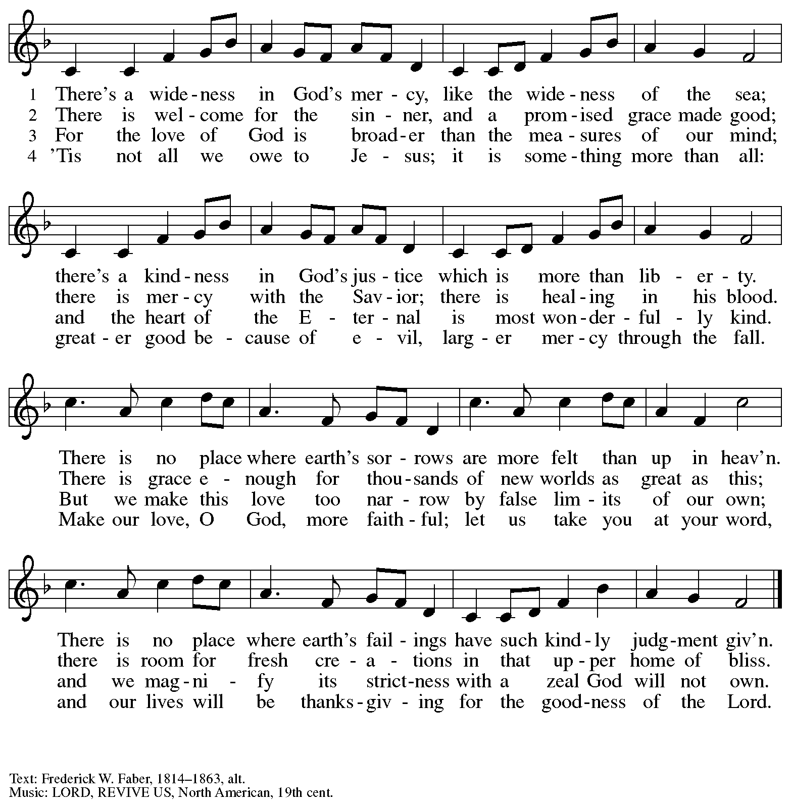

Greeting

P: The grace of our Lord Jesus Christ, the love of God,
and the communion of the Holy Spirit be with you all.
C: And also with you.

Hymn of Praise ELW p. 176

Prayer of the Day

P: Let us pray.
Almighty and eternal God, you show perpetual lovingkindness to us your servants.
Because we cannot rely on our own abilities, grant us your merciful judgment,
and train us to embody the generosity of your Son, Jesus Christ, our Savior and Lord.
C: Amen.

Please be seated.

Word
God speaks to us in Scripture reading, preaching, and song

First Reading – Jonah 3: 10 – 4: 11

¹⁰When God saw what [the people of Ninevah] did, how they turned from their evil ways, God changed God’s mind about the calamity that God had said God would bring upon them; and God did not do it.
^{4:1}But this was very displeasing to Jonah, and he became angry. ²He prayed to the Lord and said, “O Lord! Is not this what I said while I was still in my own country? That is why I fled to Tarshish at the beginning; for I knew that you are a gracious God and merciful, slow to anger, and abounding in steadfast love, and ready to relent from punishing. ³And now, O Lord, please take my life from me, for it is better for me to die than to live.” ⁴And the Lord said, “Is it right for you to be angry?” ⁵Then Jonah went out of the city and sat down east of the city, and made a booth for himself there. He sat under it in the shade, waiting to see what would become of the city.
⁶The Lord God appointed a bush, and made it come up over Jonah, to give shade over his head, to save him from his discomfort; so Jonah was very happy about the bush. ⁷But when dawn came up the next day, God appointed a worm that attacked the bush, so that it withered. ⁸When the sun rose, God prepared a sultry east wind, and the sun beat down on the head of Jonah so that he was faint and asked that he might die. He said, “It is better for me to die than to live.”
⁹But God said to Jonah, “Is it right for you to be angry about the bush?” And he said, “Yes, angry enough to die.” ¹⁰Then the Lord said, “You are concerned about the bush, for which you did not labor and which you did not grow; it came into being in a night and perished in a night.
¹¹And should I not be concerned about Nineveh, that great city, in which there are more than a hundred and twenty thousand persons who do not know their right hand from their left, and also many animals?”

L: Word of God, word of life.
C: Thanks be to God.

Psalm 145: 1-8

The psalm will be sung by the cantor, with the congregation invited to join in singing the alternate verses (in bold) and the refrain.

Psalm tone

Psalm refrain

¹I will exalt you, my | God and king,
and bless your name forev- | er and ever.
²Every day | will I bless you
and praise your name forev- | er and ever.
³Great is the Lord and greatly | to be praised!
There is no end | to your greatness.
⁴One generation shall praise your works | to another
and shall de- | clare your power. R
⁵I will speak of the glorious splendor | of your majesty
and all your | marvelous works.
⁶They shall tell of the might of your | wondrous acts,
and I will re- | count your greatness.
⁷They shall publish the remembrance of | your great goodness;
they shall sing joyfully | of your righteousness.
⁸The Lord is gracious and full | of compassion,
slow to anger and abounding in | steadfast love. R

Second Reading – Philippians 1: 21-30

²¹For to me, living is Christ and dying is gain. ²²If I am to live in the flesh, that means fruitful labor for me; and I do not know which I prefer. ²³I am hard pressed between the two: my desire is to depart and be with Christ, for that is far better; ²⁴but to remain in the flesh is more necessary for you. ²⁵Since I am convinced of this, I know that I will remain and continue with all of you for your progress and joy in faith, ²⁶so that I may share abundantly in your boasting in Christ Jesus when I come to you again.
²⁷Only, live your life in a manner worthy of the gospel of Christ, so that, whether I come and see you or am absent and hear about you, I will know that you are standing firm in one spirit, striving side by side with one mind for the faith of the gospel, ²⁸and are in no way intimidated by your opponents. For them this is evidence of their destruction, but of your salvation. And this is God’s doing. ²⁹For God has graciously granted you the privilege not only of believing in Christ, but of suffering for Christ as well—³⁰since you are having the same struggle that you saw I had and now hear that I still have.

L: Word of God, word of life.
C: Thanks be to God.

Please rise as you are able.

Gospel Acclamation Aleluya ELW p. 179

Gospel – Matthew 20: 1-16

P: The holy Gospel according to St. Matthew.
C: Glory to you, O Lord.

[Jesus said to the disciples:] ¹“The kingdom of heaven is like a landowner who went out early in the morning to hire laborers for his vineyard. ²After agreeing with the laborers for the usual daily wage, he sent them into his vineyard. ³When he went out about nine o’clock, he saw others standing idle in the marketplace; ⁴and he said to them, ‘You also go into the vineyard, and I will pay you whatever is right.’ So they went. ⁵When he went out again about noon and about three o’clock, he did the same. ⁶And about five o’clock he went out and found others standing around; and he said to them, ‘Why are you standing here idle all day?’ ⁷They said to him, ‘Because no one has hired us.’ He said to them, ‘You also go into the vineyard.’ ⁸When evening came, the owner of the vineyard said to his manager, ‘Call the laborers and give them their pay, beginning with the last and then going to the first.’ ⁹When those hired about five o’clock came, each of them received the usual daily wage. ¹⁰Now when the first came, they thought they would receive more; but each of them also received the usual daily wage. ¹¹And when they received it, they grumbled against the landowner, ¹²saying, ‘These last worked only one hour, and you have made them equal to us who have borne the burden of the day and the scorching heat.’ ¹³But he replied to one of them, ‘Friend, I am doing you no wrong; did you not agree with me for the usual daily wage? ¹⁴Take what belongs to you and go; I choose to give to this last the same as I give to you. ¹⁵Am I not allowed to do what I choose with what belongs to me? Or are you envious because I am generous?’ ¹⁶So the last will be first, and the first will be last.”
P: The Gospel of the Lord.
C: Praise to you, O Christ.

Please be seated.

Sermon

A time of silence for prayer and reflection follows the sermon.
When the hymn of the day begins, please rise as you are able.

Hymn of the Day All Who Love and Serve Your City ELW 724

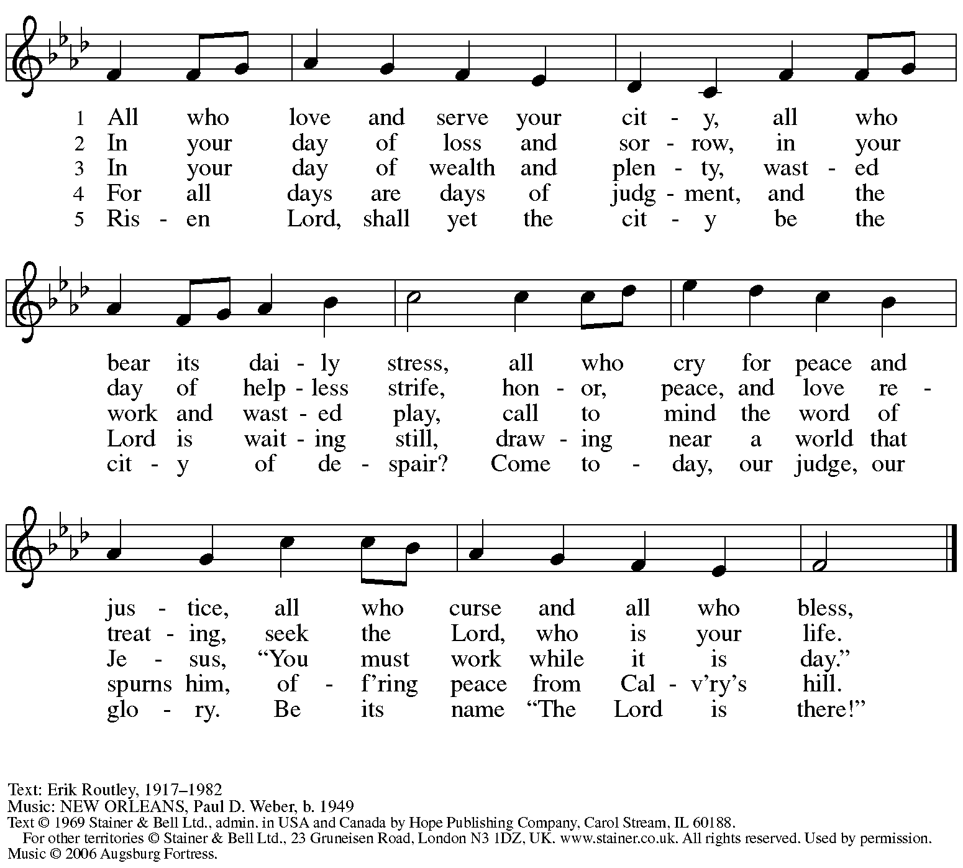
Reprinted with permission under OneLicense.net # A-722139.

Prayers of the People

A: Remembering the caring and generous works of God, we pray for the church,
the needs of our neighbors, and all creation.

After each petition
A: Merciful God,
C: receive our prayer.

The presiding minister concludes the prayers
P: Remember us according to your steadfast love, O God,
as we offer these prayers and those of our hearts,
trusting in your abundant mercy made known through Jesus Christ our Savior.
C: Amen.

Peace

The presiding minister and the assembly greet one another in the peace of the risen Christ.
P: The peace of Christ be with you always.
C: And also with you.

The people may greet those around them with a sign of Christ’s peace and may say
Peace be with you or similar words. Please be mindful that not everyone will be comfortable with sharing the peace, so please seek consent before shaking hands or hugging. Other possible ways to share the peace include a simple bow with the verbal greeting of peace, or simply a verbal expression of peace.

When the greetings of peace have concluded, please be seated.

Meal
God feeds us with the presence of Jesus Christ

Offering

We offer ourselves, our gifts, and our faithful service to God.
As the offering is gathered for the mission of the church, including the care of those in need,
the table is set for Holy Communion.

Music during the Offering

As the gifts are brought forward for presentation, please rise as you are able.

Offertory Song ELW 583
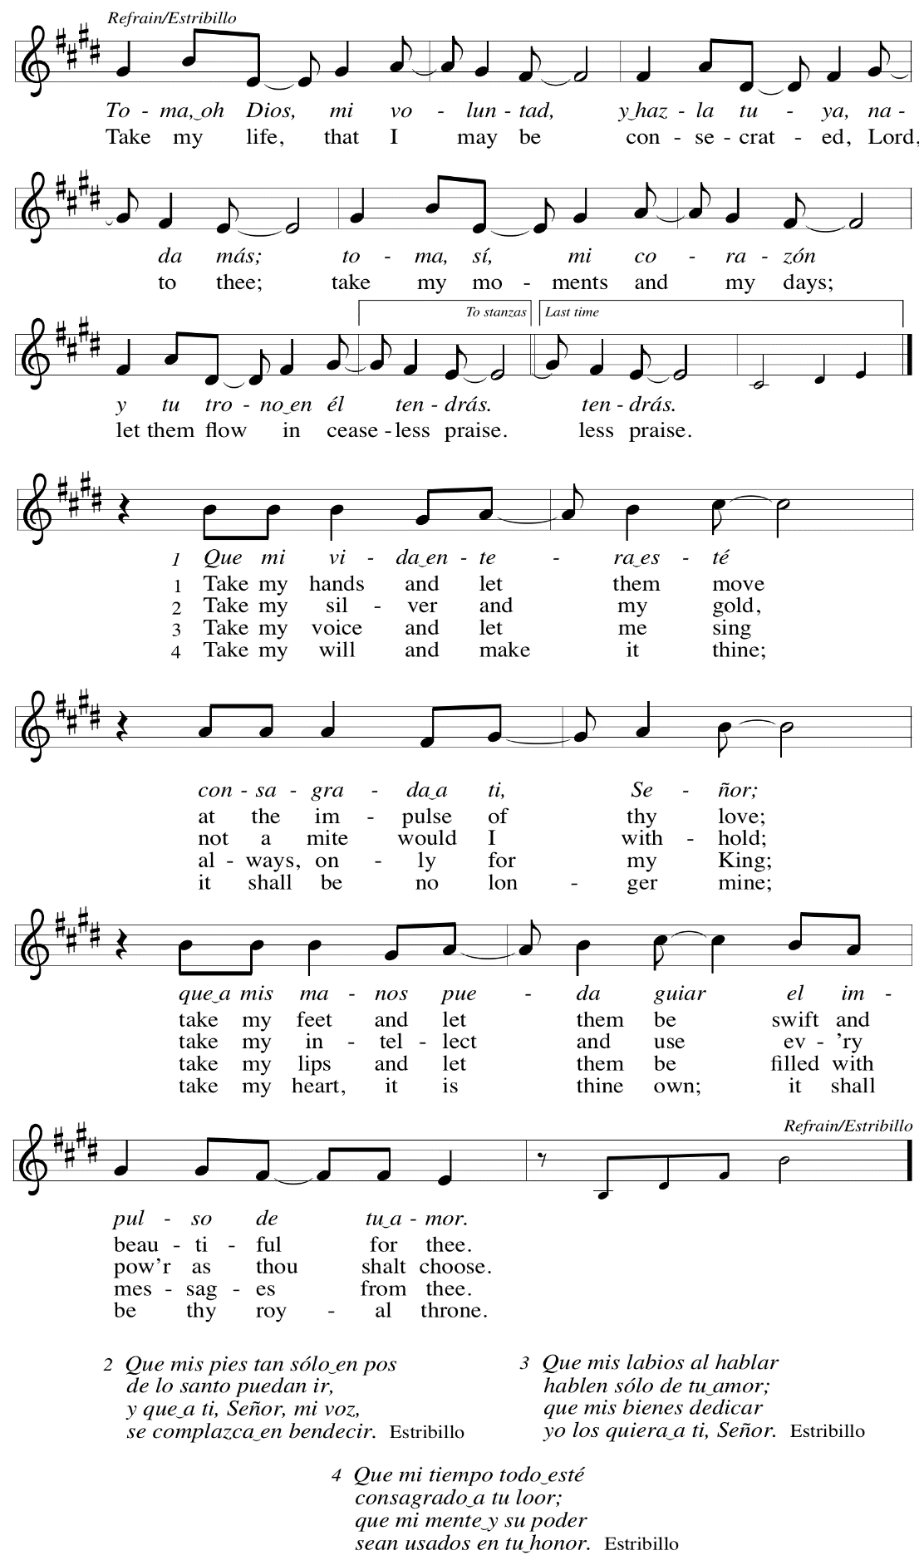

Offertory Prayer

A: Let us pray.
God of all creation,
C: all you have made is good, and your love endures forever.
You bring forth bread from the earth and fruit from the vine.
Nourish us with these gifts,
that we might be for the world signs of your gracious presence
in Jesus Christ, our Savior and Lord.
Amen.

Dialogue

P: The Lord be with you.
C: And also with you.

P: Lift up your hearts.
C: We lift them to the Lord.

P: Let us give thanks to the Lord our God.
C: It is right to give our thanks and praise.

Preface

P: It is indeed right, our duty and our joy,
that we should at all times and in all places
give thanks and praise to you, almighty and merciful God,
through our Savior Jesus Christ;
who on this day overcame death and the grave,
and by his glorious resurrection opened to us the way of everlasting life.
And so, with all the choirs of angels,
with the church on earth and the hosts of heaven,
we praise your name and join their unending hymn:

Sanctus ELW p. 181

Eucharistic Prayer

P: Holy God, holy and mighty, holy and immortal, …
… Do this for the remembrance of me.

Together as the body of Christ,
we proclaim the Lord’s death until he comes.
C: Christ has died. Christ is risen. Christ will come again.

P: With this bread and cup …
… all our sins and sorrows will be no more.
C: Amen. Come, Lord Jesus.

P: Holy God, holy and merciful one, holy and compassionate, …
… sharing your bounty with all the world.
C: Amen. Come, Holy Spirit.

… Holy and benevolent God, …
… with the Holy Spirit, in your holy church, now and forever.
C: Amen.

Lord’s Prayer

P: Gathered as one by the Holy Spirit, let us pray as Jesus taught us.
C: Our Father in heaven,
hallowed be your name,
your kingdom come,
your will be done,
on earth as in heaven.
Give us today our daily bread.
Forgive us our sins
as we forgive those
who sin against us.
Save us from the time of trial
and deliver us from evil.
For the kingdom, the power,
and the glory are yours,
now and forever. Amen.

Fraction and Invitation

Agnus Dei / Lamb of God ELW p. 182

Please be seated.

Holy Communion
- All who seek God and desire a deeper and stronger life in Christ are welcome to receive Holy Communion.
- Worshipers from the pulpit side will proceed forward first, followed by the center section, and then the lectern side.
- Please inform an usher if you would like the ministers to bring Communion to you.
- Holy Communion will be served with bread and wine/grape juice.
- The presiding minister will first distribute the bread (host) to each communicant. Please indicate if you require a gluten-free host.
- Once you have consumed the bread, please pick up an empty glass from the tray next to the presiding minister. The Communion Assistant will pour wine from the chalice or grape juice from the cruet into your glass.
- Please step to the side to consume the wine or grape juice.
- Feel free to kneel at the altar rail for prayer after receiving the sacrament.
- As you return to your pew, glasses may be returned to the empty trays on either side of the center section.
- A blessing will be provided for anyone who does not yet receive the sacrament.
- All are invited to join in singing the hymns during Holy Communion.

Hymns during Holy Communion ELW 358
Great God, Your Love Has Called Us

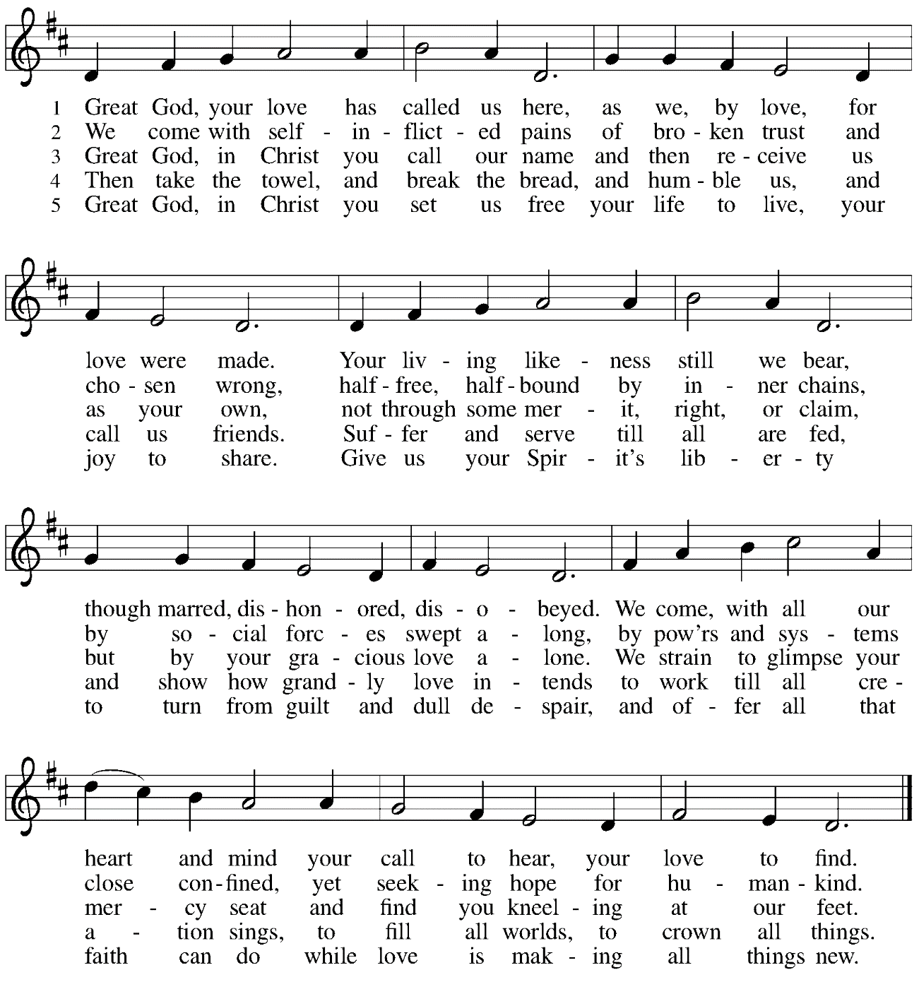

Hymns during Holy Communion
Bread of Life from Heaven ELW 474

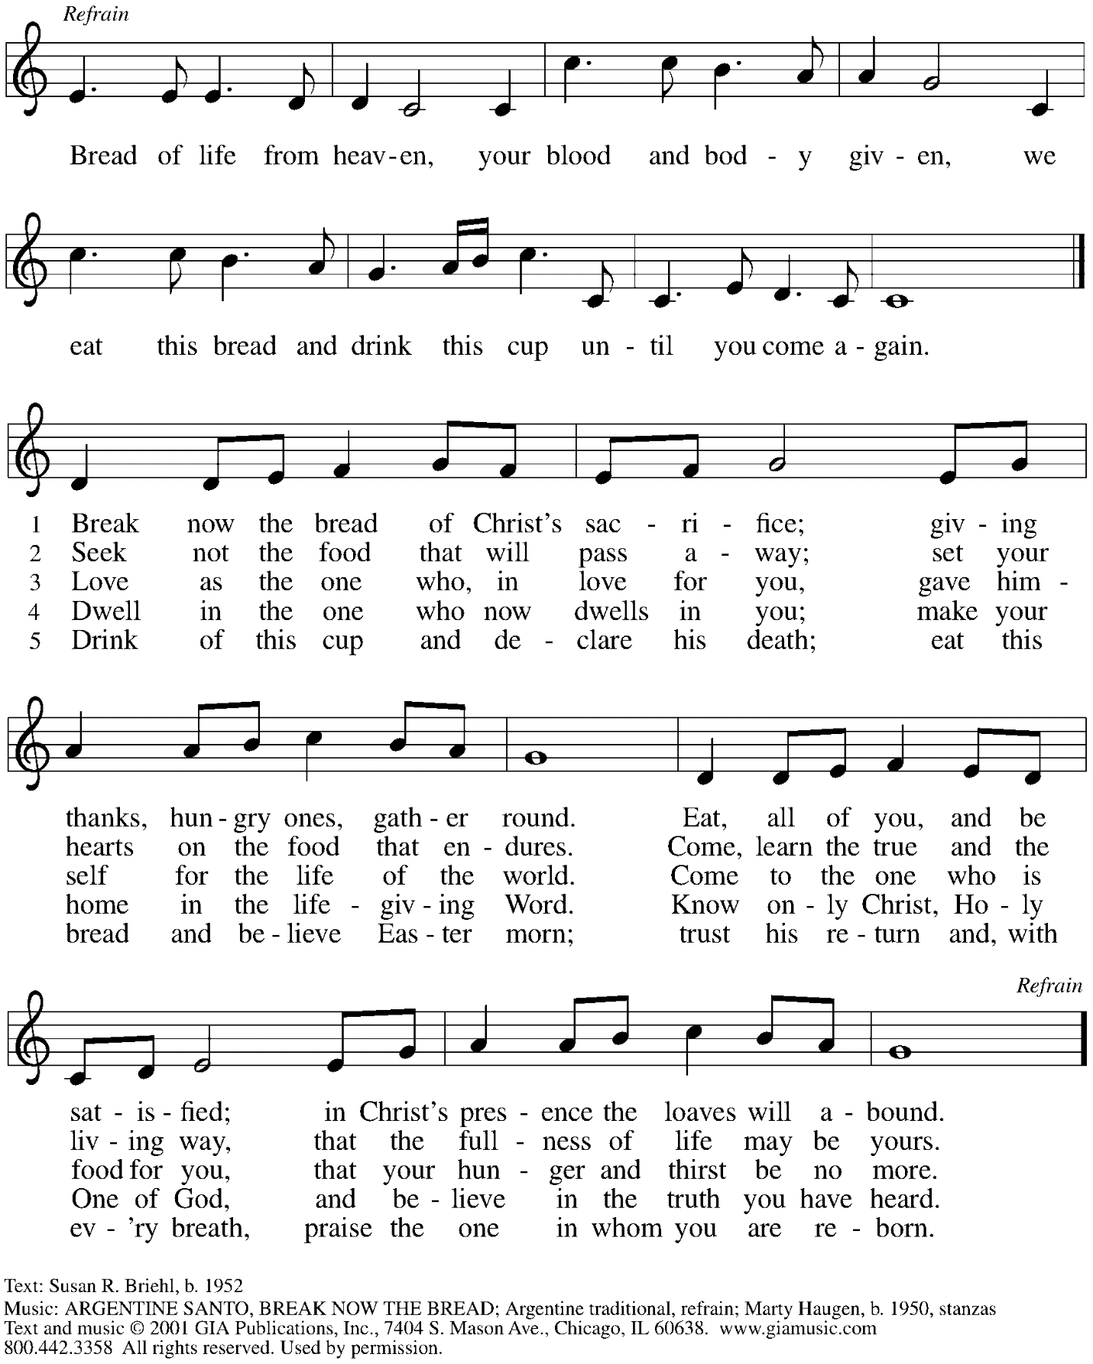
Reprinted with permission under OneLicense.net # A-722139.

Hymns during Holy Communion
Give Me Jesus ELW 770

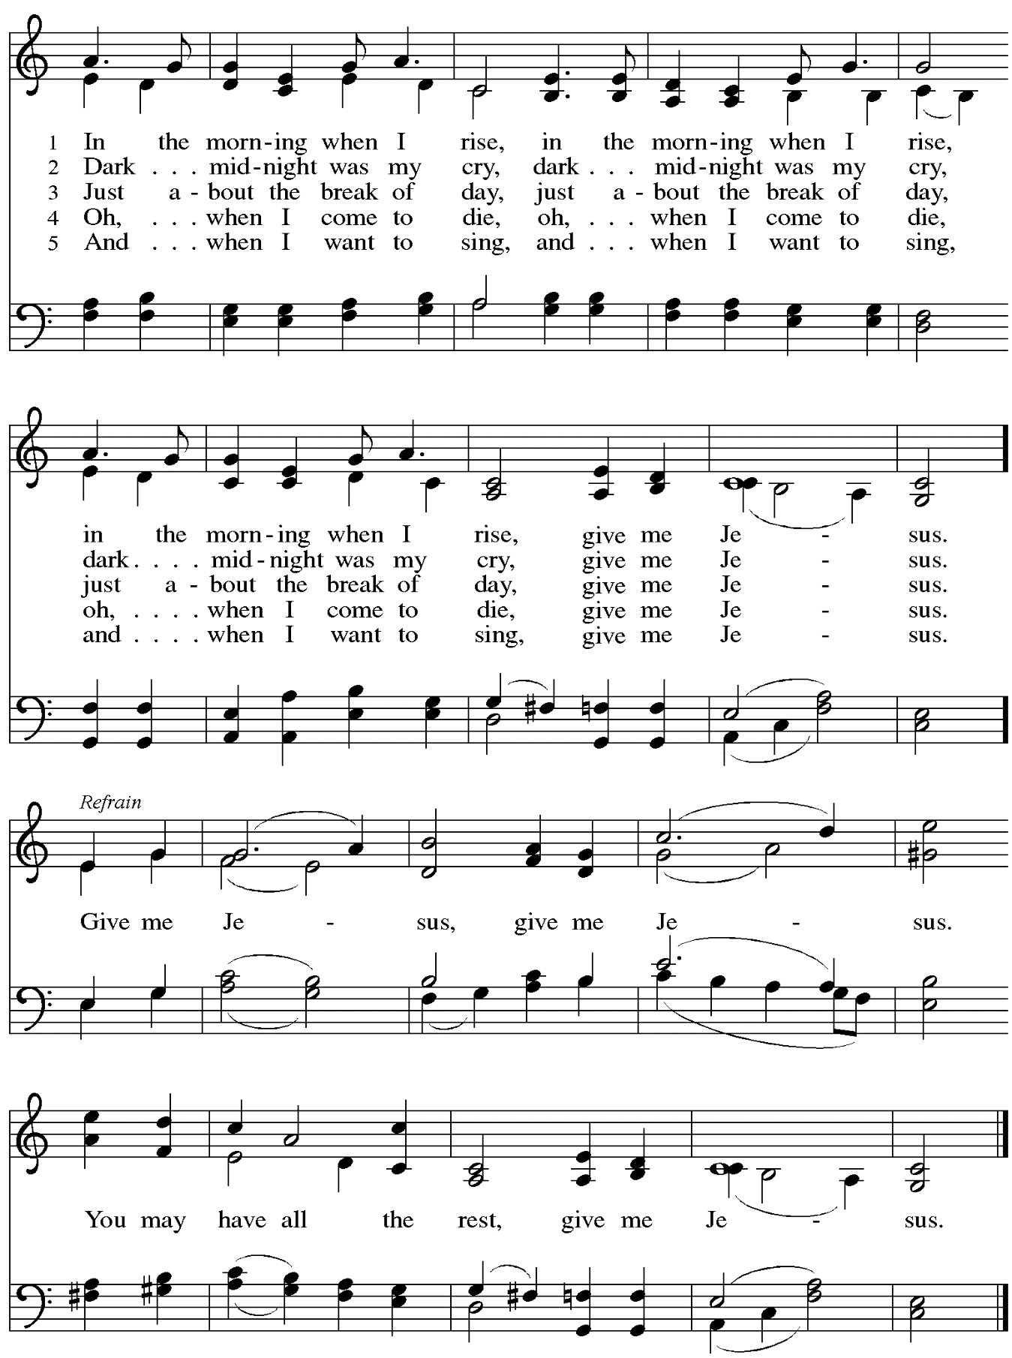

When all have returned to their places, please rise as you are able.

Blessing

P: The body and blood of our Lord Jesus Christ strengthen you and keep you in his grace.
C: Amen.

Prayer

A: Let us pray.
We give you thanks, almighty God,
that you have refreshed us through the healing power of this gift of life.
In your mercy, strengthen us through this gift,
in faith toward you and in fervent love toward one another;
for the sake of Jesus Christ our Lord.
C: Amen.
Please be seated.

Sending
God blesses us and sends us in mission to the world

Announcements

Please rise as you are able.

Benediction

P: The God of steadfastness and encouragement
grant you to live in harmony with one another,
in accordance with Christ Jesus.
C: Amen.

P: The God of hope fill you with all joy and peace in believing,
so that you may abound in hope by the power of the Holy Spirit.
C: Amen.

P: The God of all grace ☩ bless you now and forever.
C: Amen.

Sending Hymn Following page
Dios de la esperanza / May the God of Hope Go with Us

Sending Hymn ACS 984
Dios de la esperanza / May the God of Hope Go with Us

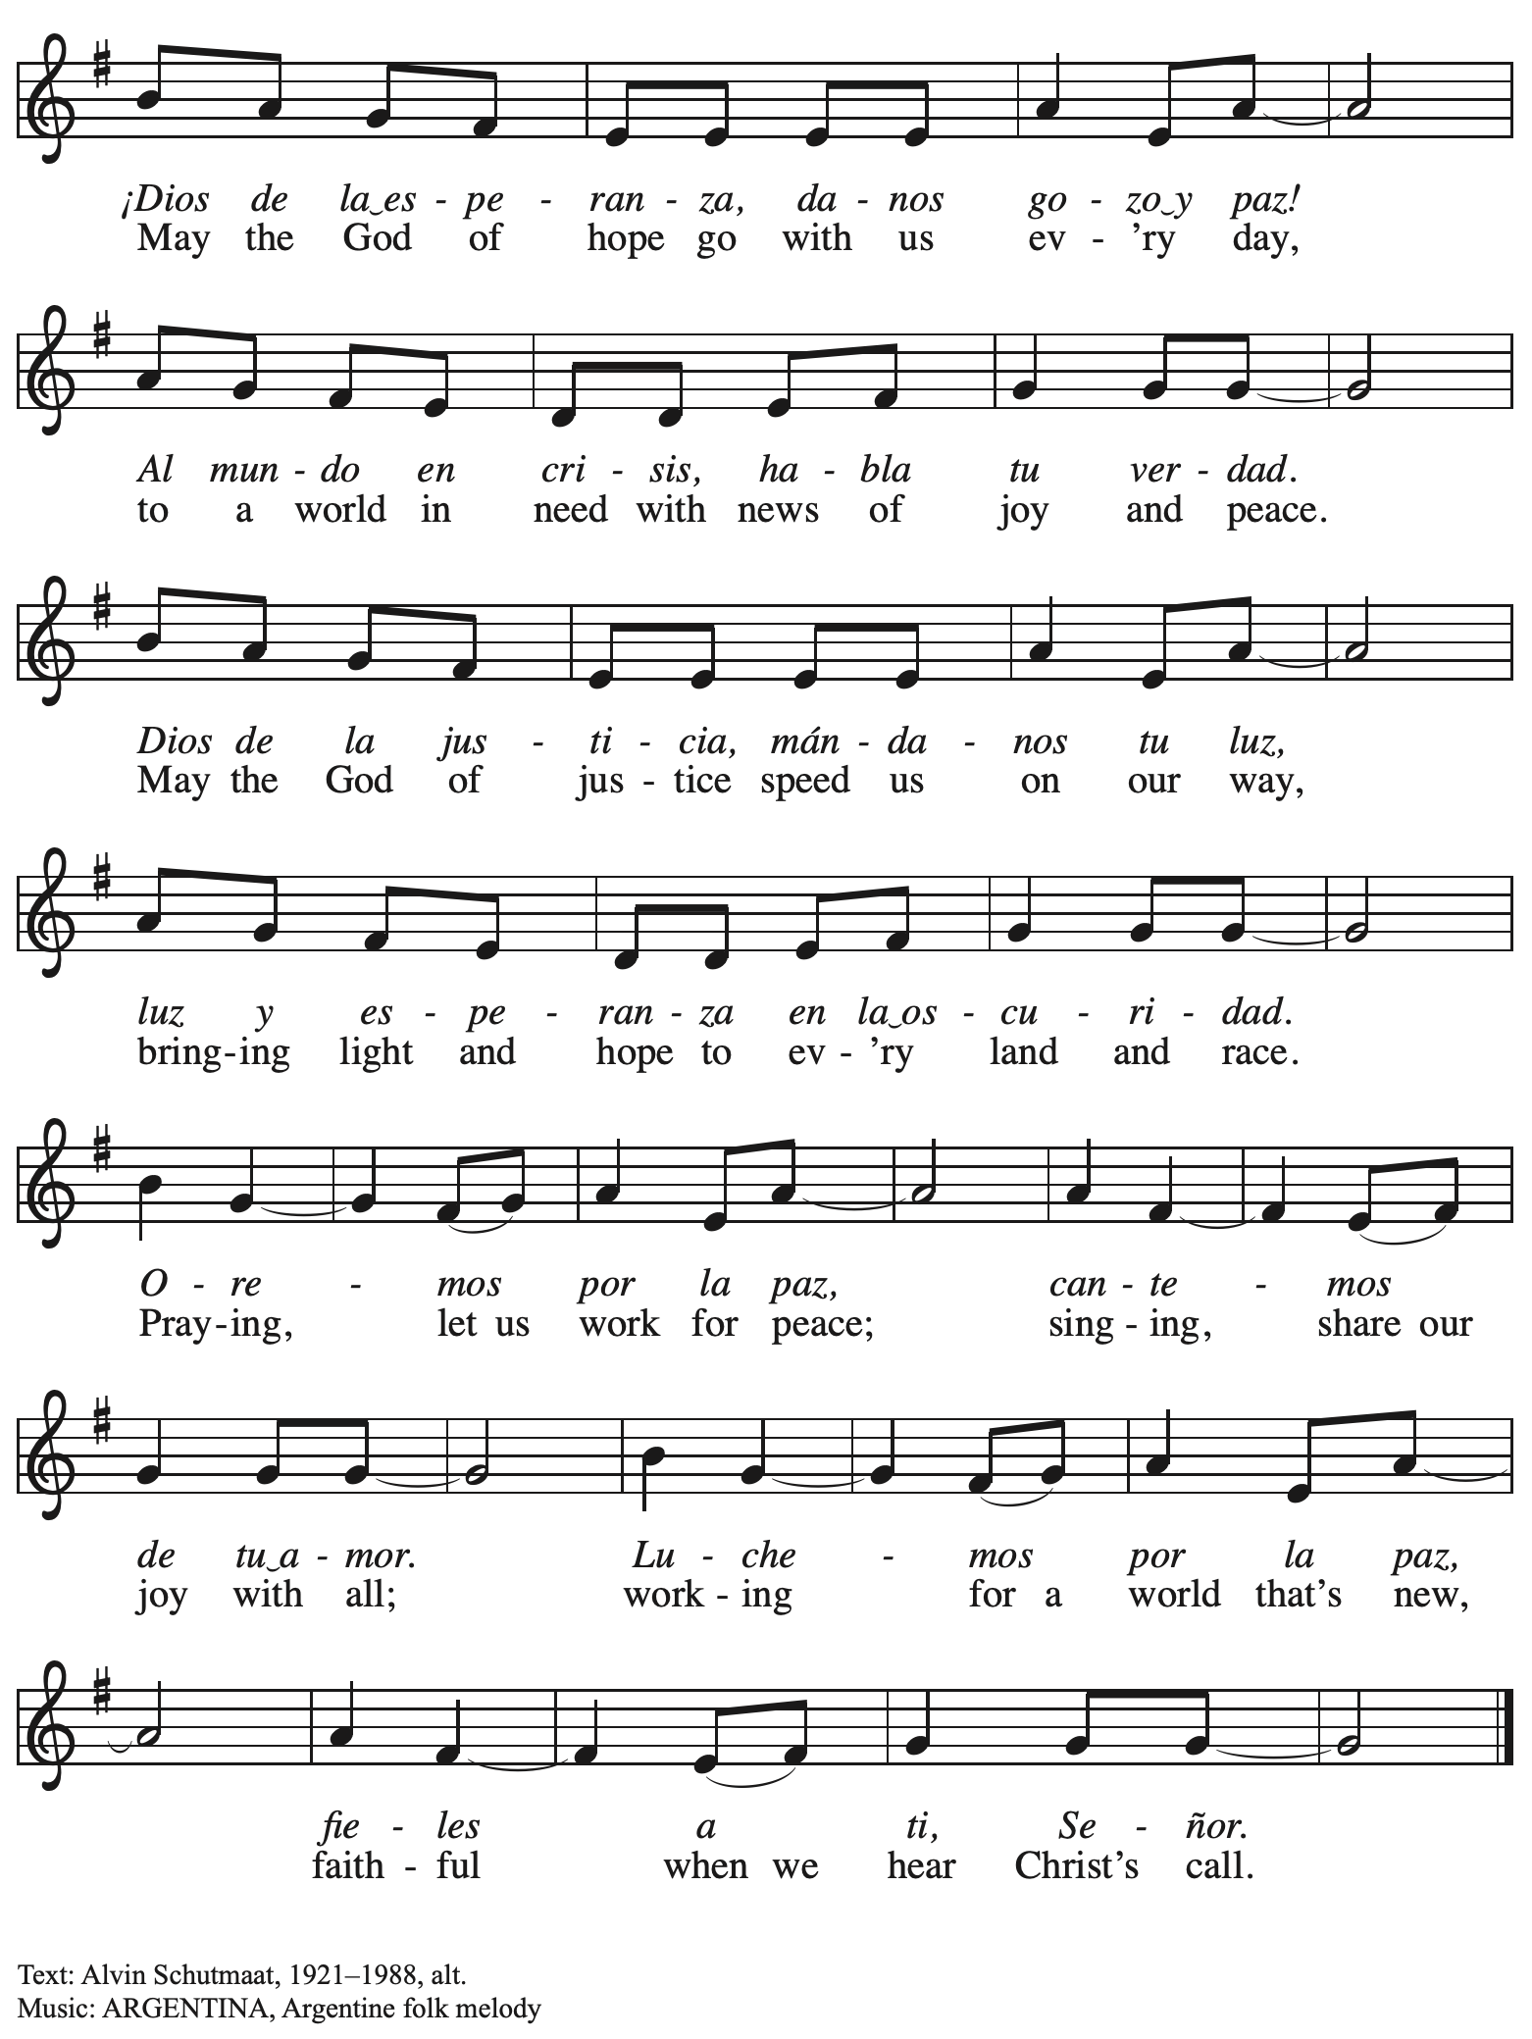

Dismissal

A: Go in peace. Serve the Lord.
C: Thanks be to God!

Postlude

Those serving in worship today

Altar Care Jodie Minor
Announcements hard Krug
Assisting Minister Mandy Best
Audio-Visual Ministers David Rollinson
Jason Galyardt
Cantor Joseph Paetz
Clarinet Maria Mangano
Lector Tim Marker
Little Church – Big Faith Leader
Minister of Music Laura Reynolds
Presiding Minister The Rev. Ross I. Carmichael

Liturgy and Hymnody Acknowledgements

From SundaysandSeasons.com. Copyright © 2023 Augsburg Fortress. All rights reserved. Reprinted under OneLicense.net # A-722139.
Used by permission of Augsburg Fortress.

Toma, oh Dios, mi voluntad – Text: Frances R. Havergal, 1836-1879, adapt.; Spanish text: Vincent Mendoza, 1875-1955. Music: TOMA MI VOLUNTAD, William Dexheimer Pharris, b. 1956. All rights reserved. Reprinted with permission under OneLicense.net # A-722139.

Great God, Your Love Had Called Us – Text: Brian A. Wren, b. 1936. Music: RYBURN, Norman Cocker, 1889-1953. Text © 1977, rev. 1995, Hope Publishing Company, Crol Stream, IL 60188. Music © Oxford University Press. All rights reserved. Reprinted with permission under OneLicense.net # A-722139.

Give Me Jesus – Text: African American spiritual. Music: GIVE ME JESUS, African American spiritual; arr. hymnal version. Arr © 2006 Augsburg Fortress. All rights reserved. Reprinted with permission under OneLicense.net# A-722139.

Dios de la esperanza / May the God of Hope Go with Us – Text: Alvin Schutmaat, 1921-1988, alt. Music: ARGENTINA, Argentine folk melody.

Please use the QR code below to link to St. Andrew’s Announcements online!

St. Andrew Lutheran Church Announcements
September 24th, 2023

- Welcome to worship at St. Andrew on the Seventeenth Sunday after Pentecost, September 24th, 2023 – We are so glad you are here, and we offer a special welcome to all visitors here or online for the first time! Worship attendees are invited to make a name tag at the back of the worship space if you would like. There are worship “toolkits” to help children engage with worship and “busy bags” for younger children available in the bookcase at the back of the sanctuary. Please feel free to take one to use with your children. We invite everyone to stay after worship for coffee and conversation in the Social Hall next to the sanctuary.
- Renew the Pews! After Worship Today – We invite your help in renewing the sanctuary, especially the pew cushions! After worship today we will be steam-cleaning the pew cushions and replacing some of the buttons that have fallen off over the years of use. We thank congregation president Kristen Asplin for organizing this event and to all who have lent their steam-cleaning equipment!
- Compline Choir Service, a Ministry of Lutheran Campus Ministry in Greater Pittsburgh, Sundays at 8:00 p.m. at Heinz Chapel – Compline was traditionally a monastic prayer service, and the Pittsburgh Compline Choir sings a choral version of compline rooted in this thousand-year old tradition of scripture, song, and silence. This service also streams on Facebook (Pittsburgh Compline Choir) and YouTube (The Pittsburgh Compline Choir). Heinz Chapel is located off of S Bellefield Ave. in Oakland.
- Looking for People to Set Up Coffee Hour – In order to facilitate conversation and
community-building, St. Andrew seeks to have Coffee Hour after worship each week. Usually this can be taken care of by one person or family unit signing up per week. The tasks include preparing the coffee maker and starting its brew cycle, along with setting out snacks, napkins, plates, etc. before worship. After worship tasks include bringing out creamer and cold drinks (water, juice boxes for children) and cleanup. We invite you to consider serving – please sign up here: https://www.signupgenius.com/go/5080b4aafaf2cabf85-coffee#/.
- Next Sunday, October 1st, St. Andrew Observes Reconciling in Christ Sunday – St. Andrew became a Reconciling in Christ on October 6th, 1996, intentionally stating our commitment to welcome and advocate for the full inclusion of and equity for all LGBTQIA+ siblings in the life of the church and society. We celebrate this pledge on a Sunday around the date when St. Andrew first adopted its RIC welcome statement and near the anniversary of the congregation, which was officially organized on October 12, 1891. We give thanks for God’s goodness and grace that has brought St. Andrew through nearly 132 years of mission and ministry in the city of Pittsburgh! For more information on Reconciling in Christ ministries, please visit www.reconcilingworks.org.
- Cross-Generational Activity (Advent Banner Preparation!) for Children, Youth, Parents / Guardians, and the Whole Congregation – After Worship on Sundays, October 1st, October 15th, and October 29th – In the past, children and youth of St. Andrew have helped created art for banners that adorn the worship space in the season of Advent, and we would like to create banners for a new church year. We invite children, youth, parents / guardians to gather after worship on the Sundays listed above to hear an Advent reading, talk about its imagery, and work together on an artistic representation of the text, which will be used to make four new banners, one for each week of the Advent season. While we hope for primary input from children and youth, we encourage everyone in the congregation to stay to support them and share in the St. Andrew community on these Sundays! Please speak with Christian Education liaison Colten Rohleder or Jimmi Kocher-Hillmer if you have questions.
- Monthly Fresh Produce Distribution – Tuesday, October 3rd, 5:30-7:00 p.m. – Each month, St. Andrew hosts a distribution of free fresh produce in partnership with the Greater Pittsburgh Community Food Bank. October’s date will be Tuesday, October 3rd, from 5:30-7:00 p.m. We ask for assistance during that time and with the setup and unloading, which happens earlier in the day, usually between 10:00 a.m. and 1:00 p.m. We will contact those who sign up for setup with the approximate delivery time window.
If you would like to assist during either time slot, please sign up here:
https://www.signupgenius.com/go/4090F45AFAF2BA75-produce8.
- Christ in Our Home Devotional Booklets for October – December Available at Church Entrances – This resource offers a daily Bible reading with a short reflection and prayer, along with additional readings and prayer topics for those who would like to expand their devotional practices. We encourage people of the congregation to take one for yourself, your family unit, or others!

