+ Eighteenth Sunday after Pentecost
October 1st, 2023
10:00 a.m.

St. Andrew Lutheran Church
304 Morewood Ave.
Pittsburgh, PA 15213
St_andrewELCA@verizon.net
www.standrewpittsburgh.org

+ Eighteenth Sunday after Pentecost
Order for Worship

Today, St. Andrew observes Reconciling in Christ (RIC) Sunday, when we lift up and renew our commitment to welcome, full inclusion, and equity for LGBTQIA+ siblings and all people in the life of the church. This year, we celebrate this essential part of our mission and ministry both near the date when St. Andrew first adopted its RIC welcome statement, October 6th, (1996), and around the anniversary of the congregation, which was officially organized on October 12th (1891). Along with the regularly appointed lectionary readings, worship includes elements provided by ReconcilingWorks: Lutherans for Full Participation. The Hymn of the Day, “Christ Goes Before,” serves as St. Andrew’s congregational refrain and theme for important observances and celebrations in the life of the congregation.

In today’s Gospel, Jesus’ parable about two sons who do not do what they say they will do reveals surprises in the reign of God. In the reading from Ezekiel, the people claim the ways of the Lord are unfair, while God offers repentance and new life. Paul urges us to look to Christ as a model of humility, putting the interests of others above our own. Nourished by the broken bread and shared cup, we offer our lives for the sake of our needy world.

Welcome to St. Andrew!

- St. Andrew Lutheran congregation welcomes all who are seeking a place of healing and wholeness – a nurturing, faith-forming spiritual home. Our community embraces people of all ages, ethnicities, cultures, abilities, sexual orientations, gender identities and expressions, and family constellations. Come and See!

- Worship Services are live streamed to multiple online platforms. By attending worship, you agree that your image and voice may be broadcast.

- Everyone is invited to make a nametag at the black bookcase in the back of the worship space. There are stickers indicating pronouns on the bookcase if you would like to include them on your name tag.

- Worship “toolkits” to help children engage with the service, along with “busy bags” for younger children, are available in the bookcase at the back of the sanctuary. Please feel free to take one to use with/for your children.

- Children are invited to attend Little Church – Big Faith, a Bible lesson and activity, during worship (after the Prayer of the Day). The group returns to the worship space for the liturgy of Holy Communion.

- Holy Communion is served with bread (gluten-free available) and wine or grape juice. The presiding minister will distribute the bread (host). Please consume this and then pick up an empty glass from the tray. The Communion Assistant will pour wine or grape juice into your glass. Please step to the side to consume the wine or grape juice. Feel free to kneel at the altar for prayer and reflection. As you return to your pew, glasses may be returned to the empty trays on either side of the center section.

- A restroom is available on the main level of the church, through the doors to the Social Hall and to the right in the main office.
Abbreviations
P: Pastor/Presiding Minister ACS: All Creation Sings hymnal
A: Assisting Minister ELW: Evangelical Lutheran Worship hymnal
L: Lector HS: Hymnal Supplement
C: Congregation

Pre-Service Music

Welcome

Prelude

Gathering
The Holy Spirit calls us together as the people of God

Thanksgiving for Baptism

Please rise as you are able. All may make the sign of the cross,
the sign that is marked at Baptism, as the presiding minister begins.

P: Blessed be the Holy Trinity, ☩ one God,
the fountain of living water,
the source of breath and nourishment.
C: Amen.

The presiding minister addresses the assembly.
P: God calls us through the waters of Baptism to be our authentic selves,
and God has called us holy. Trusting that God leads us to embody divine love on earth,
let us give thanks for the gift of Baptism.

Water may be poured into the font as the presiding minister gives thanks.

P: We praise you, O God, for the waters of life:
for streams, rivers, and estuaries, for lakes and oceans,
and for the rain and snow that sustain life for every living being.
Through the waters of the flood and the parting of the sea,
you showed your promises to be true.
In the waters of Baptism, you made sacred our bond with water,
and claimed and called each of us by our true name.
Through Baptism into ☩ Christ, you transformed our lives and made us whole.
Send now your Spirit to move in our midst,
and immerse us with your gifts of mercy, love, and grace.
C: Amen.

Gathering Hymn God, We Gather as Your People ACS 1038

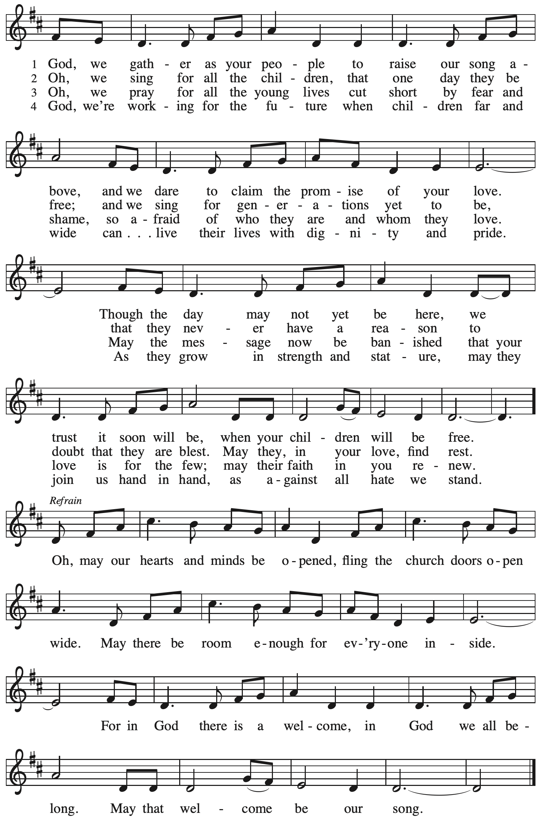

Greeting

P: The grace of our Lord Jesus Christ, the love of God,
and the communion of the Holy Spirit be with you all.
C: And also with you.

Hymn of Praise (Sung to tune of Hymn to Joy)

1. Glory be to God in heaven; peace, goodwill to all the earth.
Mighty God of all creation, Maker of surpassing worth:
we exalt you, we adore you, we lift high our thanks and praise.
Saints and angels bow before you; here on earth our songs we raise.

2. Glory be to Christ forever, Lamb of God and Lord of love.
Son of God and gracious Savior, you have come from heav’n above;
on the cross you died to save us; now you reign at God’s right hand.
Hear our prayer; restore, forgive us; in your promise firm we stand.

3. Holy One we now acclaim you; Lord alone, to you we call;
Holy One in faith we name you, God most high, yet near to all:
Jesus Christ, with God the Spirit, in the Maker’s splendor bright.
For the peace that we inherit, glory be to God on high!

Prayer of the Day

P: Let us pray. God of love, giver of life, you know our frailties and failings.
Give us your grace to overcome them, keep us from those things that harm us,
and guide us in the way of salvation, through Jesus Christ, our Savior and Lord.
C: Amen.

Please be seated.
Children are invited to join the adult leaders at the door and move to the office for Little Church – Big Faith. We ask that one additional adult from the congregation attend with the children.

Word
God speaks to us in Scripture reading, preaching, and song

First Reading – Ezekiel 18: 1-4, 25-32

¹The word of the Lord came to me: ²What do you mean by repeating this proverb concerning the land of Israel, “The parents have eaten sour grapes, and the children’s teeth are set on edge”?
³As I live, says the Lord God, this proverb shall no more be used by you in Israel. ⁴Know that all lives are mine; the life of the parent as well as the life of the child is mine: it is only the person who sins that shall die.
²⁵Yet you say, “The way of the Lord is unfair.” Hear now, O house of Israel: Is my way unfair? Is it not your ways that are unfair? ²⁶When the righteous turn away from their righteousness and commit iniquity, they shall die for it; for the iniquity that they have committed they shall die. ²⁷Again, when the wicked turn away from the wickedness they have committed and do what is lawful and right, they shall save their life. ²⁸Because they considered and turned away from all the transgressions that they had committed, they shall surely live; they shall not die. ²⁹Yet the house of Israel says, “The way of the Lord is unfair.” O house of Israel, are my ways unfair? Is it not your ways that are unfair?
³⁰Therefore I will judge you, O house of Israel, all of you according to your ways, says the Lord God. Repent and turn from all your transgressions; otherwise iniquity will be your ruin. ³¹Cast away from you all the transgressions that you have committed against me, and get yourselves a new heart and a new spirit! Why will you die, O house of Israel? ³²For I have no pleasure in the death of anyone, says the Lord God. Turn, then, and live.

L: Word of God, word of life.
C: Thanks be to God.

Psalm 25: 1-9

The psalm will be sung by the cantor, with the congregation invited to join in singing the alternate verses (in bold) and the refrain.

Psalm tone

Psalm refrain

¹To | you, O Lord,
I lift | up my soul.
²My God, I put my trust in you; let me not be | put to shame,
nor let my enemies triumph | over me.
³Let none who look to you be | put to shame;
rather let those be put to shame | who are treacherous.
⁴Show me your | ways, O Lord,
and teach | me your paths. R
⁵Lead me in your | truth and teach me,
for you are the God of my salvation; in you have I trusted all | the day long.
⁶Remember, O Lord, your compas- | sion and love,
for they are from | everlasting.
⁷Remember not the sins of my youth and | my transgressions;
remember me according to your steadfast love and for the sake of your good- | ness, O Lord.
⁸You are gracious and up- | right, O Lord;
therefore you teach sinners | in your way.
⁹You lead the low- | ly in justice
and teach the low- | ly your way. R

Second Reading – Philippians 2: 1-13

¹If then there is any encouragement in Christ, any consolation from love, any sharing in the Spirit, any compassion and sympathy, ²make my joy complete: be of the same mind, having the same love, being in full accord and of one mind. ³Do nothing from selfish ambition or conceit, but in humility regard others as better than yourselves. ⁴Let each of you look not to your own interests, but to the interests of others. ⁵Let the same mind be in you that was in Christ Jesus,
⁶who, though he was in the form of God,
did not regard equality with God
as something to be exploited,
⁷but emptied himself,
taking the form of a slave,
being born in human likeness.
And being found in human form,
⁸he humbled himself
and became obedient to the point of death—
even death on a cross.
⁹Therefore God also highly exalted him
and gave him the name
that is above every name,
¹⁰so that at the name of Jesus
every knee should bend,
in heaven and on earth and under the earth,
¹¹and every tongue should confess
that Jesus Christ is Lord,
to the glory of God the Father.
¹²Therefore, my beloved, just as you have always obeyed me, not only in my presence, but much more now in my absence, work out your own salvation with fear and trembling; ¹³for it is God who is at work in you, enabling you both to will and to work for God’s good pleasure.

L: Word of God, word of life.
C: Thanks be to God.

Please rise as you are able.

Gospel Acclamation

Gospel – Matthew 21: 23-32

P: The holy Gospel according to St. Matthew.
C: Glory to you, O Lord.

²³When [Jesus] entered the temple, the chief priests and the elders of the people came to him as he was teaching, and said, “By what authority are you doing these things, and who gave you this authority?” ²⁴Jesus said to them, “I will also ask you one question; if you tell me the answer, then I will also tell you by what authority I do these things. ²⁵Did the baptism of John come from heaven, or was it of human origin?” And they argued with one another, “If we say, ‘From heaven,’ he will say to us, ‘Why then did you not believe him?’ ²⁶But if we say, ‘Of human origin,’ we are afraid of the crowd; for all regard John as a prophet.” ²⁷So they answered Jesus, “We do not know.” And he said to them, “Neither will I tell you by what authority I am doing these things.
²⁸“What do you think? A man had two sons; he went to the first and said, ‘Son, go and work in the vineyard today.’ ²⁹He answered, ‘I will not’; but later he changed his mind and went. ³⁰The father went to the second and said the same; and he answered, ‘I go, sir’; but he did not go.
³¹Which of the two did the will of his father?” They said, “The first.” Jesus said to them, “Truly I tell you, the tax collectors and the prostitutes are going into the kingdom of God ahead of you.
³²For John came to you in the way of righteousness and you did not believe him, but the tax collectors and the prostitutes believed him; and even after you saw it, you did not change your minds and believe him.”
P: The Gospel of the Lord.
C: Praise to you, O Christ.

Please be seated.

Sermon

A time of silence for prayer and reflection follows the sermon.
When the hymn of the day begins, please rise as you are able.

Hymn of the Day Christ Goes Before Following Page

Hymn of the Day Christ Goes Before HS 808

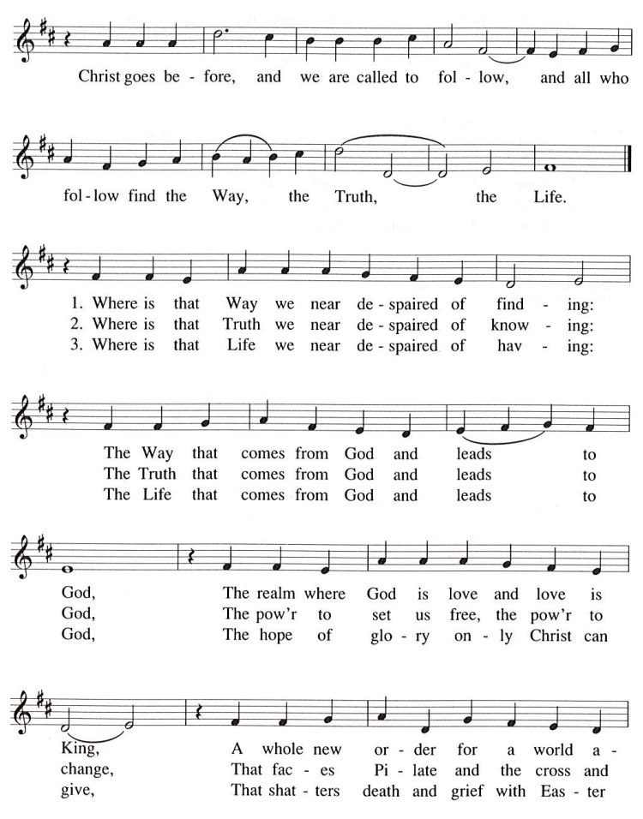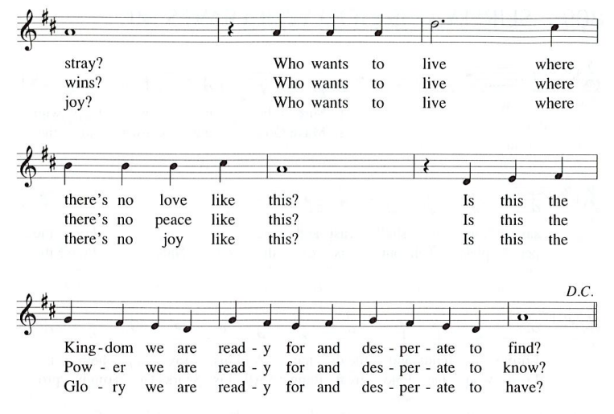

Prayers of the People

A: Trusting in God’s extraordinary love, let us come before the Holy One in prayer.

After each petition
A: Merciful God,
C: receive our prayer.

The presiding minister concludes the prayers
P: Receive the prayers of your children, merciful God,
and hold us forever in your steadfast love;
through Jesus Christ, our Savior.
C: Amen.

Peace

The presiding minister and the assembly greet one another in the peace of the risen Christ.
P: The peace of Christ be with you always.
C: And also with you.

The people may greet those around them with a sign of Christ’s peace and may say
Peace be with you or similar words. Please be mindful that not everyone will be comfortable with sharing the peace, so please seek consent before shaking hands or hugging. Other possible ways to share the peace include a simple bow with the verbal greeting of peace, or simply a verbal expression of peace.

When the greetings of peace have concluded, please be seated.

Meal
God feeds us with the presence of Jesus Christ

Offering

We offer ourselves, our gifts, and our faithful service to God.
As the offering is gathered for the mission of the church, including the care of those in need,
the table is set for Holy Communion.

Reparations Offering

On the first Sunday of each month, St. Andrew invites people of the congregation to consider a donation to a second collection for a reparations fund in acknowledgement of St. Andrew’s use of African American spiritual songs in our worship services. Please see the note in the announcements at the back of the bulletin for more information.

Music during the Offering

As the gifts are brought forward for presentation, please rise as you are able.

Offertory Song Let the Vineyards Be Fruitful ELW 184

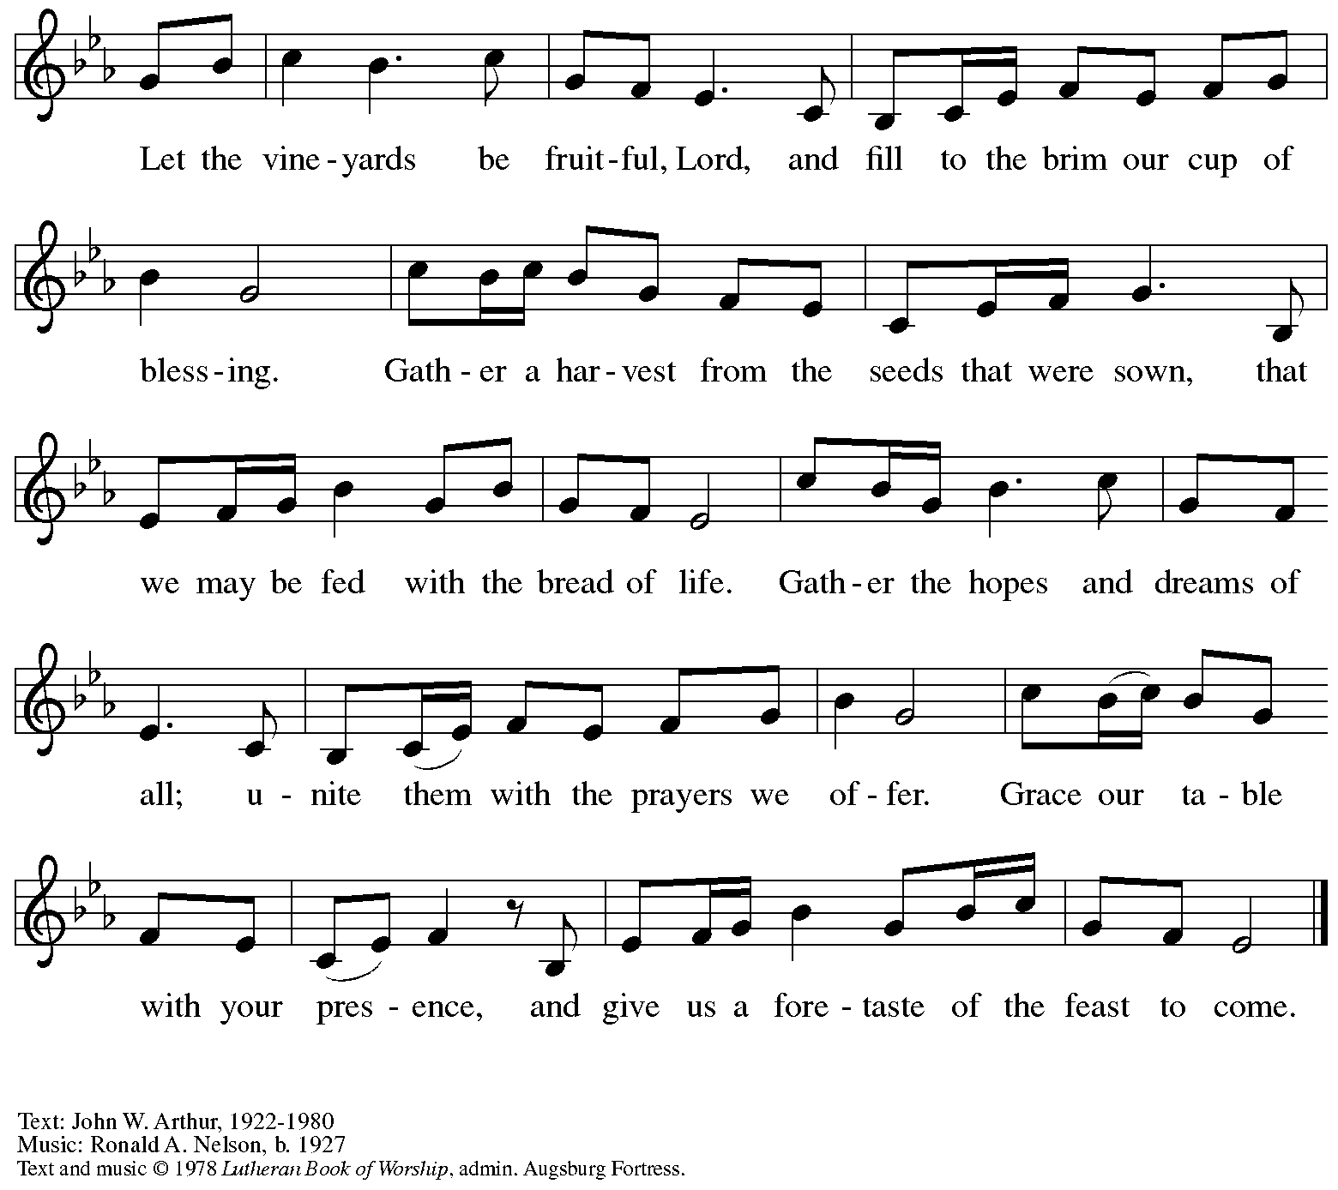

Offertory Prayer

A: Let us pray. God of all creation,
C: you have given us life, love, compassion, and hope.
We offer these gifts and those of our very being to you.
Strengthen and empower us through these gifts
to be the bearers of your mercy and justice for the world,
through Jesus Christ, our Savior. Amen.

Dialogue

P: The Lord be with you.
C: And also with you.

P: Lift up your hearts.
C: We lift them to the Lord.

P: Let us give thanks to the Lord our God.
C: It is right to give our thanks and praise.

Preface

P: It is indeed right, our duty and our joy …
… we praise your name and join their unending hymn:

Sanctus (Sung)

Holy, holy, holy Lord, God of power and might,
heav’n and earth are full of your glory.
Hosanna in the highest.
Blessed is the one who comes in the name of the Lord.
Hosanna in the highest, hosanna in the highest.

Eucharistic Prayer (after Julian of Norwich) G. Ramshaw

P: Thanks be to you, our God, blessed Trinity …
… and in your gracious goodness you desire that all shall be well:
C: All shall be well.

P: When we had fallen, Jesus fell with us, embracing us,
assuring us that at the end, all shall be well.
C: All shall be well.

P: In plenteous love, Jesus …
… Until the whole communion of saints is lovingly hidden in you,
we join in hope, praise, and thanksgiving, that in you,
All shall be well, and all shall be well, and all manner of things shall be well.
C: All shall be well, and all shall be well, and all manner of things shall be well.

P: To you, O God, blessed Trinity …
… for you are our bliss, now and forever.
C: Amen.

Lord’s Prayer

This version of the Lord’s Prayer is based on the one in “Created Whole,” a worship experience cultivated by the Rev. A.J. Houseman in partnership with ReconcilingWorks.

C: Our beloved Parent in heaven,
your name be sanctified,
your realm come,
your will unfold in heaven
and also on earth.
Give us today our nourishment that is necessary for life,
and forgive us our debts
as we forgive our debtors.
Do not ever bring us into testing situations,
and rescue us from evil.
For yours is the kin-dom,
the power, and the glory forever. Amen.

Fraction and Invitation

Agnus Dei / Lamb of God

Please be seated.

Holy Communion
- All who seek God and desire a deeper and stronger life in Christ are welcome to receive Holy Communion.
- Worshipers from the pulpit side will proceed forward first, followed by the center section, and then the lectern side.
- Please inform an usher if you would like the ministers to bring Communion to you.
- Holy Communion will be served with bread and wine/grape juice.
- The presiding minister will first distribute the bread (host) to each communicant. Please indicate if you require a gluten-free host.
- Once you have consumed the bread, please pick up an empty glass from the tray next to the presiding minister. The Communion Assistant will pour wine from the chalice or grape juice from the cruet into your glass.
- Please step to the side to consume the wine or grape juice.
- Feel free to kneel at the altar rail for prayer after receiving the sacrament.
- As you return to your pew, glasses may be returned to the empty trays on either side of the center section.
- A blessing will be provided for anyone who does not yet receive the sacrament.
- All are invited to join in singing the hymns during Holy Communion.

Hymns during Holy Communion
Commonwealth Is God’s Commandment ACS 1036

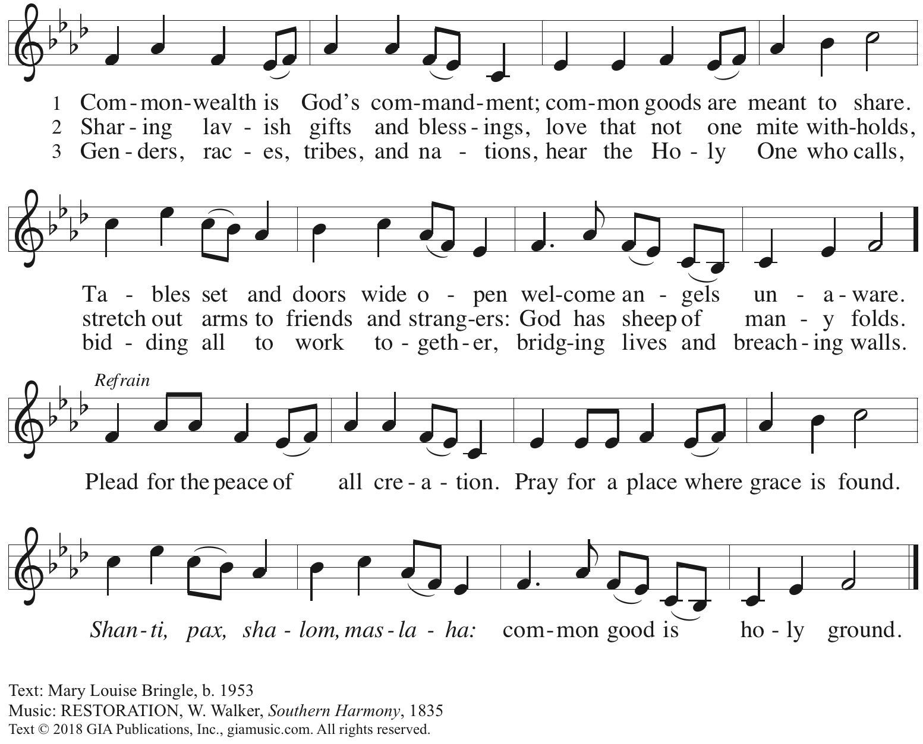
Reprinted with permission under OneLicense.net # A-722139.

Hymns during Holy Communion
What Does the Lord Require of You? ACS 1057

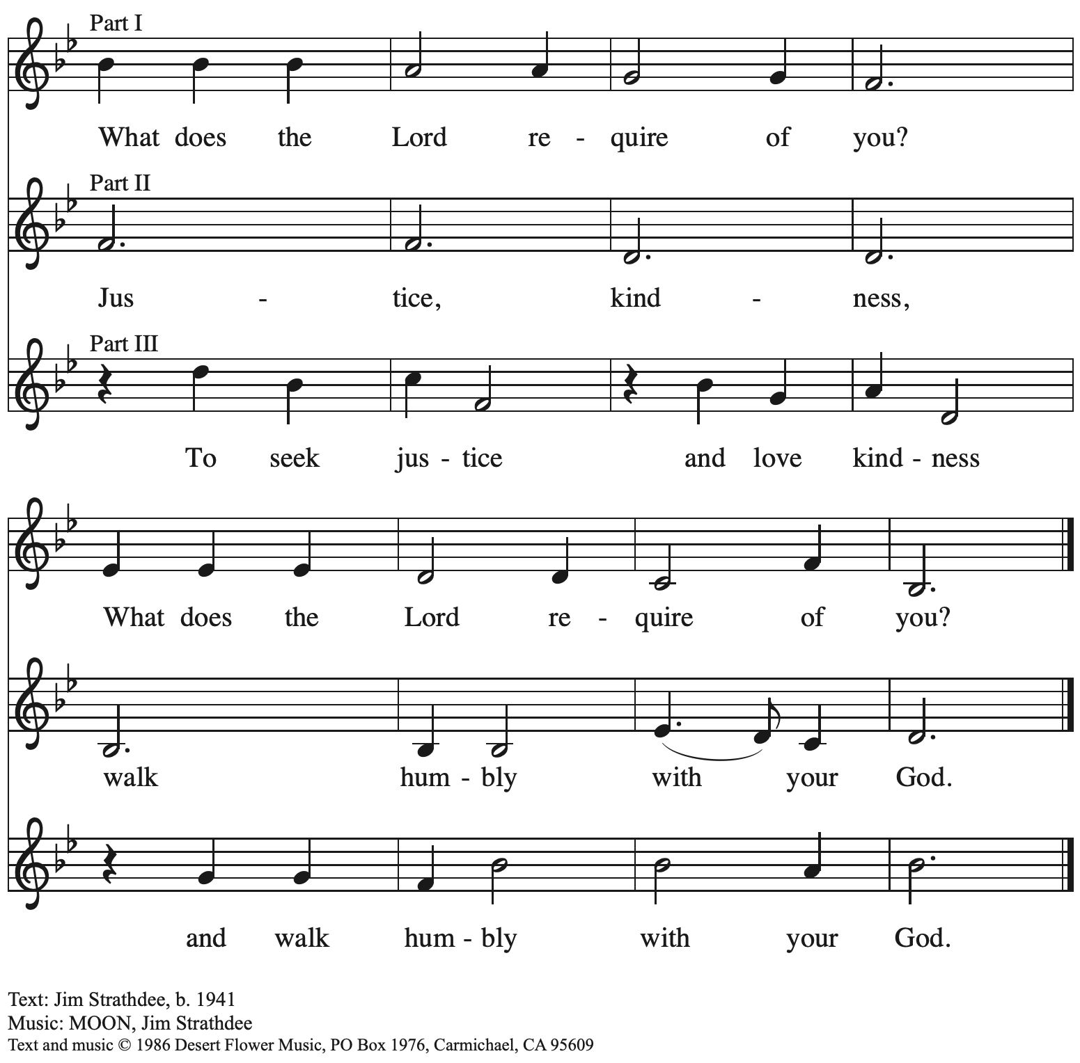
All rights reserved. Reprinted with permission under OneLicense.net # A-722139.

Hymns during Holy Communion
Come, Thou Fount of Every Blessing ELW 807

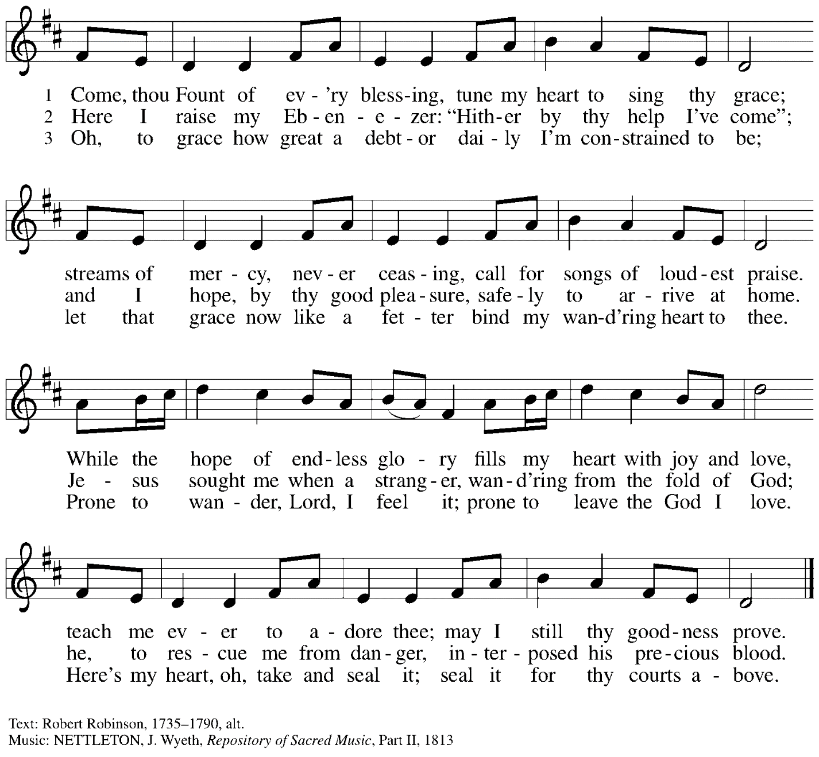

When all have returned to their places, please rise as you are able.

Blessing

P: The body and blood of our Lord Jesus Christ strengthen you and keep you in his grace.
C: Amen.

Prayer

A: Let us pray.
We give you thanks, God of mercy and love,
that you have refreshed and renewed us through this gift of life.
Bless and guide us on our journey to strive for justice, peace, and healing for all;
through Jesus Christ our redeemer.
C: Amen.

Please be seated.

Sending
God blesses us and sends us in mission to the world

Announcements

Please rise as you are able.

Benediction

P: The God of creation bless you and keep you,
Christ the Savior ☩ give you peace and wholeness,
and the Spirit of peace guide you and lead you to mercy and justice.
C: Amen.

Sending Hymn All Are Welcome Following page

Dismissal

A: Go now in peace to bear the love and justice of Jesus Christ.
C: Thanks be to God!

Postlude

Sending Hymn All Are Welcome ELW 641

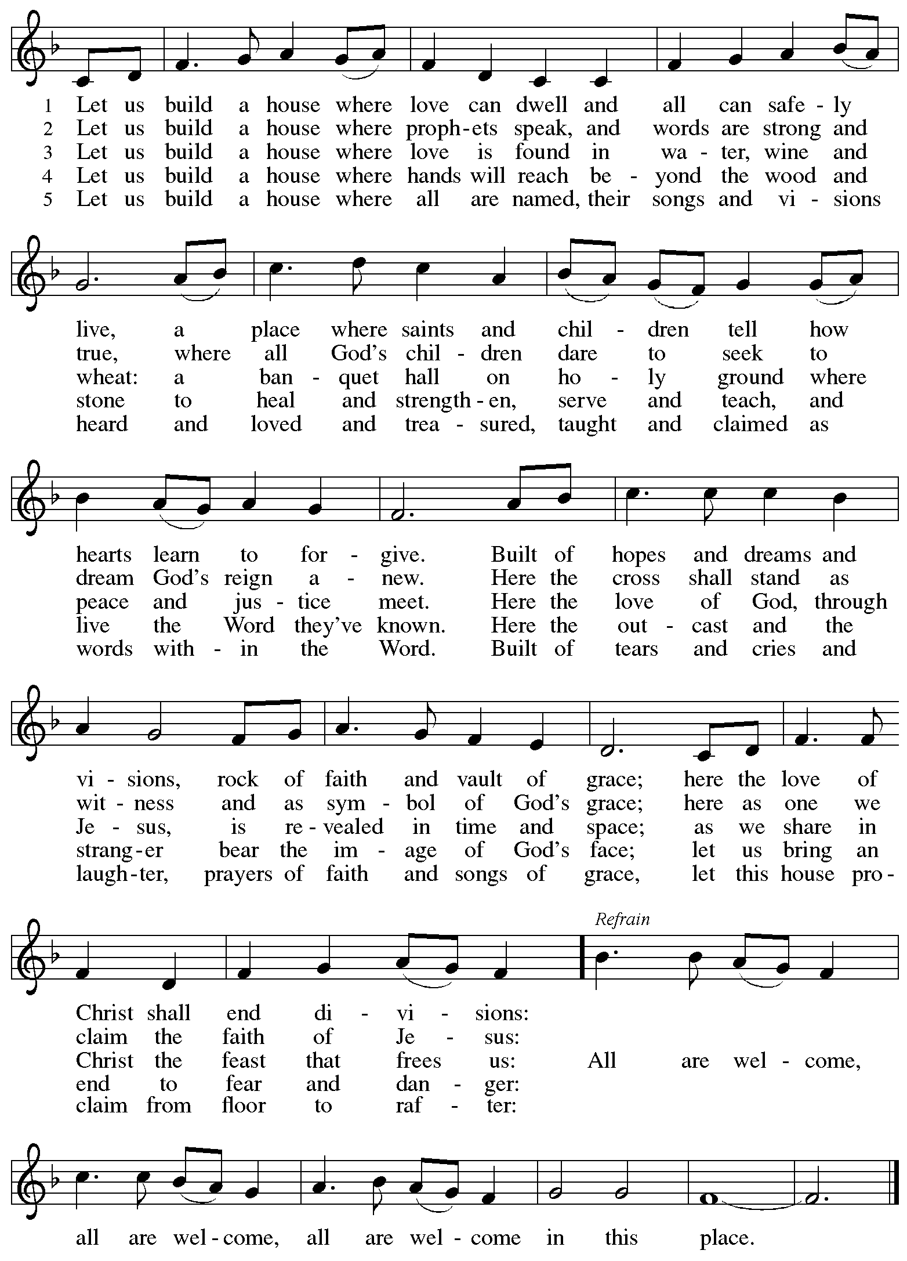

Those serving in worship today

Altar Care Jodie Minor
Announcements Janet Grzegorczyk
Assisting Minister Tim Marker
Audio-Visual Ministers Kristen Asplin
Joseph Paetz
Cantor Libby Marker
Lector Ty Best
Little Church – Big Faith Leader Emily Duque
Minister of Music Laura Reynolds
Presiding Minister The Rev. Ross I. Carmichael

Liturgy and Hymnody Acknowledgements

From SundaysandSeasons.com. Copyright © 2023 Augsburg Fortress. All rights reserved. Reprinted under OneLicense.net # A-722139.
Used by permission of Augsburg Fortress.

God, We Gather as Your People – Text: David Lohman, b. 1961. Music: WELCOME BE OUR SONG, Daviod Lohman. Text and music © 1987 Welcome Song Music, admin. Augsburg Fortress. All rights reserved. Reprinted with permission under OneLicense.net #A722139.

Christ Goes Before – Text: Jaroslav J. Vajda, b. 1919. Music: RIVERSIDE, Irregular; Carl F. Schalk, b. 1929. Text and music © 1987 GIA Publications, Inc. All rights reserved. Reprinted with permission under OneLicense.net # A-722139.

All Are Welcome – Text: Marty Haugen, b. 1951. Music: TWO OAKS, Marty Haugen. Text and music © 1994 GIA Publications, Inc., 7404 S. Mason Ave., Chicago, IL 60638. www.giamusic.com. 800.442.3358. All rights reserved. Reprinted with permission under OneLicense.net # A-722139.

A Eucharistic Prayer after Julian of Norwich – From Pray, Praise, and Give Thanks: A Collection of Litanies, Laments, and Thanksgivings at Font and Table by Gail Ramshaw, copyright © 2017 Augsburg Fortress. All rights reserved. Reprinted by permission.

Today’s Eucharistic Prayer after Julian of Norwich – The prayer comes from Dr. Gail Ramshaw, liturgical scholar, in her work Pray, Praise, and Give Thanks: A Collection of Litanies, Laments, and Thanksgivings at Font and Table. She modeled it after the writing of Julian of Norwich, renewer of the church, who lived in the late 14th and early 15th centuries, and whose life and witness to Christian faith the church commemorates each year on May 8th. Details about Julian’s life are scarce, but she was likely a Benedictine nun who lived in an isolated cell attached to the Carrow Priory in Norwich, England. When she was about 30, Julian reported religious visions that she later described in “Sixteen Chronicles of Divine Love,” which became a classic work of medieval mysticism. Julian’s visions demonstrated that love was the meaning of religious experience, provided by Christ who is love, for the purpose of love. A prayer and hymn attributed to Julian of Norwich are found in the Evangelical Lutheran Worship hymnal on p. 87 and hymn #735, “Mothering God, You Gave Me Birth.” (Some information from Sundays and Seasons: Year A 2023, p. 174)

Please use the QR code below to link to St. Andrew’s Announcements online!

St. Andrew Lutheran Church Announcements
October 1st, 2023

- Welcome to Worship at St. Andrew on the Eighteenth Sunday after Pentecost, October 1st, 2023 – We are so glad you are here, and we offer a special welcome to all visitors here or online for the first time! Worship attendees are invited to make a name tag at the back of the worship space if you would like. Children are invited to participate in Little Church – Big Faith, a Bible lesson and activity, after the prayer of the day. There are also worship “toolkits” to help children engage with worship and “busy bags” for younger children available in the bookcase at the back of the sanctuary. Please feel free to take one for your children to use. We invite everyone to stay after worship for coffee and conversation in the Social Hall next to the sanctuary.
- Worship Today – Reconciling in Christ Sunday! – Today St. Andrew lifts up our commitment to being a Reconciling in Christ congregation, one that welcomes and advocates for the full inclusion of and equity for all LGBTQIA+ siblings in the life of the church and society. We celebrate this pledge on a Sunday close to the date when St. Andrew first adopted its RIC welcome statement, on October 6, 1996, and near the anniversary of the congregation, which was officially organized on October 12, 1891. We give thanks for God’s goodness and grace that has brought St. Andrew through nearly 132 years of mission and ministry in the city of Pittsburgh! For more information on Reconciling in Christ ministries, please visit www.reconcilingworks.org.
- Monthly Reparations Offering Today during Worship – Jesus’ parable of the Good Samaritan from Luke's Gospel provides an example of how God's people are called to work for healing and repair for our neighbors, independent of who or what caused harm. In light of this, St. Andrew has made a commitment to reparations in regard to African American spiritual songs used in our worship. The text and music of most hymns is attributed to specific authors, with copyrights in place, usage reported, and royalties paid to those whose works are featured in worship. With African American spirituals, this is not possible. In response to many years of such uncredited use, St. Andrew will invite people of the congregation to give to a second collection for reparations during the offering. Funds received in our collections will be donated to our siblings at Bethel AME Church, whose land and building were taken from them in the 1950s, to fund the development they are planning in the lower Hill District.
- After Worship Today: Cross-Generational Activity (Advent Banner Preparation!) for Children, Youth, Parents / Guardians, and the Whole Congregation – In the past, children and youth of St. Andrew have helped create art for banners that adorn the worship space in the season of Advent, and we would like to create banners for a new church year. We invite children, youth, parents / guardians to gather after worship to hear an Advent reading, talk about its imagery, and work together on an artistic representation of the text, which will be used to make four new banners, one for each week of the Advent season. While we hope for primary input from children and youth, we encourage everyone in the congregation to stay to support them and share in the St. Andrew community on these Sundays! Please speak with Christian Education liaison Colten Rohleder or Pastor Ross Carmichael if you have questions. We will also gather on Sundays, October 15th, and October 29th.
- Compline Choir Service, a Ministry of Lutheran Campus Ministry in Greater Pittsburgh, Sundays at 8:00 p.m. at Heinz Chapel – Compline was traditionally a monastic prayer service, and the Pittsburgh Compline Choir sings a choral version of compline rooted in this thousand-year-old tradition of scripture, song, and silence. This service also streams on Facebook (Pittsburgh Compline Choir) and YouTube (The Pittsburgh Compline Choir). Heinz Chapel is located off of S. Bellefield Ave. in Oakland.
- Monthly Produce Distribution – Tuesday, October 3rd, 5:30-7:00 p.m. – St. Andrew’s monthly produce distribution in partnership with Greater Pittsburgh Community Food Bank is coming up Tuesday, October 3rd from 5:30-7:00 p.m. We invite people from the congregation to come and help in the evening (greeting our neighbors, assisting with the distribution, registration, and cleanup) and earlier in the day to set up tables and bring in the delivery, usually between 10:00 a.m. and 1:00 p.m. For anyone who signs up for the setup, we will notify you the day before when we are given the delivery truck's estimated arrival time. If you would like to sign up, please do so here:
https://www.signupgenius.com/go/4090F45AFAF2BA75-produce8.
- Renew the Pews Continues! – Sunday, October 8th, after Worship – We got a good start on the steam cleaning of the pew cushions this past Sunday but have a long way to go! We ask your help in continuing the renewal of the sanctuary after worship on Sunday, October 8th. We will be steam-cleaning the pew cushions and replacing some of the buttons that have fallen off over the years of use. We thank congregation president Kristen Asplin for organizing this effort and to all who have lent their steam-cleaning equipment!
- East End Cooperative Ministry Shelter Dinner – Thursday, October 19th, Arrival at 6:00 p.m., Meal at 6:30 p.m. – Each month, members of St. Andrew provide and serve a meal for the guests of the shelter at East End Cooperative Ministry (EECM), 6140 Station St., 15206. Anyone can sign up to prepare or purchase a portion of the meal to bring to EECM at 6:00 p.m. that day, or just come to help serve the meal at 6:30 p.m. If you would like to contribute, please sign up at: https://www.signupgenius.com/go/5080544AAAC22A1F58-44645161-octshelter.
- Looking for People to Set Up Coffee Hour – In order to facilitate conversation and
community-building, St. Andrew seeks to have Coffee Hour after worship each week. Usually this can be provided by one person or family unit signing up per week. The tasks include preparing the coffee maker and starting its brew cycle along with setting out snacks, napkins, plates, etc. before worship. After worship tasks include bringing out creamer and cold drinks (water, juice boxes for children) and cleanup. We invite you to consider serving – please sign up here: https://www.signupgenius.com/go/5080b4aafaf2cabf85-coffee#/.
- Christ in Our Home Devotional Booklets for October – December Available at Church Entrances – This resource offers a daily Bible reading with a short reflection and prayer, along with additional readings and prayer topics for those who would like to expand their devotional practices. We encourage people of the congregation to take one for yourself, your family unit, or others!

