+ Nineteenth Sunday after Pentecost
October 8th, 2023
10:00 a.m.

St. Andrew Lutheran Church
304 Morewood Ave.
Pittsburgh, PA 15213
St_andrewELCA@verizon.net
www.standrewpittsburgh.org

+ Nineteenth Sunday after Pentecost
Order for Worship

In today’s Gospel reading, Jesus tells a parable about a vineyard, which evokes images of God’s people Israel, a prophet’s mission, and Christ’s death. For Christians, the vineyard parable can speak of God’s love poured out in the blood of Christ, given to us for the forgiveness of sin. Grafted onto Christ the vine at Baptism, we are nourished with wine and bread, the body and blood of Christ, that we might know Christ’s presence and the power of his death and resurrection.

Welcome to St. Andrew!

- St. Andrew Lutheran congregation welcomes all who are seeking a place of healing and wholeness – a nurturing, faith-forming spiritual home. Our community embraces people of all ages, ethnicities, cultures, abilities, sexual orientations, gender identities and expressions, and family constellations. Come and See!

- Worship Services are live streamed to multiple online platforms. By attending worship, you agree that your image and voice may be broadcast.

- Everyone is invited to make a nametag at the black bookcase in the back of the worship space if they would like. There are stickers indicating pronouns on the bookcase if you would like to include them on your name tag.

- Worship “toolkits” to help children engage with the service, along with “busy bags” for younger children, are available in the bookcase at the back of the sanctuary. Please feel free to take one to use with/for your children.

- Children are invited to attend Little Church – Big Faith, a Bible lesson and activity, during worship (after the Prayer of the Day). The group returns to the worship space for the liturgy of Holy Communion.

- Holy Communion is served with bread (gluten-free available) and wine or grape juice. The presiding minister will distribute the bread (host). Please consume this and then pick up an empty glass from the tray. The Communion Assistant will pour wine or grape juice into your glass. Please step to the side to consume the wine or grape juice. Feel free to kneel at the altar for prayer and reflection. As you return to your pew, glasses may be returned to the empty trays on either side of the center section.

- A restroom is available on the main level of the church, through the doors to the Social Hall and to the right in the main office.

Abbreviations
P: Pastor/Presiding Minister ACS: All Creation Sings hymnal
A: Assisting Minister ELW: Evangelical Lutheran Worship hymnal
L: Lector
C: Congregation

Pre-Service Music

Welcome

Prelude

Gathering
The Holy Spirit calls us together as the people of God

Confession and Forgiveness

Please rise as you are able. All may make the sign of the cross,
the sign that is marked at Baptism, as the presiding minister begins.

P: Blessed be the God who made us,
☩ Jesus Christ who bears the cross,
and the Holy Spirit who guides and sustains us.
C: Amen.

P: Let us humble ourselves before God, confessing our sin.

Silence is kept for reflection.

P: Steadfast and faithful God,
C: you have revealed the ways of justice,
yet we fail to follow you.
We are overwhelmed
by the world’s violence and suffering.
We are afraid to risk what we have
for the sake of others.
For the harm we have caused,
known and unknown, forgive us.
For the unjust demands we place on others
and your creation, forgive us.
For the ways we turn away
from you and our neighbor, forgive us.
Lead us back to you, and set us on healthy, fruitful paths;
in the name of Jesus Christ, our Savior. Amen.

P: Beloved in Christ, God’s mercy stretches beyond all understanding,
God’s compassion is beyond compare.
In Jesus, God is always making a new way for us.
In ☩ Christ, you have been and always will be forgiven.
C: Amen.
Gathering Hymn Christ Is Made the Sure Foundation ELW 645

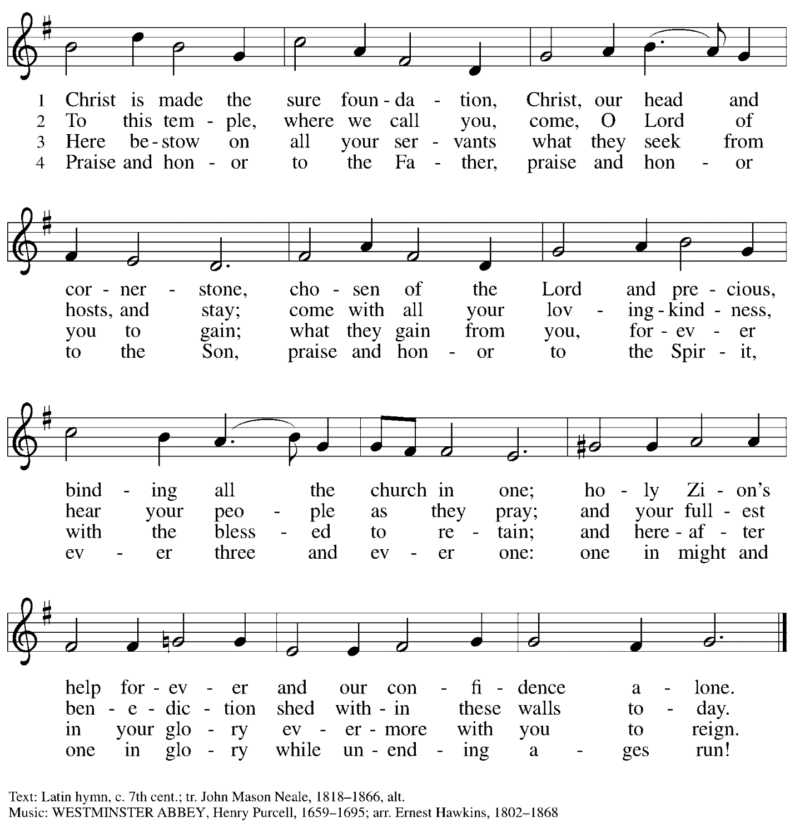

Greeting

P: The grace of our Lord Jesus Christ, the love of God,
and the communion of the Holy Spirit be with you all.
C: And also with you.
Hymn of Praise (Sung to the tune of Hymn to Joy)

1. Glory be to God in heaven; peace, goodwill to all the earth.
Mighty God of all creation, Maker of surpassing worth:
we exalt you, we adore you, we lift high our thanks and praise.
Saints and angels bow before you; here on earth our songs we raise.

2. Glory be to Christ forever, Lamb of God and Lord of love.
Son of God and gracious Savior, you have come from heav’n above;
on the cross you died to save us; now you reign at God’s right hand.
Hear our prayer; restore, forgive us; in your promise firm we stand.

3. Holy One we now acclaim you; Lord alone, to you we call;
Holy One in faith we name you, God most high, yet near to all:
Jesus Christ, with God the Spirit, in the Maker’s splendor bright.
For the peace that we inherit, glory be to God on high!

Prayer of the Day

P: The Lord be with you.
C: And also with you.

P: Let us pray.
Beloved God, from you come all things that are good.
Lead us by the inspiration of your Spirit to know those things that are right,
and by your merciful guidance, help us to do them,
through Jesus Christ, our Savior and Lord.
C: Amen.

Please be seated.
Children are invited to join the adult leaders at the door and move to the office for Little Church – Big Faith. We ask that one additional adult from the congregation attend with the children.

Word
God speaks to us in Scripture reading, preaching, and song

First Reading – Isaiah 5: 1-7

¹Let me sing for my beloved
my love-song concerning his vineyard:
My beloved had a vineyard
on a very fertile hill.
²He dug it and cleared it of stones,
and planted it with choice vines;
he built a watchtower in the midst of it,
and hewed out a wine vat in it;
he expected it to yield grapes,
but it yielded wild grapes.
³And now, inhabitants of Jerusalem
and people of Judah,
judge between me
and my vineyard.
⁴What more was there to do for my vineyard
that I have not done in it?
When I expected it to yield grapes,
why did it yield wild grapes?
⁵And now I will tell you
what I will do to my vineyard.
I will remove its hedge,
and it shall be devoured;
I will break down its wall,
and it shall be trampled down.
⁶I will make it a waste;
it shall not be pruned or hoed,
and it shall be overgrown with briers and thorns;
I will also command the clouds
that they rain no rain upon it.
⁷For the vineyard of the Lord of hosts
is the house of Israel,
and the people of Judah
are God’s pleasant planting;
The Lord expected justice,
but saw bloodshed;
righteousness,
but heard a cry!

L: Word of God, word of life.
C: Thanks be to God.

Psalm 80: 7-15

The psalm will be spoken responsively, led by the cantor,
with the congregation invited to join in the alternate verses in bold.

⁷Restore us, O God of hosts;
let your face shine upon us, and we shall be saved.
⁸You have brought a vine out of Egypt;
you cast out the nations and planted it.
⁹You cleared the ground for it;
it took root and filled the land.
¹⁰The mountains were covered by its shadow
and the towering cedar trees by its boughs.
¹¹You stretched out its tendrils to the sea
and its branches to the river.
¹²Why have you broken down its wall,
so that all who pass by pluck off its grapes?
¹³The wild boar of the forest has ravaged it,
and the beasts of the field have grazed upon it.
¹⁴Turn now, O God of hosts,
look down from heaven;
¹⁵behold and tend this vine;
preserve what your right hand has planted.

Second Reading – Philippians 3: 4b-14

[Paul writes:] ^{4b}If anyone else has reason to be confident in the flesh, I have more: ⁵circumcised on the eighth day, a member of the people of Israel, of the tribe of Benjamin, a Hebrew born of Hebrews; as to the law, a Pharisee; ⁶as to zeal, a persecutor of the church; as to righteousness under the law, blameless.
⁷Yet whatever gains I had, these I have come to regard as loss because of Christ. ⁸More than that, I regard everything as loss because of the surpassing value of knowing Christ Jesus my Lord. For his sake I have suffered the loss of all things, and I regard them as rubbish, in order that I may gain Christ ⁹and be found in him, not having a righteousness of my own that comes from the law, but one that comes through faith in Christ, the righteousness from God based on faith. ¹⁰I want to know Christ and the power of his resurrection and the sharing of his sufferings by becoming like him in his death, ¹¹if somehow I may attain the resurrection from the dead.
¹²Not that I have already obtained this or have already reached the goal; but I press on to make it my own, because Christ Jesus has made me his own. ¹³Beloved, I do not consider that I have made it my own; but this one thing I do: forgetting what lies behind and straining forward to what lies ahead, ¹⁴I press on toward the goal for the prize of the heavenly call of God in Christ Jesus.

L: Word of God, word of life.
C: Thanks be to God.

Please rise as you are able.

Gospel Acclamation

Gospel – Matthew 21: 33-46

P: The holy Gospel according to St. Matthew.
C: Glory to you, O Lord.

[Jesus said to the people:] ³³“Listen to another parable. There was a landowner who planted a vineyard, put a fence around it, dug a wine press in it, and built a watchtower. Then he leased it to tenants and went to another country. ³⁴When the harvest time had come, he sent his slaves to the tenants to collect his produce. ³⁵But the tenants seized his slaves and beat one, killed another, and stoned another. ³⁶Again he sent other slaves, more than the first; and they treated them in the same way. ³⁷Finally he sent his son to them, saying, ‘They will respect my son.’ ³⁸But when the tenants saw the son, they said to themselves, ‘This is the heir; come, let us kill him and get his inheritance.’ ³⁹So they seized him, threw him out of the vineyard, and killed him. ⁴⁰Now when the owner of the vineyard comes, what will he do to those tenants?” ⁴¹They said to him, “He will put those wretches to a miserable death, and lease the vineyard to other tenants who will give him the produce at the harvest time.”
⁴²Jesus said to them, “Have you never read in the scriptures:
‘The stone that the builders rejected
has become the cornerstone;
this was the Lord’s doing,
and it is amazing in our eyes’?
⁴³Therefore I tell you, the kingdom of God will be taken away from you and given to a people that produces the fruits of the kingdom. ⁴⁴The one who falls on this stone will be broken to pieces; and it will crush anyone on whom it falls.”
⁴⁵When the chief priests and the Pharisees heard his parables, they realized that he was speaking about them. ⁴⁶They wanted to arrest him, but they feared the crowds, because they regarded him as a prophet.
P: The Gospel of the Lord.
C: Praise to you, O Christ.

Please be seated.

Sermon

A time of silence for prayer and reflection follows the sermon.
When the hymn of the day begins, please rise as you are able.

Hymn of the Day God Loved the World Following page

Hymn of the Day God Loved the World ELW 323

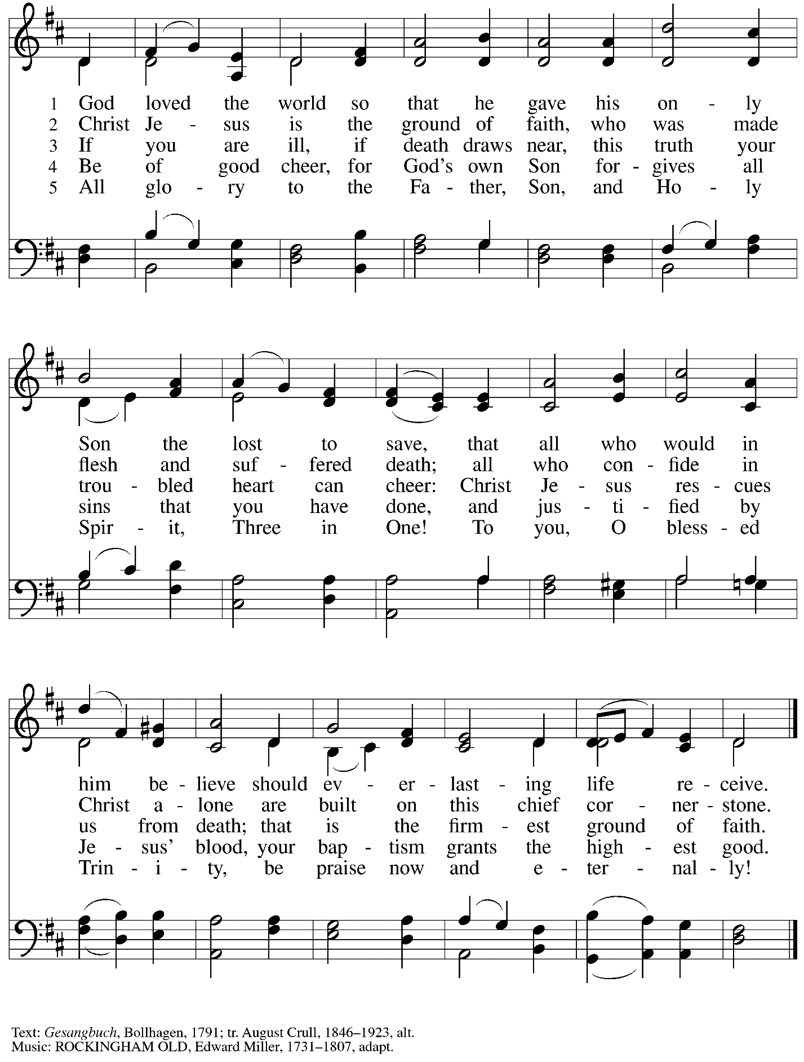

Prayers of the People

A: Remembering the caring and generous works of God, we pray for the church,
the needs of our neighbors, and all creation.

After each petition
A: Merciful God,
C: receive our prayer.

The presiding minister concludes the prayers
P: Remember us according to your steadfast love, O God,
as we offer these prayers and those of our hearts,
trusting in your abundant mercy made known through Jesus Christ our Savior.
C: Amen.

Peace

The presiding minister and the assembly greet one another in the peace of the risen Christ.
P: The peace of Christ be with you always.
C: And also with you.

The people may greet those around them with a sign of Christ’s peace and may say
Peace be with you or similar words. Please be mindful that not everyone will be comfortable with sharing the peace, so please seek consent before shaking hands or hugging. Other possible ways to share the peace include a simple bow with the verbal greeting of peace, or simply a verbal expression of peace.

When the greetings of peace have concluded, please be seated.

Meal
God feeds us with the presence of Jesus Christ

Offering

We offer ourselves, our gifts, and our faithful service to God.
As the offering is gathered for the mission of the church, including the care of those in need,
the table is set for Holy Communion.

Music during the Offering

As the gifts are brought forward for presentation, please rise as you are able.

Offertory Song Let the Vineyards be Fruitful ELW 184

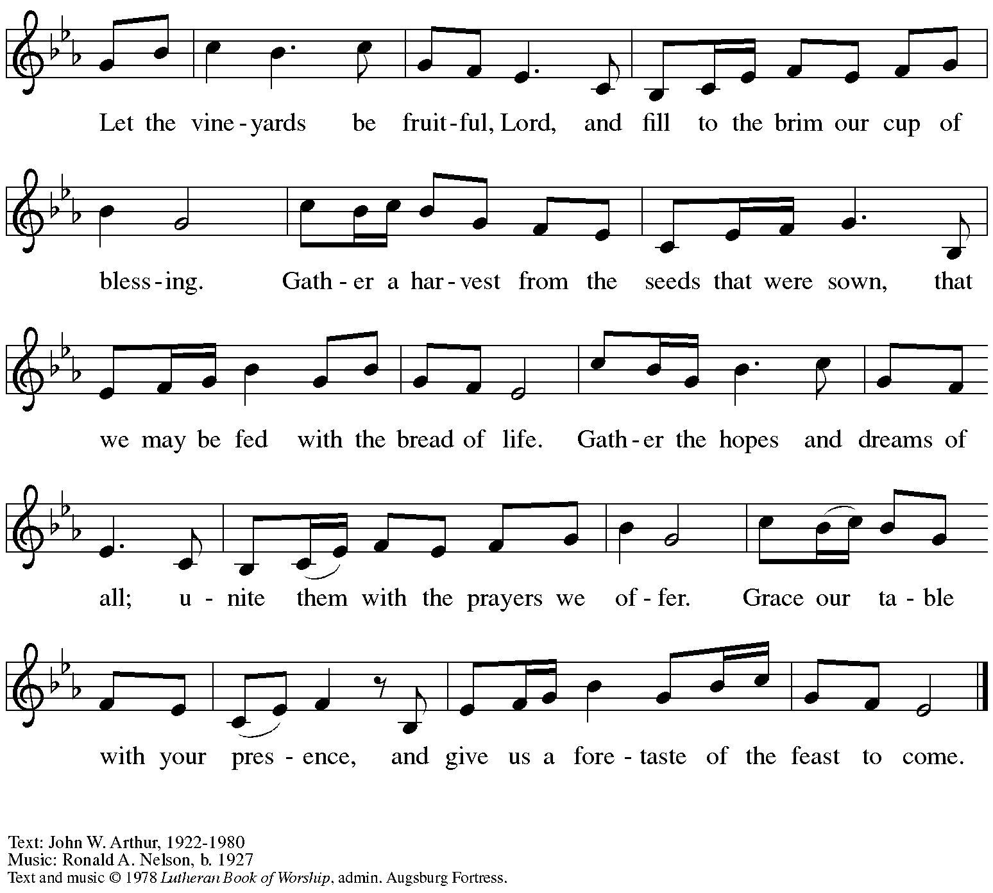
All rights reserved. Reprinted with permission under OneLiucense.net # A-722139.

Offertory Prayer

A: Let us pray.
God of all creation,
C: all you have made is good, and your love endures forever.
You bring forth bread from the earth and fruit from the vine.
Nourish us with these gifts,
that we might be for the world signs of your gracious presence
in Jesus Christ, our Savior and Lord.
Amen.

Dialogue

P: The Lord be with you.
C: And also with you.

P: Lift up your hearts.
C: We lift them to the Lord.

P: Let us give thanks to the Lord our God.
C: It is right to give our thanks and praise.

Preface

P: It is indeed right, our duty and our joy …
… we praise your name and join their unending hymn:

Sanctus (Sung)

Holy, holy, holy Lord, God of power and might,
heav’n and earth are full of your glory.
Hosanna in the highest.
Blessed is the one who comes in the name of the Lord.
Hosanna in the highest, hosanna in the highest.

Eucharistic Prayer

P: Holy God, holy and mighty, holy and immortal, …
… Do this for the remembrance of me.

Together as the body of Christ,
we proclaim the Lord’s death until he comes.
C: Christ has died. Christ is risen. Christ will come again.

P: With this bread and cup …
… all our sins and sorrows will be no more.
C: Amen. Come, Lord Jesus.

P: Holy God, holy and merciful one, holy and compassionate, …
… sharing your bounty with all the world.
C: Amen. Come, Holy Spirit.

… Holy and benevolent God, …
… with the Holy Spirit, in your holy church, now and forever.
C: Amen.

Lord’s Prayer

P: Gathered as one by the Holy Spirit, let us pray as Jesus taught us.
C: Our Father in heaven,
hallowed be your name,
your kingdom come,
your will be done,
on earth as in heaven.
Give us today our daily bread.
Forgive us our sins
as we forgive those
who sin against us.
Save us from the time of trial
and deliver us from evil.
For the kingdom, the power,
and the glory are yours,
now and forever. Amen.

Fraction and Invitation

Agnus Dei / Lamb of God

Please be seated.

Holy Communion
- All who seek God and desire a deeper and stronger life in Christ are welcome to receive Holy Communion.
- Worshipers from the pulpit side will proceed forward first, followed by the center section, and then the lectern side.
- Please inform an usher if you would like the ministers to bring Communion to you.
- Holy Communion will be served with bread and wine/grape juice.
- The presiding minister will first distribute the bread (host) to each communicant. Please indicate if you require a gluten-free host.
- Once you have consumed the bread, please pick up an empty glass from the tray next to the presiding minister. The Communion Assistant will pour wine from the chalice or grape juice from the cruet into your glass.
- Please step to the side to consume the wine or grape juice.
- Feel free to kneel at the altar rail for prayer after receiving the sacrament.
- As you return to your pew, glasses may be returned to the empty trays on either side of the center section.
- A blessing will be provided for anyone who does not yet receive the sacrament.
- All are invited to join in singing the hymns during Holy Communion.

Hymns during Holy Communion
We Place upon Your Table, Lord ELW 467

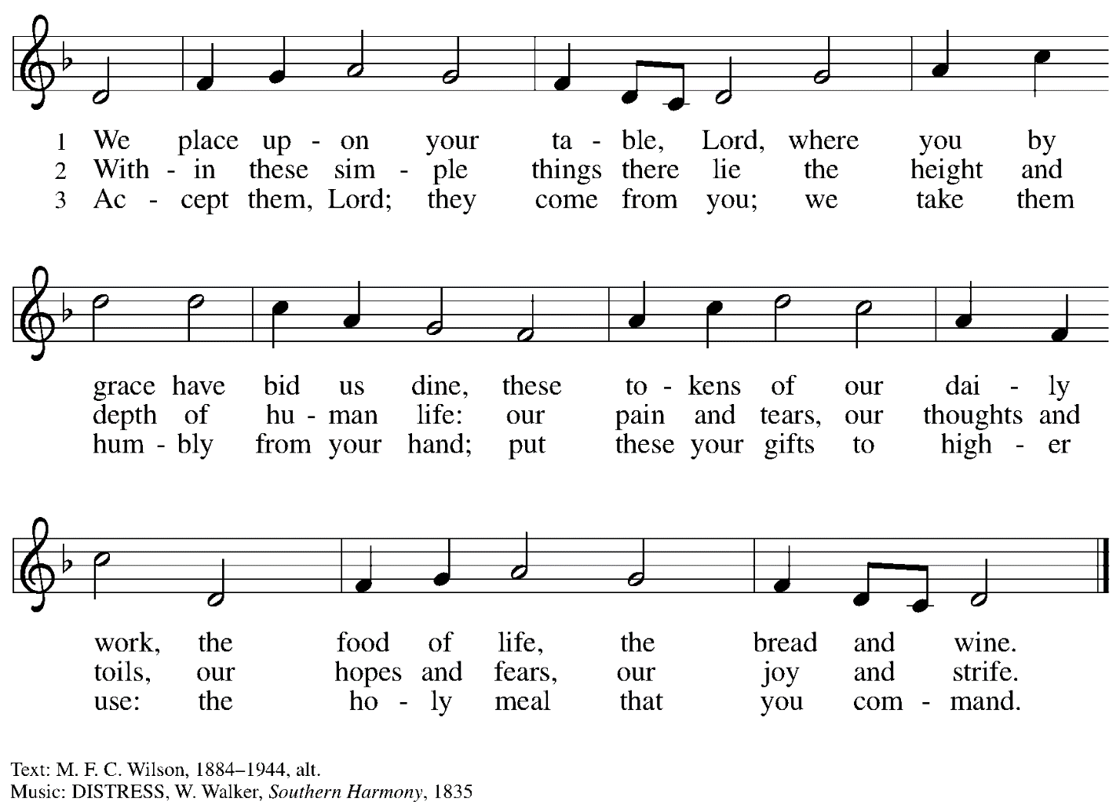

Hymns during Holy Communion
There in God’s Garden ELW 342

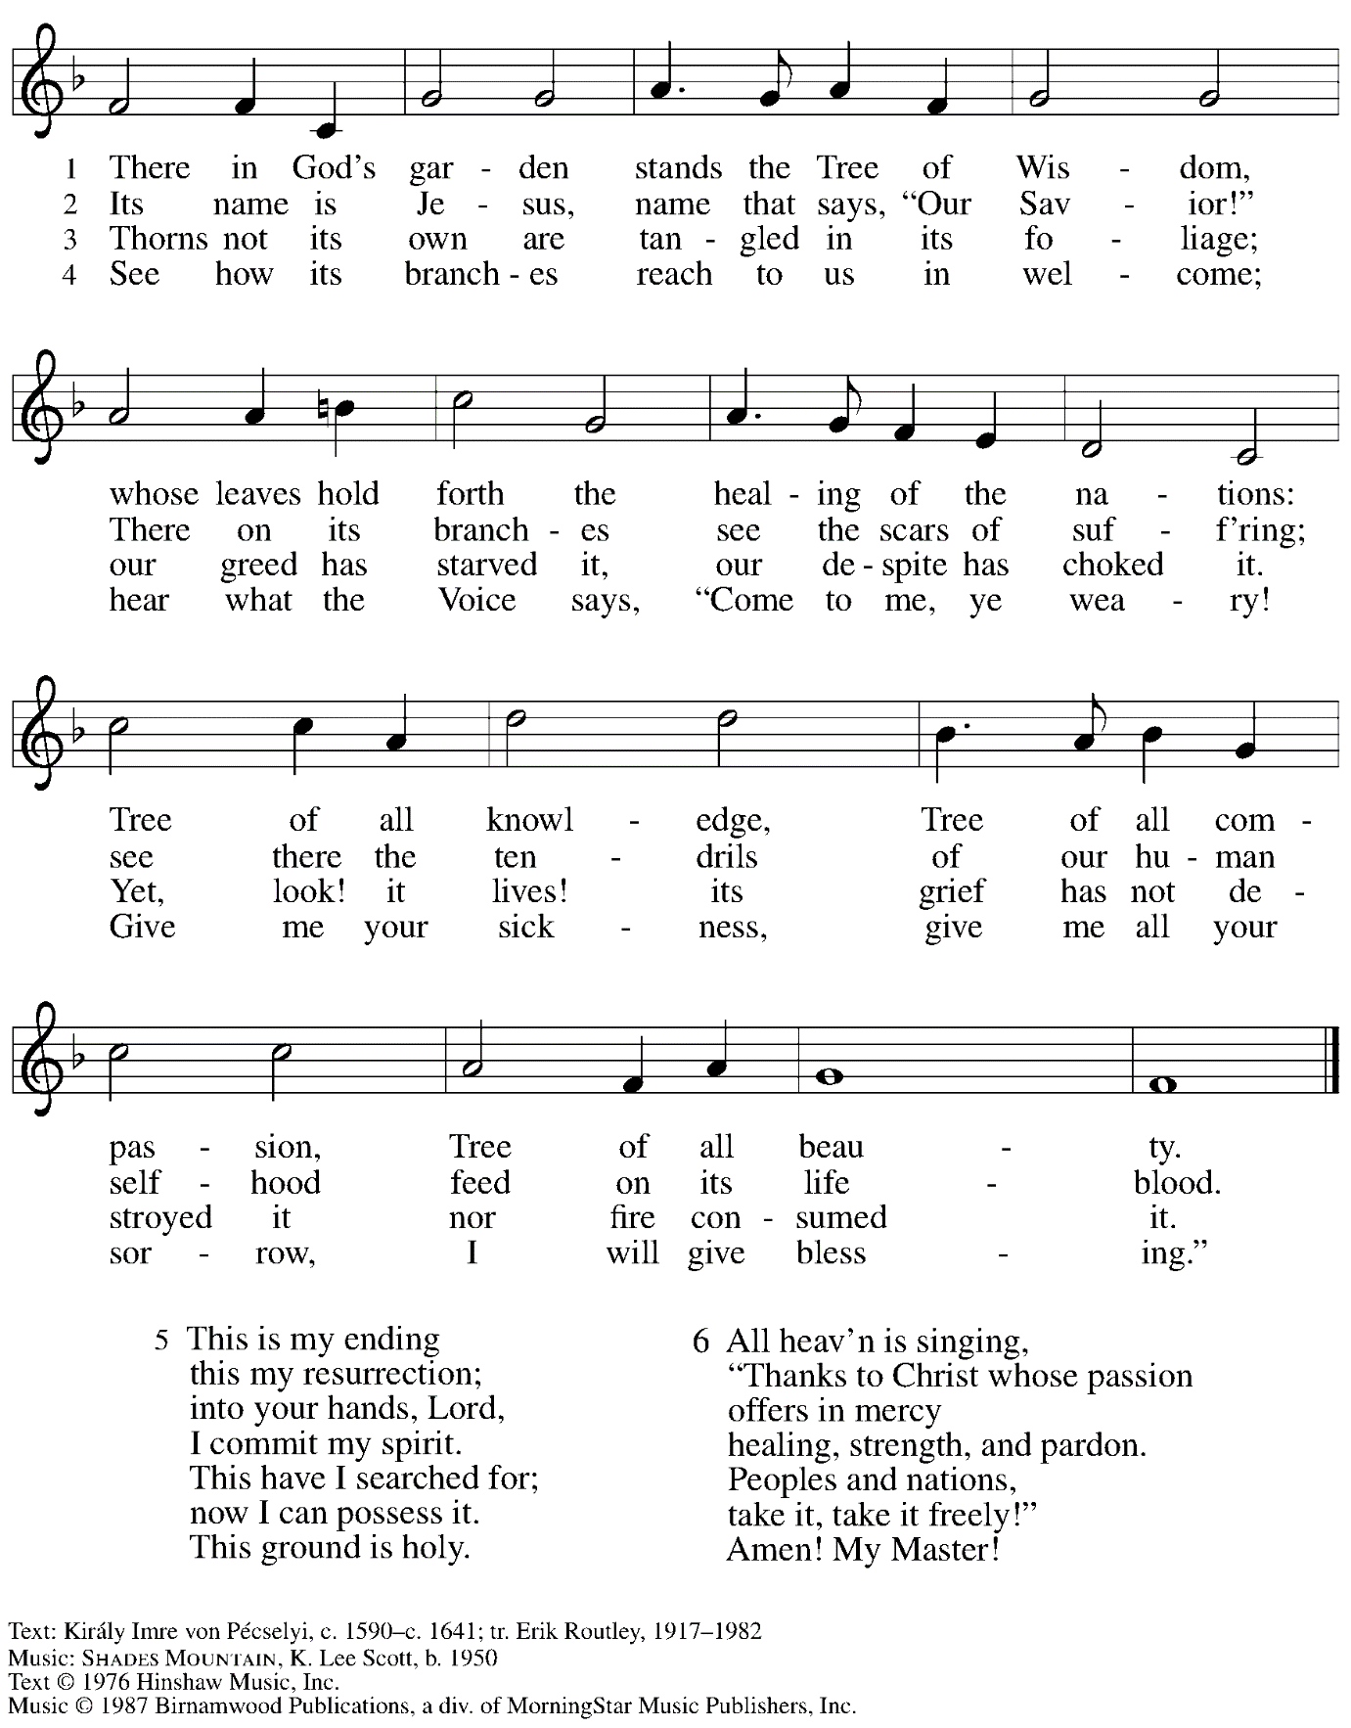
All rights reserved. Reprinted with permission under OneLicense.net # A-722139.
Hymns during Holy Communion
By Your Hand You Feed Your People ELW 469

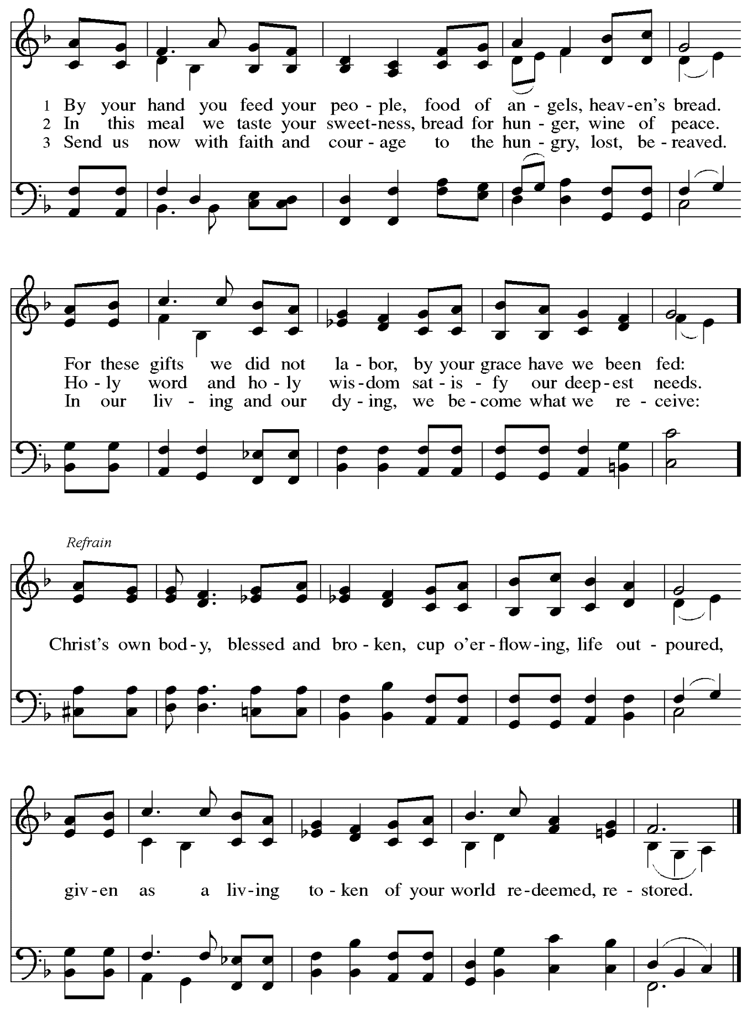
When all have returned to their places, please rise as you are able.

Blessing

P: The body and blood of our Lord Jesus Christ strengthen you and keep you in his grace.
C: Amen.

Prayer

A: Let us pray. We give you thanks, almighty God,
that you have refreshed us through the healing power of this gift of life.
In your mercy, strengthen us through this gift,
in faith toward you and in fervent love toward one another;
for the sake of Jesus Christ our Lord.
C: Amen.

Please be seated.

Sending
God blesses us and sends us in mission to the world

Announcements

Please rise as you are able.

Benediction

P: The God of steadfastness and encouragement
grant you to live in harmony with one another,
in accordance with Christ Jesus.
C: Amen.

P: The God of hope fill you with all joy and peace in believing,
so that you may abound in hope by the power of the Holy Spirit.
C: Amen.

P: The God of all grace ☩ bless you now and forever.
C: Amen.

Sending Hymn The Church of Christ, in Every Age Following page

Dismissal

A: Go in peace. Serve the Lord.
C: Thanks be to God!
Sending Hymn The Church of Christ, in Every Age ELW 729

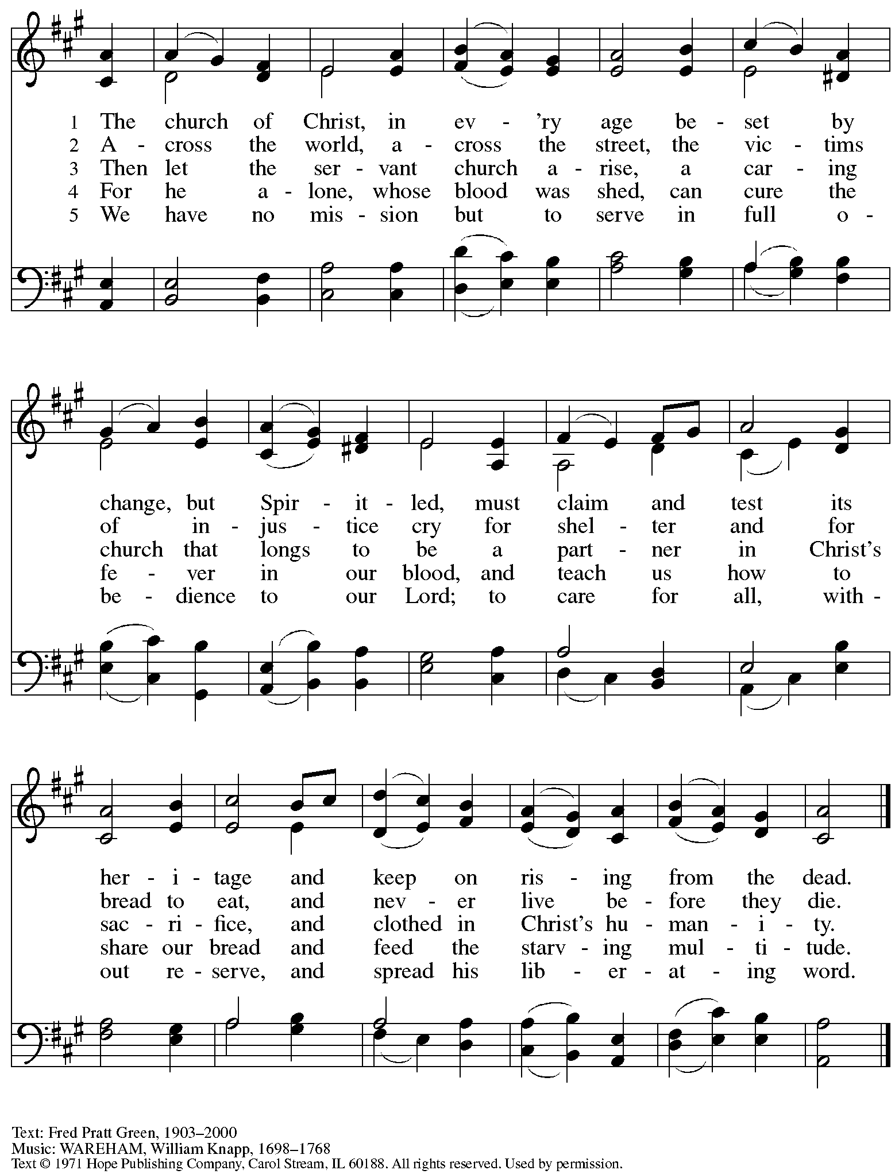
Reprinted with permission under OneLicense.net # A-722139.

Those serving in worship today

Altar Care Beverley Chapman
Assisting Minister Tim Marker
Audio-Visual Ministers Noël Marsh
Colten Rohleder
Cantor Timothy Kocher-Hillmer
Lector Kelly Spanninger
Little Church – Big Faith Leader Sue Gaugler
Musician – Organ Jimmi Kocher-Hillmer
Presiding and Preaching Minister The Rev. Peter D. Asplin

Liturgy and Hymnody Acknowledgements

From SundaysandSeasons.com. Copyright © 2023 Augsburg Fortress. All rights reserved. Reprinted under OneLicense.net # A-722139.
Used by permission of Augsburg Fortress.

By Your Hand You Feed Your People – Text: Susan R. Briehl, b. 1952. Music: CAMROSE, Marty Haugen, b. 1950. Text and music © 2002 GIA Publications, Inc. All rights reserved. Reprinted with permission under OneLicense.net # A-722139.

Please use the QR code below to link to St. Andrew’s Announcements online!

St. Andrew Lutheran Church Announcements
October 8^{sth} 2023

- Welcome to worship at St. Andrew on the Seventeenth Sunday after Pentecost, October 8th, 2023 – We are so glad you are here, and we offer a special welcome to all visitors here or online for the first time! Worship attendees are invited to make a name tag at the back of the worship space if you would like. Children are invited to take part in Little Church – Big Faith, a time of Bible stories and activities, during worship after the Prayer of the Day. There are worship “toolkits” to help children engage with worship and “busy bags” for younger children available in the bookcase at the back of the sanctuary. Please feel free to take one to use with/for your children. We invite everyone to stay after worship for coffee and conversation in the Social Hall next to the sanctuary.
- Thank You to The Rev. Peter D. Asplin for Preaching and Presiding in Worship Today! – Pastor Peter Asplin is a member of St. Andrew and Assistant to the Bishop of the Southwestern Pennsylvania Synod. We thank Pastor Asplin for sharing his gifts in leadership today!
- Renew the Pews Continues after Worship Today – We got a good start on the steam cleaning of the pew cushions this past Sunday but have a long way to go! We ask your help in continuing the renewal of the sanctuary after worship today. We will be steam-cleaning the pew cushions and replacing some of the buttons that have fallen off over the years of use. We thank congregation president Kristen Asplin for organizing this effort and to all who have lent their steam-cleaning equipment!
- Cross-Generational Activity (Advent Banner Preparation!) for Children, Youth, Parents / Guardians, and the Whole Congregation – after Worship Sundays, October 15th, and October 29th – In the past, children and youth of St. Andrew have helped create art for banners that adorn the worship space in the season of Advent, and we would like to create banners for a new church year. We invite children, youth, parents / guardians to gather after worship on the Sundays listed above to hear Advent readings, talk about their imagery, and work together on an artistic representation of the texts, which will be used to make four new banners, one for each week of the Advent season. While we hope for primary input from children and youth, we encourage everyone in the congregation to stay to support them and share in the St. Andrew community on these Sundays! Please speak with Christian Education liaison Colten Rohleder if you have questions.
- Compline Prayer Service, a Ministry of Lutheran Campus Ministry in Greater Pittsburgh, Sundays at 8:00 p.m. at Heinz Chapel – Compline was traditionally a monastic prayer service, and the Pittsburgh Compline Choir sings a choral version of compline rooted in this thousand-year-old tradition of scripture, song, and silence. This service also streams on Facebook (Pittsburgh Compline Choir) and YouTube (The Pittsburgh Compline Choir). Heinz Chapel is located off of S. Bellefield Ave. in Oakland.
- Looking for People to Set Up Coffee Hour – In order to facilitate conversation and
community-building, St. Andrew seeks to have Coffee Hour after worship each week. Usually this can be provided by one person or family unit signing up per week. The tasks include preparing the coffee maker and starting its brew cycle along with setting out snacks, napkins, plates, etc. before worship. After worship tasks include bringing out creamer and cold drinks (water, juice boxes for children) and cleanup. We invite you to consider serving – please sign up here: https://www.signupgenius.com/go/5080b4aafaf2cabf85-coffee#/.
- East End Cooperative Ministry Shelter Dinner – Thursday, October 19th, Arrival at 6:00 p.m., Meal at 6:30 p.m. – Each month, members of St. Andrew provide and serve a meal for the guests of the shelter at East End Cooperative Ministry (EECM), 6140 Station St., 15206. Anyone can sign up to prepare or purchase a portion of the meal to bring to EECM at 6:00 p.m. that day, or just come to help serve the meal at 6:30 p.m. If you would like to contribute, please sign up at: https://www.signupgenius.com/go/5080544AAAC22A1F58-44645161-octshelter.
- Christ in Our Home Devotional Booklets for October – December Available at Church Entrances – This resource offers a daily Bible reading with a short reflection and prayer, along with additional readings and prayer topics for those who would like to expand their devotional practices. We encourage people of the congregation to take one for yourself, your family unit, or others!

