+ Twenty-first Sunday after Pentecost
October 22nd, 2023
10:00 a.m.

St. Andrew Lutheran Church
304 Morewood Ave.
Pittsburgh, PA 15213
St_andrewELCA@verizon.net
www.standrewpittsburgh.org

+ Twenty-first Sunday after Pentecost
Order for Worship

In this week’s first reading, God uses the Gentile ruler Cyrus to accomplish divine purposes. When the Pharisees try to trap Jesus, he tells them to give the emperor what belongs to him
and to God what belongs to God. To gather for worship reminds us that our ultimate allegiance is to God rather than to any earthly authority. Created in the image of God,
we offer our entire selves in the service of God and for the sake of the world.

Welcome to St. Andrew!

- St. Andrew Lutheran congregation welcomes all who are seeking a place of healing and wholeness – a nurturing, faith-forming spiritual home. Our community embraces people of all ages, ethnicities, cultures, abilities, sexual orientations, gender identities and expressions, and family constellations. Come and See!

- Worship Services are live streamed to multiple online platforms. By attending worship, you agree that your image and voice may be broadcast.

- Everyone is invited to make a nametag at the black bookcase in the back of the worship space if they would like. There are stickers indicating pronouns on the bookcase if you would like to include them on your name tag.

- Worship “toolkits” to help children engage with the service, along with “busy bags” for younger children, are available in the bookcase at the back of the sanctuary. Please feel free to take one to use with/for your children.

- Children are invited to attend Little Church – Big Faith, a Bible lesson and activity, during worship (after the Prayer of the Day). The group returns to the worship space for the liturgy of Holy Communion.

- Holy Communion is served with bread (gluten-free available) and wine or grape juice. The presiding minister will distribute the bread (host). Please consume this and then pick up an empty glass from the tray. The Communion Assistant will pour wine or grape juice into your glass. Please step to the side to consume the wine or grape juice. Feel free to kneel at the altar for prayer and reflection. As you return to your pew, glasses may be returned to the empty trays on either side of the center section.

- A restroom is available on the main level of the church, through the doors to the Social Hall and to the right in the main office.

Abbreviations
P: Pastor/Presiding Minister ACS: All Creation Sings hymnal
A: Assisting Minister ELW: Evangelical Lutheran Worship hymnal
L: Lector
C: Congregation

Pre-Service Music

Welcome

Prelude

Gathering
The Holy Spirit calls us together as the people of God

Confession and Forgiveness

Please rise as you are able. All may make the sign of the cross,
the sign that is marked at Baptism, as the presiding minister begins.

P: Blessed be the holy Trinity, ☩ one God,
whose mercy endures forever.
C: Amen.

P: If we say we have no sin we deceive ourselves and the truth is not in us.
Let us confess our sin to God, who is faithful and just
and who has promised to forgive our sin and cleanse us from all unrighteousness.

Silence is kept for reflection and self-examination.

P: Most merciful God,
C: have mercy on us.
We confess to you
that we have sinned against you
in thought, word, and deed,
by what we have done
and by what we have left undone.
We have not trusted you with our whole heart.
We have not loved one another in deed and in truth.
In your compassion, forgive our sin and uphold us by your Spirit,
that we may live and serve you in newness of life
through Jesus Christ, our light and our truth.
Amen.

P: With joy I proclaim to you that Almighty God,
rich in mercy, abundant in love,
forgives you all your sin
and grants you newness of life in ☩ Jesus Christ.
C: Amen. Thanks be to God!

Gathering Hymn God Is Here! ELW 526

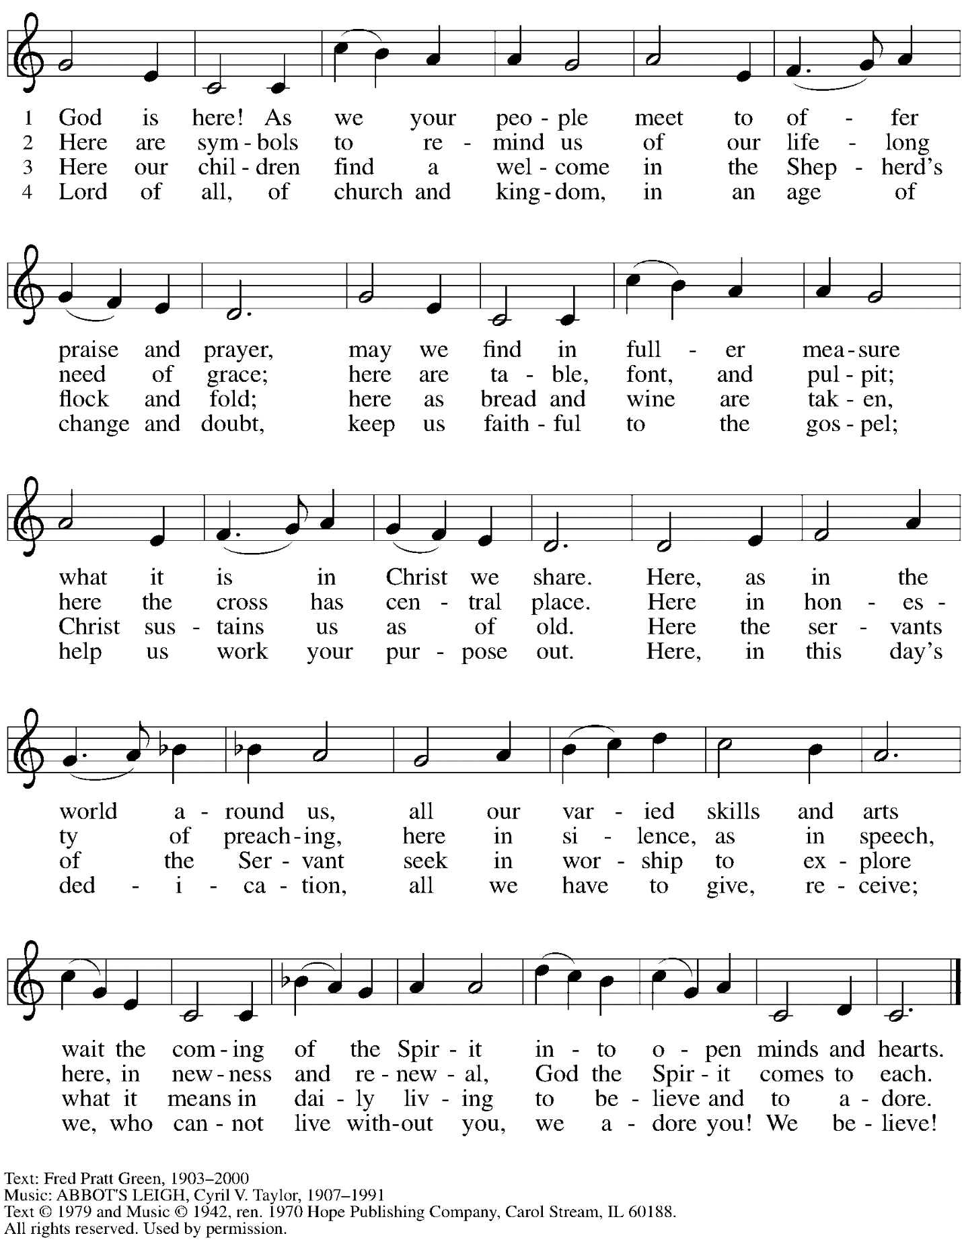
Reprinted under OneLicense.net # A-722139.

Greeting

P: The grace of our Lord Jesus Christ, the love of God,
and the communion of the Holy Spirit be with you all.
C: And also with you.

Hymn of Praise Now the Feast and Celebration HS p. 4-5

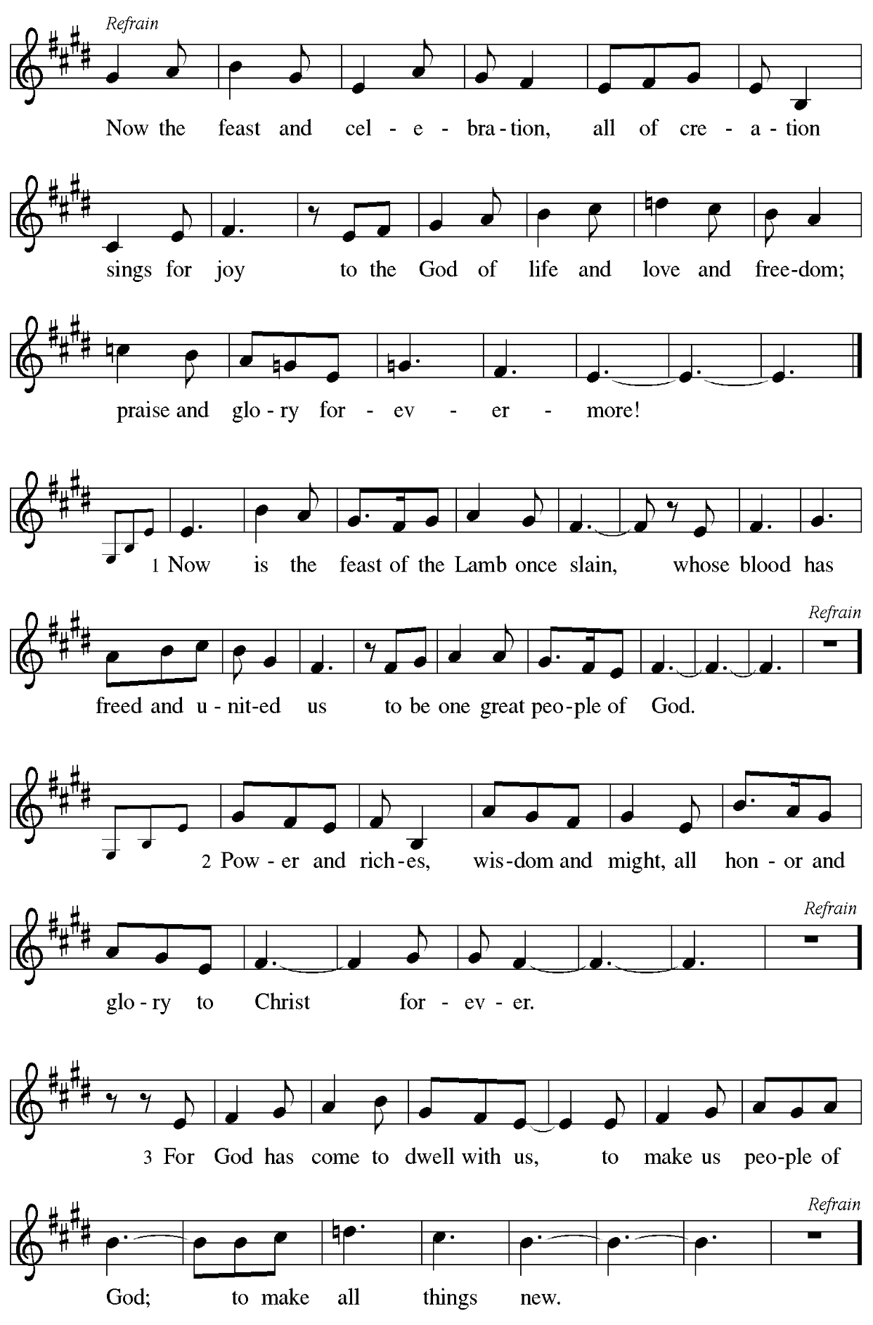
Prayer of the Day

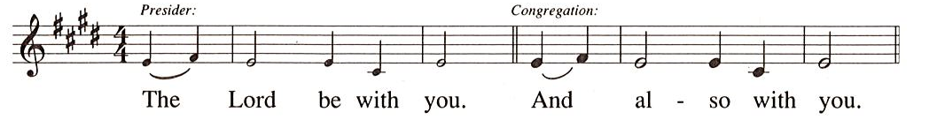

P: Let us pray.
Sovereign God, raise your throne in our hearts.
Created by you, let us live in your image;
created for you, let us act for your glory;
redeemed by you, let us give you what is yours;
through Jesus Christ, our Savior and Lord.
C: Amen.

Please be seated.
Children are invited to join the adult leaders at the door and move to the office for Little Church – Big Faith. We ask that one additional adult from the congregation attend with the children.

Word
God speaks to us in Scripture reading, preaching, and song

First Reading – Isaiah 45: 1-7

¹Thus says the Lord to God’s anointed, to Cyrus,
whose right hand I have grasped
to subdue nations before him
and strip kings of their robes,
to open doors before him—
and the gates shall not be closed:
²I will go before you
and level the mountains,
I will break in pieces the doors of bronze
and cut through the bars of iron,
³I will give you the treasures of darkness
and riches hidden in secret places,
so that you may know that it is I, the Lord,
the God of Israel, who call you by your name.
⁴For the sake of my servant Jacob,
and Israel my chosen,
I call you by your name,
I surname you, though you do not know me.
⁵I am the Lord, and there is no other;
besides me there is no god.
I arm you, though you do not know me,
⁶so that they may know, from the rising of the sun
and from the west, that there is no one besides me;
I am the Lord, and there is no other.
⁷I form light and create darkness,
I make weal and create woe;
I the Lord do all these things.

L: Word of God, word of life.
C: Thanks be to God.

Psalm 96: 1-9 [10-13]

The psalm will be led by the cantor, with the congregation invited to respond with the alternate verses (in bold) and refrain.

Psalm tone

Psalm refrain

¹Sing to the Lord| a new song;
sing to the Lord, | all the earth.
²Sing to the Lord, bless the name | of the Lord;
proclaim God’s salvation from | day to day.
³Declare God’s glory a- | mong the nations
and God’s wonders a- | mong all peoples.
⁴For great is the Lord and greatly | to be praised,
more to be feared | than all gods. R
⁵As for all the gods of the nations, they | are but idols;
but you, O Lord, have | made the heavens.
⁶Majesty and magnificence are | in your presence;
power and splendor are in your | sanctuary.
⁷Ascribe to the Lord, you families | of the peoples,
ascribe to the Lord hon- | or and power.
⁸Ascribe to the Lord the honor due the | holy name;
bring offerings and enter the courts | of the Lord. R
⁹Worship the Lord in the beau- | ty of holiness;
tremble before the Lord, | all the earth.
[ ¹⁰Tell it out among the nations: “The | Lord is king!
The one who made the world so firm that it cannot be moved will judge the peo- | ples with equity.”
¹¹Let the heavens rejoice, and let the | earth be glad;
let the sea thunder and all that is in it; let the field be joyful and all that | is therein.
¹²Then shall all the trees of the wood shout for joy at your com- | ing, O Lord,
for you come to | judge the earth.
¹³You will judge the | world with righteousness
and the peoples | with your truth. R ]

Second Reading – 1 Thessalonians 1: 1-10

¹Paul, Silvanus, and Timothy,
To the church of the Thessalonians in God the Father and the Lord Jesus Christ:
Grace to you and peace.
²We always give thanks to God for all of you and mention you in our prayers, constantly
³remembering before our God and Father your work of faith and labor of love and steadfastness of hope in our Lord Jesus Christ. ⁴For we know, kindred beloved by God, that God has chosen you, ⁵because our message of the gospel came to you not in word only, but also in power and in the Holy Spirit and with full conviction; just as you know what kind of persons we proved to be among you for your sake. ⁶And you became imitators of us and of the Lord, for in spite of persecution you received the word with joy inspired by the Holy Spirit, ⁷so that you became an example to all the believers in Macedonia and in Achaia. ⁸For the word of the Lord has sounded forth from you not only in Macedonia and Achaia, but in every place your faith in God has become known, so that we have no need to speak about it. ⁹For the people of those regions report about us what kind of welcome we had among you, and how you turned to God from idols, to serve a living and true God, ¹⁰and to wait for God’s Son from heaven, whom God raised from the dead—Jesus, who rescues us from the wrath that is coming.

L: Word of God, word of life.
C: Thanks be to God.

Please rise as you are able.

Gospel Acclamation HS p. 8

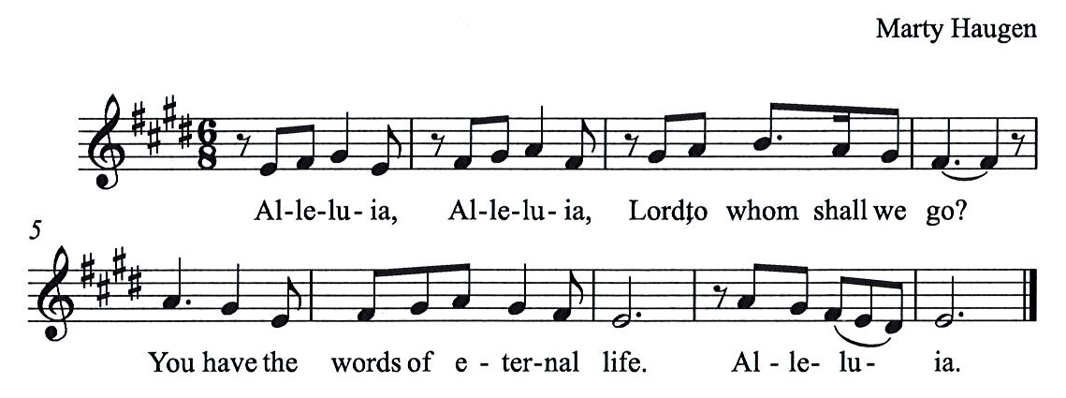

Gospel – Matthew 22: 15-22

P: The holy Gospel according to St. Matthew.
C: Glory to you, O Lord.

¹⁵Then the Pharisees went and plotted to entrap [Jesus] in what he said. ¹⁶So they sent their disciples to him, along with the Herodians, saying, “Teacher, we know that you are sincere, and teach the way of God in accordance with truth, and show deference to no one; for you do not regard people with partiality. ¹⁷Tell us, then, what you think. Is it lawful to pay taxes to the emperor, or not?” ¹⁸But Jesus, aware of their malice, said, “Why are you putting me to the test, you hypocrites? ¹⁹Show me the coin used for the tax.” And they brought him a denarius. ²⁰Then he said to them, “Whose head is this, and whose title?” ²¹They answered, “The emperor’s.” Then he said to them, “Give therefore to the emperor the things that are the emperor’s, and to God the things that are God’s.” ²²When they heard this, they were amazed; and they left him and went away.
P: The Gospel of the Lord.
C: Praise to you, O Christ.

Please be seated.

Sermon

A time of silence for prayer and reflection follows the sermon.
When the hymn of the day begins, please rise as you are able.

Hymn of the Day All My Hope on God Is Founded ELW 757

1 All my hope on God is founded
who will all my trust renew,
who through change and chance will guide me,
only good and only true.
God unknown, God alone,
call my heart to be thine own.

2 Mortal pride and earthly glory,
sword and crown betray our trust;
what with care and toil we fashion,
tow'r and temple, fall to dust.
But thy pow'r, hour by hour,
is my temple and my tow'r.

3 Great thy goodness, e'er enduring;
deep thy wisdom, passing thought;
splendor, light, and life attend thee,
beauty springing out of naught.
Evermore from thy store
newborn worlds rise and adore.

4 Still from earth to God eternal
sacrifice of praise be done,
high above all praises praising
for the gift of God's own Son.
Christ doth call one and all:
ye who follow shall not fall.

Text: Joachim Neander, 1650-1680; para. Robert Bridges, 1844-1930, alt. Music: MICHAEL, Herbert Howells, 1892-1983. Music © Novello & Co., Ltd., London, admin. G. Schirmer, Inc. Reprinted with permission under CCLI License # 11561207.

Apostles Creed

P: Let us confess our faith:
C: I believe in God, the Father almighty,
creator of heaven and earth.

I believe in Jesus Christ, God’s only Son, our Lord,
who was conceived by the Holy Spirit,
born of the virgin Mary,
suffered under Pontius Pilate,
was crucified, died, and was buried;
he descended to the dead.*
On the third day he rose again;
he ascended into heaven,
he is seated at the right hand of the Father,
and he will come to judge the living and the dead.

I believe in the Holy Spirit,
the holy catholic church,
the communion of saints,
the forgiveness of sins,
the resurrection of the body,
and the life everlasting. Amen.

*Or, “he descended into hell,” another translation of this text in widespread use.

Prayers of the People

A: Trusting in the transformative power of God’s loving Spirit,
let us pray for the church, the world, and all who are in need.

After each petition
A: God of grace,
C: receive our prayer.

The presiding minister concludes the prayers
P: Into your care, gracious God, we commend all for whom we pray,
trusting in your unending love and amazing grace;
through Jesus Christ, our Savior.
C: Amen.

Peace

The presiding minister and the assembly greet one another in the peace of the risen Christ.
P: The peace of Christ be with you always.
C: And also with you.

The people may greet those around them with a sign of Christ’s peace and may say
Peace be with you or similar words. Please be mindful that not everyone will be comfortable with sharing the peace, so please seek consent before shaking hands or hugging. Other possible ways to share the peace include a simple bow with the verbal greeting of peace, or simply a verbal expression of peace.

When the greetings of peace have concluded, please be seated.
Meal
God feeds us with the presence of Jesus Christ

Offering

We offer ourselves, our gifts, and our faithful service to God.
As the offering is gathered for the mission of the church, including the care of those in need,
the table is set for Holy Communion.

Music during the Offering Daybreak in Dublin M. Bober

As the gifts are brought forward for presentation, please rise as you are able.

Offertory Song As the Grains of Wheat ELW 465

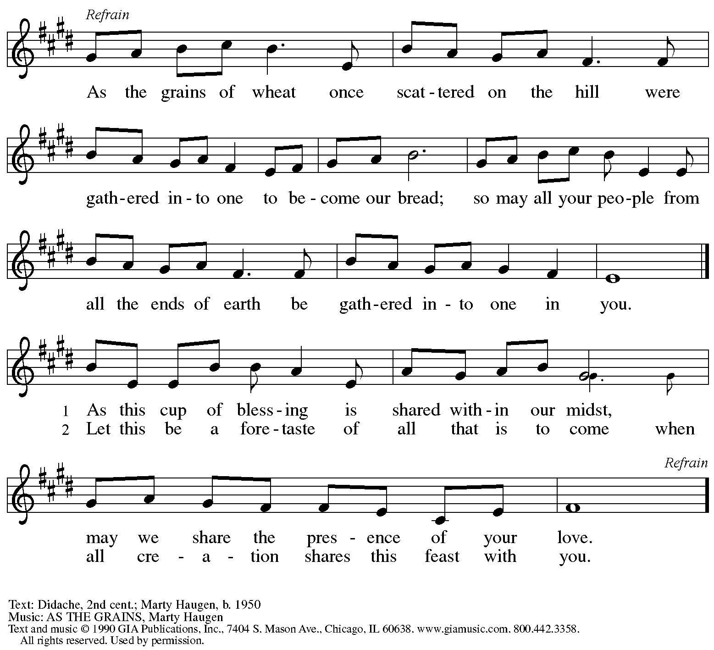
Reprinted with permission under OneLicense.net # A-722139.

Offertory Prayer

A: Let us pray.
God of mercy and grace,
C: the hearts of all wait upon you, and you open your hand in blessing.
Fill us with good things at your table, that we may come to the help of all in need,
through Jesus Christ, our redeemer and Lord.
Amen.

Dialogue HS p. 14

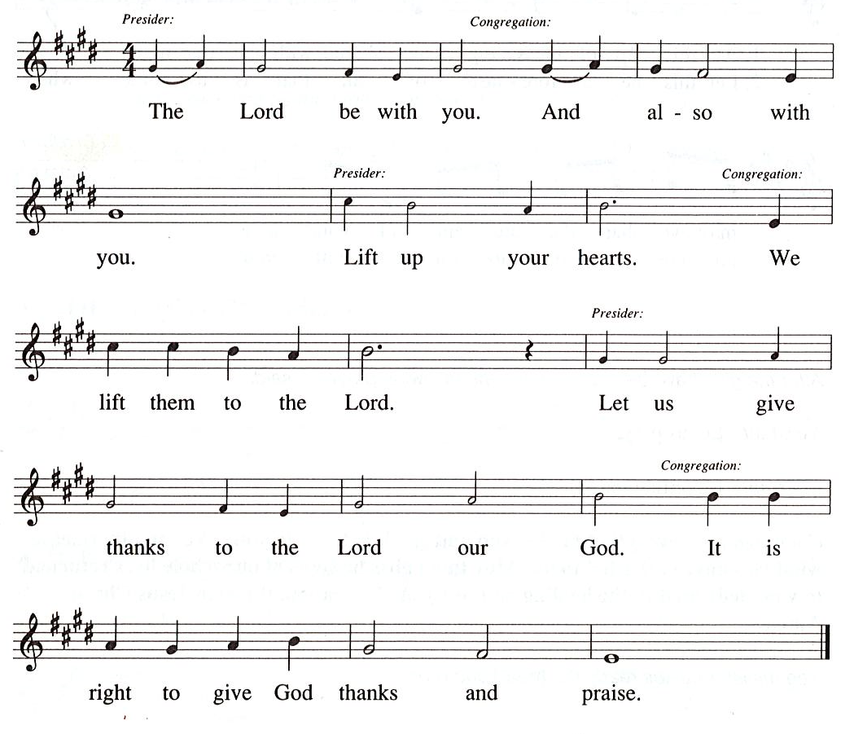

Preface (Sung by the presiding minister)

P: It is our duty and delight …
… we praise your name and join their unending hymn:

Sanctus HS p. 15

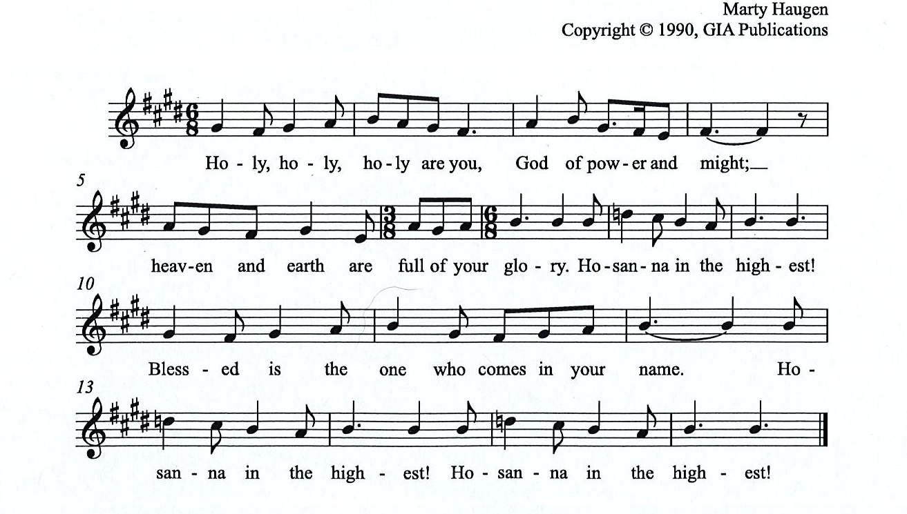

Eucharistic Prayer

P: You are indeed holy, almighty and merciful God, …
… Do this for the remembrance of me.

For as often as we eat of this bread and drink from this cup,
we proclaim the Lord’s death until he comes.
C:
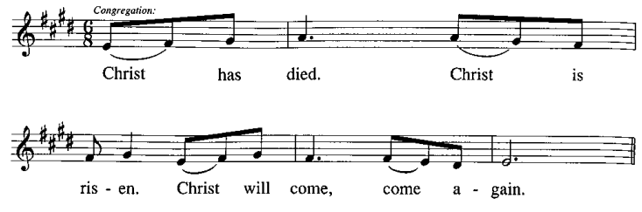

P: Remembering, therefore, …
… To you, O God, Father, Son, and Holy Spirit
be all honor and glory in your holy church, now and forever.
C:
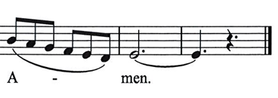

Lord’s Prayer

P: Gathered as one by the Holy Spirit, let us pray as Jesus taught us.
C: Our Father in heaven,
hallowed be your name,
your kingdom come,
your will be done,
on earth as in heaven.
Give us today our daily bread.
Forgive us our sins
as we forgive those
who sin against us.
Save us from the time of trial
and deliver us from evil.
For the kingdom, the power,
and the glory are yours,
now and forever. Amen.

Fraction and Invitation

Agnus Dei / Lamb of God HS p. 18

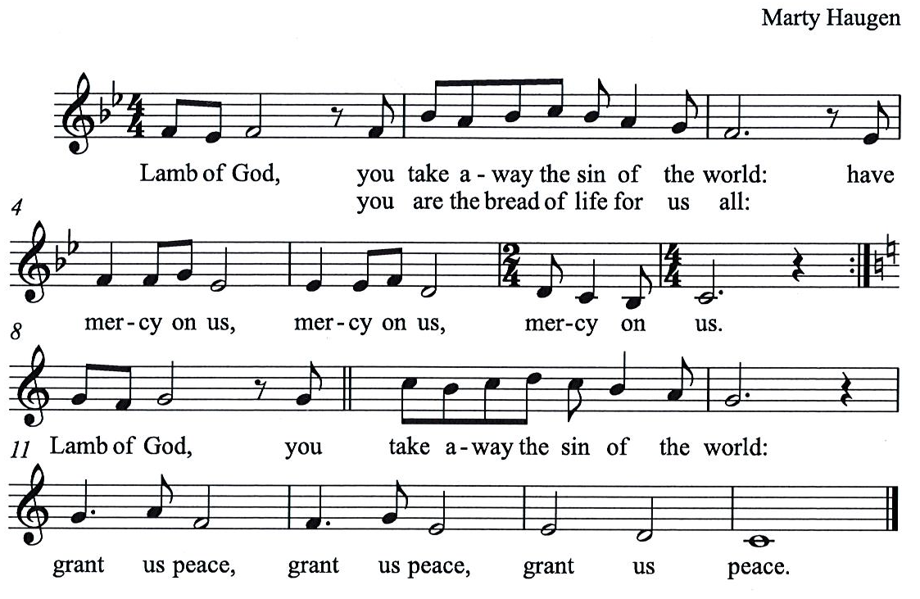

Please be seated.

Holy Communion
- All who seek God and desire a deeper and stronger life in Christ are welcome to receive Holy Communion.
- Worshipers from the pulpit side will proceed forward first, followed by the center section, and then the lectern side.
- Please inform an usher if you would like the ministers to bring Communion to you.
- Holy Communion will be served with bread and wine/grape juice.
- The presiding minister will first distribute the bread (host) to each communicant. Please indicate if you require a gluten-free host.
- Once you have consumed the bread, please pick up an empty glass from the tray next to the presiding minister. The Communion Assistant will pour wine from the chalice or grape juice from the cruet into your glass.
- Please step to the side to consume the wine or grape juice.
- Feel free to kneel at the altar rail for prayer after receiving the sacrament.
- As you return to your pew, glasses may be returned to the empty trays on either side of the center section.
- A blessing will be provided for anyone who does not yet receive the sacrament.
- All are invited to join in singing the hymns during Holy Communion.

Hymns during Holy Communion
God, Whose Giving Knows No Ending ELW 678

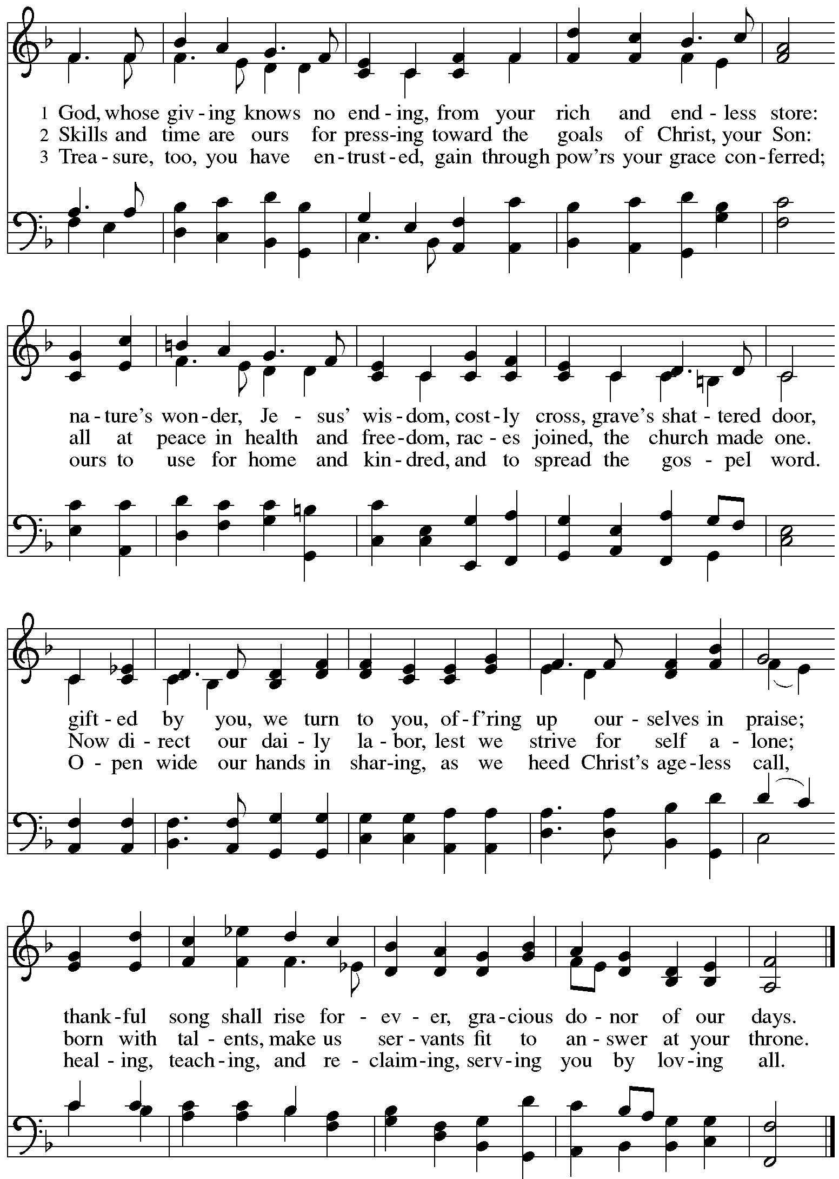
Hymns during Holy Communion
You Servants of God ELW 825

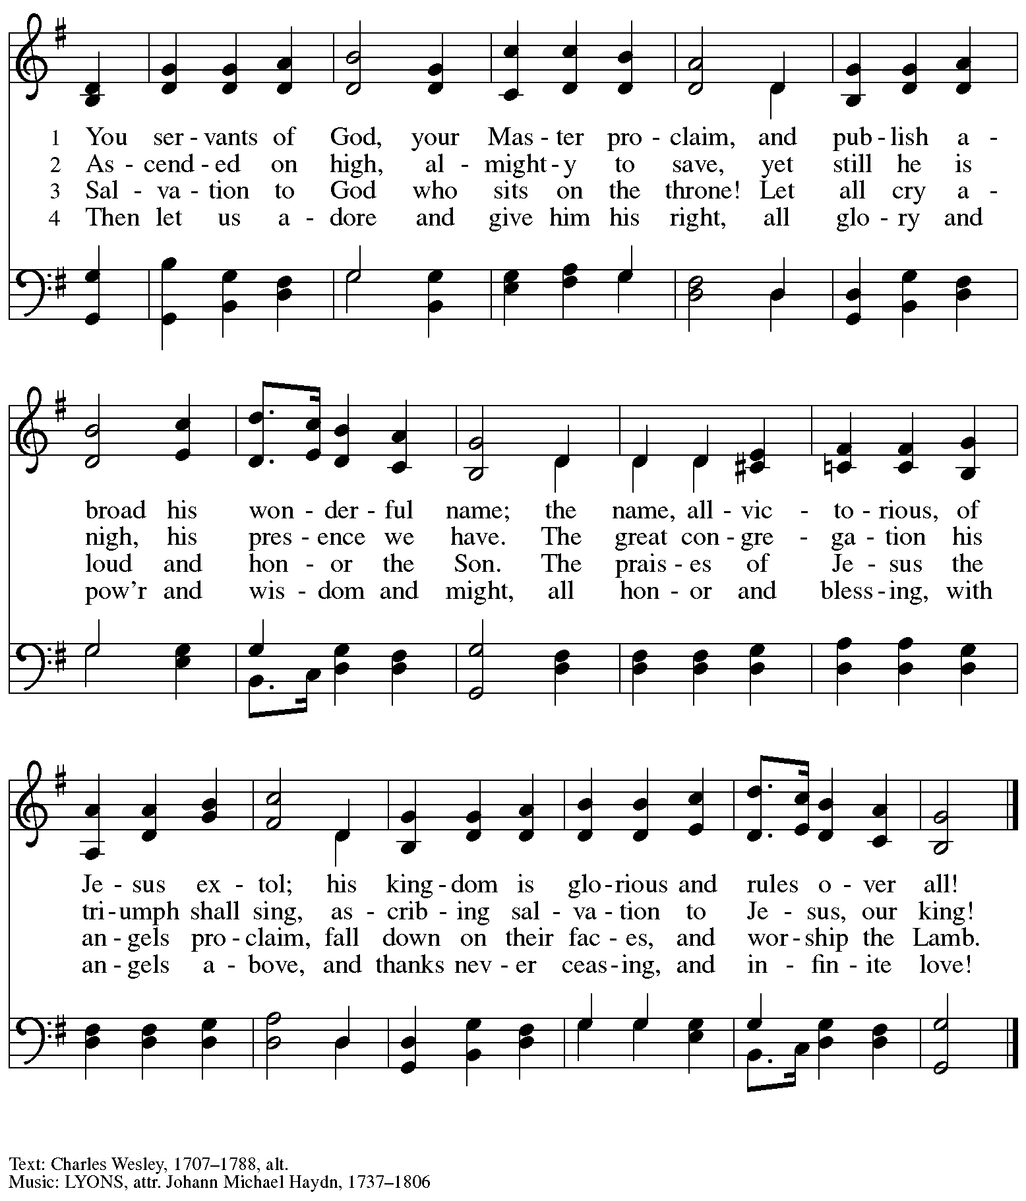

Hymns during Holy Communion
We Give Thee but Thine Own ELW 686

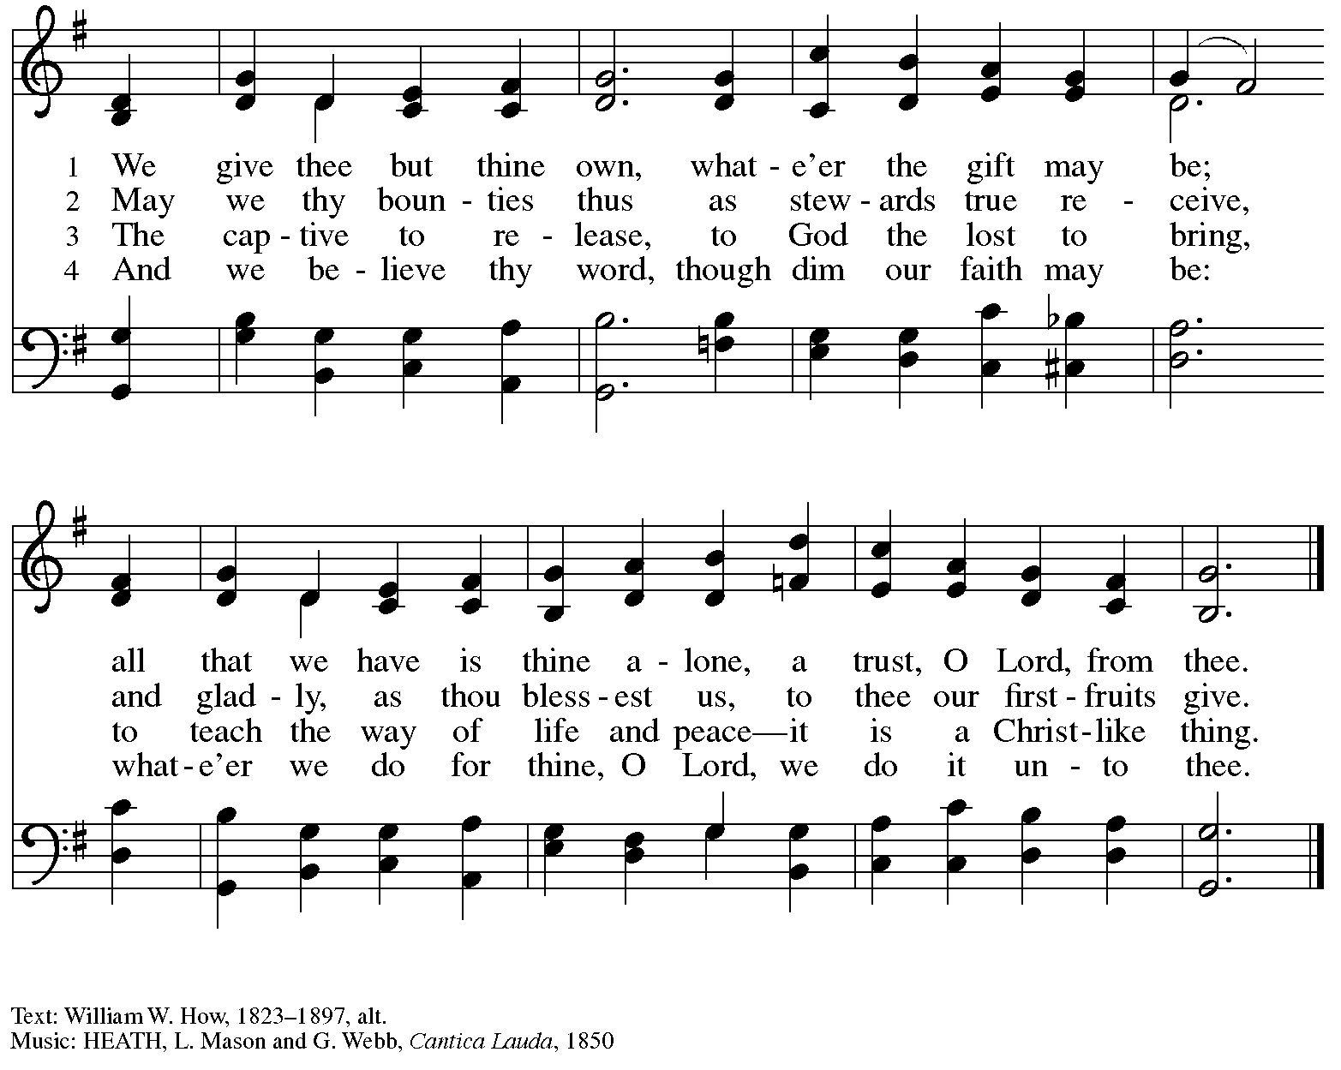

When all have returned to their places, please rise as you are able.

Blessing

P: The body and blood of our Lord Jesus Christ strengthen you and keep you in his grace.
C: Amen.

Prayer

A: Let us pray.
Gracious God,
in this meal you have drawn us to your heart,
and nourished us at your table with food and drink,
the body and blood of Christ.
Now send us forth to be your people in the world,
and to proclaim your truth this day and evermore,
through Jesus Christ, our Savior and Lord.
C: Amen.

Please be seated.

Sending
God blesses us and sends us in mission to the world

Announcements

Mission Moment – Camp Lutherlyn

Please rise as you are able.

Farewell and Godspeed

Benediction

P: The God of glory,
☩ Jesus Christ, name above all names,
and the Spirit who lives in you
bless you now and forever.
C:
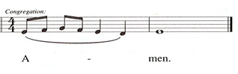

Sending Hymn God of Grace and God of Glory Following page

Dismissal

A: Go in peace. Serve the Lord.
C: Thanks be to God!

Postlude

Sending Hymn God of Grace and God of Glory ELW 705

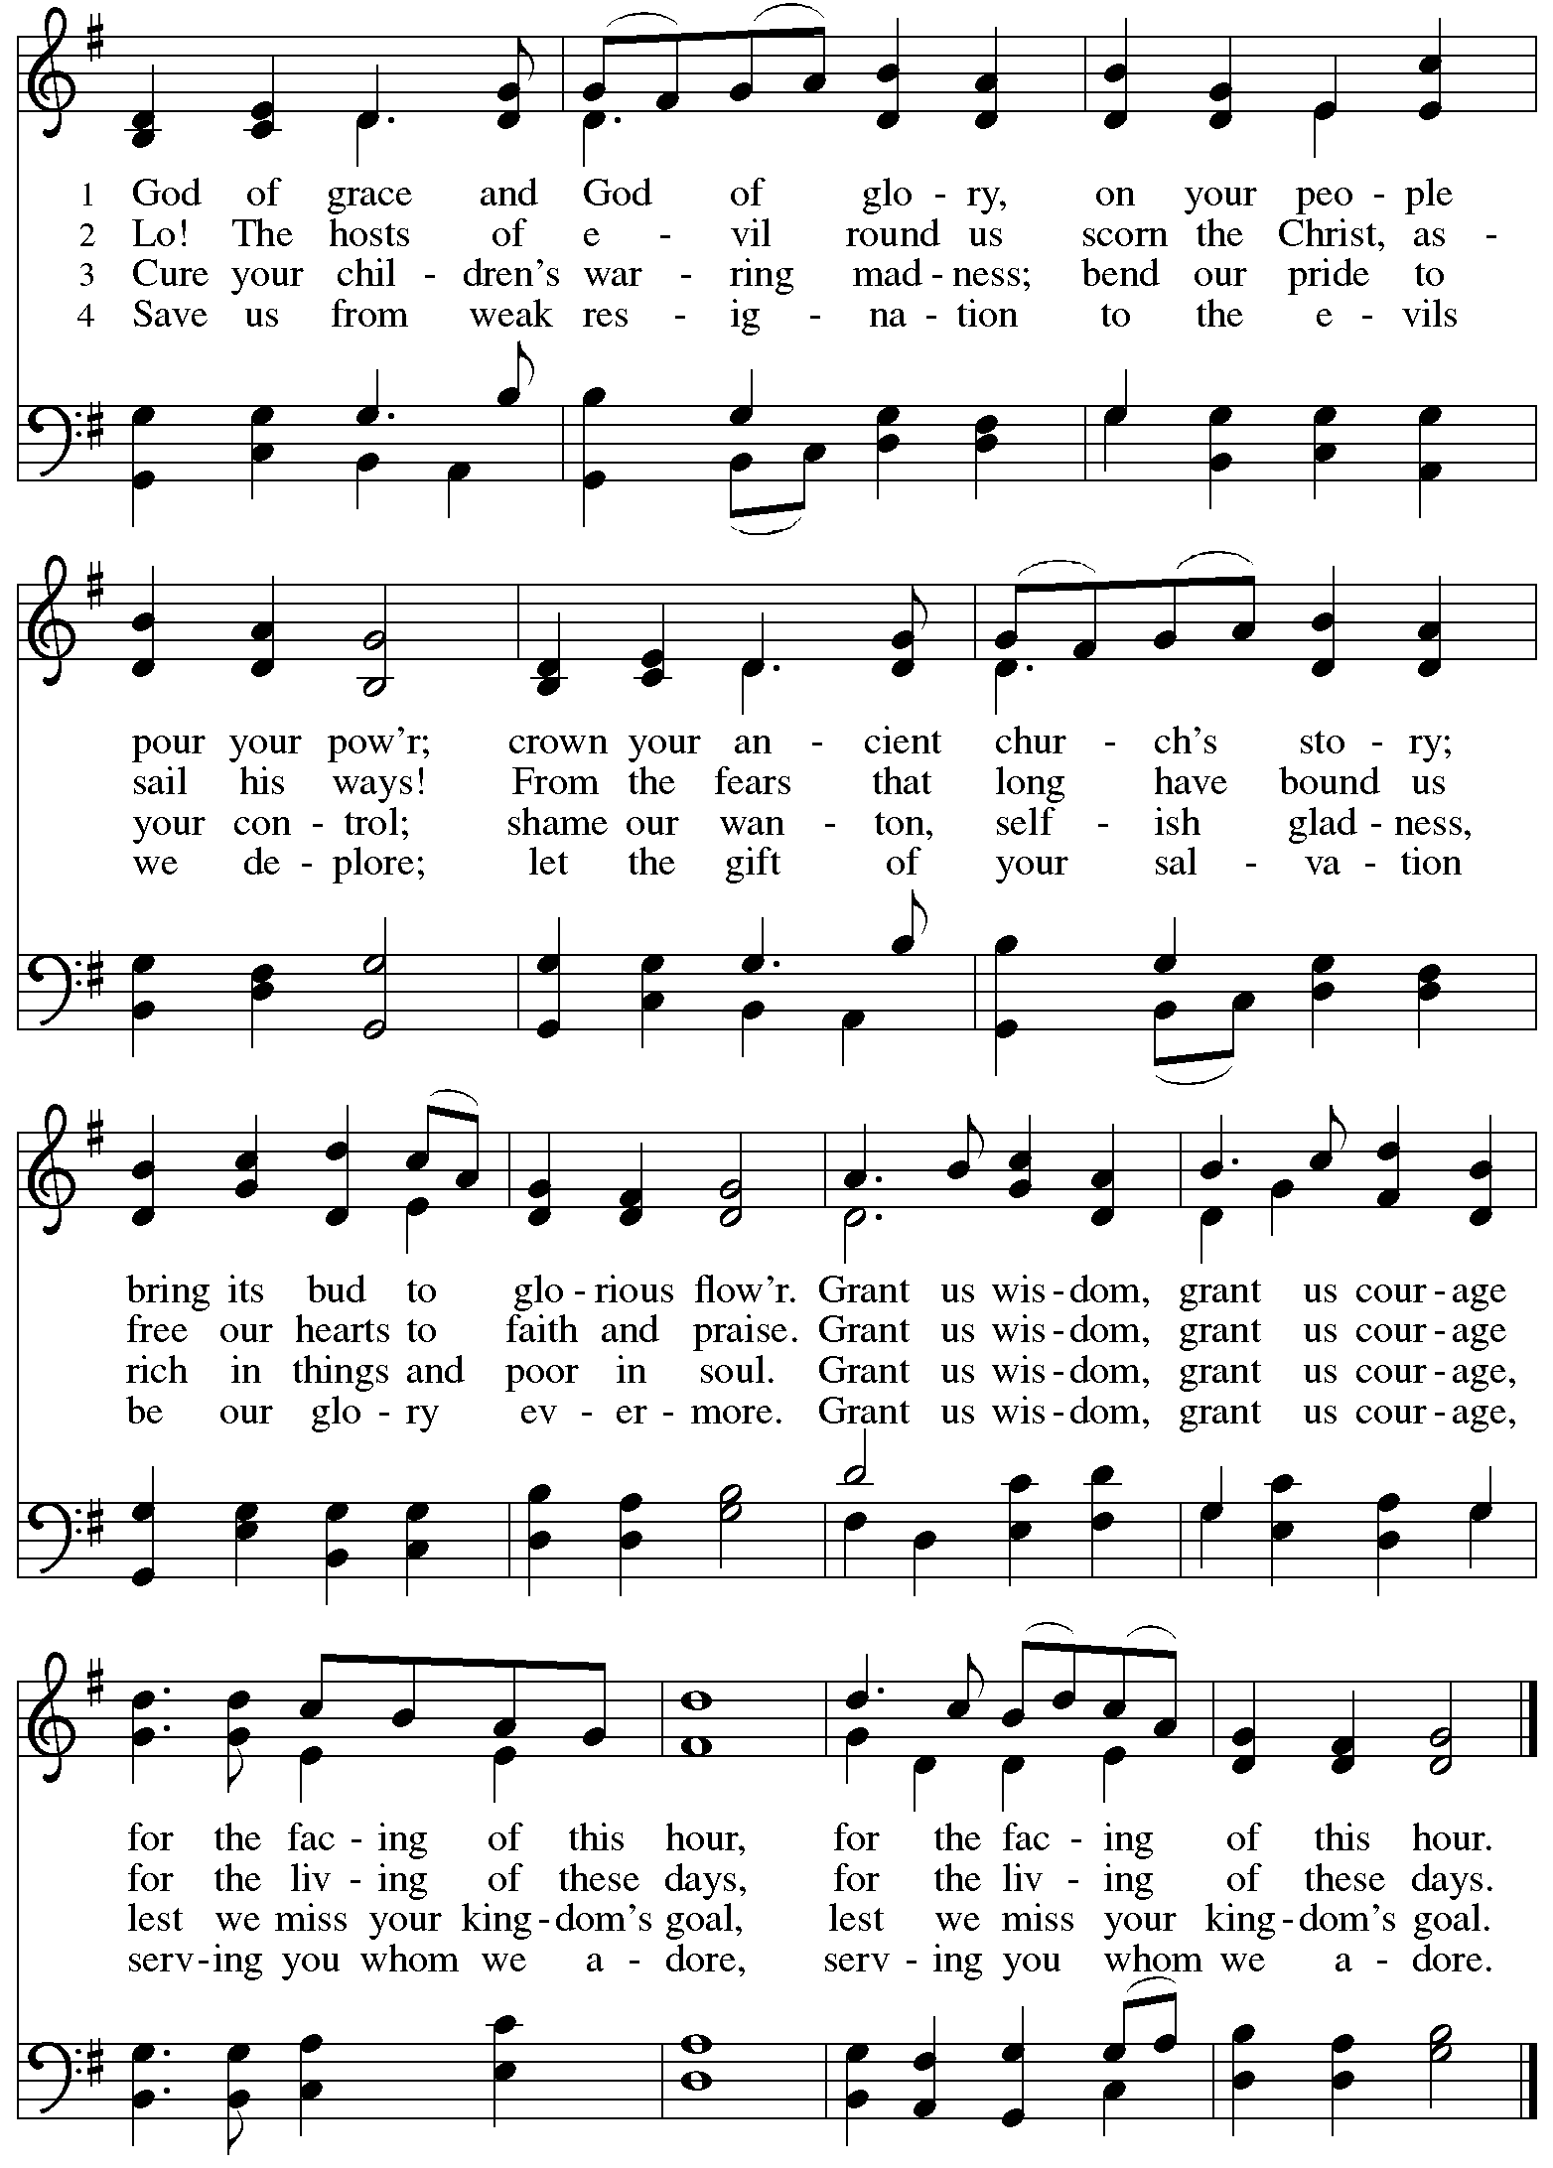
Those serving in worship today

Altar Care and Lector Christy Ruhe
Assisting Minister Colleen Cooke
Audio-Visual Minister Kristen Asplin
Cantor Noël Marsh
Little Church - Big Faith Leader Sue Gaugler
Minister of Music Laura Reynolds
Piano – Offertory Music Sarita
Presiding and Preaching Minister The Rev. Ross Carmichael

Liturgy and Hymnody Acknowledgements

From SundaysandSeasons.com. Copyright © 2023 Augsburg Fortress. All rights reserved. Reprinted under OneLicense.net # A-722139.
Used by permission of Augsburg Fortress.

Now the Feast and Celebration –Text: Marty Haugen, b. 1950. Music: NOW THE FEAST AND CELEBRATION, Marty Haugen. Text and music © 1990 GIA Publications, Inc. 7404 Mason Ave. Chicago, IL 60638. www.giamusic.com. 800.442.3358. All rights reserved. Reprinted with permission under OneLicense.net # A-722139.

God, Whose Giving Knows No Ending – Text: Robert L. Edwards, 1915-2006. Music: RUSTINGTON, C. Hubert H. Parry, 1848-1918. Text © 1961, ren. 1989 The Hymn Society, admin. Hope Publishing Company, Carol Stream, IL 60188. All rights reserved. Reprinted with permission under OneLicense.net # A-722139.

God of Grace and God of Glory – Text: Harry E. Fosdick, 1878-1969. Music: CWM RHONDA, John Hughes, 1873-1932.

Please use the QR code below to link to St. Andrew’s Announcements online!

St. Andrew Lutheran Church Announcements
October 22nd, 2023

- Welcome to worship at St. Andrew on the Twenty-first Sunday after Pentecost, October 22nd, 2023 – We are so glad you are here, and we offer a special welcome to all visitors here or online for the first time! This week we move into the “Now the Feast and Celebration” setting of the liturgy from the Hymnal Supplement. Worship attendees are invited to make a name tag at the back of the worship space if you would like. Children are invited to participate in Little Church – Big Faith, a Bible lesson and activity, after the prayer of the day. There are worship “toolkits” to help children engage with worship and “busy bags” for younger children available in the bookcase at the back of the sanctuary. Please feel free to take one to use with/for your children. We invite everyone to stay after worship for coffee and conversation in the Social Hall next to the sanctuary.

- Singing for Reformation Sunday – Rehearsal after Worship Today – Anyone who would like to participate in a choir singing one song for Reformation Sunday next week, October 29th, is invited to stay after worship for rehearsal today. There will also be a rehearsal before worship next Sunday, October 29th. Please speak with Minister of Music Laura Reynolds if you have questions or would like to participate.
- Camp Lutherlyn “Building for the Future” Campaign Continues – St. Andrew is participating in an ongoing campaign of the larger church to raise money for Lutherlyn in Prospect, PA. Lutherlyn is a camp beloved by generations in this area which has been integral in supporting the faith of children, youth, and adults and forming leaders for the church’s mission. The plan is to fund two new five-cabin villages, one of which will replace well-used cabins from 1958, and to renew and preserve the Steininger Memorial Amphitheater, and outdoor worship space. Lutherlyn is asking for commitments from individuals, families, foundations, and congregations to fund its initiatives. See the attachment to this Sunday’s bulletin, which includes a message from Honorary Campaign Chair and Bishop Emeritus of the Southwestern Pennsylvania Synod Donald McCoid, and a description and floorplan for proposed cabins. In a few weeks, we will offer an opportunity to make commitments to the campaign during worship. Please prayerfully consider how God may be calling you to support the life-changing ministries of Lutherlyn, “A God-given place to be accepted, challenged, and sent.”
- Compline Prayer Service, a Ministry of Lutheran Campus Ministry in Greater Pittsburgh, Sundays at 8:00 p.m. at Heinz Chapel – Compline was traditionally a monastic prayer service, and the Pittsburgh Compline Choir sings a choral version of compline rooted in this thousand-year-old tradition of scripture, song, and silence. This service also streams on Facebook (Pittsburgh Compline Choir) and YouTube (The Pittsburgh Compline Choir). Heinz Chapel is located off of S. Bellefield Ave. in Oakland.
- Cross-Generational Activity (Advent Banner Preparation!) for Children, Youth, Parents / Guardians, and the Whole Congregation – after Worship Next Sunday, October 29th – In the past, children and youth of St. Andrew have helped create art for banners that adorn the worship space in the season of Advent, and we would like to create banners for a new church year. We invite children, youth, parents / guardians to gather after worship next Sunday to hear an Advent reading, talk about its imagery, and work together on an artistic representation of the text, which will be used to make four new banners, one for each week of the Advent season. While we hope for primary input from children and youth, we encourage everyone in the congregation to stay to support them and share in the St. Andrew community on these Sundays! Please speak with Christian Education liaison Colten Rohleder or Jimmi Kocher-Hillmer if you have questions.
- Renew the Pews Continues after Worship on Sunday, October 29th – We have completed the cleaning of two sections of the pews with one more to go. We ask those who are not participating in the Advent banner-making to help in the sanctuary after worship. We will be steam-cleaning the pew cushions and replacing some of the buttons that have fallen off after years of use. We thank congregation president Kristen Asplin for organizing this effort and to all who have lent their steam-cleaning equipment!

- Bible Study and “The Chosen” with Pastor Paul Koch – Sundays, November 5th, 12th, and 19th – The Chosen is an online television series based on the Gospels of Jesus Christ, with some locations and timelines combined, condensed, or interpreted, and some dialogue and backstory added. Pastor Paul Koch will lead a series of studies, looking at Gospel texts, comparing and contrasting with “The Chosen,” and inviting further consideration of how we engage with the stories of Jesus. We encourage people to watch episodes of The Chosen ahead of time but will highlight specific sections to consider for our Sunday discussions. The series is available for free at the official website, https://new.thechosen.tv/, or using The Chosen app. It can also be found on YouTube, Amazon Prime, and other streaming services. We may continue the study for additional weeks if there is sufficient interest and participation.
- For Your Calendar – Interfaith Thanksgiving Service – Tuesday, November 21st, at 7:00 p.m. at Temple Sinai – Local houses of worship have been gathering for an interfaith Thanksgiving service for many years and this year’s will be held at Temple Sinai, 5505 Forbes Ave., Pittsburgh 15217 on Tuesday, November 21st, at 7:00 p.m. Join members of Pittsburgh’s many faith communities in a gathering to reconnect us with one another. Light refreshments will be served.
- Christ in Our Home Devotional Booklets for October – December Available at Church Entrances – This resource offers a daily Bible reading with a short reflection and prayer, along with additional readings and prayer topics for those who would like to expand their devotional practices. We encourage people of the congregation to take one for yourself, your family unit, or others!

