+ Reformation Sunday
October 29th, 2023
10:00 a.m.

St. Andrew Lutheran Church
304 Morewood Ave.
Pittsburgh, PA 15213
412.682.3342
St_andrewELCA@verizon.net
www.standrewpittsburgh.org

+ Reformation Sunday
Order for Worship

Rooted in the past and growing into the future, the church must always be reformed
to live the love of Christ in an ever-changing world. On Reformation Sunday we celebrate the good news of God’s grace, that Jesus Christ sets us free every day to do this life-transforming work. Trusting in the freedom given to us in Baptism, we pray for the church, that Christians around the world will unite more fully in worship and mission.

Welcome to St. Andrew!

- St. Andrew Lutheran congregation welcomes all who are seeking a place of healing and wholeness – a nurturing, faith-forming spiritual home. Our community embraces people of all ages, ethnicities, cultures, abilities, sexual orientations, gender identities and expressions, and family constellations. Come and See!

- Worship Services are live streamed to multiple online platforms. By attending worship, you agree that your image and voice may be broadcast.

- Everyone is invited to make a nametag at the black bookcase in the back of the worship space if they would like. There are stickers indicating pronouns on the bookcase if you would like to include them on your name tag.

- Worship “toolkits” to help children engage with the service, along with “busy bags” for younger children, are available in the bookcase at the back of the sanctuary. Please feel free to take one to use with/for your children.

- Children are invited to attend Little Church – Big Faith, a Bible lesson and activity, during worship (after the Prayer of the Day). The group returns to the worship space for the liturgy of Holy Communion.

- Holy Communion is served with bread (gluten-free available) and wine or grape juice. The presiding minister will distribute the bread (host). Please consume this and then pick up an empty glass from the tray. The Communion Assistant will pour wine or grape juice into your glass. Please step to the side to consume the wine or grape juice. Feel free to kneel at the altar for prayer and reflection. As you return to your pew, glasses may be returned to the empty trays on either side of the center section.

- A restroom is available on the main level of the church, through the doors to the Social Hall and to the right in the main office.

Abbreviations
P: Pastor/Presiding Minister ACS: All Creation Sings hymnal
A: Assisting Minister ELW: Evangelical Lutheran Worship hymnal
L: Lector
C: Congregation

Pre-Service Music

Welcome

Prelude

Gathering
The Holy Spirit calls us together as the people of God

Confession and Forgiveness

Please rise as you are able. All may make the sign of the cross,
the sign that is marked at Baptism, as the presiding minister begins.

P: Blessed be the holy Trinity, ☩ one God,
whose mercy endures forever.
C: Amen.

P: If we say we have no sin we deceive ourselves and the truth is not in us.
Let us confess our sin to God, who is faithful and just
and who has promised to forgive our sin and cleanse us from all unrighteousness.

Silence is kept for reflection and self-examination.

P: Most merciful God,
C: have mercy on us.
We confess to you
that we have sinned against you
in thought, word, and deed,
by what we have done
and by what we have left undone.
We have not trusted you with our whole heart.
We have not loved one another in deed and in truth.
In your compassion, forgive our sin and uphold us by your Spirit,
that we may live and serve you in newness of life
through Jesus Christ, our light and our truth.
Amen.

P: With joy I proclaim to you that Almighty God,
rich in mercy, abundant in love,
forgives you all your sin
and grants you newness of life in ☩ Jesus Christ.
C: Amen. Thanks be to God!

Gathering Hymn A Mighty Fortress Is Our God ELW 505

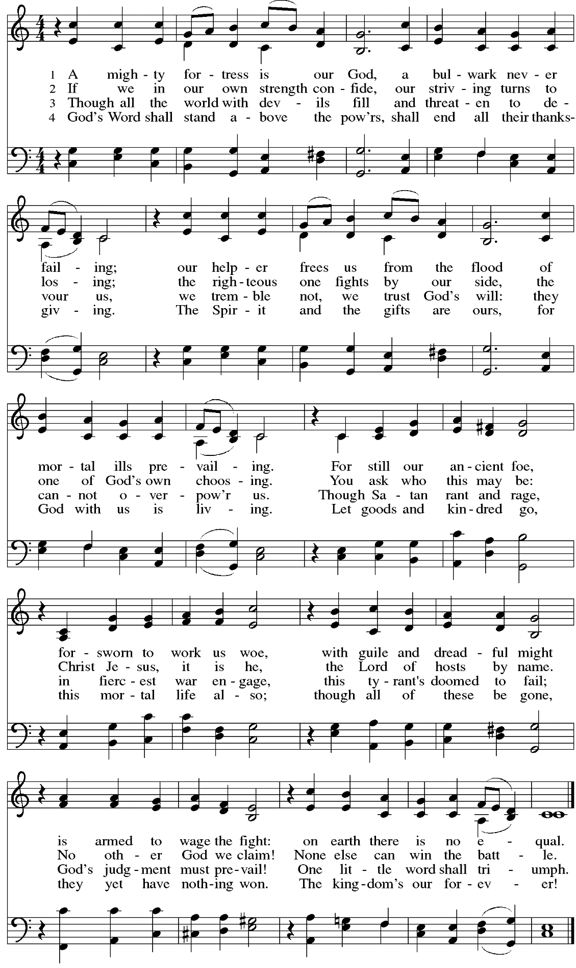
Greeting

P: The grace of our Lord Jesus Christ, the love of God,
and the communion of the Holy Spirit be with you all.
C: And also with you.

Hymn of Praise Now the Feast and Celebration HS p. 4-5

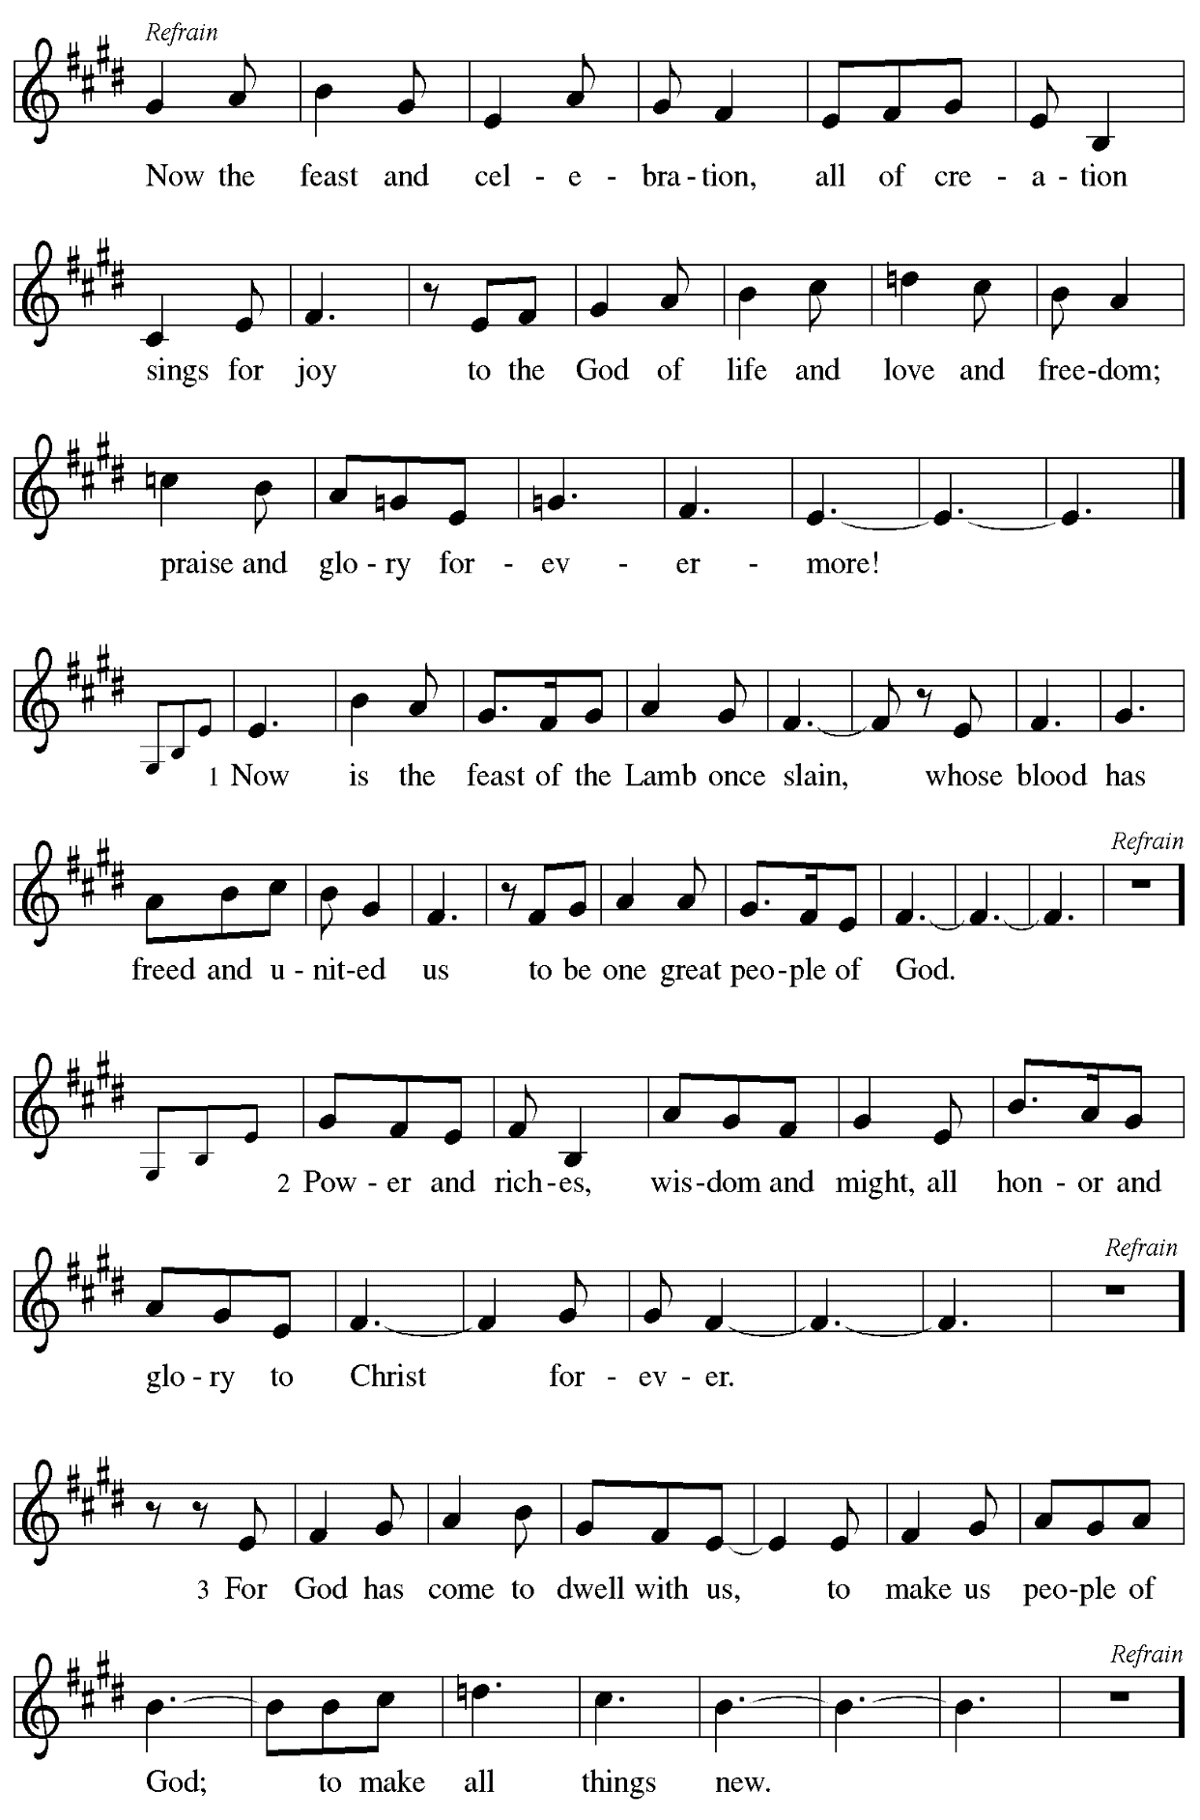
Prayer of the Day

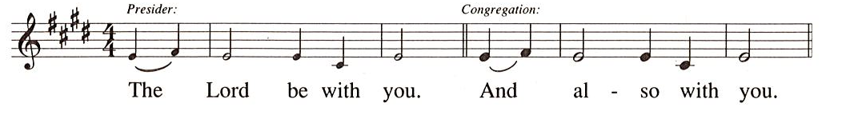

P: Let us pray.
Almighty God, gracious Lord,
we thank you that your Holy Spirit renews the church in every age.
Pour out your Holy Spirit on your faithful people.
Keep us steadfast in your word, protect and comfort us in times of trial,
defend us against all enemies of the gospel, and bestow on the church your saving peace,
through Jesus Christ, our Savior and Lord, who lives and reigns with you and the Holy Spirit, one God, now and forever.
C: Amen.

Please be seated.
Children are invited to join the adult leaders at the door and move to the office for Little Church – Big Faith. We ask that one additional adult from the congregation attend with the children.

Word
God speaks to us in Scripture reading, preaching, and song

First Reading – Jeremiah 31-31-34

³¹The days are surely coming, says the Lord, when I will make a new covenant with the house of Israel and the house of Judah. ³²It will not be like the covenant that I made with their ancestors when I took them by the hand to bring them out of the land of Egypt—a covenant that they broke, though I was their husband, says the Lord. ³³But this is the covenant that I will make with the house of Israel after those days, says the Lord: I will put my law within them, and I will write it on their hearts; and I will be their God, and they shall be my people. ³⁴No longer shall they teach one another, or say to each other, “Know the Lord,” for they shall all know me, from the least of them to the greatest, says the Lord; for I will forgive their iniquity, and remember their sin no more.

L: Word of God, word of life.
C: Thanks be to God.

Psalm 46 M. Hayes

The psalm for this week will be sung by a choir.

Second Reading – Romans 3: 19-28

¹⁹Now we know that whatever the law says, it speaks to those who are under the law, so that every mouth may be silenced, and the whole world may be held accountable to God. ²⁰For “no human being will be justified in God’s sight” by deeds prescribed by the law, for through the law comes the knowledge of sin.
²¹But now, apart from law, the righteousness of God has been disclosed, and is attested by the law and the prophets, ²²the righteousness of God through faith in Jesus Christ for all who believe. For there is no distinction, ²³since all have sinned and fall short of the glory of God; ²⁴they are now justified by God’s grace as a gift, through the redemption that is in Christ Jesus, ²⁵whom God put forward as a sacrifice of atonement by his blood, effective through faith. God did this to show God’s righteousness, because in God’s divine forbearance God had passed over the sins previously committed; ²⁶it was to prove at the present time that the divine Godself is righteous and that God justifies the one who has faith in Jesus.
²⁷Then what becomes of boasting? It is excluded. By what law? By that of works? No, but by the law of faith. ²⁸For we hold that a person is justified by faith apart from works prescribed by the law.

L: Word of God, word of life.
C: Thanks be to God.

Please rise as you are able.

Gospel Acclamation HS p. 8
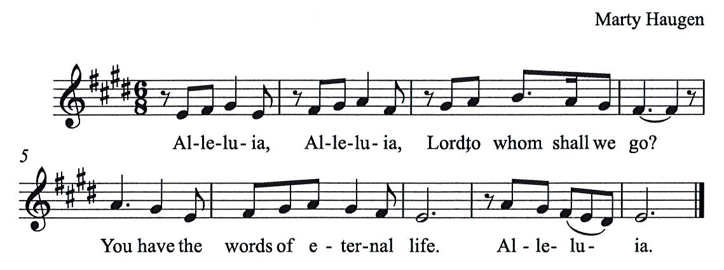

Gospel – John 8: 31-36

P: The holy Gospel according to St. John.
C: Glory to you, O Lord.

³¹Jesus said to the Jews who had believed in him, “If you continue in my word, you are truly my disciples; ³²and you will know the truth, and the truth will make you free.” ³³They answered him, “We are descendants of Abraham and have never been slaves to anyone. What do you mean by saying, ‘You will be made free’?”
³⁴Jesus answered them, “Very truly, I tell you, everyone who commits sin is a slave to sin.
³⁵The slave does not have a permanent place in the household; the son has a place there forever.
³⁶So if the Son makes you free, you will be free indeed.”
P: The Gospel of the Lord.
C: Praise to you, O Christ.

Please be seated.

Sermon

A time of silence for prayer and reflection follows the sermon.
When the hymn of the day begins, please rise as you are able.

Hymn of the Day Founded on Faith ACS 1048

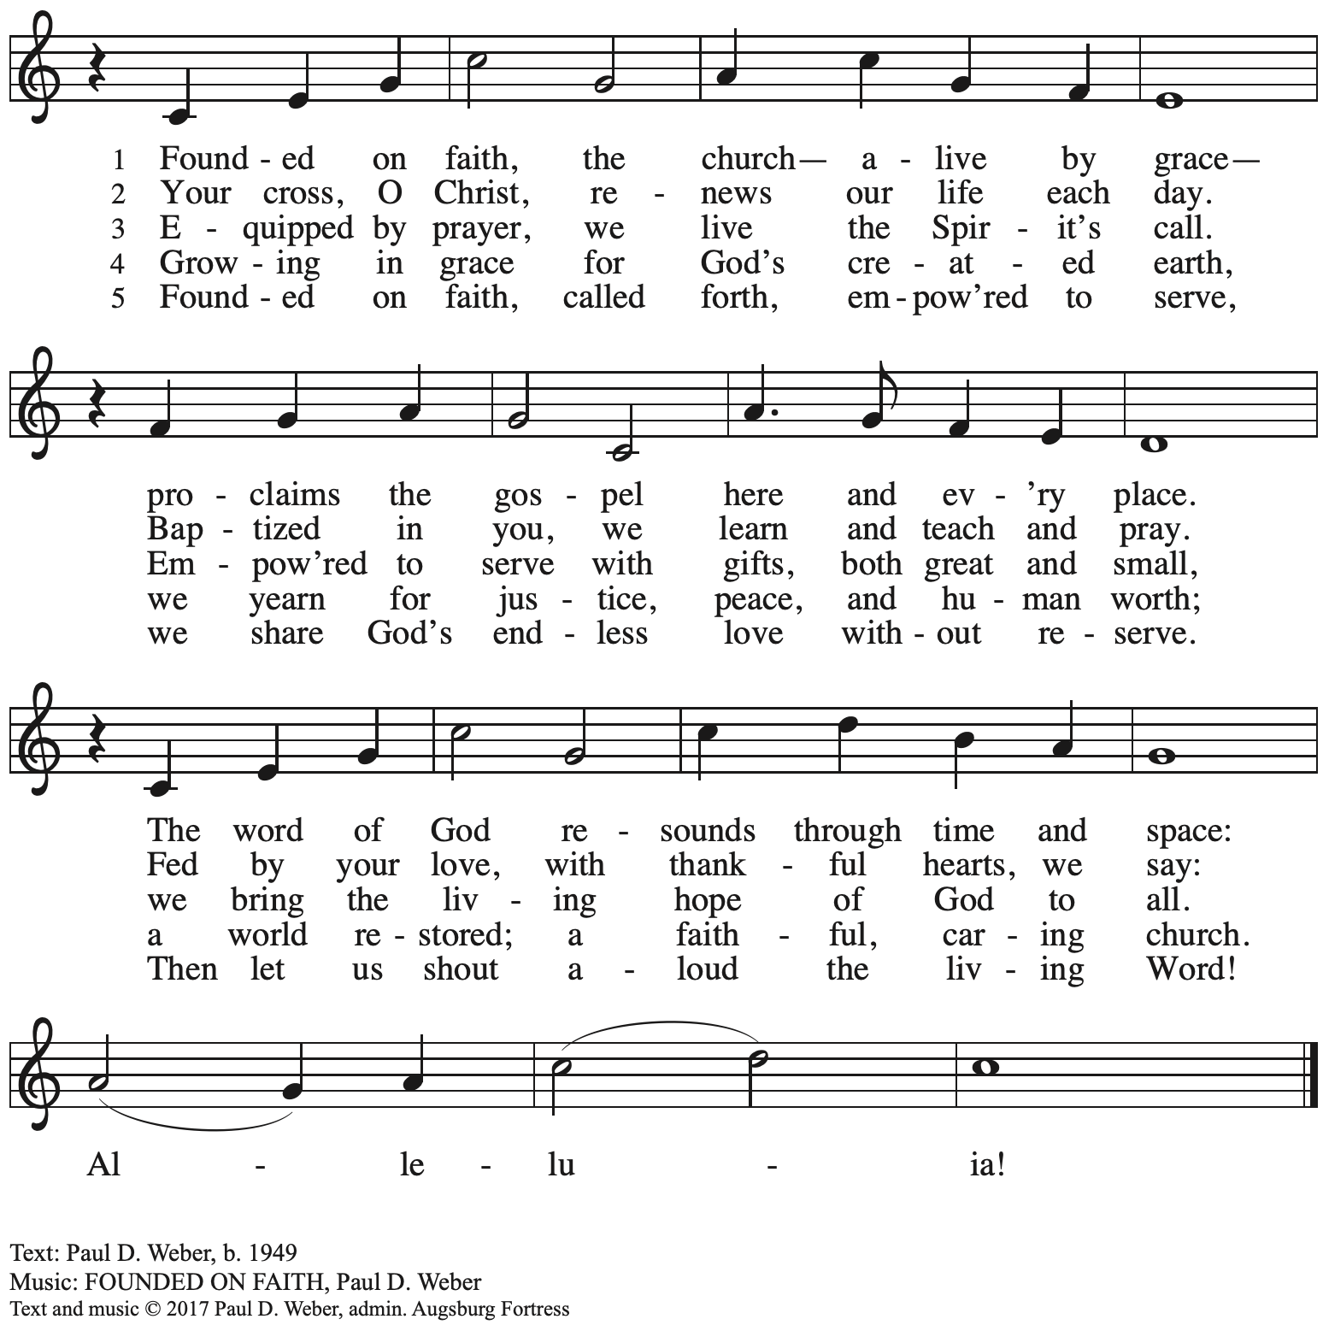
All rights reserved. Reprinted with permission under OneLicense.net # A-722139.
Apostles Creed

P: Let us confess our faith:
C: I believe in God, the Father almighty,
creator of heaven and earth.

I believe in Jesus Christ, God’s only Son, our Lord,
who was conceived by the Holy Spirit,
born of the virgin Mary,
suffered under Pontius Pilate,
was crucified, died, and was buried;
he descended to the dead.*
On the third day he rose again;
he ascended into heaven,
he is seated at the right hand of the Father,
and he will come to judge the living and the dead.

I believe in the Holy Spirit,
the holy catholic church,
the communion of saints,
the forgiveness of sins,
the resurrection of the body,
and the life everlasting. Amen.

*Or, “he descended into hell,” another translation of this text in widespread use.

Prayers of the People

A: Trusting in the transformative power of God’s loving Spirit,
let us pray for the church, the world, and all who are in need.

After each petition
A: God of grace,
C: receive our prayer.

The presiding minister concludes the prayers
P: Into your care, gracious God,
we commend all for whom we pray,
trusting in your unending love and amazing grace;
through Jesus Christ, our Savior.
C: Amen.

Peace

The presiding minister and the assembly greet one another in the peace of the risen Christ.
P: The peace of Christ be with you always.
C: And also with you.

The people may greet those around them with a sign of Christ’s peace and may say
Peace be with you or similar words. Please be mindful that not everyone will be comfortable with sharing the peace, so please seek consent before shaking hands or hugging. Other possible ways to share the peace include a simple bow with the verbal greeting of peace, or simply a verbal expression of peace.

When the greetings of peace have concluded, please be seated.

Meal
God feeds us with the presence of Jesus Christ

Offering

We offer ourselves, our gifts, and our faithful service to God.
As the offering is gathered for the mission of the church, including the care of those in need,
the table is set for Holy Communion.

Music during the Offering

As the gifts are brought forward for presentation, please rise as you are able.

Offertory Song As the Grains of Wheat ELW 465

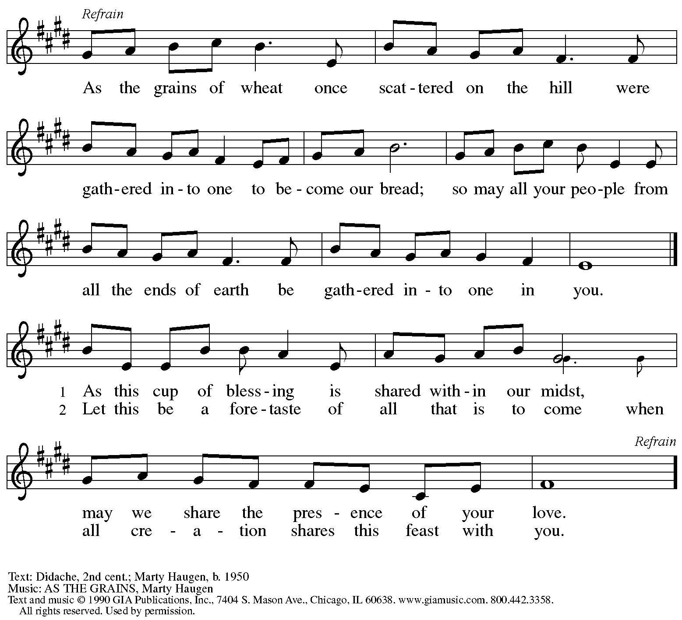
Reprinted with permission under OneLicense.net # A-722139.

Offertory Prayer

A: Let us pray.
God of all creation,
C: the eyes of all wait upon you,
and you open your hand in blessing.
Fill us with good things at your table,
that we may come to the help of all in need,
through Jesus Christ, our redeemer and Lord.
Amen.

Dialogue HS p. 14

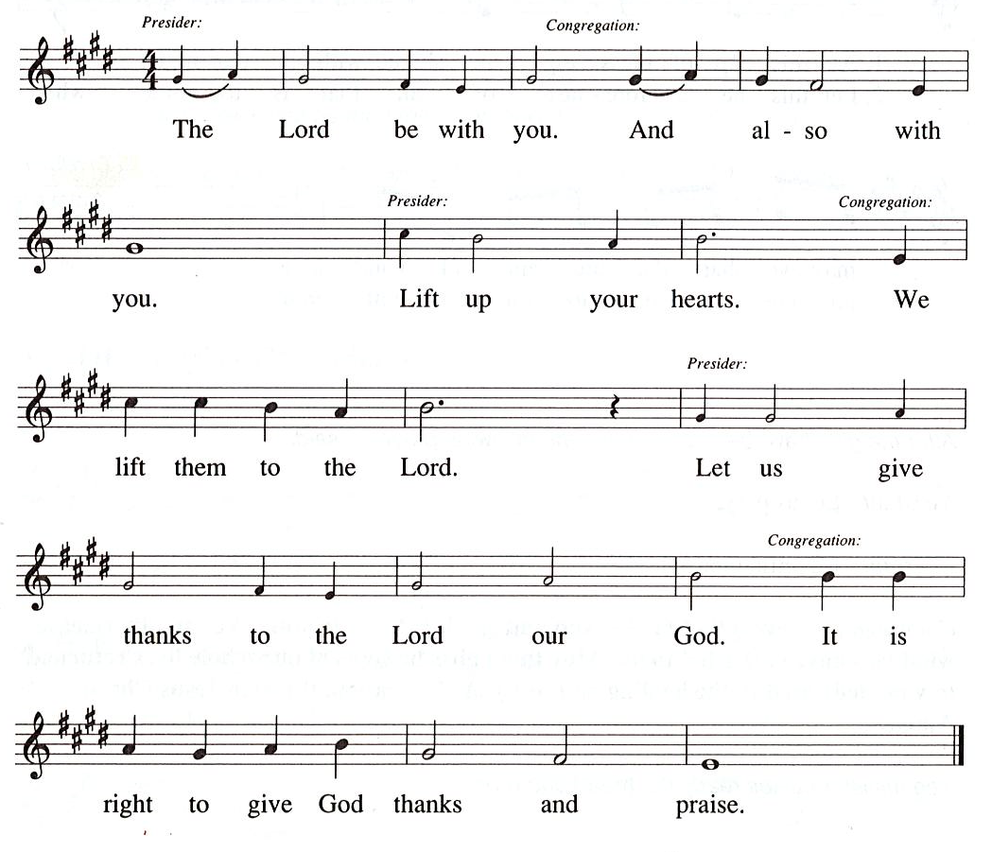

Preface (Sung by the presiding minister)

P: It is our duty and delight
that we should everywhere and always
offer thanks and praise to you, O God,
through Jesus Christ,
who calls us to follow his way
of humble service and love,
and so with the church on earth,
all creation and the hosts of heaven,
we praise your name and join their unending hymn:

Sanctus HS p. 15

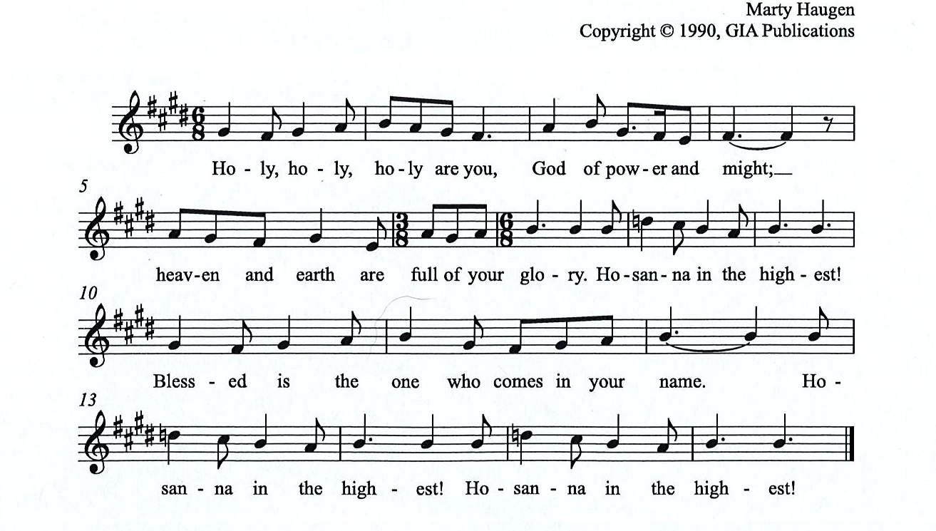

Eucharistic Prayer

P: You are indeed holy, almighty and merciful God, …
… Do this for the remembrance of me.

For as often as we eat of this bread and drink from this cup,
we proclaim the Lord’s death until he comes.
C:

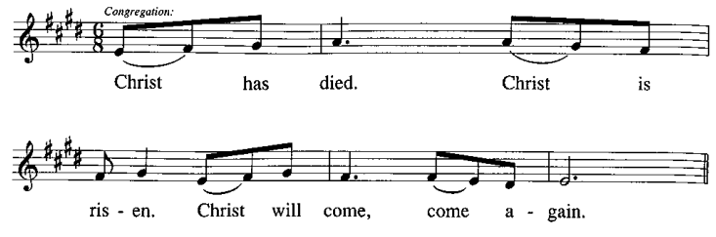

P: Remembering, therefore, …
… … To you, O God, Father, Son, and Holy Spirit
be all honor and glory in your holy church, now and forever.
C:
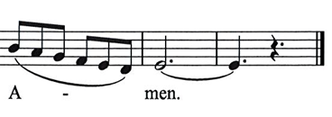

Lord’s Prayer

P: Gathered as one by the Holy Spirit, let us pray as Jesus taught us.
C: Our Father in heaven,
hallowed be your name,
your kingdom come,
your will be done,
on earth as in heaven.
Give us today our daily bread.
Forgive us our sins
as we forgive those
who sin against us.
Save us from the time of trial
and deliver us from evil.
For the kingdom, the power,
and the glory are yours,
now and forever. Amen.

Fraction and Invitation

Agnus Dei / Lamb of God HS p. 18

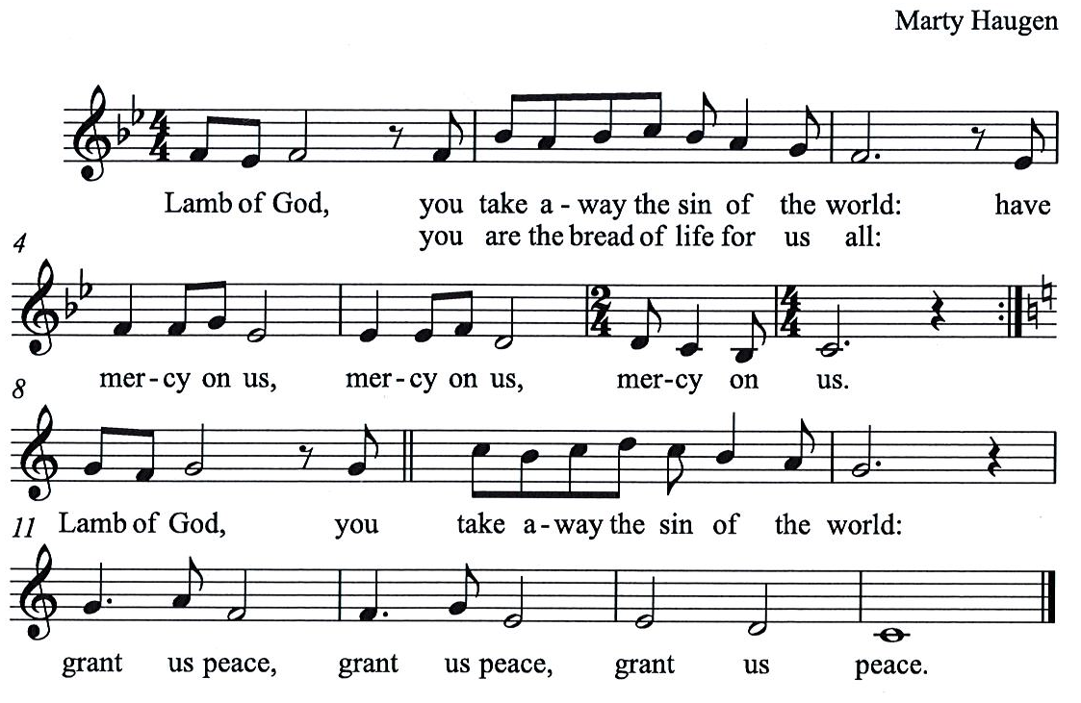

Please be seated.

Holy Communion
- All who seek God and desire a deeper and stronger life in Christ are welcome to receive Holy Communion.
- Worshipers from the pulpit side will proceed forward first, followed by the center section, and then the lectern side.
- Please inform an usher if you would like the ministers to bring Communion to you.
- Holy Communion will be served with bread and wine/grape juice.
- The presiding minister will first distribute the bread (host) to each communicant. Please indicate if you require a gluten-free host.
- Once you have consumed the bread, please pick up an empty glass from the tray next to the presiding minister. The Communion Assistant will pour wine from the chalice or grape juice from the cruet into your glass.
- Please step to the side to consume the wine or grape juice.
- Feel free to kneel at the altar rail for prayer after receiving the sacrament.
- As you return to your pew, glasses may be returned to the empty trays on either side of the center section.
- A blessing will be provided for anyone who does not yet receive the sacrament.
- All are invited to join in singing the hymns during Holy Communion.

Hymns during Holy Communion
Ask the Complicated Questions ACS 1005

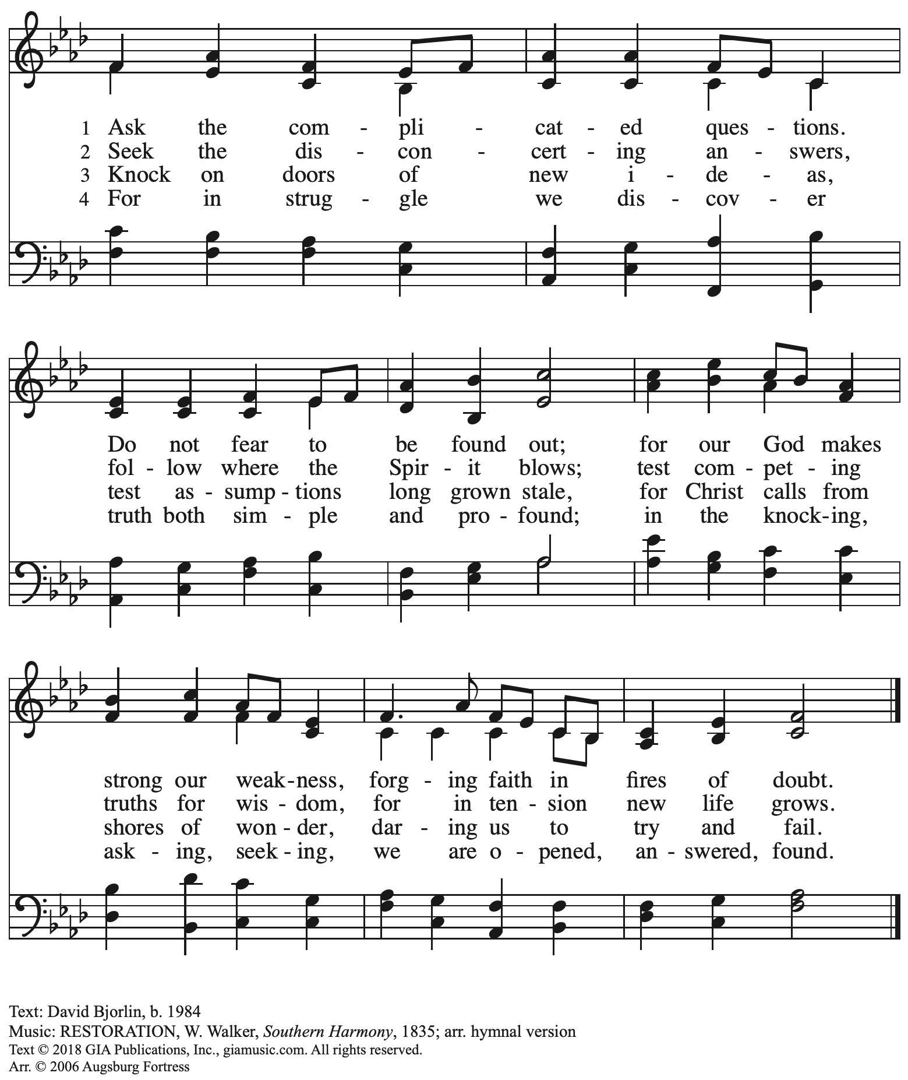
Reprinted with permission under OneLicense.net # A-722139.

Hymns during Holy Communion
By Grace We Have Been Saved ACS 1006

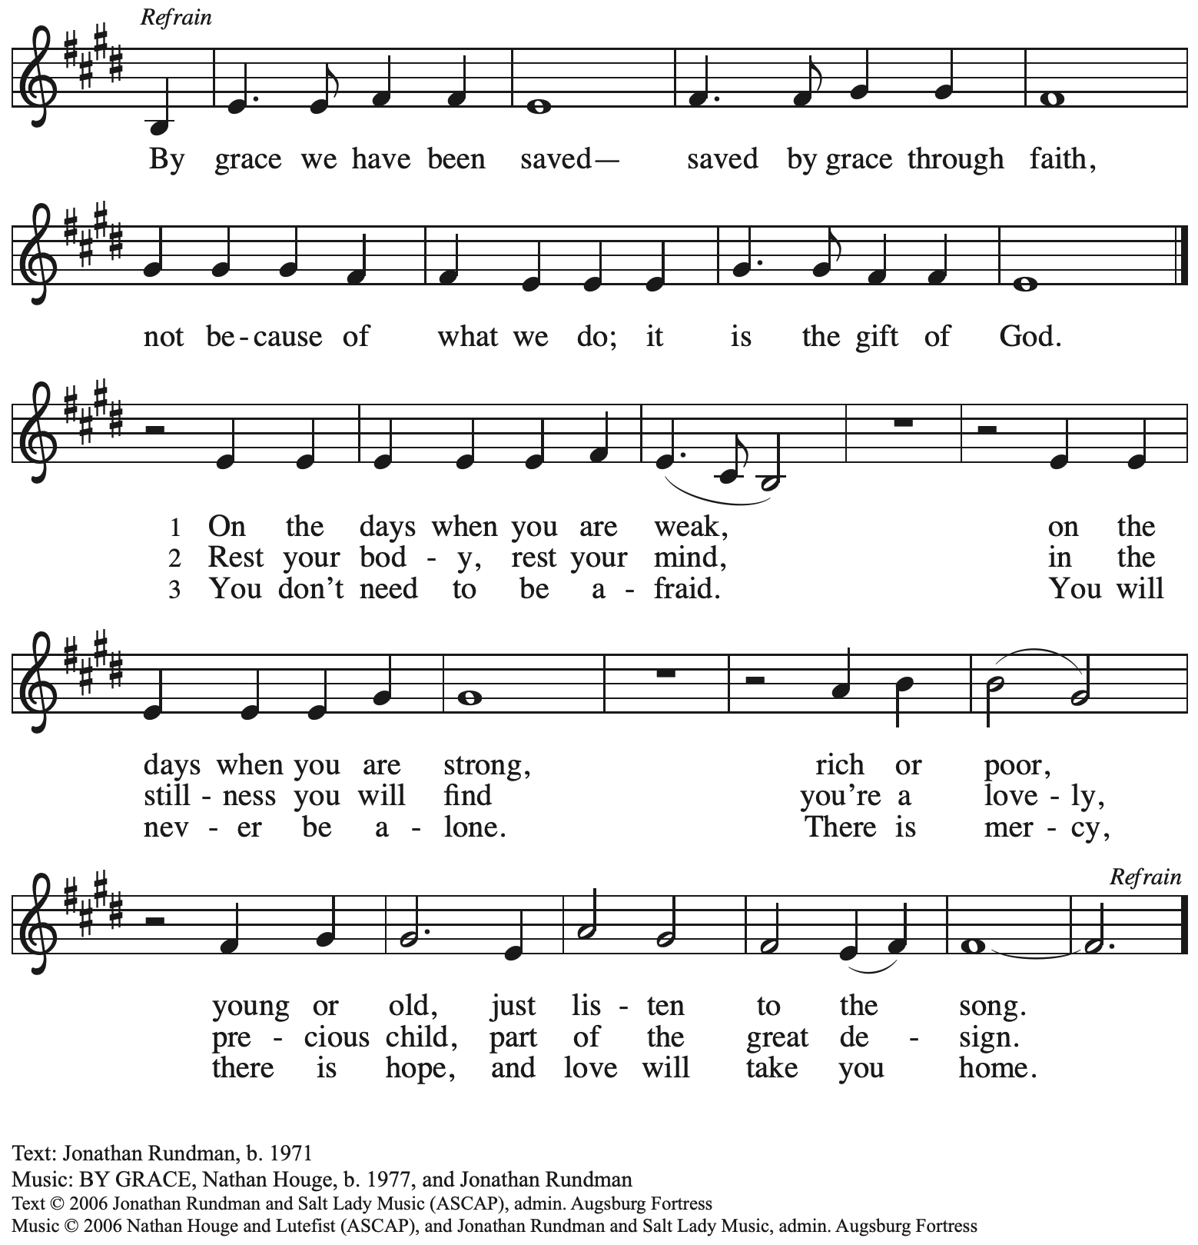
All rights reserved. Reprinted with permission under OneLicense.net # A-722139.

Hymns during Holy Communion
That Priceless Grace ELW 591

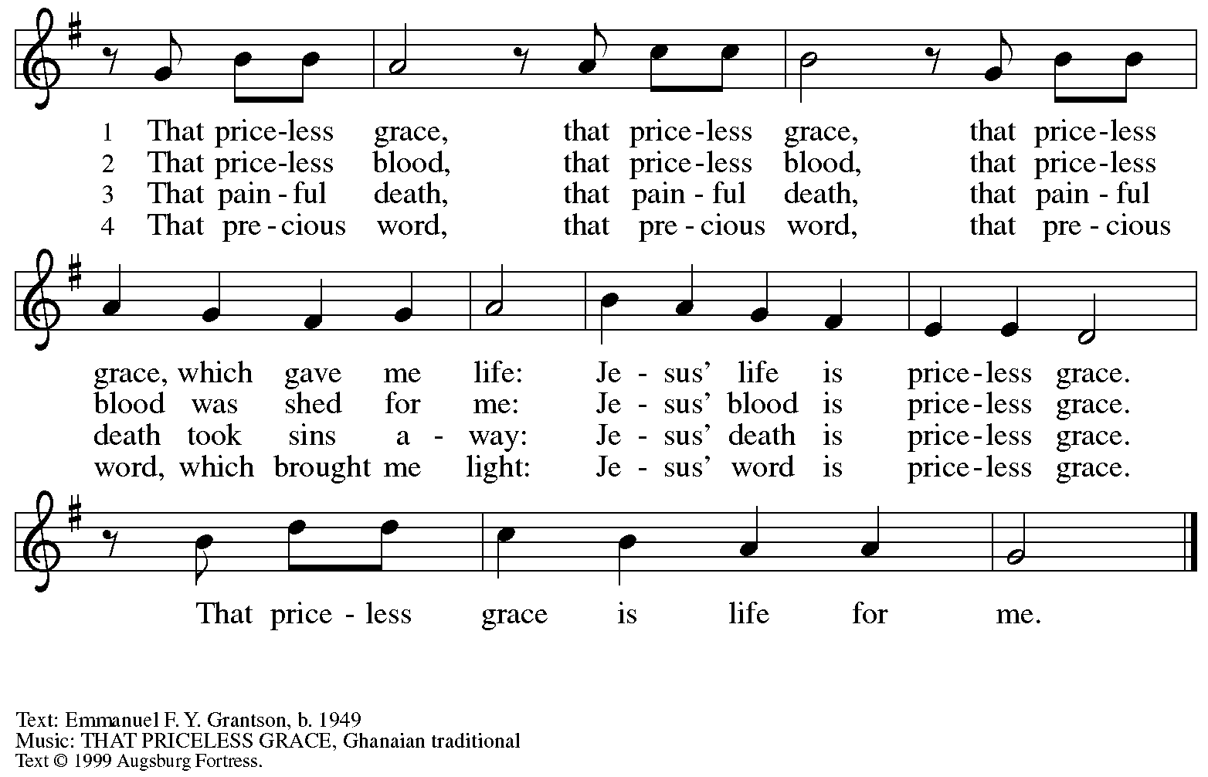
All rights reserved. Reprinted with permission under OneLicense.net # A-722139.

When all have returned to their places, please rise as you are able.

Blessing

P: The body and blood of our Lord Jesus Christ strengthen you and keep you in his grace.
C: Amen.

Prayer

A: Let us pray.
Gracious God,
in this meal you have drawn us to your heart,
and nourished us at your table with food and drink, the body and blood of Christ.
Now send us forth to be your people in the world,
and to proclaim your truth this day and evermore,
through Jesus Christ, our Savior and Lord.
C: Amen.

Please be seated.

Sending
God blesses us and sends us in mission to the world

Announcements

Please rise as you are able.

Benediction

P: The God of glory,
☩ Jesus Christ, name above all names,
and the Spirit who lives in you
bless you now and forever.
C: Amen.

Sending Hymn The Church’s One Foundation Following page

Dismissal

A: Go in peace. Serve the Lord.
C: Thanks be to God!

Postlude

Sending Hymn The Church’s One Foundation ELW 654

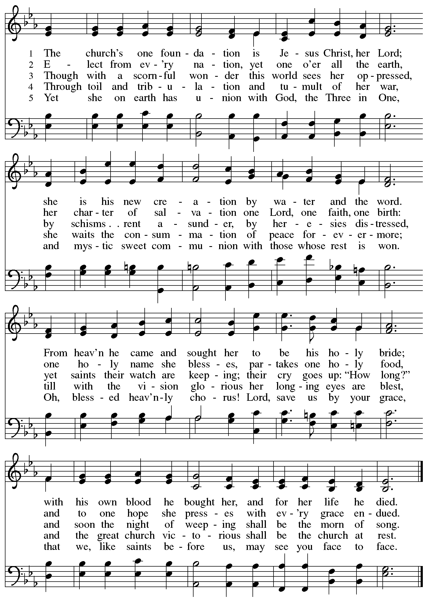

Those serving in worship today

Altar Care Jodie Minor
Assisting Minister Timothy Kocher-Hillmer
Audio-Visual Ministers Jason Galyardt
Colten Rohleder
Cantor Joy Givens
Lector Noël Marsh
Little Church – Big Faith Leader Emily Duque
Minister of Music Laura Reynolds
Organ Jimmi Kocher-Hillmer
Presiding and Preaching Minister The Rev. Ross I. Carmichael

Liturgy and Hymnody Acknowledgements

From SundaysandSeasons.com. Copyright © 2023 Augsburg Fortress. All rights reserved. Reprinted under OneLicense.net # A-722139.
Used by permission of Augsburg Fortress.

A Mighty Fortress Is Our God – Text: Martin Luther, 1483-1546; tr. Frederick H. Hedge, 1805-1890, alt. Music: EIN FESTE BURG, Martin Luther. Text © 2006 Augsburg Fortress. All rights reserved. Reprinted under OneLicense.net # A722139.

The Church’s One Foundation – Text: Samuel J. Stone, 1839-1900. Music: AURELIA, Samuel S. Wesley, 1810-1876.

Please use the QR code below to link to St. Andrew’s Announcements online!

St. Andrew Lutheran Church Announcements
October 29th, 2023

- Welcome to worship at St. Andrew on Reformation Sunday October 29th, 2023 – We are so glad you are here, and we offer a special welcome to all visitors here or online for the first time! Worship attendees are invited to make a name tag at the back of the worship space if you would like. Children are invited to participate in Little Church – Big Faith, a Bible lesson and activity, after the prayer of the day. There are worship “toolkits” to help children engage with worship and “busy bags” for younger children available in the bookcase at the back of the sanctuary. Please feel free to take one to use with/for your children. We invite everyone to stay after worship for coffee and conversation in the Social Hall next to the sanctuary.
- Cross-Generational Activity (Advent Banner Preparation!) for Children, Youth, Parents / Guardians, and the Whole Congregation – after Worship Today – In the past, children and youth of St. Andrew have helped created art for banners that adorn the worship space in the season of Advent, and we would like to create banners for a new church year. We invite children, youth, parents / guardians to gather after worship to hear an Advent reading, talk about its imagery, and work together on an artistic representation of the text, which will be used to make four new banners, one for each week of the Advent season. While we hope for primary input from children and youth, we encourage everyone in the congregation to stay to support them and share in the St. Andrew community on these Sundays! Please speak with Christian Education liaison Colten Rohleder or Pastor Ross Carmichael if you have questions.
- Camp Lutherlyn “Building for the Future” Campaign Continues – St. Andrew is participating in an ongoing campaign of the larger church to raise money for Lutherlyn in Prospect, PA. Lutherlyn is a camp beloved by generations in this area which has been integral in supporting the faith of children, youth, and adults and forming leaders for the church’s mission. The plan is to fund two new five-cabin villages, one of which will replace well-used cabins from 1958, and to renew and preserve the Steininger Memorial Amphitheater, and outdoor worship space. Lutherlyn is asking for commitments from individuals, families, foundations, and congregations to fund its initiatives. Look for more information with your Sunday bulletin in the upcoming weeks, and please prayerfully consider how God may be calling you to support the life-changing ministries of Lutherlyn, “A God-given place to be accepted, challenged, and sent.”
- Collecting Thanksgiving Food Items for November Produce Distribution Through Sunday, November 5th – St. Andrew once again plans to offer supplementary Thanksgiving foods for people of the community during the November Produce Distribution. We are asking for donations of:
  - Stuffing mix
  - Instant mashed potatoes
  - Cornbread mix
  - Brownie or cake mix
  - Other staples such as lentils, beans, and rice
Canned vegetables have already been purchased and are not needed. Items can be donated on the large table next to the pantry supplies in the Social Hall.
- Compline Prayer Service, a Ministry of Lutheran Campus Ministry in Greater Pittsburgh, Sundays at 8:00 p.m. at Heinz Chapel – Compline was traditionally a monastic prayer service, and the Pittsburgh Compline Choir sings a choral version of compline rooted in this thousand-year-old tradition of scripture, song, and silence. This service also streams on Facebook (Pittsburgh Compline Choir) and YouTube (The Pittsburgh Compline Choir). Heinz Chapel is located off of S. Bellefield Ave. in Oakland.
- Interfaith Thanksgiving Service – Wednesday, November 21st, at 7:00 p.m. at Temple Sinai – Local houses of worship have been gathering for an interfaith Thanksgiving service for many years and this year’s will be held at Temple Sinai, 5505 Forbes Ave., Pittsburgh 15217 on Wednesday, November 21st, at 7:00 p.m. Join members of Pittsburgh’s many faith communities in a gathering to reconnect us with one another. Light refreshments will be served.

