+ First Sunday of Advent
December 3rd, 2023
10:00 a.m.

St. Andrew Lutheran Church
304 Morewood Ave.
Pittsburgh, PA 15213
412.682.3342
St_andrewELCA@verizon.net
www.standrewpittsburgh.org

+ First Sunday of Advent
Order for Worship

Stir up your power, and come!
The psalmist’s plea in Psalm 80:2 is featured in the Advent prayers.
Isaiah wants God to rip the heavens open and come down.
Both cry out for an apparently distant, angry God to show up, to save, to restore.
When we hear Jesus describing the coming of the Son of Humanity with stars falling from heaven, it can sound dire, not like anything for which we would ever hope.
But when we acknowledge the great suffering of people God loves,
we can understand and share the hope that God would tear open the heavens and come.

Welcome to St. Andrew!

- St. Andrew Lutheran congregation welcomes all who are seeking a place of healing and wholeness – a nurturing, faith-forming spiritual home. Our community embraces people of all ages, ethnicities, cultures, abilities, sexual orientations, gender identities and expressions, and family constellations. Come and See!

- Worship Services are live streamed to multiple online platforms. By attending worship, you agree that your image and voice may be broadcast.

- Everyone is invited to make a nametag at the black bookcase in the back of the worship space if they would like. There are stickers indicating pronouns on the bookcase if you would like to include them on your name tag.

- Worship “toolkits” to help children engage with the service, along with “busy bags” for younger children, are available in the bookcase at the back of the sanctuary. Please feel free to take one to use with/for your children.

- Holy Communion is served with bread (gluten-free available) and wine or grape juice. The presiding minister will distribute the bread (host). Please consume this and then pick up an empty glass from the tray. The Communion Assistant will pour wine or grape juice into your glass. Please step to the side to consume the wine or grape juice. Feel free to kneel at the altar for prayer and reflection. As you return to your pew, glasses may be returned to the empty trays on either side of the center section.

- A restroom is available on the main level of the church, through the doors to the Social Hall and to the right in the main office.

Abbreviations
P: Pastor/Presiding Minister ACS: All Creation Sings hymnal
A: Assisting Minister ELW: Evangelical Lutheran Worship hymnal
L: Lector
C: Congregation

Pre-Service Music

Prelude Let All Mortal Flesh Keep Silence arr. Young

Introduction to the Season of Advent

Gathering
The Holy Spirit calls us together as the people of God

Confession and Forgiveness

Please rise as you are able. All may make the sign of the cross,
the sign that is marked at Baptism, as the presiding minister begins.

P: Blessed be the holy Trinity, ☩ one God,
who opens the heavens
and draws near to us with salvation.
C: Amen.

P: God is patient and merciful, desiring all to come to repentance.
Trusting in God’s promise of grace, let us confess our sin.

Silence is kept for reflection and self-examination.

P: Everlasting God,
C: you love justice and hate wrongdoing.
We confess the fear, greed, and self-centeredness
that make us reluctant to work against oppression.
We are complicit in systems of exploitation.
We choose comfort over courage.
We are careless with creation’s bounty.
Look upon us with mercy.
Turn our hearts again to you.
Make us glad to do your will and to follow in your ways
for the sake of our waiting world.
Amen.

P: Receive these words of assurance:
God clothes you with garments of salvation
and covers you with robes of righteousness.
In the tender compassion of ☩ Jesus Christ,
your sins are forgiven.
God’s covenant is eternal,
and God’s blessing rests upon us all.
C: Amen.
Gathering Hymn Hark! A Thrilling Voice Is Sounding! ELW 246

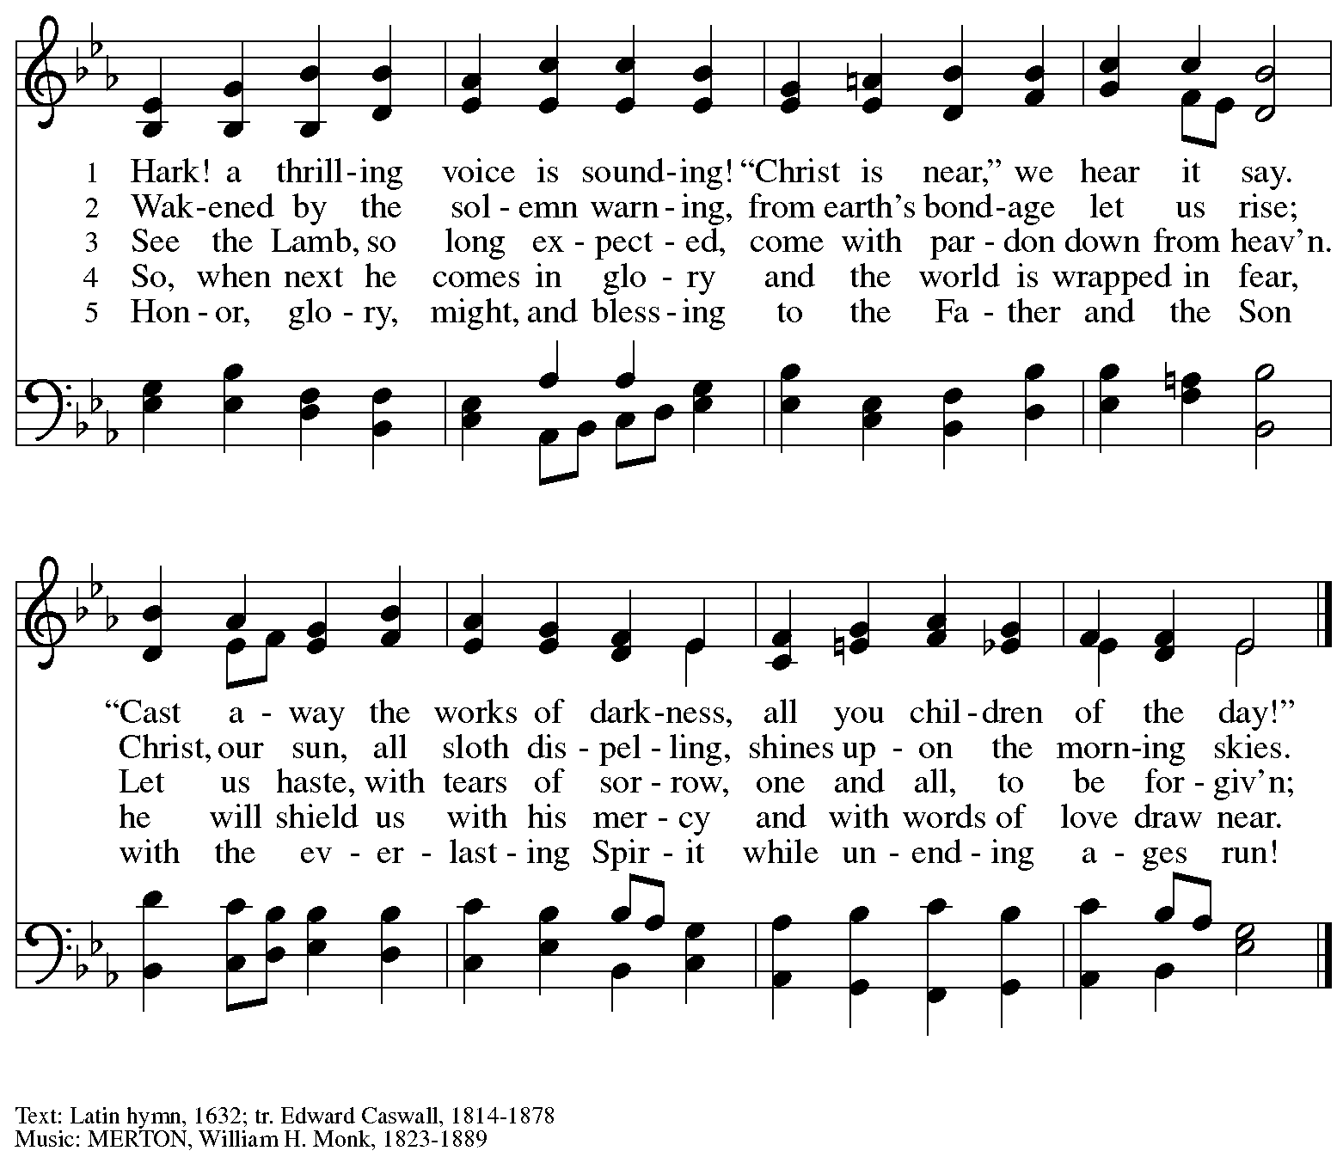

Greeting

P: The grace of our Lord Jesus Christ, the love of God,
and the communion of the Holy Spirit be with you all.
C: And also with you.

Kyrie ACS p. 31

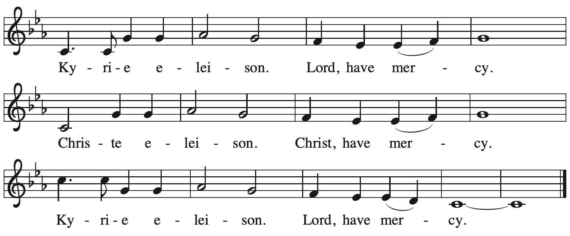

Prayer of the Day

P: The Lord be with you.
C: And also with you.

P: Let us pray.
Stir up your power, Lord Christ, and come.
By your merciful protection,
awaken us to the threatening dangers of our sins,
and keep us blameless until the coming of your new day,
for you live and reign with the Father and the Holy Spirit,
one God, now and forever.
C: Amen.

Please be seated.

Word
God speaks to us in Scripture reading, preaching, and song

First Reading – Isaiah 64: 1-9

¹O that you would tear open the heavens and come down,
so that the mountains would quake at your presence—
²as when fire kindles brushwood
and the fire causes water to boil—
to make your name known to your adversaries,
so that the nations might tremble at your presence!
³When you did awesome deeds that we did not expect,
you came down, the mountains quaked at your presence.
⁴From ages past no one has heard,
no ear has perceived,
no eye has seen any God besides you,
who works for those who wait for .
⁵You meet those who gladly do right,
those who remember you in your ways.
But you were angry, and we sinned;
because you hid yourself we transgressed.
⁶We have all become like one who is unclean,
and all our righteous deeds are like a filthy cloth.
We all fade like a leaf,
and our iniquities, like the wind, take us away.
⁷There is no one who calls on your name,
or attempts to take hold of you;
for you have hidden your face from us,
and have delivered us into the hand of our iniquity.
⁸Yet, O Lord, you are our Father;
we are the clay, and you are our potter;
we are all the work of your hand.
⁹Do not be exceedingly angry, O Lord,
and do not remember iniquity forever.
Now consider, we are all your people.

L: Word of God, word of life.
C: Thanks be to God.

Hymn Restore in Us, O God Following page
In the spirit of Psalm 80: 1-7, 17-19

Hymn Restore in Us, O God ELW 328
In the spirit of Psalm 80: 1-7, 17-19

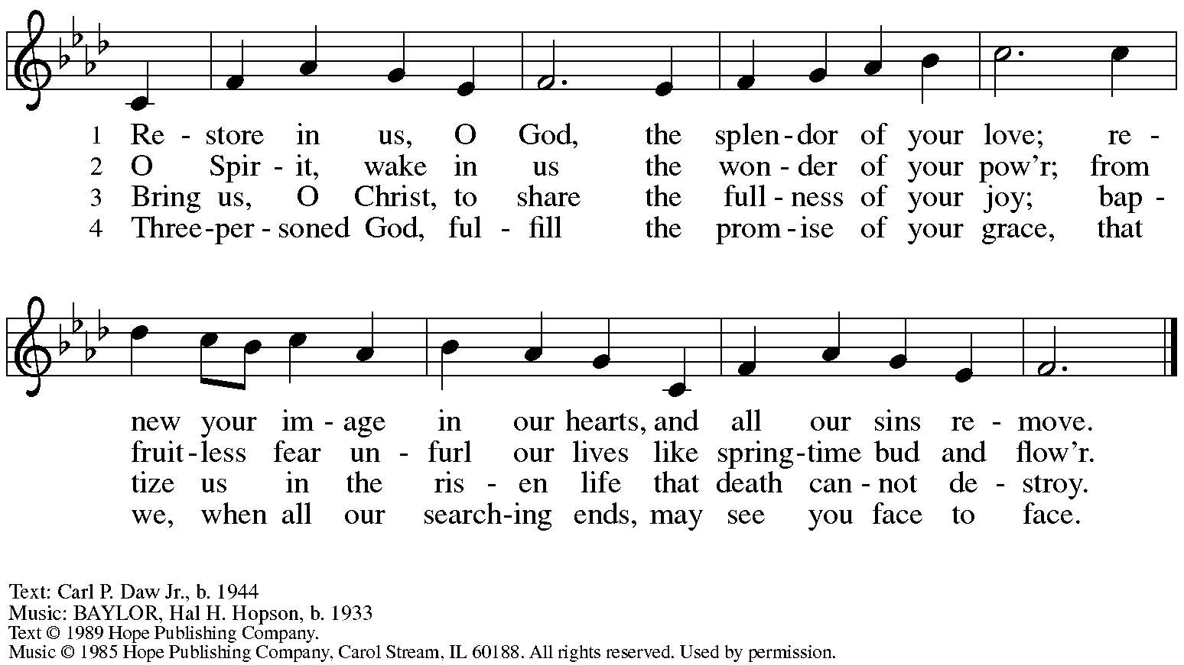
Reprinted with permission under OneLicense.net # A-722139.

Second Reading – 1 Corinthians 1: 3-9

³Grace to you and peace from God our Father and the Lord Jesus Christ.

⁴I give thanks to my God always for you because of the grace of God that has been given you in Christ Jesus, ⁵for in every way you have been enriched in God, in speech and knowledge of every kind—⁶just as the testimony of Christ has been strengthened among you—⁷so that you are not lacking in any spiritual gift as you wait for the revealing of our Lord Jesus Christ. ⁸God will also strengthen you to the end, so that you may be blameless on the day of our Lord Jesus Christ. ⁹God is faithful; by God you were called into the fellowship of God’s Son, Jesus Christ our Lord.

L: Word of God, word of life.
C: Thanks be to God.

Please rise as you are able.

Gospel Acclamation ELW p. 188

Gospel – Mark 13: 24-37

P: The holy Gospel according to St. Mark.
C: Glory to you, O Lord.

[Jesus said:] ²⁴“In those days, after that suffering,
the sun will be darkened,
and the moon will not give its light,
²⁵and the stars will be falling from heaven,
and the powers in the heavens will be shaken.
²⁶Then they will see ‘the Son of Humanity coming in clouds with great power and glory. ²⁷Then he will send out the angels, and gather his elect from the four winds, from the ends of the earth to the ends of heaven.
²⁸“From the fig tree learn its lesson: as soon as its branch becomes tender and puts forth its leaves, you know that summer is near. ²⁹So also, when you see these things taking place, you know that he is near, at the very gates. ³⁰Truly I tell you, this generation will not pass away until all these things have taken place. ³¹Heaven and earth will pass away, but my words will not pass away.
³²“But about that day or hour no one knows, neither the angels in heaven, nor the Son, but only the Father. ³³Beware, keep alert; for you do not know when the time will come. ³⁴It is like a man going on a journey, when he leaves home and puts his slaves in charge, each with his work, and commands the doorkeeper to be on the watch. ³⁵Therefore, keep awake—for you do not know when the master of the house will come, in the evening, or at midnight, or at cockcrow,
or at dawn, ³⁶or else he may find you asleep when he comes suddenly. ³⁷And what I say to you I say to all: Keep awake.”
P: The Gospel of the Lord.
C: Praise to you, O Christ.
Please be seated.

Sermon

A time of silence for prayer and reflection follows the sermon.
As the hymn of the day begins, please rise as you are able.

Hymn of the Day Wake, Awake, for Night Is Flying ELW 436

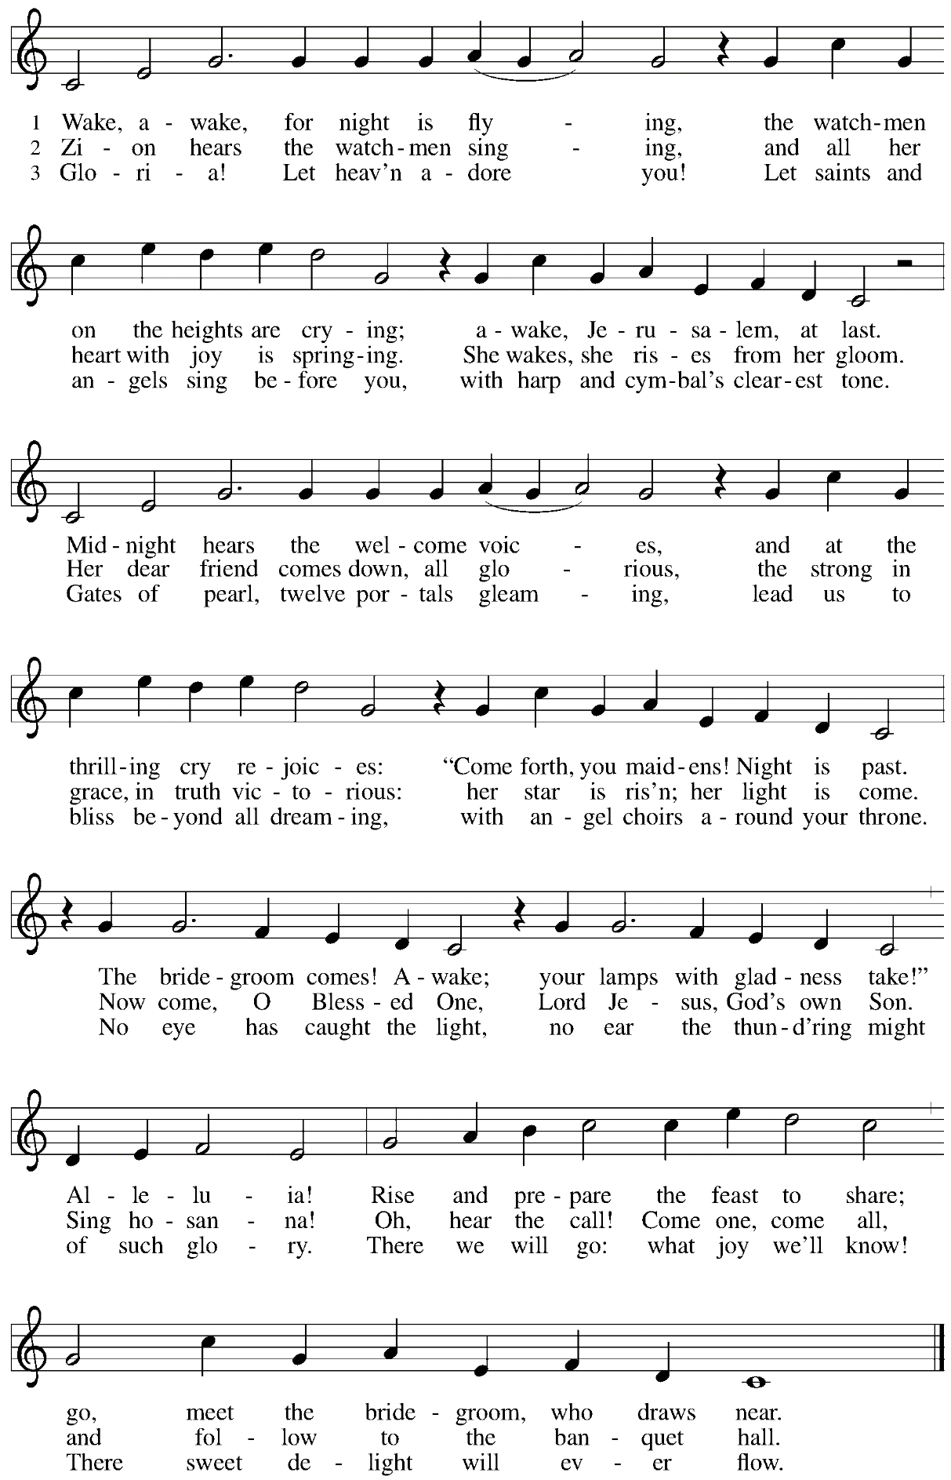

Prayers of the People

A: With hope and expectation, we offer our prayers for the church, the world,
and all who await God’s day of restoration.

After each petition
A: Merciful God,
C: receive our prayer.

The presiding minister concludes the prayers
P: Receive these and all our prayers, O God of hosts,
and restore us with your great and everlasting mercy,
through Jesus Christ, our Savior.
C: Amen.

Peace

The presiding minister and the assembly greet one another in the peace of the risen Christ.
P: The peace of Christ be with you always.
C: And also with you.

The people may greet those around them with a sign of Christ’s peace and may say
Peace be with you or similar words. Please be mindful that not everyone will be comfortable with sharing the peace, so please seek consent before shaking hands or hugging. Other possible ways to share the peace include a simple bow with the verbal greeting of peace, or simply a verbal expression of peace.

When the greetings of peace have concluded, please be seated.

Meal
God feeds us with the presence of Jesus Christ

Offering

We offer ourselves, our gifts, and our faithful service to God.
As the offering is gathered for the mission of the church, including the care of those in need,
the table is set for Holy Communion.

Reparations Offering

On the first Sunday of each month, St. Andrew invites people of the congregation to consider a donation to a second collection for a reparations fund in acknowledgement of St. Andrew’s use of African American spiritual songs in our worship services. Please see the note in the . 1-3

Music during the Offering
Lost in the Night arr. Moore

As the gifts are brought forward for presentation, please rise as you are able.

Offertory Song We Give Thee but Thine Own ELW 686
v. 1-3

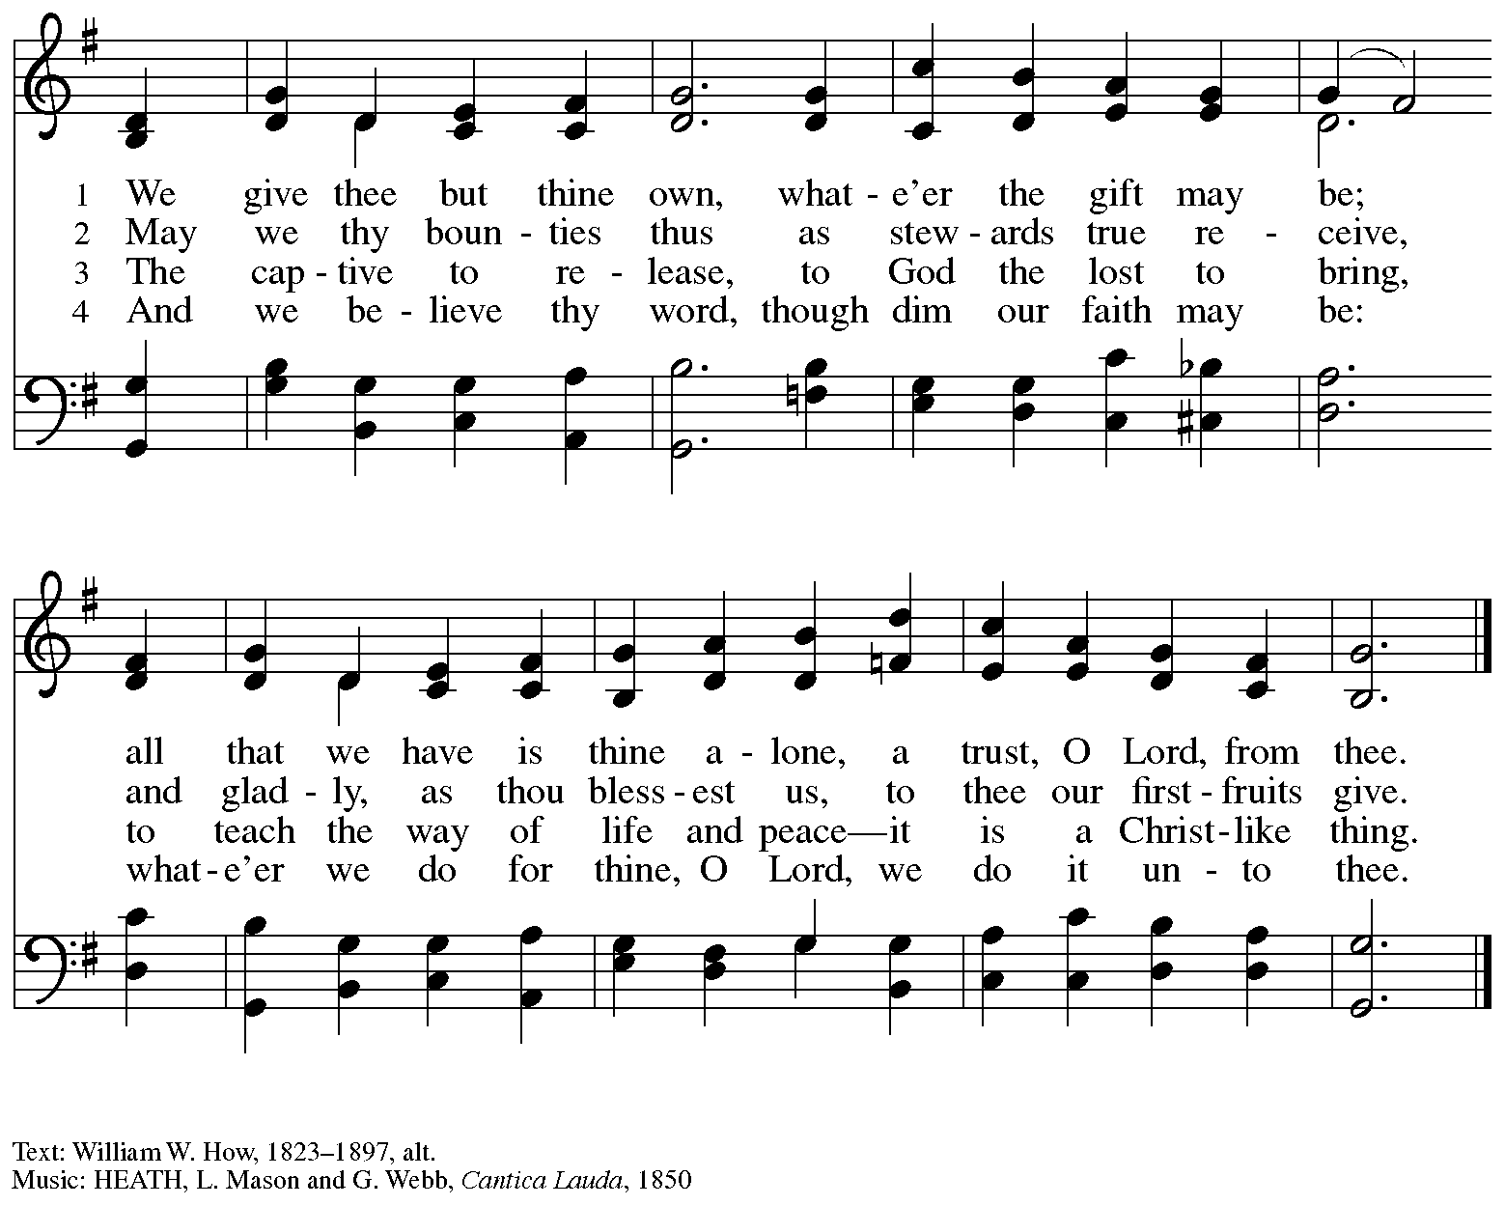

Offertory Prayer

A: Let us pray. God of abundance,
C: we bring before you the precious fruits of your creation,
and with them our very lives.
Teach us patience and hope as we care for all those in need
until the coming of your Son, Jesus Christ, our Savior and Lord.
Amen.

Dialogue

P: The Lord be with you.
C: And also with you.

P: Lift up your hearts.
C: We lift them to the Lord.

P: Let us give thanks to the Lord our God.
It is right to give our thanks and praise.

Preface

P: It is indeed right, our duty and our joy …
… we praise your name and join their unending hymn:

Sanctus ELW p. 190

Eucharistic Prayer

P: Holy one, the beginning and the end, the giver of life, …
… Do this for the remembrance of me.

Let us proclaim the mystery of faith.
C: Christ has died. Christ is risen. Christ will come again.

P: With this bread and cup …
… We look with hope for his coming.
C: Come, Lord Jesus.

P: Holy God, we long for your Spirit …
… Bring the gift of peace on earth.
C: Come, Holy Spirit.

P: All praise and glory are yours …
… one God, now and forever.
C: Amen.

Lord’s Prayer

P: Gathered as one by the Holy Spirit, let us pray as Jesus taught us.
C: Our Father in heaven,
hallowed be your name,
your kingdom come,
your will be done,
on earth as in heaven.
Give us today our daily bread.
Forgive us our sins
as we forgive those
who sin against us.
Save us from the time of trial
and deliver us from evil.
For the kingdom, the power,
and the glory are yours,
now and forever. Amen.

Fraction and Invitation

Agnus Dei / Lamb of God ELW p. 191

Please be seated.

Holy Communion
- All who seek God and desire a deeper and stronger life in Christ are welcome to receive Holy Communion.
- Worshipers from the pulpit side will proceed forward first, followed by the center section, and then the lectern side.
- Please inform an usher if you would like the ministers to bring Communion to you.
- Holy Communion will be served with bread and wine/grape juice.
- The presiding minister will first distribute the bread (host) to each communicant. Please indicate if you require a gluten-free host.
- Once you have consumed the bread, please pick up an empty glass from the tray next to the presiding minister. The Communion Assistant will pour wine from the chalice or grape juice from the cruet into your glass.
- Please step to the side to consume the wine or grape juice.
- Feel free to kneel at the altar rail for prayer after receiving the sacrament.
- As you return to your pew, glasses may be returned to the empty trays on either side of the center section.
- A blessing will be provided for anyone who does not yet receive the sacrament.
- All are invited to join in singing the hymns during Holy Communion.

Hymns during Holy Communion
O Lord, How Shall I Meet You ELW 241

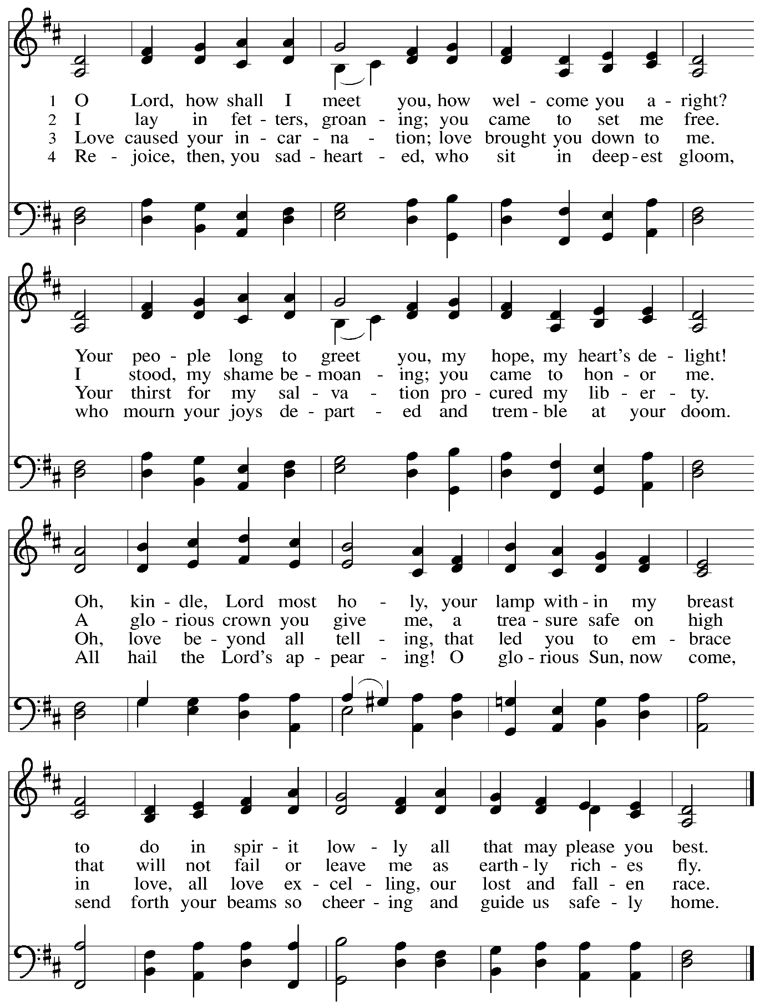

Hymns during Holy Communion
As the Dark Awaits the Dawn ELW 261

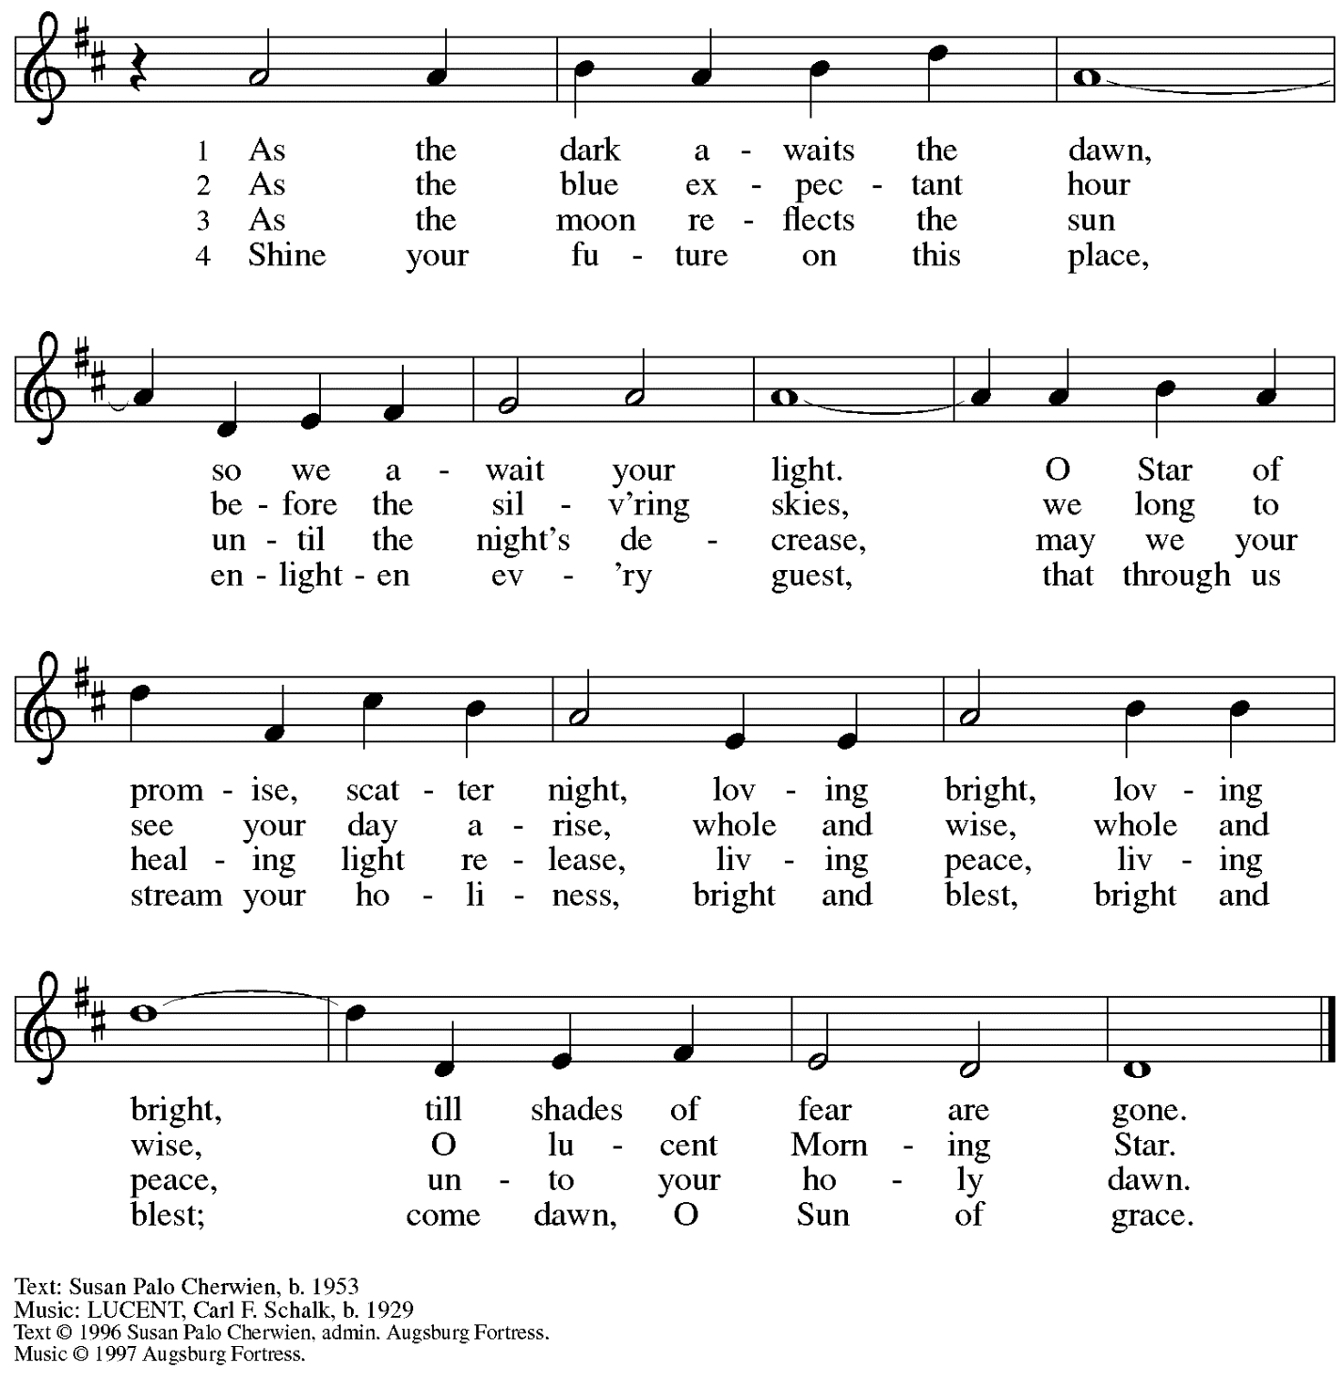
All rights reserved. Reprinted with permission under OneLicense.net # A-722139.

Hymns during Holy Communion
My Lord, What a Morning ELW 438

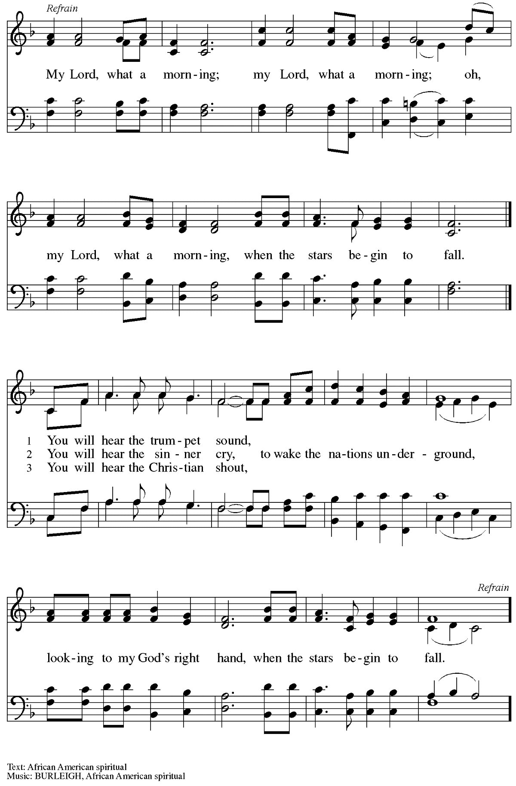

When all have returned to their places, please rise as you are able.

Blessing

P: The body and blood of our Lord Jesus Christ strengthen you and keep you in his grace.
C: Amen.

Prayer

A: Let us pray.
God for whom we wait,
in this meal you give us a foretaste of that day when the hungry will be fed with good things.
Send us forth to make known your deeds and to proclaim the greatness of your name,
through Jesus Christ, our Savior and Lord.
C: Amen.

Please be seated.

Sending
God blesses us and sends us in mission to the world

Announcements

Reflection on God’s Gifts

Please rise as you are able.

Farewell and Godspeed

At the conclusion of the rite of farewell and Godspeed,
all are invited to join in singing the congregational refrain.

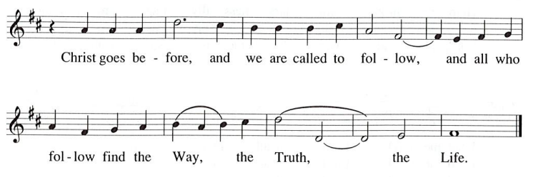

Benediction

P: The God of peace bless you,
the love of ☩ Christ sustain you in hope,
and the anointing of the Spirit remain upon you,
now and forever.
C: Amen.

Sending Hymn Awake! Awake, and Greet the New Morn Following page

Dismissal

A: Go in peace. Keep awake.
C: Thanks be to God!

Postlude Wake, Awake, for Night Is Flying arr. Unke

Sending Hymn Awake! Awake, and Greet the New Morn ELW 242

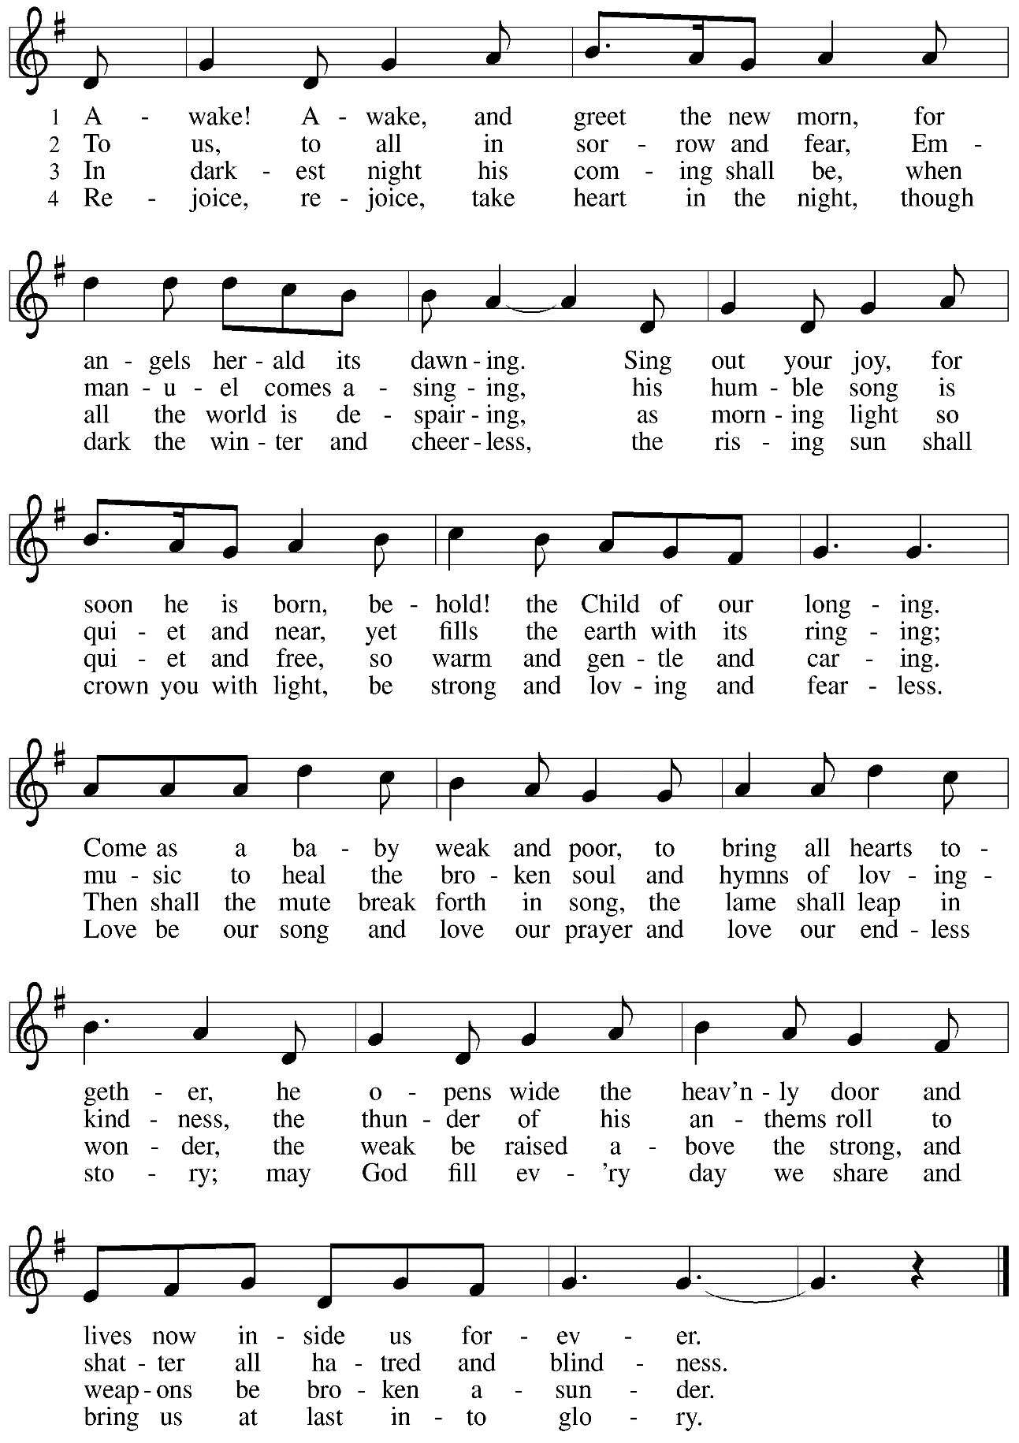

Those serving in worship today

Altar Care Jodie Minor
Assisting Minister Jeff Denlinger
Audio-Visual Minister Joseph Paetz
Cantor Ian Brown
Choir Emily Duque
Jimmi and Timothy Kocher-Hillmer
Noël Marsh
Lector Lester Prince
Little Church – Big Faith Teacher Colten Rohleder
Minister of Music Laura Reynolds
Reflection Libby and Tim Marker
Presiding and Preaching Minister The Rev. Ross I. Carmichael

Liturgy and Hymnody Acknowledgements

From SundaysandSeasons.com. Copyright © 2023 Augsburg Fortress. All rights reserved. Reprinted under OneLicense.net # A-722139.
Used by permission of Augsburg Fortress.

Wake, Awake, for Night Is Flying – Text: Philipp Nicolai, 1607-1676; tr. composite. Music: WACHET AUF, Philipp Nicolai. Text © 1999 Augsburg Fortress. All rights reserved. Reprinted with permission under OneLicense.net # A-722139

O Lord, How Shall I Meet You – Text: Paul Gerhardt, 1821-1877. Music: WIE SOLL ICH DICH EMPFANGEN, Johann Crüger, 1598-1662.

Awake! Awake, and Greet the New Morn – Marty Haugen, b. 1950. Music: REJOICE, REJOICE, Marty Haugen. Text and Music © 1983 GIA Publications, Inc., 7404 S. Mason Ave., Chicago, IL 60638. www.giamusic.com. 800.442.3358. All rights reserved. Reprinted with permission under OneLicense.net # A-722139.

Please use the QR code below to link to St. Andrew’s Announcements online!

St. Andrew Lutheran Church Announcements
December 3rd, 2023

- Welcome to worship at St. Andrew on the First Sunday of Advent, December 3rd, 2023 – We are so glad you are here as we begin the season of Advent, and we offer a special welcome to all guests who are gathered here or online! Worship attendees are invited to make a name tag at the back of the worship space if you would like. Children are invited to participate in Little Church – Big Faith, a Bible lesson and activity, after the prayer of the day. There are worship “toolkits” to help children engage with worship and “busy bags” for younger children available in the bookcase at the back of the sanctuary. Please feel free to take one to use with/for your children. We invite everyone to stay after worship for coffee and conversation in the Social Hall next to the sanctuary.
- Monthly Reparations Offering Today during Worship – Jesus’ parable from Luke's Gospel about a compassionate Samaritan provides an example of how God's people are called to work for healing and repair for our neighbors, independent of who or what caused harm. In light of this, St. Andrew has made a commitment to reparations in regard to African American spiritual songs used in our worship. The text and music of most hymns is attributed to specific authors, with copyrights in place, usage reported, and royalties paid to those whose works are featured in worship. With African American spirituals, this is not possible. In response to many years of such uncredited use, St. Andrew invites the congregation to give to a reparations offering. Funds received in worship will be donated to our siblings at Bethel AME Church, whose land and building were taken from them in the 1950s, to fund their development in the lower Hill District.
- Compline Prayer Service, a Ministry of Lutheran Campus Ministry in Greater Pittsburgh, Sundays at 8:00 p.m. at Heinz Chapel – Compline was traditionally a monastic prayer service, and the Pittsburgh Compline Choir sings a choral version of compline rooted in this thousand-year-old tradition of scripture, song, and silence. This service also streams on Facebook (Pittsburgh Compline Choir) and YouTube (The Pittsburgh Compline Choir). Heinz Chapel is located off of S. Bellefield Ave. in Oakland.
- Hearts and Hands, St. Andrew’s Crocheting and Knitting Ministry, Seeking New Participants and Meeting after Worship Today – Hearts and Hands crocheting and knitting ministry provides prayer blankets and shawls for people undergoing medical treatments, those who are mourning, Confirmands, and various others at significant times. Hearts and Hands will meet after worship today to discuss and plan activities for 2024. Anyone interested in learning to crochet, as well as current knitters and crocheters who would like to participate are welcome. The first project for the crocheters will be a scarf to add to the collection described in the next announcement. All supplies, including yarn and hooks, will be provided to anyone who may need them.
- Hearts and Hands and Community Ministry Committee Invite Congregation to Support Advent Appeal for Winter Accessories – People of the congregation are asked to bring winter hats, mittens/gloves, and scarves to church during the Advent season to support immigrants and refugees arriving in Pittsburgh. These can be handmade (knitted, crocheted, or sewn) or purchased. We can also make them available in the little pantry and at our produce distributions. A collection box will be set up in the social hall to receive these donations.
- Renew the Pews Thank You! – Thanks to all who participated in steam cleaning the pews to spruce up the sanctuary for the new church year! Lindsay Baxter, Johanna Matsui, David Rollinson, Jan Kurth, Chris Lotspeich, and Diane McHirella Elliot helped with the cleaning, and a special thank you to Sharon Koch and Lindsay Baxter for loaning us the cleaners!
- St. Andrew’s Annual Opportunity to Pledge Your Financial Support for the Year Ahead – Commitment Sunday, December 10th during Worship – Each year, St. Andrew invites people of the congregation to offer their financial gifts as an expression of faith and a grateful response for all God has done. A letter was sent to members of the congregation this past week outlining this year’s stewardship focus. Please prayerfully consider the enclosed materials and bring your Estimate of Giving card to worship next week as we dedicate our tithes and offerings to God. Thank you for the many ways you support the ministries of St. Andrew through your tithes, offerings, and generosity!
- Annual Meeting of the Congregation – Sunday, December 10th, after Worship – The annual meeting of the congregation takes place in November or December each year. This meeting is the highest decision-making body in the congregation, and includes election of leaders to serve on the congregation’s leadership council, adoption of a budget for ministry for the upcoming year, and updates about big-picture considerations and long-term planning. All confirmed members of the congregation are eligible to vote, and no absentee or proxy votes can be accepted, so please plan to attend the meeting on Sunday, December 10th.
- Coffee Hour Signup – Sunday, December 10th and Sunday, December 24th – With the annual meeting of the congregation scheduled for Sunday, December 10th and decorating for Christmas on the 24th after worship, it would be especially helpful to have sign-ups for those dates, as well. The role consists of getting out napkins, plates, and coffee-related items; starting the coffee brewing before worship; setting out other drinks after worship, and cleaning up. If you would like to serve, please sign up at: https://www.signupgenius.com/go/5080B4AAFAF2CABF85-coffee#/.
We thank those who have signed up to host coffee hour on December 3rd and 17th!
- Compline Prayer Service at St. Andrew – Sunday, December 17th, 7:00 p.m. –
The Compline Choir at times offers to lead a service in an additional location after their semester in Heinz Chapel ends, and we have agreed to host this Compline service on Sunday, December 17th, at St. Andrew at 7:00 p.m. Please plan to take part in this unique worship experience!
- East End Cooperative Ministry Shelter Dinner – Thursday, December 21st, Arrival at 6:00 p.m., Meal at 6:30 p.m. – Each month, people of St. Andrew provide and serve a meal for the guests of the shelter at East End Cooperative Ministry (EECM), 6140 Station St., 15206. Anyone can sign up to prepare or purchase a portion of the meal to bring to EECM at 6:00 p.m. that day, or just come to help serve the meal at 6:30 p.m. If you would like to contribute, please sign up at: https://www.signupgenius.com/go/5080544AAAC22A1F58-46333425-decshelter.
- Decorating for the Christmas Season – Sunday, December 24th, after Worship – Sunday morning, December 24th, is the Fourth Sunday of Advent, so we will not be able to decorate for the Christmas season until after the 10:00 a.m. worship service that day. We invite everyone to stay that day to take part in the festive activities of preparing the worship space for the Christmas season!
- Christmas Eve Service with Candlelight, Carols, and Holy Communion – Sunday, December 24th, 7:00 p.m.
- Christ in Our Home Devotional Booklets for December Still Available at Church Entrances, January-March Booklets Also Available Now – This resource offers a daily Bible reading with a short reflection and prayer, along with additional readings and prayer topics for those who would like to expand their devotional practices. We encourage people of the congregation to take one for yourself, your family unit, or others!
- Support Guests of the Women’s Center and Shelter of Greater Pittsburgh This Holiday Season – During Advent, each year, St. Andrew invites the congregation to consider giving in support of local organizations and those they serve during Advent. This year, we ask your consideration of a gift in support of the guests of the Women’s Center and Shelter of Greater Pittsburgh. We will collect items in December and deliver them in January. The Community Ministry Committee of St Andrew has selected the Women’s Center & Shelter of Greater Pittsburgh as the recipient of our Christmas gift drive this year. We will collect items through December and deliver them in January. There are 2 ways to give:
- Select items from the Urgent Needs List or Essential Needs List and bring them to the labeled bin in the church Social Hall. Needs lists are posted on the bulletin board and summarized below.
- Order items directly from the Shelter’s Amazon Wish List. They will be shipped directly to the Shelter for you. Log into your Amazon account, visit the WC&S Amazon Wish List or Children’s Wish List. You will not be able to access the lists if you are not logged into your Amazon account. See instructions and links at the Women’s Center & Shelter donation page:
https://wcspittsburgh.org/ways-to-give/donate-items/donating-new-items/

Women’s Shelter Christmas Wish Lists

Urgent Needs
Gift cards are always the most pressing need. Good choices are Walmart, Target, Dollar General, Giant Eagle, VISA.
Multicultural hair care products (Full-size) Sturdy reusable grocery bags
Hair accessories Pillow cases
Body wash (Full size) Air mattress with built-in pump
Towels Fitted and/or flat sheets

Essential Needs
Pull Ups Deodorant (full-size) Chapstick
Baby wipes Brushes Tote bags
Baby bottles Razors Umbrellas
Pacifiers New lightweight tops Size XL Shower curtain w/rings
Kids shampoo (full-size) New Heavy/warm tops Size XL Shower liners
Kids Conditioner (full-size) Combs Phone chargers
Body wash (full-size) Wash cloths Dish soap
Nail clippers Mouthwash (8 oz) New pants Size Large
Cotton swabs Shaving cream (full-size) New underwear Size Medium

