+ Twenty-fourth Sunday after Pentecost
November 12th, 2023
10:00 a.m.

St. Andrew Lutheran Church
304 Morewood Ave.
Pittsburgh, PA 15213
412.682.3342
St_andrewELCA@verizon.net
www.standrewpittsburgh.org

+ Twenty-fourth Sunday after Pentecost
Order for Worship

Today the prophet Amos calls for justice to roll down like waters. Paul urges us to encourage one another with the promised coming of the Lord. Jesus tells a parable about bridesmaids awaiting a bridegroom whose arrival has been delayed. prepared. Some of the bridesmaids wisely prepared for this possibility by bringing extra oil while others did not. Surrounded by the faithful of every time and place, we celebrate Christ’s coming in our midst in the word of life and the feast of victory—the marriage feast of the lamb.

Welcome to St. Andrew!

- St. Andrew Lutheran congregation welcomes all who are seeking a place of healing and wholeness – a nurturing, faith-forming spiritual home. Our community embraces people of all ages, ethnicities, cultures, abilities, sexual orientations, gender identities and expressions, and family constellations. Come and See!

- Worship Services are live streamed to multiple online platforms. By attending worship, you agree that your image and voice may be broadcast.

- Everyone is invited to make a nametag at the black bookcase in the back of the worship space if they would like. There are stickers indicating pronouns on the bookcase if you would like to include them on your name tag.

- Worship “toolkits” to help children engage with the service, along with “busy bags” for younger children, are available in the bookcase at the back of the sanctuary. Please feel free to take one to use with/for your children.

- Children are invited to attend Little Church – Big Faith, a Bible lesson and activity, during worship (after the Prayer of the Day). The group returns to the worship space for the liturgy of Holy Communion.

- Holy Communion is served with bread (gluten-free available) and wine or grape juice. The presiding minister will distribute the bread (host). Please consume this and then pick up an empty glass from the tray. The Communion Assistant will pour wine or grape juice into your glass. Please step to the side to consume the wine or grape juice. Feel free to kneel at the altar for prayer and reflection. As you return to your pew, glasses may be returned to the empty trays on either side of the center section.

- A restroom is available on the main level of the church, through the doors to the Social Hall and to the right in the main office.

Abbreviations
P: Pastor/Presiding Minister ACS: All Creation Sings hymnal
A: Assisting Minister ELW: Evangelical Lutheran Worship hymnal
L: Lector HS: Hymnal Supplement
C: Congregation

Pre-Service Music

Welcome

Prelude

Gathering
The Holy Spirit calls us together as the people of God

Confession and Forgiveness

Please rise as you are able. All may make the sign of the cross,
the sign that is marked at Baptism, as the presiding minister begins.

P: Blessed be the holy Trinity, ☩ one God,
whose mercy endures forever.
C: Amen.

P: If we say we have no sin we deceive ourselves and the truth is not in us.
Let us confess our sin to God, who is faithful and just
and who has promised to forgive our sin and cleanse us from all unrighteousness.

Silence is kept for reflection and self-examination.

P: Most merciful God,
C: have mercy on us.
We confess to you
that we have sinned against you
in thought, word, and deed,
by what we have done
and by what we have left undone.
We have not trusted you with our whole heart.
We have not loved one another in deed and in truth.
In your compassion, forgive our sin and uphold us by your Spirit,
that we may live and serve you in newness of life
through Jesus Christ, our light and our truth.
Amen.

P: With joy I proclaim to you that Almighty God,
rich in mercy, abundant in love,
forgives you all your sin
and grants you newness of life in ☩ Jesus Christ.
C: Amen. Thanks be to God!

Gathering Hymn O Day of Rest and Gladness ELW 521

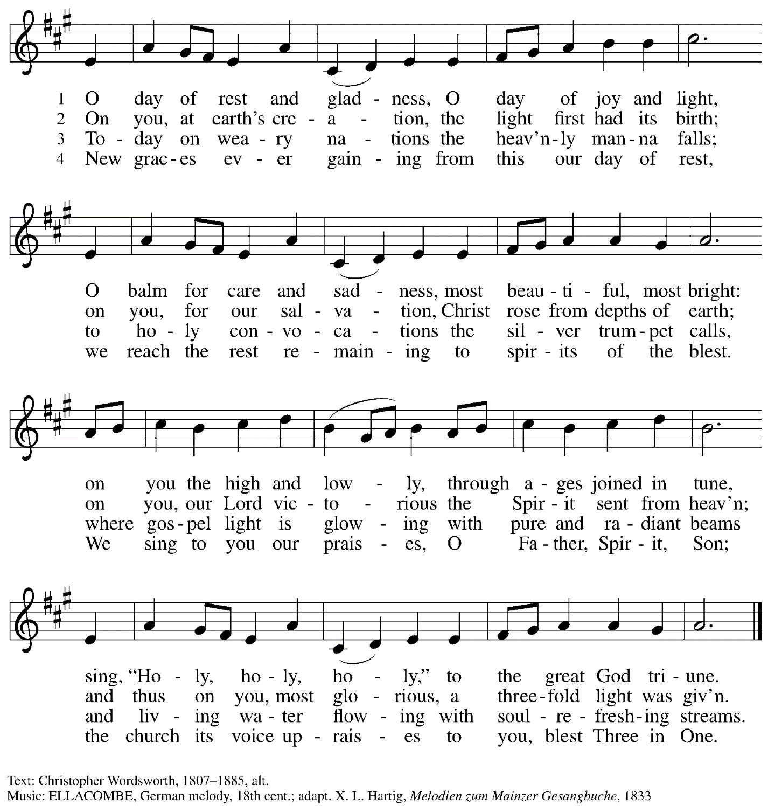

Greeting

P: The grace of our Lord Jesus Christ, the love of God,
and the communion of the Holy Spirit be with you all.
C: And also with you.

Hymn of Praise Now the Feast and Celebration HS p. 4-5

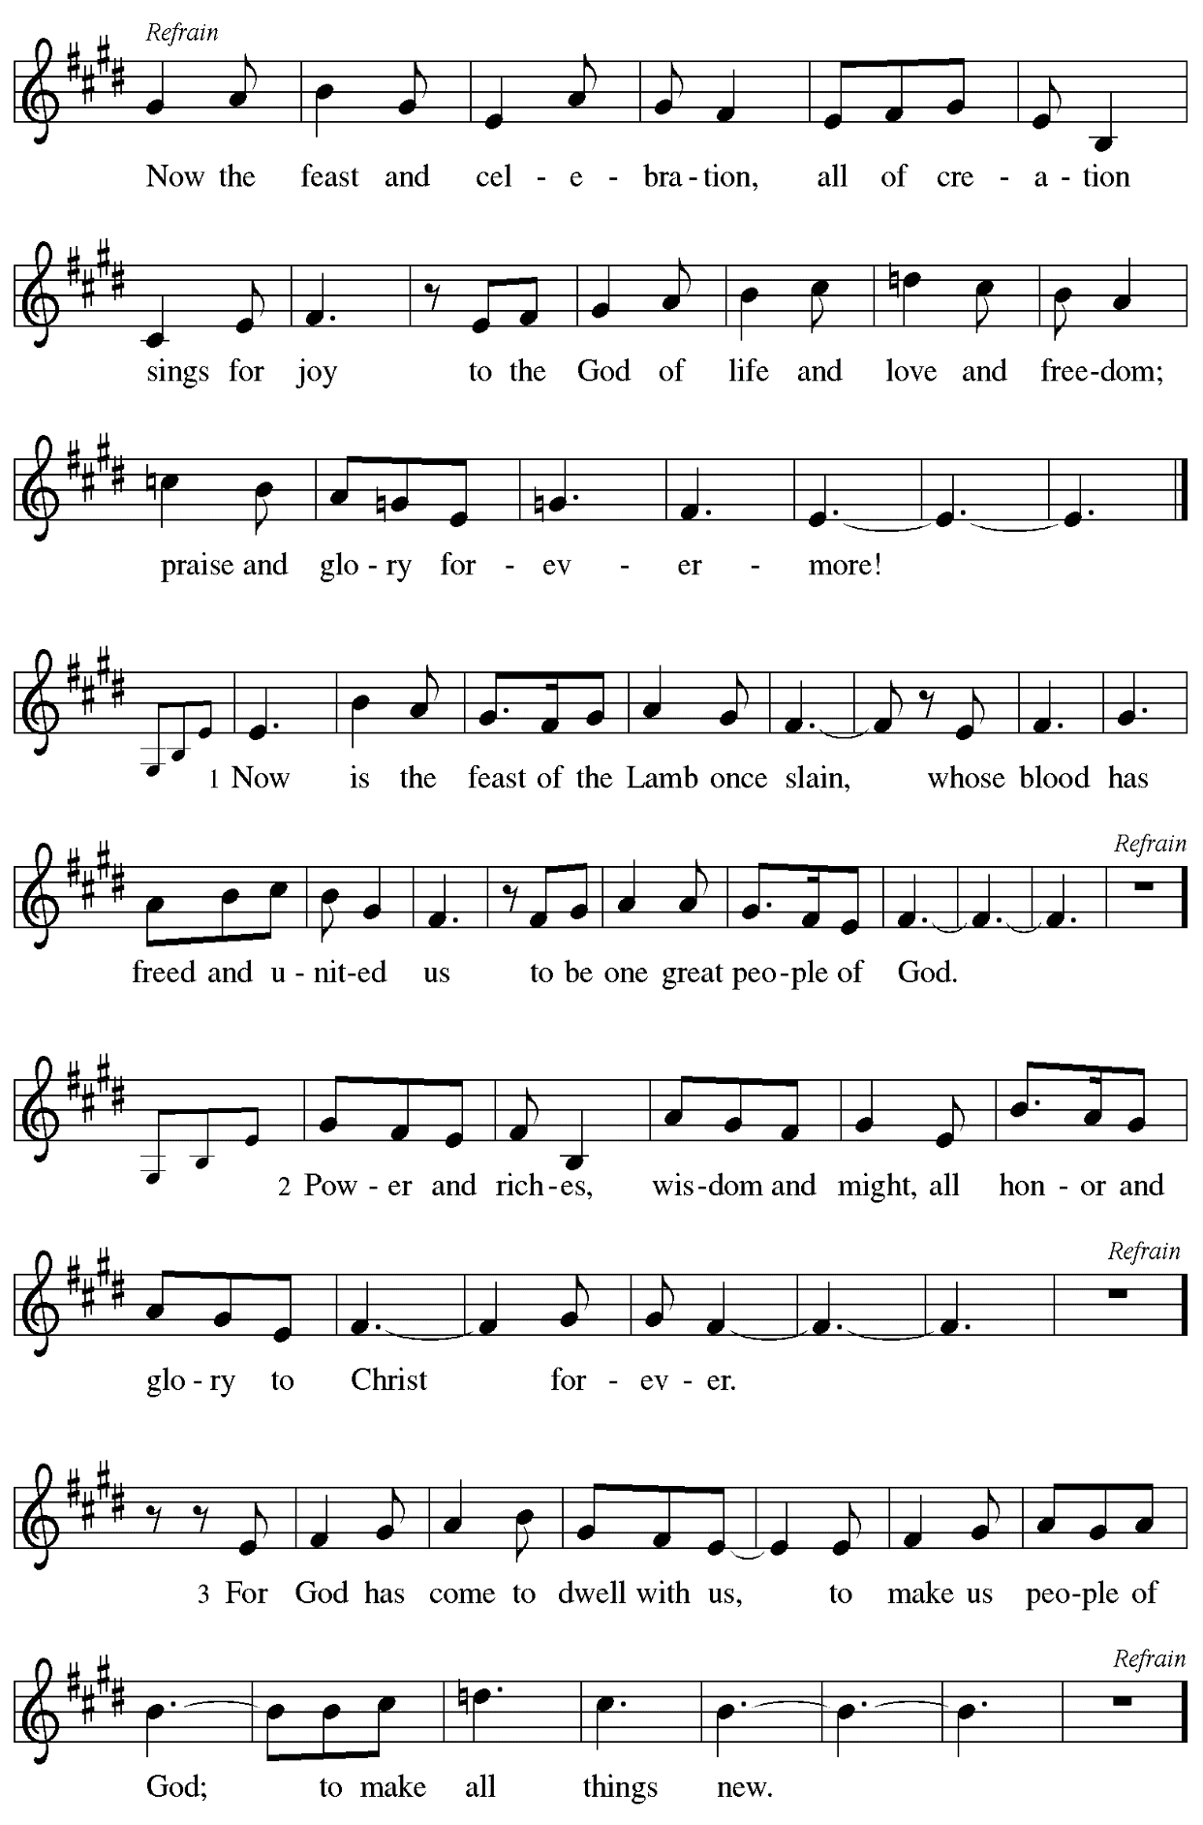
Prayer of the Day

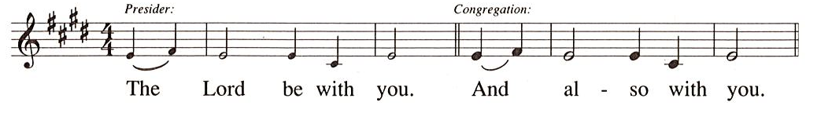

P: Let us pray.
O God of justice and love, you illumine our way through life with the words of your Son.
Give us the light we need, and awaken us to the needs of others, through Jesus Christ,
our Savior and Lord.
C: Amen.

Please be seated.
Children are invited to join the adult leaders at the door and move to the office for Little Church – Big Faith. We ask that one additional adult from the congregation attend with the children.

Word
God speaks to us in Scripture reading, preaching, and song

First Reading – Amos 5: 18-24

¹⁸Alas for you who desire the day of the Lord!
Why do you want the day of the Lord?
It is darkness, not light;
¹⁹as if someone fled from a lion,
and was met by a bear;
or went into the house and rested a hand against the wall,
and was bitten by a snake.
²⁰Is not the day of the Lord darkness, not light,
and gloom with no brightness in it?
²¹I hate, I despise your festivals,
and I take no delight in your solemn assemblies.
²²Even though you offer me your burnt offerings and grain offerings,
I will not accept them;
and the offerings of well-being of your fatted animals
I will not look upon.
²³Take away from me the noise of your songs;
I will not listen to the melody of your harps.
²⁴But let justice roll down like waters,
and righteousness like an ever-flowing stream.

L: Word of God, word of life.
C: Thanks be to God.

Psalm 70

The psalm will be sung responsively, led by the cantor. The congregation is invited to join in singing the alternate verses in bold and the refrain.

Psalm tone

Psalm refrain

¹Be pleased, O God, to de- | liver me;
O Lord, make | haste to help me.
²Let those who seek my life be put to shame | and confounded;
let those who take pleasure in my misfortune draw back and | be disgraced. R
³Let those who say to me “Aha!” and gloat | over me
turn back because | of their shame.
⁴Let all who seek you rejoice and be | glad in you;
let those who love your salvation say forever, “Great | is the Lord!”
⁵But as for me, I am poor and needy; come to me quick- | ly, O God.
You are my helper and my deliverer; O Lord, | do not tarry. R

Second Reading – 1 Thessalonians 4: 13-18

¹³We do not want you to be uninformed, kindred, about those who have died, so that you may not grieve as others do who have no hope. ¹⁴For since we believe that Jesus died and rose again, even so, through Jesus, God will bring with him those who have died. ¹⁵For this we declare to you by the word of the Lord, that we who are alive, who are left until the coming of the Lord, will by no means precede those who have died. ¹⁶For the Lord himself, with a cry of command, with the archangel’s call and with the sound of God’s trumpet, will descend from heaven, and the dead in Christ will rise first. ¹⁷Then we who are alive, who are left, will be caught up in the clouds together with them to meet the Lord in the air; and so we will be with the Lord forever.
¹⁸Therefore encourage one another with these words.

L: Word of God, word of life.
C: Thanks be to God.

Please rise as you are able.

Gospel Acclamation HS p. 8

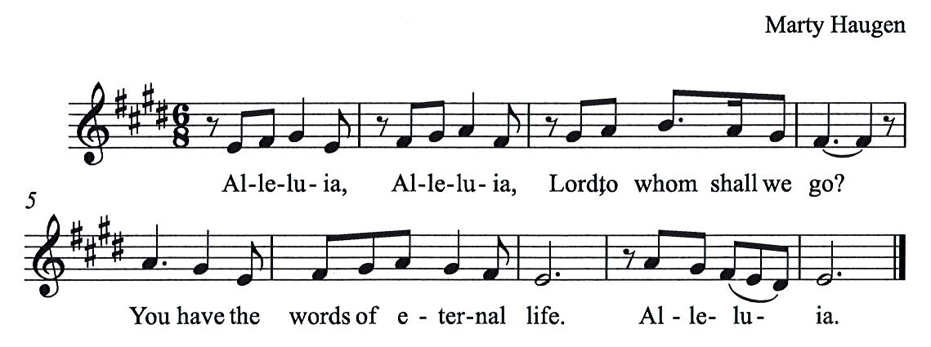

Gospel – Matthew 25: 1-13

P: The holy Gospel according to St. Matthew.
C: Glory to you, O Lord.

[Jesus said to the disciples:] ¹“Then the kingdom of heaven will be like this. Ten bridesmaids took their lamps and went to meet the bridegroom. ²Five of them were foolish, and five were wise. ³When the foolish took their lamps, they took no oil with them; ⁴but the wise took flasks of oil with their lamps. ⁵As the bridegroom was delayed, all of them became drowsy and slept. ⁶But at midnight there was a shout, ‘Look! Here is the bridegroom! Come out to meet him.’ ⁷Then all those bridesmaids got up and trimmed their lamps. ⁸The foolish said to the wise, ‘Give us some of your oil, for our lamps are going out.’ ⁹But the wise replied, ‘No! there will not be enough for you and for us; you had better go to the dealers and buy some for yourselves.’ ¹⁰And while they went to buy it, the bridegroom came, and those who were ready went with him into the wedding banquet; and the door was shut. ¹¹Later the other bridesmaids came also, saying, ‘Lord, lord, open to us.’ ¹²But he replied, ‘Truly I tell you, I do not know you.’ ¹³Keep awake therefore, for you know neither the day nor the hour.”
P: The Gospel of the Lord.
C: Praise to you, O Christ.

Please be seated.

Sermon

A time of silence for prayer and reflection follows the sermon.
As the hymn of the day begins, please rise as you are able.

Hymn of the Day Rejoice, Rejoice Believers ELW 244

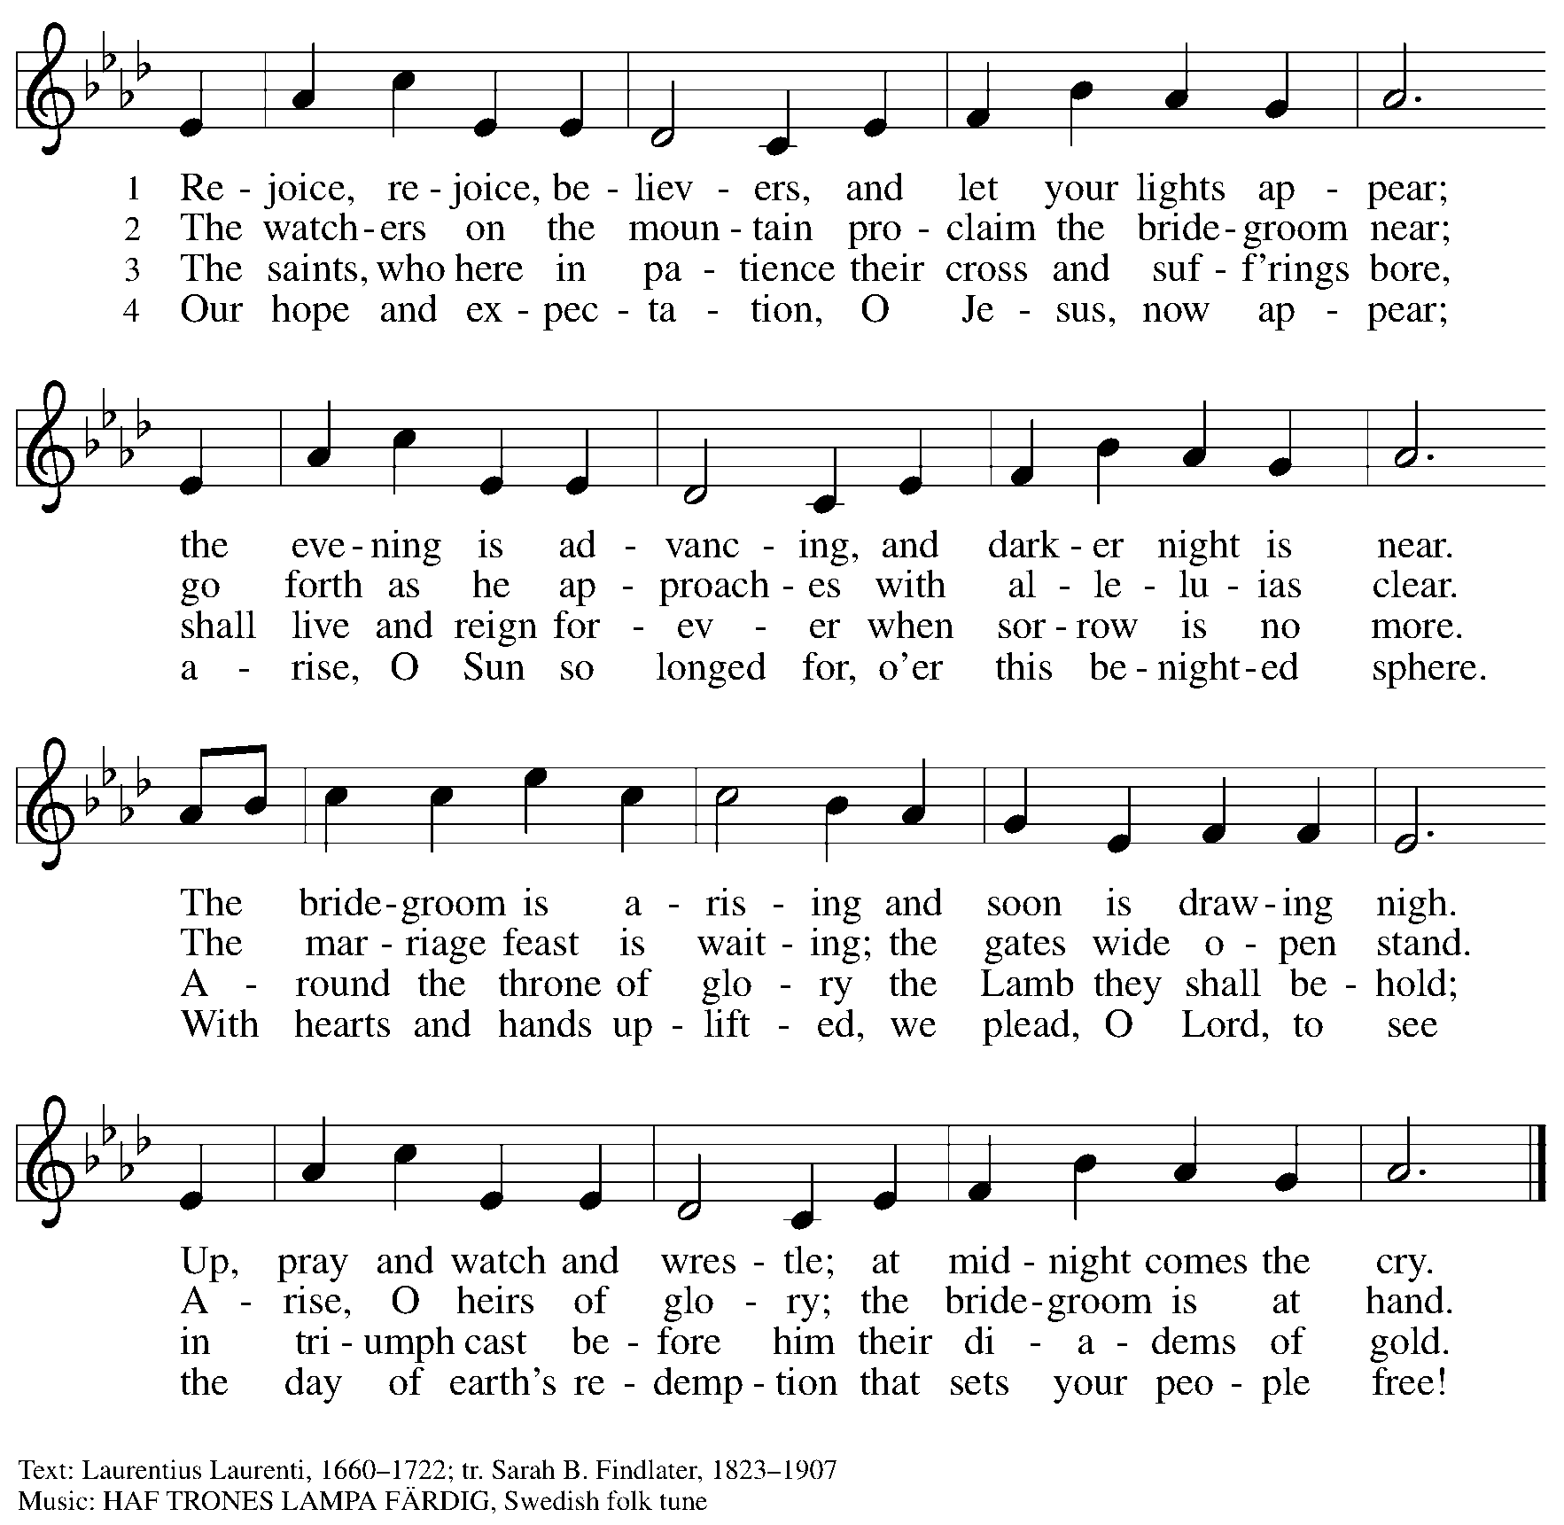

Apostles Creed

P: Let us confess our faith:
C: I believe in God, the Father almighty,
creator of heaven and earth.

I believe in Jesus Christ, God’s only Son, our Lord,
who was conceived by the Holy Spirit,
born of the virgin Mary,
suffered under Pontius Pilate,
was crucified, died, and was buried;
he descended to the dead.*
On the third day he rose again;
he ascended into heaven,
he is seated at the right hand of the Father,
and he will come to judge the living and the dead.

I believe in the Holy Spirit,
the holy catholic church,
the communion of saints,
the forgiveness of sins,
the resurrection of the body,
and the life everlasting. Amen.

*Or, “he descended into hell,” another translation of this text in widespread use.

Prayers of the People

A: Trusting in the transformative power of God’s loving Spirit,
let us pray for the church, the world, and all who are in need.

After each petition
A: God of grace,
C: receive our prayer.

The presiding minister concludes the prayers
P: Into your care, gracious God, we commend all for whom we pray,
trusting in your unending love and amazing grace;
through Jesus Christ, our Savior.
C: Amen.

Peace

The presiding minister and the assembly greet one another in the peace of the risen Christ.
P: The peace of Christ be with you always.
C: And also with you.

The people may greet those around them with a sign of Christ’s peace and may say
Peace be with you or similar words. Please be mindful that not everyone will be comfortable with sharing the peace, so please seek consent before shaking hands or hugging. Other possible ways to share the peace include a simple bow with the verbal greeting of peace, or simply a verbal expression of peace.

When the greetings of peace have concluded, please be seated.

Meal
God feeds us with the presence of Jesus Christ

Offering

We offer ourselves, our gifts, and our faithful service to God.
As the offering is gathered for the mission of the church, including the care of those in need,
the table is set for Holy Communion.

Music during the Offering

As the gifts are brought forward for presentation, please rise as you are able.

Offertory Song As the Grains of Wheat ELW 465

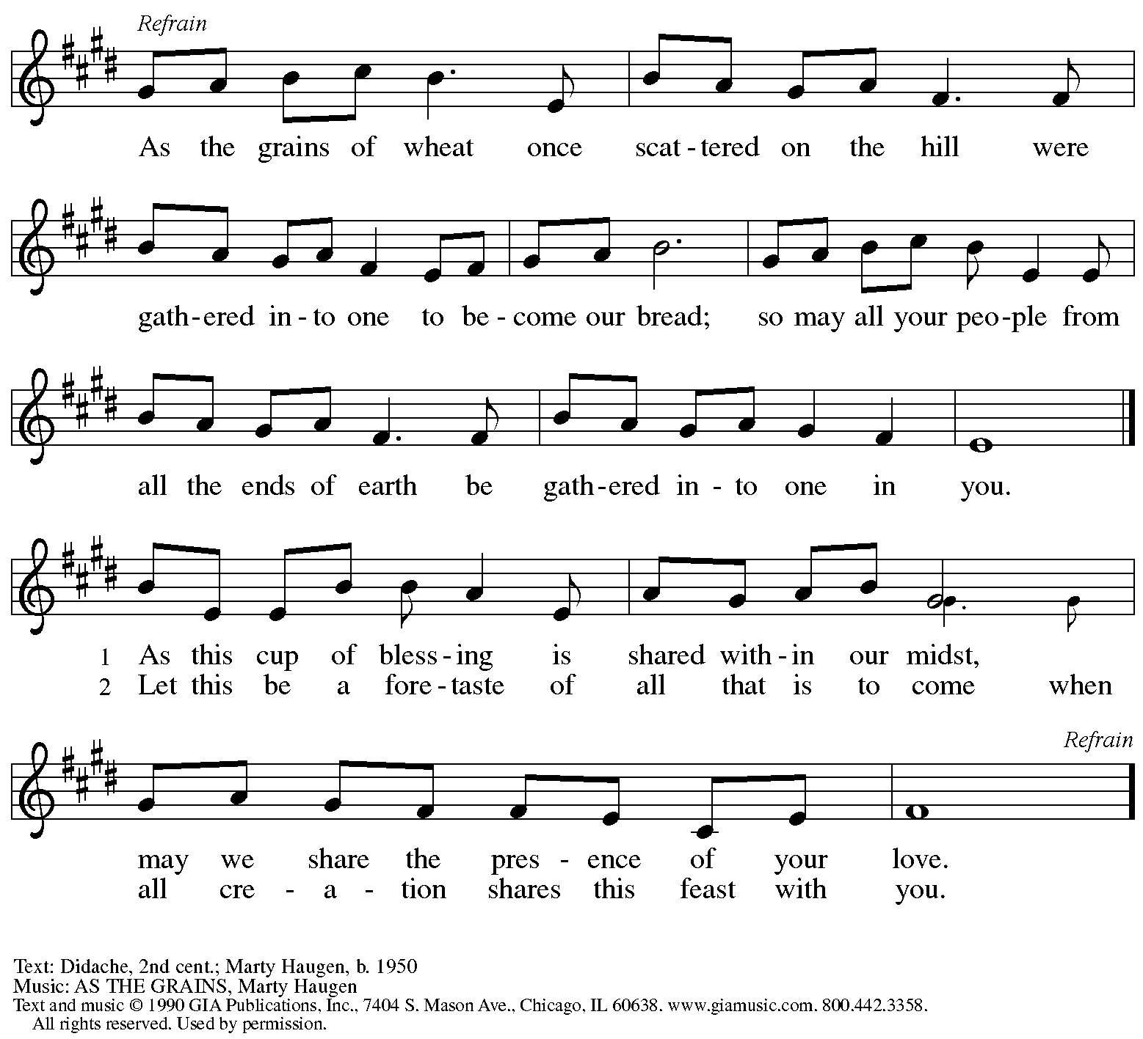
Reprinted with permission under OneLicense.net # A-722139.

Offertory Prayer

A: Let us pray.
God of all creation,
C: the eyes of all wait upon you,
and you open your hand in blessing.
Fill us with good things at your table,
that we may come to the help of all in need,
through Jesus Christ, our redeemer and Lord.
Amen.

Dialogue HS p. 14

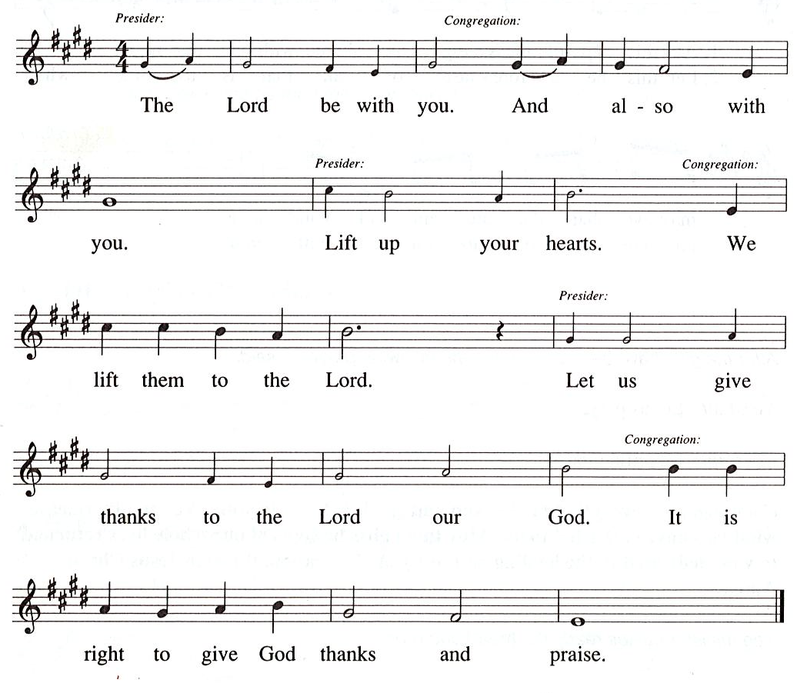

Preface

P: It is our duty and delight
that we should everywhere and always
offer thanks and praise to you, O God,
through Jesus Christ,
who calls us to follow his way of humble service and love,
and so with the church on earth,
all creation and the hosts of heaven.
we praise your name and join their unending hymn:

Sanctus HS p. 15

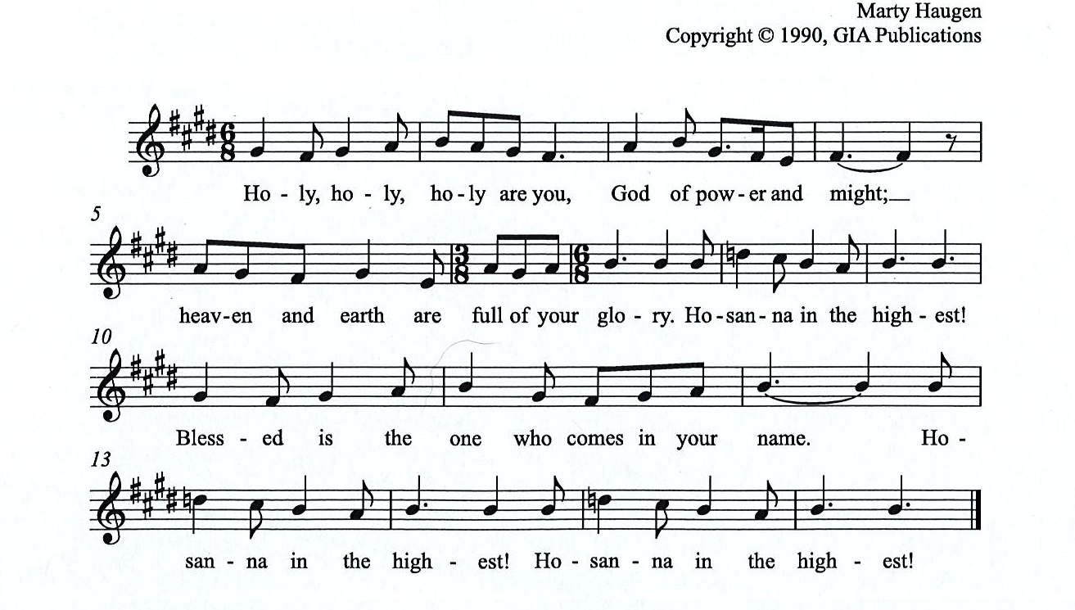

Eucharistic Prayer

P: You are indeed holy, almighty and merciful God, …
… Do this for the remembrance of me.

For as often as we eat of this bread and drink from this cup,
we proclaim the Lord’s death until he comes.

The presiding minister sings:
P: Christ has died. Christ is risen. Christ will come, come again.
The congregation responds by singing the same verse:
C:
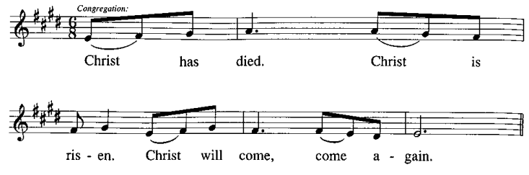
P: Remembering, therefore, …
… … To you, O God, Father, Son, and Holy Spirit
be all honor and glory in your holy church, now and forever.
C:
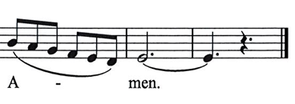

Lord’s Prayer

P: Gathered as one by the Holy Spirit, let us pray as Jesus taught us.
C: Our Father in heaven,
hallowed be your name,
your kingdom come,
your will be done,
on earth as in heaven.
Give us today our daily bread.
Forgive us our sins
as we forgive those
who sin against us.
Save us from the time of trial
and deliver us from evil.
For the kingdom, the power,
and the glory are yours,
now and forever. Amen.

Fraction and Invitation

Agnus Dei / Lamb of God HS p. 18

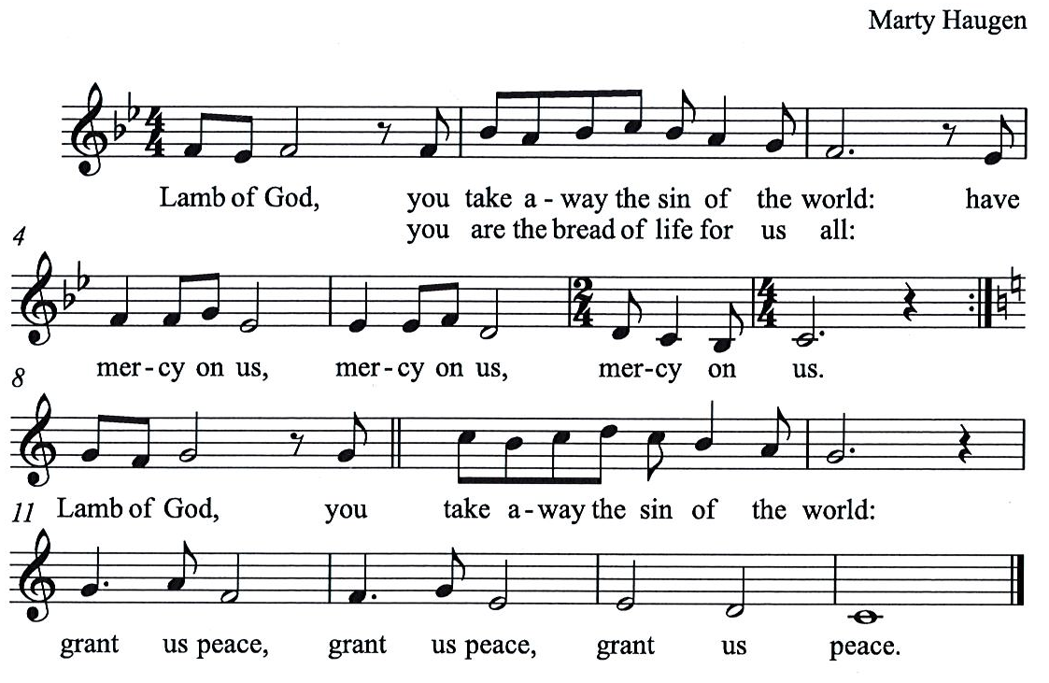

Please be seated.

Holy Communion
- All who seek God and desire a deeper and stronger life in Christ are welcome to receive Holy Communion.
- Worshipers from the pulpit side will proceed forward first, followed by the center section, and then the lectern side.
- Please inform an usher if you would like the ministers to bring Communion to you.
- Holy Communion will be served with bread and wine/grape juice.
- The presiding minister will first distribute the bread (host) to each communicant. Please indicate if you require a gluten-free host.
- Once you have consumed the bread, please pick up an empty glass from the tray next to the presiding minister. The Communion Assistant will pour wine from the chalice or grape juice from the cruet into your glass.
- Please step to the side to consume the wine or grape juice.
- Feel free to kneel at the altar rail for prayer after receiving the sacrament.
- As you return to your pew, glasses may be returned to the empty trays on either side of the center section.
- A blessing will be provided for anyone who does not yet receive the sacrament.
- All are invited to join in singing the hymns during Holy Communion.

Hymns during Holy Communion
What Is the World Like ACS 1047

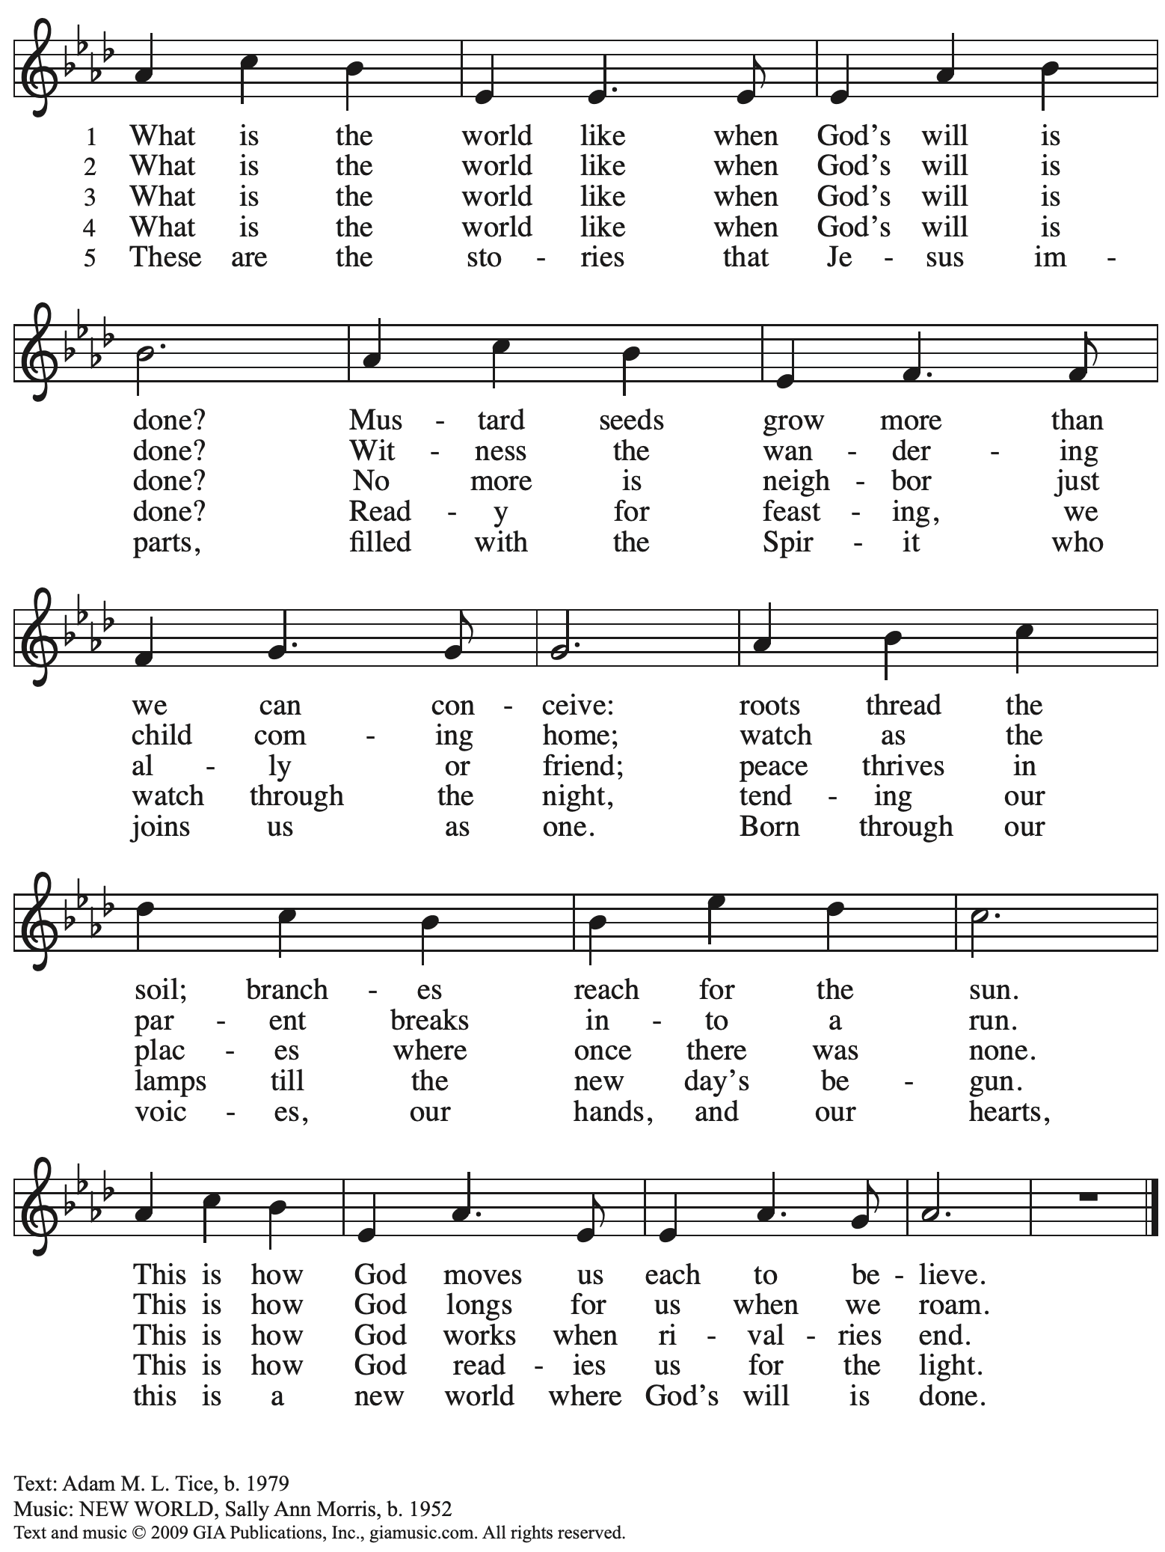
Reprinted with permission under OneLicense.net # A-722139.

Hymns during Holy Communion
O Happy Day When We Shall Stand ELW 441

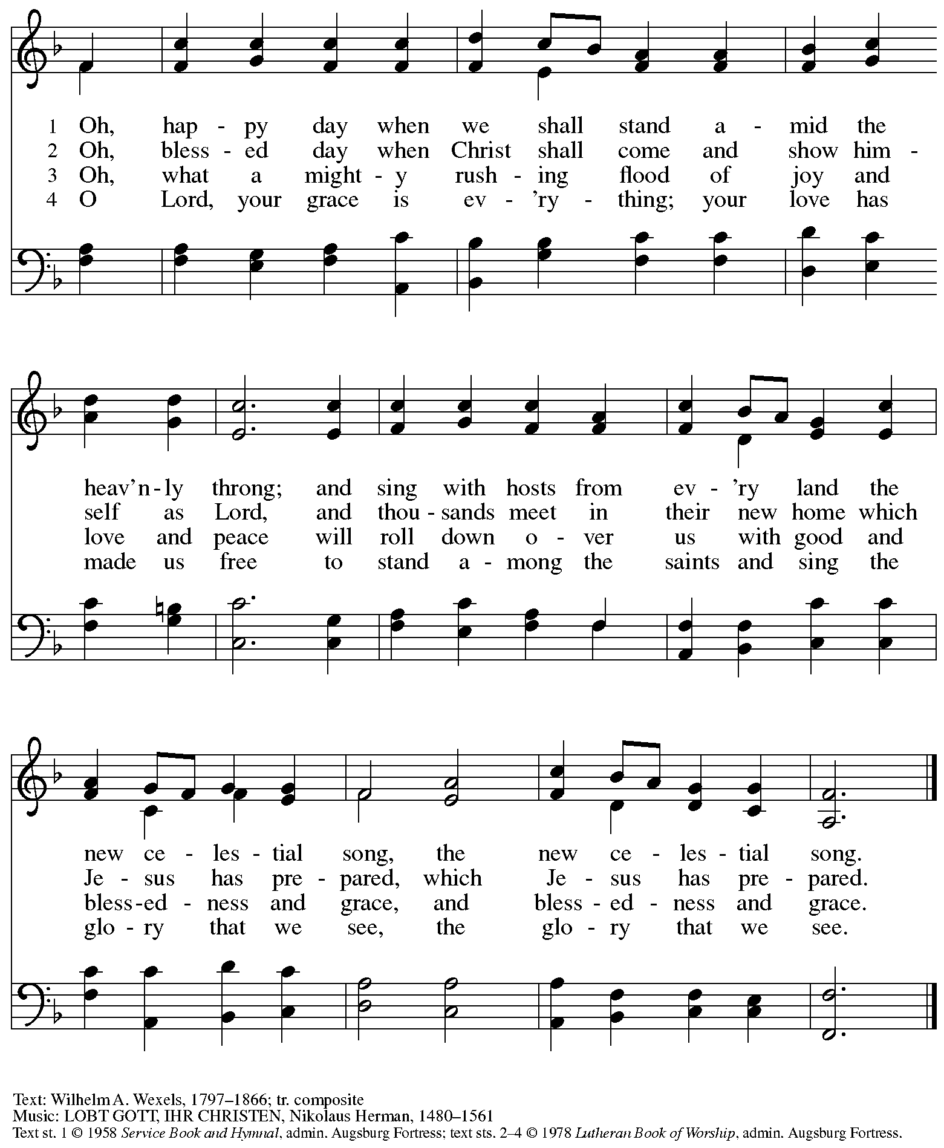
All rights reserved. Reprinted with permission under OneLicense.net # A-722139.

Hymns during Holy Communion
Blessed Assurance ELW 638

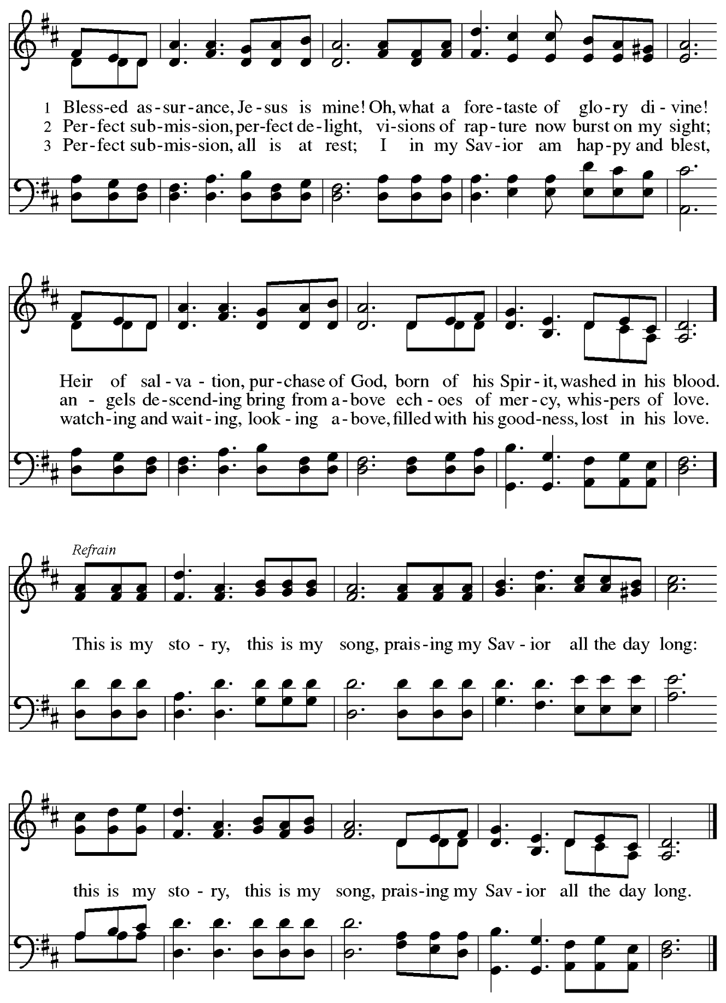

When all have returned to their places, please rise as you are able.

Blessing

P: The body and blood of our Lord Jesus Christ strengthen you and keep you in his grace.
C: Amen.

Prayer

A: Let us pray.
Gracious God,
in this meal you have drawn us to your heart,
and nourished us at your table with food and drink, the body and blood of Christ.
Now send us forth to be your people in the world,
and to proclaim your truth this day and evermore,
through Jesus Christ, our Savior and Lord.
C: Amen.

Please be seated.

Sending
God blesses us and sends us in mission to the world

Announcements

Mission Moment – Lutherlyn

Please rise as you are able.

Benediction

P: The God of glory,
☩ Jesus Christ, name above all names,
and the Spirit who lives in you
bless you now and forever.
C:
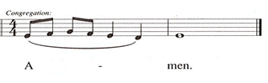

Sending Hymn Let Streams of Living Justice Following page
Sending Hymn Let Streams of Living Justice ELW 710

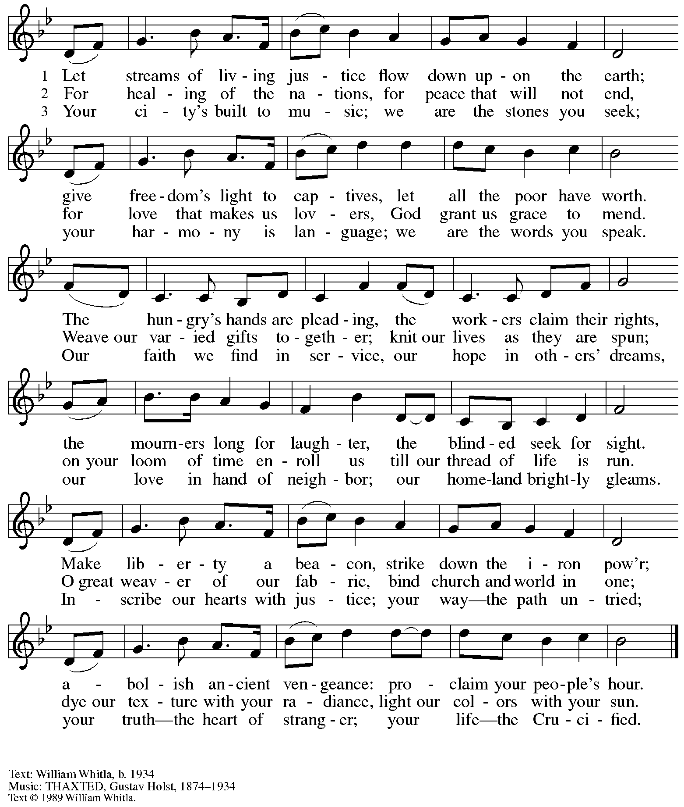
All rights reserved. Reprinted with permission of the hymnwriter, William Whitla.

Dismissal

A: Go in peace. Serve the Lord.
C: Thanks be to God!

Postlude

Those serving in worship today

Altar Care Beverley Chapman
Audio-Visual Ministers Kristen Asplin
Joseph Paetz
Cantor and Lector David Rollinson
Little Church – Big Faith Leader Sue Gaugler
Minister of Music Laura Reynolds
Presiding and Preaching Minister The Rev. Ross I. Carmichael

Liturgy and Hymnody Acknowledgements

From SundaysandSeasons.com. Copyright © 2023 Augsburg Fortress. All rights reserved. Reprinted under OneLicense.net # A-722139.
Used by permission of Augsburg Fortress.

Blessed Assurance – Text: Fanny J. Crosby, 1820-1915. Music: ASSURANCE, Phoebe P. Knapp, 1830-1908.

Please use the QR code below to link to St. Andrew’s Announcements online!

St. Andrew Lutheran Church Announcements
November 12th, 2023

- Welcome to worship at St. Andrew on the Twenty-fourth Sunday after Pentecost, November 12th, 2023 – We are so glad you are here, and we offer a special welcome to all guests who are gathered here or online! Worship attendees are invited to make a name tag at the back of the worship space if you would like. Children are invited to participate in Little Church – Big Faith, a Bible lesson and activity, after the prayer of the day. There are worship “toolkits” to help children engage with worship and “busy bags” for younger children available in the bookcase at the back of the sanctuary. Please feel free to take one to use with/for your children. We invite everyone to stay after worship for coffee and conversation in the Social Hall next to the sanctuary.
- Bible Study and “The Chosen” with Pastor Paul Koch after Worship Today and Next Sunday, November 19th – The Chosen is an online television series based on the Gospels of Jesus Christ, with some locations and timelines combined, condensed, or interpreted, and some dialogue and backstory added. Pastor Paul Koch is leading a study looking at Gospel texts, comparing and contrasting with “The Chosen,” and inviting further consideration of how we engage with the stories of Jesus. We encourage people to watch episodes of The Chosen ahead of time (we will focus on Season 3, Episode 8 for these two Sundays) but will highlight specific sections to consider during our discussions. The series is available for free at the official website, https://new.thechosen.tv/, or using The Chosen app. It can also be found on YouTube, Amazon Prime, and other streaming services. We may continue the study for additional weeks if there is sufficient interest and participation.
- Compline Prayer Service, a Ministry of Lutheran Campus Ministry in Greater Pittsburgh, Sundays at 8:00 p.m. at Heinz Chapel – Compline was traditionally a monastic prayer service, and the Pittsburgh Compline Choir sings a choral version of compline rooted in this thousand-year-old tradition of scripture, song, and silence. This service also streams on Facebook (Pittsburgh Compline Choir) and YouTube (The Pittsburgh Compline Choir). Heinz Chapel is located off of S. Bellefield Ave. in Oakland.
East End Cooperative Ministry Shelter Dinner – Thursday, November 16th, Arrival at 6:00 p.m., Meal at 6:30 p.m. – Each month, members of St. Andrew provide and serve a meal for the guests of the shelter at East End Cooperative Ministry (EECM), 6140 Station St., 15206. Anyone can sign up to prepare or purchase a portion of the meal to bring to EECM at 6:00 p.m. that day, or just come to help serve the meal at 6:30 p.m. If you would like to contribute, please sign up at: https://www.signupgenius.com/go/5080544AAAC22A1F58-45803586-novshelter.
- Camp Lutherlyn “Building for the Future” Campaign Continues – St. Andrew has been participating in an ongoing campaign to raise money for camp Lutherlyn in Prospect, PA. Lutherlyn has been integral in supporting the faith of children, youth, and adults and forming leaders for the church’s mission for 75 years. Their goal is to fund two new five-cabin villages, one of which will replace well-used cabins from 1958, and to renew and preserve the Steininger Memorial Amphitheater, and outdoor worship space. Lutherlyn is asking for commitments from individuals, families, foundations, and congregations to fund its initiatives.
In this week’s bulletin there is a brochure and pledge sheet for you to read and prayerfully consider over the next week. On Sunday, November 19th, we will offer an opportunity to dedicate these financial commitments during worship. Please prayerfully consider how God may be calling you to support the life-changing ministries of Lutherlyn, “A God-given place to be accepted, challenged, and sent.”
- Renew the Pews Continues after Worship on Sunday, November 19th – Earlier in the fall, St. Andrew began an effort to “Renew the Pews,” which includes steam cleaning of pew cushions and cleaning the pews themselves. We have one more section to go, and we invite those who are not attending Pastor Koch’s Bible Study on “The Chosen” to consider helping with this effort after worship on Sunday, November 19th. We thank Kristen Asplin for coordinating this effort, Lindsay Baxter for lending cleaning equipment, and all others who have participated!
- Interfaith Thanksgiving Service – Wednesday, November 21st, at 7:00 p.m. at Temple Sinai – Local houses of worship have been gathering for an interfaith Thanksgiving service for many years and this year’s will be held at Temple Sinai, 5505 Forbes Ave., Pittsburgh 15217 on Wednesday, November 21st, at 7:00 p.m. Join members of Pittsburgh’s many faith communities in a gathering to reconnect us with one another. Light refreshments will be served.
- Hearts and Hands, St. Andrew’s Crocheting and Knitting Ministry, Seeking New Participants and Meeting after Worship on Sunday, December 3rd – Hearts and Hands crocheting and knitting ministry provides prayer blankets and shawls for people undergoing medical treatments, those who are mourning, Confirmands, and various others at significant times. Hearts and Hands will meet after worship on Sunday, December 3rd, to discuss and plan activities for 2024. Anyone interested in learning to crochet, as well as current knitters and crocheters who would like to participate are welcome. The first project for the crocheters will be a scarf to add to the collection described in the next announcement. All supplies, including yarn and hooks, will be provided to anyone who may need them.
- Hearts and Hands and Community Ministry Committee Invite Congregation to Support Advent Appeal for Winter Accessories – People of the congregation are asked to bring winter hats, mittens/gloves, and scarves to church during the Advent season (beginning December 3rd) to support immigrants and refugees arriving in Pittsburgh. These can be handmade (knitted, crocheted, or sewn) or purchased. We can also make them available in the little pantry and at our produce distributions. A collection box will be set up in the social hall to receive these donations.
- Annual Meeting of the Congregation – Sunday, December 10th, after Worship – The annual meeting of the congregation takes place in November or December each year. This meeting is the highest decision-making body in the congregation, and includes election of leaders to serve on the congregation’s leadership council, adoption of a budget for ministry for the upcoming year, and updates about big-picture considerations and long-term planning. All confirmed members of the congregation are eligible to vote, and no absentee or proxy votes can be accepted, so please plan to attend the meeting on Sunday, December 10th.

