+ Twenty-fifth Sunday after Pentecost
November 19th, 2023
10:00 a.m.

St. Andrew Lutheran Church
304 Morewood Ave.
Pittsburgh, PA 15213
412.682.3342
St_andrewELCA@verizon.net
www.standrewpittsburgh.org

+ Twenty-fifth Sunday after Pentecost
Order for Worship

The church’s readings during November speak of the end times.
The prophet Zephaniah proclaims that the coming day of the Lord
will be filled with wrath and distress.
Paul says it will come like a thief in the night and urges us to be awake and sober.
Jesus tells the parable of the talents, calling us to use our gifts, while we still have time,
for the greater and common good. In a world filled with violence and despair,
we gather around signs of hope — word, water, wine and bread —
eager to welcome the good news of Christ’s coming among us.

Welcome to St. Andrew!

- St. Andrew Lutheran congregation welcomes all who are seeking a place of healing and wholeness – a nurturing, faith-forming spiritual home. Our community embraces people of all ages, ethnicities, cultures, abilities, sexual orientations, gender identities and expressions, and family constellations. Come and See!

- Worship Services are live streamed to multiple online platforms. By attending worship, you agree that your image and voice may be broadcast.

- Everyone is invited to make a nametag at the black bookcase in the back of the worship space if they would like. There are stickers indicating pronouns on the bookcase if you would like to include them on your name tag.

- Worship “toolkits” to help children engage with the service, along with “busy bags” for younger children, are available in the bookcase at the back of the sanctuary. Please feel free to take one to use with/for your children.

- Children are invited to attend Little Church – Big Faith, a Bible lesson and activity, during worship (after the Prayer of the Day). The group returns to the worship space for the liturgy of Holy Communion.

- Holy Communion is served with bread (gluten-free available) and wine or grape juice. The presiding minister will distribute the bread (host). Please consume this and then pick up an empty glass from the tray. The Communion Assistant will pour wine or grape juice into your glass. Please step to the side to consume the wine or grape juice. Feel free to kneel at the altar for prayer and reflection. As you return to your pew, glasses may be returned to the empty trays on either side of the center section.

- A restroom is available on the main level of the church, through the doors to the Social Hall and to the right in the main office.

Abbreviations
P: Pastor/Presiding Minister ACS: All Creation Sings hymnal
A: Assisting Minister ELW: Evangelical Lutheran Worship hymnal
L: Lector HS: Hymnal Supplement
C: Congregation
Pre-Service Music

Welcome

Prelude Simple Gifts Brackett
Arr. Vandall

Gathering
The Holy Spirit calls us together as the people of God

Confession and Forgiveness

Please rise as you are able. All may make the sign of the cross,
the sign that is marked at Baptism, as the presiding minister begins.

P: Blessed be the holy Trinity, ☩ one God,
whose mercy endures forever.
C: Amen.

P: If we say we have no sin we deceive ourselves and the truth is not in us.
Let us confess our sin to God, who is faithful and just
and who has promised to forgive our sin and cleanse us from all unrighteousness.

Silence is kept for reflection and self-examination.

P: Most merciful God,
C: have mercy on us.
We confess to you
that we have sinned against you
in thought, word, and deed,
by what we have done
and by what we have left undone.
We have not trusted you with our whole heart.
We have not loved one another in deed and in truth.
In your compassion, forgive our sin and uphold us by your Spirit,
that we may live and serve you in newness of life
through Jesus Christ, our light and our truth.
Amen.

P: With joy I proclaim to you that Almighty God,
rich in mercy, abundant in love,
forgives you all your sin
and grants you newness of life in ☩ Jesus Christ.
C: Amen. Thanks be to God!
Gathering Hymn Lord of Glory, You Have Bought Us ELW 707

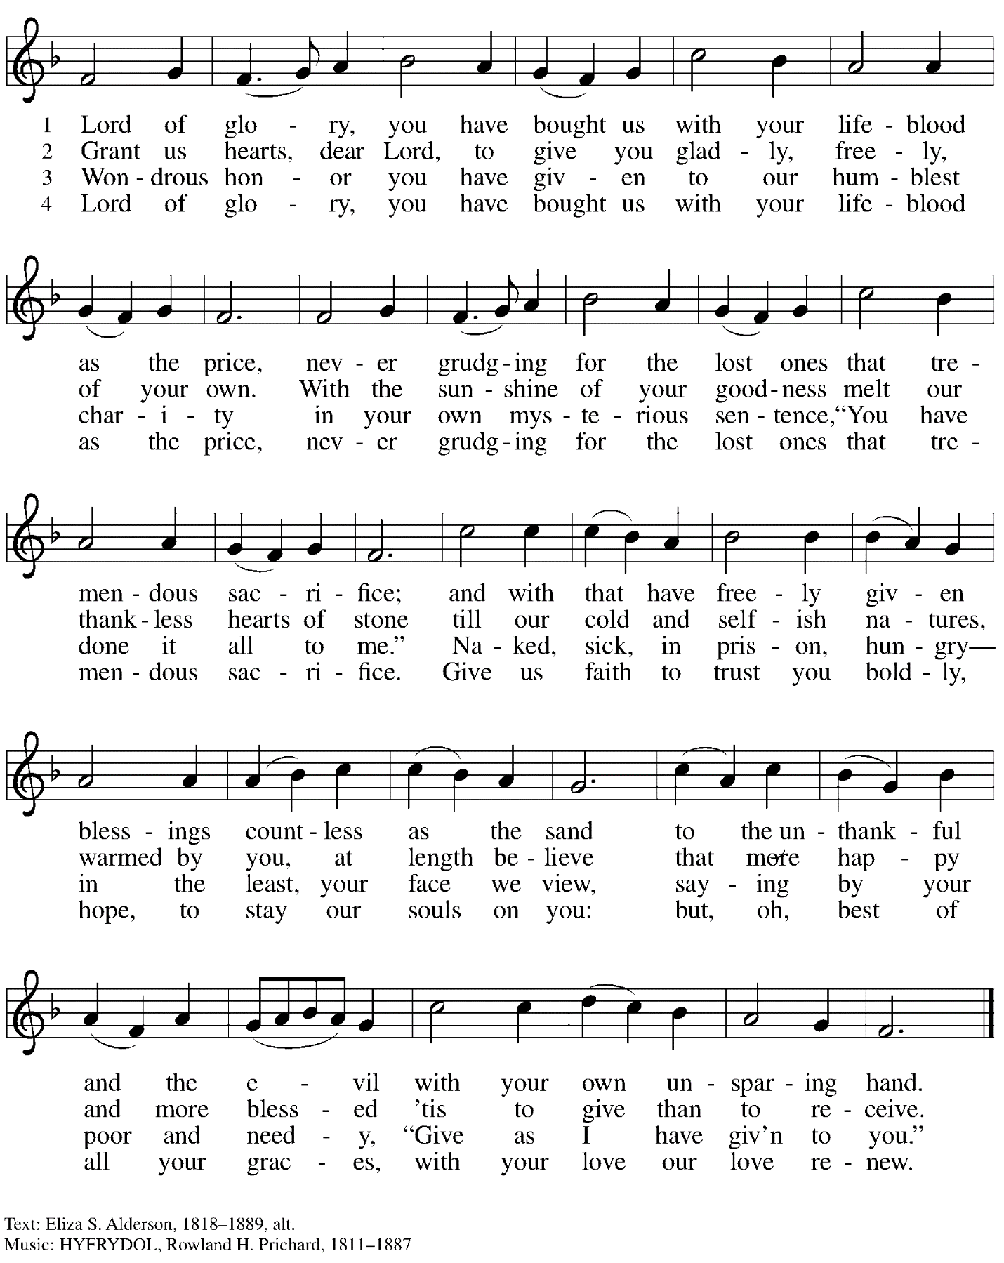

Greeting

P: The grace of our Lord Jesus Christ, the love of God,
and the communion of the Holy Spirit be with you all.
C: And also with you.

Hymn of Praise Now the Feast and Celebration HS p. 4-5

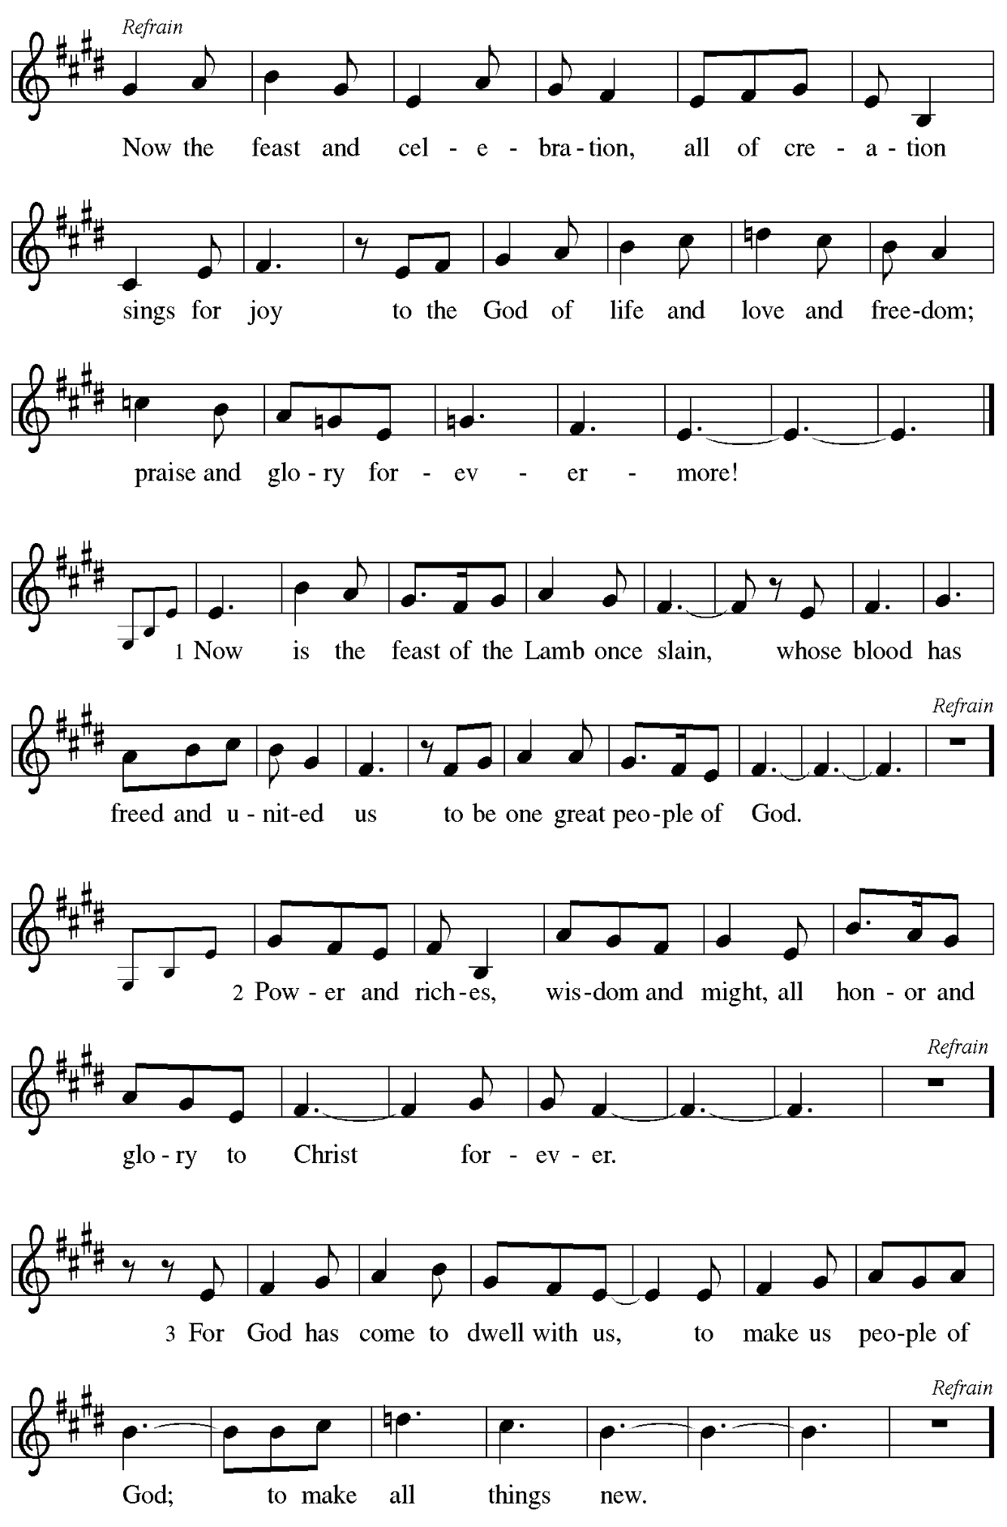
Prayer of the Day

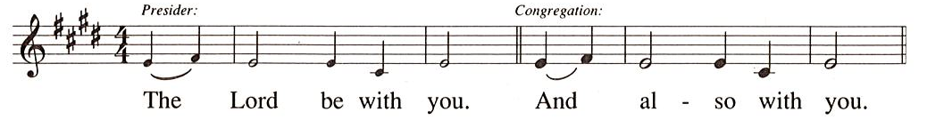

P: Let us pray.
Righteous God, our merciful sovereign,
you have made all the earth and its peoples,
and you give us all that we have.
Inspire us to serve you with justice and wisdom,
and prepare us for the joy of the day of your coming,
through Jesus Christ, our Savior and Lord.
C: Amen.

Please be seated.
Children are invited to join the adult leaders at the door and move to the office for Little Church – Big Faith. We ask that one additional adult from the congregation attend with the children.

Word
God speaks to us in Scripture reading, preaching, and song

First Reading – Zephaniah 1: 7, 12-18

⁷Be silent before the Lord God!
For the day of the Lord is at hand;
the Lord has prepared a sacrifice,
the Lord has consecrated the Lord’s guests.
¹²At that time I will search Jerusalem with lamps,
and I will punish the people
who rest complacently on their dregs,
those who say in their hearts,
“The Lord will not do good,
nor will the Lord do harm.”
¹³Their wealth shall be plundered,
and their houses laid waste.
Though they build houses,
they shall not inhabit them;
though they plant vineyards,
they shall not drink wine from them.
¹⁴The great day of the Lord is near,
near and hastening fast;
the sound of the day of the Lord is bitter,
the warrior cries aloud there.
¹⁵That day will be a day of wrath,
a day of distress and anguish,
a day of ruin and devastation,
a day of darkness and gloom,
a day of clouds and thick darkness,
¹⁶a day of trumpet blast and battle cry
against the fortified cities
and against the lofty battlements.
¹⁷I will bring such distress upon people
that they shall walk like the blind;
because they have sinned against the Lord,
their blood shall be poured out like dust,
and their flesh like dung.
¹⁸Neither their silver nor their gold
will be able to save them
on the day of the Lord’s wrath;
in the fire of the Lord’s passion
the whole earth shall be consumed;
for a full, a terrible end
the Lord will make of all the inhabitants of the earth.

L: Word of God, word of life.
C: Thanks be to God.

Psalm 90: 1-8 [9-11] 12

The psalm will be sung responsively, led by the cantor. The congregation is invited to join in singing the alternate verses in bold and the refrain.

Psalm tone

Psalm refrain

¹Lord, you have | been our refuge
from one generation | to another.
²Before the mountains were brought forth, or the land and the | earth were born,
from age to age | you are God.
³You turn us back to the | dust and say,
“Turn back, O child- | ren of earth.”
⁴For a thousand years in your sight are like yesterday when | it is past
and like a watch | in the night; R
⁵you sweep them away | like a dream,
they fade away suddenly | like the grass:
⁶in the morning it is | green and flourishes;
in the evening it is dried | up and withered.
⁷For we are consumed | by your anger;
we are afraid because | of your wrath.
⁸Our iniquities you have | set before you,
and our secret sins in the light | of your countenance. R
[ ⁹When you are angry, all our | days are gone;
we bring our years to an end | like a sigh.
¹⁰The span of our life is seventy years, perhaps in strength | even eighty;
yet the sum of them is but labor and sorrow, for they pass away quickly and | we are gone.
¹¹Who regards the power | of your wrath?
Who rightly fears your | indignation?
] ¹²So teach us to num- | ber our days
that we may apply our | hearts to wisdom. R

Second Reading – 1 Thessalonians 5: 1-11

¹Now concerning the times and the seasons, kindred, you do not need to have anything written to you. ²For you yourselves know very well that the day of the Lord will come like a thief in the night. ³When they say, “There is peace and security,” then sudden destruction will come upon them, as labor pains come upon a pregnant woman, and there will be no escape! ⁴But you, beloved, are not in darkness, for that day to surprise you like a thief; ⁵for you are all children of light and children of the day; we are not of the night or of darkness. ⁶So then let us not fall asleep as others do, but let us keep awake and be sober; ⁷for those who sleep sleep at night, and those who are drunk get drunk at night. ⁸But since we belong to the day, let us be sober, and put on the breastplate of faith and love, and for a helmet the hope of salvation. ⁹For God has destined us not for wrath but for obtaining salvation through our Lord Jesus Christ, ¹⁰who died for us, so that whether we are awake or asleep we may live with him. ¹¹Therefore encourage one another and build up each other, as indeed you are doing.

L: Word of God, word of life.
C: Thanks be to God.

Please rise as you are able.

Gospel Acclamation HS p. 8
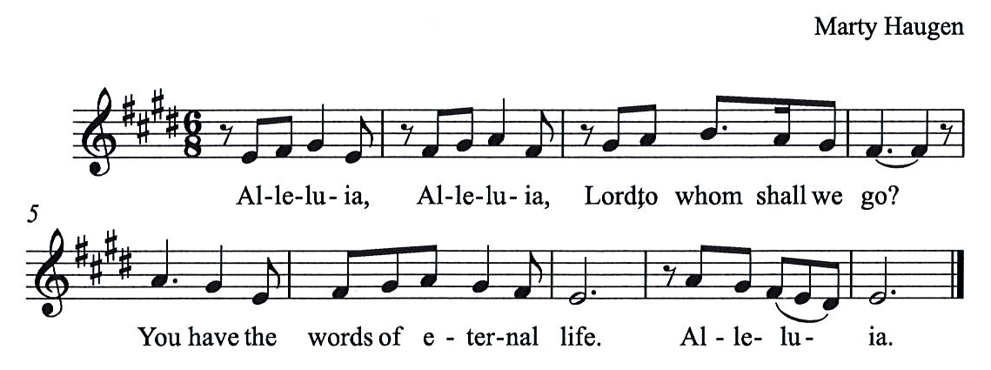

Gospel – Matthew 25: 14-30

P: The holy Gospel according to St. Matthew.
C: Glory to you, O Lord.

[Jesus said to the disciples:] ¹⁴“For it is as if a man, going on a journey, summoned his slaves and entrusted his property to them; ¹⁵to one he gave five talents, to another two, to another one, to each according to his ability. Then he went away. ¹⁶The one who had received the five talents went off at once and traded with them, and made five more talents. ¹⁷In the same way, the one who had the two talents made two more talents. ¹⁸But the one who had received the one talent went off and dug a hole in the ground and hid his master’s money. ¹⁹After a long time the master of those slaves came and settled accounts with them. ²⁰Then the one who had received the five talents came forward, bringing five more talents, saying, ‘Master, you handed over to me five talents; see, I have made five more talents.’ ²¹His master said to him, ‘Well done, good and trustworthy slave; you have been trustworthy in a few things, I will put you in charge of many things; enter into the joy of your master.’ ²²And the one with the two talents also came forward, saying, ‘Master, you handed over to me two talents; see, I have made two more talents.’ ²³His master said to him, ‘Well done, good and trustworthy slave; you have been trustworthy in a few things, I will put you in charge of many things; enter into the joy of your master.’ ²⁴Then the one who had received the one talent also came forward, saying, ‘Master, I knew that you were a harsh man, reaping where you did not sow, and gathering where you did not scatter seed; ²⁵so I was afraid, and I went and hid your talent in the ground. Here you have what is yours.’ ²⁶But his master replied, ‘You wicked and lazy slave! You knew, did you, that I reap where I did not sow, and gather where I did not scatter? ²⁷Then you ought to have invested my money with the bankers, and on my return I would have received what was my own with interest. ²⁸So take the talent from him, and give it to the one with the ten talents. ²⁹For to all those who have, more will be given, and they will have an abundance; but from those who have nothing, even what they have will be taken away. ³⁰As for this worthless slave, throw him into the outer darkness, where there will be weeping and gnashing of teeth.’ ”
P: The Gospel of the Lord.
C: Praise to you, O Christ.

Please be seated.

Sermon

A time of silence for prayer and reflection follows the sermon.
As the hymn of the day begins, please rise as you are able.

Hymn of the Day God of the Fertile Fields Following page

Hymn of the Day God of the Fertile Fields ACS 1063

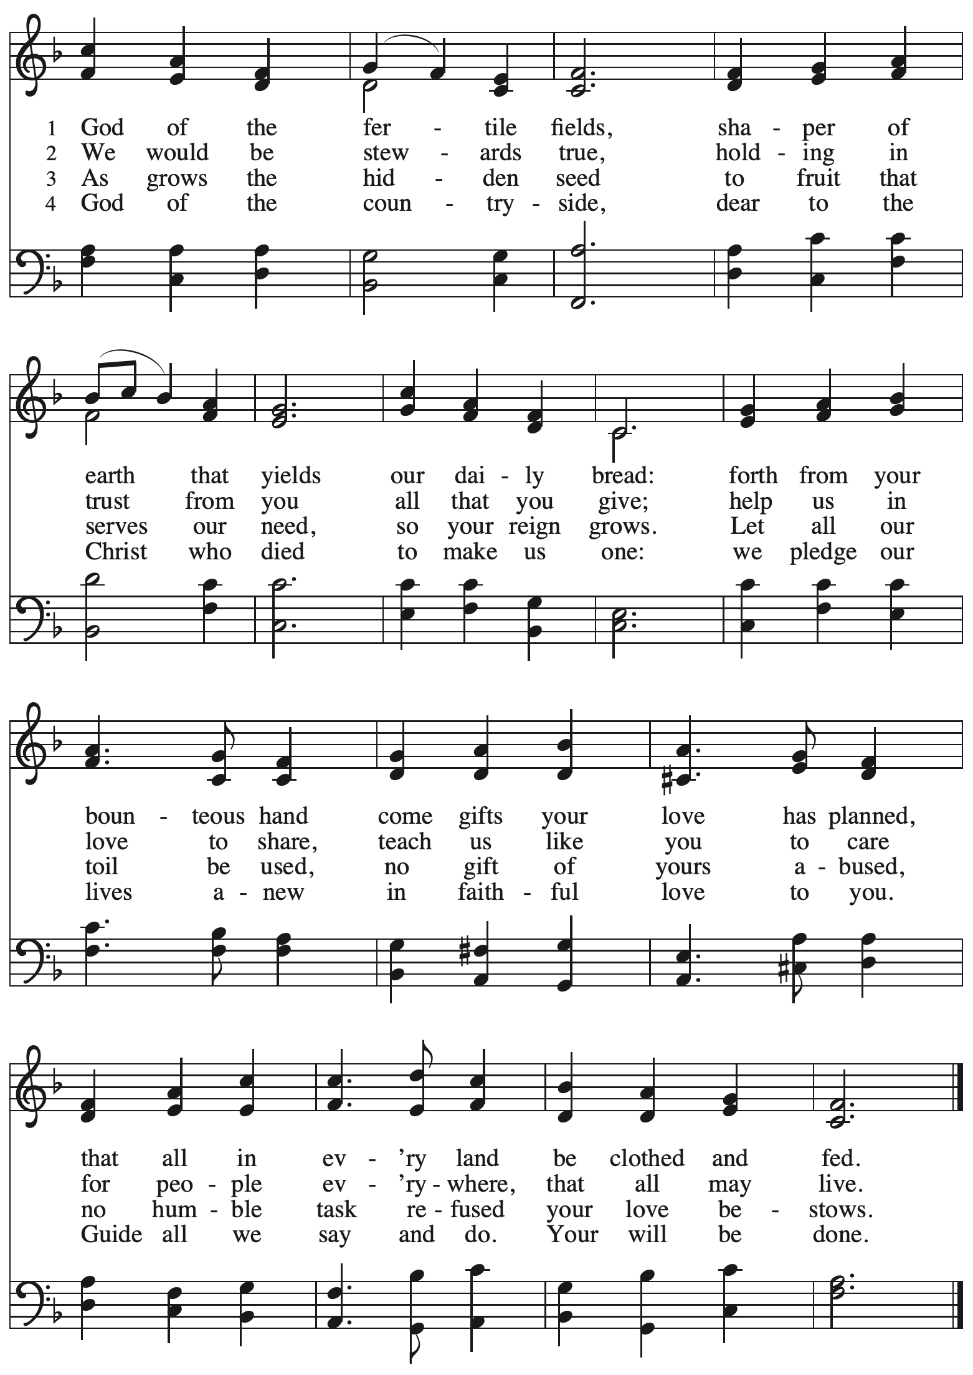
Apostles Creed

P: Let us confess our faith:
C: I believe in God, the Father almighty,
creator of heaven and earth.

I believe in Jesus Christ, God’s only Son, our Lord,
who was conceived by the Holy Spirit,
born of the virgin Mary,
suffered under Pontius Pilate,
was crucified, died, and was buried;
he descended to the dead.*
On the third day he rose again;
he ascended into heaven,
he is seated at the right hand of the Father,
and he will come to judge the living and the dead.

I believe in the Holy Spirit,
the holy catholic church,
the communion of saints,
the forgiveness of sins,
the resurrection of the body,
and the life everlasting. Amen.

*Or, “he descended into hell,” another translation of this text in widespread use.

Prayers of the People

A: Trusting in the transformative power of God’s loving Spirit,
let us pray for the church, the world, and all who are in need.

After each petition
A: God of grace,
C: receive our prayer.

The presiding minister concludes the prayers
P: Into your care, gracious God, we commend all for whom we pray,
trusting in your unending love and amazing grace;
through Jesus Christ, our Savior.
C: Amen.

Peace

The presiding minister and the assembly greet one another in the peace of the risen Christ.
P: The peace of Christ be with you always.
C: And also with you.

The people may greet those around them with a sign of Christ’s peace and may say
Peace be with you or similar words. Please be mindful that not everyone will be comfortable with sharing the peace, so please seek consent before shaking hands or hugging. Other possible ways to share the peace include a simple bow with the verbal greeting of peace, or simply a verbal expression of peace.

When the greetings of peace have concluded, please be seated.

Invitation to Dedicate Gifts for Camp Lutherlyn

Meal
God feeds us with the presence of Jesus Christ

Offering

We offer ourselves, our gifts, and our faithful service to God.
As the offering is gathered for the mission of the church, including the care of those in need,
the table is set for Holy Communion.

Music during the Offering
Joyful, Joyful, We Adore Thee Beethoven
arr. Ijames

As the gifts are brought forward for presentation, please rise as you are able.

Offertory Song As the Grains of Wheat ELW 465

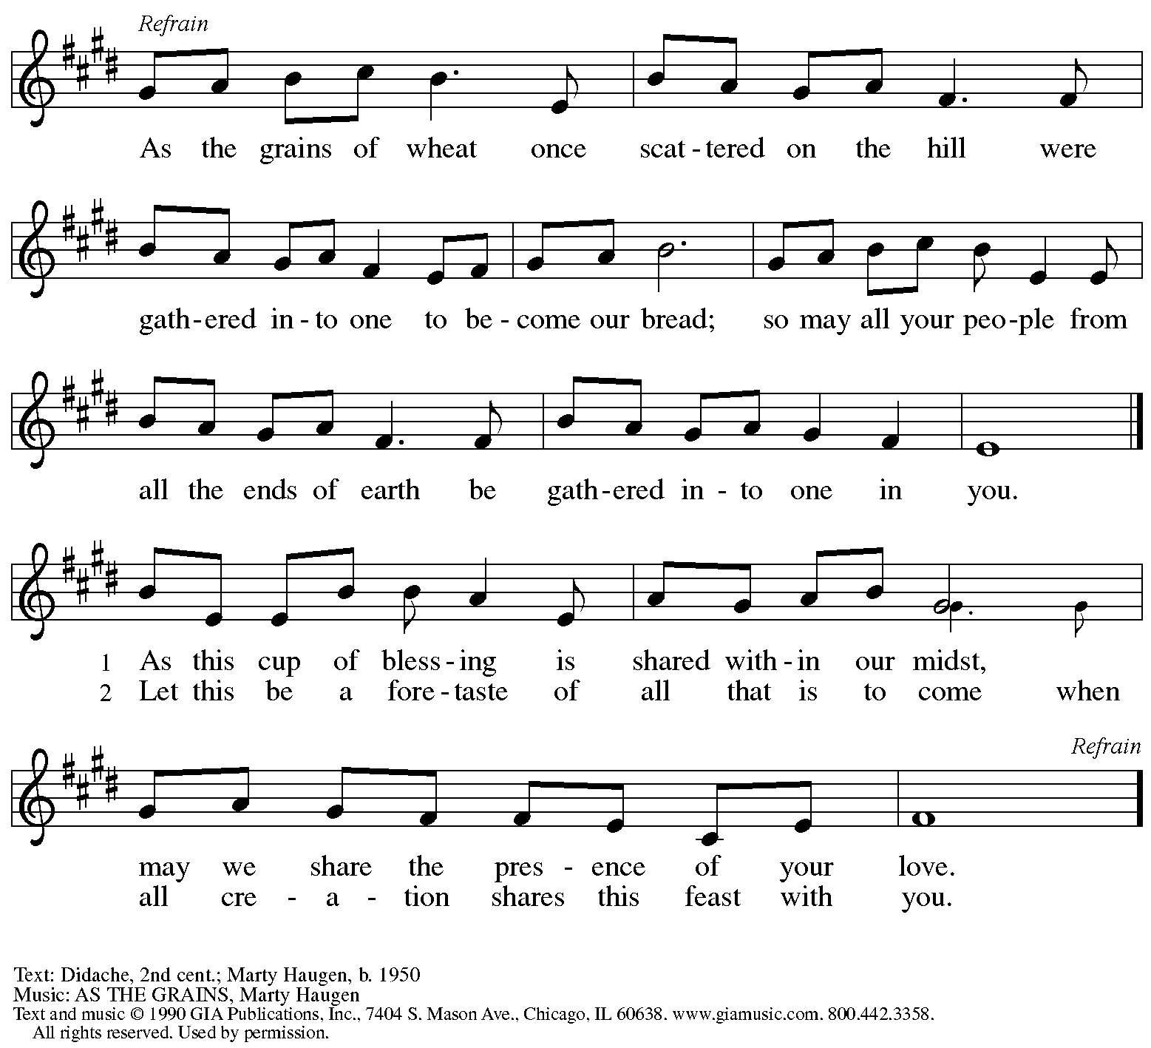
Reprinted with permission under OneLicense.net # A-722139.

Dedication of Gifts for Camp Lutherlyn

Offertory Prayer

A: Let us pray.
God of all creation,
C: the eyes of all wait upon you,
and you open your hand in blessing.
Fill us with good things at your table,
that we may come to the help of all in need,
through Jesus Christ, our redeemer and Lord.
Amen.

Dialogue HS p. 14

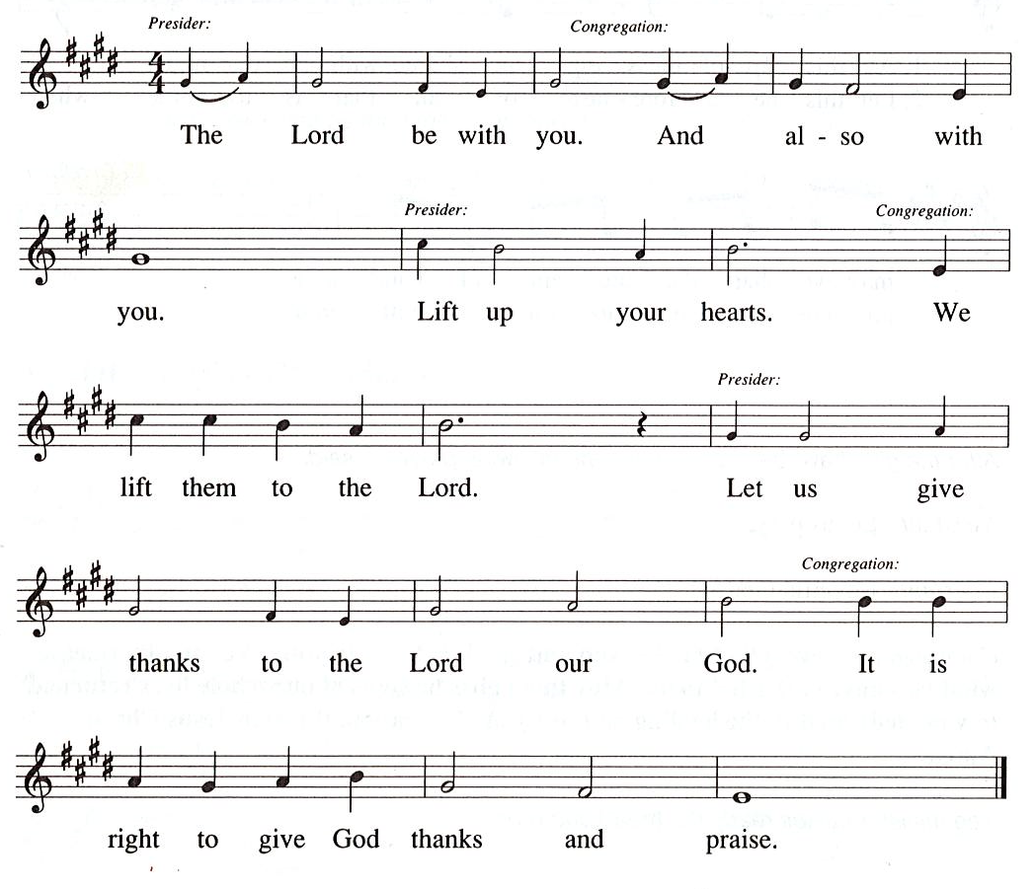

Preface

P: It is our duty and delight
that we should everywhere and always
offer thanks and praise to you, O God,
through Jesus Christ,
who calls us to follow his way of humble service and love,
and so with the church on earth,
all creation and the hosts of heaven.
we praise your name and join their unending hymn:

Sanctus HS p. 15

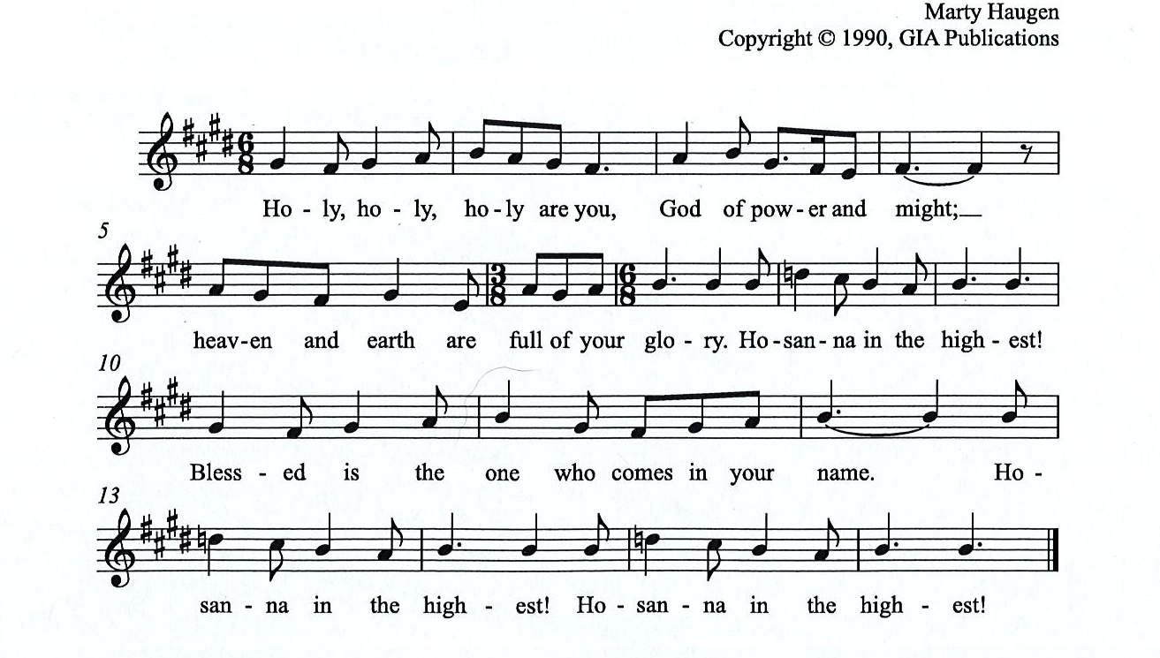

Eucharistic Prayer

P: You are indeed holy, almighty and merciful God, …
… Do this for the remembrance of me.

For as often as we eat of this bread and drink from this cup,
we proclaim the Lord’s death until he comes.
C:

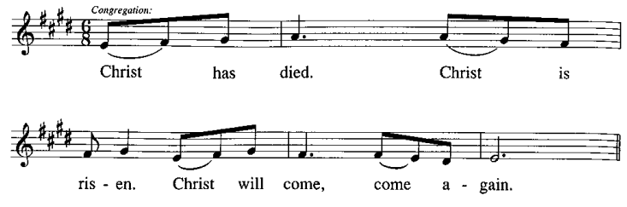

P: Remembering, therefore, …
… … To you, O God, Father, Son, and Holy Spirit
be all honor and glory in your holy church, now and forever.
C:
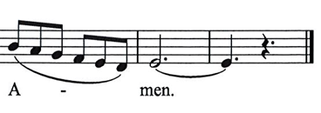

Lord’s Prayer

P: Gathered as one by the Holy Spirit, let us pray as Jesus taught us.
C: Our Father in heaven,
hallowed be your name,
your kingdom come,
your will be done,
on earth as in heaven.
Give us today our daily bread.
Forgive us our sins
as we forgive those
who sin against us.
Save us from the time of trial
and deliver us from evil.
For the kingdom, the power,
and the glory are yours,
now and forever. Amen.

Fraction and Invitation

Agnus Dei / Lamb of God HS p. 18

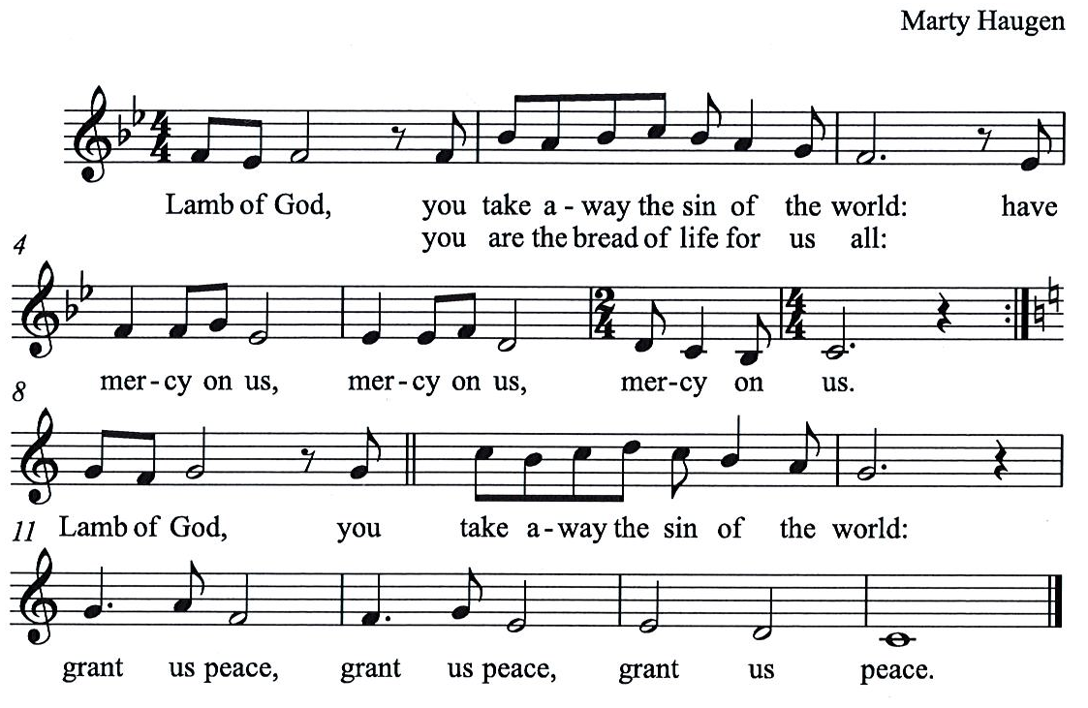

Please be seated.

Holy Communion
- All who seek God and desire a deeper and stronger life in Christ are welcome to receive Holy Communion.
- Worshipers from the pulpit side will proceed forward first, followed by the center section, and then the lectern side.
- Please inform an usher if you would like the ministers to bring Communion to you.
- Holy Communion will be served with bread and wine/grape juice.
- The presiding minister will first distribute the bread (host) to each communicant. Please indicate if you require a gluten-free host.
- Once you have consumed the bread, please pick up an empty glass from the tray next to the presiding minister. The Communion Assistant will pour wine from the chalice or grape juice from the cruet into your glass.
- Please step to the side to consume the wine or grape juice.
- Feel free to kneel at the altar rail for prayer after receiving the sacrament.
- As you return to your pew, glasses may be returned to the empty trays on either side of the center section.
- A blessing will be provided for anyone who does not yet receive the sacrament.
- All are invited to join in singing the hymns during Holy Communion.

Hymns during Holy Communion
We Place upon Your Table, Lord ELW 467

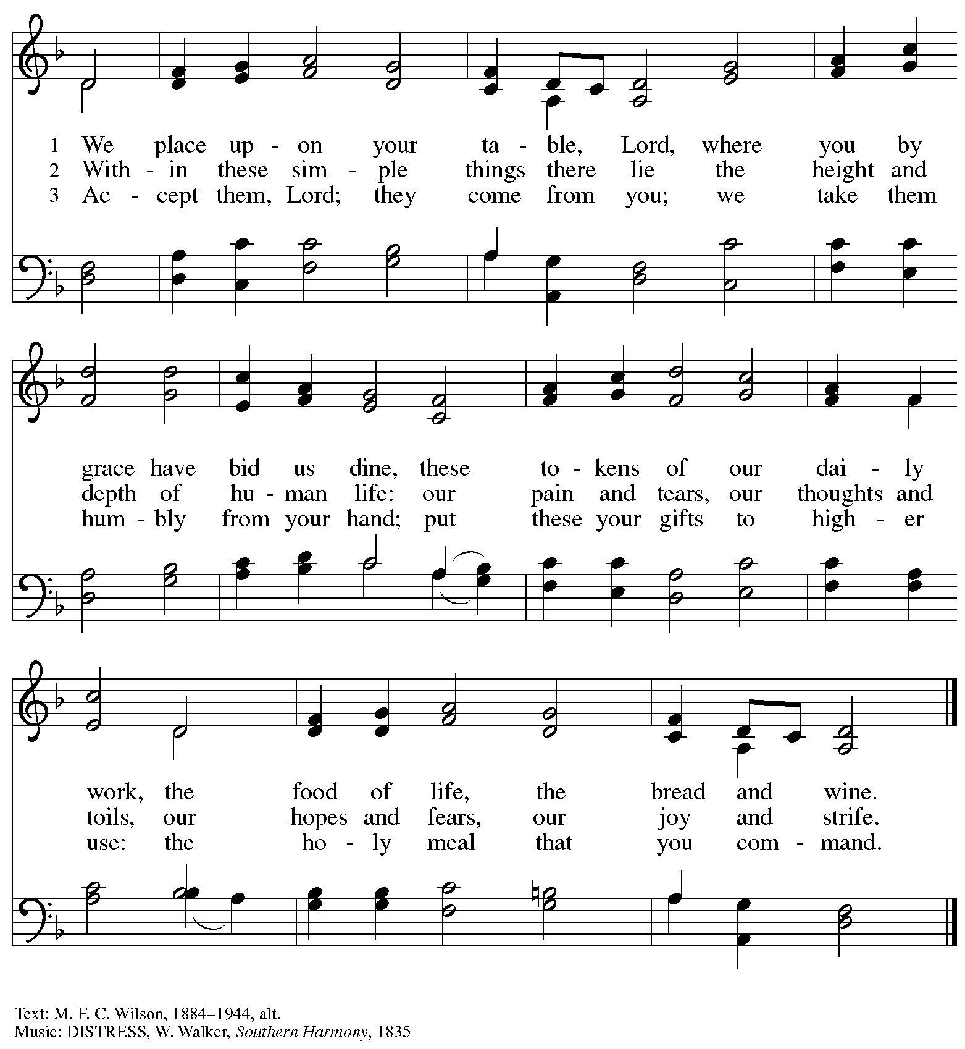

Hymns during Holy Communion
For the Fruit of All Creation ELW 679

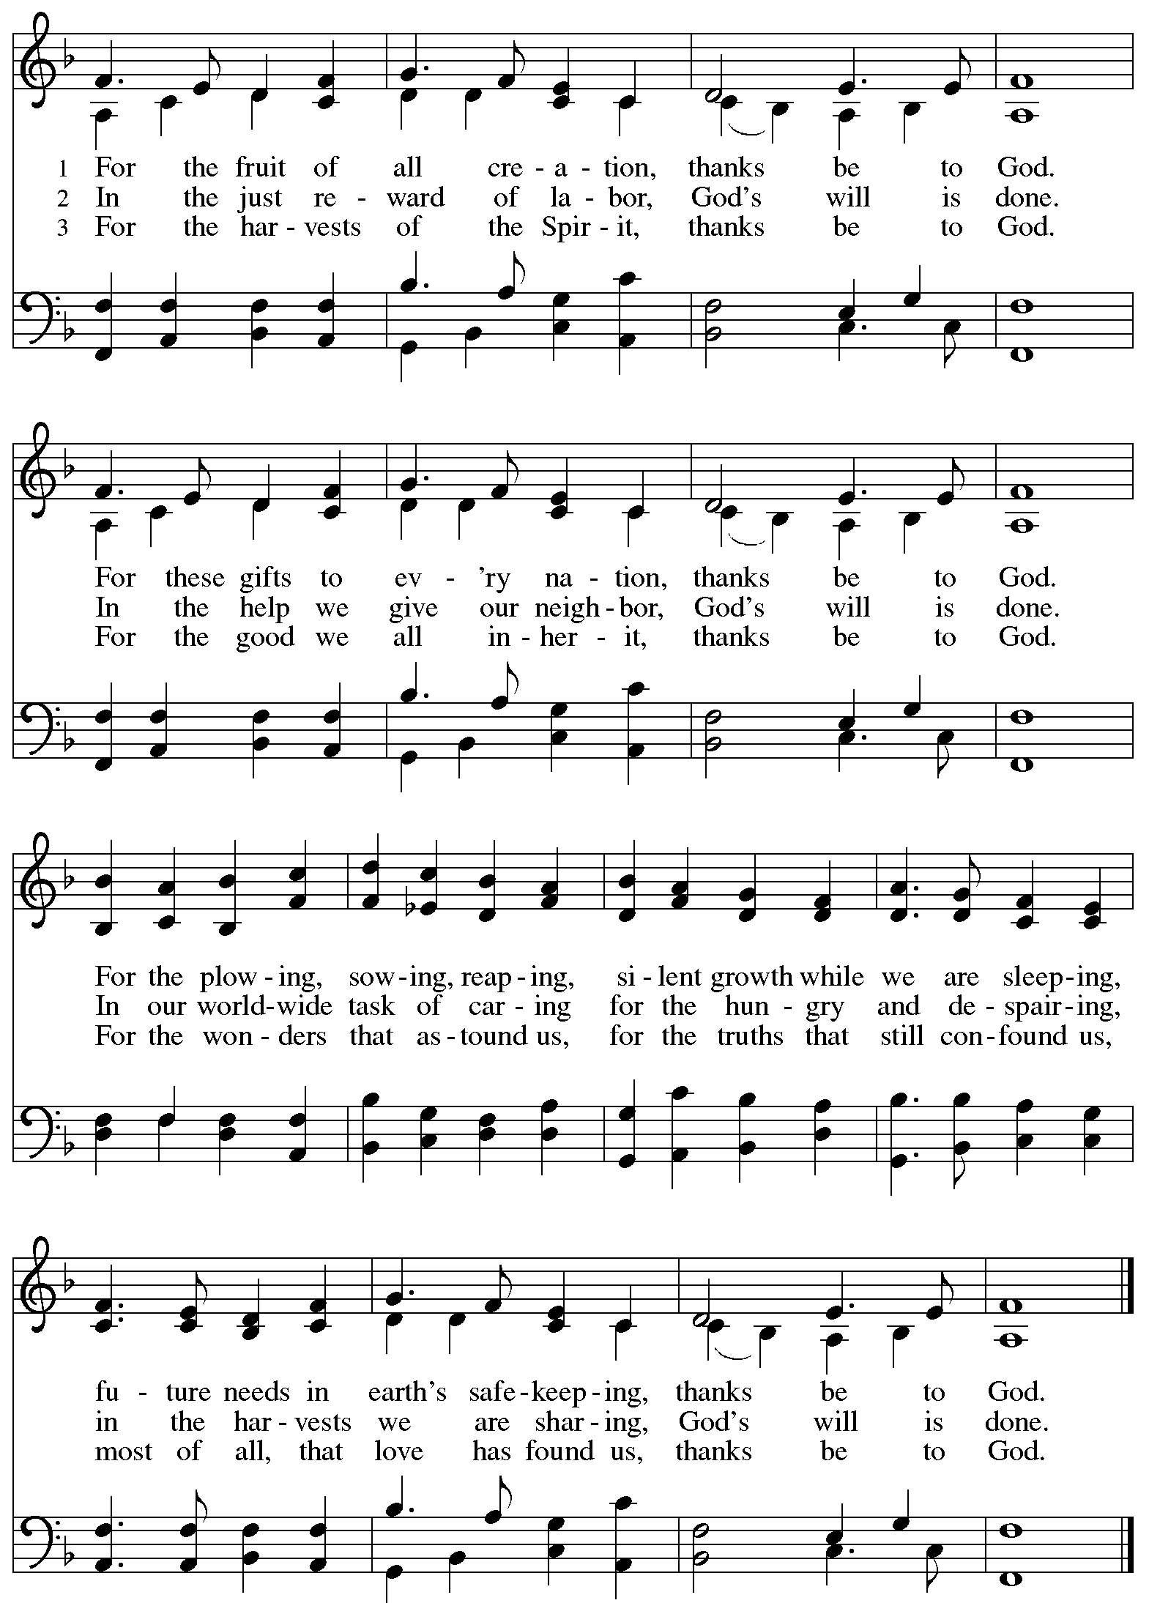
Hymns during Holy Communion
God, Whose Giving Knows No Ending ELW 678

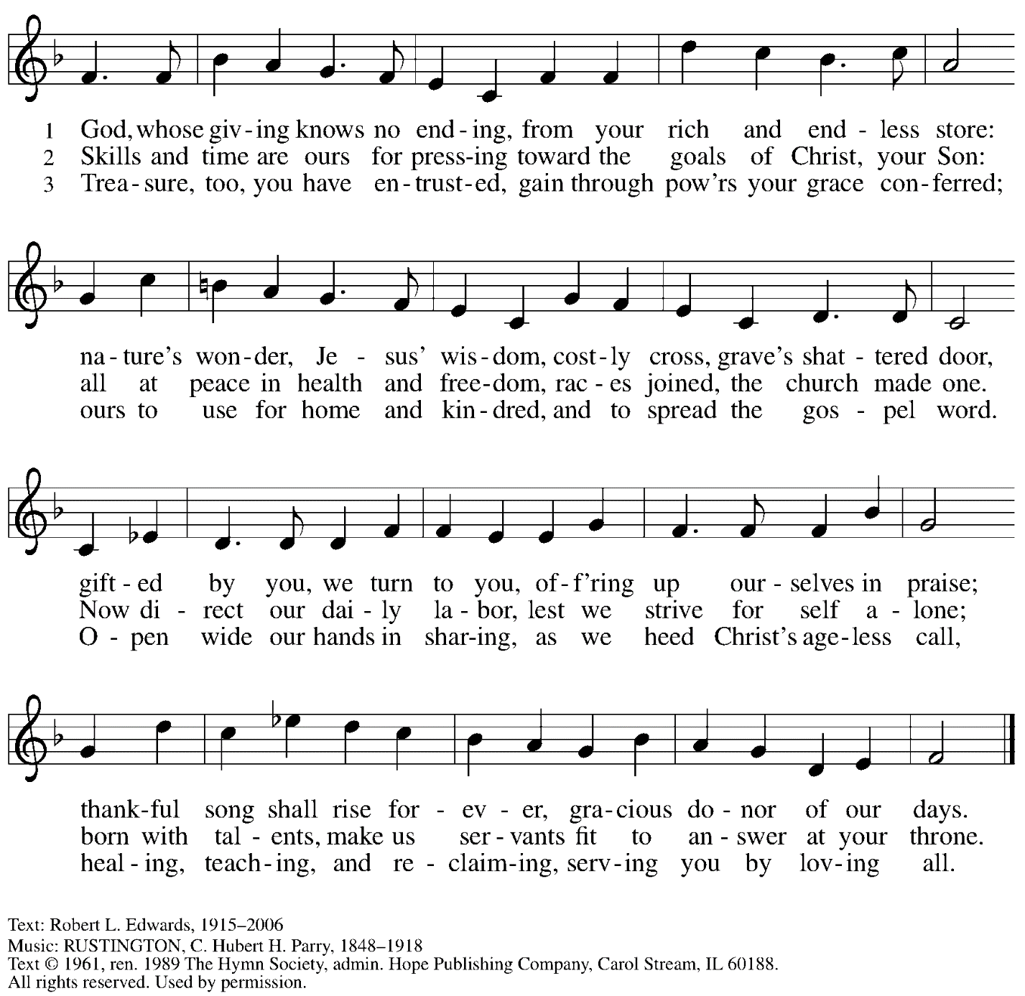
Reprinted with permission under OneLicense.net # A-722139.

When all have returned to their places, please rise as you are able.

Blessing

P: The body and blood of our Lord Jesus Christ strengthen you and keep you in his grace.
C: Amen.

Prayer

A: Let us pray.
Gracious God,
in this meal you have drawn us to your heart,
and nourished us at your table with food and drink, the body and blood of Christ.
Now send us forth to be your people in the world,
and to proclaim your truth this day and evermore,
through Jesus Christ, our Savior and Lord.
C: Amen.

Please be seated.

Sending
God blesses us and sends us in mission to the world

Announcements

Please rise as you are able.

Benediction

P: The God of glory,
☩ Jesus Christ, name above all names,
and the Spirit who lives in you
bless you now and forever.
C:
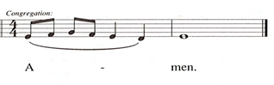

Sending Hymn Following page
Toma, oh Dios, mi voluntad / Take My Life, That I May Be

Dismissal

A: Go in peace. Serve the Lord.
C: Thanks be to God!

Postlude

Sending Hymn ELW 583
Toma, oh Dios, mi voluntad / Take My Life, That I May Be
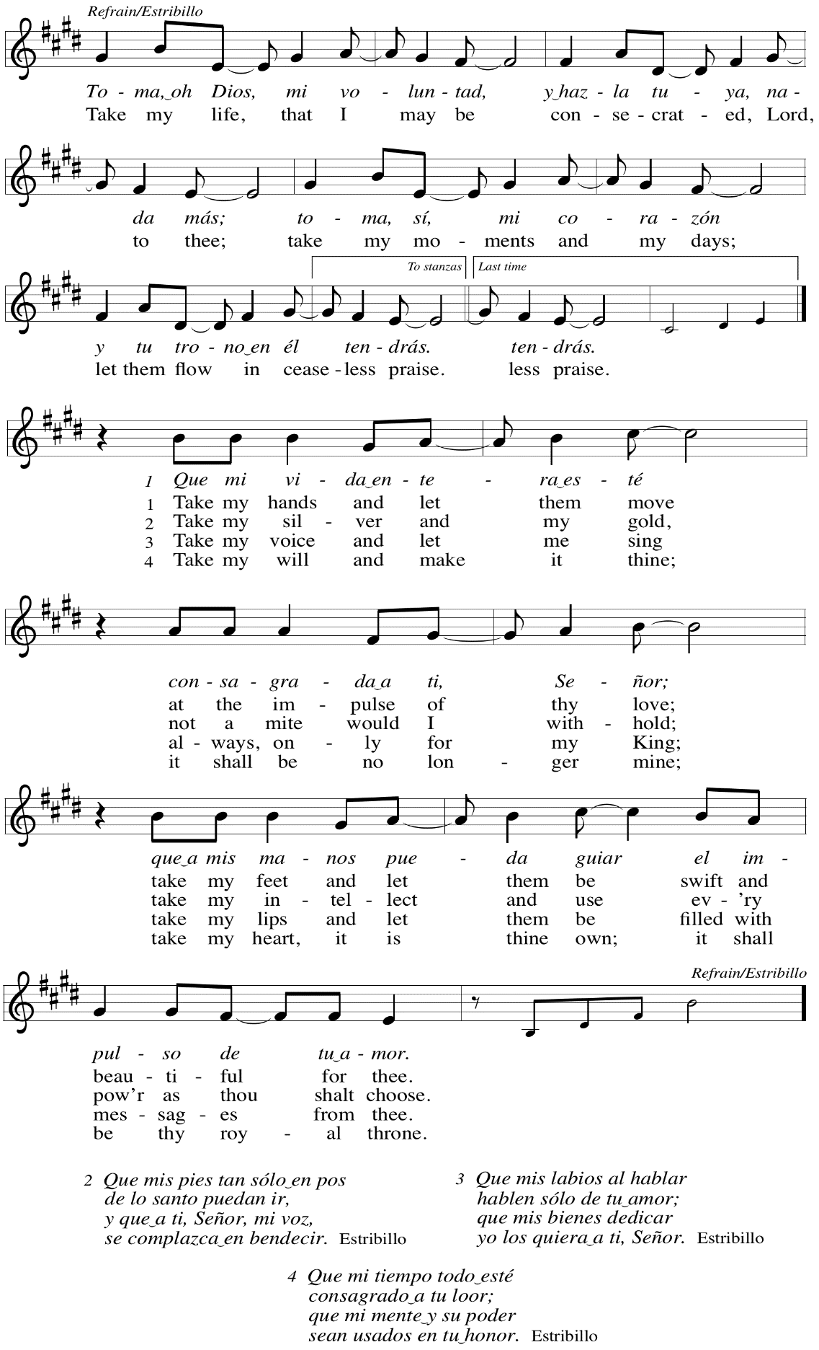
Those serving in worship today

Altar Care Christy Ruhe
Assisting Minister Chris Lotspeich
Audio-Visual Ministers Noël Marsh
Colten Rohleder
Cantor Mandy Best
Little Church – Big Faith Leader Sue Gaugler
Minister of Music Laura Reynolds
Piano Sarita
Presiding and Preaching Minister The Rev. Ross I. Carmichael

Liturgy and Hymnody Acknowledgements

From SundaysandSeasons.com. Copyright © 2023 Augsburg Fortress. All rights reserved. Reprinted under OneLicense.net # A-722139.
Used by permission of Augsburg Fortress.

God of the Fertile Fields – Text: Georgia Harkness, 1891-1974, alt. Music: ITALIAN HYMN, Felice de Giardini, 1716-1796. Text © 1955 ren. 1983 The Hymn Society, admi Hope Publishing Company, Carol Stream, IL 60188. All rights reserved. Reprinted with permission under OneLicense.net # A-722139.

For the Fruit of All Creation – Text: Fred Pratt Green, 1903-2000. Music: AR HYD Y NOS, Welsh traditional; arr. Ralph Vaughan Williams, 1872-1958. Text © 1970 Hope Publishing Company, Carol Stream, IL 60188. All rights reserved. Reprinted with permission under OneLicense.net # A-722139.

Toma, oh Dios, mi voluntad / Take My Life That I May Be – Text: Frances R. Havergal, 1836-1879, adapt.; Spanish text: Vincent Mendoza, 1875-1955. Music: TOMA MI VOLUNTAD, William Dexheimer Pharris, b. 1956. Music © 1999 Augsburg Fortress. All rights reserved. Reprinted with permission under OneLicense.net # A-722139.

Please use the QR code below to link to St. Andrew’s Announcements online!

St. Andrew Lutheran Church Announcements
November 19th, 2023

- Welcome to worship at St. Andrew on the Twenty-fifth Sunday after Pentecost, November 19th, 2023 – We are so glad you are here, and we offer a special welcome to all guests who are gathered here or online! Worship attendees are invited to make a name tag at the back of the worship space if you would like. Children are invited to participate in Little Church – Big Faith, a Bible lesson and activity, after the prayer of the day. There are worship “toolkits” to help children engage with worship and “busy bags” for younger children available in the bookcase at the back of the sanctuary. Please feel free to take one to use with/for your children.
- Camp Lutherlyn “Building for the Future” Campaign Concludes Today – St. Andrew has been participating in a campaign of the larger church to raise money for Lutherlyn in Prospect, PA. Lutherlyn is a camp beloved by generations in this area which has been integral in supporting the faith of children, youth, and adults and forming leaders for the church’s mission. The plan is to fund two new five-cabin villages, one of which will replace well-used cabins from 1958, and to renew and preserve the Steininger Memorial Amphitheater, and outdoor worship space. Today we will dedicate our gifts on behalf of Lutherlyn during worship – please return the “Statement of Intent” sheet from last week in the basket during the offering. If you do not have a Statement of Intent with you, please ask the ushers and they will give you another one. Thank you for supporting the life-changing ministries of Lutherlyn, “A God-given place to be accepted, challenged, and sent.”
- Bible Study and “The Chosen” with Pastor Paul Koch – After Worship Today – The Chosen is an online television series based on the Gospels of Jesus Christ, with some locations and timelines combined, condensed, or interpreted, and some dialogue and backstory added. Pastor Paul Koch will lead the group in looking at Gospel texts, comparing and contrasting with “The Chosen,” and inviting further consideration of how we engage with the stories of Jesus. We encourage people to watch episodes of The Chosen ahead of time, specifically Season 3, Episode 8, but will highlight specific sections to consider for our Sunday discussions. The series is available for free at the official website, https://new.thechosen.tv/, or using The Chosen app. It can also be found on YouTube, Amazon Prime, and other streaming services.
- Renew the Pews Continues after Worship Today – Earlier in the fall, St. Andrew began an effort to “Renew the Pews,” which includes steam cleaning of pew cushions and cleaning the pews themselves. We have one more section to go, and we invite those who are not attending Pastor Koch’s Bible Study on “The Chosen” to consider helping with this effort after worship on Sunday, November 19th. We thank Kristen Asplin for coordinating this effort, Lindsay Baxter for lending cleaning equipment, and all others who have participated!
- Compline Prayer Service, a Ministry of Lutheran Campus Ministry in Greater Pittsburgh, Sundays at 8:00 p.m. at Heinz Chapel – Compline was traditionally a monastic prayer service, and the Pittsburgh Compline Choir sings a choral version of compline rooted in this thousand-year-old tradition of scripture, song, and silence. This service also streams on Facebook (Pittsburgh Compline Choir) and YouTube (The Pittsburgh Compline Choir). Heinz Chapel is located off of S. Bellefield Ave. in Oakland.
- Interfaith Thanksgiving Service – Tuesday, November 21st, at 7:00 p.m. at Temple Sinai – Local houses of worship have been gathering for an interfaith Thanksgiving service for many years and this year’s will be held at Temple Sinai, 5505 Forbes Ave., Pittsburgh 15217 on Wednesday, November 21st, at 7:00 p.m. Join members of Pittsburgh’s many faith communities in a gathering to reconnect us with one another. Light refreshments will be served.
- Little Pantry Assistance Requested – The community ministry committee is looking to keep the outdoor pantry stocked during the week. If anyone coming to the church throughout the week could make time to check on the pantry and possibly restock it from the supplies in the social hall, it would be greatly appreciated!
- Hearts and Hands, St. Andrew’s Crocheting and Knitting Ministry, Seeking New Participants and Meeting after Worship on Sunday, December 3rd – Hearts and Hands crocheting and knitting ministry provides prayer blankets and shawls for people undergoing medical treatments, those who are mourning, Confirmands, and various others at significant times. Hearts and Hands will meet after worship on Sunday, December 3rd, to discuss and plan activities for 2024. Anyone interested in learning to crochet, as well as current knitters and crocheters who would like to participate are welcome. The first project for the crocheters will be a scarf to add to the collection described in the next announcement. All supplies, including yarn and hooks, will be provided to anyone who may need them.
- Hearts and Hands and Community Ministry Committee Invite Congregation to Support Advent Appeal for Winter Accessories – People of the congregation are asked to bring winter hats, mittens/gloves, and scarves to church during the Advent season (beginning December 3rd) to support immigrants and refugees arriving in Pittsburgh. These can be handmade (knitted, crocheted, or sewn) or purchased. We can also make them available in the little pantry and at our produce distributions. A collection box will be set up in the social hall to receive these donations.
- Annual Meeting of the Congregation – Sunday, December 10th, after Worship – The annual meeting of the congregation takes place in November or December each year. This meeting is the highest decision-making body in the congregation, and includes election of leaders to serve on the congregation’s leadership council, adoption of a budget for ministry for the upcoming year, and updates about big-picture considerations and long-term planning. All confirmed members of the congregation are eligible to vote, and no absentee or proxy votes can be accepted, so please plan to attend the meeting on Sunday, December 10th.
- Compline Prayer Service at St. Andrew – Sunday, December 17th, 7:00 p.m. –
The Compline Choir at times offers to lead a service in an additional location after their semester in Heinz Chapel ends, and we have agreed to host this Compline service on Sunday, December 17th, at St. Andrew at 7:00 p.m. Please plan to take part in this unique worship experience!
- Christ in Our Home Devotional Booklets for October – December Available at Church Entrances – This resource offers a daily Bible reading with a short reflection and prayer, along with additional readings and prayer topics for those who would like to expand their devotional practices. We encourage people of the congregation to take one for yourself, your family unit, or others!

