+ Reign of Christ Sunday
November 26th, 2023
10:00 a.m.

St. Andrew Lutheran Church
304 Morewood Ave.
Pittsburgh, PA 15213
412.682.3342
St_andrewELCA@verizon.net
www.standrewpittsburgh.org

+ Reign of Christ Sunday
Order for Worship

On this final Sunday of the church year our gospel is Jesus’ great story of judgment. In the end, the faithful are those who served Christ by ministering to those who are poor, hungry, naked, sick, or estranged. In the first reading God is the shepherd who seeks the lost, weak, and injured and feeds them with justice. We gather this day to celebrate the reign of Christ and his victory over death, yet we await the consummation of all things yet to come. Acknowledging Christ as our merciful ruler, we go forth that his reign may be known in our loving words and deeds.

Welcome to St. Andrew!

- St. Andrew Lutheran congregation welcomes all who are seeking a place of healing and wholeness – a nurturing, faith-forming spiritual home. Our community embraces people of all ages, ethnicities, cultures, abilities, sexual orientations, gender identities and expressions, and family constellations. Come and See!

- Worship Services are live streamed to multiple online platforms. By attending worship, you agree that your image and voice may be broadcast.

- Everyone is invited to make a nametag at the black bookcase in the back of the worship space if they would like. There are stickers indicating pronouns on the bookcase if you would like to include them on your name tag.

- Worship “toolkits” to help children engage with the service, along with “busy bags” for younger children, are available in the bookcase at the back of the sanctuary. Please feel free to take one to use with/for your children.

- Holy Communion is served with bread (gluten-free available) and wine or grape juice. The presiding minister will distribute the bread (host). Please consume this and then pick up an empty glass from the tray. The Communion Assistant will pour wine or grape juice into your glass. Please step to the side to consume the wine or grape juice. Feel free to kneel at the altar for prayer and reflection. As you return to your pew, glasses may be returned to the empty trays on either side of the center section.

- A restroom is available on the main level of the church, through the doors to the Social Hall and to the right in the main office.

Abbreviations
P: Pastor/Presiding Minister ACS: All Creation Sings hymnal
A: Assisting Minister ELW: Evangelical Lutheran Worship hymnal
L: Lector
C: Congregation

Pre-Service Music

Welcome

Prelude Prelude on St. Columba Dale Wood (1934-2003)

Gathering
The Holy Spirit calls us together as the people of God

Confession and Forgiveness

Please rise as you are able. All may make the sign of the cross,
the sign that is marked at Baptism, as the presiding minister begins.

P: Blessed be the holy Trinity, ☩ one God,
whose mercy endures forever.
C: Amen.

P: If we say we have no sin we deceive ourselves and the truth is not in us.
Let us confess our sin to God, who is faithful and just
and who has promised to forgive our sin and cleanse us from all unrighteousness.

Silence is kept for reflection and self-examination.

P: Most merciful God,
C: have mercy on us.
We confess to you
that we have sinned against you
in thought, word, and deed,
by what we have done
and by what we have left undone.
We have not trusted you with our whole heart.
We have not loved one another in deed and in truth.
In your compassion, forgive our sin and uphold us by your Spirit,
that we may live and serve you in newness of life
through Jesus Christ, our light and our truth.
Amen.

P: With joy I proclaim to you that Almighty God,
rich in mercy, abundant in love,
forgives you all your sin
and grants you newness of life in ☩ Jesus Christ.
C: Amen. Thanks be to God!

Gathering Hymn All Hail the Power of Jesus’ Name! ELW 634

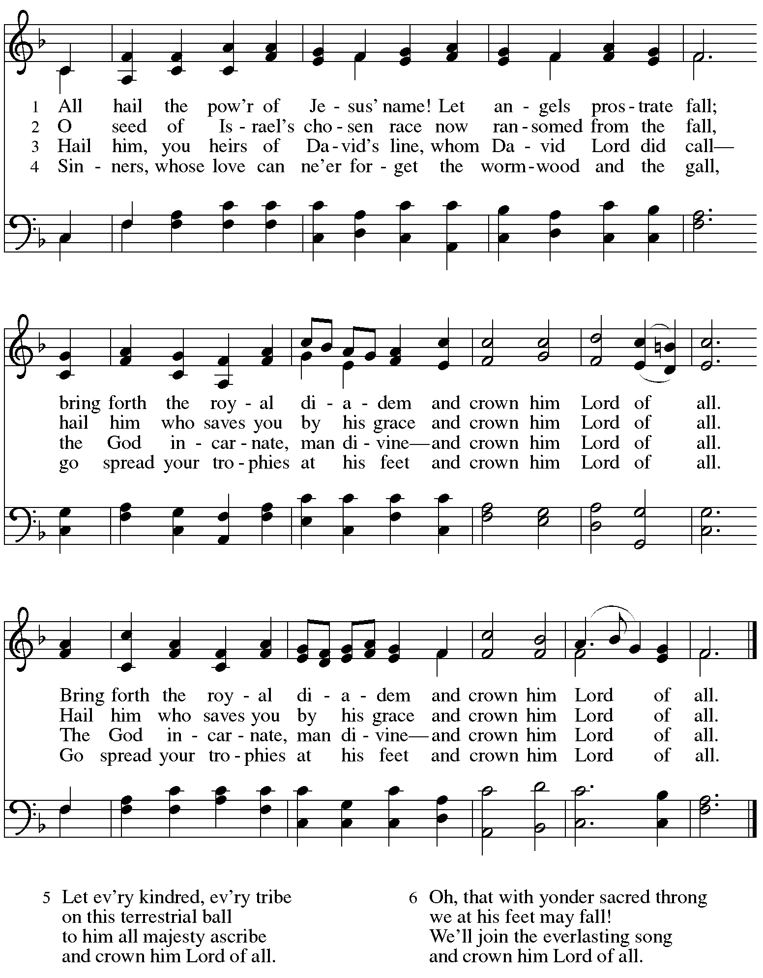

Greeting

P: The grace of our Lord Jesus Christ, the love of God,
and the communion of the Holy Spirit be with you all.
C: And also with you.

Hymn of Praise ELW p. 204

Prayer of the Day

P: The Lord be with you.
C: And also with you.

P: Let us pray.
O God of power and might, your Son shows us the way of service, and in him we inherit the riches of your grace. Give us the wisdom to know what is right and the strength to serve the world you have made, through Jesus Christ, our Savior and Lord, who lives and reigns with you and the Holy Spirit, one God, now and forever.
C: Amen.

Please be seated.

Word
God speaks to us in Scripture reading, preaching, and song

First Reading – Ezekiel 34: 11-16, 20-24

¹¹Thus says the Lord God: I myself will search for my sheep, and will seek them out. ¹²As shepherds seek out their flocks when they are among their scattered sheep, so I will seek out my sheep. I will rescue them from all the places to which they have been scattered on a day of clouds and thick darkness. ¹³I will bring them out from the peoples and gather them from the countries, and will bring them into their own land; and I will feed them on the mountains of Israel, by the watercourses, and in all the inhabited parts of the land. ¹⁴I will feed them with good pasture, and the mountain heights of Israel shall be their pasture; there they shall lie down in good grazing land, and they shall feed on rich pasture on the mountains of Israel. ¹⁵I myself will be the shepherd of my sheep, and I will make them lie down, says the Lord God. ¹⁶I will seek the lost, and I will bring back the strayed, and I will bind up the injured, and I will strengthen the weak, but the fat and the strong I will destroy. I will feed them with justice.
²⁰Therefore, thus says the Lord God to them: I myself will judge between the fat sheep and the lean sheep. ²¹Because you pushed with flank and shoulder, and butted at all the weak animals with your horns until you scattered them far and wide, ²²I will save my flock, and they shall no longer be ravaged; and I will judge between sheep and sheep.
²³I will set up over them one shepherd, my servant David, and he shall feed them: he shall feed them and be their shepherd. ²⁴And I, the Lord, will be their God, and my servant David shall be prince among them; I, the Lord, have spoken.

L: Word of God, word of life.
C: Thanks be to God.

Psalm 95: 1-7a

The psalm will be sung responsively, led by the cantor. The congregation is invited to join in singing the alternate verses in bold and the refrain.

Psalm tone

Psalm refrain

¹Come, let us sing | to the Lord;
let us shout for joy to the rock of | our salvation.
²Let us come before God’s presence | with thanksgiving
and raise a loud shout to the | Lord with psalms.
³For you, Lord, | are a great God,
and a great ruler a- | bove all gods.
⁴In your hand are the caverns | of the earth;
the heights of the hills are | also yours. R
⁵The sea is yours, | for you made it,
and your hands have molded | the dry land.
⁶Come, let us worship | and bow down,
let us kneel before the | Lord our maker.
^{7a}For the Lord| is our God,
and we are the people of God’s pasture and the sheep | of God’s hand. R

Second Reading – Ephesians 1: 15-23

¹⁵I have heard of your faith in the Lord Jesus and your love toward all the saints, and for this reason ¹⁶I do not cease to give thanks for you as I remember you in my prayers. ¹⁷I pray that the God of our Lord Jesus Christ, the Father of glory, may give you a spirit of wisdom and revelation as you come to know God, ¹⁸so that, with the eyes of your heart enlightened, you may know what is the hope to which God has called you, what are the riches of God’s glorious inheritance among the saints, ¹⁹and what is the immeasurable greatness of G od’s power for us who believe, according to the working of God’s great power. ²⁰God put this power to work in Christ when God raised him from the dead and seated him at God’s right hand in the heavenly places, ²¹far above all rule and authority and power and dominion, and above every name that is named, not only in this age but also in the age to come. ²²And God has put all things under Christ’s feet and has made him the head over all things for the church, ²³which is his body, the fullness of the one who fills all in all.

L: Word of God, word of life.
C: Thanks be to God.

Please rise as you are able.

Gospel Acclamation ELW p. 205
Gospel – Matthew 25: 31-46

P: The holy Gospel according to St. Matthew.
C: Glory to you, O Lord.

[Jesus said to the disciples:] ³¹“When the Son of Humanity comes in his glory, and all the angels with him, then he will sit on the throne of his glory. ³²All the nations will be gathered before him, and he will separate people one from another as a shepherd separates the sheep from the goats,
³³and he will put the sheep at his right hand and the goats at the left. ³⁴Then the king will say to those at his right hand, ‘Come, you that are blessed by my Father, inherit the kingdom prepared for you from the foundation of the world; ³⁵for I was hungry and you gave me food, I was thirsty and you gave me something to drink, I was a stranger and you welcomed me, ³⁶I was naked and you gave me clothing, I was sick and you took care of me, I was in prison and you visited me.’
³⁷Then the righteous will answer him, ‘Lord, when was it that we saw you hungry and gave you food, or thirsty and gave you something to drink? ³⁸And when was it that we saw you a stranger and welcomed you, or naked and gave you clothing? ³⁹And when was it that we saw you sick or in prison and visited you?’ ⁴⁰And the king will answer them, ‘Truly I tell you, just as you did it to one of the least of these who are members of my family you did it to me.’ ⁴¹Then he will say to those at his left hand, ‘You that are accursed, depart from me into the eternal fire prepared for the devil and his angels; ⁴²for I was hungry and you gave me no food, I was thirsty and you gave me nothing to drink, ⁴³I was a stranger and you did not welcome me, naked and you did not give me clothing, sick and in prison and you did not visit me.’ ⁴⁴Then they also will answer, ‘Lord, when was it that we saw you hungry or thirsty or a stranger or naked or sick or in prison, and did not take care of you?’ ⁴⁵Then he will answer them, ‘Truly I tell you, just as you did not do it to one of the least of these, you did not do it to me.’ ⁴⁶And these will go away into eternal punishment, but the righteous into eternal life.”
P: The Gospel of the Lord.
C: Praise to you, O Christ.
Please be seated.
Sermon

A time of silence for prayer and reflection follows the sermon.
As the hymn of the day begins, please rise as you are able.

Hymn of the Day O Christ, What Can It Mean for Us ELW 431

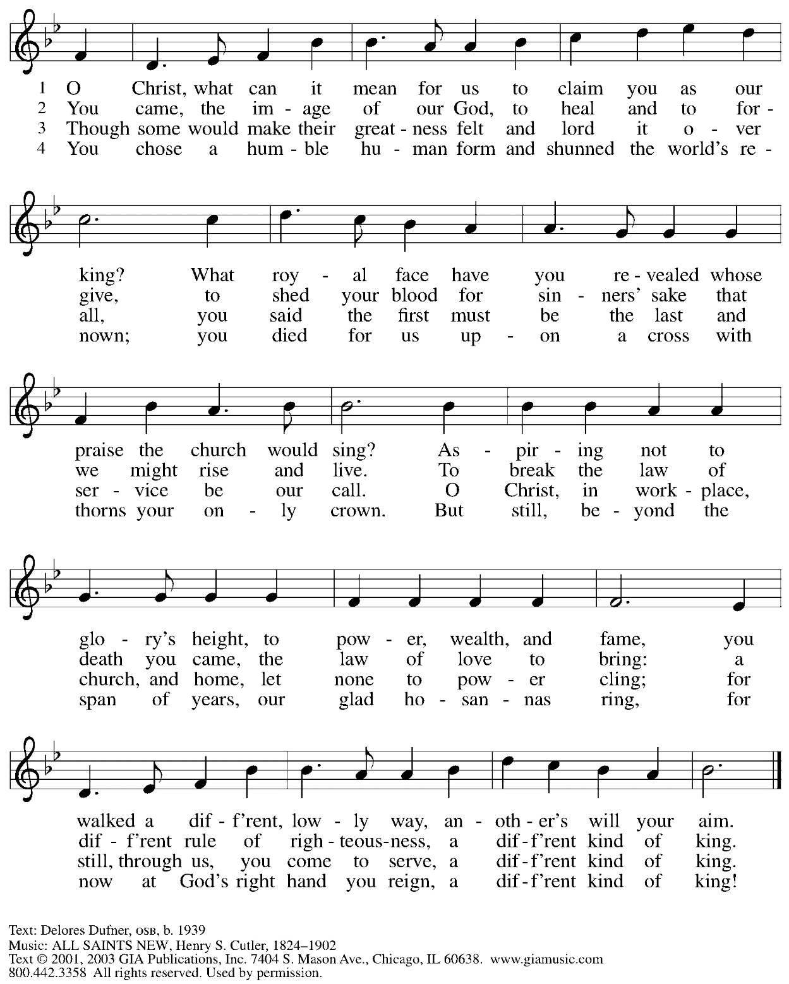
Reprinted with permission under OneLicense.net # A-722139.
Affirmation of Baptism

Those making affirmation gather with the ministers at the baptismal font.

Presentation

The presiding minister addresses the assembly with these or similar words.
P: Dear friends, we give thanks for the gift of baptism and for these people, one with us in the body of Christ, who are making public affirmation of their Baptism.

Those making affirmation are presented by a sponsor
or another representative of the congregation:
I present name/s, who desire to make public affirmation of their Baptism.

P: Let us pray.
Merciful God, we thank you for these siblings in Christ,
whom you have made your own by water and the Word in Baptism.
You have called them to yourself,
enlightened them with the gifts of your Spirit,
and nourished them in the community of faith.
Uphold your servants in the gifts and promises of baptism,
and unite the hearts of all whom you have brought to new birth.
We ask this in the name of Christ.
C: Amen.

Profession of Faith

The presiding minister addresses those making public affirmation of Baptism.
The assembly may stand and join in the responses.

P: I ask you to profess your faith in Christ Jesus, reject sin, and confess the faith of the church.

Do you renounce the devil and all the forces that defy God?
Response: I renounce them.

P: Do you renounce the powers of this world that rebel against God?
Response: I renounce them.

P: Do you renounce the ways of sin that draw you from God?
Response:
I renounce them.

P: Do you believe in God the Father
C: I believe in God, the Father almighty,
creator of heaven and earth.

P: Do you believe in Jesus Christ, the Son of God?
C: I believe in Jesus Christ, God’s only Son, our Lord,
who was conceived by the Holy Spirit,
born of the virgin Mary,
suffered under Pontius Pilate,
was crucified, died, and was buried;
he descended to the dead.*
On the third day he rose again;
he ascended into heaven,
he is seated at the right hand of the Father,
and he will come to judge the living and the dead.

P: Do you believe in God the Holy Spirit?
I believe in the Holy Spirit,
the holy catholic church,
the communion of saints,
the forgiveness of sins,
the resurrection of the body,
and the life everlasting. Amen.

*Or, “he descended into hell,” another translation of this text in widespread use.

Affirmation of Baptism

The presiding minister addresses those making public affirmation of Baptism.
You have made public profession of your faith.
Do you intend to continue in the covenant God made with you in Holy Baptism:
to live among God’s faithful people,
to hear the word of God and share in the Lord’s supper,
to proclaim the good news of God in Christ through word and deed,
to serve all people, following the example of Jesus,
and to strive for justice and peace in all the earth?
Each person responds:
I do, and I ask God to help and guide me.

The presiding minister addresses the assembly.
P: People of God, do you promise to support and pray for one another in your life in Christ?
C: We do, and we ask God to help and guide us.

The presiding minister prays for God’s blessing.
P: Let us pray.
We give you thanks, O God, that through water and the Holy Spirit
you give us new birth, cleanse us from sin, and raise us to eternal life.

P: Stir up in name the gift of your Holy Spirit: the spirit of wisdom and understanding,
the spirit of counsel and might, the spirit of knowledge and the fear of the Lord,
the spirit of joy in your presence, both now and forever.
C: Amen.

Those making public affirmation stand and face the assembly.
A: Let us rejoice with these siblings in Christ.
C: We rejoice with you in the gift of Baptism.
Together we will give thanks and praise to God
and proclaim the good news to all the world!

Welcome and Congregational Refrain

The presiding minister invites the assembly to welcome those who have made affirmation
of Baptism. As the assembly offers welcome through applause, all are invited to join in singing the congregational refrain.

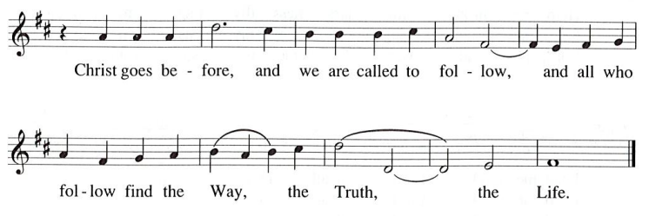

When all have returned to their places, worship continues with the prayers of the people.

Prayers of the People

A: Trusting in the transformative power of God’s loving Spirit,
let us pray for the church, the world, and all who are in need.

After each petition
A: God of grace,
C: receive our prayer.

The presiding minister concludes the prayers
P: Into your care, gracious God, we commend all for whom we pray,
trusting in your unending love and amazing grace;
through Jesus Christ, our Savior.
C: Amen.

Peace

The presiding minister and the assembly greet one another in the peace of the risen Christ.
P: The peace of Christ be with you always.
C: And also with you.

The people may greet those around them with a sign of Christ’s peace and may say
Peace be with you or similar words. Please be mindful that not everyone will be comfortable with sharing the peace, so please seek consent before shaking hands or hugging. Other possible ways to share the peace include a simple bow with the verbal greeting of peace, or simply a verbal expression of peace.

When the greetings of peace have concluded, please be seated.

Meal
God feeds us with the presence of Jesus Christ

Offering

We offer ourselves, our gifts, and our faithful service to God.
As the offering is gathered for the mission of the church, including the care of those in need,
the table is set for Holy Communion.

Music during the Offering
Andantino Charles Tournemire (1870-1939)

As the gifts are brought forward for presentation, please rise as you are able.

Offertory Song Let the Vineyards Be Fruitful ELW 184

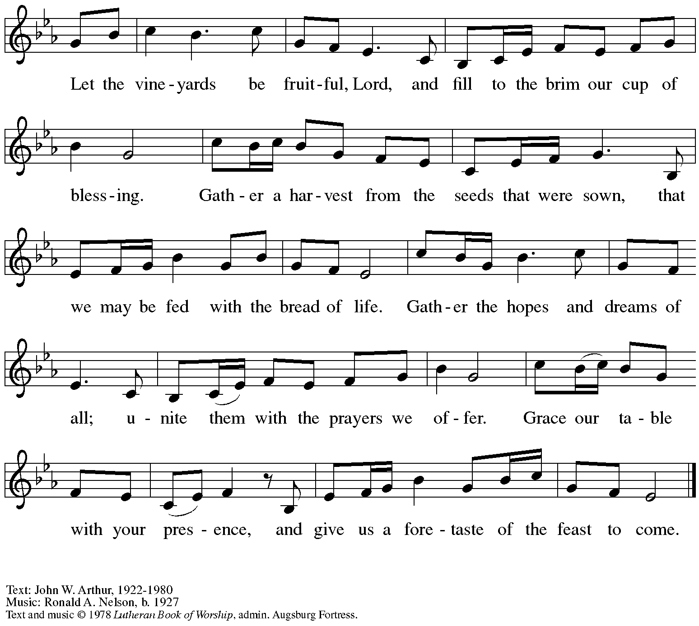
All rights reserved. Reprinted with permission under OneLicense.net # A-722139.

Offertory Prayer

A: Let us pray.
God of all creation,
C: the eyes of all wait upon you,
and you open your hand in blessing.
Fill us with good things at your table,
that we may come to the help of all in need,
through Jesus Christ, our redeemer and Lord.
Amen.

Dialogue ELW p. 206

P: The Lord be with you.
C: And also with you.

P: Lift up your hearts.
C: We lift them to the Lord.

P: Let us give thanks to the Lord our God.
It is right to give our thanks and praise.

Preface

P: It is indeed right, our duty and our joy …
… we praise your name and join their unending hymn:

Sanctus ELW p. 207

Eucharistic Prayer

P: You are indeed holy, almighty and merciful God, …
… Do this for the remembrance of me.

For as often as we eat of this bread and drink from this cup,
we proclaim the Lord’s death until he comes.
C: Christ has died. Christ is risen. Christ will come again.

P: Remembering, therefore, …
… … To you, O God, Father, Son, and Holy Spirit
be all honor and glory in your holy church, now and forever.
C: Amen.

Lord’s Prayer

P: Gathered as one by the Holy Spirit, let us pray as Jesus taught us.
C: Our Father in heaven,
hallowed be your name,
your kingdom come,
your will be done,
on earth as in heaven.
Give us today our daily bread.
Forgive us our sins
as we forgive those
who sin against us.
Save us from the time of trial
and deliver us from evil.
For the kingdom, the power,
and the glory are yours,
now and forever. Amen.

Fraction and Invitation

Agnus Dei / Lamb of God ELW p. 208

Please be seated.

Holy Communion
- All who seek God and desire a deeper and stronger life in Christ are welcome to receive Holy Communion.
- Worshipers from the pulpit side will proceed forward first, followed by the center section, and then the lectern side.
- Please inform an usher if you would like the ministers to bring Communion to you.
- Holy Communion will be served with bread and wine/grape juice.
- The presiding minister will first distribute the bread (host) to each communicant. Please indicate if you require a gluten-free host.
- Once you have consumed the bread, please pick up an empty glass from the tray next to the presiding minister. The Communion Assistant will pour wine from the chalice or grape juice from the cruet into your glass.
- Please step to the side to consume the wine or grape juice.
- Feel free to kneel at the altar rail for prayer after receiving the sacrament.
- As you return to your pew, glasses may be returned to the empty trays on either side of the center section.
- A blessing will be provided for anyone who does not yet receive the sacrament.
- All are invited to join in singing the hymns during Holy Communion.

Hymns during Holy Communion
The King of Love My Shepherd Is ELW 502

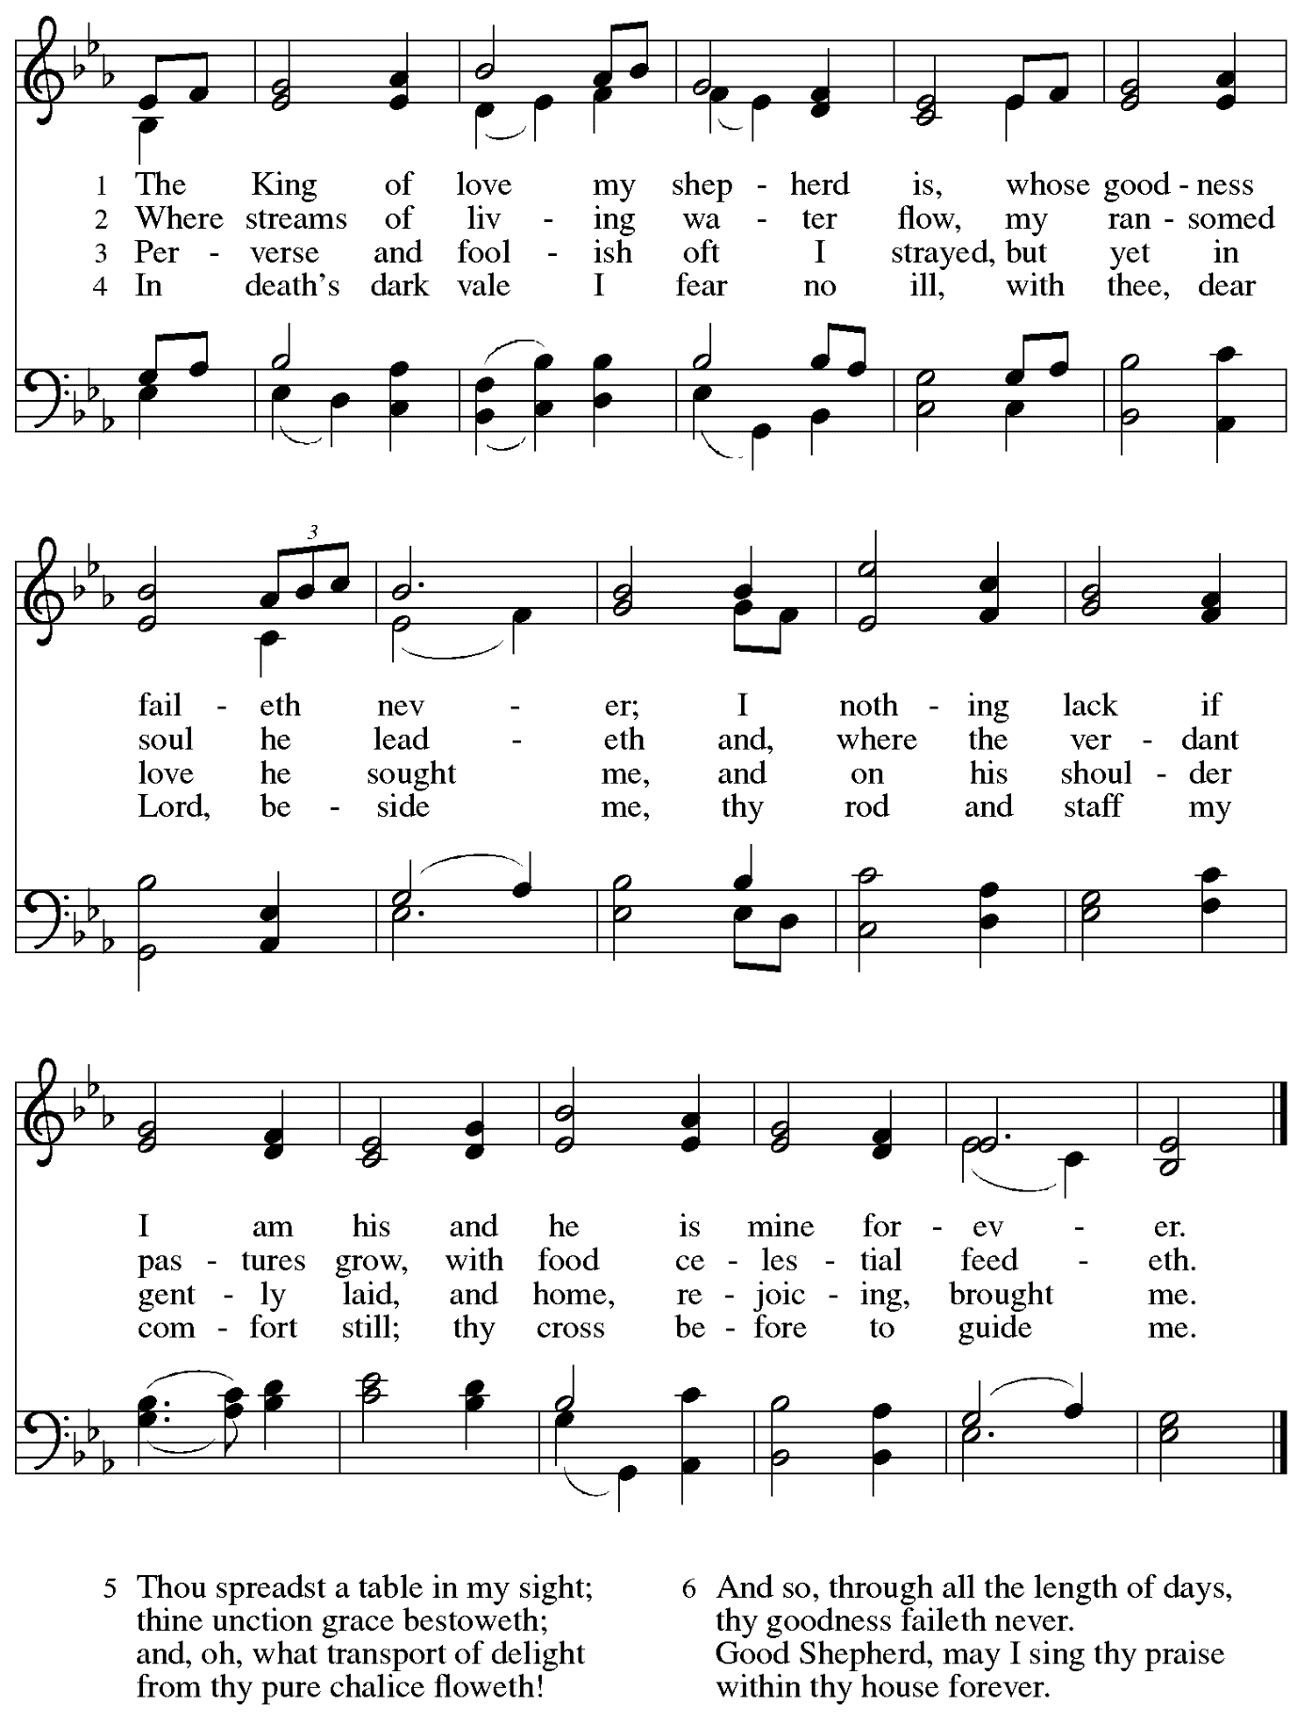
Hymns during Holy Communion
You Satisfy the Hungry Heart ELW 484

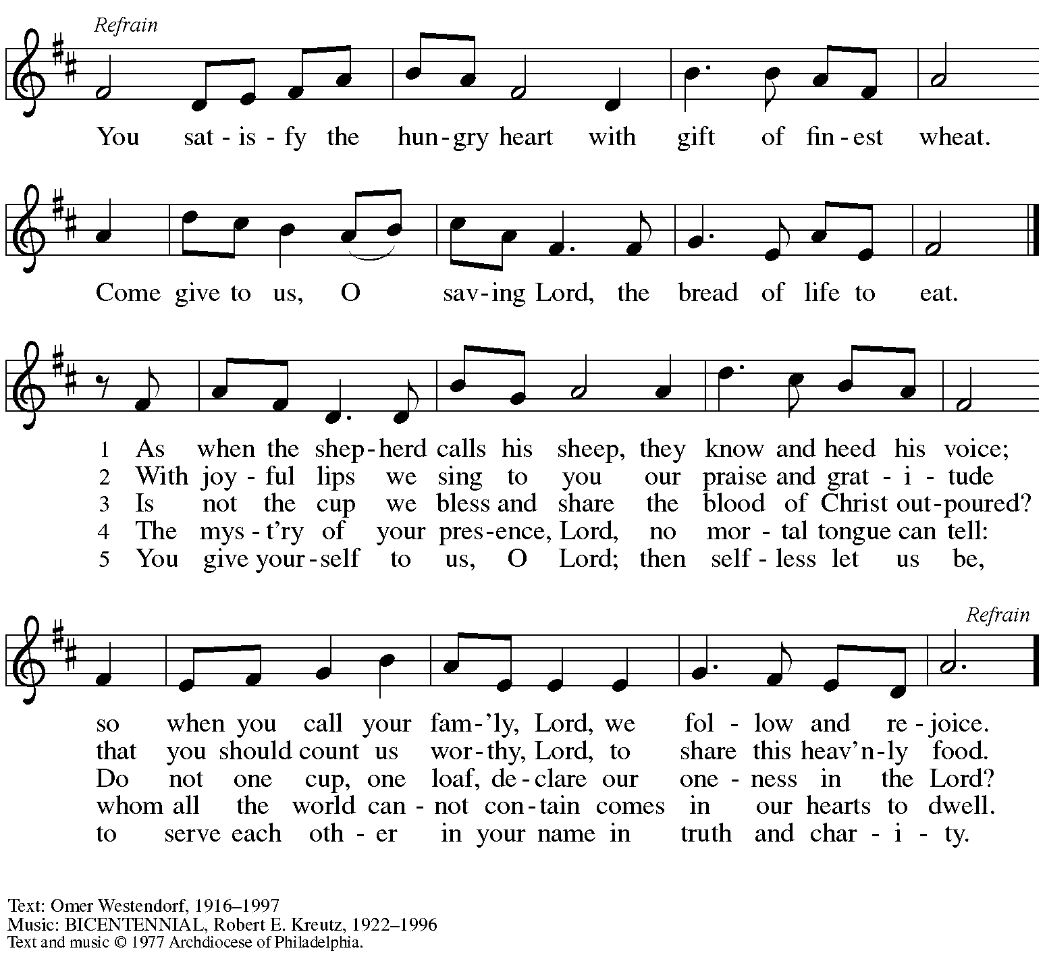
Admin. International Liturgy Publications. All rights reserved. Reprinted with permission under OneLicense.net # A-722139.

Hymns during Holy Communion
Jesus Shall Reign ELW 434

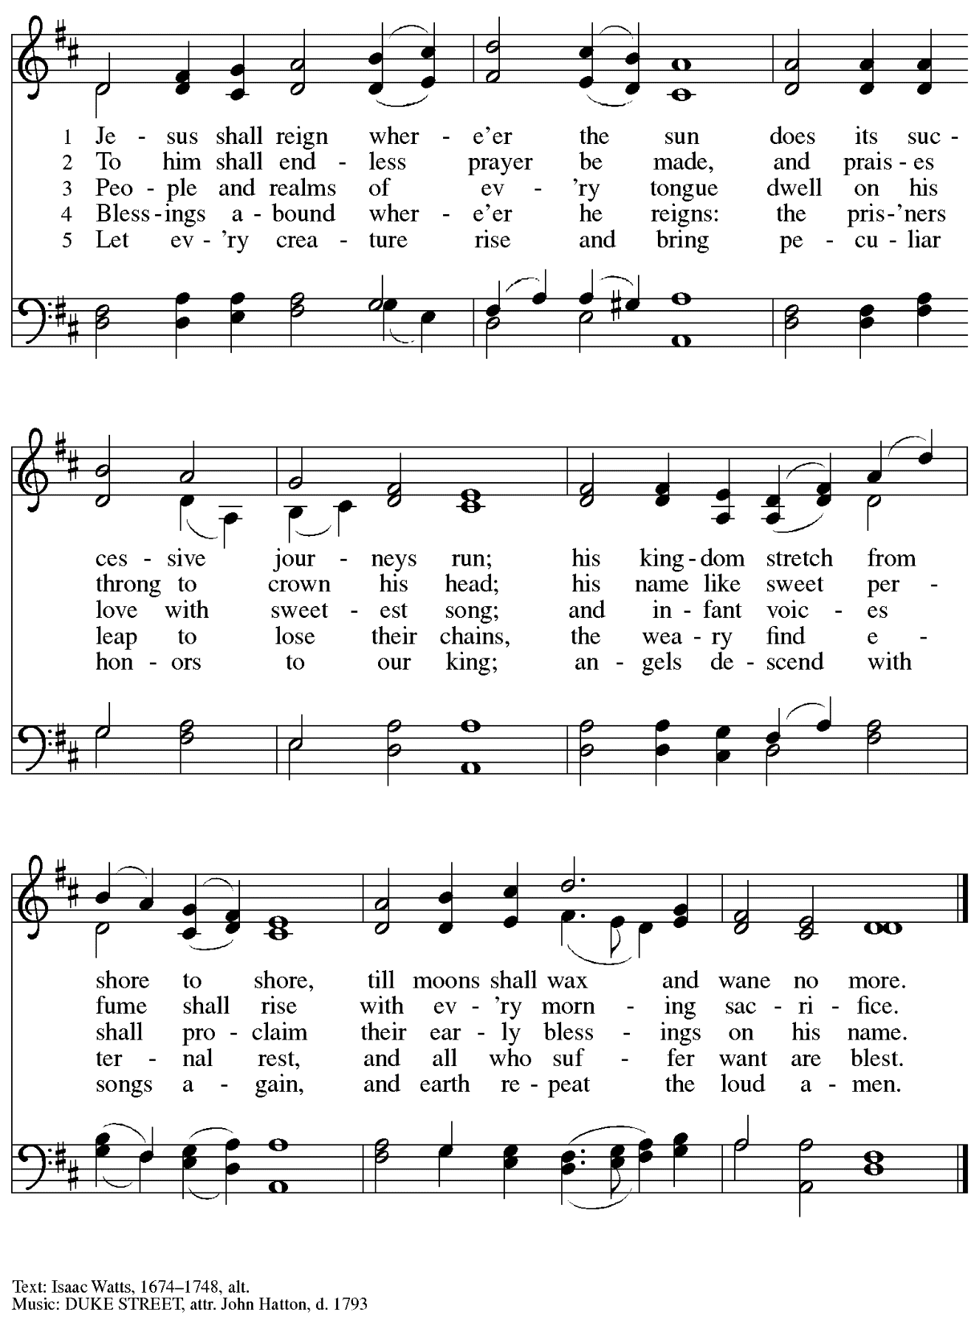

When all have returned to their places, please rise as you are able.

Blessing

P: The body and blood of our Lord Jesus Christ strengthen you and keep you in his grace.
C: Amen.

Prayer

A: Let us pray. Gracious God, in this meal you have drawn us to your heart,
and nourished us at your table with food and drink, the body and blood of Christ.
Now send us forth to be your people in the world,
and to proclaim your truth this day and evermore,
through Jesus Christ, our Savior and Lord.
C: Amen.

Please be seated.

Sending
God blesses us and sends us in mission to the world

Announcements

Please rise as you are able.

Benediction

P: The God of glory,
☩ Jesus Christ, name above all names,
and the Spirit who lives in you
bless you now and forever.
C: Amen.

Sending Hymn Crown Him with Many Crowns Following page

Dismissal

A: Go in peace. Serve the Lord.
C: Thanks be to God!

Postlude Concerto in d-minor based on Torelli
Johann Gottfried Walther (1684-1748)

Sending Hymn Crown Him with Many Crowns ELW 855

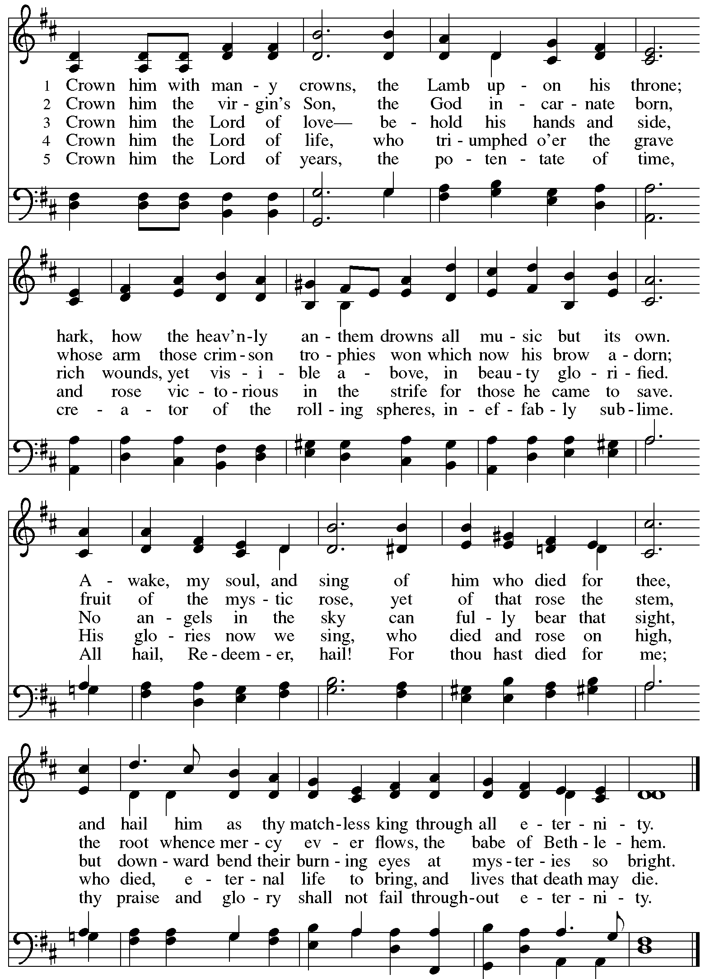
Those serving in worship today

Altar Care Janet Grzegorczyk
Assisting Minister Jimmi Kocher-Hillmer
Audio-Visual Ministers Dave Rollinson
Jason Galyardt
Cantor Jeff Denlinger
Lector Alda Maria Gonzaga
Organ Michael Salmon
Presiding and Preaching Minister The Rev. Ross I. Carmichael

Liturgy and Hymnody Acknowledgements

From SundaysandSeasons.com. Copyright © 2023 Augsburg Fortress. All rights reserved. Reprinted under OneLicense.net # A-722139.
Used by permission of Augsburg Fortress.

All Hail the Power of Jesus’ Name! – Text: Edward Perronet, 1726-1792, sts. 1-4; J. Rippon, A Selection of Hymns, 1787, sts. 5-6. Music: CORONATION, Oliver Holden, 1765-1844.

The King of Love My Shepherd Is – Text: Henry W. Baker, 1821-1877. Music: ST. COLOMBA, Irish tune.

Crown Him with Many Crowns – Matthew Bridges, 1800-1894, sts. 1-3, 5; Godfrey Thring, 1823-1903, st. 4 Music: DIADEMATA, George J. Elvey, 1816-1893.

Please use the QR code below to link to St. Andrew’s Announcements online!

St. Andrew Lutheran Church Announcements
November 26th, 2023

- Welcome to worship at St. Andrew on Reign of Christ Sunday November 26th, 2023 – We are so glad you are here, and we offer a special welcome to all guests who are gathered here or online! Worship attendees are invited to make a name tag at the back of the worship space if you would like. Children are invited to participate in Little Church – Big Faith, a Bible lesson and activity, after the prayer of the day. There are worship “toolkits” to help children engage with worship and “busy bags” for younger children available in the bookcase at the back of the sanctuary. Please feel free to take one to use with/for your children. We invite everyone to stay after worship for coffee and conversation in the Social Hall next to the sanctuary.

- Thank you to Michael Salmon for Musical Leadership on Organ Today! – We welcome to St. Andrew Michael Salmon, who will be leading music for St. Andrew’s worship today. Mr. Salmon is currently the interim director of the Pittsburgh Compline Choir. We thank you for sharing your gifts with the congregation today!
- Welcome New Members, Tyler and Adi! We invite your prayers for Tyler and Adi as they make Affirmation of Baptism and join the congregation during worship today!
- Compline Prayer Service, a Ministry of Lutheran Campus Ministry in Greater Pittsburgh, Sundays at 8:00 p.m. at Heinz Chapel – Compline was traditionally a monastic prayer service, and the Pittsburgh Compline Choir sings a choral version of compline rooted in this thousand-year-old tradition of scripture, song, and silence. This service also streams on Facebook (Pittsburgh Compline Choir) and YouTube (The Pittsburgh Compline Choir). Heinz Chapel is located off of S. Bellefield Ave. in Oakland. For more information, or to stream the services, please see www.facebook.com/pghcompline or https://www.youtube.com/@thepittsburghcomplinechoir486.
- Little Pantry Assistance Requested – The community ministry committee is looking to keep the outdoor pantry stocked during the week. If anyone coming to the church throughout the week could make time to check on the pantry and possibly restock it from the supplies in the social hall, it would be greatly appreciated!
- Hearts and Hands, St. Andrew’s Crocheting and Knitting Ministry, Seeking New Participants and Meeting after Worship on Sunday, December 3rd – Hearts and Hands crocheting and knitting ministry provides prayer blankets and shawls for people undergoing medical treatments, those who are mourning, Confirmands, and various others at significant times. Hearts and Hands will meet after worship on Sunday, December 3rd, to discuss and plan activities for 2024. Anyone interested in learning to crochet, as well as current knitters and crocheters who would like to participate are welcome. The first project for the crocheters will be a scarf to add to the collection described in the next announcement. All supplies, including yarn and hooks, will be provided to anyone who may need them.
- Hearts and Hands and Community Ministry Committee Invite Congregation to Support Advent Appeal for Winter Accessories – People of the congregation are asked to bring winter hats, mittens/gloves, and scarves to church during the Advent season (beginning December 3rd) to support immigrants and refugees arriving in Pittsburgh. These can be handmade (knitted, crocheted, or sewn) or purchased. We can also make them available in the little pantry and at our produce distributions. A collection box will be set up in the social hall to receive these donations.
- December Produce Distribution – Tuesday, December 5th, 5:30-7:00 p.m. – Each month, St. Andrew offers a community fresh produce distribution in partnership with Greater Pittsburgh Community Food Bank. The next date is Tuesday, November 7th, from 5:30-7:00 p.m. We invite people of the congregation to help serve during the distribution, welcoming and helping guests, rotating boxes, directing traffic, etc. during that time, and earlier in the day for setup and unloading of the truck, usually between 10:00 a.m. and 1:00 p.m. Those who sign up for the earlier time will be contacted the day before when we have an estimate of the delivery time. Please sign up at
https://www.signupgenius.com/go/4090F45AFAF2BA75-produce10.
- St. Andrew’s Annual Opportunity to Pledge Your Financial Support for the Coming Year – Sunday, December 10th during Worship – A letter will be sent to the congregation soon with further details. Thank you for all you do to carry out the ministry of St. Andrew!
- Annual Meeting of the Congregation – Sunday, December 10th, after Worship – The annual meeting of the congregation takes place in November or December each year. This meeting is the highest decision-making body in the congregation, and includes election of leaders to serve on the congregation’s leadership council, adoption of a budget for ministry for the upcoming year, and updates about big-picture considerations and long-term planning. All confirmed members of the congregation are eligible to vote, and no absentee or proxy votes can be accepted, so please plan to attend the meeting on Sunday, December 10th.
- Compline Prayer Service at St. Andrew – Sunday, December 17th, 7:00 p.m. –
The Compline Choir at times offers to lead a service in an additional location after their semester in Heinz Chapel ends, and we have agreed to host this Compline service on Sunday, December 17th, at St. Andrew at 7:00 p.m. Please plan to take part in this unique worship experience!
- Christ in Our Home Devotional Booklets for October – December Available at Church Entrances – This resource offers a daily Bible reading with a short reflection and prayer, along with additional readings and prayer topics for those who would like to expand their devotional practices. We encourage people of the congregation to take one for yourself, your family unit, or others!

