+ Second Sunday of Advent
December 10th, 2023
10:00 a.m.

St. Andrew Lutheran Church
304 Morewood Ave.
Pittsburgh, PA 15213
412.682.3342
St_andrewELCA@verizon.net
www.standrewpittsburgh.org

+ Second Sunday of Advent
Order for Worship

John the baptizer calls people to repent, to completely reorder their lives so that nothing gets in the way of the Lord’s coming. The reading from Isaiah gives the context for this radical call:
the assurance of forgiveness that encourages us to repent; the promise that the coming one will be gentle with the little ones. Isaiah calls us all to be heralds with John, to lift up our voices fearlessly and say, “See, your God is coming!” We convey it to one another in worship, in order to proclaim it with our lives in a world in need of justice and peace.

Welcome to St. Andrew!

- St. Andrew Lutheran congregation welcomes all who are seeking a place of healing and wholeness – a nurturing, faith-forming spiritual home. Our community embraces people of all ages, ethnicities, cultures, abilities, sexual orientations, gender identities and expressions, and family constellations. Come and See!

- Worship Services are live streamed to multiple online platforms. By attending worship, you agree that your image and voice may be broadcast.

- Everyone is invited to make a nametag at the black bookcase in the back of the worship space if they would like. There are stickers indicating pronouns on the bookcase if you would like to include them on your name tag.

- Worship “toolkits” to help children engage with the service, along with “busy bags” for younger children, are available in the bookcase at the back of the sanctuary. Please feel free to take one to use with/for your children.

- Holy Communion is served with bread (gluten-free available) and wine or grape juice. The presiding minister will distribute the bread (host). Please consume this and then pick up an empty glass from the tray. The Communion Assistant will pour wine or grape juice into your glass. Please step to the side to consume the wine or grape juice. Feel free to kneel at the altar for prayer and reflection. As you return to your pew, glasses may be returned to the empty trays on either side of the center section.

- A restroom is available on the main level of the church, through the doors to the Social Hall and to the right in the main office.

Abbreviations
P: Pastor/Presiding Minister ACS: All Creation Sings hymnal
A: Assisting Minister ELW: Evangelical Lutheran Worship hymnal
L: Lector
C: Congregation

Pre-Service Music

Centering Music O Come, O Come, Emmanuel ELW 257
v. 1-2

1 O come, O come, Emmanuel,
and ransom captive Israel,
that mourns in lonely exile here
until the Son of God appear.

Refrain
Rejoice! Rejoice! Emmanuel
shall come to you, O Israel.

2 O come, O Wisdom from on high,
embracing all things far and nigh:
in strength and beauty come and stay;
teach us your will and guide our way. Refrain

Welcome

Gathering
The Holy Spirit calls us together as the people of God

Confession and Forgiveness

Please rise as you are able. All may make the sign of the cross,
the sign that is marked at Baptism, as the presiding minister begins.

P: Blessed be the holy Trinity, ☩ one God,
who opens the heavens
and draws near to us with salvation.
C: Amen.

P: God is patient and merciful, desiring all to come to repentance.
Trusting God’s promise of grace, let us confess our sin.

Silence is kept for reflection and self-examination.

P: Everlasting God,
C: you love justice and you hate wrongdoing.
We confess the fear, greed, and self-centeredness
that make us reluctant to work against oppression.
We are complicit in systems of exploitation.
We choose comfort over courage.
We are careless with creation’s bounty.
Look upon us with mercy.
Turn our hearts again to you.
Make us glad to do your will and to walk in your ways
for the sake of our waiting world.
Amen.

P: Receive these words of assurance:
God clothes you with garments of salvation
and covers you with robes of righteousness.
In the tender compassion of ☩ Jesus Christ,
your sins are forgiven.
God’s covenant is eternal,
and God’s blessing rests upon us all.
C: Amen.

Gathering Hymn Comfort, Comfort Now My People ELW 256

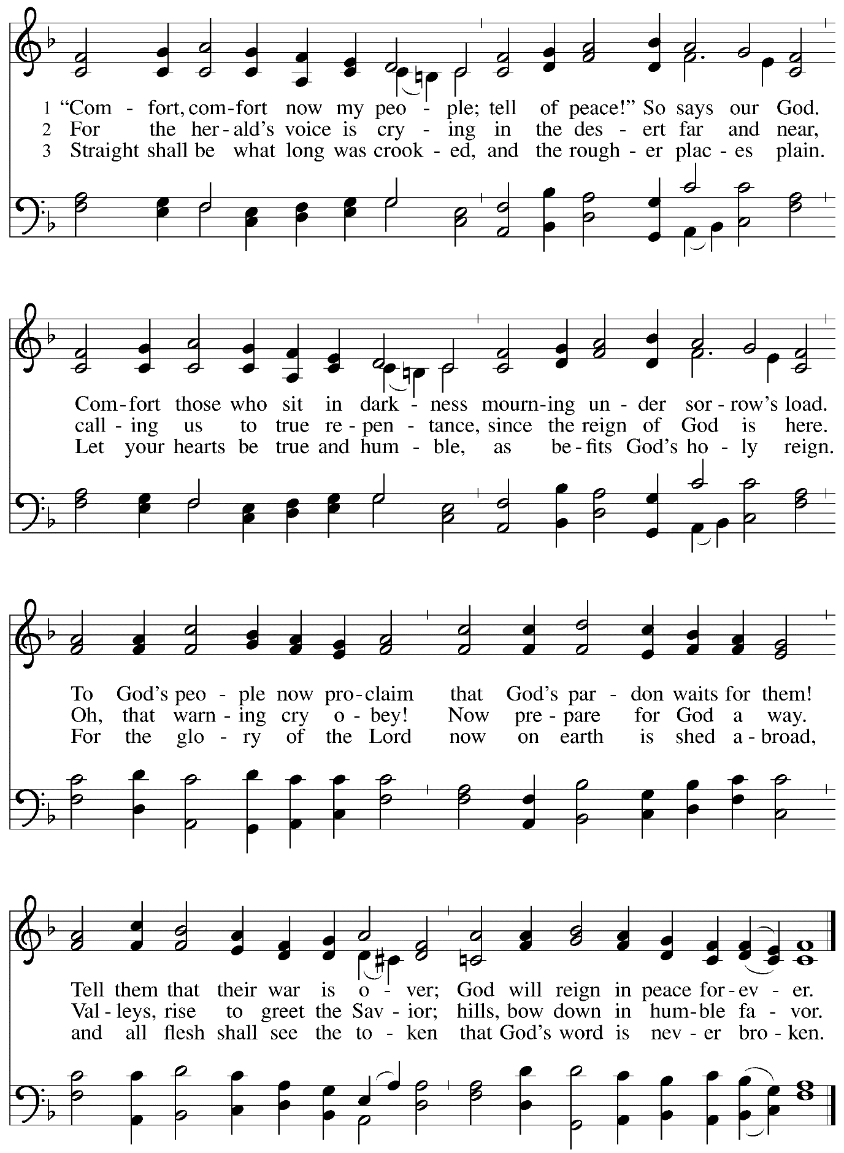

Greeting

P: The grace of our Lord Jesus Christ, the love of God,
and the communion of the Holy Spirit be with you all.
C: And also with you.

Kyrie ACS p. 31

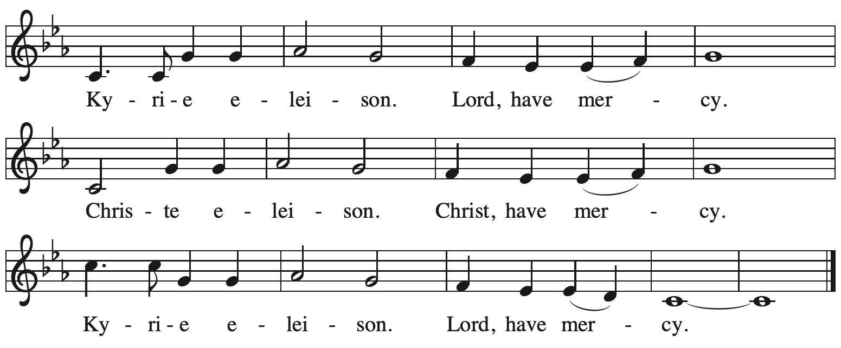

Prayer of the Day

P: The Lord be with you.
C: And also with you

P: Let us pray.
Stir up our hearts, Lord God, to prepare the way of your only Son.
By his coming strengthen us to serve you with purified lives;
through your Son, Jesus Christ, our Savior and Lord,
who lives and reigns with you and the Holy Spirit,
one God, now and forever.
C: Amen.

Please be seated.

Word
God speaks to us in Scripture reading, preaching, and song

First Reading – Isaiah 40: 1-11

¹Comfort, O comfort my people,
says your God.
²Speak tenderly to Jerusalem,
and cry to her
that she has served her term,
that her penalty is paid,
that she has received from the Lord’s hand
double for all her sins.
³A voice cries out:
“In the wilderness prepare the way of the Lord,
make straight in the desert a highway for our God.
⁴Every valley shall be lifted up,
and every mountain and hill be made low;
the uneven ground shall become level,
and the rough places a plain.
⁵Then the glory of the Lord shall be revealed,
and all people shall see it together,
for the mouth of the Lord has spoken.”
⁶A voice says, “Cry out!”
And I said, “What shall I cry?”
All people are grass,
their constancy is like the flower of the field.
⁷The grass withers, the flower fades,
when the breath of the Lord blows upon it;
surely the people are grass.
⁸The grass withers, the flower fades;
but the word of our God will stand forever.
⁹Get you up to a high mountain,
O Zion, herald of good tidings;
lift up your voice with strength,
O Jerusalem, herald of good tidings,
lift it up, do not fear;
say to the cities of Judah,
“Here is your God!”
¹⁰See, the Lord God comes with might,
and the Lord’s arm rules for God;
the Lord’s reward is with God,
and the Lord’s recompense before God.
¹¹The Lord will feed God’s flock like a shepherd;
the Lord will gather the lambs in God’s arms,
and carry them in God’s bosom,
and gently lead the mother sheep.

L: Word of God, word of life.
C: Thanks be to God.

Psalm 85: 1-2, 8-14

The psalm will be sung responsively, led by the cantor. The congregation is invited to join in singing the alternate verses in bold and the refrain.

Psalm tone

Psalm refrain

¹You have been gracious to your | land, O Lord;
you have restored the good for- | tune of Jacob.
²You have forgiven the iniquity | of your people
and blotted out | all their sins.
⁸I will listen to what the Lord| God is saying;
for you speak peace to your faithful people and to those who turn their | hearts to you.
⁹Truly, your salvation is very near to | those who fear you,
that your glory may dwell | in our land. R

Psalm refrain

¹⁰Steadfast love and faithfulness have | met together;
righteousness and peace have | kissed each other.
¹¹Faithfulness shall spring up | from the earth,
and righteousness shall look | down from heaven.
¹²The Lord will indeed | grant prosperity,
and our land will | yield its increase.
¹³Righteousness shall go be- | fore the Lord
and shall prepare for | God a pathway. R

Second Reading – 2 Peter 3: 8-15a

⁸Do not ignore this one fact, beloved, that with the Lord one day is like a thousand years, and a thousand years are like one day. ⁹The Lord is not slow about the Lord’s promise, as some think of slowness, but is patient with you, not wanting any to perish, but all to come to repentance.
¹⁰But the day of the Lord will come like a thief, and then the heavens will pass away with a loud noise, and the elements will be dissolved with fire, and the earth and everything that is done on it will be disclosed.
¹¹Since all these things are to be dissolved in this way, what sort of persons ought you to be in leading lives of holiness and godliness, ¹²waiting for and hastening the coming of the day of God, because of which the heavens will be set ablaze and dissolved, and the elements will melt with fire? ¹³But, in accordance with God’s promise, we wait for new heavens and a new earth, where righteousness is at home.
¹⁴Therefore, beloved, while you are waiting for these things, strive to be found by God at peace, without spot or blemish; ^{15a}and regard the patience of our Lord as salvation.

L: Word of God, word of life.
C: Thanks be to God.

Please rise as you are able.

Gospel Acclamation ELW p. 188

Gospel – Mark 1: 1-8

P: The holy Gospel according to St. Mark.
C: Glory to you, O Lord.

¹The beginning of the good news of Jesus Christ, the Son of God.
²As it is written in the prophet Isaiah,
“See, I am sending my messenger ahead of you,
who will prepare your way;
³the voice of one crying out in the wilderness:
‘Prepare the way of the Lord,
make the Lord’s paths straight.’”
⁴John the baptizer appeared in the wilderness, proclaiming a baptism of repentance for the forgiveness of sins. ⁵And people from the whole Judean countryside and all the people of Jerusalem were going out to him, and were baptized by him in the river Jordan, confessing their sins. ⁶Now John was clothed with camel’s hair, with a leather belt around his waist, and he ate locusts and wild honey. ⁷He proclaimed, “The one who is more powerful than I is coming after me; I am not worthy to stoop down and untie the thong of his sandals. ⁸I have baptized you with water; but he will baptize you with the Holy Spirit.”
P: The Gospel of the Lord.
C: Praise to you, O Christ.

Please be seated.

Sermon

A time of silence for prayer and reflection follows the sermon.
As the hymn of the day begins, please rise as you are able.

Hymn of the Day On Jordan’s Bank the Baptist’s Cry ELW 249

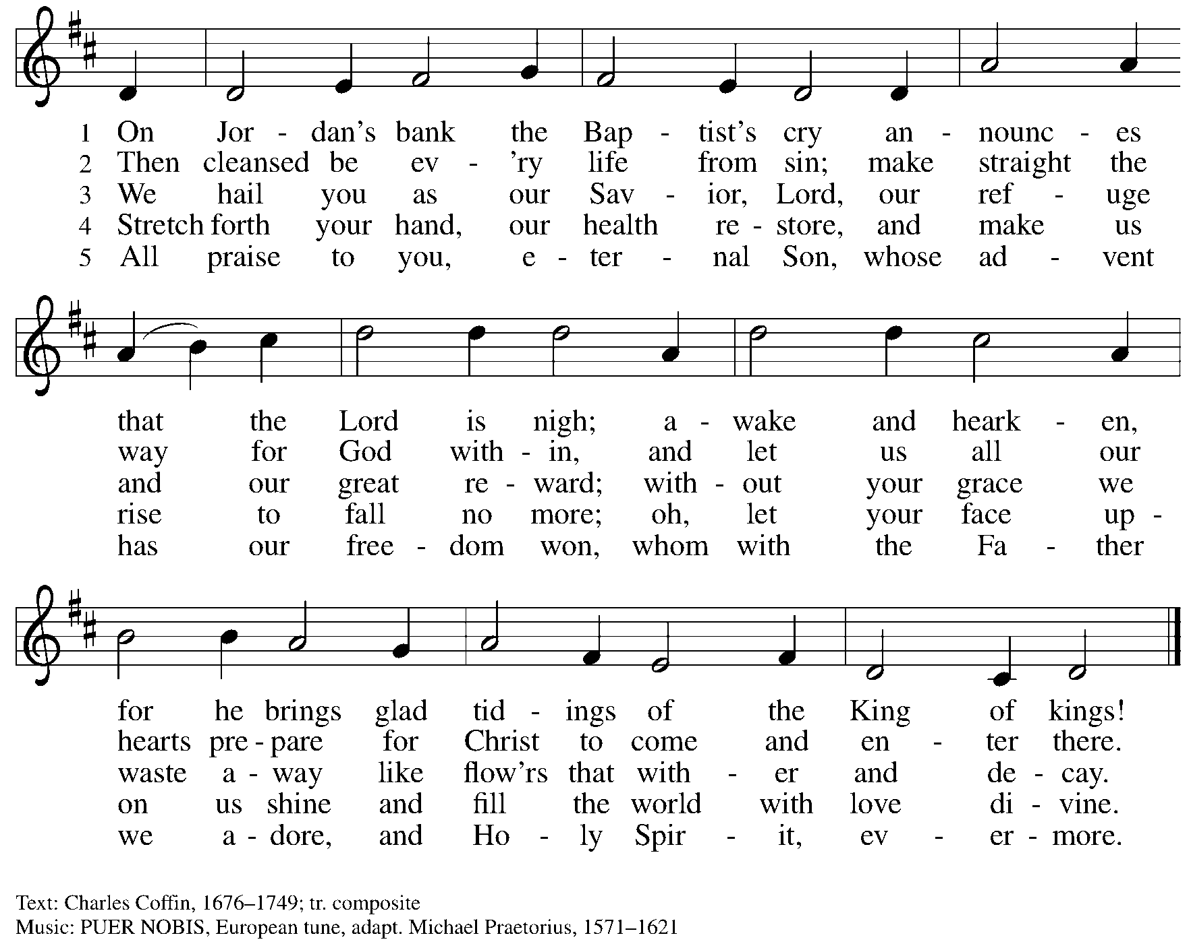

Prayers of the People

A: With hope and expectation, we offer our prayers for the church, the world,
and all who await God’s day of restoration.

After each petition
A: Merciful God,
C: receive our prayer.

The presiding minister concludes the prayers
P: Receive these and all our prayers, O God of hosts,
and restore us with your great and everlasting mercy,
through Jesus Christ, our Savior.
C: Amen.

Peace

The presiding minister and the assembly greet one another in the peace of the risen Christ.
P: The peace of Christ be with you always.
C: And also with you.

The people may greet those around them with a sign of Christ’s peace and may say
Peace be with you or similar words. Please be mindful that not everyone will be comfortable with sharing the peace, so please seek consent before shaking hands or hugging. Other possible ways to share the peace include a simple bow with the verbal greeting of peace, or simply a verbal expression of peace.

When the greetings of peace have concluded, please be seated.

Meal
God feeds us with the presence of Jesus Christ

Invitation to Commitment

Offering

We offer ourselves, our gifts, and our faithful service to God.
As the offering is gathered for the mission of the church, including the care of those in need,
the table is set for Holy Communion.

Music during the Offering
The Yearning Choir
Words: S. Bentall Boersma
Music: C. Courtney

Dedication of Offerings

Dedication of the Wayne W. Sommerfeld Memorial Scholarship Fund

The presiding minister introduces the context for the dedication of a new scholarship in memory of our late congregant, Wayne W. Sommerfeld.

Scripture Reading

P: Sing with joy to God our strength
C: and raise a loud shout to the God of Jacob.

P: Praise God with tambourine and dance;
C: praise God with strings and pipe.

P: We give you thanks, O God, creator of the universe …
… one God, now and forever.
C: Amen.

As the gifts are brought forward for presentation, please rise as you are able.

Offertory Song We Give Thee but Thine Own ELW 686
v. 1-3

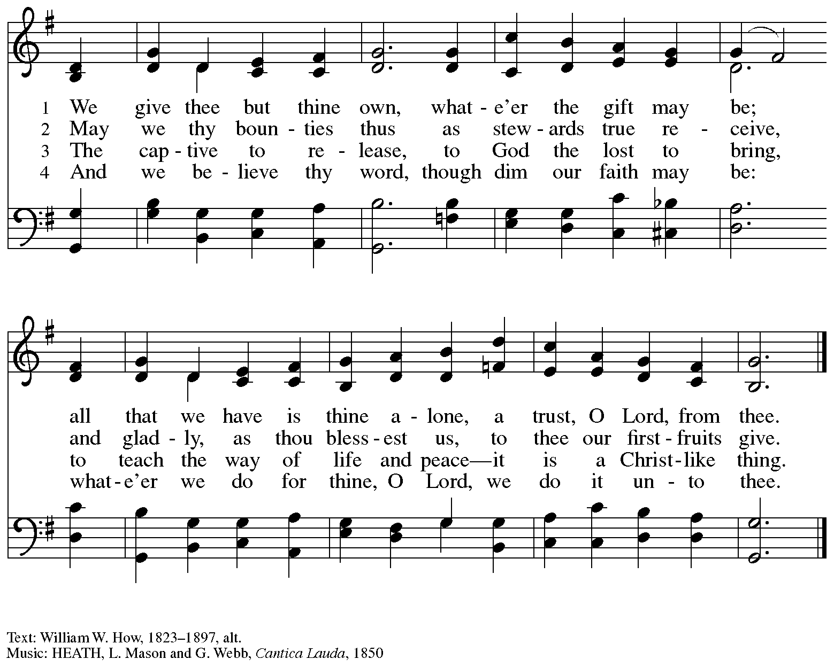

Offertory Prayer

A: Let us pray. God of abundance,
C: we bring before you the precious fruits of your creation, and with them our very lives.
Teach us patience and hope as we care for all those in need
until the coming of your Son, our Savior and Lord. Amen.

Dialogue

P: The Lord be with you.
C: And also with you.

P: Lift up your hearts.
C: We lift them to the Lord.

P: Let us give thanks to the Lord our God.
It is right to give our thanks and praise.

Preface

P: It is indeed right, our duty and our joy … we praise your name and join their unending hymn:

Sanctus ELW p. 190

Eucharistic Prayer

P: Holy one, the beginning and the end, the giver of life, …
… Do this for the remembrance of me.

Let us proclaim the mystery of faith.
C: Christ has died. Christ is risen. Christ will come again.

P: With this bread and cup …
… We look with hope for his coming.
C: Come, Lord Jesus.

P: Holy God, we long for your Spirit …
… Bring the gift of peace on earth.
C: Come, Holy Spirit.

P: All praise and glory are yours …
… one God, now and forever.
C: Amen.

Lord’s Prayer

P: Gathered as one by the Holy Spirit, let us pray as Jesus taught us.
C: Our Father in heaven,
hallowed be your name,
your kingdom come,
your will be done,
on earth as in heaven.
Give us today our daily bread.
Forgive us our sins
as we forgive those
who sin against us.
Save us from the time of trial
and deliver us from evil.
For the kingdom, the power,
and the glory are yours,
now and forever. Amen.

Fraction and Invitation

P: In this meal, righteousness and peace meet.
Come, receive the gifts God has prepared for you.

Agnus Dei / Lamb of God ELW p. 191

Please be seated.

Holy Communion
- All who seek God and desire a deeper and stronger life in Christ are welcome to receive Holy Communion.
- Worshipers from the pulpit side will proceed forward first, followed by the center section, and then the lectern side.
- Please inform an usher if you would like the ministers to bring Communion to you.
- Holy Communion will be served with bread and wine/grape juice.
- The presiding minister will first distribute the bread (host) to each communicant. Please indicate if you require a gluten-free host.
- Once you have consumed the bread, please pick up an empty glass from the tray next to the presiding minister. The Communion Assistant will pour wine from the chalice or grape juice from the cruet into your glass.
- Please step to the side to consume the wine or grape juice.
- Feel free to kneel at the altar rail for prayer after receiving the sacrament.
- As you return to your pew, glasses may be returned to the empty trays on either side of the center section.
- A blessing will be provided for anyone who does not yet receive the sacrament.
- All are invited to join in singing the hymns during Holy Communion.

Hymns during Holy Communion
Light One Candle to Watch for Messiah ELW 240

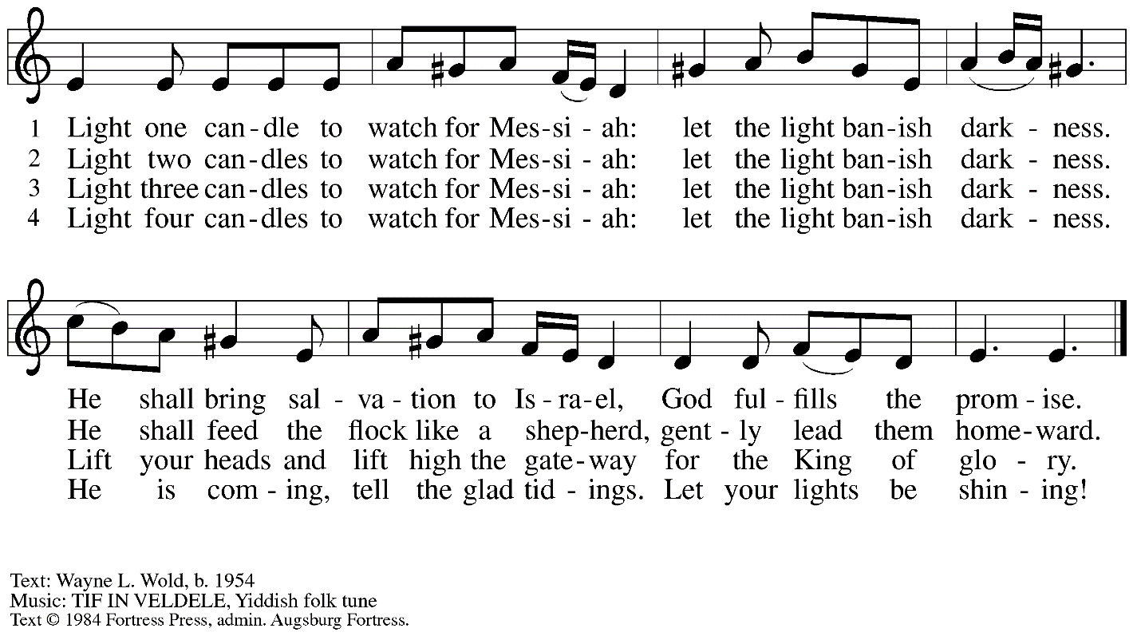
All rights reserved. Reprinted with permission under OneLicense.net # A-722139.

Hymns during Holy Communion
In Silence We Wait ACS 998

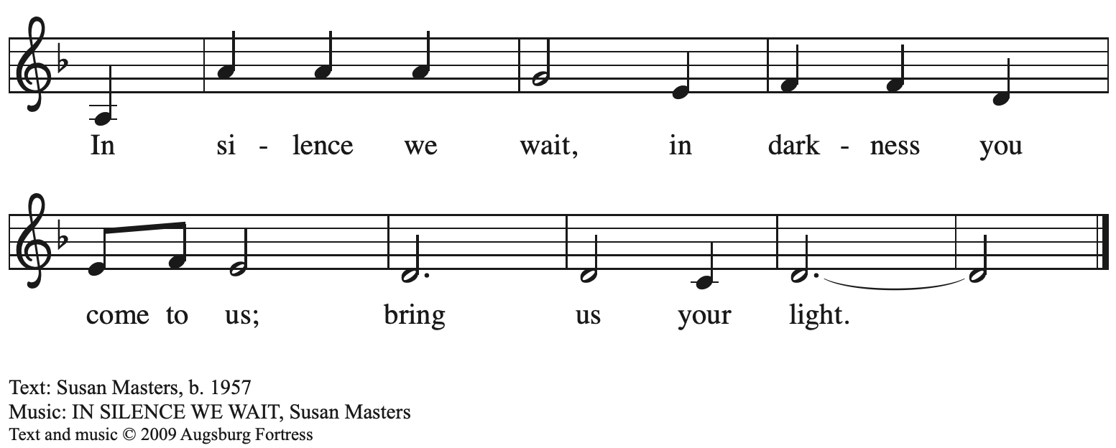
All rights reserved. Reprinted with permission under OneLicense.net # A-722139.

Hymns during Holy Communion
Prepare the Royal Highway ELW 264

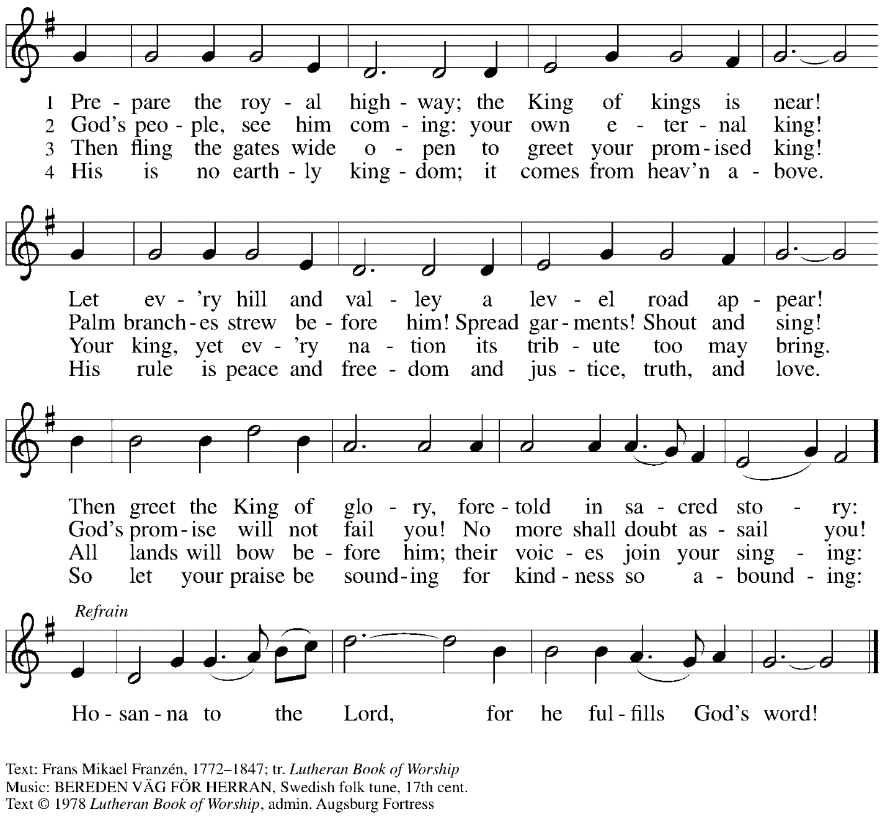
All rights reserved. Reprinted with permission under OneLicense.net # A-722139.

When all have returned to their places, please rise as you are able.

Blessing

P: The body and blood of our Lord Jesus Christ strengthen you and keep you in his grace.
C: Amen.

Prayer

A: Let us pray.
God for whom we wait,
in this meal you give us a foretaste of that day when the hungry will be fed with good things.
Send us forth to make known your deeds and to proclaim the greatness of your name,
through Jesus Christ, our Savior and Lord.
C: Amen.

Please be seated.

Sending
God blesses us and sends us in mission to the world

Announcements

Please rise as you are able.

Benediction

P: The God of peace bless you,
the love of ☩ Christ sustain you in hope,
and the anointing of the Spirit remain upon you,
now and forever.
C: Amen.

Sending Hymn Toda la tierra / All Earth Is Hopeful Following page
v. 1-3

Dismissal

A: Go in peace. Keep awake.
C: Thanks be to God!

Postlude Comfort, Comfort Now My People arr. J. Carter

Sending Hymn Toda la tierra / All Earth Is Hopeful ELW 266
v. 1-3

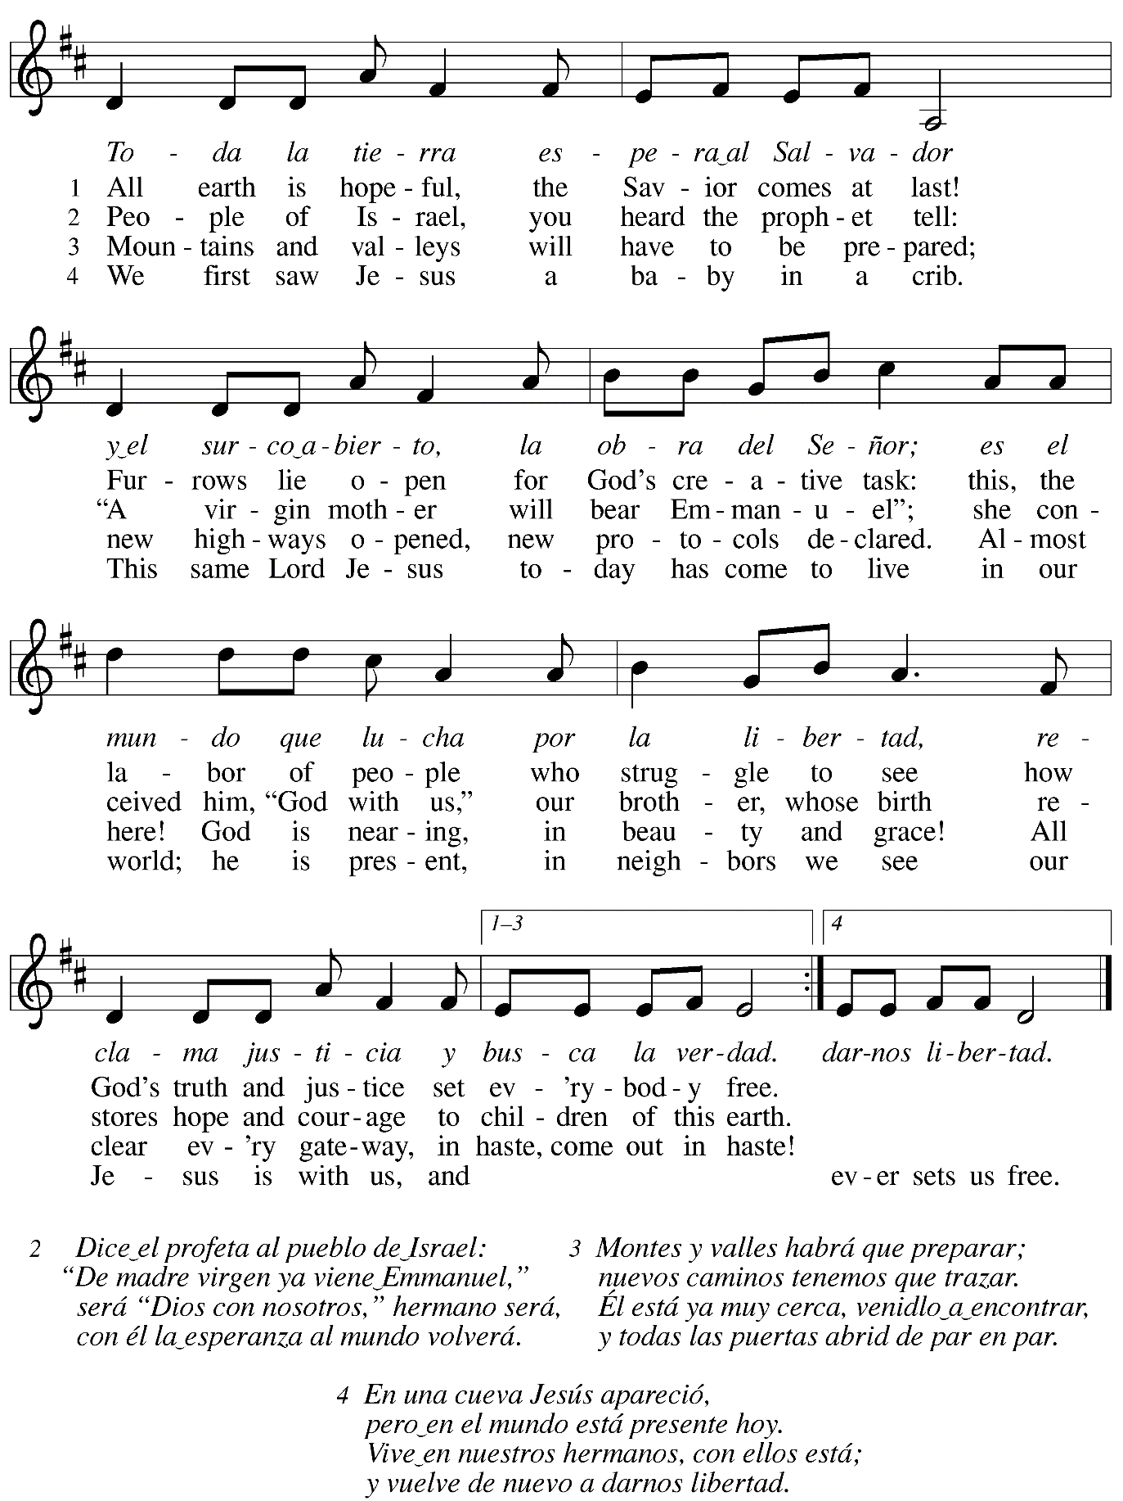
Those serving in worship today

Altar Care Beverley Chapman
Assisting Minister Colleen Cooke
Audio-Visual Minister Kristen Asplin
Cantor Libby Marker
Lector Colleen Cooke
Little Church – Big Faith Teacher Emily Duque
Minister of Music Laura Reynolds
Presiding and Preaching Minister The Rev. Ross I. Carmichael

Liturgy and Hymnody Acknowledgements

From SundaysandSeasons.com. Copyright © 2023 Augsburg Fortress. All rights reserved. Reprinted under OneLicense.net # A-722139.
Used by permission of Augsburg Fortress.

O Come, O Come, Emmanuel – Text: Psalteriolum Cantionum Catholicarum. Köln, 1710; tr. composite. Music: VENI, EMMANUEL, French processional, 15th cent. Text st. 2 © 1997 Augsburg Fortress. All rights reserved. Reprinted with permission under OneLicense.net # A-722139.

Comfort, Comfort Now My People – Text: Johann G. Olearius, 1635—1711; tr. Catherine Winkworth, 1827-1878 alt.. Music: FREU DICH SEHR, Trente quatre pseaumes de David, Geneva, 1551.

Toda la tierra / All Earth Is Hopeful – Text: Alberto Taulé, b. 1932; tr. Madeleine Forell Marshall, b. 1946. Music: TODA LA TIERRA, Alberto Taulé. Spanish text and tune © 1993 and tr. © 1995 Centro de Pastoral Litúrgica, admin. OCP Publications. All roghts reserved. Reprinted with permission under OneLicense.net # A-722139.

Please use the QR code below to link to St. Andrew’s Announcements online!

St. Andrew Lutheran Church Announcements
December 10th, 2023

- Welcome to worship at St. Andrew on the Second Sunday of Advent, December 10th, 2023 – We are so glad you are here, and we offer a special welcome to all guests who are gathered here or online! Worship attendees are invited to make a name tag at the back of the worship space if you would like. Children are invited to participate in Little Church – Big Faith, a Bible lesson and activity, after the prayer of the day. There are worship “toolkits” to help children engage with worship and “busy bags” for younger children available in the bookcase at the back of the sanctuary. Please feel free to take one to use with/for your children. We invite everyone to stay after worship for coffee and conversation in the Social Hall next to the sanctuary.
- Today is St. Andrew’s Commitment Sunday, an Annual Opportunity to Pledge Your Financial Support for the Year Ahead – Each year, St. Andrew invites people of the congregation to offer their financial gifts as an expression of faith and a grateful response for all God has done. There will be an opportunity to dedicate your gifts to God through your Estimate of Giving card, sent with a recent letter, during worship today. Additional Estimate of Giving cards are available if anyone forgot theirs. St. Andrew will also accept additional commitments in the office or by mail over the next two weeks. Thank you for the many ways you support the ministries of St. Andrew through your tithes, offerings, and generosity!
- Today St. Andrew Introduces the Wayne W. Sommerfeld Memorial Scholarship Fund – Our dear brother in Christ Wayne Sommerfeld passed away earlier this year, and his wife Mary contacted the church about making a gift in Wayne’s memory. She wanted to do this around the time of Wayne’s birthday, December 9th, near the Christmas season, which was Wayne’s favorite time of year. Wayne also loved poetry and music and held a special place in his heart for his alma mater, Valparaiso University, a Lutheran college in Indiana. With all this in mind, Mary has given a generous financial gift to institute the Wayne W. Sommerfeld Memorial Scholarship Fund, which is intended to support young musicians in attending Valparaiso’s Lutheran Summer Music program. Each summer, the university offers a faith-based music academy for high school student musicians, who receive advanced musical instruction, perform and offer their gifts in worship, and form an intentional community over several weeks. Since 1981, this program has guided and edified young musicians, many of whom credit Lutheran Summer Music as playing an important role in the path to their future vocations and careers. Our hope is that others in the congregation and community will help build this fund so that we can continue to offer young musicians the opportunity to attend the Lutheran Summer Music program in the future. We thank Mary Sommerfeld for her generosity; we thank God for the blessing that Wayne and Mary have been to this community of faith for so many years; and we ask God’s blessing upon all who will continue to be blessed by their gifts as we dedicate this gift and scholarship fund to the praise and glory of God.
- Annual Meeting of the Congregation – Today after Worship – The annual meeting of the congregation takes place in November or December each year. This meeting is the highest decision-making body in the congregation, and includes election of leaders to serve on the congregation’s leadership council, adoption of a budget for ministry for the upcoming year, and updates about big-picture considerations and long-term planning. All confirmed members of the congregation are eligible to vote, and no absentee or proxy votes can be accepted, so please plan to attend the meeting on Sunday, December 10th.
- The Pittsburgh Compline Prayer, a Ministry of Lutheran Campus Ministry in Greater Pittsburgh, Holds Last Heinz Chapel of the Semester Today at 8:00 p.m. – Compline was traditionally a monastic prayer service, and the Pittsburgh Compline Choir sings a choral version of compline rooted in this thousand-year-old tradition of scripture, song, and silence. This service also streams on Facebook (Pittsburgh Compline Choir) and YouTube (The Pittsburgh Compline Choir). Heinz Chapel is located off of S. Bellefield Ave. in Oakland.
- Hearts and Hands and Community Ministry Committee Invite Congregation to Support Advent Appeal for Winter Accessories – People of the congregation are asked to bring winter hats, mittens/gloves, and scarves to church during the Advent season to support immigrants and refugees arriving in Pittsburgh. These can be handmade (knitted, crocheted, or sewn) or purchased. We can also make them available in the little pantry and at our produce distributions. A collection box will be set up in the social hall to receive these donations.
- Compline Prayer Service at St. Andrew – Sunday, December 17th, 7:00 p.m. – The Compline Choir at times offers to lead a service in an additional location after their semester in Heinz Chapel ends, and we have agreed to host this Compline prayer service on Sunday, December 17th, at St. Andrew at 7:00 p.m. Please plan to take part in this unique worship experience!
- East End Cooperative Ministry Shelter Dinner – Thursday, December 21st, Arrival 6:00 p.m., Meal 6:30 p.m. – Each month, members of St. Andrew provide and serve a meal for the guests of the shelter at East End Cooperative Ministry (EECM), 6140 Station St., 15206. Anyone can sign up to prepare or purchase a portion of the meal to bring to EECM at 6:00 p.m. that day, or just come to help serve the meal at 6:30 p.m. If you would like to contribute, please sign up at: https://www.signupgenius.com/go/5080544AAAC22A1F58-46333425-decshelter.
- Decorating for the Christmas Season – Sunday, December 24th, after Worship – Sunday morning, December 24th, is the Fourth Sunday of Advent, so we will not be able to decorate for the Christmas season until after the 10:00 a.m. worship service that day. We invite everyone to stay that day to take part in the festive activities of preparing the worship space for the Christmas season!
- Coffee Hour Signup Requested – Sunday, December 24th – Everyone from the congregation is invited to stay after worship on Sunday, December 24th, to help decorate for Christmas, so it would be helpful to have someone to host coffee hour on that day so that people have drinks and food to share after the service. The role consists of getting out napkins, plates, and coffee-related items; starting the coffee brewing before worship; setting out other drinks after worship, and cleaning up. If you would like to serve, please sign up at: https://www.signupgenius.com/go/5080B4AAFAF2CABF85-coffee#/. We thank those who have signed up to host coffee hour on December 10th and 17th!
- Christmas Eve Service with Candlelight, Carols, and Holy Communion – Sunday, December 24th, 7:00 p.m.
- Christ in Our Home Devotional Booklets for December Still Available at Church Entrances, January-March Booklets Also Available Now – This resource offers a daily Bible reading with a short reflection and prayer, along with additional readings and prayer topics for those who would like to expand their devotional practices. We encourage people of the congregation to take one for yourself, your family unit, or others!
- Seeking Transportation for A Washer and Dryer to be Donated to a Refugee Family through Jewish Family and Community Services on or after December 18th – A family that is associated with the congregation has a washer and dryer to donate, and Jewish Family and Community Services has identified a refugee family that has space for them. The appliances are in Sewickley, the family is in Duquesne, and neither party is able to transport/deliver them. If anyone has a truck or another large vehicle that might fit the appliances and would be willing to help with the pickup and delivery, please speak with Joy Givens or Pastor Ross.

- Support Guests of the Women’s Center and Shelter of Greater Pittsburgh This Holiday Season – During Advent, each year, St. Andrew invites the congregation to consider giving in support of local organizations and those they serve during Advent. This year, we ask your consideration of a gift in support of the guests of the Women’s Center and Shelter of Greater Pittsburgh. We will collect items in December and deliver them in January. The Community Ministry Committee of St Andrew has selected the Women’s Center & Shelter of Greater Pittsburgh as the recipient of our Christmas gift drive this year. We will collect items through December and deliver them in January. There are 2 ways to give:
- Select items from the Urgent Needs List or Essential Needs List and bring them to the labeled bin in the church Social Hall. Needs lists are posted on the bulletin board and summarized below.
- Order items directly from the Shelter’s Amazon Wish List. They will be shipped directly to the Shelter for you. Log into your Amazon account, visit the WC&S Amazon Wish List or Children’s Wish List. You will not be able to access the lists if you are not logged into your Amazon account. See instructions and links at the Women’s Center & Shelter donation page:
https://wcspittsburgh.org/ways-to-give/donate-items/donating-new-items/

Women’s Shelter Christmas Wish Lists

Urgent Needs
Gift cards are always the most pressing need. Good choices are Walmart, Target, Dollar General, Giant Eagle, VISA.
Multicultural hair care products (Full-size) Sturdy reusable grocery bags
Hair accessories Pillow cases
Body wash (Full size) Air mattress with built-in pump
Towels Fitted and/or flat sheets

Essential Needs
Pull Ups Deodorant (full-size) Chapstick
Baby wipes Brushes Tote bags
Baby bottles Razors Umbrellas
Pacifiers New lightweight tops Size XL Shower curtain w/rings
Kids shampoo (full-size) New Heavy/warm tops Size XL Shower liners
Kids Conditioner (full-size) Combs Phone chargers
Body wash (full-size) Wash cloths Dish soap
Nail clippers Mouthwash (8 oz) New pants Size Large
Cotton swabs Shaving cream (full-size) New underwear Size Medium

