+ Third Sunday of Advent
December 17th, 2023
10:00 a.m.

St. Andrew Lutheran Church
304 Morewood Ave.
Pittsburgh, PA 15213
412.682.3342
St_andrewELCA@verizon.net
www.standrewpittsburgh.org

+ Third Sunday of Advent
Order for Worship

“Rejoice always,” begins this week’s reading from 1 Thessalonians. The third Sunday of Advent, sometimes called Gaudete Sunday, from the Latin word for “rejoice,” has traditionally featured this theme. Isaiah and the psalmist share the good news that God can turn our mourning into laughter and shouts of joy. This week’s Gospel continues the proclamation of John the baptizer, this time from John the evangelist’s account. He once again echoes the prophet Isaiah’s call to prepare a way for the Lord, and points to one who is greater, who will be coming after him. We join John and God’s people throughout the ages in awaiting Jesus’ coming into our lives as we gather in worship for a foretaste of God’s feast to come.

Welcome to St. Andrew!

- St. Andrew Lutheran congregation welcomes all who are seeking a place of healing and wholeness – a nurturing, faith-forming spiritual home. Our community embraces people of all ages, ethnicities, cultures, abilities, sexual orientations, gender identities and expressions, and family constellations. Come and See!

- Worship Services are live streamed to multiple online platforms. By attending worship, you agree that your image and voice may be broadcast.

- Everyone is invited to make a nametag at the black bookcase in the back of the worship space if they would like. There are stickers indicating pronouns on the bookcase if you would like to include them on your name tag.

- Worship “toolkits” to help children engage with the service, along with “busy bags” for younger children, are available in the bookcase at the back of the sanctuary. Please feel free to take one to use with/for your children.

- Holy Communion is served with bread (gluten-free available) and wine or grape juice. The presiding minister will distribute the bread (host). Please consume this and then pick up an empty glass from the tray. The Communion Assistant will pour wine or grape juice into your glass. Please step to the side to consume the wine or grape juice. Feel free to kneel at the altar for prayer and reflection. As you return to your pew, glasses may be returned to the empty trays on either side of the center section.

- A restroom is available on the main level of the church, through the doors to the Social Hall and to the right in the main office.

Abbreviations
P: Pastor/Presiding Minister ACS: All Creation Sings hymnal
A: Assisting Minister ELW: Evangelical Lutheran Worship hymnal
L: Lector
C: Congregation

Centering Music O Come, O Come, Emmanuel ELW 257
v. 3-5

3 O come, O come, O Lord of might,
as to your tribes on Sinai's height
in ancient times you gave the law
in cloud, and majesty, and awe. Refrain

Refrain
Rejoice! Rejoice! Emmanuel
shall come to you, O Israel.

4 O come, O Branch of Jesse, free
your own from Satan's tyranny;
from depths of hell your people save,
and give them vict'ry o'er the grave. Refrain

5 O come, O Key of David, come,
and open wide our heav'nly home;
make safe the way that leads on high,
and close the path to misery. Refrain

Welcome

Gathering
The Holy Spirit calls us together as the people of God

Confession and Forgiveness

Please rise as you are able. All may make the sign of the cross,
the sign that is marked at Baptism, as the presiding minister begins.

P: Blessed be the holy Trinity, ☩ one God,
who opens the heavens
and draws near to us with salvation.
C: Amen.

P: God is patient and merciful, desiring all to come to repentance.
Trusting God’s promise of grace, let us confess our sin.

Silence is kept for reflection and self-examination.

P: Everlasting God,
C: you love justice and you hate wrongdoing.
We confess the fear, greed, and self-centeredness
that make us reluctant to work against oppression.
We are complicit in systems of exploitation.
We choose comfort over courage.
We are careless with creation’s bounty.
Look upon us with mercy.
Turn our hearts again to you.
Make us glad to do your will and to walk in your ways
for the sake of our waiting world. Amen.

P: Receive these words of assurance:
God clothes you with garments of salvation
and covers you with robes of righteousness.
In the tender compassion of ☩ Jesus Christ, your sins are forgiven.
God’s covenant is eternal, and God’s blessing rests upon us all.
C: Amen.

Gathering Hymn Hark, the Glad Sound! ELW 239

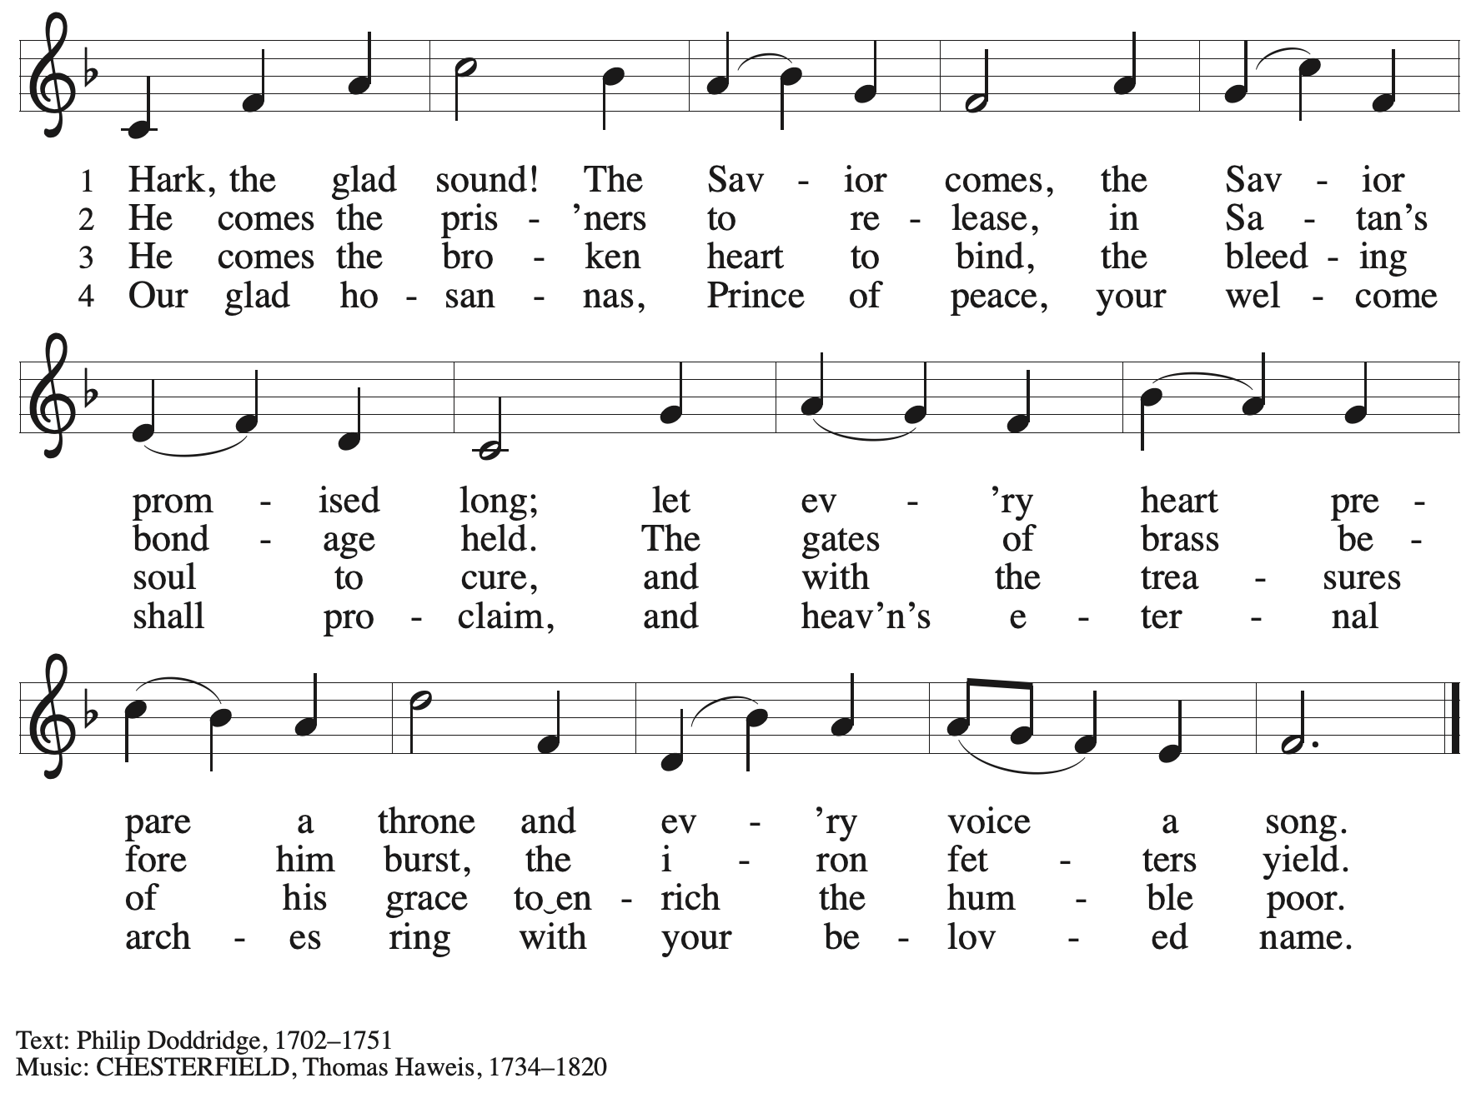
Greeting

P: The grace of our Lord Jesus Christ, the love of God,
and the communion of the Holy Spirit be with you all.
C: And also with you.

Kyrie ACS p. 31

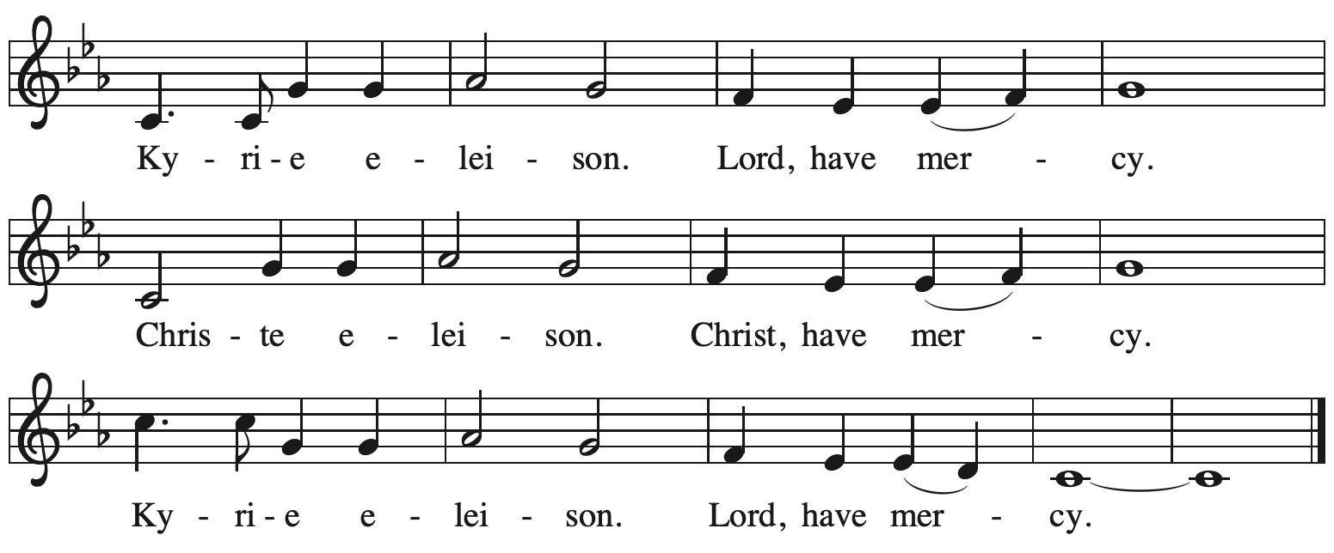

Prayer of the Day

P: The Lord be with you.
C: And also with you.

P: Let us pray.
Stir up the wills of your faithful people, Lord God,
and open our ears to the words of your prophets,
that, anointed by your Spirit, we may testify to your light;
through Jesus Christ, our Savior and Lord,
who lives and reigns with you and the Holy Spirit,
one God, now and forever.
C: Amen.

Please be seated.

Word
God speaks to us in Scripture reading, preaching, and song

First Reading – Isaiah 61: 1-4, 8-11

¹The spirit of the Lord God is upon me,
because the Lord has anointed me;
the Lord has sent me to bring good news to the oppressed,
to bind up the brokenhearted,
to proclaim liberty to the captives,
and release to the prisoners;
²to proclaim the year of the Lord’s favor,
and the day of vengeance of our God;
to comfort all who mourn;
³to provide for those who mourn in Zion—
to give them a garland instead of ashes,
the oil of gladness instead of mourning,
the mantle of praise instead of a faint spirit.
They will be called oaks of righteousness,
the planting of the Lord, to display the Lord’s glory.
⁴They shall build up the ancient ruins,
they shall raise up the former devastations;
they shall repair the ruined cities,
the devastations of many generations.
⁸For I the Lord love justice,
I hate robbery and wrongdoing;
I will faithfully give them their recompense,
and I will make an everlasting covenant with them.
⁹Their descendants shall be known among the nations,
and their offspring among the peoples;
all who see them shall acknowledge
that they are a people whom the Lord has blessed.
¹⁰I will greatly rejoice in the Lord,
my whole being shall exult in my God;
for God has clothed me with the garments of salvation,
God has covered me with the robe of righteousness,
as a bridegroom decks himself with a garland,
and as a bride adorns herself with her jewels.
¹¹For as the earth brings forth its shoots,
and as a garden causes what is sown in it to spring up,
so the Lord God will cause righteousness and praise
to spring up before all the nations.

L: Word of God, word of life.
C: Thanks be to God.

Hymn Bringing in the Sheaves
Featuring themes from Psalm 126

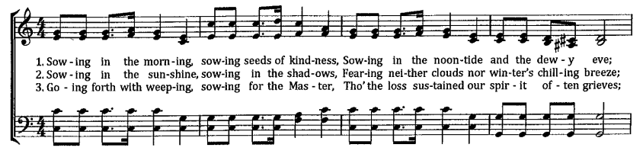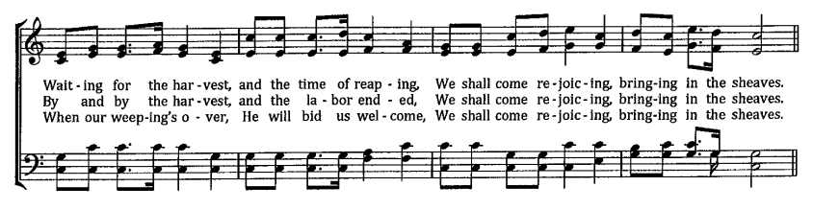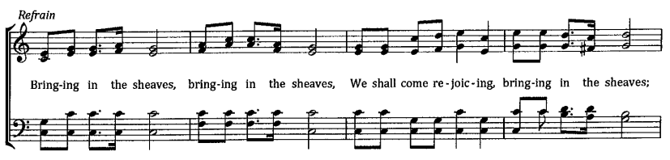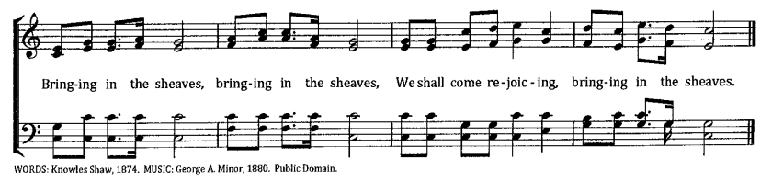

Second Reading – 1 Thessalonians 5: 16-24

¹⁶Rejoice always, ¹⁷pray without ceasing, ¹⁸give thanks in all circumstances; for this is the will of God in Christ Jesus for you. ¹⁹Do not quench the Spirit. ²⁰Do not despise the words of prophets,
²¹but test everything; hold fast to what is good; ²²abstain from every form of evil.
²³May the God of peace Godself sanctify you entirely; and may your spirit and soul and body be kept sound and blameless at the coming of our Lord Jesus Christ. ²⁴The one who calls you is faithful, and will do this.

L: Word of God, word of life.
C: Thanks be to God.

Please rise as you are able.

Gospel Acclamation ELW p. 188

Gospel – John 1: 6-8, 19-28

P: The holy Gospel according to St.
C: Glory to you, O Lord.

⁶There was a man sent from God, whose name was John. ⁷He came as a witness to testify to the light, so that all might believe through him. ⁸He himself was not the light, but he came to testify to the light.
¹⁹This is the testimony given by John when the Jews sent priests and Levites from Jerusalem to ask him, “Who are you?” ²⁰He confessed and did not deny it, but confessed, “I am not the Messiah.” ²¹And they asked him, “What then? Are you Elijah?” He said, “I am not.” “Are you the prophet?” He answered, “No.” ²²Then they said to him, “Who are you? Let us have an answer for those who sent us. What do you say about yourself?” ²³He said,
“I am the voice of one crying out in the wilderness,
‘Make straight the way of the Lord,’ ”
as the prophet Isaiah said.
²⁴Now they had been sent from the Pharisees. ²⁵They asked him, “Why then are you baptizing if you are neither the Messiah, nor Elijah, nor the prophet?” ²⁶John answered them, “I baptize with water. Among you stands one whom you do not know, ²⁷the one who is coming after me; I am not worthy to untie the thong of his sandal.” ²⁸This took place in Bethany across the Jordan where John was baptizing.
P: The Gospel of the Lord.
C: Praise to you, O Christ.
Please be seated.

Sermon

A time of silence for prayer and reflection follows the sermon.
As the hymn of the day begins, please rise as you are able.

Hymn of the Day O God of Light ELW 507

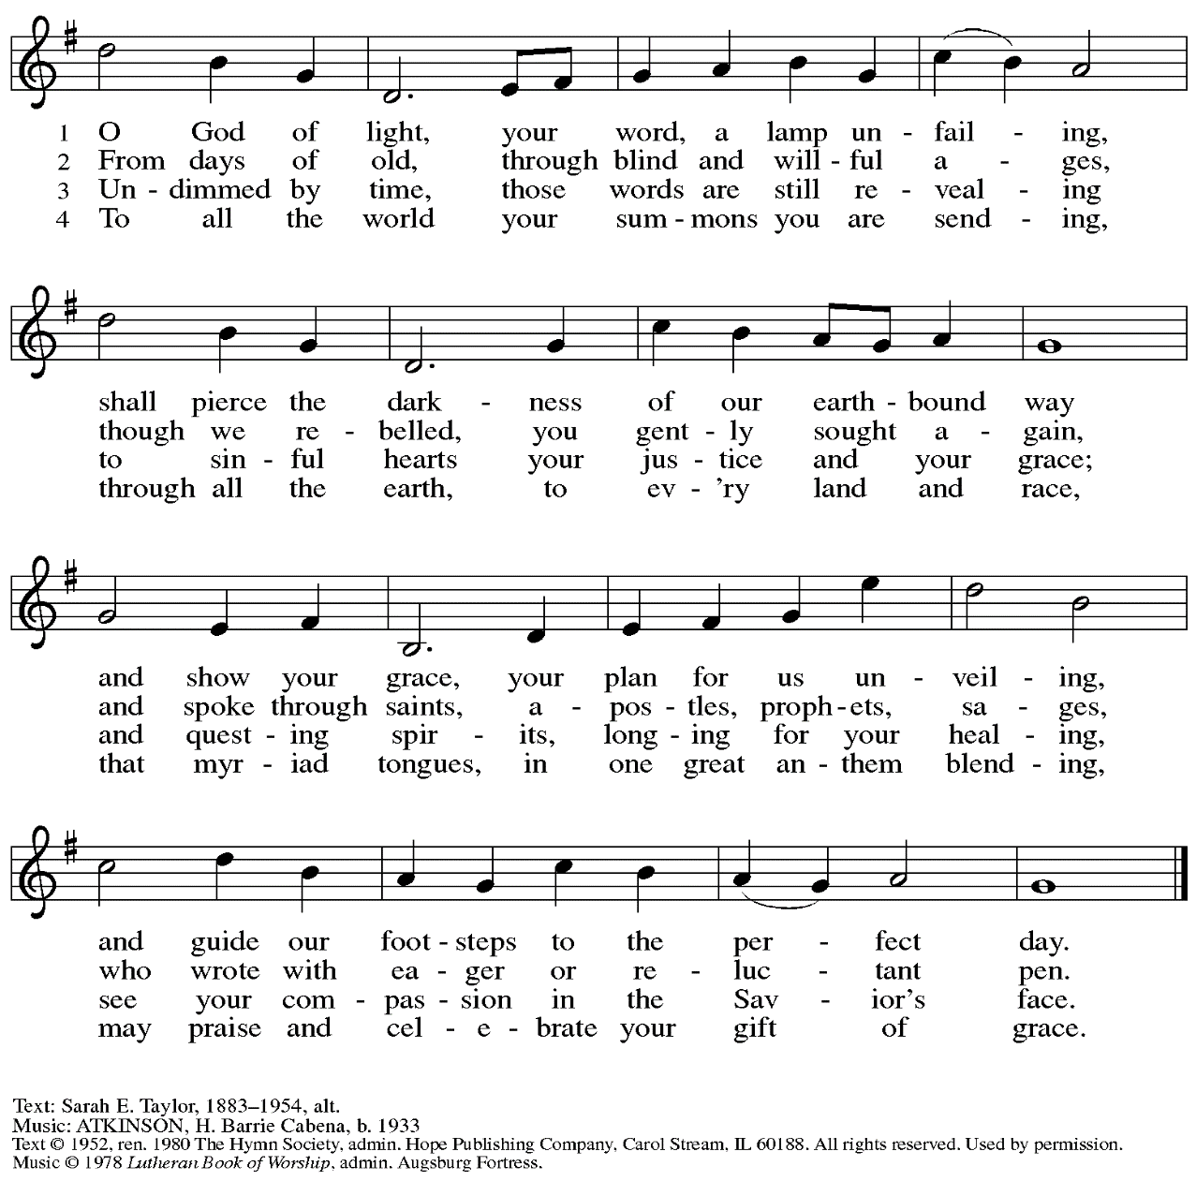
Reprinted with permission under OneLicense.net # A-722139.
Prayers of the People

A: With hope and expectation, we offer our prayers for the church, the world,
and all who await God’s day of restoration.

After each petition
A: Merciful God,
C: receive our prayer.

The presiding minister concludes the prayers
P: Receive these and all our prayers, O God of hosts,
and restore us with your great and everlasting mercy,
through Jesus Christ, our Savior.
C: Amen.

Peace

The presiding minister and the assembly greet one another in the peace of the risen Christ.
P: The peace of Christ be with you always.
C: And also with you.

The people may greet those around them with a sign of Christ’s peace and may say
Peace be with you or similar words. Please be mindful that not everyone will be comfortable with sharing the peace, so please seek consent before shaking hands or hugging. Other possible ways to share the peace include a simple bow with the verbal greeting of peace, or simply a verbal expression of peace.

When the greetings of peace have concluded, please be seated.

Meal
God feeds us with the presence of Jesus Christ

Offering

We offer ourselves, our gifts, and our faithful service to God.
As the offering is gathered for the mission of the church, including the care of those in need,
the table is set for Holy Communion.

Music during the Offering
Rejoice, Rejoice Believers arr. Raabe
with Come Now, O Prince of Peace

As the gifts are brought forward for presentation, please rise as you are able.

Offertory Song We Give Thee but Thine Own ELW 686
v. 1-3

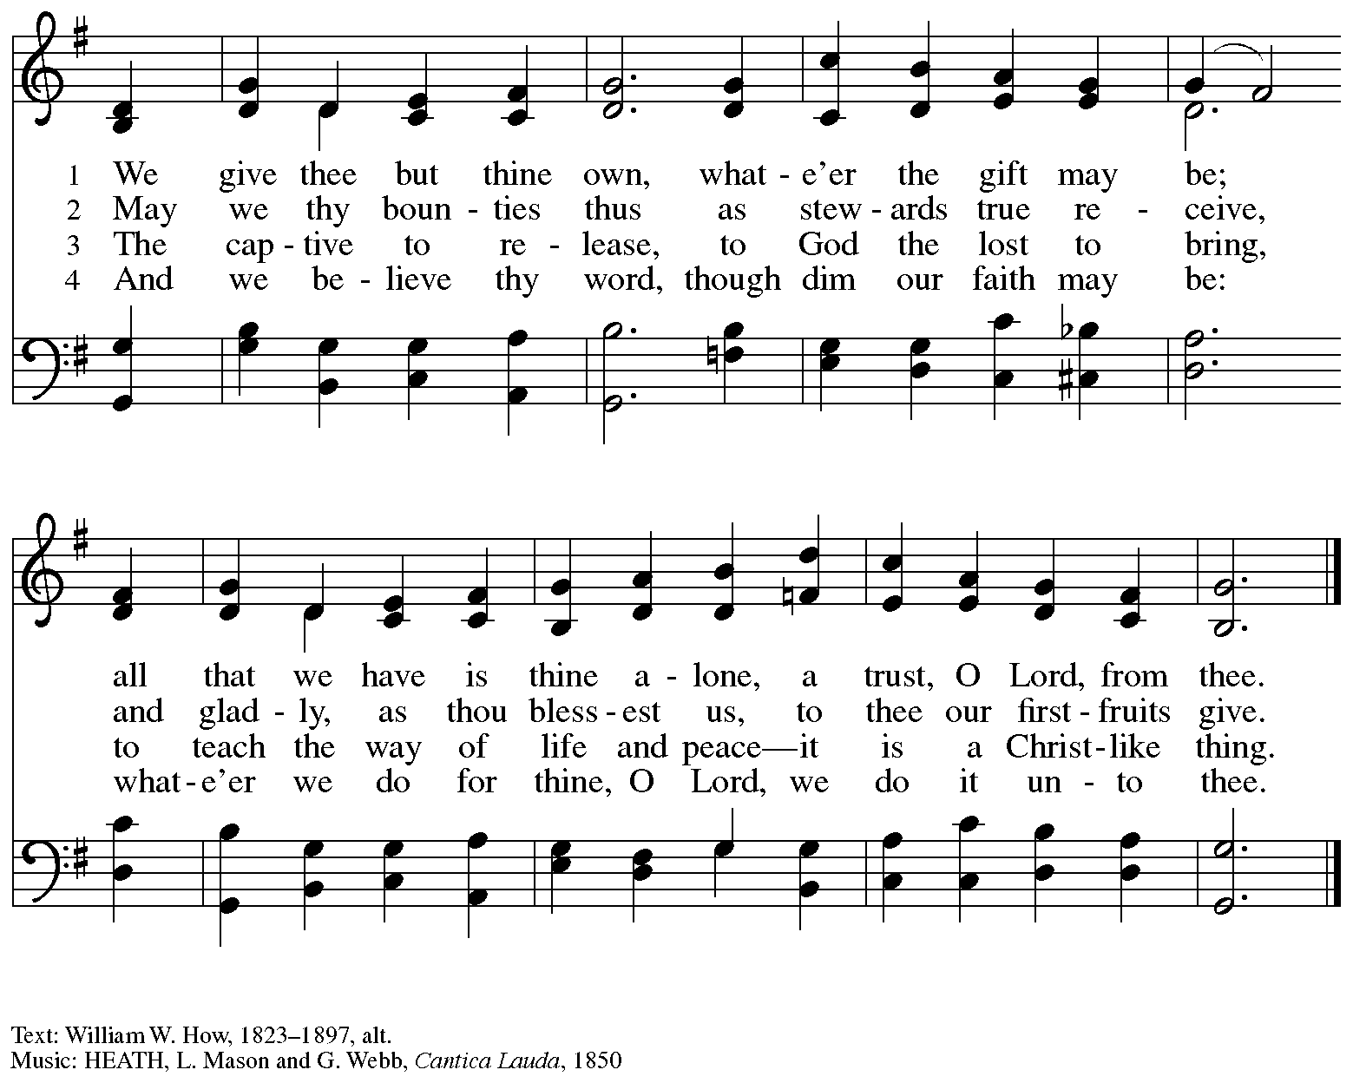

Offertory Prayer

A: Let us pray.
God of abundance,
C: we bring before you
the precious fruits of your creation,
and with them our very lives.
Teach us patience and hope
as we care for all those in need
until the coming of your Son,
our Savior and Lord.
Amen.

Dialogue

P: The Lord be with you.
C: And also with you.

P: Lift up your hearts.
C: We lift them to the Lord.

P: Let us give thanks to the Lord our God.
It is right to give our thanks and praise.

Preface

P: It is indeed right, our duty and our joy …
… we praise your name and join their unending hymn:

Sanctus ELW p. 190

Eucharistic Prayer

P: Holy one, the beginning and the end, the giver of life, …
… Do this for the remembrance of me.

Let us proclaim the mystery of faith.
C: Christ has died. Christ is risen. Christ will come again.

P: With this bread and cup …
… We look with hope for his coming.
C: Come, Lord Jesus.

P: Holy God, we long for your Spirit …
… Bring the gift of peace on earth.
C: Come, Holy Spirit.

P: All praise and glory are yours …
… one God, now and forever.
C: Amen.

Lord’s Prayer

P: Gathered as one by the Holy Spirit, let us pray as Jesus taught us.
C: Our Father in heaven,
hallowed be your name,
your kingdom come,
your will be done,
on earth as in heaven.
Give us today our daily bread.
Forgive us our sins
as we forgive those
who sin against us.
Save us from the time of trial
and deliver us from evil.
For the kingdom, the power,
and the glory are yours,
now and forever. Amen.

Fraction and Invitation

P: In this meal, righteousness and peace meet.
Come, receive the gifts God has prepared for you.

Agnus Dei / Lamb of God ELW p. 191

Please be seated.

Holy Communion
- All who seek God and desire a deeper and stronger life in Christ are welcome to receive Holy Communion.
- Worshipers from the pulpit side will proceed forward first, followed by the center section, and then the lectern side.
- Please inform an usher if you would like the ministers to bring Communion to you.
- Holy Communion will be served with bread and wine/grape juice.
- The presiding minister will first distribute the bread (host) to each communicant. Please indicate if you require a gluten-free host.
- Once you have consumed the bread, please pick up an empty glass from the tray next to the presiding minister. The Communion Assistant will pour wine from the chalice or grape juice from the cruet into your glass.
- Please step to the side to consume the wine or grape juice.
- Feel free to kneel at the altar rail for prayer after receiving the sacrament.
- As you return to your pew, glasses may be returned to the empty trays on either side of the center section.
- A blessing will be provided for anyone who does not yet receive the sacrament.
- All are invited to join in singing the hymns during Holy Communion.

Hymns during Holy Communion
Lost in the Night ELW 243

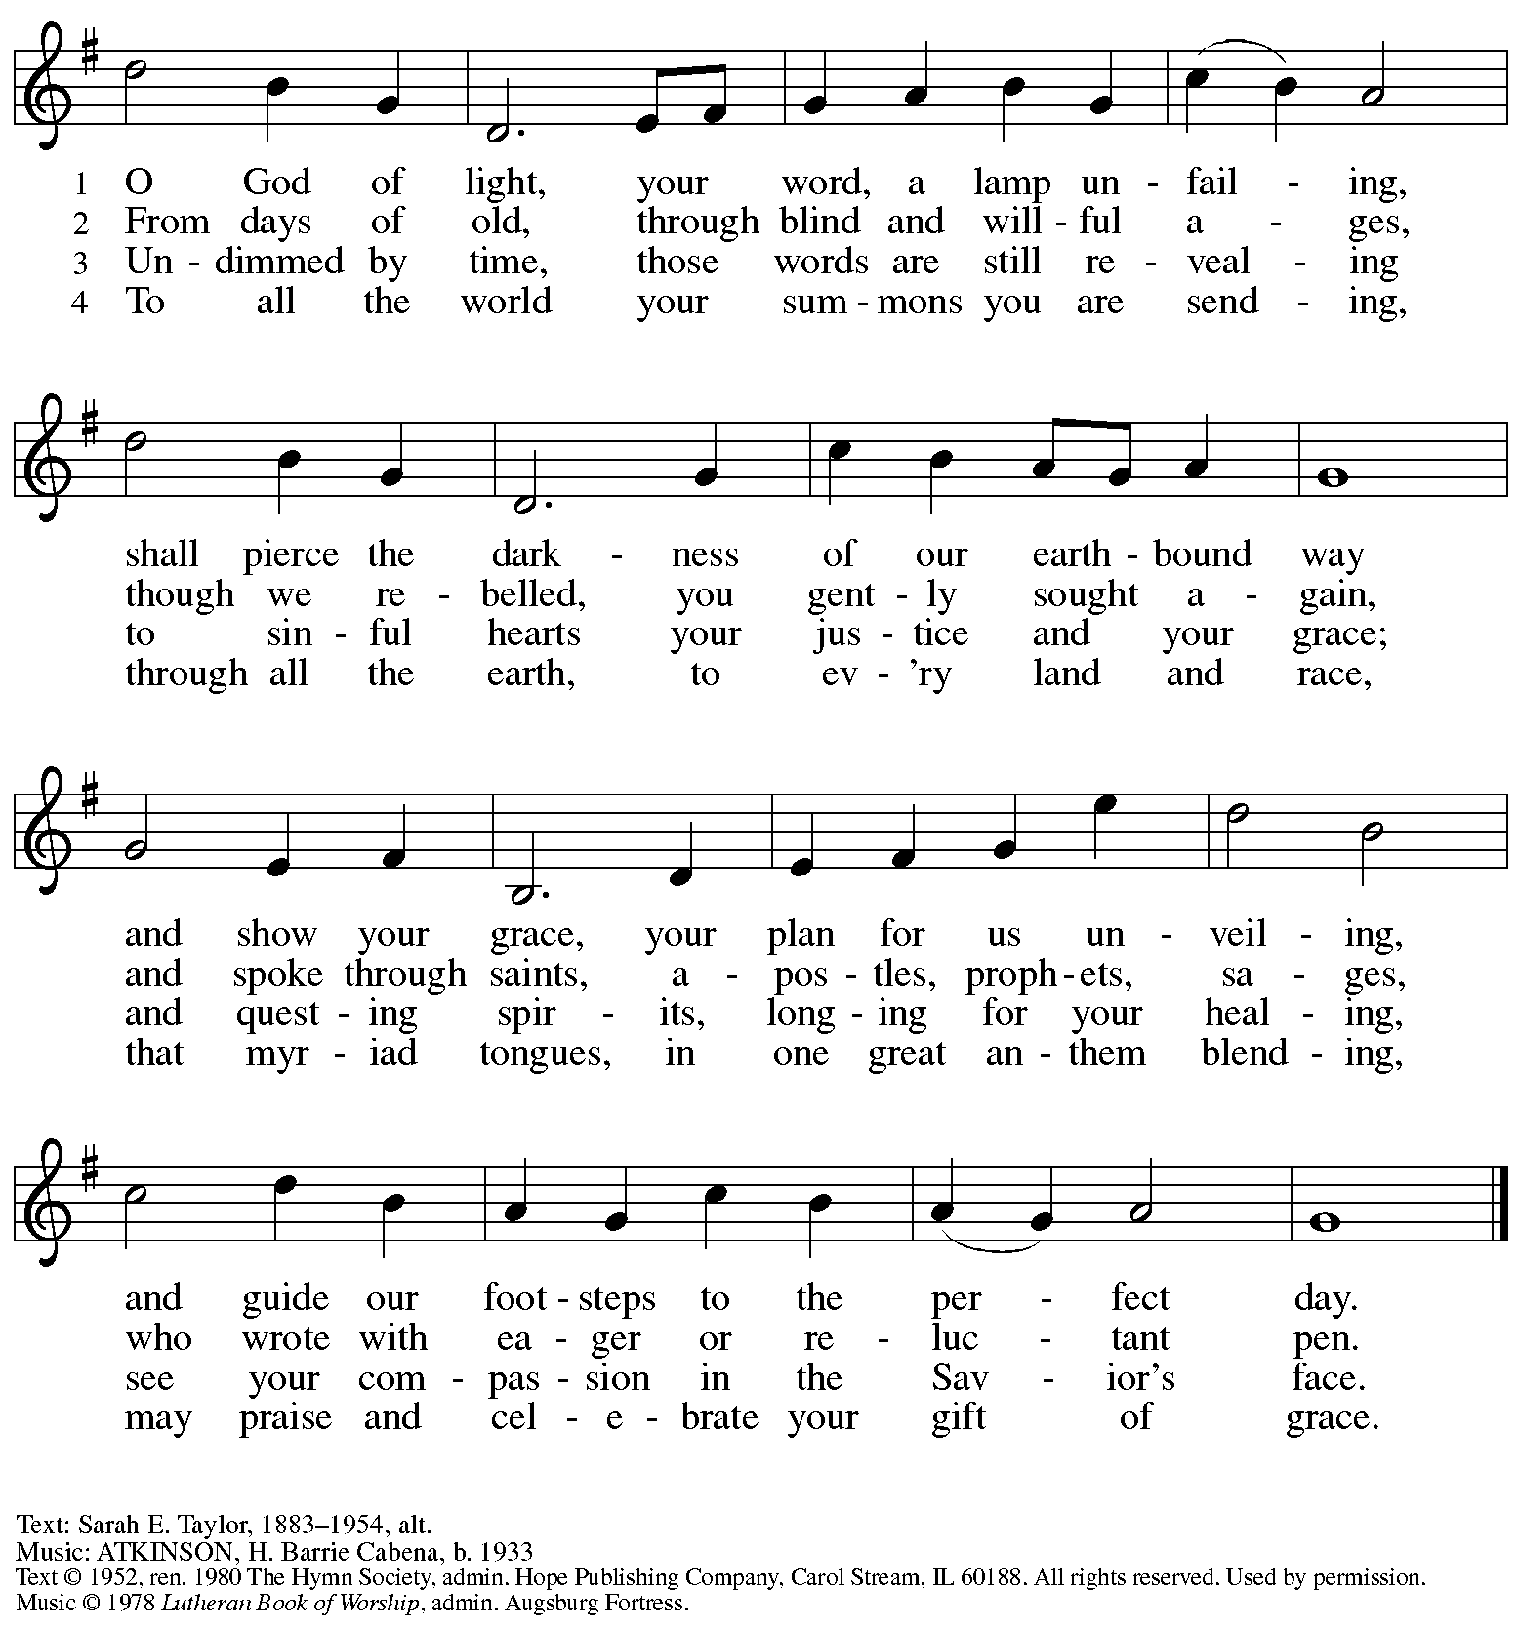
Reprinted with permission under OneLicense.net # A-722139.

Hymns during Holy Communion
Come, Thou Long-Expected Jesus ELW 254

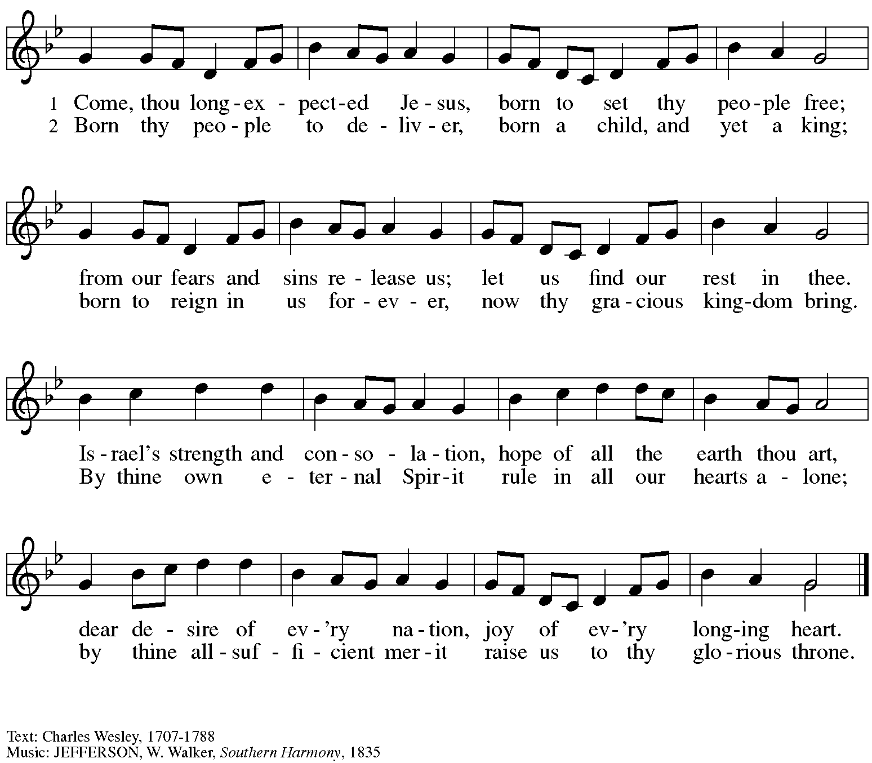

Hymns during Holy Communion
Rejoice, Rejoice, Believers ELW 244

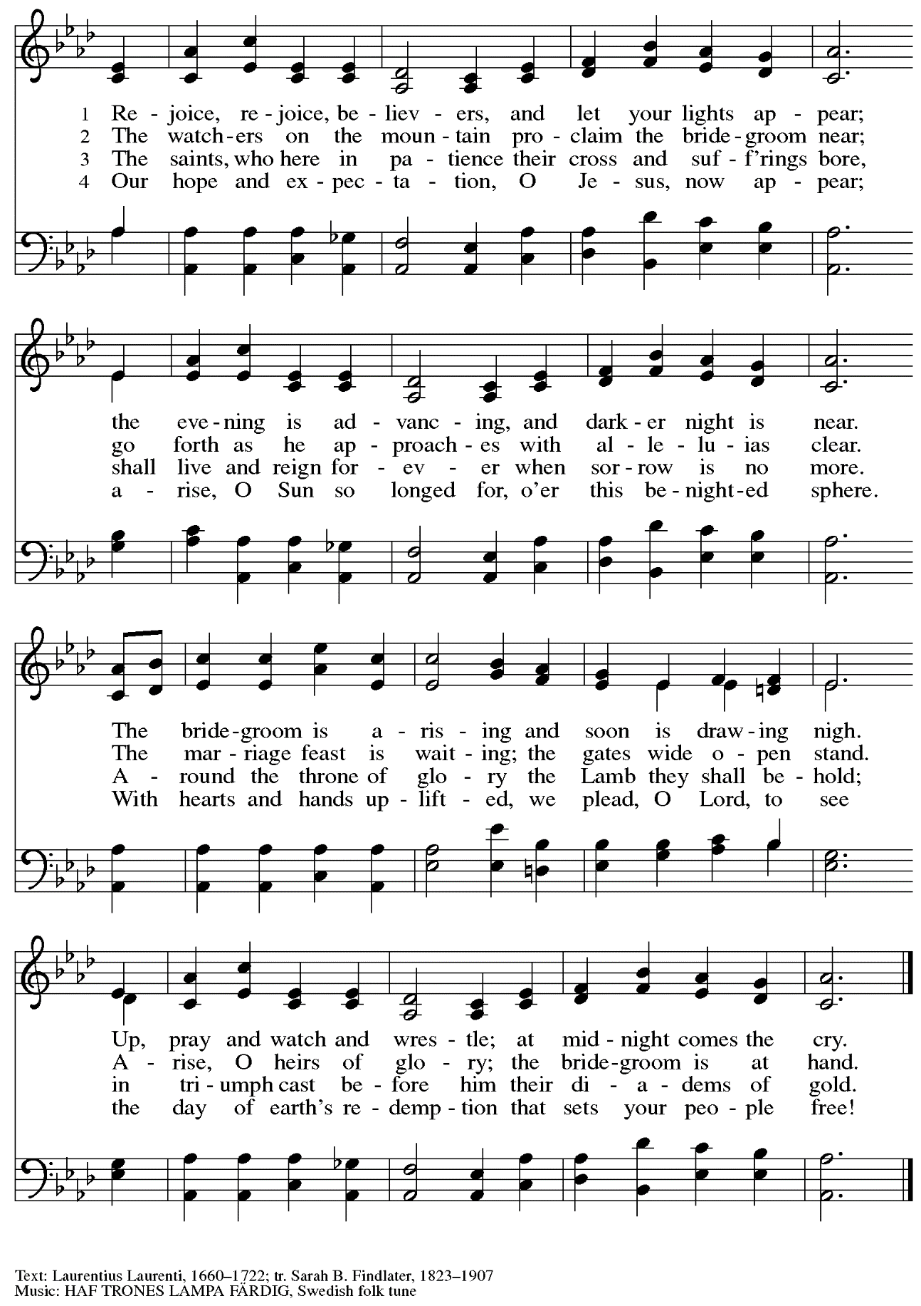

When all have returned to their places, please rise as you are able.

Blessing

P: The body and blood of our Lord Jesus Christ strengthen you and keep you in his grace.
C: Amen.

Prayer

A: Let us pray.
God for whom we wait,
in this meal you give us a foretaste of that day when the hungry will be fed with good things.
Send us forth to make known your deeds and to proclaim the greatness of your name,
through Jesus Christ, our Savior and Lord.
C: Amen.

Please be seated.

Sending
God blesses us and sends us in mission to the world

Announcements

Please rise as you are able.

Benediction

P: The God of peace bless you,
the love of ☩ Christ sustain you in hope,
and the anointing of the Spirit remain upon you,
now and forever.
C: Amen.

Sending Hymn Christ, Be Our Light Following page

Dismissal

A: Go in peace. Keep awake.
C: Thanks be to God!

Postlude Prepare the Royal Highway arr. Carter

Sending Hymn Christ, Be Our Light ELW 715

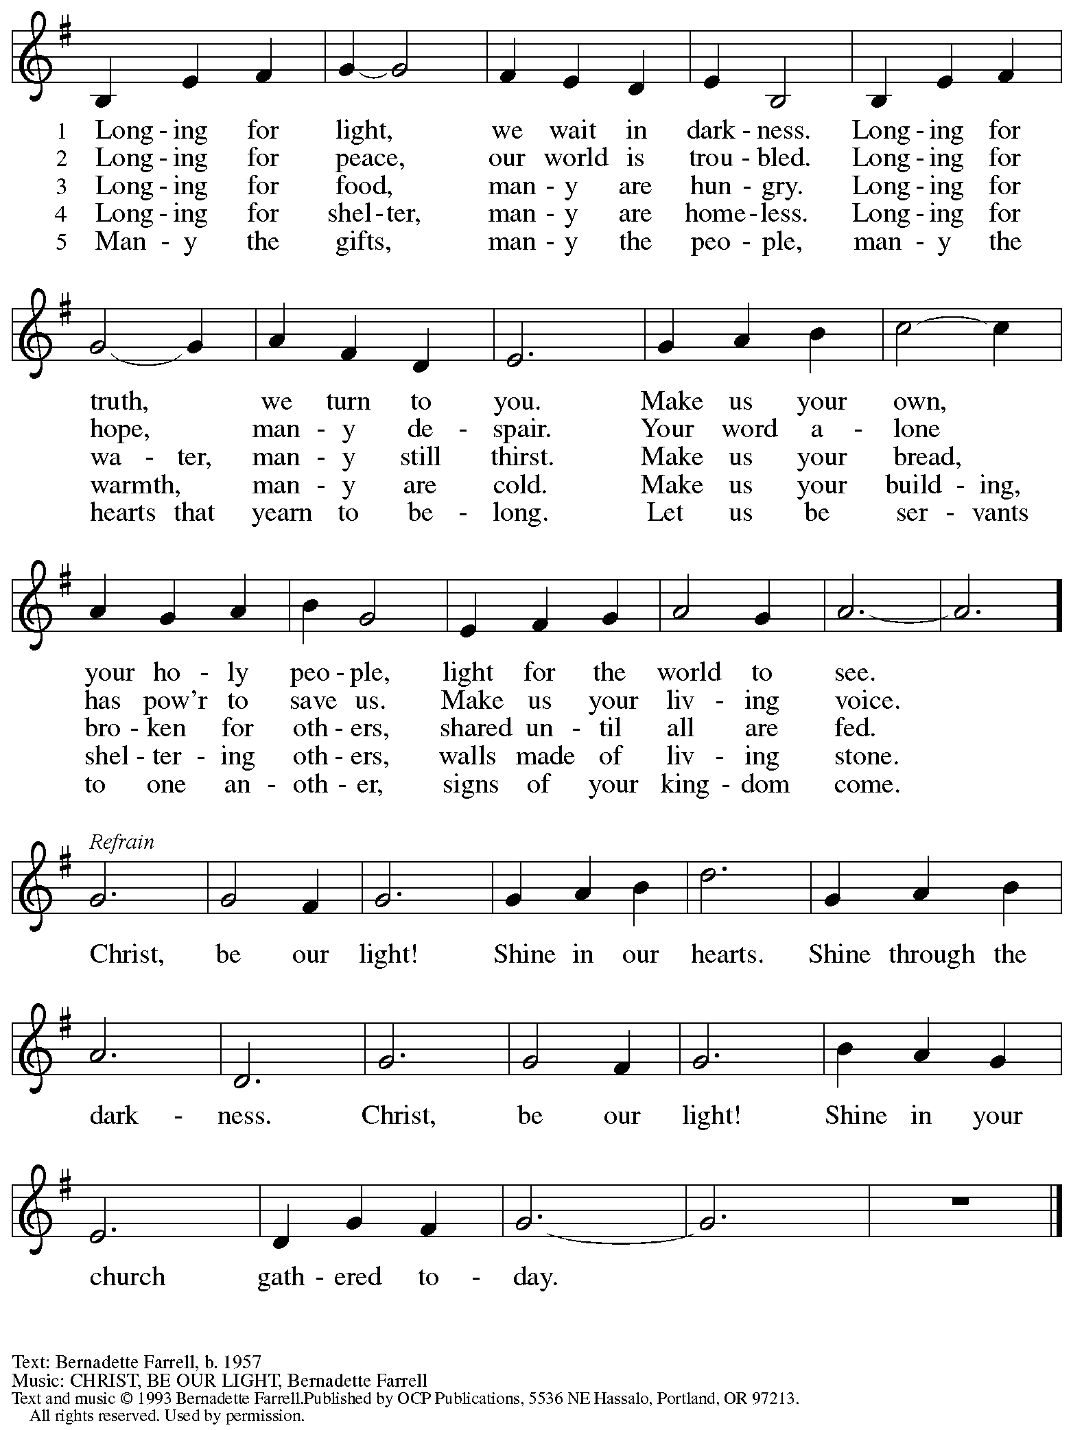
Reprinted with permission under OneLicense.net # A-722139.

Those serving in worship today

Altar Care Christy Ruhe
Audio-Visual Ministers David Rollinson
Jason Galyardt
Cantor Maria Mangano
Lector Colleen Cooke
Little Church – Big Faith Teacher Ty and Amanda Best
Minister of Music Laura Reynolds
Presiding and Preaching Minister The Rev. Ross I. Carmichael

Liturgy and Hymnody Acknowledgements

From SundaysandSeasons.com. Copyright © 2023 Augsburg Fortress. All rights reserved. Reprinted under OneLicense.net # A-722139.
Used by permission of Augsburg Fortress.

O Come, O Come, Emmanuel – Text: Psalteriolum Cantionum Catholicarum. Köln, 1710; tr. composite. Music: VENI, EMMANUEL, French processional, 15th cent.

Please use the QR code below to link to St. Andrew’s Announcements online!

St. Andrew Lutheran Church Announcements
December 17th, 2023

- Welcome to worship at St. Andrew on the Third Sunday of Advent, December 17th, 2023 – We are so glad you are here, and we offer a special welcome to all guests who are gathered here or online! Worship attendees are invited to make a name tag at the back of the worship space if you would like. Children are invited to participate in Little Church – Big Faith, a Bible lesson and activity, after the prayer of the day. There are worship “toolkits” to help children engage with worship and “busy bags” for younger children available in the bookcase at the back of the sanctuary. Please feel free to take one to use with/for your children. We invite everyone to stay after worship for coffee and conversation in the Social Hall next to the sanctuary.
- Compline Prayer at St. Andrew Today, Sunday, December 17th, 7:00 p.m. –
Compline was traditionally a monastic prayer service, and the Pittsburgh Compline Choir sings a choral version of compline rooted in this thousand-year-old tradition of scripture, song, and silence. The choir at times offers to lead a service in an additional location after their semester in Heinz Chapel ends, and St. Andrew has agreed to host this additional Compline service tonight at 7:00 p.m. Please plan to take part in this unique worship experience!
- East End Cooperative Ministry Shelter Dinner – Thursday, December 21st, Arrival 6:00 p.m., Meal 6:30 p.m. – Each month, people of St. Andrew provide and serve a meal for the guests of the shelter at East End Cooperative Ministry (EECM), 6140 Station St., 15206. Anyone can sign up to prepare or purchase a portion of the meal to bring to EECM at 6:00 p.m. that day, or just come to help serve the meal at 6:30 p.m. If you would like to contribute, please sign up at:
https://www.signupgenius.com/go/5080544AAAC22A1F58-46333425-decshelter.
- Hearts and Hands and Community Ministry Committee Invite Congregation to Support Advent Appeal for Winter Accessories – People of the congregation are asked to bring winter hats, mittens/gloves, and scarves to church during the Advent season (beginning December 3rd) to support immigrants and refugees arriving in Pittsburgh. These can be handmade (knitted, crocheted, or sewn) or purchased. We can also make them available in the little pantry and at our produce distributions. A collection box will be set up in the social hall to receive these donations.
- Help Needed: Deliver Gifts Locally to New Immigrants and Refugees – Week of December 18th – 22nd – St. Andrew member Joy Givens is an Immigrant and Refugee Youth Specialist at Jewish Family and Community Services of Pittsburgh (JFCS). She is looking for volunteers to deliver packages of Christmas/Holiday gifts to families the week of Dec 18th-22^{nd.} Volunteers will deliver to approximately four families in the same neighborhood. The day and time of delivery will be scheduled to suit the volunteers’ availability. To volunteer, call or text Joy at 412-925-2529.
- Seeking Transportation for A Washer and Dryer to be Donated to a Refugee Family through Jewish Family and Community Services on or after December 18th – A family that is associated with the congregation has a washer and dryer to donate, and Jewish Family and Community Services has identified a refugee family that has space for them. The appliances are in Sewickley, the family is in Duquesne, and neither party is able to transport/deliver them. If anyone has a truck or another large vehicle that might fit the appliances and would be willing to help with the pickup and delivery, please speak with Joy Givens or Pastor Ross.
- Decorating for the Christmas Season – Sunday, December 24th, after Worship – Sunday morning, December 24th, is the Fourth Sunday of Advent, so we will not be able to decorate for the Christmas season until after the 10:00 a.m. worship service that day. We invite everyone to stay that day to take part in the festive activities of preparing the worship space for the Christmas season!
- The Nativity of our Lord - Christmas Eve Worship with Holy Communion Service Sunday, December 24th, 7:00 p.m. – We gather for the celebration of Christ’s birth with candles, carols, and Holy Communion at 7:00 p.m. on Christmas Eve!
- Little Church – Big Faith Not Meeting at the 7:00 p.m. Christmas Eve Service or Sunday, December 31st – St. Andrew’s Bible story and activity time for children that usually meets during worship will not be held on the above dates. Classes will resume on Sunday, January 7th.
- Christ in Our Home Devotional Booklets for January - March Available at Church Entrances – This resource offers a daily Bible reading with a short reflection and prayer, along with additional readings and prayer topics for those who would like to expand their devotional practices. We encourage people of the congregation to take one for yourself, your family unit, or others. There are still some booklets for December available, too!
- Support Guests of the Women’s Center and Shelter of Greater Pittsburgh This Holiday Season – During Advent, each year, St. Andrew invites the congregation to consider giving in support of local organizations and those they serve during Advent. This year, we ask your consideration of a gift in support of the guests of the Women’s Center and Shelter of Greater Pittsburgh. We will collect items in December and deliver them in January. The Community Ministry Committee of St Andrew has selected the Women’s Center & Shelter of Greater Pittsburgh as the recipient of our Christmas gift drive this year. We will collect items through December and deliver them in January. There are 2 ways to give:
- Select items from the Urgent Needs List or Essential Needs List and bring them to the labeled bin in the church Social Hall. Needs lists are posted on the bulletin board and summarized below.
- Order items directly from the Shelter’s Amazon Wish List. They will be shipped directly to the Shelter for you. Log into your Amazon account, visit the WC&S Amazon Wish List or Children’s Wish List. You will not be able to access the lists if you are not logged into your Amazon account. See instructions and links at the Women’s Center & Shelter donation page:
https://wcspittsburgh.org/ways-to-give/donate-items/donating-new-items/

Women’s Shelter Christmas Wish Lists

Urgent Needs
Gift cards are always the most pressing need. Good choices are Walmart, Target, Dollar General, Giant Eagle, VISA.
Multicultural hair care products (Full-size) Sturdy reusable grocery bags
Hair accessories Pillow cases
Body wash (Full size) Air mattress with built-in pump
Towels Fitted and/or flat sheets

Essential Needs
Pull Ups Deodorant (full-size) Chapstick
Baby wipes Brushes Tote bags
Baby bottles Razors Umbrellas
Pacifiers New lightweight tops Size XL Shower curtain w/rings
Kids shampoo (full-size) New Heavy/warm tops Size XL Shower liners
Kids Conditioner (full-size) Combs Phone chargers
Body wash (full-size) Wash cloths Dish soap
Nail clippers Mouthwash (8 oz) New pants Size Large
Cotton swabs Shaving cream (full-size) New underwear Size Medium

