+ Fourth Sunday of Advent
December 24th, 2023
10:00 a.m.

St. Andrew Lutheran Church
304 Morewood Ave.
Pittsburgh, PA 15213
412.682.3342
St_andrewELCA@verizon.net
www.standrewpittsburgh.org

+ Fourth Sunday of Advent
Order for Worship

God keeps the promise made to David to give him an everlasting throne.
The angel Gabriel tells Mary that God will give David’s throne to her son Jesus.
She is perplexed by Gabriel’s greeting and by the news of her coming pregnancy,
but she is able still to say, “Count me in.” We who know that Jesus is called king only as he is executed still find it a mystery hard to fathom, but with Mary today we too receive the good news of what God is doing and respond, “Count me in.”

Welcome to St. Andrew!

- St. Andrew Lutheran congregation welcomes all who are seeking a place of healing and wholeness – a nurturing, faith-forming spiritual home. Our community embraces people of all ages, ethnicities, cultures, abilities, sexual orientations, gender identities and expressions, and family constellations. Come and See!

- Worship Services are live streamed to multiple online platforms. By attending worship, you agree that your image and voice may be broadcast.

- Everyone is invited to make a nametag at the black bookcase in the back of the worship space if they would like. There are stickers indicating pronouns on the bookcase if you would like to include them on your name tag.

- Children are invited to attend Little Church – Big Faith, a Bible lesson and activity, during worship (after the Prayer of the Day). The group returns to the worship space for the liturgy of Holy Communion.

- Worship “toolkits” to help children engage with the service, along with “busy bags” for younger children, are available in the bookcase at the back of the sanctuary. Please feel free to take one to use with/for your children.

- Holy Communion is served with bread (gluten-free available) and wine or grape juice. The presiding minister will distribute the bread (host). Please consume this and then pick up an empty glass from the tray. The Communion Assistant will pour wine or grape juice into your glass. Please step to the side to consume the wine or grape juice. Feel free to kneel at the altar for prayer and reflection. As you return to your pew, glasses may be returned to the empty trays on either side of the center section.

- A restroom is available on the main level of the church, through the doors to the Social Hall and to the right in the main office.

Abbreviations

P: Pastor/Presiding Minister ACS: All Creation Sings hymnal
L: Lector ELW: Evangelical Lutheran Worship hymnal
C: Congregation

Centering Music O Come, O Come, Emmanuel ELW 257
v. 6-8

6 O come, O Dayspring, come and cheer;
O Sun of justice, now draw near.
Disperse the gloomy clouds of night,
and death's dark shadow put to flight. Refrain

Refrain
Rejoice! Rejoice! Emmanuel
shall come to you, O Israel.

7 O come, O King of nations, come,
O Cornerstone that binds in one:
refresh the hearts that long for you;
restore the broken, make us new. Refrain

8 O come, O come, Emmanuel,
and ransom captive Israel,
that mourns in lonely exile here
until the Son of God appear. Refrain

Welcome

Gathering
The Holy Spirit calls us together as the people of God

Confession and Forgiveness

Please rise as you are able. All may make the sign of the cross,
the sign that is marked at Baptism, as the presiding minister begins.

P: Blessed be the holy Trinity, ☩ one God,
who opens the heavens
and draws near to us with salvation.
C: Amen.

P: God is patient and merciful, desiring all to come to repentance.
Trusting God’s promise of grace, let us confess our sin.

Silence is kept for reflection and self-examination.

P: Everlasting God,
C: you love justice and you hate wrongdoing.
We confess the fear, greed, and self-centeredness
that make us reluctant to work against oppression.
We are complicit in systems of exploitation.
We choose comfort over courage.
We are careless with creation’s bounty.
Look upon us with mercy.
Turn our hearts again to you.
Make us glad to do your will and to walk in your ways
for the sake of our waiting world.
Amen.

P: Receive these words of assurance:
God clothes you with garments of salvation
and covers you with robes of righteousness.
In the tender compassion of ☩ Jesus Christ,
your sins are forgiven.
God’s covenant is eternal,
and God’s blessing rests upon us all.
C: Amen.

Gathering Hymn Savior of the Nations, Come ELW 263

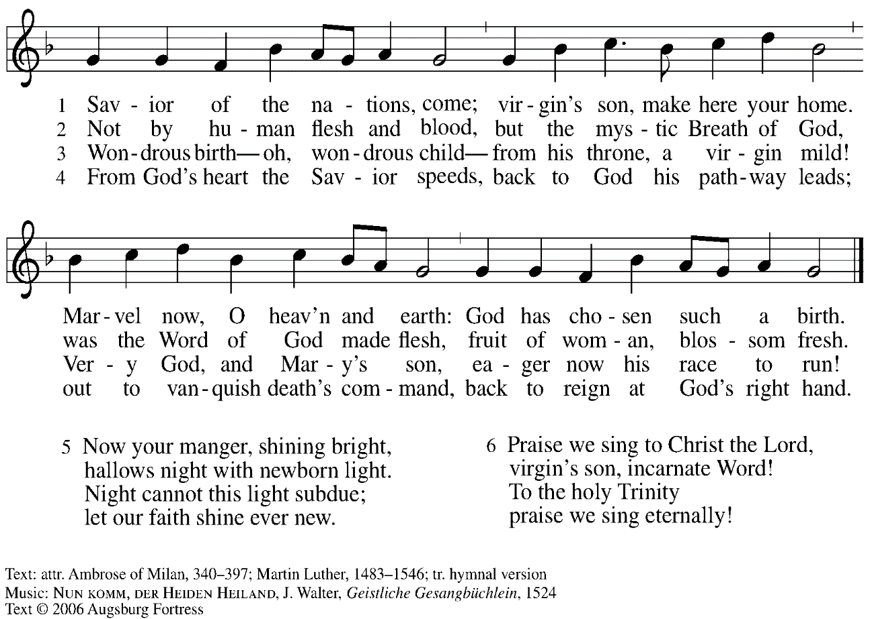
All rights reserved. Reprinted with permission under OneLicense.net # A-722139.

Greeting

P: The grace of our Lord Jesus Christ, the love of God,
and the communion of the Holy Spirit be with you all.
C: And also with you.

Kyrie ACS p. 31

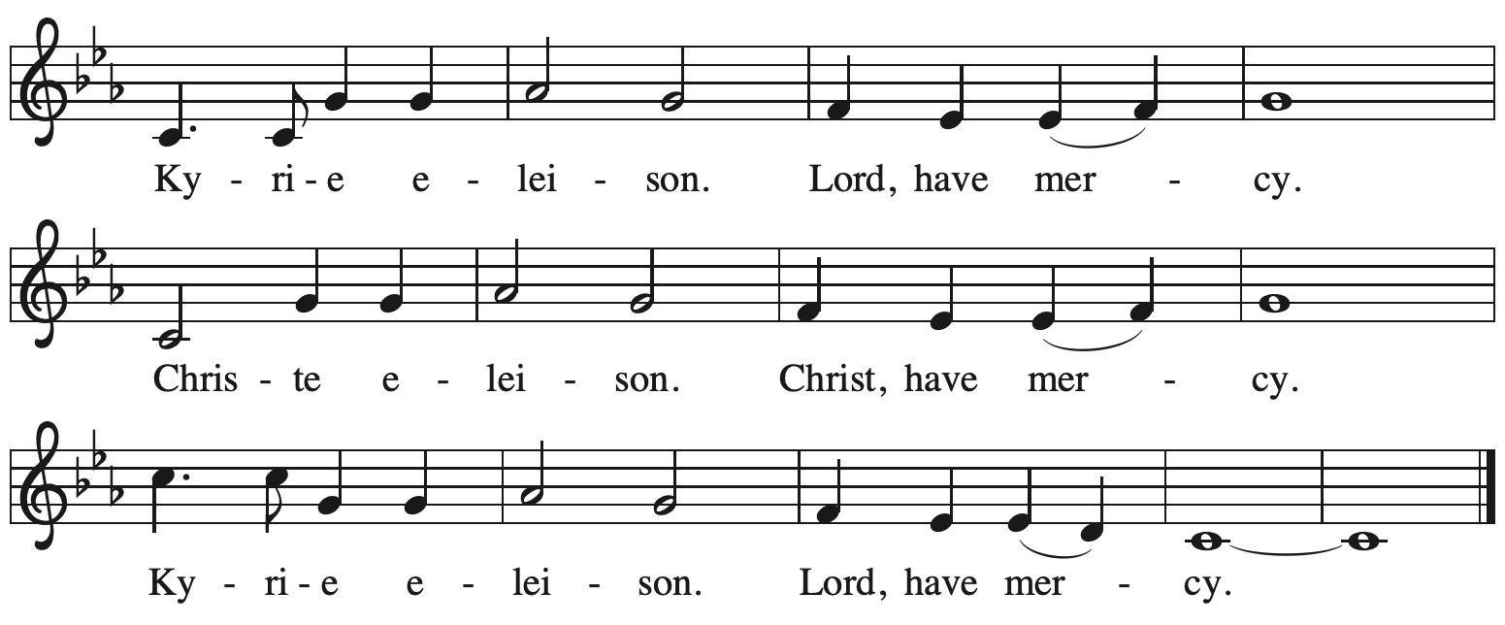

Prayer of the Day

P: The Lord be with you.
C: And also with you.

P: Let us pray.
Stir up your power, Lord Christ, and come.
With your abundant grace and might,
free us from the sin that would obstruct your mercy,
that willingly we may bear your redeeming love to all the world,
for you live and reign with the Father and the Holy Spirit,
one God, now and forever.
C: Amen.

Please be seated.

Word
God speaks to us in Scripture reading, preaching, and song

First Reading – 2 Samuel 7: 1-11, 16

¹Now when the king was settled in his house, and the Lord had given him rest from all his enemies around him, ²the king said to the prophet Nathan, “See now, I am living in a house of cedar, but the ark of God stays in a tent.” ³Nathan said to the king, “Go, do all that you have in mind; for the Lord is with you.”
⁴But that same night the word of the Lord came to Nathan: ⁵Go and tell my servant David: Thus says the Lord: Are you the one to build me a house to live in? ⁶I have not lived in a house since the day I brought up the people of Israel from Egypt to this day, but I have been moving about in a tent and a tabernacle. ⁷Wherever I have moved about among all the people of Israel, did I ever speak a word with any of the tribal leaders of Israel, whom I commanded to shepherd my people Israel, saying, “Why have you not built me a house of cedar?” ⁸Now therefore thus you shall say to my servant David: Thus says the Lord of hosts: I took you from the pasture, from following the sheep to be prince over my people Israel; ⁹and I have been with you wherever you went, and have cut off all your enemies from before you; and I will make for you a great name, like the name of the great ones of the earth. ¹⁰And I will appoint a place for my people Israel and will plant them, so that they may live in their own place, and be disturbed no more; and evildoers shall afflict them no more, as formerly, ¹¹from the time that I appointed judges over my people Israel; and I will give you rest from all your enemies. Moreover the Lord
declares to you that the Lord will make you a house. ¹⁶Your house and your kingdom shall be made sure forever before me; your throne shall be established forever.

L: Word of God, word of life.
C: Thanks be to God.

Luke 1: 46b-55 Filled with Hope and Gratitude Following page

In place of the psalm today, the appointed text is the Magnificat, the song of Mary from Luke’s Gospel. We join in singing “Filled with Hope and Gratitude,” a paraphrase of the Magnificat.

Luke 1: 46b-55 Filled with Hope and Gratitude ACS 907

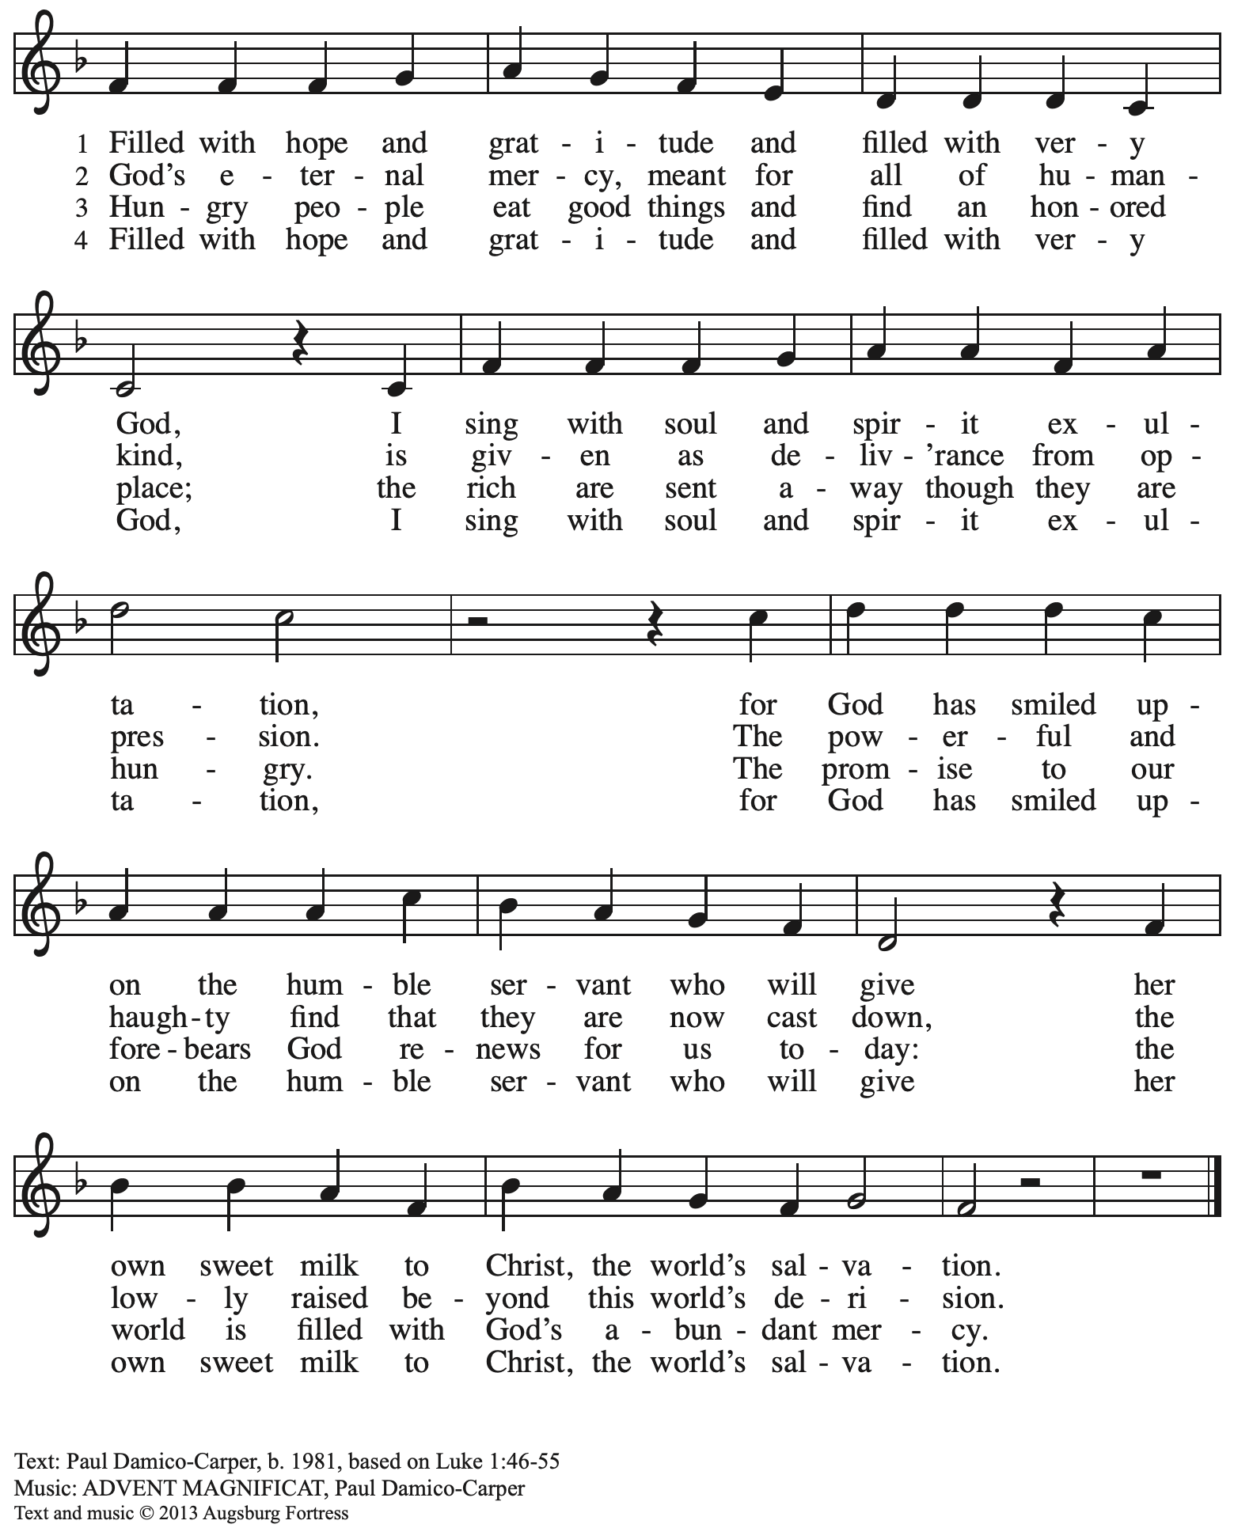
All rights reserved. Reprinted with permission under OneLicense.net # A-722139.
Second Reading – Romans 16: 25-27

²⁵Now to God who is able to strengthen you according to my gospel and the proclamation of Jesus Christ, according to the revelation of the mystery that was kept secret for long ages ²⁶but is now disclosed, and through the prophetic writings is made known to all the Gentiles, according to the command of the eternal God, to bring about the obedience of faith—²⁷to the only wise God, through Jesus Christ, to whom be the glory forever! Amen.

L: Word of God, word of life.
C: Thanks be to God.

Please rise as you are able.

Gospel Acclamation ELW p. 188

Gospel – Luke 1: 26-38

P: The holy Gospel according to St. Luke.
C: Glory to you, O Lord.

²⁶In the sixth month the angel Gabriel was sent by God to a town in Galilee called Nazareth, ²⁷to a virgin engaged to a man whose name was Joseph, of the house of David. The virgin’s name was Mary. ²⁸And he came to her and said, “Greetings, favored one! The Lord is with you.” ²⁹But she was much perplexed by his words and pondered what sort of greeting this might be. ³⁰The angel said to her, “Do not be afraid, Mary, for you have found favor with God. ³¹And now, you will conceive in your womb and bear a son, and you will name him Jesus. ³²He will be great, and will be called the Son of the Most High, and the Lord God will give to him the throne of his ancestor David. ³³He will reign over the house of Jacob forever, and of his kingdom there will be no end.” ³⁴Mary said to the angel, “How can this be, since I am a virgin?” ³⁵The angel said to her, “The Holy Spirit will come upon you, and the power of the Most High will overshadow you; therefore the child to be born will be holy; he will be called Son of God. ³⁶And now, your relative Elizabeth in her old age has also conceived a son; and this is the sixth month for her who was said to be barren. ³⁷For nothing will be impossible with God.” ³⁸Then Mary said, “Here am I, the servant of the Lord; let it be with me according to your word.” Then the angel departed from her.
P: The Gospel of the Lord.
C: Praise to you, O Christ.

Sermon

A time of silence for prayer and reflection follows the sermon.
As the hymn of the day begins, please rise as you are able.

Hymn of the Day No Wind at the Window ACS 906

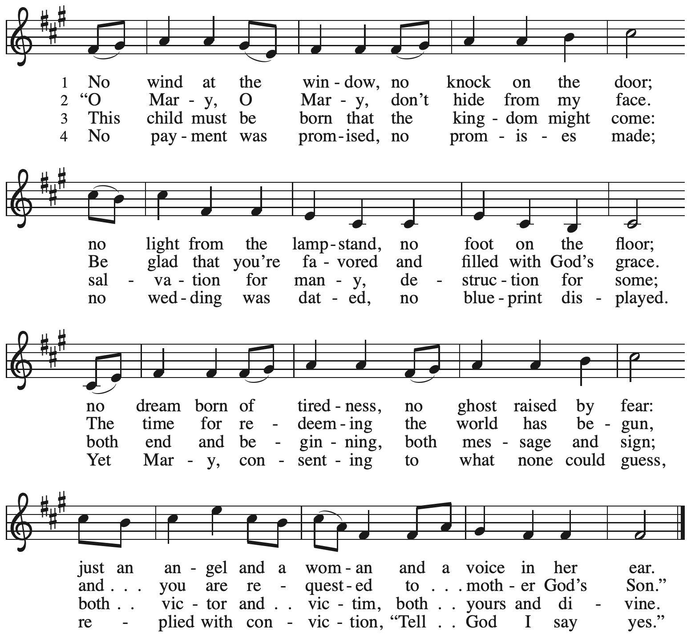

Prayers of the People

P: With hope and expectation, we offer our prayers for the church, the world,
and all who await God’s day of restoration.

After each petition
P: Merciful God,
C: receive our prayer.

The presiding minister concludes the prayers
P: Receive these and all our prayers, O God of hosts,
and restore us with your great and everlasting mercy,
through Jesus Christ, our Savior.
C: Amen.

Peace

The presiding minister and the assembly greet one another in the peace of the risen Christ.
P: The peace of Christ be with you always.
C: And also with you.

The people may greet those around them with a sign of Christ’s peace and may say
Peace be with you or similar words. Please be mindful that not everyone will be comfortable with sharing the peace, so please seek consent before shaking hands or hugging. Other possible ways to share the peace include a simple bow with the verbal greeting of peace, or simply a verbal expression of peace.

When the greetings of peace have concluded, please be seated.

Meal
God feeds us with the presence of Jesus Christ

Offering

We offer ourselves, our gifts, and our faithful service to God.
As the offering is gathered for the mission of the church, including the care of those in need,
the table is set for Holy Communion.

Music during the Offering arr. Oines
Comfort, Comfort Now My People / Now the Heavens Start to Whisper

As the gifts are brought forward for presentation, please rise as you are able.

Offertory Song We Give Thee but Thine Own ELW 686
v. 1-3

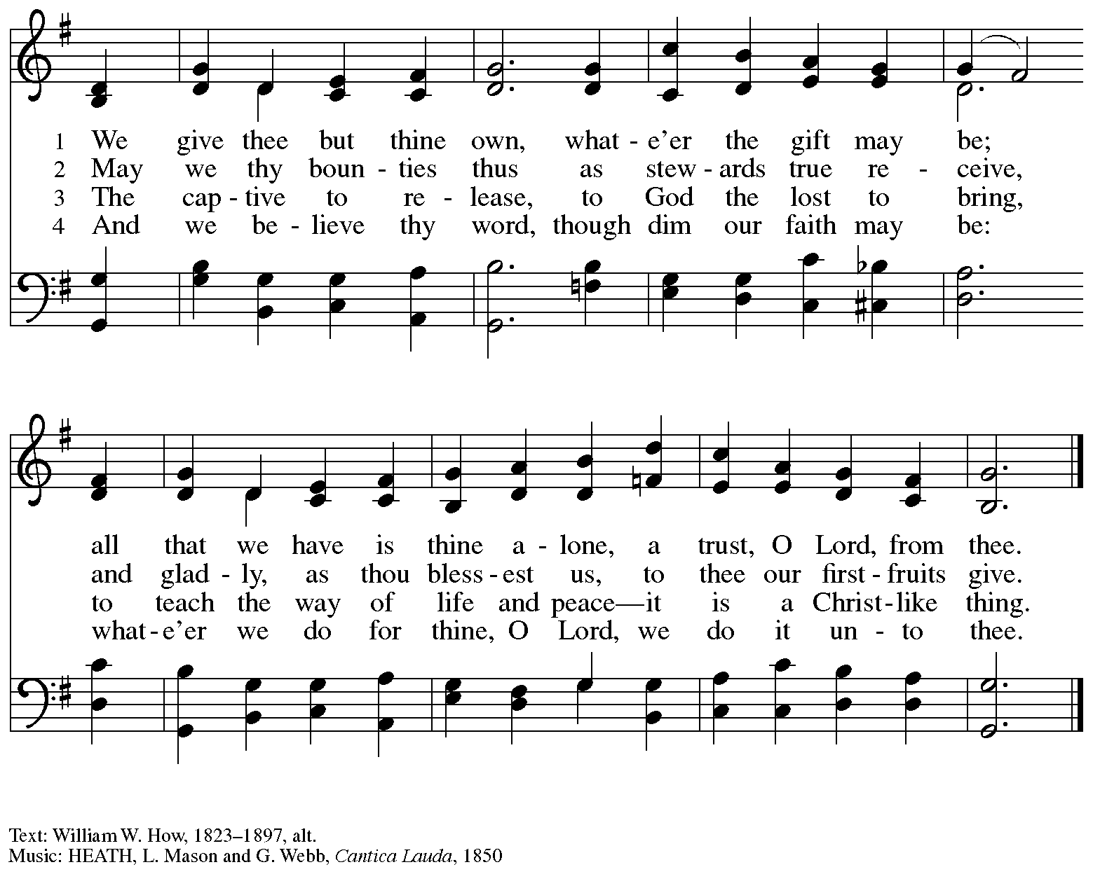

Offertory Prayer

P: Let us pray.
God of abundance,
C: we bring before you
the precious fruits of your creation,
and with them our very lives.
Teach us patience and hope
as we care for all those in need
until the coming of your Son,
our Savior and Lord.
Amen.

Dialogue

P: The Lord be with you.
C: And also with you.

P: Lift up your hearts.
C: We lift them to the Lord.

P: Let us give thanks to the Lord our God.
C: It is right to give our thanks and praise.

Preface

P: It is indeed right, our duty and our joy …
… we praise your name and join their unending hymn:

Sanctus ELW p. 190

Eucharistic Prayer

P: Holy one, the beginning and the end, the giver of life, …
… Do this for the remembrance of me.

Let us proclaim the mystery of faith.
C: Christ has died. Christ is risen. Christ will come again.

P: With this bread and cup …
… We look with hope for his coming.
C: Come, Lord Jesus.

P: Holy God, we long for your Spirit …
… Bring the gift of peace on earth.
C: Come, Holy Spirit.

P: All praise and glory are yours …
… one God, now and forever.
C: Amen.

Lord’s Prayer

P: Gathered as one by the Holy Spirit, let us pray as Jesus taught us.
C: Our Father in heaven,
hallowed be your name,
your kingdom come,
your will be done,
on earth as in heaven.
Give us today our daily bread.
Forgive us our sins
as we forgive those
who sin against us.
Save us from the time of trial
and deliver us from evil.
For the kingdom, the power,
and the glory are yours,
now and forever. Amen.

Fraction and Invitation

P: In this meal, righteousness and peace meet.
Come, receive the gifts God has prepared for you.

Agnus Dei / Lamb of God ELW p. 191

Please be seated.

Holy Communion
- All who seek God and desire a deeper and stronger life in Christ are welcome to receive Holy Communion.
- Worshipers from the pulpit side will proceed forward first, followed by the center section, and then the lectern side.
- Please inform an usher if you would like the ministers to bring Communion to you.
- Holy Communion will be served with bread and wine/grape juice.
- The presiding minister will first distribute the bread (host) to each communicant. Please indicate if you require a gluten-free host.
- Once you have consumed the bread, please pick up an empty glass from the tray next to the presiding minister. The Communion Assistant will pour wine from the chalice or grape juice from the cruet into your glass.
- Please step to the side to consume the wine or grape juice.
- Feel free to kneel at the altar rail for prayer after receiving the sacrament.
- As you return to your pew, glasses may be returned to the empty trays on either side of the center section.
- A blessing will be provided for anyone who does not yet receive the sacrament.
- All are invited to join in singing the hymns during Holy Communion.

Hymns during Holy Communion
Unexpected and Mysterious ELW 258

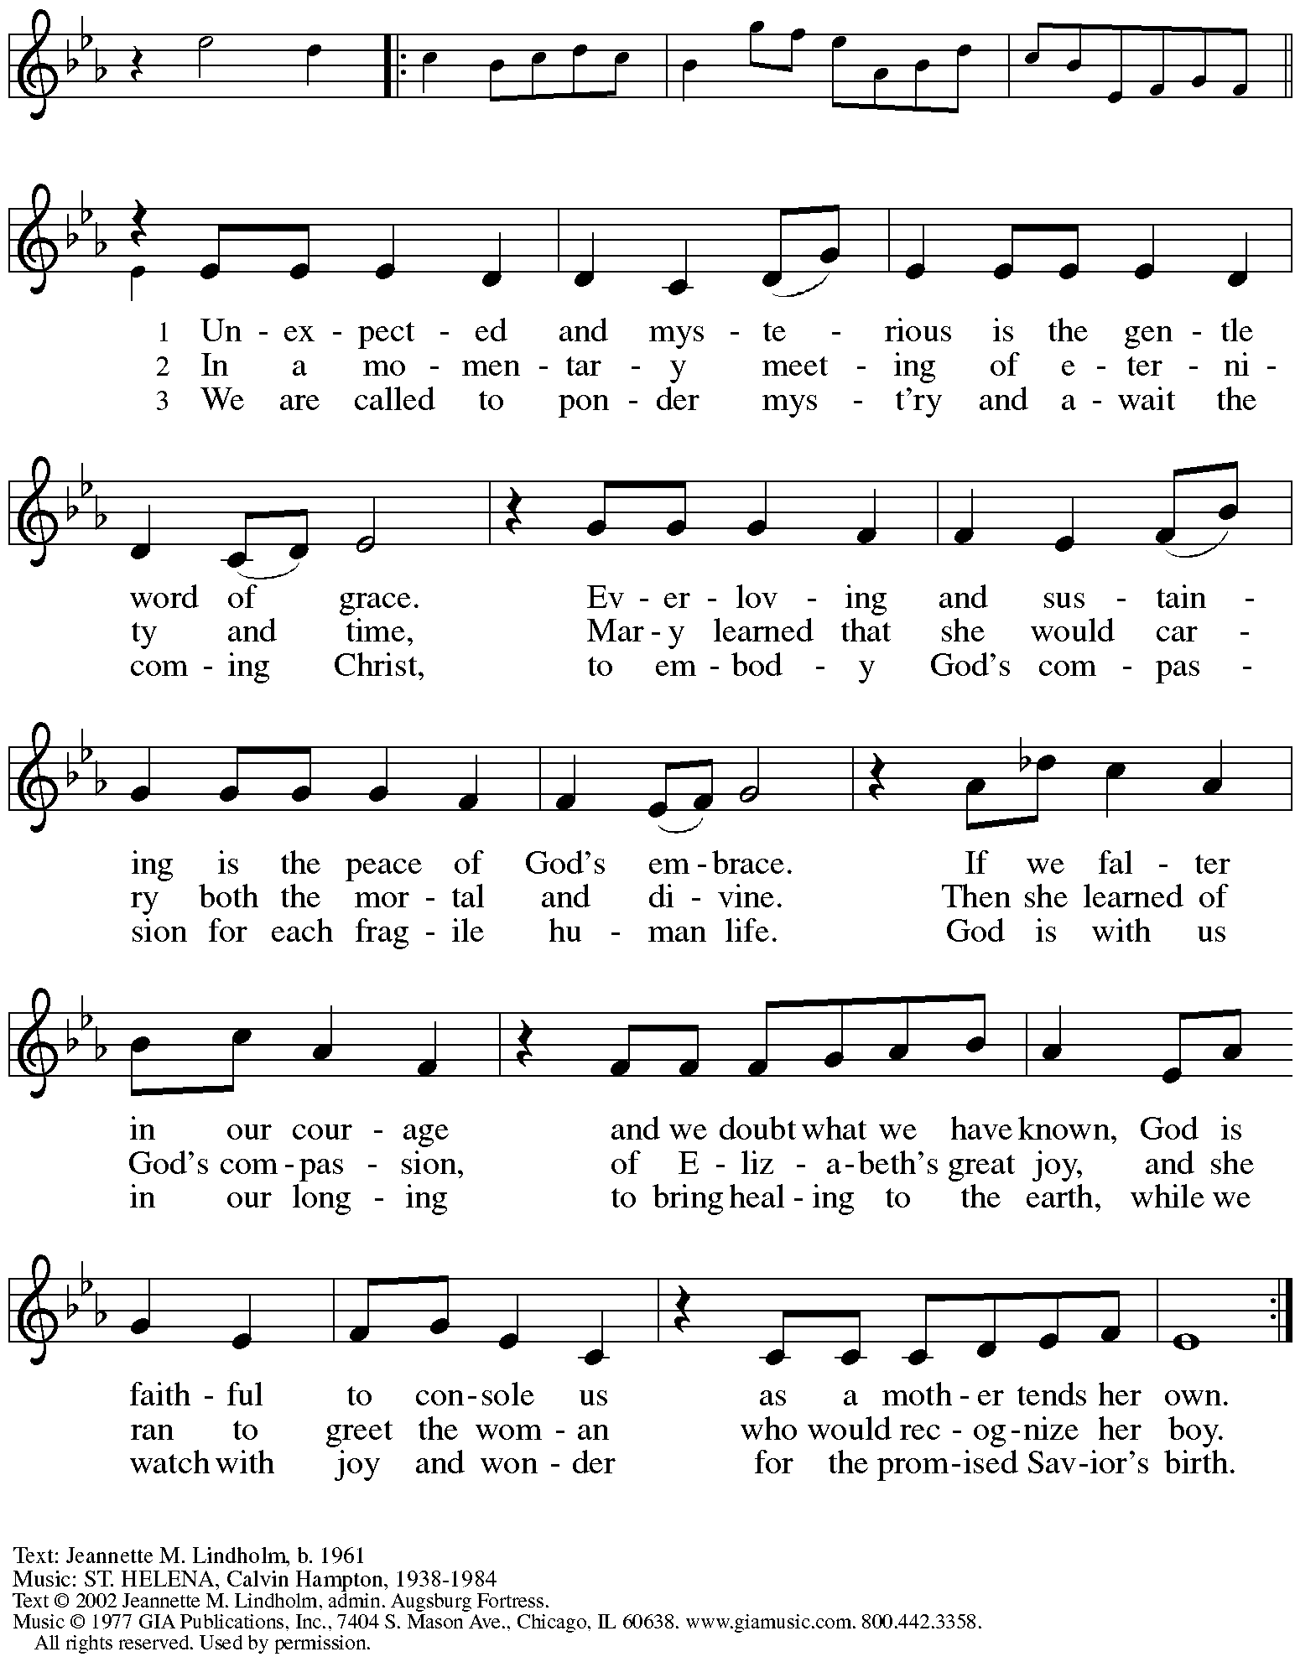
Reprinted with permission under OneLicense.net # A-722139.
Hymns during Holy Communion
We Are Waiting for Jesus ACS 905

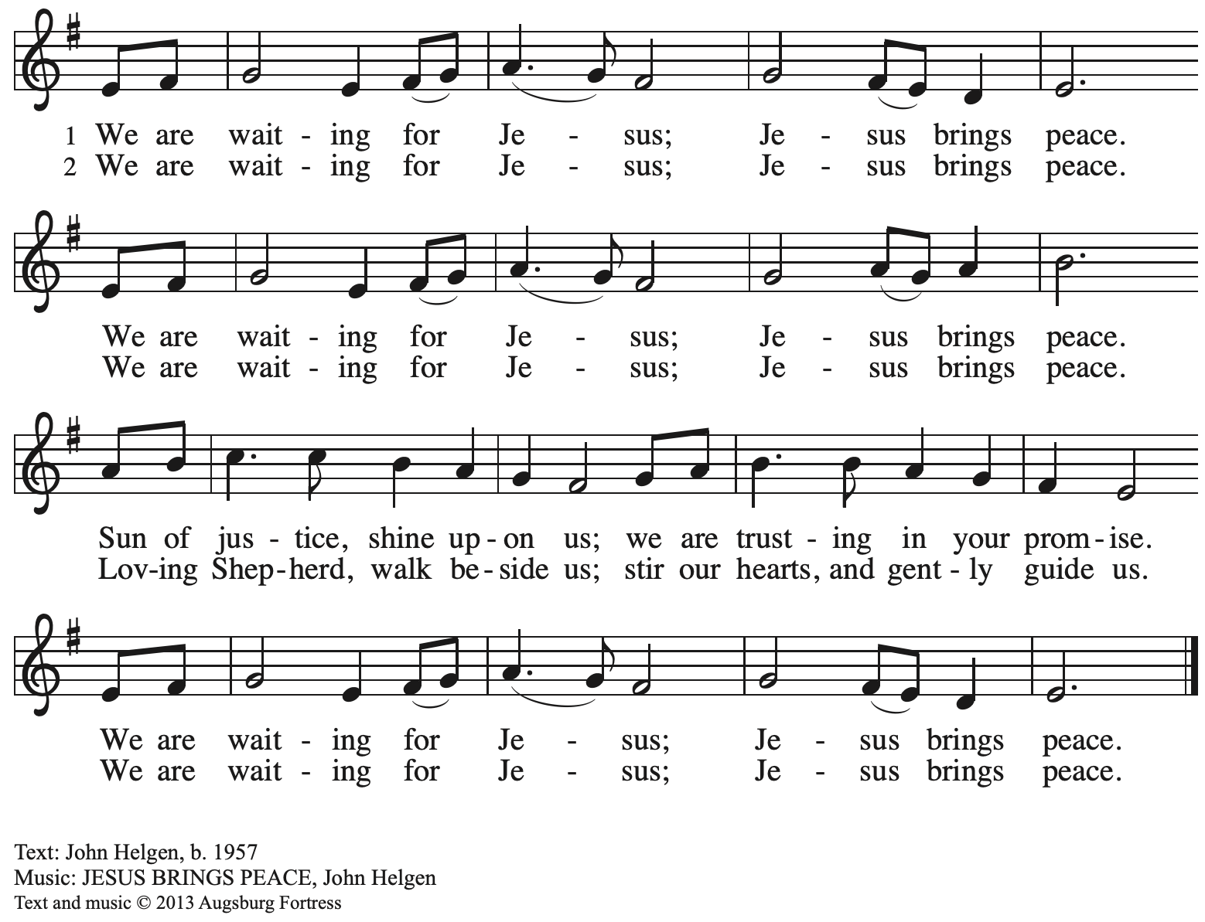
All rights reserved. Reprinted with permission under OneLicense.net # A-722139.

Hymns during Holy Communion
Now the Heavens Start to Whisper ACS 901

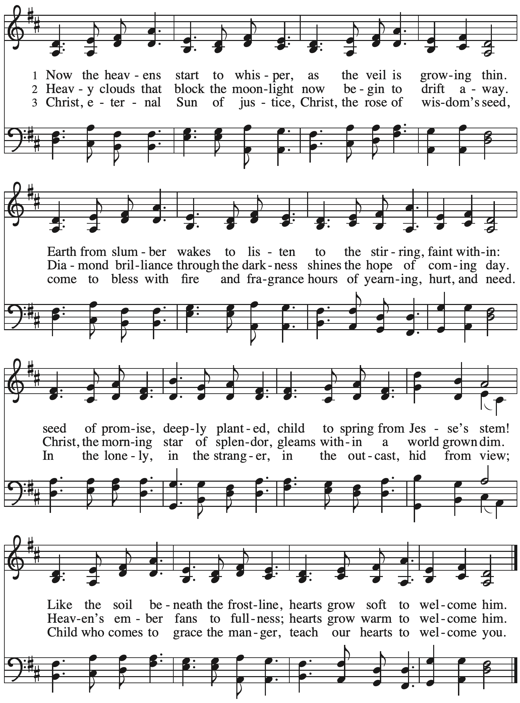
When all have returned to their places, please rise as you are able.

Blessing

P: The body and blood of our Lord Jesus Christ strengthen you and keep you in his grace.
C: Amen.

Prayer

P: Let us pray.
God for whom we wait,
in this meal you give us a foretaste of that day when the hungry will be fed with good things.
Send us forth to make known your deeds and to proclaim the greatness of your name,
through Jesus Christ, our Savior and Lord.
C: Amen.

Please be seated.

Sending
God blesses us and sends us in mission to the world

Announcements

Please rise as you are able.

Benediction

P: The God of peace bless you,
the love of ☩ Christ sustain you in hope,
and the anointing of the Spirit remain upon you,
now and forever.
C: Amen.

Sending Hymn Canticle of the Turning Following page

Dismissal

P: Go in peace. Keep awake.
C: Thanks be to God!

Postlude People, Look East arr. Giamanco

Sending Hymn Canticle of the Turning ELW 723

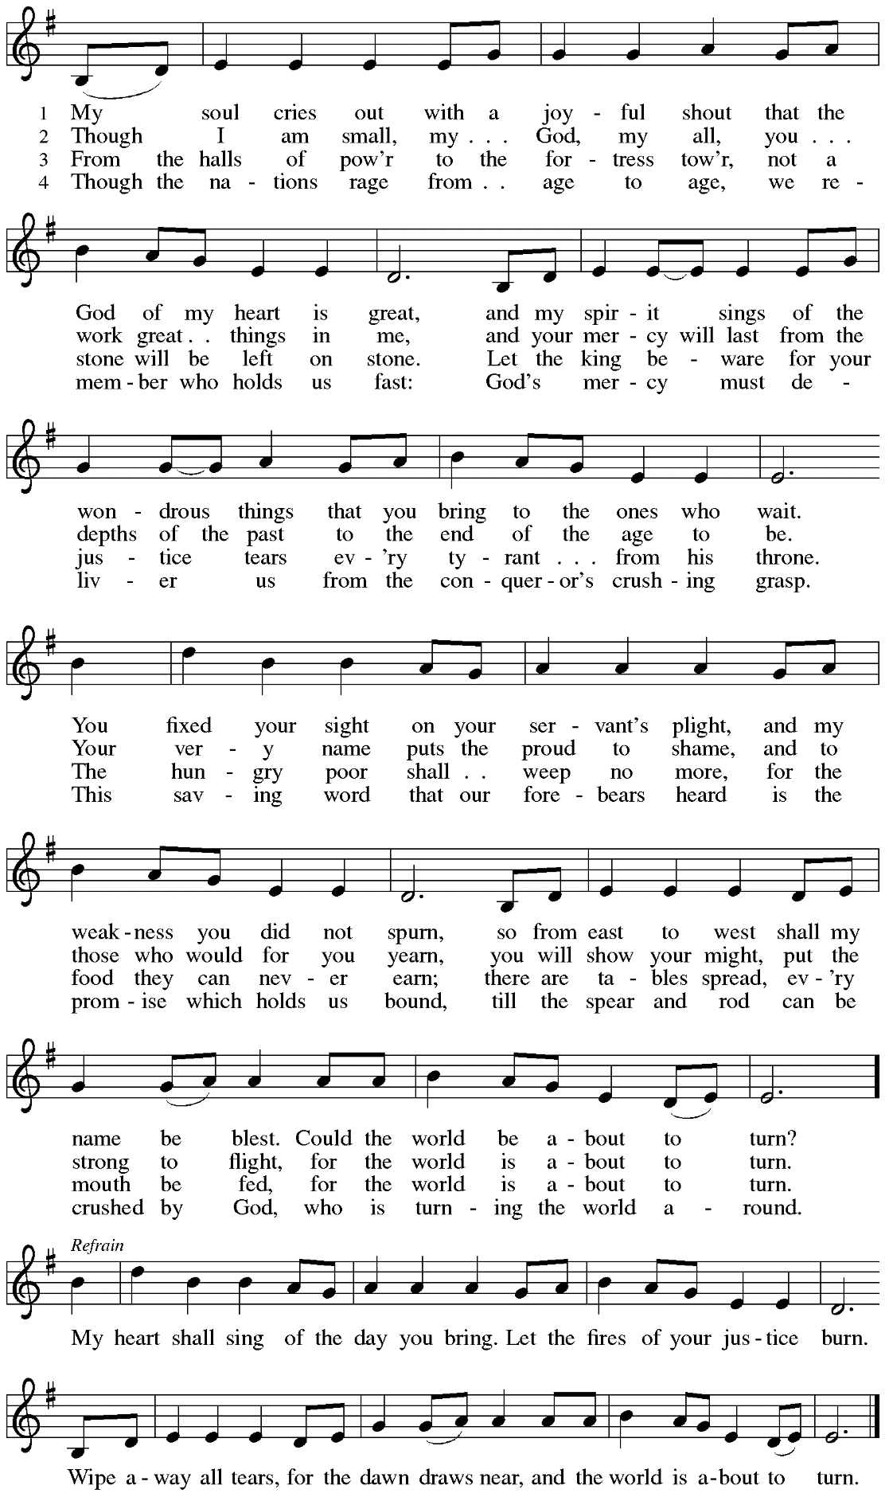

Those serving in worship today

Altar Care Jodie Minor
Audio-Visual Minister Kristen Asplin
Cantor Timothy Kocher-Hillmer
Communion Assistant Jimmi Kocher-Hillmer
Lector Michael Chapman
Little Church – Big Faith Teacher Sue Gaugler
Minister of Music Laura Reynolds
Presiding and Preaching Minister The Rev. Ross I. Carmichael

Liturgy and Hymnody Acknowledgements

From SundaysandSeasons.com. Copyright © 2023 Augsburg Fortress. All rights reserved. Reprinted under OneLicense.net # A-722139.
Used by permission of Augsburg Fortress.

O Come, O Come, Emmanuel – Text: Psalteriolum Cantionum Catholicarum. Köln, 1710; tr. composite. Music: VENI, EMMANUEL, French processional, 15th cent. Text st. 6, 7 © 1997 Augsburg Fortress. All rights reserved. Reprinted with permission under OneLicense.net # A-722139.

No Wind at the Window – Text: John L. Bell, b. 1949. Music: COLUMCILLE, Irish melody; arr. John L. Bell. Text and arr. © 1992 WGRG, Iona Community, admin. GIA Publications, Inc. All rights reserved. Reprinted with permission under OneLicense.net # A-722139.

Now the Heavens Start to Whisper – Text: Mary Louise Bringle, b. 1953. Music: SUO GÂN, Welsh melody; arr. hymnal version. Text © 2006 GIA Publications, Inc. giamusic.com. All rights reserved. Arr. © 2020 Augsburg Fortress. Reprinted with permission under OneLicense.net # A-722139.

Canticle of the Turning – Text: Rory Cooney, b. 1952, based on the Magnificat. Music: STAR OF COUNTY DOWN, Irish traditional. Text © 1990 GIA Publications, Inc. 7404 S. Mason Ave., Chicago, IL 60638. www.giamusic.com. 800.442.3358. All rights reserved. Reprinted with permission under OneLicense.net # A-722139.

Please use the QR code below to link to St. Andrew’s Announcements online!

St. Andrew Lutheran Church Announcements
December 24th, 2023

- Welcome to worship at St. Andrew on the Fourth Sunday of Advent, December 24th, 2023 – We are so glad you are here, and we offer a special welcome to all guests who are gathered here or online! Worship attendees are invited to make a name tag at the back of the worship space if you would like. Children are invited to participate in Little Church – Big Faith, a Bible lesson and activity, after the prayer of the day. There are worship “toolkits” to help children engage with worship and “busy bags” for younger children available in the bookcase at the back of the sanctuary. Please feel free to take one to use with/for your children. We invite everyone to stay after worship for coffee and conversation in the Social Hall next to the sanctuary.
- Decorating for Christmas Season – Today after Worship – We invite everyone to stay after worship today to help prepare the worship space for the Christmas season!
The Nativity of our Lord – Christmas Eve Service with Holy Communion, Sunday, December 24th, 7:00 p.m. – We gather for the celebration of Christ’s birth with candles, carols, and Holy Communion at 7:00 p.m. on Christmas Eve!
- Little Church – Big Faith Not Meeting at the 7:00 p.m. Christmas Eve Service or Sunday, December 31st – St. Andrew’s Bible story and activity time for children that usually meets during worship will not be held on the above dates. Classes will resume on Sunday, January 7th.
- Christ in Our Home Devotional Booklets for January - March Available at Church Entrances – This resource offers a daily Bible reading with a short reflection and prayer, along with additional readings and prayer topics for those who would like to expand their devotional practices. We encourage people of the congregation to take one for yourself, your family unit, or others!
- St. Andrew Accepting Financial Pledge Cards through the End of the Year – Sunday, December 10th was Commitment Sunday, but anyone who would still like to return a pledge card expressing your offering to God through the church for 2024 is encouraged to do so by placing it in the offering plate, bringing it to the office, or sending it by mail. If you are in need of a card, please speak with Pastor Ross.
- Hearts and Hands Meeting on First Sundays of the Month after Worship – Next Gathering January 7th, 2024 – Hearts and Hands, St. Andrew’s crocheting and knitting ministry group, plans to gather each month on the first Sunday after worship, beginning on January 7th. The leaders will teach anyone who would like to learn to crochet and have yarn and hooks to help get you started! We are currently in need of knitted or crocheted shawls, afghans, and stoles to replenish the congregation’s supply. Anyone is welcome to make something and drop it off even if they are not available or choose not to come to a meeting.
- Hearts and Hands and Community Ministry Committee Invite Congregation to Support Advent Appeal for Winter Accessories – People of the congregation are asked to bring winter hats, mittens/gloves, and scarves to church during the Advent season (beginning December 3rd) to support immigrants and refugees arriving in Pittsburgh. These can be handmade (knitted, crocheted, or sewn) or purchased. We can also make them available in the little pantry and at our produce distributions. A collection box will be set up in the social hall to receive these donations.

- Support Guests of the Women’s Center and Shelter of Greater Pittsburgh This Holiday Season – Each year around Christmas, St. Andrew invites the congregation to consider giving in support of local organizations and those they serve. This year, we ask your consideration of a gift in support of the guests of the Women’s Center and Shelter of Greater Pittsburgh. We have been collecting items in December and will deliver them in January. There are 2 ways to give:
- Select items from the Urgent Needs List or Essential Needs List and bring them to the labeled bin in the church Social Hall. Needs lists are posted on the bulletin board and summarized below.
- Order items directly from the Shelter’s Amazon Wish List. They will be shipped directly to the Shelter for you. Log into your Amazon account, visit the WC&S Amazon Wish List or Children’s Wish List. You will not be able to access the lists if you are not logged into your Amazon account. See instructions and links at the Women’s Center & Shelter donation page:
https://wcspittsburgh.org/ways-to-give/donate-items/donating-new-items/

Women’s Shelter Christmas Wish Lists

Urgent Needs
Gift cards are always the most pressing need. Good choices are Walmart, Target, Dollar General, Giant Eagle, VISA.
Multicultural hair care products (Full-size) Sturdy reusable grocery bags
Hair accessories Pillow cases
Body wash (Full size) Air mattress with built-in pump
Towels Fitted and/or flat sheets

Essential Needs
Pull Ups Deodorant (full-size) Chapstick
Baby wipes Brushes Tote bags
Baby bottles Razors Umbrellas
Pacifiers New lightweight tops Size XL Shower curtain w/rings
Kids shampoo (full-size) New Heavy/warm tops Size XL Shower liners
Kids Conditioner (full-size) Combs Phone chargers
Body wash (full-size) Wash cloths Dish soap
Nail clippers Mouthwash (8 oz) New pants Size Large
Cotton swabs Shaving cream (full-size) New underwear Size Medium

