+ First Sunday of Christmas
December 31st, 2023
10:00 a.m.

St. Andrew Lutheran Church
304 Morewood Ave.
Pittsburgh, PA 15213
412.682.3342
St_andrewELCA@verizon.net
www.standrewpittsburgh.org

+ First Sunday of Christmas
Order for Worship

The psalmist calls on the natural world, celestial bodies, fire and earth, creatures, and all humanity to praise God. The voices of the devout Simeon and the 84-year-old prophet Anna join the chorus, recognizing what God is doing in Jesus. Simeon’s song is often sung after Holy Communion, for the assembled community encounters God’s salvation in the bread and wine. Then we are invited, like Anna, to tell of Jesus to all who look for the healing of the world.

Welcome to St. Andrew!

- St. Andrew Lutheran congregation welcomes all who are seeking a place of healing and wholeness – a nurturing, faith-forming spiritual home. Our community embraces people of all ages, ethnicities, cultures, abilities, sexual orientations, gender identities and expressions, and family constellations. Come and See!

- Worship Services are live streamed to multiple online platforms. By attending worship, you agree that your image and voice may be broadcast.

- Worship “toolkits” to help children engage with the service, along with “busy bags” for younger children, are available in the bookcase at the back of the sanctuary. Please feel free to take one to use with/for your children.

- Holy Communion is served with bread (gluten-free available) and wine or grape juice. The presiding minister will distribute the bread (host). Please consume this and then pick up an empty glass from the tray. The Communion Assistant will pour wine or grape juice into your glass. Please step to the side to consume the wine or grape juice. Feel free to kneel at the altar for prayer and reflection. As you return to your pew, glasses may be returned to the empty trays on either side of the center section.

- A restroom is available on the main level of the church, through the doors to the Social Hall and to the right in the main office.

Abbreviations

P: Pastor/Presiding Minister ELW: Evangelical Lutheran Worship hymnal
A: Assisting Minister ACS: All Creation Sings hymnal
L: Lector
C: Congregation

Welcome

Prelude

Gathering
The Holy Spirit calls us together as the people of God

Confession and Forgiveness

Please rise as you are able. All may make the sign of the cross,
the sign that is marked at Baptism, as the presiding minister begins.

P: Blessed be the holy Trinity, ☩ one God,
the Word made flesh, our life and our salvation.
C: Amen.

P: Trusting the goodness and lovingkindness of God our Savior,
let us confess our sin.

Silence is kept for reflection.

P: God of life,
C: you promise good news of great joy for all people,
and call us to be messengers of your peace.
We confess that too often we hoard our joy,
our resources, and our security.
We nurture conflict and build barriers.
We neglect the needs of our neighbors
and ignore the groaning of creation.
Have mercy on us.
Where we are self-centered, open our hearts.
Where we are reluctant, give us courage.
Where we are cynical, restore our trust.
Renew us with your grace
and give us again the hope of eternal life in you.
Amen.

P: Hear the good news:
We are children of God and heirs of God’s promises
through the outpouring of the Holy Spirit.
In ☩ Jesus we are forgiven and redeemed.
Sing with joy, for all the ends of the earth
shall know the salvation of God.
C: Amen.

Gathering Hymn Jesus, the Light of the World ACS 914

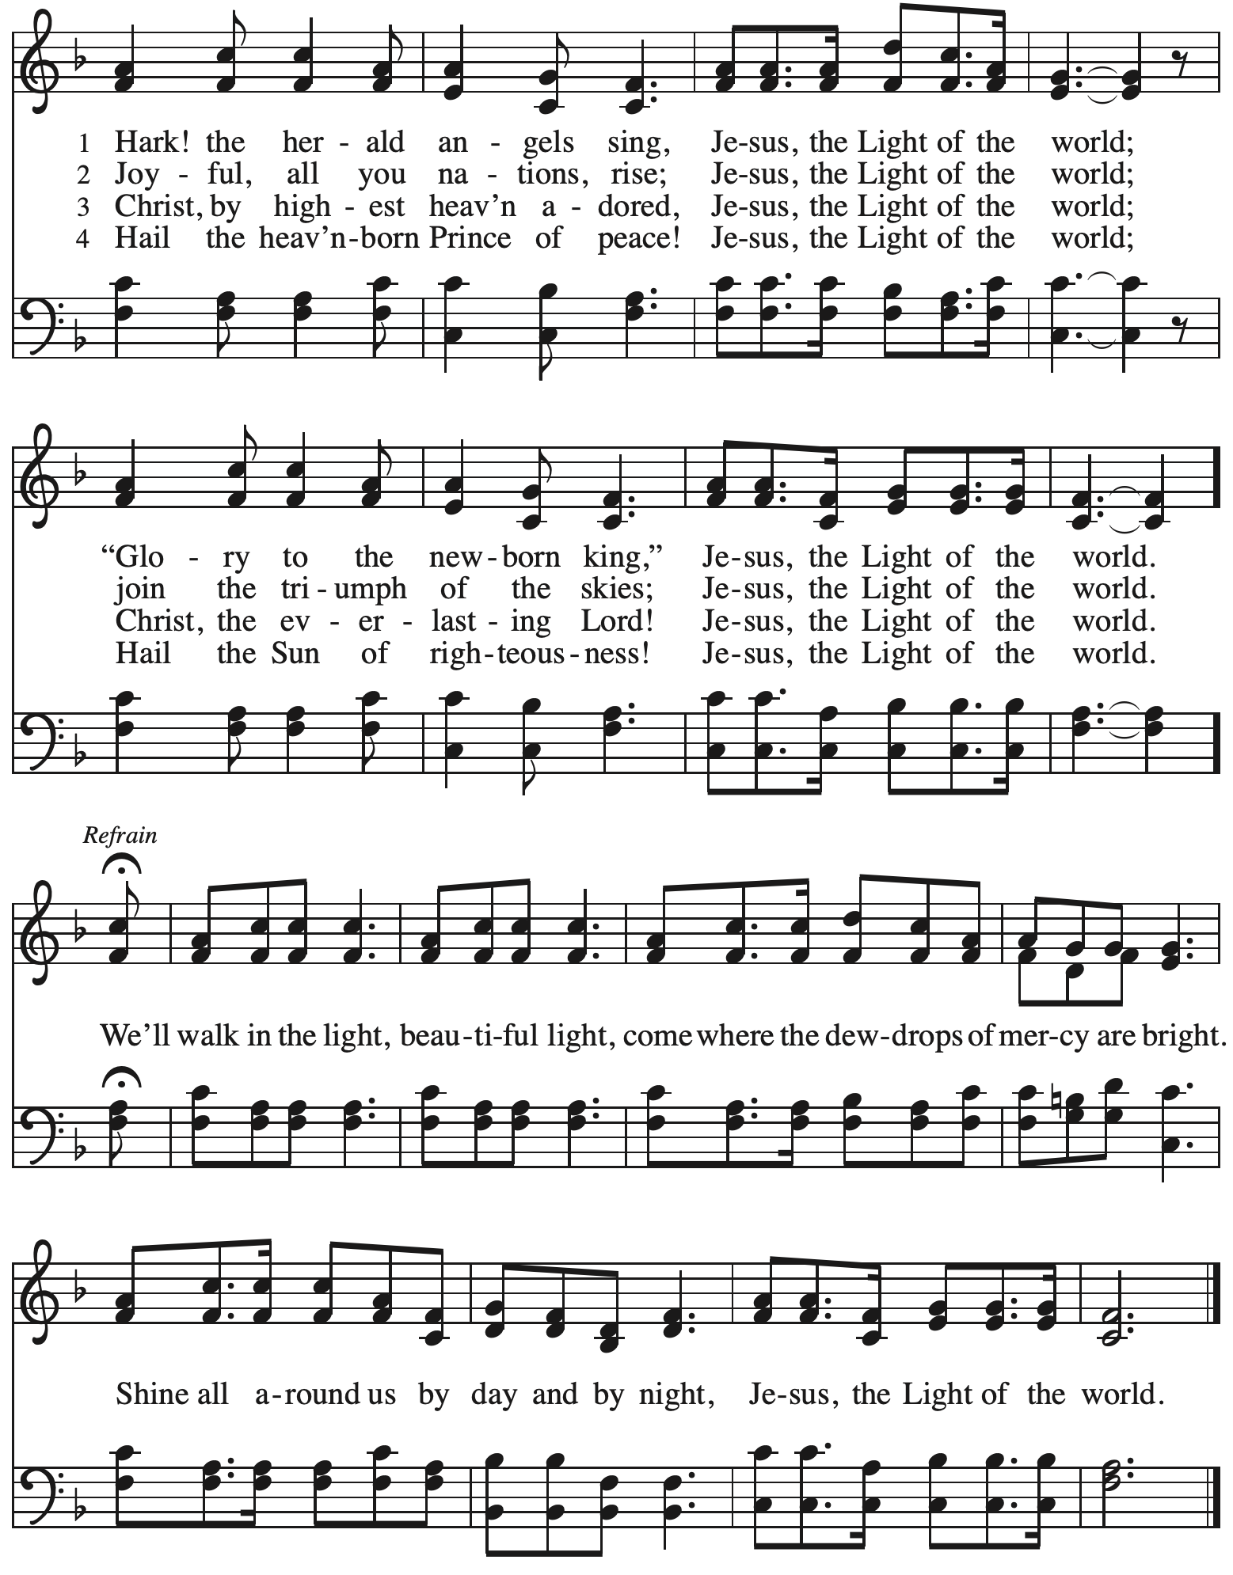

Greeting

P: The grace of our Lord Jesus Christ, the love of God,
and the communion of the Holy Spirit be with you all.
C: And also with you.

Kyrie ELW p. 147

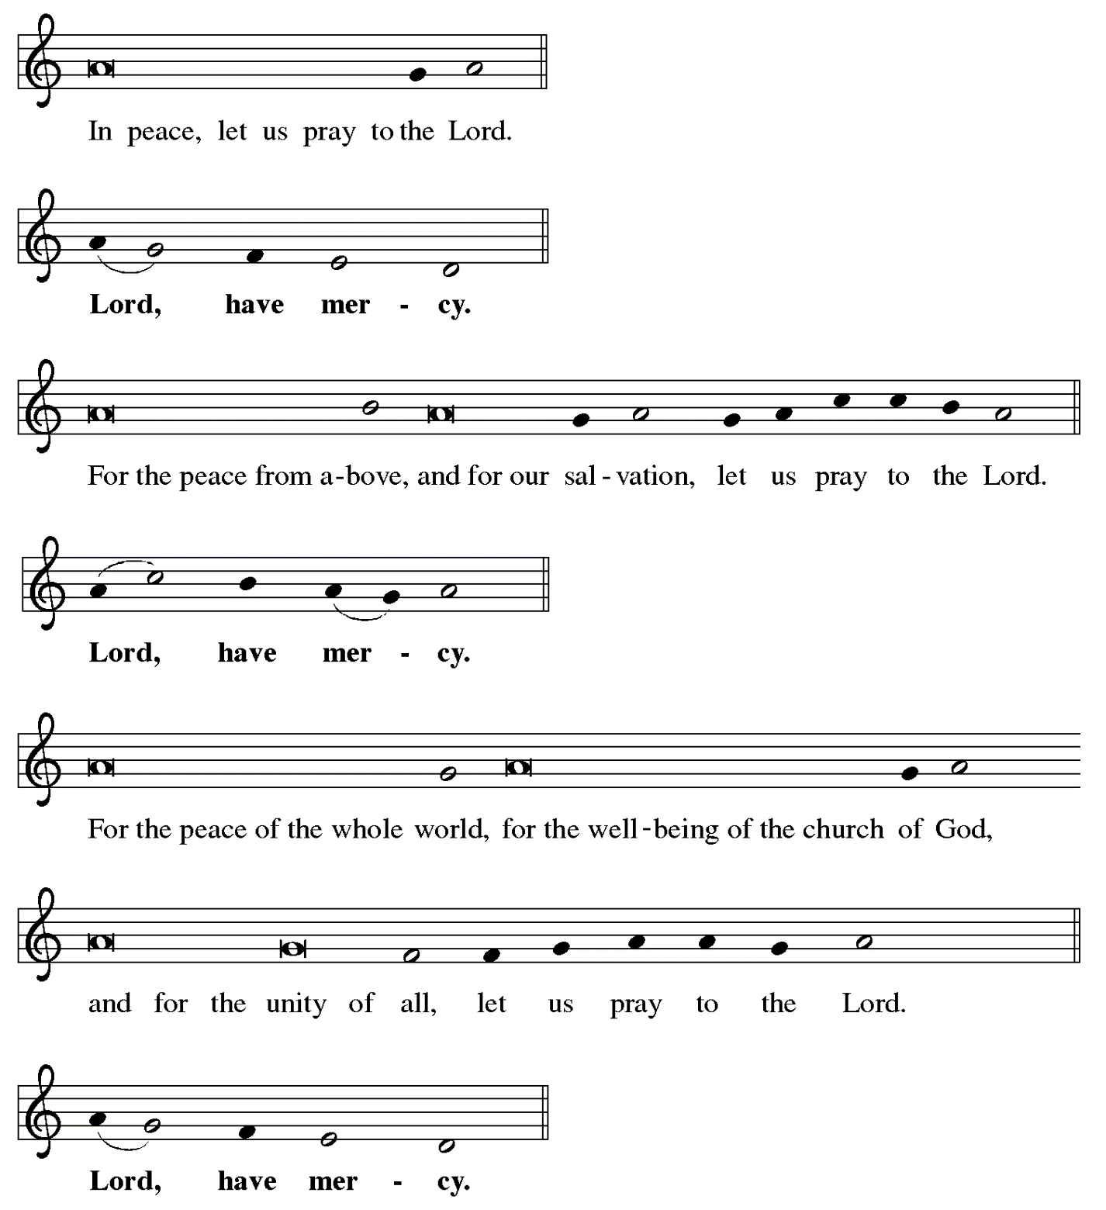

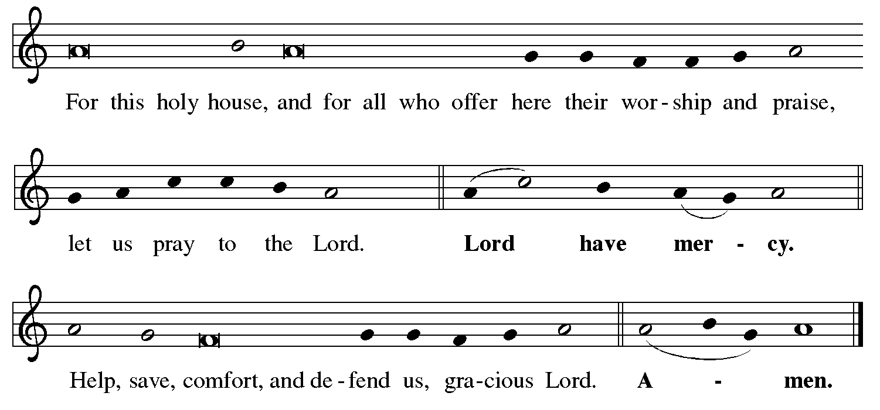

Hymn of Praise Angels We Have Heard on High ELW 289

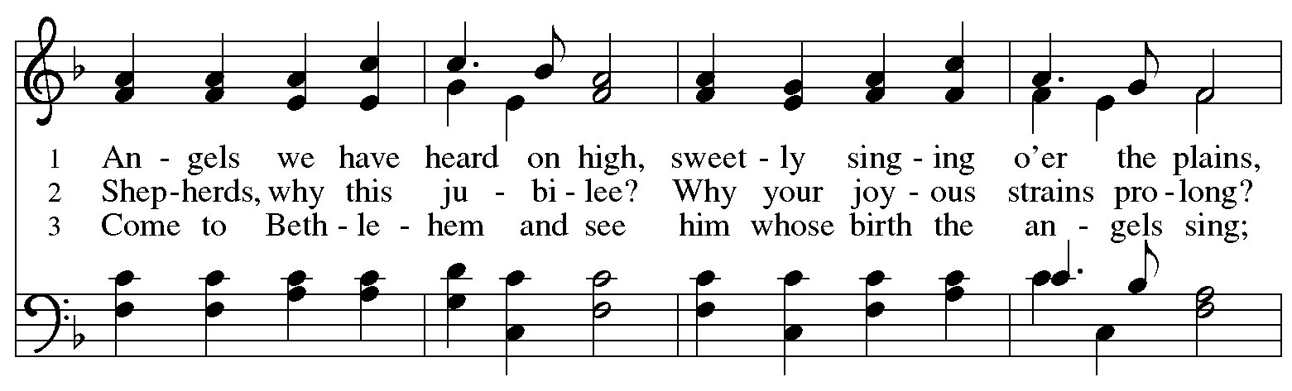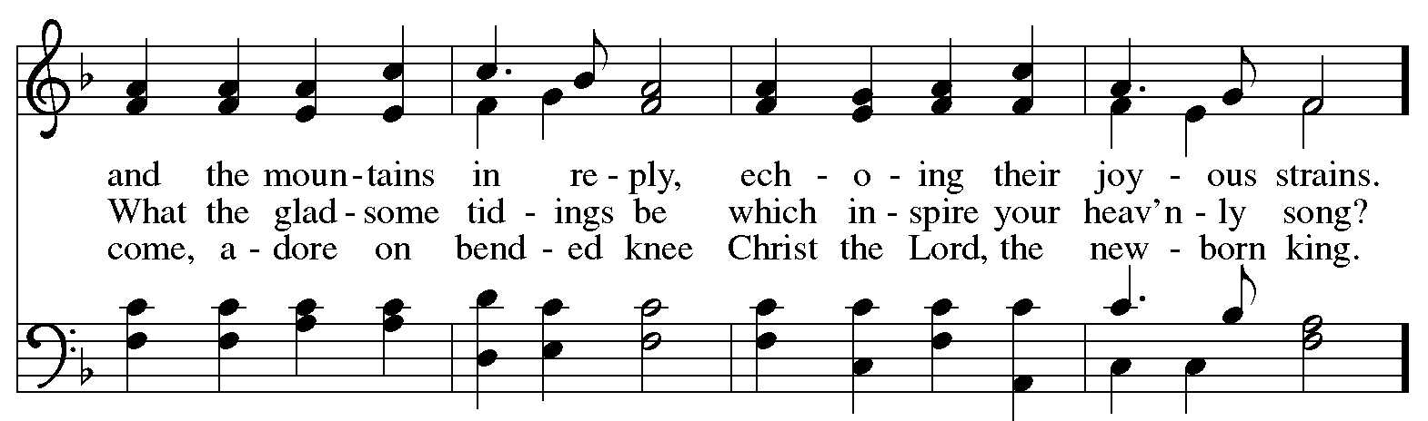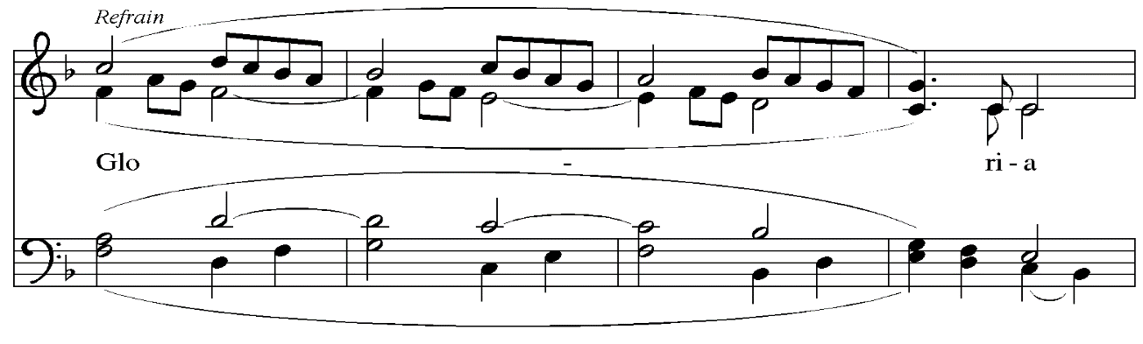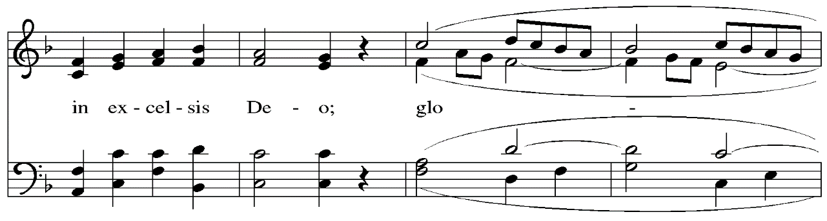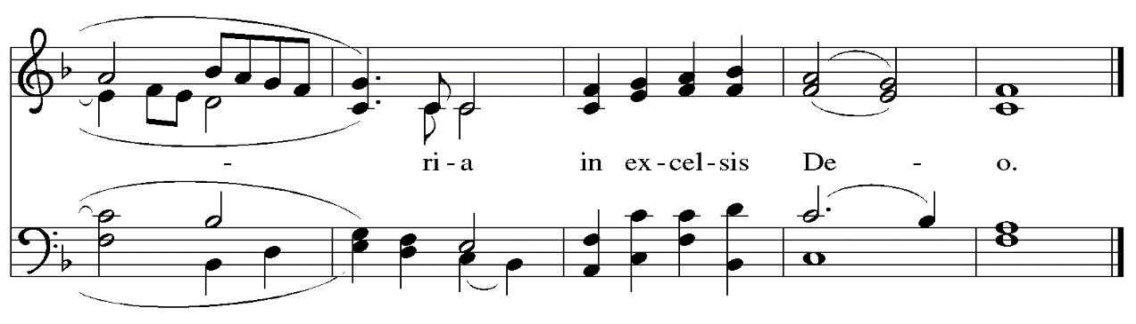
Prayer of the Day

P: The Lord be with you.
C: And also with you.

P: Let us pray.
Almighty God,
you wonderfully created the dignity of human nature and yet more wonderfully restored it.
In your mercy, let us share the divine life of the one who came to share our humanity,
Jesus Christ, your Son, our Lord, who lives and reigns with you and the Holy Spirit,
one God, now and forever.
C: Amen.

Please be seated.

Word
God speaks to us in Scripture reading, preaching, and song

First Reading – Isaiah 61: 10 – 62: 3

¹⁰I will greatly rejoice in the Lord,
my whole being shall exult in my God;
for the Lord has clothed me with the garments of salvation,
the Lord has covered me with the robe of righteousness,
as a bridegroom decks himself with a garland,
and as a bride adorns herself with her jewels.
¹¹For as the earth brings forth its shoots,
and as a garden causes what is sown in it to spring up,
so the Lord God will cause righteousness and praise
to spring up before all the nations.
^{62:1}For Zion’s sake I will not keep silent,
and for Jerusalem’s sake I will not rest,
until her vindication shines out like the dawn,
and her salvation like a burning torch.
²The nations shall see your vindication,
and all the kings your glory;
and you shall be called by a new name
that the mouth of the Lord will give.
³You shall be a crown of beauty in the hand of the Lord,
and a royal diadem in the hand of your God.

L: Word of God, word of life.
C: Thanks be to God.

Psalm 148

Psalm tone

Psalm refrain

¹Hallelujah! Praise the Lord | from the heavens;
praise God | in the heights.
²Praise the Lord, | all you angels;
sing praise, all you | hosts of heaven.
³Praise the Lord, | sun and moon;
sing praise, all you | shining stars.
⁴Praise the Lord, heav- | en of heavens,
and you waters a- | bove the heavens.
⁵Let them praise the name | of the Lord,
who commanded, and they | were created,
⁶who made them stand fast forev- | er and ever,
giving them a law that shall not | pass away. R
⁷Praise the Lord | from the earth,
you sea monsters | and all deeps;
⁸fire and hail, | snow and fog,
tempestuous wind, do- | ing God’s will;
⁹mountains | and all hills,
fruit trees | and all cedars;
¹⁰wild beasts | and all cattle,
creeping things and | flying birds;
¹¹sovereigns of the earth | and all peoples,
princes and all rulers | of the world;
¹²young | men and maidens,
old and | young together. R
¹³Let them praise the name | of the Lord,
whose name only is exalted, whose splendor is over | earth and heaven.
¹⁴The Lord has raised up strength for the people and praise for all | faithful servants,
the children of Israel, a people who are near the Lord. | Hallelujah! R

Second Reading – Galatians 4: 4-7

⁴When the fullness of time had come, God sent God’s Son, born of a woman, born under the law, ⁵in order to redeem those who were under the law, so that we might receive adoption as children. ⁶And because you are children, God has sent the Spirit of God’s Son into our hearts, crying, “Abba! Father!” ⁷So you are no longer a slave but a child, and if a child then also an heir, through God.

L: Word of God, word of life.
C: Thanks be to God.

Please rise as you are able.

Gospel Acclamation Alleluia ELW p. 151

Gospel – Luke 2: 1-20

P: The holy Gospel according to St. Luke.
C: Glory to you, O Lord.

²²When the time came for their purification according to the law of Moses, [Joseph and Mary] brought [Jesus] up to Jerusalem to present him to the Lord ²³(as it is written in the law of the Lord, “Every firstborn male shall be designated as holy to the Lord”), ²⁴and they offered a sacrifice according to what is stated in the law of the Lord, “a pair of turtledoves or two young pigeons.”
²⁵Now there was a man in Jerusalem whose name was Simeon; this man was righteous and devout, looking forward to the consolation of Israel, and the Holy Spirit rested on him. ²⁶It had been revealed to him by the Holy Spirit that he would not see death before he had seen the Lord’s Messiah. ²⁷Guided by the Spirit, Simeon came into the temple; and when the parents brought in the child Jesus, to do for him what was customary under the law, ²⁸Simeon took him in his arms and praised God, saying,

The song of Simeon is proclaimed by the congregation

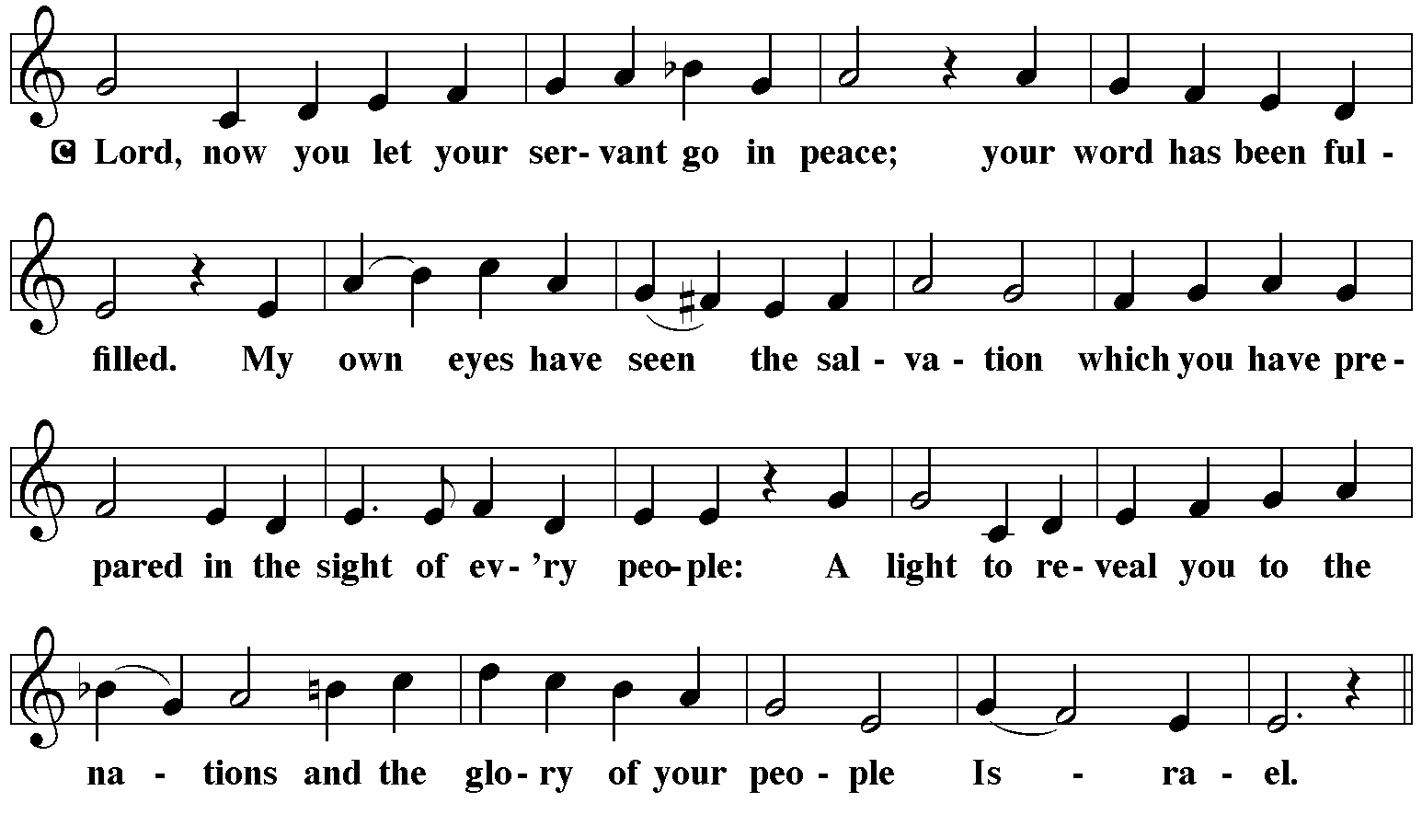
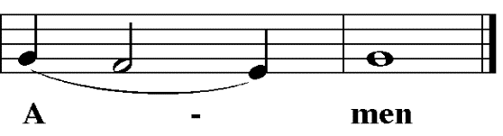
³³And the child’s father and mother were amazed at what was being said about him. ³⁴Then Simeon blessed them and said to his mother Mary, “This child is destined for the falling and the rising of many in Israel, and to be a sign that will be opposed ³⁵so that the inner thoughts of many will be revealed—and a sword will pierce your own soul too.”
³⁶There was also a prophet, Anna the daughter of Phanuel, of the tribe of Asher. She was of a great age, having lived with her husband seven years after her marriage, ³⁷then as a widow to the age of eighty-four. She never left the temple but worshiped there with fasting and prayer night and day. ³⁸At that moment she came, and began to praise God and to speak about the child to all who were looking for the redemption of Jerusalem.
³⁹When they had finished everything required by the law of the Lord, they returned to Galilee, to their own town of Nazareth. ⁴⁰The child grew and became strong, filled with wisdom; and the favor of God was upon him.

P: The Gospel of the Lord.
C: Praise to you, O Christ.

Please be seated.
Sermon

A time of silence for prayer and reflection follows the sermon.
As the hymn of the day begins, please rise as you are able.

Hymn of the Day Lo, How a Rose E’er Blooming ELW 272

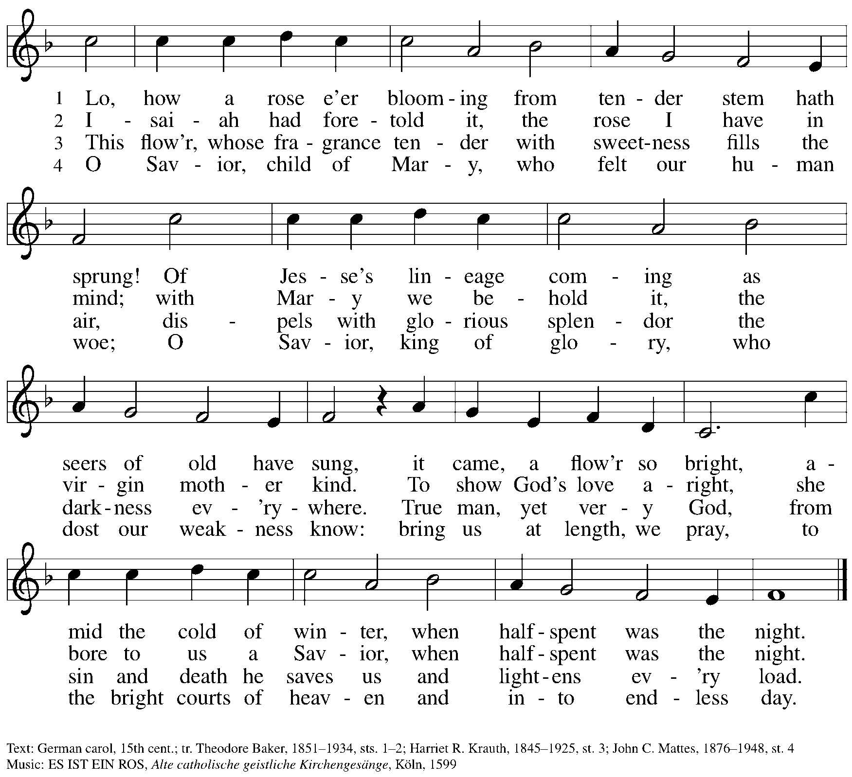

Nicene Creed

P: Rejoicing in the good news of Christ’s birth, we confess our faith:
C: We believe in one God,
the Father, the Almighty,
maker of heaven and earth,
of all that is, seen and unseen.

C: We believe in one Lord, Jesus Christ,
the only Son of God,
eternally begotten of the Father,
God from God, Light from Light,
true God from true God,
begotten, not made,
of one Being with the Father;
through him all things were made.
For us and for our salvation
he came down from heaven,
was incarnate of the Holy Spirit and the virgin Mary
and became truly human.
For our sake he was crucified under Pontius Pilate;
he suffered death and was buried.
On the third day he rose again
in accordance with the scriptures;
he ascended into heaven
and is seated at the right hand of the Father.
He will come again in glory to judge the living and the dead,
and his kingdom will have no end.

We believe in the Holy Spirit, the Lord, the giver of life,
who proceeds from the Father and the Son,*
who with the Father and the Son is worshiped and glorified,
who has spoken through the prophets.
We believe in one holy catholic and apostolic church.
We acknowledge one baptism for the forgiveness of sins.
We look for the resurrection of the dead,
and the life of the world to come. Amen.
*Or, “who proceeds from the Father.” The phrase “and the Son” is a later addition to the creed.

Prayers of the People

A: Trusting in God’s good news of great joy for all people, we offer our prayers for the church,
those in need, and the world God so loves.

After each petition
A: God of grace,
C: receive our prayer.

The presiding minister concludes the prayers
P: Rejoicing in your Word made flesh among us, we commend these prayers to you, O God,
trusting in your love and grace made known to us in Jesus Christ, our Savior.
C: Amen.

Peace

The presiding minister and the assembly greet one another in the peace of the risen Christ.
P: The peace of Christ be with you always.
C: And also with you.

The people may greet those around them with a sign of Christ’s peace and may say
Peace be with you or similar words. Please be mindful that not everyone will be comfortable with sharing the peace, so please seek consent before shaking hands or hugging. Other possible ways to share the peace include a simple bow with the verbal greeting of peace, or simply a verbal expression of peace.

When the greetings of peace have concluded, please be seated.

Meal
God feeds us with the presence of Jesus Christ

Offering

We offer ourselves, our gifts, and our faithful service to God.
As the offering is gathered for the mission of the church, including the care of those in need,
the table is set for Holy Communion.

Music during the Offering

As the gifts are brought forward for presentation, please rise as you are able.

Offertory Song What Child Is This ELW 296
v. 1, 3

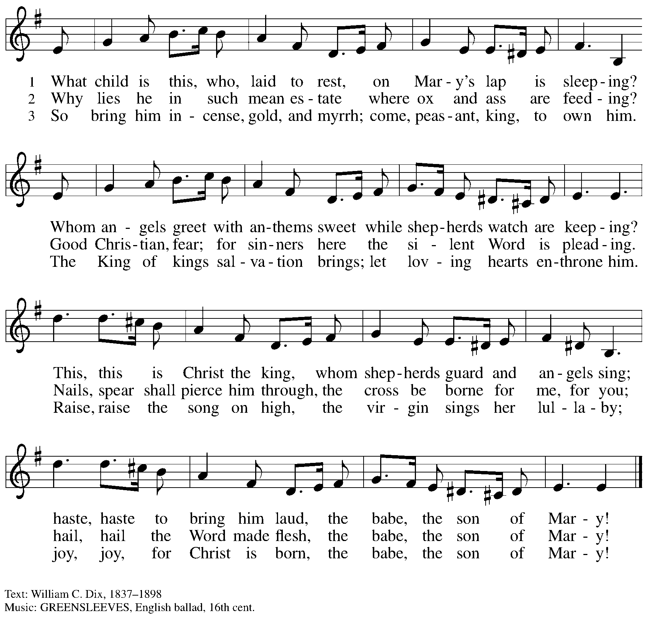

Offertory Prayer

A: Let us pray.
Good and loving God,
C: we rejoice in the birth of Jesus,
who came among the poor to bring the riches of his grace.
As you have blessed us with your gifts, let them be a blessing for others.
With the trees of the field, with all earth and heaven,
we shout for joy at the coming of your Son, Jesus Christ our Lord. Amen.

Dialogue ELW p. 152

Preface (Sung)

P: It is indeed right, our duty and our joy …
… we praise your name and join their unending hymn:

Sanctus ELW p. 153

Eucharistic Prayer

P: Holy one, the beginning and the end, the giver of life, …
… Do this for the remembrance of me.

Let us proclaim the mystery of faith.
C: Christ has died. Christ is risen. Christ will come again.

P: With this bread and cup …
… We look with hope for his coming.
C: Come, Lord Jesus.

P: Holy God, we long for your Spirit …
… Bring the gift of peace on earth.
C: Come, Holy Spirit.

P: All praise and glory are yours …
… one God, now and forever.
C: Amen.

Lord’s Prayer

P: Gathered as one by the Holy Spirit, let us pray as Jesus taught us.
C: Our Father in heaven,
hallowed be your name,
your kingdom come,
your will be done,
on earth as in heaven.
Give us today our daily bread.
Forgive us our sins
as we forgive those
who sin against us.
Save us from the time of trial
and deliver us from evil.
For the kingdom, the power,
and the glory are yours,
now and forever. Amen.

Fraction and Invitation

P: Glory to God in the highest!
Come to the table of peace.

Agnus Dei / Lamb of God ELW p. 154

Please be seated.

Holy Communion
- All who seek God and desire a deeper and stronger life in Christ are welcome to receive Holy Communion.
- Worshipers from the pulpit side will proceed forward first, followed by the center section, and then the lectern side.
- Please inform an usher if you would like the ministers to bring Communion to you.
- Holy Communion will be served with bread and wine/grape juice.
- The presiding minister will first distribute the bread (host) to each communicant. Please indicate if you require a gluten-free host.
- Once you have consumed the bread, please pick up an empty glass from the tray next to the presiding minister. The Communion Assistant will pour wine from the chalice or grape juice from the cruet into your glass.
- Please step to the side to consume the wine or grape juice.
- Feel free to kneel at the altar rail for prayer after receiving the sacrament.
- As you return to your pew, glasses may be returned to the empty trays on either side of the center section.
- A blessing will be provided for anyone who does not yet receive the sacrament.
- All are invited to join in singing the hymns during Holy Communion.

Hymns during Holy Communion
Angels from the Realms of Glory ELW 275

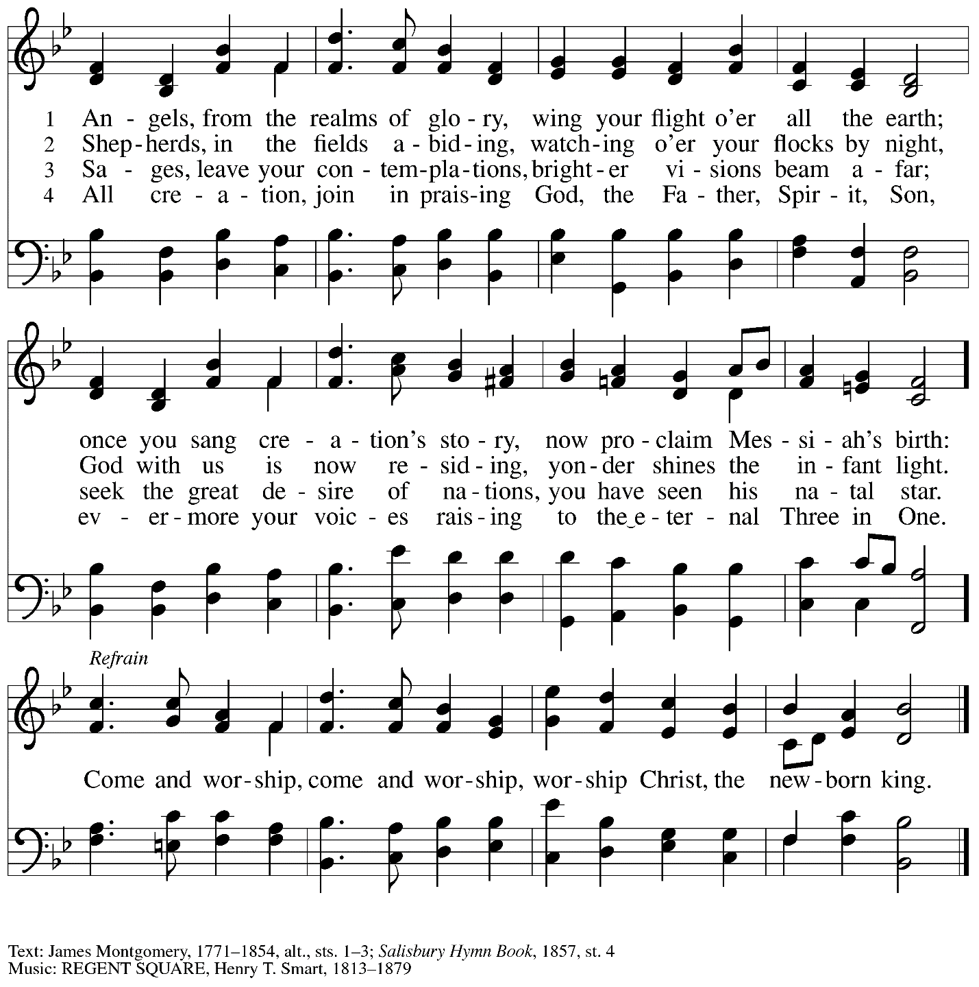

Hymns during Holy Communion
Once in Royal David’s City ELW 269

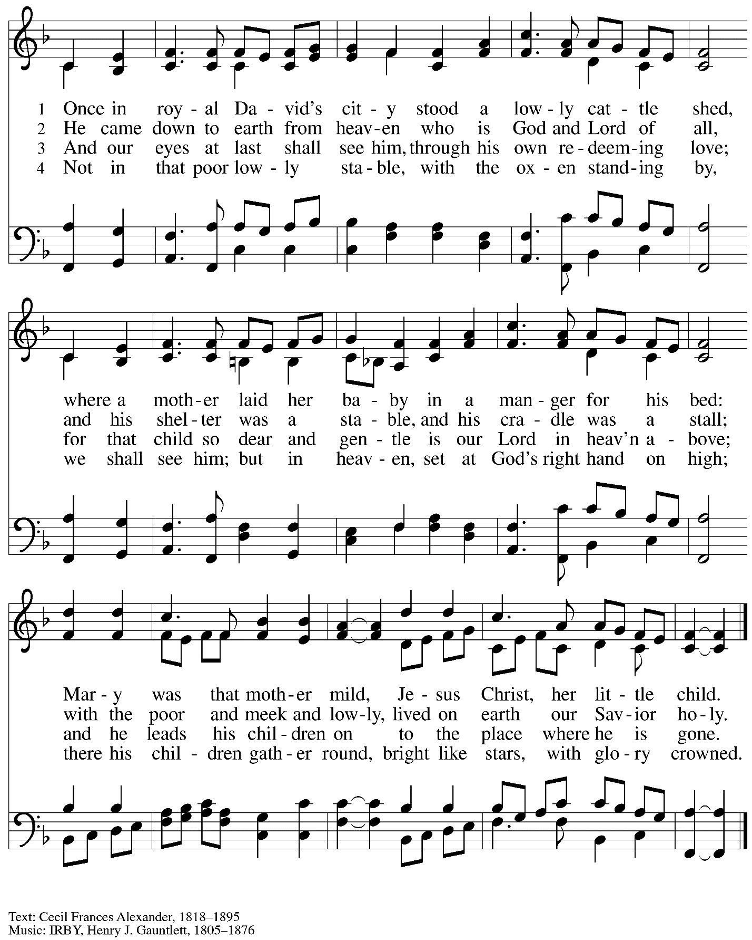

Hymns during Holy Communion
Let All Together Praise Our God ELW 287

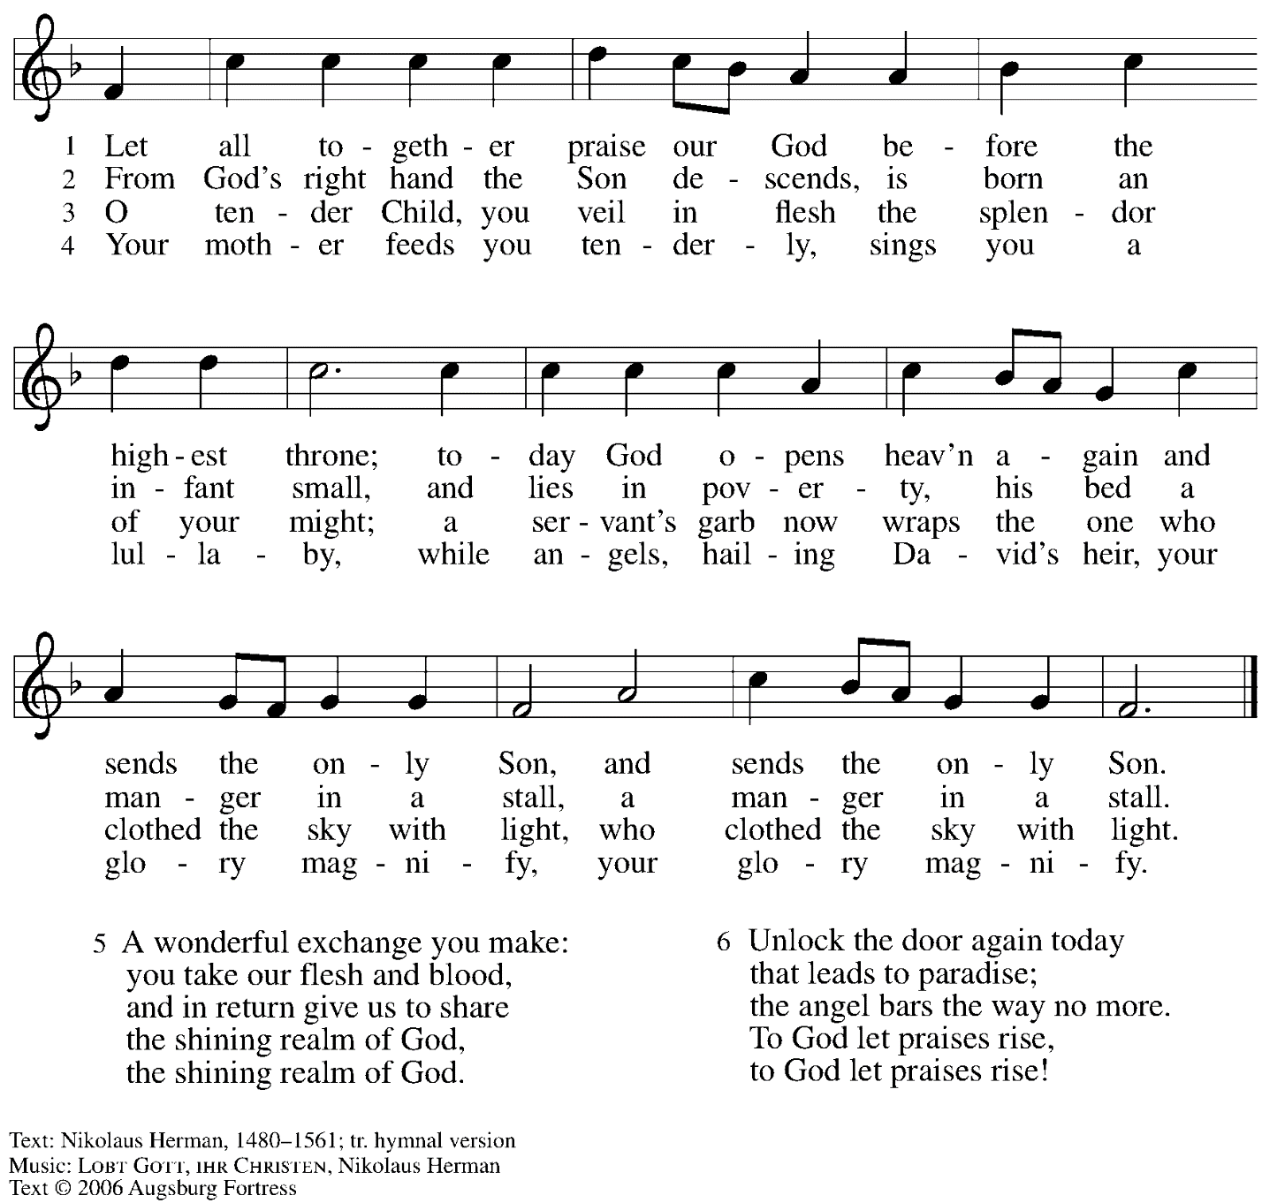
All rights reserved. Reprinted with permission under OneLicense.net # A-722139

When all have returned to their places, please rise as you are able.

Blessing

P: The body and blood of our Lord Jesus Christ strengthen you and keep you in his grace.
C: Amen.

Prayer

A: Let us pray.
Radiant God, you have brought us your salvation,
and in this meal we have feasted on your grace.
May your Word take flesh in us, that we may be your holy people,
Revealing your glory made known to us in Jesus Christ, our Savior and Lord.
C: Amen.

Sending
God blesses us and sends us in mission to the world

Benediction

P: God bless you and keep you,
☩ Jesus grant you grace and truth,
and the Spirit send peace upon your hearts,
now and forever.
C: Amen.

Sending Hymn Jesus, What a Wonderful Child Following page

Dismissal

A: Go in peace. Share the good news!
C: Thanks be to God!

Postlude

Sending Hymn Jesus, What a Wonderful Child ELW 297

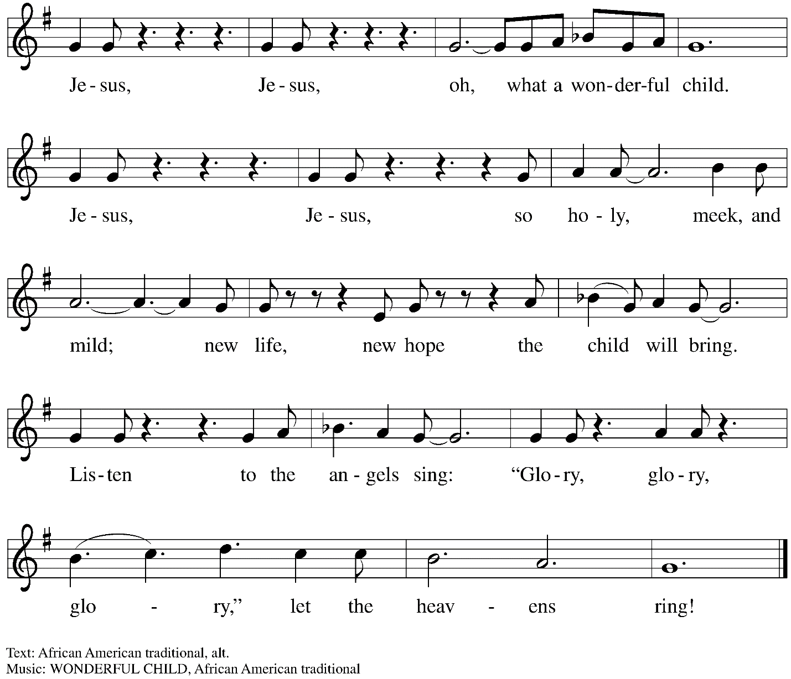

Those serving in worship

Altar Care Jodie Minor
Assisting Minister Jeff Denlinger
Audio-Visual Minister Kristen Asplin
Lector Lindsay Baxter
Minister of Music Laura Reynolds
Presiding and Preaching Minister The Rev. Ross I. Carmichael

Liturgy and Hymnody Acknowledgements

From SundaysandSeasons.com. Copyright © 2023 Augsburg Fortress. All rights reserved. Reprinted under OneLicense.net # A-722139.
Used by permission of Augsburg Fortress.

Jesus, the Light of the World – Text: Charles Wesley, 1707-1788, stanzas; George D. Elderkin, 1845-1928, refrain. Music WE’LL WALK IN THE LIGHT, Traditional; arr. George D. Elderkin.

Angels We Have Heard on High – Text: French carol; tr. H. F. Hemy, The Crown of Jesus Music, 1864. Music: GLORIA, French carol; arr. Edward F. Barnes, 1881-1958.

Please use the QR code below to link to St. Andrew’s Announcements online!

St. Andrew Lutheran Church Announcements
December 31st, 2023

- Welcome to worship at St. Andrew on the First Sunday of Christmas, December 31st, 2023 – We are so glad you are here, and we offer a special welcome to all guests who are gathered here or online! There are worship “toolkits” to help children engage with worship and “busy bags” for younger children available in the bookcase at the back of the sanctuary. Please feel free to take one to use with/for your children.
- Christ in Our Home Devotional Booklets for January - March Available at Church Entrances – This resource offers a daily Bible reading with a short reflection and prayer, along with additional readings and prayer topics for those who would like to expand their devotional practices. We encourage people of the congregation to take one for yourself, your family unit, or others!
- Fresh Produce Distribution – Tuesday, January 2nd, 5:30-7:00 p.m. – On the first Tuesday of every month, St. Andrew hosts a fresh produce distribution in partnership with Greater Pittsburgh Community Food Bank. We ask people of the congregation to assist with setup and unloading, usually sometime between 10:00 a.m. and 1:00 p.m., and with the distribution itself from 5:30-7:00 p.m. There is no signup link for this month, but we plan to provide them again in time for February’s distribution.
- Hearts and Hands Meeting on First Sundays of the Month after Worship – Next Gathering January 7th, 2024 – Hearts and Hands, St. Andrew’s crocheting and knitting ministry group, plans to gather each month on the first Sunday after worship, beginning on January 7th. The leaders will teach anyone who would like to learn to crochet and have yarn and hooks to help get you started! We are currently in need of knitted or crocheted shawls, afghans, and stoles to replenish the congregation’s supply. Anyone is welcome to make something and drop it off even if they are not available or choose not to come to a meeting.
- Save the Date – Service of Prayer and Lament for the Holy Land – Saturday, January 27th at St. Andrew. Meal and Presentation – 5:00 p.m., Service – 6:00 p.m.

