+ The Nativity of our Lord
December 24th, 2023
7:00 p.m.

St. Andrew Lutheran Church
304 Morewood Ave.
Pittsburgh, PA 15213
412.682.3342
St_andrewELCA@verizon.net
www.standrewpittsburgh.org

+ The Nativity of our Lord
Christmas Eve
Order for Worship

In the deepest night of the northern hemisphere’s winter, we welcome the light of the Christ child. Isaiah declares that the light of the long-promised king will illumine the world and bring endless peace and justice. Paul reminds us that the grace of God through Jesus Christ brings salvation to all people. The angels declare that Jesus’ birth is good and joyful news for everyone, including lowly shepherds. Filled with the light that shines in our lives, we go forth to share the light of Christ with the whole world.

Welcome to St. Andrew!

- St. Andrew Lutheran congregation welcomes all who are seeking a place of healing and wholeness – a nurturing, faith-forming spiritual home. Our community embraces people of all ages, ethnicities, cultures, abilities, sexual orientations, gender identities and expressions, and family constellations. Come and See!

- Worship Services are live streamed to multiple online platforms. By attending worship, you agree that your image and voice may be broadcast.

- Worship “toolkits” to help children engage with the service, along with “busy bags” for younger children, are available in the bookcase at the back of the sanctuary. Please feel free to take one to use with/for your children.

- Holy Communion is served with bread (gluten-free available) and wine or grape juice. The presiding minister will distribute the bread (host). Please consume this and then pick up an empty glass from the tray. The Communion Assistant will pour wine or grape juice into your glass. Please step to the side to consume the wine or grape juice. Feel free to kneel at the altar for prayer and reflection. As you return to your pew, glasses may be returned to the empty trays on either side of the center section.

- A restroom is available on the main level of the church, through the doors to the Social Hall and to the right in the main office.

Abbreviations

P: Pastor/Presiding Minister ELW: Evangelical Lutheran Worship hymnal
L: Lector
C: Congregation

Pre-Service Music

Manger Medley arr. Hayes
Angels We Have Heard on High arr. Raabe
God Rest You Merry arr. Oines
I Wonder as I Wander arr. Raabe
Joy to the World arr. Helgen

Gathering
The Holy Spirit calls us together as the people of God

Christmas Proclamation

Many ages from the time when God created the heavens and the earth
and then formed humanity in God’s own image;
long after the great flood, when God set the rainbow in the clouds
as a sign of the covenant;
twenty-one centuries from the time the promise was given to Abraham and Sarah;
thirteen centuries after Moses led the people of Israel out of Egypt
and Miriam danced in freedom;
eleven centuries from the time of Ruth and the judges;
one thousand years from the anointing of David as king;
in the sixty-fifth week, according to the prophecy of Daniel;
in the one hundred and ninety-fourth Olympiad;
the seven hundred and fifty-second year from the founding of the city of Rome;
the forty-second year of the reign of Octavian Augustus;
in the sixth age of the world, the whole world being at peace,
Jesus Christ, eternal God and Son of the eternal Father,
desiring to sanctify the world by his most merciful coming,
being conceived by the Holy Spirit and nine months of growth having passed
in the womb of his mother—
was born of the Virgin Mary in Bethlehem of Judea.
Today is the nativity of our Lord Jesus Christ, God made flesh.

Gathering Hymn O Come, All Ye Faithful ELW 283

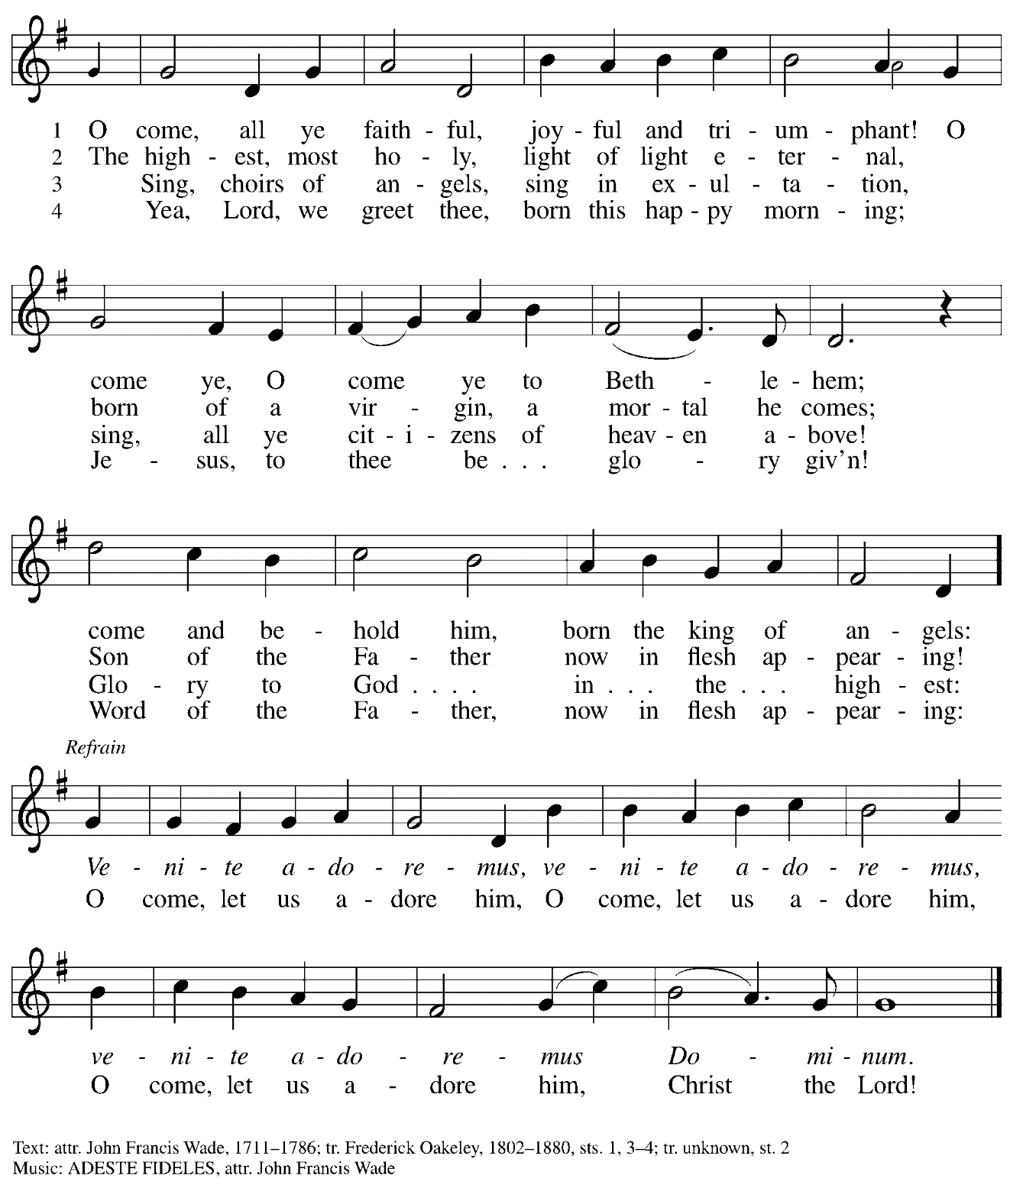

Greeting

P: The grace of our Lord Jesus Christ, the love of God,
and the communion of the Holy Spirit be with you all.
C: And also with you.

Kyrie ELW p. 147

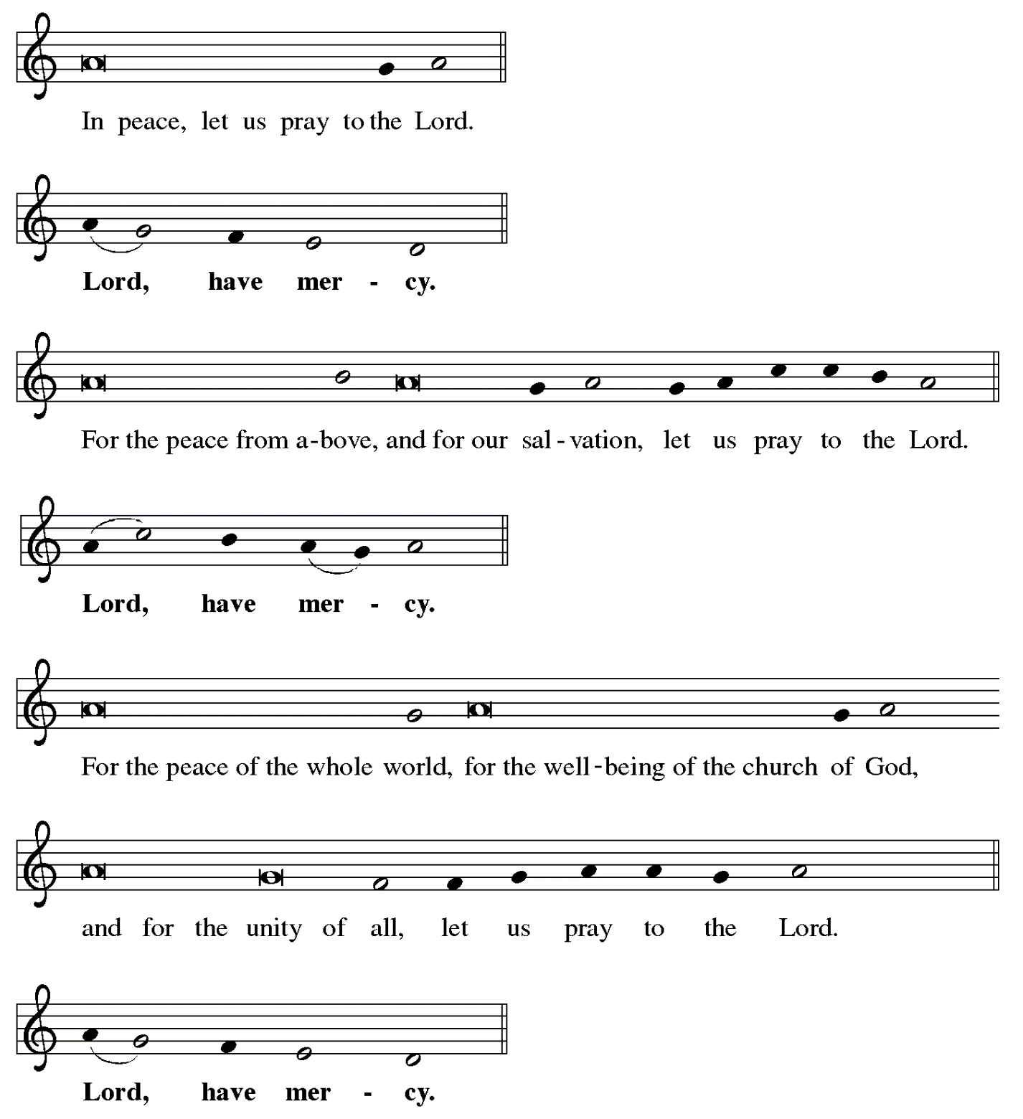

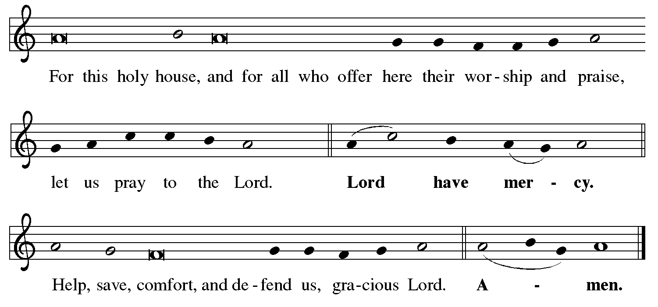

Hymn of Praise Angels We Have Heard on High ELW 289

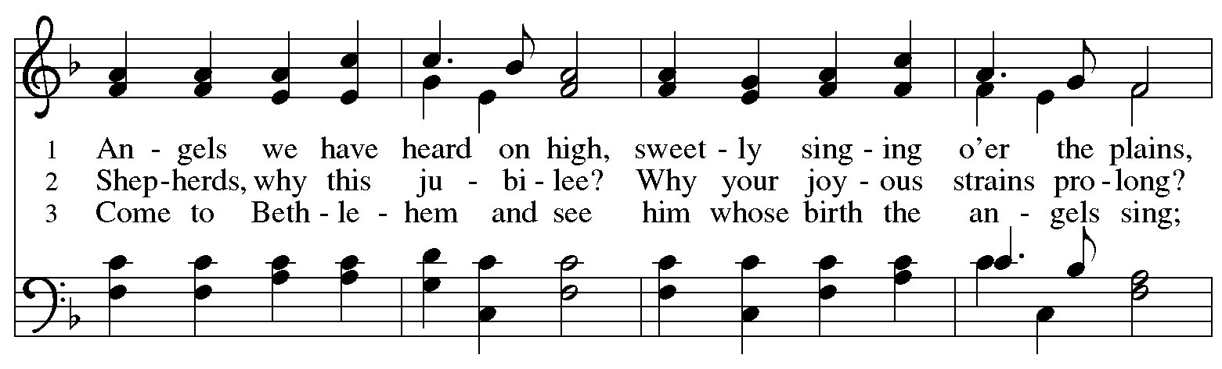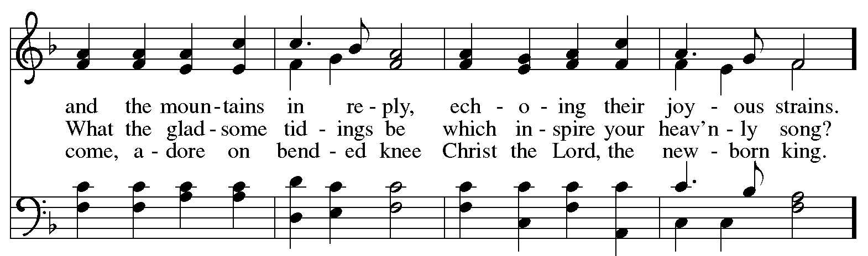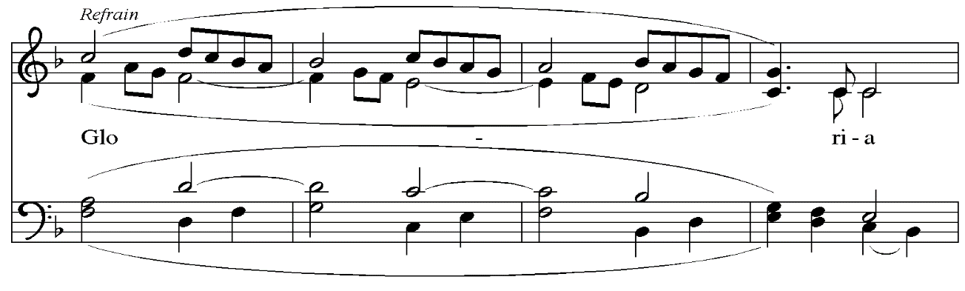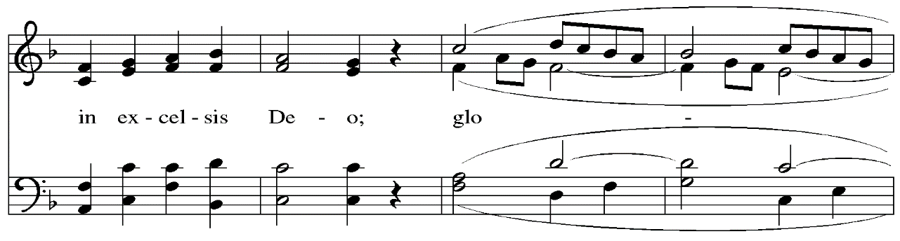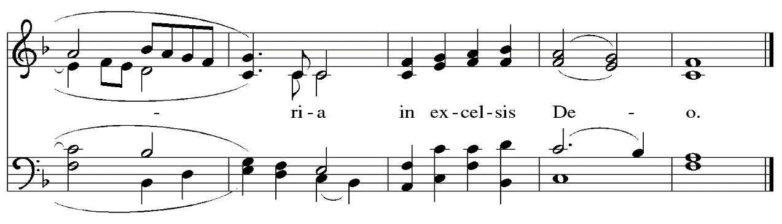
Prayer of the Day

P: The Lord be with you.
C: And also with you.

P: Let us pray.
Almighty God, you made this holy night shine with the brightness of the true Light.
Grant that here on earth we may walk in the light of Jesus’ presence
and in the last day wake to the brightness of his glory;
through your Son, Jesus Christ our Lord,
who lives and reigns with you and the Holy Spirit,
one God, now and forever.
C: Amen.

Please be seated.

Word
God speaks to us in Scripture reading, preaching, and song

First Reading – Isaiah 9: 2-7

²The people who walked in darkness
have seen a great light;
those who lived in a land of deep darkness—
on them light has shined.
³You have multiplied the nation,
you have increased its joy;
they rejoice before you
as with joy at the harvest,
as people exult when dividing plunder.
⁴For the yoke of their burden,
and the bar across their shoulders,
the rod of their oppressor,
you have broken as on the day of Midian.
⁵For all the boots of the tramping warriors
and all the garments rolled in blood
shall be burned as fuel for the fire.
⁶For a child has been born for us,
a son given to us;
authority rests upon his shoulders;
and he is named
Wonderful Counselor, Mighty God,
Everlasting Father, Prince of Peace.
⁷His authority shall grow continually,
and there shall be endless peace
for the throne of David and his kingdom.
He will establish and uphold it
with justice and with righteousness
from this time onward and forevermore.
The zeal of the Lord of hosts will do this.

L: Word of God, word of life.
C: Thanks be to God.

Hymn Love Has Come ELW 292

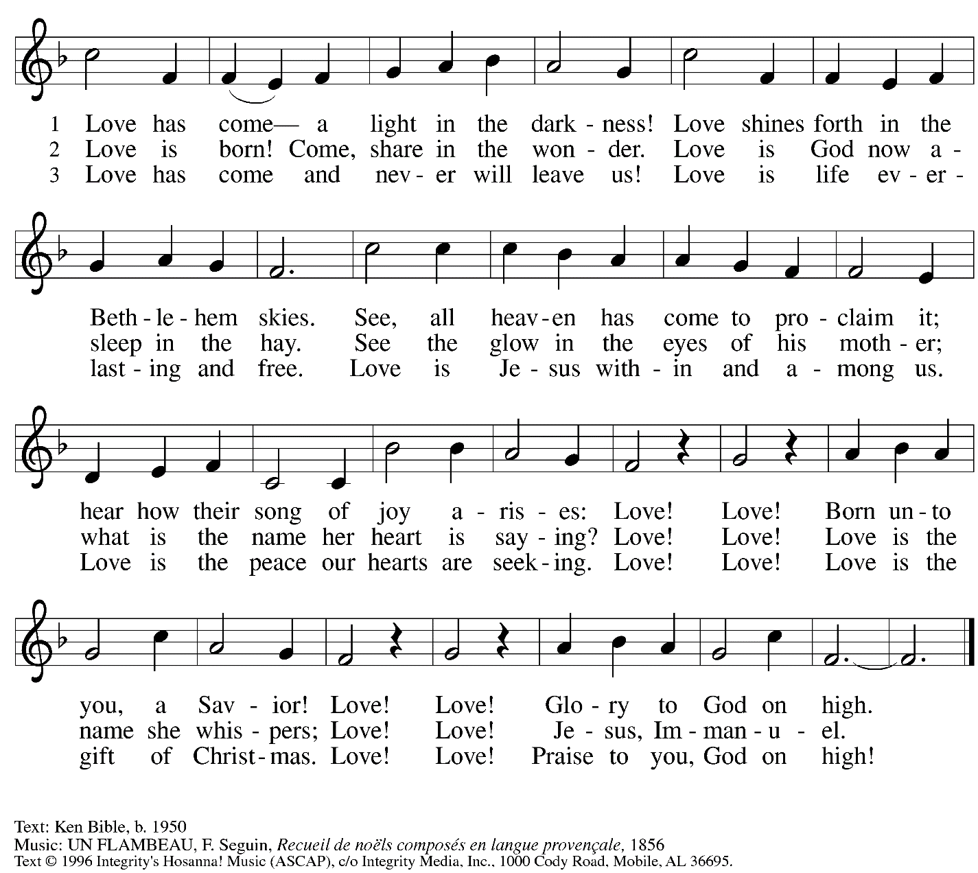
All rights reserved. Reprinted with permission under OneLicense.net # A-722139.

Second Reading – Titus 2: 11-14

¹¹The grace of God has appeared, bringing salvation to all, ¹²training us to renounce impiety and worldly passions, and in the present age to live lives that are self-controlled, upright, and godly,
¹³while we wait for the blessed hope and the manifestation of the glory of our great God and Savior, Jesus Christ. ¹⁴He it is who gave himself for us that he might redeem us from all iniquity and purify for himself a people of his own who are zealous for good deeds.

L: Word of God, word of life.
C: Thanks be to God.

Please rise as you are able.
As the Gospel Acclamation, Silent Night, Holy Night! begins, candles are lighted.
As the light is passed through the congregation, please tilt your unlit candle toward the flame.
Once your candle is lit, please hold it upright to assist others in lighting theirs.
Battery-powered candles are available so that young children can participate safely.

Gospel Acclamation Silent Night, Holy Night! ELW 281
v. 1-2

1 Silent night, holy night!
All is calm, all is bright
round yon virgin mother and child.
Holy Infant, so tender and mild,
sleep in heavenly peace,
sleep in heavenly peace.

2 Silent night, holy night!
Shepherds quake at the sight;
glories stream from heaven afar,
heav'nly hosts sing, alleluia!
Christ, the Savior, is born!
Christ, the Savior, is born!

Gospel – Luke 2: 1-20

P: The holy Gospel according to St. Luke.
C: Glory to you, O Lord.

¹In those days a decree went out from Emperor Augustus that all the world should be registered. ²This was the first registration and was taken while Quirinius was governor of Syria. ³All went to their own towns to be registered. ⁴Joseph also went from the town of Nazareth in Galilee to Judea, to the city of David called Bethlehem, because he was descended from the house and family of David. ⁵He went to be registered with Mary, to whom he was engaged and who was expecting a child. ⁶While they were there, the time came for her to deliver her child. ⁷And she gave birth to her firstborn son and wrapped him in bands of cloth, and laid him in a manger, because there was no place for them in the inn.
⁸In that region there were shepherds living in the fields, keeping watch over their flock by night. ⁹Then an angel of the Lord stood before them, and the glory of the Lord shone around them, and they were terrified. ¹⁰But the angel said to them, “Do not be afraid; for see—I am bringing you good news of great joy for all the people: ¹¹to you is born this day in the city of David a Savior, who is the Messiah, the Lord. ¹²This will be a sign for you: you will find a child wrapped in bands of cloth and lying in a manger.” ¹³And suddenly there was with the angel a multitude of the heavenly host, praising God and saying,
¹⁴“Glory to God in the highest heaven,
and on earth peace among those whom God favors!”
¹⁵When the angels had left them and gone into heaven, the shepherds said to one another, “Let us go now to Bethlehem and see this thing that has taken place, which the Lord has made known to us.” ¹⁶So they went with haste and found Mary and Joseph, and the child lying in the manger.
¹⁷When they saw this, they made known what had been told them about this child; ¹⁸and all who heard it were amazed at what the shepherds told them. ¹⁹But Mary treasured all these words and pondered them in her heart. ²⁰The shepherds returned, glorifying and praising God for all they had heard and seen, as it had been told them.
P: The Gospel of the Lord.
C: Praise to you, O Christ.

Gospel Acclamation Silent Night, Holy Night! ELW 281
v. 3

All are invited to sing the concluding verse of Silent Night, Holy Night!
When the hymn concludes, please feel free to extinguish your candles.

3 Silent night, holy night!
Son of God, love's pure light
radiant beams from your holy face,
with the dawn of redeeming grace,
Jesus, Lord, at your birth,
Jesus, Lord, at your birth.

Text: Joseph Mohr, 1792-1849; tr. Johan F. Young, 1820-1885. Music: STILLE NACHT, Franz Gruber, 1787-1863.

Please be seated.

Sermon

A time of silence for prayer and reflection follows the sermon.
As the hymn of the day begins, please rise as you are able.

Hymn of the Day Hark! The Herald Angels Sing ELW 270

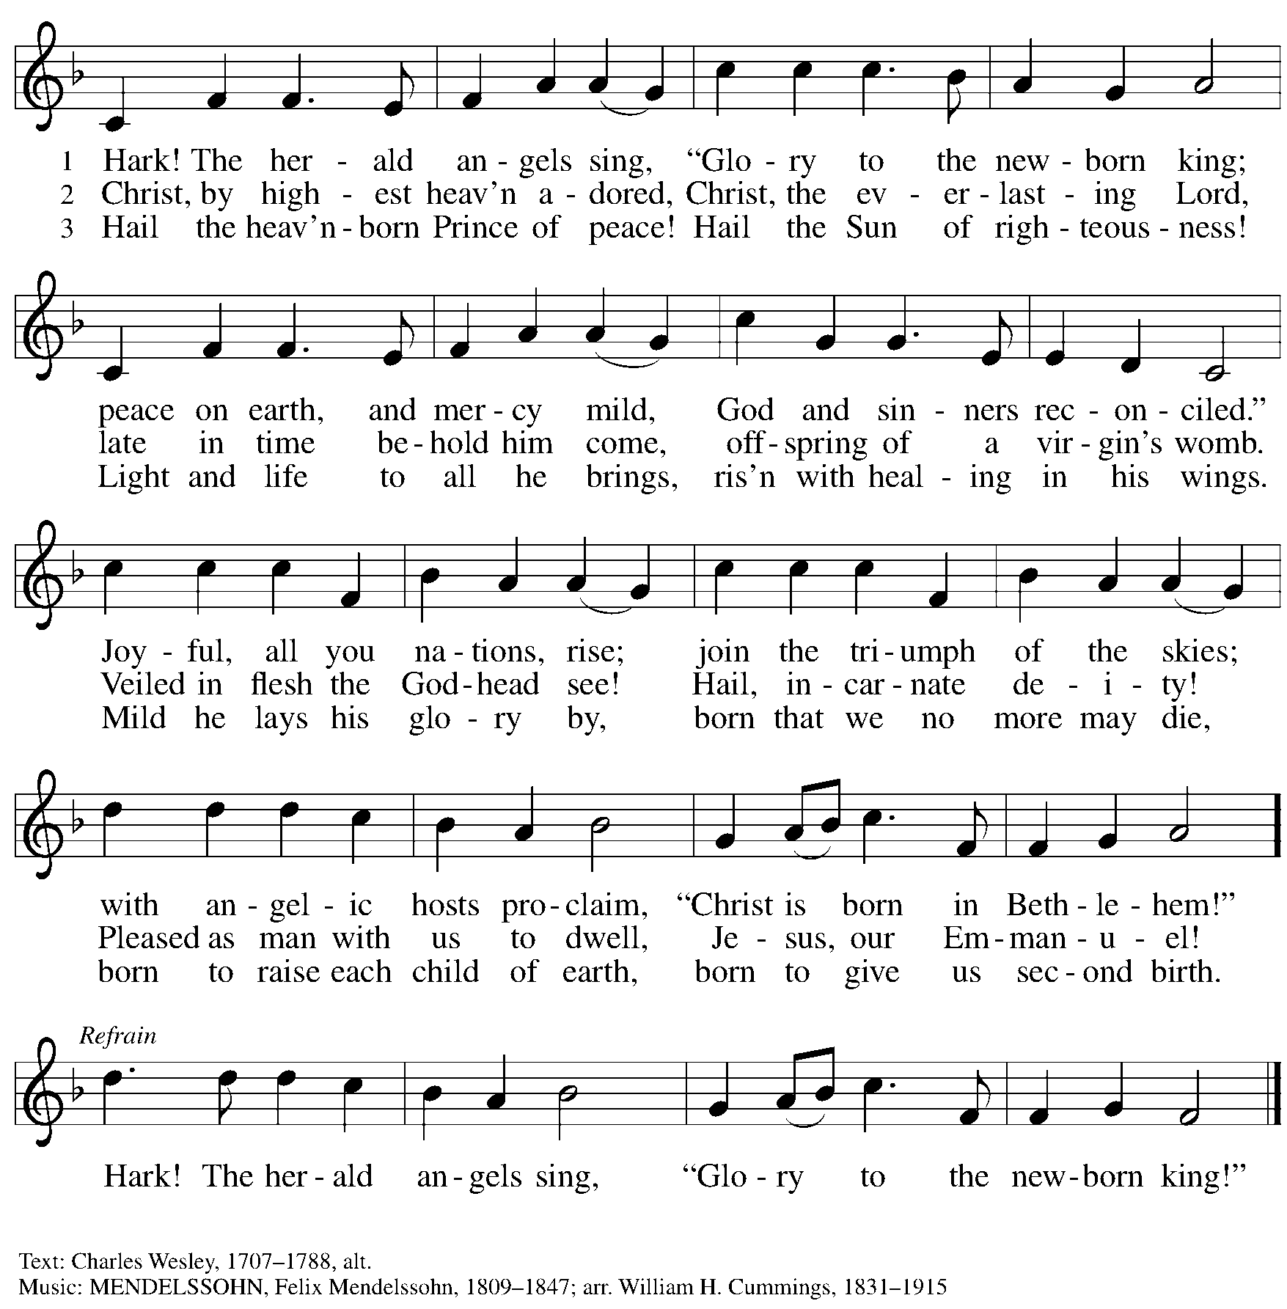

Nicene Creed

P: Rejoicing in the good news of Christ’s birth, we confess our faith:
C: We believe in one God,
the Father, the Almighty,
maker of heaven and earth,
of all that is, seen and unseen.

C: We believe in one Lord, Jesus Christ,
the only Son of God,
eternally begotten of the Father,
God from God, Light from Light,
true God from true God,
begotten, not made,
of one Being with the Father;
through him all things were made.
For us and for our salvation
he came down from heaven,
was incarnate of the Holy Spirit and the virgin Mary
and became truly human.
For our sake he was crucified under Pontius Pilate;
he suffered death and was buried.
On the third day he rose again
in accordance with the scriptures;
he ascended into heaven
and is seated at the right hand of the Father.
He will come again in glory to judge the living and the dead,
and his kingdom will have no end.

We believe in the Holy Spirit, the Lord, the giver of life,
who proceeds from the Father and the Son,*
who with the Father and the Son is worshiped and glorified,
who has spoken through the prophets.
We believe in one holy catholic and apostolic church.
We acknowledge one baptism for the forgiveness of sins.
We look for the resurrection of the dead,
and the life of the world to come. Amen.
*Or, “who proceeds from the Father.” The phrase “and the Son” is a later addition to the creed.

Prayers of the People

P: Trusting in God’s good news of great joy for all people, we offer our prayers for the church,
those in need, and the world God so loves.

After each petition
P: God of grace,
C: receive our prayer.

The presiding minister concludes the prayers
P: Rejoicing in your Word made flesh among us, we commend these prayers to you, O God,
trusting in your love and grace made known to us in Jesus Christ, our Savior.
C: Amen.

Peace

The presiding minister and the assembly greet one another in the peace of the risen Christ.
P: The peace of Christ be with you always.
C: And also with you.

The people may greet those around them with a sign of Christ’s peace and may say
Peace be with you or similar words. Please be mindful that not everyone will be comfortable with sharing the peace, so please seek consent before shaking hands or hugging. Other possible ways to share the peace include a simple bow with the verbal greeting of peace, or simply a verbal expression of peace.

When the greetings of peace have concluded, please be seated.

Meal
God feeds us with the presence of Jesus Christ

Offering

We offer ourselves, our gifts, and our faithful service to God.
As the offering is gathered for the mission of the church, including the care of those in need,
the table is set for Holy Communion.

Music during the Offering
Night of Silence / Silent Night D. Kantor

As the gifts are brought forward for presentation, please rise as you are able.

Offertory Song What Child Is This ELW 296
v. 1, 3

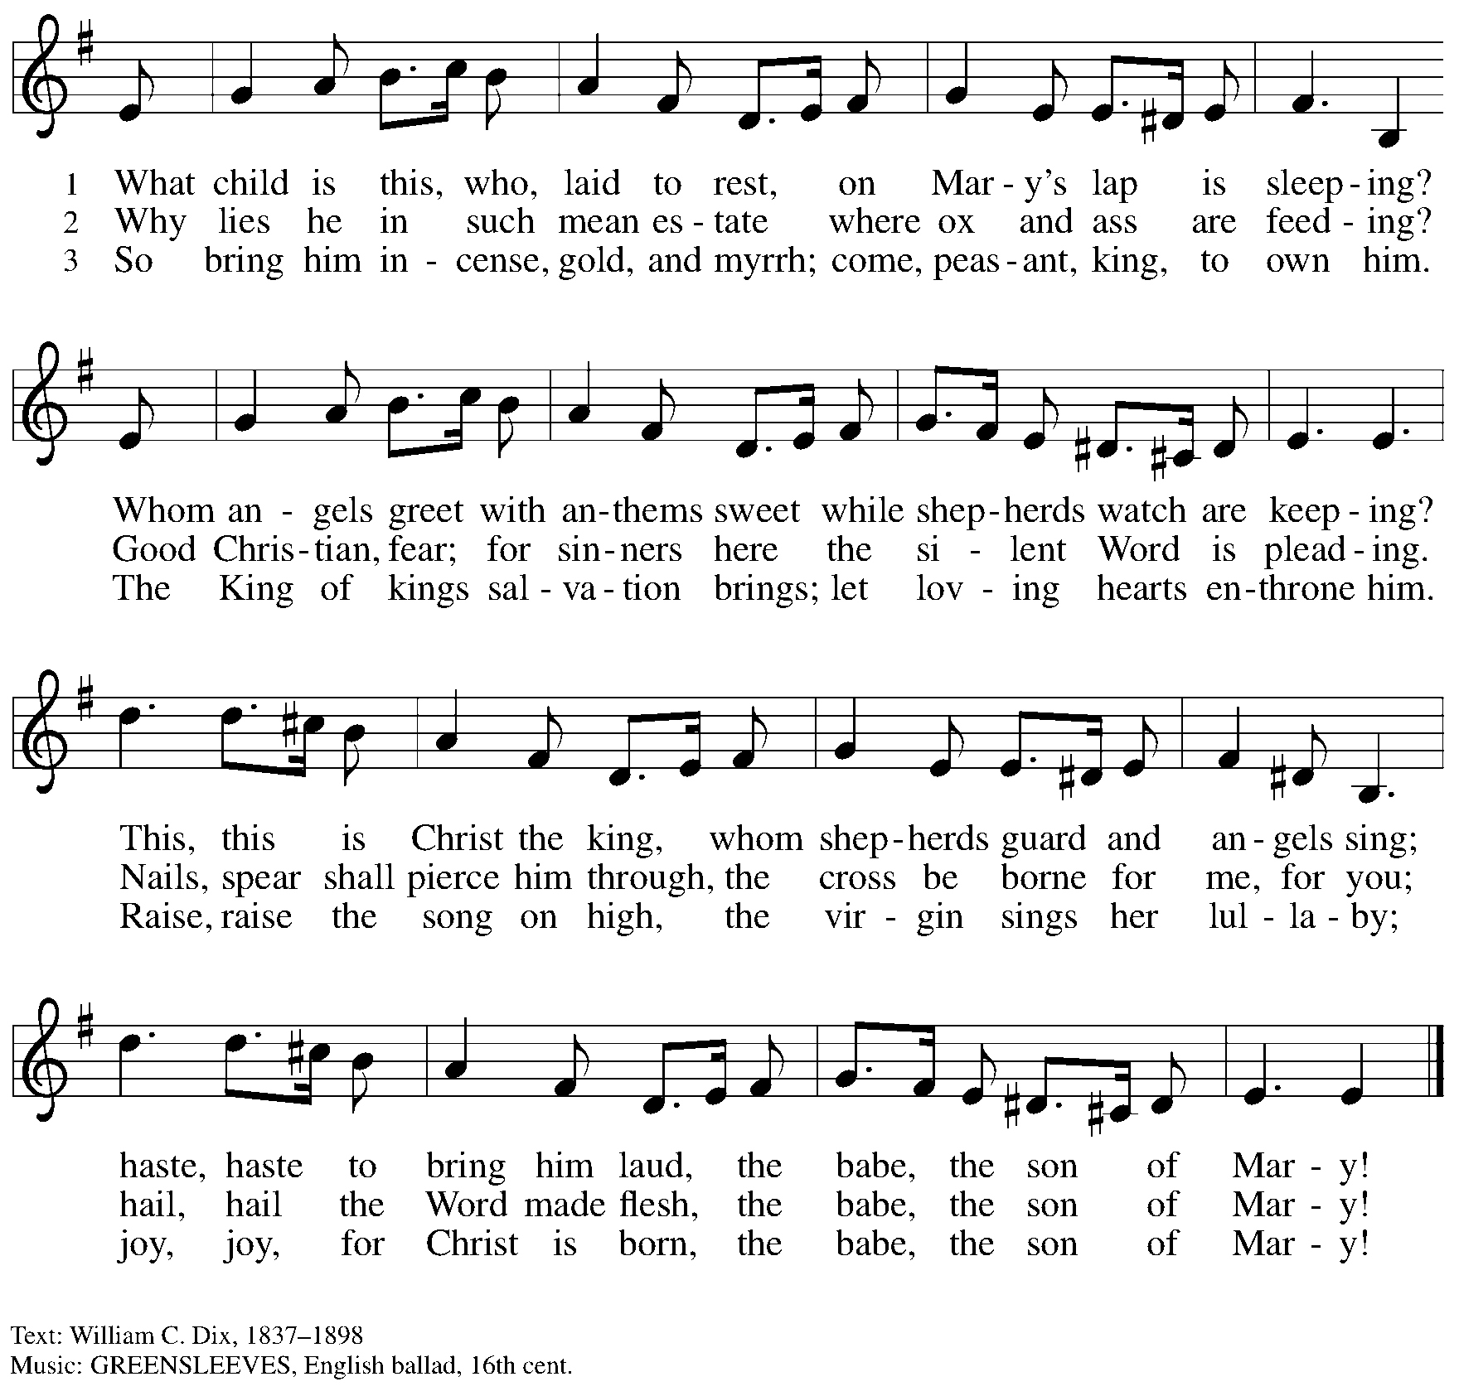

Offertory Prayer

P: Let us pray.
Good and loving God,
C: we rejoice in the birth of Jesus,
who came among the poor to bring the riches of his grace.
As you have blessed us with your gifts, let them be a blessing for others.
With the trees of the field, with all earth and heaven,
we shout for joy at the coming of your Son, Jesus Christ our Lord. Amen.

Dialogue ELW p. 152

Preface (Sung)

P: It is indeed right, our duty and our joy …
… we praise your name and join their unending hymn:

Sanctus ELW p. 153

Eucharistic Prayer

P: Holy one, the beginning and the end, the giver of life, …
… Do this for the remembrance of me.

Let us proclaim the mystery of faith.
C: Christ has died. Christ is risen. Christ will come again.

P: With this bread and cup …
… We look with hope for his coming.
C: Come, Lord Jesus.

P: Holy God, we long for your Spirit …
… Bring the gift of peace on earth.
C: Come, Holy Spirit.

P: All praise and glory are yours …
… one God, now and forever.
C: Amen.

Lord’s Prayer

P: Gathered as one by the Holy Spirit, let us pray as Jesus taught us.
C: Our Father in heaven,
hallowed be your name,
your kingdom come,
your will be done,
on earth as in heaven.
Give us today our daily bread.
Forgive us our sins
as we forgive those
who sin against us.
Save us from the time of trial
and deliver us from evil.
For the kingdom, the power,
and the glory are yours,
now and forever. Amen.

Fraction and Invitation

P: Glory to God in the highest!
Come to the table of peace.

Agnus Dei / Lamb of God ELW p. 154

Please be seated.

Holy Communion
- All who seek God and desire a deeper and stronger life in Christ are welcome to receive Holy Communion.
- Worshipers from the pulpit side will proceed forward first, followed by the center section, and then the lectern side.
- Please inform an usher if you would like the ministers to bring Communion to you.
- Holy Communion will be served with bread and wine/grape juice.
- The presiding minister will first distribute the bread (host) to each communicant. Please indicate if you require a gluten-free host.
- Once you have consumed the bread, please pick up an empty glass from the tray next to the presiding minister. The Communion Assistant will pour wine from the chalice or grape juice from the cruet into your glass.
- Please step to the side to consume the wine or grape juice.
- Feel free to kneel at the altar rail for prayer after receiving the sacrament.
- As you return to your pew, glasses may be returned to the empty trays on either side of the center section.
- A blessing will be provided for anyone who does not yet receive the sacrament.
- All are invited to join in singing the hymns during Holy Communion.

Hymns during Holy Communion
Away in a Manger ELW 277

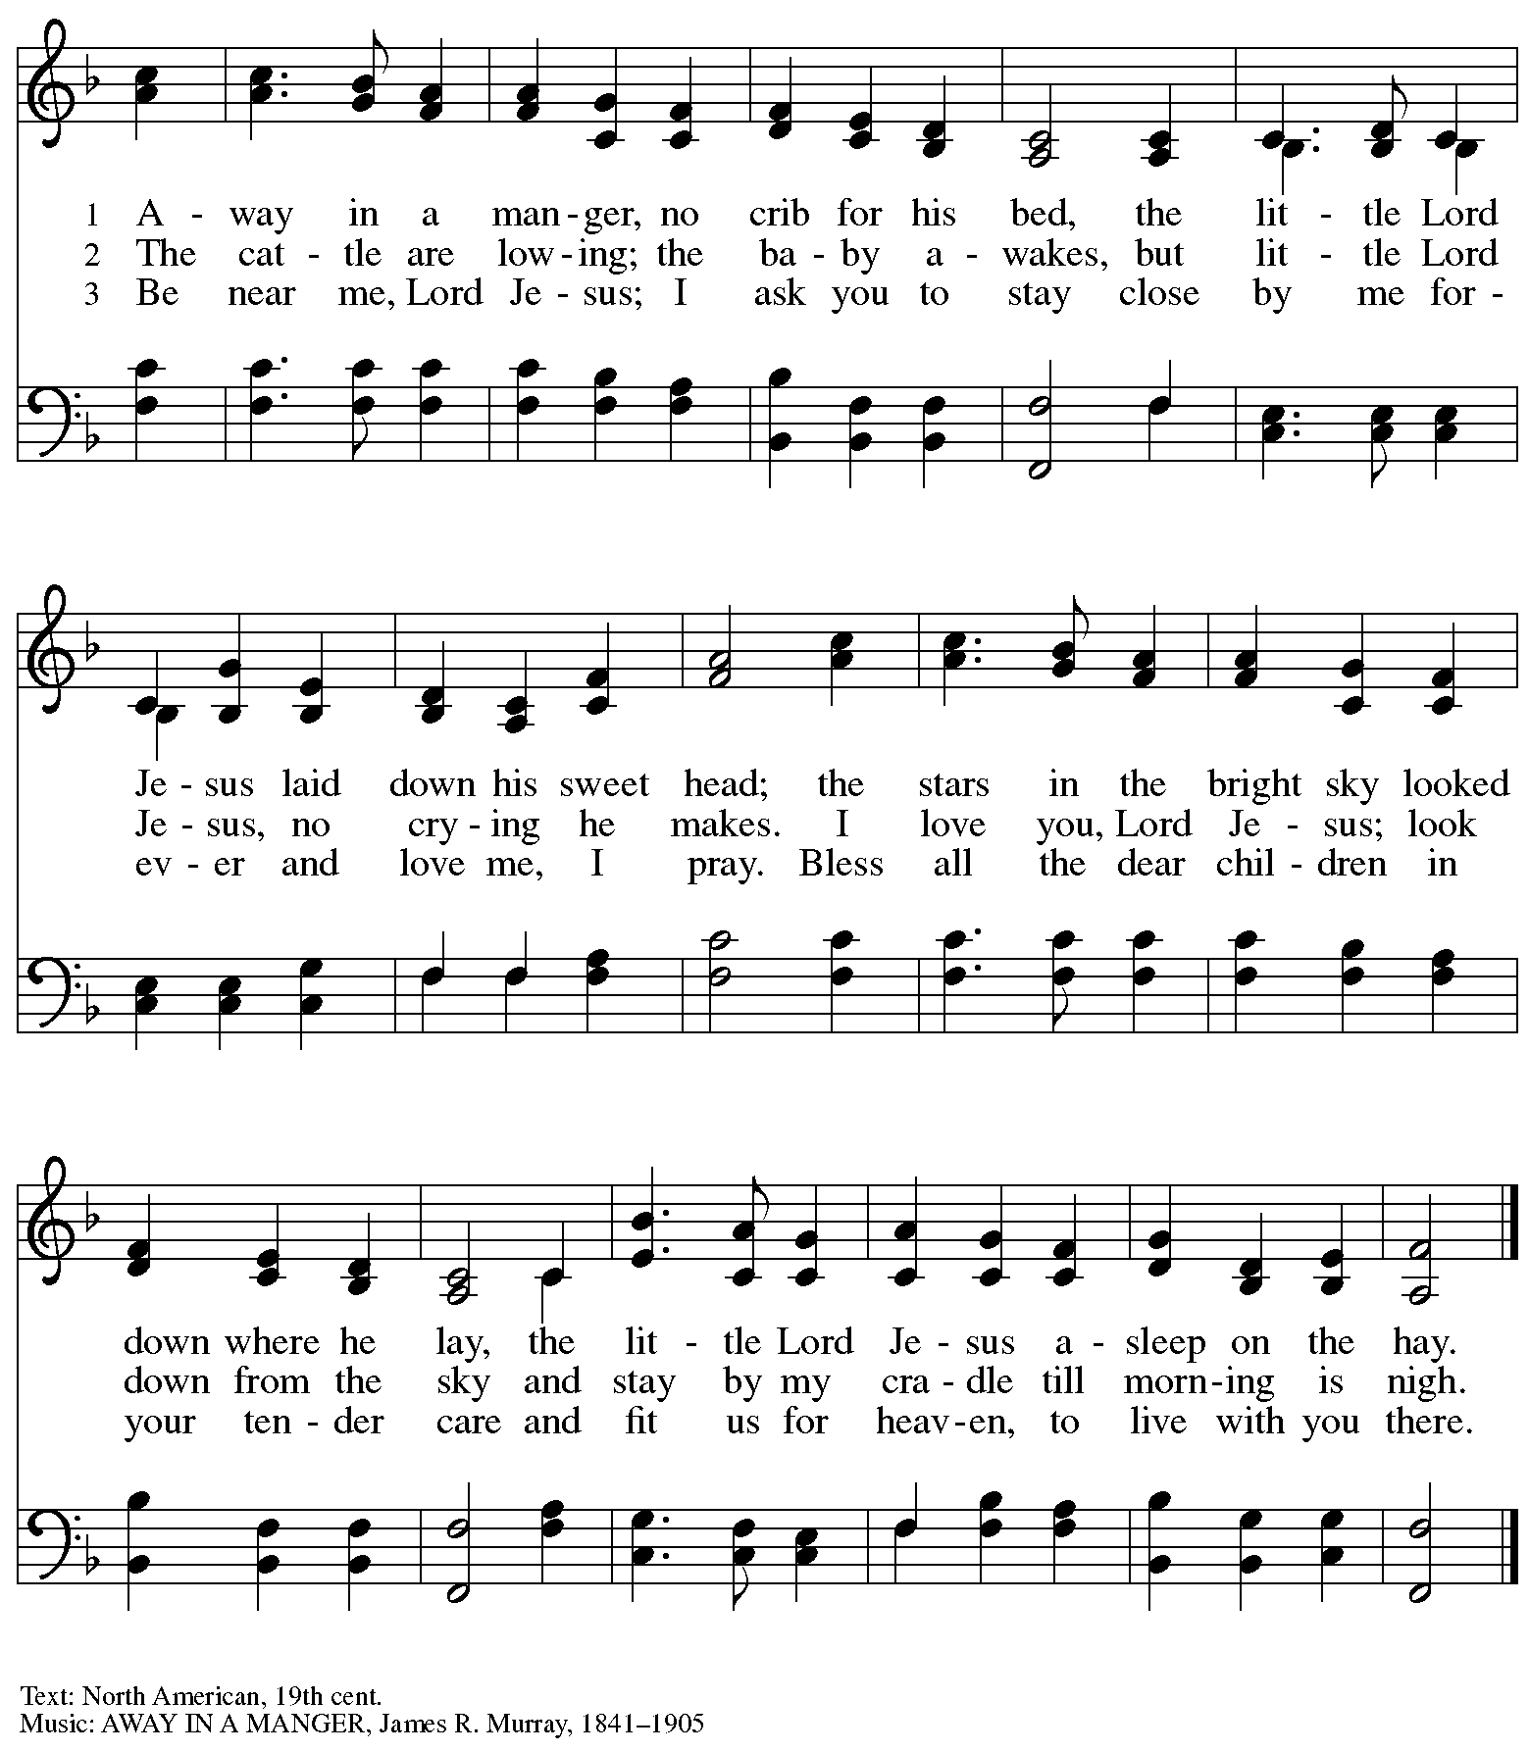

Hymns during Holy Communion
O Little Town of Bethlehem ELW 279

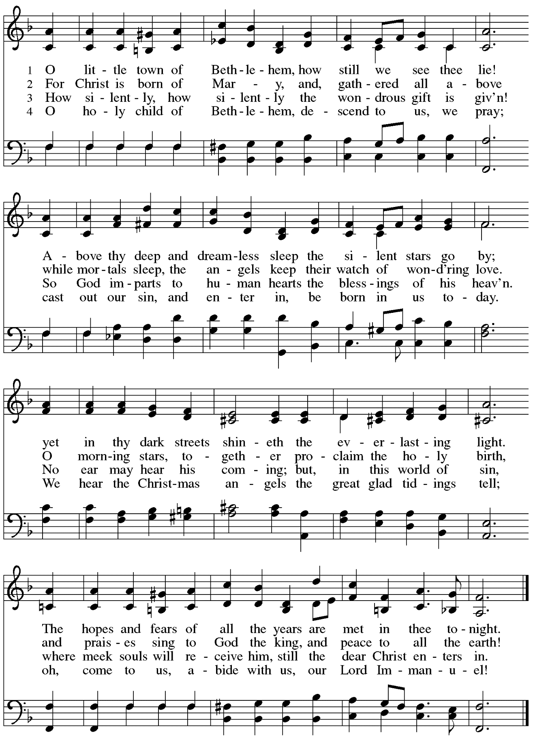
Hymns during Holy Communion
The First Noel ELW 300

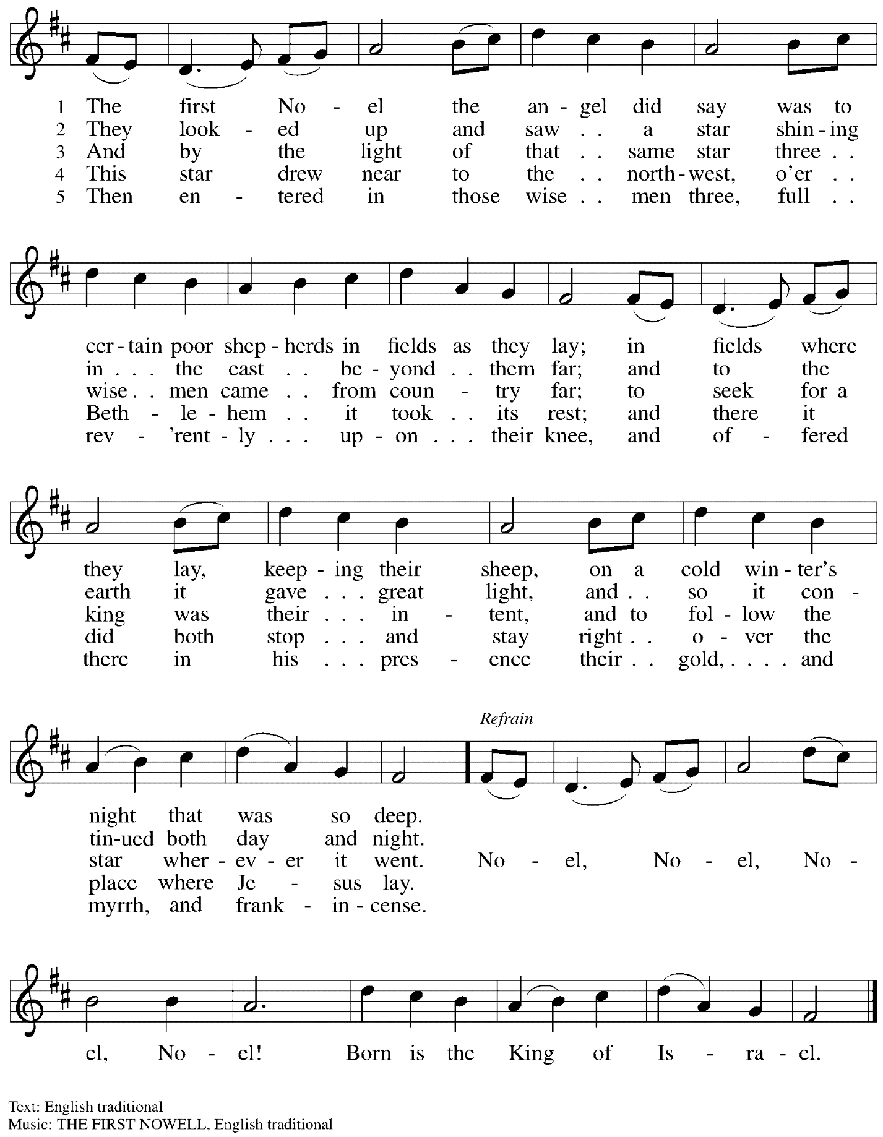
Hymns during Holy Communion
Infant Holy, Infant Lowly ELW 276

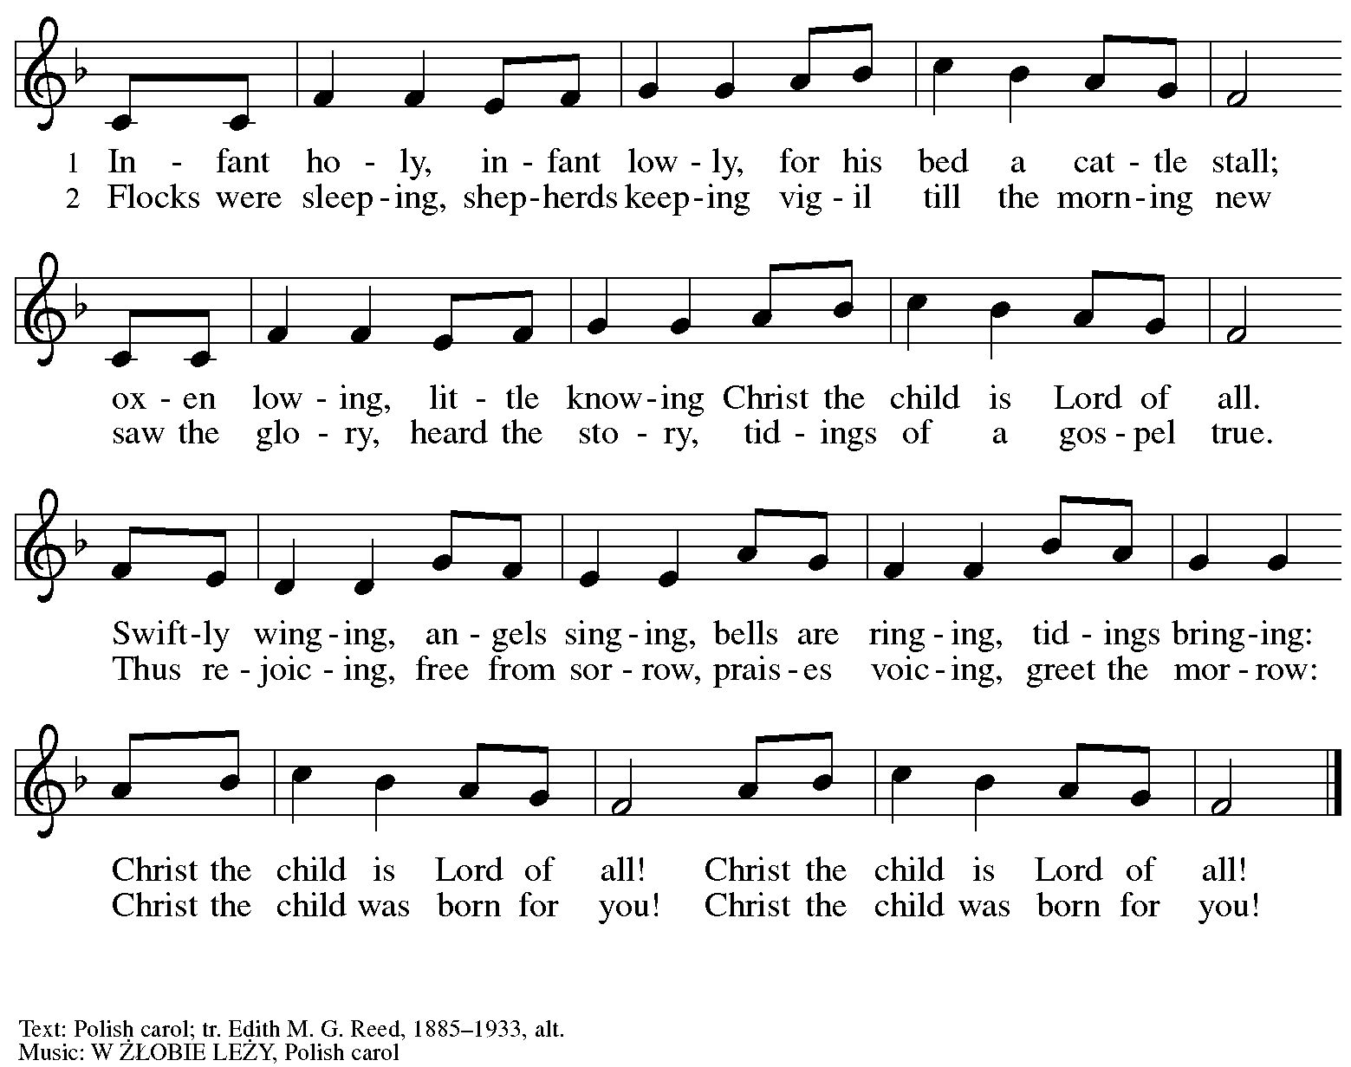

Hymns during Holy Communion
It Came upon the Midnight Clear ELW 282

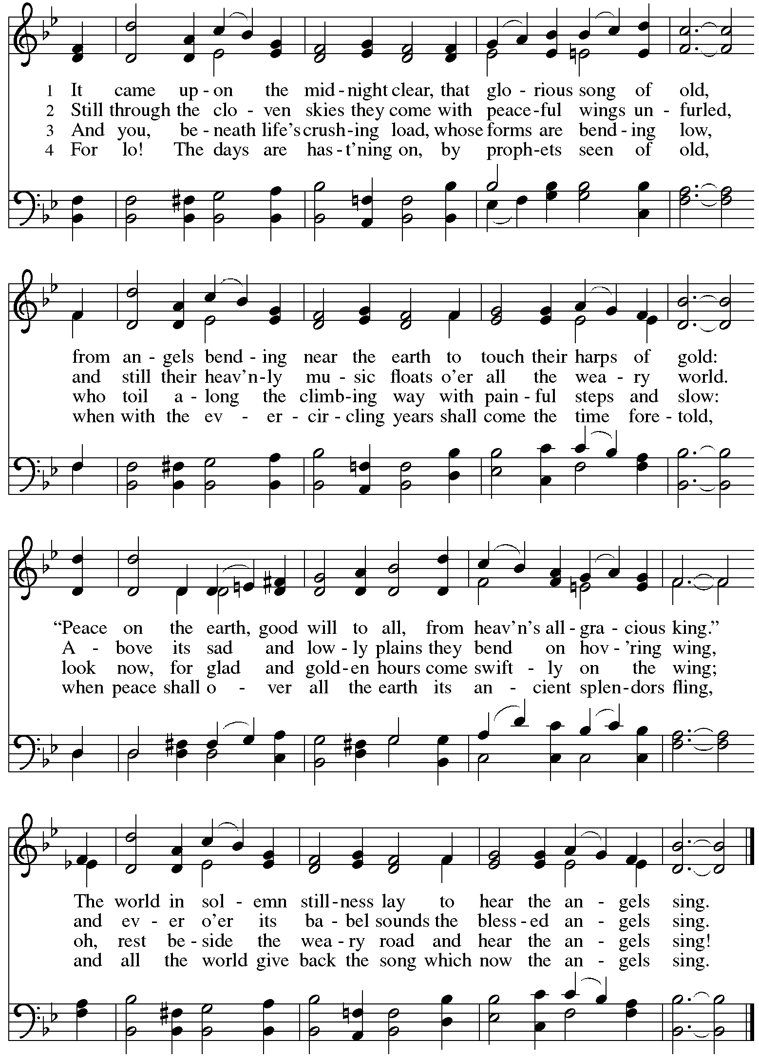
Hymns during Holy Communion
Go Tell It on the Mountain ELW 290

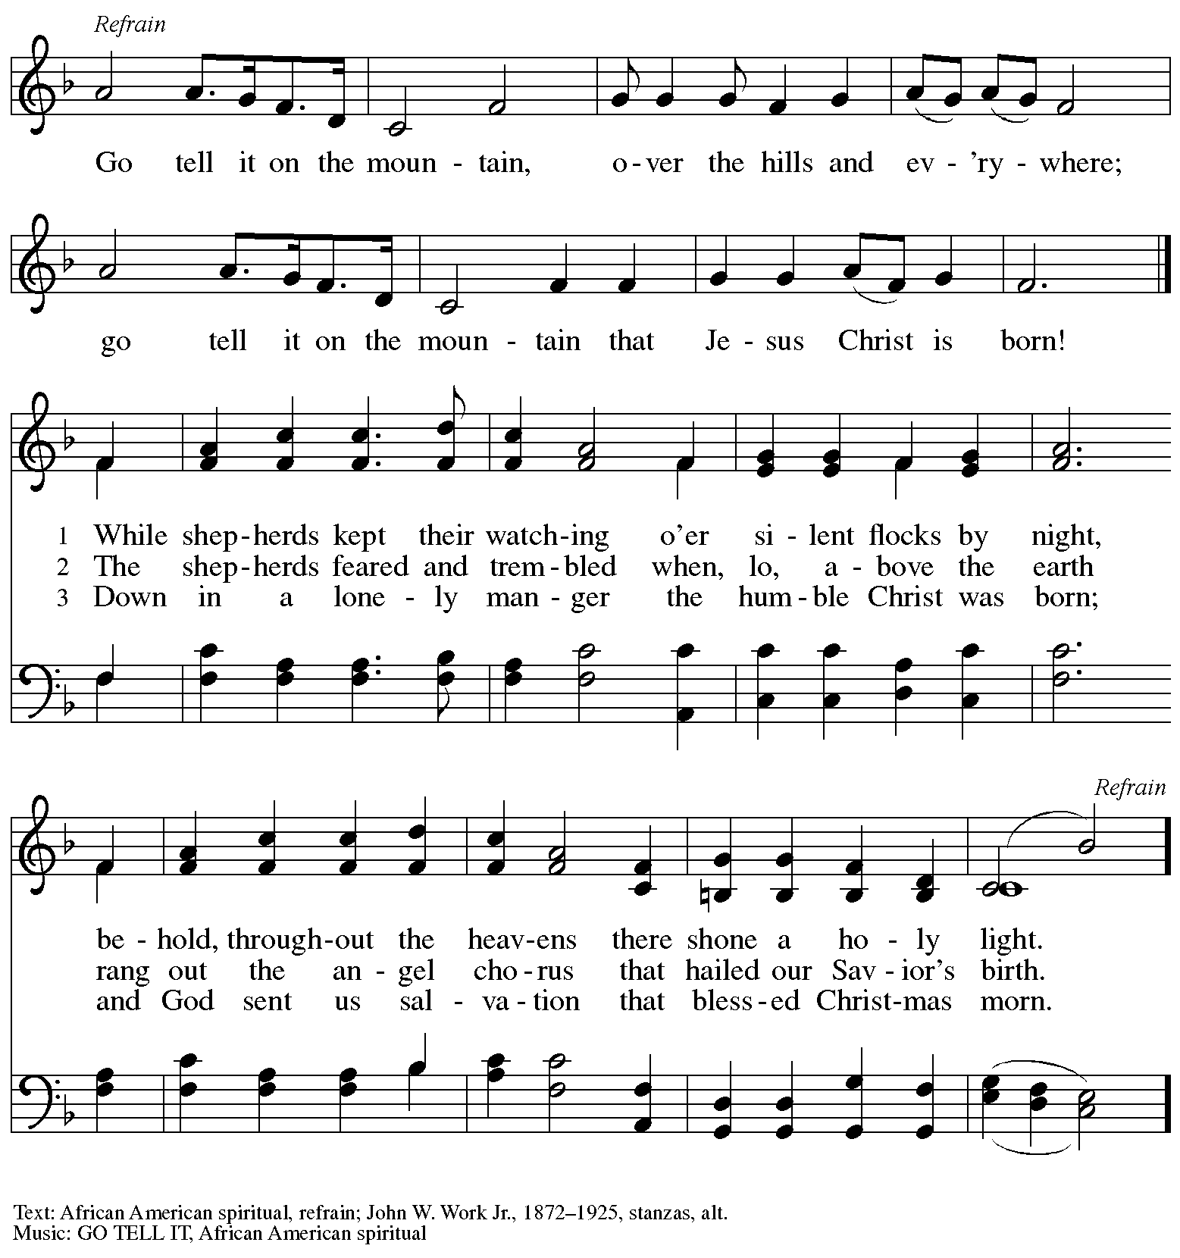

When all have returned to their places, please rise as you are able.

Blessing

P: The body and blood of our Lord Jesus Christ strengthen you and keep you in his grace.
C: Amen.

Prayer

P: Let us pray.
Radiant God, you have brought us your salvation,
and in this meal, we have feasted on your grace.
May your Word take flesh in us, that we may be your holy people,
revealing your glory made known to us in Jesus Christ, our Savior and Lord.
C: Amen.

Sending
God blesses us and sends us in mission to the world

Benediction

P: God bless you and keep you,
☩ Jesus grant you grace and truth,
and the Spirit send peace upon your hearts,
now and forever.
C: Amen.

Sending Hymn Joy to the World Following page

Dismissal

P: Go in peace. Share the good news!
C: Thanks be to God!

Postlude

Sending Hymn Joy to the World ELW 267

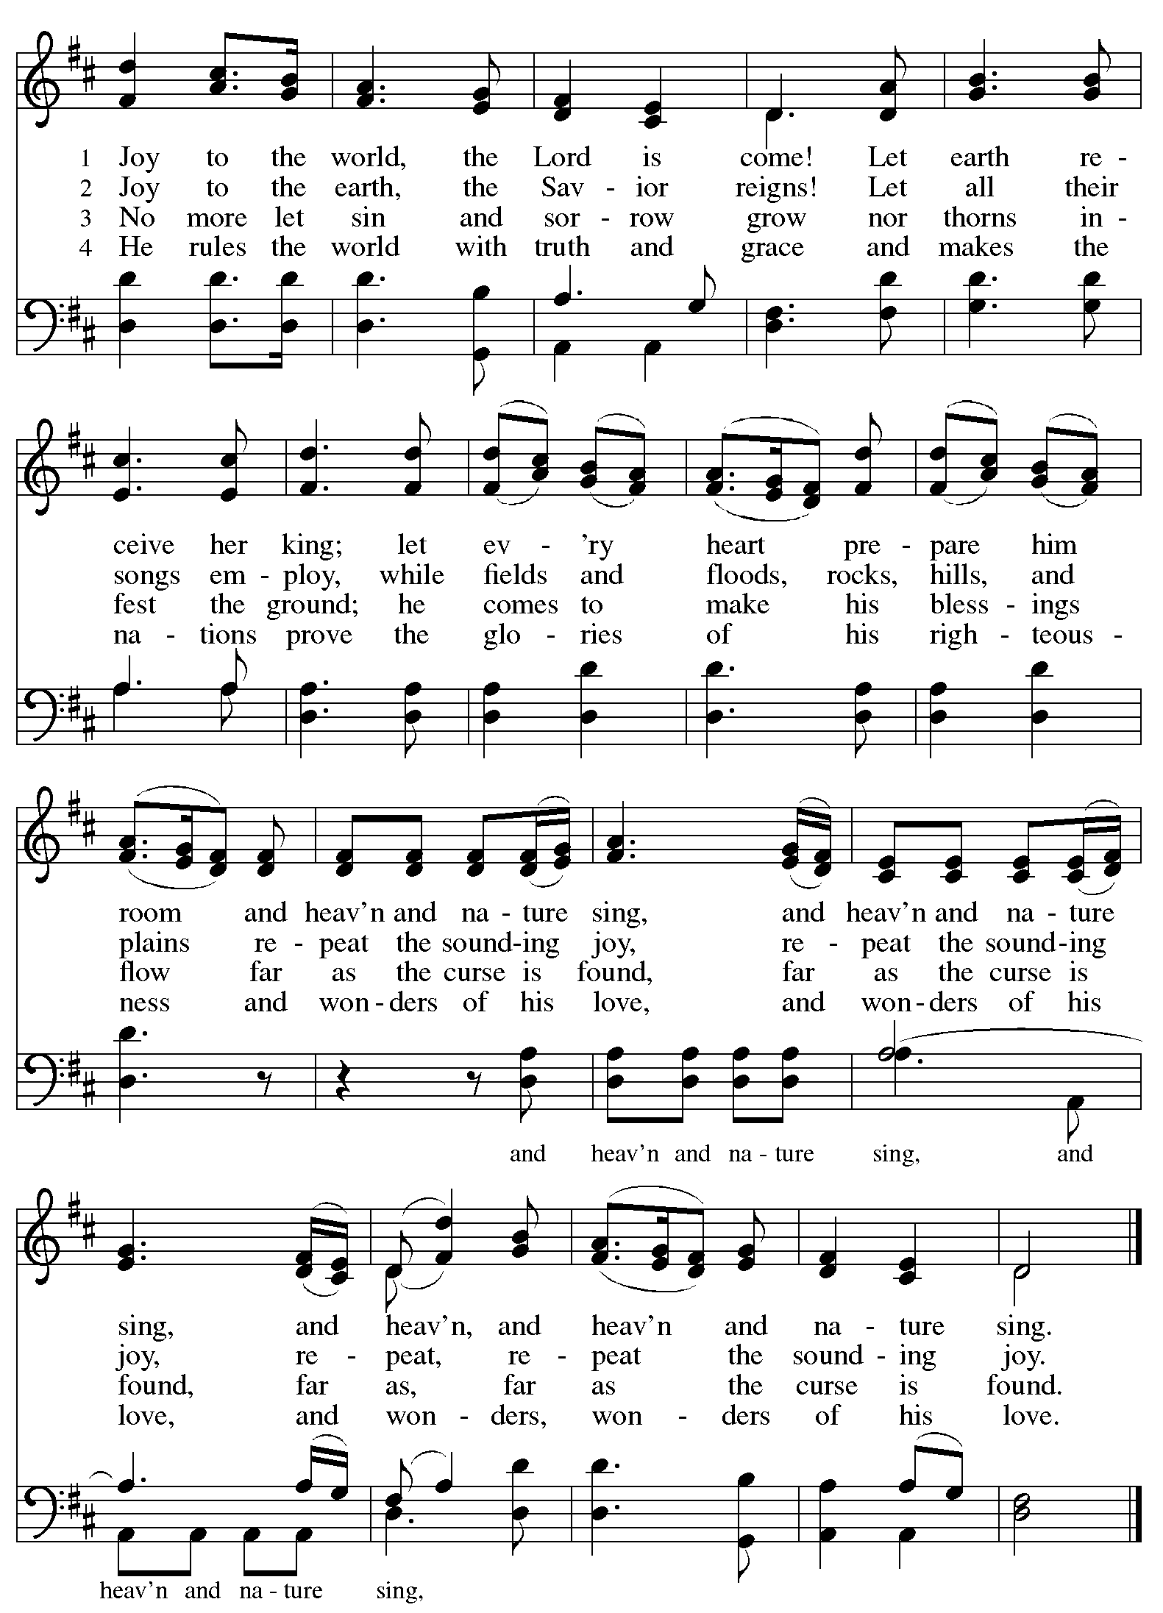
Those serving in worship

Altar Care Jodie Minor
Audio-Visual Minister Kristen Asplin
Cantor Richard Krug
Communion Assistant Lindsay Baxter
Lector Kelly Spanninger
Vocalists April Galyardt
Kai Galyardt
Minister of Music Laura Reynolds
Presiding and Preaching Minister The Rev. Ross I. Carmichael

Liturgy and Hymnody Acknowledgements

From SundaysandSeasons.com. Copyright © 2023 Augsburg Fortress. All rights reserved. Reprinted under OneLicense.net # A-722139.
Used by permission of Augsburg Fortress.

Angels We Have Heard on High – Text: French carol; tr. H. F. Hemy, The Crown of Jesus Music, 1864. Music: GLORIA, French carol; arr. Edward F. Barnes, 1881-1958.

O Little Town of Bethlehem – Text: Phillips Brooks, 1835—1893. Music: ST. LOUIS, Lewis H. Redner, 1831-1908.

It Came upon the Midnight Clear – Text: Edmund H. Sears, 1810-1876. Music: CAROL, Richard S. Willis, 1819-1900.

Please use the QR code below to link to St. Andrew’s Announcements online!

St. Andrew Lutheran Church Announcements
December 24th, 2023

- Welcome to worship at St. Andrew on the Nativity of our Lord – Christmas Eve, December 24th, 2023 – We are so glad you are here, and we offer a special welcome to all guests who are gathered here or online! There are worship “toolkits” to help children engage with worship and “busy bags” for younger children available in the bookcase at the back of the sanctuary. Please feel free to take one to use with/for your children.
- Christ in Our Home Devotional Booklets for January - March Available at Church Entrances – This resource offers a daily Bible reading with a short reflection and prayer, along with additional readings and prayer topics for those who would like to expand their devotional practices. We encourage people of the congregation to take one for yourself, your family unit, or others!
- Weekly Worship at St. Andrew is on Sundays at 10:00 a.m. – All Are Welcome!

