+ Second Sunday after Epiphany
January 14th, 2024
10:00 a.m.

St. Andrew Lutheran Church
304 Morewood Ave.
Pittsburgh, PA 15213
412.682.3342
St_andrewELCA@verizon.net
www.standrewpittsburgh.org

+ Second Sunday after Epiphany
Order for Worship

All the baptized have a calling in God’s world. God calls not just pastors and deacons but also the youngest child, like Samuel. The story of the calling of Nathanael plays with the idea of place. Nathanael initially dismisses Jesus because he comes from Nazareth. But where we come from isn’t important; it’s where—or rather whom—we come to. Jesus refers to Jacob, who had a vision in a place he called “the house of God, and … the gate of heaven” (Gen. 28:17). Jesus says he is the place where Nathanael will meet God.

Welcome to St. Andrew!
- St. Andrew Lutheran congregation welcomes all who are seeking a place of healing and wholeness – a nurturing, faith-forming spiritual home. Our community embraces people of all ages, ethnicities, cultures, abilities, sexual orientations, gender identities and expressions, and family constellations. Come and See!
- Worship Services are live streamed to multiple online platforms. By attending worship, you agree that your image and voice may be broadcast.
- Everyone is invited to make a nametag at the black bookcase in the back of the worship space if they would like. There are stickers indicating pronouns on the bookcase if you would like to include them on your name tag.
- Children are invited to attend Little Church – Big Faith, a Bible lesson and activity, during worship (after the Prayer of the Day). The group returns to the worship space for the liturgy of Holy Communion.
- Worship “toolkits” to help children engage with the service, along with “busy bags” for younger children, are available in the bookcase at the back of the sanctuary. Please feel free to take one to use with/for your children.
- Holy Communion is served with bread (gluten-free available) and wine or grape juice. The presiding minister will distribute the bread (host). Please consume this and then pick up an empty glass from the tray. The Communion Assistant will pour wine or grape juice into your glass. Please step to the side to consume the wine or grape juice. Feel free to kneel at the altar for prayer and reflection. As you return to your pew, glasses may be returned to the empty trays on either side of the center section.
- A restroom is available on the main level of the church, through the doors to the Social Hall and to the right in the main office.

Abbreviations

P: Pastor/Presiding Minister ELW: Evangelical Lutheran Worship hymnal
A: Assisting Minister ACS: All Creation Sings hymnal
L: Lector
C: Congregation

Welcome

Prelude Be Thou My Vision arr. Carter

Gathering
The Holy Spirit calls us together as the people of God

Confession and Forgiveness

Please rise as you are able. All may make the sign of the cross,
the sign that is marked at Baptism, as the presiding minister begins.

P: Blessed be the holy Trinity, ☩ one God,
creator of darkness and light, word of truth,
our life and our salvation.
C: Amen.

P: Let us confess our sin in the presence of God and of one another.

Silence is kept for reflection.

P: God, our rock and refuge,
C: We confess that we have sinned against you
and wounded one another.
We have not loved you and our neighbors as you have loved us.
We have not always recognized the Holy Spirit dwelling in each of us.
Remember your covenant.
Renew your creation.
Restore us,
that we might proclaim your good news to all.
Amen.

P: The voice of the Lord is upon the waters.
God has spoken: The time of grace is now.
In Jesus, the reign of God has come near.
By the authority of ☩ Jesus Christ, your sins are forgiven.
You are God’s beloved.
C: Amen.

Gathering Hymn Dearest Jesus, at Your Word ELW 520

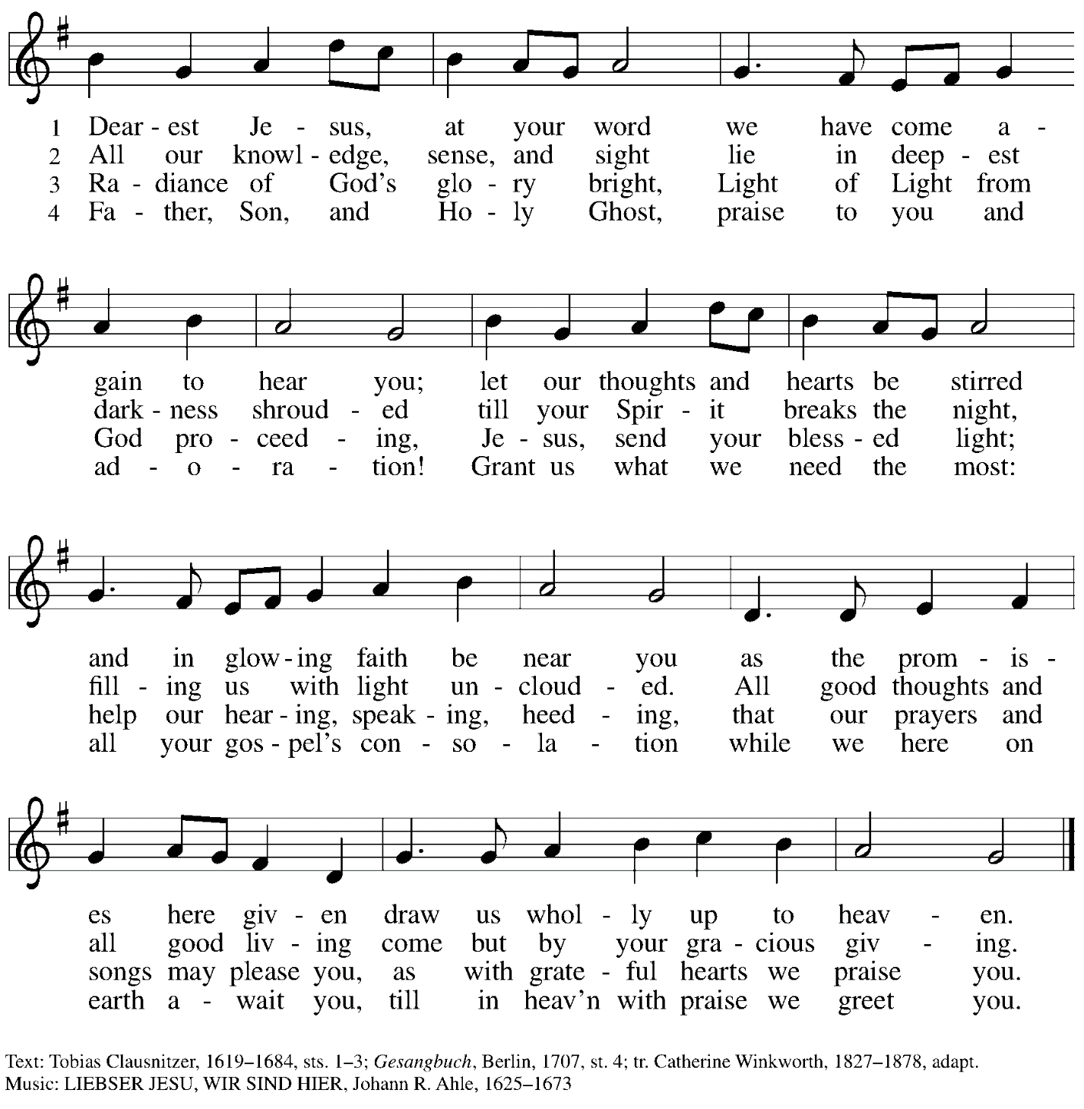

Greeting

P: The grace of our Lord Jesus Christ, the love of God,
and the communion of the Holy Spirit be with you all.
C: And also with you.

Hymn of Praise

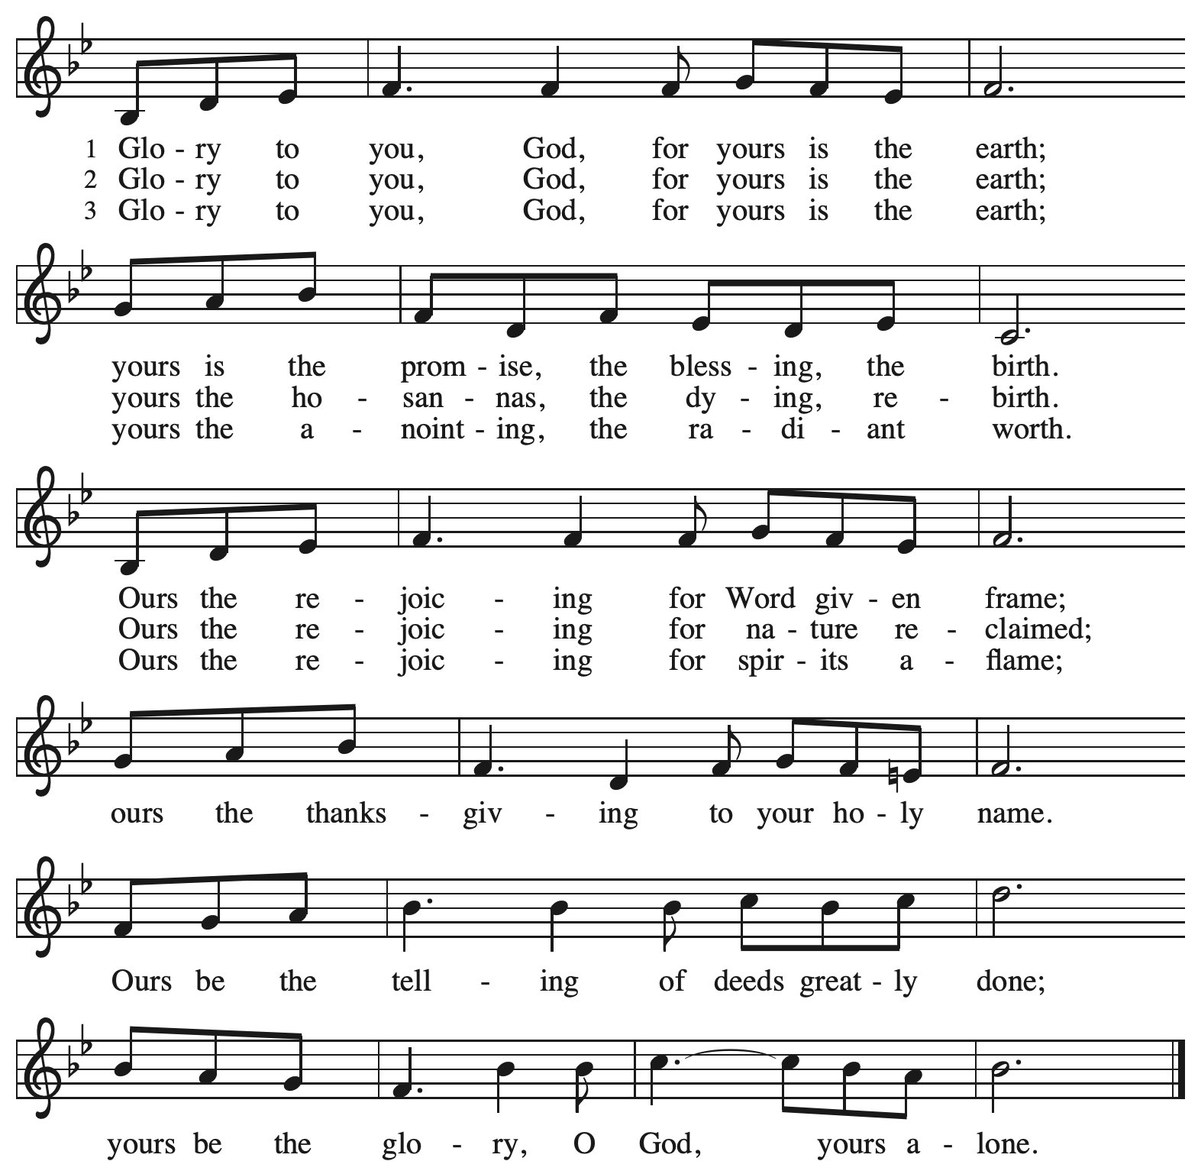

Prayer of the Day

P: Let us pray. Loving God, you have revealed you glory and led many to faith by the works of your son. As he brought gladness, healing, and to his people, grant us these same gifts and lead us also to follow him faithfully, through Jesus Christ our Lord.
C: Amen.

Please be seated.
Children are invited to join the adult leaders at the door and move to the office for Little Church – Big Faith. We ask that one additional adult from the congregation attend with the children.

Word
God speaks to us in Scripture reading, preaching, and song

First Reading – 1 Samuel 3: 1-10

¹Now the boy Samuel was ministering to the Lord under Eli. The word of the Lord was rare in those days; visions were not widespread.
²At that time Eli, whose eyesight had begun to grow dim so that he could not see, was lying down in his room; ³the lamp of God had not yet gone out, and Samuel was lying down in the temple of the Lord, where the ark of God was. ⁴Then the Lord called, “Samuel! Samuel!” and he said, “Here I am!” ⁵and ran to Eli, and said, “Here I am, for you called me.” But he said, “I did not call; lie down again.” So he went and lay down. ⁶The Lord called again, “Samuel!” Samuel got up and went to Eli, and said, “Here I am, for you called me.” But he said, “I did not call, my son; lie down again.” ⁷Now Samuel did not yet know the Lord, and the word of the Lord had not yet been revealed to him. ⁸The Lord called Samuel again, a third time. And he got up and went to Eli, and said, “Here I am, for you called me.” Then Eli perceived that the Lord was calling the boy. ⁹Therefore Eli said to Samuel, “Go, lie down; and if he calls you, you shall say, ‘Speak, Lord, for your servant is listening.’” So Samuel went and lay down in his place.
¹⁰Now the Lord came and stood there, calling as before, “Samuel! Samuel!” And Samuel said, “Speak, for your servant is listening!”

L: Word of God, word of life.
C: Thanks be to God.

Psalm 139: 1-6, 13-18

Psalm tone

Psalm refrain

¹Lord, you have | searched me out;
O Lord, you | have known me.
²You know my sitting down and my | rising up;
you discern my thoughts | from afar.
³You trace my journeys and my | resting-places
and are acquainted with | all my ways.
⁴Indeed, there is not a word | on my lips,
but you, O Lord, know it | altogether. R
⁵You encompass me, behind | and before,
and lay your | hand upon me.
⁶Such knowledge is too wonder- | ful for me;
it is so high that I cannot at- | tain to it.
¹³For you yourself created my | inmost parts;
you knit me together in my | mother’s womb.
¹⁴I will thank you because I am mar- | velously made;
your works are wonderful, and I | know it well. R
¹⁵My body was not hid- | den from you,
while I was being made in secret and woven in the depths | of the earth.
¹⁶Your eyes beheld my limbs, yet unfinished in the womb; all of them were written | in your book;
my days were fashioned before they | came to be.
¹⁷How deep I find your | thoughts, O God!
How great is the | sum of them!
¹⁸If I were to count them, they would be more in number | than the sand;
to count them all, my life span would need to | be like yours. R

Second Reading – 1 Corinthians 6: 12-20

¹²“All things are lawful for me,” but not all things are beneficial. “All things are lawful for me,” but I will not be dominated by anything. ¹³“Food is meant for the stomach and the stomach for food,” and God will destroy both one and the other. The body is meant not for fornication but for the Lord, and the Lord for the body. ¹⁴And God raised the Lord and will also raise us by his power. ¹⁵Do you not know that your bodies are members of Christ? Should I therefore take the members of Christ and make them members of a prostitute? Never! ¹⁶Do you not know that whoever is united to a prostitute becomes one body with her? For it is said, “The two shall be one flesh.” ¹⁷But anyone united to the Lord becomes one spirit with him. ¹⁸Shun fornication! Every sin that a person commits is outside the body; but the fornicator sins against the body itself. ¹⁹Or do you not know that your body is a temple of the Holy Spirit within you, which you have from God, and that you are not your own? ²⁰For you were bought with a price; therefore glorify God in your body.

L: Word of God, word of life.
C: Thanks be to God.

Please rise as you are able.

Gospel Acclamation Alleluia ACS p. 151

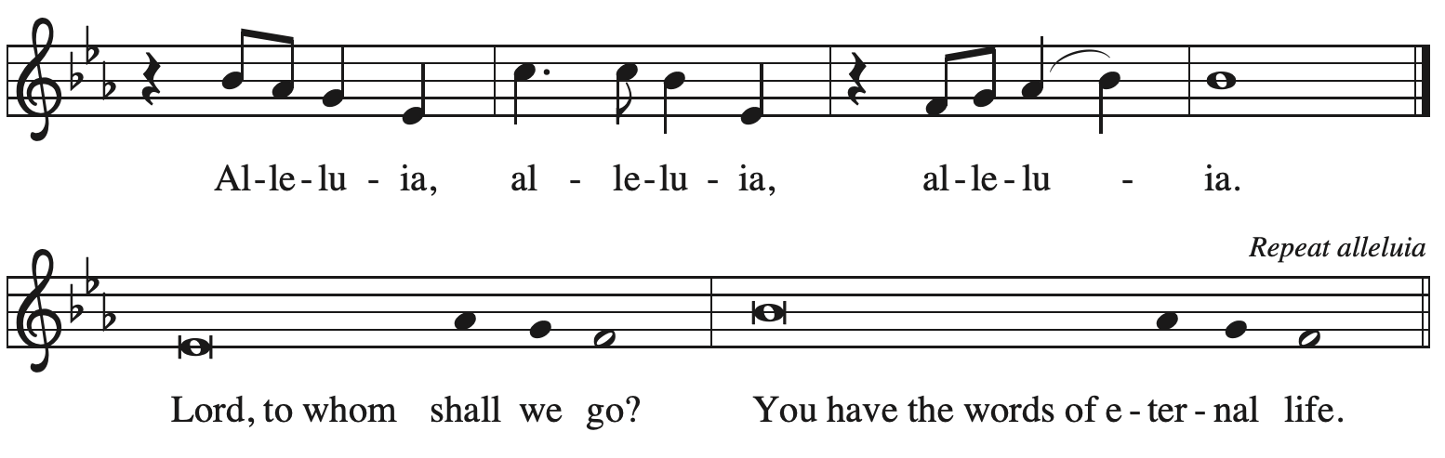

Gospel – John 1: 43-51

P: The holy Gospel according to St. John.
C: Glory to you, O Lord.

⁴³The next day Jesus decided to go to Galilee. He found Philip and said to him, “Follow me.” ⁴⁴Now Philip was from Bethsaida, the city of Andrew and Peter. ⁴⁵Philip found Nathanael and said to him, “We have found him about whom Moses in the law and also the prophets wrote, Jesus son of Joseph from Nazareth.” ⁴⁶Nathanael said to him, “Can anything good come out of Nazareth?” Philip said to him, “Come and see.” ⁴⁷When Jesus saw Nathanael coming toward him, he said of him, “Here is truly an Israelite in whom there is no deceit!” ⁴⁸Nathanael asked him, “Where did you get to know me?” Jesus answered, “I saw you under the fig tree before Philip called you.” ⁴⁹Nathanael replied, “Rabbi, you are the Son of God! You are the King of Israel!” ⁵⁰Jesus answered, “Do you believe because I told you that I saw you under the fig tree? You will see greater things than these.” ⁵¹And he said to him, “Very truly, I tell you, you will see heaven opened and the angels of God ascending and descending upon the Son of Humanity.”

P: The Gospel of the Lord.
C: Praise to you, O Christ.

Please be seated.
Sermon

A time of silence for prayer and reflection follows the sermon.
As the hymn of the day begins, please rise as you are able.

Hymn of the Day Will You Come and Follow Me Following page

Hymn of the Day Will You Come and Follow Me ELW 798

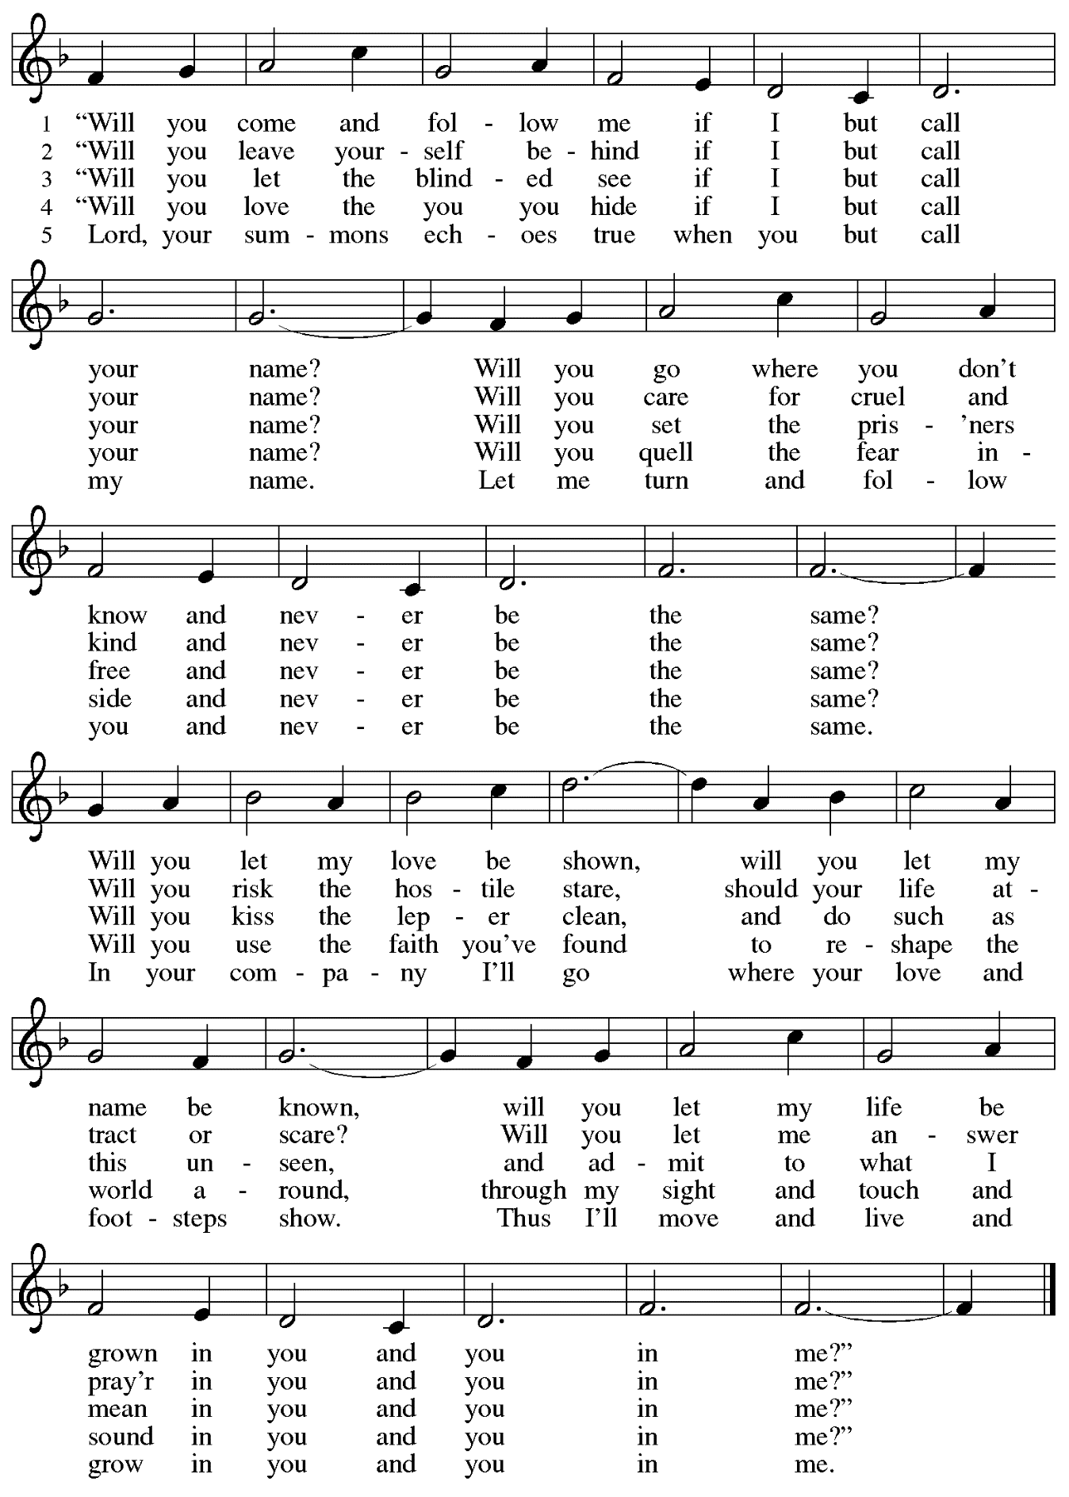
Apostles Creed

P: With the whole church throughout the world, let us confess our faith:
C: I believe in God, the Father almighty,
creator of heaven and earth.

I believe in Jesus Christ, God’s only Son, our Lord,
who was conceived by the Holy Spirit,
born of the virgin Mary,
suffered under Pontius Pilate,
was crucified, died, and was buried;
he descended to the dead.*
On the third day he rose again;
he ascended into heaven,
he is seated at the right hand of the Father,
and he will come to judge the living and the dead.

I believe in the Holy Spirit,
the holy catholic church,
the communion of saints,
the forgiveness of sins,
the resurrection of the body,
and the life everlasting. Amen.

*Or, “he descended into hell,” another translation of this text in widespread use.

Prayers of the People

A: Called together to follow Jesus, let us pray for the church, the world,
and all who are in need.

After each petition
A: God of grace,
C: receive our prayer.

The presiding minister concludes the prayers
P: Knowing that the Holy Spirit intercedes for us, we offer these prayers
and the silent prayers of our hearts to you, O God, through Jesus Christ, our Savior.
C: Amen.

Peace

The presiding minister and the assembly greet one another in the peace of the risen Christ.
P: The peace of Christ be with you always.
C: And also with you.

The people may greet those around them with a sign of Christ’s peace and may say
Peace be with you or similar words. Please be mindful that not everyone will be comfortable with sharing the peace, so please seek consent before shaking hands or hugging. Other possible ways to share the peace include a simple bow with the verbal greeting of peace, or simply a verbal expression of peace.

When the greetings of peace have concluded, please be seated.

Meal
God feeds us with the presence of Jesus Christ

Offering

We offer ourselves, our gifts, and our faithful service to God.
As the offering is gathered for the mission of the church, including the care of those in need,
the table is set for Holy Communion.

Music during the Offering
Just As I Am arr. Bober

As the gifts are brought forward for presentation, please rise as you are able.

Offertory Song God of the Fertile Fields ACS 1063
v. 2-4

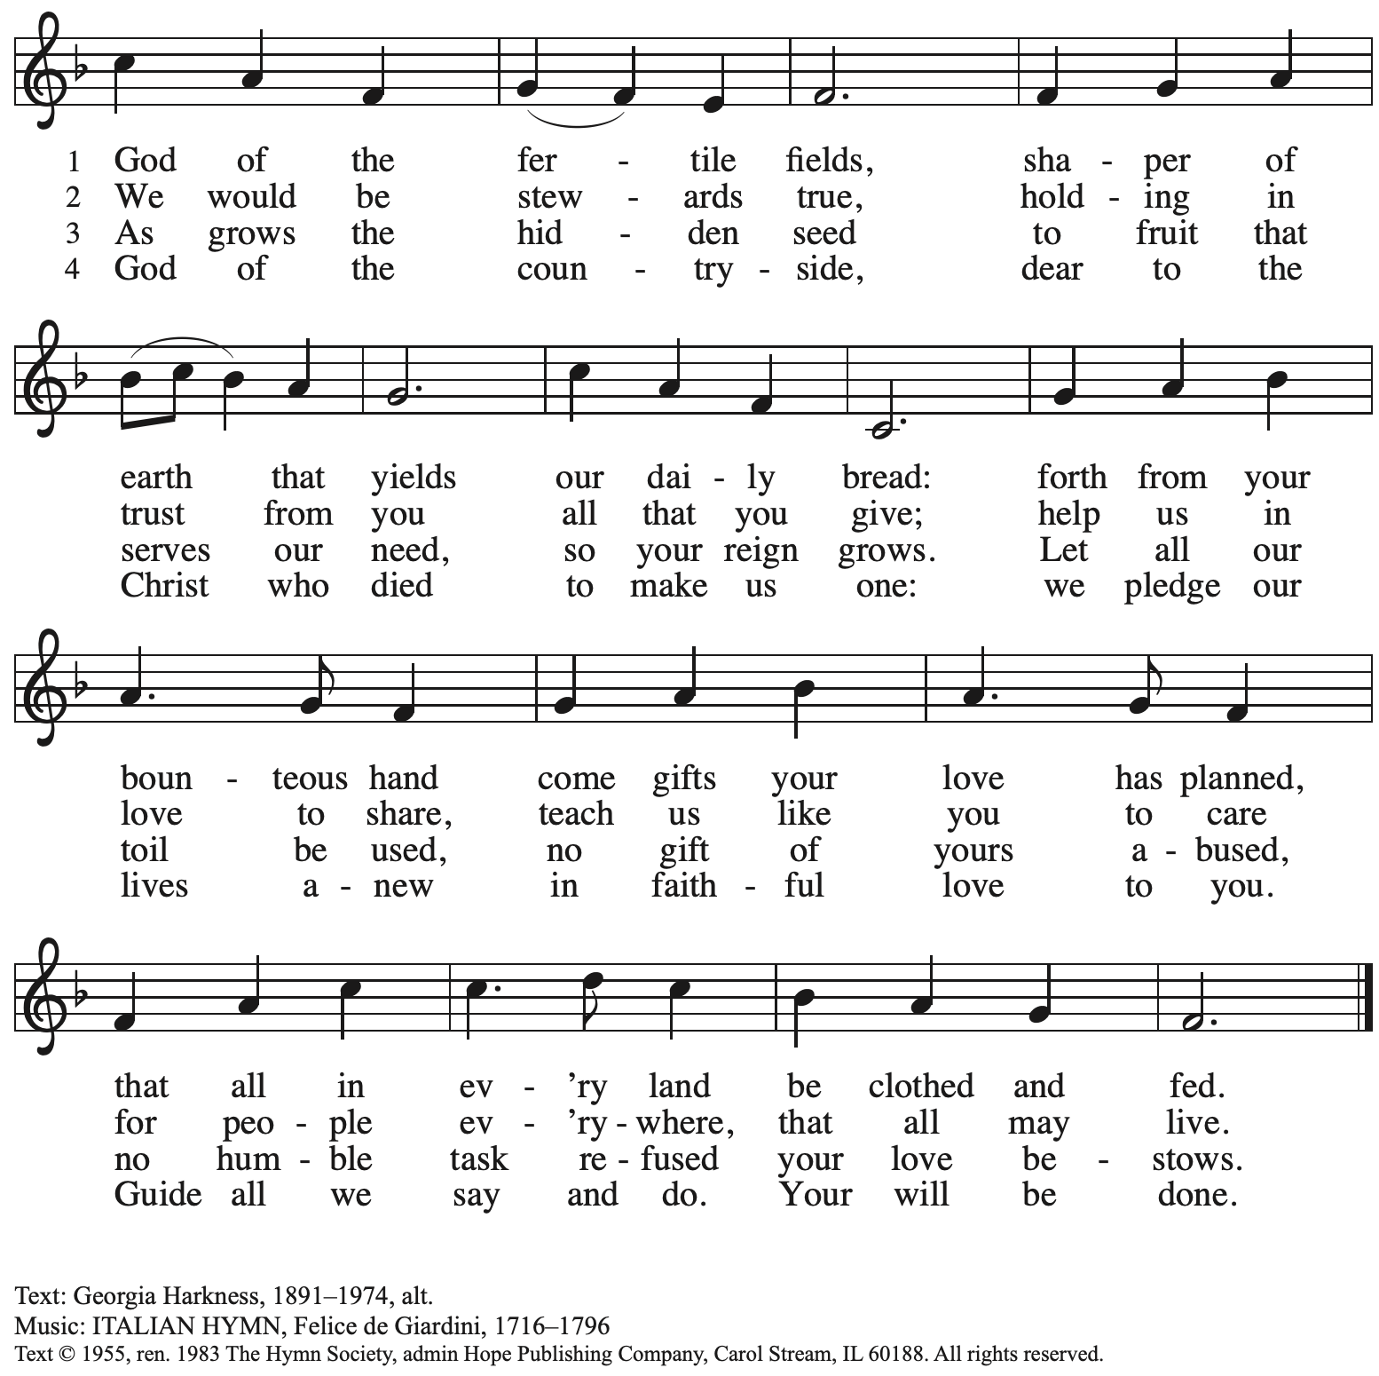
Reprinted with permission under OneLicense.net # A-722139.

Offertory Prayer

A: Let us pray.
Blessed are you,
C: O God, maker of all things.
Through your goodness you have blessed us with these gifts:
our selves, our time, and our possessions.
Work through us and what we have gathered
to feed the world with your love,
through the one who gave himself for us,
Jesus Christ, our Savior and Lord. Amen.

Dialogue ACS p. 36

P: The Lord be with you.
C: And also with you.

P: Lift up your hearts.
C: We lift them to the Lord.

P: Let us give thanks to the Lord our God.
C: It is right to give our thanks and praise.

Preface

P: It is indeed right, our duty and our joy,
that we should at all times and in all places
give thanks and praise to you, almighty and merciful God,
through our Savior Jesus Christ;
who on this day overcame death and the grave,
and by his glorious resurrection opened to us the way of everlasting life.
And so, with all the choirs of angels,
with the church on earth and the hosts of heaven,
we praise your name and join their unending hymn:

Sanctus ELW p. 36

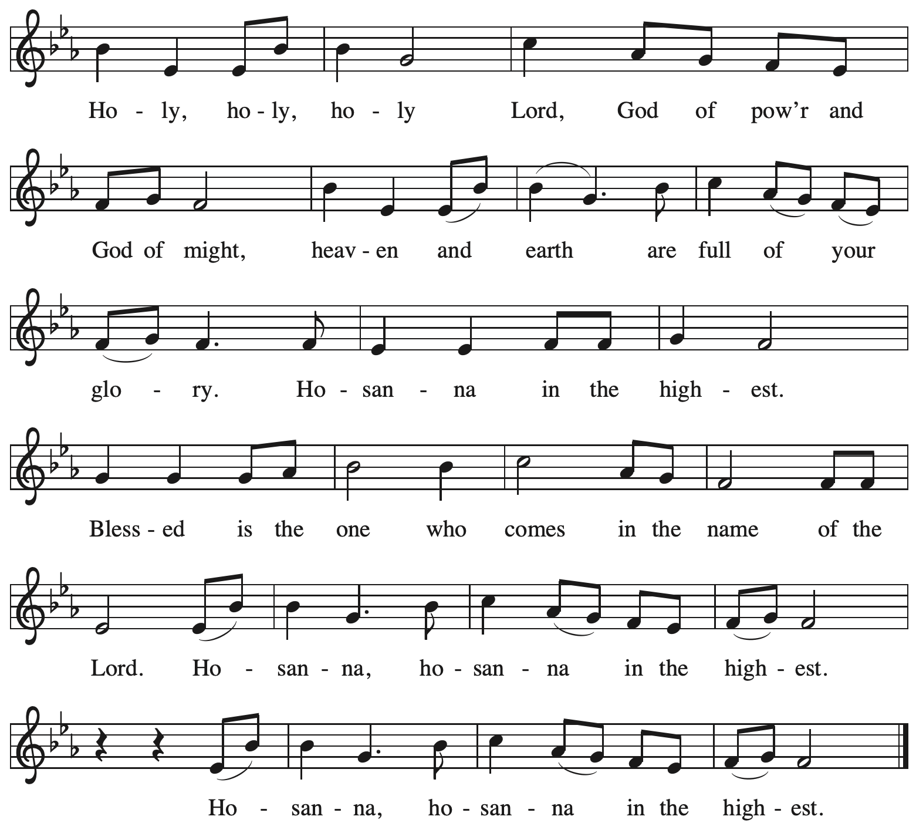

Eucharistic Prayer

P: Holy God, holy and merciful, your people praise you, saying:
Your mercy endures forever.
C: Your mercy endures forever.

P: By your promise you bound yourself to earth and all its creatures, granting them life
and calling them to flourish, setting the sign of the bow in the clouds, the colors of your love
and faithfulness. Your mercy endures forever.
C: Your mercy endures forever.

P: By your promise you bound yourself to your people of old,
blessing them with family outnumbering the stars and calling them to be a blessing to others,
showing them steadfast love in every generation and calling them to be a light to the nations.
Your mercy endures forever.
C: Your mercy endures forever.

P: By your promise you joined us to Jesus, your Beloved …
… Do this for the remembrance of me.

With this bread and cup
we remember his life laid down and lifted up
as we proclaim the mystery of faith.
C: Christ has died. Christ is risen. Christ will come again.

P: Send your Holy Spirit upon us …
… in your Spirit, now and forever.
C: Amen.

Lord’s Prayer

P: Gathered as one by the Holy Spirit, let us pray as Jesus taught us.
C: Our Father in heaven,
hallowed be your name,
your kingdom come,
your will be done,
on earth as in heaven.
Give us today our daily bread.
Forgive us our sins
as we forgive those
who sin against us.
Save us from the time of trial
and deliver us from evil.
For the kingdom, the power,
and the glory are yours,
now and forever. Amen.

Fraction and Invitation

P: At Christ’s table, heaven and earth are joined as one.
Come and see.

Agnus Dei / Lamb of God ACS p. 40

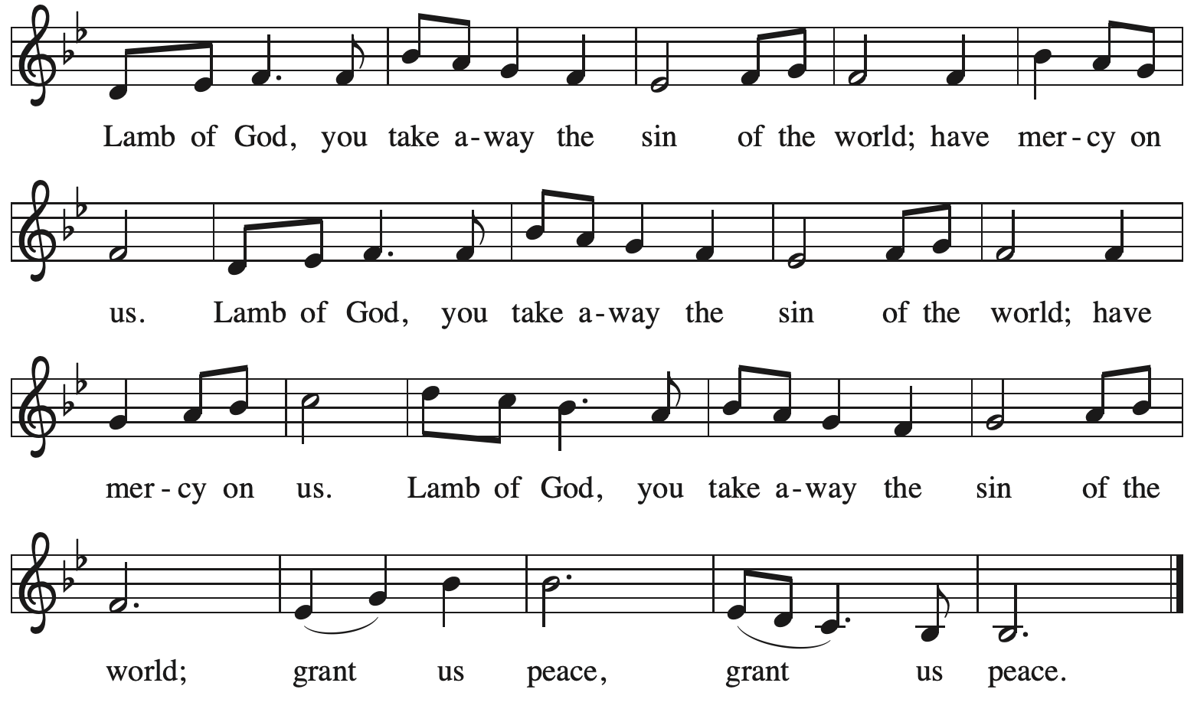

Please be seated.

Holy Communion
- All who seek God and desire a deeper and stronger life in Christ are welcome to receive Holy Communion.
- Worshipers from the pulpit side will proceed forward first, followed by the center section, and then the lectern side.
- Please inform an usher if you would like the ministers to bring Communion to you.
- Holy Communion will be served with bread and wine/grape juice.
- The presiding minister will first distribute the bread (host) to each communicant. Please indicate if you require a gluten-free host.
- Once you have consumed the bread, please pick up an empty glass from the tray next to the presiding minister. The Communion Assistant will pour wine from the chalice or grape juice from the cruet into your glass.
- Please step to the side to consume the wine or grape juice.
- Feel free to kneel at the altar rail for prayer after receiving the sacrament.
- As you return to your pew, glasses may be returned to the empty trays on either side of the center section.
- A blessing will be provided for anyone who does not yet receive the sacrament.
- All are invited to join in singing the hymns during Holy Communion.

Hymns during Holy Communion
The Son of God, Our Christ ELW 584

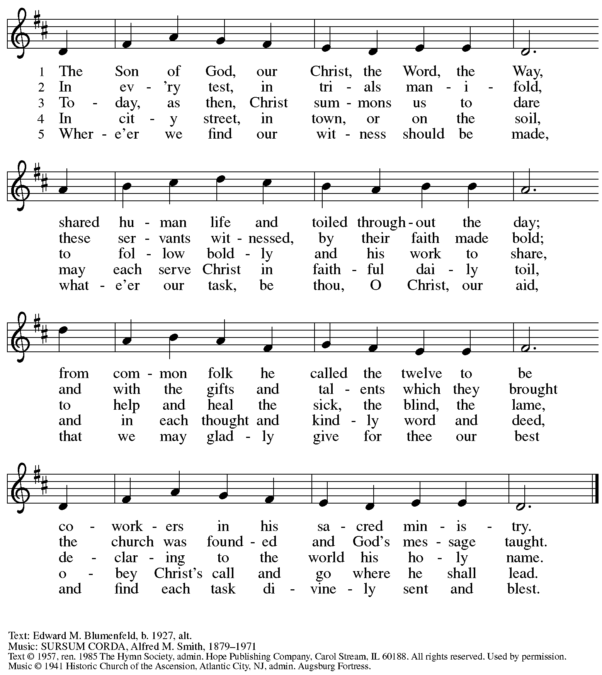
All rights reserved. Reprinted with permission under OneLicense.net # A-722139.

Hymns during Holy Communion
Come and See ACS 976

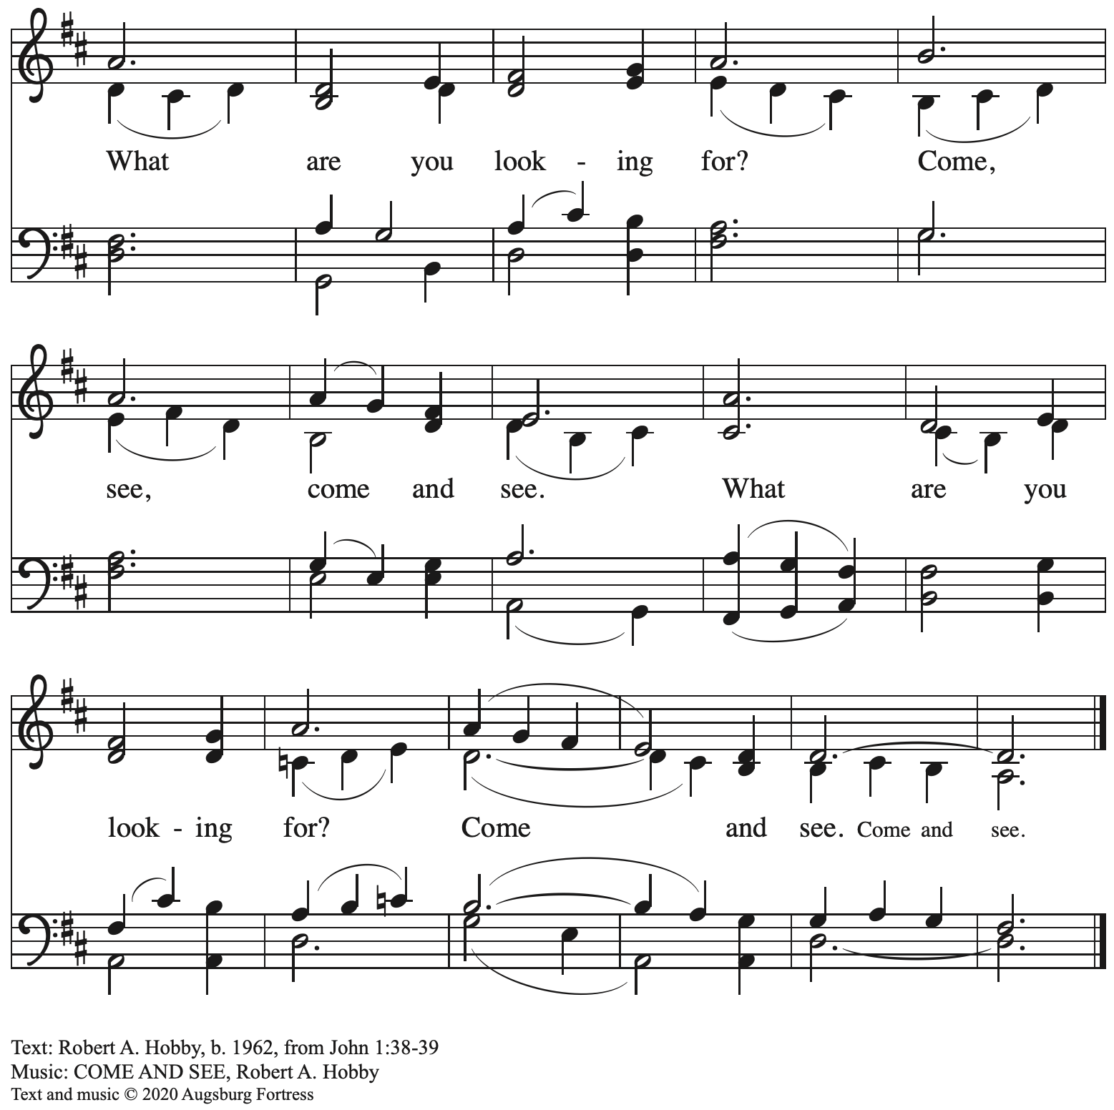
All rights reserved. Reprinted with permission under OneLicense.net # A-722139.

Hymns during Holy Communion
Thuma mina, Nkosi yam – Send Me, Jesus ELW 549

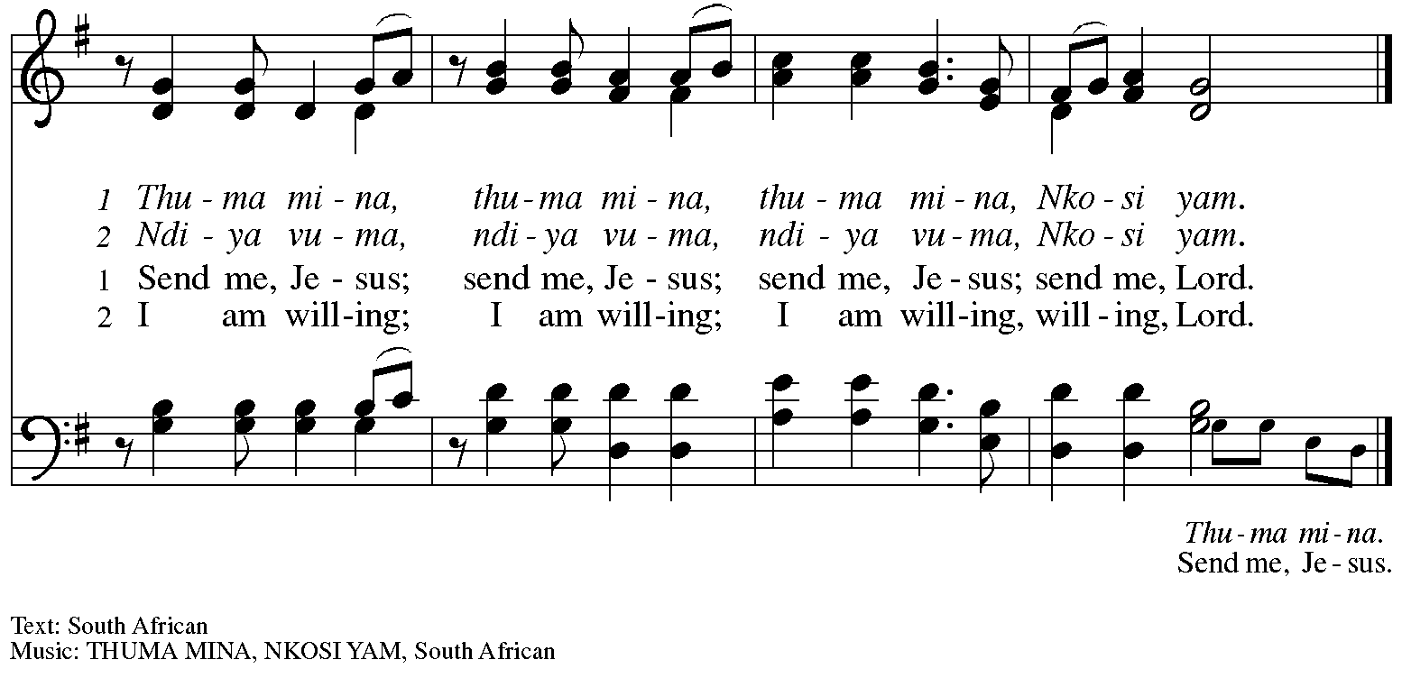

When all have returned to their places, please rise as you are able.

Blessing

P: The body and blood of our Lord Jesus Christ strengthen you and keep you in his grace.
C: Amen.

Prayer

A: Let us pray.
God of abundance, with this bread of life and cup of salvation you have united us with Christ, making us one with all your people. Now send us forth in the power of your Spirit,
that we may proclaim your redeeming love to the world
and continue forever in the risen life of Jesus Christ, our Lord.
C: Amen.

Please be seated.

Sending
God blesses us and sends us in mission to the world

Announcements

Please rise as you are able.

Benediction

P: God who names you,
Christ who claims you,
and the Holy Spirit who dwells in you,
☩ bless you now and forever.
C: Amen.

Sending Hymn Here I Am, Lord Following page

Dismissal

A: Go in peace. You are beloved.
C: Thanks be to God!

Postlude Take My Life and Let It Be L. Herold

Sending Hymn Here I Am, Lord ELW 574

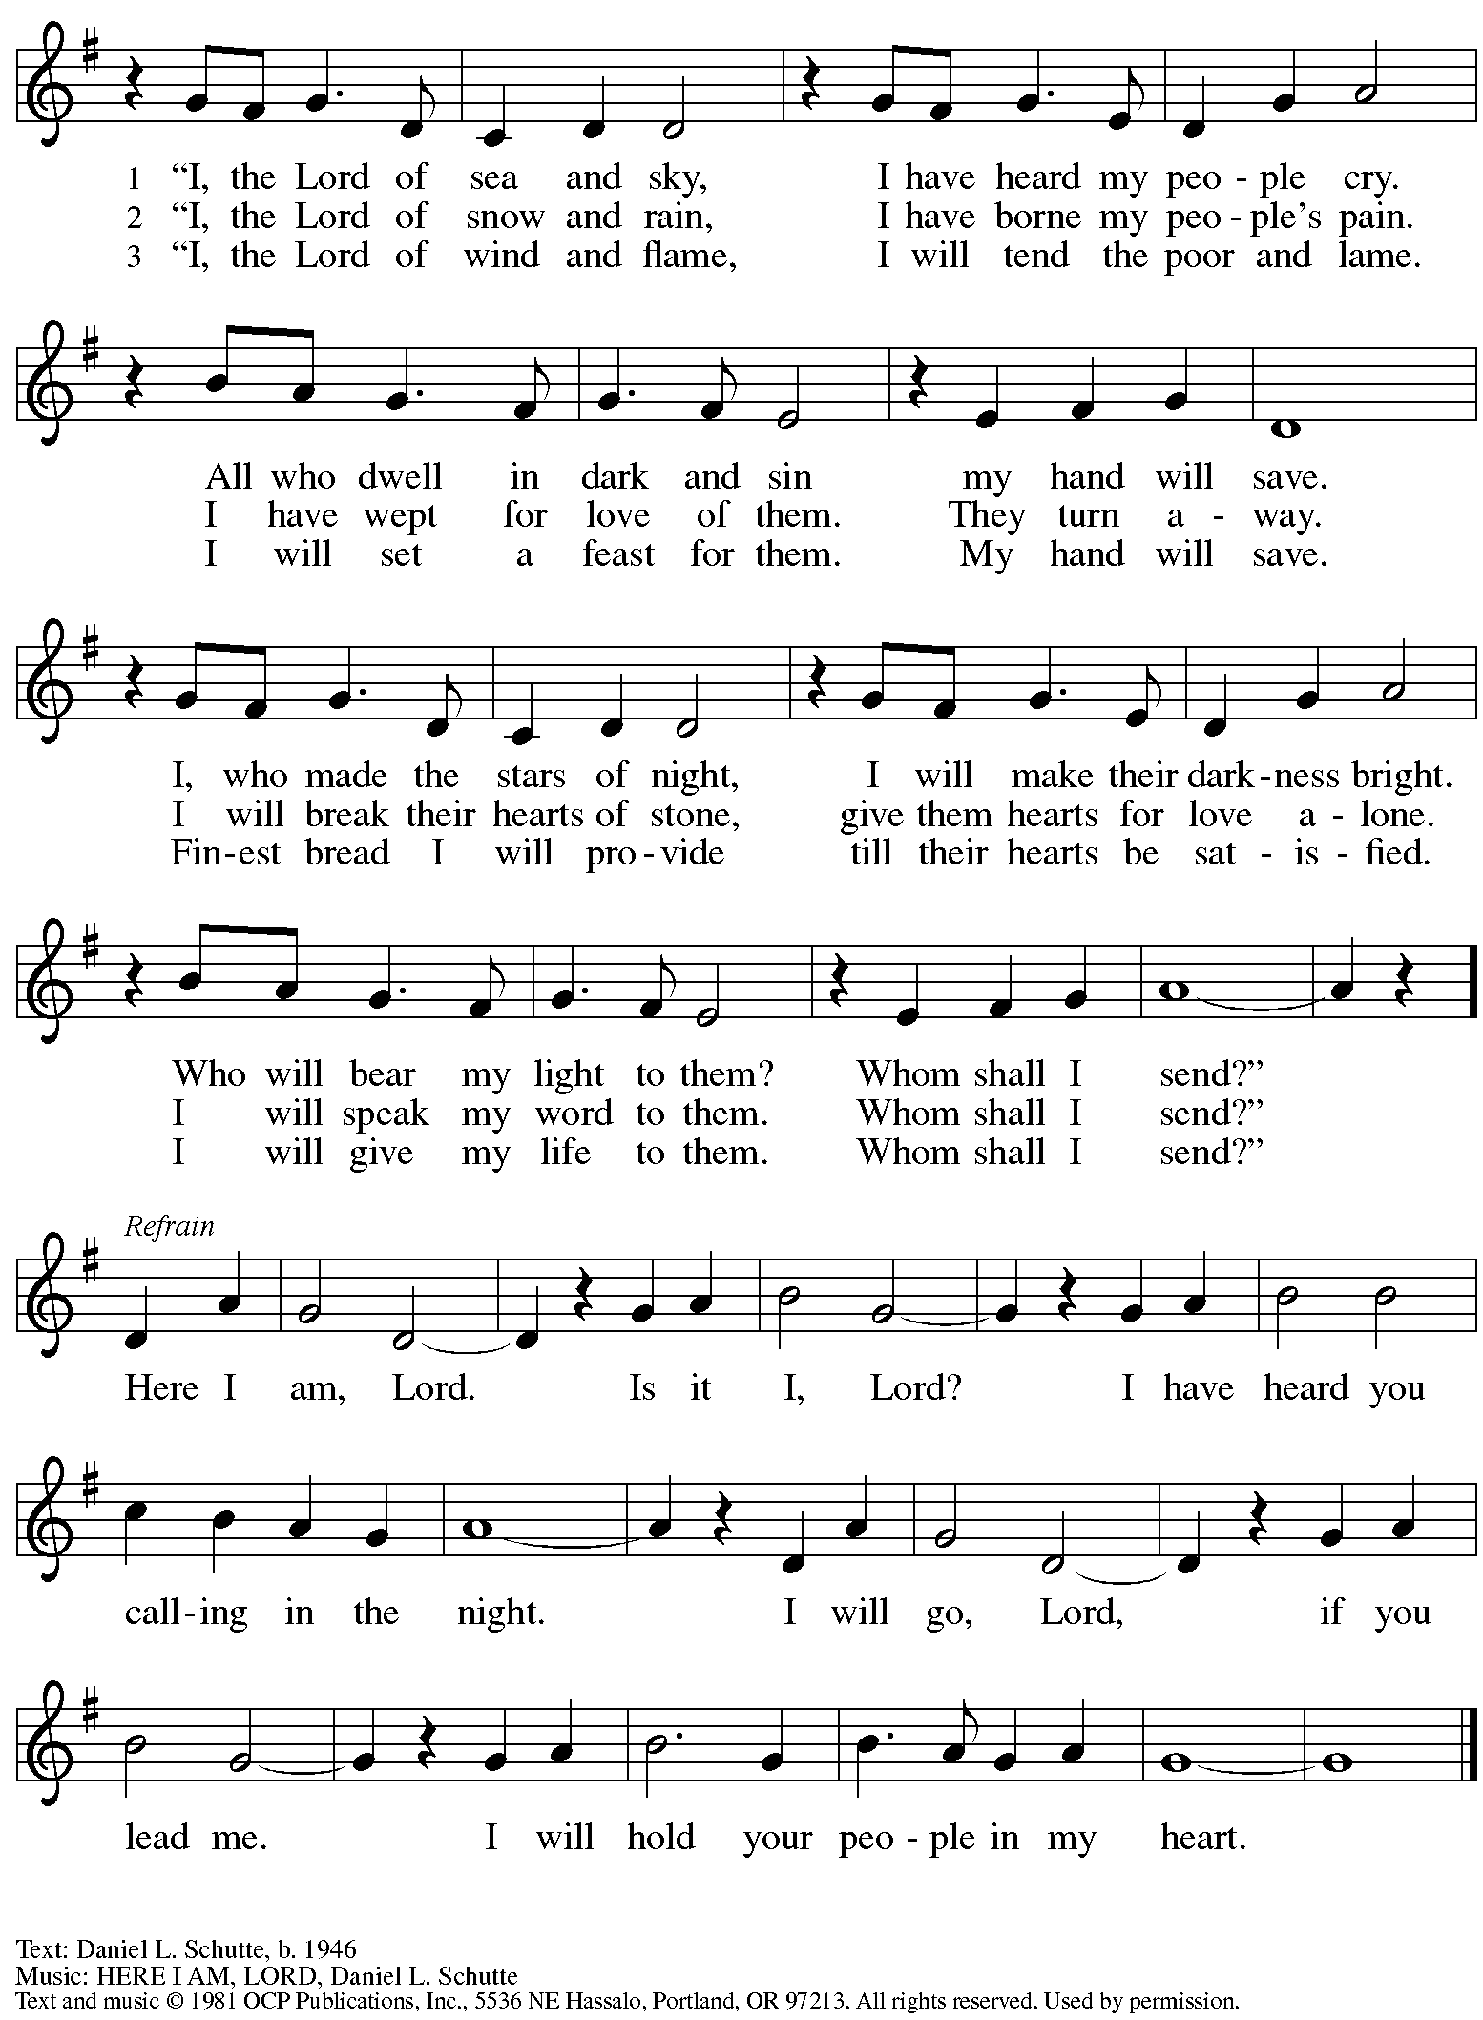
Reprinted with permission under OneLicense.net # A-722139.

Those serving in worship

Altar Care Christy Ruhe
Assisting Minister Tim Marker
Audio-Visual Ministers David Rollinson
Joseph Paetz
Cantor Libby Marker
Lector Kelly Spanninger
Little Church – Big Faith Teacher Sue Gaugler
Minister of Music Laura Reynolds
Piano – Hymn of the Day and Offertory Sarita
Presiding and Preaching Minister The Rev. Ross I. Carmichael

Liturgy and Hymnody Acknowledgements

From SundaysandSeasons.com. Copyright © 2024 Augsburg Fortress. All rights reserved. Reprinted under OneLicense.net # A-722139.
Used by permission of Augsburg Fortress.

Will You Come and Follow Me – Text: John L. Bell, b. 1949. Music: KELVINGROVE, Scottish traditional. Text © 1987 Iona Community, GIA Publications, Inc., agent. 7404 S. Mason Ave., Chicago, IL 60638. www.giamusic.com. 800.442.3358. All rights reserved. Reprinted with permission under OneLicense.net # A-722139.

Please use the QR code below to link to St. Andrew’s Announcements online!

St. Andrew Lutheran Church Announcements
January 14th, 2024

- Welcome to worship at St. Andrew on the Second Sunday after Epiphany, January 14th, 2024 – We are so glad you are here, and we offer a special welcome to all guests who are gathered at the church or online! Children are invited to participate in Little Church – Big Faith, a Bible lesson and activity, after the prayer of the day. There are worship “toolkits” to help children engage with worship and “busy bags” for younger children available in the bookcase at the back of the sanctuary. Please feel free to take one to use with/for your children.
- Online Event – An Evening with The Rev. Dr. Mitri Raheb, Lutheran Pastor and Founder of Dar Al-Kalima University in Bethlehem, Palestine – Monday, January 15th, 5:00-7:00 p.m. – The Rev. Dr. Mitri Raheb, a Lutheran Pastor, will be speaking at Lutheran Church of the Redeemer in Atlanta on Monday, January 15th, from 5:00-7:00 p.m. He will share updates on Dar Al-Kalima University, Palestine, and Lutheran Christians work in the Holy Land. The event will be livestreamed at https://www.redeemer.org/.
- Shelter Dinner at East End Cooperative Ministry – Thursday, January 18th, 6:30 p.m. – Each month, people of St. Andrew provide and serve a meal for the guests of the shelter at East End Cooperative Ministry (EECM), 6140 Station St., 15206. Anyone can sign up to prepare or purchase a portion of the meal to bring to EECM at 6:00 p.m. that day, or just come to help serve the meal at 6:30 p.m. If you would like to contribute, please sign up at: https://www.signupgenius.com/go/5080544AAAC22A1F58-46992157-jan.
- “Noisy Offering” to Return Sunday, January 21st – In the past, the children and youth of St. Andrew would lead the congregation in a “noisy offering” once a month. People of the congregation would bring loose change to worship to throw into metal buckets that the children brought around the church during the offering. All offerings went to support a local charitable organization on an occasional basis. St. Andrew would like to return to the Noisy Offering on the third Sunday of each month, beginning January 21st – Please save your change!
- Save the Date – Service of Prayer and Lament for the Holy Land – Saturday, January 27th at St. Andrew. Meal and Presentation – 5:00 p.m., Service – 6:00 p.m.
- Support Abuelas Responden – Grannies Respond with Donations of Used Winter Clothing Items – Abuelas Responden - Grannies Respond is a local organization that supports traveling asylum seekers as they come through Pittsburgh. The group goes to the downtown bus station to meet asylum seekers who have been released from the Moshannon Valley detention center and supply them with much needed items as they travel to join family or friends in other cities. The primary need is for warm winter clothing. A bin will be set up in the social hall to receive these items. Right now the most needed items are:
- Men’s warm (but not too bulky) coats, jackets, fleece hoodies - People need to be able to fit everything in bags so there is no space for a heavy coat.
- Men’s Pants and Shoes (Please no sweatpants - this is what the people receive in detention, so we want to avoid outfitting anyone with something that looks like prisoners’ clothes.
- Men’s gloves
- Christ in Our Home Devotional Booklets for January - March Available at Church Entrances – This resource offers a daily Bible reading with a short reflection and prayer, along with additional readings and prayer topics for those who would like to expand their devotional practices. We encourage people of the congregation to take one for yourself, your family unit, or others!

