

**+ Third Sunday after Epiphany**

**January 21st, 2024**

**10:00 a.m.**



**St. Andrew Lutheran Church**

**304 Morewood Ave.**

**Pittsburgh, PA 15213**

**412.682.3342**

[**St_andrewELCA@verizon.net**](mailto:St_andrewELCA@verizon.net)

[**www.standrewpittsburgh.org**](http://www.standrewpittsburgh.org)

**+ Third Sunday after Epiphany**

**Order for Worship**

*As we continue through the time after Epiphany, stories of the call to discipleship show us the implications of our baptismal calling to show Christ to the world. Jesus begins proclaiming the good news and calling people to repentance right after John the Baptist is arrested for preaching in a similar way. Knowing that John was later executed, we see at the very outset the cost of discipleship. Still, the two sets of brothers leave everything they have known and worked for all their lives to follow Jesus and fish for people.*

**Welcome to St. Andrew!**

* St. Andrew Lutheran congregation welcomes all who are seeking a place of healing and wholeness – a nurturing, faith-forming spiritual home. Our community embraces people of all ages, ethnicities, cultures, abilities, sexual orientations, gender identities and expressions, and family constellations. Come and See!
* Worship Services are live streamed to multiple online platforms. By attending worship, you agree that your image and voice may be broadcast.
* Everyone is invited to make a nametag at the black bookcase in the back of the worship space if they would like. There are stickers indicating pronouns on the bookcase if you would like to include them on your name tag.
* Children are invited to attend Little Church – Big Faith, a Bible lesson and activity, during worship (after the Prayer of the Day). The group returns to the worship space for the liturgy of Holy Communion.
* Worship “toolkits” to help children engage with the service, along with “busy bags” for younger children, are available in the bookcase at the back of the sanctuary. Please feel free to take one to use with/for your children.
* Holy Communion is served with bread (gluten-free available) and wine or grape juice. The presiding minister will distribute the bread (host). Please consume this and then pick up an empty glass from the tray. The Communion Assistant will pour wine or grape juice into your glass. Please step to the side to consume the wine or grape juice. Feel free to kneel at the altar for prayer and reflection. As you return to your pew, glasses may be returned to the empty trays on either side of the center section.
* A restroom is available on the main level of the church, through the doors to the Social Hall and to the right in the main office.

*Abbreviations*

P: Pastor/Presiding Minister ***ELW*: *Evangelical Lutheran Worship* hymnal**

A: Assisting Minister ***ACS*: *All Creation Sings* hymnal**

L: Lector

**C: Congregation**

**Welcome**

**Prelude** *What Wondrous Love Is This* arr. M. Howarth

**Gathering**

*The Holy Spirit calls us together as the people of God*

**Confession and Forgiveness**

*Please rise as you are able. All may make the sign of the cross,*

*the sign that is marked at Baptism, as the presiding minister begins.*

P: Blessed be the holy Trinity, ☩ one God,

creator of darkness and light, word of truth,

our life and our salvation.

**C: Amen.**

P: Let us confess our sin in the presence of God and of one another.

*Silence is kept for reflection.*

P: God, our rock and refuge,

**C: We confess that we have sinned against you**

**and wounded one another.**

**We have not loved you and our neighbors as you have loved us.**

**We have not always recognized the Holy Spirit** **dwelling in each of us.**

**Remember your covenant.**

**Renew your creation.**

**Restore us,**

**that we might proclaim your good news to all.**

**Amen.**

P: The voice of the Lord is upon the waters.

God has spoken: The time of grace is now.

In Jesus, the reign of God has come near.

By the authority of ☩ Jesus Christ, your sins are forgiven.

You are God’s beloved.

**Gathering Hymn Faith Begins by Letting Go *ACS* 1004**

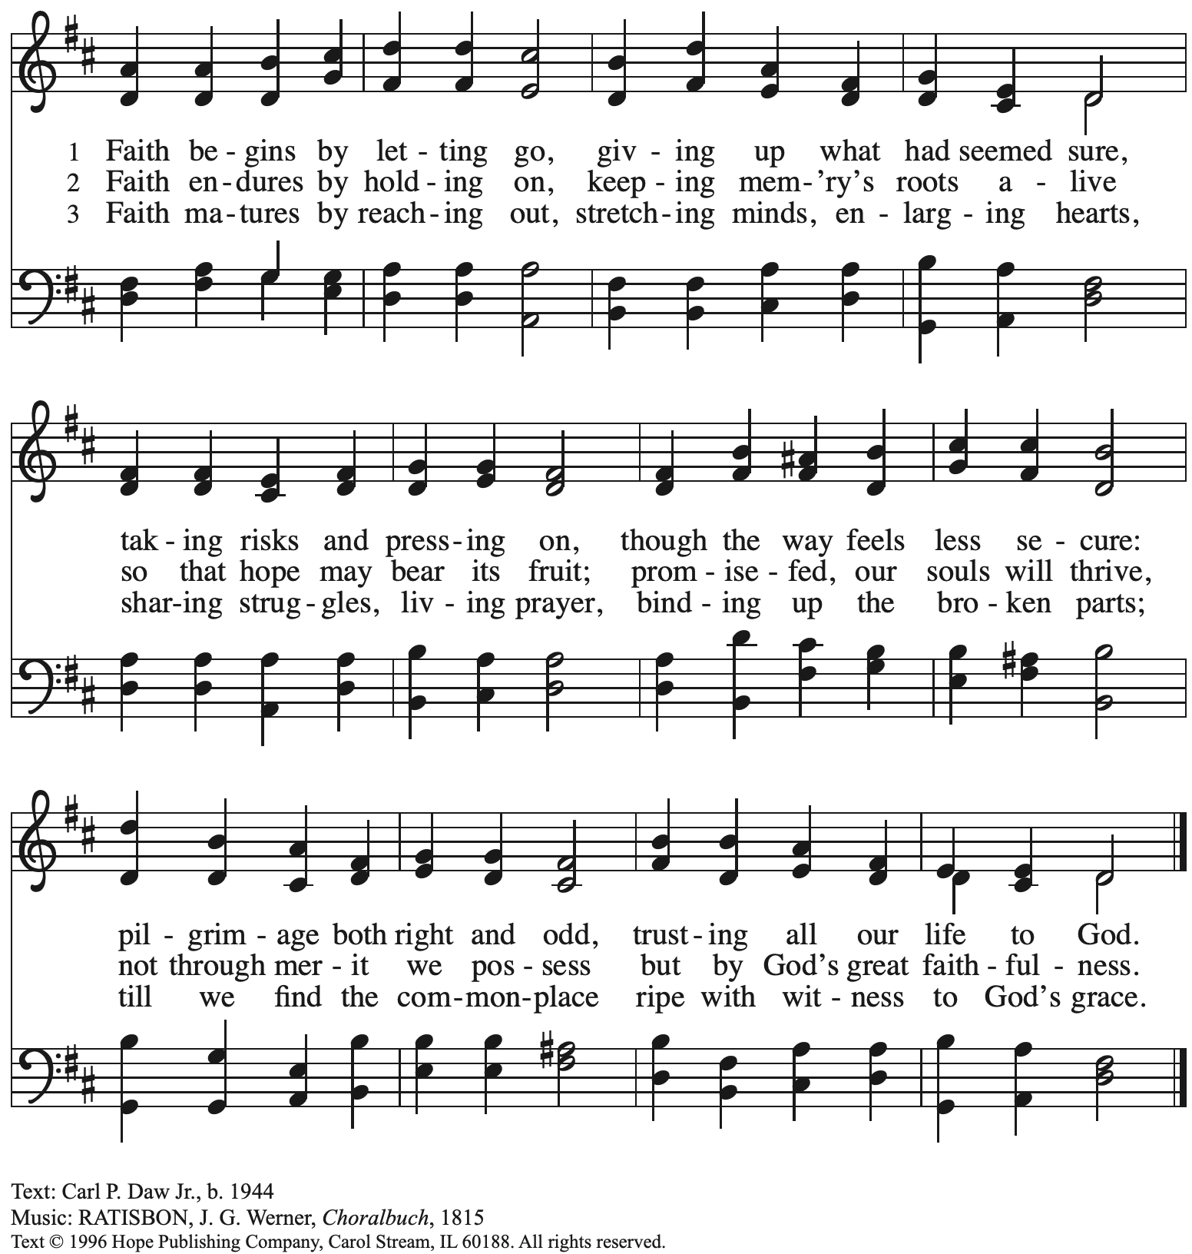

Reprinted with permission under OneLicense.net # A-722139.

**Greeting**

P: The grace of our Lord Jesus Christ, the love of God,

and the communion of the Holy Spirit be with you all.

**C: And also with you.**

**Hymn of Praise** *ACS* p. 31

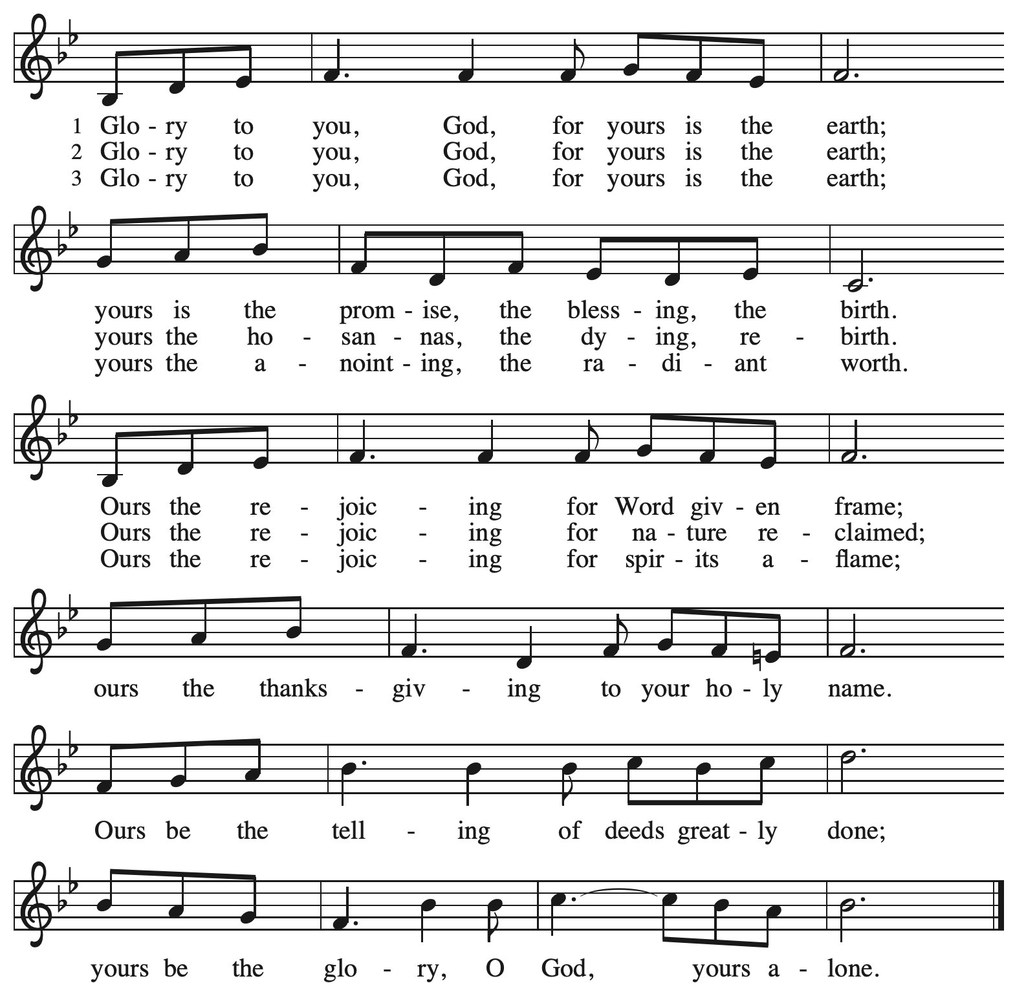

**Prayer of the Day**

P: Let us pray.

Almighty God, by grace alone you call us and accept us into your service.

Strengthen us by your Spirit, and make us worthy of your call,

through Jesus Christ, our Savior and Lord.

**C: Amen.**

*Please be seated.*

*Children are invited to join the adult leaders at the door and move to the office for Little Church – Big Faith. We ask that one additional adult from the congregation attend with the children.*

**Word**

*God speaks to us in Scripture reading, preaching, and song*

**First Reading** **– Jonah 3: 1-5, 10**

1The word of the Lord came to Jonah a second time, saying, 2“Get up, go to Nineveh, that great city, and proclaim to it the message that I tell you.” 3So Jonah set out and went to Nineveh, according to the word of the Lord. Now Nineveh was an exceedingly large city, a three days’ walk across. 4Jonah began to go into the city, going a day’s walk. And he cried out, “Forty days more, and Nineveh shall be overthrown!” 5And the people of Nineveh believed God; they proclaimed a fast, and everyone, great and small, put on sackcloth.  
 10When God saw what they did, how they turned from their evil ways, God changed God’s mind about the calamity that God had said God would bring upon them; and God did not do it.

L: Word of God, word of life.

**C: Thanks be to God.**

**Psalm 62: 5-12**

*Psalm tone*



*Psalm refrain*



5For God alone I **|** wait in silence;  
  truly, my hope **|** is in God.

6**God alone is my rock and | my salvation,**  
  **my stronghold, so that I shall nev- | er be shaken.**  
 7In God is my deliverance **|** and my honor;  
  God is my strong rock **|** and my refuge.  
 8**Put your trust in God al- | ways, O people,**  
  **pour out your hearts before the one who | is our refuge. R**  
 9Those of high degree are but a fleeting breath; those of low estate can- **|** not be trusted.  
  Placed on the scales together they weigh even less **|** than a breath.  
 10**Put no trust in extortion; in robbery take no | empty pride;**  
  **though wealth increase, set not your | heart upon it.**  
 11God has spoken once, twice **|** have I heard it,  
  that power be- **|** longs to God.  
 12**Steadfast love belongs to | you, O Lord,**  
  **for you repay all according | to their deeds. R**

**Second Reading – 1 Corinthians 7: 29-31**

29Kindred, theappointed time has grown short; from now on, let even those who have wives be as though they had none, 30and those who mourn as though they were not mourning, and those who rejoice as though they were not rejoicing, and those who buy as though they had no possessions, 31and those who deal with the world as though they had no dealings with it. For the present form of this world is passing away.

L: Word of God, word of life.

**C: Thanks be to God.**

*Please rise as you are able.*

**Gospel Acclamation** *Alleluia**ACS* p. 33

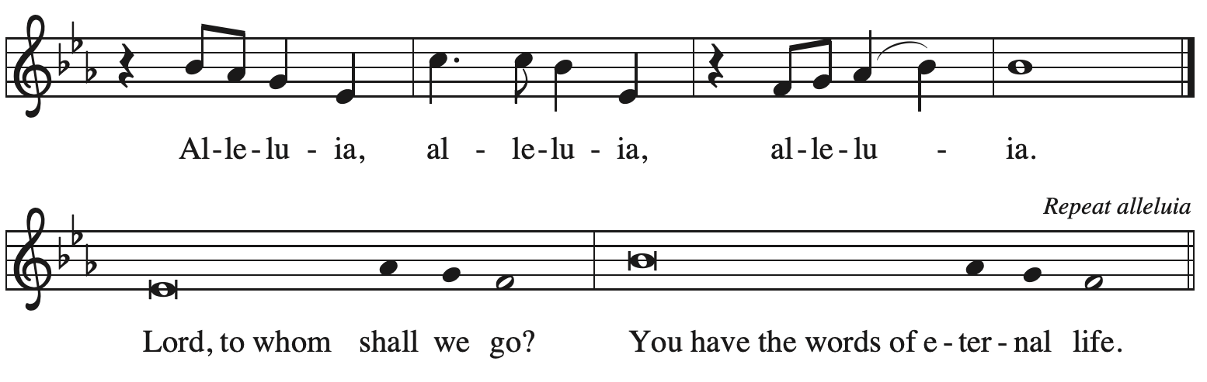

**Gospel – Mark 1: 14-20**

P: The holy Gospel according to St. Mark.

**C: Glory to you, O Lord.**

14Now after John was arrested, Jesus came to Galilee, proclaiming the good news of God, 15and saying, “The time is fulfilled, and the kingdom of God has come near; repent, and believe in the good news.”  
  
 16As Jesus passed along the Sea of Galilee, he saw Simon and his brother Andrew casting a net into the sea—for they were fishermen. 17And Jesus said to them, “Follow me and I will make you fish for people.” 18And immediately they left their nets and followed him. 19As he went a little farther, he saw James son of Zebedee and his brother John, who were in their boat mending the nets. 20Immediately he called them; and they left their father Zebedee in the boat with the hired men, and followed him.

P: The Gospel of the Lord.

**C: Praise to you, O Christ.**

*Please be seated.*

**Sermon**

*A time of silence for prayer and reflection follows the sermon.*

*As the hymn of the day begins, please rise as you are able.*



**Hymn of the Day Jesus Calls Us; o’er the Tumult *ELW* 696**

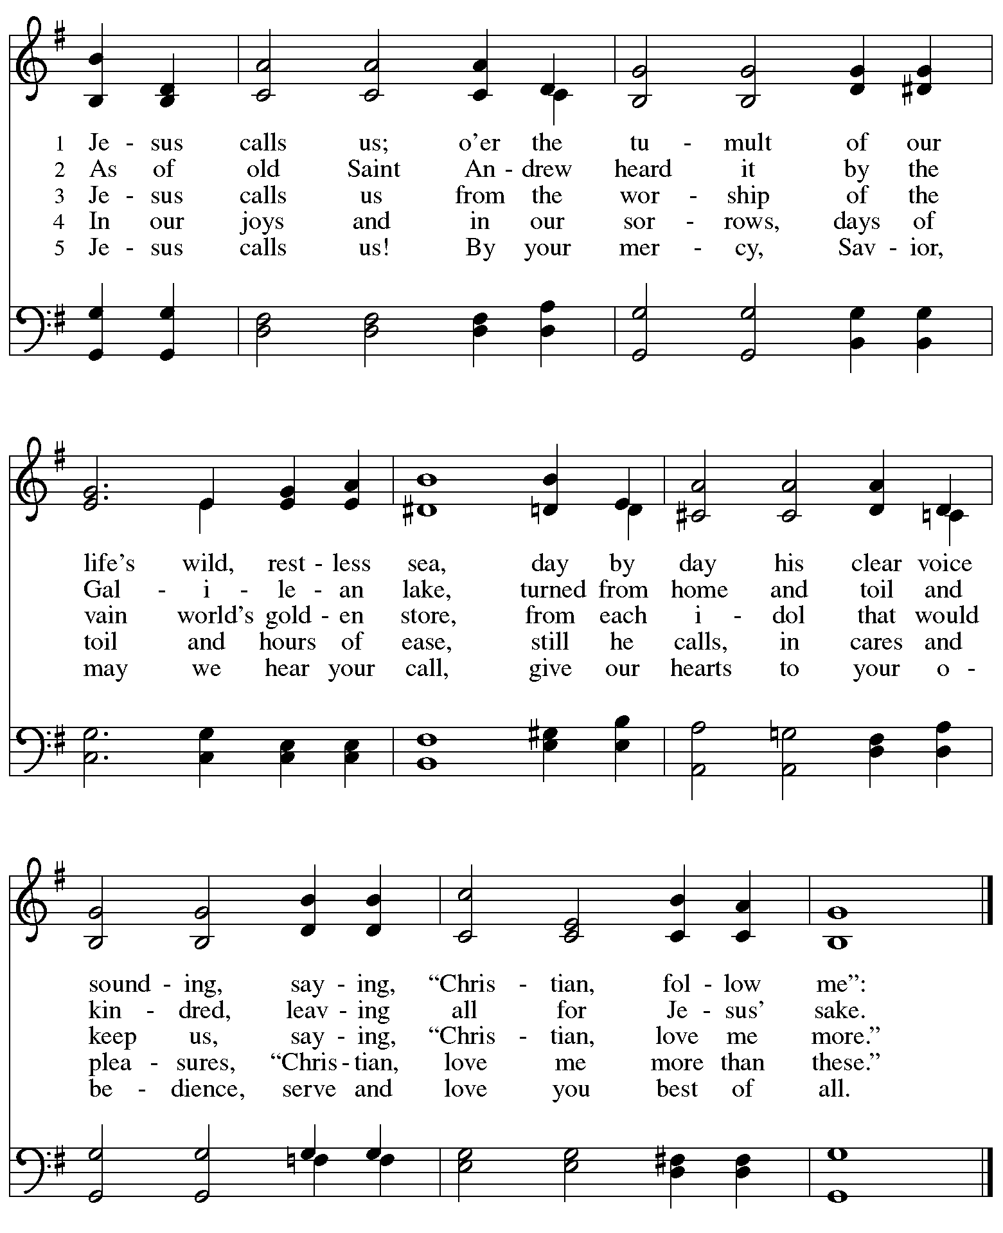

Text: Cecil Frances Alexander, 1818-1895. Music: GALILEE, William H. Jude, 1851-1922.

**Apostles Creed**

P: With the whole church throughout the world, let us confess our faith:

**C: I believe in God, the Father almighty,**

**creator of heaven and earth.**

**I believe in Jesus Christ, God’s only Son, our Lord,**

**who was conceived by the Holy Spirit,**

**born of the virgin Mary,**

**suffered under Pontius Pilate,**

**was crucified, died, and was buried;**

**he descended to the dead.\***

**On the third day he rose again;**

**he ascended into heaven,**

**he is seated at the right hand of the Father,**

**and he will come to judge the living and the dead.**

**I believe in the Holy Spirit,**

**the holy catholic church,**

**the communion of saints,**

**the forgiveness of sins,**

**the resurrection of the body,**

**and the life everlasting. Amen.**

*Or, “he descended into hell,” another translation of this text in widespread use.

**Prayers of the People**

A: As we celebrate Christ’s incarnation and revelation, we pray for the church, the world,

and all who are in need.

*After each petition*

A: God of grace,

**C: receive our prayer.**

*The presiding minister concludes the prayers*

P: Knowing that the Holy Spirit intercedes for us, we offer these prayers and the silent prayers of our hearts to you, O God, through Jesus Christ, our Savior.

**C: Amen.**

**Peace**

*The presiding minister and the assembly greet one another in the peace of the risen Christ.*

P: The peace of Christ be with you always.

**C: And also with you.**

*The people may greet those around them with a sign of Christ’s peace and may say*

Peace be with you *or similar words. Please be mindful that not everyone will be comfortable with sharing the peace, so please seek consent before shaking hands or hugging. Other possible ways to share the peace include a simple bow with the verbal greeting of peace, or simply a verbal expression of peace.*

*When the greetings of peace have concluded, please be seated.*



**Meal**

*God feeds us with the presence of Jesus Christ*

**Offering**

*We offer ourselves, our gifts, and our faithful service to God.*

*As the offering is gathered for the mission of the church, including the care of those in need,*

*the table is set for Holy Communion.*

**Noisy Offering**

*As children of the congregation will carry metal buckets around the sanctuary, people of the congregation are invited to throw in their change. This month’s offering will support Glade Run Lutheran Services, a service ministry of the church with the mission to empower individuals to experience personal wellness and growth through a variety of programs.*

**Music during the Offering**

*As the gifts are brought forward for presentation, please rise as you are able.*

*Just a Closer Walk with Thee* Trad.

**Offertory Song God of the Fertile Fields *ACS* 1063**

**v. 2-4**

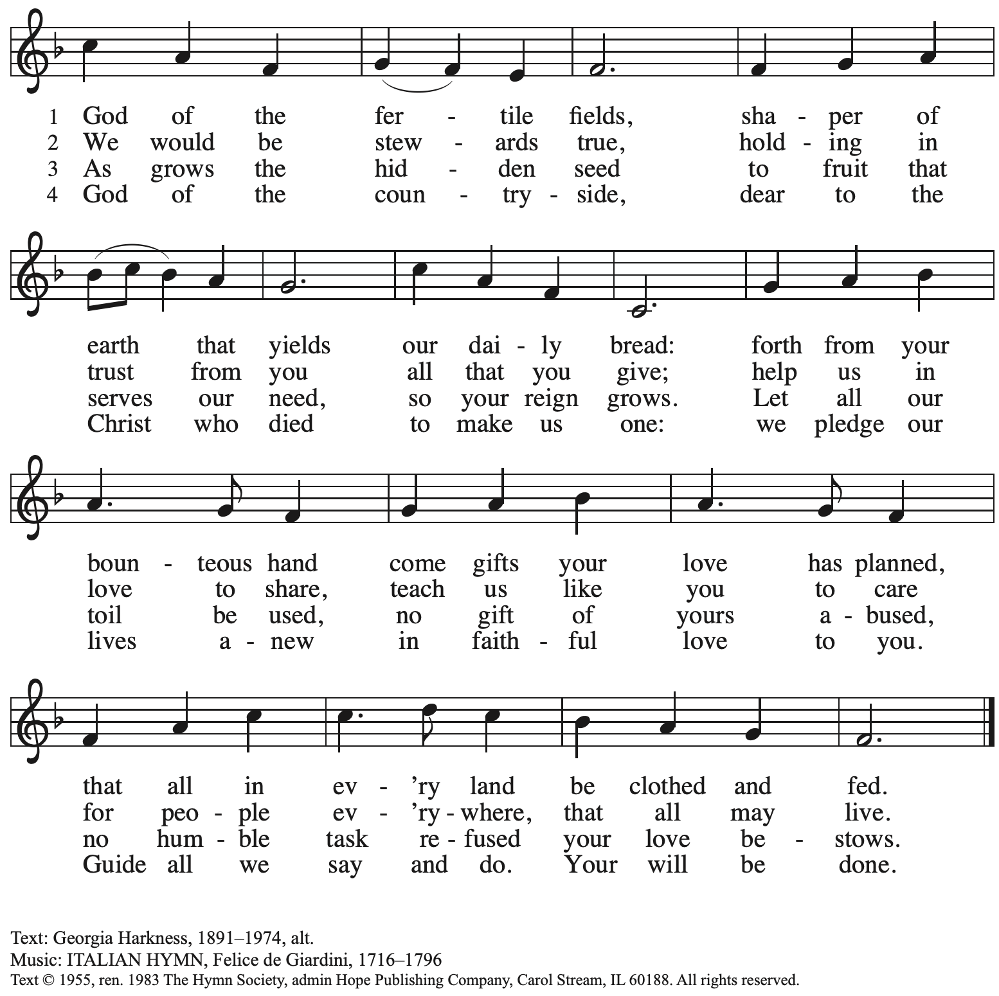

Reprinted with permission under OneLicense.net # A-722139.

**Offertory Prayer**

A: Let us pray.

Blessed are you,

**C: O God, maker of all things.**

**Through your goodness you have blessed us with these gifts:**

**our selves, our time, and our possessions.**

**Work through us and what we have gathered**

**to feed the world with your love, through the one who gave himself for us,**

**Jesus Christ, our Savior and Lord. Amen.**



**Dialogue**

P: The Lord be with you.

**C: And also with you.**

P: Lift up your hearts.

**C: We lift them to the Lord.**

P: Let us give thanks to the Lord our God.

**C: It is right to give our thanks and praise.**

**Preface**

P: It is indeed right, our duty and our joy,  
that we should at all times and in all places

give thanks and praise to you, almighty and merciful God,

through our Savior Jesus Christ;

who on this day overcame death and the grave,

and by his glorious resurrection opened to us the way of everlasting life.

And so, with all the choirs of angels,

with the church on earth and the hosts of heaven,

we praise your name and join their unending hymn:

**Sanctus** *ACS* p. 36

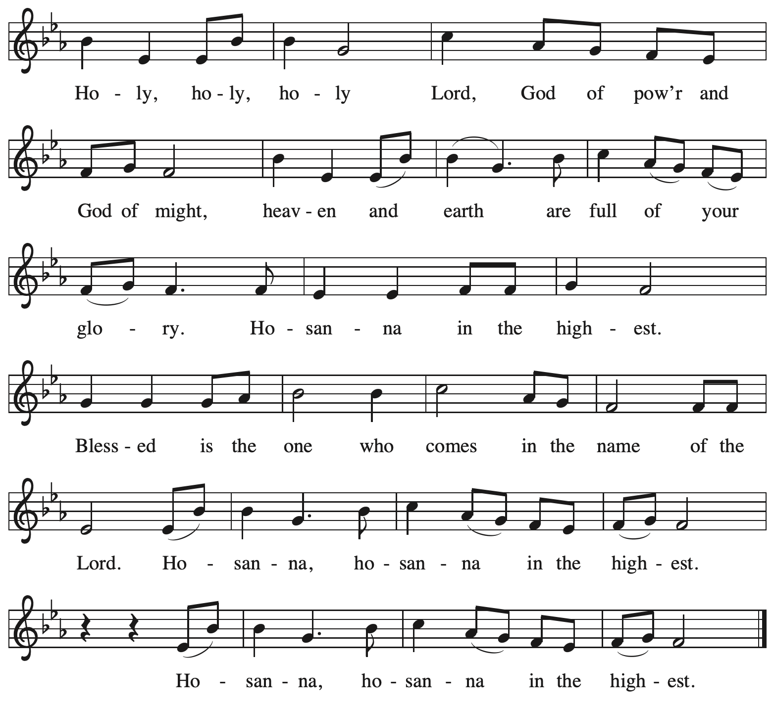

**Eucharistic Prayer**

P: Holy God, holy and merciful, your people praise you, saying:

Your mercy endures forever.

**C: Your mercy endures forever.**

P: By your promise you bound yourself to earth and all its creatures, granting them life

and calling them to flourish, setting the sign of the bow in the clouds, the colors of your love

and faithfulness. Your mercy endures forever.

**C: Your mercy endures forever.**

P: By your promise you bound yourself to your people of old,

blessing them with family outnumbering the stars and calling them to be a blessing to others,

showing them steadfast love in every generation and calling them to be a light to the nations.

Your mercy endures forever.

**C: Your mercy endures forever.**

P: By your promise you joined us to Jesus, your Beloved …

… Do this for the remembrance of me.

With this bread and cup

we remember his life laid down and lifted up

as we proclaim the mystery of faith.

**C: Christ has died. Christ is risen. Christ will come again.**

P: Send your Holy Spirit upon us …

… in your Spirit, now and forever.

**C: Amen.**

**Lord’s Prayer**

P: Gathered as one by the Holy Spirit, let us pray as Jesus taught us.

**C: Our Father in heaven,**

**hallowed be your name,**

**your kingdom come,**

**your will be done,**

**on earth as in heaven.**

**Give us today our daily bread.**

**Forgive us our sins**

**as we forgive those**

**who sin against us.**

**Save us from the time of trial**

**and deliver us from evil.**

**For the kingdom, the power,**

**and the glory are yours,**

**now and forever. Amen.**

**Fraction and Invitation**

P: At Christ’s table,

heaven and earth are joined as one.

Come and see.

***Agnus Dei /* Lamb of God** *ACS* p. 40

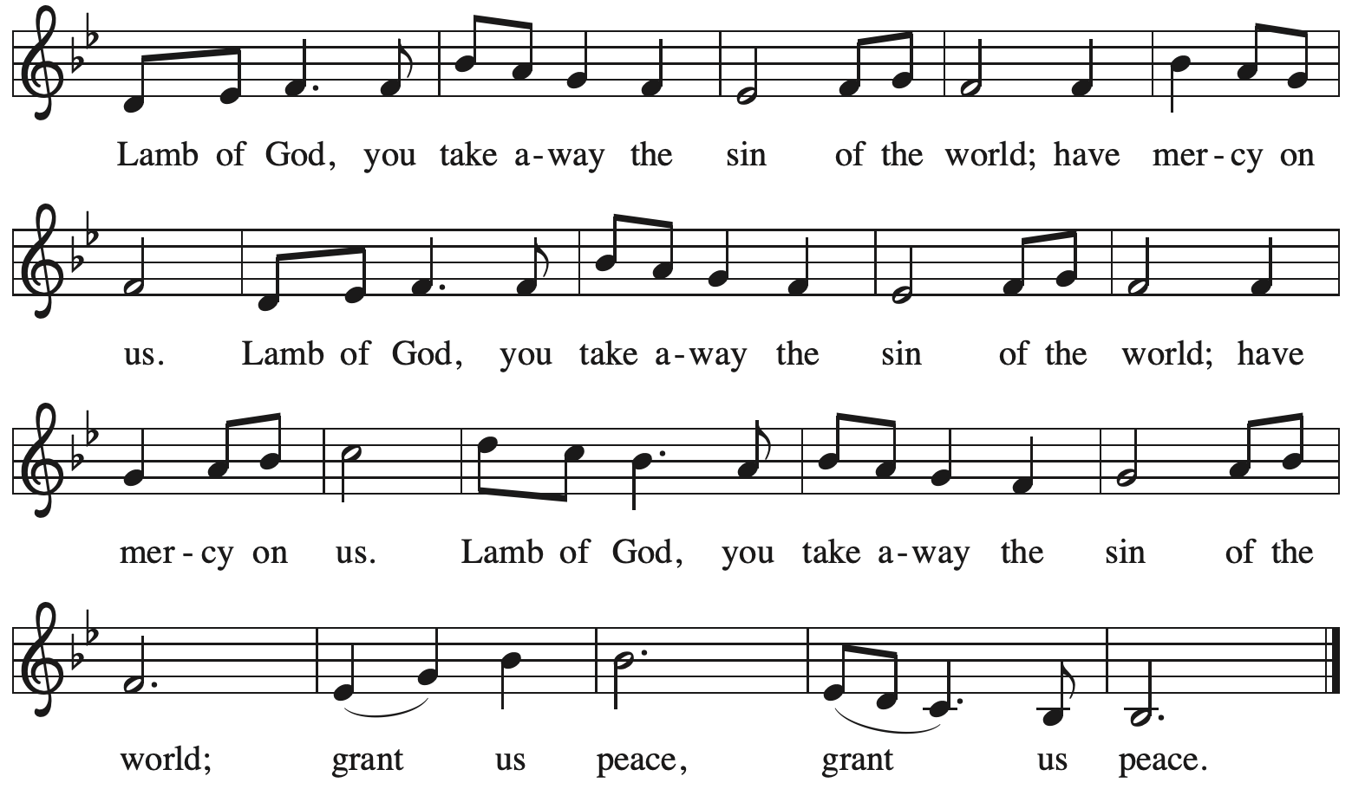

*Please be seated.*

**Holy Communion**

* *All who seek God and desire a deeper and stronger life in Christ are welcome to receive Holy Communion.*
* *Worshipers from the pulpit side will proceed forward first, followed by the center section, and then the lectern side.*
* *Please inform an usher if you would like the ministers to bring Communion to you.*
* *Holy Communion will be served with bread and wine/grape juice.*
* *The presiding minister will first distribute the bread (host) to each communicant. Please indicate if you require a gluten-free host.*
* *Once you have consumed the bread, please pick up an empty glass from the tray next to the presiding minister. The Communion Assistant will pour wine from the chalice or grape juice from the cruet into your glass.*
* *Please step to the side to consume the wine or grape juice.*
* *Feel free to kneel at the altar rail for prayer after receiving the sacrament.*
* *As you return to your pew, glasses may be returned to the empty trays on either side of the center section.*
* *A blessing will be provided for anyone who does not yet receive the sacrament.*
* *All are invited to join in singing the hymns during Holy Communion.*

**Hymns during Holy Communion**

*Come to the Banquet* Joseph M. Martin

**Hymns during Holy Communion**

**I Love to Tell the Story *ELW* 661**

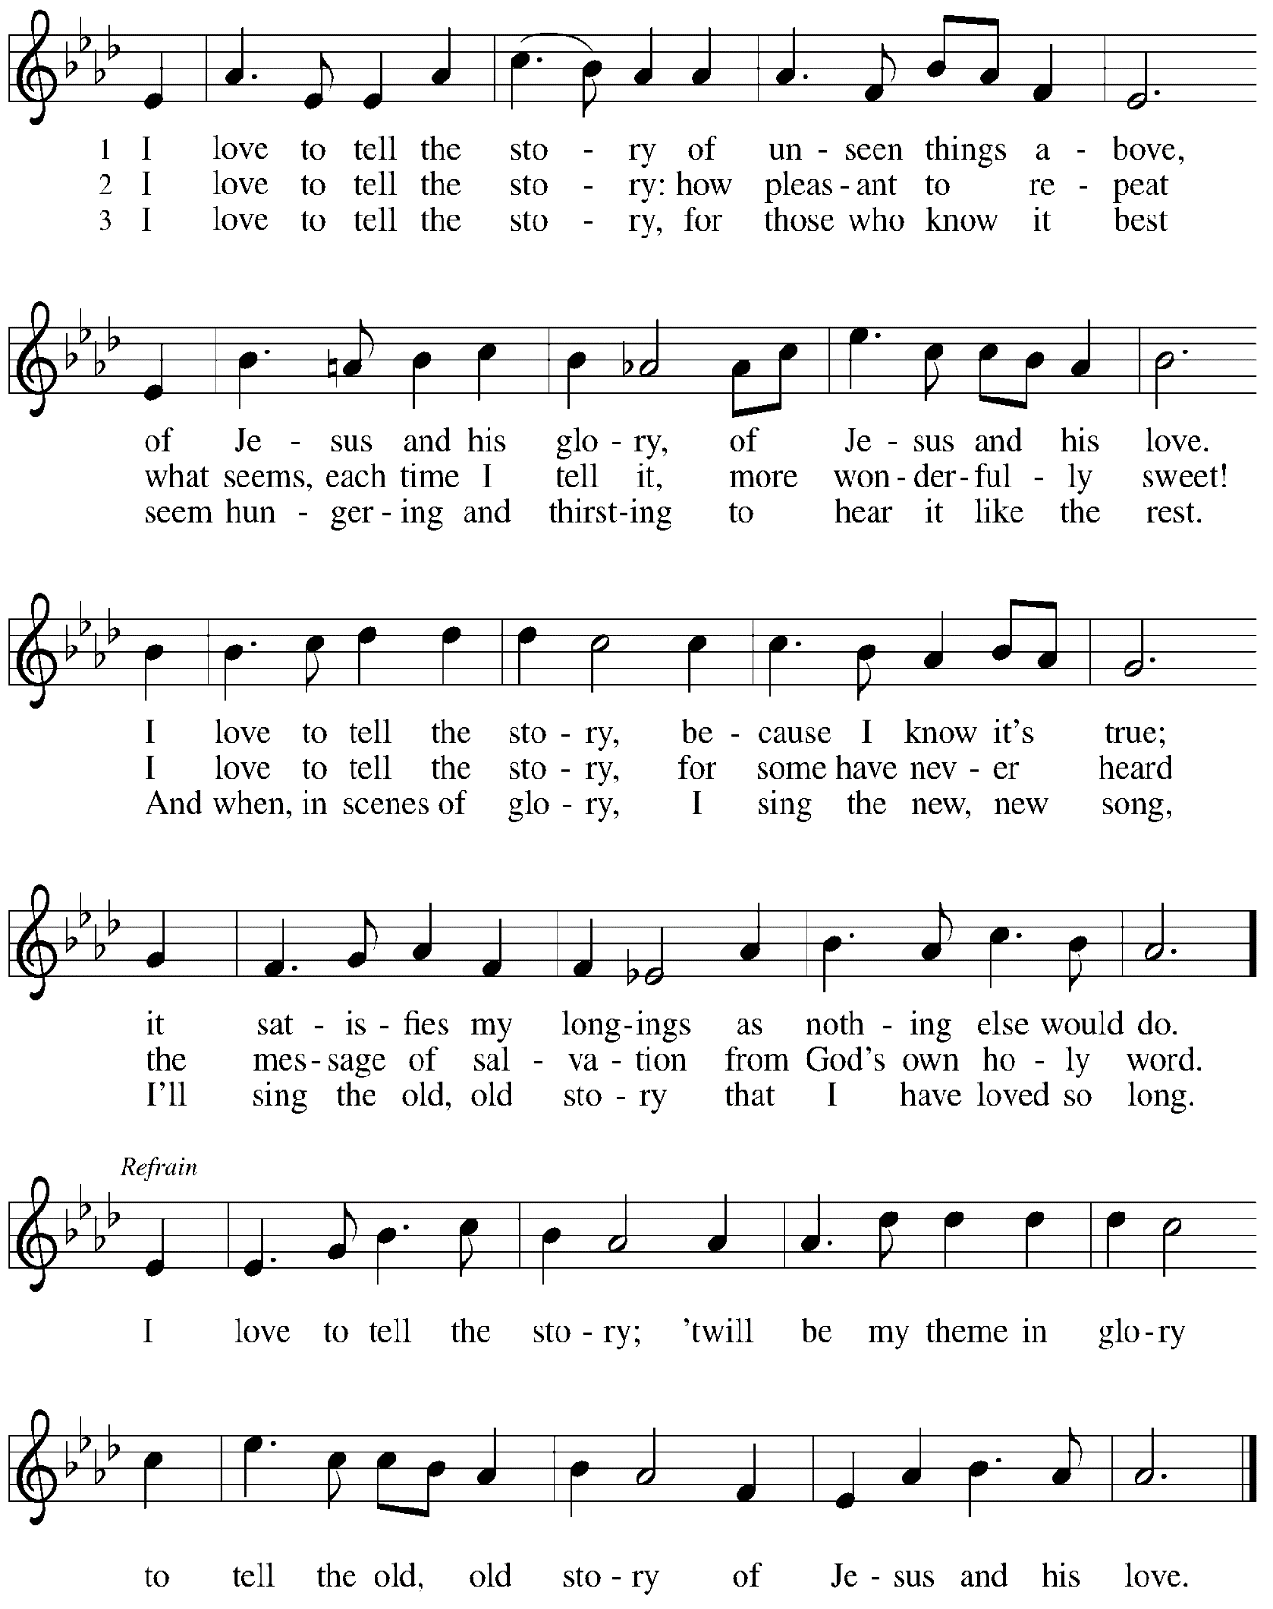

**Hymns during Holy Communion**

**I Want to Walk as a Child of the Light *ELW* 815**

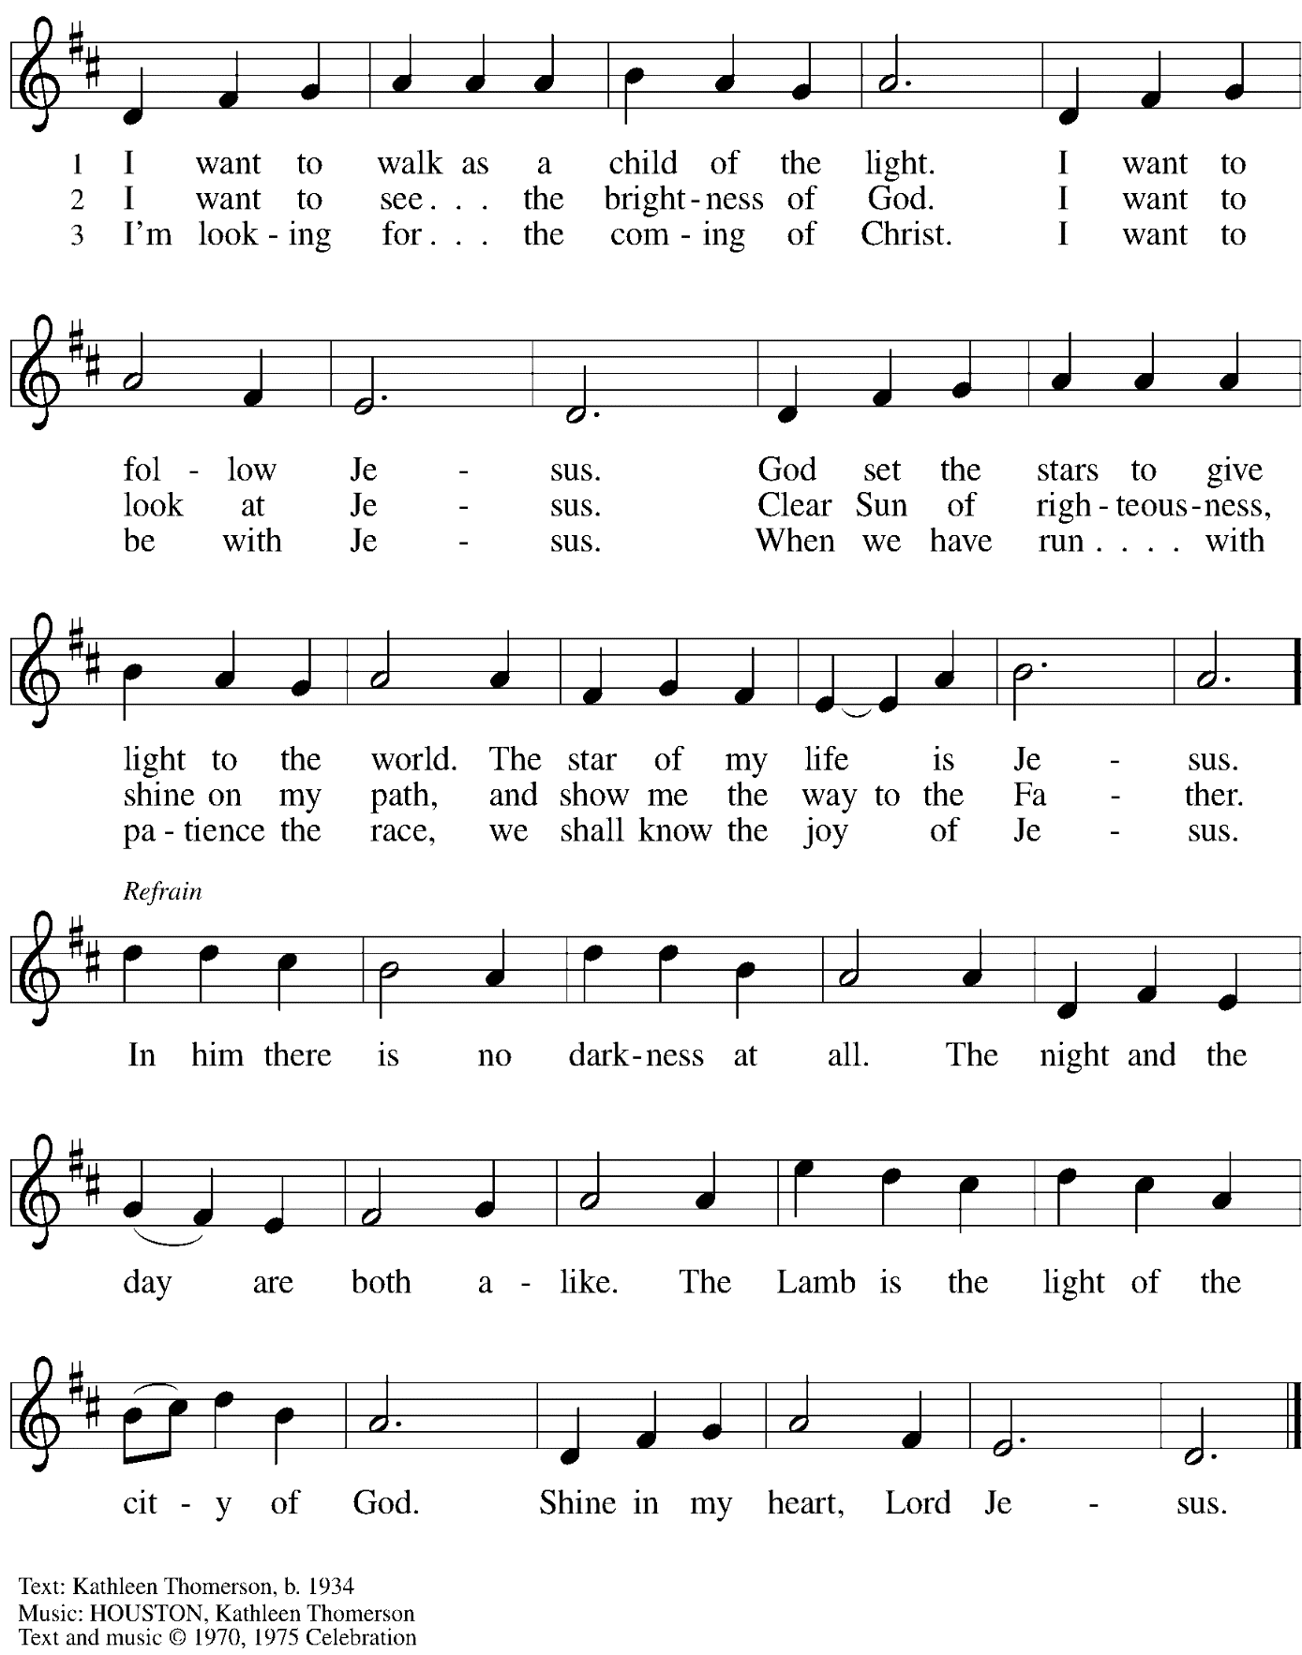

All rights reserved. Reprinted with permission under CCLI # 11561207.

*When all have returned to their places, please rise as you are able.*

**Blessing**

P: The body and blood of our Lord Jesus Christ strengthen you and keep you in his grace.

**C: Amen.**

**Prayer**

A: Let us pray.

God of abundance, with this bread of life and cup of salvation you have united us with Christ, making us one with all your people. Now send us forth in the power of your Spirit,

that we may proclaim your redeeming love to the world

and continue forever in the risen life of Jesus Christ, our Lord.

**C: Amen.**

*Please be seated.*

**Sending**

*God blesses us and sends us in mission to the world*

**Announcements**

*Please rise as you are able.*

**Benediction**

P: God who names you,

Christ who claims you,

and the Holy Spirit who dwells in you,

☩ bless you now and forever.

**C: Amen.**

**Sending Hymn Go to the World!** *Following page*

**Dismissal**

A: Go in peace. You are beloved.

**C: Thanks be to God!**

**Postlude** *Sent Forth by God’s Blessing* arr. J. Helgen

**Sending Hymn Go to the World! *ACS* 991**

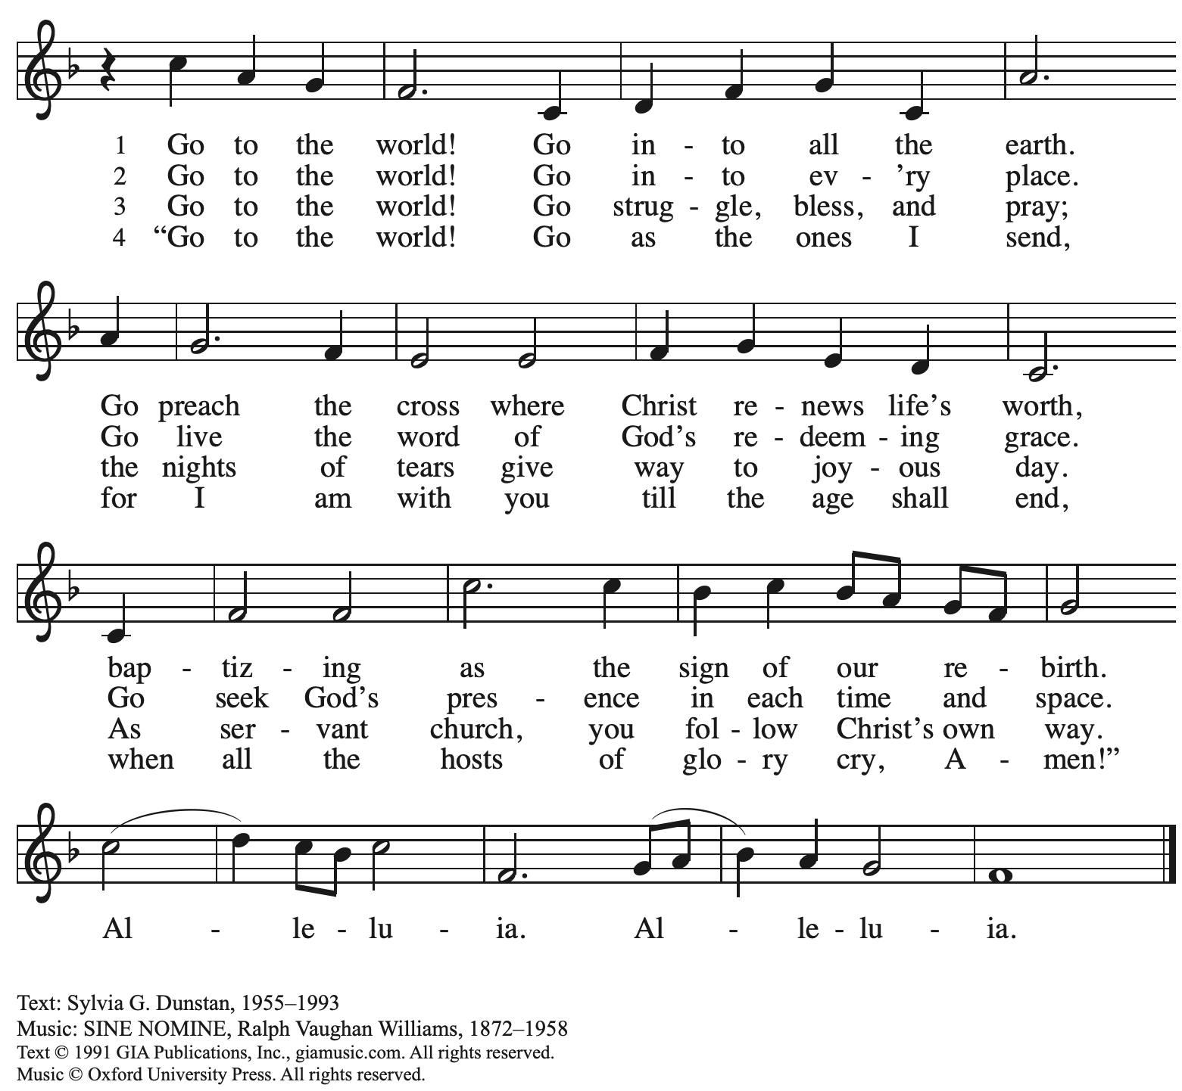

Reprinted with permission under OneLicense.net # A-722139.

*Those serving in worship*

Altar Care Beverley Chapman

Assisting Minister Kathy Hays

Audio-Visual Ministers Sarita

Joseph Paetz

Cantor Marit Bakken

Ensemble Libby Marker

Joseph Paetz

Marit Bakken and Jered Stratton

Lector Pastor Paul Koch

Little Church – Big Faith Teacher Maria Mangano

Minister of Music Laura Reynolds

Presiding and Preaching Minister The Rev. Ross I. Carmichael

*Liturgy and Hymnody Acknowledgements*

From SundaysandSeasons.com. Copyright © 2024 Augsburg Fortress. All rights reserved. Reprinted under OneLicense.net # A-722139.

Used by permission of Augsburg Fortress.

**I Love to Tell the Story** – Text: Katherine Hankey, 1834-1911. Music: HANKEY, William E. Fischer, 1849-1936.

.

*Please use the QR code below to link to St. Andrew’s Announcements online!*



**St. Andrew Lutheran Church Announcements**

**January 21st, 2024**

* **Welcome to worship at St. Andrew on the Third Sunday after Epiphany, January 21st, 2024** –We are so glad you are here, and we offer a special welcome to all guests who are gathered at the church or online! Children are invited to participate in Little Church – Big Faith, a Bible lesson and activity, after the prayer of the day. There are worship “toolkits” to help children engage with worship and “busy bags” for younger children available in the bookcase at the back of the sanctuary. Please feel free to take one to use with/for your children.
* **Noisy Offering Returns Today, January 21st** – Today St. Andrew resumes the Noisy Offering, in which children and youth of St. Andrew lead the congregation in special offering, carrying metal buckets around the church. People of the congregation are invited to throw in change. This month’s offering will support Glade Run Lutheran Service, a service ministry of the church that help people with personal wellness and growth through a variety of programs. Learn more about Glade Run Lutheran Services at [Glade Run Lutheran Services](https://gladerun.org/).
* **Save the Date – Service of Prayer and Lament for the Holy Land – Saturday, January 27th at St. Andrew. Meal and Presentation – 5:00 p.m., Service – 6:00 p.m.** – Join in a service of lament and prayer for peace in the Holy Land. The service will be preceded by a meal and presentation by Pastor Paul Koch, who will share about geography and history of the region from a Christian perspective and give an overview of the Lutheran church’s presence and ministry through the Evangelical Lutheran Church in Jordan and the Holy Land.
* **Ukrainian Egg Workshop – A Focused Spiritual Meditation for Lent, Saturday, February 17th, 1:00-4:30 p.m.** – Jimmi and Timothy Kocher Hillmer will lead a workshop on the tradition of Ukrainian egg decoration as a spiritual discipline for the season of Lent. *Pysanky*, the Ukrainian name for the tradition, comes from the word “write,” similar to the spiritual practice of “writing” icons, and the process involves both writing on and dyeing the eggs. Due to safety considerations (open flame, hot wax) this workshop is recommended for people 6th grade and up. To ensure ample space and supplies, registration will be limited to 20 participants. If you would like to participate, please sign up at <https://www.signupgenius.com/go/5080B4AAFAF2CABF85-47277468-ukrainian> by Sunday, February 10th. If you have questions, please contact Jimmi at [**jimotha@yahoo.com**](mailto:jimotha@yahoo.com)**.** Please bring an old dish towel on which to work.
* **Support Abuelas Responden – Grannies Respond with Donations of Used Winter Clothing Items –** Abuelas Responden - Grannies Respond is a local organization that supports traveling asylum seekers as they come through Pittsburgh. The group goes to the downtown bus station to meet asylum seekers who have been released from the Moshannon Valley detention center and supply them with much needed items as they travel to join family or friends in other cities. The primary need is for warm winter clothing. A bin will be set up in the social hall to receive these items. Right now the most needed items are:
* Men’s warm (but not too bulky) coats, jackets, fleece hoodies - People need to be able to fit everything in bags so there is no space for a heavy coat.
* Men’s Pants and Shoes (Please no sweatpants - this is what the people receive in detention, so we want to avoid outfitting anyone with something that looks like prisoners’ clothes.
* Men’s gloves
* ***Christ in Our Home* Devotional Booklets for January - March Available at Church Entrances** – This resource offers a daily Bible reading with a short reflection and prayer, along with additional readings and prayer topics for those who would like to expand their devotional practices. We encourage people of the congregation to take one for yourself, your family unit, or others!