+ Fifth Sunday after Epiphany
February 4th, 2024
10:00 a.m.

St. Andrew Lutheran Church
304 Morewood Ave.
Pittsburgh, PA 15213
412.682.3342
St_andrewELCA@verizon.net
www.standrewpittsburgh.org

+ Fifth Sunday after Epiphany
Order for Worship

In the book of the prophet Isaiah, the one God who sits above the earth and numbers the stars also strengthens the powerless. So in Jesus’ healing work we find the hand of the creator God, lifting up Simon’s mother-in-law, who is ill, to health and service (diakonia). Like her, we are lifted up and healed to serve. Following Jesus, we strive to strengthen the powerless; like Jesus, we seek to renew our own strength in quiet times of prayer.

Welcome to St. Andrew!
- St. Andrew Lutheran congregation welcomes all who are seeking a place of healing and wholeness – a nurturing, faith-forming spiritual home. Our community embraces people of all ages, ethnicities, cultures, abilities, sexual orientations, gender identities and expressions, and family constellations. Come and See!
- Worship Services are live streamed to multiple online platforms. By attending worship, you agree that your image and voice may be broadcast.
- Everyone is invited to make a nametag at the black bookcase in the back of the worship space if they would like. There are stickers indicating pronouns on the bookcase if you would like to include them on your name tag.
- Children are invited to attend Little Church – Big Faith, a Bible lesson and activity, during worship (after the Prayer of the Day). The group returns to the worship space for the liturgy of Holy Communion.
- Worship “toolkits” to help children engage with the service, along with “busy bags” for younger children, are available in the bookcase at the back of the sanctuary. Please feel free to take one to use with/for your children.
- Holy Communion is served with bread (gluten-free available) and wine or grape juice. The presiding minister will distribute the bread (host). Please consume this and then pick up an empty glass from the tray. The Communion Assistant will pour wine or grape juice into your glass. Please step to the side to consume the wine or grape juice. Feel free to kneel at the altar for prayer and reflection. As you return to your pew, glasses may be returned to the empty trays on either side of the center section.
- A restroom is available on the main level of the church, through the doors to the Social Hall and to the right in the main office.

Abbreviations

P: Pastor/Presiding Minister ELW: Evangelical Lutheran Worship hymnal
A: Assisting Minister ACS: All Creation Sings hymnal
L: Lector
C: Congregation

Welcome

Prelude Hope in Me T. Johnson
Based on Isaiah 40

Gathering
The Holy Spirit calls us together as the people of God

Confession and Forgiveness

Please rise as you are able. All may make the sign of the cross,
the sign that is marked at Baptism, as the presiding minister begins.

P: Blessed be the holy Trinity, ☩ one God,
creator of darkness and light, word of truth,
our life and our salvation.
C: Amen.

P: Let us confess our sin in the presence of God and of one another.

Silence is kept for reflection.

P: God, our rock and refuge,
C: We confess that we have sinned against you
and wounded one another.
We have not loved you and our neighbors as you have loved us.
We have not always recognized the Holy Spirit dwelling in each of us.
Remember your covenant.
Renew your creation.
Restore us,
that we might proclaim your good news to all.
Amen.

P: The voice of the Lord is upon the waters.
God has spoken: The time of grace is now.
In Jesus, the reign of God has come near.
By the authority of ☩ Jesus Christ, your sins are forgiven.
You are God’s beloved.
C: Amen.

Gathering Hymn I Heard the Voice of Jesus Say ELW 611

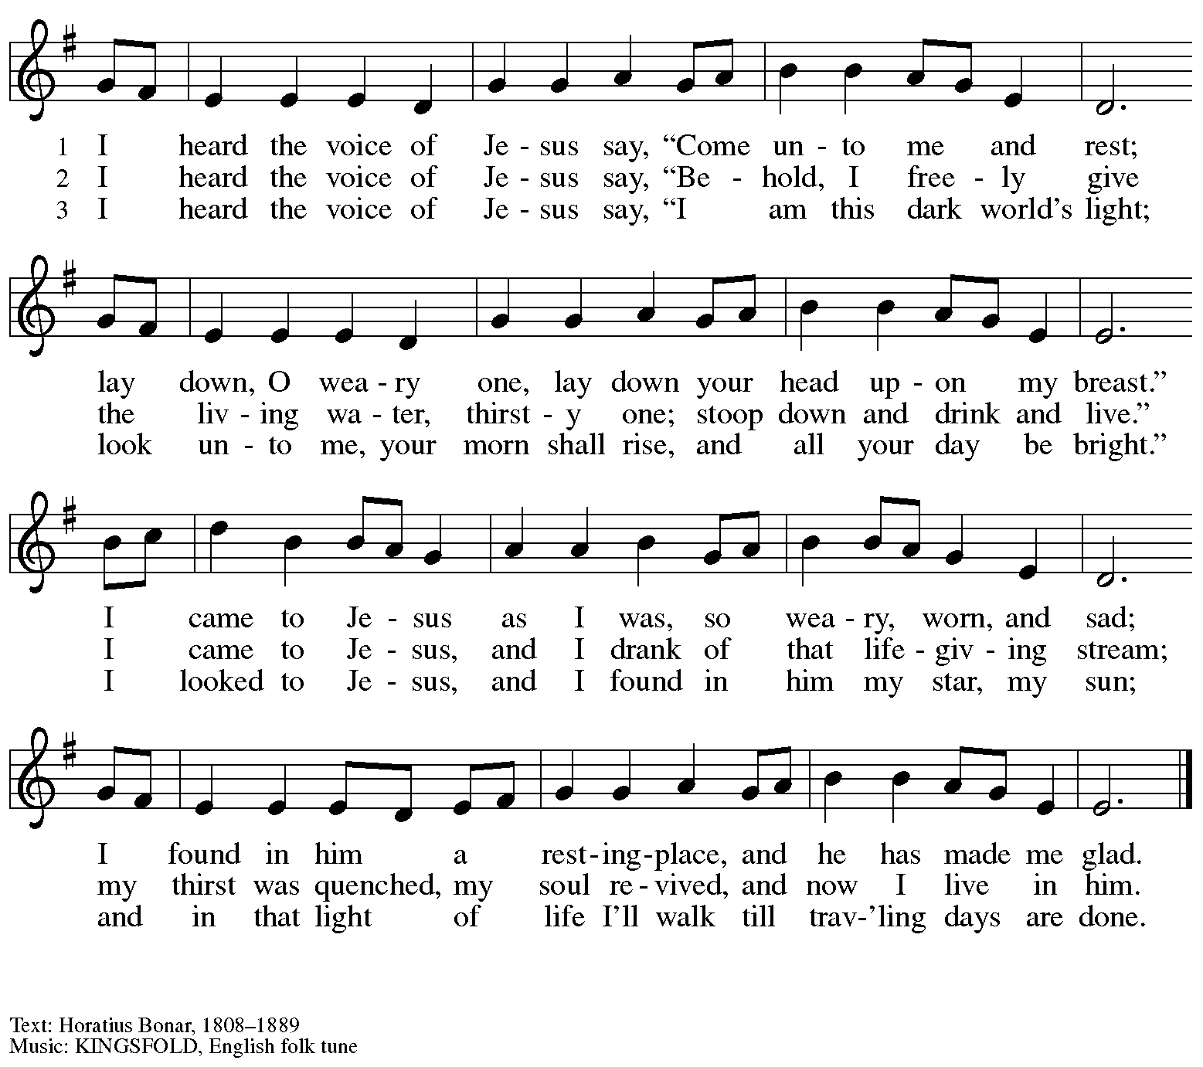

Greeting

P: The grace of our Lord Jesus Christ, the love of God,
and the communion of the Holy Spirit be with you all.
C: And also with you.

Hymn of Praise ACS p. 31

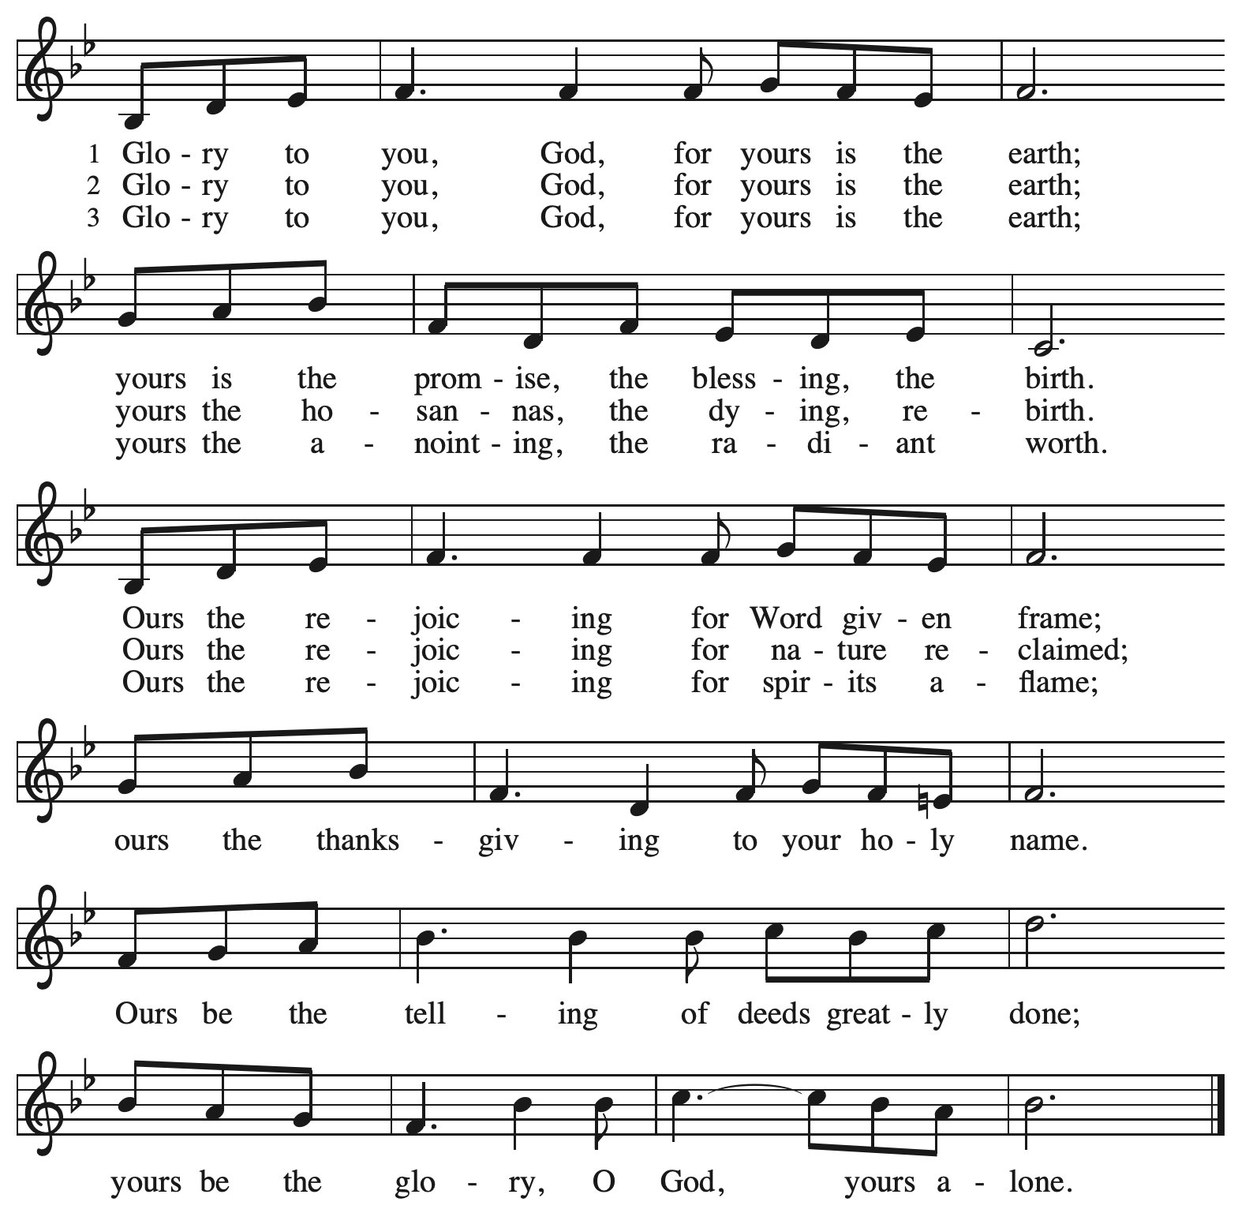

Prayer of the Day

P: Let us pray.
Everlasting God, you give strength to the weak and power to the faint.
Make us agents of your healing and wholeness, that your good news may be made known
to the ends of your creation, through Jesus Christ, our Savior and Lord.
C: Amen.

Please be seated.
Children are invited to join the adult leaders at the door and move to the office for Little Church – Big Faith. We ask that one additional adult from the congregation attend with the children.

Word
God speaks to us in Scripture reading, preaching, and song

First Reading – Isaiah 40: 21-31

²¹Have you not known? Have you not heard?
Has it not been told you from the beginning?
Have you not understood from the foundations of the earth?
²²It is the one who sits above the circle of the earth,
and its inhabitants are like grasshoppers;
who stretches out the heavens like a curtain,
and spreads them like a tent to live in;
²³who brings princes to naught,
and makes the rulers of the earth as nothing.
²⁴Scarcely are they planted, scarcely sown,
scarcely has their stem taken root in the earth,
when the Lord blows upon them, and they wither,
and the tempest carries them off like stubble.
²⁵To whom then will you compare me,
or who is my equal? says the Holy One.
²⁶Lift up your eyes on high and see:
Who created these?
The one who brings out their host and numbers them,
calling them all by name;
because the Lord is great in strength,
mighty in power,
not one is missing.
²⁷Why do you say, O Jacob,
and speak, O Israel,
“My way is hidden from the Lord,
and my right is disregarded by my God”?
²⁸Have you not known? Have you not heard?
The Lord is the everlasting God,
the Creator of the ends of the earth.
The Lord does not faint or grow weary;
the Lord’s understanding is unsearchable.
²⁹The Lord gives power to the faint,
and strengthens the powerless.
³⁰Even youths will faint and be weary,
and the young will fall exhausted;
³¹but those who wait for the Lord shall renew their strength,
they shall mount up with wings like eagles,
they shall run and not be weary,
they shall walk and not faint.

L: Word of God, word of life.
C: Thanks be to God.

Psalm 147: 1-11, 20c

Psalm tone

Psalm refrain

¹Hallelujah! How good it is to sing praises | to our God!
How pleasant it is to honor | God with praise!
²The Lord re- | builds Jerusalem,
and gathers the ex- | iles of Israel.
³The Lord heals the | brokenhearted
and binds | up their wounds.
⁴The Lord counts the number | of the stars
and calls them all | by their names. R
⁵Great is our Lord and might- | y in power;
there is no limit | to God’s wisdom.
⁶The Lord lifts | up the lowly,
but casts the wicked | to the ground.
⁷Sing to the Lord | with thanksgiving;
make music upon the harp | to our God,
⁸who covers the heav- | ens with clouds
and prepares rain for the earth, making grass to grow up- | on the mountains. R
⁹God provides food | for the cattle
and for the young ravens | when they cry.
¹⁰God is not impressed by the might | of a horse,
and has no pleasure in the speed | of a runner,
¹¹but finds pleasure in those who | fear the Lord,
in those who await God’s steadfast love. ^{20c|} Hallelujah! R

Second Reading – 1 Corinthians 9: 16-23

¹⁶If I proclaim the gospel, this gives me no ground for boasting, for an obligation is laid on me, and woe to me if I do not proclaim the gospel! ¹⁷For if I do this of my own will, I have a reward; but if not of my own will, I am entrusted with a commission. ¹⁸What then is my reward? Just this: that in my proclamation I may make the gospel free of charge, so as not to make full use of my rights in the gospel.
¹⁹For though I am free with respect to all, I have made myself a slave to all, so that I might win more of them. ²⁰To the Jews I became as a Jew, in order to win Jews. To those under the law I became as one under the law (though I myself am not under the law) so that I might win those under the law. ²¹To those outside the law I became as one outside the law (though I am not free from God’s law but am under Christ’s law) so that I might win those outside the law. ²²To the weak I became weak, so that I might win the weak. I have become all things to all people, that I might by all means save some. ²³I do it all for the sake of the gospel, so that I may share in its blessings.

L: Word of God, word of life.
C: Thanks be to God.

Please rise as you are able.

Gospel Acclamation Alleluia ACS p. 33

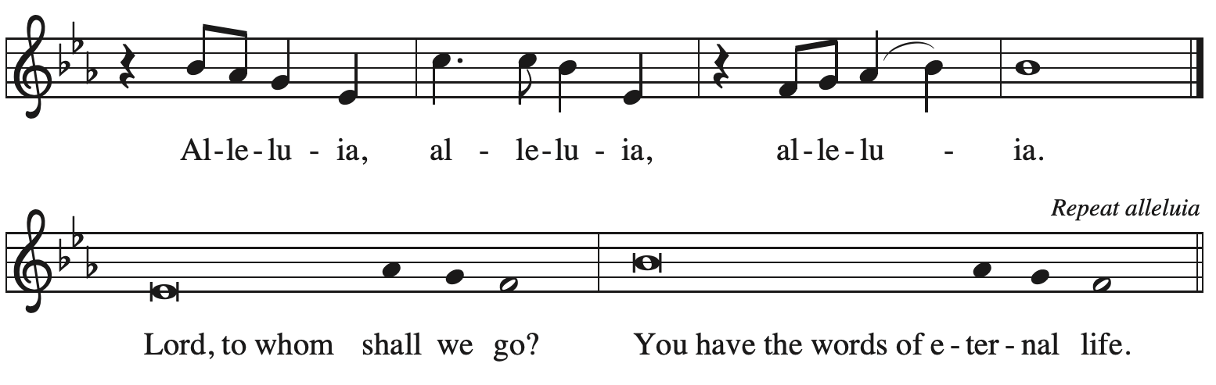

Gospel – Mark 1: 29-39

P: The holy Gospel according to St. Mark.
C: Glory to you, O Lord.

²⁹As soon as [Jesus and the disciples] left the synagogue, they entered the house of Simon and Andrew, with James and John. ³⁰Now Simon’s mother-in-law was in bed with a fever, and they told him about her at once. ³¹He came and took her by the hand and lifted her up. Then the fever left her, and she began to serve them.
³²That evening, at sunset, they brought to him all who were sick or possessed with demons.
³³And the whole city was gathered around the door. ³⁴And he cured many who were sick with various diseases, and cast out many demons; and he would not permit the demons to speak, because they knew him.
³⁵In the morning, while it was still very dark, he got up and went out to a deserted place, and there he prayed. ³⁶And Simon and his companions hunted for him. ³⁷When they found him, they said to him, “Everyone is searching for you.” ³⁸He answered, “Let us go on to the neighboring towns, so that I may proclaim the message there also; for that is what I came out to do.” ³⁹And he went throughout Galilee, proclaiming the message in their synagogues and casting out demons.

P: The Gospel of the Lord.
C: Praise to you, O Christ.

Please be seated.

Sermon The Rev. Canon Natalie Hall

A time of silence for prayer and reflection follows the sermon.
As the hymn of the day begins, please rise as you are able.

Hymn of the Day Dearest Jesus, We Are Here ELW 443

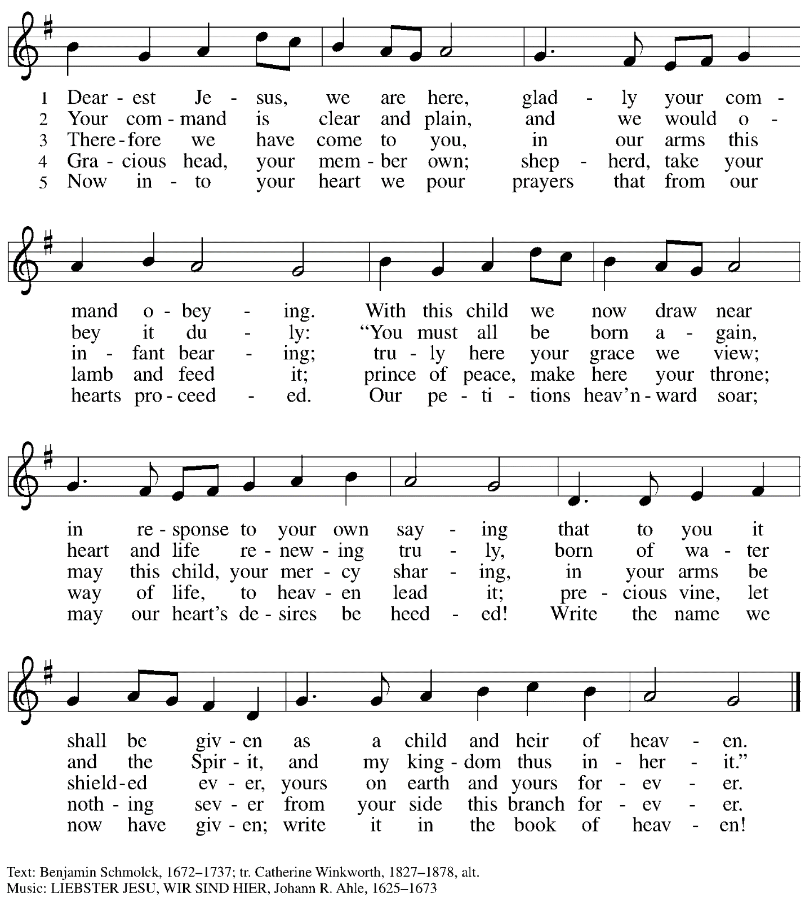

Holy Baptism

Presentation

P: God, who is rich in mercy and love, gives us a new birth into a living hope through the sacrament of Holy Baptism. By water and the Word God delivers us from sin and death and raises us to new life in Jesus Christ. We are united with all the baptized in the one body of Christ, anointed with the gift of the Holy Spirit, and joined in God's mission for the life of the world.

Sponsors for each candidate, in turn, present the candidates:
I present name for baptism.

The presiding minister addresses parents or others who bring for Baptism children who are not able to answer for themselves:
P: Called by the Holy Spirit, trusting in the grace and love of God, do you desire to have your child baptized into Christ?
Response: I do.

P: As you bring your child to receive the gift of baptism, you are entrusted with responsibilities:
to live with them among God's faithful people,
bring them to the word of God and the holy supper,
teach them the Lord's Prayer, the Creed, and the Ten Commandments,
place in their hands the holy scriptures,
and nurture them in faith and prayer,
so that your children may learn to trust God,
proclaim Christ through word and deed,
care for others and the world God made,
and work for justice and peace.
Do you promise to help your child grow in the Christian faith and life?
Response: I do.

The presiding minister addresses sponsors:
P: Sponsors, do you promise to nurture this person in the Christian faith as you are empowered by God's Spirit, and to help them live in the covenant of Baptism and in communion with the church?
Response: I do.

The presiding minister addresses the assembly:
P: People of God, do you promise to support name/s and pray for them in their new life in Christ?
C: We do.

Please rise as you are able.

Profession of Faith

The presiding minister addresses candidates for baptism as well as the parents and sponsors of young children. The assembly may join in the responses.
P: I ask you to profess your faith in Christ Jesus, reject sin, and confess the faith of the church.

Do you renounce the devil and all the forces that defy God?
Response:
I renounce them.
Do you renounce the powers of this world that rebel against God?
Response:
I renounce them.
Do you renounce the ways of sin that draw you from God?
Response:
I renounce them.

P: Do you believe in God the Father?
C: I believe in God, the Father almighty,
creator of heaven and earth.

P: Do you believe in Jesus Christ, the Son of God?
C: I believe in Jesus Christ, God’s only Son, our Lord,
who was conceived by the Holy Spirit,
born of the virgin Mary,
suffered under Pontius Pilate,
was crucified, died, and was buried;
he descended to the dead.*
On the third day he rose again;
he ascended into heaven,
he is seated at the right hand of the Father,
and he will come to judge the living and the dead.

P: Do you believe in God the Holy Spirit?
C: I believe in the Holy Spirit,
the holy catholic church,
the communion of saints,
the forgiveness of sins,
the resurrection of the body,
and the life everlasting. Amen.

*Or, “he descended into hell,” another translation of this text in widespread use.

Thanksgiving at the Font

Water may be poured into the font before or during the thanksgiving.

At the font, the presiding minister begins the thanksgiving:
P: The Lord be with you.
C: And also with you.

P: Let us give thanks to the Lord our God.
C: It is right to give our thanks and praise.

P: We give you thanks, O God, for in the beginning your Spirit moved over the waters and by your Word you created the world, calling forth life in which you took delight. Through the waters of the flood you delivered Noah and his family, and through the sea you led your people Israel from slavery into freedom. At the river your Son was baptized by John and anointed with the Holy Spirit. By the baptism of Jesus' death and resurrection you set us free from the power of sin and death and raise us up to live in you.
Pour out your Holy Spirit, the power of your living Word, that those who are washed in the waters of Baptism may be given new life. To you be given honor and praise through Jesus Christ our Lord, in the unity of the Holy Spirit, now and forever.
C: Amen.

Baptism

The presiding minister baptizes the candidate. The candidate is immersed into the water,
or water is poured on the candidate's head, as the presiding minister says:
Name , I baptize you in the name of the Father,
The candidate is immersed or water is poured on the candidate's head a second time:
and of the Son,
The candidate is immersed or water is poured on the candidate's head a third time:
and of the Holy Spirit.
C: Amen.

The presiding minister continues:
P: Let us pray.
We give you thanks, O God, that through water and the Holy Spirit you give your children
new birth, cleanse them from sin, and raise them to eternal life.

Laying both hands on the head of the newly baptized, the minister prays:
P: Sustain name with the gift of your Holy Spirit: the spirit of wisdom and understanding,
the spirit of counsel and might, the spirit of knowledge and the fear of the Lord,
the spirit of joy in your presence, both now and forever.
C: Amen.

The presiding minister marks the sign of the cross on the forehead of each of the baptized.
Oil prepared for this purpose may be used. As the sign of the cross is made, the minister says:
P: Name , child of God, you have been sealed by the Holy Spirit and marked with the cross of Christ forever.
C: Amen.

Welcome

A lighted candle may be given to each of the newly baptized (to a sponsor of a young child)
as a representative of the congregation says:
A: Let your light so shine before others
that they may see your good works
and glorify your Father in heaven.

The ministers and the baptismal group face the assembly.
A representative of the congregation leads the assembly in the welcome.
A: Let us welcome the newly baptized.
C: We welcome you into the body of Christ and into the mission we share:
join us in giving thanks and praise to God
and bearing God's creative and redeeming word to all the world.

All are invited to join in singing the congregational refrain in celebration of the gift of Baptism.

Congregational Refrain

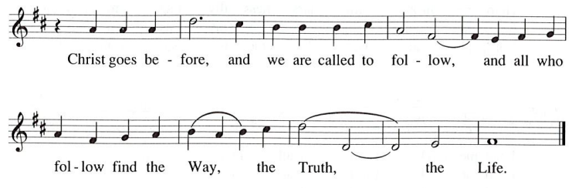

Those who have gathered at the font return to their places.
Worship continues with the prayers of intercession.

Prayers of the People

A: Called together to follow Jesus, let us pray for the church, the world,
and all who are in need.

After each petition
A: God of grace,
C: receive our prayer.

The presiding minister concludes the prayers
P: Knowing that the Holy Spirit intercedes for us, we offer these prayers
and the silent prayers of our hearts to you, O God, through Jesus Christ, our Savior.
C: Amen.

Peace

The presiding minister and the assembly greet one another in the peace of the risen Christ.
P: The peace of Christ be with you always.
C: And also with you.

The people may greet those around them with a sign of Christ’s peace and may say
Peace be with you or similar words. Please be mindful that not everyone will be comfortable with sharing the peace, so please seek consent before shaking hands or hugging. Other possible ways to share the peace include a simple bow with the verbal greeting of peace, or simply a verbal expression of peace.

When the greetings of peace have concluded, please be seated.

Meal
God feeds us with the presence of Jesus Christ

Offering

We offer ourselves, our gifts, and our faithful service to God. If anyone would like to make an offering using a QR code, please see the laminated cards in the pew racks. We invite those who already give electronically to place these cards in the plate to express your offering. As the offering is gathered for the mission of the church, including the care of those in need,
the table is set for Holy Communion.

Reparations Offering

On the first Sunday of each month, St. Andrew invites people of the congregation to consider a donation to a second collection for a reparations fund in acknowledgement of St. Andrew’s use of African American spiritual songs in our worship services. Please see the note in the announcements for more information.

Music during the Offering
As the gifts are brought forward for presentation, please rise as you are able.

Offertory Song God of the Fertile Fields ACS 1063
v. 2-4

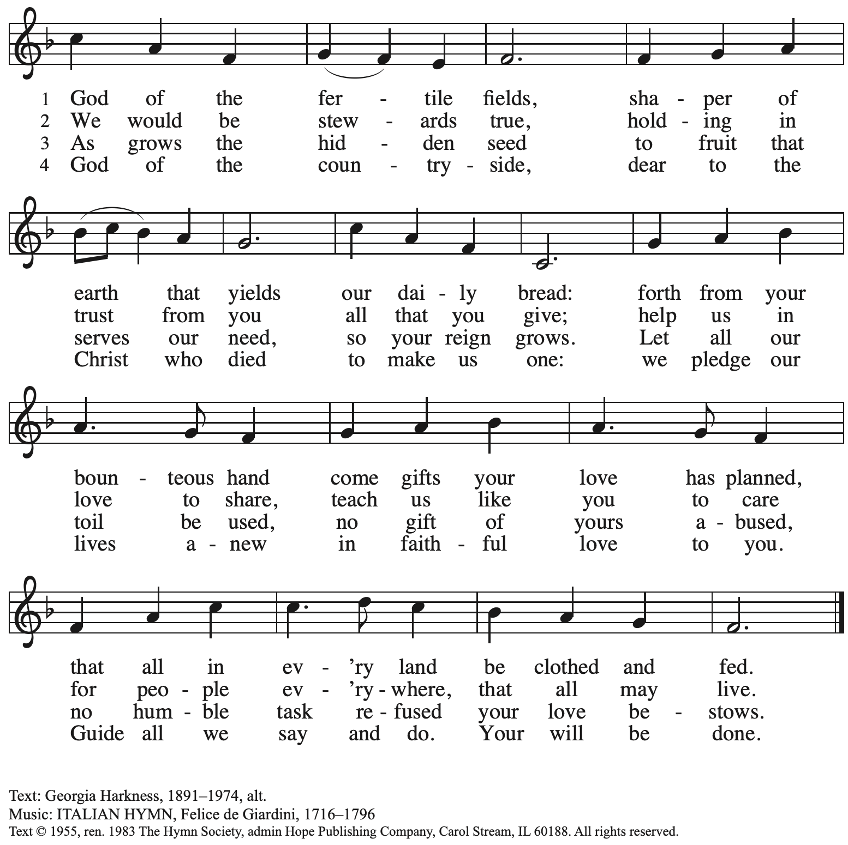
Reprinted with permission under OneLicense.net # A-722139.

Offertory Prayer

A: Let us pray.
Blessed are you,
C: O God, maker of all things.
Through your goodness you have blessed us with these gifts:
our selves, our time, and our possessions.
Work through us and what we have gathered
to feed the world with your love, through the one who gave himself for us,
Jesus Christ, our Savior and Lord. Amen.

Dialogue

P: The Lord be with you.
C: And also with you.

P: Lift up your hearts.
C: We lift them to the Lord.

P: Let us give thanks to the Lord our God.
C: It is right to give our thanks and praise.

Preface

P: It is indeed right, our duty and our joy,
that we should at all times and in all places
give thanks and praise to you, almighty and merciful God,
through our Savior Jesus Christ;
who on this day overcame death and the grave,
and by his glorious resurrection opened to us the way of everlasting life.
And so, with all the choirs of angels,
with the church on earth and the hosts of heaven,
we praise your name and join their unending hymn:

Sanctus ACS p. 36

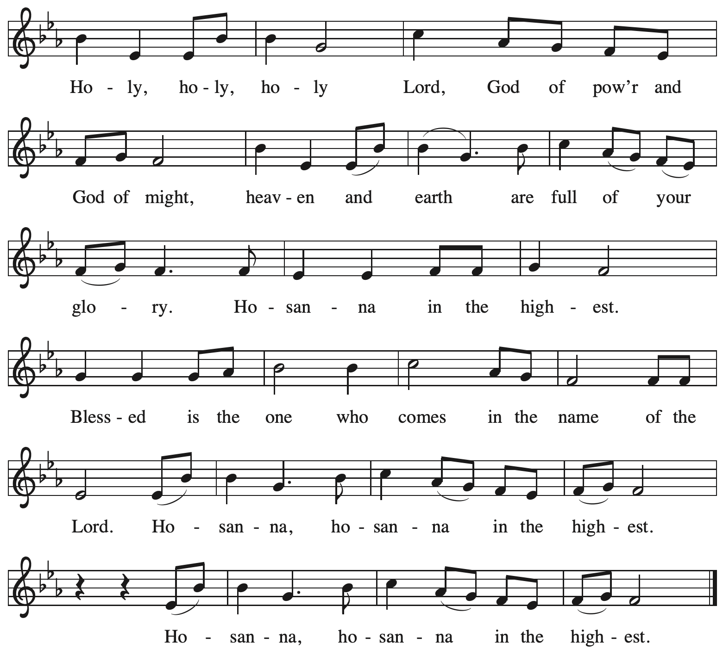

Eucharistic Prayer

P: Holy God, holy and merciful, your people praise you, saying:
Your mercy endures forever.
C: Your mercy endures forever.

P: By your promise you bound yourself to earth and all its creatures, granting them life
and calling them to flourish, setting the sign of the bow in the clouds, the colors of your love
and faithfulness. Your mercy endures forever.
C: Your mercy endures forever.

P: By your promise you bound yourself to your people of old,
blessing them with family outnumbering the stars and calling them to be a blessing to others,
showing them steadfast love in every generation and calling them to be a light to the nations.
Your mercy endures forever.
C: Your mercy endures forever.

P: By your promise you joined us to Jesus, your Beloved …
… Do this for the remembrance of me.

With this bread and cup
we remember his life laid down and lifted up
as we proclaim the mystery of faith.
C: Christ has died. Christ is risen. Christ will come again.

P: Send your Holy Spirit upon us …
… in your Spirit, now and forever.
C: Amen.

Lord’s Prayer

P: Gathered as one by the Holy Spirit, let us pray as Jesus taught us.
C: Our Father in heaven,
hallowed be your name,
your kingdom come,
your will be done,
on earth as in heaven.
Give us today our daily bread.
Forgive us our sins
as we forgive those
who sin against us.
Save us from the time of trial
and deliver us from evil.
For the kingdom, the power,
and the glory are yours,
now and forever. Amen.

Fraction and Invitation

P: At Christ’s table,
heaven and earth are joined as one.
Come and see.

Agnus Dei / Lamb of God ACS p. 40

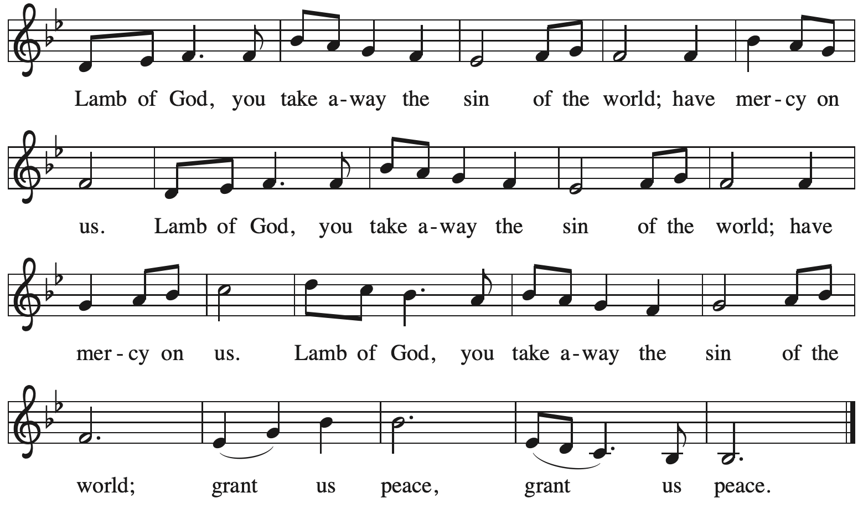

Please be seated.

Holy Communion
- All who seek God and desire a deeper and stronger life in Christ are welcome to receive Holy Communion.
- Worshipers from the pulpit side will proceed forward first, followed by the center section, and then the lectern side.
- Please inform an usher if you would like the ministers to bring Communion to you.
- Holy Communion will be served with bread and wine/grape juice.
- The presiding minister will first distribute the bread (host) to each communicant. Please indicate if you require a gluten-free host.
- Once you have consumed the bread, please pick up an empty glass from the tray next to the presiding minister. The Communion Assistant will pour wine from the chalice or grape juice from the cruet into your glass.
- Please step to the side to consume the wine or grape juice.
- Feel free to kneel at the altar rail for prayer after receiving the sacrament.
- As you return to your pew, glasses may be returned to the empty trays on either side of the center section.
- A blessing will be provided for anyone who does not yet receive the sacrament.
- All are invited to join in singing the hymns during Holy Communion.
Hymns during Holy Communion
God, Whose Almighty Word ELW 673

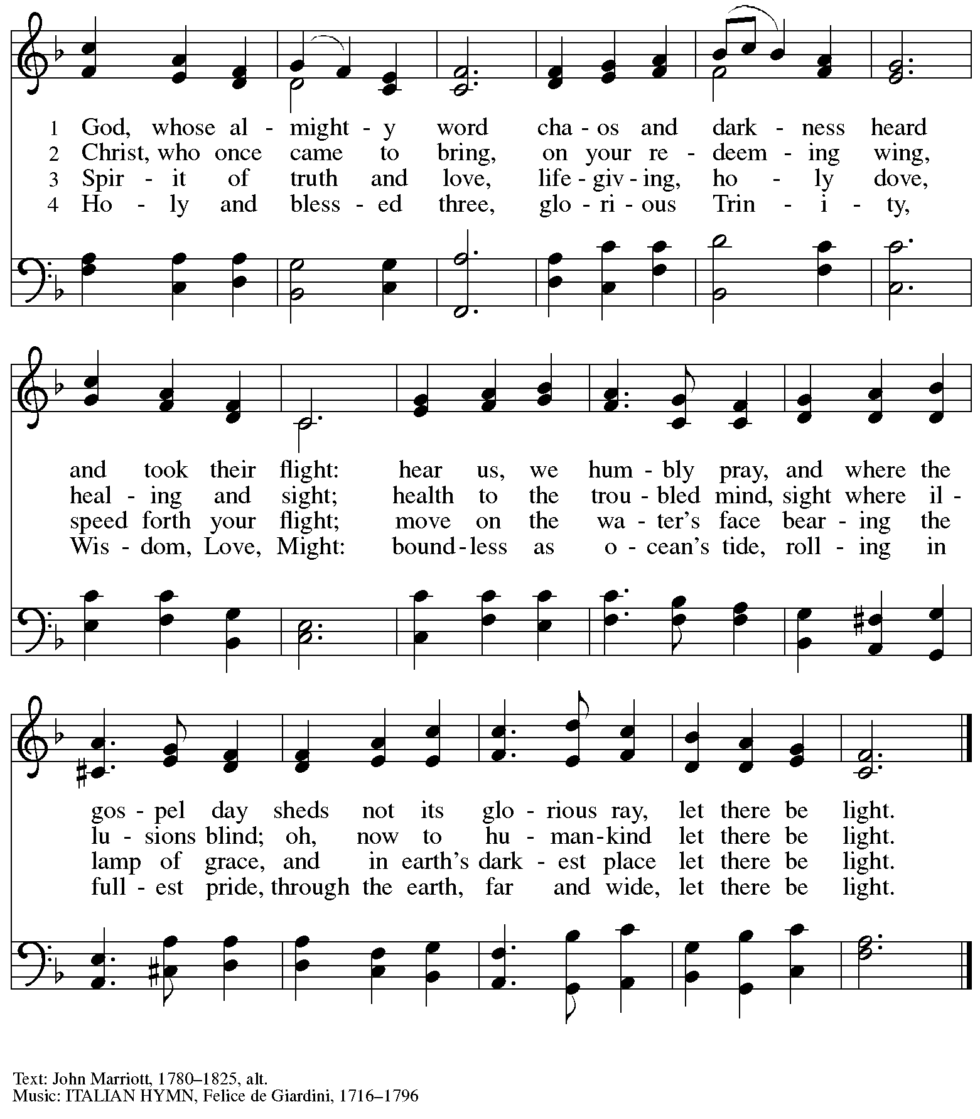

Hymns during Holy Communion
God of Promise, Let These Signs of Grace ACS 959

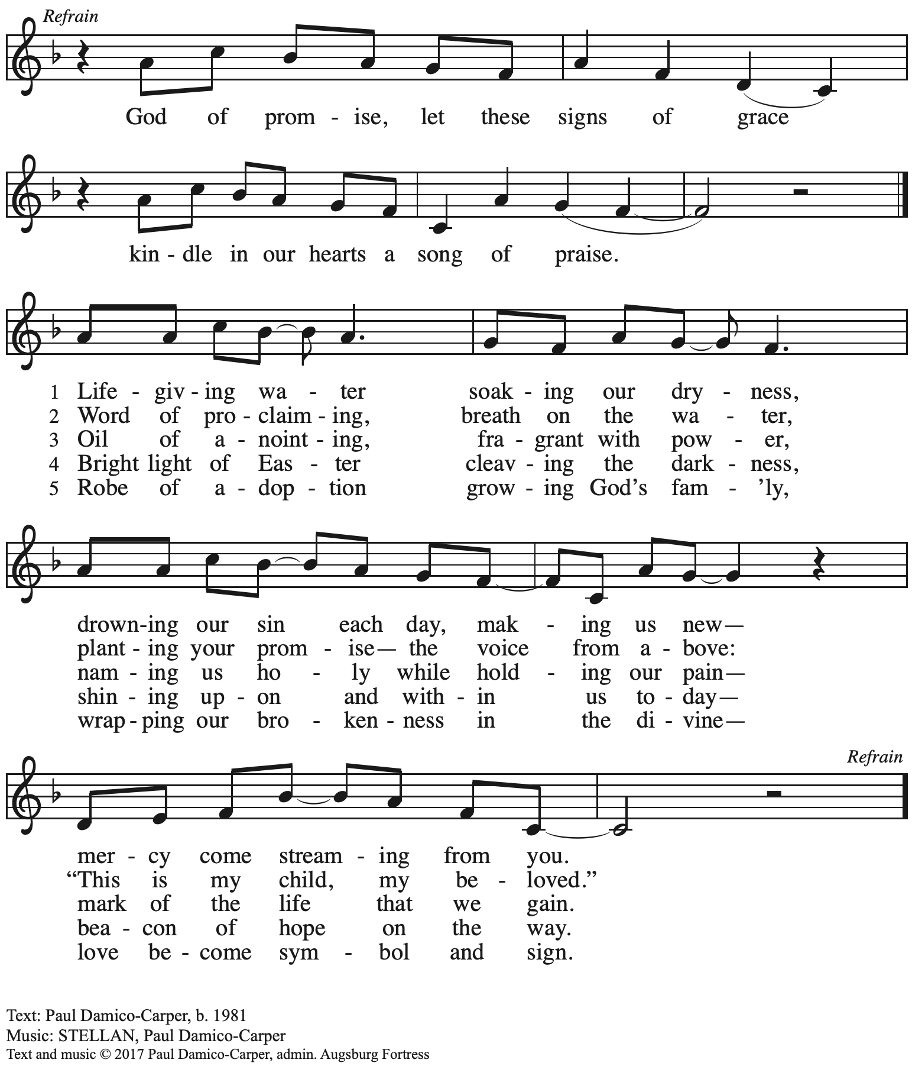
All rights reserved. Reprinted with permission under OneLicense.net #A-722139.

Hymns during Holy Communion
You Call Us to the Feast Erickson / Stuempfle

This hymn tune, YODER, was written by organist David Erickson in honor of his late friend and colleague, The Rev. George Yoder, Lutheran pastor and grandfather of those receiving First Communion today.

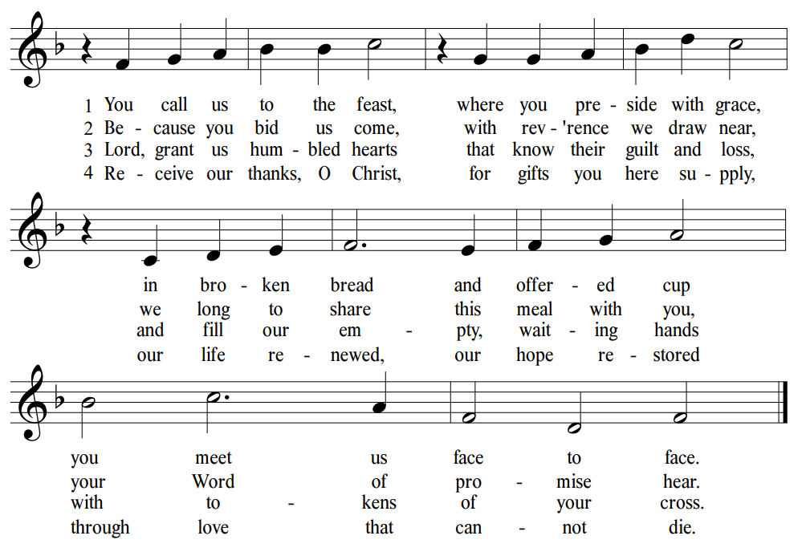
Text: Herman G. Stuempfle, Jr. Music: YODER, David Erickson. Text © 1994

Hymns during Holy Communion
Loaves Were Broken, Words Were Spoken ACS 966

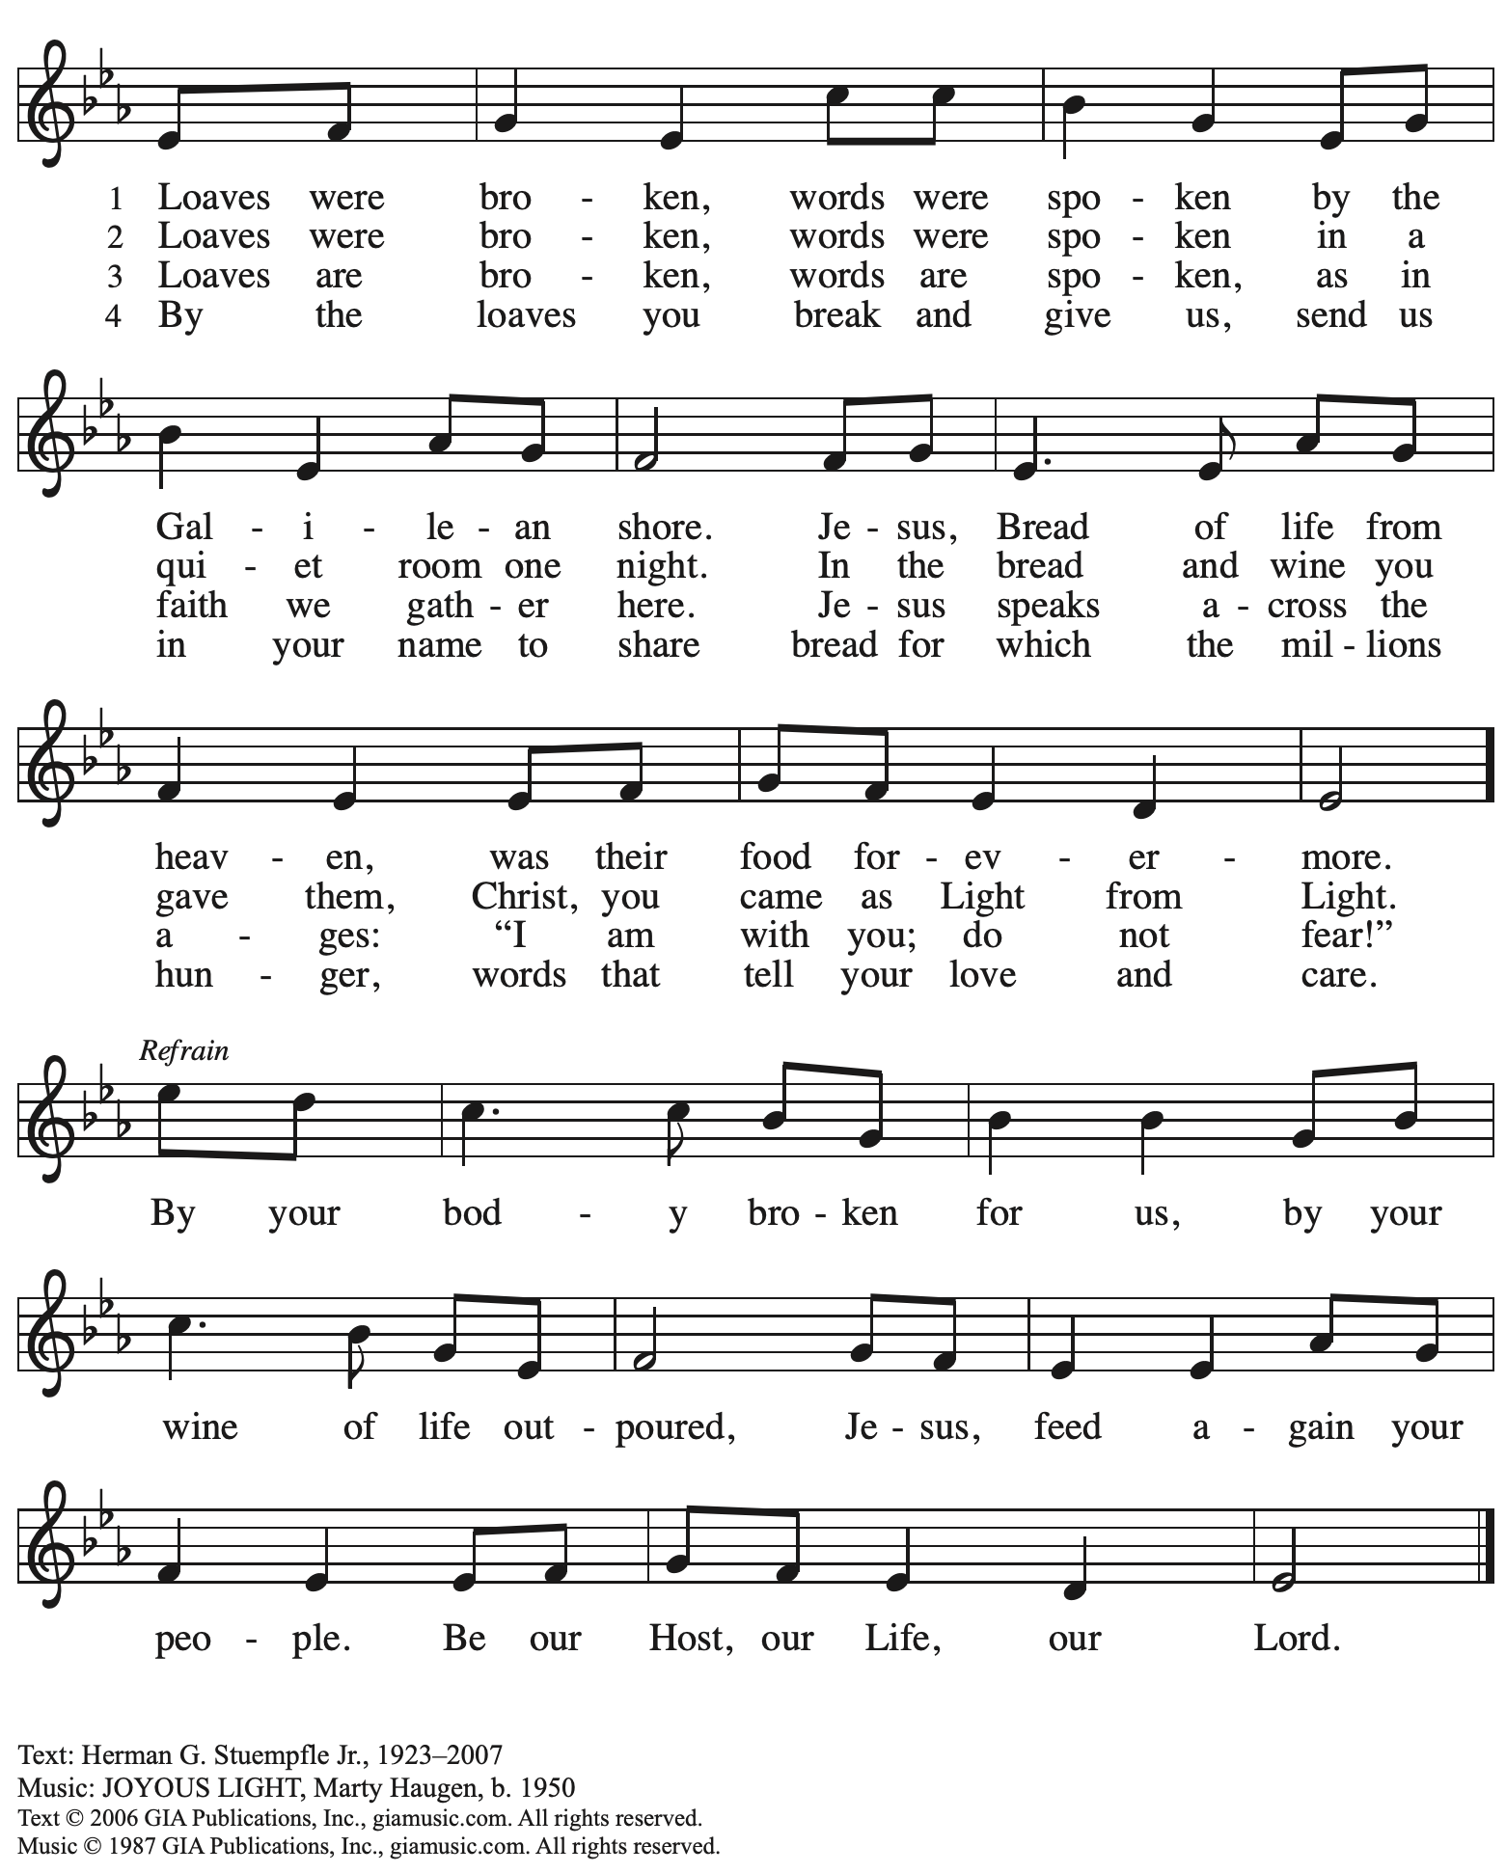
Reprinted with permission under OneLicense.net # A-722139.

When all have returned to their places, please rise as you are able.

Blessing

P: The body and blood of our Lord Jesus Christ strengthen you and keep you in his grace.
C: Amen.

Prayer

A: Let us pray.
God of abundance, with this bread of life and cup of salvation you have united us with Christ, making us one with all your people. Now send us forth in the power of your Spirit,
that we may proclaim your redeeming love to the world
and continue forever in the risen life of Jesus Christ, our Lord.
C: Amen.

Please be seated.

Sending
God blesses us and sends us in mission to the world

Announcements

Please rise as you are able.

Benediction

P: God who names you,
Christ who claims you,
and the Holy Spirit who dwells in you,
☩ bless you now and forever.
C: Amen.

Sending Hymn I’m So Glad Jesus Lifted Me
Following page

Dismissal

A: Go in peace. You are beloved.
C: Thanks be to God!

Postlude

Sending Hymn I’m So Glad Jesus Lifted Me ELW 860

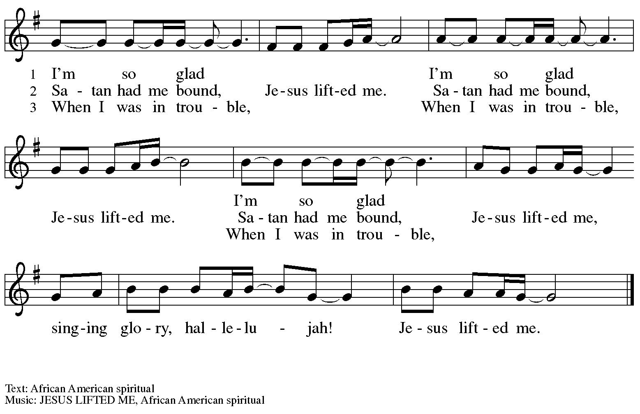

Those serving in worship

Altar Care Janet Grzegorczyk
Assisting Minister Jimmi Kocher-Hillmer
Audio-Visual Ministers David Rollinson
Jason Galyardt
Cantor Jered Stratton
Choir People of St. Andrew
Clarinet and Coffee Hour Maria Mangano
Flute Lindsay Baxter
Lector Lester Prince
Little Church – Big Faith Teacher Emily Duque
Minister of Music Laura Reynolds
Preaching Minister The Rev. Canon Natalie Hall
Presiding Minister The Rev. Ross I. Carmichael

Liturgy and Hymnody Acknowledgements

From SundaysandSeasons.com. Copyright © 2024 Augsburg Fortress. All rights reserved. Reprinted under OneLicense.net # A-722139.
Used by permission of Augsburg Fortress.

.

Please use the QR code below to link to St. Andrew’s Announcements online!

St. Andrew Lutheran Church Announcements
February 4th, 2024

- Welcome to worship at St. Andrew on the Fifth Sunday after Epiphany, February 4th, 2024 – We are so glad you are here, and we offer a special welcome to all guests who are gathered at the church or online! Children are invited to participate in Little Church – Big Faith, a Bible lesson and activity, after the prayer of the day. There are worship “toolkits” to help children engage with worship and “busy bags” for younger children available in the bookcase at the back of the sanctuary. Please feel free to take one to use with/for your children. We invite everyone to gather in the social hall (through the door on the left of the worship space) after the service for coffee and conversation!
- St. Andrew Welcomes Guest Preacher, The Rev. Canon Natalie Hall! – The Rev. Canon Natalie Hall was ordained in the Lutheran Church (ELCA) in 2009 and has served in the Southwestern Pennsylvania Synod since then. She was called to serve an ecumenical position as Canon for Faith Formation and Evangelism on the Bishop’s staff of the Episcopal Diocese of Pittsburgh and has since received a call to serve as Rector of the Episcopal Church of the Redeemer (Squirrel Hill), living into the full communion agreement between the Lutheran and Episcopal church bodies. In 2017 she planted a church that came to be called St. Mary Magdalene Lutheran Episcopal Church that primarily serves households with young children and continues to meet at Redeemer. She is honored to preach and serve together with Pastor Ross Carmichael at the baptismal celebration of her beloved neighbor, Solia.
- Monthly Reparations Offering Today during Worship – Jesus’ parable from Luke's Gospel about a compassionate Samaritan provides an example of how God's people are called to work for healing and repair for our neighbors, independent of who or what caused harm. In light of this, St. Andrew has made a commitment to reparations in regard to African American spiritual songs used in our worship. The text and music of most hymns is attributed to specific authors, with copyrights in place, usage reported, and royalties paid to those whose works are featured in worship. With African American spirituals, this is not possible. In response to many years of such uncredited use,
St. Andrew invites the congregation to give to a reparations offering. Funds received in worship will be donated to our siblings at Bethel AME Church, whose land and building were taken from them in the 1950s, to fund their development in the lower Hill District.
- Hearts and Hands Crocheting and Knitting Group Meeting Today after Worship (First Sunday of the Month) – All are welcome, and leaders will teach anyone who would like to learn to crochet. Yarn and hooks will be provided to help get you started! We are currently in need of knitted or crocheted shawls, afghans, and stoles to replenish the congregation’s supply. Anyone is welcome to make something and drop it off even if they are not able or choose not to come to the monthly gathering.
- Monthly Fresh Produce Distribution – Tuesday, February 6th, 5:30-7:00 p.m. – On the first Tuesday of every month, St. Andrew hosts a fresh produce distribution in partnership with Greater Pittsburgh Community Food Bank. We ask people of the congregation to assist with setup and unloading, usually sometime between 10:00 a.m. and 1:00 p.m., and with the distribution itself from 5:30-7:00 p.m. People of St. Andrew are also welcome to come and select produce.

- Pick Up Gathered into One: Devotions for Lent 2024 at Church Entrances – The Christian church’s season of Lent, from a word that meant “springtime,” begins with Ash Wednesday on February 14th. Many during Lent practice some form of spiritual discipline, with prayer, fasting, or charitable giving. Gathering into One offers a brief reading, prayer, and reflection for each day of the Lenten season. We invite everyone to take one for yourself and/or others from the church entrances.
- Ash Wednesday Worship with Imposition of Ashes and Holy Communion – February 14th, 7:00 p.m. – Ash Wednesday begins the season of Lent on February 14th this year. This is a day of worship that often includes Imposition of Ashes, an ancient sign of mourning and repentance. On this day, we receive the call to confess our sins and return to God, acknowledging our human vulnerability and dependence on God. Worship with Imposition of Ashes and Holy Communion will be held at 7:00 p.m.
- Shelter Dinner at East End Cooperative Ministry – Thursday, February 15th, Arrival 6:00 p.m., Dinner 6:30 p.m. – Each month, on the third Thursday, people of St. Andrew provide and serve a meal for the guests of the shelter at East End Cooperative Ministry (EECM), 6140 Station St., 15206. Anyone can sign up to prepare or purchase a portion of the meal to bring to EECM at 6:00 p.m. that day, or just come to help serve the meal at 6:30 p.m. If you would like to contribute, please sign up at: https://www.signupgenius.com/go/5080544AAAC22A1F58-47342991-shelter.
- Ukrainian Egg Workshop – A Focused Spiritual Meditation for Lent, Saturday, February 17th, 1:00-4:30 p.m. – Jimmi and Timothy Kocher Hillmer will lead a workshop on the tradition of Ukrainian egg decoration as a spiritual discipline for the season of Lent. Pysanky, the Ukrainian name for the tradition, comes from the word “write,” similar to the spiritual practice of “writing” icons, and the process involves both writing on and dyeing the eggs. Due to safety considerations (open flame, hot wax) this workshop is recommended for people 6th grade and up. To ensure ample space and supplies, registration will be limited to 20 participants. If you would like to participate, please sign up at https://www.signupgenius.com/go/5080B4AAFAF2CABF85-47277468-ukrainian by Sunday, February 11th. If you have questions, please contact Jimmi at jimotha@yahoo.com. Please bring an old dish towel on which to work.
- Growing in Faith Together – Gatherings for People New to St. Andrew on the Sundays in Lent – Over the past year, St. Andrew has been blessed by the presence of many people new to the community of faith! In the past, we have offered small group gatherings to help people get to know one another, share in conversation and faith stories based on the weekly readings, and to pray for one another. Our next gatherings, led by St. Andrew member Jeff Denlinger, will be on Sundays, February 18th, 25th, March 3rd, March 10th (Congregational Meeting), March 17th, and March 24th. If you are interested in participating or have any questions, please speak with Pastor Ross or contact Jeff at jdenlinger26@icloud.com.
- Meeting of the Congregation – Sunday, March 10th, after Worship – Each year in the winter/spring, St. Andrew gathers for a congregational meeting to review financial figures for the previous year, report of our various ministries, and update the congregation on upcoming developments and initiatives. Please put this date on your calendars!
- Support Abuelas Responden – Grannies Respond with Donations of Used Winter Clothing Items – Abuelas Responden - Grannies Respond is a local organization that supports traveling asylum seekers as they come through Pittsburgh. The group goes to the downtown bus station to meet asylum seekers who have been released from the Moshannon Valley detention center and supply them with much needed items as they travel to join family or friends in other cities. The primary need is for warm winter clothing. A bin will be set up in the social hall to receive these items. Right now the most needed items are:
- Men’s warm (but not too bulky) coats, jackets, fleece hoodies - People need to be able to fit everything in bags so there is no space for a heavy coat.
- Men’s Pants and Shoes (Please no sweatpants - this is what the people receive in detention, so we want to avoid outfitting anyone with something that looks like prisoners’ clothes.
- Men’s gloves
- Inviting Coffee Hour Signups for Upcoming Sundays – One way that we at St. Andrew build community is by sharing conversation over food and drinks at coffee hour after worship on Sundays. We invite people of the congregation to serve by getting the coffee brewing, setting out cups, napkins, food items, and cold drinks, and cleaning up afterward. Everything needed is at St. Andrew and instructions are available. If you would be willing to set up coffee hour on any of the upcoming Sundays, please sign up here:
https://www.signupgenius.com/go/5080B4AAFAF2CABF85-47069030-coffee.
Thank you for your consideration!
- Call for Parishioners to Serve in Worship Roles – St. Andrew's worship is made possible by many people who serve in various roles – Some people prepare the altar and setup Communion, some run the sound/streaming system, while others teacher Little Church – Big Faith for the children, serve as ushers, wash communion cups, count the offering, and more. It is not just roles like Cantor and Lector that involve being up in front of the congregation! If you are interested in getting more involved in worship, talk to Pastor Ross or Joseph Paetz. Most positions serve once a month or less!
- Compline Prayer Service, a Ministry of Lutheran Campus Ministry in Greater Pittsburgh, Sundays at 8:00 p.m. at Heinz Chapel – Compline was traditionally a monastic prayer service, and the Pittsburgh Compline Choir sings a choral version of compline rooted in this thousand-year-old tradition of scripture, song, and silence. This service also streams on Facebook (Pittsburgh Compline Choir) and YouTube (The Pittsburgh Compline Choir). Heinz Chapel is located off of S. Bellefield Ave. in Oakland.
- Christ in Our Home Devotional Booklets for January - March Available at Church Entrances – This resource offers a daily Bible reading with a short reflection and prayer, along with additional readings and prayer topics for those who would like to expand their devotional practices. We encourage people of the congregation to take one for yourself, your family unit, or others!

